Original Research Article
Exploitation of Heterosis in Brinjal (Solanum melongena L.) for Growth and Yield Traits

ABSTRACT
Brinjal (Solanum melongena L.) is a commercially important annual vegetable widely cultivated across India for its edible fruits. The exploitation of heterosis in vegetable crops is a key strategy to develop superior hybrids, as it reflects phenotypic superiority over the parents and suggests the predominance of non-additive genetic effects. The present study was conducted at ICAR-Indian Institute of Horticultural Research, Bengaluru, using six parental lines and nine hybrids, evaluated in a Randomized Block Design (RBD) with three replications. The cross IIHR-824 × VI046101, exhibited highly significant positive heterosis for plant height, with 30.38% and 53.15% heterosis over the mid parent and better parent, respectively. Significant positive heterosis was also recorded for the number of primary branches per plant in IIHR-824 × IIHR-766 (25.91%) and VI046103 × IIHR-766 (26.60%) over both mid-parent and better parent values. A significant negative heterosis for days to 50% flowering, indicating early flowering, was observed in the crosses IIHR-824 × IIHR-766 (-27.16%) and VI046103 × IIHR-766 (-31.63%) over the better parent. For yield components, IIHR-824 × VI046101 showed significant positive heterosis for the number of fruits per plant (82.35%) over the mid parent and highly significant heterosis over mid parent for fruit yield per plant in the crosses viz., IIHR-824 xVI046101 (66.34 %) and IIHR-B-BR-54 xVI046101 (62.97 %). The heterosis observed in this study can be effectively utilized in future crop improvement programs for the development of superior hybrids.
Keywords: Brinjal, Heterosis, Parents, Hybrids, Growth, Yield and yield attributes.
Introduction
Brinjal (Solanum melongena L.; 2n = 24), a significant vegetable crop in the family Solanaceae, is believed to have originated in the Indo–Burma region, with secondary centers of origin in China and Southeast Asia (Vavilov, 1931). It is known by various vernacular names across India, including Baigan (Hindi), Badanekai (Kannada), Vangi (Marathi), Katharikai (Tamil), and Vankai (Telugu). Globally, it is commonly referred to as eggplant or aubergine. Brinjal is widely cultivated in both tropical and subtropical regions of the world (Ismael et al., 2017). According to FAO (2021), the global cultivation area spans approximately 1.8 million hectares, producing around 59.60 million tonnes. In India, it is cultivated over an area of approximately 676.70 thousand hectares, yielding about 12.78 million tonnes, with an average productivity of 18.90 MT/ha (Indiastatagri, 2023). The crop contributes approximately 8.1% to India’s total vegetable production. Major brinjal-producing states in India include West Bengal, Odisha, Andhra Pradesh, Gujarat, Bihar, Maharashtra, Chhattisgarh, Karnataka, Madhya Pradesh, Haryana, Jharkhand, and Assam.
Botanically, Solanum melongena exhibits three distinct varietal groups based on fruit shape and colour. The large or egg-shaped fruit types are classified as S. melongena var. esculentum, while the long, slender types fall under S. melongena var. serpentinum, and the dwarf types are categorized as S. melongena var. depressum. Consumer preferences for brinjal vary significantly across different regions and localities, necessitating the characterization of genotypes with broad adaptability and market acceptance. India possesses a rich genetic diversity in brinjal, providing considerable potential for genetic improvement through heterosis breeding. Enhancing productivity in brinjal can be effectively achieved via heterosis breeding, which is both feasible and promising in this crop (Kakikazi, 1931). Heterosis plays a critical role in improving both yield and quality and is commonly assessed using parameters such as relative heterosis, heterobeltiosis, and standard heterosis. Estimating heterosis for yield and its associated traits is essential to identify superior hybrid combinations for commercial exploitation. Parental selection is a crucial step in heterosis breeding to develop hybrids exhibiting significant and commercially viable heterosis. In eggplant, the exploitation of hybrid vigour has emerged as a powerful tool for crop improvement (Bavage, 2005). The ease of hybridization and high seed set in brinjal further facilitate the practical application of heterosis breeding. The present study was undertaken to assess the nature and magnitude of heterosis for yield and its component traits across various crosses, with the aim of identifying promising hybrids for future crop improvement programs.
Materials and Methods
Experimental site
This research was carried out in the research plot of Department of Vegetable Crops, Indian Institute of Horticultural Research (IIHR) is located in Southern India on the Deccan Plateau an elevation of 930 m above the mean sea level at 13º 13” N latitude and 77º 49” E longitudes.

Development of F₁hybrids
Crossing was carried out during the Kharif season in line x tester mating design. The healthy buds were emasculated and covered in the evening hours between 4.00 pm to 6.00 pm and pollination was done in the next day morning during anthesis time (6.30 am to10.00 am). The pollinated flowers were tagged and covered with butter paper bags to avoid contamination. Six parents 3lines (IIHR-824, IIHR-B-BR-54 and VI046103) & 3 testers (IIHR-766, IIHR-835 and VI046101) and resulting nine hybrids were raised under Randomized Block Design with two replications. The heterosis was calculated for seven characters viz., plant height (cm), number of primary branches, days to 50% flowering, fruit width (cm), fruit length (cm), average fruit weight (g), number of fruits per plant and fruit yield per plant (kg) studied in the nine hybrid combinations and expressed in percentage over mid parent i.e., relative heterosis and better parent i.e., heterobeltiosis.

Relative heterosis = | F₁ – Mid Parent | x100
Relative heterosis = | Mid Parent | x100
Hetero beltiosis = | F₁ – Better parent | x100
Hetero beltiosis = | Better parent | x100

Where, Mid parent refers to the mid value of the parents mean and better parent refers to mean of the better parent.

Statistical analysis

The significance at both 5% and 1% levels were tested statistically for all traits by using GRAPES software package and mean was calculated accordingly (Gopinath, 2020).

Results

Heterosis refers to the phenomenon where the offspring resulting from the crossing of different varieties within a species or between species display enhanced traits such as increased biomass, accelerated growth, and improved fertility compared to both parent lines (Birchler, 2010). It is commonly defined as the superiority of hybrids over their parents and serves as a key measure for evaluating hybrid advantages. Table 1 presents the six parental lines sourced from IIHR, Bengaluru and World Vegetable Centre, Taiwan. The extent of heterosis was observed to be higher when the parental lines originated from genetically diverse regions rather than from a common geographical source (Hayes, 1965). Table 2 illustrates the relative heterosis and heterobeltiosis, observed for various traits across nine hybrids.

Plant height (cm)

Plant height is an important trait by which growth and vigour of the plants are determined. The relative heterosis was positive and significant in four out of thirty hybrids registered over mid parental value. Crosses 1, 2, 4, 5, 7, and 8 showed positive heterosis over the mid parent in terms of plant height. The remaining crosses ranged from 4.04 per cent (cross 6) to10.56 per cent (cross 9). In the meantime, cross 2 showed highly significant and positive heterosis over the mid parent and better parent. All other crosses (hetero beltiosis), ranging from 0.12% (cross 6) to 11.45 % (cross 8). The significance of the [h] and [l] components (cross 2) may be responsible for the significant heterosis over the better parent and mid parent.

No. of primary branches plant-1
Overall relative heterosis (%) ranged from 4.71 (cross 3) to 35.26 (cross 2), and heterobeltiosis (%) ranged from 1.69 to 26.60. The significant heterosis over better parent and mid parent could be attributed to significance of [h] and [l] components. The estimates of heterosis are positively significant over mid parent and better parent over in cross 1 and cross 4. Relative heterosis (%) is positively significant over mid parent in cross 2 and cross 5. The remaining crosses were found non-significant over mid parent and better parent.

Days to 50% flowering

Earliness is one of the important components influencing the duration of the crop, which is measured in terms of days to 50 % flowering. The heterosis is negatively significant over mid parent and better parent in crosses, 1, 4 and 7. Mean while hetero beltiosis was ranged from -4.26 (cross 5) to -27.16 % (cross1) and found significant and negative in cross 1,3,4,6, and cross 7. The relative heterosis (%) ranged from 2.11(cross 5) to-20.98 (cross7). The negative sign associated with estimates of heterosis suggested earliness in flowering which is desirable. The significant heterosis over better parent and mid parent could be attributed to the significance of [h] and [l] components.

Number of fruits per plant
Significant heterosis over the mid parent was found for the number of fruits per plant in all crossings (cross 1 to cross 9) in the desired direction, falling between 26.91% (cross 6) and 82.35 % (cross 7). Cross 7 showed highly significant positive heterosis over mid parent. In all crosses, there is no considerable heterosis over the better parent. An increase in the quantity of fruits per plant was shown by the positive heterosis sign.

Average fruit weight(g)
The estimates of heterosis are significant over mid parent and better parent in crosses 1, 4 and 7 in negative direction. Relative heterosis is significant over mid parent in crosses 5 and 8 in positive direction. Meanwhile, heterobeltiosis significant over better parent was observed in cross 3 (-18.41) in the negative direction. The significant of heterosis over better parent and mid parent could be attributed to significance of [h] and [l] components.

Fruit length (cm)
For fruit length, significantheterosisovermidparentwasobservedforcrosses1,2and 8 in positive direction, the remaining crosses fell in between 5.90 (cross 6) to 19.38 % (cross 3). Non-significant heterosis over better parent was observed in all crosses, ranged from 3.69 (cross 1) to 27.21 % (cross 8).

Fruit diameter (cm)
Crosses 3,7, and9showedasignificantly, positive heterosis over the better parent and mid parent. Crosses 1 (94.73 %), 4 (25.60%) and 8 (44.05%) showed significant relative heterosis (%) in a positive direction over mid parent. Moreover, cross 6 showed a negative trend of considerable heterosis over better parent. Over the mid parent and better parent, the remaining crosses are not statistically significant. The relevance of the [h] and [l]components may be responsible for the heterosis over the better parent and mid parent.

Fruit yield per plant (kg)

With the exception of crosses 1, 3, 4, and 7, all crosses showed considerable and positive heterosis over the mid parent in terms of fruit yield per plant, rangingfrom8.00(cross 4) to 66.34 % (cross 2). All other crosses showed non-significant heterosis over the better parent, which ranged from 2.18 (cross 7) to 18.18% (cross 2).
Table 1. Source and plant characters of parents
S.No. | Genotypes | Source
Lines
1 | IIHR-824 | IIHR, Bengaluru
2 | VI0 46103 | IIHR, Bengaluru
3 | IIHR-B-BR-54 | IIHR, Bengaluru
Testers
4 | IIHR-766 | IIHR, Bengaluru
5 | VI0 46101 | World Vegetable Center, Taiwan
6 | IIHR-356 | IIHR, Bengaluru

DISCUSSION
Heterosisbreedingexploitshybridvigorincrossbreedingtosignificantlyincreasecrop production and productivity Farinati et al., (2023). The assessment of relative heterosis is important for investigating the genetics of heterosis, although it has limited practical applications. However, it is quite practicable to quantify heterosis over the better parent. One of the best ways that genetics has been applied to the field of plant breeding is through the commercial use of heterosis. It has been successfully exploited in many crops, including tomato, brinjal, chilli, radish, bottle gourd and bitter gourd Yu et al. (2021). The current study, estimated the heterosis over better and mid-level parents as well as the relative heterosis and heterobeltiosis for each of the nine crossings in relation to various horticultural traits.
Heterobeltiosis (heterosis over better parent) for different traits was ranging from-12.16 % to 163.19 % and highest heterobeltiosis was recorded in fruit diameter (163.19 %in IIHR-B-BR-54 x IIHR-356), the results were confirmed with Ali et al., (2022) in tomato, meanwhile heterosis over mid parent (relative heterosis) ranges from 14.14 % to 249.35 %. The highest relative heterosis (heterosis over mid parent) also recorded in fruit diameter (249.35 % in IIHR-B-BR-54 x IIHR-356). Similar results were observed by Sharma et al., (2016) in brinjal.
Negative heterobeltiosis and relative heterosis indicating earliness was observed for days to 50% flowering of the hybrids. The maximum significant values over better parent and mid parent in desirable direction were recorded in the hybrid VI046103 × IIHR-766, which was followed by IIHR-B-BR-54 × IIHR-766 and IIHR-824 × IIHR-766. Similar negative heterosis was observed in brinjal by Kalaiyarasi et al. (2018). Regarding plant height (cm), positive heterosis over mid parent and better parent was observed in IIHR-824 × VI046101, but only relative heterosis was noticed in IIHR-824 × IIHR-766, VI046103 × IIHR-766, VI046101 × VI046101, IIHR-B-BR-54 × IIHR-766 and IIHR-B-BR-54 × VI046101. The report of Muthuvel (2003) supports the present findings on positive heterosis.
Regarding number of primary branches per plant, significant positive relative heterosis and heterobeltiosis were exhibited in IIHR-824 × IIHR-766 and VI046103 × IIHR-766. Only two hybrids viz., IIHR-824 × VI046101 and VI046103 × VI046101 showed significant positive relative heterosis. These results were in confirmation with the reports of Gopalakrishnan et al. (1987b) and Nikhila (2022).
In this study, all nine crosses showed positive significant relative heterosis for number of fruits per plant. Out of nine crosses, maximum significant relative heterosis was recorded in the hybrid IIHR-B-BR-54 × IIHR-766, which was followed by IIHR-824 × IIHR-766, but all nine crosses were non-significant over better parent. Heterosis over mid parent was reported by Makani et al. (2013) and Mistry et al. (2018) in brinjal. Negative heterosis over mid parent and better parent was observed for average fruit weight in hybrids viz., IIHR-824 × IIHR-766, VI046103 × IIHR-766 and IIHR-B-BR-54 × IIHR-766. Only one hybrid, IIHR-824 × IIHR-356, was negatively significant over better parent but non-significant over mid parent. Two crosses viz., VI046103 × VI046101 and IIHR-B-BR-54 × VI046101 were positively significant over mid parent but non-significant over better parent.
Positive significant heterosis over mid parent for fruit length (cm) was observed in IIHR-824 × IIHR-766, IIHR-824 × VI046101 and IIHR-B-BR-54 × VI046101, but remaining all crosses were non-significant for both mid parent and better parent. In this present study, maximum significant positive heterosis for fruit diameter over mid parent and better parent was observed in the hybrid IIHR-B-BR-54 × IIHR-356, followed by IIHR-824 × IIHR-356 and IIHR-B-BR-54 × IIHR-766. Negative heterobeltiosis for fruit diameter over better parent was observed in VI046103 × IIHR-356 but was non-significant over mid parent. High magnitude of relative heterosis for fruit yield was recorded by IIHR-824 × VI046101, IIHR-B-BR-54 × VI046101, VI046103 × VI046101, VI046103 × IIHR-356 and IIHR-B-BR-54 × IIHR-356. Remaining all crosses were non-significant over better parent and mid parent.
Several researchers have also reported heterosis in the desired direction for various characteristics of brinjal such as Hazra et al. (2010) and Ramesh et al. (2013). Biswas et al. (2013) also revealed significant and desirable mid parent heterosis for total fruit yield per plant. Vidhya (2015) reported significant heterosis for plant height, days to 50% flowering, fruit length and fruit yield per plant over mid parent. Furthermore, Chowdhary et al. (2011) also revealed significant heterosis for days to 50% flowering over mid parent and better parent. Similarly, Sharma et al. (2016) recorded desirable positive heterosis over better parent for plant height, plant stem girth, fruit yield, number of fruits per plant, fruit length and average fruit weight, and significant negative heterosis over better parent and standard check for earliness for days to 50% flowering. Mistry et al. (2018) observed positive and significant heterobeltiosis and relative heterosis for fruit length and fruit yield per plant in brinjal.

Table 2 Heterosis percentage over better parent (BP) and mid parent (MP) for various traits of brinjal

$Crosses | PH(cm) |  | NPBPP |  | DFF(50%) |  | NFPP |  | AFW(g) |  | FL(cm) |  | FDM(cm) |  | FYPP(kg)
$Crosses | BP(%) | MP  (%) | BP  (%) | MP  (%) | BP  (%) | MP  (%) | BP  (%) | MP  (%) | BP  (%) | MP  (%) | BP  (%) | MP  (%) | BP  (%) | MP  (%) | BP  (%) | MP  (%)
1 | 0.77 | 14.14** | 24.87* | 25.91** | -27.16** | -15.48** | 2.48 | 69.09** | -78.50** | -63.28** | 3.69 | 29.78** | 31.17 | 94.73** | 3.75 | 14.96
2 | 30.38** | 53.15** | 18.66 | 35.26** | -10.95 | -2.95 | 10.06 | 45.25** | 7.35 | 18.20 | 5.70 | 29.01** | -7.88 | 33.39 | 18.18 | 66.34**
3 | 1.06 | 8.25 | 4.29 | 4.71 | -12.16* | -6.95 | 5.23 | 33.70** | -18.41* | -9.58 | -7.53 | 19.38 | 134.57** | 159.90** | 8.77 | 26.97
4 | -0.19 | 16.18** | 26.60* | 29.92** | -31.63** | -19.12** | 2.89 | 67.69** | -76.88** | -61.97** | -19.16 | -7.86 | 6.75 | 25.60* | 5.23 | 8.00
5 | 1.29 | 15.81** | 18.43 | 32.91** | -4.26 | 2.11 | 0.69 | 29.77** | 6.25 | 29.01** | -2.02 | 14.82 | -4.05 | 16.92 | 6.70 | 57.24**
6 | 0.12 | 4.04 | 11.40 | 13.85 | -12.42* | -5.18 | 2.46 | 26.91** | 0.95 | 1.71 | -3.54 | 5.90 | -24.35* | 26.41 | 3.58 | 29.06*
7 | -1.55 | 31.72** | 1.69 | 8.53 | -30.07** | -20.98** | 13.65 | 82.35** | -77.76** | -63.46** | -9.82 | 4.77 | 50.70** | 93.84** | 2.18 | 8.71
8 | 11.45 | 16.13* | -9.59 | 9.69 | -11.34 | -0.66 | 9.18 | 36.56** | 3.02 | 25.51** | 27.21 | 51.87** | 15.65 | 44.05* | 12.87 | 62.97**
9 | -3.53 | 10.56 | -16.39 | -10.40 | -10.50 | -7.96 | 10.65 | 32.74** | 0.37 | 1.56 | -19.76 | -10.10 | 163.19** | 249.35** | 11.09 | 34.45*
(PH–plant height; NPBPP–number of primary branches per plant; DFF–days to first flowering; FL–fruit length; FW–fruit width; AFW–Average fruit weight t; FDM-fruit diameter; NFPP–number of fruits per plant; FYPP– fruit yield per plant).
*Significantat5%and**Significantat1%level. BP: Better parent MP: Mid parent

$Crosses:
1. IIHR-824 x IIHR-766, 2. IIHR-824 xVI046101, 3. IIHR-824 x IIHR-356, 4.VI046103 x IIHR-766, 5.VI046103 xVI046101, 6.VI046103 x IIHR-356, 7. IIHR-B-BR-54 x IIHR-766, 8. IIHR-B-BR-54 xVI046101, and9.IIHR-B-BR-54 x IIHR-356

CONCLUSION
Heterosis is an important criterion in developing superior hybrids with good yield. The present results clearly depicts that all the growth and yield characters showed higher heterosis value which indicates the non-additive genetic effects in their expression. In order to enhance yield characters, studies should be focused on suitable breeding programmes to produce hybrids of high heterosis and combining ability which in turn results in yield improvement. The best performing hybrids for fruit yield contributing parameters viz., VI046103 x IIHR-766 and IIHR-824 x IIHR-766 might be studied for specific combining ability in the further research for commercially exploiting the hybrid vigour of the above hybrids

Data availability statement
The data sets and plant material are available from Division of Vegetable Crops, ICAR-IIHR, Bengaluru, upon reasonable request.
Conflict of interest disclosure
We, the authors, contributed fairly and substantively to this study, and we state that we have no competing interests.
Ethics approval statement
The manuscript was not submitted elsewhere, and the findings were provided without distortion, falsification, or data manipulation. There is no risk to public health or national security from research.
Patient consent statement
Not applicable
Permission to reproduce material from other sources
Not applicable
Clinical trial registration
Not applicable

REFERENCES
- Ali, M.I., Hassan-Khojah, A., Mohsen, M., & Murie (2022). Combining ability and heterosis for yield and some fruit traits of tomato. Applied Science, 3: 15-23.
- Bavage, M.S., Madalageri, M.B., & Mulge, R. (2005). Hybrid performance of round fruited brinjal (Solanum melongena L.). The Karnataka Journal of Horticulture, 1: 95-97.
- Birchler, J.A., Yao, H., Chudalayandi, S., Vaiman, D., & Veitia, R.A. (2010). Heterosis. The Plant Cell, 22(7): 2105–2112.
- Farinati, S., Scariolo, F., Palumbo, F., Vannozzi, A., Barcaccia, G., & Lucchin, M. (2023). Heterosis in horticultural crop breeding: combining old theoretical bases with modern genomic views. Frontiers in Horticulture, 2: 1250875.
- Gopalakrishnan, T.R., Nair, C.S., Joseph, J.S., & Peter, K.V. (1987b). Heterosis and combining ability analysis in chilli. Indian Journal of Genetics, 47: 205-209.
- Gopinath, P.P., Parsad, R., Joseph, B., & Adarsh, V.S. (2020). GRAPES: General Rshiny Based Analysis Platform Empowered by Statistics. version 1.0.0. DOI: 10.5281/zenodo.4923220.
- Hayes, H.K. (1965). A Professor’s story of hybrid corn. Minneapolis: Burgess Publishing Company.
- Kakikazi, Y. (1931). Hybrid vigour in eggplant and its potential utilization. Journal of Heredity, 21: 253-258.
- Kalaiyarasi, S., Ranjith, R.R., & Saravan (2018). Studies on heterosis for yield in brinjal (Solanum melongena L.). Horticultural Biotechnology Research, 4: 35-38.
- Makani, A.Y., Patel, A.L., Bhatt, M.M., & Patel, P.C. (2013). Heterosis for yield and its contributing attributes in brinjal (Solanum melongena L.). The Bioscan, 8(4): 1369-1371.
- Mistry, Chintan R., Keshubhai B., Kathiria, Srikanth Sabolu, & Sushil Kumar (2018). Heterosis and inbreeding depression for fruit yield attributing traits in eggplant. Current Plant Biology, 16: 27-31.
- Muthuvel, I. (2003). Studies on evaluation of F1 hybrids and exploring the possibilities of utilizing induced male sterility and natural self-incompatibility system in chilli (Capsicum annuum L.) [Ph.D. thesis]. Tamil Nadu Agricultural University, Coimbatore, India.
- IndiaStatAgri. (2023). [Online]. Available: https://www.indiastatagri.com/table/agriculture/area-production-productivity-brinjal-india-1987-19/14880.
- Ismael, J.H.S., Sulaiman, S.M., Muhidden, A., Faraj, S.M., & Abdul-Khaliq, H. (2017). Control of root-knot nematode of eggplant and its effect on plant growth and yield under plastic house condition. International Journal of Forestry & Horticulture, 2: 28-34.
- Nikhila, Jyoti P., Jirankali, Gowda Thand, & Dushyanthkumar (2022). Heterosis studies for yield and yield-attributing traits in brinjal (Solanum melongena L.). The Pharma Innovation Journal, 11(5): 738-741.
- Sharma, T.K., Pant, S.C., Kumar, K., Kurrey, V.K., Pandey, P.K., & Bairwa, P.L. (2016). Studies on heterosis in brinjal (Solanum melongena L.). International Journal of Bioresource and Stress Management, 7(5): 964-969.
- Vavilov, N.I. (1931). The role of Central Asia in origin of cultivated plants. Bulletin of Applied Botany, Genetics and Plant Breeding, 26(3): 3-44.
- Yu, D., Xingfang Gu, Shengping Zhang, Shaoyun Dong, Han Miao, Kiros Gebretsadik, & Kailiang Bo (2021). Molecular basis of heterosis and related breeding strategies reveal its importance in vegetable breeding. Horticulture Research, 8: 120.

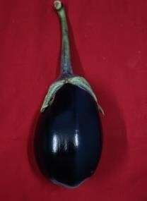

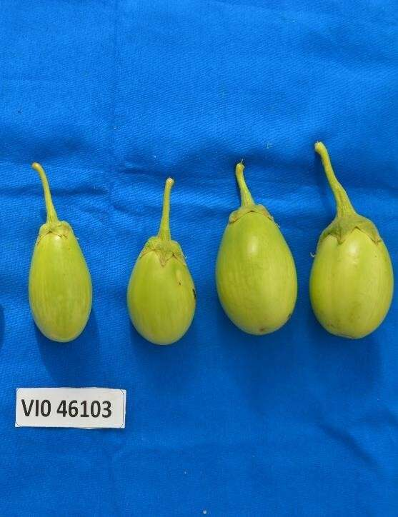
IIHR-766

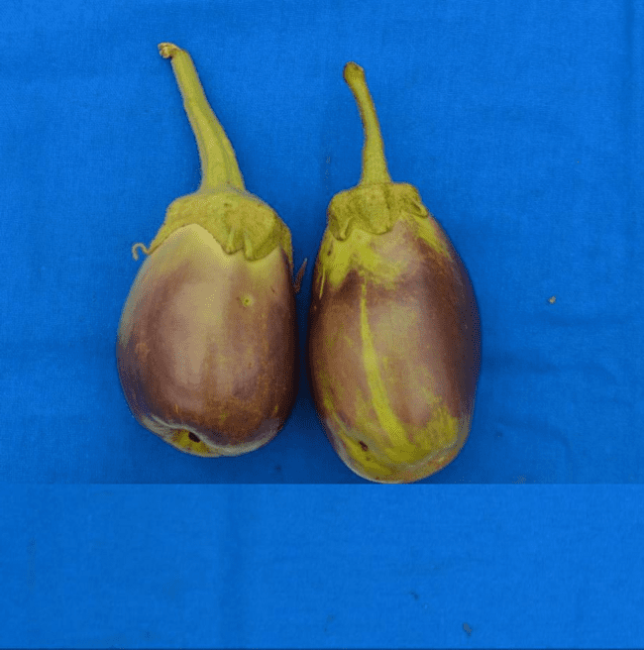
X
VI046103xIIHR-766

Plate1.a Best performing hybrid:VI046103x IIHR-766

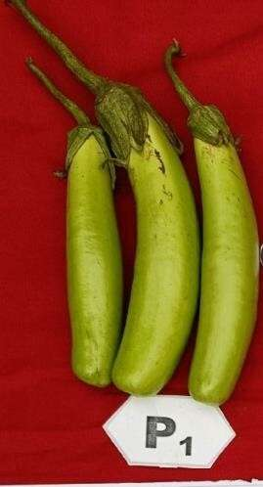
IIHR-824

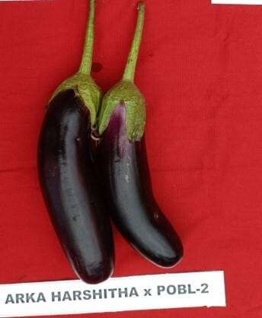
X

Plate1.b Best performing hybrid: IIHR-824xIIHR-766
IIHR-766

