Technical Efficiency of Paddy Production in Madurai District-DEA Approach

Abstract
Paddy (rice) farming plays a crucial role in the agricultural sector of many developing nations, especially across Asia, where it serves as the main dietary staple and supports countless farmers' livelihoods. However, paddy cultivation encounters several issues, including suboptimal productivity, ineffective resource use and unstable market dynamics. With growing population demands and limited cultivable land, enhancing the efficiency of paddy production has become essential for achieving food security and boosting the economic well-being of farming communities. A sample of 120 respondents was collected from the Madurai district. This study examines the technical efficiency of paddy production by assessing how effectively farmers convert inputs into output. Cost and returns analysis indicate that net income obtained by the farmers are Rs. 20477 per hectare in paddy cultivation. Using analytical methods like Data Envelopment Analysis (DEA), the research identifies efficiency levels across different farming units and highlights the factors influencing performance variations. The study revealed 60 per cent technical efficiency and 66.66 per cent scale efficiency in paddy cultivation. The variable return to scale has a mean efficiency of 0.978. The results indicated that the existence of scale inefficiencies emphasizes the need for focused efforts to enhance resource use and productivity in paddy farming.
Keywords: Technical efficiency, Scale efficiency, Data Envelopment Analysis.
Introduction
Paddy (rice) cultivation holds a central place in global agriculture, particularly in regions where rice is the principal dietary staple. It serves as the primary food source for over half of the world’s population and provides livelihood security to more than two billion people. Regions such as East Asia, Southeast Asia, South Asia, the Middle East, and the Caribbean are highly dependent on rice, where it acts as the dominant source of dietary energy. Globally, rice is the staple in 17 countries across Asia and the Pacific, nine countries in North and South America, and eight countries in Africa.
With the world’s population continuing to rise, the demand for food grains, especially rice, is expected to increase substantially. However, the expansion of cultivable land is increasingly constrained by urbanization, environmental degradation, and limited natural resources. As a result, improving the productivity of existing farmland has become the most viable and sustainable strategy to meet future food needs.
Productivity gains in paddy farming can be achieved through the adoption of improved agricultural practices, innovative technologies, and efficient use of resources. However, introducing new technologies alone is not sufficient. Many farmers, particularly in developing countries, are unable to fully realize the benefits of available technologies due to suboptimal resource use, lack of awareness, and other operational inefficiencies. This situation underscores the importance of improving production efficiency to enhance output without necessarily increasing input use.
Technical efficiency (TE) is a crucial concept in this context. It refers to a farm's ability to achieve the maximum possible output from a given set of inputs under existing technology. By measuring TE, we can identify the gap between actual and potential productivity, offering insights into where inefficiencies exist and how they can be addressed. Enhancing technical efficiency is vital for better resource allocation, cost reduction, and yield improvements especially when expanding land or input use is not feasible.
In India, the average yield of paddy remains significantly below potential levels, with a yield gap of around 40 percent. Despite the presence of advanced technologies and improved farming inputs, this gap reflects the underlying inefficiencies in the agricultural system. Bridging this yield gap requires targeted efforts to address technological, infrastructural, policy-related, and socio-economic constraints that limit farmers’ ability to farm efficiently.
Paddy is also a resource-intensive and water-sensitive crop, and poor resource management often leads to unsustainable practices and lower yields. Efficient water use and balanced application of fertilizers and pesticides can enhance both productivity and environmental outcomes. Technical efficiency analysis helps to uncover such inefficiencies and promotes better farming practices that support both farm income and ecological sustainability.
Recent policy trends emphasize not just input intensity but smart farming practices such as mechanization, precision agriculture, integrated pest and nutrient management and improved post-harvest methods. However, the adoption of such practices is uneven across farmers due to disparities in access to information, education, financial support, market linkages and risk tolerance.
Evaluating technical efficiency also allows for benchmarking of best practices, enabling policymakers and researchers to identify high-performing farms. These farms can serve as models for peer learning and targeted extension services. Moreover, efficiency assessments at the regional level can inform strategic investments in rural infrastructure such as irrigation systems, storage facilities, transport networks, and extension outreach all of which are vital to reducing inefficiencies.
Given this background, the present study focuses on assessing the technical efficiency of paddy production in Madurai district of Tamil Nadu. The study not only measures the current efficiency levels among farmers but also explores the determinants of efficiency variations. The findings aim to support informed decision-making by stakeholders and contribute to designing policies that enhance farm productivity, ensure food security and promote sustainable agricultural development.
RESEARCH METHODOLOGY
Sources of data
The current study is based predominantly on first-hand data gathered from paddy farmers in Madurai district of Tamil Nadu. To enhance the reliability and contextual relevance of the data, initial exploratory interviews were conducted to gain insights into the local agricultural environment and to fine-tune the survey instruments. The main data collection was executed using a structured and pilot-tested questionnaire, specifically formulated to evaluate the technical efficiency of the farmers involved in paddy cultivation.
A multi-stage stratified random sampling approach was adopted to ensure a balanced and representative selection of participants. In the first stage, the district was divided into strata based on important agricultural and socio-economic factors. From these strata, three villages were randomly selected to capture diversity in farming systems, resource availability and infrastructural access. In the subsequent stage, 40 farmers were randomly chosen from each selected village, culminating in a total sample of 120 respondents for the analysis.
Data Envelopment Analysis (DEA)
Data Envelopment Analysis (DEA) is a non-parametric method based on linear programming that evaluates the relative efficiency of production units, such as farms (Charnes et al. 1978). It utilizes observed input and output data to construct a piece-wise linear production frontier, representing the best-performing units in the sample. For each farm, the DEA model solves a linear programming problem to assess its position relative to this frontier. In this study, an output-oriented DEA model was applied to measure the differences in productive efficiency between farmers who are part of agricultural organizations and those who are not. The model aims to estimate the maximum possible increase in output, given existing input levels.
DEA was initiated by Charnes, Cooper, and Rhodes (1978) with assumptions of constant returns to scale in the production process. Banker, Charnes, and Cooper (1984) later proposed alternate models that could handle more flexible cases of variable returns to scale. These models formed a succession in two directions, namely increasing the number of inputs and varying the outputs. Sexton and Lewis (2003) extended the classical DEA model to a two-stage chain model and showed a simple sample in which each decision-making unit (DMU) consumes one input, produces and consumes one intermediate product and produces one output.
Asogwa et al. (2011) focused on the application of DEA for the analysis of farm efficiency and they found that the constant returns to scale assumption was only appropriate when all decision-making units were operating at an optimal scale. Imperfect competition, constraints on finance, etc., might cause a DMU to not be operating at an optimal scale.
DEA offers several advantages over traditional parametric and statistical methods. Unlike conventional approaches that evaluate efficiency based on average performance (central tendency), DEA compares each unit against the most efficient peers, using an extreme-point approach. Another important benefit is that DEA does not rely on a predefined functional relationship between inputs and outputs; instead, it builds the production frontier directly from the data, reducing the risk of incorrect model specification. Parametric models, such as those based on Cobb-Douglas or Translog functions, require such assumptions and may lead to biased results if the chosen form does not accurately represent the underlying production process.
Moreover, DEA accommodates multiple inputs and outputs without requiring them to be aggregated into a single index, making it suitable for complex production environments like agriculture. In contrast, parametric models are often limited to single-output settings or require simplifying assumptions. DEA is also well-suited for studies with small sample sizes, whereas parametric techniques, especially those relying on stochastic frontier analysis, generally require large datasets (typically more than 100 observations) to effectively distinguish between inefficiency and statistical noise.
The foundation of production theory lies in the concept of the production function, which, as defined by Ferguson (1966), describes the maximum output attainable from a specific combination of inputs. Traditional estimation techniques, such as Ordinary Least Squares (OLS), provide an average response and do not capture the efficiency frontier. Farrell (1957) introduced a deterministic approach using linear programming to estimate a cost frontier, assuming all observations lie on or above it. Later, Aigner and Chu (1968) adapted this concept to a production frontier, where observations must lie on or below the frontier. DEA also enables to assess under which returns of scale each farm operates and to calculate their scale inefficiency.
Variable returns to scale (VRS) model to measure the pure technical efficiency is specifies as the following linear programming model:
Max θ,λθ
Subject to
-yi+Yλ≥0
θxi-Xλ≥0
λ≥0
N1λ=1
Where, N1 is n × 1 vector matrix of ones.
θ represents the efficiency score, expressed as a scalar value ranging between 0 and 1 for each individual farm. A value of θ = 1 indicates that the farm is operating efficiently, while any value less than 1 suggests inefficiency. The vector λ, which is of dimension n × 1, contains the optimal weight values obtained from the model.
These λ coefficients are used to form a weighted combination of efficient farms, which serves as a reference or benchmark for projecting inefficient farms onto the efficiency frontier.
Recognizing the limitations of deterministic models, especially their sensitivity to extreme values, researchers such as Timmer (1971), Ferrier and Lovell (1990), and Forsund (1992) proposed stochastic frontier models. These probabilistic approaches separate inefficiency from random error by incorporating a stochastic term and often exclude outlier observations to obtain more reliable estimates of production efficiency.
RESULTS AND DISCUSSION
Cost and Returns
The analysis of cost and return in paddy cultivation helps assess the profitability and economic efficiency of rice farming. It provides insights into input utilization, production efficiency and farmers’ income levels.
Table 1 provides a detailed analysis of the cost and returns of the paddy crop cultivated by the farmers.
Table 1. Cost and Returns of Paddy crop
(per ha)
S.No | Particulars | Sample Farmers
I. | Variable Cost
1. | Preparatory cultivation | 4450
2. | Seeds | 256
3. | Machine labour | 2430
4. | Human labour | 5170
5. | Manures | 4300
6. | Fertilizers | 9650
7. | Plant protection | 5180
8. | Irrigation charges | 1516
9. | Interest on working capital | 2306.64
10. | Land revenue | 85
11. | Depreciation | 1236
II. | Cost A1 | 36579.64
12. | Rent or paid for leased in land | 440.00
III. | Cost A2 | 37017.64
13. | Interest on fixed capital | 1999.92
IV. | Cost B1 | 39019.56
14. | Rental value of owned land | 16660
V. | Cost C2 | 55679.56
15. | Imputed value of family labour | 4500
VI. | Cost C1 | 60179.56
VII. | Cost C2 | 76839.56
16. | Managerial cost | 7683.956
VIII. | Cost C3 | 84523.516
IX. | Yield (Kg/ha) | 3500
X | Price (Rs.) | 30
XI | Gross income | 105000
XII. | Net income | 20476.48
Source: Primary data, 2024.
The cost structure for paddy cultivation among the sample farmers reveals a detailed breakdown of both variable and fixed costs. The total variable cost (Cost A1) is ₹36,579.64. In addition, an expense of ₹440 is incurred as rent for leased-in land, leading to Cost A2 of ₹37,017.64. When interest on fixed capital (₹1,999.92) is accounted for, the cost rises to Cost B1 at ₹39,019.56. Furthermore, incorporating the rental value of owned land (₹16,660) results in Cost C2 amounting to ₹55,679.56. Including the imputed value of family labour (₹4,500), Cost C1 stands at ₹60,179.56, and Cost C2 increases to ₹76,839.56 after considering both owned land and family labour.
Adding a notional managerial cost of 10% of Cost C2 (₹7,683.96), the final Cost C3 is calculated to be ₹84,523.52. The average yield recorded was 3,500 kilograms per hectare, and with the prevailing market price of ₹30 per kilogram, the gross income realized per farmer was ₹1,05,000. Subtracting the total cost (Cost C3) from the gross income yields a net income of ₹20,476.48 per farmer.
Data Envelopment Analysis-Technical and Scale Efficiency
The data envelopment analysis is a non-parametric method that measures the productive efficiency of crop cultivation by the sample farmers. The results of the Data Envelopment Analysis for the paddy cultivation by the sample farmers are given in Table 2.
The analysis of efficiency scores highlights considerable variation in the performance of the sample farmers. Under the Constant Returns to Scale (CRS) framework, only 40 per cent of the farmers attained full technical efficiency. In contrast, the Variable Returns to Scale (VRS) model showed a higher proportion 66.66 per cent reaching full efficiency, suggesting that scale-related inefficiencies are affecting a notable segment of the farming population.
In terms of Scale Efficiency (SE), 50 per cent of the farmers operated at optimal scale, pointing to the opportunity for enhancing efficiency by adjusting the scale of operations or optimizing resource use. The average efficiency values were 0.901 for Technical Efficiency under Constant Returns to Scale, 0.978 for Technical Efficiency under Variable Returns to Scale, and 0.921 for Scale Efficiency, implying that most farmers are operating relatively close to the efficient frontier, particularly when variable returns to scale are taken into account.

Table 2. TE and SE of the Paddy crop of the sample farmers

S.No. | Descriptive Statistics | Sample Famers (N=120)
S.No. | Descriptive Statistics | CRSTE | VRSTE | SE
 | No. of Efficient Farmers (100%) | 48  (40.00) | 80  (66.66) | 60  (50.00)
 | (90%-99%) | 24  (20.00) | 10  (8.33) | 20  (16.66)
 | (Below 90%) | 48  (40.00) | 30  (25.00) | 40  (33.33)
1. | Mean | 0.901 | 0.978 | 0.921
2. | Standard Deviation | 0.120 | 0.089 | 0.087
3. | Minimum | 0.59 | 0.642 | 0.749
4. | Maximum | 1 | 1 | 1
(Figures in parentheses are percentage to total farmers)
CRSTE- Technical Efficiency under Constant Returns to Scale; VRSTE- Technical Efficiency under Variable Returns to Scale; SE - Scale Efficiency.
The bar diagram (Figure 1) illustrates the production efficiency distribution of 120 paddy farmers under three models. This comparison clearly shows that efficiency improves under the VRS model, indicating that scale inefficiencies are a major factor affecting farmer performance.
Figure 1: Production efficiency of sample farmers
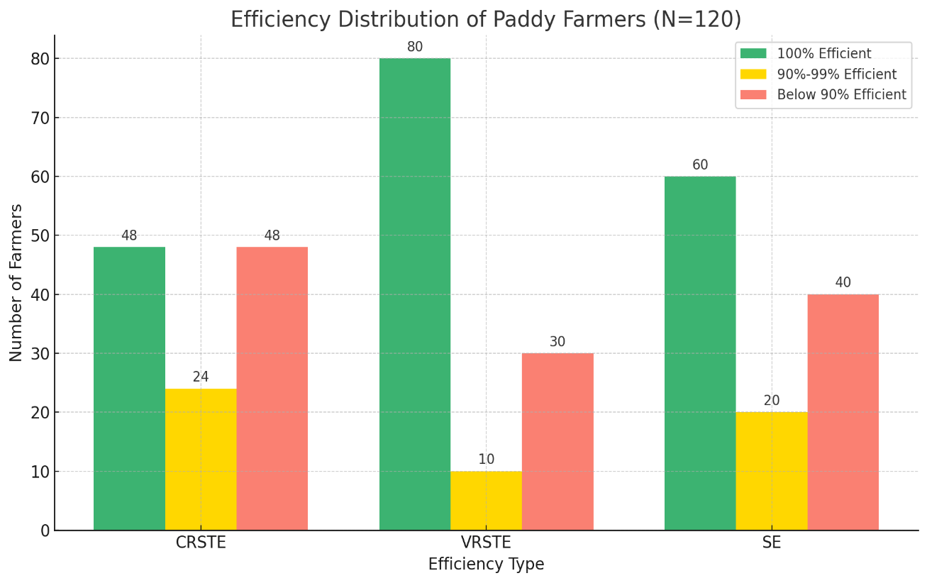

Despite this, the presence of variability as indicated by standard deviations of 0.120 (CRSTE), 0.089 (VRSTE) and 0.087 (SE) shows that many farmers are still operating inefficiently. Additionally, a significant proportion had efficiency scores below 90 per cent, 40 per cent under CRSTE, 25 per cent under VRSTE and 33.33 per cent under SE. This underlines the need for focused strategies to improve efficiency through better use of inputs, technology uptake and adjustments in farm scale.
In summary, while many farmers show high levels of efficiency, there is clear potential for further improvement, particularly by addressing scale inefficiencies and enhancing resource management.
Conclusion
The technical efficiency of paddy cultivation is assessed using Data Envelopment Analysis to measure how effectively farmers utilize resources to achieve optimal output. Paddy cultivation among the sample farmers proved to be economically beneficial, generating a net return of ₹20,476.48 per hectare from a gross income of ₹1,05,000, with total production costs (Cost C3) amounting to ₹84,523.52. These results indicate that paddy farming is financially viable and point to opportunities for improving profitability through better cost management. The analysis shows that although many paddy farmers perform close to the efficiency frontier, only 40 per cent achieve full efficiency under the Constant Returns to Scale model, whereas 66.66% do so under the Variable Returns to Scale model. This suggests the existence of scale inefficiencies emphasizes the need for focused efforts to enhance resource use and productivity in paddy farming.
References
- Aigner, D. J., & Chu, S. F. (1968). On estimating the industry production function. The American Economic Review, 58(4), 826–839.
- Asogwa, B.C., J.C. Ihemeje., J.A.C. Ezihe (2011), ''Technical and Allocative Efficiency Analysis of Nigerian Rural Farmers: Implication for Poverty Reduction,'' Agricultural Journal, 6(5) :243-251.
- Banker, R.D., A.Charnes, and W.W. Cooper (1984), ''Some Models for Estimating Technical and Scale Inefficiencies in DEA'', Management Science, 30:9.
- Charnes, A., W. W. Cooper, B. Golany, L. Seiford, and J. Stutz(1978), “Foundations of Data Envelopment Analysis for Pareto-Koopmans Efficient Empirical Production Functions”, Journal of Econometrics, 30(1) : 91-107.
5. Farrell, M. J. (1957). The measurement of productive efficiency. Journal of the Royal Statistical Society: Series A (General), 120(3), 253–290. https://doi.org/10.2307/2343100
6. Ferguson, C. E. (1966). Microeconomic theory. Homewood, IL: Richard D. Irwin.
7.Ferrier, G. D., & Lovell, C. A. K. (1990). Measuring cost efficiency in banking: Econometric and linear programming evidence. Journal of Econometrics, 46(1–2), 229–245. https://doi.org/10.1016/0304-4076(90)90057-Z
8.Forsund, F. R. (1992). The Malmquist productivity index, some properties. Scandinavian Journal of Economics, 94, 193–203.
9.Sexton, T.R., and H.F. Lewis (2003), ''Two-Stage DEA: An Application to Major League Baseball'', Journal of Productivity Analysis, 19:227-249.
10. Timmer, C. P. (1971). Using a probabilistic frontier production function to measure technical efficiency. Journal of Political Economy, 79(4), 776–794. https://doi.org/10.1086/259783.

