Exploiting the microbial and cancer inhibiting potentials of Cassia alata: using molecular docking, density functional theory and ADMET methods.

ABSTRACT
Cassia alata also known as senna alata is a medicinal plant widely known for its antifungal property, it is known for its ability to attack ring worm. The present work investigates the medicinal strength of cassia alata leaves by studying its anti-bacterial, anti-fungi and anti-cancer properties using molecular docking method. The phytochemical contents of the leaves were revealed via GC-MS experiment. The 3-D structures of the identified compounds were downloaded from pubchem online server and subjected to molecular docking investigation using three controls penicillin for bacteria, fluconazole for fungi and dabrafenib for skin cancer and three proteins namely Cytochrome P450 14 alpha-sterol demethylase (CYP51) (PDB:1EA1) fugal protein, S. aureus TyrRS in complex with SB-239629 (PDB:1jij) bacterial protein, and ERK2 in complex with N,N-dimethyl-4-(4-phenyl-1H-pyrazol-3-yl)-1H-pyrrole-2-carboxamide (PDB: 2ojg) skin cancer protein. Density functional theory calculation to ascertain the relationship between structure and reactivity was performed on the drug controls and four compounds identified in the GC-MS analysis. To ascertain the drug like performance of the compound, adsorption distribution metabolism and elimination screening was performed on four of the identified compounds. The GC-M results revealed the presence of 16 compounds, the molecular docking result showed that Kaempferol (-8.3 kcalmol⁻¹ in 1ea1, -9.5 kcalmol⁻¹ in 1jij, -8.7 kcalmol⁻¹ in 2ojg) showed the best docking scores in the three proteins used. The density functional theory result showed that Kaempferol has the lowest energy gap which could make ease of electron transfer. The ADME result showed that the four compounds studied could effectively serve as drugs without significant side effects.
Keywords: cassia alata, molecular docking, inhibition, density functional theory, PYRX
INTRODUCTION
Molecular docking is a computational simulation method through which one can study the interaction between two structures; the ligand (drug) and the target (disease) [1-3]. Molecular docking can be used to perform visual screening on a large library of compounds [4-5]. It is a technique in drug design used to estimate the binding strength of small molecules (ligand) on protein targets. Knowledge of the preferred orientation could help in predicting the binding energy between the ligand and the target using a specific scoring function. In drug design, molecular docking can help determine whether a disease will be activated or inhibited by a particular drug.
The successful use of materials of plant origin as medicine is gaining mountain attention; [6-7] this could be attributed to the fact that these materials are non-toxic and easily obtainable [8]. One of such plants that has gained wide application is Cassia alata also known as Senna alata. It is a medicinal plant distributed in the humid and tropical regions [9-10]. Over the years it has been used traditionally for the treatment of ring worm, eczema, typhoid, malaria, diabetes, asthma, tinea, scabies and other skin infections [11-12].
Cassia alata is a very important medicinal as well as an ornamental plant. It is also known as ringworm bush. Different parts of the plant have been used previously as therapeutic materials for the management of diverse infections [13-15]. It is used locally for the treatment of ringworm and other fungal infections especially in children [16-17]. The leaves are squeezed and rubbed on the affected area for the treatment of various skin infections [18-19]. In Nigeria, the sap from the leaves is rubbed on the skin for its antifungal and ringworm management [20-21].
In this research, the chemical components of cassia alata will be ascertained using GC-MS screening, anti-cancer, anti-fungal and anti-bacteria screening will be undertaken using molecular docking approach,
2. MATERAILS AND METHODS
2.1. Preparation of plant material
The cassia alata leaves used in this project was acquired in a local village in Imo State. The leaves were dried, ground to a powdered form. 40 g of the powder was dipped in chloroform and left for 72-hours [22], filtered and submitted for GC-MS screening [23].
2.2 preparation of ligands
The compound revealed in the GC-MS result were used as the ligand for the molecular docking procedure [24-25]. The 3-Dimentional structures of the compounds were downloaded from the pubchem [26] online software. And uploaded in PYRX software as the ligands [27].
2.3 protein preparation
In the molecular docking analysis, the compounds revealed in the plant material were screened for their bacteria, fungal and skin cancer inhibiting properties. Three proteins, S. aureus TyrRS in complex with SB-239629 (PDB:1jij) bacterial protein, Cytochrome P450 14 alpha-sterol demethylase (CYP51) (PDB:1EA1) fugal protein, and ERK2 in complex with N,N-dimethyl-4-(4-phenyl-1H-pyrazol-3-yl)-1H-pyrrole-2-carboxamide (PDB: 2ojg) skin cancer protein were sourced from literature [28-30] and used as the proteins for the molecular docking analysis
2.4. Molecular docking
Molecular docking calculations was achieved using the Auto dock tool imbibed the PYRX online software. Calculations were performed between the identified compounds and the prepared proteins using penicillin, dabrafenib, and fluconazole as control drugs. The proteins were loaded and used as the macromolecules for the molecular docking calculations, the compound were uploaded in the PYRX software using the open babel tool, minimized and converted to autodock ligand (pdbqt) [31] and calculations were achieved in the vina wizard tool to identify the ligands with the best conformation pose within the active site of the macromolecule [32]. After docking calculations, the ligand-protein interactions were extracted and further visualized in Discovery studio software [33].
2.5 Density functional theory (DFT) calculations
DFT calculations were performed on the compounds with good docking scores using the Dmol3 tools found the material studio 7.0 software [34]. Calculations were performed using chloroform as the extraction solvent. Geometric optimization was performed on the compound prior to the calculation of the frontier molecular orbitals [35].
2.5. Absorption, Distribution, Metabolism and Elimination (ADMET) and drug likeness properties
To estimate pharmacokinetic parameters as well as other molecular properties of the compounds with good docking scores, their canonical simplified molecular input line entry system (SMILE) were obtained from pubchem software and submitted to SwissADME web tool [36]. Admet properties such as human intestinal absorption (HIA), number of hydrogen bond acceptor (HBA), blood brain barrier (BBB), number of hydrogen bond donor (HBD) and topological polar surface area (TPSA) were predicted.
3. RESULTS
3.1 Gas chromatography-mass spectrophotometry Result
To understand the chemical composition of cassia alata leave extract, GC-MS screening was performed on the extract. The result showed the presence of 16 compounds with Pinene as the compound with the highest composition (33.34 %); other compounds present in high concentrations in the GC-MS result are: Ferullic acid (15.45 %), Humulene (13.45 %), Erucic acid and (12.50 %) and Kaempferol (11.34 %) these compounds have been used severally as drugs for the treatment of many diseases [37]. Table 1 shows the compounds identified in the GC-MS analysis; the chromatogram is presented in Figure 1. The mass spectra of ferulic acid, Catechin, humulene and Kaempferol are shown in figure 2 (a-d).

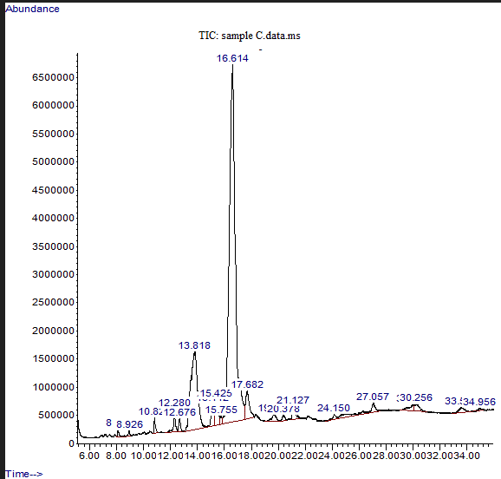
Figure 1. GC-MS chromatogram of cassia alata extract

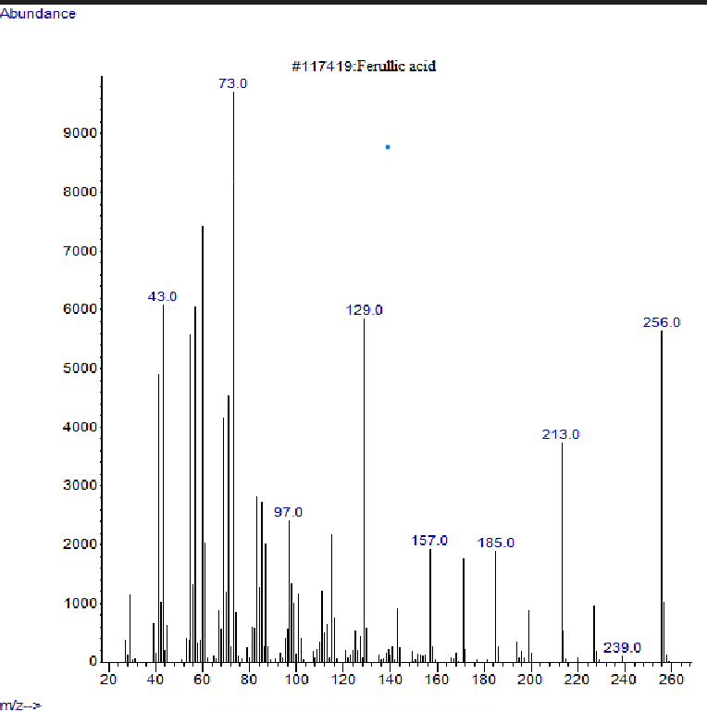
(a)
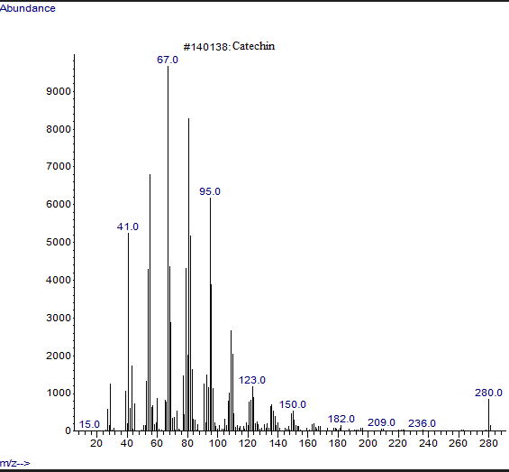
(b)

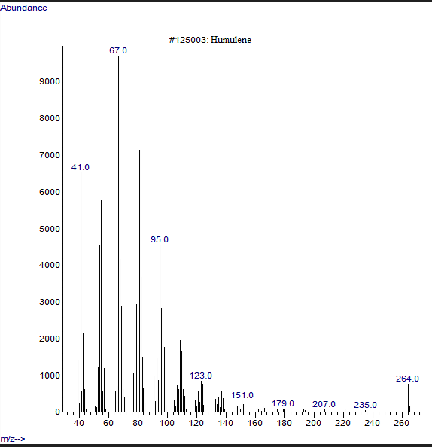
(c)

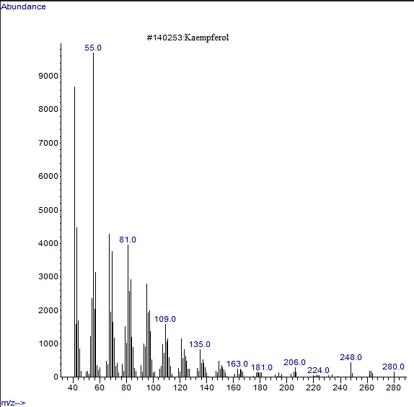
(d)
Figure 2 Mass spectra of (a) ferulic acid (b) Catechin (c) humulene and (d) Kaempferol
Table 1 compounds obtained from the GC-MS analysis and their docking scores
S/No | Area % | Name | Structure | Docking score |  |  | Pubchem Cid
 |  |  |  | 1ea1  (Kcal/mol) | 1jij  (Kcal/mol) | 2ojg  (Kcal/mol) | Pubchem Cid
 | Control (anti-bacteria drug) | Penicillin | 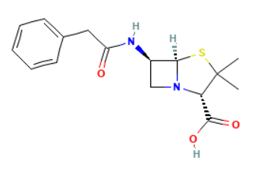 | -6.2 | -7.1 | -6.4 | 52946032
 | Control (anti-fungal drug) | Fluconazole | 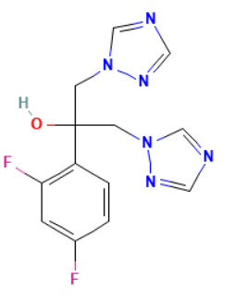 | -7.3 | -8.0 | -7.5 | 3365
 | Control (skin cancer drug) | Dabrafenib | 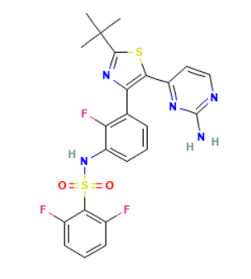 | -8.2 | -8.4 | -8.4 | 44462760
1. | 0.45 | Hexadecane | 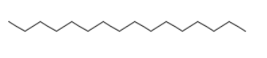 | -3.7 | -4.9 | -5.4 | 11006
2. | 0.20 | Methyl tetradecanoate | 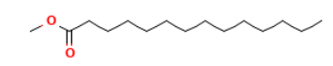 | -5.1 | -4.7 | -5.5 | 31284
3. | 0.56 | Tetradecanal | 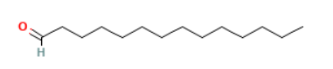 | -4.4 | -4.7 | -5.2 | 31291
4. | 1.32 | 2-Heptadecanone | 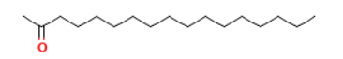 | -4.4 | -5,1 | -5.4 | 18027
5. | 0.60 | Luteolin | 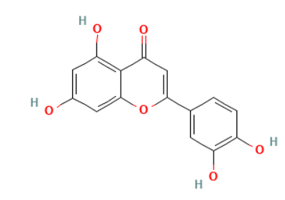 | -7.0 | -9.9 | -9.3 | 5280445
6. | 15.45 | Ferullic acid | 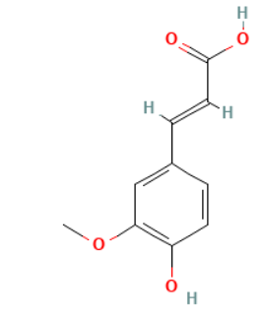 | -6.5 | -6.8 | -6.5 | 445858
7. | 1.95 | Catechin | 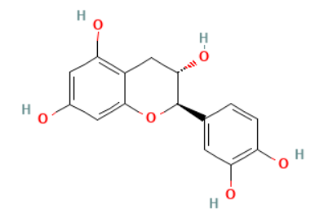 | -8.0 | -9.3 | -9.2 | 9064
8. | 2.79 | 9-Octadecenoic acid, methyl ester, (E)- | 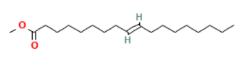 | -5.6 | -4.8 | -5.7 | 5280590
9. | 0.48 | Methyl stearate | 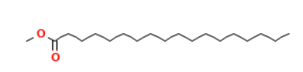 | -5.0 | 4.9 | -5.6 | 8201
10. | 33.34 | Pinene | 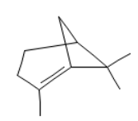 | -5.8 | -5.5 | -5.9 | 15837102
11. | 13.45 | Humulene | 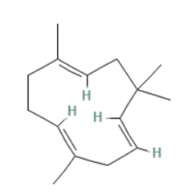 | -6.7 | -7.1 | -6.7 | 5281520
12. | 3.66 | Oleic Acid | 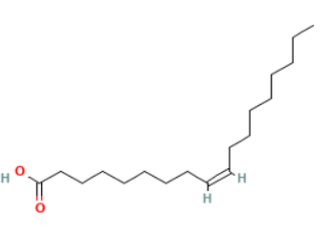 | -4.0 | -5.0 | -4.5 | 445639
13. | 0.34 | 9-Octadecenal, (Z)- | 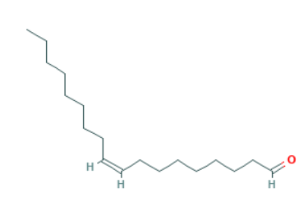 | -6.0 | -5.0 | -5.3 | 5364492
14. | 11.34 | Kaempferol | 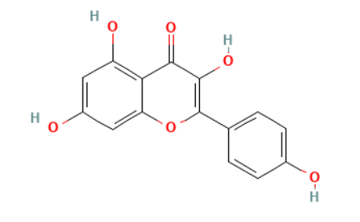 | -8.3 | -9.5 | -8.7 | 5280863
15. | 12.50 | Erucic acid | 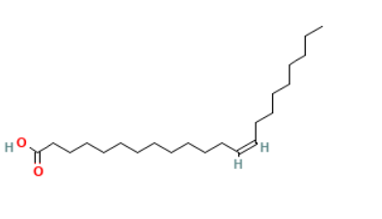 | -5.4 | -4.9 | -4.8 | 5281116
16. | 0.96 | Z-2-Octadecen-1-ol | 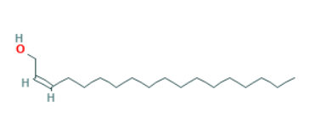 | -5.7 | -5.0 | -6.1 | 5365011

3.2 molecular docking Results
Molecular docking to study the interactions between the identified compounds (ligands) and the chosen proteins was achieved in PYRX software [38], the docking scores are presented in Table 1 while the visualized interactions are shown in Figure 3. The scores shown in Table 1 shows that four compounds; Ferullic acid ( -6.5, -6.8, -6.5 Kcal/mol), catechin (-8.0, -9.3, -9.2 Kcal/mol), Humulene (-6.7, -7.1, -6.7 Kcal/mol) and kaempferol (-8.3, -9.5, -8.7 Kcal/mol) showed good docking scores within the active site of the 1EA1 fungal protein, 1jij bacterial and 2ojg skin cancer proteins meaning that these compounds, if consumed from cassia alata could have very positive effect on fungi, bacteria and skin cancer diseases. The molecular docking scores presented in Table 1 showed that the components of Cassia alata leaves functioned better as antibacterial drug since all the compounds showed good docking scores in the 1jij bacterial protein.
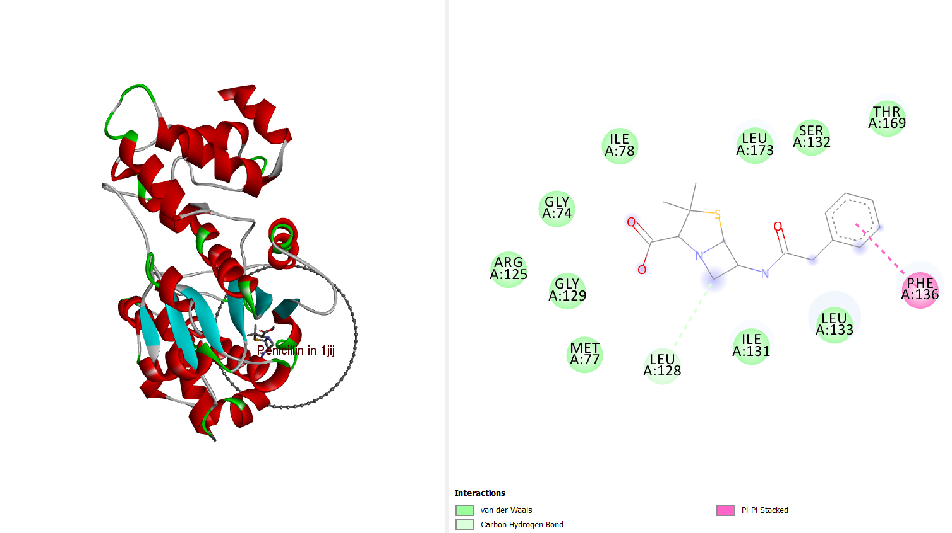
Penicillin in 1jij
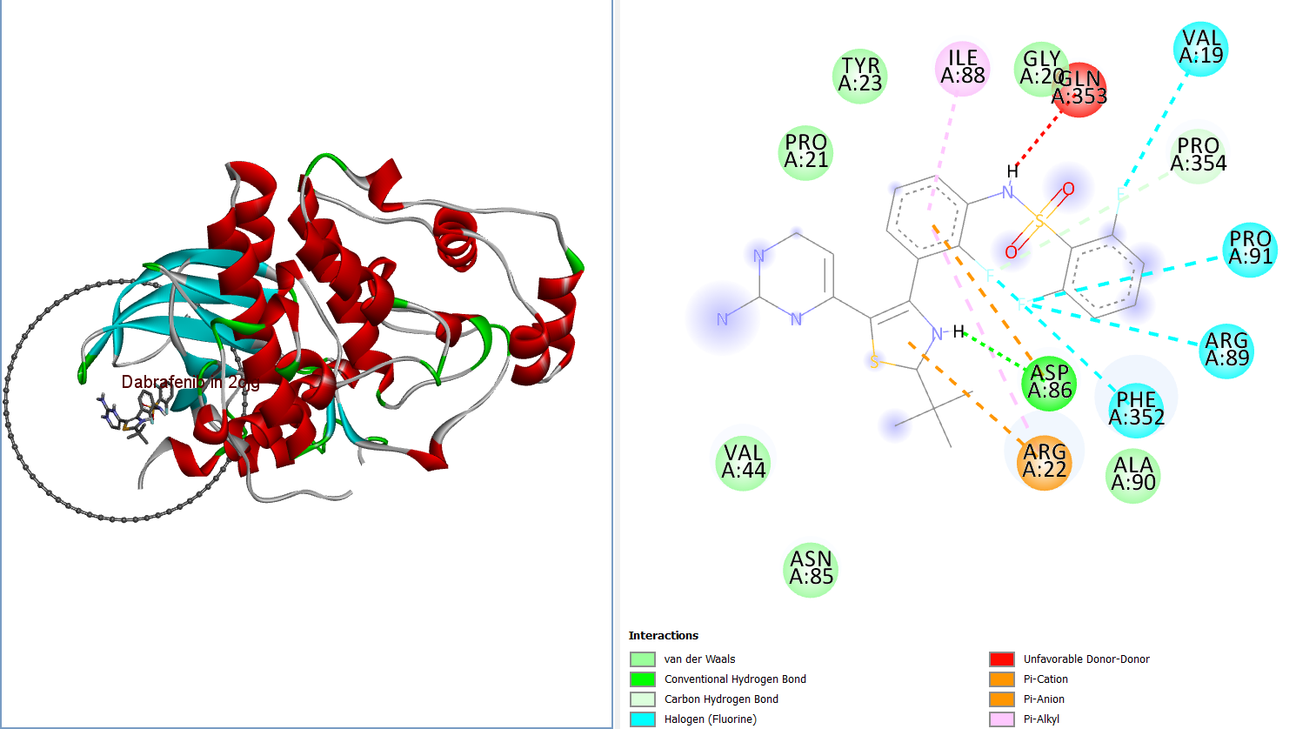

Dabrafenib in 2ojg
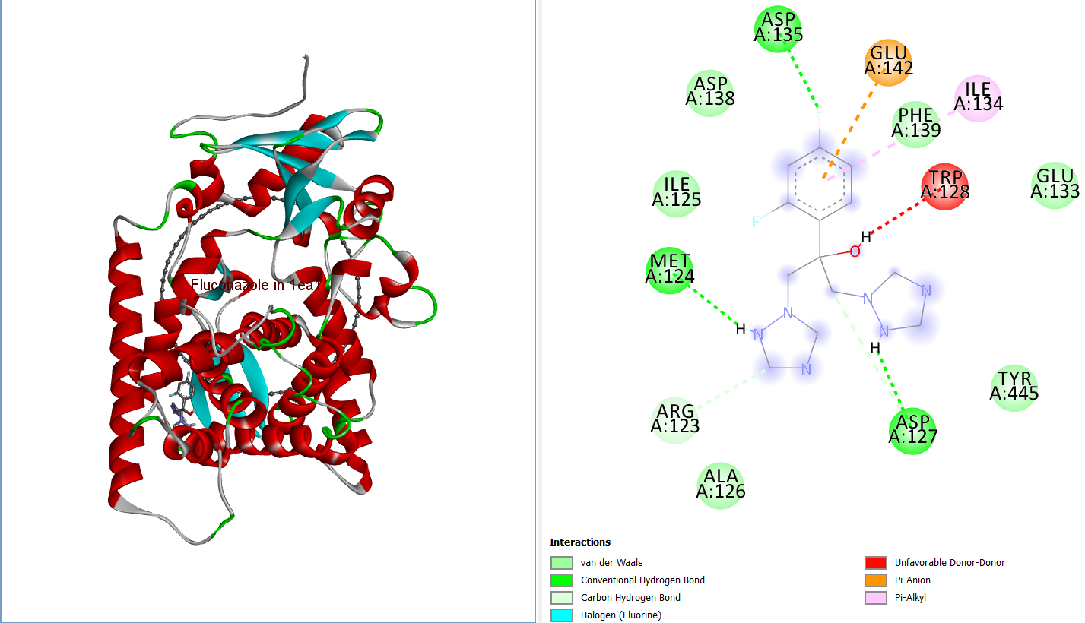
Fluconazole in1ea1

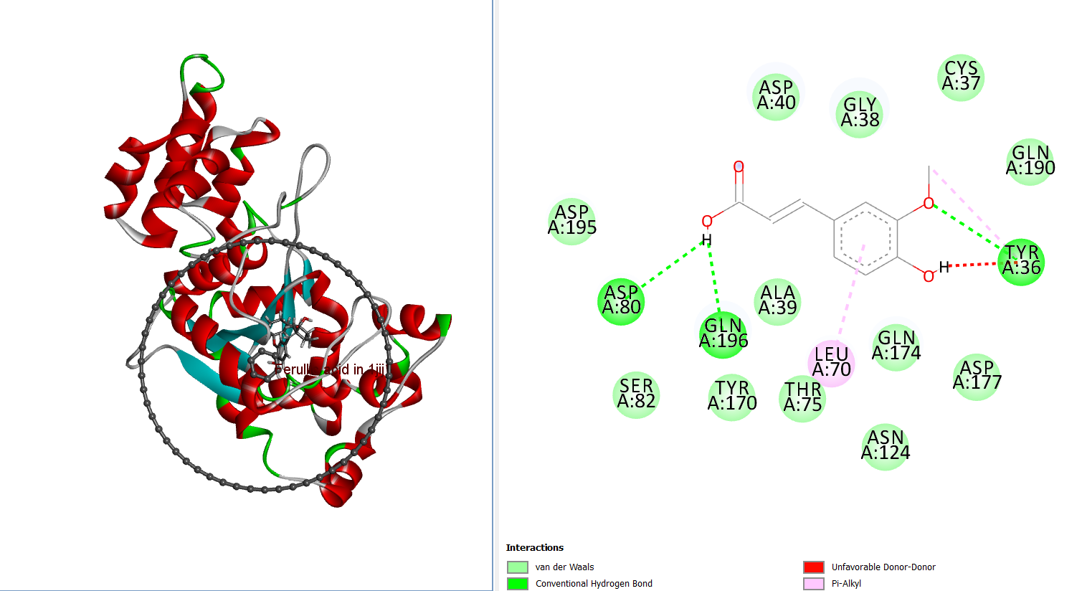
Ferullic acid in 1jij

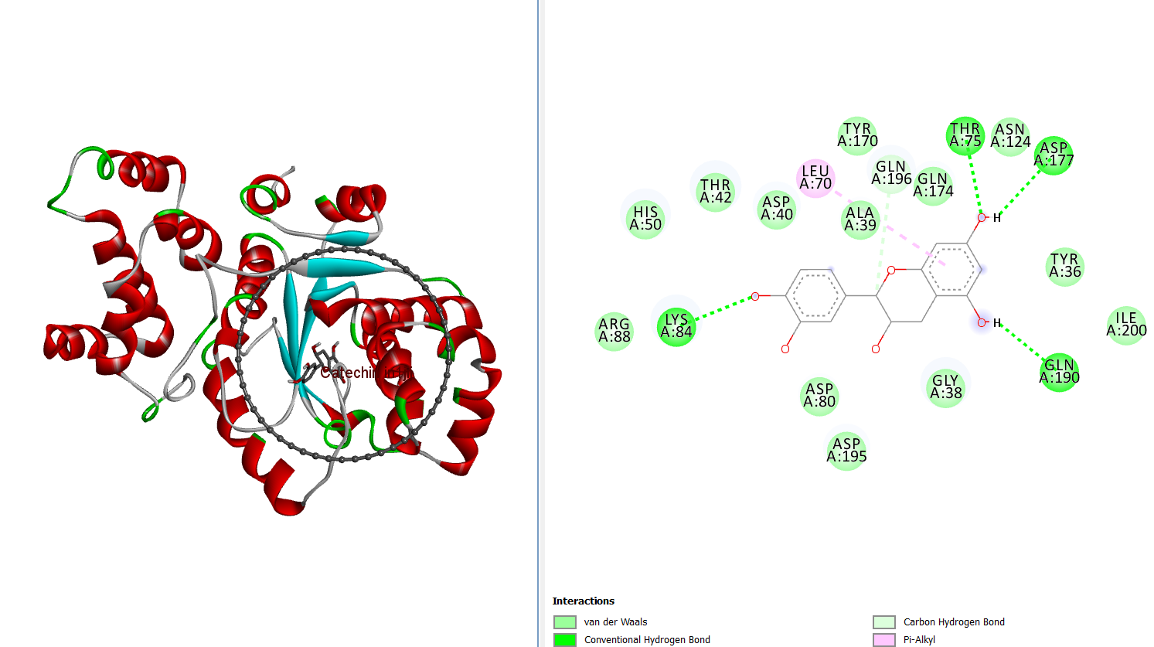
Catechin in 1jij
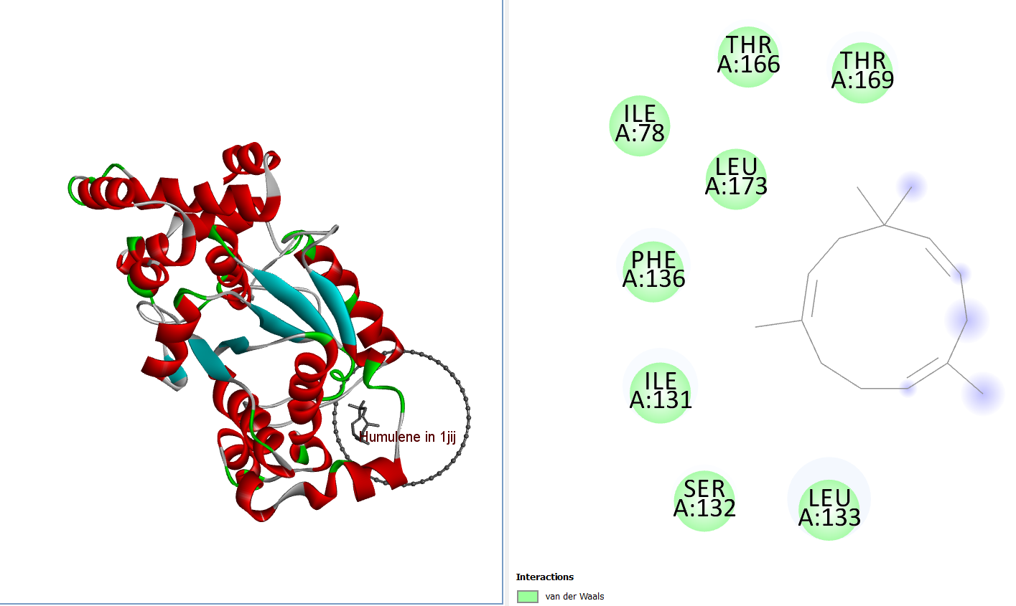
Humulene in1jij

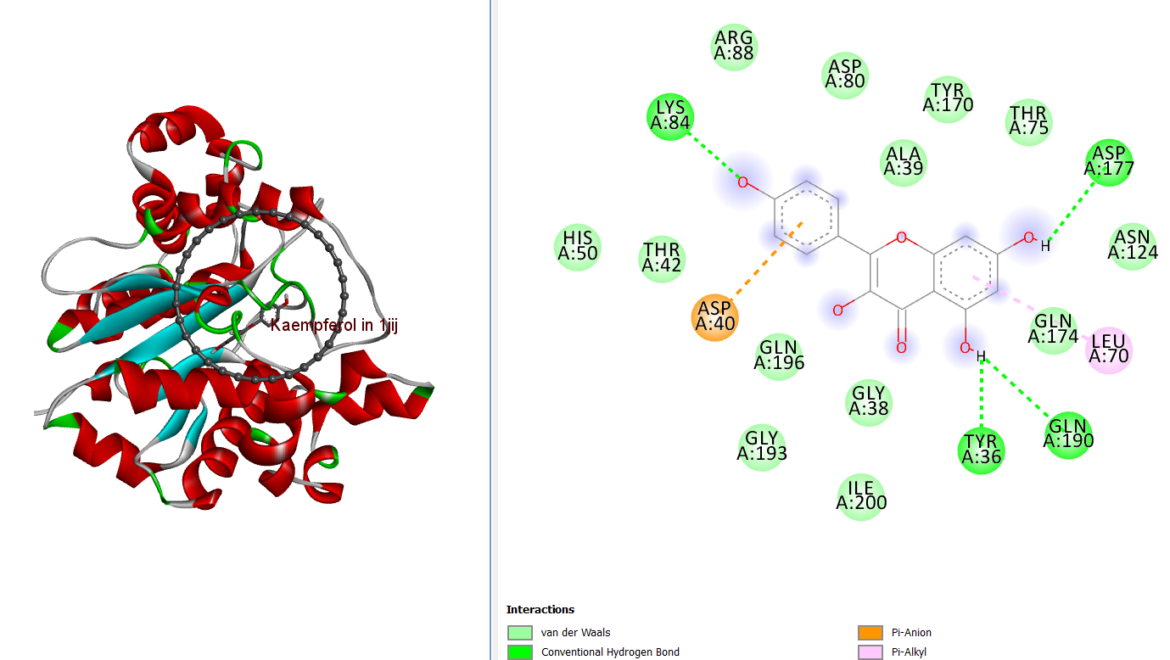
Kaempferol in 1jij
Figure 3: visualized 3D and 2D interactions of some of the seleced compounds
3.3 Density functional theory results
Density functional theory calculations were achieved with the aid of the electronic structure program DMol3 tools using Perdew Wand (PW) local correlation density functional and Mulliken population analysis DND basic set [39] found in acceryl material studio software 7.0. To stabilize the compounds before calculation, geometric optimization was performed on each compound. The optimized structures as well as the frontier molecular orbitals (HOMO & LUMO) are presented in Figure 4. The HOMO energy ($E_{HOMO})$, LUMO energy ($E_{LUMO})$ and energy gap $\left(∆E=E_{LUMO}-E_{HOMO}\right)$ were calculated and presented in Table 2. The ionization energy (I) and electron affinity (A) are related to the HOMO and LUMO energies according to equations 1 and 2. The quantum chemical descriptors including absolute hardness (η), softness (δ) absolute electronegativity (𝜒), and electrophilicity (ω) were estimated from the HOMO and LUMO energies according to equations 3-6 and presented in Table 2.Values of the energy gap helps to predict chemical reactivity as low values indicate the ease of electron transfer between the ligand and protein, interestingly, Table 2 reveals that Kaempferol showed the least energy gap compared to other studied compounds suggesting good chemical reactivity and considerable energy transfer from the highest occupied molecular orbital (HOMO) to the lowest unoccupied molecular orbital (LUMO). This result is in good agreement with the molecular docking result. Chemical hardness (or softness) is an important indicator of a compound’s propensity as regards to covalent bonding as softness enhances close interaction between the ligand and protein [40]. Absolute electronegativity (𝜒) [41] shows a compounds ability to attract electron to itself in the combined form, electrophilicity (ω) is the feature of a compound to act as an electrophile [42], it shows the molecule’s ability to accept an electron from a nucleophile. The values of the quantum chemical descriptors computed in Table 2 show that the compounds studied showed values which are comparable to other compounds that had functioned as drugs [43].

${I=-E}_{HOMO}$ (1)
${A=-E}_{LUMO}$ (2)
$η=I/2-A/2$ (3)
$δ=I/η$ (4)
$χ=I/2+A/2$ (5)
$ω=\frac{χ^{2}}{2η}$ (6)
The highest occupied molecular (HOMO) orbital is usually an electron rich center from where electrons can be transferred while the lowest unoccupied molecular (LUMO) orbital is an electron deficient center ready to accept electron.

Name of compound | 3-D structure | HOMO orbital | LUMO orbital
Penicillin | 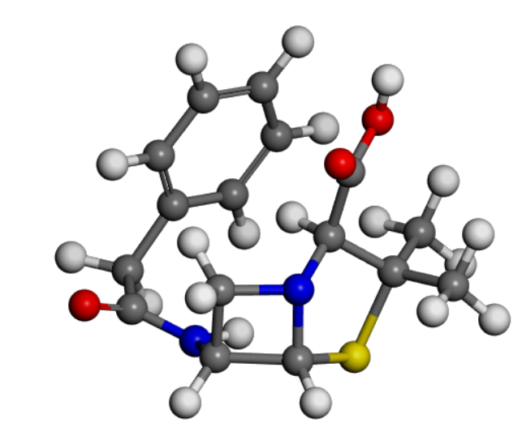 | 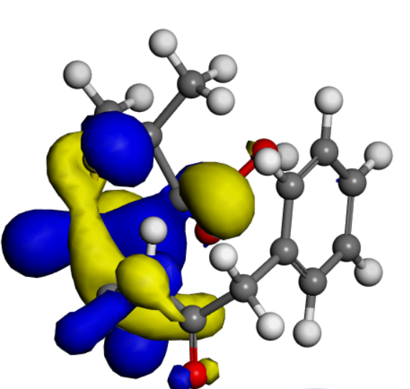 | 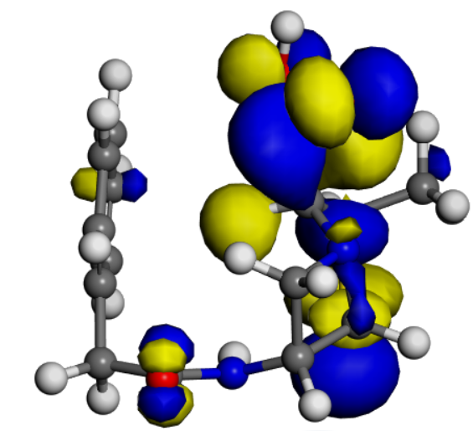
Dabrafenib | 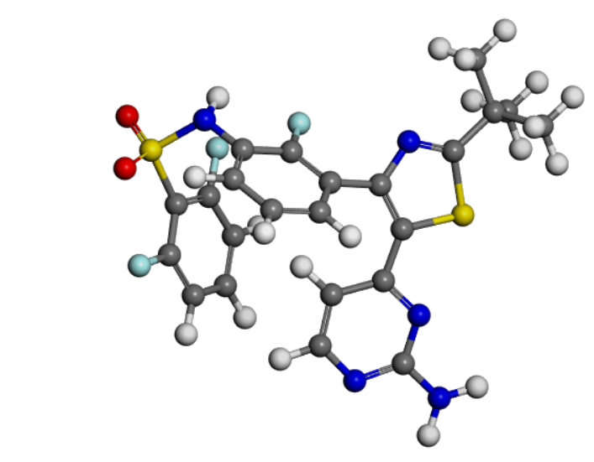 | 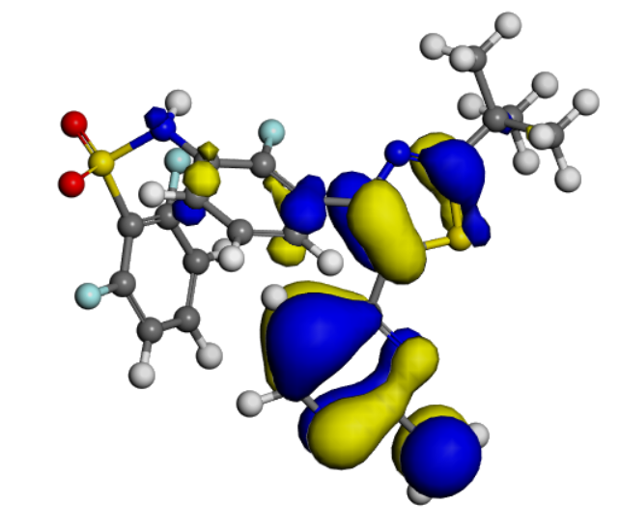 | 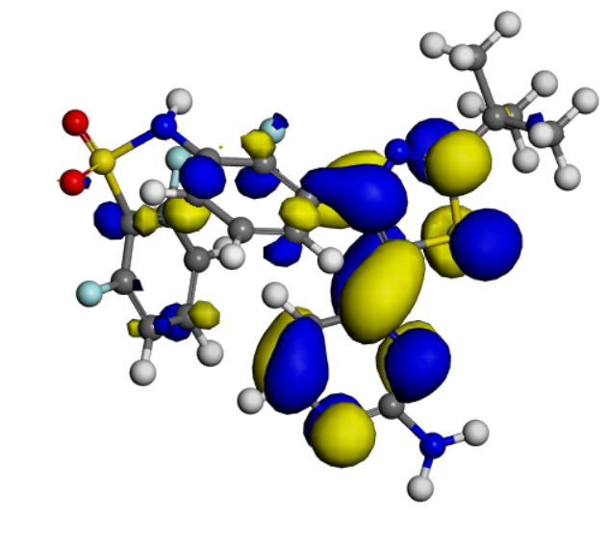
Fluconazole | 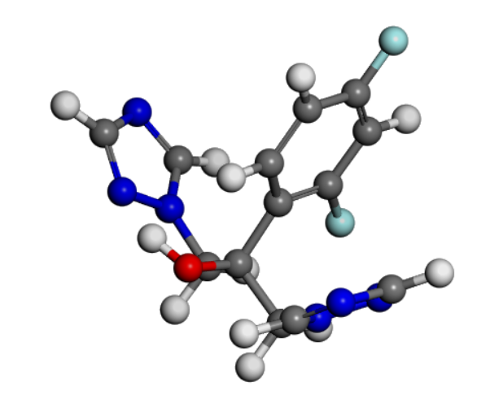 | 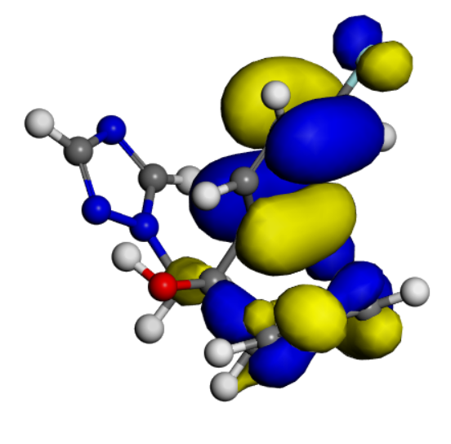 | 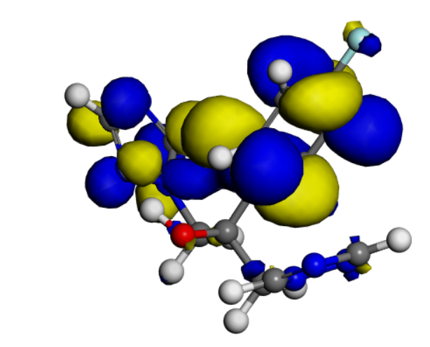
Ferullic acid | 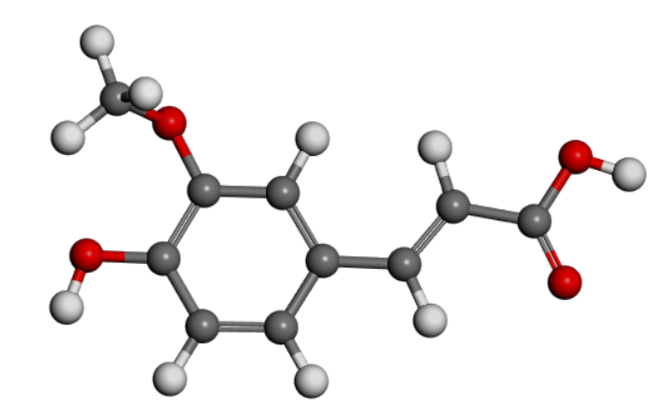 | 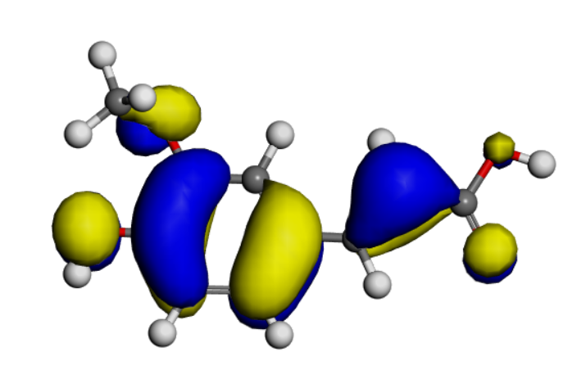 | 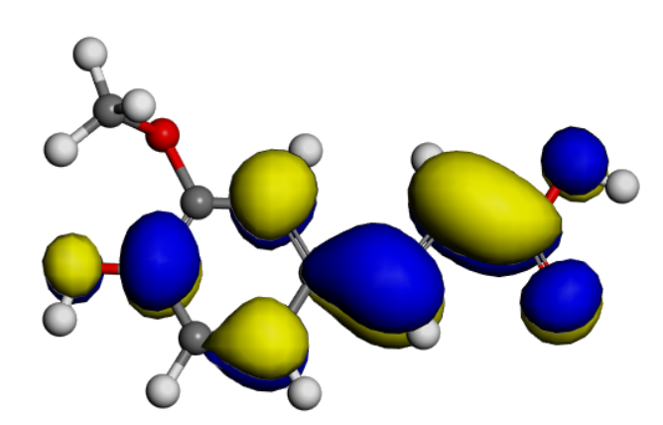
Catechin | 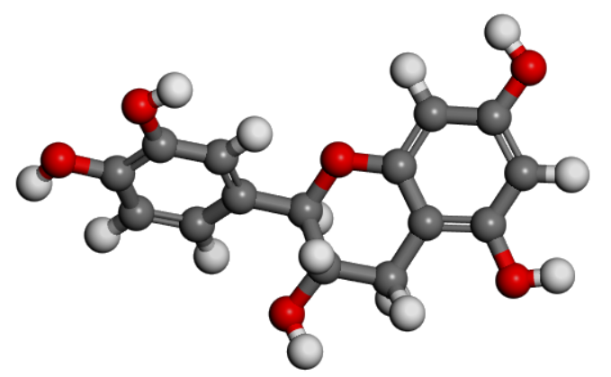 | 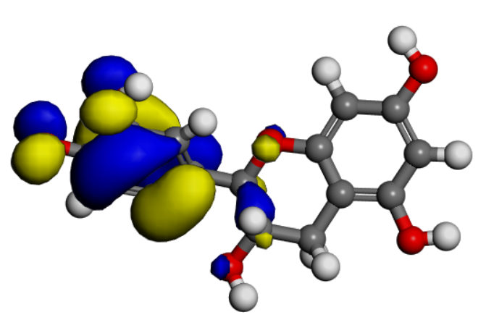 | 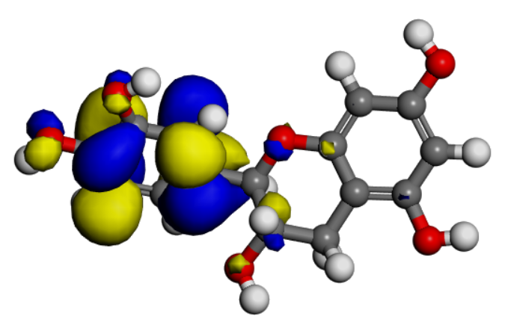
Humulene | 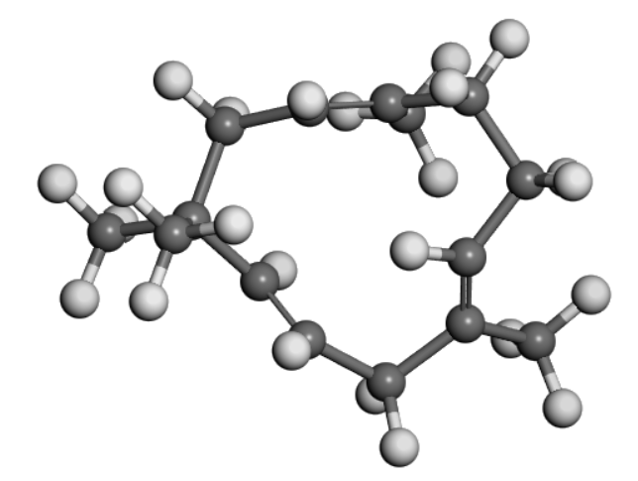 | 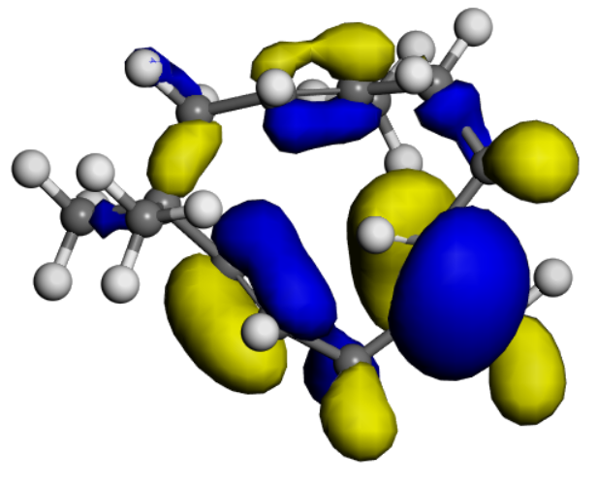 | 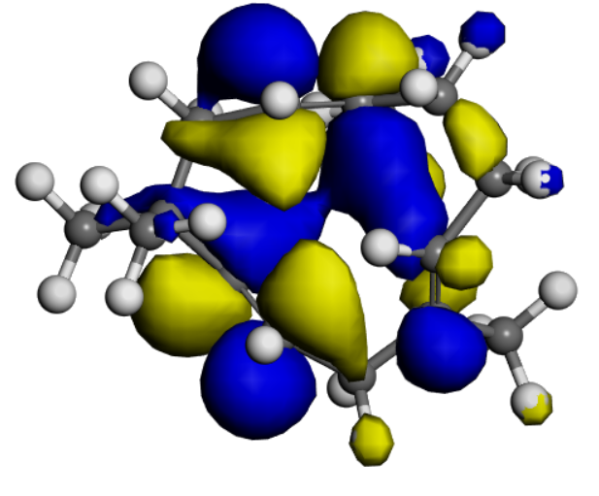
Kaempferol | 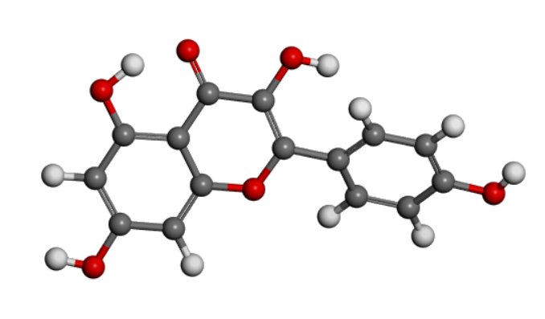 | 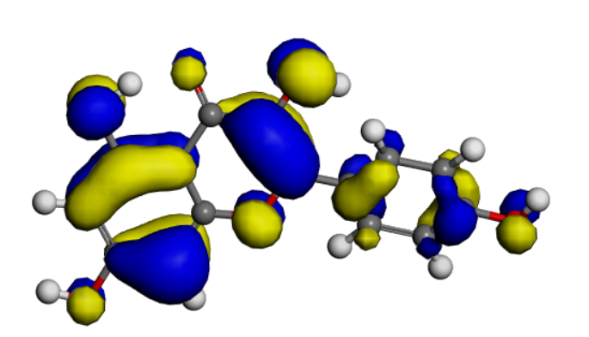 | 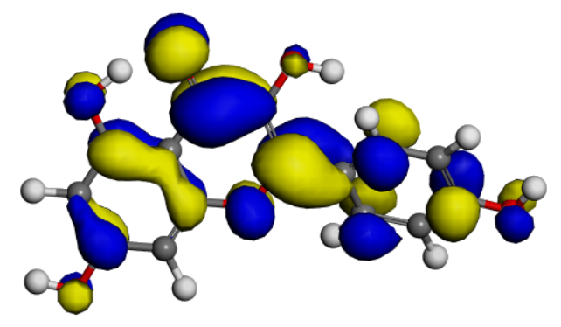

Figure 4: The optimized, HOMO and LUMO orbitals of the compounds studied.

Table 2: Quantum chemical descriptors of some compounds found in Cassia alata leaves

Compound | $E_{HOMO}$ (eV) | $E_{LUMO}$ (eV) | ${I=-E}_{HOMO}$ (eV) | ${A=-E}_{LUMO}$ (eV) | $∆E=E_{LUMO}-E_{LUMO}$ (eV) | 𝜒  (eV) | $η$  (eV) | $δ$  $${\left(eV\right)}^{-1}$$ | $$ω$$  $${\left(eV\right)}^{-1}$$
Penicillin | -5.3642 | -1.6588 | 5.3642 | 1.6588 | 3.7054 | 3.5115 | 1.8527 | 0.5398 | 7.2303
Dabrafenib | -5.7404 | -3.0365 | 5.7404 | 3.0365 | 2.7039 | 4.3885 | 1.3520 | 0.7396 | 7.1224
Fluconazole | -6.3351 | -1.5808 | 6.3351 | 1.5808 | 4.7543 | 3.9580 | 2.3772 | 0.4207 | 3.2950
Ferullic acid | -5.5668 | -2.7602 | 5.5668 | 2.7602 | 2.8066 | 4.1635 | 1.4033 | 0.7126 | 6.1764
Catechin | -5.0821 | -0.9150 | 5.0821 | 0.9150 | 4.1671 | 2.9986 | 2.0836 | 0.4800 | 2.1577
Humulene | -5.2166 | -0.5552 | 5.2166 | 0.5552 | 4.6614 | 2.8859 | 2.3307 | 0.4291 | 1.7867
Kaempferol | -5.2597 | -2.7840 | 5.2597 | 2.7840 | 2.4757 | 4.0219 | 1.2379 | 0.8078 | 6.5335

3.4. Absorption, Distribution, Metabolism and Elimination (ADMET) and drug likeness prediction Results
Compounds that must function effectively as drugs are expected to reach the target in their bioactive form and stay there long enough for the expected drug-target interaction to take place. Thorough ADMET examination is urgently needed to reduce failures during drug formulations, two web tools, swissADME and ADMETlab 3.0 were used for screening four of the compounds and the controls for their pharmacokinetics and pharmacodynamics behaviors. Properties estimated including human intestine absorption (HIA), blood brain barrier (BBB), The partition coefficient between n-octanol and water (log Po/w), topological polar surface area (TPSA), number of rotatable hydrogen bonds, Number Hydrogen bond acceptors and Number of Hydrogen bond donors are presented in Table 3 while Table 4 shows the P-glycoprotein and inhibitor of pharmacokinetics. Interestingly, none of the four compounds studied violated more than 1 of the Lipinski’s rule of 5 described in our previous works [44]. Three of the compounds showed positive human intestinal absorption (HIA) showing that they would be easily absorbed by the human intestine, three showed negative blood-brain barrier (BBB) which implies that they can readily cross the BBB and enter the brain tissue, for effective delivery to the brain [45]. The logarithm of the partition coefficient between n-octanol and water (log Po/w) was studied, it is a measure of the distribution of a drug between octanol and water phases. It tells the lipophilicity or hydrophobicity nature of a drug, it is a property that predicts a drug's aptness to cross biological membranes [46], the range of values for log Po/w for a good drug is between 1 and 5. Fortunately, all compounds studied fall within this range. The total polar surface (TPSA) is an indication of the membrane permeability efficacy of a drug molecule, the range of value for a good compound is 20 Å < TPSA < 130 Å and all four compounds studied as well as the controls drugs fall within this range.
The swissADME online tool was also used to study the interaction of the compounds with cytochromes P450 (CYP), a group of enzymes, usually found in the liver, that play an important role in the metabolism of both xenobiotics and endogenous compounds. Being an inhibitor of these enzymes CYP can result in reduced drug metabolism, and may lead to drug interactions that may imply treatment outcomes (47). All four compounds are non-inhibitors of CYP2C19, Ferullic acid, catechin and humelene are non-inhibitors of CYP1A2, CYP2D6 and CYP3A4 while Kaempferol is an inhibitor, all four compounds except humelene are inhibitors of CYP2C9. Only catechin is a substrate of permeability glycoprotein (P-gp), a molecule that actively pumps molecules and drugs out of cells. these results indicate that the compounds studied can comfortably act as drugs without much side effects.
Table 3. Drug likeness results as computed with SwissADME
S/No. | Compound | Molecular weight (g/mol) | HIA | BBB | $${Log P}_{O/W}$$ | TPSA  (Å²) | HBR | HBA | HBD
1 | Penicillin |  | High | No |  | 69.640 | 5 | 5 | 2
  320.120
  1.597
2 | Dabrafenib |  | Low | No |  |  |  | 8 | 2
  519.100
  4.770
  147.48
  6
3. | Fluconazole |  | High | No |  |  | 5 | 7 | 1
  306.27
  0.88
  81.65
4 | Ferullic acid | 194.18 | High | yes |  | 66.760 | 3 | 4 | 2
  1.360
5 | Catechin |  | High | No |  |  | 1 | 6 | 5
  290.27
  0.83
  110.38
6 | Humulene |  | Low | No |  |  | 0 | 0 | 0
  204.35
  4.26
  0.00
7 | Kaempferol | 286.24 | High | No |  |  | 1 | 6 | 4
  1.58
  111.13
HIA = Human intestine absorptivity, BBB = Blood brain barrier, log P_{O/W} = n=octane/water distribution coefficient, TPSA = total polar surface, NRB-Number of rotatable bond, HBA-Number of hydrogen bond acceptor, HBD = Number of hydrogen bond donor

Table 4. ADME results of some selected compounds
S/No. | Name of compound | Inhibitor Interaction (SwissADME)
S/No. | Name of compound | P-gp  Substrate | CYP1A2  Inhibitor | CYP2C19  Inhibitor | CYP2C9  Inhibitor | CYP2D6  Inhibitor | CYP3A4  Inhibitor
 | Penicillin | Yes | No | No | No | No | No
 | Dabrafenib | No | No | Yes | Yes | No | Yes
 | Fluconazole | Yes | No | Yes | No | No | No
 | Ferullic acid | No | No | No | No | No | NO
 | Catechin | Yes | No | No | No | No | No
 | Humulene | No | No | No | Yes | No | No
 | Kaempferol | No | Yes | No | No | Yes | Yes
\

CONCLUSION:
The leave extract of cassia alata was studied for its bacteria, fungi and skin cancer inhibiting properties using penicillin, fluconazole and dabrafenib as control for each disease. GC-MS analysis was used to identify 16 chemical contents of the chloroform extract of the plant. All the compounds were screened for their bacteria, fungi and skin cancer inhibit ability using molecular docking procedure. Kaempferol showed very good inhibiting potential for all the diseases studied. DFT analysis to study the reactivity behavour of the compounds was performed on the compounds with high docking energies, the result showed that Kaempferol gave the lowest energy gap between the HOMO and LUMO orbitals validating the molecular docking result. ADME screening using swissadme and ADMETlab 3.0 online sever showed that the compounds with good docking score have good druglike properties. The findings in this research have validated the claim that cassia alata is a lead candidate in the management of bacteria, fungi and skin cancer diseases.
REFERENCES
- Agu P. C., Afiukwa C. A., Orji O. U., Ezeh E. M., Ofoke I. H., Ogbu C. O., Ugwuja E. I., Aja P. M., 2023, Molecular docking as a tool for the discovery of molecular targets of nutraceuticals in diseases management. Sci Rep 13(13398), https://doi.org/10.1038/s41598-023-40160-2.
- Nivatya H.K., Singh, A., Kumar, N. et al. Assessing molecular docking tools: understanding drug discovery and design. Futur J Pharm Sci 11, 111 (2025). https://doi.org/10.1186/s43094-025-00862-y
- Hongyan L., Yuhua H., Bo S., Ziyi X., Yitao F., Jiachun S., 2025. Network pharmacology, molecular docking, and molecular dynamics simulation in drug development: A comprehensive perspective, Current Pharmaceutical Analysis 21, 402–405. https://doi.org/10.1016/j.cpan.2025.09.001
- Luca P., Giulio R., 2019. Molecular Docking: Shifting Paradigms in Drug Discovery, International journal of molecular sciences. 20(18), 4331; https://doi.org/10.3390/ijms20184331.
- Bender B. J., Gahbauer S., Luttens A., Lyu J., Webb C. M., Stein R. M., Fink E. A.M, Balius T. E., Carlsson J., Irwin J. J., Shoichet B. k., 2021. A practical guide to large-scale docking. Nat Protoc. 16, 4799–4832. https://doi.org/10.1038/s41596-021-00597-z
- El-Saadony M. T., Saad A. M., Mohammed D. M., Korma S. A., Alshahrani M. Y., Ahmed A. E., Ibrahim E. H., Salem H. M., Alkafaas S. S., Saif A. M., Elkafas S. S., Fahmy M. A., Abd El-Mageed T. A., Abady M. M., Assal H. Y., El-Tarabily M. K., Mathew B. T., AbuQamar S. F., El-Tarabily K. A., Ibrahim S. A., 2025. Medicinal plants: bioactive compounds, biological activities, combating multidrug-resistant, microorganisms, and human health benefits - a comprehensive review, Front. Immunol. 16, 1491777. doi: 10.3389/fimmu.2025.1491777
- Veeresham C., 2012. Natural products derived from plants as a source of drugs. J Adv Pharm Technol Res. 3(4), 200-1. doi: 10.4103/2231-4040.104709. PMID: 23378939; PMCID: PMC3560124.
- Pawłowska, A., Stepczyńska, M., 2022. Natural Biocidal Compounds of Plant Origin as Biodegradable Materials Modifiers. Journal of polymer and the environment. 30, 1683–1708. https://doi.org/10.1007/s10924-021-02315-y
- Bharathi D. R., Mani R. K., Ajay B. V., Pooja R. C., Jai S. M., Kiran K., Mahesh C., 2022. Cassia alata: phytopharmacological, traditional, and medicinal considerations. World Journal of Current Med and Pharm Research. 4(6),147-50. Available from: https://wjcmpr.org/index.php/journal/article/view/244
- Marissa A., Ainul M. Rizna T. D., Sofa F., Nusaibah M., Yasmin E., Indah D. D., 2021. Physicochemical and phytochemical standardization, and antibacterial evaluation of Cassia alata leaves from different locations in Indonesia}, PHARMACIA. 68(4), 947-956. https://doi.org/https://pharmacia.pensoft.net/issue/3327/
- Yon J. A. L., Lee S. K., Keng J. W., Chow S, C., Liew K. B., Teo S. S., Shaik-Mossadeq W. M., Marriott P. J., Akowuah G. A., Ming L. C., et al. 2023. Cassia alata (Linnaeus) Roxburgh for Skin: Natural Remedies for Atopic Dermatitis in Asia and Their Pharmacological Activities. Cosmetics. 10(5). https://doi.org/10.3390/cosmetics10010005
- Chew Y. L., Khor M. A., Xu Z., Lee S. K., Keng J. W., Sang S. H., Akowuah G. A., Goh K. W., Liew K. B., Ming L. C., 2022. Cassia alata, Coriandrum sativum, Curcuma longa and Azadirachta indica: Food Ingredients as Complementary and Alternative Therapies for Atopic Dermatitis-A Comprehensive Review. Molecules. 27(17), 5475. doi: 10.3390/molecules27175475. PMID: 36080243; PMCID: PMC9457827.
- Chew Y. L., Khor M. A., Xu Z., Lee S. K., Keng J. W., Sang S. H., Akowuah G. A., Goh K. W., Liew K. B., Ming L. C., 2022. Cassia alata, Coriandrum sativum, Curcuma longa and Azadirachta indica: Food Ingredients as Complementary and Alternative Therapies for Atopic Dermatitis-A Comprehensive Review. Molecules. 27(17), 5475. doi: 10.3390/molecules27175475. PMID: 36080243; PMCID: PMC9457827.
- Abubakar I. B., Kankara S. S., Malami I., Danjuma J. B., Muhammad Y. Z., Yahaya H., Singh D., Usman U. J., Ukwuani-Kwaja A. N., Muhammad A., Ahmed S. J., 2021. Folami SO, Falana MB, Nurudeen QO. Traditional medicinal plants used for treating emerging and re-emerging viral diseases in northern Nigeria. Eur J Integr Med.102094. doi: 10.1016/j.eujim.2021.102094. Epub 2021 Nov 27. PMID: 36573184; PMCID: PMC9760313.
- Colin M. N., Claudiana N. S. E., Kaffah A. U., Hasanah A. N., Megantara S.. 2024. Review on Cassia alata Bioactive Compounds: In silico, in vitro, and in vivo Studies. Drug Des Devel Ther. 4(18), 4427-4447. doi: 10.2147/DDDT.S477679. PMID: 39381590; PMCID: PMC11460278.
- Keng J. W., Lee S. K., Sang S. H., Liew K. B., Teo S. S., Mossadeq W. M. S. M., Chow S. C., Akowuah G. A., Lee S. K., Mai C. W., Chew Y.L., 2024. Cassia alata and Its Phytochemicals: A Promising Natural Strategy in Wound Recovery. Sci. 6(2), 34. https://doi.org/10.3390/sci6020034.
- Oladeji O. S., Adelowo F. E., Oluyori A. P., 2020. Bankole DT. Ethnobotanical Description and Biological Activities of Senna alata. Evid Based Complement Alternat Med. 20, 2580259. doi: 10.1155/2020/2580259. PMID: 32148534; PMCID: PMC7054808.
- Ahmad M. M., Irfan Z., Siti N., 2022. Antibacterial activity of Cassia alata stem, ethanol extract against Staphylococcus aureus, Acta Pharmaciae Indonesia:, Acta Pharm Indo. 10(1), 5462, 2022, doi https://doi.org/10.20884/1.api.2022.10.1.5462.
- Folorunso V. T., Onifade A. K.,, Oladunmoye K., Akinyele B. J., 2021. Comparative Study of the Antimicrobial Efficacy of Three Medicinal Plants against Dermatophytic Pathogens, European Journal of Medicinal Plants. 32(10), 32-48. DOI: 10.9734/EJMP/2021/v32i1030423.
- Sindhu V., Arun K. K. V., Anagha M., Haritha K., Megha V. S., Roshni M., Sandhra S., 2024. Exploring The Therapeutic Potential of Cassia Alata: A Comprehensive, Review Of Its Pharmacological Attributes, Sindhu V., Int. J. of Pharm. Sci. 2(8), 2349-2358, DOI:10.5281/zenodo.13150449.
- Fatmawati S., Yuliana, Purnomo A. S., Abu B. M. F., 2020. Chemical constituents, usage and pharmacological activity of Cassia alata. Heliyon. 6(7), e04396. doi: 10.1016/j.heliyon.2020.e04396. PMID: 32685725; PMCID: PMC7358271.
- Habeeb A., Ramesh S., Shanmugam R., 2024. Calotropis procera and the Pharmacological Properties of Its Aqueous Leaf Extract: A Review. Cureus. 16(5), e60354. doi: 10.7759/cureus.60354. PMID: 38883127; PMCID: PMC11178124.
- Ouandaogo H. S., Diallo S., Odari E., Kinyua J., 2023. Phytochemical Screening and GC-MS Analysis of Methanolic and Aqueous Extracts of Ocimum kilimands charicum Leaves. ACS Omega. 8(50), 47560-47572. doi: 10.1021/acsomega.3c05554. PMID: 38144100; PMCID: PMC10733911.
- Smrutiranjan D., Naimish N., Mrutyunjay B., Rupali B. S., Ayushmaan R., Reema D., 2024. GC-MS and Molecular Docking Analyses of Phytoconstituents from the Plant Tephrosia purpurea, Journal of chemical health risks, JCHR. 14(5), 196-211.
- Rakhmawati R., Wahyudi S. T., Wahyuningsih M. S. H., Mustofa M., Sadewa A. H., 2024. GC-MS and in silico analyses revealed the potential inhibitory activity of compounds isolated from Ciplukan herb (Physalisangulata L.) targeting GLUT-4 receptors, Journal of Applied Pharmaceutical Science. 14(8), 142-149. DOI: 10.7324/JAPS.2024.171953.
- Dashti H., Wedell J., Westler, W. Marley J. L., Eghbalnia H. R., 2019. Automated evaluation of consistency within the PubChem Compound database. Scientific Data 6, 190023. https://doi.org/10.1038/sdata.2019.23.
- Ikezu U. J. M., Ugariogu S. N., Ikpa C. B. C, Adindu C. B.,Maduka T. O., 2023. Insilico determination of anti-cancer activity of phytochemical from clove (SYzygium aromaticumL) seed. 2023. J. Chem. Soc. Nigeria. 48(4), 767-784,
- Xiayang Q., Janson C. A., Smith W. W., Green S. M., McDevitt P., Johanson K., Carter P., Hibbs M., Lewis C., Chalker A., Fosberry A., 2021. Crystal structure of Staphylococcus aureus tyrosyl-tRNA synthetase in complex with a class of potent and specific inhibitors, protein science. 10(10), 2008-2016. https://doi.org/10.1110/ps.18001
- Podust L. M., Poulos T. L., Waterman M. R., 2001. Crystal structure of cytochrome P450 14α-sterol demethylase (CYP51) from Mycobacterium tuberculosis in complex with azole inhibitors, PNAS. 98(6), 3068-3073, https://doi.org/10.1073/pnas.061562898
- Aronov A. M., Baker C., Bemis G. W., Cao J., Chen G., ET AL. et al., Chen G., Ford P. J., Germann U. a., Green J., Hale M. R., Jacobs M., Janetka J. W., Maitais F., Martinez-Botella G., Namchuk M. N., Straub J., Tang Q., Xie X., 2007. Flipped Out: Structure-Guided Design of Selective Pyrazolylpyrrole ERK Inhibitors, Journal of Medicinal Chemistry.50(6), American Chemical Society. https://doi.org/10.1021/jm061381f. doi: 10.1021/jm061381f. Epub 2007 Feb 15
- Kondapuram S. K., Sarvagalla S., Coumar M. S., 2021. Docking-Based Virtual Screening Using PyRx Tool: Autophagy Target Vps34 as a Case Study, In book: Molecular Docking for Computer-Aided Drug Design, Bioinformatics. 463-477. DOI:10.1016/B978-0-12-822312-3.00019-9
- Adindu C. B., Kalu G. I., Ikezu U. J.M., Ikpa C. B. C., Okeke P., 2024. Molecular Docking, ADMET & DFT Predictions of Cinnamomum zylanicum for Prostate Cancer Inhibition, journal of Materials Science Research and Reviews. 7(3), 392-426.
- Ikpa C. B. C., Maduka T. O., Ikezu U. J. M., Adindu C. B., Ugariogu S., 2023. The Insilico Molecular Docking of the Compounds of the Crude Extract of Dacryodes Edulis Leaves Against Alpha Enolase to Assess Its Activities on the Treatment of Bacterial Pneumonia, Iconic research and engineering journals (IRE) Journal 7(1).
- Adindu C. B., Nwanonenyi S. C., Ikpa C. B. C., 2023. Experimental and computational studies of the corrosion inhibitive effects of Zingiber officinale rhizomes on mild steel corrosion in acidic solutions, Journal of the Nigerian society of physical sciences, 5, 1386. DOI:10.46481/jnsps.2023.1386.
- Adindu C. B., Kalu G. I., Nwokeke U. G., Ibe F. C., 2024. Screening of Potential Cancer Inhibitors Using Curcuma longa (Turmeric) Extract through Molecular Docking, ADME and DFT Methods. South Asian Research Journal of Natural Products. 7 (3), 358-382.
- Ononamadu C. J., Ibrahim A., 2021. Molecular docking and prediction of ADME/drug-likeness properties of potentially active antidiabetic compounds isolated from aqueous-methanol extracts of Gymnema sylvestre and Combretum micranthum. BioTechnologia (Pozn). 102(1), 85-99. doi: 10.5114/bta.2021.103765. PMID: 36605715; PMCID: PMC9645566.
- Adindu C. B., Okeke P. I., 2025. Computational screening of potential ulcer inhibitors from Moringa olefera Lam. Leaves. World news of natural sciences. 61(2), 237-254.
- Adindu C. B., Chidiebere A. M., 2023. Analysis of the Chemical Constituents of Xylopia Aethiopica targeting the Progesterone Receptors for inhibiting the growth of Uterine Leiomyoma in-Silico approach, Nigerian Journal of Nutritional Sciences. 45(2), Doi: https://dx.doi.org/10.4314/njns.v45i2.6.
- Chidiebere A. M., Njoku D. I., Obike I. A., Nwanonenyi S. C., Akalezi C., Adindu B., Oguzie E. E., 2020. Experimental and Theoretical Studies on the Protective Effect of a Biomass Corrosion Inhibitor (vigna radiata) on Mild Steel in Acidic Medium, Electroanalysis. 32, 3117 – 3130. DOI: 10.1002/elan.202060378.
- Kaya S., Putz M. V., 2022. Atoms-In-Molecules’ Faces of Chemical Hardness by Conceptual Density Functional Theory. Molecules. 27(24), 8825. https://doi.org/10.3390/molecules27248825.
- Reed J. L., 2023. Electronegativity: Coordination Compounds, The Journal of Physical Chemistry A, J. Phys. Chem. A. 107(41), 8714–8722 https://doi.org/10.1021/jp030389n
- Islam N., Ghosh D. C., 2012. On the electrophilic character of molecules through its relation with electronegativity and chemical hardness. Int J Mol Sci. 13(2), 2160-2175. doi: 10.3390/ijms13022160. Epub 2012 Feb 17. PMID: 22408445; PMCID: PMC3292014.
- El-Shamy N. T., Alkaoud A. M., Hussein R. K., Ibrahim M. A., Alhamzani A. G., Abou-Krisha M. M., 2022. DFT, ADMET and Molecular Docking Investigations for the Antimicrobial Activity of 6,6'-Diamino-1,1',3,3'-tetramethyl-5,5'-(4-chlorobenzylidene)bis[pyrimidine-2,4(1H,3H)-dione]. Molecules. 27(3), 620. doi: 10.3390/molecules27030620. PMID: 35163880; PMCID: PMC8839838.
- Adindu C. B., 2023. In-Silico Screening of Lung Cancer, Inhibiting Potential of the Chemical Constituents of N-Hexane Extract of Elaisi guineenses, Journal of Materials Science Research and Reviews. 6(3), 572-582.
- Wu D., Chen Q., Chen X., Han F., Chen Z., Wang Y., 2023. The blood-brain barrier: structure, regulation, and drug delivery. Signal Transduct Target Ther. 8(1), 217. doi: 10.1038/s41392-023-01481-w. PMID: 37231000; PMCID: PMC10212980.
- Hakkola J., Hukkanen J., Turpeinen M., Pelkonen O., 2020. Inhibition and induction of CYP enzymes in humans: an update. Archives of Toxicology. 94, 3671–3722. https://doi.org/10.1007/s00204-020-02936-7.
- Deodhar M, Al Rihani SB, Arwood MJ, Darakjian L, Dow P, Turgeon J, Michaud V. Mechanisms of CYP450 Inhibition: Understanding Drug-Drug Interactions Due to Mechanism-Based Inhibition in Clinical Practice. Pharmaceutics. 2020; 12: 9:846. doi: 10.3390/pharmaceutics12090846. PMID: 32899642; PMCID: PMC7557591.

