POTENTIAL AND CHALLENGES OF RIVER TOURISM-SWOT ANALYSIS, ASSAM, INDIA

Abstract:
The river and river tourism destinations have become extremely popular in the last decade. Assam offers great opportunities for river to explore the beautiful Exotic River and landscapes of Barak and Brahmaputra, as well as offering opportunities for aerial and water adventure activities. River tourism is at the initial development stage in Assam and is the growing tourism industry. Assam is also a state with stunning natural beauty with Kaziranga National Park, a UNESCO World Heritage Site, which protects the endangered one-horned rhinoceros. Assam is becoming a popular travel destination for nature lover because of its beautiful river scenery and diverse landscape. River tourism development could increase tourist arrivals and the region’s business opportunities. This paper tries to explore the potential for growth and development in the tourism sector of the State, especially river tourism. To assess the strengths, weaknesses, opportunities and threats associated with river tourism in Assam, a SWOT analysis is conducted. It provides a systematic insight of the existing condition of river tourism in the area and helps in identifying potential challenges and areas for development. The present study examines the potential of River in Assam and focuses on the challenges of River tourism development. The study also extends to provide some suggestions for the development of river tourism and the utilization of its river as resources for river tourism.
Keywords: River tourism, Economy, Assam, Brahmaputra, infrastructure

Introduction:
Rivers are attractive places that constitute a significant tourism resource of cultural heritage and natural environment. Surprisingly, there is little attention among policymakers involved in the development of river tourism which has not been fully utilized for river tourism purposes compared with other tourism sectors. One of the world’s largest and fastest-growing industries is tourism (Mowforth, M., & Munt, I., 2023, Abbes, E. W et al., 2022). Tourism is also one of the fastest-growing business in the world, tourism contributes significantly to the creation of both jobs and foreign exchange for many nations (Mak. J., 2003) in fact one of the most amazing economic and social developments. The river is one of the most important resources for human civilization. These fascinating places exhibit both a natural charm and usefulness for various human activities such as transport routes, food sources, and in recent times as places to be visited and enjoyed. (Prideaux, Timothy et. al., 2009) stated that rivers have taken a central place in human history since the time of civilization, and before and therefore it can be called as, ever since the existence of humans on the earth, river act as a lifeline for survival. River provides water and the fertile alluvial plains that sustained the first human settlements, and it promoting the growth of wealth based on agriculture and trade. The river is one of the vitally important tourism resources to be studied among all other natural resources. Various river-based activities can be performed in the river. In general, River Tourism is a combination of the river and tourism industry.
(Tandon, N., 2012; Tomej, K., et al., 2020) rivers are a major tourism resource that provides magnificent settings, recreational opportunities, and riverside landscapes in many centres of tourism interest, a means of transport, and an essential source of water for human consumption. The world’s great rivers have a long history of travelling and act as the medium backdrop for travel. The most important exciting activities that can be done through the river include water adventure tourism which comprises river-cruise, water-rafting, fishing, river exploration, boating, kayaking, and leisure that could be interesting parts to attract the tourist thus could potentially develop in the selected area.
River tourism is a profitable trade with the potential of making a major contribution to the local economies through employment on cruise ships, pleasure boats, and parks and recreational facilities along the river banks (Shakiry, 2007, Cheng, Y., 2023). It is possible that implementing tourism projects and activities along the rivers would potentially give benefits to the local surrounding peoples. Brahmaputra River is one of the important water reservoirs and resources for the people of Assam.
The current status of the Brahmaputra River still not been fully explored yet. However, there is the construction of a number of hydroelectric power stations situated upstream of the Brahmaputra River which formed the Lake reservoir. Dams that are built in the river give immense impetus to the development of river tourism in the state. The main feature of river tourism is water, one of the most popular natural sites for rest and recreation. Even short periods near water are claimed; stress-free to have beneficial relaxation for most people (Amnuay-ngerntra, S., & Hideki, S., 2013 Mahanta, B., 2023).
There is a closer relationship between man and river since life exists on Earth. Most of the diverse cultures have developed in the river. Economic activities, livelihood, and collection of various natural resources begin in the river. Therefore, the river is called a lifeline for human survival. Man has always been fascinated by travel, with a desire to explore new and exotic locations, seek out environmental changes, and engage with different experiences Ramaswamy, S., & Sathis Kumar, G. (2010). This passion for travel dates back to the very beginning of recorded history. One of the few economic sectors that span the economy and creates prospects for sustainable development, investment, and employment in emerging economies is tourism, which involves human decisions and choices Stylidis, D., Biran, A., Sit, J., & Szivas, E. M. (2014). Today, tourism is a sizable global sector that is seen as a significant socio-economic and environmental force that can improve a region’s culture and economics. It is a very diverse phenomenon, with several products acting as draw factors for travelers in a given area Collins‐Kreiner, N. (2010). The aims of the paper were to identify factors encouraging, limiting development of river tourism, defining potential destination and suggested measures to promote river tourism. Thus it gives ideas about how river and tributaries of Brahmaputra become a good scope for river tourism in Assam.
Literature Review
A review of the tourism literature shows that apart from an edited book on river tourism by Prideaux and Copper (2009) and a relatively small number of papers (eg. Fachrudin & Lubis, 2016; Moreira & dos Santos, 2010; Bittar-Rodrigues and Prideaux, 2018) that have a specific focus on tourism activity on waterways; research into the tourism use of waterways and rivers is limited. River tourism has become increasingly popular in recent decades, particularly in Europe but also in Asia and parts of the United States of America (Prideaux 2022)
Rivers are an important but surprisingly neglected aspect of the global tourism industry, and have apparently been of little interest to tourism scholars (Prideaux et al, 2009, p. 3). There is little attention among policymakers on the River tourism of Brahmaputra. It is noted that river tourism comprises tourism besides the river and tourism on the river (Cooper & Prideaux, 2009, p. 258). Tourism beside the river represents hotels, casinos, and restaurants for instance, whereas tourism on the river represents boating, cruise, waterway transportation, and canoeing to mention but a few. A number of cities are built beside rivers where urban-river activities and lifestyles of local residents living next to the waterway are most interesting to visitors. In the countryside, rivers appeal to people because they retain much of their natural beauty and offer an opportunity for fishing, boating, and other forms of recreation (Prideaux et al, 2009).
Rivers are a major tourism resource providing magnificent settings, recreational opportunities, and waterfront landscapes in many centres of tourism interest, a means of transport, and an essential source of water for human use (Bruce et Al., 2009). The world’s great rivers have a long history of fascinating travelers and even in ancient times provided the environment for travel. From the studies, it is clear that apart from mountains, beaches, caves, lakes, waterfalls, and other nature tourism, the river is one of the most attractive tourist resources to be preferred. Recently Cruise tourism has experienced significant growth in the river (Newsome et. Al., 2013) and present-day studies show that the development of this type of tourism will be even more significant in the future (Parker, 2013; Gogonea & Zaharia, 2013).
Cruises are constantly rising in popularity worldwide, as they present an attractive form of modern tourist traffic (CLIA, 2005; Marti, 2004; Ward, 2005; Peisley, 1992, 2006; Hobson, 1993; Gibson, 2004, 2008). Cruises have become a tourist niche with the fastest growth rate over the last decade. A river cruise is a voyage that takes place on a river vessel for leisure purposes (Tomej & Lund Durlacher, 2020). In navigable inland waterways such as rivers and Canals River cruises are conducted, possibly through, lakes and estuaries, or even along the coast directly connected to rivers or canals.
There are several direct relationships between tourism and rivers. 1st, rivers provide a wealth of attractions and aesthetic appeal for tourists and a unique venue in which tourism takes place. The 2nd, relationship is rivers as transportation corridors. Navigable rivers are a valuable asset to several regions or countries for the transportation of raw materials and manufactured products. Rivers are taking an additional element of commerce and trade that of transporting tourists on sightseeing cruises. In the countryside and less developed regions, rivers have retained their natural characteristics, creating interest in rivers as eco-tourism and nature-based resources (Prideaux et al, 2009).
Geographical background of the study area
Assam is the gateway to the exotic North Eastern region of India. Assam with it breathtaking scenic beauty lofty blue hills, the mighty Brahmaputra that is one of the largest rivers of the world. Assam indeed a place in the adventure sports map due to the turbulent rivers, the mystic blue hills, the savage terrains and serene countryside. It extends from 24.5⁰ N to 28.0⁰ N latitudes and from 88.25⁰ E to 96.0⁰ E longitudes. The area of the state is 78,438 sq. kms (Fig.1). The state constitutes 2.4 per cent of the total land area of the country. Assam is bordered by the kingdom of Bhutan and the state of Arunachal Pradesh in the north, Arunachal Pradesh, Nagaland and Manipur in the east and south east, Mizoram, Tripura and Meghalaya in the south and south-west, Bangladesh and West Bengal in the west and south-west. On the basis of physiographic characteristics, Assam may be divided into three physical divisions, namely Brahamputra Valley, Barak Valley and the hilly region consisting of Karbi Anglong and North Cachar Hills.
The rich natural beauty, the serenity and exotic flora and fauna and number of big and small river of the seven sisters of North East states-Arunachal Pradesh, Assam, Manipur, Meghalaya, Mizoram, Nagaland and Tripura, are invaluable resources for the development of tourism more specifically river tourism and ecotourism. The region is endowed with diverse tourist attractions and each State has its own distinct features. The location of North Eastern region is strategically important as it has international borders with Bangladesh, Bhutan, China and Myanmar. The Union and the State Governments have attached great importance for the tourism development of the region in view of immense tourism potential of the region. The valley surrounded on all sides except the west, by mountains and is intersected by many streams and rivulets that flow from the neighbouring hills to empty into the Brahmaputra. It is an alluvial plain bordered by Arunachal Himalaya in the north, Naga Hills in the south-east and Karbi and Meghalaya plateaus in the south. The plain is about 725 km long and 80 km wide on the average and it covers an area of 56,339 sq. km representing 72% of the total geographical area of the state (Das, 1984). As the river has to flow on a plain of very gradient; braiding takes place and numerous temporary and semi permanent river islands are formed by the deposition of sediments.
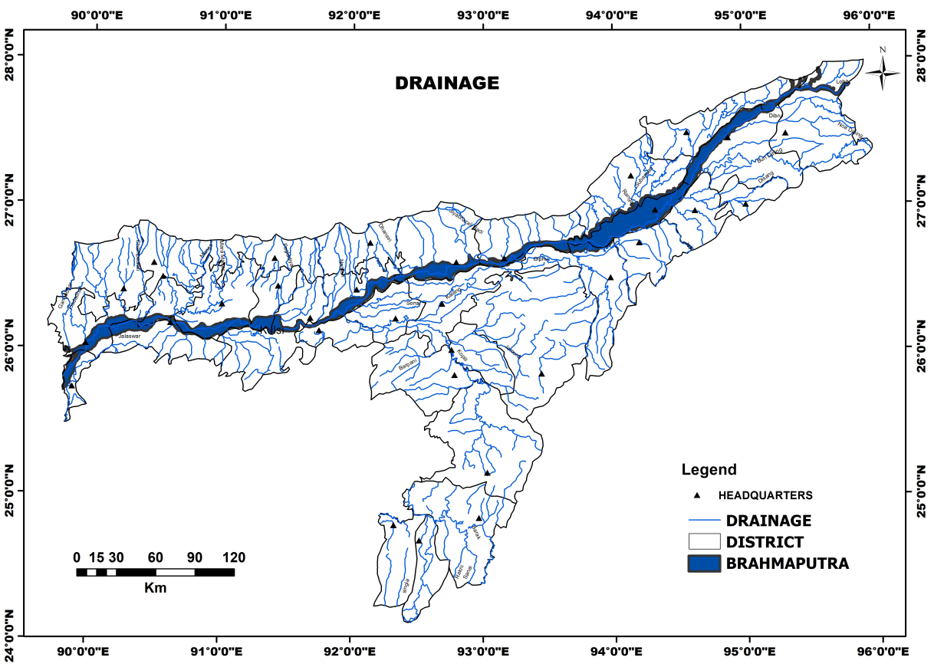
Fig.1. River and stream of the study area
Prepared by the Author

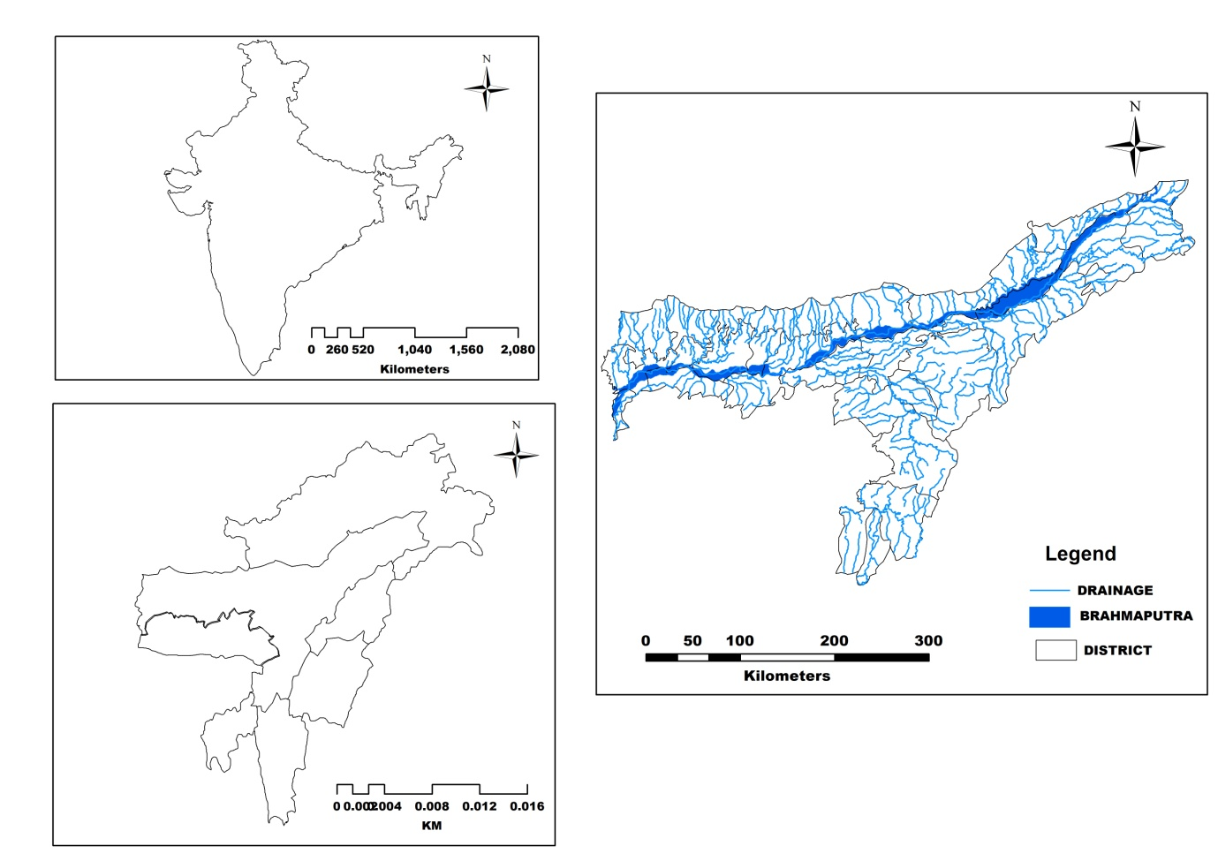
Fig.2.Location of the Study Area
Prepared by the Author

Material and Methods
The present study is a conceptual in nature and the paper is based on secondary data. The data were collected from various journals, papers, magazines, internet, Ministry of Tourism, articles and newspapers; in addition, the researcher, being a resident of Assam, is herself aware about the river tourism potentials of Assam. Secondary data were also collected from Director of inland water transport Assam, Brahmaputra Board, Water resources Department Assam, Assam Tourism Development Corporation (ATDC) and official website of Government of Assam.
Analysis and discussion
River Tourism in Assam
Assam is endowed with enormous water resources. The large perennial rivers and other water bodies with rich aquifer speak about vastness of its water resources. Thus among all the natural resources of Assam, water resources is considered as one of the most important resources of the State. Water is fundamental need of all human, animal and plant life on earth. Water is essential for the survival of all these biotic factors. Besides, water in adequate quantity is very much essential for the development of agriculture, fishery, animal husbandry and also for industrial development. Under the constitution, water resource is primarily a “State Subject”, with legislation and administration substantially framed within the context of State Boundaries. In Assam, water is available from both surface run water and underground sources. Namami Brahmaputra River Festival was a ray of hope in the field of development of river tourism, is an international festival that celebrates the beauty of the Brahmaputra River. Since independence it was the first international river festival to be celebrated from 31 March to 4th April, 2017 by the government of Assam to showcases Assam art, heritage, and culture. The event was held in 21 districts of Assam across the state touched by the River Brahmaputra. Brahmaputra Pushkaram festival a 12 days (5th to 16th November) mega river festival was held in 2019 to give the holy importance of the River (Department of Tourism, 2019).
MV Ganga Vilas is the world’s longest river cruise. It was flagged off by the prime minister of India Narenda Modi on 13 January 2023. Antara Luxury River Cruises in india, is an 18-suite ship that offers the longest, most picturesque river cruise in the world. MV Ganga Vilas journey was for 51 days across 2 countries, 5 states and 27 river systems, Antara Ganga Vilas sails from Varanasi to Dibrugarh via Dhaka. Antara Luxury River Cruises is a rapidly growing boutique cruise brand that is bringing travellers to India’s majestic waterways and has them sail in luxury to find adventure and pleasure.
Assam Government Tourism Policy
In today’s world, tourism is an important driver of economic growth. Through tourism, a number of nations have transformed their economies. From unskilled to skilled employment, tourism has a huge potential to create jobs on a large scale. The first Assam Tourism policy was introduced in 2008 and the main focus under this policy was given to Public Private Partnership. This has rapidly increased the number of tourist coming to Assam. The second Assam Tourism Policy was announced in 2017 focusing on enhancement of major economic sectors. The third Assam Tourism Policy was introduced in 2022 with a focus to improve infrastructure of Assam’s different tourist destination. The 3rd Tourism policy of Assam i.e. Assam Tourism Policy 2022 was approved by Assam Cabinet on 28th July 2022. This policy aims to develop and improve the infrastructure of various tourist destinations of Assam.
The Key features of Assam Tourism Policy 2022 are as follows:
- Engagement of local peoples of various tourist places of Assam directly or indirectly
- Support for the development of Home Stay Scheme or Amar Alohi Schemes among the local communities of the tourist place of Assam
- Coordination between Tourism and Transport sector are focused under this policy
- Special Tourism Zones (STZ) are created under this policy.
- Private Sector Investment in tourism is promoted.
Under Assam Tourism Policy 2022, Special Tourism Zones (STZ) is to be created. These Special Tourism Zones are created to promote the following type of Tourism in Assam.
- Tea Tourism of Assam
- Wildlife Tourism of Assam
- Golf Tourism
- Medical & Wellness Tourism of Assam
- Spiritual Tourism
- Ethnic Tourism
- River Tourism
- Transit Tourism
- Adventure Tourism
- Monsoon & Leisure Tourism
- Eco Tourism
- Mining Tourism
- Film Tourism
SWOT Analysis of River Tourism in Assam
The State of Assam known for its stunning scenery and extensive cultural legacy, has a lot of potential for river tourism (Das. D., 2012; Chutia. S., 2015; Das. R., 2017). The state’s vast network of rivers which includes the magnificent Brahmaputra, presents an exceptional potential to create and expand tourism-related ventures along their banks (Mahanta. B., 2023). To gain a comprehensive understanding of the strengths, weaknesses, opportunities and threats associated with river tourism in Assam, a SWOT analysis has been conducted. The internal and external aspects that may affect the growth and success of river tourism in the area are highlighted in the analysis.

STRENGTH:
1. Rich Natural Resources: The large perennial rivers and the tributaries are the water resources of Assam. The Brahmaputra River is the most notable of the various rivers. There are numerous opportunities for river-based activities like boating, fishing, river cruises and water sports along the Brahmaputra. The river is surrounded by dense vegetation as well as mesmerising scenery and calm surroundings.
The natural resources of Assam may be classified into following types – mineral, forest, water and agricultural resources. Assam is one of the richest biodiversity zones in the world and consists of tropical rainforests, deciduous forests, riverine grasslands, bamboo orchards and numerous wetland ecosystems. Assam is abundant on mineral resources like coal, petroleum; limestone and natural gas. In Assam, agriculture makes the highest contribution to its domestic sectors, accounting for more than a third of Assam's income and employs about 69% of workforce in the alluvial plain of river Brahmaputra. Assam has the single largest tea growing area in the world, constituting around one-seventh of the global tea production.
2. Biodiversity and Wildlife sanctuaries: Assam has a rich biodiversity because of its distinctive geography and varied ecosystems. The environment along the river banks of Brahmaputra and its tributaries provides a great habitat for a wide variety of plant and animal species. The potential for animal viewing and eco-tourism along the riverbanks is also increased by the presence of national parks and wildlife sanctuaries like, Kaziranga, Manas and Dibru-Saikhowa, Nameri National Park, Sonai Rupai Wildlife Sanctuary, Dehing Patkai Wildlife Sanctuary, Deepor Beel Bird Sanctuary, Bordoibam Bilmukh Bird Sanctuary, Pabha Wildlife Sanctuary, Orang National Park, Pobitora Wildlife Sanctuary, Molai forest is the Brahmaputra River near Kokilamukh, Assam, India. All the mention Biodiversity and Wildlife sanctuaries in and around near the bank of the mighty river Brahmaputra give impetus for the development of river tourism in Assam.
3. Unique River Cruises: The main route for river cruises in Assam is the Brahmaputra River. These excursions provide a fantastic opportunity to discover the beautiful scenery, wildlife-rich regions and cultural treasures that line the riverbanks. The world’s biggest and smallest river islands are located in the river Brahmaputra i.e. Majuli and Umananda respectively. Majuli is the World’s largest river island. The river is known for its mythology and folklore. On the cultural front also, river is rich enough to draw the attention of the tourists. Umatumuni River Island and Gupta Kashi are also one of the most exotic and beautiful places to be visited in the River Brahmaputra located in the Biswanath district of Assam. Cruise on the mighty Brahmaputra exist but it is not known to most of the tourist in the states as well as abroad. The river covers a distance of 1800 miles from its source in the Tibetan Himalayas to its delta in the Bay of Bengal through Assam a natural beautiful state. Cruise in this magnificent river provide an opportunities for tourist to enjoy a fabulous beauty of the nature and diverse flora and fauna. It offers mind blowing wildlife viewing and bird watching for wildlife enthusiasts; it offers a glimpse of the diverse and colourful ethnic blend of the Assam to the cultural diversity lovers. Cruises on the Brahmaputra River are offered by both government and by private operators. Some of these operate small tours along Guwahati city while some operators offer luxury services to Kaziranga and beyond. The cruises cover some of the national parks including the Kaziranga National Park, a World Heritage Site, and Majuli, one of the largest riverine islands in the world. Similarly on the Brahmaputra River, waterborne transport has been important for the local communities for centuries and recently for international visitors travelling along with the Brahmaputra River. The cruises normally depart from Guwahati or Jorhat and visit a number of locations including Dibrugarh, Majuli Island and Kaziranga National Park. On these cruises, visitors can see magnificent sunrises and sunsets, view wildlife, visit tea gardens and engage with locals. Apart from this, River Island cruises may be included to islands such Umananda Island, Peacock Island and Neematighat Island. Kanchanjangha Floating restaurant at Bogibeel Ghat, Near Bogibeel Bridge is one of the worth mention in the path of development of river tourism in Assam.
4. Potential for river Adventure Tourism: The presence of rivers opens up direction for river adventure activities like river rafting, kayaking and boating. This will attract adventure seekers to the region. Network of rivers, rivulets and mountain streams make the region ideal for white water rafting, canoeing, kayaking and other water sports. Parasailing: ATDC Ltd facilitates parasailing at Dalibari in North Guwahati. The sandbars at Guwahati (during the annual Brahmaputra Beach Festival) and near Dibru-Saikhowa National Park in eastern Assam are ideal spots too. Private tour operators organise parasailing at Dibru-Saikhowa. There is more Parasailing location in Assam which needs to be explored and execute.
Boat racing: Boat racing in Assam can be an important part in the potential for river tourism. Numbers of big and Small River can be taken into consideration. There are few to be mention as of now, Speed fests similar to snake boat racing in Kerala have traditionally been organized during festivals in Guwahati, Hajo, Sualkuchi and Barpeta. For kayaking and canoeing enthusiasts, Charanbeel in Morigaon district, only an hour’s drive from Guwahati. The Assam Boat Racing and Rowing Association, together with the Department of Tourism, also organises boat racing during the annual spring-time Brahmaputra Beach Festival. Many more boating activities can be practice and development in the tributaries of the river Brahmaputra.
River Rafting: The Brahmaputra and its turbulent tributaries such as Manas and Kopili dare, subansiri adventurers with their swift current and fiery rapids. But rafting is only organised at Jia Bhoroli, and Brahmaputra tributary which needs promotion for development of river tourism.
Angling: Jia Bhoroli, Kapili and Manas are the best places for angling. The Jia Bhoroli River is home to the fierce game fish, the Golden Mahseer, or tiger of the Himalayan rivers. An annual Angling competition is regularly organised by Assam Bhoreli Anglers’ Association at Nameriat Jia Bhoroli where a number of anglers both from outside the state as well as abroad participate every year in November or December. There are many more river where Angling can be practice and promote.
WEAKNESSES:
- Limited Infrastructure: Infrastructure for tourism includes basic infrastructure components like airports, railways, roads, waterways, electricity, water supply, drainage, sewerage, solid waste disposal systems and services. Moreover, facilities like accommodation, restaurants, recreational facilities and shopping facilities also comes under the ambit of Tourism Infrastructure. Each of these elements boosts tourism development mostly by raising the attractiveness and competitiveness of a destination. Tourists expect facilitates in their chosen destination to be comparable to what they enjoy at home, especially those that have become the essential element of everyday life recreation (Murphy et.al. 2000; Crouch and Ritchie, 2000). The other important ones are development of infrastructure products like trekking material, winter sports material, wildlife and beach resorts and trained human resource. Facilitating and developing private sector participation is also a key factor to the growth of tourism. Recreational facilities are an integral part of physical infrastructure which is an indispensable pillar of overall economic and tourism development (Khadaroo and Seetanah in: Jafari and Xiao, 2016). Assam’s current river tourist infrastructure, which includes ports and passenger facilities, is not adequate and required further development. The smooth operation of river cruises and the quality of the overall tourist experience can be hampered by inadequate infrastructure.
- Seasonal restrictions: River tourism in Assam is mostly focused on the Brahmaputra River, which has substantial seasonal changes in water levels. The river flooded during the monsoon season, posing navigational difficulties and safety issues for river excursions. It can be challenging to keep consistent cruise schedules throughout the year.
- Connectivity issues: Due to rugged terrain and topography in NE India, connectivity is lacking behind compared to other part of India. Limited connectivity options may pose as hindrance for tourist. Peoples love to visit places with smooth connectivity (e.g. airways, railways, Inland water service, roadways etc). Remote riverine areas experience connectivity issues, which hinder visitors’ ability to move freely and reach tourism sites.
- Safety and security: Safety and security are vital to provide quality in tourism. More than any other economic activity, the success or failure of a tourism destination depends on being able to provide a safe and secure environment for visitors both in tangible and intangible manner.
OPPORTUNITIES:
- Unexplored Potential: Assam’s River tourism is still mostly unexplored and untouched, which presents a chance for the tourism sector to expand and diversify. By diversifying the river tourism sectors the local people can be benefited and may result to rise in the state’s economy. It can attract both national and international tourist of different interests and preferences.
- River-based Adventure Activities: More tourists can be attracted by including river rafting, kayaking adventures and river camping experiences in addition to regular river cruises. This potential can be realized by creating the necessary infrastructure, guaranteeing safety precautions and promoting these activities to adventure tourism markets.
- Cultural Diversity: The State’s diverse cultural legacy can be used to provide tourists with special cultural experience. Tourism services can be enhanced by planning river-based festivals and events like boat races, cultural performances on river islands and riverfront music festivals. These occasions can promote the area’s cultural diversity, draw domestic and foreign tourists. Diffusion of tourism is taking place in Assam which is a great opportunities for the people of Assam to gain momentum in this sectors. River Based Festivals knows as Majuli Festivals is celebrated every year in the winter month of November i.e. 21st of November to the 24th of the November.
- Economic Growth and Employment: River tourism has the ability to create jobs and aid in the development of state’s economy. Jobs in a variety of industries, such as tourism, hospitality, cruise operations, tour guiding, crafts and entertainment can be created. Additionally, river tourism will benefit regional economy. It promotes the construction and upkeep of docking facilities, visitor centres and lodging facilities along the riverbanks.
THREATS:
- Environmental Concerns: Safety of the environment attracts more people towards tourism industry, and its keeps on multiplying. Unplanned and uncontrolled tourism operations could endanger the delicate river ecosystems by causing pollution. It includes carbon emission by burning fuels, plastic bags, endangering the wild, cutting off the tree to establish hotel resorts, and many other issues. The solid waste and littering, releases of sewage, oil and chemicals become threats to tourism sites.
- Inadequate Infrastructure: Tourism infrastructure, including airports, roadways, highways and public transportation, is inadequate and often not to the mark. Many tourist destinations lack basic amenities such as clean water, sanitation facilities, and healthcare services, banking, advertisement board, toilet etc.
- Human Resources & Planning: Limited Professional institution for tourism is an threat to tourism industry. There are very few institutes that offer professional training for tourism service. That’s why we don’t see often professionalism in the tourism industry. Unskilled employed in the various sectors of tourism result to poor quality product and services.
- Competition from Other Destinations: The State may face competition from other river tourism destinations within India and abroad. It may need to employ innovative marketing strategies to attract visitors. The tourism industry has become very competitive. Many small entrepreneurs have jumped into it and they offer low-quality service at high prices.
- Safety and Security: Maintaining a great tourist experience depends on ensuring the safety and security of visitors, particularly during river excursions and water-based activities.
- Insufficient Digital Promotion: As the tourism industry continues to grow, social media marketing has become an essential tool for businesses to reach and engage with potential visitors. Social media platforms such as Facebook, Twitter, Instagram, and YouTube are among the most widely used tools for marketing in the tourism industry. Social media platforms are playing a major role in providing information about different tourist site in the world-wide. But Assam has yet to be in digital platforms to promote river tourism in Assam.
Suggestions
In order to develop river tourism in Assam, the following suggestions could be profitable:
- Educating and creating awareness among locals, planners and administrators, bring out monthly publications and organize seminars, workshops and presentations on the economic and societal benefits of river tourism.
- In order to take charge of river tourism in Assam, trained and expert professionals should be invited.
- Assam should be advertised/ marketed both nationally and globally as a river tourism destination.
- In order to train and teach river lovers throughout the state, several river tourism sports institutes should be opened in the state.
- New modern equipment should replace old-fashioned equipment to boost river tourism.
- Adequate infrastructure for river tourism activities should be developed in the tourist sites.
- It is important for river tourism to ensure safety and security before and on the activities in the tour.
- Appropriate policies must be formulated by the government to boost river tourism.
- The achievement of river tourism advertising and planning in region depends on the public-private partnership and on its complementary and supporting role. Private entrepreneurs need to add to the government's efforts to execute the plans to develop river tourism in Assam.
Conclusion
River tourism is a recreational activity and Assam has the finest and tremendous potential of river tourism and is one of the best destinations for river activities. It is the initial segment of the tourism industry in Assam and it is very important to develop this sectors. The maximum resources for river tourism in Assam are virgin; their utilization could generate economic development and job opportunities in the region. Assam has made considerable progress in attracting investments and promoting tourism opportunities through initiatives like ‘Advantage Assam’. It aimed to depict Assam as India’s gateway to ASEAN and highlighted the state’s favourable economic climate, regulatory reforms and ease of doing trade. The importance of tourism as a driving force of economic growth and job creation is emphasised in both the Assam Government Tourism Policy and the Indian Government Tourism Policy.

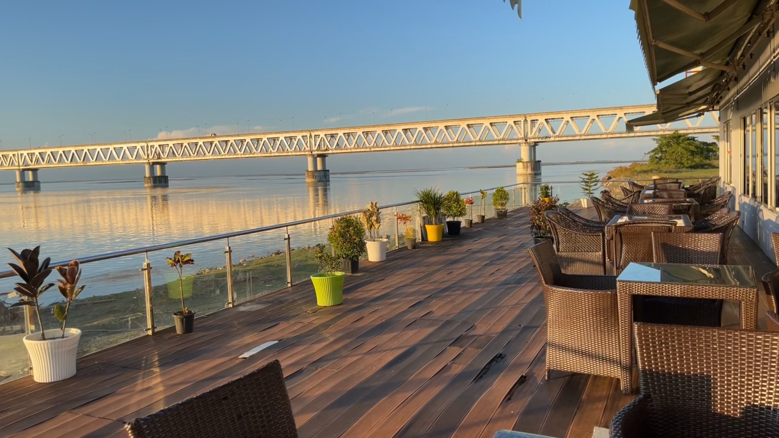
Fig.2. The Bogibeel Bridge is the longest rail-cum-road bridge of India on the Brahmaputra River in Assam

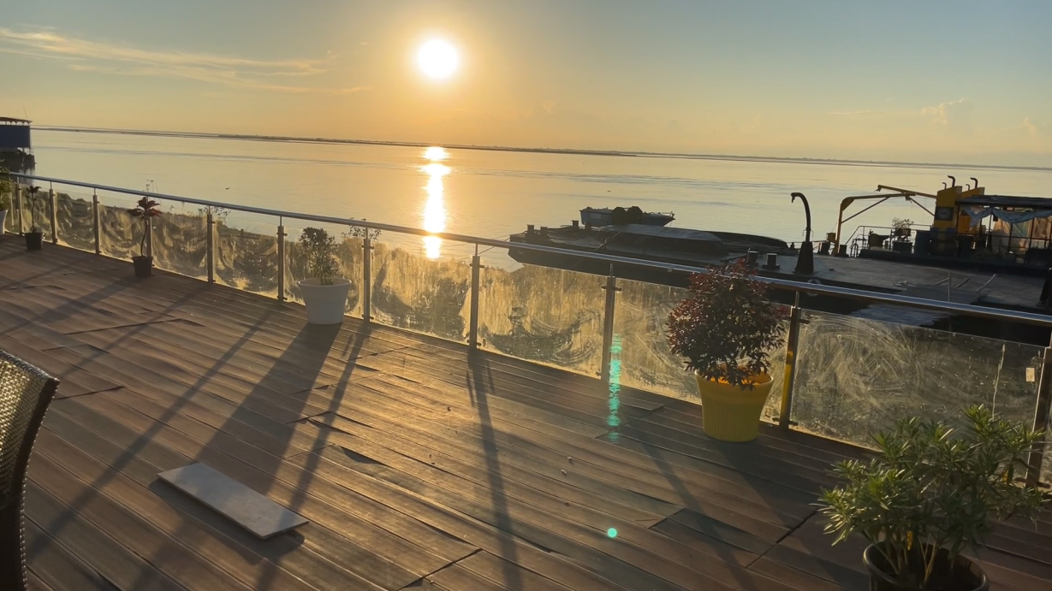
Fig.3. Bogibeel bridge sunset on the Brahmaputra river in Assam
References:
- Abbas, E. W., Rusmaniah, R., Mutiani, M., Putra, M. A. H., & Jumriani, J. (2022). Integration of River Tourism Content in Social Studies Teaching Materials as an Efforts to Strengthen Student Understanding. The Innovation of Social Studies Journal, 4(1), 11-33. https://doi.org/10.20527/iis.v4i1.6312
- Amnuay-ngerntra, S., & Hideki, S. (2013). Developing river tourism on the upper Mekong: Challenges and opportunities. European Journal of Business and Social Sciences, 1(10), 36-51.
- Cheng, Y., Zhu, K., Zhou, Q., El Archi, Y., Kabil, M., Remenyik, B., & Dávid, L. D. (2023). Tourism Ecological Efficiency and Sustainable Development in the Hanjiang River Basin: A Super-Efficiency Slacks-Based Measure Model Study. Sustainability, 15(7), 6159. https://doi.org/10.3390/su15076159
- Chutia, S. (2015). Prospects and Problems of Tourism Industry in Assam. International Journal of Innovative Research in Science, Engineering and Technology. https://doi.org/10.15680/IJIRSET.2015.0402083
- CLIA 2005. Industry predicts cruising will be vacation of choice in 2005, Cruise Line International Association News Releas. Available at www.cruising.org (accessed 19 January 2005).
- Collins-Kreiner, N. (2010). Researching pilgrimage: Continuity and transformations. Annals of Tourism Research, 37(2), 440-456. https://doi.org/10.1016/j.annals.2009.10.016
- Das, D. (2012). Prospects and problems of tourism industry in Assam. Global Research Methodology Journal. https://aranyasuraksa.com/grmjournal/Vol-II_7th_issue_Nov-Dec-Jan_2012-13.pdf
- Das, R. (2017). Prospects and problems of tourism in Assam. International Journal of Advanced Educational Research, 2(5), 70-73.
- Fachrudin, H. T., & Lubis, M. D. (2016). Planning for riverside area as water tourism destination to improve quality of life local residents, case study: Batuan–Sikambing River, Medan, Indonesia. Procedia-Social and Behavioral Sciences, 234, 434-441. https://doi.org/10.1016/j.sbspro.2016.10.261
- Ferguson, L. (2007). The United Nations World Tourism Organisation. New Political Economy, 12(4), 557-568. https://doi.org/10.1080/13563460701661587
- Frank, A. G. (1992). The Centrality of Central Asia. Studies in History, 8(1), 43-97. https://doi.org/10.1177/025764309200800103
- Ghanem, J. (2017). Conceptualizing “the Tourist”: A critical review of UNWTO definition. (Master's thesis). Universitat de Girona. http://hdl.handle.net/10256/14825
- Gibson, P. (2004). Life and learning in further education: constructing the circumstantial curriculum. Journal of Further and Higher Education, 28(3), 333–346. https://doi.org/10.1080/0309877042000241797
- Gibson, P. (2006). Cruise operations management: Hospitality perspectives. Butterworth-Heinemann. https://doi.org/10.4324/9780080456300
- Gibson, P. (2008). Cruising in the 21st century: Who works while others play?. International Journal of Hospitality Management, 27(1), 42-52. https://doi.org/10.1016/j.ijhm.2007.07.005
- Hall, C. M., & Page, S. J. (2009). Progress in tourism management: From the geography of tourism to geographies of tourism – A review. Tourism Management, 30(1), 3-16. https://doi.org/10.1016/j.tourman.2008.05.014
- Hall, C. M., & Page, S. J. (2014). The geography of tourism and recreation: Environment, place and space. Routledge. https://doi.org/10.4324/9780203796092
- Hobson, J. P. (1993). Analysis of the US cruise line industry. Tourism Management, 14(6), 453-462. https://doi.org/10.1016/0261-5177(93)90098-6
- Mahanta, B. (2023). The Brahmaputra River Tourism Development In Guwahati Metro. The Researchers' International Research Journal, 9(1), 29-35. https://doi.org/10.21276/tr.2023.9.1.AN3
- Mak, J. (2003). Tourism and the economy: Understanding the economics of tourism. University of Hawaii Press. https://uhpress.hawaii.edu/title/tourism-and-the-economy/
- Marti, B. E. (2004). Trends in world and extended-length cruising (1985–2002). Marine Policy, 28(3), 199–211. https://doi.org/10.1016/j.marpol.2003.09.004
- Moreira, C. O., & Santos, N. P. (2010). New opportunities for water environments: River tourism and water leisure activities. In E. Brito-Henriques, J. Sarmento, & M. A. Lousada (Eds.), *Water and tourism: Resources management, planning and sustainability* (pp. 147–168). Centro de Estudos Geográficos, Universidade de Lisboa. https://hdl.handle.net/10316/20067
- Mowforth, M., & Munt, I. (2016). Tourism and Sustainability: Development, Globalisation and New Tourism in the Third World. https://doi.org/10.4324/9781315795348
- Newsome, D., Moore, S. A., & Dowling, R. K. (2013). Natural area tourism: Ecology, impacts and management (2nd ed.). Channel View Publications. https://www.channelviewpublications.com/title-detail/natural-area-tourism/
- Peisley, T. 1992. The world cruise ship industry in the 1990’s. Special Report No. 2104. London: Economist Intelligence Unit.
- Peisley, T. 2006. The future of cruising – boom or bust, Seatrade Research Report (Colchester: Seatrade).
- Pinnock, F. (2014). The future of tourism in an emerging economy: the reality of the cruise industry in Caribbean. Worldwide Hospitality and Tourism Themes, 6(2), 127-137. https://doi.org/10.1108/WHATT-12-2013-0052
- Prideaux, B. (2018). Canals: An old form of transport transformed into a new form of heritage tourism experience. In F. Vallerani & F. Visentin (Eds.), Waterways and the Cultural Landscape (pp. 143-157). Routledge. https://doi.org/10.4324/9781315398464
- Prideaux, B. (2023). River and Canal Waterways as a Tourism Resource. In J. S. Chen (Ed.), Advances in Hospitality and Leisure (pp. 137–153). https://doi.org/10.1108/S1745-354220220000018008
- Prideaux, B., & Cooper, M. (Eds.). (2009). River Tourism. CABI. https://doi.org/10.1079/9781845934682
- Prideaux, B., Timothy, D. J., & Cooper, M. (2009). Introducing river tourism: physical, ecological and human aspects. In B. Prideaux & M. Cooper (Eds.), River tourism (pp. 1-22). CABI. https://doi.org/10.1079/9781845934682.0001
- Prideaux, B., Timothy, D. J., & Cooper, M. (2009). Introducing river tourism: Physical, ecological and human aspects. In B. Prideaux & M. Cooper (Eds.), River tourism (pp. 1-22). CABI. https://doi.org/10.1079/9781845934682.0001
- Ramsey, D., & Malcolm, C. D. (2018). The importance of location and scale in rural and small town tourism product development: The case of the Canadian Fossil Discovery Centre, Manitoba, Canada. The Canadian Geographer/Le Géographe canadien, 62(2), 250-265. https://doi.org/10.1111/cag.12409
- Shakiry, A. S. (2007). River Tourism: Can Iraq Benefit from Europe’s experience.
- Sharpley, R. (2002). Tourism: a vehicle for development?. In R. Sharpley & D. J. Telfer (Eds.), Tourism and development: Concepts and issues (pp. 11-34). Channel View Publications. https://www.cabidigitallibrary.org/doi/10.1079/9780851995538.0011
- Stylidis, D., Biran, A., Sit, J., & Szivas, E. M. (2014). Residents' support for tourism development: The role of residents' place image and perceived tourism impacts. Tourism Management, 45, 260-274. https://doi.org/10.1016/j.tourman.2014.05.006
- Tandon, N. (2012). Sustainability issues in river tourism: A case study of Ganges in Varanasi. Atna Journal of Tourism Studies, 7(2), 87-102. https://doi.org/10.12727/ajts.8.5
- Tomej, K., & Lund-Durlacher, D. (2020). Research note: River cruise characteristics from a destination management perspective. Journal of Outdoor Recreation and Tourism, 30, 100301. https://doi.org/10.1016/j.jort.2020.100301 .
- Tomej, K., & Lund-Durlacher, D. (2020). Research note: River cruise characteristics from a destination management perspective. Journal of Outdoor Recreation and Tourism, 30, 100301. https://doi.org/10.1016/j.jort.2020.100301 .

