Cryotechnic Space Rocket Engines: Importance of the Pre-Ignition Transient

.
ABSTRACT

The safe ignition of cryotechnic space launchers is threatened by flow instabilities that occur before ignition, a phase that remains poorly understood. While most research focuses on post-ignition instabilities, we investigated the critical few hundred milliseconds preceding ignition. Using injectors simulating LOX flow in Vulcain and Vinci engines, we studied this transient phase for two conditions: 1) with nitrogen only, 2) with helium gas injected simultaneously with nitrogen during the 150 first milliseconds. Our measurements revealed that the inert gas purge eliminated high-frequency thermoacoustic instabilities, stabilizing the flow. We hypothesize this is due to a reduction in the thermal gradient between the wall and the flow, which likely enhances engine ignition reliability.

Keywords: cryogenic engine; cryotechnic engine; ignition; instabilities; frequency; space rocket; two-phase.

1. INTRODUCTION

Igniting cryogenic rocket engines is crucial for space missions, as improper timing or power can jeopardize the mission. Controlling ignition and re-ignition based on pre-ignition transients is critical: ignition failure or prolonged ignition can cause launcher loss or engine explosion due to gas accumulation in the combustion chamber, potentially destroying payloads (Haydn et al., 2008).
Cryogenic space rocket engines can function at either low or high pressure under nominal conditions, depending on the specific technology employed. Ignition typically involves a pre-ignition transient phase, characterized by low pressure before the activation of turbopumps required to achieve high pressure (Cho et al., 2004). Most of the studies available in scientific literature address the problems of these engines when ignition has already taken place and the combustion of propellants contributes to the instability of the system (e.g. Vekilov et al.’s review, 2024). This is characterized by high pressures since turbopumps using propergols (usually LOX et LH2) have started to work, contributing to instabilities characterized by high-frequency oscillations (>1kHz). However, the pre-ignition phase is characterized by low pressures and low frequency instabilities: “Strong LF [low frequency] instabilities arose during the start-up transient, […] corresponding to the time when the LOX flow across the injector orifice experienced a phase change with dropping LOX injection temperature and increasing pressure” (Son et al., 2023:2) occurring when coolant flow vaporized (Casiano et al., 2010). LF is usually less than 200Hz (Bennewitz et al., 2013; Vekilov et al., 2024).
The purpose of this paper is to contribute to filling the gap of the characterization of pre-ignition phase in cryogenic rocket engines.

Nomenclature
SYMBOLS & UNITS
Symbol Quantity Units
α Void fraction None
γ Surface tension N/m
ρ Density g/m³
A Area m²
d Diameter m
dp Pressure drop Pa
f, F Force N
G Mass flow g/s
p Pressure Pa
s Slip ratio None
T Temperature K
t Time s
v Velocity m/s
We Weber number None
X Vapor quality None

SUBSCRIPTS
Symbol Relates to
l Liquid
SG/SL relates to superficial velocity of gas and liquid resp.
g Gas
Exit Injector exit

ABBREVIATIONS
Symbol Definition
He Helium
LOX Liquid oxygen
LN2/GN2 Liquid / Gas nitrogen
N2 Nitrogen
O2 Oxygen

2. material and methods

2.1. Design

Experiments used a mock-up with liquid nitrogen (LN2) simulating LOX supply in one injector typical of the cryotechnic Vulcain or Vinci space engines during a 300ms pre-ignition transient (Fig. 1 & 2). LN2 was stored in a pressurized, insulated tank and delivered to the injector through a solenoid gate valve. Stainless steel was used in the construction of the mock-up.
LN2 was kept at 3.5bar and 77K to represent pre-ignition conditions before starting the turbopumps. An inert gas sweep (0.1g/s), using helium like in the rocket engine, was carried out, maintained constant and independent from downstream pressure by creating a sonic flow through a micrometric valve.
The injector was made up of five parts (Fig. 2): a converging part (angle: 15°, length: 1.5mm), inlet (diameter: 2mm, length: 3 mm), diverging part (angle: 51°, length: 1mm), cylindrical part (diameter: 4.5mm, length: 14.5mm), converging part (angle: 37°, length: 1mm), outlet part (diameter: 3mm, length: 18mm).

2.2. Procedure

Two conditions were tested: (1) inert gas sweep before opening the LN2 valve, and (2) inert gas sweep before and 150ms after opening the LN2 valve.
In both conditions, the time t=0 was associated with the opening of the LN2 valve which was closed 300ms after. Data acquisition was performed during these 300ms.

2.3. Metrology

Along the injector, pressure was measured in three points by piezoresistive sensors: before inlet (according to the fluid low) p₁, entrance constriction p₂, before exit p₃. At the exit of the injector where external pressure p₄ ; void fraction and thrust were measured by means resp. of a microwave resonator and a plate mounted on a piezoelectric load cell (Fig. 1 & 2). This metrology is fully described in a previous study (Fauquet-Alekhine, 2016).

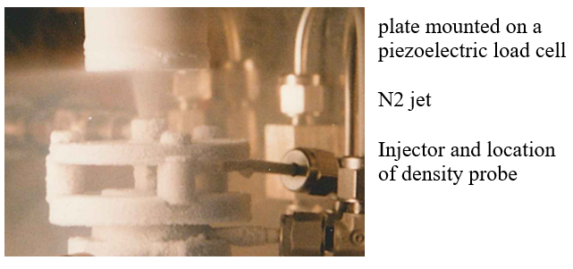
Fig. 1. View of the N2 jet at injector exit impacting plate.

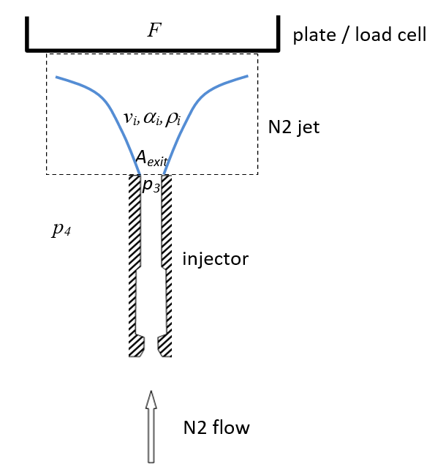
Fig. 2. Sketch of the N2 jet at injector exit impacting plate.

Measurements of these parameters acquired at 5ms interval allowed us to calculate the mass flow rate G vs pressure drop d_{p}=p₃ – p₄ at the exit. Characteristics of pressure and force probes are given in Table 1.

Table 1. Characteristics of pressure and force probes.

Physical quantity |  | probe |  | sensitivity |  | range |  | resolution |  | temperature range |  | temperature sensitivity
pressure | miniature piezoresistive sensors |  | 5pC/bar |  | 0-200bar |  | 0.005bar |  | -196 to +240°C |  | 2.10⁻⁴ /°C
force | piezoelectric load cell |  | 46.8pC/N |  | -500 to +500N |  | 0.005N |  | -115 to +240°C |  | 2.10⁻⁴ /°C

Density measurement was the most sensitive aspect of the metrology. Two-phase flow density was estimated using a cylindrical hyperfrequency resonator placed at the injector exit, with fluid passing through its axis. The method calculated fluid density ρ_{m} from the resonator's resonance frequency, which depends on the fluid's dielectric permittivity. Its principle was described in (Krupka, 2006; Paez et al., 2015) and fully described in a previous study (Fauquet-Alekhine, 2016).
Based on the volume balance indicated by the dotted line in Fig. 2 and applying the momentum conservation equation, the total N2 mass flow G at the injector exit was derived as demonstrated by Fauquet-Alekhine (2016): the total N2 mass flow G at injector exit can be estimated as follows:

$G^{2}= A_{exit}ρ_{m}f$ (1)

with:
$f=F- A_{exit} \left(p_{3}-p_{4}\right)$ (2)
$ρ_{m}= αρ_{g}+ \left(1-α\right)ρ_{l}$ (3)

3. results and discussion

3.1. Type of flow

The data collected clearly show an unstable flow under both conditions, with similar period in both conditions for large amplitude oscillations, and a final flow rate at t=300ms twice higher for condition 2 when compared with condition 1.

The analytical framework for the present research is informed by preceding work of Fauquet-Alekhine (2016). In that study, a detailed analysis of experimental data led to the identification of a distinct flow progression, beginning as an inverted annular flow and evolving into a fully developed mist flow. A mist flow, by definition, is a highly dispersed regime where the liquid phase exists as a population of small, spherical droplets entrained within a continuous gaseous vapor. The propensity of the flow to achieve such a homogeneous state was largely attributed to the specific thermophysical properties of the working fluid, liquid nitrogen. Namely, the small ratio of liquid to vapor density and the intrinsically low viscosity of liquid nitrogen acted in concert to reduce interfacial tension and enhance phase mixing, thereby favoring the formation of a uniform mixture.
Moreover, the flow conditions presented in the present article were studied previously (Fauquet-Alekhine, 2016) and were determined to be critical, with dynamic instabilities manifesting as thermoacoustic oscillations (TAO). To provide a broader context for flow regime classification, the seminal work of Fu et al. (2008) was found highly relevant. Their investigation, which focused on stabilized vertical flows of nitrogen in a narrow duct (1.931 mm internal diameter), produced several seminal two-phase flow regime maps. Among these, the map correlating mass flux G with vapor quality X provided a particularly useful benchmark. By cross-referencing the operational parameters of the study with this specific map from Fu et al. (2008), a classification was suggested. The comparative analysis clearly positioned the data within the annular flow regime, as a fundamental characteristic of the flows under the conditions considered in the study.
An illustration is given in Fig.3 for the flow rate.

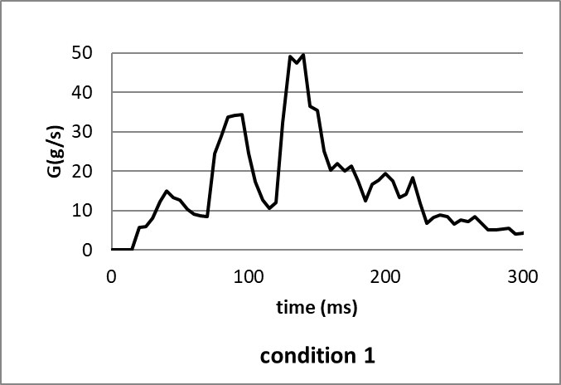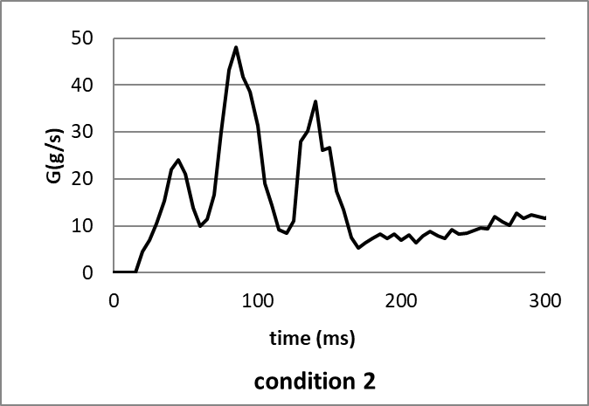
Fig. 3. Flow rate calculated in condition 1 and condition 2.

Reconsidering the work of Fu et al. (2008), we found that the map flow of Fu et al. expressed in terms of We_{GS} versus We_{LS} gave a more accurate characterization with:

${We}_{GS}= \frac{d}{γ} . \frac{G^{2}X^{2}}{ρ_{G}}$ and ${We}_{LS}= \frac{d}{γ} . \frac{G^{2}{(1- X)}^{2}}{ρ_{L}}$ (4a&b)

Since vapor quality is close to 1, the value of We_{LS} is close to 0 while We_{GS} varies significantly during flow. It is therefore the value of We_{GS} that characterizes the flow. Fig. 4 represents the map flow of Fu et al. (2008) in terms of We. The points characterizing the flow under both conditions are shown. When the flow is of the slug type, the points of the two conditions overlap. When the flow is annular, the points are clearly differentiated, with the superficial velocity of the gas in condition 2 being significantly higher than that of condition 1. We_{GS} thresholds for transitions are: 5m/s for churn or slug / bubbly, 45m/s for annular / churn.

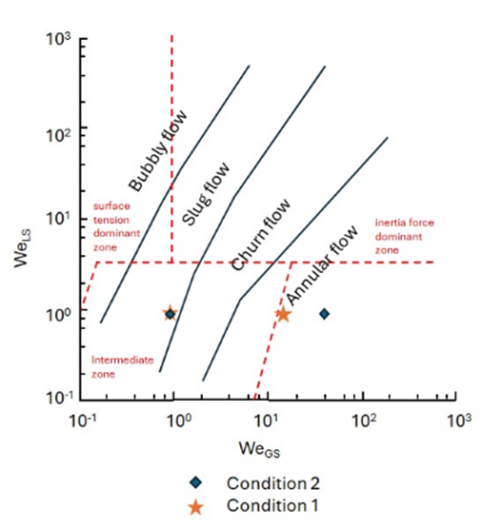
Fig. 4. Flow map superficial Weber numbers from Fu et al. (2008) and location of the present experimental conditions.

The We map flow confirms that the flows are of the annular type under both conditions, but only over a short period at the beginning of the injection.
When the evolution of We_{GS} for the two conditions is plotted as a function of the flow time and is compared to the thresholds identified for the flow regime transitions, the transition times are as follows (see Fig. 5):
- The annular flow is identifed:
  - from t=50 to 60ms in condition 1
  - from t=40 to 55ms in condition 2
- This episode is followed by a churn flow passage:
  - from t=50 to 60ms in conditions 1 and 2
- The flow is slug type for the remaining periods, especially beyond the first 100 milliseconds under both conditions.

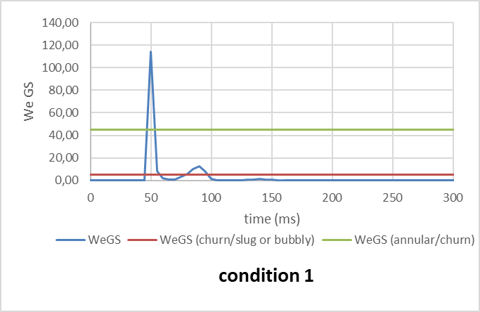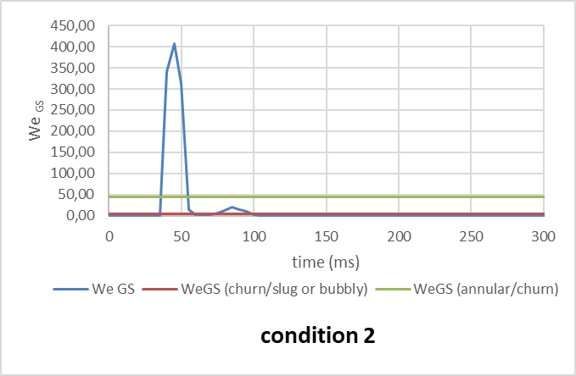

Fig. 5. Evolution of superficial Weber number for gas phase from Fu et al. (2008) with time (note that the scale of the y-axis is different on each of the graphs for the sake of curve visibility).
We thresholds for transitions: 5m/s for churn or slug / bubbly, 45m/s for annular / churn.

These two periods of annular flow and churn flow correspond to the first two flow rate peaks Fig.3.

The analysis and interpretation of the present experimental results can be significantly informed by the work of Hu et al. (2012). Their investigation provided a characterization of vertical two-phase nitrogen (N2) flows within an 8mm diameter pipe, employing a robust methodology that combined direct measurement with high-speed videography. This approach allowed for a detailed, visual documentation of the flow regime transitions. Crucially, under conditions analogous to those established in the current study, Hu et al. meticulously delineated the thermal-hydraulic phenomena of the chilldown process, the initial cooldown phase when cryogenic nitrogen first enters a warm pipe. Their observations revealed a dramatic and rapid evolution of flow patterns. Specifically, Hu et al. determined that during the initial stages of chilldown and under high mass flow rates (according to Hu et al.’s criteria, conditions 1 and 2 of the present study are high mass flow rates), the flow structure progresses through distinct phases. It begins as an inverted annular flow, where a continuous liquid core is surrounded by a vapor film, and subsequently transitions into a mist flow regime. The latter is characterized as a highly dispersed flow, consisting of numerous small, spherical liquid droplets entrained within a continuous gaseous vapor phase. A critical insight from their research, which is particularly relevant for the present findings, is their explanation that these specific flow transitions occur while the pipe wall temperature remains elevated when compared with that of the fluid, specifically above the critical rewetting temperature. This suggests that the flow mechanics during early chilldown are dominated by violent boiling and entrainment processes at the liquid-vapor interface, rather than by direct and stable liquid-wall contact.

The fundamental difference between flow regimes lies in which fluid forms the continuous medium. In mist flow, the gas is continuous. The liquid is dispersed as droplets within this continuous gas stream. In slug and churn flow, the liquid is continuous. The gas is in large, coherent structures (slugs) or churns through the liquid.

All these considerations suggest considering that the continuous phase of the two phase flow moves from gas to liquid from t=0ms to about 50ms.

The Fourier transform analysis (FFT) of the frequencies of the evolution of the flow rate G over time also indicates specific characteristics (Fig.6). In both cases, three frequency modes are dominant: a 25Hz mode (period: 40ms) and a 13Hz mode (period: 80ms) corresponding to the flow oscillations. The third mode at 50Hz (period: 20ms) corresponds to the secondary oscillations of the flow rate. These modes are consistent with studies carried out elsewhere (e.g. Fu et al., 2008; Hu et al., 2012). It is interesting to note that beyond t=100ms, the 25Hz mode fades under both conditions and the observation of the evolution of the flow rates Fig. 3 indicates that the high amplitude oscillations disappear beyond t=170ms in both conditions. On the other hand, in condition 1, the 13Hz mode persists while it fades in condition 2. The 50Hz mode remains in condition 1 with a slight offset (40-45Hz) and fades in condition 2.

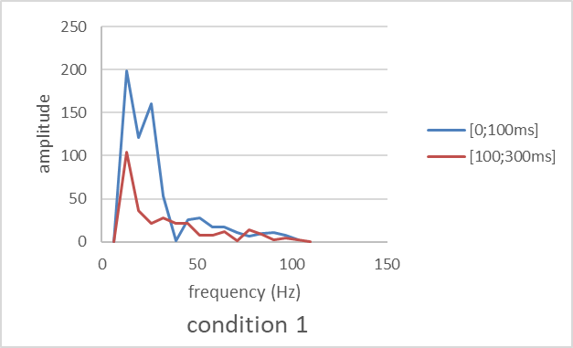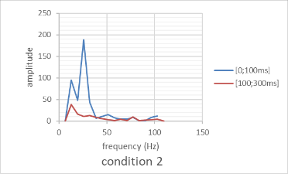

Fig. 6. FFT of flow rate signal in condition 1 and condition 2.

It is tempting to relate oscillations observed in conditions 1 and 2 to the pressure drop oscillation (PDO), or to density wave oscillation (DWO) mechanism due to vaporization of LN2 in the injector, the former sustaining the latter. However, these kinds of instabilities are associated with large amplitude excursion of the physical quantities (Kakac & Bon, 2008). The frequency identified here are typical of low-frequency (LF) thermo-acoustic oscillations (TAO) (Ruspini et al., 2014; Smirnov et al., 1997; Tadrist, 2007), linked with resonance of pressure waves inside the considered system and related to the time needed for the pressure waves to propagate in the system. This is coherent with other studies. Startup of the engine is characterized by LF instabilities (Son et al., 2023) occurring when coolant flow vaporized (Casiano et al., 2010). Tadrist’s review (2007:55) addressing two-phase flow instabilities in narrow spaces concluded that TAO in small millimeter ducts are characterized by low frequency (<100Hz) and explained “This instability is triggered by the amplitude film thickness variation, bubble collapse, which in turn induces a change in pressure. The amplitude of the acoustic oscillations is generally small with frequencies varying in the range 10–100 Hz”.
These observations are combined with the variation in flow rate beyond t=170ms. For condition 1, the flow G follows a downward slope of 20 to 4 g.s⁻¹, while for condition 2, G follows an upward slope of 5 to 12 g.s⁻¹. In terms of the velocity of the two-phase flow, in condition 1, it oscillates around 40m/s (+-20m/s) before t=170ms then the amplitude of the oscillations decreases (±10m/s) still around 40m/s, while in condition 2, the velocity oscillates around 60m/s (±20m/s) before t=170ms then the amplitude of the oscillations decreases around 70m/s (±10m/s). Regarding the density of the flow, after t=170ms, at the end of the injection period, it is unstable and decreases in condition 1 while it is stable in condition 2.
In summary, the He sweep in condition 2 has an optimizing effect on the flow compared to condition 1 by reducing instabilities and increasing the flow rate.
Another positive factor in condition 2 is the evolution of the flow rate over the final 130ms: it increases due to the increase in velocity combined with a stable density. In condition 1, the flow rate decreases, which is not in favor of a correct ignition of the engine a priori.
The hypothesis that is made to explain this difference between the two conditions is that in condition 2, the He sweep increases the temperature of the two-phase medium and reduces the temperature gradient between the injector wall and the fluid flow compared to condition 1. Thus, thermal effects may be assumed as major to explain the differences between the two conditions.
The stability map by Ishii and Ishii & Zuber (1970), which uses dimensionless subcooling and phase change numbers, suggests that He reduces both heat flux and inlet subcooling enthalpy. This shifts the operating point towards a more stable region on the map. Further investigations are needed to discuss this hypothesis in depth.

4. Conclusion

We studied the pre-ignition transient in a full-scale space rocket engine injector (used in the Ariane 6 launcher) under conditions simulating O2 flow, using N2. Prolonged inert gas (He) sweeping optimized flow during the pre-ignition phase, an important discovery for stabilizing cryotechnic engines and favoring reliable ignition. The flow was found critical with instabilities analyzed as being thermoacoustic oscillations (TAO). Thermal effect was identified as major in the production of these oscillations, with a rapid transition of the continuous phase (around 50ms) from gas to liquid.
Additional experiments are needed to measure how heat flux and subcooling enthalpy contribute to stabilization. Gaining this knowledge could help improve future spaceflight engines, as each (re)ignition phase carries a notable risk of failure.

COMPETING INTERESTS DISCLAIMER:
Authors have declared that they have no known competing financial interests OR non-financial interests OR personal relationships that could have appeared to influence the work reported in this paper.

References

Bennewitz, J. W., & Frederick, R. A. (2013). Overview of combustion instabilities in liquid rocket engines-coupling mechanisms & control techniques. 49th AIAA/ASME/SAE/ASEE Joint Propulsion Conference, 4106, 1-14.
Casiano, M. J., Hulka, J. R., & Yang, V. (2010). Liquid-propellant rocket engine throttling: A comprehensive review. Journal of propulsion and power, 26(5), 897-923.
Cho, N., Kim, S., Kim, Y., Jeong, S., & Jung, J. (2004). Two-phase flow characteristics of liquid oxygen flow in low pressure liquid rocket engine. Cryogenics, 44(6-8), 493-500.
Fauquet-Alekhine, P. (2016). Improvement of Cryogenic Space Rocket Engine Ignition: Inert Gas Sweep Effects. Physical Science International Journal, 9(2), art.PSIJ.22317, 1-14.
Fu, X., Qi, S. L., Zhang, P., & Wang, R. Z. (2008). Visualization of flow boiling of liquid nitrogen in a vertical mini-tube. International journal of multiphase flow, 34(4), 333-351.
Haidn, O. J. (2008). Advanced Rocket Engines. In Advances on Propulsion Technology for High-Speed Aircraft, Educational Notes, Neuilly-Sur-Seine, Vol. 6, No (pp. 1-40). RTO-EN-AVT-150.
Hu, H., Chung, J. N., & Amber, S. H. (2012). An experimental study on flow patterns and heat transfer characteristics during cryogenic chilldown in a vertical pipe. Cryogenics, 52(4-6), 268-277.
Ishii, M., & Zuber, N. (1970). Thermally induced flow instabilities in two phase mixtures. In International Heat Transfer Conference 4, 26, 1-12. Begel House Inc.
Kakaç, S., & Bon, B. (2008). A review of two-phase flow dynamic instabilities in tube boiling systems. International journal of heat and mass transfer, 51(3-4), 399-433.
Krupka, J. (2006). Frequency domain complex permittivity measurements at microwave frequencies. Measurement Science and Technology, 17(6), R55.
Paez, E. J., Callarotti, R. C., & Sanchez, Y. (2015). Measurable dielectric permittivity range for TE and TM modes in a shielded dielectric resonator. Journal of Electromagnetic Analysis and Applications, 7(06), 189-197.
Ruspini, L. C., Marcel, C. P., & Clausse, A. (2014). Two-phase flow instabilities: A review. International journal of heat and mass transfer, 71, 521-548.
Smirnov, H. F., Zrodnikov, V. V., & Boshkova, I. L. (1997). Thermoacoustic phenomena at boiling subcooled liquid in channels. International journal of heat and mass transfer, 40(8), 1977-1983.
Son, M., Börner, M., Armbruster, W., & Hardi, J. S. (2023). Orifice flow dynamics in a rocket injector as an excitation source of injector-driven combustion instabilities. Aerospace, 10(5), art.452, 1-16.
Tadrist, L. (2007). Review on two-phase flow instabilities in narrow spaces. International Journal of Heat and fluid flow, 28(1), 54-62.
Vekilov, S., Lipovskyi, V., & Pustovyi, R. (2024). The problem of combustion instability in liquid rocket engines. Challenges and Issues of Modern Science, 2, 100-110.

