Case report
An eyelid mass revealing an intraorbital schwannoma: a rare case report

Abstract:
Introduction:
Orbital schwannomas are rare benign tumors arising from Schwann cells of peripheral nerve sheaths and account for a small percentage of orbital masses. They are most commonly located within the intraconal space, while involvement of extraocular muscles is exceptional. We report a rare case of an isolated schwannoma originating from the inferior rectus muscle.
Case Presentation:
A 60-year-old woman with no significant medical history presented with a progressive left lower eyelid swelling evolving over three months, associated with binocular vertical diplopia. Ophthalmological examination revealed normal best-corrected visual acuity in both eyes, left hypertropia, a well-circumscribed inferior eyelid mass, and limitation of infraduction. Orbital magnetic resonance imaging demonstrated a well-defined lesion arising from the left inferior rectus muscle, measuring 21 × 13.5 × 12 mm, hypointense on T1-weighted images, hyperintense on T2-weighted images, with peripheral gadolinium enhancement. The lesion displaced the globe superiorly without intraocular extension. Histopathological examination following transconjunctival biopsy confirmed the diagnosis of schwannoma. Complete en bloc surgical excision was achieved via a subciliary approach. The postoperative course was uneventful, and no recurrence was observed after one year of follow-up.
Discussion:
Orbital schwannomas represent approximately 1–6.5% of orbital tumors and typically present with slowly progressive symptoms related to mass effect. Imaging, particularly MRI, plays a crucial role in lesion characterization and surgical planning, while histopathological analysis remains essential for definitive diagnosis. Complete surgical excision is the treatment of choice and is associated with excellent outcomes and a low recurrence rate.
Conclusion:
Although rare, intraorbital schwannoma should be considered in the differential diagnosis of atypical orbital masses presenting with diplopia. MRI findings are suggestive, but histological confirmation is necessary. Early and complete surgical excision offers a favorable prognosis.
Keywords: schwannoma, muscle, orbital masses, exophtalmos
Introduction:
Orbital schwannomas are rare benign neoplasms that arise from Schwann cells of the peripheral nerve sheaths within the orbit. They represent a small fraction of orbital tumors, accounting for approximately 1–6.5% of all orbital masses. These tumors are typically slow growing and well encapsulated, which often results in a delayed clinical presentation. Most orbital schwannomas are located within the intraconal space and originate from sensory branches of the trigeminal nerve; less commonly, they may arise from motor nerves supplying the extraocular muscles.
Clinical presentation is variable and largely depends on tumor size, growth rate, and anatomical location. While many patients remain asymptomatic for prolonged periods, progressive mass effect may eventually lead to symptoms such as painless exophthalmos, diplopia, ocular motility disturbances, or visual impairment. Involvement of the extraocular muscles is particularly uncommon and may pose a diagnostic challenge, as it can mimic more frequent orbital or palpebral pathologies, including inflammatory, vascular, or myogenic lesions.
Magnetic resonance imaging (MRI) plays a central role in the evaluation of orbital schwannomas by allowing precise localization and characterization of the lesion, as well as assessment of its relationship to adjacent orbital structures. However, imaging features are not specific, and histopathological examination remains mandatory for definitive diagnosis.
We report herein a rare and unusual case of an isolated schwannoma originating from the inferior rectus muscle in a 60-year-old woman, presenting as a lower eyelid mass associated with diplopia. This case underscores the diagnostic challenges posed by extraocular muscle schwannomas and highlights the importance of considering this entity in the differential diagnosis of atypical orbital masses.

Case presentation:
A 60-year-old woman with no significant past medical history presented with a progressive left lower eyelid swelling evolving over three months, associated with binocular vertical diplopia. Ophthalmological examination revealed a best-corrected visual acuity of 10/10 in both eyes. Ocular motility assessment showed left hypertropia (figure 1) associated with a well-circumscribed inferior eyelid mass, mobile relative to the superficial plane, and limitation of infraduction. The remainder of the anterior and posterior segment examination was unremarkable.
Orbital magnetic resonance imaging (MRI) demonstrated a well-defined lesion arising from the left inferior rectus muscle, measuring 21 × 13.5 × 12 mm (figure 2). The lesion appeared hypointense on T1-weighted images, hyperintense on T2-weighted images, with peripheral contrast enhancement following gadolinium administration. The mass displaced the globe superiorly without intraocular extension and was associated with grade I exophthalmos.
A transconjunctival biopsy was performed, revealing a benign mesenchymal neoplasm with neural differentiation consistent with a schwannoma. Complete en bloc excision was achieved via a subciliary approach (figures 3+4) . Histopathological examination revealed a spindle-cell mesenchymal proliferation with a low proliferative index, with Ki-67 expression in approximately 3% of tumor cells (figures 5-8). The postoperative course was uneventful. Clinical and radiological follow-up was maintained for one year, with no evidence of local recurrence(figure 9).


Figure 1: clinical examination showing left exophthalmos associated with hypertropia.

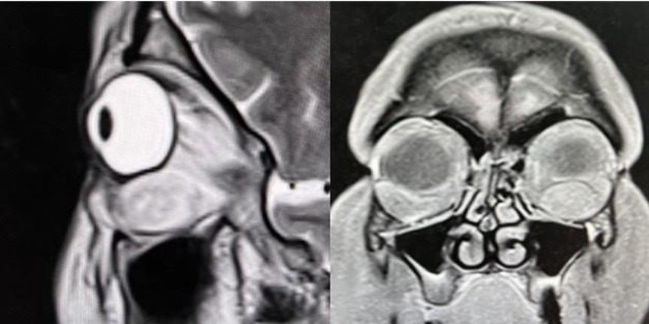
Figure 2: Sagittal and frontal orbital MRI section demonstrated a well-defined lesion arising from the left inferior rectus muscle.
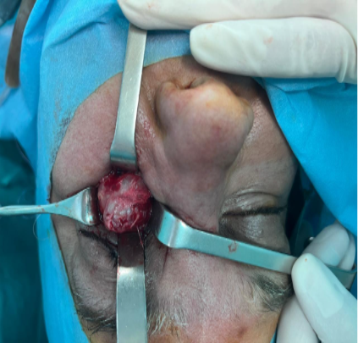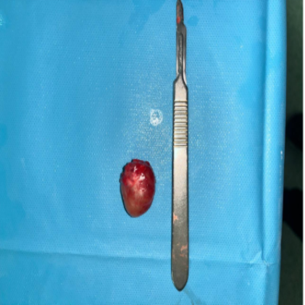

Figures 3 and 4: Intraoperative appearance of the tumor

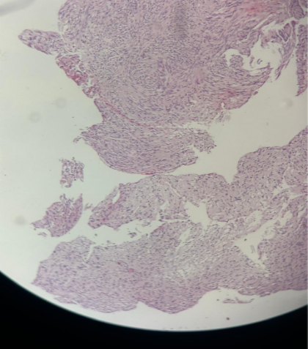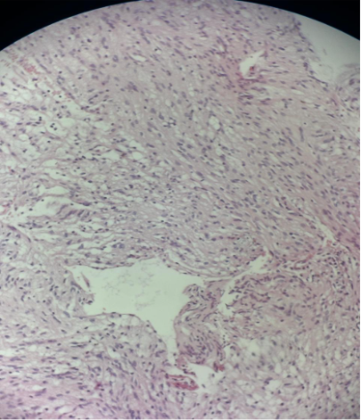
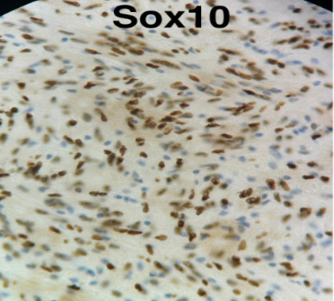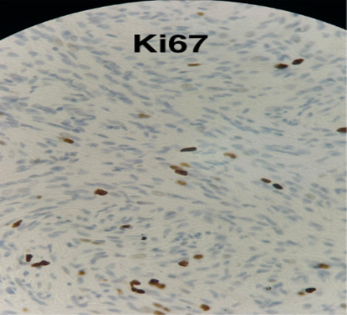
Figures 5–8: Immunohistochemical images (×40 magnification) showing a spindle-cell mesenchymal proliferation with a low proliferative index, with Ki-67 expression in approximately 3% of tumor cells

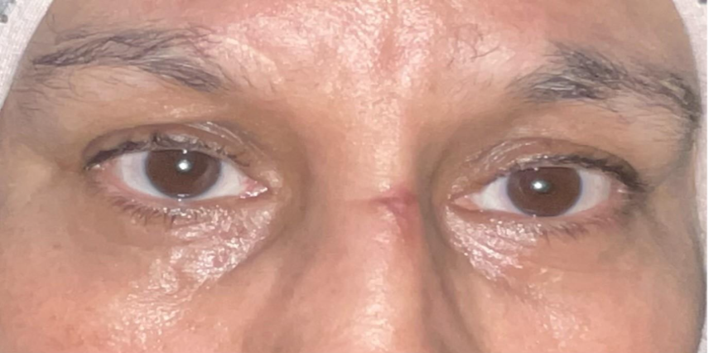
Figure 9: Postoperative follow-up at 9 months

Discussion:
Orbital schwannomas are uncommon benign tumors, accounting for approximately 1–6.5% of all orbital tumors, and originate from Schwann cells of peripheral nerves within the orbit [1]. Large clinical series and reviews have confirmed their rarity and emphasized the diagnostic difficulty posed by these tumors due to their nonspecific presentation [7]. They are most often intraconal and arise from sensory nerves; isolated involvement of extraocular muscles remains exceptional [1,8].
Due to their slow-growing nature, orbital schwannomas typically become clinically apparent after the second decade of life, often after a prolonged asymptomatic period [2]. Several authors have reported delayed diagnosis related to the indolent evolution of these tumors, allowing progressive enlargement before clinical detection [7]. However, atypical presentations, including rapidly enlarging lesions, have also been described and may raise concern for malignancy [9].
Although frequently asymptomatic, orbital schwannomas may present with painless progressive exophthalmos, orbital discomfort, diplopia, or visual disturbances related to mass effect [3]. Diplopia is more frequently observed when the tumor arises from or infiltrates an extraocular muscle, as reported in cases involving the inferior rectus or medial rectus muscles [1,2,8]. Palpebral swelling as the initial manifestation, as observed in our patient, is particularly uncommon and may mimic eyelid or lacrimal pathologies, further delaying diagnosis [7,10].
The diagnosis is primarily based on orbital imaging, particularly magnetic resonance imaging (MRI), with definitive confirmation achieved through histopathological examination [4]. MRI typically demonstrates a well-circumscribed, encapsulated mass, hypointense on T1-weighted images and hyperintense on T2-weighted images, with homogeneous or heterogeneous enhancement after gadolinium injection [7,8]. Long-standing tumors may show cystic degeneration or heterogeneous signal intensity. Computed tomography (CT) remains useful for evaluating bone remodeling and surgical planning [5].
Surgical excision remains the treatment of choice for orbital schwannomas. The surgical approach should be individualized according to tumor size, location, and relationship to adjacent neurovascular structures in order to achieve complete resection while minimizing morbidity [6]. Several authors have highlighted the effectiveness of transconjunctival and subciliary approaches for anteriorly located intraconal or extraconal lesions, offering adequate exposure with excellent cosmetic outcomes [4,7].
Isolated orbital schwannomas, whether intraconal or extraconal, can often be safely excised with meticulous microsurgical dissection to preserve surrounding tissues and extraocular muscle function [4]. Complete excision is associated with an excellent prognosis and a very low recurrence rate [6,8]. Partial excision should be reserved for cases in which complete resection is contraindicated due to proximity to critical neurovascular structures, as incomplete removal may predispose to recurrence [5].
Histopathological examination typically reveals a well-encapsulated spindle-cell neoplasm composed of alternating Antoni A and Antoni B areas. Antoni A areas are characterized by dense cellularity with nuclear palisading and Verocay bodies, while Antoni B areas demonstrate looser architecture and reduced cellularity. Immunohistochemical analysis shows strong S-100 protein expression, confirming Schwann cell origin, and a low Ki-67 labeling index, consistent with the benign behavior of the tumor [1,7].

Conclusion:
Intraorbital schwannoma is a rare benign tumor with a broad and sometimes misleading clinical spectrum, particularly when it presents as an isolated eyelid mass associated with diplopia. Such atypical presentations may lead to diagnostic delay or misdiagnosis, especially in the absence of marked visual impairment. Orbital magnetic resonance imaging plays a pivotal role in lesion detection, characterization, and surgical planning; however, imaging findings alone are not pathognomonic. Histopathological and immunohistochemical analyses therefore remain essential for definitive diagnosis. Complete surgical excision, when feasible, represents the treatment of choice and is associated with excellent functional and anatomical outcomes, as well as a very low risk of recurrence. This case highlights the importance of considering orbital schwannoma in the differential diagnosis of unusual orbital or palpebral masses and underscores the need for a multidisciplinary approach to ensure accurate diagnosis and optimal management.

References:
[1] P. Afshar, S. M. Rafizadeh, N. Eshraghi, S. Mansourian, A. Aghajani, et F. A. Amoli, “Orbital schwannoma arising within inferior rectus muscle: A rare orbital tumor,” Am. J. Ophthalmol. Case Rep., vol. 36, p. 102172, 2024. https://doi.org/10.1016/j.ajoc.2024.102172

[2] H. A. Alotaibi, F. Madani, R. N. Althaqib, et H. M. AlSulaiman, “Intramuscular orbital schwannoma: case report and review of the literature,” Front. Ophthalmol., vol. 5, 23 May 2025. https://doi.org/10.3389/fopht.2025.1586465

[3] J. Lopez, E. B. Hamill, et M. Burnstine, “Orbital schwannoma management: a case report, literature review, and potential paradigm shift,” Orbit, 2021 https://doi.org/10.1080/01676830.2020.1858431

[4] H. Kiratli, K. Erkan, et F. Söylemezoglu, “Schwannomes orbitaires isolés : aspects cliniques, radiologiques et chirurgicaux,” J. Fr. Ophtalmol., vol. 30, no. 10, pp. 986–991, 2007 https://doi.org/10.1016/s0181-5512(07)79274-4

[5] N. Ech-Cherif, E. Kettani, I. Chaoui, A. El Quessar, M. R. El Hassani, N. Chakir, N. Boukhrissi, et M. Jiddane, “NR71 Le schwannome bénin orbitaire,” J. Radiol. Neuroradiol., vol. 86, no. 10, p. 1519, Oct. 2005 https://doi.org/10.1016/S0221-0363(05)81519-X

[6] U. Schick, J. Bleyen, et W. Hassler, “Treatment of orbital schwannomas and neurofibromas,” Br. J. Neurosurg., vol. 17, no. 6, pp. 541–545, Dec. 2003 https://doi.org/10.1080/02688690310001627786

[7] Zouak, A., Abou-Elfadl, M., Roubal, M., & Mahtar, M. (2014). Un cas de schwannome orbitaire. Les Cahiers d'Ophtalmologie, (185), 28–29. https://www.cahiers-ophtalmologie.fr/wp-content/uploads/2015/01/cahiers-ophtalmologie-185-28-29.pdf

[8] El Halimi, R., Kharbouch, H., Chefchaouni, M. C., El Hassan, A., Bencherifa, F., & Berraho, A. (2013). Orbital schwannoma: Clinical, imaging and surgical features. *Journal Français d’Ophtalmologie*, *36*(2), 160–163. https://doi.org/10.1016/j.jfo.2012.09.003

[9] Ma, K. K., Callahan, A. B., Wang, S. J., Goldman, J. E., & Kazim, M. (2017). Atypical rapidly enlarging orbital schwannoma. Ophthalmic Plastic and Reconstructive Surgery, 33(Suppl 1), S111–S114. https://doi.org/10.1097/IOP.0000000000000740

[10] Young, S. M., Kim, Y. D., Hwang, S. S., & Woo, K. I. (2018). Orbital schwannoma with atypical presentation. Journal of Craniofacial Surgery. https://doi.org/10.1097/SCS.0000000000004177

