Original Research Article

Histomorphological Spectrum of Eyelid Lesions: A Cross-Sectional Study at a Tertiary Care Centre in South India

.
ABSTRACT

Background: Eyelid lesions are commonly encountered in ophthalmic practice and encompass a wide spectrum of non-neoplastic and neoplastic conditions. Accurate histopathological diagnosis is critical for appropriate management, given the functional and cosmetic significance of the eyelid.
Aims: To study the histomorphological spectrum of eyelid lesions and evaluate their incidence and pathological characteristics at a tertiary care center.
Study design: Cross-sectional analytical study.
Place and Duration of Study: Departments of Pathology and Ophthalmology at Osmania Medical College and Sarojini Devi Eye Hospital, Hyderabad, over a period of two years.
Methodology: A total of 400 patients presenting with eyelid lesions and undergoing biopsy were included. Lesions were classified as non-neoplastic (inflammatory, cystic, developmental) or neoplastic (benign, malignant) based on histopathology. Immunohistochemistry (IHC) was performed when required for definitive diagnosis. Demographic and clinical data were collected, and statistical analysis was performed using SPSS.
Results: Among the 400 cases, benign neoplastic lesions were most common (52.25%), followed by non-neoplastic lesions (37.5%) and malignant neoplastic lesions (10.25%). Non-neoplastic lesions included epidermoid cysts (19.5%), dermoid cysts (15.3%), chalazion (6.7%), granulomatous reactions (6.4%), and pigmented nevi (classified as non-neoplastic). Among benign neoplasms, hemangiomas (11%), epidermal cysts (10.5%), and squamous papilloma (4.3%) were observed. Malignant neoplasms were predominantly sebaceous cell carcinoma (51.2%), followed by basal cell carcinoma (19.5%), squamous cell carcinoma (17.1%), non-Hodgkin lymphoma (7.3%), and malignant melanoma (4.9%). The highest prevalence of lesions was in the 40–60 years age group (51%), with a female preponderance (59%). Upper eyelid involvement was slightly more common than lower eyelid involvement (50.8% vs. 47.3%).
Conclusion: Benign eyelid lesions are the most frequent, with malignant tumors representing a smaller but clinically significant subset, particularly sebaceous gland carcinoma in the Indian population. Histopathological evaluation, supplemented by IHC when necessary, remains essential for accurate diagnosis and optimal management. Early detection and proper classification are crucial to prevent morbidity and guide treatment strategies.

Keywords: (Eyelid lesions, Histopathology, Sebaceous carcinoma, Benign neoplasm, Non-neoplastic, Immunohistochemistry)

1. INTRODUCTION

The eyelid is an essential component of the ocular adnexa, playing a pivotal role in protecting the globe, maintaining ocular surface integrity, and ensuring optimal visual function. Through coordinated blinking and uniform tear film distribution, the eyelid helps preserve corneal health while also contributing significantly to facial aesthetics. Anatomically, the eyelid is a complex structure composed of multiple tissue elements, including epidermis, dermis, muscle, tarsal plate with meibomian glands, and palpebral conjunctiva. This structural diversity renders the eyelid susceptible to a wide range of pathological conditions originating from any of these components.¹,²
Eyelid lesions constitute a significant proportion of ophthalmic and dermatologic disorders encountered in routine clinical practice. Globally, eyelid tumors account for approximately 5–10% of all cutaneous tumors and nearly 15% of facial malignancies.³ While the majority of eyelid lesions are benign, malignant tumors represent an important subset due to their potential for local invasion, recurrence, and, in certain cases, metastasis. The epidemiological distribution of eyelid lesions varies widely across geographic regions and populations, influenced by environmental exposure, genetic susceptibility, and racial factors. Basal cell carcinoma is the most frequently reported malignant eyelid tumor in Western countries, whereas sebaceous gland carcinoma is more prevalent in Asian populations, including India.⁴,⁵
Clinically, eyelid lesions often present a diagnostic challenge owing to their overlapping morphological features. Benign conditions such as chalazion, epidermal inclusion cysts, papillomas, and nevi may closely resemble malignant lesions in their early stages. Conversely, malignant tumors—particularly sebaceous gland carcinoma—are notorious for masquerading as benign inflammatory conditions, leading to misdiagnosis and delayed intervention.⁶ Several studies have demonstrated that clinical assessment alone may be insufficient for accurate classification, with diagnostic concordance rates varying widely depending on clinician experience. Consequently, histopathological examination remains the gold standard for definitive diagnosis and plays a critical role in guiding appropriate therapeutic strategies.⁷
The functional and cosmetic significance of the eyelid further emphasizes the importance of early and accurate diagnosis. Untreated or inadequately managed eyelid malignancies can result in significant ocular morbidity, including corneal exposure, visual impairment, lid deformities, and facial disfigurement, adversely affecting the patient’s quality of life. Moreover, delayed diagnosis may allow tumor progression with deeper tissue invasion or regional metastasis, complicating management and worsening prognosis.⁸
Despite the clinical importance of eyelid lesions, there is a relative paucity of comprehensive data documenting their histomorphological spectrum in developing countries. In India, available studies from tertiary care centers report a predominance of benign lesions but highlight a substantial burden of malignant tumors, with sebaceous gland carcinoma emerging as a common entity—distinct from trends observed in Western literature.⁹,¹⁰ Such regional variations underscore the need for population-specific data to aid in accurate diagnosis and effective management.
The present study aims to evaluate the histomorphological spectrum, incidence, and histopathological features of various eyelid lesions encountered at a tertiary care centre.

2. material and methods

This hospital-based cross-sectional analytical study was conducted in the Department of Pathology, Osmania Medical College, Hyderabad, in collaboration with Sarojini Devi Eye Hospital, Mehdipatnam, Hyderabad. The study was carried out over a period of two years following approval from the Institutional Ethics Committee. Patients presenting to the ophthalmology outpatient department with eyelid lesions and undergoing surgical biopsy during the study period were considered for inclusion after obtaining written informed consent.
All patients of any age and gender with eyelid lesions who consented to histopathological evaluation were included in the study. Cases with inadequate or inconclusive biopsy specimens and those who did not provide consent were excluded. A purposive, non-probability sampling technique was employed, wherein all consecutive eligible cases presenting during the study period were enrolled. The sample size was determined by the total number of patients meeting the inclusion criteria over the two-year duration.
Following clinical evaluation by an ophthalmologist, demographic and clinical details including age, gender, laterality, and anatomical location of the lesion were recorded. Surgical biopsy specimens were fixed in 10% neutral buffered formalin and processed using standard histopathological techniques. Paraffin-embedded tissue sections of 3–5 µm thickness were stained with hematoxylin and eosin, and special stains were employed when required. Histopathological examination and diagnosis were performed by experienced pathologists.
Based on histopathological findings, eyelid lesions were classified into non-neoplastic and neoplastic categories. Non-neoplastic lesions were further subdivided into inflammatory, cystic, and developmental lesions, while neoplastic lesions were categorized as benign or malignant. Each case was analyzed and categorized according to established histomorphological criteria. Clinical–pathological correlation was assessed wherever applicable to evaluate diagnostic concordance.
Data were collected using a structured proforma and compiled from ophthalmology and pathology department records. Independent variables included age, gender, laterality, and lesion location, while outcome variables comprised the histopathological category and specific diagnosis. Data analysis was performed using SPSS software, with categorical variables expressed as frequencies and percentages, and continuous variables summarized as mean and standard deviation. Confidentiality was maintained throughout the study, and no additional risk or financial burden was imposed on the participants.

3. results and discussion

A total of 400 patients with eyelid lesions were included in the study. The age of participants ranged from below 20 to above 80 years. The majority of patients (204; 51.0%) were in the 40–60 years age group, followed by 89 cases (22.25%) in the 20–40 years range. Patients aged 60–79 years comprised 75 cases (18.75%), those below 20 years were 25 cases (6.25%), and patients over 80 years were least represented (7; 1.75%) (Table 1). Female patients (236; 59%) outnumbered males (164; 41%). Right-sided lesions were slightly more common (205; 51.25%) than left-sided (187; 46.75%), with bilateral involvement in 8 cases (2%). The upper eyelid was affected in 203 patients (50.75%), the lower eyelid in 189 (47.25%), and both eyelids in 8 cases (2%) (Table 1).

Table 1: Demographic and Clinical Profile of Patients (n = 400)

Parameter | Category | Frequency (n)
Age | <20 | 25
 | 20–40 | 89
 | 40–60 | 204
 | 60–79 | 75
 | >80 | 7
Sex | Female | 236
 | Male | 164
Laterality | Right | 205
 | Left | 187
 | Both | 8
Eyelid involved | Upper | 203
 | Lower | 189
 | Both | 8

Histopathological evaluation classified lesions into non-neoplastic, benign neoplastic, and malignant neoplastic categories. Non-neoplastic lesions were observed in 150 cases (37.5%) and included inflammatory, cystic, and developmental lesions. Inflammatory lesions comprised chalazion (24; 6.69%) and granulomatous reactions (23; 6.41%). Cystic lesions included epidermoid cysts (70; 19.5%) and hydrocystadenoma (9; 2.51%). Developmental lesions included dermoid cysts (55; 15.32%) and pigmented nevi (45; 12.53%). Other non-neoplastic conditions were abscess or suppurative lesions (6; 1.67%) and molluscum contagiosum (11; 3.06%) (Tables 2 and 3). In selected cases, immunohistochemistry (IHC) was performed to confirm the diagnosis, particularly for differentiating malignant tumors such as sebaceous cell carcinoma, basal cell carcinoma, and non-Hodgkin’s lymphoma. (Figure 1, 2)

Table 2: Distribution of Eyelid Lesions by Pathology

Lesion Category | Frequency (n) | Percentage (%)
Non-neoplastic | 150 | 37.50
Benign neoplastic | 209 | 52.25
Malignant neoplastic | 41 | 10.25

Benign neoplastic lesions accounted for 209 cases (52.25%). The most frequent subtypes were hemangioma (23; 11%), epidermal cyst (22; 10.53%), squamous papilloma (9; 4.31%), and other lesions grouped under segregated lesions (90; 43.06%) (Table 3). (Figure 3)

Malignant neoplastic lesions represented 41 cases (10.25%), with sebaceous cell carcinoma being the most prevalent (21; 51.22%). Basal cell carcinoma was observed in 8 cases (19.51%), squamous cell carcinoma in 7 cases (17.07%), non-Hodgkin’s lymphoma in 3 cases (7.32%), and malignant melanoma in 2 cases (4.88%) (Table 3). These findings highlight that while benign lesions predominated, malignant lesions, particularly sebaceous cell carcinoma, require early recognition due to their aggressive potential. (Figure 4)

Overall, the study showed that benign neoplastic lesions were the most common, followed by non-neoplastic lesions, and malignant neoplastic lesions were less frequent. Among non-neoplastic lesions, cystic and developmental lesions were predominant, and among neoplastic lesions, sebaceous cell carcinoma was the most common malignant tumor. Histopathological evaluation remains essential for accurate classification and management of eyelid lesions.

Table 3: Histopathological Subtypes of Eyelid Lesions

Lesion Type | Histopathological Diagnosis | Frequency (n) | Percentage (%)
Non-neoplastic | Abscess/Suppurative | 6 | 1.67
 | Chalazion | 24 | 6.69
 | Granulomatous reaction | 23 | 6.41
 | Epidermoid cyst | 70 | 19.50
 | Dermoid cyst | 55 | 15.32
 | Hydrocystadenoma | 9 | 2.51
 | Pigmented nevi | 45 | 12.53
 | Molluscum contagiosum | 11 | 3.06
Benign neoplastic | Hemangioma | 23 | 11.00
 | Epidermal cyst | 22 | 10.53
 | Squamous papilloma | 9 | 4.31
 | Segregated lesions* | 90 | 43.06
Malignant neoplastic | Sebaceous cell carcinoma | 21 | 51.22
 | Basal cell carcinoma | 8 | 19.51
 | Squamous cell carcinoma | 7 | 17.07
 | Non-Hodgkin’s lymphoma | 3 | 7.32
 | Malignant Melanoma | 2 | 4.88

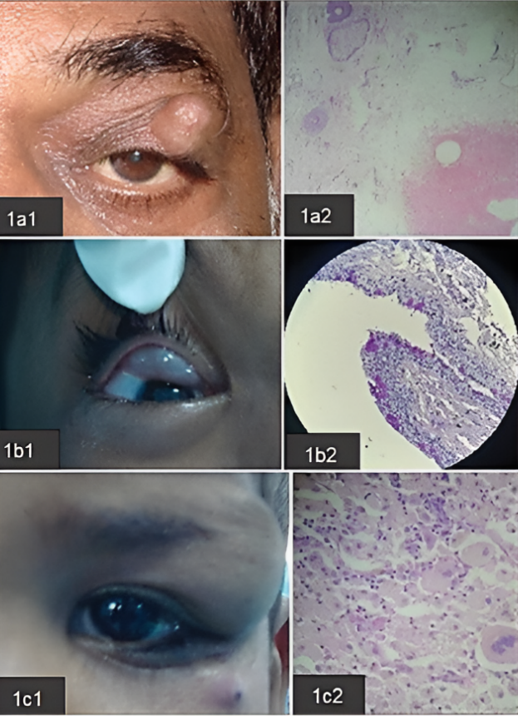

Figure 1: Clinical image (1a1) and Histopathology(1a2) of dermoid cyst; Clinical image (1b1) and Histopathology(1b2) of epidermal inclusion cyst; Clinical image (1c1) and Histopathology (1c2) of cyst with granulomatous reaction (Haematoxylin & Eosin stain, 40x magnification)
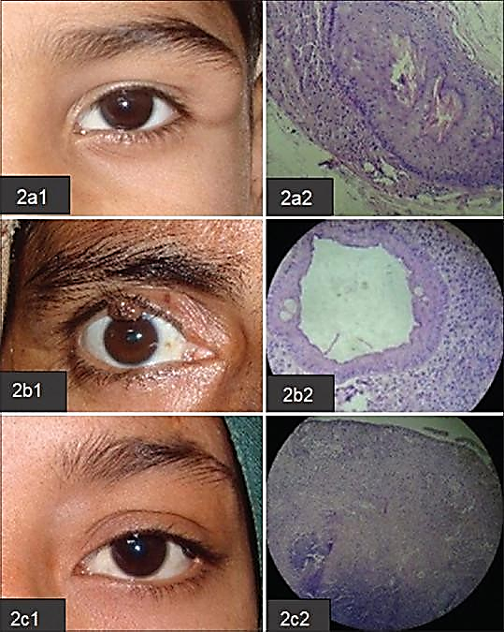

Figure 2: Clinical image (2a1) and Histopathology (2a2) of dermoid cyst; Clinical image (2b1) and Histopathology (2b2) of intradermal naevus; Clinical image (2c1) and Histopathology (2c2) of dermal naevus (Haematoxylin & Eosin stain, 40x magnification)

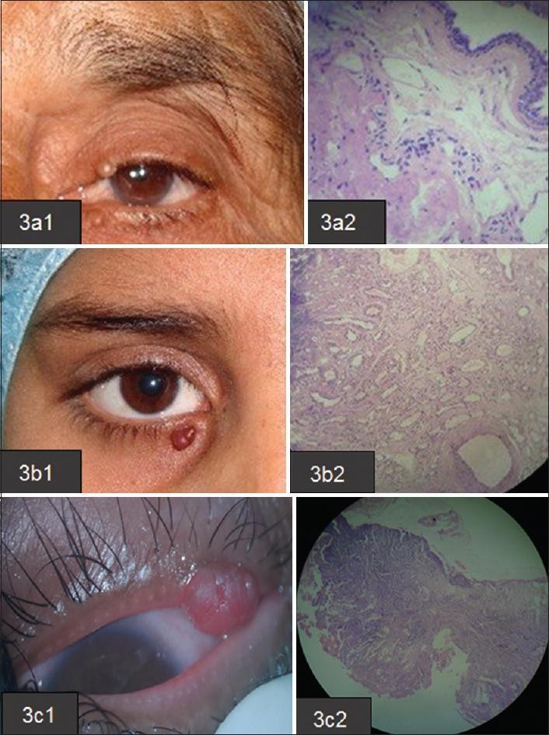

Figure 3: Clinical image (3a1) and Histopathology(3a2) of apocrine hidrocystoma; Clinical image (3b1) and Histopathology (3b2) of Capillary Hemangioma (Haematoxylin & Eosin stain, 40x magnification)
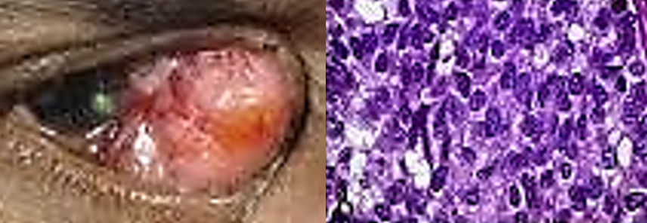

Figure 4: Clinical image and Histopathology of sebaceous carcinoma. (Haematoxylin & Eosin stain, 40x magnification)

In this cross-sectional analytical study of 400 histopathologically evaluated eyelid lesions, benign neoplastic lesions were the most prevalent, followed by non-neoplastic and malignant neoplastic lesions. This pattern is consistent with multiple large series reporting that most eyelid lesions are benign, with malignant tumors comprising a smaller proportion of cases. In a 20-year tertiary care review from South India, benign lesions accounted for over 80% of eyelid lesions, with inflammatory and cystic entities predominating, whereas malignant tumors constituted less than 20% of cases.⁴ Our findings align with this global trend, emphasizing the predominance of benign pathology in routine ophthalmic practice.
Non-neoplastic lesions in our cohort included inflammatory, cystic, and developmental entities. Epidermoid cysts and dermoid cysts were frequent, and pigmented nevi were reclassified here as non-neoplastic based on their developmental origin. Non-neoplastic lesions such as chalazion and granulomatous reactions represented common causes of eyelid swelling, consistent with observations in other regional studies.¹¹ The broad spectrum of non-neoplastic lesions reflects the diverse embryologic and inflammatory processes affecting eyelid anatomy, underscoring the need for histopathological confirmation to distinguish these from neoplastic mimics.
Among neoplastic lesions, benign tumors such as hemangiomas, epidermal cysts, and squamous papilloma were frequently encountered. This observation parallels previous reports where benign tumors were markedly more common than malignant ones and often presented at younger ages.¹² The prevalence of hemangiomas in the benign category may reflect regional demographic patterns and referral bias in tertiary care settings.
Malignant neoplastic lesions constituted 10.25% of cases in our series, with sebaceous cell carcinoma being the most common malignant subtype. This finding is consistent with several reports from India and other parts of Asia, where sebaceous carcinoma frequently surpasses basal cell carcinoma in prevalence, contrasting with Western populations where basal cell carcinoma predominates.¹³ In a large Indian cohort of malignant eyelid tumors, sebaceous gland carcinoma accounted for over half of malignancies, followed by basal cell and squamous cell carcinomas, similar to our distribution.⁸ The aggressive nature of sebaceous carcinoma and its propensity to masquerade as benign inflammatory conditions such as chalazion highlight the importance of maintaining a high index of suspicion and the utility of histopathology, often supported by immunohistochemistry (IHC), for accurate diagnosis.¹²
The demographic profile in our study showed a female preponderance and peak incidence in middle to older age groups, which aligns with published literature. Many reports indicate that incidence increases with age and that malignancy is more likely in older patients.⁴ Consistent histopathological evaluation, supplemented by IHC where necessary—especially for distinguishing poorly differentiated malignant tumors such as sebaceous carcinoma, lymphoma, or melanoma—enhances diagnostic precision and guides appropriate management.¹²

4. Conclusion

This study provides a comprehensive evaluation of the histomorphological spectrum of eyelid lesions in a South Indian tertiary care setting. Benign neoplastic lesions were the most prevalent, followed by non neoplastic lesions, while malignant neoplastic lesions comprised a smaller but clinically significant proportion. Among malignant tumors, sebaceous cell carcinoma was the most common, highlighting regional differences compared to Western populations where basal cell carcinoma predominates. Non neoplastic lesions were predominantly cystic and developmental, including epidermoid and dermoid cysts and pigmented nevi. Histopathological examination, supplemented by immunohistochemistry (IHC) where necessary, proved essential for accurate diagnosis and appropriate clinical management. The findings emphasize the importance of early recognition and proper classification of eyelid lesions to prevent local invasion, metastasis, or functional and cosmetic morbidity.

LIMITATIONS
Being confined to one tertiary care center, the findings may not fully represent the epidemiology of eyelid lesions across other regions of India. Although 400 cases were analyzed, a larger multicentric study over a longer duration would provide more generalizable data. While IHC was performed in select malignant cases, no molecular or genetic studies were conducted, which could have added prognostic insights. Some clinical features, such as lesion duration and recurrence, were not systematically analyzed, limiting clinicopathological correlation.
RECOMMENDATIONS
Future research should include multicentric data collection across diverse geographic regions in India to better understand regional epidemiological patterns. Increased awareness among clinicians regarding the potential malignant nature of seemingly benign eyelid lesions could improve early detection and treatment outcomes. Incorporating follow-up data would help assess recurrence, metastasis, and long-term outcomes, particularly for malignant lesions.

Consent : NOT APPLICABLE

Ethical approval
Ethical approval was taken from the Institutional Ethical Committee.

References

- Mohan, B. P., & Letha, V. (2017). Profile of eyelid lesions over a decade: a histopathological study from a tertiary care center in South India. International Journal of Advances in Medicine, 4(5), 1406-1411. https://doi.org/10.18203/ijam.v4i5.1406
- Punja, G. M., Bharathi, M., & Shashidhar, H. B. (2018). Histomorphological spectrum of eyelid lesions–A 6 year retrospective study. Tropical Journal of Pathology and Microbiology, 4(8), 586-591. https://doi.org/10.17511/jopm.2018.i08.07
- Raina, B., Mahajan, S., & Kai, S. (2022). Clinical profile and histo-pathological profile of peri-ocular lesions. International Journal of Research in Medical Sciences, 10(7), 1460–1463. https://doi.org/10.18203/2320-6012.ijrms20221586
- Gupta, Y., Gahine, R., Hussain, N., & Memon, M. J. (2017). Clinico-Pathological Spectrum of Ophthalmic Lesions: An Experience in Tertiary Care Hospital of Central India. Journal of Clinical and Diagnostic Research, 11(1), EC09-EC13. https://doi.org/10.7860/JCDR/2017/23589.9230
- Sushma, T. A., Geethamani, V., Thejaswini, M. U., Suguna, B. V., & Dharani, V. C. (2018). Epidemiology of neoplastic eyelid lesions in a tertiary care hospital. *Indian Journal of Pathology and Oncology*, *5*(1), 67–74. https://www.ipinnovative.com/journals/indian-journal-of-pathology-and-oncology/number-1-2018
- Kaliki, S., Ayyar, A., Dave, T. V., Ali, M. J., Mishra, D. K., & Naik, M. N. (2015). Sebaceous gland carcinoma of the eyelid: clinicopathological features and outcome in Asian Indians. Eye (London, England), 29(7), 958–963. https://doi.org/10.1038/eye.2015.79
- Shields, J. A., Demirci, H., Marr, B. P., Eagle, R. C. Jr, & Shields, C. L. (2005). Sebaceous carcinoma of the ocular region: a review. Survey of Ophthalmology, 50(2), 103-122. https://doi.org/10.1016/j.survophthal.2004.12.008
- Takamura, H., & Yamashita, H. (2005). Clinicopathological Analysis of Malignant Eyelid Tumor Cases at Yamagata University Hospital: Statistical Comparison of Tumor Incidence in Japan and in Other Countries. Japanese Journal of Ophthalmology, 49(5), 349–354. https://doi.org/10.1007/s10384-005-0229-5
- Reddy SC et al. International histopathological distribution of eyelid lesions (mimics, prevalence variations).
- Smith KJ, Skelton HG. Tumors and tumor-like lesions of the eyelid. Dermatol Clin.
- Deprez, M., & Uffer, S. (2009). Clinicopathological features of eyelid skin tumors. A retrospective study of 5504 cases and review of literature. American Journal of Dermatopathology, 31(3), 256–262. https://doi.org/10.1097/DAD.0b013e3181961861
- Mohan, B. P., & Letha, V. (2017). Profile of eye lid lesions over a decade: a histopathological study from a tertiary care center in South India. https://doi.org/10.18203/2349-3933.ijam20174293
- Kaliki S, Ali MJ, Mishra DK, et al. Malignant eyelid tumors in India: clinico-pathological features and outcomes. Indian J Ophthalmol. 2012;60:36-41.

