Presence of Escherichia coli, Salmonella species, and Staphylococcus aureus in street foods in Bamako, Mali

.

ABSTRACT

Introduction: Foodborne illnesses are becoming an increasingly significant public health challenge in both developed and developing countries. The most common causes of foodborne illnesses worldwide are bacteria pathogens, among them Escherichia coli, Salmonella spp, Staphylococcus aureus, …
Aims: The aim of this study was to assess the microbiological quality of street foods sold in Bamako, Mali
Place and Duration of Study: It was a prospective cross-sectional study conducted from July 2019 to October 2023 in Bamako, Mali
Methodology: Street food samples were collected in the six (06) municipalities in Bamako district. Microbiological analysis of samples groups (food group 1,
group 2, group 3, group 4, group 5, group 6, group 7, group 8 and group 9), was focused on identifying Escherichia coli, Salmonella spp and Staphylococcus aureus found in these. The standards NF ISO 16649-2, ISO 6579:2002, and NFV 08.057.1 were used.
Results: In municipalities I and II, E. coli was 50% in food group 7, S. aureus 100% in group 9 respectively. The E. coli was 67% in group 7, followed by S. aureus 40% in group 9 and group 6, Salmonella spp 20% in group 5 in municipality III. E. coli and Salmonella spp were 29% in group 7 in municipality IV. E. coli was 50% in group 5 in municipality V. E. coli was 100% in group 7, group 5 and group 1 in municipality VI
Conclusion: In all food groups, E. coli was most present followed by S. aureus and Salmonella spp. Moreover, strain identification must be completed by the antibiotic sensitivity study in E. coli, Salmonella spp and S. aureus.

Keywords: Identification, E. coli, Salmonella spp, S. aureus, street food, Bamako.

1. INTRODUCTION
The consumption of animal products like meat, milk, and egg is increased due to rapid human population growth, urbanization, rising per capita income, globalization, and changes in consumption patterns (preference for a protein-rich diet). This situation leads to high demand for animal-based foods and results in intensive animal production and product processing, particularly mass production and the global movement of products. During this period, there may be faulty processing practices at any point in the farm-to-fork chain, increasing the risk of contamination and the spread of foodborne pathogens.(Abebe et al., 2020). Bacteria are responsible for two-thirds of foodborne disease outbreaks, although there have been approximately 250 different foodborne diseases. Bacterial foodborne diseases are among the most prevalent public health problems worldwide in recent times (Abebe et al., 2020). Foodborne pathogens commonly associated with street food include Clostridium perfringens, Escherichia coli, Shigella spp., Campylobacter jejuni, Staphylococcus aureus, Salmonella spp., and Bacillus cereus (Birgen et al., 2020).
Foods of animal origin, particularly meat (beef, lamb, and pork), dairy products (milk, cheese, yogurt, and ice cream), and eggs are the three main routes through which people are exposed to pathogenic bacteria (Abebe et al., 2020).
Raw milk, or milk that has not undergone any sanitation treatment, may contain bacteria belonging to the genera Salmonella spp., Escherichia coli, Staphylococcus aureus, and Listeria monocytogenes, which can cause foodborne illnesses such as fever, vomiting, diarrhea, kidney failure, miscarriage, and even death (Kouamé-Sina et al., 2010).
Raw foods, including meat and poultry, raw eggs, fish and shellfish, as well as fruits and vegetables, should all be considered potential sources of foodborne pathogens entering the home. The list of infectious agents that have been introduced into the home through food includes species of Salmonella, Campylobacter, Listeria, and E. coli O157 (Elizabeth Scott, 2003).
Human and animal occupants of the home can also be sources of foodborne pathogens. Humans and animals can be symptomatic and asymptomatic carriers, as well as post-symptomatic Pathogens excretors can be transferred from various sources to inanimate contact surfaces in the home or directly to other foods or human occupants through transient carriage on the hands. Foodborne pathogens that have been introduced into households via humans include Salmonella species, Shigella sonnei, Staphylococcus aureus, rotaviruses, and hepatitis A virus (Elizabeth Scott, 2003).
In addition, certain pathogenic strains of E. coli are known to doctors as the causative agents of infantile gastroenteritis or the well-known “traveler's diarrhea.” The main intestinal pathotypes, described according to the clinical signs they cause and the pathogenicity factors they express, are: enterotoxigenic E. coli (ETEC), enteropathogenic E. coli (EPEC), enteroaggregative E. coli (EAggEC), enterohaemorrhagic E. coli (EHEC) and enteroinvasive E. coli (EIEC) (Cohen & Karib, 2006).
Analysis of global epidemiological data shows that a significant number of serotypes of enterohaemorrhagic Escherichia coli (EHEC, more than 200) are associated with the onset of severe clinical symptoms in humans, such as hemorrhagic colitis or hemolytic uremic syndrome (HUS). Among typical EHEC, the strains most frequently involved in epidemics today have been defined by ANSES as “major typical EHEC” strains. They belong to the five serotypes O26:H11, O103:H2, O111:H8, O145:H28, and O157:H7 and their non-motile derivatives (Brugère et al., 2012).
Among the “atypical” EHEC strains, it is worth mentioning EHEC infections caused by strains of serogroup O91 or O104, including strain O104: H4, which was responsible for two epidemics in Germany and France in 2011 and which epidemiological studies have shown to be associated with the consumption of contaminated fenugreek seeds after sprouting .(Brugère et al., 2012).
Salmonella enterica is one of the leading causes of community-acquired bloodstream infections in many low- and middle-income countries. The serovars Typhi, Paratyphi A, Paratyphi B, and Paratyphi C of Salmonella enterica can be collectively referred to as Salmonella typhoid, while the other serovars are grouped under the name Salmonella non-typhoid (NTS). Typhoidal Salmonella strains are host-restricted organisms that cause typhoid fever and paratyphoid fever, collectively known as enteric fever. NTS strains may be generalist, infecting or colonizing a wide range of vertebrate animals, or adapted or restricted to certain non-human animal species (Crump et al., 2015).
S. enterica subsp. enterica serovars Typhimurium and Enteritidis are the most common and can cause disease in several animals. Certain serogroups are adapted to specific species. For example, S. enterica Typhi and S. enterica Paratyphi are limited to humans and cause typhoid fever and paratyphoid fever, respectively. Those adapted to cattle, S. enterica Dublin, and pigs, S. enterica Choleraesuis, are occasionally reported in humans, causing serious illness (Fernandes et al., 2018).
Staphylococcus aureus is both a commensal of human skin and mucous membranes, but also a common cause of serious infections leading to morbidity, mortality, and high healthcare costs (Sakr et al., 2018). It is one of the main pathogens affecting humans.
S. aureus causes various diseases, including staphylococcal food poisoning (SFP), toxic shock syndrome and other systemic diseases, bacteremia, pneumonia, and skin and soft tissue infections, to name but a few (Mekhloufi et al., 2021).
Staphylococcus aureus, including methicillin-resistant S. aureus (MRSA), is not only one of the most common etiological factors in human infectious diseases, but also a pathogen with a profound impact on animal welfare due to increasing antibiotic resistance and the resulting economic burden (Kasela et al., 2023).
Among coagulase-negative species, S. cohnii, S. epidermidis, S. xylosus, and S. haemolyticus were isolated from sheep's milk and were found to produce one or more Staphylococcal Enterotoxins (SE). Other species such as S. saprophyticus, S. warneri, S. chromogenes, and S. lentus isolated from healthy goat milk and dried hams were found to have enterotoxigenic potential. (Rohinishree Yadahalli & Pradeep Singh, 2011).
Staphylococcus saprophyticus is a uropathogen associated with 10-20% of urinary tract infections in sexually active young women worldwide. S. saprophyticus is a common colonizer of the human gastrointestinal tract, cervix, urethra, vagina, perineum, and rectum. It also colonizes the intestines and skin of food-producing animals, which could be a source of contamination in food-related environments (Lawal et al., 2021).
The presence of bacteria in raw or cooked foods, coupled with their resistance to antibiotics through the production of enzymes and toxins, jeopardizes human life and poses a real public health problem (Mousse et al., 2016). In Mali, street food has grown significantly in recent years due to rural exodus, population growth in cities, and Insufficient hygiene was observed in cleaning raw materials and kitchen utensils; vendors have little education on food handling, processing, and hygiene practices (Sako et al., 2014), (Dembele et al., 2024). In addition, unqualified street food vendors have set up shops in an unregulated manner around our schools in Bamako, where our children spend a large part of their day buying food. These vendors pose a threat to the health of Bamako's urban population. This study aims to assess the microbiological quality of street foods sold in Bamako.

2. material and methods

2.1. Study sites
This was a prospective cross-sectional study conducted from July 2019 to October 2023 in the six municipalities of Bamako district, Mali (Fig. 1). Street food samples were collected in the six (06) municipalities. The target areas for sampling were the student area (an area frequented by students for food); the large market area (an area not only for commerce but also where people go to buy food); the administrative area (where public services are located); and the areas surrounding the main roads of Bamako district
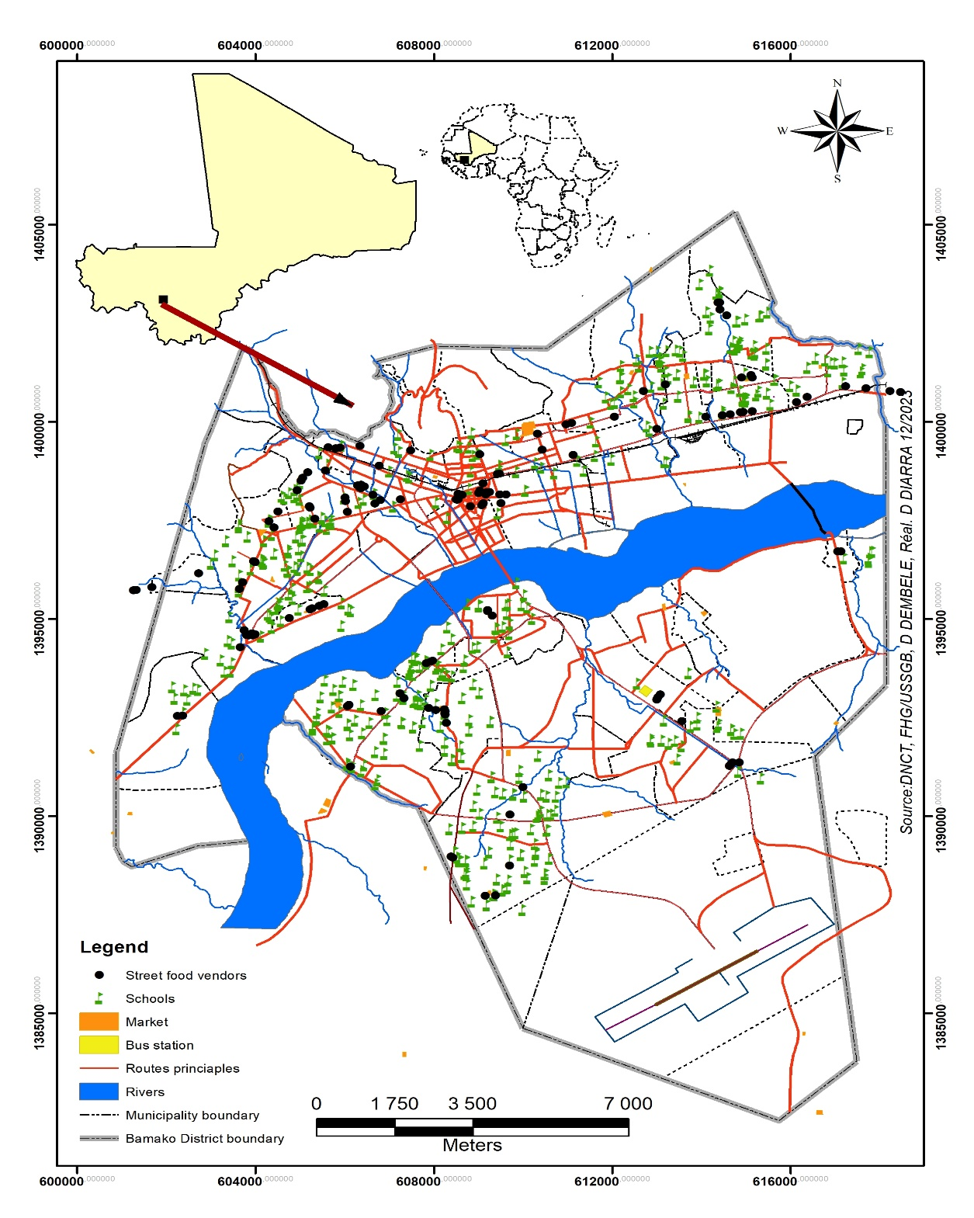
Fig. 1. Map of samples collect sites in Bamako (DNCT, FHG/USSGB, Realized by DIARRA 12/2023)

2.2. Sampling of Street foods
Street foods were selected because of their frequently consumed by the population of Bamako, Mali. Samples were regrouped into nine (09) food groups.
Group 1 consisted of Nem (meat sauce), meat sauce made from beef feet or sheep's head, grilled meat skewers, grilled liver skewers, meat sauce (soup), liver sauce, and shawarma.
Group 2 consisted of white rice with tomato sauce, rice with fat, white rice with peanut sauce and green vegetables, white rice with both tomato sauce and meat sauce, white rice with okra sauce, white rice with < fakoye > sauce and white rice with
< saga-saga > sauce.
Group 3 consisted of < attieke >, red < djouka > (fonio + peanuts), tô (Made from a thick paste of millet, corn, or sorghum flour) with sauce.
Group 4 consisted of bissap juice, ginger juice, tamarind juice, peanut juice, and monkey bread juice (baobab). mango juice,
Group 5 consisted of spaghetti, omelet, egg with sauce, surprise (omelet), macaroni, egg.
Group 6 consisted of grilled fish, braised fish, fish with sauce.
Group 7 consisted of steamed millet with yogurt, yogurt (curdled milk).
Group 8 consisted of beans, sandwiches, French fries, and Alloco.
Finally, group 9 consisted of roast chicken and chicken sauce.
All samples collected were analyzed in National Health Laboratory (LNS),

To determine the size of the sample required for this study, the Poisson approximation was used, with a margin of error of 5%, for a confidence interval of 95% and setting an expected proportion p = 0.5 by default, and with an estimate of the target population N = 1067, so our sample size was estimated at 300, with 50 samples per municipality.

For samples collection in the field, monthly visits to each municipality were organized during the collection period. Samples were taken twice a day, depending on their shelf life (at the beginning of the sale and towards the end of the sale of the food product). Samples were taken during two period of the year: the dry season and the rainy season. During each visit, at least one dish was sampled and placed in sterile STOMACHER bags stored in an insulated cooler at 4°C, then we process microbiological analysis.

2.3 Microbiological analysis

2.3.1 Preparation of stock suspension and decimal dilutions of street food

According to the standard (ISO 6887-1 to 4 in 2017), for each sample to be analyzed, 10 g were weighed under aseptic conditions in a sterile STOMACHER filter bag. To revitalize microorganisms, 90 ml of sterile tryptone salt (TS) solution was added. The contents of the bag were ground in a STOMACHER bag mixer for two minutes, then left to stand for approximately 10 minutes until a homogeneous solution was obtained.
The resulting solution is the stock solution (10⁻¹ dilution). Various dilutions were then carried out. The solution was left to stand for 40 minutes to allow any bacteria that may have been stressed by the shock of grinding to revive. A series of three decimal dilutions was performed. For the first dilution, 1 ml of the stock solution was diluted in 9 ml of TS to obtain a 10⁻² solution. The dilution leading to the 10⁻³ suspension consisted of diluting 1 ml of the homogenized 10⁻² solution in 9 ml of TS.

2.3.2 Characterization of Escherichia. coli
These bacteria were searched for on Tryptone Bile X-glucuronide (TBX) agar according to the standard (NF EN ISO 16649-2) for street food. The TBX medium, melted and cooled in a water bath to 45°C, was added to the inoculum at a rate of 15 ml per box. The mixture was then homogenized by rotating movements. After complete solidification, a second layer (approximately 4 ml) of agar was added, and the plates were incubated at 44°C and counted after 24 hours. Blue to blue-green colonies with a diameter greater than or equal to 0.5 mm are characteristic of β-D-glucuronidase-producing E. coli. The number of germs per gram of product analyzed was determined by calculation, considering the dilution factor. The research on E. coli was completed by an indole production test.

The number of E. coli colonies was determined by counting the plates containing between 10 and 150 colonies. The number of germs per gram of sample (N) was determined using the following formula:
N = $\frac{ΣCn}{\left(n_{n}xv_{n}\right)dn} Cn=$number of colonies counted on the Petri dishes retained.
nn = number of Petri dishes retained from the n-th dilution.
Vn = Volume of the inoculum of the n-th dilution
dn = Value of the n-th dilution
Then, confirmation tests such as Gram staining and indole production were performed.

    - Characterization of Salmonella spp
The Salmonella spp research was carried out according to the standard (NFV08-054, 2009). For Pre-enrichment, 25 g of each sample was collected in a sterile STOMACHER bag and added to 225 ml of sterile buffered peptone water. This gave us a dilution of 10⁻¹. This suspension was incubated at 37°C for 20 hours. Enrichment was carried out using selective enrichment media: Rappaport-Vassiliadis (RV) broth and selenite-cystine broth. 0.1 ml and 2 ml of the pre-enrichment were inoculated into 10 ml of Rappaport Vassiliadis broth and 20 ml of selenite-cystine broth, respectively. The tubes were incubated at 41°C and 37°C for 24 hours, respectively, and isolation was performed on selective Hektoen agar (HEK) medium. The isolation medium was melted and cooled in a water bath at 45°C, then poured into sterile Petri dishes. After solidification, it was streaked on the surface using a platinum loop or Pasteur pipette from the enrichment media. The dishes were incubated for 24 hours at 37°C. Upon reading, the colonies appear bluish with or without a black center (H₂S production or not). Then the Confirmation tests (Kligler Hajna (TSI) and Galerie API 20E^{®)} were performed.
    - Characterization of Staphylococcus aureus
According to the standard (NFV 08.057.1), the S. aureus strains were isolated using the method described by Speck (1976). The culture medium of choice used for this research was Baird-Parker (BP) medium with egg yolk and potassium tellurite. A volume of 0.1 ml of the stock suspension and various decimal dilutions were poured onto BP agar poured into Petri dishes and spread over the surface using a sterile glass or plastic spreader. The plates were incubated at 37°C for 48 hours. An initial reading was taken after 24 hours; a second reading was taken after 48 hours of incubation. For counting purposes, we selected boxes containing between 15 and 150 characteristic colonies for two successive dilutions. The number of germs per gram of product analyzed was determined by calculation, considering the dilution factor. Staphylococcal colonies appear black, shiny, convex, surrounded by a white precipitate and a halo of lightening or not (Marami et al., 2022). The identification of S. aureus strains was performed using additional tests, namely: coagulase and PASTOREXTM.STHAPH-PLUS.
  - Data analysis
All the statistical analysis was carried out with R version 4.2.3. software. The descriptive statistical, cross tables were carried out. and the statistical value of Khi2 of Pearson associated was determined. A multidimensional analysis was carried out to use of packages “Ade 4” and “Fact extra”. The multidimensional analysis strengthened, a multiple correspondence analysis (ACM) followed a rising classification hierarchic (CAH) according to Ward method were carried out so that to regroup the variables differently. IBM SPSS version 22 was used to test the statistical difference in the microbial counts with statistically different means separated (ANOVA).

3. results and discussion

  - Proportion of food groups commonly consumed in Bamako

The results (Fig. 2) showed that of the nine (09) groups of street foods collected in the six municipalities of Bamako, the proportion of group 1 was high 32.4%, followed by the group 2 (17.6%) and group 3 (11.3%).
Group1
Group 2
Group 3
Group 4
Group 5
Group 6
Group 7
Group 8
Group 9
0
10
20
30
40
2
.
8
6
.
3
6
.
3
7
.
0
7
.
7
8
.
5
1
1
.
3
1
7
.
6
3
2
.
4
Food Groups
P
r
o
p
o
r
t
i
o
n
s

(
%
)

Fig. 2. Proportion of major street food groups in Bamako
  - Proportion of bacteria identified during microbiological analysis of street food in Bamako

According to the results (Fig. 3), among the eighteen bacteria species identified, the proportion of Staphylococcus epidermidis, Staphylococcus saprophyticus, and Escherichia coli was high 63.4%, 55.6%, and 45.8%, respectively.
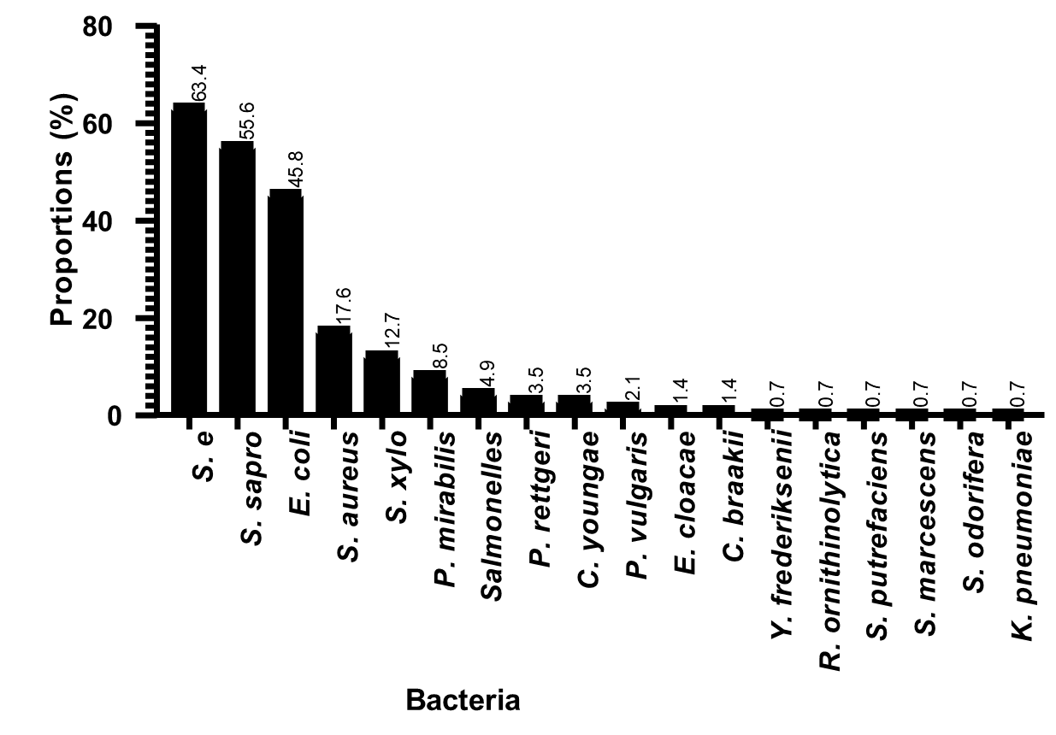
Fig. 3. Frequency of bacteria identified in street food in Bamako
  - Proportion and probability diagram of intersection between E. coli, Salmonella spp, and S. aureus in street food

According to the results in (Fig. 4), bacteria species were represented by black spherical balls. The vertical lines below the x-axis connect the bacteria based on their interaction in a mixed contamination. The vertical bars indicate the size of the combination of the intersection between two and three different bacteria. E. coli was the most abundant bacteria with over 60%, followed by S. aureus around 22% and Salmonella spp around 10%. The probability of intersection for E. coli was 43%, In mixed contamination, the intersection probability between E. coli and S. aureus was 16%.

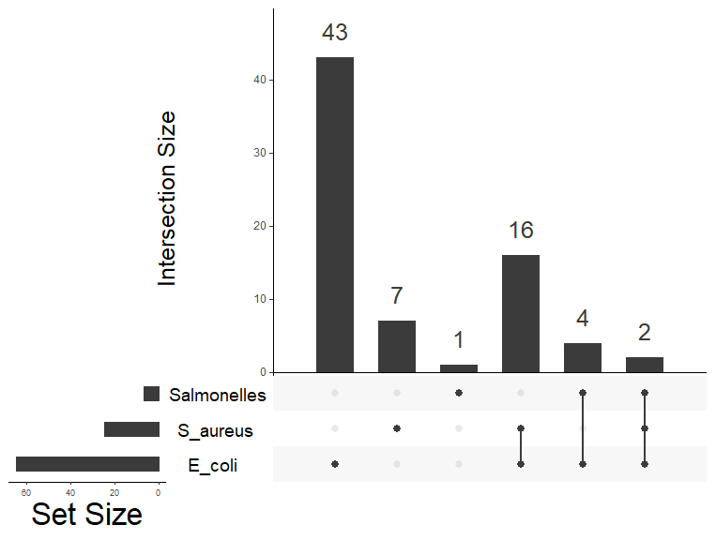
Fig. 4. Diagram Techniques for visualizing the sets and arrangement of the matrix of intersections of three microorganisms found in street food.
  - Contamination rates and types of bacteria identified in street food in the municipality I
The results (Fig. 5) showed that in the eight food groups in municipality I, at least one group was contaminated with bacteria. S. epidermidis was higher (100%) in group 5, followed by E. coli (50%) in group 7. The food group 1 was the most contaminated with six bacteria at once.

3.5 Frequency of contamination and type of bacteria identified in street food in municipality II
According to the results (Fig. 6), in the eight food groups in municipality II, at least one group was contaminated with bacteria. S. aureus was 100% in group 9. In municipality II, seven out of eight food groups were contaminated with S. epidermidis 67% in group 2, 50% in group 8, and E. coli, 29% in group 5. The frequency of multiple contaminations was high in group 1, with six bacteria identified.
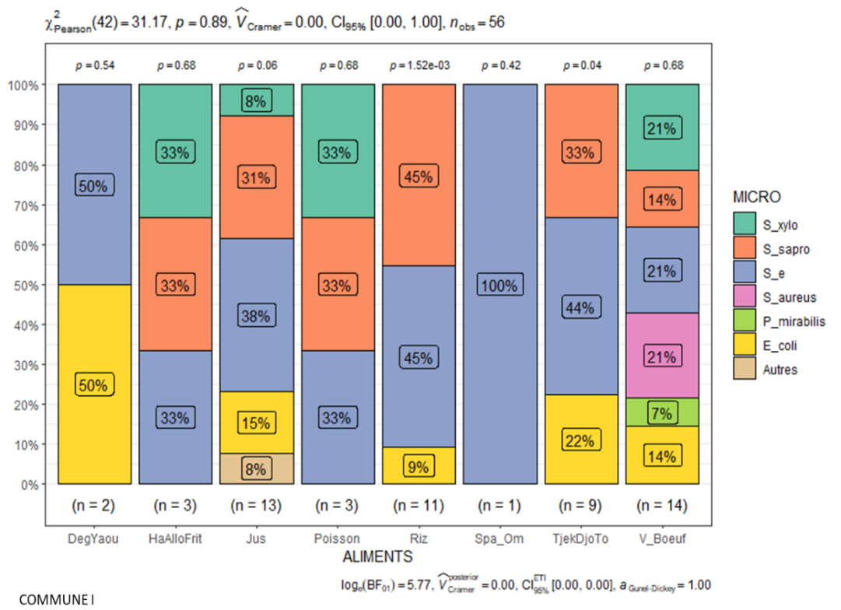
Food groups
Municipality I
Group1
Group3
Group5
Group2
Group6
Group4
Group7
Group8
Fig. 5. Frequency of bacteria identified in street food in municipality I
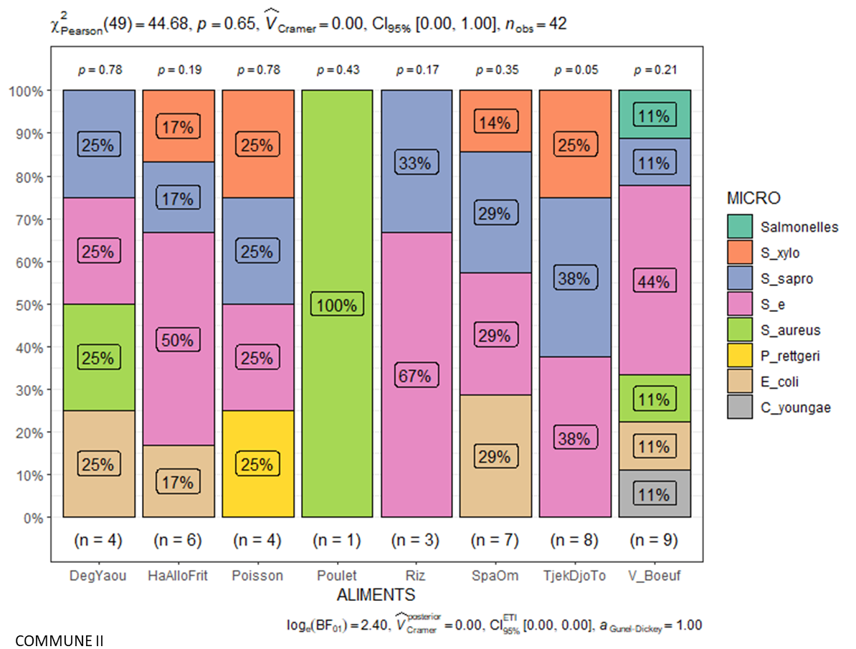
Food groups
Municipality II
Group8
Group7
Group1
Group3
Group5
Group2
Group9
Group6
Fig. 6. Frequency of bacteria identified in street food in municipality II
  - Frequency of contamination and type of bacteria identified in street food in municipality III

Analysis of the results for municipality III (Fig. 7) showed that, out of the eight food groups, E. coli was 67% in group 7, followed by S. aureus 40% in groups 5 and 9 groups. Salmonella spp 20% in group 5. S. epidermidis and S. saprophyticus were 50% in groups 1 and 3. The frequency of multiple contamination was high, with nine bacteria in group 1. This was followed by group 6 with eight bacteria.

3.7 Contamination frequency and type of bacteria identified in street food in municipality IV

According to the results in (Fig. 8), the nine food groups collected and analyzed in municipality IV were contaminated with at least two species of bacteria. In group 4, the contamination rate was 50% of S. epidermidis and S. saprophyticus, E. coli was 33% in groups 6 and 7 Salmonella spp was 29% in group 5. The highest frequency of multiple contamination was found in food group 1, with about eight bacteria at once.

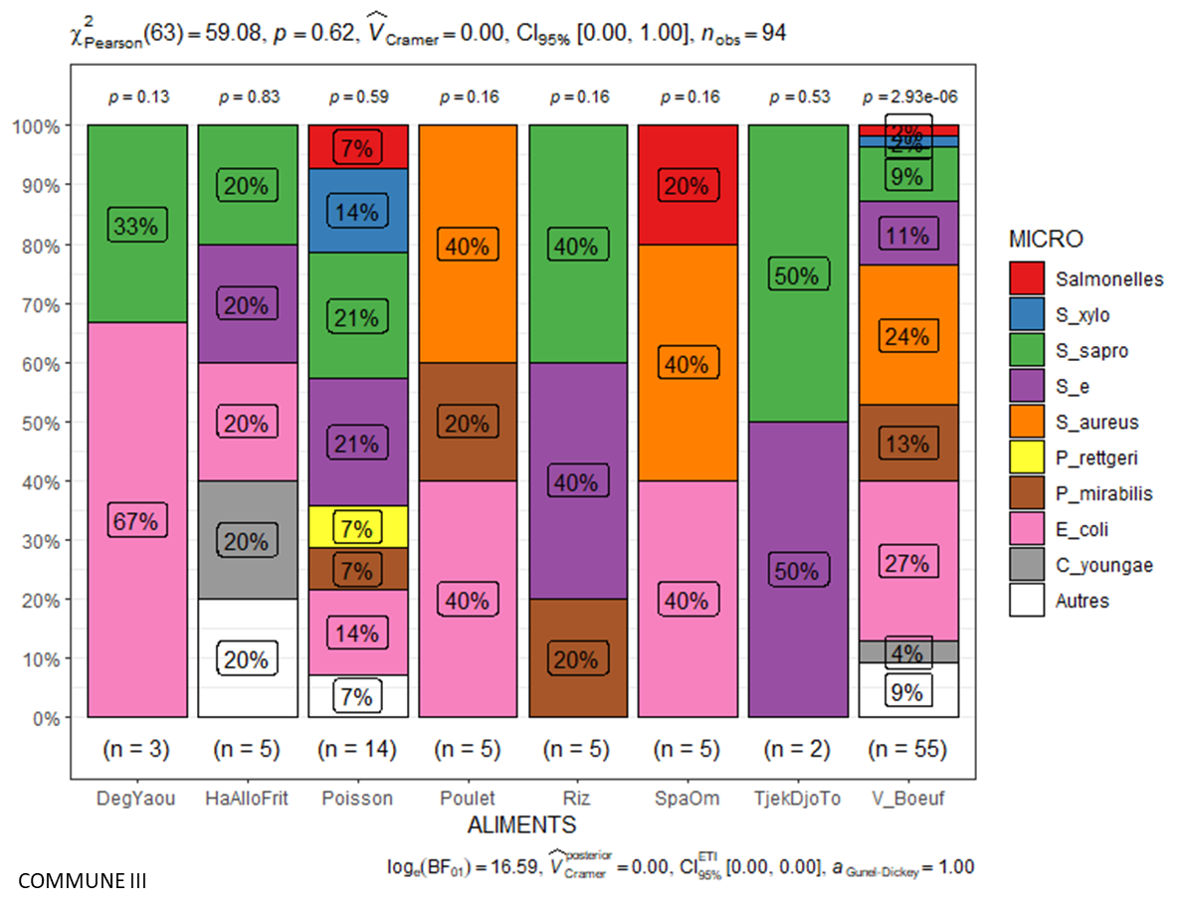
Food groups
Municipality III
Group1
Group3
Group5
Group2
Group9
Group6
Group8
Group7
Fig. 7. Frequency of bacteria identified in street food in municipality III
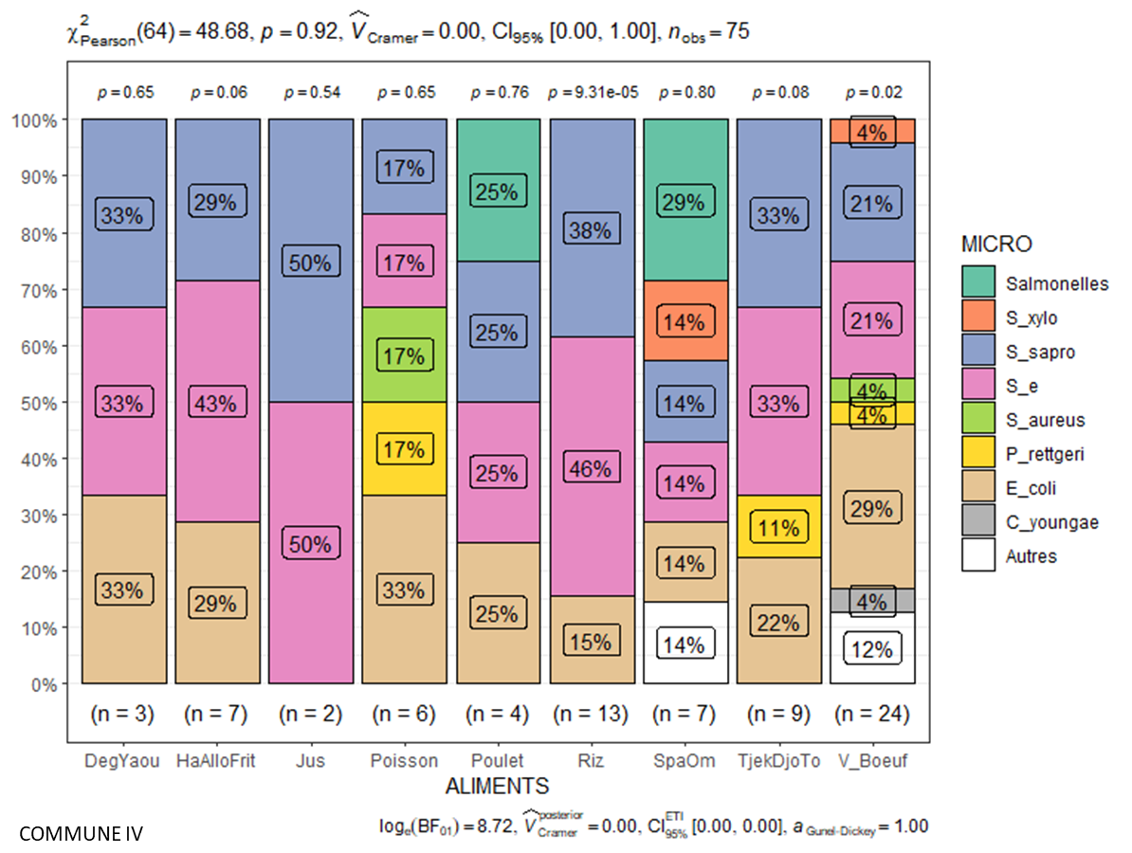
Food groups
Municipality IV
Group7
Group8
Group4
Group1
Group3
Group5
Group6
Group9
Group2
Fig. 8. Frequency of bacteria identified in street food in municipality IV

3.8 Contamination frequency and type of bacteria identified in street food in the municipality of V

Analysis of the results (Fig. 9) showed that the seven food groups collected and analyzed in municipality V were all contaminated with at least two species of bacteria. The contamination rate for E. coli and S. saprophyticus was 50% in group 5. The highest frequency of multiple contaminations was found in 3 and 4 groups, with four bacteria at once.

3.9 Contamination frequency and type of bacteria identified in street food in municipality VI

According to the results (Fig. 10), all four food groups were contaminated with at least one bacterium. The rate of E. coli was 100% in 1, 5 and 7 groups. This was followed by S. epidermidis, 60% in group 2.

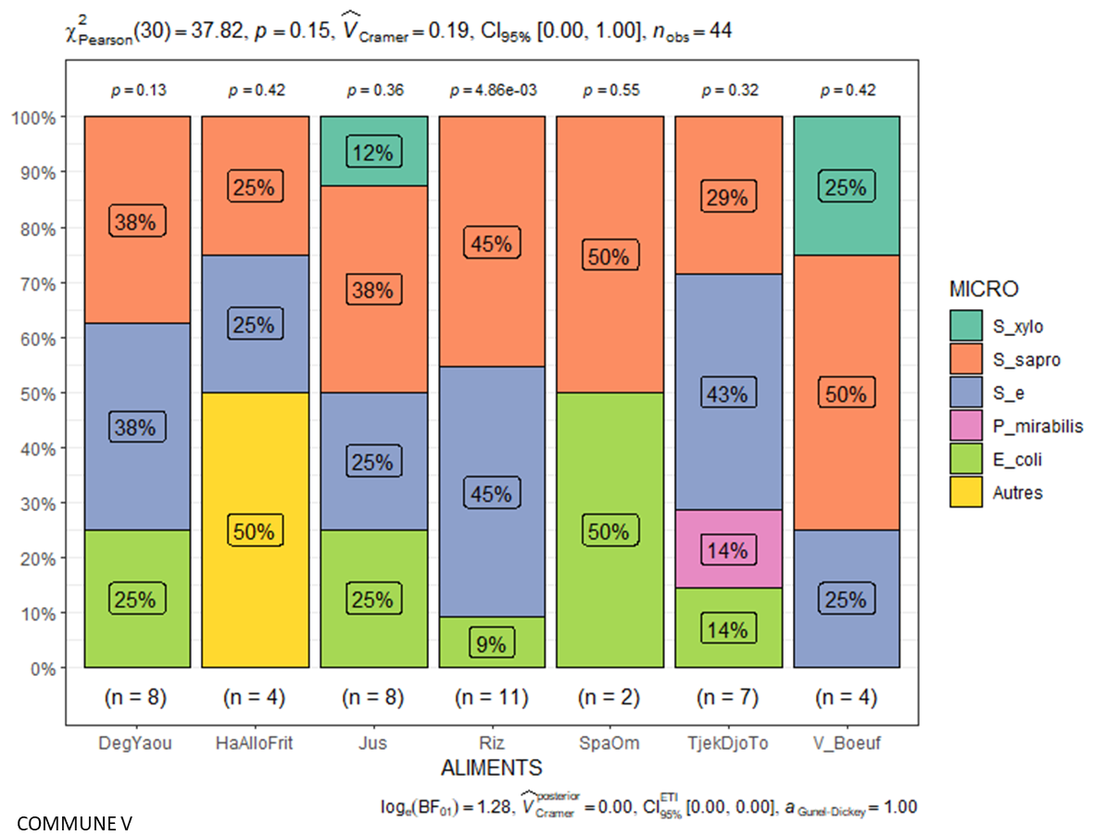
Food groups
Municipality V
Group 1
Group 3
Group 5
Group 2
Group 4
Group 8
Group 7
Fig. 9. Frequency of bacteria identified in street food in municipality V

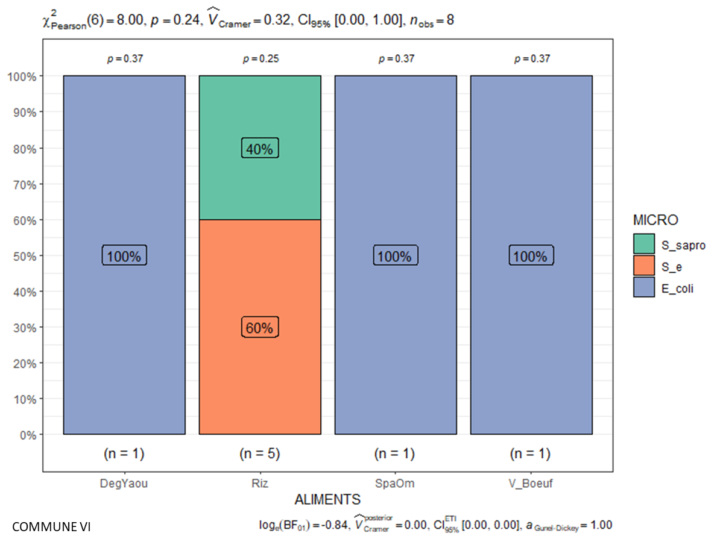
Group 1
Group 7
Group 5
Group 2
Food groups
Municipality VI
Fig. 10. Frequency of bacteria identified in street food in municipality VI

  - Proportion of E. coli, Salmonella spp and S. aureus in pooled samples of six municipalities of Bamako

The results (Fig. 11) showed that of the nine food groups analyzed, S. aureus was (72%), E. coli (40%) in group 1, followed by Salmonella spp (42.9%). in group 5 Furthermore, E. coli was present in all food groups.
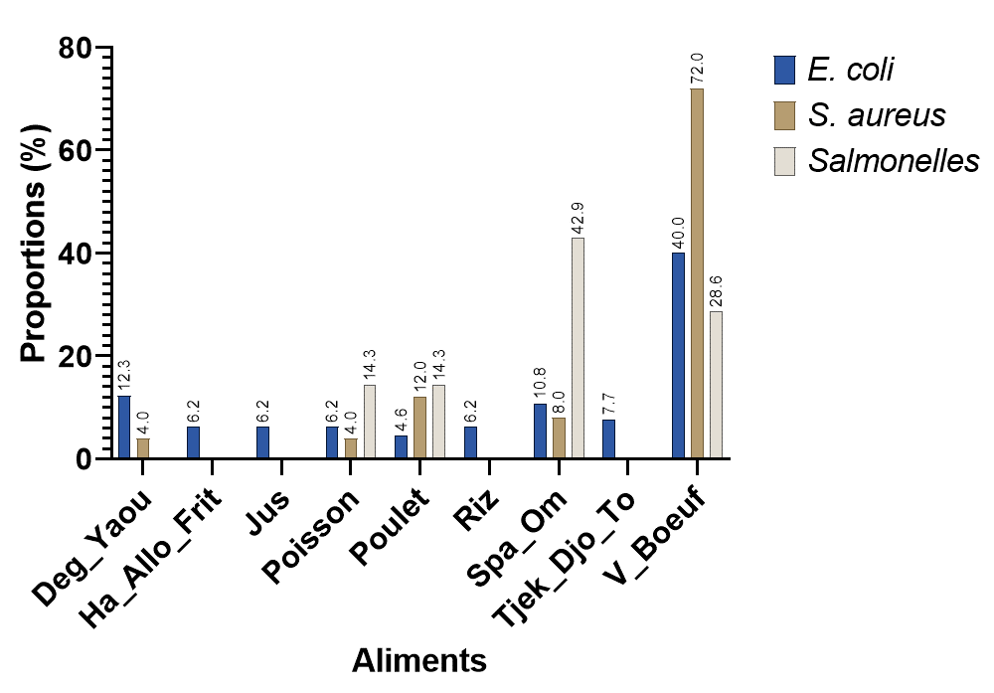

Food Groups
Group 1
Group 3
Group 5
Group 7
Group 8
Group 4
Group 6
Group 9
Group 2
Fig.11. Proportion of E. coli, Salmonella spp, and S. aureus identified in pooled samples from six municipalities in Bamako

  - Frequency of E. coli according to the sample collection period

According to the results (Table 1), the positive case of E. coli was almost similar in samples collected during the two periods (dry season and rainy season) 50.8% and 49.2% respectively. The statistical difference was not significant (P < 0.018) with an odds ratio of 2.04.

Table 1. Frequency of E. coli according to the sample collection period

Collect period | Dry season | Rany season | Total | P | OR
E. coli
Negative case | 95 | 45 | 140 | 0.018 | 2.04 [1.12-3.73]
Negative case | 67.9% | 32.1% | 100.0% | 0.018 | 2.04 [1.12-3.73]
Positive case | 33 | 32 | 65 | 0.018 | 2.04 [1.12-3.73]
Positive case | 50.8% | 49. 2% | 100.0% | 0.018 | 2.04 [1.12-3.73]
Total | 128 | 77 | 205 | 0.018 | 2.04 [1.12-3.73]
Total | 62.4% | 37.6% | 100.0% | 0.018 | 2.04 [1.12-3.73]

  - Frequency of Salmonella spp. according to the sample collection period

The results (Table 2) showed that the positive case of Salmonella spp was six times higher in samples collected during the rainy season (85.7%) than in those collected in dry season (14.3%). The statistical difference was significant (P < 0.01), with an odds ratio of 10.7.

Table 2. Frequency of Salmonella spp. according to the sample collection period

Collect period | Dry Season | Rainy Season | Total | P | OR
Salmonella spp
Negative case | 127 | 71 | 198 | Fisher=  0.01 | 10.7 [1.2-90.9]
Negative case | 64.1% | 35.9% | 100.0% | Fisher=  0.01 | 10.7 [1.2-90.9]
Positive case | 1 | 6 | 7 | Fisher=  0.01 | 10.7 [1.2-90.9]
Positive case | 14.3% | 85.7% | 100.0% | Fisher=  0.01 | 10.7 [1.2-90.9]
Total | 128 | 77 | 205 | Fisher=  0.01 | 10.7 [1.2-90.9]
Total | 62.4% | 37.6% | 100.0% | Fisher=  0.01 | 10.7 [1.2-90.9]

  - Frequencies of S. aureus and other bacteria identified

The results (Table 3) showed a positive case of S. aureus that was three times higher in samples collected during the dry season (75%) than in those collected during the rainy season (25%). The statistical difference was significant (P < 0.001).

Table 3. Frequency of S. aureus and other bacteria identified

Collect period | Dry Season | Rainy Season | Total | P
S. aureus
Negative case | 85 | 74 | 159 | 0.001
Negative case | 53.5% | 46.5% | 100.0% | 0.001
Positive case | 9 | 3 | 12 | 0.001
Positive case | 75.0% | 25.0% | 100.0% | 0.001
Total | 128 | 77 | 205 | 0.001
Total | 62.4% | 37.6% | 100.0% | 0.001

  - Average load of E. coli, Salmonella spp, and S. aureus in samples collected during the two seasons of the year

According to the results (Table 4), the average load of E. coli Salmonella spp, S. epidermidis, S. saprophyticus, and S. xylosus load was higher in rainy season 4.0x10⁴ CFU/g, 3.0x10⁴ CFU/g, 5.0x10⁴ CFU/g, 8.5x10³ CFU/g, and 7.0x10² CFU/g than dry season 3.0x10⁴ CFU/g, 9.0x10³ CFU/g, 4.0x10⁴ CFU/g, 9.4x10² CFU/g, and 3.0x10² CFU/g respectively. In contrast, S. aureus, average load was higher in the dry season 1.2x10⁵ CFU/g than rainy season 7.0x10⁴ CFU/g

Table 4, Average load of E. coli, Salmonella spp, S. aureus, and other bacteria

Mean load | Dry Season |  |  | Rainy Season |  | Total
Mean load | Mean (CFU/g) | N | Std. Deviation | Mean (CFU/g) | N | Mean (CFU/g) | N | Std. Deviation
E. coli load | 3.0x10⁴ | 33 | 47962.860 | 4.0x10⁴ | 32 | 3.2x10⁴ | 65 | 50563.053
Salmonella spp load | 9.0x10³ | 1 |  | 3.0x10⁴ | 6 | 2.4x10⁴ | 7 | 55705.293
S. aureus load | 1.2x10⁵ | 9 | 61496.838 | 7.0x10⁴ | 3 | 1.1x10⁵ | 12 | 65097.678
S. epidermidis load | 4.0x10⁴ | 46 | 57702.777 | 5.0x10⁴ | 44 | 5.0x10⁴ | 90 | 61349.207
S. saprophyticus load | 9.4x10² | 19 | 774.823 | 8.5x10³ | 44 | 6.2x10³ | 63 | 17841.026
S. xylosus load | 3.0x10² | 11 | 161.245 | 7.0x10² | 5 | 4.3x10² | 16 | 300.000

4. Discussion

We show that, among the nine (09) groups of street foods collected in the six municipalities of Bamako, the proportion of group 1 was high 32.4%, followed by group 2 (17.6%). In Ghana, a study reported similar rates of street foods, with rice and beans 32%, sweets drinks 24.4%, and fried yam and plantain 12.6% (Amegah et al., 2020).
Furthermore, among the eighteen bacterial species identified, E. coli was 45.8%, S. aureus 17.6% and Salmonella spp 4.9%.
These results are similar to those reported in a previous study in Ethiopia, which found E. coli 30.7%, Salmonella spp 4.4% and S. aureus 22.6% (Alelign and al., 2023).
Our results are comparable to those obtained by (Rajaei et al., 2021), who reported E. coli 48%, S. aureus 22% and Salmonella spp 10%. in ready-to-eat meat-based foods sold in public markets.
Our results showed that in the eight food groups in municipality I (Figure 5), at least one group was contaminated with bacteria. The frequency of E. coli was 50% and
S. epidermidis 100%. Among all eight food groups, the frequency of multiple contamination was high in 1 and 4 groups, with at least six bacteria species present at the same time. Compared to the other groups, the difference was statistically significant (P < 0.001).
Our results are similar those obtained by certain authors in Africa. In Benin, (Mousse et al., 2016) found E. coli 57.14% in rice. In Ethiopia, (Alelign et al., 2023) reported
E. coli 30.7% and S. aureus 22.6% in street food.
According to our study, overall, the eight food groups in municipality II were contaminated with at least one bacterium. The frequency of multiple contamination was similar in five groups. It was high in food group 1, with six bacteria identified. The frequency of S. aureus was very high 100%, S. epidermidis 67%, E. coli 29% and Salmonella spp 11% (Figure 6). The difference was statistically significant (P < 0.001).
Our results are comparable to those obtained by (Dang Xuan Binh et al., 2017), who reported E. coli 53.33% and S. aureus 21.66% and Salmonella spp 15% in beef-based foods sold in public markets. our results contrasts with those obtained by (Moges et al., 2025), who found S. aureus 40% and Salmonella spp (29.5%). This could be explained by the difference in design between the methodologies and the other hand, by the difference in sample size between the two studies.
Our study showed that in the eight food groups in municipality III, the frequency of multiple contamination was high in the one and six groups. Group 1 was contaminated by nine bacteria at once and group 6 by eight bacteria. Among the bacteria associated with these contaminations, E. coli was the highest, 67% in group 7 (Figure 7).
Our results are comparable to those obtained by (Ahiabor et al., 2024), who reported Escherichia coli 64% in Ghana, (Sanneh et al., 2018) reported E. coli 28.6% in Gambia (Alelign et al., 2023) obtained E. coli 30.7%, S. aureus 22.6% and Salmonella spp 4.4% in Ethiopia. Another study conducted in Côte d'Ivoire showed a rate of 32.8% for S. aureus (Attien et al., 2014).
These results are still similar to those of a previous study that reported E. coli 26.5% and Salmonella spp 28.2% (Oduori et al., 2022). These results are like those of a previous study conducted in Iran, which reported E. coli 70%, Salmonella spp 58% and S. aureus 36% , followed by E. coli 48%, S. aureus 22% and Salmonella spp 10% in street food (Kebab and Hamburger) (Rajaei et al., 2021). The difference between the two results for S. aureus and Salmonella spp was statistically significant (P < 0.001), which could be due to the sample size of the two studies.
According to our results (Figure 8), the nine food groups collected in municipality IV were contaminated with at least two bacteria.
The highest frequency of multiple contamination was found in group 1, with eight bacteria, followed by group 5 with six bacteria at a time. E. coli was 33% in the seven and six groups, followed by Salmonella spp 29% in group 5 and S. aureus 17% in group 6.
These results are lower than those reported in previous studies, which found E. coli 67.5% and S. aureus 32.6% in 2015 in cattle and pigs at slaughter in South Africa. (Tanih et al., 2015). Similarly, in Iran (Maryam Rajaei et al., 2021) reported that E. coli 70% and 48%, Salmonella spp 58% and 10%, S. aureus 36% and 22% in Kebab and Hamburger food.
Our results (Figure 9) showed that in the seven food groups collected in municipality V they were all contaminated with at least two bacteria. The contamination rate of E. coli and S. saprophyticus was 50% in group 5, S. epidermidis 43%. The highest frequency of multiple contamination was found in three and four groups, with four bacteria at once.
Our results are high than those of previous studies, such as that conducted by (Amqam et al., 2021) in Indonesia, who reported S. saprophyticus 10% and S. epidermidis 3.3%. and (Sergelidis et al., 2014), who obtained 13%, 12% and 2% of S. epidermidis, S. xylosus and S. saprophyticus respectively. This difference will be owing to the design and the samples size between the three studies (P < 0.001).
According to the results (Figure 10) in municipality VI, all four food groups were contaminated with at least one bacterium. E. coli was 100% in the one, five and seven food groups. This was followed by S. epidermidis 60% and S. saprophyticus 40% in food group 2.
Similar results have been reported in some studies, such as that by (Abakari et al., 2018) reported 96.7% of E. coli in the salad samples collected in Ghana, and (Sapkota et al., 2019) conducted in Nepal, where contamination rates were 44%, 22.2%, and 13.88% for E. coli in different samples.
Overall, our pooled results showed that of the nine food groups analyzed, S. aureus was high (72%) in food group 1, followed by Salmonella spp (42%) in group 5 and E. coli (40%) in group 1. (Figure 11).
Similar results have been reported in certain studies, such as that conducted by (Jaja et al., 2020) in South Africa, where the contamination of S. aureus was 80% and E. coli 42.6%. In Ethiopia (Belina et al., 2021), who reported E. coli 45.39% in Raw milk and Salmonella spp 35.56% in Retrial meat in Ethiopia.
Our results, according to the sample collection period (Table 1), show that the frequency of E. coli was 50.8% in the dry season and 49.2% in the rainy season. For Salmonella spp, it was 14.3% in the dry season and 85.7% in the rainy season
(Table 2). The frequency of S. aureus was 75% in the dry season and 25% in the rainy season (Table 3).
Our results are similar those obtained in Benin by (Mousse et al., 2016), who reported E. coli rates 68.75% and 31.25% in the dry season and 64.29% and 35.71% in the rainy season. However, the rate of S. aureus in the rainy season in our study was high (75%).
According to our results (Table 4), the average load of E. coli Salmonella spp, S. epidermidis, S. saprophyticus, and S. xylosus load was higher in rainy season 4.0x10⁴ CFU/g, 3.0x10⁴ CFU/g, 5.0x10⁴ CFU/g, 8.5x10³ CFU/g, and 7.0x10² CFU/g than dry season 3.0x10⁴ CFU/g, 9.0x10³ CFU/g, 4.0x10⁴ CFU/g, 9.4x10² CFU/g, and 3.0x10² CFU/g respectively. In contrast, S. aureus, average load was higher in the dry season 1.2x10⁵ CFU/g than rainy season 7.0x10⁴ CFU/g
Our results are higher than those of previous studies, which reported average loads of 7.6x10³, 1.1x10⁴, and 1.0x10⁴ for S. aureus and 6.6, 15.9, and 12.4 for Salmonella spp. in Sambussa, Bonbolino, and Ambasha in Ethiopia, respectively (Moges et al., 2025). The difference between the two results was statistically significant (P < 0.001).
Our results are also comparable to those obtained by (Djibrine et al., 2018) showed the average of 0.11x10⁶ and 0.15x10⁶ for E. coli and coagulase-positive staphylococci, respectively. The mean average loads of S. aureus were higher in our study. This could be explained by the difference in the meat sample between the two studies. In Ghana (Asati et al., 2024) obtained average load for E. coli (2.96) and S. aureus (3.13). Salmonella spp. was absent in their study.

5. Conclusion

On the nine (09) groups of street foods collected in the six municipalities of Bamako, the proportion of food group 1 was high 32.4%, followed by the group 2 17.6%. Moreover, among the eighteen bacteria identified, the proportion of S. epidermidis, S. saprophyticus, and E. coli were higher, 63.4%, 55.6%, and 45.8%, respectively. Moreover, the highest frequency of multiple contamination, with height or nine bacteria at once was found in one and six food groups. The average load of E. coli and Salmonella spp. was high in rainy season, 4.0x10⁴ CFU/g and 3.0x10⁴ CFU/g, respectively. S. aureus average load was high in dry season (1.2x10⁵ CFU/g). Therefore, strain identification must be completed by the antibiotic sensitivity study in E. coli, Salmonella spp and S. aureus. research of genes associated in E. coli, Salmonella spp and S. aureus antibiotic resistance.

Consent (where ever applicable)

Not applicable

Ethical approval (where ever applicable)

Not applicable

Definitions, Acronyms, Abbreviations

Group1 : Consisted of Nem (meat sauce), meat sauce made from beef feet or sheep's head, grilled meat skewers, grilled liver skewers, meat sauce (soup), liver sauce, and shawarma.
Group 2: Consisted of white rice with tomato sauce, rice with fat, white rice with peanut sauce and green vegetables, white rice with both tomato sauce and meat sauce, white rice with okra sauce, white rice with <fakoye> sauce, white rice with <saga-saga> sauce, and boiled rice.
Group 3 : Consisted of Mets <attieke>, red <djouka> (fonio + peanuts), <tô> (from a thick paste of millet, corn, or sorghum flour) with sauce.
Group 4: Consisted of bissap juice, ginger juice, tamarind juice, peanut juice, and monkey bread juice (baobab). mango juice,
Group 5: Consisted of spaghetti, egg with sauce, surprise (omelet), macaroni, egg.
Group 6: Consisted of grilled fish, braised fish, fish with sauce.
Group 7: Consisted of steamed millet with yogurt, yogurt (curdled milk).
Group 8: Consisted of beans, sandwiches, French fries, and Alloco.
Group 9: Consisted of roast chicken and chicken sauce.

References

Abebe, E., Gugsa, G., & Ahmed, M. (2020). Review on Major Food-Borne Zoonotic Bacterial Pathogens. Journal of Tropical Medicine. https://doi.org/10.1155/2020/4674235

Birgen, B. J., Njue, L. G., Kaindi, D. M., Ogutu, F. O., & Owade, J. O. (2020). Determinants of Microbial Contamination of Street-Vended Chicken Products Sold in Nairobi County, Kenya. International Journal of Food Science. https://doi.org/10.1155/2020/2746492

Kouamé-Sina, S. M., Bassa, A., Dadié, A., Makita, K., Grace, D., Djè, M., & Bonfoh, B. (2010). Analyse des risques microbiens du lait cru local à Abidjan (Côte d’Ivoire). Revue Africaine de Santé et de Productions Animales, 8(S), 35–42. https://cgspace.cgiar.org/bitstream/10568/10217/2/KouameSina_RASPA.pdf

Scott, E. (2003). Food safety and foodborne disease in 21st century homes. Can J Infect Dis, 14(5), 277–280. https://doi.org/10.1155/2003/363984

Cohen, N., & Karib, H. (2006). Risque hygiénique lié à la présence des Escherichia coli dans les viandes et les produits carnés : Un réel problème de santé publique ?. Les Technologies de Laboratoire. https://doi.org/10.34874/PRSM.teclab-vol1iss1.317

Brugère, H., Auvray, F., Mariani-Kurkdjian, P., King, L. A., & Loukiadis, E. (2012). E. coli producteurs de shigatoxines (STEC) : définitions, virulence et propriétés des souches entérohémorragiques (EHEC). Bulletin Epidémiologique Hebdomadaire, Hors-série. https://www.santepubliquefrance.fr/content/download/181881/document_file/35410_10671-ps.pdf

Crump, J. A., Sjölund-Karlsson, M., Gordon, M. A., & Parry, C. M. (2015). Epidemiology, Clinical Presentation, Laboratory Diagnosis, Antimicrobial Resistance, and Antimicrobial Management of Invasive Salmonella Infections. Clinical Microbiology Reviews, 28(4), 901–937. https://doi.org/10.1128/CMR.00002-15

Fernandes, D. V. G. S., Castro, V. S., Cunha Neto, A. da, and Figueiredo, E. E. de S. (2018). Salmonella spp. in the fish production chain: A review. Ciência Rural, 48, e20180141.

Sakr, A., Brégeon, F., Mège, J.-L., Rolain, J.-M., & Blin, O. (2018). Staphylococcus aureus Nasal Colonization: An Update on Mechanisms, Epidemiology, Risk Factors, and Subsequent Infections. Frontiers in Microbiology, 9, 2419. https://doi.org/10.3389/fmicb.2018.02419

Mekhloufi, O. A., Chieffi, D., Hammoudi, A., Bensefia, S. A., Fanelli, F., & Fusco, V. (2021). Prevalence, Enterotoxigenic Potential and Antimicrobial Resistance of Staphylococcus aureus and Methicillin-Resistant Staphylococcus aureus (MRSA) Isolated from Algerian Ready to Eat Foods. Toxins, 13(12), 835. https://doi.org/10.3390/toxins13120835

Kasela, M., Ossowski, M., Dzikoń, E., Ignatiuk, K., Wlazło, Ł., & Malm, A. (2023). The epidemiology of animal-associated methicillin-resistant Staphylococcus aureus. Antibiotics, 12(6), 1079. https://doi.org/10.3390/antibiotics12061079

Shrihari, R., & Negi, P. (2011). Detection, Identification and Characterization of Staphylococci in Street Vend Foods—Characterization of Staphylococcus Isolates. Food and Nutrition Sciences. https://doi.org/10.4236/fns.2011.24044

Lawal, O. U., Barata, M., Fraqueza, M. J., Worning, P., Bartels, M. D., Goncalves, L., Paixão, P., Goncalves, E., Toscano, C., Empel, J., Urbaś, M., Domínguez, L., Westh, H., de Lencastre, H., & Miragaia, M. (2021). Staphylococcus saprophyticus From Clinical and Environmental Origins Have Distinct Biofilm Composition. Frontiers in Microbiology, 12, 663768. https://doi.org/10.3389/fmicb.2021.663768

Moussé, W., Baba-Moussa, F., Adjanohoun, A., Noumavo, P. A., Sina, H., Assogba, S., & Baba-Moussa, L. (2016). Virulence profiles of pathogenic Escherichia coli strains isolated from street foods in Bénin. *International Journal of Biotechnology and Food Science*, *4*(3), 52-64. http://sciencewebpublishing.net/ijbfs/index.htm

Sako, M., Kone, S., Yaro, F., Traore, A., Diallo, A., Sangare, S., Diakite, F., Diallo, F., Kanoute, G., Diarra, O., Camara, M., Cisse, D., & Keita, S. (2014). Evaluation des risques sanitaires liés à l'alimentation de rue dans le District de Bamako. Mali Santé Publique, 4(01), 44–47. https://doi.org/10.53318/msp.v4i01.1454
Dembele, D., Wele, M., Boya, B., Sina, H., Konmy, B. B. S., Adjanohoun, A., & Baba-Moussa, L. (2024). Factors Contributing to Contamination of Street Foods in Bamako, Mali. Food and Nutrition Sciences, 15(03), 199–210. https://doi.org/10.4236/fns.2024.153012
Marami, L. M., Berhanu, G., Tekle, M., Agga, G. E., Beyene, T. J., Tufa, T. B., Beyi, A. F., & Edao, B. M. (2022). Antimicrobial Resistance of Staphylococci at Animal Human Interface in Smallholders and Dairy Farms in Central Oromia, Ethiopia. Infection and Drug Resistance, 15, 3767–3777. https://doi.org/10.2147/IDR.S370592

Amegah, K. E., Addo, H. O., Ashinyo, M. E., Fiagbe, L., Akpanya, S., Akoriyea, S. K., & Dubik, S. D. (2020). Determinants of Hand Hygiene Practice at Critical Times among Food Handlers in Educational Institutions of the Sagnarigu Municipality of Ghana: A Cross-Sectional Study. Environmental Health Insights, 14, 1178630220960418. https://doi.org/10.1177/1178630220960418

Alelign, D., Yihune, M., Bekele, M., Oumer, Y., Beyene, K., & Atnafu, K. (2023). Bacteriological Quality and Antimicrobial Resistant Patterns of Foodborne Pathogens Isolated from Commonly Vended Street Foods in Arba Minch Town, Southern Ethiopia. Infection and Drug Resistance, 16, 2883–2899. https://doi.org/10.2147/IDR.S411162

Rajaei, M., Moosavy, M. H., Gharajalar, S. N., & Khatib, S. A. (2021). Antibiotic resistance in the pathogenic foodborne bacteria isolated from raw kebab and hamburger: phenotypic and genotypic study. BMC Microbiology, 21(1), Article 272. https://doi.org/10.1186/s12866-021-02326-8

Dang Xuan Binh, Nghiem Ngoc Minh, & Doan Thi Nguyet. (2017). Prevalence of Listeria monocytogenes, E. coli, Salmonella Spp. And Staphylococcus aureus Bacteria Contamination on Meat at Public Market in the North of Vietnam. SOJ Microbiology and Infectious Diseases, 5(5), 1–22. https://doi.org/10.15226/sojmid/5/5/00184

Ahiabor, W. K., Kotey, F. C. N., Tetteh-Quarcoo, P. B., & Donkor, E. S. (2024). Foodborne Microbiological Hazards in Ghana: A Scoping Review. Environmental Health Insights, 18, 1–19. https://doi.org/10.1177/11786302241260485

Sanneh, B., Kebbeh, A., Jallow, H. S., Camara, Y., Mwamakamba, L. W., Ceesay, I. F., Barrow, E., Sowe, F. O., Sambou, S. M., Baldeh, I., Jallow, A., Rau, M. A. J., & Andremont, A. (2018). Prevalence and risk factors for faecal carriage of Extended Spectrum β-lactamase producing Enterobacteriaceae among food handlers in lower basic schools in West Coast Region of The Gambia. PLOS ONE, 13(8), e0200894. https://doi.org/10.1371/journal.pone.0200894

Attien, P., Sina, H., Moussaoui, W., Zimmermann, G., Dadié, T., Keller, D., Riegel, P., Edoh, V., Kotchoni, S. O., Djè, M., Prévost, G., & Baba-Moussa, L. (2014). Mass spectrometry and multiplex antigen assays to assess microbial quality and toxin production of Staphylococcus aureus strains isolated from clinical and food samples. BioMed Research International, 2014, 1–8. https://doi.org/10.1155/2014/485620

Oduori, D. O., Kwoba, E., Thomas, L., Grace, D., & Mutua, F. (2022). Assessment of Foodborne Disease Hazards in Beverages Consumed in Nigeria: A Systematic Literature Review. Foodborne Pathogens and Disease, 19(1), 1–18. https://doi.org/10.1089/fpd.2021.0043

Tanih, N. F., Sekwadi, E., Ndip, R. N., & Bessong, P. O. (2015). Detection of pathogenic Escherichia coli and Staphylococcus aureus from cattle and pigs slaughtered in abattoirs in Vhembe District, South Africa. The Scientific World Journal. https://doi.org/10.1155/2015/195972
Amqam, H., Natsir, M. F., Thamrin, Y., Gunawan, N. A., Sari, I. Y., & Hermawati, E. (2021). Bacteria contamination analysis on the hands and bowls of meatball cart vendors: An observational descriptive study. Gaceta Sanitaria, 35, S71–S75. https://doi.org/10.1016/j.gaceta.2020.12.020
Sergelidis, D., Abrahim, A., Papadopoulos, T., Soultos, N., Martziou, E., Koulourida, V., Govaris, A., Pexara, A., Zdragas, A., & Papa, A. (2014). Isolation of methicillin-resistant Staphylococcus spp. From ready-to-eat fish products. Letters in Applied Microbiology, 59(5), 500–506. https://doi.org/10.1111/lam.12304

Abakari, G., Cobbina, S. J., & Yeleliere, E. (2018). Microbial quality of ready-to-eat vegetable salads vended in the central business district of Tamale, Ghana. International Journal of Food Contamination. https://doi.org/10.1186/s40550-018-0065-2

Sapkota, S., Adhikari, S., Pandey, A., Khadka, S., Adhikari, M., Kandel, H., Pathak, S., & Pandey, A. (2019). Multi-drug resistant extended-spectrum beta-lactamase producing E. coli and Salmonella on raw vegetable salads served at hotels and restaurants in Bharatpur, Nepal. BMC Research Notes, 12(1), 516. https://doi.org/10.1186/s13104-019-4557-9

Jaja, I. F., Jaja, C.-J. I., Chigor, N. V., Anyanwu, M. U., Maduabuchi, E. K., Oguttu, J. W., & Green, E. (2020). Antimicrobial Resistance Phenotype of Staphylococcus aureus and Escherichia coli Isolates Obtained from Meat in the Formal and Informal Sectors in South Africa. BioMed Research International. https://doi.org/10.1155/2020/3979482
Belina, D., Hailu, Y., Gobena, T., Hald, T., & Njage, P. M. K. (2021). Prevalence and epidemiological distribution of selected foodborne pathogens in human and different environmental samples in Ethiopia: A systematic review and meta-analysis. One Health Outlook, 3(1), 19. https://doi.org/10.1186/s42522-021-00048-5
Moges, M., Rodland, E. K., & Ambelu, A. (2025). Health risk assessment of Staphylococcus aureus and Salmonella from the consumption of street foods in Ethiopia. BMC Infectious Diseases. https://doi.org/10.1186/s12879-025-10977-5

Djibrine, M. A., Tidjani, A., Ngandolo, B. N., Nadlaou, B., & Barro, N. (2018). Microbiological quality of some street foods in N’Djamena, Chad: Case of sandwiches. *International Journal of Biological and Chemical Sciences*, *12*(3), 1113–1122. https://doi.org/10.4314/ijbcs.v12i3.3

Asati, D. A., Abdulai, P. M., Boateng, K. S., Appau, A. A. A., Ofori, L. A., & Agyekum, T. P. (2024). Food safety knowledge and practices among raw meat handlers and the microbial content of raw meat sold at Kumasi Abattoir Butchery Shops in Kumasi, Ghana. BMC Public Health, 24(975), 1–13. https://doi.org/10.1186/s12889-024-18514-w

