Isolation, Molecular Detection and Antimicrobial Sensitivity Profile of Pasteurella multocida Isolates from Cattle Affected with Haemorrhagic Septicaemia in the Puducherry Region

ABSTRACT
Aims: To isolate, molecularly detect and evaluate the antimicrobial sensitivity profile of Pasteurella multocida from cattle clinically suspected of haemorrhagic septicaemia in the Puducherry region, and to assess the diagnostic value of blood smear examination and real-time PCR.
Study design: A cross-sectional observational study involving clinically suspected cattle was conducted to compare conventional and molecular diagnostic findings and to determine antimicrobial sensitivity patterns of culture-confirmed isolates.
Place and Duration of Study: Large Animal Medicine Unit, Veterinary Clinical Complex, Rajiv Gandhi Institute of Veterinary Education and Research (RIVER), Puducherry, India. The study was carried out over a period of twelve months.
Methodology: Sixty-three unvaccinated cattle showing clinical signs suggestive of haemorrhagic septicaemia were examined. Blood smears were stained with Leishman stain for detection of bipolar organisms. Whole blood samples were subjected to real-time PCR targeting the KMT1 gene for confirmation of P. multocida. Ten qPCR-positive samples were cultured on Sheep Blood Agar for bacterial isolation. Antimicrobial sensitivity was assessed using the Kirby–Bauer disc diffusion method with commonly used therapeutic agents.
Results: Out of sixty-three suspected cases, twenty-one animals (33.33%) were positive for P. multocida by both blood smear examination and real-time PCR. All smear-positive samples showed amplification in qPCR with Cycle Threshold values ranging from 12 to 29. Culture of ten qPCR-positive samples yielded non-haemolytic, dew-drop–like colonies consistent with P. multocida. Antimicrobial sensitivity testing revealed 100% sensitivity to Enrofloxacin and Gentamicin, followed by Cefquinome (90%), Ceftiofur (80%) and Co-trimoxazole (50%), whereas complete resistance was observed to Penicillin G and Oxytetracycline.
Conclusion: Real-time PCR proved to be the most sensitive diagnostic tool for rapid confirmation of haemorrhagic septicaemia. The antimicrobial profile indicates high efficacy of fluoroquinolones, aminoglycosides and cephalosporins against P. multocida, while resistance to Penicillin G and Oxytetracycline highlights the need for rational therapeutic selection in affected cattle.
Key words: Pasteurella multocida, Haemorrhagic septicaemia, qPCR, Blood Agar, Bipolar.

1. INTRODUCTION
According to the Food and Agriculture Organization Corporate Statistical Database (FAOSTAT), India has remained the top milk-producing country for the past three decades. Recent data indicate that India contributes over 24% of global milk production, and within the last decade, milk production has increased by 63.56%. Approximately 53% of the total milk is produced from cows, highlighting the importance and central role of cattle in the dairy industry. However, erratic climatic conditions, changes in vector patterns, and global warming have made cattle increasingly prone to various diseases, particularly cross-bred cattle. Research reports indicate that the most common diseases affecting cattle include mastitis, theileriosis, foot and mouth disease, haemorrhagic septicaemia, brucellosis, tuberculosis, and lumpy skin disease. Haemorrhagic septicaemia (HS) is a per-acute to acute epizootic and septicaemic disease of large ruminants caused by Pasteurella multocida. Among the five prevalent capsular serotypes (A, B, D, E, and F) and sixteen somatic serotypes (1–16) of this organism, serotype B:2 (Asian type), belonging to the family Pasteurellaceae, is predominantly involved in HS outbreaks. Data from the National Animal Disease Referral Expert System (NADRES) indicate that Puducherry is one of the thirty-six districts predicted to be at risk for HS in 2025, with a prediction accuracy of 99.03%. The humid and moist climatic conditions of Puducherry, combined with recent drastic climatic fluctuations, favour the growth and pathogenicity of the commensal organism P. multocida. This endemic bacterial disease carries significant economic importance due to its high morbidity and mortality rates, which may exceed 60–70%, as well as concerns regarding antimicrobial residues in slaughtered animals. According to M.M. Chanda et al., 2020, more than 25,000 HS outbreaks have been reported in India over the past three decades, with most cases recorded in South India (up to 70%), particularly in the states of Tamil Nadu, Andhra Pradesh, Karnataka, Lakshadweep, and Puducherry. However, specific data on haemorrhagic septicaemia from the Puducherry region remain limited. This underscores the need for isolation, molecular diagnosis, and antimicrobial sensitivity studies in cattle affected by haemorrhagic septicaemia in the Puducherry region.
2. METHODOLOGY
2.1 Study Area and Clinical Case Selection
The study was conducted in the Large Animal Medicine Unit, Veterinary Clinical Complex, Rajiv Gandhi Institute of Veterinary Education and Research (RIVER), Puducherry. The objective was to isolate Pasteurella multocida from clinically suspected cases of Haemorrhagic Septicaemia (HS). Animals of any age, breed, or sex exhibiting typical clinical signs include high fever, congested mucous membranes, mucopurulent nasal discharge, respiratory distress (rapid and shallow breathing), restlessness, and oedematous swelling of the throat or brisket (jowl and brisket oedema) were included.
2.2 Clinical Examination
Each animal underwent a systematic clinical assessment, including measurement of rectal temperature, evaluation of lymph nodes and mucous membranes, assessment of respiratory rate and dyspnoea, documentation of oro-nasal discharge, and inspection for throat or brisket oedema. All findings were recorded.
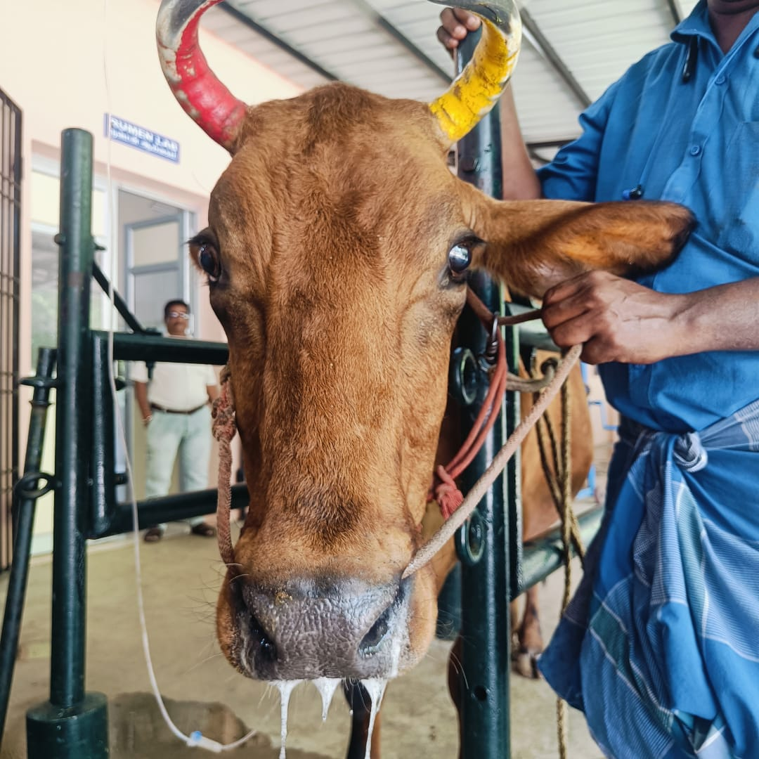
Fig1 - Cow with watery nasal discharge and frothy salivation.
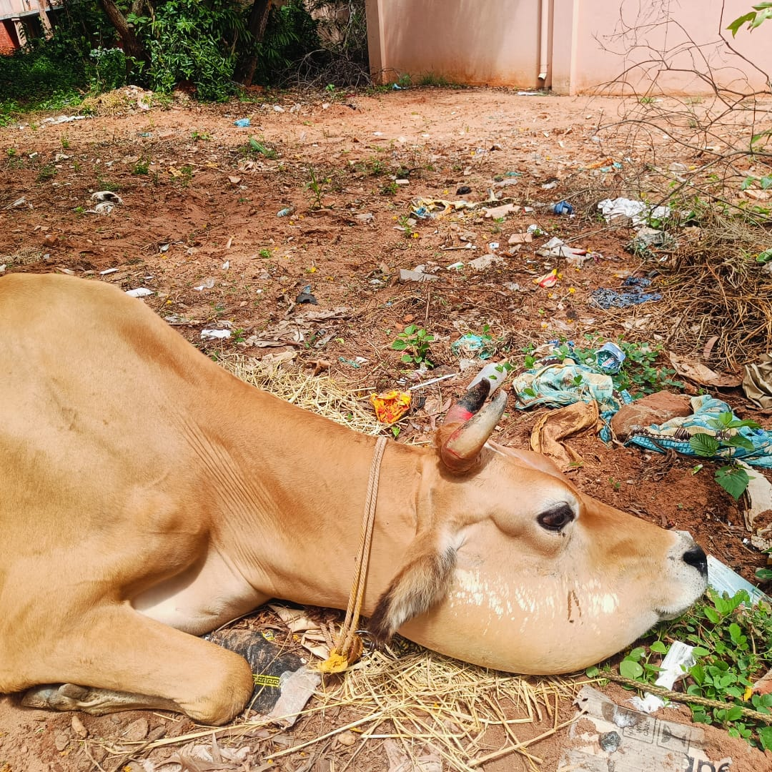
Fig2 - Cross bred jersey cow with jowl edema and sternal recumbence.
2.3 Sample Collection
Aseptic blood samples in K3 EDTA vacutainer were collected from the jugular vein of suspected cattle on the day of presentation. Samples were used for microscopic examination, molecular diagnosis, and bacteriological culture.
2.4 Direct Microscopic Examination
Thin peripheral blood smears were prepared on grease-free slides and stained using Leishman stain following the method of Bain and Lewis., 2012. Briefly, slides were air-dried, flooded with Leishman stain for fixation, diluted with buffered distilled water (pH 7.2), stained for 10 minutes, rinsed, and examined under a 100× oil immersion objective for the presence of bipolar organisms.
2.5 DNA Extraction
Template DNA was extracted using the Hi-Media® magnetic bead based DNA extraction kit. A 200 µL blood sample was mixed with lysis buffer, magnetic beads, and proteinase K, vortexed, and incubated at room temperature for 10 minutes. Ethanol was added to precipitate DNA, and the mixture was placed on a magnetic separator. After discarding the supernatant, beads were washed and DNA was eluted with 50 µL elution buffer at 65°C for 5 minutes. Extracted DNA was stored at −40°C until molecular analysis (Lorente-Leal et al., 2024) (see qPCR related data in Table 1 to 3)
Primer /Probe | Sequence (5’→3’) | Target gene | Amplicon size
KMT1_qPCR_For | ATCCGCTATTTACCCAGTGG | KMT1 | 186 bp
KMT1_qPCR_Rev | GGCTCAACACACCAAACTCC | KMT1 | 186 bp
Table 1 - Oligonucleotide primers for the detection of Pasteurella multocida

Sl.No. | PCR components | Amount (μl)
1 | 2X qPCR (SyBr-Green) Mastermix | 7.5
2 | Forward primer (10pmol/µl) | 0.25
3 | Reverse primer (10pmol/µl) | 0.25
4 | Template DNA | 4
5 | Nuclease free water | 3
Total volume per reaction |  | 15 µl
Table 2 - Pasteurella multocida specific qPCR reaction mixture

Conditions | Temperature and Time
Initial denaturation | 95˚C for 10 min
Denaturation | 95˚C for 15 sec | 40 cycles
Annealing / Elongation | 60˚C for 20 sec | 40 cycles
Hold | 4˚C
Table 3 - qPCR conditions
2.6 Bacterial Isolation and Culture
Sheep Blood Agar (SBA; Hi-Media® Laboratories Pvt. Ltd., Mumbai, India) was used as the primary medium for bacterial isolation. Blood samples positive for bipolar organisms and qPCR results were plated directly or inoculated into enrichment broth (Luria broth supplemented with sterile foetal calf serum). After incubation at 37°C for 18–24 hours, turbid broth cultures were streaked onto 5% SBA and incubated in a candle jar at 37°C for 24 hours. Non-haemolytic colonies were subjected to Gram staining to confirm Gram-negative coccobacilli. Pure cultures were obtained by sub-culturing onto fresh SBA or Mueller–Hinton agar plates and incubating at 37°C for 24 hours. Confirmed isolates were preserved in 30% Glycerol-Luria broth at −20°C for further characterization (Gharibi et al., 2017).
2.7 Antimicrobial Sensitivity Testing
Antimicrobial susceptibility of ten isolates was determined using the Kirby–Bauer disc diffusion method on Mueller–Hinton agar plates (Hi-Media®), following CLSI guidelines (CLSI, 2019). A standardized bacterial suspension was swabbed onto agar plates, and discs of various antimicrobials. Plates were incubated at 37°C for 24 hours. Inhibition zone diameters were measured and interpreted according to CLSI breakpoints.
Antimicrobial | Disc quantity
Penicillin G | 10 U
Gentamicin | 10 µg
Cefquinome | 30 µg
Co-trimoxazole | 25 µg
Oxytetracycline | 30 µg
Ceftiofur | 30 µg
Enrofloxacin | 10 µg
Table 4- list of antimicrobials used for antimicrobial sensitivity.
3. RESULTS
3.1 Occurrence of Haemorrhagic Septicaemia
The occurrence of haemorrhagic septicaemia (HS) was assessed in cattle presented to the Large Animal Medicine Unit, of the 63 non-vaccinated cattle clinically suspected, 21 animals tested positive for Pasteurella multocida, representing an occurrence of 33.33% (Fig3).

Fig3 - Occurrence of Haemorrhagic Septicaemia in cattle.

3.2 Direct Blood Smear Examination
Twenty-one smears (33.33%) showed bipolar organisms morphologically consistent with P. Multocida in peripheral blood smears. The organisms displayed the characteristic bipolar “safety-pin” appearance when stained with Leishman stain and examined under oil immersion (100×) (See Fig4)
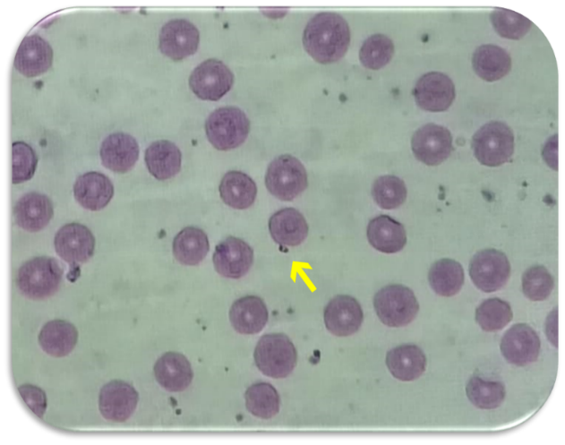
Fig4 – Peripheral blood smear showing bipolar organism suggestive of Pasteurella multocida under Leishman stain (100X oil immersion).

3.3 Molecular Diagnosis (Real-Time PCR)
All the 63 whole blood samples were subjected to molecular confirmation using a SYBR Green–based quantitative PCR (qPCR) assay. DNA was extracted from each sample prior to analysis. Of these, twenty-one samples corresponding to those positive on blood smear examination tested positive for P. multocida by qPCR, along with the positive control (ATCC 12945 P. multocida) and negative control (ATCC 25922 E. coli). The Cycle Threshold (Ct) values ranged from 12 to 29, confirming the presence of the organism (See Fig5)
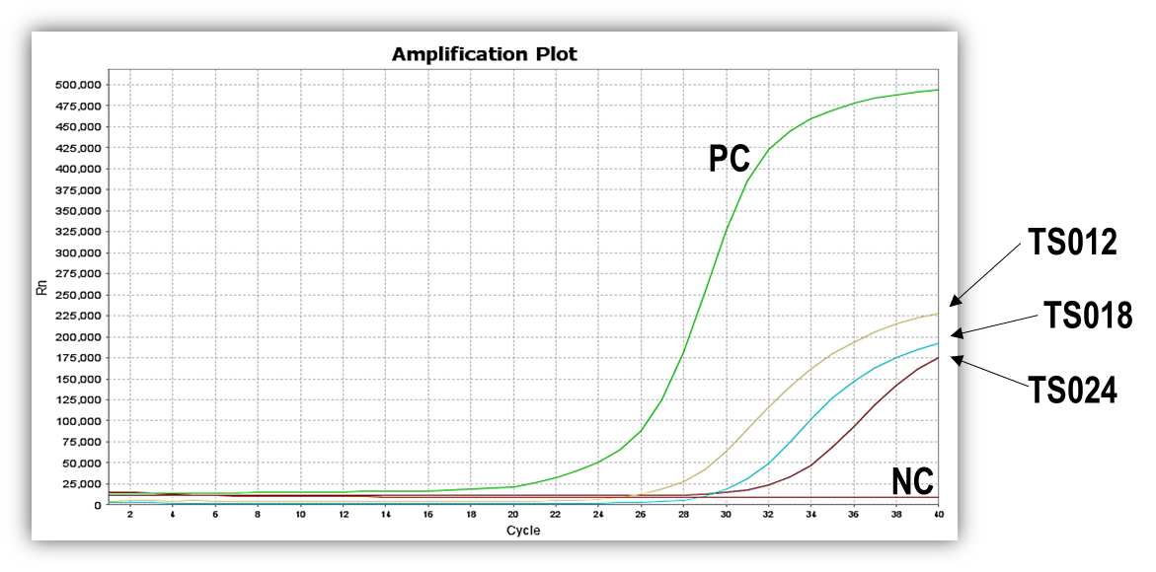
Fig 5 - Graph depicting the Amplification plot for the representative test samples (TS012, TS018 & TS024) along with the Positive Control (PC- ATCC 12945 P. multocida culture) and Negative Control (NC- E. coli ATCC 25922).
3.4 Bacterial Culture
After incubation at 37°C for 24 hours. The recovered colonies were non-haemolytic, small, round, smooth, translucent, and greyish, with a dew-drop–like appearance characteristic of P. multocida. Gram staining of the colonies revealed Gram-negative coccobacilli (See Fig 6 & 7).
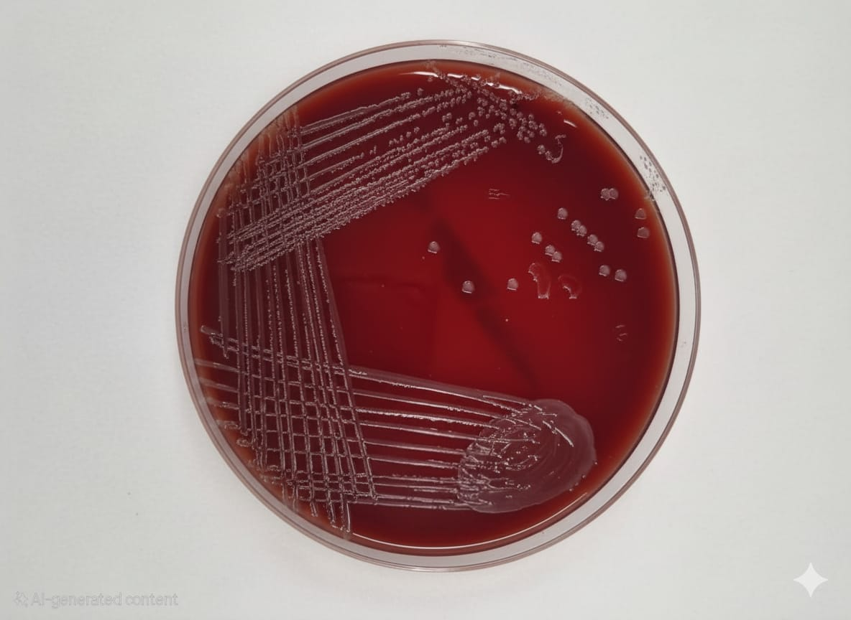
Fig 6 - Non-haemolytic smooth colonies of Pasteurella multocida on SBA plate
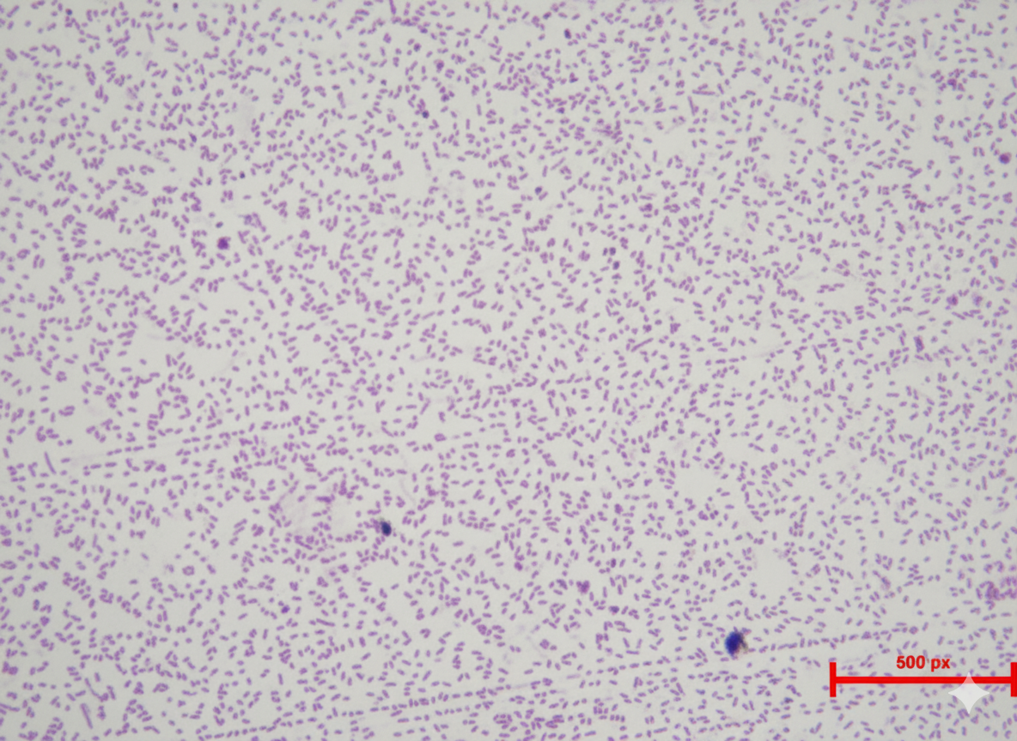
Fig 7 - Microphotograph showing Gram-negative coccobacilli (100X)
3.5 Antibiotic Sensitivity Test (ABST)
The in-vitro antimicrobial susceptibility profile of ten P. multocida isolates showed variable sensitivity patterns. Enrofloxacin and Gentamicin demonstrated 100% sensitivity, followed by Cefquinome (90%), Ceftiofur (80%), and Co-trimoxazole (50%). In contrast, Penicillin G and Oxytetracycline exhibited complete resistance in all tested isolates (See Fig 8 & 9, Table 5).
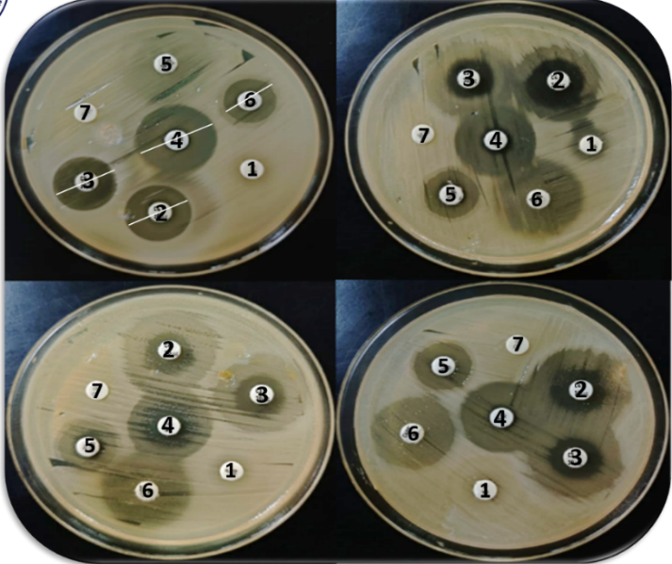
Fig 8 - Antibiotic sensitivity pattern of P. multocida isolated from clinical cases

Sl.No | Antimicrobial agent | Concentration (µg) | Antimicrobial sensitivity (%)
Sl.No | Antimicrobial agent | Concentration (µg) | Sensitive | Intermediate | Resistant
1 | Penicillin G (P) | 10 U | 0 | 0 | 10(100%)
2 | Cefquinome (CFQ) | 30 | 9 (90%) | 1(10%) | 0
3 | Ceftiofur (CFR) | 30 | 8 (80%) | 2 (20%) | 0
4 | Enrofloxacin (EX) | 10 | 10 (100%) | 0 | 0
5 | Co–Trimoxazole (SXT) (Sulphamethoxazole–Trimethoprim) | 25 | 5(50%) | 0 | 5 (50%)
6 | Gentamicin (GEN) | 10 | 10(100%) | 0 | 0
7 | Oxytetracycline (O) | 30 | 0 | 0 | 10(100%)
Table 5 - Antibiotic sensitivity pattern of P. multocida isolated from suspected clinical cases.

Fig 9 - Bar diagram depicting percentage distribution of Antibiotic Sensitivity among P. multocida isolates
4. DISCUSSION
In the present study, twenty-one out of sixty-three suspected cattle (33.33%) were confirmed positive for P. multocida by both blood smear examination and PCR. This finding is comparable to the prevalence of 25.4% reported by Shome et al., 2019 in Assam. The detection of bipolar organisms exhibiting the characteristic “safety-pin” morphology is a hallmark feature of P. multocida infection, and the present observations align with earlier studies by Rhoades et al., 1967, Hassan and Mustafa., 1985, Verma et al., 2004, Kumar et al, 2011, Shivachandra et al., 2011, Chung et al., 2015, and WOAH., 2021. The successful identification of bipolar organisms in this study may be attributed to sampling during the per-acute to acute stages of HS, when bacteraemia is typically high, thereby facilitating morphological detection in peripheral blood smears. In advanced stages of disease, or following empirical antimicrobial administration, bacterial load often declines, reducing the likelihood of observing bipolar organisms microscopically.
Molecular confirmation using SYBR Green–based qPCR targeting the KMT1 gene further validated the presence of P. multocida in all twenty-one smear-positive samples. The KMT1 gene, which encodes an outer membrane protein, is a well-established molecular marker and forms the basis of the classical diagnostic protocol described by Townsend et al., 1998. The high sensitivity and specificity demonstrated in this study are consistent with the results of Wang et al., 2023, who emphasized the superiority of qPCR over conventional culture methods due to its rapidity and enhanced diagnostic accuracy. Although the isolation rate in the present study was high, earlier reports documented considerably lower isolation rates. Bote et al., 2017 recovered only 3.39% from suspected HS cases, while Gulaydın and Gurturk., 2018 reported 13.2% positivity in healthy cattle and 32.2% in diseased cattle. Variation in isolation rates across studies may be attributable to differences in host species, sample type, stage of infection, prior antimicrobial treatment, and methodological differences in culture protocols. Comparable variability has also been documented in rabbits (Mahrous et al., 2016) and poultry (Geda et al., 2025).
The antimicrobial sensitivity profile observed in the present study aligns with several earlier reports. P. multocida isolates showed 100% susceptibility to Enrofloxacin and Gentamicin, consistent with the findings of Cuevas et al. (2020). High sensitivity to Ceftiofur and Cefquinome observed in this study also corresponds with reports by Pintér et al., 2024 and Somogyi et al., 2023, who documented more than 90% susceptibility to β-lactam antibiotics and fluoroquinolones. The intermediate sensitivity to Co-trimoxazole aligns with the 48–55% sensitivity reported by Ali et al., 2025. In contrast, several studies reported higher susceptibility to Oxytetracycline, including Bitew et al., 2025 of 91.7% and Klima et al., 2020 of >25%, whereas complete resistance was observed in the present study. Such discrepancies could be attributed to regional differences in antimicrobial usage, selection pressure, and the emergence of plasmid-mediated resistance mechanisms. The high efficacy of Enrofloxacin and Gentamicin may result from their conserved bacterial targets, which are less prone to mutational resistance. Similarly, the strong activity of Cefquinome and Ceftiofur may be due to their β-lactamase stability and superior tissue penetration. Conversely, the complete resistance to Penicillin G and Oxytetracycline could be attributed to their prophylactic and empirical usage.
5. CONCLUSION
Haemorrhagic septicaemia (HS) remains one of the most important infectious diseases affecting livestock worldwide. Despite its endemicity, detailed investigations on HS had not been previously conducted in the Puducherry region. The present study highlights the importance of different diagnostic modalities and proper therapeutic intervention, which are crucial for the successful management of HS. Real-time PCR proved to be a highly sensitive and reliable diagnostic tool, outperforming direct blood smear examination and conventional culture techniques in detecting P. multocida from clinically suspected cases. The antibiotic sensitivity profile of the isolates revealed high susceptibility to Enrofloxacin, Gentamicin, Ceftiofur and Cefquinome, whereas complete resistance was observed to Penicillin G and Oxytetracycline. Overall, the findings emphasize the utility of molecular diagnostics for rapid confirmation of HS and underscore the need for rational, evidence-based antimicrobial selection for effective treatment of P. multocida infections in cattle.

6. REFERENCES
- Chanda, M. M., Purse, B. V., Hemadri, D., Patil, S. S., Yogisharadhya, R., Prajapati, A., & Shivachandra, S. B. (2024). Spatial and temporal analysis of haemorrhagic septicaemia outbreaks in India over three decades (1987–2016). Scientific Reports, 14, 6773. https://doi.org/10.1038/s41598-024-56213-z
- Bain, B. J., & Lewis, S. M. (2012). Preparation and staining methods for blood and bone marrow films. In B. J. Bain, I. Bates, M. A. Laffan, & S. M. Lewis (Eds.), Dacie and Lewis practical haematology (11th ed., pp. 57–68). Elsevier. https://doi.org/10.1016/b0-443-06660-4/x5001-6
- Lorente-Leal, V., Gomez-Buendia, A., Gutiérrez-Tobaruela, A., de Juan, L., Bezos, J., & Romero, B. (2024). Shaken, not stirred: Magnetic bead DNA extraction as a rapid and effective method for scaling up bovine tuberculosis diagnosis. BMC Veterinary Research, 20, 568. https://doi.org/10.1186/s12917-024-04427-8 .
- Gharibi, D., Haji Hajikolae, M. R., Ghorbanpoor, M., & Barzegar, S. K. (2017). Isolation, molecular characterization and antibiotic susceptibility pattern of Pasteurella multocida isolated from cattle and buffalo from Ahwaz, Iran. Archives of Razi Institute, 72(2), 93–100. https://doi.org/10.22092/ari.2017.109838 .
- Clinical and Laboratory Standards Institute. (2019). A quality management system model for laboratory services (5th ed., QMS01-Ed5E). https://www.clsi.org/standards/products/quality-management/documents/qms01/ .
- Shome, R., Deka, R. P., Sahay, S., Grace, D., & Lindahl, J. F. (2019). Seroprevalence of hemorrhagic septicemia in dairy cows in Assam, India. Infection Ecology & Epidemiology, 9(1), 1604064. https://doi.org/10.1080/20008686.2019.1604064 .
- Rhoades, K. R., Heddleston, K. L., & Rebers, P. A. (1967). Experimental hemorrhagic septicemia: Gross and microscopic lesions resulting from acute infections and from endotoxin administration. Canadian Journal of Comparative Medicine and Veterinary Science, 31(9), 226–233. https://www.ncbi.nlm.nih.gov/pmc/articles/PMC1494749/ .
- Hassan, A. K. M., & Mustafa, A. A. (1985). Isolation of Pasteurella multocida type B from an outbreak of haemorrhagic septicaemia in camels in the Sudan. Revue d'élevage et de médecine vétérinaire des pays tropicaux, 38(1), 31–33. https://www.cirad.fr/revues/revue-d-elevage-et-de-medecine-veterinaire-des-pays-tropicaux/1985/38-1/isolement-de-pasteurella-multocida-type-b-chez-des-dromadaires-au-soudan .
- Verma, S. C., Mahajan, N. K., Malik, G., & Dahiya, J. P. (2004). An epidemiological study on bovine haemorrhagic septicaemia in Haryana. Indian Journal of Animal Research, 38(1), 14–19. https://arccjournals.com/journal/indian-journal-of-animal-research/ARCC-2004-38-1-14-19 .
- Kumar, A., Qureshi, S. D., Pal, B. C., Yadav, S. K., Jain, U., Khan, S., & Varshney, P. (2011). Status of haemorrhagic septicemia in cattle and buffalo in Uttar Pradesh, India. Applied Biological Research, 13(2), 99–104.
- Shivachandra, S. B., Viswas, K. N., & Kumar, A. A. (2011). A review of hemorrhagic septicemia in cattle and buffalo. Animal Health Research Reviews, 12(1), 67–82. https://doi.org/10.1017/S146625231100003X .
- Chung, E. L., Abdullah, F. F., Adamu, L., Marza, A. D., Ibrahim, H. H., Zamri-Saad, M., Haron, A. W., Saharee, A. A., Lila, M. A., Omar, A. R., Bakar, M. Z., & Norsidin, M. J. (2015). Clinico-pathology, hematology, and biochemistry responses toward Pasteurella multocida Type B:2 via oral and subcutaneous route of infections. *Veterinary World*, *8*(6), 783–792. https://doi.org/10.14202/vetworld.2015.783-792 .
- WOAH. (2021). Haemorrhagic septicaemia (Pasteurella multocida serotypes 6:b and 6:e). In OIE Terrestrial Manual (Chapter 3.4.10) https://www.woah.org/en/what-we-do/standards/codes-and-manuals/terrestrial-manual-online-access/ .
- Townsend, K. M., Frost, A. J., Lee, C. W., Papadimitriou, J. M., & Dawkins, H. J. S. (1998). Development of PCR assays for species- and type-specific identification of Pasteurella multocida isolates. Journal of Clinical Microbiology, 36, 1096–1100. https://doi.org/10.1128/JCM.36.4.1096-1100.1998 .
- Wang, H., Xin, L., Wu, Y., Liu, Y., Yao, W., Zhang, H., Hu, Y., Tong, R., & Zhu, L. (2023). Construction of a one-step multiplex real-time PCR assay for the detection of serogroups A, B, and E of Pasteurella multocida associated with bovine pasteurellosis. Frontiers in Veterinary Science. https://doi.org/10.3389/fvets.2023.1193162 .
- Bote, Y., Legesse, K., Shawul, G., & Tassew, A. (2017). Isolation, identification and antimicrobial susceptibility of Pasteurella multocida from cattle with hemorrhagic septicemia in Assosa and Bambasi districts, Benishangul Gumuz Regional state, Ethiopia. International Journal of Fauna and Biological Studies, 1, 67–75. https://www.journalofanimalresearch.com/archives/2017/volume-1-issue-2/1-2-10-100.pdf .
- Gulaydın, O., & Gurturk, K. (2018). Identification of Pasteurella multocida Strains Isolated from Respiratory Tract of Healthy and Diseased Cattle and Determination of Capsular Types by PCR. Van Veterinary Journal, 29(3), 143–146. http://dergipark.gov.tr/vanvetj .
- Mahrous, E. H., Abd Al-Azeem, M. W., Ahmed, S. A., & Wasel, F. A. (2016). Some microbiological studies on Pasteurella multocida in rabbits. Assiut Veterinary Medical Journal, 62(151), 101–106. https://doi.org/10.21608/avmj.2016.170012 .
- Geda, A. M., Wendimu, A., Lulie, S., Dessalegn, B., Tesfaw, L., Assefa, E., Birhanu, K., Deresse, G., Dufera, D., Enbiyale, G., Tesfaye, M., & Mihret, T. (2025). Molecular detection and antibiogram profiling of Pasteurella multocida isolated from breeder chickens suspected of fowl cholera in Gondar City, Ethiopia. International Journal of Microbiology. https://doi.org/10.1155/ijm/8356389 .
- Cuevas, I., Carbonero, A., Cano, D., García-Bocanegra, I., Amaro, M. Á., & Borge, C. (2020). Antimicrobial resistance of Pasteurella multocida type B isolates associated with acute septicemia in pigs and cattle in Spain. BMC Veterinary Research, 16(1), 222. https://doi.org/10.1186/s12917-020-02442-z .
- Pintér, K., Pollák, B. D., Gantelet, H., & Magyar, T. (2024). Antimicrobial susceptibility of Pasteurella multocida strains isolated from different host species. Acta Veterinaria Hungarica, 72(2), 71–79. https://doi.org/10.1556/004.2024.01051 .
- Somogyi, Z., Mag, P., Simon, R., Kerek, Á., Makrai, L., Biksi, I., & Jerzsele, Á. (2023). Susceptibility of Actinobacillus pleuropneumoniae, Pasteurella multocida and Streptococcus suis isolated from pigs in Hungary between 2018 and 2021. Antibiotics, 12(8), 1298. https://doi.org/10.3390/antibiotics12081298 .
- Ali, S., Tariq, M. H. A., Yaqoob, M., Haq, M. U., & Zahra, R. (2025). Molecular epidemiology and characterization of antibiotic resistance of Pasteurella multocida isolated from livestock population of Punjab, Pakistan. International Journal of Veterinary Science and Medicine, 13(1), 1–12. https://doi.org/10.1080/23144599.2024.2437223 .
- Bitew, Z., Tefera, T. A., Deneke, Y., T/Mariam, T., & Yihunie, F. B. (2025). Molecular serotyping and antimicrobial susceptibility profiles of Pasteurella multocida isolated from cases of hemorrhagic septicemia in cattle from selected districts of Keffa and Bench Sheko zones, South West Ethiopia. BMC Microbiology, 25(1), 224. https://doi.org/10.1186/s12866-025-03947-z .
- Klima, C. L., Holman, D. B., Cook, S. R., Conrad, C. C., Ralston, B. J., Allan, N., Anholt, R. M., Niu, Y. D., Stanford, K., Hannon, S. J., Booker, C. W., & McAllister, T. A. (2020). Multidrug resistance in Pasteurellaceae associated with bovine respiratory disease mortalities in North America from 2011 to 2016. Frontiers in Microbiology, 11, 606438. https://doi.org/10.3389/fmicb.2020.606438 .
- Sharma, M., Devi, A., & Bharti, R. (2023). Brief overview of the most significant livestock diseases in India. The Pharma Innovation Journal, 12(3), 4136–4141. https://www.thepharmajournal.com/archives/2023/vol12issue3/PartF/12-3-109-900.pdf .

