Evaluation of the Bacteriological Quality of Cattle Carcasses from Mpila Slaughter Areas and Antibiotic Susceptibility Profile of Staphylococcus spp. Isolates

Abstract
The objective of this study was to assess the bacteriological quality of cattle carcasses slaughtered in the Mpila slaughter areas. A total of thirty (30) samples were collected and subjected to microbiological analyses to quantify the total aerobic mesophilic flora (TAMF) and to identify total and fecal coliforms, Staphylococcus spp., and Salmonella spp. The results revealed a high prevalence of total coliforms (90%), fecal coliforms (56%), and staphylococci (70%). Compared to international food safety standards, 83% of the samples were non-compliant for TAMF, 57% for fecal coliforms, and 67% for Staphylococcus spp. No Salmonella strain was detected, indicating a 100% compliance rate for this parameter. Antibiotic susceptibility testing showed high resistance among isolates to penicillin (100%), erythromycin (95%), and doxycycline (86%). Moreover, 67% of Staphylococcus isolates were methicillin-resistant, indicating the presence of multidrug-resistant strains. These findings highlight a concerning level of carcass contamination and call for stricter hygiene measures in slaughter facilities, rational management of antibiotic use in livestock, and the establishment of an epidemiological surveillance system to limit the spread of multidrug-resistant bacteria.
Keywords: Bacteriological quality, cattle, antibiotic susceptibility, Staphylococcus spp.
INTRODUCTION
In recent years, the concept of a direct relationship between optimal nutrition and a healthy lifestyle has gained increasing attention among the general public. Consequently, the market for healthy foods has expanded significantly to meet the growing consumer demand for controlling their quality of life and health through better dietary choices (Iquierdo, 2009) [1]. Beef constitutes an essential component of the diet for many populations worldwide, providing the human body with key nutrients, including proteins, iron, and vitamins. The growth in meat consumption has been particularly marked in countries undergoing significant economic transitions. Since 1961, for example, meat consumption in China and Brazil has increased by factors of 15 and 4, respectively (Giromini & Givens, 2022) [2]. Beef production is expected to rise in sub-Saharan Africa, driven by rapid population growth and increasing demand for meat among the population (OECD/FAO, 2021; Luc Loubamba et al., 2023) [3]. However, being a highly perishable product, beef is susceptible to contamination at various stages of the production chain, including slaughtering, cutting, transportation, and marketing. It plays an important role as a vector for transmitting infectious agents from animals to humans (EFSA & ECDC, 2018; Frank et al., 2011) [4,5], representing a significant risk to consumer health (Ncoko, Jaja, & Oguttu, 2020) [6]. The hygienic quality of bovine carcasses sold in local markets thus raises important public health concerns.
Several studies conducted in sub-Saharan Africa have reported the presence of various pathogenic agents in meat, including Escherichia coli, Salmonella spp., Staphylococcus aureus, and Listeria monocytogenes (Azage & Kibret, 2017; Selby et al., 2006) [7,8]. These pathogens can cause gastroenteritis, systemic infections, or neurological complications, particularly among vulnerable populations such as children, the elderly, and immunocompromised individuals (Azage & Kibret, 2017; Niyonzima et al., 2018) [7,9].
The study by Luc Loubamba et al. (2021) [10] reported a 99% prevalence of carcasses contaminated with Escherichia coli, with an average bacterial load of 3.03 log₁₀ CFU/cm². Another recent study highlighted that Shiga toxin-producing E. coli (STEC) carrying the stx1-stx2 genes could pose a potential public health risk. Serogroups O26, O111, and O145, known to be associated with human health risks, were also detected (Luc Loubamba et al., 2023) [3]. A French study further established an epidemiological link between cattle and foodborne illness, implicating E. coli O157 in a case of foodborne intoxication (Santé Publique France, 2024) [11]. Moreover, Salmonella infections are of significant veterinary and medical importance, with high incidence rates in humans (Bornert, 2000) [12]. In the Republic of Congo (Congo-Brazzaville), very few studies have assessed the public health risks associated with beef consumption. The lack of laboratory facilities for microbiological analysis of foodstuffs, combined with limited data on this topic, represents a major public health concern.
Therefore, the present study aims to evaluate the level of contamination in beef by investigating certain pathogenic indicators of fecal contamination or poor hygiene and to determine the antibiotic susceptibility profiles of Staphylococcus spp. isolates.
2. MATERIALS AND METHODS
2.1.Sampling
In this study, the biological material consisted of cattle carcasses collected from the slaughter areas of Mpila. A total of thirty (30) cattle carcass samples were analyzed. Sampling was carried out over ten (10) weeks, with three (3) samples collected per week, and analyzed at the Bacteriology Department of the National Public Health Laboratory (LNSP) in Brazzaville. Samples were collected early in the morning under strict aseptic conditions. Approximately 30 g of meat were randomly sampled from different parts of the carcass (thigh, flank, rump steak, shoulder). Each sample was placed in a zip-lock bag, stored at +4°C in an insulated container, and transported to the laboratory on the same day for analysis.
2.2.Bacteriological Analysis
A stock solution was prepared, and serial dilutions up to 10^-10 were performed. Briefly, 25 g of each carcass sample were homogenized and diluted in 225 mL of sterile physiological saline (0.9%). Ten milliliters of the suspension were vortexed and used for bacteriological analysis. One milliliter of each dilution was evenly spread on the surface of the appropriate culture media in Petri dishes. The plates were incubated at 37°C for variable durations depending on the target bacteria. After bacterial growth, colonies were counted for each dilution to determine colony-forming units per gram (CFU/g).
For the enumeration of total aerobic mesophilic flora (TAMF), samples were plated on Plate Count Agar (PCA) and incubated at 37°C for 24–48 hours. For the isolation and enumeration of coliforms, samples were plated on MacConkey agar and incubated at 37°C and 44°C to enumerate total coliforms and fecal coliforms, respectively, for 24–48 hours. Staphylococcal strains were isolated on Mannitol Salt Agar (MSA) by plating 0.1 mL of each dilution onto the solidified medium. Plates were left at room temperature with lids closed for 15 minutes to allow absorption, then incubated at 37°C for 24–48 hours.
Salmonella detection was performed in multiple steps. First, suspensions were pre-enriched for 3 hours in 225 mL of buffered peptone water and incubated at 37°C to resuscitate bacteria. This was followed by selective enrichment using selenite broth, incubated for 18–24 hours at 37°C. Finally, enriched samples were plated on Hektoen enteric agar and incubated at 37°C for 24–48 hours to obtain characteristic colonies for identification.
2.3. Identification of Isolates
Isolate identification was performed using conventional microbiological methods, including Gram staining, the KOH test, and enzymatic tests such as catalase and coagulase (Dia et al., 2014; Moyen et al., 2014).

2.4. Antibiotic Susceptibility Testing
Antibiotic susceptibility was assessed using the disk diffusion method on Mueller-Hinton agar according to the recommendations of the French Society of Microbiology Antibiogram Committee (CASFM, 2021). Briefly, filter paper disks impregnated with predetermined concentrations of antibiotics were placed on the surface of agar plates previously inoculated with 24-hour-old bacterial cultures. Results were interpreted as susceptible (S) or resistant (R) based on critical diameter measurements. The antibiotics tested included Tobramycin, Vancomycin, Doxycycline, Erythromycin, Levofloxacin, Cefoxitin, Clindamycin, Amoxicillin-clavulanic acid, Norfloxacin, and Penicillin.

4. RESULTS
4.1. Distribution of contamination levels according to microbial groups
The figure below illustrates the variation in contamination levels (CFU/g) across different microbial groups for the 30 analyzed samples. It was observed that 83% of the samples exceeded the contamination threshold for the Total Aerobic Mesophilic Flora (TAMF) (Figure a). Regarding fecal coliforms, 43% of the samples were within acceptable limits, while 57% exceeded the standard values (Figure b). For Staphylococci, 67% of the samples were non-compliant and 33% met the standards (Figure c). Finally, Salmonella was completely absent, with 100% of the samples conforming to the regulations (Figure d).

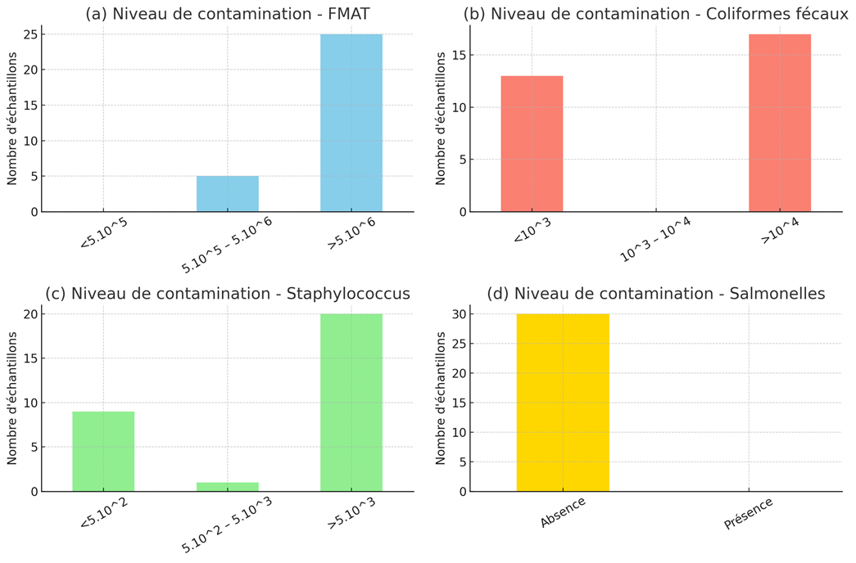
Figure 1: Distribution of contamination levels according to microbial groups
4.2. Isolation and Identification of Microbial Groups from Cattle Carcasses
Out of the 30 samples collected and analyzed, total coliforms were detected in 27 samples, fecal coliforms in 17 samples, and Staphylococcus spp. were isolated from 21 samples. No Salmonella strains were detected in any of the 30 samples, as previously mentioned in the enumeration.
The coagulase test performed on the 21 Staphylococcus isolates identified 3 coagulase-positive isolates (14%), whereas the remaining 18 isolates tested negative for coagulase, representing 86% (Figure 2).

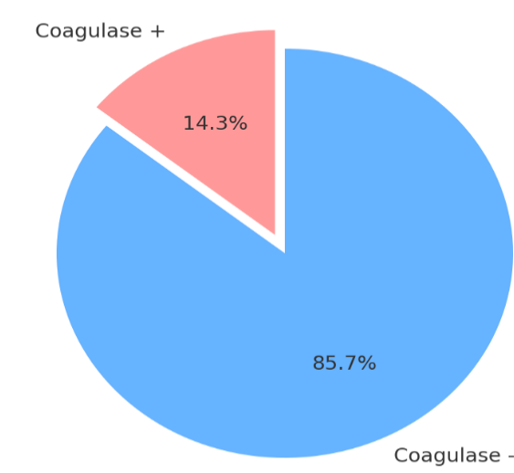
Figure 2: Results of Conventional Microbiological Tests (Coagulase).
4.3. Antibiotic Susceptibility Profile of Staphylococcus spp.
The Staphylococcus spp. strains were subjected to antibiotic susceptibility testing. Among the 21 strains tested (Figure 3), the highest susceptibility rates were observed for levofloxacin (86%, 18/21), followed by norfloxacin (62%, 13/21) and amoxicillin/clavulanic acid (57%, 12/21). Moderate susceptibilities were noted for cefoxitin (23%, 5/21) and clindamycin (33%, 7/21). Equal susceptibility rates of 14% (3/21) were observed for tobramycin, vancomycin, and doxycycline, while erythromycin showed the lowest susceptibility at 5% (1/21). In contrast, all strains were resistant to penicillin. Particularly high resistance rates were observed against erythromycin (95%, 20/21), doxycycline (86%, 18/21), vancomycin (81%, 17/21), tobramycin (76%, 16/21), as well as cefoxitin and clindamycin (67%, 14/21 each). Moderate resistance rates were recorded for amoxicillin/clavulanic acid (38%, 8/21), norfloxacin (33%, 7/21), and levofloxacin (14%, 3/21).

Figure 3: Antimicrobial susceptibility of Staphylococcus spp. Isolates
4.4. Methicillin resistance
Methicillin resistance was assessed using the cefoxitin disk (Table I). The results showed that 14 isolates (67%) were resistant to methicillin, while 7 isolates (33%) were methicillin-susceptible. Among the 14 methicillin-resistant (MR) strains, 3 were coagulase-positive and 11 were coagulase-negative.
Table 1: Frequency of Methicillin-Resistant and Methicillin-Sensitive Staphylococcus spp. Based on FOX Disk Test Results
ATB disk | Number of Staphylococcus spp | Frequency
FOX Méti-R | 14 | 67%
FOX Méti-S | 7 | 33%
Total | 21 | 100 %

5.DISCUSSION
Variation of Contamination Levels According to Microbial Groups

Total Aerobic Mesophilic Flora (TAMF)
The TAMF encompasses a broad range of microorganisms whose quantification serves as a relevant indicator of good hygiene practices. In this study, an average microbial load of 2.58×10¹³ CFU/g was measured, revealing an alarming rate of non-compliance. Indeed, only 17% of the samples were deemed suitable for human consumption, while the remaining 83% exceeded regulatory thresholds. This high prevalence of non-compliance clearly highlights significant breaches of hygiene protocols during carcass processing. These results differ markedly from those reported by Mohammed et al. (2023) [15], who observed an 80% compliance rate and only 13% non-compliance, and from Nkolo (2007) [16] in Senegal, who reported 76% compliance versus 24% non-compliance. This discrepancy can likely be explained by the fact that these studies were conducted in structured slaughterhouses where hygiene standards are generally stricter and more rigorously enforced.

Detection of Fecal Coliforms
Analysis revealed that fecal coliforms significantly impact sample quality, with only 43% compliance and a corresponding 57% non-compliance rate. This gap indicates a marked deterioration in sample quality or a particular specificity of the sites studied. These findings contrast with previous literature, which reported higher compliance rates, such as Nkolo (2007) [16] with 88.9% compliance and 11.1% non-compliance, and Ebengo (2022) [17] with 76% compliance and 28% non-compliance. During this study, it was noted that not all samples showed contamination at the dilutions used. Contamination of viscera by fecal coliforms at the time of evisceration appears evident. Ray (2001) and Savoye (2011) [18,19] reported that the primary source of E. coli contamination in meat is the animal’s digestive tract. Luc et al. (2021) [10] further noted that the presence of fecal coliforms in meat can be attributed to various factors, including hygiene practices, the rigor of handling during evisceration, and the location of slaughter.
Detection of Staphylococci
In this study, staphylococci were detected in 67% of the analyzed samples, corresponding to 33% compliance and 67% non-compliance. These results differ from those reported by Mohammed et al. (2023) [15], who observed compliance rates ranging from 60% to 89.57% and non-compliance rates between 11.43% and 40% in raw beef samples from slaughterhouses and butcheries. The presence of staphylococci indicates human-origin contamination, particularly during handling by carriers of these bacteria. Staphylococci are commonly found on human skin and in the nasal cavity. Their presence on fresh meat is unacceptable and serves as a clear indicator of inadequate hygiene. Hand hygiene and operator behavior are particularly crucial during cutting operations. This finding aligns with previous studies (Agossa et al., 2010; Benaissa et al., 2014) [20,21], which emphasized human-origin contamination whenever carcasses come into contact with humans, especially during transport and butchering.
Detection of Salmonella
Bacteriological analysis of the 30 samples for Salmonella detection yielded negative results, establishing a 100% compliance rate. These findings are consistent with those of Karib et al. (1996) [22], who also reported no Salmonella contamination in bovine samples. It should be noted, however, that the scope of our conclusions is limited to the samples analyzed. In contrast, Matafwari et al. (2022) [23] observed an 11.8% Salmonella contamination rate. This discrepancy may be explained by several factors, including meat type, sample size, hygiene conditions, and geographic and environmental differences.

Antibiotic Susceptibility of Staphylococcus spp. Strains
A disparity was observed in the susceptibility of strains to the antibiotics tested. Penicillin showed no effectiveness against the strains, exhibiting 100% resistance. High resistance rates were also observed for erythromycin (95%), doxycycline (86%), vancomycin (81%), and tobramycin (76%), while clindamycin and cefoxitin showed 67% resistance. Better efficacy was noted for amoxicillin/clavulanic acid (38%) and norfloxacin (33%), with levofloxacin emerging as the most effective antibiotic, showing the lowest resistance rate of only 14%. These results are consistent with findings reported by Marwa et al. (2019) [24] and other studies [25,26], which also highlighted high resistance to penicillin and varying resistance levels to other antibiotics. The high prevalence of resistance can be attributed to inappropriate and often excessive antibiotic use, particularly unregulated use in livestock practices, which promotes the emergence of resistant bacteria and poses a major public health risk (Carle, 2009) [27]. For doxycycline, our results were higher than those reported by Ashraf et al. (2015) [28] (32.5% resistance). Resistance to vancomycin and tobramycin differed from those reported by Etinosa et al. (2016) [26] and Guran et al. (2022) [29], potentially reflecting variations in antibiotic usage policies across contexts. Resistance rates for amoxicillin/clavulanic acid (87%) and norfloxacin (25.9%) were higher in Etinosa et al. (2016) [26]. Our results for cefoxitin (55.6% resistance) and levofloxacin (11.3%) are in agreement with Shi Wu et al. (2019) [30] and Ashraf et al. (2015) [28], respectively.
Methicillin Resistance
In this study, 14 methicillin-resistant staphylococcal (MR) strains were isolated, with only one identified as MRSA among three S. aureus strains, while the remaining 13 were methicillin-resistant coagulase-negative staphylococci (MR-CoNS), representing 7% MRSA and 93% MR-CoNS. This prevalence is higher than that reported by Guran et al. (2022) [29], who observed MRSA rates of 3% in beef, 1% in turkey, and 0% in chicken and duck. Similarly, Ge et al. (2017) [31] reported an overall MRSA prevalence of 1.9% in beef, 3.5% in turkey, and 0.3% in chicken. However, our MRSA prevalence is lower than that reported by De Boer et al. (2009) [32], who reported 11.9% MRSA prevalence in various meat products in the Netherlands. A meta-analysis by Wu et al. (2018) [33] reported a 35.0% MRSA prevalence in retail meats in China. These prevalence disparities may be attributed to geographic factors, livestock practices, hygiene conditions during slaughter and processing, and the detection methods employed

Conclusion
The results of this study revealed deficiencies in the slaughtering processes at the Mpila site. The level of contamination of bovine carcasses exceeded regulatory compliance thresholds, indicating issues with hygiene and handling practices. However, the absence of Salmonella remains a favorable indicator of safety. Among the 30 samples analyzed, 83% exhibited a Total Aerobic Mesophilic Flora (FMAT) count above the reference threshold, reflecting generally poor bacteriological quality, with only 17% of samples meeting compliance standards.
For fecal coliforms, 57% of samples exceeded acceptable limits, indicating a risk of fecal contamination, while 43% remained within permissible levels. Regarding Staphylococcus spp., 67% of samples were unsatisfactory, suggesting human-origin contamination.
The antibiotic resistance profile of the isolated Staphylococcus spp. revealed concerning levels of resistance to several commonly used drugs, including penicillin (100%), erythromycin (95%), doxycycline (86%), and vancomycin (81%). Such resistance levels suggest excessive and likely unregulated antibiotic use in livestock, promoting the selection of resistant strains and posing a significant public health concern.
Finally, when comparing these results with other studies conducted in similar or different contexts, it appears that the situation observed in Mpila’s slaughtering areas reflects broader issues of meat safety in the Republic of Congo. Moreover, the high proportion of methicillin-resistant strains observed in this study suggests extensive contamination, likely due to insufficient hygiene practices during meat handling and processing.
In conclusion, this study fully addresses its initial objectives and highlights the urgent need to implement strict hygiene measures and to regulate antibiotic use rigorously in order to minimize health risks for consumers.

References
Izquierdo, E. A. (2009). Bacterial proteins as biomarkers of probiotic activity. Doctoral thesis, University of Strasbourg.
Giromini, C., & Givens, D. I. (2022). Benefits and risks associated with meat consumption during key life processes and in relation to the risk of chronic diseases. Foods, 11, 2063. https://doi.org/10.3390/foods11142063
Loubamba, L., Diallo, A. A., Musabyemariya, B., Moyen, R., Sylla, K. S. B., & Alambédji, R. B. (2023). Virulence genes (stx1/stx2/aea) and O serogroups of Escherichia coli strains isolated from slaughtered cattle and ground meat sold in retail markets in Dakar, Senegal. The Microbe. https://doi.org/10.1016/j.microb.2023.100024
Frank, C., Werber, D., Cramer, J. P., Askar, M., Faber, M., Der Heiden, M., et al. (2011). Epidemic profile of Shiga toxin-producing Escherichia coli O104:H4 outbreak in Germany. New England Journal of Medicine, 365(19), 1771–1780. https://doi.org/10.1056/NEJMoa1106483
EFSA & ECDC (European Food Safety Authority & European Centre for Disease Prevention and Control). (2018). The European Union summary report on the trends and sources of zoonoses, zoonotic agents, and food-borne outbreaks in 2017. EFSA Journal, 16(12), 5500. https://doi.org/10.2903/j.efsa.2018.5500
Loubamba, L., Musabyemariya, B., Moyen, R., Diallo, A. A., Sylla, K. S. B., Bedekelabou, P. A., & Alambédji, R. B. (2021). Hazard assessment and resistance profile of Escherichia coli strains isolated from bovine carcasses at the main slaughterhouses of Dakar, Senegal. African Journal of Microbiology Research, 15(9), 467–474. https://doi.org/10.5897/AJMR2021.9566
Ray, B. (2001). Indicators of bacterial pathogens. In B. Ray (Ed.), Fundamental food microbiology (pp. 409–417). Boca Raton: CRC Press.
Savoye, F. (2011). Optimization of the protocol for the detection of Shiga toxin-producing Escherichia coli (STEC) in food. Doctoral thesis, University of Burgundy, 197(54).
Dia, M. L., Diongue, K., Diop, A., Ka, R., Sonko, M. A., Diagne, R., Sow, A. I., & Cissé, M. F. (2014). Mechanisms of β-lactam resistance in Staphylococcus aureus strains isolated at CHU of Dakar, Senegal. Rev. CAMES Santé, 2(2), 9–12.
Moyen, R., Ahombo, G., Nguimbi, E., Ontsira, N. E., Niama, R. F., Yala, G. C., & Obengui, L. D. (2014). Activity of β-lactam antibiotics and production of β-lactamases in bacteria isolated from wound infections in Brazzaville, Congo. African Journal of Microbiology Research, 8(23), 2290–2294.
Azage, M., & Kibret, M. (2017). Bacteriological quality, safety, and antibiogram of Salmonella isolates from fresh meat in retail shops of Bahir Dar City, Ethiopia. International Journal of Food Science, 2017, 4317202. https://doi.org/10.1155/2017/4317202
Selby, T. L., Berzins, A., Gerrard, D. E., Corvalan, C. M., Grant, A. L., & Linton, R. H. (2006). Microbial heat resistance of Listeria monocytogenes and the impact on ready-to-eat meat quality after post-package pasteurization. Meat Science, 74(3), 425–434. https://doi.org/10.1016/j.meatsci.2/18
Niyonzima, E., Ongol, M. P., Brostaux, Y., Korsak, N., Daube, G., Kimonyo, A., & Sindic, M. (2018). Meat retail conditions in establishments of Kigali city (Rwanda): Bacteriological quality and risk factors for Salmonella occurrence. Tropical Animal Health and Production, 50(3), 537–546. https://doi.org/10.1007/s11250-017-1466-6
Nkolo, S. C. (2007). Bacteriological quality of frozen buffalo meat imported into Senegal. Doctoral thesis, Cheikh Anta Diop University of Dakar, p. 56.
CASFM. (2021). Comité de l’antibiogramme de la Société Française de Microbiologie, Version 1.0, 188p.
Mohammed, A., Benhamida, A., & Smail, F. N. (2023). Evaluation of the microbiological quality of raw beef in abattoirs and butcheries in the Djelfa region, Algeria. Master’s Thesis, Ziane Achour University – Djelfa, Algeria.
Benaissa, A., Ould El Hadj-Khelil, A., & Babelhadj, B. (2014). Microbiological characterization of camel and sheep meat preserved using different methods. Emirates Journal of Food and Agriculture, 26(5), 465–471.
Agossa, R. (2010). Evaluation of hygienic quality of fresh beef at abattoirs in Cotonou-Porto Novo. Master’s Thesis in Animal Production and Health, EPAC, UAC, 61p.
Matafwari, M., Motassim El Hanafi, B., Bouchrif, B., Derkaoui, S., Dahani, S., Zyate, N., Bouchriti, N., & Nassik, S. (2022). Prevalence of Salmonella spp. in animal-derived food products marketed in Rabat, Morocco. International Journal of Innovation and Applied Studies, 40(4), 631–645.
Karib, H., Bouchrif, B., & El Marrakchi, A. (1996). Evaluation of bacterial contamination of ovine carcasses in Moroccan abattoirs. Revue de Médecine Vétérinaire, 147(12), 1031–1036.
De Boer, E., Zwartkruis-Nahuis, J. T. M., Wit, B., Huijsdens, X. W., De Neeling, A. J., Bosch, T., … & Heuvelink, A. E. (2009). Prevalence of methicillin-resistant Staphylococcus aureus in meat. International Journal of Food Microbiology, 134, 52–56.
Carle, S. (2009). Antibiotic resistance: an important public health issue. Pharmactuel, 42(Suppl. 2), 6–13.
Ge, B., Mukherjee, S., Hsu, C. H., Davis, J. A., Tran, T. T. T., Yang, Q., et al. (2017). Methicillin-resistant and multidrug-resistant Staphylococcus aureus in U.S. retail meats, 2010–2011. Food Microbiology, 62, 289–297.
Ashraf, M., Saad, S. M., Hasanine, F., Shaltout, F., & Zaghloul, M. (2019). Prevalence of methicillin-resistant Staphylococcus aureus in selected ready-to-eat meat products. Benha Veterinary Medical Journal, 37, 12–15.
Etinosa, I. O., Beshiru, A., Akporehe, L. U., Oviasogie, F. E., & Igbinosa, O. O. (2016). Prevalence of methicillin-resistant Staphylococcus aureus and other Staphylococcus species in raw meat intended for human consumption in Benin City, Nigeria: Implications for public health. International Journal of Environmental Research and Public Health, 13(9), 949. https://doi.org/10.3390/ijerph13090949
Etinosa, I. O., Beshiru, A., Akporehe, L. U., & Ogofure, A. G. (2016). Detection of methicillin-resistant staphylococci isolated from food-producing animals: A public health implication. Veterinary Sciences, 3, 1–11.
Alexandra, F., Britta, K., Gladys, K., Beatriz, G., Katja, A., Jens-André, H., Annemarie, K., Juliane, B., Bernd, A., & Bernd-Alois, T. (2011). Methicillin-susceptible and -resistant Staphylococcus aureus from farm to fork: Impact on food safety. Tehnol. Mesa, 52, 60–65.
Wu, S., Huang, J., Wu, Q., Zhang, F., Zhang, J., Lei, T., Chen, M., Xue, L., Wang, J., & Ding, Y. (2018). Prevalence and characteristics of Staphylococcus aureus isolated from retail raw meats in China. Food Control, 84, 1–8. https://doi.org/10.1016/j.foodcont.2017.07.014
Wu, S., Huang, J., Zhang, F., Wu, Q., Zhang, J., Pang, R., Zeng, H., Yang, X., Chen, M., Wang, J., Dai, J., Xue, L., Lei, T., & Wei, X. (2019). Prevalence and characterization of food-related methicillin-resistant Staphylococcus aureus (MRSA) in China. Frontiers in Microbiology, 10, 304. https://doi.org/10.3389/fmicb.2019.00304

