Effect of Etiolation and IBA on the Rhizogenesis of Magnolia liliiflora

Abstract

The present investigation entitled “Effect of Etiolation and IBA on the Rhizogenesis of Magnolia liliiflora” was conducted at experimental field of the Division `of Floriculture and Landscape Architecture, Sher-e-Kashmir University of Agricultural sciences &Technology, Shalimar Srinagar during the year 2023-24. The design of the experiment was CRD with 3 replications. The equal number of etiolated and non-etiolated cuttings were taken from Magnolia liliiflora plants treated with Indole-3-butyric acid at 0 ppm (control), 1000 ppm, 2000 ppm, 3000 ppm. It was summarized that etiolation followed by IBA treatment significantly enhanced the rooting in Magnolia liliiflora. Results indicated that etiolation + IBA 3000 ppm provided the best outcomes across most of the parameters. The treatment produced the highest number of primary roots (6.55), secondary roots (20.66,), root length (12.89 cm), rooting percentage (55%)and survival rate (63.97%) in Magnolia liliiflora. It also resulted in the shortest days to rooting 55.22 days in Magnolia liliiflora. These findings suggest that etiolation and using of higher concentrations of rooting hormones, especially IBA at 3000 ppm, significantly enhances propagation success in the Magnolia liliiflora.
Keywords: Etiolation, IBA, Rhizogenesis, Cuttings

Introduction
Traditionally, magnolias are propagated from seeds. Although growing magnolias from seed is generally easier than vegetative methods, seedlings from named cultivars often do not match the quality of their parent plants. Besides seed propagation, magnolias can also be propagated through grafting and rooting stem cuttings; however, seed germination rates are relatively low, and cuttings frequently have poor rooting success. To produce large quantities of disease-free and genetically uniform planting material, Clonal micro propagation has been adopted as a suitable method.
Top of Form
Bottom of Form
The ease of rooting varies greatly between different species and cultivars. Some cultivars root so readily that even simple methods and basic care result in high rooting rates. Conversely, other cultivars may only root effectively when specific influencing factors are addressed and maintained. Using stem cuttings is often recommended for quicker establishment and faster production (Kester et al., 1990). Various treatments and techniques have been developed to assist in propagating difficult-to-root woody plants. Methods such as using Indole-3-Butyric Acid (IBA), etiolation, banding, and layering have been employed to improve rooting success. Indole-3-Butyric Acid, a synthetic auxin, is widely used for rooting stem cuttings and is more effective when dissolved in acetone or ethanol (Maynard and Bassuk, 1991; Amissah and Bassuk, 2004).
The rooting success of cuttings can be influenced by various factors, including the position of the crown on the parent plant, the length of the cuttings, and the duration for which cuttings are soaked in external hormones (Elhaak et al., 2015). Nonetheless, the impact of these factors on root initiation can differ between species.

All classes of exogenous hormones auxin, cytokinin, gibberlin, ethylene, and abscisic acid, and ancillary compounds such as growth retardants/inhibitors, polyamines, and phenolics influence root initiation directly or indirectly (Davis and Haissig 1990). Exogenous hormones are commonly used in plant propagation methods to enhance the root development, number, and quality of roots. Generally, a high or low concentration of exogenous hormones supplemented in the propagation method could promote or inhibit cell growth. Auxin and gibberellin, particularly IBA, NAA, IAA, and GGR6, have been shown to promote rooting in various plant species, though the success rates can differ. Many studies indicate that IBA and NAA are more effective growth regulators for inducing rooting in cuttings, primarily due to their stability.
The etiolation process involves covering the shoots with a black cloth structure at the onset of bud break and before leaves emerge. This setup is kept in place to block light from reaching the developing shoots until they have grown sufficiently, typically 2 to 5 inches, to allow for banding. Shoot elongation is monitored through brief visual inspections every few days. Once etiolation is complete, banding material is applied to the base of the etiolated shoots. Hormones may be applied alongside the Velcro band at this time. After approximately four weeks, the cutting is taken by severing the shoot just below the band, which is then removed. The cutting is placed in a mist propagation chamber for rooting, and before insertion, the cuttings are treated with IBA. Stems that are etiolated or shaded tend to develop thicker layers of less specialized parenchymal tissue. This tissue has a higher potential for meristematic activity, which can easily trigger the formation of adventitious root primordia (Maynard and Bassuk, 1985).

Materials and Methods
The investigation “Effect of etiolation and IBA on Rhizogenesis of Magnolia liliiflora” was conducted during the year 2023-24, in the propagation unit at the experimental Field of Division of Floriculture and Landscape Architecture, Sher-e-Kashmir University of Agricultural Sciences and Technology of Kashmir. The District of Srinagar in the Union Territory of Jammu and Kashmir lies between 35.5 and 34.7 degrees North latitude and 74.8 to 74.9 degrees East longitude, at an elevation of 1,588 meters above sea level. It is bordered by the impressive Himalayan ranges to the southeast and northeast. The SKUAST-K campus is located at the base of these ranges to the northeast, roughly 15 km from the city center. The climate in general is temperate-cum-Mediterranean and of continental type that is characterized by hot summer and severe cold. Winter extends over 70 days from the middle of December to middle of March with June and July being hottest months and January and February the coldest months. Careful measures were taken to ensure that the cuttings were of similar size. Primarily, cuttings measuring about 10 cm in length and approximately 20 mm in diameter were collected from healthy branches of mother plant. During the 1st week of April limbs were bent downwards to allow lateral shoots to grow. In the 3rd week of April when newly grown shoots are about two inches’ etiolation with adhesive tape covering one inch of shoots leaving one inch free. After about 6 weeks (in first week of June) when shoots are about 7 inches with etiolated basal portion along with equal number of non-etiolated cuttings were taken with their leaves intact. The experiment was carried out in the propagation unit at the experimental field to ensure optimal temperature for root development. Coarse sand was used as the rooting medium, which was drenched with a 0.02% Bavistin solution before planting the cuttings to prevent the transmission of fungal diseases. A straight, horizontal cut was made at the base of each cutting, right below a node. The lower ends of the cuttings were then briefly dipped for 5 seconds in different concentrations of IBA: 1000 ppm, 2000 ppm, and 3000 ppm. Twenty cuttings from each treatment were treated with IBA, and the experiment was replicated thrice using a completely randomized design. Some cuttings were not immersed in any solution and were planted directly after the horizontal cut, as control. The cuttings of Magnolia liliiflora treated with IBA were immediately planted during the third week of July. Care was taken to ensure the rooting medium remained moist through regular water spraying, and weeds and dead cuttings were frequently removed. Observations on rooting behavior were recorded 45 days after planting the cuttings. All data collected for the various parameters in this studies were statistically analyzed using the methods outlined by Gomez and Gomez (1983). The data related to the rooted cuttings were subjected to analysis of variance for a completely randomized design with three replications, utilizing O.P. Stat. Significance was tested using ‘F’ values at the 5% level of probability. Critical difference (CD) values were calculated whenever the ‘F’ test indicated significance.
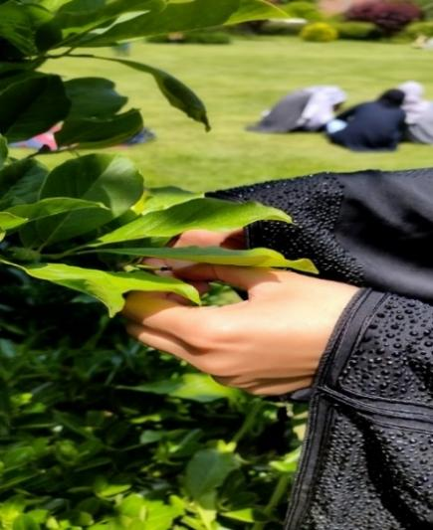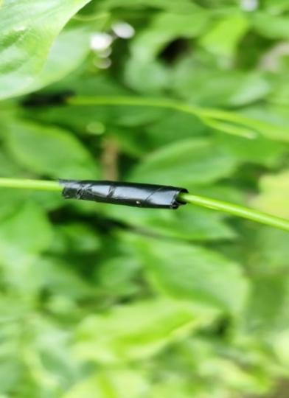
1A 1B
FIG 1A,1B Banding of shoots

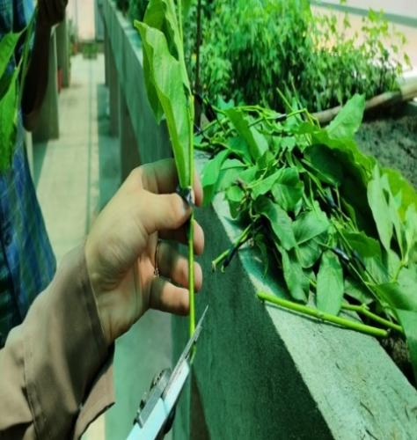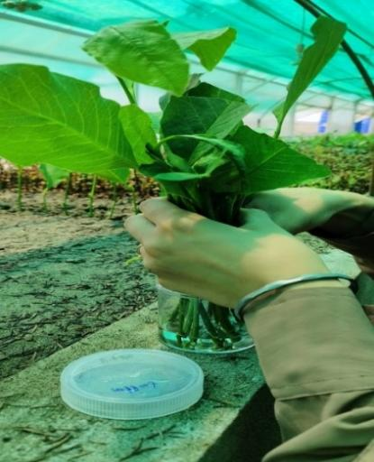
FIG 2 Preparation of cuttings FIG 3. Quick dip treatment

RESULT AND DISCUSSION
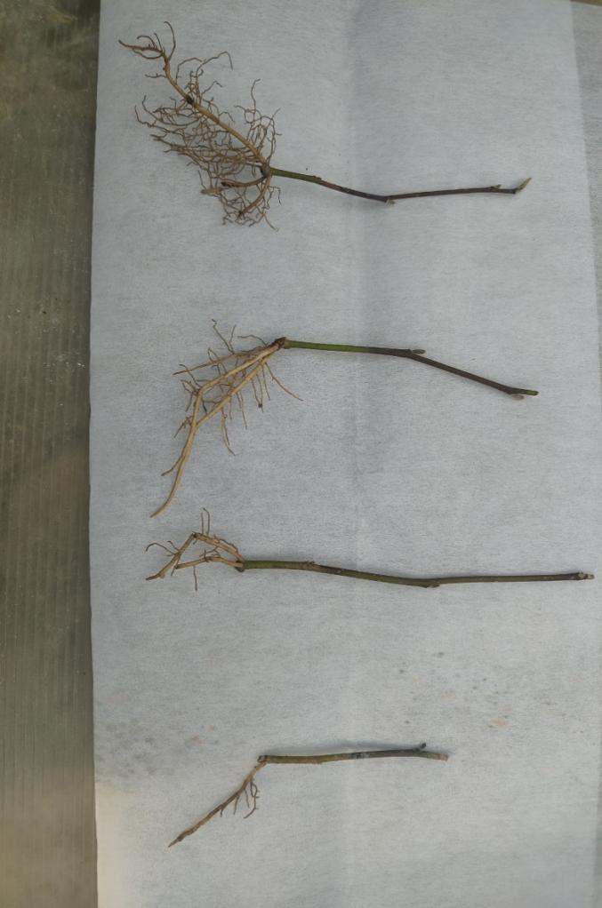
Control 1000 ppm 2000 ppm 3000 ppm
FIG 4. Rooting density over different concentration
The results shown in the Table 1 indicate that the duration for rooting was significantly influenced by the etiolation treatment. Non-etiolated cuttings took more time to develop roots, with an average of 65.60 days, while etiolated cuttings exhibited the shortest rooting time, averaging 63.33 days. whereas non-etiolated cuttings took more days to root, averaging 62.28 days, while etiolated cuttings had the shortest rooting time, with an average of 55.47 days. The time required for rooting in Magnolia liliiflora was significantly influenced by the concentrations of IBA. As IBA levels increased from 0 ppm to 3000 ppm, there occurred a notable decrease in the time taken for root initiation. Among the different IBA concentrations, the control group had the longest average rooting time at 69.49 days, followed by the IBA 1000 ppm treatment at 66.66 days. The shortest time for root emergence was observed in cuttings treated with IBA 3000 ppm, averaging 58.10 days. This suggests that increasing IBA concentrations significantly reduced the time to rooting. The root count of adventitious primary was greatly affected by the etiolation treatments in Magnolia liliiflora. The number of primary roots recorded were significantly lower in non-etiolated cuttings (2.63) compared to etiolated cuttings, which averaged 4.191, as illustrated in Table 2. The number of primary adventitious roots in Magnolia liliiflora were significantly influenced by varying IBA concentrations, the highest average of primary adventitious roots (5.05) were observed in cuttings treated with IBA 3000 ppm, while the lowest average (2.05) was recorded in the control group. The number of secondary roots obtained was significantly less in non-etiolated cuttings 9.05, as compared to number obtained in etiolated cuttings 13.69 in Magnolia liliiflora as depicted in the table 3 In Magnolia liliiflora the highest average number of secondary adventitious roots (16.77) were found in cuttings treated with IBA 3000 ppm, while the lowest average number (6.27) was recorded in the control group. The average length of adventitious primary roots was significantly influenced by etiolation treatments and was less in non-etiolated cuttings (5.65 cm) as compared to length of roots obtained in etiolated cuttings (7.34 cm) as depicted in the Table 4. Different concentrations of IBA significantly affected the length of primary roots per cutting (cm). The longest average length 10.11 cm was observed in cuttings treated with IBA 3000 ppm, while the shortest average length 4.02 cm, was recorded in the control group in Magnolia liliiflora. The data displayed in the Table 5. showed that Etiolated cuttings recorded 35.83 per cent rooting which was significantly superior over non-etiolated cuttings (28.33). Also the data in Table 5 indicate that all concentrations of IBA significantly affected the rooting percentage. The maximum rooting percentage (45.83%) was observed at 3000 ppm, followed by 35.00% at 2000 ppm. The control group yielded only 17.50% rooting. The data on the diameter of adventitious primary roots was greatly impacted by the etiolation treatments in Magnolia liliiflora. The results shown in Table 6. indicate that the diameter of primary roots in etiolated cuttings was significantly greater (2.21 mm) compared to the diameter of roots produced by non-etiolated cuttings (1.69 mm). The data in Table 6. demonstrate that all levels of IBA had a significant impact on the diameter of primary roots compared to the control. The maximum diameter (2.38 mm) was observed in cuttings treated with IBA 3000 ppm, while the minimum diameter (1.53 mm) was noted in the control group. The results in Table 7. indicate that etiolated cuttings demonstrated a higher percentage of survival (59.33%) compared to non-etiolated cuttings, which had a survival rate of 52.39%. The results in Table 7. indicate that different concentrations of IBA significantly affected the survival rate of rooted cuttings (%). The highest survival rate (58.92%) was observed in cuttings treated with IBA 3000 ppm, while the lowest survival rate (51.66%) was noted in the control group.The survival percentage of cuttings rooted was significantly influenced by the interaction between etiolation and IBA concentrations.
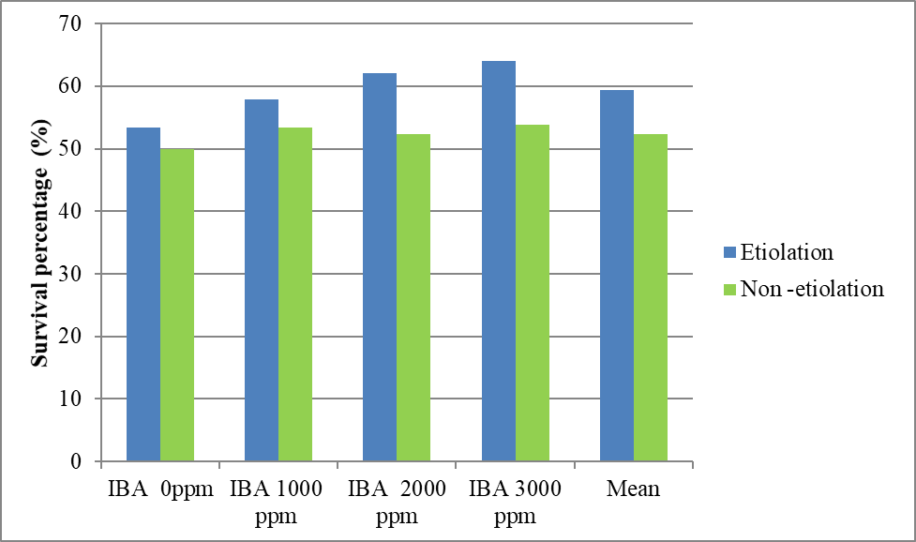
Fig 5. Effect of etiolation and IBA on the survival percentage of Magnolia liliiflora cuttings
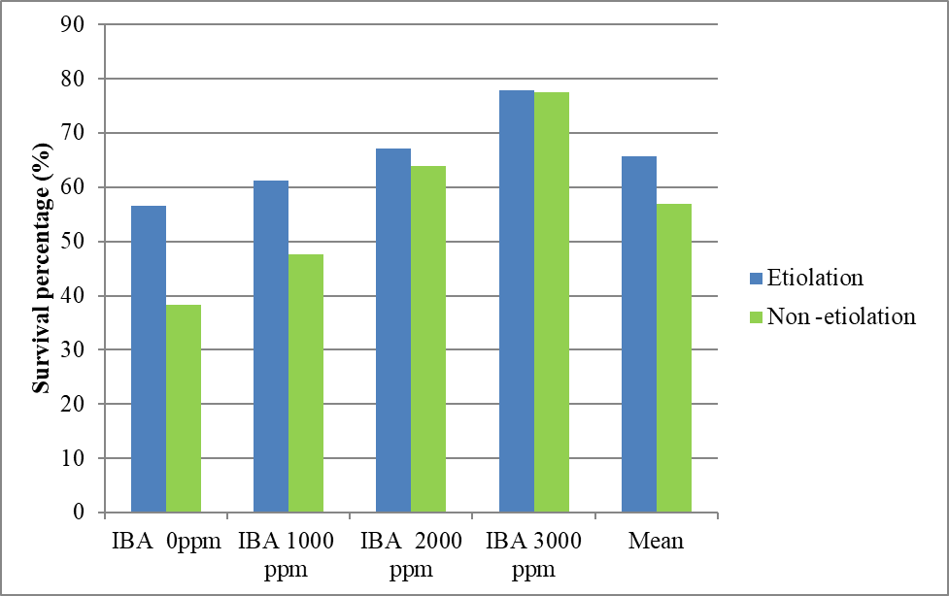
Fig. 6. Effect of Etiolation and IBA on the survival percentage of rooted cuttings
The increase in the percentage survival of rooted cuttings with etiolation and IBA is supported by findings from Mukherjee et al. (1986), who reported 81.25% survival using etiolation combined with 10,000 ppm IBA in air layers of Bael. Chatterjee et al. (1989) recorded a survival rate of 90.9% with etiolation and 10,000 ppm IBA in air layers of Sapota. Paul and John (1993) noted a 76.66% survival rate with etiolation and 500 ppm IBA in Chinese Privet. Additionally, Syamal and Singh reported a survival rate of 73.78% in Litchi using etiolation and 300 ppm IBA. The improved survival rates at higher IBA concentrations are likely due to the establishment of a more effective root system, characterized by a greater number of primary and secondary roots and increased root length. This enhanced root structure probably leads to better water and nutrient absorption. In contrast, the lower survival rate in untreated cuttings may be ascribed to the reduced primary and secondary root count. These results align with findings by Patel and Patel (2018) on Fig (Ficus carica).
CONCLUSION
The following conclusions were drawn from the present investigation:
- Etiolated cuttings achieved better rooting performance.
- IBA at 3000 ppm was determined to be superior to all other concentrations in improving adventitious roots in Magnolia liliiflora

TABLE 1. rooting performance
Treatments | Days taken to Rooting | Average number of primary adventitious roots | Average number of secondary roots | Average length of primary adventitious roots | Average number of successful rooted cuttings | Diameter of primary rooted cuttings | Survival percentage of rooted cuttings
IBA 0ppm | 69.49 | 2.05 | 6.27 | 4.02 | 17.50 | 1.53 | 51.66
IBA 1000ppm | 66.66 | 2.94 | 9.88 | 5.22 | 30.00 | 1.78 | 55.63
IBA 2000ppm | 63.60 | 3.60 | 12.55 | 6.63 | 35.00 | 2.10 | 57.24
IBA 3000ppm | 58.10 | 5.05 | 16.77 | 10.11 | 45.83 | 2.38 | 58.92
CD(P≤0.05) | 2.342 | 0.536 | 0.624 | 0.304 | 1.613 | 0.151 | 1.090
Etiolation | 63.33 | 4.191 | 13.69 | 7.34 | 35.83 | 2.21 | 59.33
Non-Etiolation | 65.6 | 2.63 | 9.05 | 5.65 | 28.33 | 1.69 | 52.39
CD(P≤0.05) | 0.644 | 0.379 | 0.441 | 0.215 | 1.141 | 0.107 | 0.771
REFRENCES
- Amissah, J. N., & Bassuk, N. L. (2004). Clonal propagation of Quercus spp. using a container layering technique. Journal of Environmental Horticulture, 22(2), 80-84. https://doi.org/10.24266/0738-2898-22.2.80
- Chatterjee, B. K., Ray, D. P., Chakladar, B. P. and Mukherjee, S., K. 1989. Effect of different concentrations of growth regulators, etiolation and invigoration on the rooting of air layers of Sapota (Archas zapota). Indian journal of Horticulture 46(4):426-429.
- Davis, T. and Hassig, B. 1990. Chemical control of adventitious root formation in cuttings.-Quarterly-PGRSA 18: 1-17.
- Elhaak, M. A., Matter, M. Z., Zayed, M. A., & Gad, D. A. (2015). Propagation Principles in Using Indole-3-Butyric Acid for Rooting Rosemary Stem Cuttings. Journal of Horticulture, 2(1), 1-13. https://doi.org/10.4172/2376-0354.1000121
- Kester, D., Davies, F. and Hartmann, H. 1990. Plant Propagation: Principles and Practices.-Prentice-Hall, India
- Maynard, B. K., and Bassuk, N. L. 1991. Stock plant etiolation and stem banding effects on the auxin dode-response of rooting in stem cuttings of CarpinusbetulusL.cv. fastigata. Plant Growth Regulation 10: 305-311.
- Maynard, B. K., & Bassuk, N. L. (1985). Etiolation as a tool for rooting cuttings of difficult-to-root woody plants. *Combined Proceedings International Plant Propagators' Society*, *35*, 488-495. https://ipps.org/uploads/docs/35_97.pdf
- Mukherjee, S. K., Chalakdar, B. P. and Chatterjee, B. K. 1986. Effect of growth regulators, invigoration and etiolation on rooting of air layers of Bael (Aegle marmelos). Indian journal of Horticulture 43(1&2): 9-12.
- Patel, H. R., & Patel, M. J. (2018). Role of auxins on rooting of different types of cuttings in fig (Ficus carica). International Journal of Current Microbiology and Applied Sciences, 7(3), 1317-1322. https://doi.org/10.20546/ijcmas.2018.703.157
- Paul, T. M. and Jhon, A. Q. 1193. Effect of etiolation and indole-butyric acid on rooting of Chinese privet (Lingustrum lucidium) cuttings. Advances in Plant Sciences 6(2): 351-354.
- Syamal, M. M. and Singh, S. K. 1993. Effect of etiolation and plant growth substances on rooting of air layers in Litchi. Indian journal of Horticulture 50(3): 241-244.

