Protein Extraction Characteristics of Defatted Sal (Shorea robusta) Seed Cake under Different Particle Sizes and Alkaline Conditions

Abstract
Sal (Shorea robusta) seed cake, a by-product of oil extraction, represents an underutilized plant-based protein resource with significant potential for value addition. The present study investigated the effects of particle size, extraction solvent, and precipitation pH on protein recovery from defatted Sal seed cake to identify optimal processing conditions for maximum protein yield. Protein extraction was carried out using three solvent systems distilled water with alkaline pH adjustment, 0.25 M sodium hydroxide (NaOH), and 0.2 M potassium hydroxide (KOH) across two particle size fractions (<0.5 mm and 0.5–1.0 mm) and precipitation pH levels ranging from 2 to 5.
Results demonstrated that particle size had a pronounced influence on extraction efficiency, with the finer fraction (<0.5 mm) consistently yielding higher protein recovery than the coarser fraction (0.5–1.0 mm) across all solvents. Among the extraction media, alkaline solvents significantly outperformed distilled water, confirming the effectiveness of alkaline-induced protein solubilization. The highest protein yield (38.63%) was achieved using 0.25 M NaOH at pH 4 with particle size <0.5 mm, while KOH extraction produced a maximum yield of 22.38% at pH 4 under the same particle size condition. Distilled water extraction resulted in comparatively lower yields, with a maximum of 18.67% observed at pH 5 for the finer fraction. The minimum protein recovery (4.58%) occurred with distilled water extraction at pH 5 for the 0.5–1.0 mm particle size.
Overall, the study highlights the synergistic role of particle size reduction, alkaline solvent selection, and optimised precipitation pH in enhancing protein extraction efficiency from Sal seed cake. These findings provide a scientific basis for developing cost-effective and sustainable protein recovery strategies, contributing to the valorisation of Sal seed cake for potential applications in food, feed, and nutraceutical formulations.

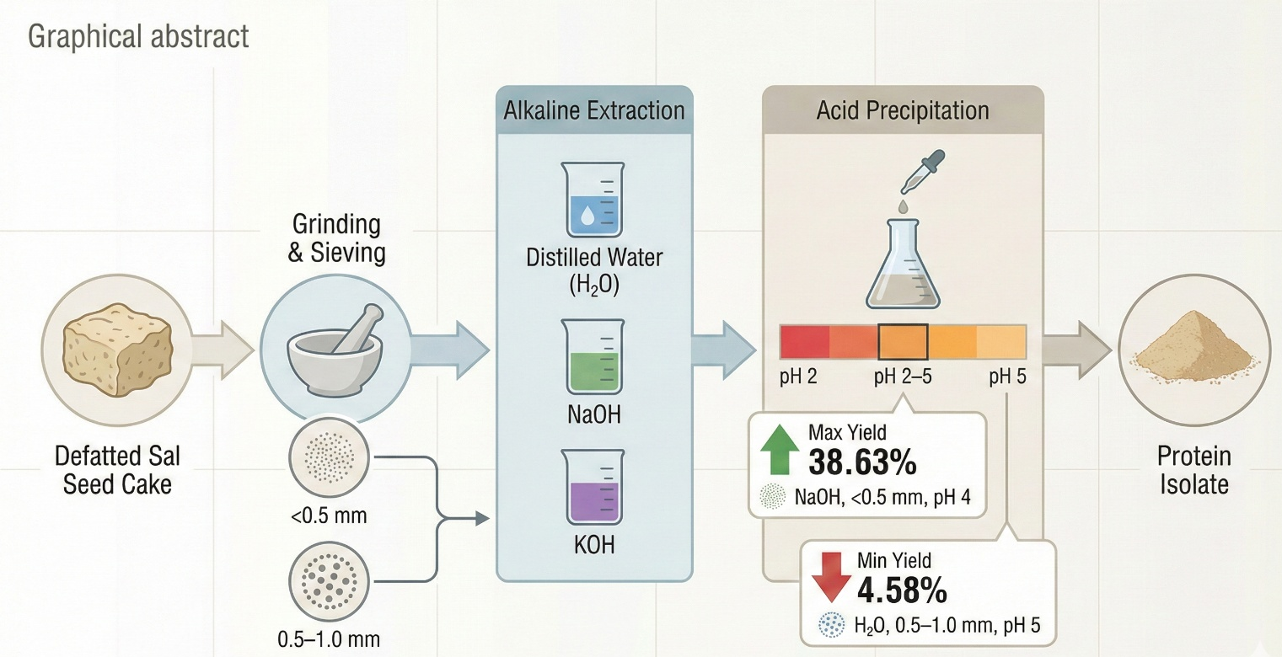
Keywords: Alkaline extraction; Particle size; Protein recovery; Sal seed cake; Solvent system; Protein extraction,
1. INTRODUCTION
The increasing global demand for sustainable, plant-based protein sources has intensified research interest in non-conventional oilseed by-products, particularly defatted seed cakes generated after oil extraction. These by-products are often rich in residual protein and represent an economically viable and environmentally sustainable alternative to conventional protein sources, while also supporting circular bioeconomy concepts in agro-processing systems (Singh et al., 2022; Hadidi et al., 2023). Efficient recovery of protein from such materials not only reduces industrial waste but also creates value-added ingredients for food, feed and nutraceutical applications.
Shorea robusta, commonly known as Sal, is a major forest tree species widely distributed across the Indian subcontinent, particularly in central and eastern India. Sal seeds are traditionally exploited for Sal fat (Sal butter), and large quantities of defatted Sal seed cake are generated annually as a by-product of oil extraction. Proximate composition studies indicate that Sal seed cake contains appreciable nutritional value, with reported crude protein levels ranging from approximately 18–22%, crude fiber between 9–13%, residual fat 5–8%, and ash content around 4–6% on a dry matter basis (Feedipedia, 2012; Wouters et al., 2016). Despite this favourable composition, Sal seed cake remains largely underutilized and is often relegated to low-value applications or discarded.
The protein fraction present in Sal seed cake is of particular interest due to its potential functional and nutritional properties. Proteins extracted from oilseed cakes have been reported to exhibit desirable techno-functional characteristics such as water-holding capacity, emulsification, and foaming ability, which are critical for their incorporation into food and feed formulations (Hadidi et al., 2023; Singh et al., 2022). However, the efficiency of protein recovery from plant matrices is strongly dependent on processing parameters, including particle size, extraction solvent, and pH conditions, which influence protein solubility, molecular interactions, and mass transfer behaviour (Zhang et al., 2020).
Particle size reduction is widely recognized as a key pretreatment step in protein extraction. Decreasing particle size increases surface area exposure, disrupts cellular structures, and enhances solvent penetration, thereby improving protein solubilization and extraction yield (Li et al., 2020; Hettiarachchy et al., 1995). Similarly, alkaline extraction using NaOH or KOH is commonly employed for oilseed protein recovery, as elevated pH promotes ionization of amino acid side chains, cleavage of disulfide bonds, and weakening of protein–polysaccharide complexes within the cell wall matrix (Hadidi et al., 2023; Zhang et al., 2020). Subsequent acid precipitation near the isoelectric point enables effective protein recovery from the extract.
Recent studies have demonstrated the effectiveness of optimizing these parameters in other forest and oilseed cakes. For instance, Gaharwariya et al. (2025) reported that reducing particle size and employing alkaline solvents significantly enhanced protein recovery from defatted Kusum (Schleichera oleosa) seed cake. Similarly, Gaharwariya et al. (2025) optimized protein extraction from defatted Neem (Azadirachta indica) seed cake, highlighting the combined influence of particle size, solvent selection, and precipitation pH on yield optimization. These studies clearly establish that systematic process optimization is essential for maximizing protein recovery from underutilized seed cakes. However, comparable, detailed investigations focusing on defatted Sal seed cake remain scarce in the literature.
Given the substantial availability of Sal seed cake, its favourable nutritional profile, and the growing demand for alternative plant proteins, there is a clear need to evaluate and optimize protein extraction conditions specific to this material. Understanding how particle size, alkaline solvent type, and pH affect protein recovery from Sal seed cake will provide valuable insights for its valorisation as a sustainable protein source. Therefore, the present study aims to investigate the protein extraction characteristics of defatted Sal (Shorea robusta) seed cake under different particle sizes and alkaline conditions, contributing to the broader effort of utilizing forest-based oilseed by-products for high-value protein applications. Figure 1 illustrates the multi-sectoral utilization potential of Sal seed protein. In the food industry, it can be incorporated into protein supplements, bakery products, meat analogues, and emulsified foods. In animal nutrition, Sal protein isolate serves as a cost-effective alternative protein source in feed formulations. The nutraceutical and functional food sector can exploit its bioactive potential, while industrial applications include biodegradable films, adhesives, and binders due to favourable physicochemical characteristics. This visual reinforces the importance of optimizing protein extraction from Sal seed cake for sustainable bioresource utilization.
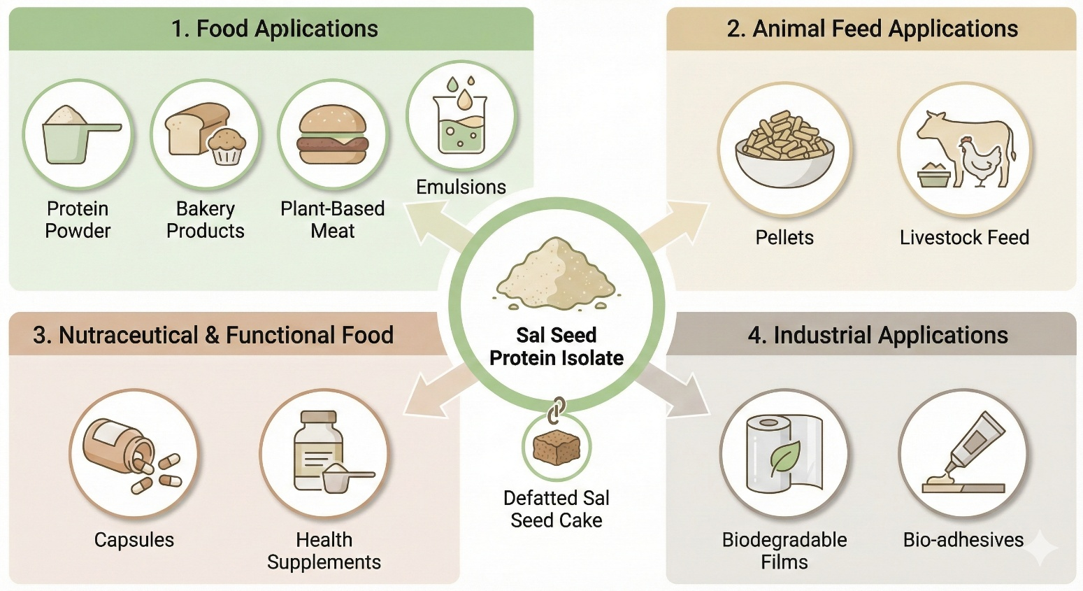
Figure 1. Applications of Protein Extracted from Defatted Sal (Shorea robusta) Seed Cake
2. MATERIALS AND METHODS
2.1 Materials
2.1.1 Chemicals, Reagents, Glassware, and Instruments
All chemicals employed during the experimental work were of analytical grade and used without further purification. The reagents included hydrochloric acid (HCl), sodium hydroxide (NaOH), potassium hydroxide (KOH), and distilled water, which were used for pH adjustment, alkaline extraction, and washing steps. Routine laboratory glassware comprising conical flasks, beakers, Petri dishes, measuring cylinders, and borosilicate glass funnels was used throughout the study.
The major equipment utilized for sample preparation and analysis included a laboratory electric grinder for particle size reduction, an analytical balance with a precision of ±0.001 g for accurate weighing, a rotary shaker to ensure uniform solvent–sample interaction, and a refrigerated centrifuge for phase separation during protein recovery. Additional instruments included adjustable micropipettes and a calibrated digital pH meter to allow precise control and monitoring of pH during extraction and precipitation stages.
2.1.2 Raw Materials
Defatted Sal (Shorea robusta) seed cake was obtained from the Agricultural Structure and Process Engineering Division, ICAR–National Institute of Secondary Agriculture, Namkum, Ranchi, Jharkhand, India (PIN: 834010) shown in Plate 1. The collected seed cake, generated as a by-product after oil extraction, was transported to the laboratory and stored in clean, airtight, food-grade containers under ambient conditions. This storage protocol was adopted to minimize moisture uptake and oxidative deterioration prior to further processing and experimental use.
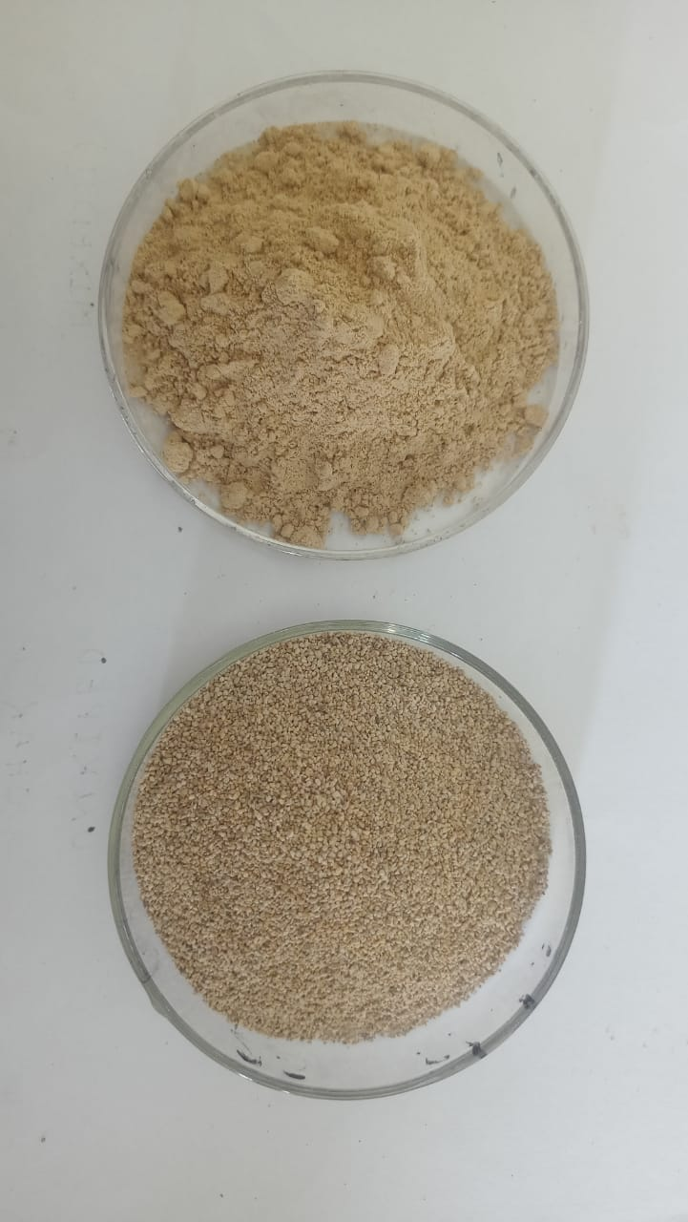
Plate 1. Defatted Kusum seed cake powder
2.2 Methods
2.2.1 Preparation of Seed Cake Powder and Particle Size Separation
The defatted Sal seed cake was first ground using a laboratory-scale electric grinder to obtain a uniform powder suitable for protein extraction studies. The ground material was subsequently classified into different particle size fractions using British Standard Sieves (BSS). Two sieve fractions were selected for investigation: a coarse fraction retained between 16–30 BSS (approximately 0.5–1.0 mm) and a fine fraction passing through a 30 BSS sieve (<0.5 mm). Each particle size fraction was collected separately, sealed in airtight containers, and stored until further analysis. These fractions were used to evaluate the effect of particle size on protein extraction efficiency.
2.2.2 Protein Extraction Procedures
Protein extraction from defatted Sal seed cake was carried out using three different solvent systems: (i) distilled water with alkaline pH adjustment, (ii) potassium hydroxide (KOH), and (iii) sodium hydroxide (NaOH). The extraction protocol was based on the alkaline solubilization followed by acid precipitation technique, which is widely applied for protein recovery from oilseed cakes. Minor modifications were introduced to accommodate the structural and compositional characteristics of Sal seed cake, while maintaining consistency with previously reported oilseed protein extraction methodologies.
2.2.2.1 Distilled water with pH regulation
For each extraction experiment, 10 g of defatted Sal seed cake powder was suspended in 150 mL of distilled water. The pH of the suspension was gradually increased to 12 using 1 M NaOH to promote alkaline solubilization of protein, following conditions adapted from Uddin et al. (2018). The mixture was agitated on a rotary shaker at 150 rpm for 2 hours to ensure effective solute–solvent interaction. After extraction, the suspension was centrifuged at 4,500 rpm for 20 minutes, and the supernatant containing solubilized proteins was carefully collected.
Protein precipitation was achieved by adjusting the pH of the supernatant to 2, 3, 4, and 5 using 1 N HCl, as described by Gaarwariya et al. (2025). The resulting protein curd was separated by centrifugation at 4,500 rpm for 20 minutes. The precipitate was washed with distilled water and centrifuged again at 4,500 rpm for 10 minutes to remove residual acidity, following the procedure of Gaharwariya et al. (2025). The purified protein isolate was then dried in a hot-air oven at 40 °C until a constant weight was obtained.
2.2.2.2 Potassium hydroxide (KOH) extraction
For KOH-assisted extraction, 10 g of defatted Sal seed cake powder was mixed with 150 mL of 0.2 M KOH solution. The suspension was agitated on a rotary shaker at 150 rpm for 2 hours under alkaline conditions to facilitate protein solubilization. Following extraction, the mixture was centrifuged at 4,500 rpm for 20 minutes, and the supernatant was separated.
Protein precipitation was carried out by adjusting the pH of the supernatant to values between 2 and 5 using 1 N HCl. The precipitated protein was recovered by centrifugation (4,500 rpm, 20 minutes), washed with distilled water, and re-centrifuged to ensure removal of residual alkali and acid. The final protein isolate was dried at 40 °C until constant mass was achieved.
2.2.2.3 Sodium hydroxide (NaOH) extraction
In the NaOH extraction method, 10 g of defatted Shorea robusta seed cake powder was dispersed in 150 mL of 0.25 M NaOH, following alkaline extraction conditions adapted from Uddin et al. (2018). The suspension was agitated at 150 rpm for 2 hours to promote protein solubilization. After extraction, the mixture was centrifuged at 4,500 rpm for 20 minutes, and the supernatant containing dissolved proteins was collected.
Protein precipitation was induced by adjusting the supernatant pH to 2–5 using 1 N HCl. The precipitated protein was separated by centrifugation, washed with distilled water, and re-centrifuged. The final protein isolate was dried in a hot-air oven at 40 °C until a stable weight was obtained. A schematic representation of the extraction process is presented in Figure 2, with representative samples shown in Plate 2.
Plate 2. Process flow chart for the methodology of the defatted Sal seed cake protein extraction using alkaline solvent

Figure 2. Flow diagram illustrating alkaline solubilization–acid precipitation–based protein extraction from defatted Sal (Shorea robusta) seed cake.
2.2.3 Replication and Yield Reporting
All extraction experiments were performed in triplicate to ensure reproducibility and reliability of results. Protein yield was calculated on a dry weight basis, and the final values were expressed as the mean of three independent determinations.
3. RESULTS
3.1 Effect of Particle Size on Protein Extraction Yield
The influence of particle size on protein recovery from defatted Sal (Shorea robusta) seed cake was evaluated using two particle size fractions, namely <0.5 mm (passing 30 BSS) and 0.5–1.0 mm (16–30 BSS), across different extraction media and precipitation pH conditions. The results are summarised in Table 1.
Table 1. Protein yield (%) from defatted Sal (Shorea robusta) seed cake as affected by particle size, solvent system, and precipitation pH.
pH | Distilled water |  | NaOH |  | KOH
 | <0.5mm | 0.5-1mm | <0.5mm | 0.5-1mm | <0.5mm | 0.5-1mm
2 | 17.25 | 7.13 | 34.89 | 17.91 | 20.09 | 14.62
3 | 17.47 | 6.96 | 35.78 | 18.01 | 19.61 | 17.07
4 | 18.28 | 5.83 | 38.62 | 15.99 | 20.92 | 19.28
5 | 18.67 | 4.58 | 37.21 | 21.73 | 22.38 | 21.45

Across all extraction systems distilled water with alkaline adjustment, 0.25 M NaOH, and 0.2 N KOH a consistent trend was observed in which the finer particle fraction (<0.5 mm) yielded significantly higher protein recovery compared to the coarser fraction (0.5–1.0 mm). This enhancement can be attributed to the increased specific surface area of finer particles, which improves solvent accessibility, promotes efficient mass transfer, and facilitates greater protein solubilization during extraction. In distilled water extraction, protein yield for the <0.5 mm fraction increased gradually with rising precipitation pH, reaching a maximum value of 18.67% at pH 5, while the corresponding yield for the 0.5–1.0 mm fraction declined sharply to 4.58% at the same pH.
The relatively low recovery under distilled water conditions indicates limited protein solubilization in the absence of strong alkaline solvents. NaOH extraction resulted in substantially higher protein yields compared to distilled water. The highest protein recovery (38.62%) was obtained at pH 4 for the <0.5 mm fraction, whereas the corresponding yield for the 0.5–1.0 mm fraction was markedly lower (15.99%). This highlights the combined effect of fine particle size and strong alkaline conditions in enhancing protein extraction efficiency. Similarly, KOH extraction showed improved protein recovery for the finer fraction, with the maximum yield of 22.38% recorded at pH 5 for particles <0.5 mm. In contrast, yields from the larger particle fraction remained consistently lower across all pH levels.
Overall, these results confirm that particle size plays a critical role in determining protein extraction efficiency from Sal seed cake. Reduction in particle size enhances solvent accessibility, promotes effective cell wall disruption, and facilitates improved protein solubilization and precipitation, particularly under alkaline extraction conditions.
3.2 Effect of Different Extraction Methods on Protein Yield
Protein extraction from plant-derived oilseed by-products is most effectively achieved under alkaline conditions due to enhanced protein solubility at elevated pH levels. In the present study, sodium hydroxide (NaOH) and potassium hydroxide (KOH) were employed as alkaline extraction media, while distilled water with pH adjustment served as a comparative control to evaluate solvent efficiency in protein recovery from defatted Sal seed cake.
The results clearly indicated that alkaline solvents significantly outperformed distilled water across all particle size fractions and precipitation pH levels. This improved performance can be attributed to the ability of alkaline environments to increase the net negative charge on protein molecules, leading to electrostatic repulsion, unfolding of protein structures, and disruption of intermolecular hydrogen and disulfide bonds. Such physicochemical changes enhance protein solubilization and facilitate greater diffusion of proteins into the extraction medium.
Among the alkaline solvents tested, NaOH exhibited the highest protein recovery, particularly for the finer particle size fraction (<0.5 mm), indicating its strong solubilization capacity and effective penetration into the Sal seed cake matrix. KOH also demonstrated superior extraction efficiency compared to distilled water, although slightly lower yields than NaOH were observed under comparable conditions. The relatively lower performance of distilled water, even under alkaline pH adjustment, suggests limited disruption of cell wall components and weaker solubilization of bound protein fractions.
Additionally, the interaction between solvent type, particle size, and precipitation pH played a crucial role in determining extraction efficiency. Alkaline solvents combined with reduced particle size enhanced cell wall disintegration, improved solvent accessibility, and promoted efficient protein precipitation at optimized pH levels. Overall, these findings emphasize that solvent selection is a critical determinant in developing an effective protein extraction protocol for Sal seed cake.
3.2.1 Distilled Water with pH Adjustment Method
The effect of pH and particle size on protein extraction from defatted Sal seed cake using distilled water with pH adjustment is illustrated in Figure 3. Protein yields were evaluated for two particle size fractions (≤0.5 mm and 0.5–1.0 mm) at precipitation pH values of 2, 3, 4, and 5.
Results indicated that the finer particle size (≤0.5 mm) consistently resulted in higher protein recovery compared to the coarser fraction across all pH levels. The maximum protein yield (18.66%) was obtained at pH 5 for the ≤0.5 mm fraction, whereas the minimum yield (4.58%) was recorded for the 0.5–1.0 mm fraction at the same pH.
The observed increase in protein yield with decreasing particle size can be attributed to enhanced solvent penetration and improved solubilization kinetics. Furthermore, protein solubility in aqueous systems is strongly governed by pH and ionic conditions, as variations in pH modify the net charge of protein molecules, thereby influencing intermolecular interactions, aggregation behaviour, and solubilization efficiency (Damodaran & Parkin, 2017; Kinsella & Melachouris, 1976). Although distilled water extraction yielded lower recoveries than alkaline solvents, the results confirm that controlled pH adjustment and particle size reduction can improve protein extraction efficiency from Sal seed cake.
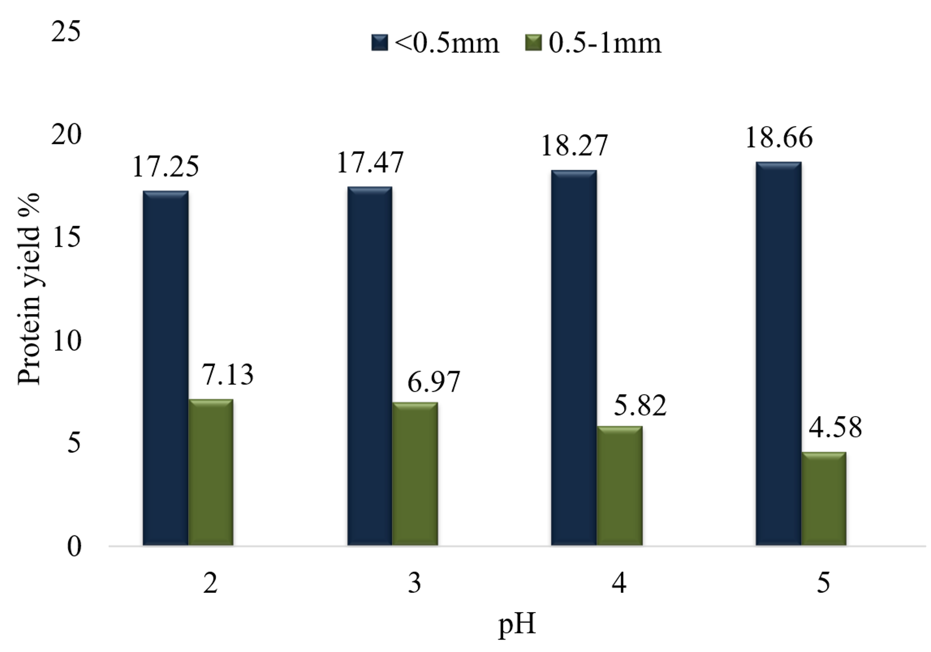
Figure 3. Effect of pH and particle size on protein yield of defatted Sal seed cake with distilled water.

3.2.2 NaOH Alkaline Solvent Extraction Method
The influence of pH and particle size on protein extraction from Sal seed cake using 0.25 M NaOH is presented in Figure 4. NaOH extraction resulted in substantially higher protein yields than distilled water across all experimental conditions.
Protein recovery increased with decreasing particle size, with the ≤0.5 mm fraction consistently outperforming the coarser fraction. The highest protein yield (38.62%) was obtained at pH 4 for the finer particle size, whereas the corresponding yield for the 0.5–1.0 mm fraction was significantly lower (15.98%). Protein yield increased with pH from 2 to 4 and showed a slight decline at pH 5, indicating an optimal precipitation range near pH 4 for NaOH-extracted Sal proteins.
These results demonstrate the strong effectiveness of NaOH in disrupting the Sal seed cake matrix and solubilizing proteins, particularly when combined with fine particle size and optimized pH conditions.
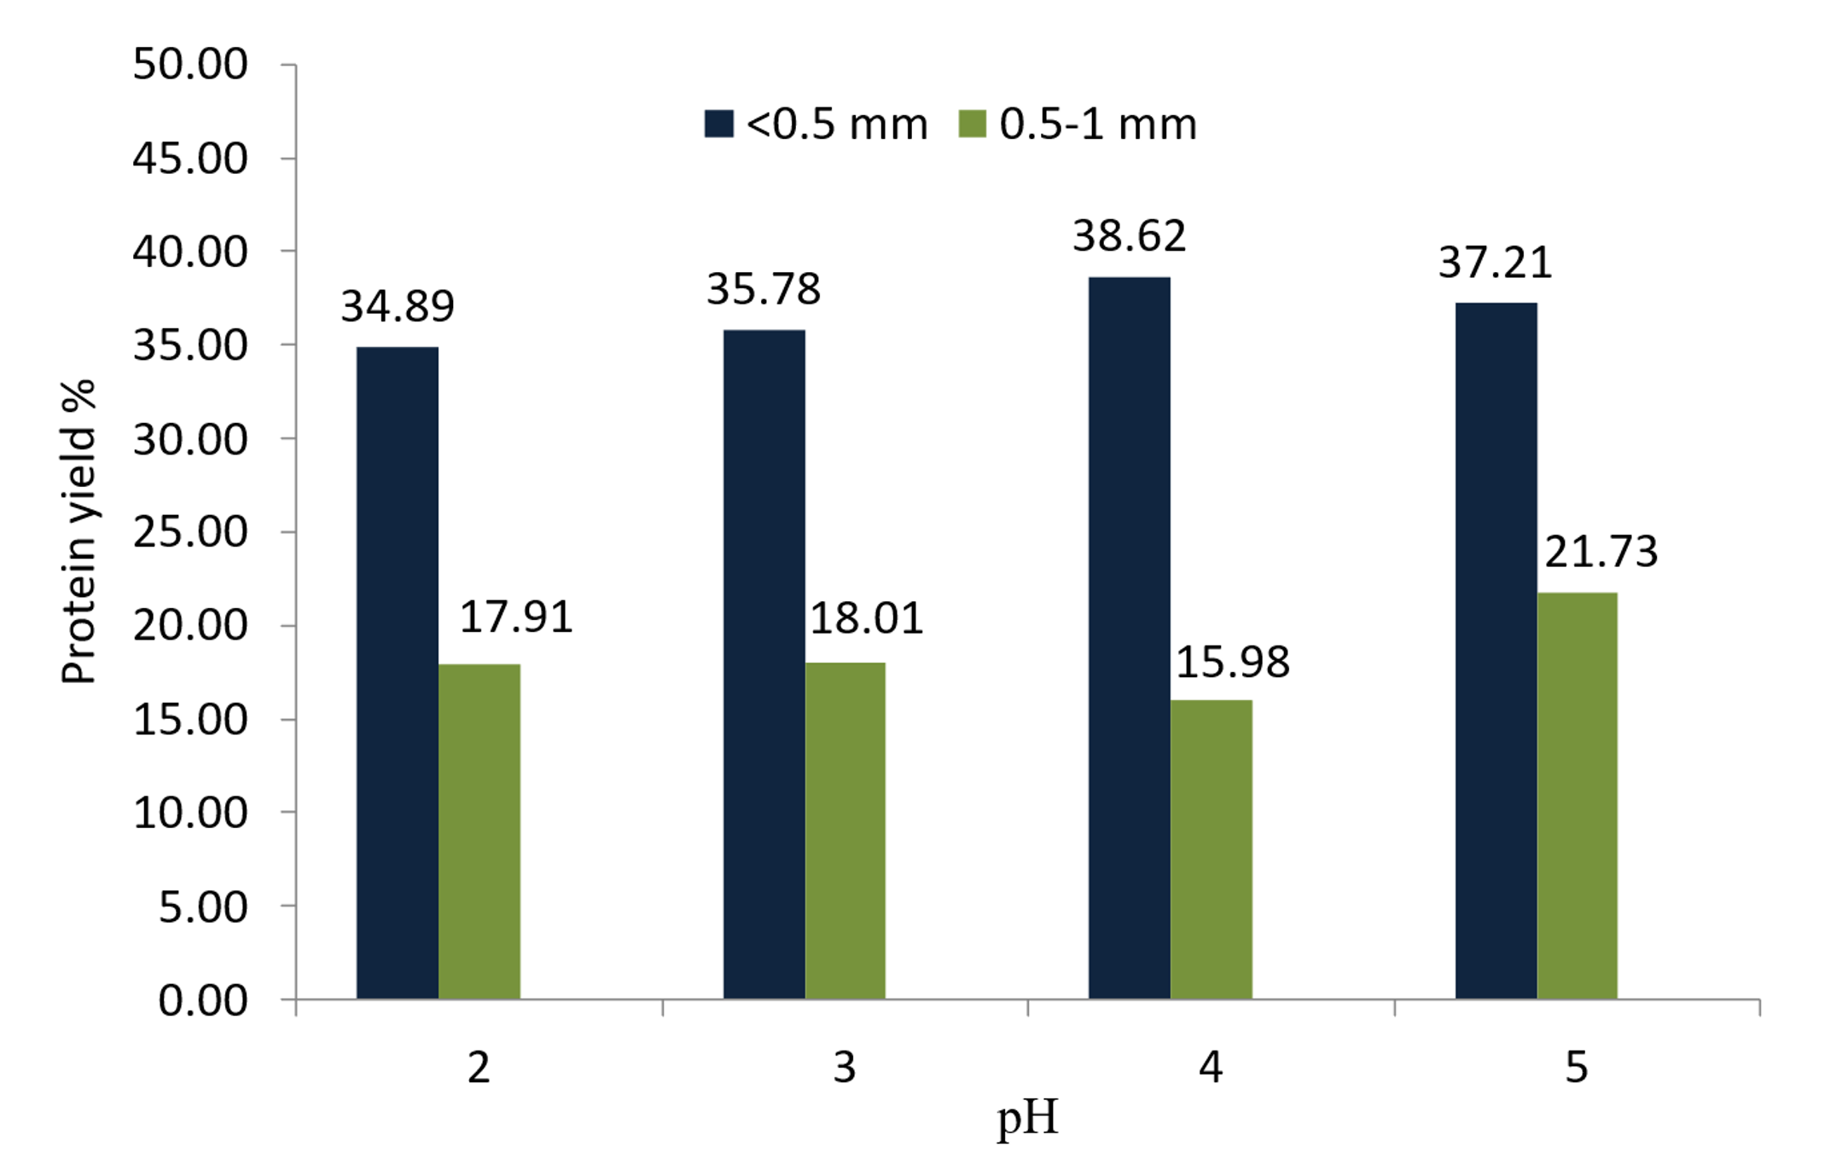
Figure 4. Effect of pH and particle size on protein yield of Defatted Kusum seed cake extracted with NaOH.
3.2.3 KOH Alkaline Solvent Extraction Method
The effect of potassium hydroxide (0.2 N KOH) on protein extraction from defatted Sal (Shorea robusta) seed cake was evaluated at two particle size fractions (<0.5 mm and 0.5–1.0 mm) across precipitation pH values ranging from 2 to 5, as illustrated in Figure 5. The results clearly demonstrated that particle size had a pronounced influence on protein recovery, with the finer fraction (<0.5 mm) consistently yielding higher protein extraction compared to the coarser fraction. For the <0.5 mm particle size, protein yield increased with rising pH from 2 to 4, reaching a maximum value of 22.38% at pH 4, followed by a slight decline at pH 5. In contrast, the 0.5–1.0 mm fraction exhibited lower extraction efficiency across all pH levels, with the lowest yield of 14.62% observed at pH 2. The yield for this coarser fraction showed a gradual increase with increasing pH, although it remained significantly lower than that of the finer particles. Overall, the KOH extraction results indicate that moderate alkaline conditions (around pH 4) combined with reduced particle size favour enhanced protein solubilization and recovery from Sal seed cake. The observed trends highlight the importance of particle size reduction in improving solvent accessibility and extraction efficiency during alkaline protein recovery processes.
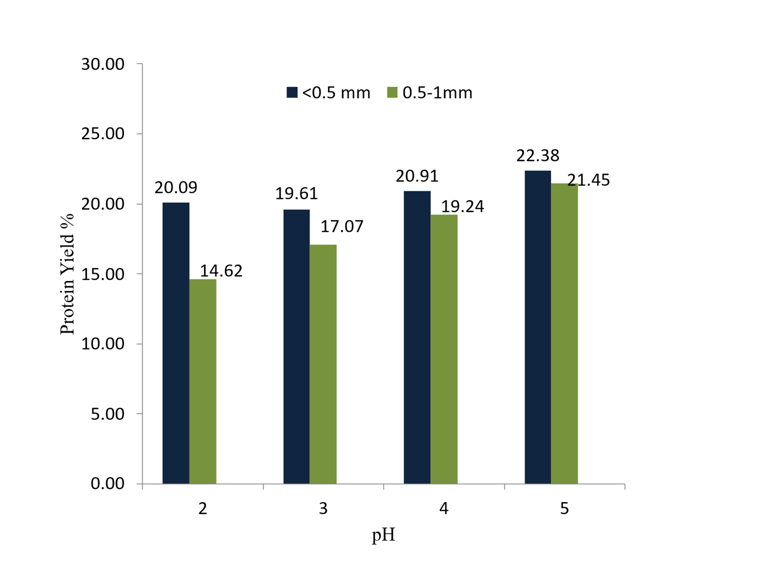
Figure 5. Effect of pH and particle size on protein yield of sal seed with KOH.

4. DISCUSSION
The present investigation demonstrates that protein recovery from defatted Sal (Shorea robusta) seed cake is strongly influenced by particle size, extraction solvent, and precipitation pH. Across all extraction systems evaluated, the finer particle fraction (<0.5 mm) consistently produced higher protein yields than the coarser fraction (0.5–1.0 mm). This behaviour can be attributed to the increased surface area associated with smaller particles, which enhances solvent accessibility, improves mass transfer, and facilitates more effective disruption of the protein–cell wall matrix during extraction.
Among the extraction methods, alkaline solvents (NaOH and KOH) were markedly more efficient than distilled water with pH adjustment. NaOH extraction yielded the highest protein recovery, reaching a maximum of 38.62% at pH 4 for the <0.5 mm particle size, highlighting the strong solubilization capability of sodium hydroxide. Alkaline conditions promote ionization of amino acid side chains, cleavage of disulfide bonds, and weakening of intermolecular interactions, thereby increasing protein solubility and release from the seed matrix. KOH extraction also enhanced protein recovery compared to distilled water, though yields were comparatively lower than NaOH, suggesting differences in solvent strength and interaction with Sal protein structures.
The effect of precipitation pH further influenced protein recovery patterns. Protein yields generally increased with pH from 2 to 4, followed by a slight decline at pH 5 in some treatments, indicating proximity to the isoelectric precipitation behaviour of Sal seed proteins. At inappropriate pH levels, incomplete precipitation or re-solubilization may occur, resulting in reduced recovery.
Overall, the findings confirm that optimal protein extraction from Sal seed cake requires a combined strategy involving particle size reduction, alkaline solubilization particularly with NaOH and controlled pH-based precipitation. These results emphasize the potential of Sal seed cake as a valuable plant protein source when appropriate process parameters are applied.
5. FUTURE SCOPE
The promising protein recovery achieved from defatted Sal (Shorea robusta) seed cake highlights substantial opportunities for future research and industrial valorisation. Further studies should focus on comprehensive characterization of the extracted protein, including amino acid profiling, digestibility, allergenicity, and techno-functional properties such as solubility, emulsifying capacity, foaming stability, and gelation behaviour. Such evaluations are essential to establish its suitability as a functional ingredient in human food systems.
Process optimization using advanced statistical tools such as response surface methodology (RSM) and artificial intelligence-based modeling could further enhance extraction efficiency while minimizing chemical usage and energy input. Exploration of green extraction techniques, including enzyme-assisted extraction, ultrasound-assisted extraction, and membrane-based protein concentration, may improve yield and sustainability.
From an application perspective, incorporation of Sal protein into plant-based food formulations, fortified foods, and alternative protein products warrants investigation. In parallel, its use as a protein supplement in livestock and aquaculture feeds should be evaluated through feeding trials to assess growth performance and nutrient utilization. Additionally, the potential of Sal protein in non-food applications such as biodegradable films, bioplastics, and natural binders represents a promising avenue for circular bio-economy development.
Overall, systematic scale-up studies, life-cycle assessment, and techno-economic analysis are required to translate laboratory-scale findings into commercially viable protein recovery systems.
6. CONCLUSION
The present investigation systematically evaluated the influence of particle size, extraction solvent, and precipitation pH on protein recovery from defatted Sal (Shorea robusta) seed cake. The results clearly demonstrated that all three process parameters significantly affected protein extraction efficiency. Across all extraction methods, reduction in particle size to <0.5 mm consistently enhanced protein yield compared to the coarser fraction (0.5–1.0 mm), highlighting the role of increased surface area and improved solvent accessibility in facilitating protein solubilization.
Among the extraction media tested, alkaline solvents exhibited superior performance over distilled water. NaOH extraction produced the highest protein recovery, with a maximum yield of 38.62% at pH 4 for the finer particle fraction, indicating effective disruption of cellular structures and enhanced protein solubilization under alkaline conditions. KOH extraction also resulted in appreciable protein yields, achieving a maximum of 22.38% at pH 4-5, while distilled water with pH adjustment yielded comparatively lower recoveries, confirming the limited solubilization capacity of non-alkaline systems. Variation in precipitation pH further influenced extraction outcomes, with optimal protein recovery generally observed between pH 4 and 5, suggesting favourable precipitation behaviour of Sal seed proteins near this range.
Overall, the study establishes that an integrated approach involving particle size reduction, alkaline extraction, and controlled precipitation pH can significantly improve protein recovery from Sal seed cake. These findings highlight the potential of Sal seed cake as a promising alternative plant protein source and support its valorisation within sustainable agro-industrial processing systems.
DISCLAIMER (ARTIFICIAL INTELLIGENCE)
During the preparation of this manuscript, the author(s) used Google GIMINI AI to improve the structure, flow, grammar and language style of the text. After using this tool/service, the author(s) reviewed and edited the content as needed and take full responsibility for the content of the published article.
References
- Damodaran, S. (2017). Amino acids, peptides, and proteins. In S. Damodaran & K. L. Parkin (Eds.), *Fennema’s food chemistry* (5th ed., pp. 235-356). CRC Press. https://doi.org/10.1201/9781315372914
- INRAE, CIRAD, AFZ, & FAO. (2012). Sal (Shorea robusta) seeds and oil meal. Feedipedia - Animal Feed Resources Information System. https://www.feedipedia.org/node/220
- Gaharwariya, S. K., Fahmidha, S., Soni, A., Sanjay, K., Sharma, J., & Balasundaram, R. P. (2025). Process parameter optimization for protein extraction from defatted neem (Azadirachta indica) seed cake: Role of particle size, solvent selection and pH. International Journal of Agriculture and Food Science, 7(12), 226–232. https://doi.org/10.33545/2664844X.2025.v7.i12c.1048
- Gaharwariya, S., Soni, A., Sharma, J., Fahmidha, Prakash, B. R., & Sanjay, K. (2025). Influence of particle size, extraction solvent and pH on the protein recovery from defatted Kusum (Schleichera oleosa (Lour.) Oken) seed cake. European Journal of Nutrition & Food Safety, 17(12), 61–72. https://doi.org/10.9734/ejnfs/2025/v17i121913
- Hadidi, M., Aghababaei, F., & McClements, D. J. (2023). Enhanced alkaline extraction techniques for isolating and modifying plant-based proteins. Food Hydrocolloids, 145, 109132. https://doi.org/10.1016/j.foodhyd.2023.109132
- Hettiarachchy, N. S., Kalapathy, U., & Myers, D. J. (1995). Alkali-modified soy protein with improved adhesive and hydrophobic properties. Journal of the American Oil Chemists' Society, 72(12), 1461-1464. https://doi.org/10.1007/bf02577838
- Kinsella, J. E., & Melachouris, N. (1976). Functional properties of proteins in foods: A survey. Critical Reviews in Food Science and Nutrition, 7(3), 219-280. https://doi.org/10.1080/10408397609527208
- Li, G., Guo, W., Gao, X., Wang, Y., & Sun, S. (2020). Effect of superfine grinding on physicochemical and antioxidant properties of soybean residue powder. Food science & nutrition, 8(2), 1208-1214.
- Singh, R., Langyan, S., Sangwan, S., Rohtagi, B., Khandelwal, A., & Shrivastava, M. (2022). Protein for Human Consumption From Oilseed Cakes: A Review. Frontiers in Sustainable Food Systems, 6, 856401. https://doi.org/10.3389/fsufs.2022.856401
- Shafiqur, R., Islam, M. A., Rahman, M. M., Uddin, M. B., & Mazumder, M. A. R. (2018). Isolation of protein from defatted peanut meal and characterize their nutritional profile. Chemistry Research Journal, 3(2), 187-196. https://chemrj.org/archive
- Wouters, A. G. B., Rombouts, I., Fierens, E., Brijs, K., & Delcour, J. A. (2016). Relevance of the functional properties of enzymatic plant protein hydrolysates in food systems. Comprehensive Reviews in Food Science and Food Safety, 15(4), 786-800. https://doi.org/10.1111/1541-4337.12209
- Zhang, Z., He, S., Liu, H., Sun, X., Ye, Y., Cao, X., Wu, Z., & Sun, H. (2020). Effect of pH regulation on the components and functional properties of proteins isolated from cold-pressed rapeseed meal through alkaline extraction and acid precipitation. Food Chemistry, 327, 126998. https://doi.org/10.1016/j.foodchem.2020.126998

