Original Research Article

Cheap and efficient way for sustained release of micronutrient through modified prosopis gum: Mechanism and kinetic of boron and zinc release in water and soil

Abstract

Conventional method of fertilizer application leads to loss of plant nutrient through leaching, run-off, volatilisation, denitrification etc. These in turn affect the health of environment directly or indirectly. The use of controlled release fertilizers (CRFs) starts to evolve as a promising direction by offering an excellent means to improve management of nutrient and by reducing environmental threats. In this aspect, plant polysaccharides are of special interest as they are easily available, safe to environment and easy to modify. Adopting microwave assisted technique, prosopis gum-based hydrogel loaded with boron and zinc was synthesized. The synthesized hydrogel was characterized by elemental analyzer, FTIR, EDX and SEM. Release patterns studied in water revealed that % cumulative release of boron and zinc during the span of 6 days were 51-58% and 59-68 % repectively. In the soil, it was found to be 62-74 % and 52-58% upto 20 days beyond which the release patterns were constant. The kinetics study revealed that both boron and zinc follow Fickian mechanism (n<0.5) in water whereas in the soil it follows non-Fickian mechanism (n>0.5). Sustained release of boron and zinc was achieved with a half-life of 33-57 days and 49-86 repectively.

Key words: prosopis, boron, hydrogel

PIC 1. Graphical abstract

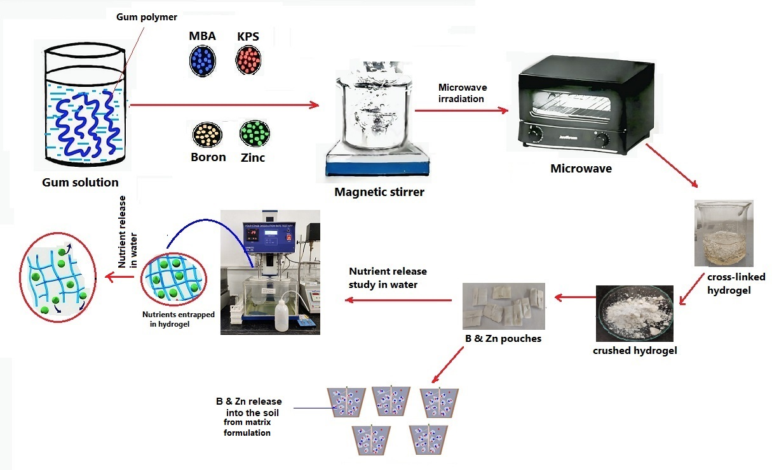

1. Introduction
Proper crop nutrients management is extremely important for maximum yield of the crops. Based on the requirement of the plant, nutrients are broadly classified as macronutrients and micronutrient [1] [Table 1]. However, micronutrients are often negelected and in many cases the crop yield is hampered without timely intervention. Even though demands for micronutrients are small in quantity, these nutrients directly affect crop growth and development even when all other nutrients are present in adequate amount [2]. One micronutrient that has profound role in plant is boron which has intergral role in cell wall synthesis and in maintaining structure integrity. Plants take up boron in the form of small uncharged boric acid (H₃BO₃) or B (OH)₃ [3, 4]. About 50% of the world’s potentially arable soils are acidic. In such soils, deficiencies of anionic plant nutrients Boron (B) through fixation and leaching are foremost factors limiting crop production. Boron deficiency also leads to considerable yield reduction in many annual, cereal, legume/pulse, oilseeds and perennial crops [5, 6]. Zinc is another essential micronutrient that is necessary for plant growth and development. In many enzymes, zinc acts as a functional, structural, or regulatory cofactor, control of gene expression, stabilizing RNA and DNA among others [7]. Plant deficient of Zn are reported to be more susceptible to diseases [8, 9]. As a matter of fact, Zinc and Boron are classified as one of the most major nutrient deficiencies in the soil world wide [10]. It is necessary to supplement them externally.
Furthermore, it is to be noted that the presence of one element can impede the availability of other elements or have synergestic effect. Therefore, it is essential to know the antagonism-synergism effect of various elements while formulating fertilizers or micronutrients. Fig.1b shows Mulder’s chart which can provide useful information regarding this [11]. Based on Mulder’s chart, it is unlikely that B and Zinc would have antagonism-synergism interaction when they are applied together as matrix formulation.
Control Release Formulation (CRF) is often used as means of nutrient release in agricultural practices. This method can deliver nutrients at a desirable rate and dose for extended period of time [12-15]. This is achieved through matrix formulation in which plant nutrients are dispersed in the matrix and diffused through pores or channels. Plant polysaccharides because of their excellent properties have been employed for decades for controlled release of plant nutrient [16, 17].
Prosopis gum (PG) also known as Mesquite gum is an exudate extracted from the bark of Mesquite trees (Prosopis sp.). Mesquite trees belong to leguminous family and are widely occurred in arid & semi-arid regions of the globe. Major producer species of this gum are Prosopis juliflora and Prosopis laevigata [18]. The gum is somewhat similar to Gum Arabic both in physical appearance and functional properties. The main functional properties of prosopis gum are its
water solubility, intrinsic viscosity, surface activity, emulsifying ability, encapsulating capacity etc. All these unique properties make the gum a functional hydrocolloid [19-22]. The gum has also been used in edible films and coating for extension of shelf life of fruits [23].
Table 1. Lists of essential macro and micronutrients [1].

Essential plant nutrients
Primarly Macronutrients | Secondary Macronutrient | Micronutrients
Nitrogen (N) | Calcium (Ca) | Boron (B)
Phosphorus (P) | Magnesium (Mg) | Zinc (Zn)
Potassium (K) | Sulphur (S) | Iron (Fe)
 |  | Manganese (Mn)
 |  | Copper (Cu)
 |  | Molybdenum (Mo)
 |  | Chlorine (Cl)

1.2. Composition and Chemical Structure of prosopis gum
Chemical structure of Prosopis gum is comprise of backbone chain of (1-3)-linked β-D-Galactose units and (1-6)-linked branches containing L-Arabinose in pyranose & furanose ring form, L-rhamnose, β-D-glucuronate& 4-O-methyl-β-D-glucuronate as single monomer unit or as oligosaccharide side chains [24, 25]. Studies revealed that prosopis gum obtained from Prosopisvelutina upon acid hydrolysis yields principal carbohydrate residues of L-Arabinose & D-Galactose, and traces of D-Glucuronate, D-Mannose & D-Xylose [26, 27]. Little amount (approximately 4%) of uronic acids (glucuronic acid) was also reported. The main difference in composition of Prosopis gum as compared to gum arabic is absence of L-rhamnose in the former
[28]. [Fig. 1a]. Protein in the gum is chiefly composed of serine, hydroxyproline, valine and glycine which are mainly responsible for its emulsification ability [29]. Since the gum is still unexplored and has not been utilized in the field of nutrient delivery system, slow controlled release formulation for Boron and Zinc was synthesized using the gum. This paper reports the release pattern of boron and zinc in water and soil and their release kinetic.

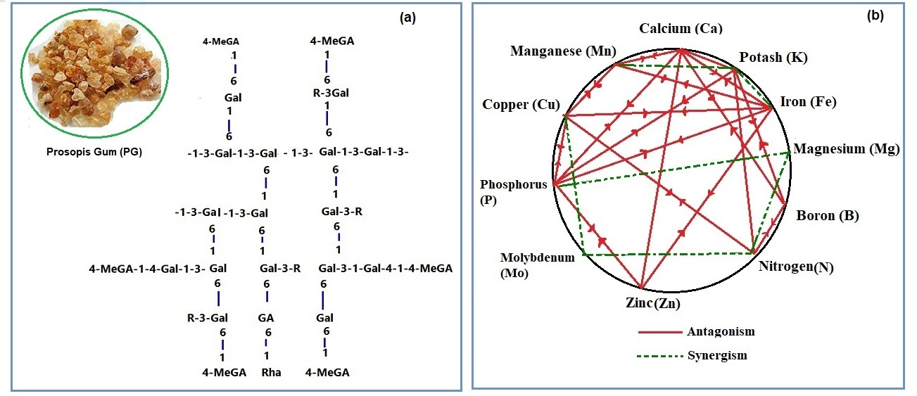

Fig 1. (a) Chemical structure of Prosopis gum (PG) [27], (b) Mulder’s chart of antagonistic (solid lines (and synergistic (dashed lines) elements.

2. Material and methods
2.1. Materials
Boric acid (H3BO3) and Zinc sulphate (Zn₂SO₄) were purchased from Sigma-Aldrich.
Prosopis gum was procured from local market, other chemicals like NN’MBA and acrylamide were purchased HIMEDIA, Mumbai, India.

2.2. Synthesis of micronutrients loaded hydrogel
In situ incorporation of boric acid (H₃BO₃) and Zinc sulphate (Zn₂SO₄) (0.5 mg each) in Prosopis gum solution was carried out adopting microwave assisted technique for synthesis. For this gum solution was prepared, acrylamide, NN’MBA and KPS were added into the solution mixture with uniform stirring through magnetic stirrer. The yielded hydrogel with uniformly distributed B and Zn was achieved throughout the gel network. The optimized dosage of the initiator and monomer were evaluated from the percentage grafting, calculated as:

$$\% Grafting= \frac{Wt. of graft copolymer-Wt. of polysaccharide }{Wt. of polysaccahride } X 100 Eq. (1)$$

2.3. Characterization
The synthesized hydrogel was characterized using the following instrumental techniques:
2.3.1. Elemental analysis
The estimation of four elements, i.e., carbon, hydrogen, nitrogen, and oxygen, was under taken by Elemental Analyzer (model: Vario EL III, Make –M/s Elementar, Germany).

2.3.2. FT-IR analysis
Presence of functional group was determined by Fourier Transform Infrared Radiation (FTIR), Model: IRPrestige21, Shimadzu Corporation, Japan). Condition for analysis: 400 to 4000 cm⁻¹, resolution of 4 cm⁻¹using KBr pellet method.

2.3.3. EDX
Distribution of Boron and Zinc was confirmed by Energy Dispersive X-ray Spectroscopy (EDX) analysis, equipped with SEM, Oxford EDX, DCL 7673 model.

2.3.4. Scanning Electron Microscopy (SEM) analysis
The surface morphology was evaluated by Scanning Electron Microscopy (model: JSM-6390LV, Jeol, Japan).

2.4. Release study
Nutrient release study of B and Zn in water at 25°C was done following USP drug dissolution study protocol [30] in dissolution rate test apparatus (Simeco, Kol-25). Release pattern of boron and zinc were studied in water and soil. For water system, solutions containing the matrix were stirred at 65rpm for sufficient time. Aliquot was drawn at interval and amount of micronutrient release from hydrogel into water was determined by UV-VIS spectrophotometer at λ_{max} = 430 nm for Zinc [31] and 420nm for boron [32] using standard calibration curve [Fig.2]. The cumulative release (%) was calculated as [33, 34]:
$$Cumulative release \left(\%\right)= \frac{Mt}{M∞} X 100 (1)$$
Where Mt and M∞ are the amount of micronutrient released at time‘t’and initial loaded micronutrient contents, respectively. Release study of micronutrient in continuous releasing in water is parallel with stagnant water system.
Similarly, release study was also performed in soil to see its application in the field of agriculture. For this, hydrogel was put into permeable tea pouches which were buried in plastic beaker containing 200 g of dry soil at 2.0 cm depth. Then, 150 mL of distilled water was added to each beaker and kept at room temperature. One package was removed after every 2 days. The hydrogel was put in 100mL distilled water [33, 34]. The amount of micronutrient extracted from the hydrogel into the water was estimated by UV-VIS spectrophometer using the above equation.

Fig. 2. Standard calibration curves of boron and zinc using UV-VIS spectrophotometer

2.5. Kinetic study
Similarly, the drug release kinetics of hydrogel was determined by using the well-known equation [35, 36].
$\frac{Mt}{ M∞}=k.t^{n}$(2)
M_{t,} is the amount of micronutrient release at time ‘t’ andM∞ initial loaded micronutrient contents respectively. And k is releasing factor and the releasing exponent ‘n’ describes the type of diffusion. The above equation can be linearized as [35, 36]:
$$\log{\frac{Mt}{M∞}= }\log{k +nlog t} (3)$$
The values of n, k and R² were calculated from the plot of log (Mt/M∞) vs log (t) for all the matrix tablets using the above equation. The above equation is applicable for only if the first 60% of the fractional drug release from the tablet occurs (Mt/M∞ ≤0.6; log Mt/M∞≤–0.22) [37]. If the calculated ‘n’ value is less than 0.5, then release pattern follow Fickian diffusion where diffusion rate is usually less than the rate of relaxation [38]. If ‘n’ value lies between 0.5-1.0, then it is non-Fickian diffusion (diffusion rate and relaxation are the same) [38]. When the value of ‘n’=1, the diffusion follows zero order kinetic and this is true for most erodible matrices. The half-life was determined using the formula =0.693/k

3. Results and discussion
3.1. Synthesis of micronutrients loaded hydrogel
Prosopis Gum based hydrogel was synthesized using microwave assisted technique [39, 40]. For this, 1 g of gum was dissolved in 50 ml distilled water in a magnetic stirrer. Selective quantity of acrylamide (5 g) was slowly added into the solution and mixed well. Then 0.1 g of initiator (KPS) and 0.1 g of cross linker (NN’MBA) were added into it with constant stirring to get uniform homogenized solution [41]. Simultenously, in situ incorporation of boric acid (H₃BO₃) (awater soluble source of B) and Zinc sulphate (water soluble source of Zinc), each 0.5mg into the solution mixture was done with uniform stirring. The whole reaction mixture was subjected to microwave reactor at 700 W (model: Catalyst TM system CATA 4 R) until a solid gel like mass was produced [41, 42]. The irradiation was then stopped at 70 °C and resulting gel mass was precipitated with excess of acetone for 72 h to remove any competing homopolymer [43]. Following the same method, different grades of hydrogel were synthesizedby varying the amount of cross-linker and %graftingwas calculated [Table 2]. It was found that beyond 0.5 g of cross-linker the % grafting decrease. This was due to unavailability of free sites because of competition for space among the grafted chain [44] or termination of free radicals due to bimolecular collision. A similar phenomenon was also observed during synthesis of carrageen-based hydrogel [45].
Grades | Amount of monomer (g) | Amount of cross-linker (g) | % Grafting  (G%)
PG-g-AM-cl-NN’MBA 1 | 5 | 0.1 | 670
PG-g-AM-cl-NN’MBA 2 | 5 | 0.2 | 700
PG-g-AM-cl-NN’MBA 3 | 5 | 0.3 | 730
PG-g-AM-cl-NN’MBA 4 | 5 | 0.4 | 850
PG-g-AM-cl-NN’MBA 5 | 5 | 0.5 | 900

Table 2. Synthesis of different grades of Prosopis gum-based hydrogel (PG-g-AM-cl-NN’MBA) for controlled release of Boron and Zinc

3.2. Mechanism involved in the synthesis of cross-linked PG loaded with boron and zinc

During the process of synthesis, the initiator (potassium persulfate) react with OH group present in the gum polysaccharide to form alkoxy radical on the substrate (gum) thereby creating an active centre [42, 43]. This active centre further initiated free radical polymerization reaction of acrylamide with NN’MBA and resulted in the formation of complex network of cross linked products as depicted in PIC 2.
PIC 2. Proposed mechanism involved in synthesis of hydrogel (PG-g-AM-cl-MBA) loaded with B & Zn using ‘Microwave assisted technique’.

3.3. Swelling index of hydrogel
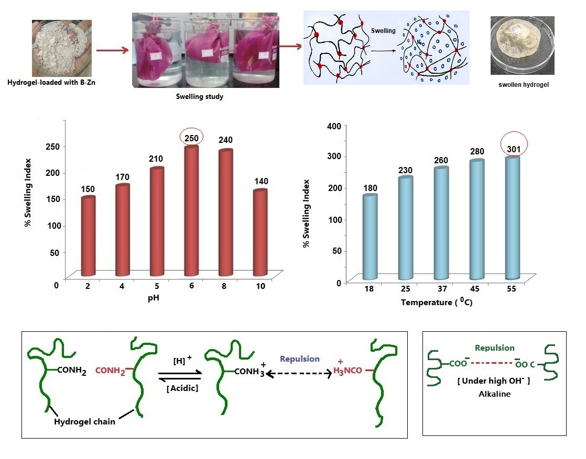
Swelling index of a hydrogel is important as it indicate its water absorption capacity when place in different environment. This index is a crucial parameter for understanding a hydrogel's suitability for various applications, particularly in areas like wound dressing, tissue engineering, and control realse. Under slightly low pH, sufficient H⁺was available to protonate the CONH₂ moieties present in the polymeric chain of hydrogel. This resulted in mutual repulsion between two polymeric chains of the hydrogel and so high swelling index was observed [46]. This type of phenomena was also observed in many synthetic hydrogel [47]. Under slightly alkaline condition (presence of OH), COOH existed as anion (COO-) and consequently mutual repulsion between polymeric chain occurred. Hence high swelling was also observed [48]. Furthermore, increased in temperature induce higher swelling index because of the rupture of weak bonds existing between cross-linked and monomer chain. Fig. 3 shows swelling index of PG based hydrogel at different pH and temperature.
Fig. 3. Swelling index of PG hydrogel subjected to different pH and Temperature

3.4. Characterization
3.4.1. Elemental Analysis
When analysed under Elemental analyzers, the percentage of Carbon, hydrogen and oxygen were found to be in 36.23, 7.02 and 56.75 % respectively. Whereas, in hydrogel the % was found to be 40.23, 8.12, 38.32 respectively with additional 13.33% for nitrogen (Fig.4a).

3.4.2. FTIR
From the FTIR spectra (Fig.4b), Gum of prosopisdisplayed characteristic broad peaks at 3240 cm⁻¹and 2900cm⁻¹ due to O-H and C-H stretching respectively. The peak at 1050 cm⁻¹ and 1650 cm⁻¹ were due to C-O-C stretching vibrations and O-H bending mode [49].The glucuronic acids present in the gum polysaccharide also displayed a specific peak at 1400 cm⁻¹ due to carbonyl stretching. In the case of synthesized hydrogel spectrum, the peakat 3200cm⁻¹ (O-H stretching) was reduced to lower intensity and shifted to longer wave-length at 3401 cm⁻¹. This suggested that hydroxyl group was now involved in formation of covenant bond with the cross linker, NN’MBA. Moreover, absorption band at 1650 (H-O-H bending) vanished which was present in crude Prosopis gum confirming grafting was successful [50].

3.4.3. EDX Analysis
Energy dispersive X-ray spectroscopy analysis of the Prosopis Gum based hydrogel also confirmed the presence of boron and Zinc as major components along with other elements viz. S, O, P, and K (Fig.4c).

3.4.4. SEM Analysis
Fig.4d & 4e shows two distinct surface appearances of Prosopis gum and synthesized hydrogel under SEM analysis with 20 kV and 500X magnifications. In the case of the former, the surface was smooth without any crack and fissure while the later exhibited profound morphological changed with numerous macro and micro pores. This confirmed successful grafting (Fig.4e). Along with other techniques, SEM analysis is often used as a confirmation proof for successful grafting onto polymer.

Fig. 4. a)% of C,H,O& N as analyzed by Elemental analyzerb) FTIR spectra of Prosopis gum and hydrogel c)Energy Dispersive X-ray spectroscopy analysis d) SEM image of crude prosopis gum and e) SEM image of hydrogel.

3.5. Release behavior
Fig 5a & 5b represents release behavior of the B and Zn micronutrient in water from various hydrogel grades. It was observed that the cumulative release of B from different hydrogel grades was 51-58% during the span of 6 days. Whereas, in the case of Zn, cumulative release was found to be 59-68 % during the span of 6 days. The low release of boron was due to low solubility of Boric acid (5.7 g/100ml at 25ºC) in water when compared with Zinc whose solubility was higher (57.7g/ 100ml at 25ºC). Furthermore, the release rates for all hydrogels grades increased regularly and then became more or less constant after 108 hrs in water. It was also observed that increased in % grafting displayed better sustained release in both cases.
Fig. 5c & 5d shows the release behavior of boron and zinc from different grades of hydrogel in the soil. The cumulative release of boron in the soil ranges from 62-74 % for all the grades upto 20 days beyond which the release was more or less constant. It could be possible that small fraction of boron (H₃BO₃ & H₂BO₃⁻) was fixed on soil colloid either physically or chemically [51, 52]. In the case of zinc, it was found to be 52-58 % upto 20 days beyond which the release was more or less constant. From the study it was confirmed that cumulative release of zinc was far lower than boron in the soil. This could be because zinc (II) cations are strongly adsorbed by negative clay colloids [31]. Mechanism of B and Zn fixation in the soil is depicted in Figure 6.

Figure 5. a) Release pattern of Boron from hydrogelin water b) release pattern of Zinc from hydrogel in water c) release pattern of Boron from hydrogel in soil and d) release patter of zinc from hydrogel in soil.

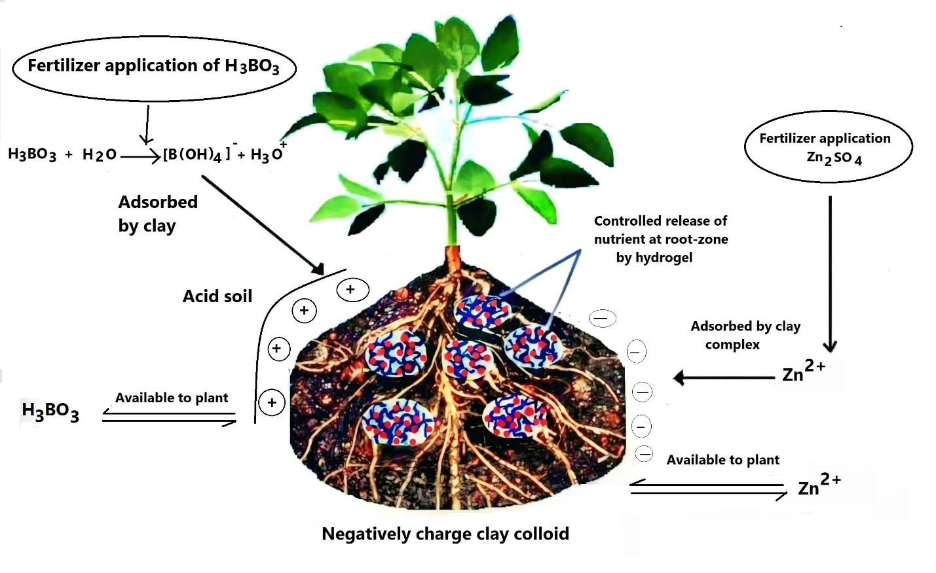
Figure 6. Mechanism of nutrients (B & Zn) release in the soil.

3.6. Kinetic study

The diffusion exponent ‘n’ and diffusion constant ‘k’ of boron and zinc released from hydrogels in water and soil were calculated from the plot oflog (Mt/M∞) vslog (t) (Fig. 7). The calaculated value of kinetic parameters are summarized in Table 3. It was observed that the value of ‘n’ for boron and zince in water were all less than 0.5. This indicates that PG-g-AM-cl-NN’MBAs hydrogel follow Fickian release behaviour. This suggested that the nutrient release in the hydrogel was predominantly controlled by rate of relaxation of the hydrogel while diffusion was the secondary means of nutrient release [38]. Furthermore, it was observed that the half-life was dependent on cross-linking density of the hydrogel which was highest in the case of PG-g-AM-cl-NN’MBA5 with highest % grafting.
Likewise, the kinetic release of boron and zinc in the soil revealed ‘n’ values to be higher than 0.5. This means both boron and zinc follow non-Fickian mechanism in the soil which suggested the rate release is controlled by diffusion and relaxation of the hydrogel. The half-life was found to be 33-57 days in boron while for zinc it was found to be 49-86 days [For comparison with other available CRF, see Table 4]. Thus, it can be said that for all the hydrogel grades, the total cumulative release value in water was far higher than soil [53, 54]. In the soil, the nutrients are released from hydrogel when hydrogel got swollen by soil solution [53, 54]. The solution, then, dissolved the soluble part of nutrient, and thenutrient molecules slowly diffused through the pores of hydrogel releasing it into the soil. The over all study indicated that PG hydrogel (PG-g-AM-cl-NN’MBA) displayed great potential as a matrix for nutrient delivery ensuring sustained supply of boron and zinc which confirmed its edge over the conventional fertilizers.
Figure. 7. Plot of log (Mt/M∞) vs log (t) for control release of Boron and Zinc in the soil.

3.7. Advantage of modified plant polysaccharide as controlled release matrix
Prosopis gum being plant-based carbohydrate material acts as food for the microbes and is highly prone to microbial degradation [55]. This degradable nature is what makes plant polysaccharide-based hydrogel eco-friendly and environmentally acceptable [56]. Fig. 8 shows the SEM images of hydrogel before and after 30 days burial in the soil. The hydrogel displayed structural changes with numerous cracks and fissures due microbial attack and other degradation forces.

Figure 8. SEM image of a) Hydrogel before incorpartion in the soil b) hydrogel after 30 days burial in soil.

Boron release kinetic profile in water
Grades | n | k | Half-life (hrs)
PG-g-AM-cl-NN’MBA 1 | 0.225 | 0.051 | 326
PG-g-AM-cl-NN’MBA 2 | 0.231 | 0.048 | 346
PG-g-AM-cl-NN’MBA 3 | 0.245 | 0.043 | 386
PG-g-AM-cl-NN’MBA 4 | 0.255 | 0.038 | 437
PG-g-AM-cl-NN’MBA 5 | 0.265 | 0.034 | 489
Zinc release kinetic profile in water
PG-g-AM-cl-NN’MBA 1 | 0.342 | 0.068 | 244
PG-g-AM-cl-NN’MBA 2 | 0.360 | 0.062 | 268
PG-g-AM-cl-NN’MBA 3 | 0.381 | 0.05 | 332
PG-g-AM-cl-NN’MBA 4 | 0.401 | 0.049 | 339
PG-g-AM-cl-NN’MBA 5 | 0.408 | 0.042 | 396
Boron release kinetic in soil half-life in days
PG-g-AM-cl-NN’MBA 1 | 0.54 | 0.021 | 33
PG-g-AM-cl-NN’MBA 2 | 0.56 | 0.019 | 36
PG-g-AM-cl-NN’MBA 3 | 0.58 | 0.017 | 40
PG-g-AM-cl-NN’MBA 4 | 0.59 | 0.013 | 53
PG-g-AM-cl-NN’MBA 5 | 0.63 | 0.012 | 57
Zinc release kinetic in soil (half-life in days)
PG-g-AM-cl-NN’MBA 1 | 0.51 | 0.014 | 49
PG-g-AM-cl-NN’MBA 2 | 0.54 | 0.012 | 57
PG-g-AM-cl-NN’MBA 3 | 0.71 | 0.011 | 63
PG-g-AM-cl-NN’MBA 4 | 0.85 | 0.010 | 69
PG-g-AM-cl-NN’MBA 5 | 0.98 | 0.008 | 86

Table 3. Calculated values of different release kinetic parameters of boron and zinc in water and soil with T₅₀ (half-life).

Sl no. | Polymer | Active ingredient | Plant | Release time | Reference
1 | Gelatin | Ammonium  nitrate | Cucumber,  Tomato | 2 days | [57]
2 | Double hydrogel network of sodium alginate and  polymerization of 𝛽-cyclodextrin, acrylic acid, and  acrylamide in the presence of halloysite | Urea | Cotton | 4 days | [58]
3 | Inorganic materialsand organic polymers | Urea | Orchards | 7 days | [59]
4 | NaCMC and carrageenan (CG) | Zinc | Wheatgrass | 10 days | [60]
5 | Wheatstraw | Urea | Tomato | 10 days | [61]
6 | corncob-g-poly (acrylic acid)/bentonite | Urea | Cottton | 30 days | [62]
7 | Acrylic acid | Urea | maize | 40 days | [63]
8 | ZnO Nanoparticle | Zinc | Cyamopsissp. | 30-40 days | [64]
9 | Composites made of biopolymers (microcrystalline  cellulose, chitosan, and alginate) and ZnOnanoparticles | Zinc | Maize | 30 days | [65]
10 | Poly(hydroxybutyrate) | NPK | Lettuce seed groups | 30 days | [66]
11 | Hydroxy propyl methyl cellulose, PVA, glycerol and blended pape | urea | Cotton | 44 day | [67]
12 | Polyurethane (PU) was copolymerized with  hydroxypropyl-terminated polydimethylsiloxane (HP-PDMS | Urea | Maize | over 60 day | [68]
13 | Bio-based epoxy | NPK | Vegetable | 60 days | [69,70]
14 | PG-g-AM-cl-NN’MBA | Zinc & Boron | Not specified | 86 days | This study

Table 4. Types of Hydrogels used as controlled release for nutrients with their release rate.

Conclusion
The rate of release of zinc is faster than boron in water as zinc sulphate is more soluble than boric acid. It was observed that cross-linking density affect the release rate in all the cases. The kinetics study suggested that release of boron and zinc follow Fickian mechanism (n<0.5). This means in water, the nutrient release is largely controlled by relaxation of the hydrogel. However, in soil it follows non-Fickian mechanism (n>0.5) which means the release rate is controlled by hydrogel relaxation and diffusion method. The half-life was observed to be 33-57 days for boron and 49-86 for zinc in soil.

COMPETING INTERESTS DISCLAIMER:
Authors have declared that they have no known competing financial interests OR non-financial interests OR personal relationships that could have appeared to influence the work reported in this paper.

References
[1] Etienne, P., Diquelou, S., Prudent, M., Salon, C., Maillard, A., & Ourry, A. (2018). Macro and Micronutrient Storage in Plants and Their Remobilization When Facing Scarcity: The Case of Drought. Agriculture, 8(1), 14. https://doi.org/10.3390/agriculture8010014
[2] Shaviv, A. (2001). Advances in controlled-release fertilizers. Advances in Agronomy, 71, 1–49. https://doi.org/10.1016/S0065-2113(01)71011-5
[3] Goldbach, H. E., Wimmer, M. A., & Findeklee, P. (2000). Discussion paper: Boron—How can the critical level be defined?. Journal of Plant Nutrition and Soil Science, 163(1), 115–121. https://doi.org/10.1002/(SICI)1522-2624(200002)163:1<115::AID-JPLN115>3.0.CO;2-#
[4] K. Mengel, E.A. Kirkby, Principles of plant nutrition Switzerland: International Potash Institute, 3rd Edition, 1982.
[5] Haynes, R. J., & Mokolobate, M. S. (2001). Amelioration of Al toxicity and P deficiency in acid soils by additions of organic residues: A critical review of the phenomenon and the mechanisms involved. Nutrient Cycling in Agroecosystems, 59(1), 47–63. https://doi.org/10.1023/A:1009823600950
[6] Singh, M. V. (2008). Micronutrient deficiencies in crops and soils in India. In B. J. Alloway (Ed.), Micronutrient deficiencies in global crop production (pp. 93–125). Springer Netherlands. https://doi.org/10.1007/978-1-4020-6860-7_4
[7] Brown, P. H., Cakmak, I., & Zhang, Q. (1993). Form and function of zinc in plants. In A. D. Robson (Ed.), Zinc in soils and plants (pp. 93-106). Kluwer Academic Publishers. https://doi.org/10.1007/978-94-011-0878-2_7
[8] H. S. Grewal, R. D. Graham, Z. Rengel, Genotypic variation in zinc efficiency and resistance to crown rot disease (Fusariumgraminearum Schw Group 1) in wheat, Plant Soil 186 (1996) 219–226. doi: 10.1007/BF02415517.
[9] Streeter, T. C., Rengel, Z., Neate, S. M., & Graham, R. D. (2001). Zinc fertilisation increases tolerance to Rhizoctonia solani (AG 8) in Medicago truncatula. Plant and Soil, 228(2), 233–242. https://doi.org/10.1023/A:1004874027331
[10]. Suri, V. K., Choudhary, A. K., Chander, G., & Verma, T. S. (2011). Influence of vesicular arbuscular mycorrhizal fungi and applied phosphorus on root colonization in wheat and plant nutrient dynamics in a phosphorus-deficient acid alfisol of Western Himalayas. Communications in Soil Science and Plant Analysis, 42(10), 1177–1186. https://doi.org/10.1080/00103624.2011.566962
[11] Rietra, R. P. J. J., Heinen, M., Dimkpa, C., & Bindraban, P. S. (2015). Effects of nutrient antagonism and synergism on fertilizer use efficiency. VFRC Report 2015/5. Virtual Fertilizer Research Center, Washington, D.C. https://hub.ifdc.org/handle/20.500.14297/1748
[12] Ni, B., Liu, M., & Lü, S. (2009). Multifunctional slow-release urea fertilizer from ethylcellulose and superabsorbent coated formulations. Chemical Engineering Journal. https://doi.org/10.1016/j.cej.2009.08.025
[13] Guilherme, M. R., Reis, A. V., Paulino, A. T., Moia, T. A., Mattoso, L. H. C., & Tambourgi, E. B. (2010). Pectin-based polymer hydrogel as a carrier for release of agricultural nutrients and removal of heavy metals from wastewater. Journal of Applied Polymer Science, 117(6), 3146–3154. https://doi.org/10.1002/app.32200

[14] Ni, B., Liu, M., Lü, S., Xie, L., & Wang, Y. (2011). Environmentally friendly slow-release nitrogen fertilizer. Journal of Agricultural and Food Chemistry, 59(18), 10169–10175. https://doi.org/10.1021/jf202131z
[15] Davidson, D. W., Verma, M. S., & Gu, F. X. (2013). Controlled root targeted delivery of fertilizer using an ionically crosslinked carboxymethyl cellulose hydrogel matrix. Springerplus, 2(1), 318. https://doi.org/10.1186/2193-1801-2-318.
[16] F. A. Aouada, M. R. de Moura, E. de A. Menezes, A. R. de A. Nogueira, L. H. C. Mattoso, Hydrogel synthesis and kinetics of ammonium and potassium release, Revista Brasile De Cencia do Solo 32 (4) (2008) 1643–1649.
[17] Cong, Z., Shen, Y., Du, C., Zhou, J., Wang, H., & Chen, X. (2010). Evaluation of waterborne coating for controlled-release fertilizer using wurster fluidized bed. Industrial & Engineering Chemistry Research, 49(20), 9644–9647. https://doi.org/10.1021/ie101239m
[18] Vernon-Carter, E. J., Beristain, C. I., & Pedroza-Islas, R. (2000). Mesquite gum (Prosopis gum). In G. Doxastakis & V. Kiosseoglou (Eds.), Novel macromolecules in food systems (pp. 217-238). Elsevier. https://doi.org/10.1016/S0167-4501(00)80011-4
[19] Vasile, F. E., Martinez, M. J., Ruiz-Henestrosa, V. M. P., Judis, M. A., & Mazzobre, M. F. (2016). Physicochemical, interfacial and emulsifying properties of a non-conventional exudate gum (Prosopis alba) in comparison with gum arabic. Food Hydrocolloids, 56, 245-253. https://doi.org/10.1016/j.foodhyd.2015.12.016
[20] Cortes-Camargo, S., Acuna-Avila, P. E., Rodriguez-Huezo, M. E., Roman-Guerrero, A., Varela-Guerrero, V., & Perez-Alonso, C. (2019). Effect of chia mucilage addition on oxidation and release kinetics of lemon essential oil microencapsulated using mesquite gum–Chia mucilage mixtures. *Food Research International*, *116*, 1010-1019. https://doi.org/10.1016/j.foodres.2018.09.040
[21] Lopez-Franco, Y. L., Valdez, M. A., Hernandez, J., Calderon de la Barca, A. M., Rinaudo, M., & Goycoolea, F. M. (2004). Macromolecular dimensions and mechanical properties of monolayer films of Sonorean mesquite gum. Macromolecular Bioscience. https://doi.org/10.1002/mabi.200400055.
[22] Sangamithra, A., Venkatachalam, S., John, S. G., & Kuppuswamy, K. (2015). Foam mat drying of food materials: A review. Journal of Food Processing and Preservation, 39(6), 3165-3174. https://doi.org/10.1111/jfpp.12421
[23] Bosquez-Molina, E., Tomas, S. A., & Rodríguez-Huezo, M. E. (2010). Influence of CaCl2 on the water vapor permeability and the surface morphology of mesquite gum based edible films. LWT - Food Science and Technology, 43(9), 1419-1425. https://doi.org/10.1016/j.lwt.2010.04.023.
[24] Aspinall, G. O., & Whitehead, C. C. (1970). Mesquite gum. I. The 4-O-methylglucuronogalactan core. Canadian Journal of Chemistry, 48(24), 3840–3849. https://doi.org/10.1139/v70-647
[25] Aspinall, G. O., & Whitehead, C. C. (1970). Mesquite gum. II. The arabinan peripheral chains. Canadian Journal of Chemistry, 48(24), 3850–3855. https://doi.org/10.1139/v70-648

[26] López-Franco, Y. L., Calderón de la Barca, A. M., Valdez, M. A., Peter, M. G., Rinaudo, M., Chambat, G., & Goycoolea, F. M. (2008). Structural characterization of mesquite (Prosopis velutina) gum and its fractions. Macromolecular Bioscience, 8(8), 749–757. https://doi.org/10.1002/mabi.200700285
[27] Mudgil, D., & Barak, S. (2020). Mesquite gum (Prosopis gum): Structure, properties & applications - A review. International Journal of Biological Macromolecules, 159, 1094-1102. https://doi.org/10.1016/j.ijbiomac.2020.05.153
[28] M. Rinaudo, F.M. Goycoolea, M.A. Valdez, Emulsifying properties of mesquite gum, Food Foods Ingredients J. Jpn. 213 (2008) 239–248.
[29] Alftrén, J., Penarrieta, J. M., Bergenstahl, B., & Nilsson, L. (2011). Comparison of molecular and emulsifying properties of gum arabic and mesquite gum using asymmetrical flow field flow fractionation. Food Hydrocolloids, 26. https://doi.org/10.1016/j.foodhyd.2011.04.008
[30] USP, General Chapter <711> Dissolution, USP 27, The United States Pharmacopeial Convention, Inc., Rockville, MD. 2003. p. 2303.
[31] D. Nagarjuna Reddy, K. Vasudeva Reddy, K. Hussain Reddy, Simple and sensitive spectrophotometric determination of Zn (II) in Biological and Pharmaceutical samples with 2-Benzoylpyridine thiosemicarbazone (BPT), Journal of Chemical and Pharmaceutical Research 3(3) (2011) 205-213.
[32] Anitha, M. S., Anil Kumar, K. S., & Prashantha, G. M. (2015). Distribution of plant available boron in major soil types and their correlation with other properties of the soil. Ecology, Environment and Conservation, 21, S143–S148. https://www.eminternational.co.in/journal-papers/ecology-environment-and-conservation-journal-papers/
.
[33] Ma, Z., Jia, X., Hu, J., Liu, Z., Wang, H., & Zhou, F. (2013). Mussel-inspired thermosensitive polydopamine-graft-poly(N-isopropylacrylamide) coating for controlled-release fertilizer. Journal of Agricultural and Food Chemistry, 61(50), 12232–12237. https://doi.org/10.1021/jf4038826
[34] Jamnongkan, T., & Kaewpirom, S. (2010). Potassium release kinetics and water retention of controlled-release fertilizers based on chitosan hydrogels. Journal of Polymers and the Environment, 18(3), 413–421. https://doi.org/10.1007/s10924-010-0228-6
[35] Peppas, N. A., & Franson, N. M. (1983). The swelling interface number as a criterion for prediction of diffusional solute release mechanisms in swellable polymers. Journal of Polymer Science: Polymer Physics Edition, 21, 983–997. https://doi.org/10.1002/pol.1983.180210614
[36] Ritger, P. L., & Peppas, N. A. (1987). A simple equation for description of solute release II. Fickian and anomalous release from swellable devices. Journal of Controlled Release, 5(1), 37-42. https://doi.org/10.1016/0168-3659(87)90035-6
[37] Singh, B. (2007). Psyllium as therapeutic and drug delivery agent. International Journal of Pharmaceutics, 334(1-2), 1-14. https://doi.org/10.1016/j.ijpharm.2007.01.028

[38] Song, C. X., Labhasetwar, V., & Levy, R. J. (1997). Controlled release of U-86983 from double-layer biodegradable matrices: Effect of additives on release mechanism and kinetics. Journal of Controlled Release, 45(2), 177–192. https://doi.org/10.1016/S0168-3659(96)01551-9

[39 Ruehrwein, R. A., & Ward, D. W. (1952). Mechanism of clay aggregation by polyelectrolytes. Soil Science, 73, 485–492. https://doi.org/10.1097/00010694-195206000-00007
[40] Sanghi, R., Bhattacharya, B., & Singh, V. (2006). Use of Cassia javahikai seed gum and gum-g-polyacrylamide as coagulant aid for the decolorization of textile dye solutions. Bioresource Technology, 97(10), 1259–1264. https://doi.org/10.1016/j.biortech.2005.05.004
[41] Kongparakul, S., Prasassarakich, P., & Rempel, G. L. (2008). Effect of grafted methyl methacrylate on the catalytic hydrogenation of natural rubber. European Polymer Journal, 44(6), 1915–1920. https://doi.org/10.1016/j.eurpolymj.2007.09.021
[42] Rani, G. U., Mishra, S., Sen, G., & Jha, U. (2012). Polyacrylamide grafted Agar: synthesis and applications of conventional and microwave assisted technique. Carbohydrate Polymers, 90(2), 784–791. https://doi.org/10.1016/j.carbpol.2012.05.069
[43] Rani, G. U., Dey, K. P., Bharti, S., & Mishra, S. (2014). Controlled drug release of 5-amino salicylic acid by poly(2-hydroxyethylmethacrylate) grafted agar. *Frontiers of Chemical Science and Engineering*, *8*(4), 465–470. https://doi.org/10.1007/s11705-014-1452-8
[44] E.A. Collins, J. Bares, F.W. Billmeyer, Experiments in polymer science. Wiley, New York. (1973)
[45] Hosseinzadeh, H., Pourjavadi, A., Zohuriaan-Mehr, M. J., & Mahdavinia, G. R. (2005). Modified carrageenan. 1. H-CarragPAM, a novel biopolymer-based superabsorbent hydrogel. *Journal of Bioactive and Compatible Polymers*, *20*(5), 475–490. https://doi.org/10.1177/0883911505055164
[46] Wang, B., Xu, X. D., Wang, Z. C., Cheng, S. X., Zhang, X. Z., & Zhuo, R. X. (2008). Synthesis and properties of pH and temperature sensitive P(NIPAAm-co-DMAEMA) hydrogels. Colloids and Surfaces B: Biointerfaces, 64(1), 34–41. https://doi.org/10.1016/j.colsurfb.2008.01.001
[47] Mahdavinia, G. R., Pourjavadi, A., Hosseinzadeh, H., & Zohuriaan, M. J. (2004). Modified chitosan 4. Superabsorbent hydrogels from poly(acrylic acid-co-acrylamide) grafted chitosan with salt- and pH-responsiveness properties. European Polymer Journal, 40(7), 1399–1407. https://doi.org/10.1016/j.eurpolymj.2004.01.039
[48] Pourjavadi, A., Soleyman, R., & Barajee, G. R. (2008). Novel nanoporous superabsorbent hydrogel based on poly(acrylic acid) grafted onto salep: Synthesis and swelling behavior. Starch-Stärke, 60(9), 467–475. https://doi.org/10.1002/star.200700706
[49] S.S. Prasad, K.M. Rao, P.R. Reddy, N.S. Reddy, K.K. Rao, M.C.S. Subha, Synthesis and characterization of guar gum-g-poly(acrylamide-glycolic acid) by redox initiator, Indian J Adv. Chem. Sci. 1(1) (2012) 28–32.
[50] Krȩglewski, M., & Winther, F. (1992). High-resolution infrared spectrum of methyl amine: assignment and analysis of the wagging state. *Journal of Molecular Spectroscopy*, *156*(2), 261–291. https://doi.org/10.1016/0022-2852(92)90231-C
[51] D. R. Chaudhary, L. M. Shukla, A. Gupta, Boron equilibria in soil - A review, Agricultural Reviews 26 (4) (2005) 288–294.
[52] Biggar, J. W., & Fireman, M. (1960). Boron adsorption and release by soils. Soil Science Society of America Journal, 24(2), 115-120. https://doi.org/10.2136/sssaj1960.03615995002400020015x.
[53] Bajpai, A. K., & Giri, A. (2002). Swelling dynamics of a macromolecular hydrophilic network and evaluation of its potential for controlled release of agrochemicals. Reactive and Functional Polymers, 53(2-3), 125–141. https://doi.org/10.1016/S1381-5148(02)00168-2

[54] Sankar, C., & Mishra, B. (2003). Development and in vitro evaluations of gelatin A microspheres of ketorolac tromethamine for intranasal administration. *Acta Pharmaceutica*, *53*(2), 101–110. https://doi.org/10.2478/acph-2003-0009
[55] Thombare, N., Jha, U., Mishra, S., & Siddiqui, M. Z. (2016). Guar gum as a promising starting material for diverse applications: A review. International Journal of Biological Macromolecules, 88, 361-372. https://doi.org/10.1016/j.ijbiomac.2016.04.001
[56] Timilsena, Y. P., Adhikari, R., Casey, P., Muster, T., Gill, H., & Adhikari, B. (2015). Enhanced efficiency fertilisers: A review of formulation and nutrient release patterns. Journal of the Science of Food and Agriculture, 95(6), 1131-1142. https://doi.org/10.1002/jsfa.6812
[57] M. Pulat, N.Yoltay, presented at ICRES: International Conference on Research in Education and Science, Marmaris, Turkey, April 2018.
[58] Shen, Y., Wang, H., Li, W., Liu, Z., Liu, Y., Wei, H., & Li, J. (2020). Synthesis and characterization of double-network hydrogels based on sodium alginate and halloysite for slow release fertilizers. *International Journal of Biological Macromolecules*, *164*, 557. https://doi.org/10.1016/j.ijbiomac.2020.07.154
[59] Liang, D., Shi, H., Lu, Q., Quirino, R. L., & Zhang, C. (2023). Controlled-release fertilizers with an ultralow coating content. Journal of Materials Chemistry A, 11(9), 4527–4538. https://doi.org/10.1039/D2TA08807J.
[60] Akalin, G. O., & Pulat, M. (2020). Controlled release behavior of zinc-loaded carboxymethyl cellulose and carrageenan hydrogels and their effects on wheatgrass growth. Journal of Polymer Research, 27(1), 6. https://doi.org/10.1007/s10965-019-1950-y
[61] Liang, R., Yuan, H., Xi, G., & Zhou, Q. (2009). Synthesis of wheat straw-g-poly(acrylic acid) superabsorbent composites and release of urea from it. Carbohydrate Polymers, 77(2), 181-187. https://doi.org/10.1016/j.carbpol.2008.12.018
[62] Wen, P., Han, Y., Wu, Z., He, Y., Ye, B. C., & Wang, J. (2017). Rapid synthesis of a corncob-based semi-interpenetrating polymer network slow-release nitrogen fertilizer by microwave irradiation to control water and nutrient losses. Arabian Journal of Chemistry, 10(7), 922-934. https://doi.org/10.1016/j.arabjc.2017.03.002
[63] Cheng, D., Liu, Y., Yang, G., & Zhang, A. (2018). Water- and Fertilizer-Integrated Hydrogel Derived from the Polymerization of Acrylic Acid and Urea as a Slow-Release N Fertilizer and Water Retention in Agriculture. Journal of Agricultural and Food Chemistry, 66(23), 5762-5769. https://doi.org/10.1021/acs.jafc.8b00872
[64] Raliya, R., & Tarafdar, J. C. (2013). ZnO Nanoparticle Biosynthesis and Its Effect on Phosphorous-Mobilizing Enzyme Secretion and Gum Contents in Clusterbean (Cyamopsis tetragonoloba L.). Agricultural Research, 2(1), 48–57. https://doi.org/10.1007/s40003-012-0049-z
[65] Martins, N. C. T., Avellan, A., Rodrigues, S., Salvador, D., Rodrigues, S. M., & Trindade, T. (2020). Composites of Biopolymers and ZnO NPs for Controlled Release of Zinc in Agricultural Soils and Timed Delivery for Maize. ACS Applied Nano Materials. https://doi.org/10.1021/acsanm.9b01492
[66] Daitx, T. S., de Lima, V. S., Gryczak, M., Petzhold, C. L., Carli, L. N., & Mauler, R. S. (2020). Poly(hydroxybutyrate)-based systems behavior on the controlled release of NPK fertilizers. *Polymers for Advanced Technologies*, *31*(11), 2579–2587. https://doi.org/10.1002/pat.5020
[67] Kareem, S. A., Dere, I., Gungula, D. T., Andrew, F. P., Saddiq, A. M., Adebayo, E. F., Tame, V. T., Kefas, H. M., Joseph, J., & Patrick, D. O. (2021). Synthesis and Characterization of Slow-Release Fertilizer Hydrogel Based on Hydroxy Propyl Methyl Cellulose, Polyvinyl Alcohol, Glycerol and Blended Paper. Gels, 7(4), 262. https://doi.org/10.3390/gels7040262
[68] Dai, C., Yang, L., Xie, J., & Wang, T.-J. (2019). Nutrient Diffusion Control of Fertilizer Granules Coated with a Gradient Hydrophobic Film. Colloids and Surfaces A: Physicochemical and Engineering Aspects, 588, 124361. https://doi.org/10.1016/j.colsurfa.2019.124361
[69] Li, Y., & Jia, C. (2018). Synthesis and performance of bio-based epoxy coated urea as controlled release fertilizer. Progress in Organic Coatings, 119, 50–56. https://doi.org/10.1016/j.porgcoat.2018.02.013
[70] Li, Y., Jia, C., Wang, Y., Li, H., Xie, C., Li, W., & Tian, H. (2018). Synthesis and performance of bio-based epoxy coated urea as controlled release fertilizer. Progress in Organic Coatings, 119, 50–56. https://doi.org/10.1016/j.porgcoat.2018.02.013

