Development of Zero-till Planter for North Eastern Hilly Region

Abstract
It is a well-established fact that the zero-till sowing/ planting in precision farming results in timely sowing and energy saving. Although amongst several designs of planters for planting of cereals and pulses, few planters having 5-7 furrow openers matching to the mini tractor are available. But they are for cereal crops and works in till land and not under zero-till condition. Studies on optimization of operating parameters and their use in planting of small mustard seeds like that of mustard have not been reported yet. Therefore, in present research work, 5 row zero-till mustard planter, mounted on mini tractor (15-21 hp) was designed and developed. Also, optimization of operating parameters along with performance evaluation of mini-tractor mounted zero-till planter was done. The planter was designed based on the matching power source of the tractor besides considering the limitation posed by the small size hill farms. The seed metering system was designed based on the physical and mechanical properties of mustard seeds. Inverted T – type furrow openers were used as suggested by various researchers for zero till sowing. Hopper was designed to hold 8-10 kg mustard seeds.The results of the field performance evaluation of the planter to plant mustard indicated that the theoretical field capacity, effective field capacity and field efficiency of the zero-till mustard planter were 0.479 ha h⁻¹, 0.366 ha h⁻¹ and 76.38% respectively. Seed rate for planting of mustard was 2.1 kg ha⁻¹. The plant emergence after 20 days of planting was found to be 92%.
Keywords: Hilly areas, Zero-till planter, Inverted T-type furrow opener, Effective field capacity and Field efficiency

1. Introduction
It is an established fact that mechanization play vital role in increasing the production and productivity due to timely farm operations, increased utilization efficiency of agricultural inputs, higher work quality, reduction in cost of operations and drudgery (Godaraet al., 2015). India is an agriculture based country, yet the productivity of crops is comparatively low that can be improved by proper use of farm power. In intensive crop farming, timeliness of farm operations is one of the most important factors, which can be achieved by appropriate mechanization (Srigiriet al., 2016).
Sowing and planting are vital agricultural operations in crop cultivation in which seeds are placed in the soil under favourable conditions for proper germination. To get the potential yield, seeds have to be placed at optimum soil moisture zone at recommended depth and spacing. This requirement can only be achieved by the mechanical placement of seeds.
Planter is a farm machine used for sowing of seeds at an equal distance and at uniform depth. Furrow openers and metering systems are the critical components of planters and seed drills. In general, furrow opener cuts a furrow slice and allows seeds to be placed at specified depth before covering with soil. Based on the soil and operating conditions, different types of furrow openers have been designed and are being used. Most commonly used furrow openers are; shoe, shovel, runner, hoe, single disc, double disc and inverted-T type. For no tillage and minimum tillage systems, generally used furrow openers are chisel, winged chisel, hoe, triple-disc and inverted -T type (Chaudhuri, 2001).
Seed planters are classified according to the seed planting patterns. The available planters are classified as: (a) regular row crop planter: used to place the seed individually by picking it with the help of metering mechanism, (b) hill drop planter: seed placement is done by the rotary valve, (c) check row planter: used to place the seed at equal spacing both in a row and inter row in a cross pattern.
Rapeseed-mustard (Brassica juncea), is one of the most important oilseed crop, holds third place in oil production in the world after soybean (Glycine max) and palm oil (Elaeisguineensis Jacq.). Mustard contributes 28.6% in the total oilseed production of the country. In India, 14.1% of total cultivable area is under oilseeds wherein mustard and rapeseed contributes 3% (Shekhawat et al., 2012).
In India, sowing of mustard crop start after harvesting of Kharif crops like cluster bean, maize, pulses, cotton, millet and rice etc. due to which, sowing of mustard is delayed. The time needed for the vegetative (roots, stem and leaves) and reproductive (flowering) growth is reduced due to late sowing causing heavy yield loss.
Due to lack of appropriate metering systems for small seeds, sowing of mustard is done by broadcasting method. It is important to maintain the desired plant population through planting method that can help to avoid unnecessary plant population density and thereby additional thinning operation (Jangir et al., 2017). The higher spacing between plants and rows helps for easy intercultural operations. Metering parameters such as missing index, multiple index, quality of feed index, degree of variation and mechanical seed damage significantly affects the seed to seed spacing, crop emergence and plant population per hectare.
2. Materials and Methods
2.1 Development of zero-till planter
The agronomical requirement of mustard cultivation for better growth and plant yield was kept in mind while designing and developing of five rows zero-till mustard planter. The recommended row to row spacing for mustard is 30 cm whereas plant to plant spacing is 10 cm. Therefore, the inverted-T type furrow opener was attached in the frame of the planter at a distance of 30 cm. Seed plate was designed to drop seeds at 10 cm spacing. Distance between furrow openers was kept changeable for maintaining different row to row spacing. Vertical metering mechanism was attached below the hopper of planter for metering single seeds at a fixed distance. The planting depth can be adjusted with the help of hydraulic system of tractor. The following functional and agronomical requirements were considered while designing the planter.
1. Simple in design and use of standard materials for fabrication of different components of the zero-till planter,
2. Reliable and ease of maintenance,
3. Five furrow openers were attached to fit for small width terraces of NEH region,
4. It could serve the purpose of sowing small seeds efficiently,
5. Controlled seed rate and adjustable depth of sowing,
6. Planter should maintain the uniformity in depth of placement of the mustard seeds.
7. Row to row spacing and plant to plant spacing were kept 30 cm and 10 cm, respectively according to the agronomic requirements of the mustard crop.
All the above considerations were kept in mind while designing and developing the zero-till planter for the mustard crop.
2.2 Design details of various components of the zero-till planter
2.2.1 Computation of optimum planter width
Width for the zero-till planter matching to the mini tractor (Kubota A211) was calculated by using the following criteria.
1. Break horse power of the tractor (BHP) = 21 hp
2. Speed of operation = 4.0 – 6.0 km h⁻¹
3. Type of soil = Heavy clay soil
The value of drawbar horse power (DBHP) of tractor was calculated by using the following relations.
DBHP = 60% of BHP (1)
Therefore,
DBHP = 21 × 0.60 = 12.6 hp
Also,
DBHP = $\frac{Draft( kg)× speed(km/h)}{270}$ (2)
The operating speed of sowing would be in the range of 4 – 6 km h⁻¹. Therefore, 5 km h⁻¹ operating speed was considered to operate the planter. Putting the value of speed and DBHP in equation (2), we get,
Draft available for sowing= $\frac{12.6 × 270}{5}$ = 680 kg
The draft requirement per meter width of planter = 150 kg m⁻¹ (Hunt, 1983)
Therefore,
Width of planter = $\frac{680}{150}$ = 4.53 m
But, designing a 4.53 m wide planter will have a buckling effect and will also create problem in transportation and handling in the narrow-terraced lands of NEH region in general and Sikkim in particular. Also, such a wide planter will not be feasible for hill/valley farming. Therefore, it was decided to design the planter with 5 furrow openers having 30 cm row spacing between the furrow openers which gave total working width close to the tractor wheel base.
Working width of the planter = number of furrow openers × row spacing = 5 × 30 = 150 cm
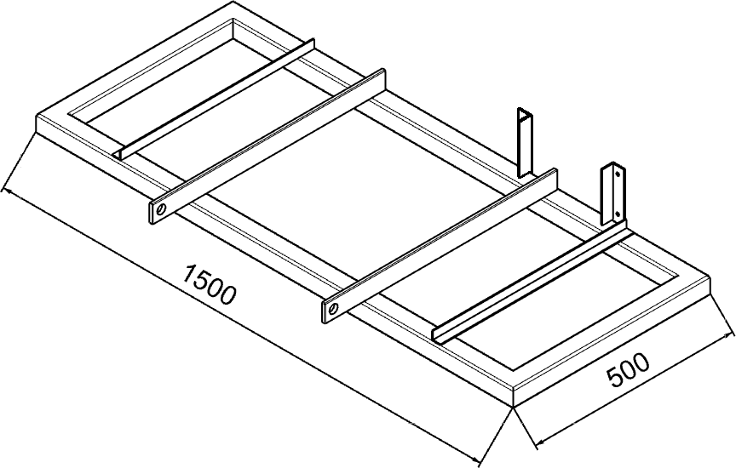
Therefore, planter frame having 150 cm width was designed. Isometric view of planter frame is shown in Fig.1
Fig.1 Isometric view of the planter frame (Dimensions are in mm)

2.2.2 Design of seed-box for zero-till planter
The size of seed-box was calculated by following method. For calculation of length of seed box, following standard relationship was used. (Sharma and Mukesh, 2013).
Lb = W – 2b (3)
where,
Lb = Length of seed box, mm
W = Working width of planter, mm (3)
b = Distance between the side box wall and ground wheel (considered 300 mm) Working width of zero-till planter (W) = 1500 mm
By putting the value of working width and b, we get,
Length of seed box = 1500 ˗ 2(300) = 900 mm
Considering the seed-rate for sowing in planter (maximum capacity) = 8.0 kg ha⁻¹
Actual field capacity of planter (AFC) =$\frac{S×W×η}{10}$ (4)
where,
S = Operating speed of planter, km h⁻¹;
W = Working width of planter, m; and
η = Field efficiency, % Let, the operating speed = 5 km h⁻¹ and field efficiency 70%
By putting the values of S, W and η in equation (4), we get,
AFC (ha h⁻¹) = $\frac{5×1.5×0.7}{10}$ = 0.525 ha h⁻¹
The zero-till planter was designed for such a capacity that it requires refilling of seed after 2.5 hours.
Weight of seed required to refill after 3.5 h =
Seed rate (kg ha⁻¹) × area covered (ha h⁻¹) × refilling Time (h) (5)
Putting the values of seed rate 8 kg ha⁻¹ (Varshney et al., 2004) area covered and refilling time in equation 5 and also putting the value of bulk density (811) in given relation for calculation of volume of box.
8 × 0.525 × 3.5 = 14.7 kg
Volume of seed box (V) =$\frac{Weight of seeds (kg)}{Bulk density of seeds ({kg}^{-3}) }$
= $\frac{14.7}{811}$ = 0.01812 m³
Considering 10% extra for free board, total volume of seed box
Total volume of seed box (Vs) = 1.1 × V
1.1 × 0.01812 = 0.01993 m³
Trapezoidal shape seed box is considered for design (Fig. 2)
The volume of trapezoidal shape seed box is given by the equation 6 (Sharma and Mukesh, 2013).
$Vs=\frac{(a+b)}{2}×h×l_{b}$ (6)
Where,
V_{s} = Volume of seed box having trapezoidal section, cm³,
a = Bottom width of seed box, cm,
b = Top width of seed box, cm,
h = height of seed box, cm; and
l_{b} = length of seed box, cm
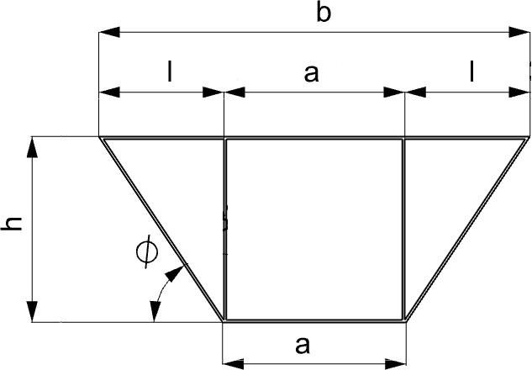
Fig.2 Trapezoidal section of seedbox
For trapezoidal section, b = a + 2l
By putting the value of b in equation (6), we get
$$Vs=\frac{(a+b)}{2}×h×l_{b}$$
$Vs=(a+l)×h×l_{b}$ [h/l = tan$∅$]
Where,
Ø = Angle of repose
V_{s} = (a+hcotØ)×h ×l_{b}
For free flow, the side angle of seed box is taken more than the angle of repose (Ø = 75°) and bottom width of 15 cm is considered.
0.01993 = [0.15 + (hcot75°)] h×0.9
0.01993 = 0.135h + 0.24111h²
0.24111h² + 0.135h – 0.01993 = 0
h = 0.1213m = 12.13 cm (considering 120 mm)
where,
l = hcotØ
= 12 × 0.2679 = 3.21 cm
and b = a +2l = 15 + 2(3.21) = 21.52 cm, (considering 220 mm)
Thus, specifications of seed box (Fig.3) is;
1. Length of seed box = 900 mm
2. Bottom width of seed box=150 mm
3. Top width of seed box = 220 mm
4. Height of seed box = 120 mm
5. Angle of repose = 75°
6. Material for seed box = MS sheet
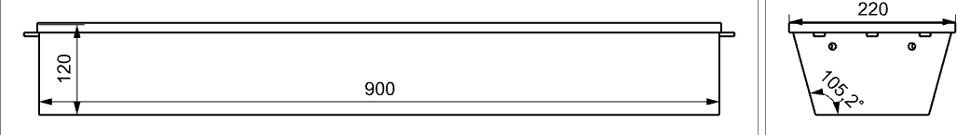
Fig.3 Detailed view of seed box for zero-till planter
2.2.3Design of seed metering mechanism for mustard seeds
Ground wheel diameter of the planter, velocity ratio between the ground wheel shaft and seed metering shaft and the number of seed cells on the seed metering disc were decided based on the following relationships (Mandal et al., 2018).
$N_{h=}\frac{πDg}{ix}$ (7)
$N_{g= }\frac{1000}{60} ×\frac{V}{πDg}$ (8)
${ V}_{d}= \frac{π×Dg×Ng}{S}×\frac{π×Dd}{60×Nh}$ (9)
where,
i = Power transmission ratio;
x = Desired seed to seed spacing (m);
Dg = Diameter of ground wheel of the planter, m;
N_{g} = Rotary speed of the ground wheel, rpm;
V = Forward speed, km h⁻¹;
Dd = Pitch circle diameter of seed cells, m;
V_{d} = Peripheral speed of the disc at the pitch circle of the seed cells, m s^{-1;}
S = Seed spacing in rows, m; and
N_{h} = Number of seed cells on seed metering disc.
Putting all values in above equations, we get,
$N_{h=}\frac{π×0.4}{1×0.1}$= 12.5712 = 13 cells (dia of ground wheel taken as 400 mm)
$N_{g= }\frac{1000}{60} ×\frac{5}{π×0.4}$= 66 rpm
${ V}_{d}= \frac{π×0.4×66}{0.3}×\frac{π×0.055}{60×13}$= 0.0612 m s⁻¹
This peripheral speed of metering mechanism is within the range of 0.05 to 0.19 m s⁻¹ for picking the seeds recommended by Yazgi and Degirmencioglu (2007) and Deb et al. (2002) Thus, the specifications of seed metering mechanism are as below and shown in Fig.4
1. Diameter of ground wheel = 400 mm
2. Diameter of seed metering disc = 55 mm
3. Number of cells for maintaining 10 cm seed to seed spacing = 13

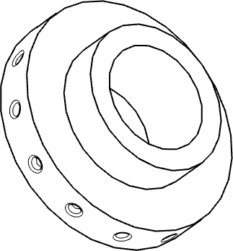
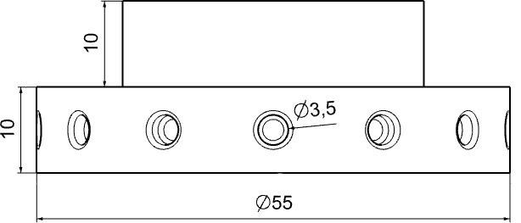
Fig.4 Isometric view of developed seed metering plate
2.2.4 Design of power transmission system
For power transmission from ground wheel to metering mechanism, the medium-sized chain having pitch of 19 mm and 19 teeth sprockets were used. Another sprocket of the same size (19 teeth) was used for seed metering shaft to maintain the transmission ratio of 1:1.
The seed hopper was fitted on the frame of the planter in such a way that the centre to centre distance is maintained at 400 mm (sprocket and shaft sprocket distance). Standard chain having 15 mm pitch was used for power transmission. The length of chain was calculated by equation (10).
M = 2C/P + (Z₁+ Z₂)/2 + (Z₂ – Z₁)2/2Pπ (10)
Where,
M = Number of chain links
C = Centre to centre distance between two sprockets, mm
Z₁= Number of teeth in driver sprocket,
Z₂ = Number of teeth in driven sprocket, and
P = Chain pitch; mm.
Putting the values in equation (10),
M = ((2×600)/15) + (16+16)/2 + (16-16)²/2π×15 = 96
Chain length was calculated by using the following relationship
L= M×P (11)
= 96×15 = 1440 mm
Again, to find the length of chain that connect the main shaft to seed metering shaft, putting the values in equation (10).
M = ((2×400)/15) + (16+16)/2 + (16-16)²/2π×15 = 69.33 (Considered as 70)
Now chain length was calculated by using the equation (11).
L= M×P = 70×15 = 1050 mm.
2.2.5 Design of inverted-T type furrow opener
In a furrow opener, the opening tool is attached at one extreme end of the shank and another end of the shank is fixed to the frame. During the field operation, an effective draft force ‘D’ acts on the tip of the tool that generates a bending force on the shank. The nomenclatures of furrow opener (Fig.5) are defined below.
b × h = Shank cross sectional area, cm²
l = Length of the shoe, cm
a = Working depth of opener, cm
H = Height of the shank from the tip of the operation to the frame, cm
Hl = Shank height from the frame to the top end of the shoe, cm
k = Specific soil resistance, kg cm⁻²
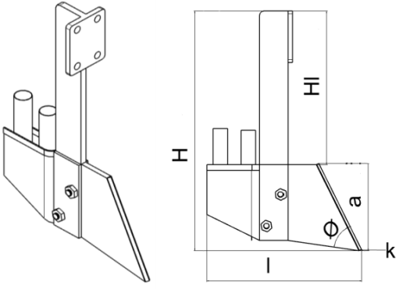
Ø = Rake angle, degree.
Fig.5 Details of inverted-T type furrow opener

Draft force (D_{f}) exerted on the inverted-T type furrow opener of the planter was calculated by using the standard relationship (equation 12) (Varshney et al., 2004).
D_{f} = k × w × d (12)
Where,
D_{f} = Draft force, kg;
k = Specific soil resistance, kg cm⁻²;
w = Width of furrow opener, cm;
d = Depth of sowing, cm
Assuming, w = 10 mm, d = 150 mm and k = 0.8 kg cm⁻² for heavy soils (Varshney et al., 2004) and for calculation purpose, soil resistance K was assumed to be 3-5 times higher (as matter of safety) than the specific soil resistance
By putting all values in equation (12)
D_{f} = 1×15×0.8 = 12 kg
Now, for mild steel shank, we can take factor of safety (FOS) of 3.
So, design draft of furrow opener is computed by equation (13)
= D _{f}× FOS. (13)
= 12×3 = 36 kgf
Considering the furrow opener shank as cantilever beam of 500 mm size fixed to the frame at one end (krutzet al., 1984), maximum bending moment (M) in the shank is given by
M = Design draft × beam span
= 36 × 50 =1800 kgf
Section modulus of the shank Z is calculated by using the equation (14).
σ_{b} = MC/I = M/Z (14)

Where,
Z = I/C
σ_{b}= Bending stress in tyne, kg cm⁻². Bending stress in the mild steel flat is taken as 1000 kg cm⁻² (Sengar, 2002).
M = Bending moment in the tyne; kg-cm
C = Distance from the natural axis to the point at which stress is calculated; cm
I = Moment of inertia of rectangular section; cm⁴ and
Z = Section modulus of the tyne.
Also, for rectangular section,
Z = t × b²/6 (15)
Thickness to width ratio (t:b) can vary between 1:3 to 1:4 for the shank. Therefore, 1:4 is taken for the design of inverted-T type furrow opener shank. (Varshney et al., 2004).
So,
t:b =1:4
b = 4t
From equation (14) and (15)
Z = 16t³/6
Z = M/σ_{b}=1800/1000 kg-cm = 1.8 kg-cm
1.8 = 16t³/6
t = 0.877 or 8.77 say 10 mm.
So,
b = 10×4 = 40 mm
Therefore, cross-section of the shank is 10 mm × 40 mm.
Based on the previous reviews, other selected parameters for designing the furrow opener are given below:
(1) Rake angle = 55° (Chaudhury, 2001)
(2) Wedge angle = 45° (Abernathy and Porterfield 1969)
(3) Length and width = 147 mm and 128 mm respectively (Varshney et al., 2004)
2.2.6 Selection of fabrication materials
During the field operation zero-till planter is subjected to various abrasive and compressive forces. Therefore, it should be strong, stiff, reliable, and wear resistant. It should have low fabrication cost and it should also serve all purposes of operation easily in the field. Selection of proper fabrication materials of various components of zero-till planter is of paramount importance. The BIS test code IS 6813: 2000 was followed for selecting fabrication materials of various components of the zero-till planter. Various materials used are given below in Table 1.
Table 1. Specifications of materials used for fabrication of different parts of the zero-till planter
Sr. No. | Materials used | Name of the parts
1 | Mildsteel | Frame,groundwheel,shaft,shank,boot  Andhitchingmechanism(mast)
2 | Galvanizedsteelsheet | Seedbox
3 | Highcarbon steel | Furrowopener
4 | Polyethylenetubes | Seedconveying tube
5 | Aluminium,A-4Mgrade | Seedmeteringmechanism
6 | Carbonsteel | Shoe

2.2.7 Fabrication of zero-till planter
Fabrication of different parts of the zero-till planter was done in the workshop of College of Agricultural Engineering and Post-Harvest Technology, Ranipool, Sikkim. Some of the fabrication glimpses views are shown in Figures 6 to 9.
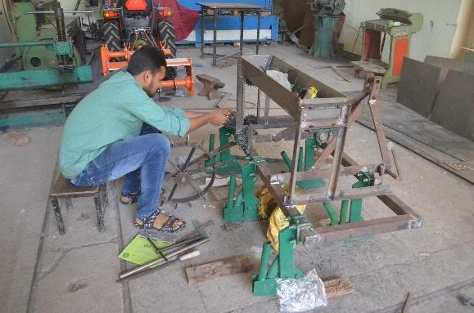
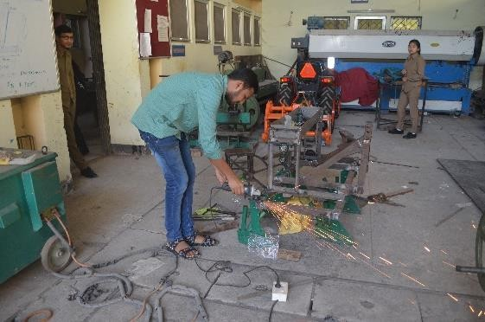
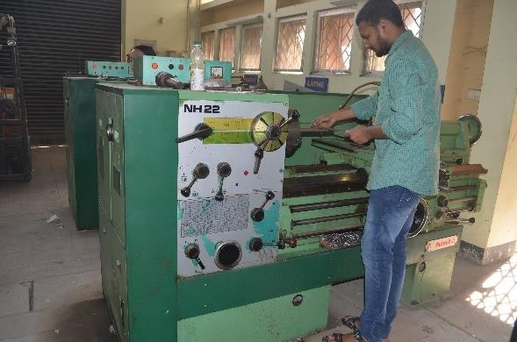
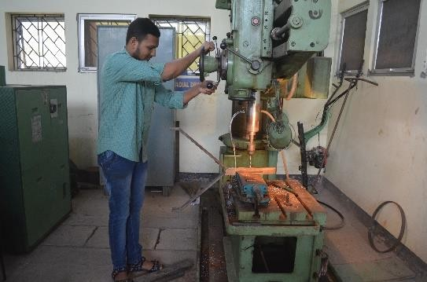
Fig.6 Drilling in the mastFig.7 Facing of metering shaft
Fig.8 Grinding operation of different parts Fig.9 Assembling of different parts
2.2.8 Constructional details of various components of zero-till planter
a.Frame
The main function of the frame is to provide support to furrow openers, seed box, power transmission, and seed metering mechanism. The functional requirements of the zero-till planter is to sow mustard in five rows at the spacing of 30 cm. Therefore, the working width of the frame was taken as 150 cm (30 cm×5). The main frame of the machine was fabricated by 50 mm mild steel square pipe.
b.Ground wheel
A pegged ground wheel is required to be used under sticky and wet soil conditions to reduce its sliding. Therefore, pegged ground wheel having 40 cm diameter was fabricated by using mild steel flat having 50 mm width and 5 mm thickness. Trapezoidal shaped pegs having 65 mm length were fitted on the periphery of the ground wheel.
c. Power transmission system
The power transmission system is used to transmit the power from the ground wheel to the metering mechanism. Medium size chain having pitch of 15 mm was selected with 19 teeth sprocket for power transmission. Equal teeth sprockets were fitted on the planter to maintain transmission ratio of 1:1.
d. Shaft
The shaft is placed below the seed box for holding and providing rotary motion to the metering mechanism. A 25 mm mild steel rod was used as a shaft.
e. Seed box
Seed box was designed and developed to supply seeds to in the five vertical plates metering mechanism of five rows. Trapezoidal shaped seed box was fabricated with a length of 90 cm, bottom width of 15 cm and top width of 22 cm. Galvanized steel sheet having 18 gauge was used for the fabrication of seed box.
f. Seed metering mechanism
The seed metering mechanism is a device used to meter correct amount of seeds in a planter. Aluminium vertical cell metering plates having outer diameter of 55 mm and 10 mm thickness were used for fabrication of metering mechanism. Seed cell diameter was decided based on the size of mustard seeds, to achieve free flow of mustard seeds, the metering cell size was created slightly more than the size of mustard seeds. Therefore, 13 cells having 3.5 mm cell diameter were created on the periphery of the metering mechanism.
g. Seed conveying tubes
Seed conveying tubes convey the seeds from seed box to furrow opener boots. Polyethene tubes having 30 mm diameter were used as seed conveying tubes.
h.Furrow openers
The designed planter has to be used under zero-till conditions after harvesting of paddy in the presence of stubbles. Under such conditions, the use of inverted -T type furrow openers has been suggested by Verma and Dewangan (2007). Therefore, in the present study, inverted -T type furrow openers were used in the developed planter. Based on the width of planter calculated in the section 2.2.1 and row spacing of 30 cm, the five furrow openers were fabricated and attached at a distance of 30 cm in staggered manner. As high carbon steel is highly wear resistive. Therefore, furrow openers were fabricated with this material.
3. Results and discussion
3.1 Development of zero-till planter
Zero–till planter was designed and fabricated as per the agronomical requirements of mustard crop and design consideration the machine components. The detailed view and design diagram of the developed planter is shown in Fig.10 and details are tabulated in table 2
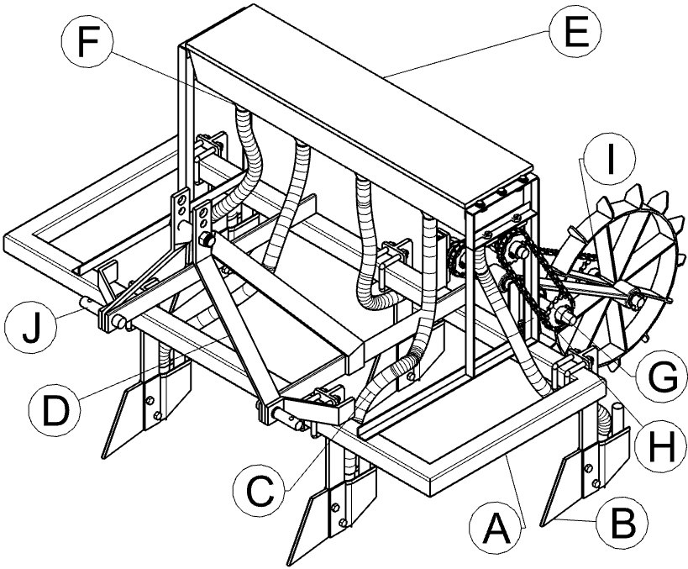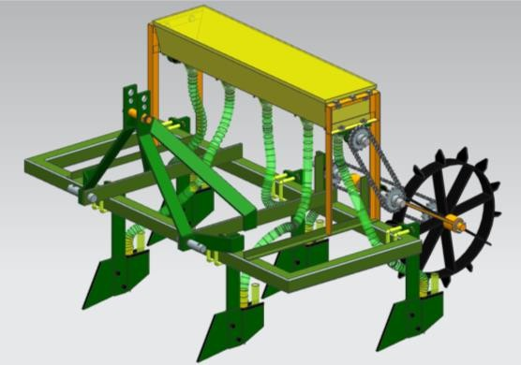
Fig.10 Views of developed planter
Table 2. Details of various components of the zero-till planter
Symbol of parts | Names of parts
A | Frame of planter
B | Furrow opener
C | Seed conveying pipe
D | Mast for hitching
E | Seed box
F | Seed metering mechanism
G | Sprocket
H | Chain
I | Ground wheel
J | Connecting link

During the field testing, the developed planter was used to sowing of mustard seeds and result of sowing was found good in terms of germinations of mustard seeds with specific seeding distance. Specification of the developed planter is given Table 3.
Table 3. Specifications of the zero-till mustard planter
Sr. No. |  | Description | Specification
1 | Type |  | 5row zero-till planter
2 | Frame |  | 50mm x 50mm x3mm MS box  section
3 | Shaft |  | Round mild steel bar
3 | (i) | Length of shaft, mm | 1020
3 | (ii) | Diameter of shaft,mm | 25
4 | Seed metering mechanism
4 | (i) | Type | Cell type vertical plate metering  mechanism
4 | (ii) | Diameter of metering plate, mm | 55
4 | (iii) | Number and size of cells | 13Nos.of 3.5mm cell at13.29mm  Peripheral distance
4 | (iv) | Numberofmeteringplates | 5
5 | Seedbox
5 | (i) | Type | Trapezoidal shape
5 | (ii) | Capacity,kg | 8
6 | (i) | Seedtubes | Polyethylenetubes
6 | (ii) | Innerdiameterofseedtube,mm | 30

3.2 Calibration of the zero-till planter
The calibration of zero-till planter was carried out in the lab to determine the seed rate, mechanical seed damage and uniformity of seeding for this purpose sticky belt method is used to ensure the uniformity in metering. Measurement of Mechanical damage of mustard seeds was carried out by counting and weighing the damage seeds from 100 g sample collected from each furrow opener. The mechanical damage seed was found 0.03%. The seed rate was calculated by weighing the seeds of 10 revolutions of ground wheel and calculated accordingly. The seeding uniformity test for mustard was conducted on sticky belt having 10 m long to travel under the seed tubes in such a way that speed of the belt is equal to running speed of drill. A sticky layer of grease was applied to the belt to facilitate proper embedding of seeds without any displacement. The seed tube was arranged in such a way that minimum distance can be achieved between the seed tube and sticky belt to prevent seed displacement after dropping from the seed tube on the sticky belt. The belt was painted and marked in centimeters for quick reading. Zero-till planter was operated at the speed of 3 km h⁻¹ over the sticky belt to measure the uniformity of seed placement. For proper germination and growth of mustard plant, plant should have 10 cm seed to seed distance and 30 cm row to row distance is required. To maintain the 30 cm row to row distance furrow opener was placed at 30 cm distance and for maintain 10 cm seed to seed spacing a metering device having 13 numbers of cells was used at this spacing the seed rate was found 2.1 kg ha^{-1.} 550 seeds are placed at range of 10 to 10.5 cm distance.
3.3 Filed performance test of zero-till planter
The developed zero-till planter was operated in the farmer field located at the Villege of Sumin Dist. Gangtok, Sikkim after the harvesting of paddy crop at leveled stubbled condition which is suitable for zero-till drill. Sowing of mustard is done in between 15 Oct. to 15 November. In the time of sowing field have a moisture content of soil, bulk density of soil and soil hardness were found 13.5%, 1.31 g/cc and 5.17 kg cm⁻² respectively. Performance parameters such as theoretical field capacity, actual field capacity, field efficiency, seed rate and seed germination were determined and summarized in Table 4.

Table 4. Machine performance data zero till planter for planting of mustard
Sr. No. | Parameters | Mustard crop
 | Type of soil | Alluvial soil
 | Av. soil moisture, % | 13.2 to 13.5
 | Av. speed of operation, km h⁻¹ | 3.16 to 3.24
 | Av. wheel slippage, % | 7.8 to 8.0
 | Row spacing, cm | 30
 | Average depth of sowing, cm: | 5.1 to 5.3
 | Seed to seed spacing, cm | 10
 | Av. width of sowing, cm | 149.68 to 149.72
 | Effective field capacity, ha h⁻¹ | 0.359 to 0.373
 | Theoretical field capacity, ha h⁻¹ | 0.473 to 0.485
 | Time required for sowing 1 hectare, h | 2.68 to 2.79
 | Av. Seed rate, kg/ha | 2.0 to 2.1
 | Av. rate of germination, % | 92
 | Field efficiency, % | 75.82 to 76.94
 | Av. implement draft, kgf | 178.2 to 183.8
 | Power requirement, kW | 1.56 to 1.68
 | Fuel consumption, l h⁻⁻¹ | 2.52 to 2.93

The range of working width for sowing of mustard, area covered, depth of seed placement, field efficiency, draft and power requirement were observed in the range of 149.68 to 149.72 cm, 0.359 to 0.373 ha h⁻¹, 5.1 to 5.3 cm, 75.82 to 76.94% 178.2 to 183.8 kgf and 2.52 to 2.93 kW, respectively. After the sowing of mustard crop from the developed planter seed germination was found 92%.
4. Conclusion
Developed planter was tested in the field at the Sumin Village Gangtok, Sikkim.]Planter was easy to adjust and operate with tractor at desired power. The manoeuvrability of the tractor and planter is considered satisfactory. The developed planter works excellent in the field for sowing.

References
Abernathy, G. H., & Porterfield, J. G. (1969). Effect of planter opener shape on furrow characteristics. Transactions of the ASAE, 12(1), 16-19. https://doi.org/10.13031/2013.38750 .
Chaudhuri, D. (2001). PM—Power and Machinery: Performance Evaluation of Various Types of Furrow Openers on Seed Drills—a Review. Journal of Agricultural Engineering Research, 79(2), 125-137. https://doi.org/10.1006/jaer.2000.0688 .
Deb, K., Pratap, A., Agarwal, S., & Meyarivan, T. (2002). A fast and elitist multiobjective genetic algorithm: NSGA-II. IEEE Transactions on Evolutionary Computation, 6(2), 182-197. https://doi.org/10.1109/4235.996017 .
Godara, A., Sharma, M., & Sharma, A.K. (2015). Influence of different types of furrow openers on soil disruption for tractor drawn seed drill. Journal of Scientific and Engineering Research, 2(3), 1-8. https://jsaer.com/volume-2-issue-3-2015/ .
Bureau of Indian Standards. (2000). *Sowing equipment—Seed-cum-fertilizer drill—Specification* (IS 6813:2000). Bureau of Indian Standards. https://www.services.bis.gov.in/php/BIS/standards/Bis_standards/search_result.php?search_type=is_no&search_value=6813 .
Jangir, R., Arvadia, L. K., & Kumar, S. (2017). Growth and Yield of Mustard (Brassica juncea L.), Dry Weight of Weeds and Weed Control Efficiency Influence by Different Planting Methods and Weed Management. International Journal of Current Microbiology and Applied Sciences, 6(7), 2586-2593. https://doi.org/10.20546/ijcmas.2017.607.365 .
Krutz, G., Thompson, L., and Claar, P. (1984). Design of agricultural machinery. John Wiley and Sons. Sigapore. pp 245-255
Mandal, S., Kumar, G. P., Tanna, H., & Kumar, A. (2018). Design and evaluation of a pneumatic metering mechanism for power tiller operated precision planter. CURRENT SCIENCE, 115(6), 1106-1114. https://doi.org/10.18520/cs/v115/i6/1106-1114 .
Sengar, S.M. (2002). Design and development of animal drawn seeder for rice cum green manure crops for biasi cultivation system (Doctoral dissertation, Indira Gandhi Krishi Vishwavidyalaya, (Raipur Chhattisgarh pin no. 492012) India.
Sharma, D.N., and Mukesh, S. (2013). Farm machinery design: principles and problems. Rajasthan, Jain Brothers, p.134.
Shekhawat, K., Rathore, S. S., Premi, O. P., Kandpal, B. K., & Chauhan, J. S. (2012). Advances in agronomic management of Indian mustard (Brassica juncea (L.) Czernj. Cosson): An overview. International Journal of Agronomy. https://doi.org/10.1155/2012/408284 .
Srigiri, D., Veeraprasad, G., Rajkiran, B., & Edukondalu, L. (2016). PERFORMANCE EVALUATION OF MANUALLY OPERATED PUSH TYPE MULTI CROP PLANTER. International Journal of Agriculture Sciences, 8(29), 1624-1626. https://www.bioinfopublication.org/pages/upload_files/21%20IJAS%208(29)%201624-1626.pdf .
Varshney, A.C. (2004). Data book for agricultural machinery design. pp 210-243.
Verma, A. K., Dewangan, M. L., Singh, V. V., & Das, V. (2007). Mechanical consideration for design and development of furrow openers for seed cum fertilizer drill. Agricultural Mechanization in Asia, Africa and Latin America, 38(2), 74-78. .
Yazgi, A., & Degirmencioglu, A. (2007). Optimisation of the seed spacing uniformity performance of a vacuum-type precision seeder using response surface methodology. Biosystems engineering, 97(3), 347-356. https://doi.org/10.1016/j.biosystemseng.2007.03.013 .

