Opinion of the occupants of apartment regarding natural ventilation of their respective houses.

Abstract

To introduce fresh air into an interior space without utilising mechanical systems like air conditioning or fans is called natural ventilation. It depends on phenomena like wind and buoyancy to move air around and create a cosy and hygienic interior atmosphere. By replacing stale indoor air with fresh outdoor air, natural ventilation aims to maintain a suitable indoor air quality and thermal comfort. Because it uses less energy and depends less on mechanical systems, natural ventilation is regarded as an energy-efficient and sustainable building design approach. However, a number of variables, including the surrounding environment, local climate, and building design significantly affect the natural ventilation. This article is to study the opinion of the inmate of the apartment regarding natural ventilation. To predict the opinion of the members resides in the sample apartment regarding natural ventilation and to study the effects of indoor ventilation on occupants of apartment. interviews were scheduled, where different questions are asked related to ventilation issue and their effect on health. The study reveals the insights into electricity consumption, window usage habits, air conditioning and fan usage, as well as overall satisfaction with natural ventilation. Key findings include a prevalence of high summer electricity bills due to insufficient natural ventilation, varied window-opening habits, common use of air conditioning to get comfort and satisfaction.

Key word: Natural ventilation, thermal comfort, Design and layout, Cross ventilation

Introduction:
Natural ventilation refers to the use of passive airflow techniques to circulate fresh air throughout the living space without relying on mechanical systems. It harnesses the power of natural forces such as wind and temperature differences to facilitate the exchange of indoor and outdoor air, creating a healthier and more comfortable living environment. In densely populated urban areas, apartment buildings are often designed with limited access to outdoor spaces, making it challenging to maintain optimal indoor air quality. This is where natural ventilation plays a vital role. By incorporating carefully designed openings, such as windows, doors, and vents, apartment dwellers can take advantage of the natural elements to regulate airflow and improve ventilation. One of the primary benefits of natural ventilation is its ability to remove stale air, odours, and pollutants from the apartment. Opening windows strategically allows the escape of indoor air that may contain airborne particles, volatile organic compounds (VOCs), or excessive moisture. Simultaneously, fresh air from outside enters the apartment, replenishing the oxygen levels and creating a more pleasant living environment. While natural ventilation offers numerous advantages, it is crucial to strike a balance between air exchange and maintaining thermal comfort. Apartment design and layout play a vital role in optimizing natural ventilation. This issue is prevalent in cities throughout India, including Bhubaneswar, where a significant number of poorly ventilated apartments can be found. In my survey, I have chosen to focus on one such an apartment complex located in the northern regions of Bhubaneswar, specifically in Raghunathpur. This particular building was constructed with a greater number of flats in a limited amount of space, prioritizing economic benefits over the provision of natural ventilation and natural light. The consequences of such poor ventilation in these apartments can have a detrimental impact on the health and well-being of the residents.
Review of literature:
As India is a developing country, the building sector is developing in a rapid way in India. It has been predicted that by 2050, the total building area will cross 40 billion(Belleri, Lollini, & Dutton, 2014). In current scenario, 33% of total energy is consumed by building sector in India and it is expected to be grow at the rate of 8% annually (Rawal et al., 2012). It has been observed that, majority portion of the building energy is utilized for mechanical ventilation such as cooling fan, Air conditioning and air drive blowers. All the instruments used for mechanical ventilation are mainly driven by electricity. Till today, around 70% of electricity is produced from fossil fuel-based power plants. 90% of CO₂ are directly emitted from these fossil fuel-based power plants. As a result, continuous rise in average temperature has been observed due to greenhouse effect. Moreover, the harmful gases like oxides of nitrogen, oxide of sulphur and huge particulate matter are emitted through combustion product gas increases the overall pollutant level in the ambient air. Hence, in order to reduce the energy consumption, many research works have been conducting globally on NetZero energy house concept where importance has been given for the natural ventilation than artificial ventilating system.
Natural ventilation mainly depends on building orientation, location and climate of the building, building design and layout, external obstruction, internal heat source and operable elements like door and windows opening. Therefore, architectural parameters play a key role for an effective natural ventilation system. Although the climate and location of the building is not under the control of an architecture but it is possible to enhance the effective natural ventilation by a proper designing of building and proper placement of windows and proper size of window as well. Designing of buildings with open floor plans, atriums, and courtyards can promote cross-ventilation and airflow throughout the interior spaces. Installation of vents, louvers, or clerestory windows at high points in the building facilitate the release of warm air and promotes stack effect ventilation.
Methodology:
The study was done by in detail study of selected apartment as case study and also by conducting interviews with residents of the apartment, using a structured interview schedule. A purposive random sampling technique was employed to select participants. The interviews were conducted with family members from aged 18 and above, who were free from ailments such as anaemia, diabetes, heart problems, or any other chronic health disorders. In this interview participants were asked questions regarding their house and the equipment used for maintaining thermal comfort and ventilation. Since there were 88 houses in total, the sample size for first part of interview was N=88. An interview schedule was developed and pre tested on 20 respondents. Interview schedule having different questions on different aspect like demographic information and some specific information on electricity bill, window opening time and duration, number of air conditions, fan, exhaust fan used, and the duration of usage of these electrical appliances at their home. Whether they are satisfied/unsatisfied with the natural ventilation of the home and what are the reason for not satisfactions etc. the collected data were compiled, tabulate and represented in the form of graph by using MS Excel.

Result and discussion:

Case study of selected apartment:
Selected sample apartment is situated in Raghunathpur, Bhubaneswar, Odisha, India, is an apartment developed by a private Builders. The apartment comprises four distinct blocks: Block-A, Block-B, Block-C, and Block-D. Offering a total of 88 flats, it provides residents with a choice between 16, 2 BHK flats, having 1120 sq. ft. each, and 72 number of 3 BHK flats, having floor area1540 sq. ft. The construction of selected sample apartment commenced in November 2012, and it was completed by August 2016. With a height reaching 72 ft, having a basement and five stories in total, the apartment primarily serves residential purposes. The basement and the first floor are dedicated to parking facilities, while the remaining four floors house the residential units.

Climate and topography
Bhubaneswar experiences a tropical climate characterized by two distinct seasons: a dry season spanning from November to May, and a rainy season brought on by the monsoon, occurring from June to October. The rainy season typically concludes in early to mid-October. Prior to the arrival of the monsoon, which typically begins in early March and lasts until early June, the city undergoes scorching temperatures accompanied by sporadic showers, particularly in May. During the peak of summer, temperatures can soar up to 45 °C (113 °F), and in June 2022, it even reached an exceptionally high temperature of 46.7 °C (116 °F). Bhubaneswar receives an annual average rainfall of and the wettest month is September, with precipitation measuring approximately 8.41 inches. As for wind patterns, April stands as the windiest month, with an average wind speed of 11 mph. In terms of the coldest month, January takes the lead, with an average temperature of 73 degrees Fahrenheit.(Garg, 2022)

Orientation
The selected apartment is facing towards the west direction with latitude of 20.3747ºN and longitudes 85.8305ºE. A road is located to the front of the apartment which connect Bhubaneswar to Cuttack. The wind orientation is from South and South west mainly in the range of 1.5 -4.5 m/s over the year. The sun rises from west of the plot. (Pradhan, 2013)
. 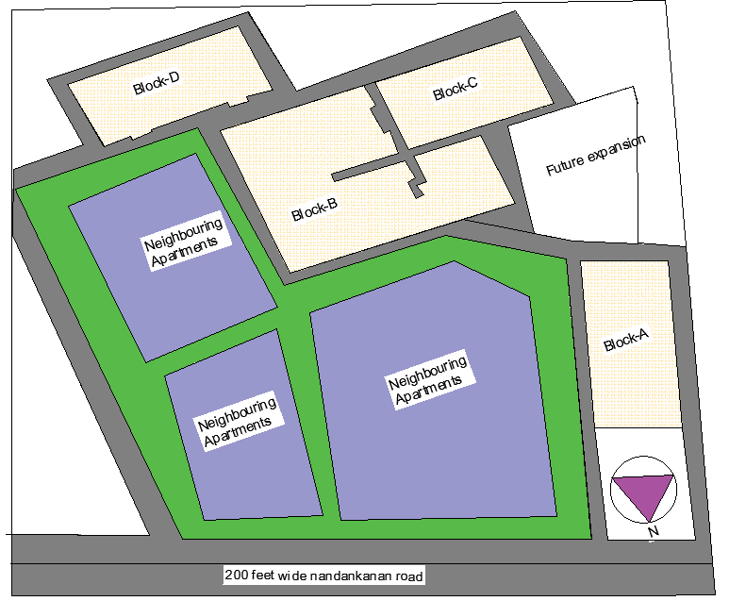
Figure 1: Lay out plane of the blocks of selected apartment for study

Planning concept of selected apartment for study
The sample apartment is an economically designed building that maximizes the available space while compromising on natural ventilation and lighting. The building consists of four blocks named Block-A, Block-B, Block-C, and Block-D, with a congested layout. Three blocks shown in fig-1 are situated closely together, while Block-A is positioned separately. The shape of all blocks are rectangular, featuring narrow passages for circulation. Among the blocks, Block-B is particularly congested, housing eight flats arranged in a mirrored position with another set of four flats, connected by a narrow corridor measuring only 3 feet in width and 75 feet in length. All blocks consist of three bedrooms, one dining space, one living room, one kitchen, two toilets, and two balconies, except for Block-A, which has two bedrooms, one dining space, one living room, two toilets, and one balcony it is clearly shown in fig-2. Among the total 77 flats in the building, 17 flats in Block-D have a size of 1540 square feet, while the remaining 60 flats in Block-B and Block-C have a super built-up area of 1455 square feet. Additionally, there are 16 two-bedroom flats, with eight flats measuring 1120 square feet and the other eight measuring 1175 square feet of super built-up area. Each block is equipped with one staircase and one lift for vertical connections between floors, except for Block-B, which has three staircases and three lifts. The apartment also features two community halls and one gym space for the residents. Parking is available on the basement and first floor, connected through a cemented ramp. Notably, there is an unused and unconstructed swimming pool near Block-D.
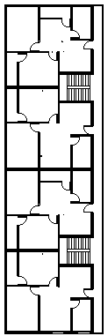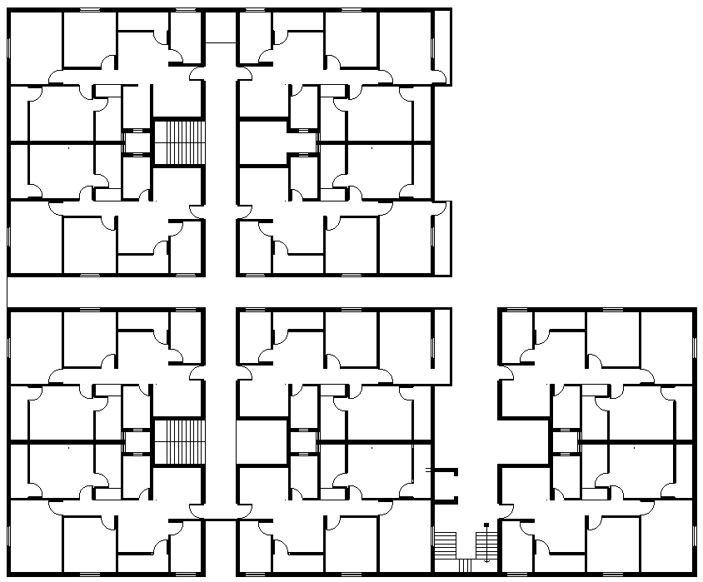
Floor plan of block -A Floor plan of block-B
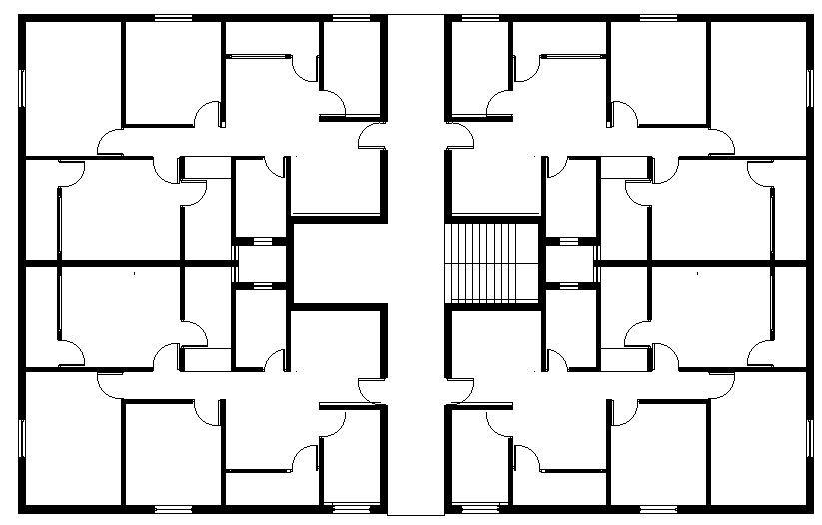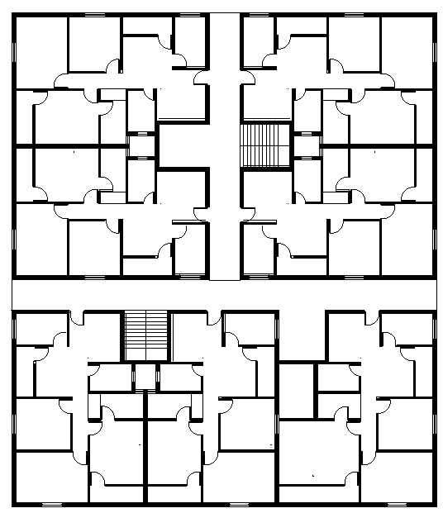
Floor plan of block-C Floor plan of block-D
Figure 2:Floor plan of different blocks
:Floor plan of different blocks

Built up area.
Hear built up area is referring to carpet area pulse area of thickness of wall and ducts pulse area of balcony, corridor, this is usually more than 10% of the carpet area. Built up area for 3 bhk is 950sq ft and built-up area for 2 bhk is 755 sq ft. The apartment is having service area like ducts 54 sq ft floor area each, two lifts 23 sq ft and rest four lifts of 16 sq ft of floor area each. Floor area of each staircase are 16’ 4”.
Below, placed several figures depicting various elements within the apartment that contribute to poor ventilation. These elements are illustrated in the 3 Conjugated Blocks and Figure 4 Narrow Spaces within the Sample Apartment. These figures provide a visual representation of the factors responsible for the inadequate ventilation in the apartment.
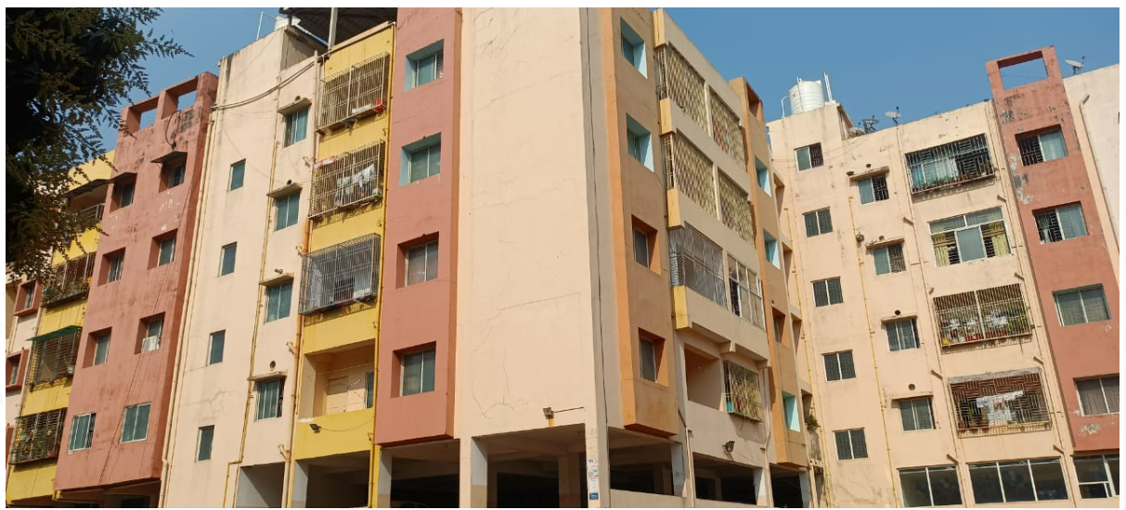
Figure 3 :Conjugated blocks (Block-B) and (Block-C)
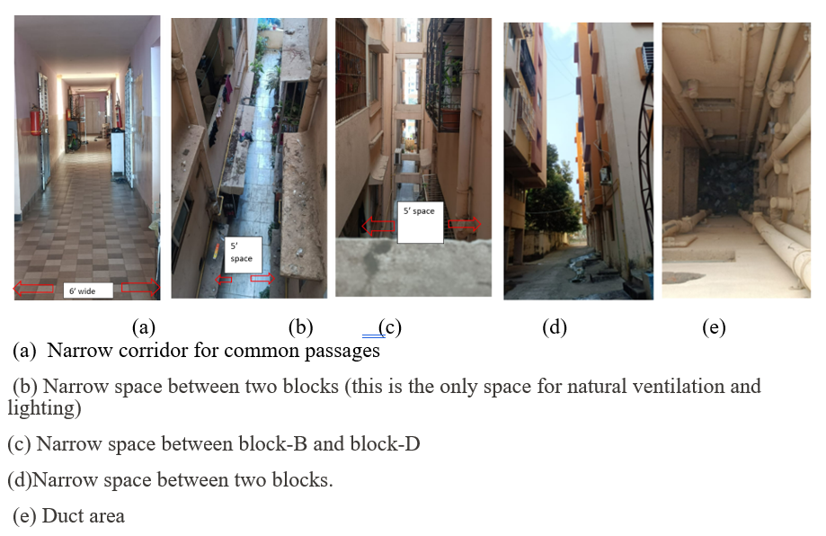
Figure 4:Different narrow space present in sample apartment. (a), (b), (c), (d), (e).

The builder has maximized space usage to construct a densely populated building, primarily driven by economic considerations, unfortunately, compromising the well-being of its occupants. However, an attempt to mitigate this issue is visible in 5, where a rooftop vent has been incorporated to facilitate natural ventilation.
In addition, some of the residents have taken proactive measures to enhance air quality and beautify the surroundings, as depicted in Figure 5, by creating immediate exterior plantations. These green spaces serve the dual purpose of purifying the air and enhancing the aesthetic appeal of the environment.

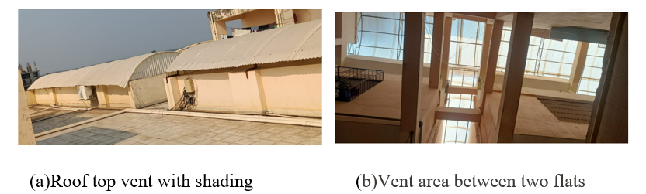
Figure 5 Architectural feature for natural ventilation and natural lighting(a), (b)
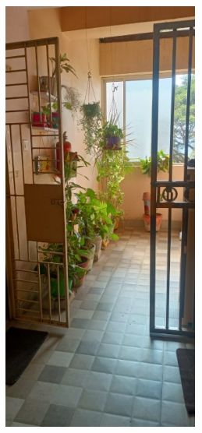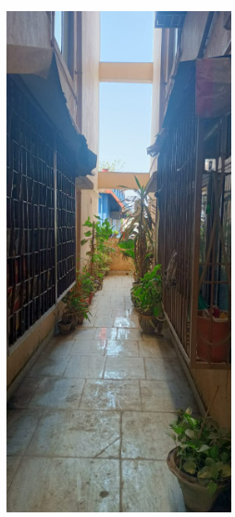
Figure 6:Immediate exterior plantation for clean air and beautification.
Table 1: Number, sizes and percentage of openability of door and window
Bed room type | No of Door | sizes | Openability  (%) | No of window | sizes | Openability  (%)
3 bhk | 6 | 3’ x7’ | 100 | 4 | 4’ x4’ | 50
 | 2 | 2’6”’x7’ | 100 | 1 | 6’ x 4’ | 33.3
2 bhk | 5 | 3’ x7’ | 100 | 5 | 4’ x4’ | 50
 | 2 | 2’6” x7’ | 100 | 1 | 6’ x4’ | 33.3

Table-1 provides information on the openability of doors and windows in different bedroom types, with a specific focus on ventilation. The data is categorized into two-bedroom types: 3 BHK (3 bedrooms, hall, and kitchen) and 2 BHK (2 bedrooms, hall, and kitchen). For each bedroom type, the table displays the number of doors, their sizes, and openability percentages, as well as the number of windows, their sizes, and openability percentages. The data reveals that the openability of windows in both 3 BHK and 2 BHK bedroom types is limited. Windows play a crucial role in facilitating natural ventilation, and the low openability percentages signify that residents may face challenges in achieving adequate airflow

Opinion of the inmate on apartment regarding natural ventilation:
The information for this study was obtained by conducting interviews with residents of the apartment, using a structured interview schedule. A purposive random sampling technique was employed to select participants. The interviews were conducted with family members aged 12 and above, who were free from ailments such as anaemia, diabetes, heart problems, or any other chronic health disorders, and who were present during the interview. The interview schedule consisted of two parts. In the first part, participants were asked questions regarding their house and the equipment used for maintaining thermal comfort. Since there were 88 houses in total, the sample size for this part was N=88. The second part of the interview schedule focused on the participants' perceptions of thermal comfort and ventilation in their homes. For this part, a sample size of 200 respondents was used. To know the opinion from the respondent about the effect of indoor ventilation on them by living in the apartment for a long time. An interview schedule was developed and pre tested on 20 respondents. Interview schedule having different questions on different aspect like some general information about the family and some specific information on electricity bill, window opening time and duration, number of air conditions, fan, exhaust fan used, and the duration of usage of these electrical appliances at their home. Whether they are satisfied/unsatisfied with the natural ventilation of the home and what are the reason for not satisfactions etc. the collected data were compiled, tabulate and represented in the form of graph by using MS Excel.

Information obtains from the respondent of the families 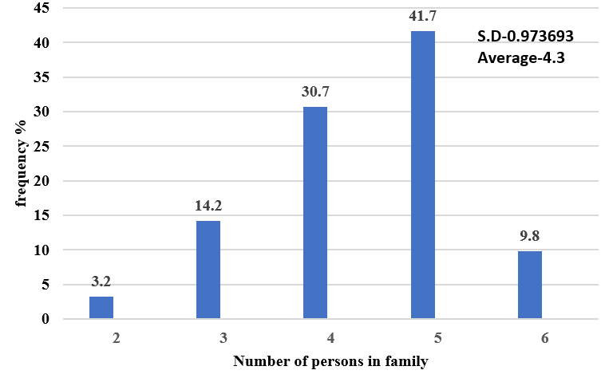
Figure 7:No of persons living in the family
Figure 7 provides a breakdown of the family sizes in the apartment. Among the 88 flats surveyed, it is evident that 3.2% of the flats are occupied by 2 family members, 14.2% by 3 family members, 30.7% by 4 family members, 41.7% by 5 family members, and 9.8% by 6 family members. On average, each family in this apartment consists of 4 members, with a standard deviation of 0.97.
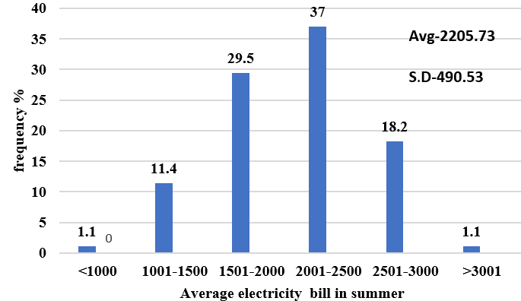
Figure 8:Average electricity bill in summer months in rupees.
In Figure 8 it can be observed that during the summer months (May, June, July, and August), a significant proportion of families experience higher electricity bills. Specifically, 37 percent of families pay more than Rs 2000 to 2500 per month, while 29.5 percent pay between Rs 1500 and Rs 3000. Additionally, 18.2 percent of families pay bills ranging from Rs 2500 to Rs 3000, and 1.1 percent pay more than Rs 3000.It is found that among 88 families the average electricity bill is of Rs 2205.73, with a standard deviation of approximately Rs 490.53. The main reason for the majority of families experiencing higher electricity bills is attributed to inadequate natural ventilation or airflow in their houses.
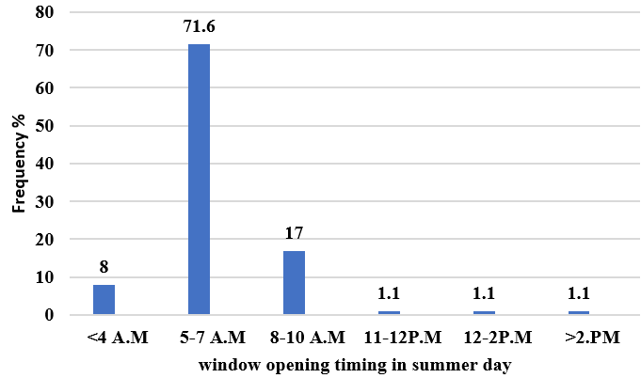
Figure 9:Time of opening windows by the family.
The findings from the research on respondents' window-opening habits at different times of the day, as depicted in Figure 9. provide valuable insights into the behaviour of families in relation to window usage. The primary objective of this inquiry was to examine the timing of window openings throughout the day, without specifying the rooms where the windows were located (e.g., living room, bedrooms, etc.). During weekends, holidays, and summer days, the data revealed that a significant number of families residing in the apartment opened their windows between 5 to 7 am in the morning, with the exact timing depending on their wake-up routines. Approximately 17 percent of the families reported opening their windows between 8 to 10 am. Additionally, 8 percent of the families mentioned that they opened their windows in the very early hours, specifically before 4 am. The remaining 1.1 percent of families opened their windows between 11 to 12 pm, 12 to 2 pm, and after 2 pm, respectively. A study on Malaysia home by (Kubota & Ahmad, 2005) shows that by opening the windows, these households can effectively enhance the thermal conditions within their residences. However, during nighttime, the proportion of open windows decreased significantly, reaching approximately 10%. This research underscores the importance of understanding how families utilize windows at different times of the day. The findings can inform architectural and design considerations for residential buildings, emphasizing the significance of well-ventilated spaces to optimize thermal comfort. By aligning building designs with occupants' window-opening preferences and considering the heat capacity of various building materials, sustainable and energy-efficient housing solutions can be developed to promote comfortable living environments while reducing energy consumption.
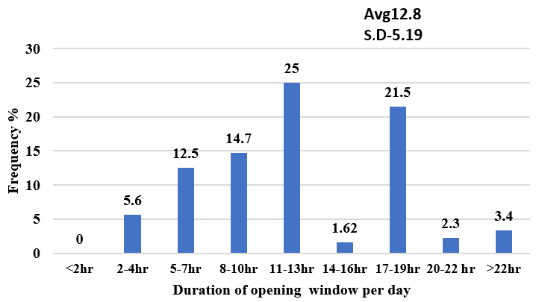
Figure 10:Window opening timing per day
The findings in Figure 10 indicate that a significant portion of families, approximately 25 percent, open their windows for 11 to 13 hours each day. This duration allows for a sufficient exchange of fresh air and ventilation within the house. Furthermore, approximately 21.5 percent of the surveyed families mentioned that they keep their windows open for a slightly longer period, ranging from 14 to 16 hours daily. This extended window opening duration suggests that these households prioritize natural ventilation and air circulation within their living spaces. A smaller portion of the families, comprising 12.5 percent, reported opening their windows for 5 to 7 hours daily. While this duration may be comparatively shorter, it still allows for some fresh air to enter the common areas of the house, such as the dining, living, and kitchen rooms. Interestingly, a minority of families, representing 5.6 percent, reported only opening their windows for a limited duration of 2 to 4 hours. Although this percentage is relatively low, it is worth noting that even a short window opening period can contribute to the overall ventilation and air quality within a home. The study also highlighted that approximately 3.4 percent of families consistently keep their windows open for more than 22 hours. This extended window usage suggests a strong preference for fresh air and a desire to maintain a well-ventilated environment throughout the day. In contrast, households with air conditioning installed in their rooms tend to keep the windows closed when the air conditioning is in use. This behaviour is understandable since the purpose of the air conditioning system is to regulate temperature and maintain a controlled indoor environment. It is important to emphasize that these findings are based on the common areas of the house, such as dining, living, and kitchen rooms. The usage patterns of windows in individual rooms may differ, especially when air conditioning units are present. Overall, these research findings shed light on the window usage habits of families during the summer season. Understanding these patterns can be useful for designing energy-efficient buildings and promoting healthy indoor environments by optimizing natural ventilation and reducing reliance on mechanical cooling systems.
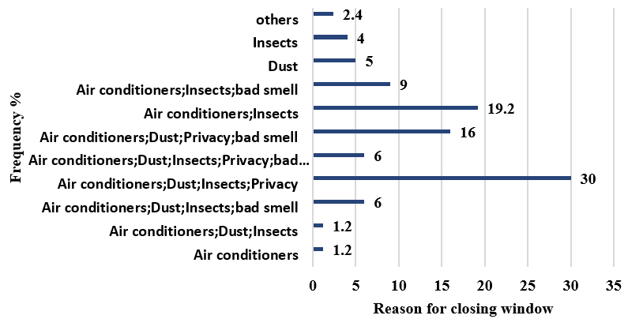
Figure 11:Reason for closing window
With regards to reason for not opening window all time, as shown in the Figure 11 30 percent of the families mention that due to running air conditions, dust outside the house, insects and for the privacy they have to close their windows. 19.2 percent families said due to use of air condition and entry of insects they are closing window.16 percent of the families expressed the reasons as air conditioners, dust, privacy and bed smell for closing the window .9 percent of the families given the answer as A.C, insects and bad smell as the reason.6,6 percent stated the reason as A.C, dust, insects, privacy, bad smell respectively. Based on a comprehensive study and analysis, it has been found that there are multiple reasons why families choose not to keep their windows open at all times, as illustrated in Figure 4. Firstly, 30 percent of the families surveyed mentioned that the primary reason for keeping their windows closed is the use of air conditioning systems. This finding is consistent with the desire to maintain a comfortable indoor temperature regardless of the external weather conditions. Secondly, the presence of dust outside the house was identified as a significant factor leading to window closure, as reported by 30 percent of the surveyed families. Dust particles can have detrimental effects on indoor air quality, potentially causing respiratory issues and discomfort. By keeping the windows closed, families aim to minimize the entry of dust and maintain a cleaner and healthier living space. Insects were also a reason for keeping windows closed by 30 percent of the families. Insects, such as mosquitoes, flies, and other pests, can not only be annoying but also pose health risks due to the transmission of diseases. By preventing their entry through closed windows, families can create a protective barrier and reduce the chances of encountering these unwanted pests. Privacy concerns were mentioned by 30 percent of the families as another reason for keeping windows closed. Maintaining privacy within one's home is essential for personal security and comfort. Closed windows help to limit visibility from the outside, ensuring a sense of privacy for individuals and families. Furthermore, 19.2 percent of the families indicated that the use of air conditioning and the entry of insects were the primary factors behind their decision to close the windows. This combination of reasons emphasizes the importance of both comfort and health concerns in their decision-making process. In addition, 16 percent of the families expressed multiple reasons for window closure, including air conditioners, dust, privacy, and bad smells. This suggests that these families consider various factors simultaneously when deciding to keep their windows closed. Moreover, 9 percent of the families cited air conditioning, insects, and bad smells as their reasons for window closure. This indicates that these families prioritize a clean and pleasant indoor environment, free from unpleasant odours and the intrusion of insects, while also maintaining a comfortable temperature through air conditioning. Lastly, 6.6 percent of the families identified a combination of factors, such as air conditioning, dust, insects, privacy, bad smells, or a combination thereof, as their reasons for keeping the windows closed. This group recognizes the importance of considering multiple aspects to ensure a satisfactory living environment. The decision to keep windows closed is influenced by a variety of reasons, as demonstrated by the study findings. These include the use of air conditioning systems, concerns regarding dust, insects, privacy, and unpleasant odours. By understanding these factors and their respective impacts, families can make informed choices to create a comfortable, healthy, and secure living space.
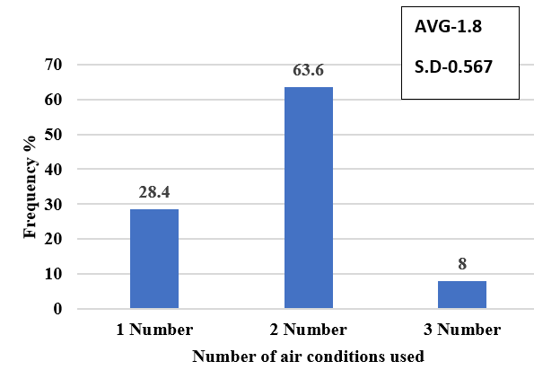
Figure 12:No of air conditions installed per family.
Figure 12 shows the data on number of air conditions used. In selected apartment all flats had installed air condition as due to less air entered inside the house and the temperature outside is very high in summer days. Out of 88 families present in apartment 63.6 percent of the families having two numbers of Air conditions ,28.4 percent of the family having one Air conditions in their home and 8 percent of the family says they have installed three Air condition in their home. According to the data presented in Figure 5, it can be observed that the usage of air conditioners in apartment is influenced by several factors. The main reason behind the high installation rate of air conditioners in this residential building is the limited air circulation and the extremely high temperatures experienced during summer days. Out of the total 88 families residing in apartment, a significant percentage of 63.6% have opted to install two air conditioners in their homes. This can be attributed to the need for efficient cooling in order to counter the lack of fresh air entering the premises, as well as to maintain comfortable indoor temperatures during the scorching summer season. Furthermore, 28.4% of the families in apartment have chosen to install a single air conditioner in their homes. This may be due to various reasons such as financial constraints, space limitations, or personal preferences. Despite having only one air conditioner, these families still aim to enhance their indoor comfort levels by providing some level of cooling within their living spaces. Lastly, 8% of the families have reported the installation of three air conditioners in their homes. This relatively smaller percentage suggests that only a minority of households require multiple air conditioners, likely indicating larger living spaces or specific cooling needs.
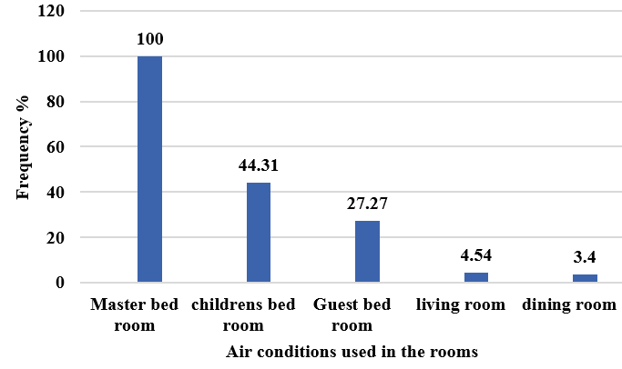
Figure 13:the room having air condition installed.
Based on the findings presented in Figure 13, it is evident that air conditioning usage varies among 88 families. The data clearly demonstrates that 100 percent of the families surveyed utilize air conditioning in their master bedrooms, indicating its widespread use in this particular room. Furthermore, it was observed that 44.31 percent of the families surveyed also employ air conditioning in their children's bedrooms. Upon further examination, it was discovered that out of the total 100 families surveyed, 27.27 percent of them utilize air conditioning in their guest bedrooms. Moreover, a smaller proportion of families, specifically 4.54 percent, make use of air conditioning in their living rooms, while 3.4 percent of families reported using air conditioning in their dining rooms. These findings are supported by existing research on the prevalence of air conditioning usage in residential settings. According to a study conducted(Kubota, Jeong, Toe, & Ossen, 2011), it was observed that the master bedroom is one of the most commonly air-conditioned spaces in households, due to the emphasis placed on individual comfort during sleep. Additionally, the study also highlighted the significance of air conditioning in children's bedrooms, as it contributes to maintaining suitable temperatures for optimal sleep and overall well-being. Furthermore, the study conducted by (Lin & Deng, 2006)found that guest bedrooms often have air conditioning units to ensure the comfort and satisfaction of visiting guests. Similarly, the inclusion of air conditioning in living rooms and dining rooms was also noted, as these areas are frequently utilized for social gatherings and relaxation, necessitating a pleasant indoor environment. Therefore, the data from Figure 3-11 provides valuable insights into the air conditioning preferences and usage patterns among the surveyed families, aligning with established research in the field.
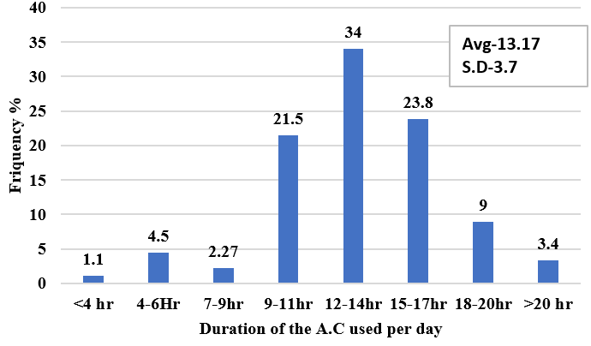
Figure 14:number of hours A.C used per day
According to the findings illustrated in Figure 14, the respondents' views on the duration of air conditioner (A.C.) usage during summer vary significantly. Approximately 34 percent of the families reported using A.C. for 12 to 14 hours per day, while 23.8 percent stated a usage duration of 15 to 17 hours. Furthermore, 21.5 percent of the families reported using A.C. for 9 to 11 hours, 9 percent for 18 to 20 hours, and 3.4 percent for more than 20 hours. Only 4.5 percent of the families reported using A.C. for 4 to 6 hours, and a mere 1.1 percent reported usage of less than 4 hours per day. The primary reason for the extended usage of air conditioners in these households can be attributed to their location within the apartment complex. These houses are situated in the middle of the building and are surrounded by neighbouring flats on all sides, resulting in limited natural airflow and reduced natural light entering the premises. As a consequence, these families heavily rely on air conditioning systems to maintain a comfortable indoor environment.
Conversely, some households within the same apartment complex reported using air conditioners for significantly less time. This can be attributed to the fact that these families primarily consist of older individuals who face health issues such as joint pains and cold symptoms when spending an extended period in an air-conditioned room. Due to these health concerns, they opt for limited A.C. usage to minimize any potential discomfort or adverse effects on their well-being.
Study by (Kempton, Feuermann, & McGarity, 1992)suggests that the use of air conditioners can have both positive and negative impacts on health. While A.C. usage provides relief from heat-related illnesses and improves indoor air quality by filtering out pollutants, excessive exposure to air conditioning can lead to health problems. Prolonged periods spent in air-conditioned environments can cause dry skin, respiratory issues, and exacerbate existing conditions such as arthritis and cold symptoms, particularly in older individuals.
Considering the unique circumstances of the apartment complex and the health concerns of the residents, it is crucial to strike a balance between the usage of air conditioners and the well-being of the individuals. This can be achieved by implementing strategies to improve natural ventilation and light within the households, such as utilizing fans, opening windows during cooler periods, and incorporating natural airflow pathways in the building design. Additionally, educating residents on proper A.C. usage and encouraging regular breaks from air-conditioned environments can help mitigate the potential health risks associated with prolonged exposure.
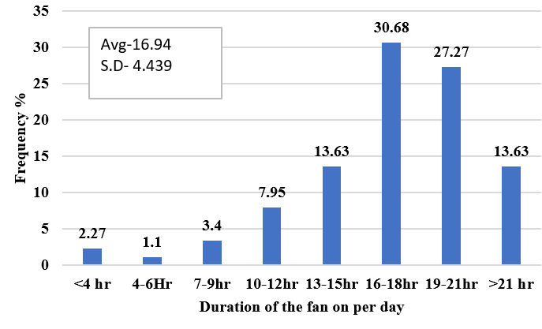
Figure 15:duration of fan used per day
The findings indicates that in Figure 15 the majority of households heavily rely on fans for cooling during summer days (May-August), with only a few exceptions for the kitchen and toilet. A comprehensive survey was conducted to understand the usage patterns of fans in different households. The findings revealed that 30.68 percent of families used fans for 16-18 hours daily, while 27.27 percent used fans for 19-21 hours. Additionally, 13.63 percent of households reported running fans for 13-15 hours, and an equal percentage for more than 21 hours per day. A smaller portion, 7.95 percent, utilized fans for 10-12 hours during summer. Further analysis showed that 3.4 percent of families relied on fans for 7-9 hours, and only 2.27 percent ran fans for less than four hours per day. Surprisingly, a mere 1.1 percent of households used fans for 4 to 6 hours. The primary reason behind such extensive fan usage was the limited natural airflow in the respondents' homes. Many households reported feeling inadequate natural ventilation, compelling them to depend heavily on either fans or air conditioning to maintain a comfortable indoor environment during hot summer days.
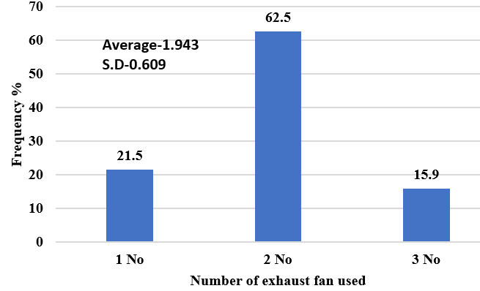
Figure 16:Number of exhaust fan used
According to Figure 16 the respondents view of all 88 flats in selected apartment 62.5 percent of families are using two numbers of exhaust fan in their houses whereas 21.5 percent households using one exhaust fan in their house and 15.9 percent families are using three numbers of exhaust fan. The families who used one exhaust fan they specifically used it in their frequently used toilet. The families who used two numbers of exhaust fans they have used them one in kitchen and one in their toilet and few families used the three exhaust fans one in kitchen and two in their toilets to sucks air out of the toilets and kitchens and directs it outsides. Using exhaust fan in the house creates air circulation in the space or ventilates the area and dries out the air. If exhaust fan is not used in the toilets specially then moist air remain long time for .it makes paint to peel off, promotes mould growth and rusts metal fixtures. It can even damage wall and ceiling framings.
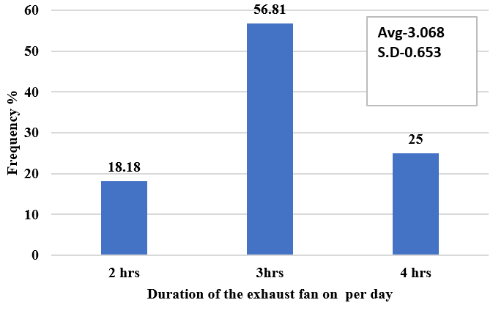
Figure 17:Duration of exhaust fan used
According to Figure 17, a significant proportion of households, approximately 56.81 percent, utilize exhaust fans for a duration of 3 hours. About 25 percent of the surveyed households run their exhaust fans for 4 hours, while 18.18 percent of families prefer a usage time of 2 hours. As the apartments located in the middle section of the building, there are narrow corridors on three sides and one common wall on the other side. To optimize ventilation in such flats, residents tend to operate their exhaust fans for 4 hours.
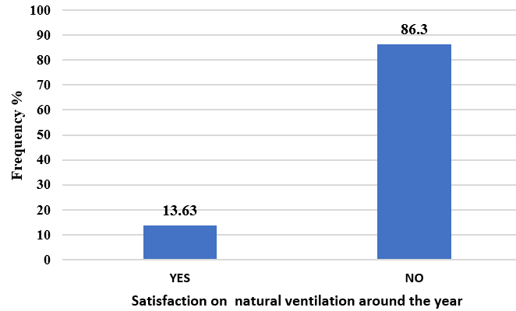
Figure 18:Satisfaction on natural ventilation
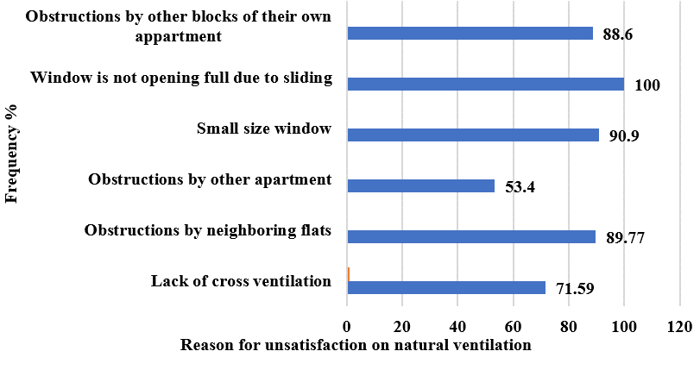
Figure 19:Reason for less natural ventilation
According to the findings presented in Figure 19, a significant majority of households 86.3 percent, express dissatisfaction with the natural ventilation in their homes. However, there is a minority of households, comprising 13.63 percent, who report being satisfied with the natural ventilation. Upon further investigation, as indicated in Figure (12), it was discovered that the primary reason for unsatisfactory natural ventilation among respondents is the limited opening of windows. In fact, 100 percent of the participants highlighted that their windows only open to 50 percent of their full capacity due to the sliding design, resulting in reduced airflow into their homes. Furthermore, the study participants also mentioned other factors contributing to their dissatisfaction with natural ventilation. Ninety percent of the respondents expressed dissatisfaction due to small-sized windows, while 89.77 percent attributed their lack of satisfaction to neighbouring flats obstructing the airflow. Additionally, 88.6 percent of households reported that their homes were hindered by other blocks within the same apartment complex. Lack of cross ventilation was cited as a reason for unsatisfactory natural ventilation by 71.59 percent of families, and 53.4 percent of respondents claimed that their homes were less ventilated due to obstructions from neighbouring apartments. These observations are supported by various research studies that shed light on the importance of proper ventilation in residential buildings. For instance, a study conducted by(Kapoor et al., 2021) demonstrated that inadequate ventilation can lead to poor indoor air quality, which in turn can have negative effects on occupants' health and well-being. The research findings of(Park, Choi, Song, & Kim, 2021) further emphasize the significance of natural ventilation in reducing the risk of airborne diseases and improving overall indoor comfort.
    - Conclusion:
- The findings from the survey conducted in the apartment shed light on various aspects related to family sizes, electricity bills, window usage habits, air conditioning usage, fan usage, exhaust fan usage, and satisfaction with natural ventilation.
- The data shows that a significant proportion of families face higher electricity bills Among the 88 surveyed families, the average electricity bill is Rs. 2205.73, with a standard deviation of approximately Rs. 490.53. The primary reason for these high electricity bills is inadequate natural ventilation or airflow in homes, which forces the inmates to depend on air conditioning and mechanical ventilation.
- Families tend to open their windows in the morning and keep them open for a considerable duration to enhance air circulation. However, there are several reasons for closing windows, including the use of air conditioning, dust, insects, and privacy concerns.
- The installation of air conditioners is common in the apartment, with the master bedroom being the most frequently air-conditioned room. The usage duration of air conditioners varies among families, with some using them for extended periods.
- Fan usage is prevalent in households due to limited natural airflow, and exhaust fans are primarily used in toilets and kitchens.
- A significant 86.3% of households report being dissatisfied with the natural ventilation in their houses, primarily because of windows that only open halfway. Inadequate ventilation is also caused by small windows (90%) and obstructions from nearby apartments (897.7%) and other buildings in the same complex (88.6%). Furthermore, 53.4% of families report impediments from nearby apartments, and 71.59% of families are impacted by a lack of cross ventilation. The percentage of homes satisfied with their natural ventilation is just 13.63%.
These findings highlight the importance of optimizing natural ventilation, designing energy-efficient buildings, and promoting healthy indoor environments in residential settings.

References:

- Belleri, A., Lollini, R., & Dutton, S. M. (2014). Natural ventilation design: An analysis of predicted and measured performance. Building and Environment, 81, 123-138. https://doi.org/10.1016/j.buildenv.2014.06.009
- Garg, R. D. (2022). Evaluating the impact of climate change on the urban environment using geospatial technologies in Bhubaneswar, India. The International Archives of the Photogrammetry, Remote Sensing and Spatial Information Sciences, 48, 159-166. https://doi.org/10.5194/isprs-archives-XLVIII-4-W5-2022-159-2022
- Kapoor, N. R., Kumar, A., Meena, C. S., Kumar, A., Alam, T., Balam, N. B., & Ghosh, A. (2021). A systematic review on indoor environmental quality in naturally ventilated school classrooms: A way forward. Advances in Civil Engineering https://doi.org/10.1155/2021/8851685
- Kempton, W., Feuermann, D., & McGarity, A. E. (1992). “I always turn it on super”: user decisions about when and how to operate room air conditioners. Energy and Buildings, 18(3-4), 177–191. https://doi.org/10.1016/0378-7788(92)90012-6
- Kubota, T., & Ahmad, S. (2005). Questionnaire survey on behavior for natural ventilation and electricity consumption in terraced houses: A case study of Johor Bahru City. Paper presented at the Asian Planning Schools Association (APSA) Conference. https://core.ac.uk/download/pdf/11786000.pdf
- Kubota, T., Jeong, S., Toe, D. H. C., & Ossen, D. R. (2011). Energy consumption and air-conditioning usage in residential buildings of Malaysia. Journal of International Development and Cooperation, 17(3), 61-69. https://doi.org/10.15027/32444
- Lin, Z., & Deng, S. (2006). A questionnaire survey on sleeping thermal environment and bedroom air conditioning in high-rise residences in Hong Kong. Energy and Buildings, 38(11), 1302-1307. https://doi.org/10.1016/j.enbuild.2006.04.004
- Park, S., Choi, Y., Song, D., & Kim, E. K. (2021). Natural ventilation strategy and related issues to prevent coronavirus disease 2019 (COVID-19) airborne transmission in a school building. Science of The Total Environment, 789, 147764. https://doi.org/10.1016/j.scitotenv.2021.147764
- Pradhan, A. C. (2013). The New Capital at Bhubaneswar. Orissa Review, 69(9), 55-59. http://magazines.odisha.gov.in/Orissareview/2013/apr/engpdf/april-or-2013.pdf
- Rawal, R., Vaidya, P., Ghatti, V., Ward, A., Seth, S., Jain, A., & Parthasarathy, T. (2012). Energy code enforcement for beginners: A tiered approach to energy code in India. In Proceedings of the ACEEE Summer Study on Energy Efficiency in Buildings (pp. 4-313–4-324) https://www.aceee.org/files/proceedings/2012/data/papers/4313.pdf .

