Correlation-based analysis of weighted and unweighted weather indices for Pear yield in Kashmir

Abstract
Pear is an important temperate fruit crop in the Kashmir Valley, where climatic variability poses serious challenges to horticultural productivity. This study investigates the relationship between pear yield and weekly weather variables, maximum and minimum temperature, rainfall, sunshine hours, and relative humidity over a 39-year period (1985–2023). Using meteorological data from the Indian Meteorological Department (IMD) and yield records from the Directorate of Economics and Statistics, a correlation analysis based on both unweighted and weighted weather indices was conducted using Pearson’s method.
The findings reveal that weighted weather indices exhibited stronger correlations with pear yield than unweighted indices, highlighting their superior predictive efficiency. Among the main weather variables, rainfall (Z31) and relative humidity (Z51) emerged as the most influential, while interaction-based weighted indices such as Z231 and Z351 showed particularly high correlations (r > 0.60). Visual tools such as correlation heatmaps and bar plots further confirmed the strength and direction of these associations.
Keywords: Pear, Weighted weather indices, Unweighted weather indices, Correlation analysis, Kashmir

1. Introduction
Agriculture continues to be a key pillar of India’s economy, providing livelihood to nearly half of the workforce. The sector, including livestock, contributes about 18% to the national Gross Domestic Product (GDP) (Economic Survey 2023–24, Ministry of Finance, Government of India, 2024) ⁸. Accelerated agricultural development is essential for promoting sustainable and broad-based growth. Within J&K, agriculture continues to hold a central position in economic progress. The state was ranked 15th in the agriculture (ICAR).In the Union Territory of Jammu and Kashmir (J&K), agriculture and allied sectors contribute around 16% to the Gross State Domestic Product (GSDP) in the fiscal year 2016-2017, with nearly 70% of the population depending on it for livelihood (Eco Stat, J&K) ⁴.
Horticulture has emerged as a vital component of this agricultural economy. The Kashmir Valley, with its temperate agro-climatic conditions, is ideally suited for fruit crops such as apple, pear, cherry, and plum. The horticulture sector contributes approximately 9% to the GSDP of J&K (Department of Horticulture, J&K)³. In 2024, the total area under pear cultivation in Srinagar was 3,879 hectares, producing about 21,227 metric tons (Department of Horticulture, J&K)³.
Climate plays a crucial role in determining agricultural productivity. However, increasing climate variability poses a major challenge to horticultural crops in temperate regions. Studies have reported a gradual warming trend of about 0.8°C since the 1980s, accompanied by fluctuations in rainfall and sunshine duration in the Kashmir Valley (Zaz et al., 2019)¹⁶. Such changes have been found to adversely affect the yield and productivity of fruit crops (Godara, 2021; Sharma et al., 2021)⁵^{,13}. Understanding how weather fluctuations affect pear yield is essential for developing effective climate-resilient orchard management strategies.
Statistical modelling involves constructing mathematical equations to represent relationships among variables, facilitating prediction and systematic experimentation. By providing a structured framework, it reduces ad hoc experimentation and helps design studies to answer specific questions or distinguish between alternative mechanisms. Widely applied in fields such as agriculture, biometrics, econometrics, education, meteorology, industry, horticulture, and forestry (Prasad, 2010; Omran et al., 2021)^{12,10}, it enables the analysis of input-output relationships within systems. In agriculture, for instance, models help assess crop yield based on biometrical characteristics, predict disease and pest incidence using weather data, and evaluate fertilizer effects on productivity.
Crop yield is influenced by various factors, including weather variables (such as minimum and maximum temperature, rainfall, sunshine hours, and relative humidity), plant characteristics during growth stages, pest and disease incidence, and agricultural inputs. Forecasting accuracy improves when all these factors are considered. However, developing a single model encompassing such diverse data may not be reliable. In such cases, separate models can be constructed for different groups of variables, and their forecasts can be combined to create a composite prediction model.
Correlation analysis serves as an important statistical tool to quantify the strength and direction of the relationship between yield and climatic variables. Traditionally, correlation studies have been conducted using monthly or seasonal averages, which often mask week-to-week variations crucial for crop growth and yield (Lomas et al., 1985)⁷. To address this limitation, researchers have developed weather indices, which are aggregated representations of climatic variables over shorter time frames such as weeks (Agrawal et al., 1986)². While unweighted indices are simple averages or sums of weather parameters, weighted weather indices incorporate statistical weights based on their correlation with yield, thereby identifying the most influential weather periods (Pandey et al., 2016)¹¹.
2. Study Area
The study was carried out for the Kashmir Valley, a temperate region of the Union Territory. Weekly weather data for a 39-year period (1985–2023) were obtained from the Indian Meteorological Department (IMD), including maximum and minimum temperature (°C), rainfall (mm), sunshine hours (hours), and relative humidity (%). Corresponding pear yield (MT/Hac) data for the same period were collected from the Directorate of Economics and Statistics, Government of Jammu and Kashmir⁴.
Pear cultivation in the Kashmir Valley passes through distinct phenological stages that respond differently to short-term weather changes. These include the dormant and silver bud stages (SMW 8–11), green tip and green shoot (SMW 11–15), white shoot and flowering (SMW 15–19), fruiting (SMW 21–22), fruit growth (SMW 23–30), and ripening (SMW 30–33), followed by harvest after SMW 33.
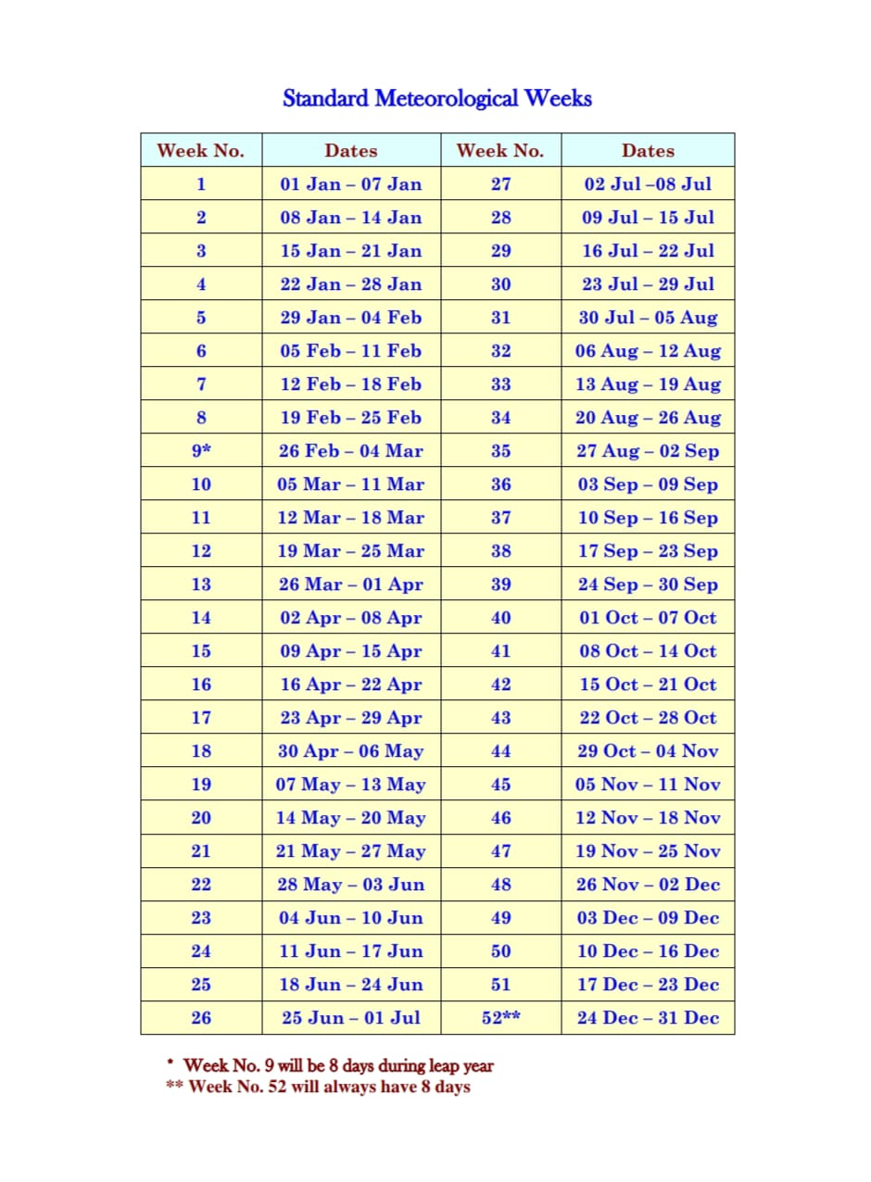

Fig. 1: SMW chart (Source: ICAR-CRIDA)
*SMW (Standard Meteorological Weeks)
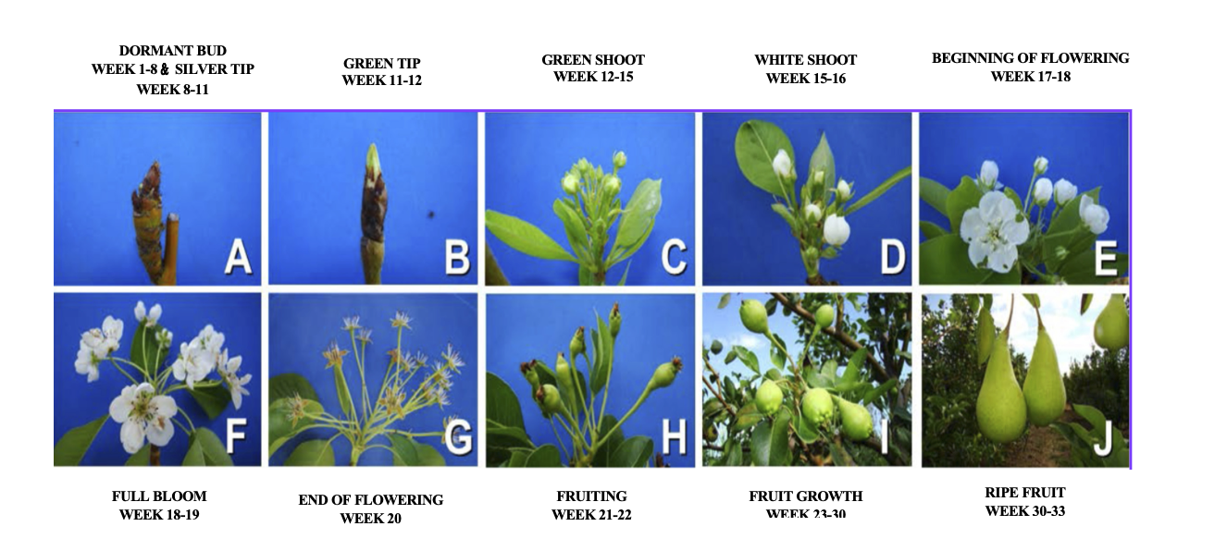
Fig. 2: Phenological Growth Stages in Pear during different weeks (Source: Oliveira, I. V. M., Lopes, P. R. C., & Silva-Matos, R. R. S. (2017). Phenological assessment of ‘Princesinha’ pear trees (Pyrus communis L.) under semiarid conditions in Northeastern Brazil. Revista Brasileira de Fruticultura, 39(3), e-598. https://doi.org/10.1590/0100-29452017598)

Because pear growth changes week by week across these stages, weekly weather variations directly influence annual yield; therefore, weekly data were used to study the correlation between weather variables and pear yield.

3. Methodology
The statistical models were proposed by expressing effect of changes in weather variables on yield in w^{th} week as a linear function of respective correlation coefficients between detrended yield and weekly weather data (Agrawal et al., 1986)². The trend effect on yield was also removed from yield to eliminate the effects of technological and management improvements over time using a linear trend function, while calculating correlation coefficients of yield with weather variables were used as weights.
$Y_{d}=Y-(\hat{a}+\hat{b}t)$,
Where,
$Y_{d}$ Is the detrended yield,
$Y$ is the actual yield,
$\hat{a}$ and $\hat{b}$ are regression coefficients.

Unweighted and weighted weather indices were developed. Summation of individual weather variables or interaction of two weather variables at a time were used for generating unweighted weather indices; the sum product of individual weather variables or interaction of weather variables and its correlation with adjusted crop yield was computed for weighted weather indices. The unweighted and weighted weather indices were calculated using the following formulas:
Un-weighted weather indices:
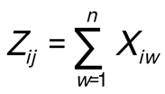
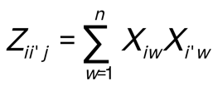
Weighted weather indices:
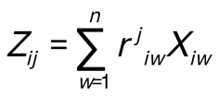
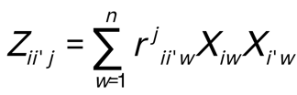
Where,
X_{iw}/X_{i’w} is the value of the i^{th} and iˈ^{th} weather variable in w^{th} week,
r^{j}_{iw}/r^{j}_{ii’w} is the correlation coefficient of yield adjusted for trend effect with i^{th} weather variable or product of i^{th} and iˈ^{th} weather variable in w^{th} week,
n is the number of weeks considered in developing the indices.
Table 1: Un-weighted and weighted weather indices
 | Un-weighted weather indices |  |  |  |  | Weighted weather indices
 | T max | T min | RF | SSH | RH | T max | T min | RF | SSH | RH
T max | Z10 |  |  |  |  | Z11
T min | Z120 | Z20 |  |  |  | Z121 | Z21
RF | Z130 | Z230 | Z30 |  |  | Z131 | Z231 | Z31
SSH | Z140 | Z240 | Z340 | Z40 |  | Z141 | Z241 | Z341 | Z41
RH | Z150 | Z250 | Z350 | Z450 | Z50 | Z151 | Z251 | Z351 | Z451 | Z51

Correlation Analysis
Correlation analysis is a useful tool for understanding how different weather parameters are related to pear yield. It helps to measure whether changes in temperature, rainfall, sunshine, or humidity are linked to increases or decreases in yield, and how strong those links are, in this study, we used Pearson’s correlation coefficient, which is one of the most common methods for checking such relationships. The correlation coefficient ($r$) always ranges between –1 and +1.
Pearson’s correlation coefficient is used to assess the strength and direction of the relationship between pear yield and both weighted and unweighted weather indices, and graphical tools such as correlation heatmaps and bar plots were used to visualize the results.
- A value close to +1 means a strong positive relationship (as one increases, the other also increases).
- A value near –1 indicates a strong negative relationship, meaning that as one variable increases, the other decreases.
- A value around 0 means there is little or no linear relationship.
The formula for Pearson’s correlation coefficient is
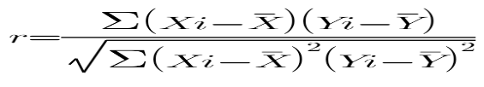
Where:
- r = Pearson’s correlation coefficient
- ​$X_{i}$ and ​$Y_{i}$ = individual values of variables X (weather index) and Y (pear yield)
- $\overline{X }$and $\overline{Y }$= means of X and Y
- ∑ = summation over all observations
Along with the correlation values, p-values were also calculated to check whether the relationships were statistically significant. A p-value less than 0.05 suggests that the correlation is unlikely to have occurred by chance and therefore can be considered meaningful.This analysis is an important first step in identifying which weather factors matter most for pear production and will guide the modeling and interpretation of results in later sections.
4. Results and Discussion

The correlation between the pear yield (Y) and various main weather indices (unweighted and weighted) was calculated using Pearson correlation coefficient. Tables 2 and 3 highlight the key findings of Pearson correlation analysis between pear yield and weather indices.
From Table 2 The Pearson correlation analysis between pear yield and weather indices revealed that the weighted indices showed stronger and more consistent associations with yield compared to their unweighted counterparts. For maximum temperature, the weighted index (Z11) had a moderate positive correlation (0.53) with yield and was highly significant, whereas the unweighted index (Z10) showed only a weak positive, non-significant relationship (0.30), A similar pattern was observed for minimum temperature, where the weighted index (Z21) showed a moderate and significant correlation (0.42), while the unweighted index (Z20) had a weak and non-significant relationship (0.13). Rainfall also followed this trend, with the weighted index (Z31) showing a strong and highly significant positive correlation (0.61), while the unweighted index (Z30) exhibited a weak and non-significant negative correlation (–0.20). For sunshine hours, the weighted weather index (Z41) showed a moderate and statistically significant correlation with yield (0.42), whereas the unweighted index (Z40) displayed a weak and non-significant relationship. In the case of relative humidity, the weighted index (Z51) exhibited a strong positive correlation with yield (0.63), while the unweighted index (Z50) had a weak negative correlation that was not significant (–0.22).
These results emphasize that main weighted weather indices were more effective in capturing the relationship between weather variables and pear yield.
Table 2: Correlation Coefficients and Significance for main Weather Indices

Unweighted | Correlation Coefficient | p-Value | Significance | Weighted | Correlation Coefficient | p-Value | Significance
Z10 | 0.30 | 0.069 | NS | Z11 | 0.53 | 0.001 | **
Z20 | 0.13 | 0.423 | NS | Z21 | 0.42 | 0.009 | **
Z30 | -0.20 | 0.225 | NS | Z31 | 0.61 | 0.000 | **
Z40 | 0.18 | 0.282 | NS | Z41 | 0.42 | 0.008 | **
Z50 | -0.22 | 0.178 | NS | Z51 | 0.63 | 0.000 | **

Significance Levels:
Note: **: p ≤ 0.01; *: p ≤ 0.05
NS: Not Significant (p > 0.05)

Similarly, for the interaction weather indices presented in Table 3, the results indicate that the interaction weighted indices consistently perform better than the unweighted ones in explaining yield variation. In several cases, unweighted indices showed weak or non-significant correlations (p > 0.05), while their weighted counterparts displayed stronger and statistically significant relationships with yield. For instance, the unweighted index Z140 showed a weak positive but non-significant correlation of 0.26, whereas the weighted version Z141 exhibited a much stronger and significant positive correlation of 0.43. Likewise, Z450 (unweighted) had only a weak correlation and non-significant relationship (0.12), but its weighted form Z451 demonstrated a moderate and significant correlation of 0.36.
These findings highlight that assigning weights to weather parameters improves their explanatory power, as weighted indices capture the relative importance of different weeks more effectively. Thus, weighted indices provide more reliable insights into the weather and yield relationship. Similar superiority of weighted indices was also documented by Agrawal & Mehta (2007)¹ and Pandey et al. (2016)¹¹, who reported more reliable forecasts when weights were used to capture variable importance.
The lower triangular heatmap (Fig.3) further illustrates the correlation structure, clearly showing stronger colour intensities for weighted indices compared to unweighted ones. Additionally, the bar plot of significant correlations (Fig.4) visually emphasizes the superior performance of weighted indices, reinforcing their role as better predictors of pear yield. The lower triangular heatmap (Fig.5) illustrates the correlation structure of significant weighted indices only, clearly showing stronger colour intensities for weighted indices.
These findings indicate that assigning statistical weights to weekly weather parameters enhances the ability of indices to explain yield variability. Similar superiority of weighted indices was also reported by Agrawal and Mehta (2007)¹ and Pandey et al. (2016)¹¹. Visualizations such as the lower triangular heatmap (Figs. 3,5) and bar plot (Fig. 4) further illustrate this pattern, with stronger colour intensities and higher bars for weighted indices, confirming their greater predictive value and emphasizing their usefulness in identifying key climatic drivers of pear yield in the Kashmir Valley.

Table 3: Correlation Coefficients and Significance for interaction Weather Indice
Unweighted | Correlation Coefficient | p-Value | Significance | Weighted | Correlation Coefficient | p-Value | Significance
Z120 | 0.23 | 0.159 | NS | Z121 | 0.49 | 0.002 | **
Z130 | -0.12 | 0.467 | NS | Z131 | 0.59 | 0.000 | **
Z140 | 0.26 | 0.118 | NS | Z141 | 0.43 | 0.007 | **
Z150 | 0.27 | 0.096 | NS | Z151 | 0.48 | 0.002 | **
Z230 | -0.08 | 0.626 | NS | Z231 | 0.61 | 0.000 | **
Z240 | 0.20 | 0.225 | NS | Z241 | 0.38 | 0.017 | *
Z250 | 0.11 | 0.508 | NS | Z251 | 0.45 | 0.005 | **
Z340 | -0.25 | 0.132 | NS | Z341 | 0.60 | 0.000 | **
Z350 | -0.23 | 0.173 | NS | Z351 | 0.62 | 0.000 | **
Z450 | 0.12 | 0.465 | NS | Z451 | 0.36 | 0.027 | *
Significance Levels:
Note: **: p ≤ 0.01; *: p ≤ 0.05
NS: Not Significant (p > 0.05)

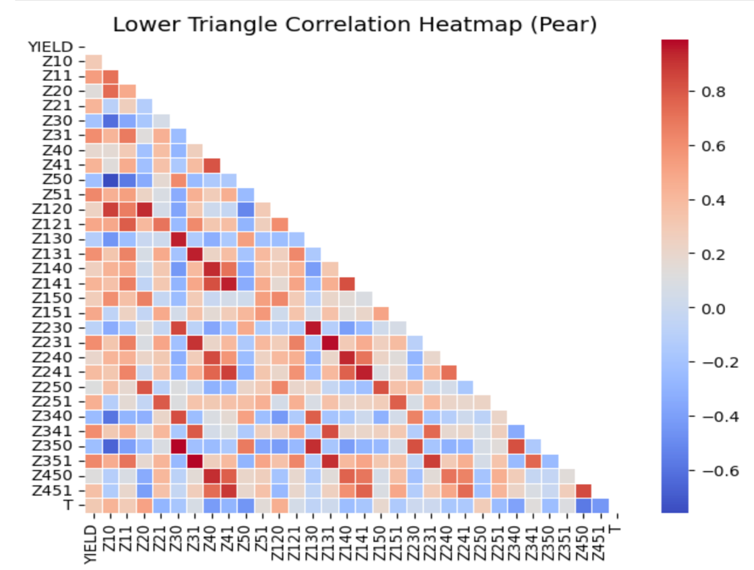

Fig. 3: Correlation heatmap (all unweighted and weighted indices)

Fig. 4: Bar Plot of Significant Correlations Between Weather Indices and pear Yield

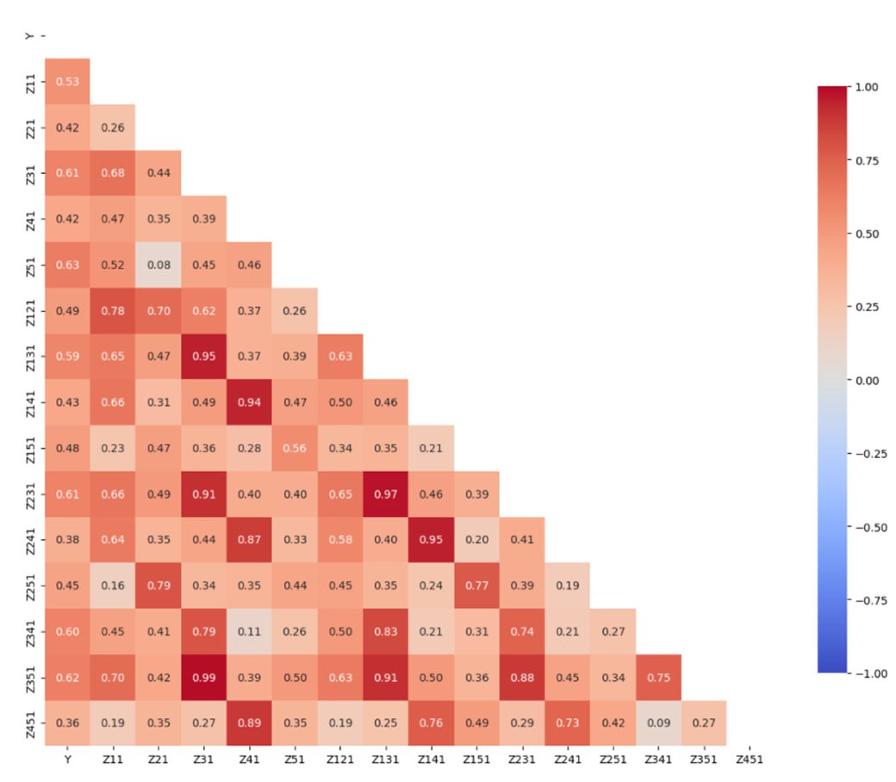

Fig. 5: Correlation heatmap (Significant weighted indices)

5. Summary and Conclusion
The present study investigated the relationship between pear yield and key weekly weather variables, maximum and minimum temperature, rainfall, sunshine hours, and relative humidity over a 39-year period (1985–2023) in the Kashmir Valley. Unweighted and weighted weather indices were developed following the method of Agrawal et al. (1986)², and their associations with yield were examined using Pearson’s correlation analysis.
The results revealed that weighted weather indices exhibited stronger and more consistent correlations with yield than their unweighted counterparts. Among the main indices, rainfall (Z31) and relative humidity (Z51) emerged as the most influential factors, showing strong and highly significant positive relationships with pear yield. Maximum and minimum temperatures (Z11 and Z21) and sunshine hours (Z41) also displayed moderate but significant correlations. Furthermore, several interaction-based weighted indices showed high correlation coefficients, with Z351 (rainfall × relative humidity), Z341 (rainfall × sunshine hours), Z231 (minimum temperature × rainfall), and Z131 (maximum temperature × rainfall) ranking among the most influential. These results highlight the combined role of temperature, moisture, and radiation in determining pear yield variability.
Overall, the findings confirm that weighted weather indices are more effective than unweighted ones in capturing the complex influence of climatic variables on yield. Incorporating statistical weights enhances the precision and sensitivity of weather–yield relationships, thereby improving the reliability of yield forecasting and contributing to climate-resilient management strategies for pear cultivation under the temperate conditions of the Kashmir Valley.
Further, stepwise multiple linear regression (SMLR) was used to identify the specific SMW range that showed the strongest and most consistent association with pear yield. This period was therefore selected as the key window, and it will be useful for further analysis and interpretation of the weather yield relationship.

5. Future Scope
- Expanding data and scope: Using larger, more diverse datasets and applying the framework to other crops and regions could improve model robustness and generalizability.
- Enhancing model complexity and predictors: Including soil, pest/disease, fertilizer, and irrigation data, and exploring deep learning, hybrid, or spatio-temporal models with adaptive weighting could improve prediction accuracy and capture nonlinear interaction.
5. References

- Agrawal, R., & Mehta, S. C. (2007). Weather-based forecasting of crop yield: A review. Indian Journal of Agricultural Sciences, 77(2), 97–104.
- Agrawal, R., Jain, R. C., & Mehta, S. C. (1986). Models for studying weather–crop yield relationships. Agricultural Meteorology, 37(3), 203–210.
- Department of Horticulture, Government of Jammu and Kashmir. (2024). Horticulture Statistics Report 2024. Srinagar, J&K.
- Directorate of Economics and Statistics, Government of Jammu and Kashmir. (2017). Economic Survey 2017. Planning Development & Monitoring Department, Government of Jammu and Kashmir. https://jk.gov.in/documents/economic-survey-2017/
- Godara, A. K. (2021). Impact of climate variability on horticultural crops in temperate regions of India. Environmental Monitoring and Assessment, 193(7), 421–428.
- Kulsum, U., Nazir, N., Mir, S. A., Pukhta, M. S., Gautam, K., Habib, M., & Dhekale, B. (2025). Correlation-based analysis of weighted and unweighted weather indices for rice yield in Kashmir. International Journal of Statistics and Applied Mathematics, 10(7S), 04-07. https://doi.org/10.22271/maths.2025.v10.i7Sa.2083
- Lomas, J., Stanhill, G., & Fuchs, M. (1985). The use of correlation analysis for assessing crop–weather relationships. Agricultural Meteorology, 34(1–2), 1–15.
- Ministry of Finance, Government of India. (2024). Economic Survey 2023–24. New Delhi: Government of India. https://www.indiabudget.gov.in/economicsurvey/
- Oliveira, I. V. D. M., Lopes, P. R. C., & Silva-Matos, R. R. S. D. (2017). Phenological characterization of pear trees (Pyrus communis L.)‘Princesinha’under semiarid conditions in the northeastern Brazil. Revista Brasileira de Fruticultura, 39(3), e-598. https://doi.org/10.1590/0100-29452017598
- Omran, I. I., Al-Saati, N. H., Salman, A. A., Al-Saati, Z., & Hashim, K. S. (2021). Statistical modeling of monthly streamflow using time series and artificial neural network models: Hindiya Barrage as a case study. Water Practice and Technology, 16(2), 681-691. https://doi.org/10.2166/wpt.2021.012
- Pandey, V., Singh, R., & Agrawal, R. (2016). Development of weighted weather indices for crop yield forecasting. Journal of Agrometeorology, 18(2), 252–258.
- Prasad, H. 2010. Statistical modeling technique on export of fruit crops in India. Indian Journal of Agricultural Sciences 74(5): 619-625.
- Sharma, R., Bhardwaj, D. R., & Thakur, P. (2021). Climatic trends and extreme events in the Western Himalaya. Theoretical and Applied Climatology, 143(3–4), 1411–1424.
- Wijesena, S., & Pradhan, B. (2025). Enhancing weather index insurance through surrogate models: leveraging machine learning techniques and remote sensing data. Environmental Research Communications, 7(4), 045009. https://doi.org/10.1088/2515-7620/adba2c
- Yavrum, C., Selcuk-Kestel, A. S., & Garrido, J. (2025). Comparative Analysis of Weather-Based Indexes and the Actuaries Climate Index$^{TM}$ for Crop Yield Prediction and Weather-Derivative Pricing. https://arxiv.org/abs/2504.21143
- Zaz, S. N., Ahmad, S., & Rather, F. A. (2019). Climate change and its impact on agriculture in Kashmir Valley. Journal of Agrometeorology, 21(2), 190–197.

