Performance evaluation of the helical blade type rotary ridger in soil bin

Abstract
A helical blade-type rotary ridger was developed and its performance was evaluated in a mechanized soil bin to determine the influence of key operational parameters on torque and power requirements. Forward speed (1–2 km/h), blade rotational speed (105–135 rpm), and depth of operation (50–120 mm) were selected as independent variables, and twenty-seven experimental runs were conducted using an optimal custom design. The torque and power demands of the blade varied from 20.64 to 33.2 N·m and 226.90 to 467.852 W, respectively, across the tested range of operating conditions. Analysis of variance revealed that both torque and power models were highly significant at the 1% level, with F-values of 86.51 and 203.96, indicating strong model predictability. Second-order polynomial regression models effectively described the relationship between operational parameters and performance responses. Results showed that torque and power requirements increased with higher forward speed, rotational speed, and depth of operation. The maximum load occurred at 2 km/h, 120–135 rpm, and 120 mm depth, while the minimum load was observed at 1 km/h, 105 rpm, and 50 mm depth. The study demonstrates that proper selection of operating parameters can substantially reduce energy demand, improve machine efficiency, and support effective design optimization for helical blade rotary ridgers.
Keywords: Helical blade, Torque requirement, Power requirement
1.0 INTRODUCTION
Tillage and soil-engaging operations constitute a major portion of the energy demand in agricultural mechanization. Among various soil-working tools, rotary tillage implements are widely adopted due to their ability to pulverize soil, break clods, and prepare fine seedbeds with greater efficiency. The performance of rotary tools, particularly those equipped with specially shaped blades such as helical blades, depends largely on their interaction with soil and the magnitude of mechanical forces required for their operation. Accurate estimation of torque and power requirements is therefore essential for optimizing tool design, improving field performance, and ensuring compatibility with available power sources such as power tillers and small tractors.
The helical blade, owing to its continuous cutting action and reduced impact loading, offers potential advantages over conventional straight blades in terms of energy consumption and soil profile formation. However, its performance is highly influenced by operational parameters such as forward speed, rotational speed, and depth of operation. Understanding the relationship between these parameters and the resulting torque and power requirements is critical for improving design efficiency and enhancing the operational suitability of helical blade-based implements.
Soil bin testing provides an ideal controlled environment for studying soil–tool interactions without the variability associated with field conditions. Mechanized soil bins allow for precise adjustment of forward speed, soil moisture, soil texture, and depth of cut, enabling systematic evaluation of torque and power responses under different operating combinations. Such controlled studies are also essential for developing predictive models using statistical techniques such as Response Surface Methodology (RSM), which facilitates the identification of significant factors, their interactions, and the development of optimized operational ranges.
In this study, experiments were conducted using a mechanized soil bin to investigate the torque and power requirements of a power tiller-mounted helical blade. Forward speed, rotational speed of the blade, and depth of operation were selected as independent variables, while torque and power were taken as the responses. A quadratic response surface model was developed to analyze the effects of operational parameters and their interactions. The study further aimed to generate predictive regression equations and contour/response surface plots to assist in the selection of optimal operating conditions for efficient performance of the helical blade
2.0 MATERIALS AND METHODS
2.1 Performance Evaluation of the Developed Machine under Laboratory Conditions
2.1.1 Mechanized Soil Bin Facility
The performance evaluation of the developed helical blade system was carried out in a mechanized soil bin located at the Department of Farm Machinery and Power. The soil bin (Fig. 1) consists of a stationary soil container, a motorized carriage system, soil processing tools, a power transmission unit, data acquisition instruments, and a tool-mounting frame. The bin measures 20.0 m in length, 1.8 m in width, and 0.75 m in depth, with 28 structural pillars (14 on each side) supporting longitudinal rails for trolley movement. A 15 hp electric motor, connected through a gearbox and rope-drum mechanism, powered the soil processing trolley. Stainless steel ropes transmitted motion to the trolley, allowing precise forward speeds through selectable gear ratios in the reduction unit. The carriage system housed a rotary tiller, soil leveler, roller compactor, toolbar frame, and a water sprayer for moisture regulation. The soil bin was equipped with a computer-based data acquisition system and Catmaneasy software for real-time recording of torque and cone index measurements.
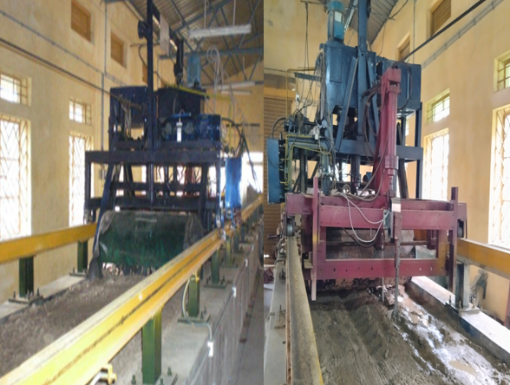
Fig. 1 Front view and rear view of the mechanized soil bin
2.1.2 Rotary Tiller Assembly
A rotary tiller fitted on the carriage system was used to pulverize the soil to the required tilth before each test The tiller was equipped with standard L-type blades, commonly used for primary and secondary tillage operations. Tillage depth was controlled using a hydraulic cylinder mounted on the tool carriage. The tiller operated at pre-selected speeds and depths to prepare a uniform reference soil condition for experimentation.
2.1.3 Soil Leveler
The soil leveler was employed to achieve a uniform soil surface before each test run. It was attached to the tool carriage and operated through a hydraulic system for precise depth control. After pulverization with the rotary tiller, the soil was leveled to eliminate surface irregularities and ensure uniformity in subsequent compaction and testing.
2.1.4 Roller Compactor
A roller compactor installed on the carriage system was used to achieve the required bulk density and soil strength. The roller depth was controlled hydraulically. The soil bed was compacted by 8–10 passes of the cylindrical roller until uniform compaction was attained. Prior to testing, the soil exhibited a cone index in the range of 575–590 kPa, indicating consistent soil strength suitable for controlled laboratory evaluation.
2.1.5 Preparation of Soil Bed
The soil bed preparation involved three steps: pulverization with the rotary tiller, surface leveling with the soil leveler, and compaction using the roller. Water was applied uniformly using the mounted sprayer to achieve the desired moisture content. The final soil bed (Fig. 2) met the required conditions of moisture content, cone penetration resistance, and bulk density, ensuring reproducibility of experimental results.
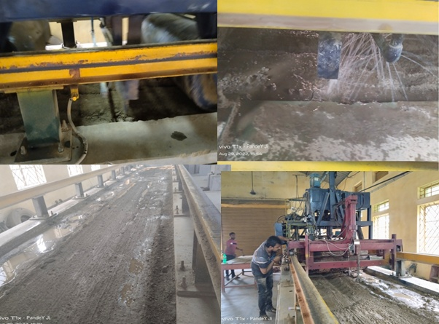
Fig. 2 Soil bed of the soil bin
2.1.6 Installation of the Helical Blade Assembly
The helical blade assembly was installed on the soil bin carriage (Fig. 3). The blade shaft length and diameter were designed to match the rotary tiller mounting specifications. A 5 hp, 3-phase electric motor supplied power to the system. Motion from the motor was transmitted to a gearbox through a flexible coupling, and then to the helical shaft via a double-grooved V-belt drive with built-in speed reduction.The gearbox enabled both forward and reverse rotations, allowing variable speed selection. The helical shaft was supported by two heavy-duty bearings capable of handling eccentric loading during rotation. The mounting ensured stable operation during torque and power measurement experiments.
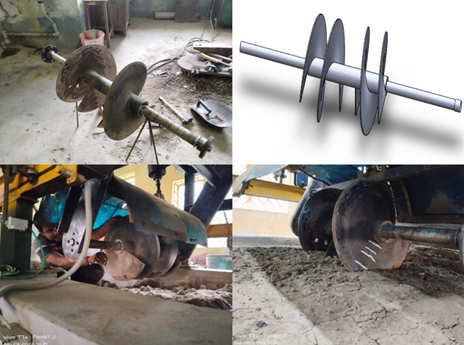
Fig.3 Installation of the helical blade in the soil bin
2.1.7 Data Recording Using Catmaneasy Software
A high-precision HBM data acquisition unit was interfaced with a computer via a communication converter to record real-time experimental data. Catmaneasy software was used for configuration, monitoring, and storage of torque and cone power measurements.The software automatically detected connected sensors and allowed setting of time intervals, recording duration, and parameter groups. During each test run, the software generated real-time data plots and stored logged datasets, which were later exported to spreadsheet format for further analysis. The recorded data served as the basis for evaluating the torque and power requirements of the helical blade under controlled soil bin conditions
3.0 Results and Discussion
3.1 Studies on torque and power requirements of helical blade under mechanized soil bin conditions
The studies on torque and power of helical blade were conducted in the mechanized soil bin under the Department of Farm machinery and Power. The helical blade was installed on a rotating shaft in the soil bin for determining the torque and power requirement. The independent variables were forward speed (X₁), blade rpm (X₂) and depth of operation (X₃) and the dependent variables were torque and power requirement. Table.1 shows the calculated value of responses as per the design matrix of optimal custom for torque (N.m) and power (W) requirements of helical blade.

Table 1 Optimal design matrix of torque and power requirements study of the helical blade in the soil bin with calculated value
 | Forward speed | Rotational speed | Depth of operation | Required torque | Required power
Runs
Runs | (Km/h) | (rpm) | (mm) | (N.m) | W
1 | 2 | 120 | 80 | 29.9 | 359.33
2 | 1.5 | 105 | 120 | 32.07 | 453.293
3 | 1 | 135 | 80 | 27.3 | 342.997
4 | 1 | 120 | 120 | 31.3 | 344.097
5 | 1.5 | 120 | 50 | 30.92 | 339.919
6 | 1.5 | 120 | 80 | 31.3 | 344.097
7 | 1.5 | 135 | 50 | 33.1 | 467.852
8 | 1.5 | 105 | 80 | 31.3 | 344.097
9 | 2 | 105 | 50 | 29.9 | 375.664
10 | 2 | 120 | 120 | 32.9 | 413.356
11 | 1 | 135 | 80 | 27.3 | 342.997
12 | 1.5 | 105 | 80 | 31.6 | 397.022
13 | 1.5 | 120 | 50 | 20.64 | 226.906
14 | 2 | 105 | 50 | 26.7 | 377.391
15 | 1 | 105 | 50 | 26.7 | 377.391
16 | 1.5 | 120 | 50 | 27.3 | 342.997
17 | 2 | 120 | 80 | 30.71 | 434.07
18 | 1.5 | 120 | 120 | 30.71 | 434.07
19 | 1 | 120 | 120 | 29.9 | 375.664
20 | 1.5 | 135 | 120 | 33.2 | 417.125
21 | 1 | 105 | 120 | 20.64 | 226.906
22 | 2 | 135 | 50 | 32.07 | 453.293
23 | 1.5 | 135 | 120 | 28.6 | 359.33
24 | 2 | 120 | 80 | 32.07 | 453.293
25 | 2 | 120 | 80 | 30.65 | 336.951
26 | 1.5 | 105 | 80 | 33.2 | 417.125
27 | 2 | 105 | 120 | 29.9 | 375

3.1.1 Effect of forward speed, blade rotational speed and depth of operation on torque
The obtained experimental results were found statistically significant at one percent level indicated by F- Value of 86.51 as shown in ANOVA shown in Table 2. The experimental data shows that the torque requirement of the helical blade was between 20.64 N-m and 33.2 N.m for the ranges of rotational speed (105-135 rpm), forward speed (1-2 km/h) and depth of operation (50-120 mm) studied. The minimum torque requirement of 20.64 N-m.was found at the forward speed, rotational speed and depth of operation of 1 km/h, 105 rpm and 50 mm respectively.
A second order multiple regression equation was formulated with the values of experimental results keeping the forward speed (X₁), blade rotational speed (X₂) and depth of operation (X₃) as independent parameters with respect to torque (T). The multiple regression equation in given in Eqn. (3.1)
$T=-91.825+18.462X_{1}+1.215X_{2}+0.592X_{3}-{0.0838X}_{1}X_{2}-0.0623X_{1}X_{3}- 0.0014X_{2}X_{3}-0.0905{X_{1}}^{2}-0.0036{X_{2}}^{2}-0.00145{X_{3}}^{2}$ ... (3.1)
The coefficient of the regression equation represented the expected change in response per unit change in the value of the remaining elements. The constant or the intercept in an orthogonal design is the overall average response of all the runs. The positive magnitude of actual coefficients (X₁, X_{2,} X₃) indicated the positive contributions of all process variables while X₁², X₂²,X₃² made a negative contribution. Thus, from Equ (5.1), it can be concluded that the coefficient of linear terms X₁, X_{2,} and X₃ positively affected the torque indicating that an increase in values of forward speed, rotational speed, and depth of operation will increase the torque requirement of the blade. The response surfaces were generated to visualize the combined effect of two independent parameters on the dependent variable, i.e., torque requirement.
Fig. 4 shows the generated response surface diagram with forward speed (X₁) and rotational speed of blade (X₂) for the depth of cut (X₃) of 50, 80, and 120 mm keeping torque as dependent variable. The maximum torque requirement of 33.2 N.m was found at 2 km/h forward speed and 120 rpm rotational speed for 120 mm depth of cut. The minimum torque of 30.71 N m was found at 2 km/h forward speed and 135 rpm rotational speed for 50 mm depth of operation
Fig. 5 shows the generated response surface diagram with forward speed (X₁) and depth of cut (X₃) for the rotational speed of blade (X₂) of 105, 120 and 135 rpm keeping torque as dependent variable. The maximum torque of 33.2 Nm was found at 2 km/h forward speed and 120 mm depth of cut for 120 rpm rotational speed. The minimum torque of 30.47 Nm was found at 1.5 km/h forward speed and 80 mm depth of operation for 135 rmp rotational speed
Fig. 6 shows the generated response surface diagram with rotational speed of blade (X₂) and depth of cut (X₃) for the forward speed (X₁) of 1, 1.5 and 2 km/h keeping torque as dependent variable. The maximum torque requirement of 33.2 N.m was found at 120 rpm rotational speed of blade and 120 mm depth of cut for 2 km/h forward speed. The minimum torque of 32.9 Nm was found at 120 rpm rotational speed of blade and 120 mm depth of operation for
3.1.2 Effect of forward speed, blade rotational speed and depth of operation on required power
The obtained experimental results were found statistically significant at one percent level indicated by F- Value of 203.96 as shown in ANOVA in Table 2. The experimental data shows that the power requirement of the helical blade was between 226.90 W and 467.852 W for the ranges of rotational speed (105-135 rpm), forward speed (1-2 km/h) and depth of operation (50-120 mm) studied. The minimum power requirement of 226.90 was found at the forward speed, rotational speed and depth of operation of 1km/h, 105 rpm and 50 mm respectively.
A second order multiple regression equation was formulated with the value of experimental results keeping the forward speed (X₁), blade rotational speed (X₂) and depth of operation (X₃) as independent parameters with respect to power (T). The multiple regression equation in given in Eqn. (3.2)
$P=-1090.136+166.547X_{1}+12.937X_{2}+5.937X_{3}-0.531X_{1}X_{2}-0.718X_{1}X_{3}-0.007X_{2}X_{3}-2.1815{X_{1}}^{2}-0.029{X_{2}}^{2}-0.017{X_{3}}^{2}$ ... (3.2)
The coefficient of the regression equation represented the expected change in response per unit change in the value of the remaining elements when they are all maintained constant. The constant or the intercept in an orthogonal design is the overall average response of all the runs. The positive magnitude of actual coefficients (X₁, X_{2,} X₃) indicated the positive contributions of all process variables while X₁², X₂², X₃² made a negative contribution. Thus, from Eqn (3.2), it can be concluded that the coefficient of linear terms X₁, X_{2,} and X₃ positively affected the power requirement indicating that an increase in values of forward speed, rotational speed, and depth of operation will increase the power requirement of the blade. The response surfaces were generated to visualize the combined effect of two independent parameters on the dependent variable, i.e., power requirement.
Fig. 4 shows the generated response surface diagram with forward speed (X₁) and rotational speed of blade (X₂) for the depth of operation (X₃) of 50, 80 and 120-mm keeping required power as dependent variable. The maximum power requirement of 467.852 W was found at 1 km/h forward speed and 135 rpm rotational speed for 120 mm depth of cut. The minimum power of 442.997 W was found at 1.5 km/h forward speed and 120 rpm rotational speed for 50 mm depth of operation.
Fig. 5 shows the generated response surface diagram with forward speed (X₁) and depth of cut (X₃) for the rotational speed of blade (X₂) of 105,120 and 135 rpm keeping torque as dependent variable. The maximum power requirement of 467.852 W was found at 1 km/h forward speed and 120 mm depth of operation for 135 rmp rotational speeds. The minimum power of 344.097 W was found at 2 km/h forward speed and 80 mm depth of operation for 105 rpm rotational speed.
Fig. 6 shows the generated response surface diagram with rotational speed of blade (X₂) and depth of operation (X₃) for the forward speed (X₁) of 1, 1.5 and 2 km/h keeping torque as dependent variable. The maximum power requirement of 467.852 W was found at 135 rpm rotational speed of blade and 120 mm depth of cut for 1 km/h forward speed. The minimum required power of 434.07 W was found at 120 rpm rotational speed of blade and 135 mm depth of operation for 2 km/h forward speed.

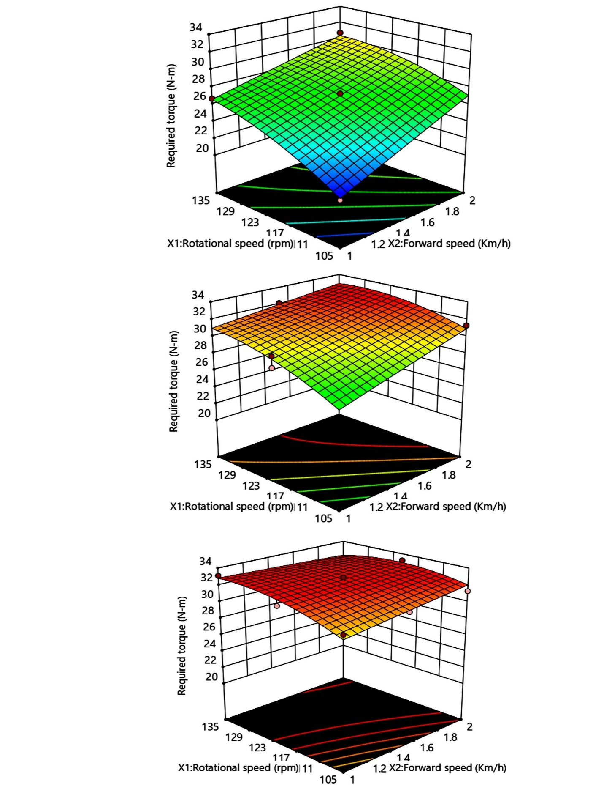
Depth of operation = 120 mm
Depth of operation = 50 mm
Depth of operation = 80 mm

Fig. 4 Effect of depth of operation of helical blade on torque requirement
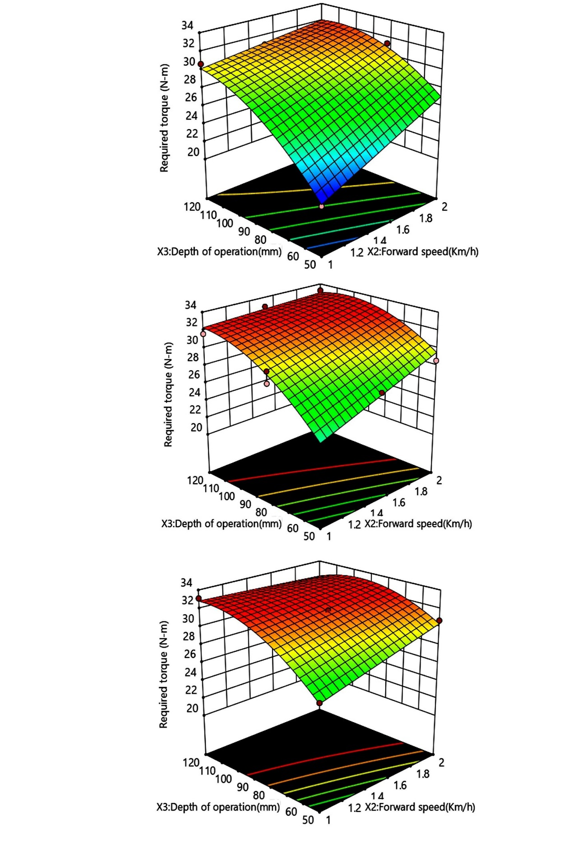
Rotational speed = 105 rpm
Rotational speed = 135 rpm

Rotational speed = 120 rpm

Fig. 5 Effect of rotational speed of helical blade on torque requirement
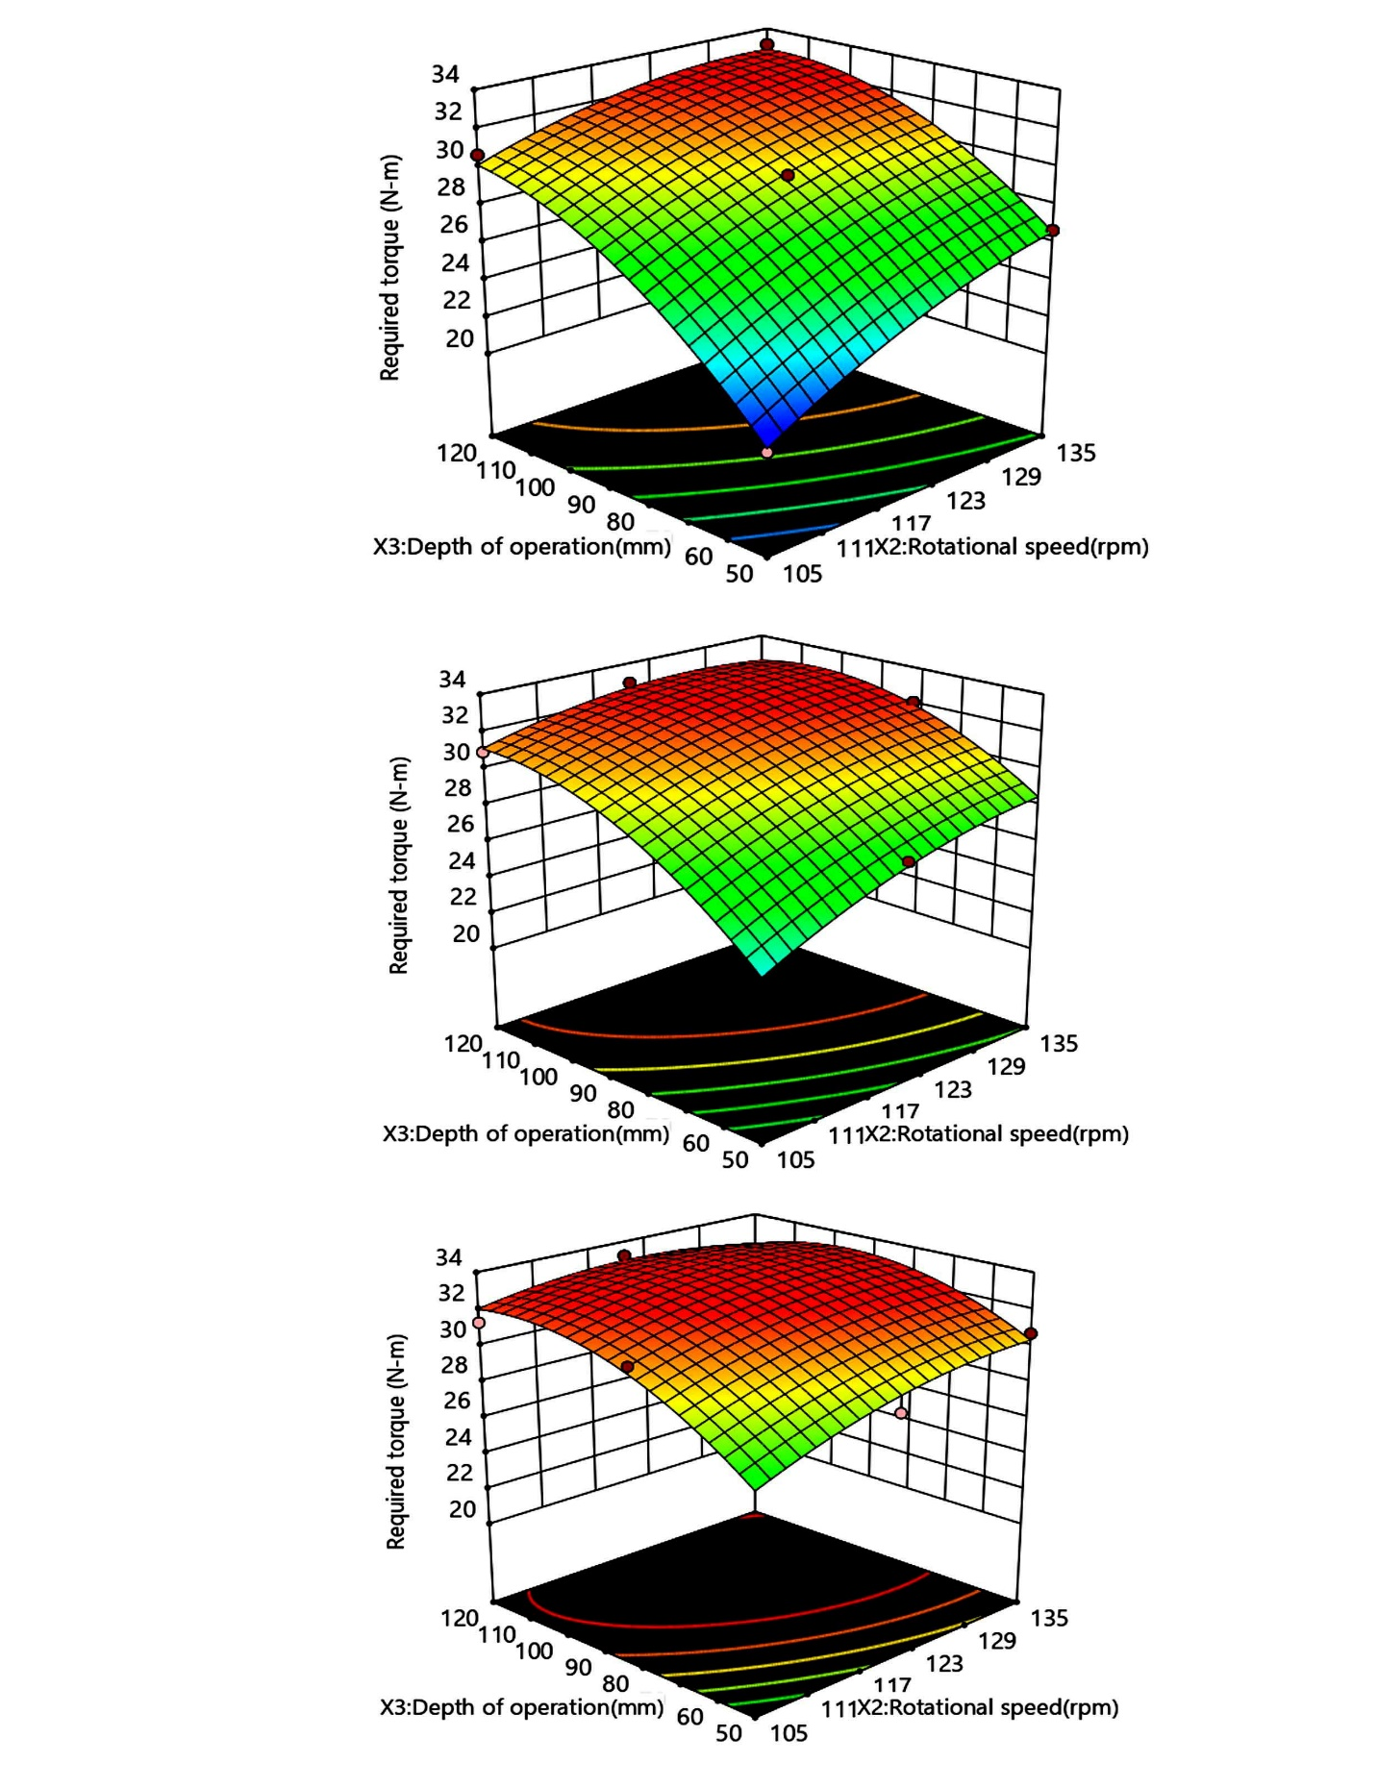
Forward speed = 2 km/h
Forward speed = 1.5 km/h
Forward speed =1km/h
Fig 6 Effect of forward speed of the helical blade on torque requirement

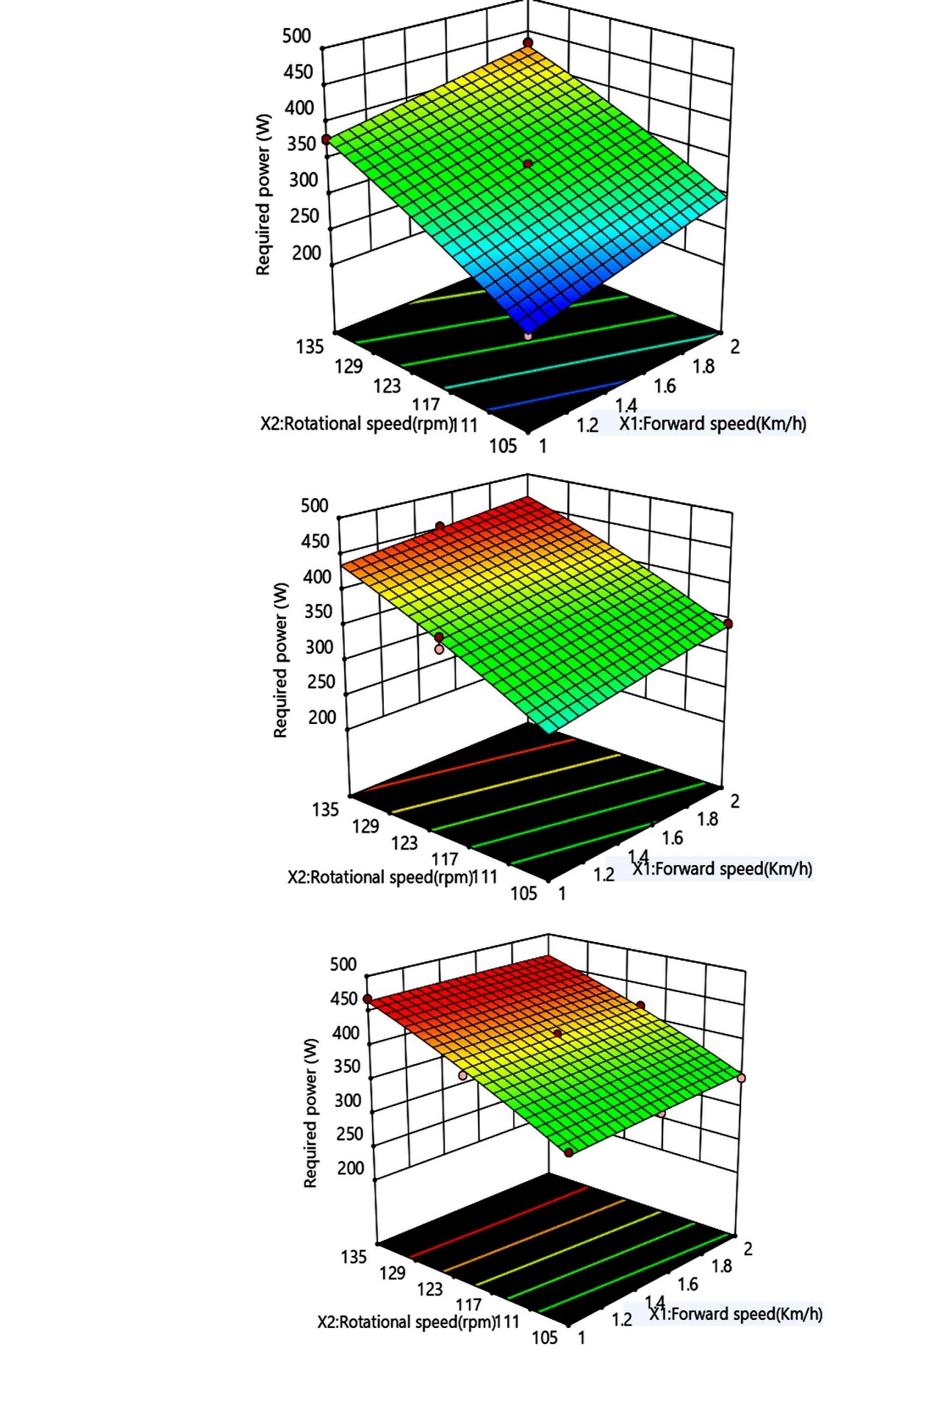
Depth of operation = 80 mm

Depth of operation = 120 mm

Depth of operation = 50 mm
Fig7 Effect of depth of operation of helical blade on power
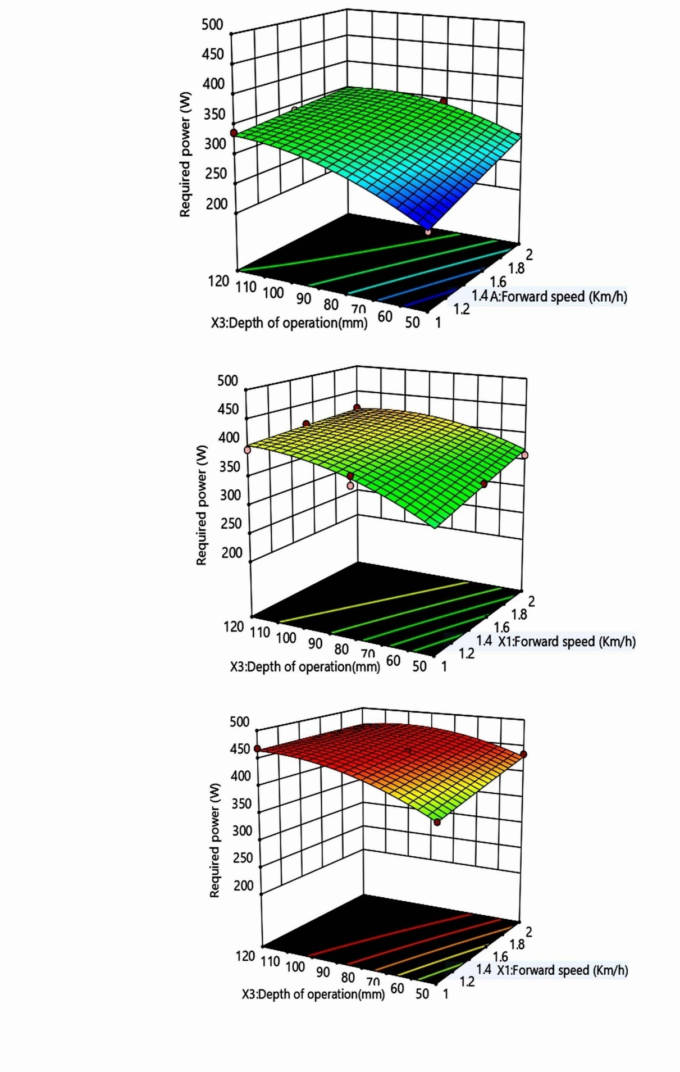
Rotational speed = 135 rpm

Rotational speed = 120 rpm

Rotational speed = 105 rpm

Fig.8 Effect of rotational speed of helical blade on power requirement
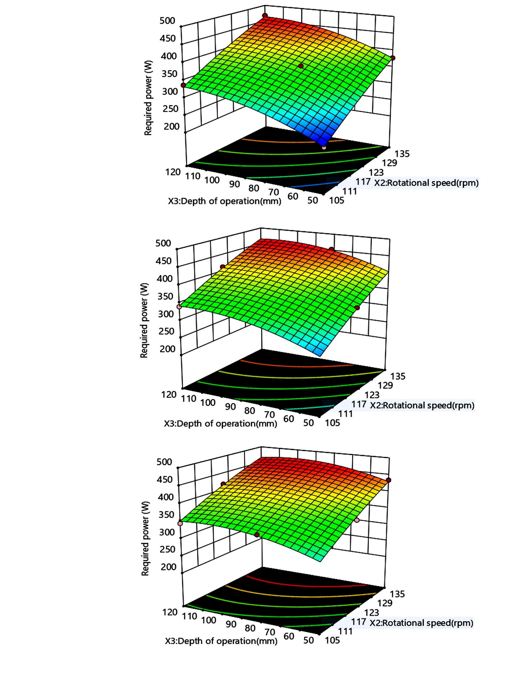
Forward speed =1.5 Km/h

Forward speed = 2 Km/h

Forward speed = 1.0 km/h

Fig. 9 Effect of forward speeds of the helical blade on power requirement
Actual factor forward speed at 2 Km/h

Table 2 ANOVA for the effect of independent parameters for response surface quadratic model on torque
Source | Sum of Squares | df | Mean Square | F-value | p-value
Model | 274.79 | 9 | 30.53 | 86.51 | < 0.0001 | significant
Model | 30.32 | 1 | 30.32 | 85.89 | < 0.0001
X₁ | 24.99 | 1 | 24.99 | 70.81 | < 0.0001
X₂ | 115.50 | 1 | 115.50 | 327.24 | < 0.0001
X₃- | 3.13 | 1 | 3.13 | 8.87 | 0.0084
X₁X₂ | 12.85 | 1 | 12.85 | 36.40 | < 0.0001
X₁X₃ | 4.48 | 1 | 4.48 | 12.69 | 0.0024
X₂X₃ | 0.0026 | 1 | 0.0026 | 0.0075 | 0.9322
X₁² | 4.14 | 1 | 4.14 | 11.72 | 0.0032
X₂² | 16.54 | 1 | 16.54 | 46.87 | < 0.0001
X₃² | 6.00 | 17 | 0.3530
Lack of Fit | 3.35 | 5 | 0.6691 | 3.02 | 0.0539 | not significant
Pure Error | 2.65 | 12 | 0.2212
Cor Total | 280.79 | 26
** Significant at 1% level of significance, * Significant at 5 % level of significance
Table 3 ANOVA for effect of independent parameters for response surface quadratic model on required power
Source | Sum of Squares | df | Mean Square | F-value | p-value
Model | 91627.38 | 9 | 10180.82 | 203.96 | < 0.0001 | significant
X₁ | 4689.17 | 1 | 4689.17 | 93.94 | < 0.0001
X₂ | 49199.32 | 1 | 49199.32 | 985.63 | < 0.0001
X₃ | 18282.91 | 1 | 18282.91 | 366.27 | < 0.0001
X₁X₂ | 125.64 | 1 | 125.64 | 2.52 | 0.1311
X₁X₃ | 1706.37 | 1 | 1706.37 | 34.18 | < 0.0001
X₂X₃ | 124.33 | 1 | 124.33 | 2.49 | 0.1329
X₁² | 1.53 | 1 | 1.53 | 0.0306 | 0.8632
X₂² | 276.84 | 1 | 276.84 | 5.55 | 0.0308
X₃² | 2415.66 | 1 | 2415.66 | 48.39 | < 0.0001
Residual | 848.58 | 17 | 49.92
Lack of Fit | 371.35 | 5 | 74.27 | 1.87 | 0.1741 | not significant
Pure Error | 477.23 | 12 | 39.77
Cor Total | 92475.96 | 26

CONCLUSION
The performance evaluation of the helical blade was carried out in a mechanized soil bin to assess the effects of forward speed, rotational speed, and depth of operation on torque and power requirements. A total of twenty-seven experimental trials were conducted, revealing that torque values ranged from 20.64 to 33.20 N·m, while power consumption varied between 226.90 and 467.852 W across the different operating conditions. Statistical analysis confirmed that both torque and power models were highly significant at the 1% level, indicating strong model reliability. The positive linear coefficients of the regression equations showed that increases in forward speed, blade rotational speed, and depth of operation led to corresponding increases in torque and power demand, while the negative interaction and quadratic terms reflected curvature and interaction effects among the variables. Higher forward speeds, greater depths, and moderately high rotational speeds consistently increased soil resistance, thereby raising the mechanical load on the blade. Maximum torque and power values were observed at higher depth and rpm combinations, whereas the lowest values occurred under minimal settings. Overall, the study demonstrates that operating parameters have a substantial influence on the mechanical load experienced by the helical blade. Operating the blade at lower forward speeds, shallower depths, and reduced rotational speeds effectively minimizes torque and power requirements. These insights are valuable for improving the design and operational efficiency of helical blade-type rotary tillage implements under controlled soil conditions
REFERENCES
- Abebe, A., & Wright, M. E. (2000). An analytical model of soil-tool interaction using the finite element method. Journal of Terramechanics, 37(3), 123–138.
- Aluko, O. B., & Seig, D. A. (2000). Prediction of torque requirement for rotary tillers using soil mechanical properties. Soil & Tillage Research, 55(3–4), 203–212.
- American Society of Agricultural Engineers. (2003). ASAE D497.4: Agricultural Machinery Management Data. ASAE Standards. https://www.asabe.org/standards/published-standards
- Gill, W. R., & Vanden Berg, G. E. (1967). Soil dynamics in tillage and traction. USDA Agricultural Handbook No. 316. Washington, D.C.: U.S. Government Printing Office. https://hdl.handle.net/2027/uiug.30112019700000
- Godwin, R. J., & O'Dogherty, M. J. (2007). Integrated soil tillage force prediction models. Journal of Terramechanics, 44(1), 3–14. https://doi.org/10.1016/j.jterra.2006.01.001
- Grisso, R. D., Yasin, M., & Kocher, M. F. (1996). Tillage implement forces operating in silty clay loam. Transactions of the ASAE, 39(6), 1977–1982. https://doi.org/10.13031/2013.27699
- Grisso, R. D., Yasin, M., & Kocher, M. F. (1996). Tillage implement forces operating in silty clay loam soil. Transactions of the ASAE, 39(6), 1977–1982.
- Kepner, R. A., Bainer, R., & Barger, E. L. (1978). Principles of Farm Machinery (3rd ed.). Avi Publishing Company, Inc.
- Kepner, R. A., Bainer, R., & Barger, E. L. (2011). Principles of Farm Machinery (3rd ed.). CBS Publishers & Distributors, New Delhi.
- McKyes, E. (1985). Soil Cutting and Tillage. Elsevier Science Publishers. https://www.elsevier.com/books/soil-cutting-and-tillage/mckyes/978-0-444-42548-5
- McKyes, E. (1985). Soil cutting and tillage. Elsevier Science Publishers. https://www.elsevier.com/books/soil-cutting-and-tillage/mckyes/978-0-444-42548-5
- Olatunji, O. M., & Mohammed, A. (2011). Effect of forward speed and depth of cut on draft requirement of tillage implements. Nigerian Journal of Technological Development, 8(2), 22–6.
- Owsiak, Z. (1997). Effect of operational parameters on power requirement of rotary tillers. Journal of Agricultural Engineering Research, 67(4), 317–325.
- Soni, P., Salokhe, V. M., & Saha, H. N. (1998). Soil bin studies on rotary tiller blades in sandy loam soil. AMA, 29(3), 23–27.
- Sreenivas, V., & Ramesh, K. (2012). Performance evaluation of rotary blades in controlled soil bin. International Journal of Agricultural Engineering, 5(1), 89–95.
- Upadhyay, A., & Raheman, H. (2018). Optimization of rotary tiller blades using RSM under soil bin testing. Soil & Tillage Research, 182, 73–82.
- Yadav, R., & Pandey, K. P. (1997). Draft and power requirements of tillage implements. Journal of Terramechanics, 34(3), 107–120

