Original Research Article

A Comparative Climatic Variability Study of Chhattisgarh Districts, India

ABSTRACT

This study compares important meteorological characteristics across two time periods: 1951– 1986 and 1986–2020 in order to examine long-term climate variability throughout the 27 districts (as of 2020) and the 3 agro-climatic zones considered (Bastar Plateau zone, Northern Hill Zone and Chhattisgarh Plain Zone) of Chhattisgarh, India. The study uses district-level meteorological data to examine changes in diurnal temperature range (DTR), annual rainfall, the number of rainy days, maximum and minimum temperatures, and extreme weather indices like the Cold Spell Duration Index (CSDI), Warm Spell Duration Index (WSDI), Consecutive Dry Days (CDD), and Consecutive Wet Days (CWD). These indices were calculated using RClimDex, a R software package developed by ETCCDI. The findings show that although certain areas of the Bastar Plateau Zone had an increase in rainfall, the Chhattisgarh Plain and Northern Hill Zones saw a significant decline in annual rainfall. Maximum temperatures and DTR increased in several regions, while dry periods were longer and more frequent. Most areas also saw a substantial rise in warm periods and a decrease in cold spells, suggesting a shift towards a warmer and more varied environment. The need of localized adaptation strategies and climate-resilient planning is highlighted by these geographically diverse climatic patterns. Policymakers, planners, and other stakeholders engaged in climate adaptation and sustainable development in the area may benefit greatly from the results.

Keywords: Climate variability; rainfall trends; diurnal temperature range (DTR); consecutive dry days (CDD); climate risk assessment; chhattisgarh districts.

INTRODUCTION
Climate change and variability have been recognized as some of the most hazardous man- made risks to mankind, with detrimental effects on ecosystems, livelihood security, and human health. Due to their reliance on agriculture for both food and money, the rural population is especially susceptible to such climate shifts in emerging nations like India. Indicators of risk assessments are often used to quantify and describe a system's vulnerability and ability to adapt to climate change. In vulnerability research, indicator-based assessment is still a common methodological technique. Vulnerability is "the degree to which a system is susceptible to and copes with the adverse effects of climate change, including climate variability and extremes," according to the Intergovernmental Panel on Climate Change (IPCC). It is affected by the kind, extent, and pace of climate change in addition to the sensitivity and adaptability of a system. Vulnerability may also be thought of as the possibility of "future damage" from the standpoint of climate change (Wolf et al., 2013). Researchers concur that vulnerability is a dynamic, multifaceted phenomena that is impacted by a number of interrelated traits within a socio-ecological system. These traits together define how exposed or robust a people or area may be (Oppenheimer et al., 2015).
Worldwide, climate change has become a serious threat to people's livelihoods and general well-being (Chalchisa & Sani, 2016). According to the IPCC's Fifth Assessment Report (AR5), the average global surface temperature between 1850 and 1900 is expected to increase by 1.5 °C by 2100 (Stocker et al., 2013). According to more recent estimates from the (Lee H, 2023), mean sea level increased by 0.20 [0.15 to 0.25] m between 1901 and 2018, and global surface temperature was already 1.09 [0.95 to 1.20] °C higher in 2011–2020 than it was in 1850–1900. Under the worst-case emission scenarios, model-based forecasts (CMIP-6) indicate a temperature increase of more than 3 °C in South Asia (Mishra et al., 2020). The frequency and severity of severe events in India are predicted to
rise, despite less clear national precipitation patterns (Kumar et al., 2011).

Strategies for mitigating and adapting to climate change are directly impacted by these shifts. International and national organisations are stressing the need of adaptation, especially in poor countries, since the advantages of mitigation take decades to materialise (Rao et al., 2016). Institutional capability, local expertise, and scientific forecasts are all combined with sectoral specialisation and geographical sensitivity to achieve effective adaptation (Runhaar et al., 2018). Agrarian countries like India, where smallholder farmers confront heightened risks from climate change, land degradation, market volatility, and growing input prices, should pay special attention to this (Birthal & Hazrana, 2019). India may have a temperature increase of 1.7°C to 2.0°C and a rainfall increase of 5% to 6% by the 2030s, rising to 3.3°C to 4.8°C and 6% to 14%, respectively, by the 2080s, according to CMIP-5 models (Chaturvedi et al., 2012). The security of food and livelihood will probably be further threatened by these anticipated changes.
One of the areas in central India that is seeing significant climate changes is Chhattisgarh. There is evidence that the state is seeing an increasing number of natural catastrophes and severe weather occurrences. Early analyses of Chhattisgarh's regional climate change revealed significant district-to-district variation. There was a 30–35% drop in rainfall in some areas, but just a 0–5% decrease in others. This discrepancy illustrates how climate change affects agro- climatic zones differently. Due to its heavy reliance on monsoon-based agriculture, especially the production of rice, the state is very vulnerable to even little changes in climatic trends (Sastri, 2010).
Numerous research has shown the need of conducting localized assessments of climate risk. Using the IPCC AR5 framework and CMIP-5 forecasts (RCP 4.5), a nationwide assessment found that several districts, including Chhattisgarh, had high to extremely high levels of

climate risk and vulnerability, necessitating focused adaptation planning (N Kumar et al., 2017 and Rao et al., 2025). Using MCMC modelling, another research conducted in Chhattisgarh examined rainfall data from 1986 to 2021 and discovered that crop production peaks when the wet-day chance falls between 55 and 65%, indicating that late June is the best time to plant (Tandel et al., 2023). Increased climate- related catastrophes in Uttarakhand have been associated with infrastructure vulnerability; a dual architecture has been suggested to promote resilience against landslides and floods (Singh & Pandey, 2024).
Although previous research has emphasized the need of conducting localized climate risk assessments, there are still few thorough district- level analyses conducted over long periods of time. Building upon the standard year of 1986, which is generally acknowledged as a pivotal moment in climate patterns brought on by increased anthropogenic warming, this research takes one step further by offering a more thorough and comparative examination of climatic variability across Chhattisgarh districts. It looks at variations in a variety of factors, such as the diurnal temperature range (DTR), the number of wet days, the annual rainfall, and the highest and lowest temperatures. In order to provide a comprehensive, geographically disaggregated evaluation of changing climate hazards, the research also includes severe weather indicators including consecutive dry days (CDD), consecutive wet days (CWD), cold spell length indicator (CSDI), and warm spell duration indicator (WSDI).
The three main agroclimatic zones the Bastar Plateau Zone, the Northern Hill Zone, and the Chhattisgarh Plain Zone each having unique vulnerabilities are used to evaluate these indicators. According to district-level exposure, sensitivity, and adaptable capability, the research uses the IPCC AR5 risk framework to identify priority locations, climate change hotspots, and well-informed adaptation approaches (Allen et al., 2018); (Das et al., 2020). Strong policy recommendations must update these assessments with fresh data and concepts since risk is dynamic (Jurgilevich et al., 2017).
In conclusion, this study makes a significant contribution to the current discussion on the effects of climate change by providing a district-level comparison in Chhattisgarh before to and after 1986. It serves as a critical input for
climate-resilient planning and adaptation, supporting policymakers and development practitioners in formulating locally relevant, evidence-based strategies for resilience and sustainable development.

MATERIALS AND METHODS

Study Area
This study was carried out over the state of Chhattisgarh, in central India between latitudes 17°46′ N and 24°5′ N and longitudes 80°15′ E to 84°20′ E. Most of Chhattisgarh is agricultural, and for a good number of its people, farming is their main means of income. Generally, split into three main agro-climatic zones—the Chhattisgarh Plain Zone, the Northern Hill Zone, and the Bastar Plateau Zone—the state has varied topographical and agro-climatic characteristics. These zones vary in height, type of soil, pattern of rainfall, temperature range, and sensitivity to climatic fluctuation. Given the state's reliance on monsoon-driven agriculture and natural resources, it offers a fitting background for evaluating climate-induced hazards across time and geography. Micro-level climatic trend study was made much easier by the administrative split into blocks and districts.

Data Collection and Sources
Drawn on real-world secondary sources, the research made use of 70 years of climate data covering the years 1951 to 2020. Important data variables were daily rainfall, number of rainy days, maximum and minimum temperatures, and several climate indices including diurnal temperature range (DTR), consecutive dry days (CDD), consecutive wet days (CWD), cold spell duration indicator (CSDI), and warm spell duration indicator (WSDI). Government reports and regional agro-climatic research stations complemented the data mostly coming from the Indian Meteorological Department (IMD). To more accurately evaluate spatial variances, district-level and block-level data were aggregated Verification and cleansing processes were applied to the data to guarantee dependability and consistency throughout the chosen periods.

Time Period Division
To assess the effects of long-term climate change, the study period was divided into two major time frames:

    - Pre-climate shift period (1951–1986)
    - Post-climate shift period (1986–2020)

Climate Risk Indicators
To identify district-wise climate hazards, the evaluation concentrated on a whole range of climatic indicators. These included variations in annual rainfall, count of rainy days, and patterns in annual maximum and lowest temperatures. In order to depict climatic stress and fluctuation, the Diurnal Temperature Range (DTR), which is determined as the difference between daily maximum and lowest temperatures, was investigated both yearly and seasonally. Four standardised indexes of climatic extremes also were utilised:
    - Consistent Dry Days (CDD), which show
the longest run of dry periods (rainfall less 1 mm/day),
    - Consecutive Wet Days (CWD), which indicate ongoing days of noteworthy precipitation (≥1 mm/day),
    - The Cold Spell Duration Indicator (CSDI) measures cold wave spells depending on daily minimum temperatures below the 10th percentile for six or more days and
    - Warm Spell Duration Indicator (WSDI) – measuring heat waves through daily maximum temperatures exceeding the 90th percentile for six or more days.

Designed from the ETCCDI (Expert Team on Climate Change Detection and indicators) framework, extensively used in climate risk research, these indicators were modified.

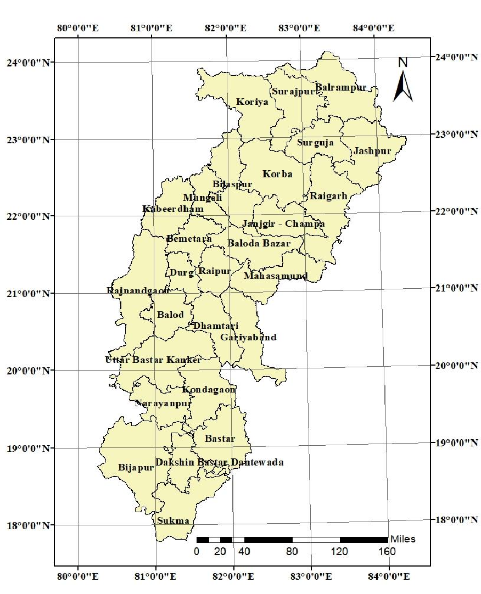
Fig. 1. Study area

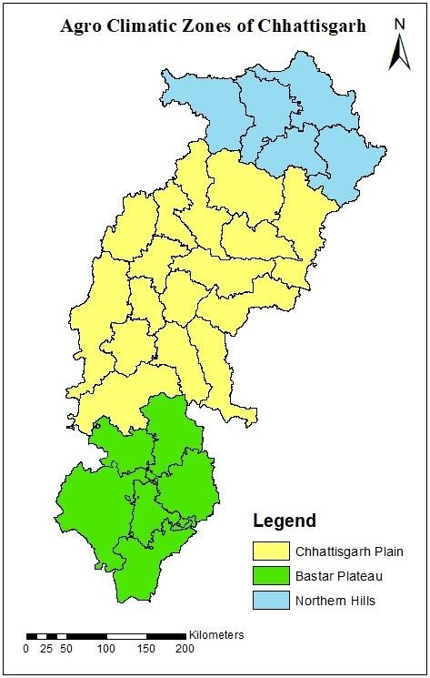

Fig. 2. Agroclimatic zones of Chhattisgarh

Spatial and Zonal Analysis
    - To identify regional trends, district-level data were combined zone-wise (Plain, Hill, and Plateau).
    - Particularly targeted blocks within districts were investigated to find micro-climatic changes.

Data Processing and Analysis
    - The two time periods were compared using descriptive statistics (mean, range, and percentage change).
    - Spatial patterns in temperature, precipitation, and climatic extremes were shown using graphical visualisation and geographic mapping.

    - Yearly and seasonal averages were computed, and change detection analysis was performed to identify significant variations across the two periods.

RESULT
Various climatic risks including changes in the climate over the past 70 years were calculated and the results are presented here. These climatic risks were calculated on two-time scales viz., 1951 to 1986 and 1986 to 2020.

Changes in Annual Average Rainfall, Number of Rainy Days, Maximum and Minimum Temperature
Changes in the number of wet days, temperature, and annual average rainfall before and after 1986 are shown in Fig. 1 to 3. The Chhattisgarh Plain Zone and Northern Hill Zone witnessed the biggest drops in rainfall, with districts like Balod, Durg, Raipur, Bilaspur, and Jashpur seeing decreases of over 160 mm yearly. Overall, the majority of Chhattisgarh districts suffered cuts of more than 80 mm each year. There were, however, 120–240 mm increases in rainfall in districts including Bijapur, Sukma, Bastar, and Dantewada (Sanikhani et al., 2018); (Meshram et al., 2017).
Balod, Durg, Bemetara, portions of Koriya, and Balrampur observed annual increases of 1-4 days in rainy days. Although there were fewer wet days in the Bastar Plateau Zone, there was an increase in rainfall, suggesting more powerful rainfall events. The Northern Hill Zone saw more rainy days but less intense rainfall, while the Chhattisgarh Plain Zone experienced simultaneous increases in both rainfall and rainy days.
The Bastar Plateau and Chhattisgarh Plain Zones had an increase in annual maximum temperatures of 0.3 to 0.4°C, whereas the Northern Hill Zone saw an increase of 0.1 to 0.3°C (Singh et al., 2008). Bijapur, Sukma, and Dantewada had modest rises (0.1–0.2°C) in minimum temperatures, whereas Narayanpur, Kondagaon, Gariyaband, Raigarh, and other locations saw drops (0.1–0.4°C). While the majority of the Northern Hill Zone had a decrease in minimum temperatures of 0.1 to 0.3°C, Koriya district was mostly unaltered (Mall et al., 2021).

Diurnal Temperature Range (DTR) Difference
The annual Diurnal Temperature Range (DTR) increased in much of Chhattisgarh after 1986, except for Narayanpur and Kondagaon (Bastar Plateau Zone), as seen in Fig. 4 and 5. The DTR rose by 0.2 to 0.4°C in the majority of places. at the Chhattisgarh Plain Zone, the biggest rise of 0.7°C was seen at Baramkela, Pusour (Raigarh), and Bindranavagarh (Gariyaband). There was a 0.4°C increase in portions of Kanker, Mungeli, Bilaspur, Rajnandgaon, and Kabeerdham. Bastar's trends were similar to those in the Northern Hill Zone.
Changes in seasonal DTR are seen in. 6. In most areas, DTR increased by 0.2 to 0.8°C throughout the winter, with Gariyaband and Raigarh blocks seeing the most rise (1°C). There was a 0.8°C increase in Narayanpur and Kondagaon. Surguja and Jashpur had increases of 0.6 to 0.8°C, while Surajpur experienced the least change (0.2°C) in the Northern Hill Zone.
During the summer, the DTR rose by 0.2 to 0.4°C in the Bastar Plateau Zone. The biggest rise in temperature in the Chhattisgarh Plains was 0.7°C in districts like Balod, Dhamtari, and Gariyaband, while the lowest was 0.2°C in Kabeerdham and Rajnandgaon. All Northern Hill districts had a 0.4°C increase, with the exception of Surguja (0.2°C) and Surajpur (no change).
Fig. 7 and 8 show how DTR varies throughout the monsoon seasons in the southwest and northeast. Bastar saw a 0.2–0.4°C increase in temperature, whereas the majority of the Chhattisgarh Plains experienced 0.4–0.6°C rises. Apart from Balrampur (0.2°C), the Northern Hill Zone had a 0.4°C increase.
Bijapur and Usur saw the lowest DTR increase (0.2°C) during the northeast monsoon, while Narayanpur and Kondagaon experienced the most (0.6°C). The Chhattisgarh Plain Zone had the lowest temperature increase (0.2°C) in Lormi, Mungeli, and portions of Bilaspur, while Kabeerdham, Mohla, and Kanker saw the highest temperature increase (0.7°C). Most other blocks had risen of 0.4 to 0.6°C. In the Northern Hill Zone, blocks like Batouli, Mainpat, and Sitapur (Surguja) saw the maximum increase of 0.7°C, while Koriya and Balrampur had a rise of 0.2°C.

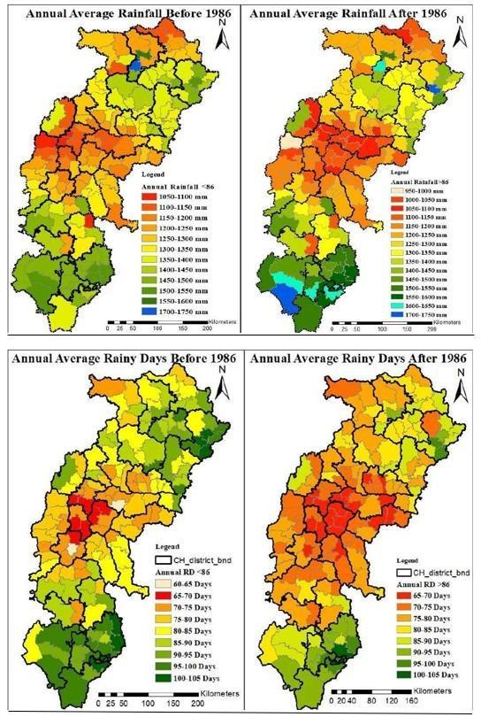

Fig. 3. Annual average rainfall and number of rainy days before and after 1986

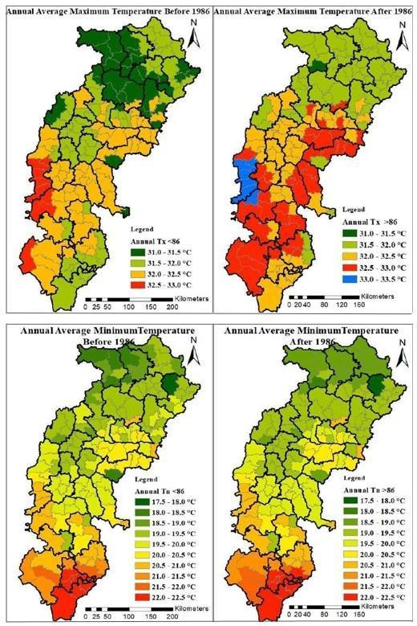
Fig. 4. Annual average maximum and minimum temperature before and after 1986

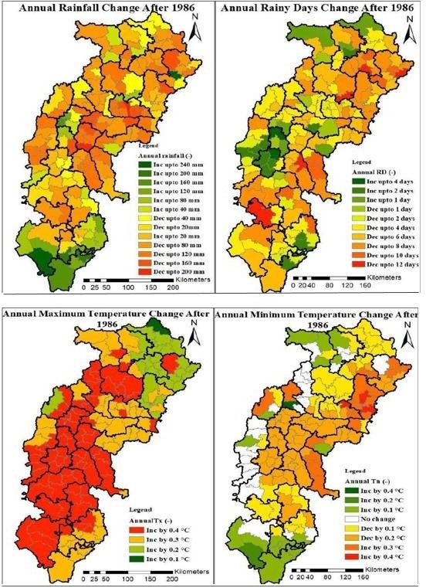
Fig. 5. Change in Annual Rainfall, Number of rainy days, Maximum and Minimum Temperature After 1986

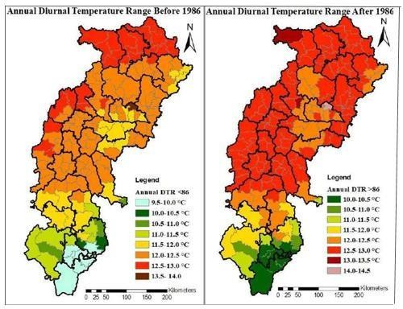
Fig. 6. Annual diurnal temperature range before and after 1986
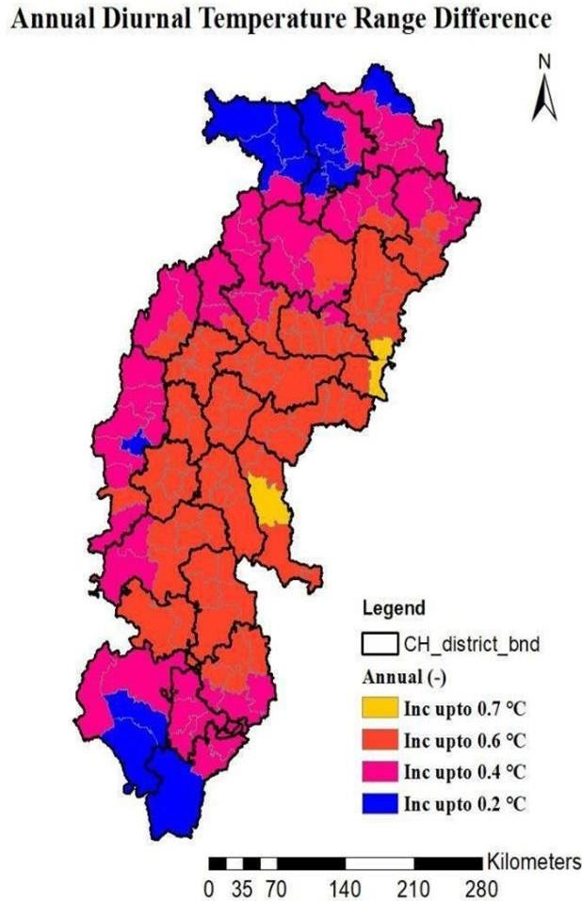
Fig. 7. Change in annual diurnal temperature range

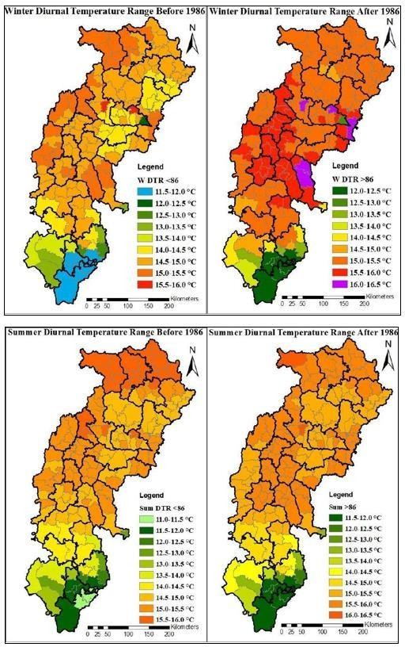
Fig. 8. Winter and summer diurnal temperature range before and after 1986

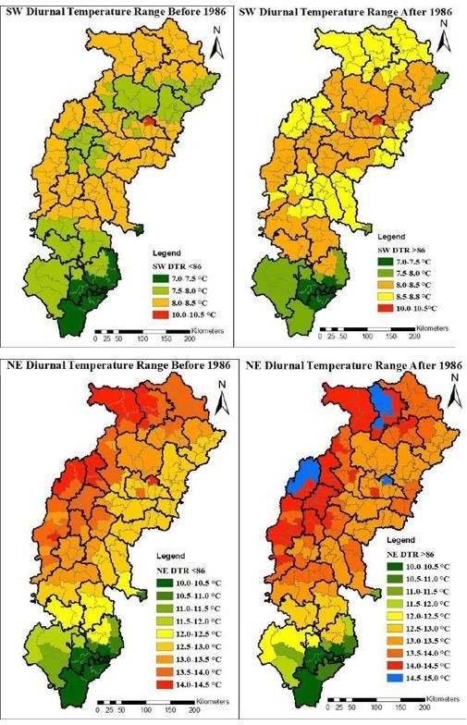
Fig. 9. South-west and north-east diurnal temperature range before and after 1986

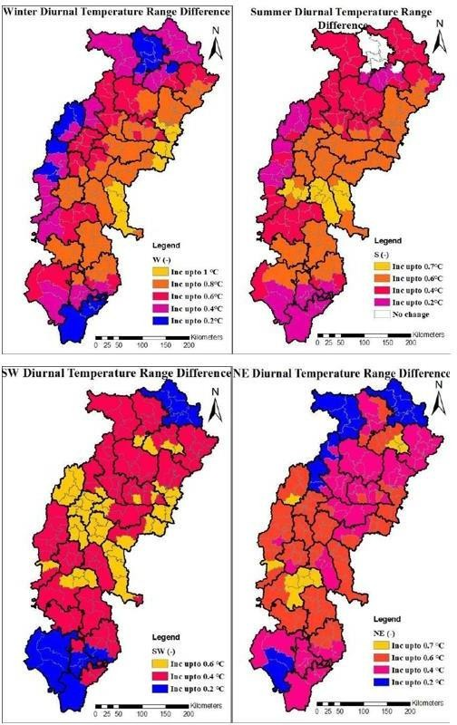
Fig. 10. Change in diurnal temperature range

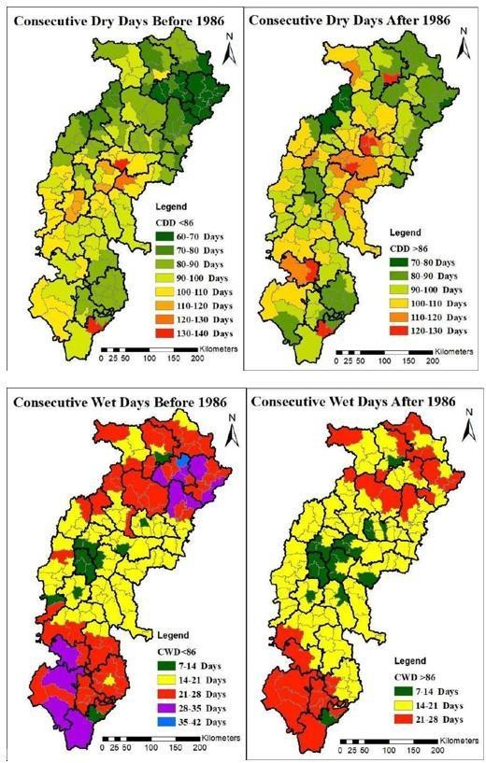
Fig. 11. Annual consecutive wet and dry days before and after 1986

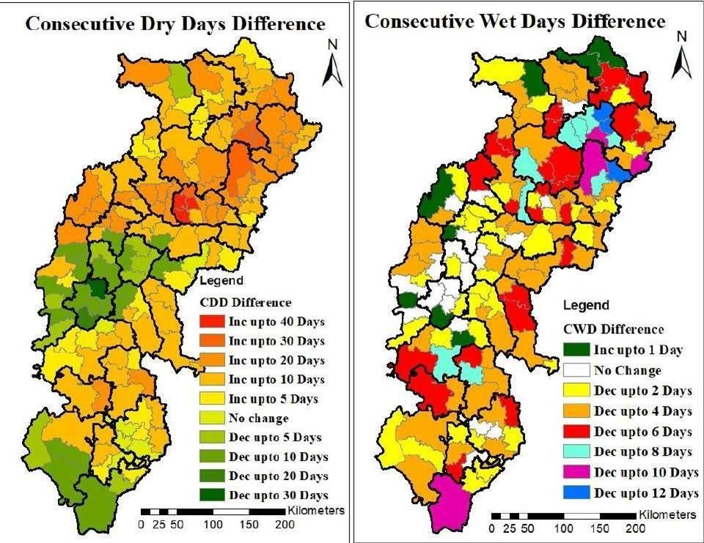
Fig. 12. Change in annual consecutive dry and wet days

Difference in Consecutive Dry Days (CDD)
Before and after 1986, annual CDD and CWD are shown in Fig. 9. Major regions of the state have seen a rise in CDD overall; only those where rainfall has increased have shown a reduction in CDD. While Dantewada district showed no change, the other districts showed increases in CDD of up to 20 days. In the Bastar Plateau Zone, Bhopalpattnam, Bijapur, and Usur blocks of Bijapur district have seen decreases in CDD of 5 to 20 days, while Sukma block has seen a slight increase of 5 days. Within the Chhattisgarh Plain Zone, there is a five to thirty day downward tendency in the districts of Rajnandgaon, Durg, Balod, Raipur, Dhamtari, Kurud, and Palari in the Dhamtari district, Palari in the Baloda Bazar district, and Mahasamund in the Mahasamund district. which results from sporadic or unseasonable rainfall. The remaining components, however, have an increase of 5 to 40 days. Only Kanker's Charma block remains unchanged in this area. CDD has risen by 5 to 30 days in the Northern Hills, whereas it has only reduced by up to 5 days in the Sonhat block in the Koriya district.

Difference in Consecutive Wet Days (CWD)
The yearly CDD and CWD changes are shown in Fig. 10. CWD is declining in most of the state; in the districts of the Bastar Plateau Zone, the Konta block of Sukma district has the highest probability of 10 decreasing days, while the other districts have a variation of 2 to 8 decreasing days. The Katekalyan block of Dantewada, Lohandiguda, and Tokapal blocks of Bastar district have no change. Chhattisgarh Plain Zone districts, Rajnandgaon's Ambagarh and Dongargaon blocks, portions of Raipur district, Balod, Durg, Kawarda block of Kabeerdham district, Mungeli block of Mungeli district, and Janjgir block of Janjgir-Champa district have not seen any changes in CWD. In contrast, there has been a little one-day rise in CWD in the Kanker block of the Kanker district, the Dondi block of the Dondi district, and the Ambargarh block of Rajnandgaon. Days have been shortened by two to twelve days in the remaining sections. Sonhat block in Koriya district, Ramanujganj, and Wadrafnagar in Balrampur district all see one-day rises in the Northern Hills. While the rest of Surajpur has changed by eight to ten days, the Surajpur block in the Surajpur district has not changed.

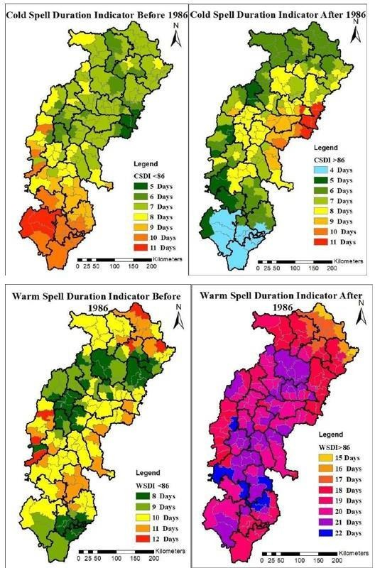
Fig. 13. Cold and warm spell duration before and after 1986

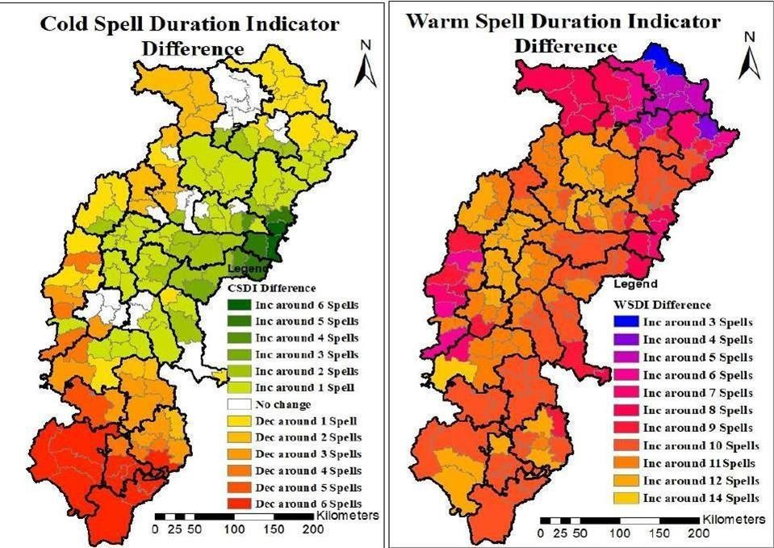
Fig. 14. Annual change in cold and warm spell durations

Difference in Cold Spell Duration Indicator (CSDI)
Fig. 11 displays the annual CSDI and WSDI before to and after 1986. The CSDI dropped by one to six spells in the districts of the Bastar Plateau Zone. The districts of Bijapur, Dantewada, Sukma, and Bastar had the biggest decline in the state—six periods. In the Chhattisgarh Plain Zone, the CSDI has not changed in the Pendra block of Bilaspur, Sakti block of Janjigir Champa, Manipur block of Gariyaband, Balod and portions of Dhamtari, Baloda Bazar, and Pathariya block of Mungeli district. Raigarh, on the other hand, had the most change, increasing by around six spells. Between 1 and 5, Kabeerdham, Rajnandgaon, and Kanker have less spells. There has been no change in the Northern Hill Zone, Surajpur district, Lundra, or Mainpat blocks of Surguja. While the remainder of the Jashpur district has seen a drop of one to two spells, the southern area has had a minor rise of one spell.

Difference in Warm Spell Duration Indicator (WSDI)
The annual CSDI and WSDI changes are shown in Fig. 12. The WSDI is rising across the state. It varies from 8 to 14 spells in the Bastar Plateau
Zone, which is the largest increase in the state when compared to the pre-1986 situation. The Durgkondal block of Kanker has five to six spells in the Chhattisgarh Plain Zone, Manpur, Khairagarh, and Ambagarh block of Rajnandgaon, while the other areas have more, reaching up to fourteen spells in the state's highest districts of Korba, Bemetara, Balod, Raipur, Janjgir-Champa, and Kanker. Three to eight spells were added in Northern Hills. The lowest increase in Balrampur is three spells in the Ramanujganj block, followed by four spells in the other blocks, and five to eight spells in the other areas of this zone.

DISCUSSION
With clear geographical and temporal patterns, the study exposes significant climate changes throughout the districts of Chhattisgarh during the last seven decades. Over 160 mm in numerous districts, the Chhattisgarh Plain and Northern Hill Zones suffered notable declines in annual rainfall; in several Bastar Plateau Zone districts, including Bijapur, Sukma, and Dantewada, rises ranged from 120 to 240 mm. Variability in the number of rainy days implies unequal rainfall distribution; some regions report more frequent but less intense rains while others have fewer but more intense precipitation events.

While minimum temperatures exhibited a varied trend with many areas reported reductions, annual maximum temperatures rose throughout all zones by 0.1°C to 0.4°C. Rising in almost all areas, particularly in Raigarh and Gariyaband, Diurnal Temperature Range (DTR) indicated more day-night temperature variations. Seasonal DTR increases were constant during monsoon, summer, and winter. While Consecutive Wet Days (CWD) dropped, therefore suggesting less continuous rainfall, Consecutive Dry Days (CDD) rose throughout much of the state. With up to 14 extra warm spells recorded in certain areas, Cold Spell Duration (CSDI) dropped while Warm Spell Duration (WSDI) increased dramatically. These patterns point Chhattisgarh towards a more unpredictable, drier, warmer environment.

CONCLUSION
The study clearly demonstrates that Chhattisgarh has undergone significant climatic changes over the past 70 years, with evident variations in rainfall, temperature, and extreme weather indicators across its districts and agro-climatic zones. Rising maximum temperatures and expanding daily temperature ranges along with declining annual rainfall and rainy days in many areas point to increasing stress on agricultural systems and water supplies. Together with the decrease in cold spells and rainy days, the rise in consecutive dry days and warm period lengths emphasises even more the increasing character of climatic variability and extremes. These variations highlight the necessity of localised evaluation and policy actions as they are not homogeneous. District-level adaptation plans tailored to particular climatic vulnerabilities are desperately needed as climate hazards get more severe. Climate-resilient agriculture, water conservation, early warning systems, and incorporating climate risk assessments into regional planning should all take front stage. Future studies should concentrate on developing a complete climate risk and resilience framework for Chhattisgarh by including remote sensing data, agricultural yield modelling, and socioeconomic vulnerability indicators. Furthermore supporting more focused adaptation, mitigation, and long-term sustainable development planning are scenario-based predictions utilising high-resolution climate models.
DISCLAIMER (ARTIFICIAL INTELLIGENCE)
Author(s) hereby declare that NO generative AI technologies such as Large Language Models
(ChatGPT, COPILOT, etc) and text-to-image generators have been used during writing or editing of this manuscript.

REFERENCES
Allen, S. K., Ballesteros-Canovas, J., Randhawa, S. S., Singha, A. K., Huggel, C., & Stoffel,
Birthal, P. S., & Hazrana, J. (2019). Crop diversification and resilience of agriculture to climatic shocks: Evidence from India. Agricultural Systems, 173, 345–354. https://doi.org/10.1016/j.agsy.2019.03.005
Chalchisa, S. S. T., & Sani, S. (2016). Sani S, Chalchisa T (2016) Farmers’ Perception, Impact and Adaptation Strategies to Climate Change among Smallholder Farmers in Sub-Saharan Africa. A Syst Rev 26:1–8. Journal of Resources Development and Management, 26(1), 32–
39. https://www.iiste.org/Journals/index.php/JRDM/article/view/34685
Chaturvedi, R. K., Joshi, J., Jayaraman, M., Bala, G., & Ravindranath, N. H. (2012). Multi- model climate change projections for India under representative concentration pathways. Current Science, 791–802.
Das, S., Ghosh, A., Hazra, S., Ghosh, T., de Campos, R. S., & Samanta, S. (2020). Linking IPCC AR4 & AR5 frameworks for assessing vulnerability and risk to climate change in the Indian Bengal Delta. Progress in Disaster Science, 7, 100110. https://doi.org/10.1016/j.pdisas.2020.100110
IPCC (2007). Contribution of Working Group I to the fourth assessment report of the Intergovernmental Panel on Climate Change 2007. (No Title). https://www.ipcc.ch/report/ar4/wg1/
Jurgilevich, A., Räsänen, A., Groundstroem, F., & Juhola, S. (2017). A systematic review of dynamics in climate risk and vulnerability assessments. Environmental Research Letters, 12(1), 13002. https://doi.org/10.1088/1748-9326/aa5508
Kumar, K. K., Patwardhan, S. K., Kulkarni, A., Kamala, K., Rao, K. K., & Jones, R. (2011). Simulated projections for summer monsoon climate over India by a high- resolution regional climate model (PRECIS). Current Science, 312–326. http://www.ias.ac.in/currsci/Volumes/101/03/0312.pdf
Kumar, N., Tischbein, B., Kusche, J., Laux, P., Beg, M. K., & Bogardi, J. J. (2017). Impact of climate change on water resources of upper Kharun catchment in Chhattisgarh, India. Journal of Hydrology: Regional

Studies, 13, 189-207. https://doi.org/10.1016/j.ejrh.2017.07.008
Lee H, R. J. (2023). Summary for Policymakers of the Intergovernmental Panel on Climate Change. https://doi.org/10.59327/IPCC/AR6-9789291691647.001
M. (2018). Translating the concept of climate risk into an assessment framework to inform adaptation planning: Insights from a pilot study of flood risk in Himachal Pradesh, Northern India. Environmental Science & Policy, 87, 1–10. https://doi.org/10.1016/j.envsci.2018.05.013
Mall, R. K., Chaturvedi, M., Singh, N., Bhatla, R.,
Singh, R. S., Gupta, A., & Niyogi, D. (2021). Evidence of asymmetric change in diurnal temperature range in recent decades over different agro-climatic zones of India. Int. J. Climatol, 41(4), 2597–2610. https://doi.org/10.1002/joc.6978
Meshram, S. G., Singh, V. P., & Meshram, C. (2017). Long-term trend and variability of precipitation in Chhattisgarh State, India. Theoretical and Applied Climatology, 129, 729–744. https://doi.org/10.1007/s00704-016-1804-z
Mishra, V., Bhatia, U., & Tiwari, A. D. (2020). Bias-corrected climate projections for South Asia from coupled model intercomparison project-6. Scientific Data, 7(1), 338. https://doi.org/10.1038/s41597-020-00681-1
Oppenheimer, M., Campos, M., Warren, R., Birkmann, J., Luber, G., O’Neill, B., Takahashi, K., Brklacich, M., Semenov, S., & Licker, R. (2015). Emergent risks and key vulnerabilities. In Climate change 2014 impacts, adaptation and vulnerability: Part A: Global and sectoral aspects (pp. 1039–1100). Cambridge University Press. https://doi.org/10.1017/CBO9781107415379.024
Rao, C. A. R., Raju, B. M. K., Islam, A., Rao, A.,
Rao, K. V, Gajjala, R. C., Ramaraju, N. K., Matyam, P., Kotha, S. R., & Bhaskar, S. (2025). Climate change risk assessment for adaptation planning in Indian agriculture. Mitigation and Adaptation Strategies for Global Change, 30(3), 1–34. https://doi.org/10.1007/s11027-025-10208-x
Rao, C. A. R., Raju, B. M. K., Rao, A. V. M. S.,
Rao, K. V, Rao, V. U. M., Ramachandran, K., Venkateswarlu, B., Sikka, A. K., Rao,
M. S., & Maheswari, M. (2016). A district level assessment of vulnerability of Indian agriculture to climate change. Current
Science, 1939–1946. https://www.jstor.org/stable/24908182
Runhaar, H., Wilk, B., Persson, Å., Uittenbroek, C., & Wamsler, C. (2018). Mainstreaming climate adaptation: taking stock about “what works” from empirical research worldwide. Regional Environmental Change, 18, 1201–1210. https://doi.org/10.1007/s10113-017-1259-5
Sanikhani, H., Kisi, O., Mirabbasi, R., & Meshram, S. G. (2018). Trend analysis of rainfall pattern over the Central India during 1901–2010. Arabian Journal of Geosciences, 11, 1– 14. https://doi.org/10.1007/s12517-018-3800-3
Sastri, A. (2010). Climate change in Indian sub- continent and its impact on agriculture. Nova Acta Leopoldina, 384, 227–240.
Singh, G., & Pandey, A. (2024). Climate change induced disasters and highly vulnerable infrastructure in Uttarakhand, India: current status and way forward towards resilience and long-term sustainability. Sustainable and Resilient Infrastructure, 9(2), 145–167. https://doi.org/10.1080/23789689.2023.2253409
Stocker, T. F., Qin, D., Plattner, G. K., Tignor, M.
M. B., Allen, S. K., Boschung, J., Nauels,
A., Xia, Y., Bex, V., & Midgley, P. M. (2013). Climate change 2013 the physical science basis: Working Group I contribution to the fifth assessment report of the intergovernmental panel on climate change. Climate Change 2013 the Physical Science Basis: Working Group I Contribution to the Fifth Assessment Report of the Intergovernmental Panel on Climate Change, 9781107057999, 1–1535. https://doi.org/10.1017/CBO9781107415324
Tandel, D., Verma, S., Kumar, K., & Verma, M.
K. (2023). Impact assessment of wet and dry spell on agriculture productivity of Chhattisgarh, India. Journal of Environmental Informatics Letters, 10(1), 10–22. https://doi.org/10.3808/jeil.202300108
Wolf, S., Hinkel, J., Hallier, M., Bisaro, A., Lincke, D., Ionescu, C., & Klein, R. J. T. (2013). Clarifying vulnerability definitions and assessments using formalisation. International Journal of Climate Change Strategies and Management, 5(1), 54–70. https://doi.org/10.1108/17568691311299363

