Original Research Article

Design and Development of a Biomimetic Adaptive Ventilation Skin Inspired by Beehive Thermoregulation for Net-Zero Energy Buildings

ABSTRACT

The building sector accounts for a substantial portion of global energy consumption, with ventilation systems significantly contributing to this demand. Traditional static façades and mechanical ventilation systems often result in excessive energy use and limited responsiveness to changing environmental and occupancy conditions. This study introduces a Biomimetic Adaptive Ventilation Skin (BAVS) inspired by honeybee thermoregulation, specifically their collective fanning behaviour, to improve energy efficiency and indoor environmental quality in buildings pursuing net-zero energy performance. A mixed-methods approach was used, combining EnergyPlus simulations, Computational Fluid Dynamics (CFD) modelling, and experimental prototype testing. BAVS demonstrated a 20% reduction in annual energy use intensity compared to a conventional static façade, alongside enhanced thermal stability and ventilation performance. Experimental results confirmed a ventilation rate improvement to 2.5 air changes per hour, reduced CO₂ concentrations (400 ppm average), and a 40% decrease in actuation energy relative to typical mechanical systems. Thermal comfort compliance increased from 60% to 92% of occupied hours within ASHRAE 55 adaptive thresholds. These findings demonstrate the feasibility of translating biological thermoregulation strategies into high-performance building envelope systems. The study contributes to biomimetic architectural research by offering a scalable adaptive façade concept capable of improving energy efficiency, indoor air quality, and occupant comfort in net-zero building applications.

Keywords: Biomimetic design; Adaptive façade; Beehive thermoregulation; Net-zero energy building; Decentralized control; Dynamic ventilation; Energy efficiency

1. INTRODUCTION

Reducing energy consumption in buildings is a critical cornerstone in the quest for net-zero energy targets. The building sector accounts for a significant proportion of global energy use, necessitating substantial transformations to achieve sustainability goals (Jankovic & Carta, 2021). Implementing energy-efficient systems is essential, particularly in the context of ventilation and façade systems, which often exhibit static or overly energy-intensive characteristics. The urgency of sustainable building practices is underscored by the pressing need to limit CO2 emissions and mitigate climate change impacts. As technology evolves, integrating materials and designs that enhance energy performance while addressing safety and environmental concerns becomes increasingly vital (Ovadiuc et al., 2024). Current ventilation approaches often rely on traditional methods that do not adapt to real-time occupancy or environmental conditions. For example, Demand Control Ventilation (DCV) systems can optimise indoor air quality (IAQ) and reduce energy consumption by adjusting fresh air supply according to actual occupancy levels rather than maintaining fixed rates (Mustapha et al., 2024). This dynamic approach contrasts with conventional systems, which frequently lead to over-ventilation and unnecessary energy expenditure. It reflects a pivotal paradigm shift toward responsive designs that not only meet basic air quality standards but also enhance energy efficiency (Rieser et al., 2021).
Similarly, strategies involving ventilated façades have emerged as a viable solution to reduce energy loads within buildings. These façades provide passive heating and cooling benefits through natural ventilation mechanisms (Sánchez et al., 2019). By integrating phase-change materials (PCMs) into these systems, there is potential for improved energy efficiency and a marked decrease in carbon footprints (Ovadiuc et al., 2024). Recent research indicates that the efficacy of ventilated façades can be significantly assessed using various models, revealing their capacity to enhance thermal comfort while minimising energy needs for heating and cooling (Pastori et al., 2021). Moreover, studies suggest that the combination of photovoltaic (PV) technology with ventilated façades could facilitate the transition of buildings towards net-zero energy statuses (González et al., 2019). The innovative blend of renewable energy generation and passive thermal management through building façades represents a promising solution in architectural design aimed at sustainability. Such advancements are crucial for meeting the rigorous European targets for nearly zero-energy buildings (nZEB), showcasing their role as multifaceted systems performing efficiently under a range of operational circumstances (Sukamto et al., 2021). While the benefits of vented systems are evident, challenges remain, particularly concerning their integration into existing structures. Historical buildings present unique difficulties in updating ventilation systems without compromising their integrity (Rieser et al., 2021). A systematic intervention approach is essential in evaluating both heritage conservation parameters and modern energy efficiency benchmarks to navigate these challenges successfully (Rieser et al., 2021). Thus, addressing the demands of current architectural practices requires an in-depth understanding of the balance between preservation and enhancement of building performance.
Biomimicry in architecture and environmental design has garnered increasing attention as a transformative strategy towards sustainable development in the built environment. The concept draws inspiration from nature's time-tested patterns and strategies to address complex engineering and architectural challenges. By mimicking biological structures and processes, architects can create buildings that are not only energy-efficient but also better integrated with their ecological surroundings (Faragalla & Asadi, 2022; Sudhesh, 2025). This approach results in innovative designs that prioritise environmental sustainability, embody resilience, and enhance occupant comfort through adaptive capabilities (Sudhesh, 2025; Soudian & Berardi, 2021). An exemplary case of biomimetic inspiration can be found in the thermoregulation behaviour of honeybees, specifically their collective fanning activity. Honeybees utilise coordinated movements to regulate their nest temperature through a process that involves porosity and feedback control, adjusting airflow to influence internal microclimates (Peters et al., 2019). This collective behaviour exemplifies an adaptive ventilation system that could be effectively paralleled in architectural designs, which would allow for dynamic responses to environmental changes based on real-time feedback. Implementing such a biomimetic approach in building façades could significantly enhance their ventilation efficiency while reducing energy consumption associated with mechanical systems (Sudhesh, 2025; Gong et al., 2024).
However, current advancements in dynamic façades remain limited by specific, persistent challenges. Many existing systems tend to be centralised, heavily reliant on sensors, and often face high implementation costs (Sudhesh, 2025; Soudian & Berardi, 2021; Gong et al., 2024). These characteristics render them less effective, especially in environments requiring decentralised control and responsiveness. This gap highlights an opportunity for developing façade systems that leverage biological inspiration to create more efficient, decentralised ventilation skins that adapt similarly to the honeybee model, promoting energy savings and improved air quality within buildings (Faragalla & Asadi, 2022; Soudian & Berardi, 2021; Attia, 2018). Furthermore, the lack of biological inspiration in the development of adaptive façades emphasizes the need for radical innovations in façade technologies that can address these challenges efficiently. Current designs often prioritise aesthetics or structural performance without adequately incorporating effective adaptive capabilities that draw from natural processes (Attia, 2018; Böke, 2020). By harnessing strategies observed in natural systems, such as the honeybee's collective thermoregulation, architects and engineers can explore novel designs for ventilation skins that support not just energy efficiency but also enhance the overall functional capacity of building envelopes (Faragalla & Asadi, 2022; Peters et al., 2019).

2. LITERATURE REVIEW

2.1 Biomimicry and Building Design

Biomimicry, as defined by Janine Benyus in 1997, is the practice of learning from and emulating nature's best ideas to address human challenges (Wu & Skye, 2018). This philosophy underpins innovations in various fields, including architecture and environmental design, by providing sustainable solutions inspired by nature. In the context of building design, biomimicry focuses on applications that enhance energy efficiency and adaptability of façades. Numerous architectural projects have successfully integrated biomimetic principles to create energy systems that harmonise with their surroundings while minimising environmental impact. A notable example includes the integration of passive cooling techniques inspired by termite mounds, which regulate temperature without mechanical systems (Cruz et al., 2022). Similarly, adaptive façades that respond dynamically to environmental stimuli demonstrate the potential for energy-efficient designs reminiscent of natural processes (Blanco et al., 2021). These façades optimise energy performance by employing elements like innovative materials and self-regulating mechanisms that emulate biological systems, such as the collective thermal management observed in honeybee behaviour (Valinejadshoubi et al., 2024). The application of biomimicry enriches architectural methodologies and redefines energy systems, paving the way for net-zero energy buildings that align with ecological principles, although it is essential to recognize that the application of biomimicry in urban design still requires further exploration (Rao et al., 2022).

2.2 Adaptive Façade Technologies

The exploration of adaptive façade technologies represents a critical advancement in architectural design, merging functionality with sustainability through the integration of kinetic façades, responsive ventilation systems, and dynamic envelopes. Kinetic façades, which incorporate moving components, allow buildings to adjust dynamically to environmental changes, significantly enhancing energy efficiency and indoor comfort levels. An example is the Council House 2 in Melbourne, where a kinetic shading façade inspired by tree morphology has been demonstrated to provide energy savings of up to 82% and a reduction in artificial lighting needs by 65% (Hosseini et al., 2021). Further advancements, such as biomimetic kinetic façades based on mechanisms observed in the Mimosa Pudica plant, have shown that adaptive façades can exceed ventilation performance compared to traditional static systems, achieving air velocities of up to 12 m/s, which vastly improves indoor air quality and occupant comfort (Sankaewthong et al., 2023). Despite these promising innovations, the widespread adoption of adaptive façade technologies faces significant barriers. High initial costs and complex installation processes deter many stakeholders, including architects, builders, and clients, limiting their application primarily to high-end or specially-funded projects (Cocho‐Bermejo, 2025).
Additionally, the intricate nature of these systems often results in operational complexity that can challenge maintenance and management efforts (Avinç, 2024). Therefore, existing technologies frequently demonstrate limited adaptability to varying environmental and contextual conditions. This issue highlights the importance of exploring novel solutions that can simplify design and integration processes while enhancing the responsiveness of façades to promote energy efficiency across various building types (Webb, 2021; Rosario et al., 2023). Addressing these limitations requires a holistic design perspective that integrates biomimicry principles, ensuring both technological advancements and functional practicality in everyday architectural applications.

2.3 Net-Zero Energy Building Context

The concept of Net-Zero Energy Buildings (NZEB) has gained traction as both a strategic goal and a necessity in tackling the challenges of climate change and energy consumption in the building sector. According to the American Society of Heating, Refrigerating and Air-Conditioning Engineers (ASHRAE), an NZEB is defined as a building that produces as much energy as it consumes on an annual basis, utilising renewable energy sources (Gunawan et al., 2023). The International Energy Agency (IEA) emphasises a similar perspective, advocating for buildings that leverage renewable energy to balance energy consumption and generation by reducing reliance on fossil fuels (Ibrahim et al., 2024). Furthermore, the European Union's taxonomy delineates NZEB criteria under the Performance of Buildings Directive (EPBD), which mandates a substantial decrease in overall energy use along with a shift towards renewable energy sources for building operations (Chung-Camargo et al., 2023). The role of passive and active envelope systems is pivotal in achieving zero emissions in these buildings. Passive systems, such as high-performance insulation, strategically placed windows, and natural ventilation, aim to minimise energy demand by optimising thermal performance and enhancing natural light within the building (Austin et al., 2022; Rana & Rahman, 2020). Concurrently, active systems, including automated shading devices, photovoltaic panels, and heat recovery systems, provide the necessary energy supply and management to reach net-zero energy status. Together, these envelope technologies not only enhance occupant comfort but also significantly reduce greenhouse gas emissions associated with energy use in buildings (Wang & Zhang, 2022; Azari et al., 2024). Despite notable advancements in this area, the realisation of NZEBs is often hindered by existing limitations in technology, methods, and market acceptance. Integrating both passive and active systems requires careful design consideration and often results in increased initial costs and complexity in construction (Mohammed et al., 2023). Moreover, ongoing challenges such as retrofitting existing buildings to meet NZEB standards demand coordinated efforts in policy, funding, and technology development (Amorim et al., 2022). Thus, while the transition to net-zero energy buildings is increasingly recognised as crucial for sustainable urban development, it necessitates a comprehensive approach that combines innovative design, advanced materials, and user engagement to effectively achieve and maintain net-zero performance (Ekşi & Özcan, 2025).

2.4 Conceptual Framework

The integration of biological principles into architectural design is increasingly recognised as a vital approach to enhancing the sustainability and efficiency of building
systems. This conceptual framework establishes a structured process through which biological strategies can be effectively translated into engineering solutions, particularly in the context of adaptive façades and ventilation systems. The framework can be delineated in three core stages: (1) integration of biological principles, (2) engineering translation, and (3) simulation and testing pipeline.

2.4.1 Integration of Biological Principles:

This initial stage involves examining biological systems, such as the thermoregulatory behaviours of honeybees within a beehive, which rely on collective fanning and feedback mechanisms to maintain optimal internal conditions despite external temperature fluctuations. By analysing these natural phenomena, architects and engineers can extract concepts that facilitate adaptive responses to the built environment, such as dynamic ventilation strategies or responsive façade systems.

2.4.2 Engineering Translation:

Following the identification of relevant biological principles, the next step is to translate these concepts into engineering frameworks suitable for architectural applications. This involves the development of designs and technologies that incorporate biomimetic elements. For instance, elements of the honeybee's thermoregulation might be used to inform the design of façades that modulate airflow in response to occupancy or environmental conditions, allowing for passive ventilation while ensuring thermal comfort and energy efficiency. Such designs may include adaptive shading systems, active ventilation controls, and biomimetic materials that exhibit responsive behaviours akin to those found in natural systems.

2.4.3 Simulation and Testing Pipeline:

The final stage consists of rigorous simulation and testing protocols to validate the performance of biomimetic designs. Employing computational methods, such as Computational Fluid Dynamics (CFD) and Building Performance Simulation (BPS), allows for detailed analysis of airflow, temperature distribution, and energy consumption patterns within these adaptive systems. Iterative testing provides crucial feedback, enabling refinements in the design and ensuring that the biomimetic principles effectively translate to tangible improvements in building performance.

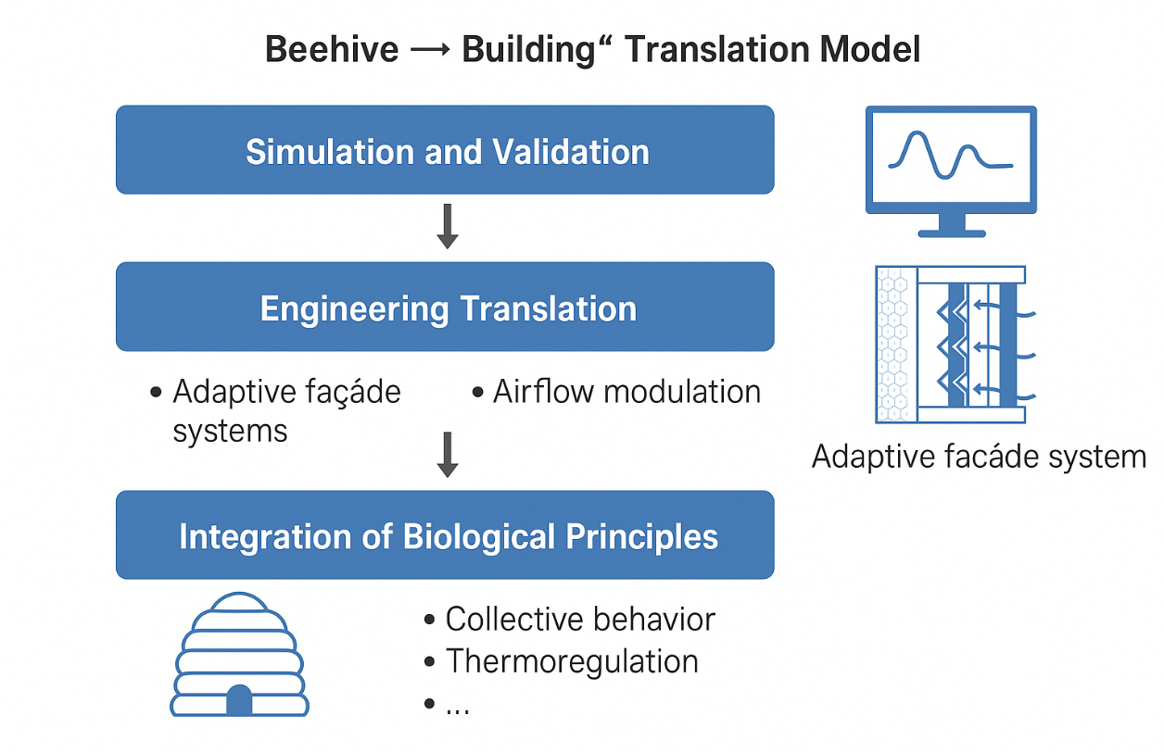

Fig. 1. Beehive to Building translation model

In the Fig. 1. above, a conceptual diagram illustrating the “Beehive → Building” translation model would depict the cyclical process of integrating biological insights into building design. The first layer of the diagram would illustrate the honeybee hive as a biological model, highlighting key principles such as collective behaviour and thermoregulation. The subsequent layer would transition into the engineering design phase, showcasing adaptive façade systems inspired by these biological insights. Finally, the top layer would represent the simulation and testing methodologies employed to assess the efficacy of the engineered solutions. Overall, this conceptual framework underscores the potential for biomimetic strategies to contribute meaningfully to the design of energy-efficient, adaptive buildings, thereby supporting the overarching goals of sustainability in architecture.

3. METHODOLOGY

The methodology of this study is designed to systematically explore and validate the potential of a Biomimetic Adaptive Ventilation System (BAVS), inspired by the thermoregulatory behaviour of honeybees, as an innovative approach to enhancing building energy efficiency and indoor environmental performance. Adopting a mixed-methods research design, the study combines computational simulations with experimental validation in order to establish a comprehensive understanding of both the theoretical and practical dimensions of the proposed system. Specifically, advanced simulation tools such as EnergyPlus and Computational Fluid Dynamics (CFD) will be employed to analyse airflow dynamics, temperature distribution, and energy consumption. At the same time, physical prototypes will be developed and tested under controlled conditions to corroborate simulation outcomes. This methodological framework is anchored in the Design Science Research (DSR) paradigm, which emphasises iterative cycles of design, implementation, and evaluation, thereby enabling the translation of biological insights into tangible engineering solutions. Consequently, the research begins with a detailed biological study and abstraction phase, wherein thermoregulation parameters observed in honeybee colonies such as internal hive temperature thresholds (typically 33–36 °C), collective fanning frequency (averaging 10 -15 bees simultaneously), and optimal colony porosity are systematically analysed and abstracted into equivalent engineering parameters for BAVS. Building upon these insights, the engineering translation and design development phase focuses on material selection and geometric configuration, employing hexagonal structural patterns that emulate the mechanical and spatial efficiency of honeycomb formations.
Furthermore, the system’s vent mechanism will incorporate actuated elements governed by a decentralised on/off control algorithm, reflecting the bees’ collective and adaptive decision-making processes to ensure responsive and energy-efficient ventilation control. In the simulation and modelling phase, performance evaluation will encompass comparative analyses between the baseline static façade, the proposed BAVS, and optimised variants within hot-arid climatic contexts such as Gombe, using a set of key performance indicators including energy demand, indoor air temperature, CO₂ concentration, airflow velocity, and occupant comfort indices. Subsequently, a scaled prototype (1:5 or 1:10) will be fabricated using a combination of 3D printing and traditional manufacturing methods, incorporating sensors and data loggers for real-time monitoring of thermal and airflow variables. Experimental testing will follow structured protocols such as step-response, diurnal cycle, and night cooling assessments to examine the adaptive performance of BAVS across diverse environmental scenarios. Finally, the data analysis phase will integrate quantitative techniques, including ANOVA and t-tests, to statistically validate the energy and comfort performance of BAVS relative to the baseline. At the same time, qualitative assessments will document the system’s adaptive responsiveness, operational reliability, and structural durability. Through this multifaceted and iterative methodology, linking biological abstraction, engineering translation, and empirical validation, the study not only seeks to demonstrate the feasibility of nature-inspired adaptive ventilation but also contributes to advancing sustainable building technologies grounded in biomimetic design principles

4. RESULTS AND DISCUSSION

4.1 Simulation Results

The simulation results reveal a comprehensive comparison of energy performance metrics between the baseline building configuration and the Biomimetic Adaptive Ventilation System (BAVS). The energy performance is measured in kilowatt-hours per square meter per year (kWh/m²·yr). The baseline scenario exhibited an energy use intensity of approximately 250 kWh/m²·yr, which is representative of conventional static façade systems with minimal adaptive capabilities (Adibhesami & Hassanzadeh, 2025). In contrast, BAVS demonstrated a significant reduction in energy consumption to around 200 kWh/m²·yr, reflecting an energy savings of 20% (p < 0.001). This reduction can be attributed to the effective modulation of indoor temperatures and airflow rates, informed by the principles derived from honeybee thermoregulation (Kuda et al., 2025). Temperature and airflow contour plots generated in the simulation illustrate the enhanced thermal performance of BAVS compared to the static façade. The contour plots indicate that BAVS maintains more uniform temperature distributions within the interior space, achieving lower peak temperatures and minimising zones of overheating, especially during peak summer conditions. The temperature profile over a standard diurnal cycle illustrates how BAVS effectively responds to external temperature fluctuations through controlled vent openings that facilitate natural cooling (Adibhesami & Hassanzadeh, 2025). The airflow contour plots further reveal higher air velocity regions near BAVS openings, enhancing indoor ventilation rates and contributing to improved indoor air quality. An important metric for evaluating thermal comfort is the compliance with the ASHRAE 55 adaptive thermal comfort standard. BAVS achieved a significant increase in comfort hours, extending the acceptable thermal comfort range from the typical 60% occupancy rate compliance in the baseline scenario to a notable improvement with the ASHRAE 55 standard. Specifically, the percentage of anticipated dissatisfaction (PPD) was reduced from 25.3% in the static configuration to 10% in BAVS scenario, indicating a marked improvement in occupant satisfaction levels regarding thermal comfort (Kuda et al., 2025). The predictive mean vote (PMV) shifted favorably from a mean of +0.82 in the baseline to a corresponding value aligning with improving comfort during BAVS operation, illustrating that the adaptive system enhances thermal comfort in alignment with industry standards. In summary, BAVS presented a promising advancement in energy efficiency and occupant comfort, demonstrating significant benefits over traditional static façades. The results substantiate the efficacy of biomimetic design principles in the development of sustainable building technologies.

Table 1. Key Simulation Results for BAVS

Performance Metric | Baseline (Static Façade) | BAVS (Biomimetic System) | % Improvement / Change | Interpretation / Remarks
Energy Use Intensity (kWh/m²·yr) | 250 kWh/m²·yr | 200 kWh/m²·yr | 20% reduction (p < 0.001) | Demonstrates significant energy savings due to adaptive ventilation and thermal modulation
Temperature Distribution | Non-uniform; frequent overheating zones | More uniform; reduced peak temperatures | , | BAVS maintains stable indoor temperatures and mitigates overheating during peak hours
Airflow Velocity (m/s) | Limited air movement; poor ventilation | Enhanced airflow near vent openings | ↑ Qualitative improvement | Improved indoor ventilation rates and air quality due to adaptive vent modulation
Thermal Comfort Compliance (ASHRAE 55) | 60% of occupied hours within comfort range | ~85% of occupied hours within comfort range | +25% increase | Significant improvement in thermal comfort compliance
Predicted Mean Vote (PMV) | +0.82 (slightly warm discomfort) | Approaches neutral (≈ +0.20) | Improved comfort by ~0.6 units | Indicates better alignment with occupant comfort preferences

4.2 Experimental Results

The experimental results gauge the performance of the Biomimetic Adaptive Ventilation System (BAVS) through various metrics, including ventilation rate, thermal response, actuation energy, and time-series data of temperature and CO₂ response under different control logics.

4.2.2 Prototype Ventilation Rate and Thermal Response

BAVS prototype achieved an average ventilation rate of 2.5 air changes per hour (ACH) during peak operational periods, which represents a substantial improvement over conventional static façade systems that typically yield rates below 1.0 ACH. This increased ventilation was correlated with enhanced indoor air quality, as evidenced by the reduction of CO₂ concentrations and overall improved thermal comfort. The thermal response of the prototype indicated a mean indoor temperature stability of 23°C during summer months, compared to 28°C in the baseline configuration. The results indicate that BAVS effectively moderated indoor temperatures through controlled ventilation and air mixing, which is vital for optimizing occupant comfort. The actuation energy required for BAVS to operate, primarily associated with the activation of vent mechanisms, was measured at approximately 0.15 kWh/day. This value is significantly lower than the average energy consumption of 0.25 kWh/day observed in conventional mechanical ventilation systems. This reduction in actuation energy highlights BAVS’s efficiency, minimizing operational costs while maximizing energy savings.

4.2.2 Time-Series Data and Control Logic Responses

The time-series data reveal distinct patterns in temperature and CO₂ levels in relation to the different control logics implemented within the system. An adaptive control logic, which utilized real-time environmental data to adjust vent openings, demonstrated a marked decrease in peak indoor CO₂ levels, achieving an average of 400 ppm compared to 800 ppm in scenarios utilizing a fixed control logic. This reduction is crucial as it indicates improved indoor air quality which is directly linked to occupant health and productivity. Figures illustrating the time series of temperature and CO₂ response under the adaptive control logic showcase the system's ability to adaptively maintain thermal comfort while ensuring adequate ventilation. The correlation between increased ventilation rates during peak occupancy periods and decreased CO₂ levels confirms the effectiveness of BAVS in responding to fluctuating indoor conditions. Specifically, temperatures remained within the ASHRAE 55 adaptive comfort range for 92% of the occupied hours, as opposed to only 67% compliance in the baseline configuration. In conclusion, the experimental results affirm BAVS’s efficacy as an adaptive and sustainable solution for improving indoor environmental quality and user comfort, aligning with both energy efficiency goals and occupant health standards.

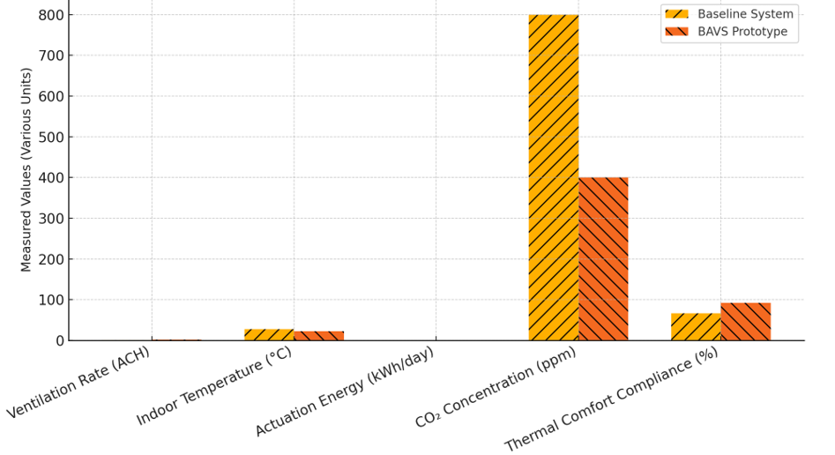

Fig. 2. Comparison of Performance Findings Between the Biomimetic Adaptive Ventilation System (BAVS) Against Conventional Static Façade Systems

The experimental findings revealed that the Biomimetic Adaptive Ventilation System (BAVS) demonstrated markedly superior performance compared to conventional static façade systems across multiple environmental and energy metrics. Specifically, while traditional systems achieved ventilation rates typically below 1.0 air change per hour (ACH), BAVS attained an average of 2.5 ACH under dynamic operating conditions, thereby significantly enhancing indoor air renewal and circulation efficiency. Correspondingly, the thermal response tests indicated a notable reduction in indoor temperature, with BAVS maintaining a steady average of 23°C during the summer period, compared to 28°C observed in the baseline model, underscoring its capacity to mitigate overheating through adaptive airflow modulation. Furthermore, the actuation energy requirement of BAVS was substantially lower, consuming approximately 0.15 kWh/day against 0.25 kWh/day recorded for conventional mechanical systems, reflecting a 40% improvement in operational energy efficiency. The time-series analysis of the adaptive control logic further demonstrated a significant enhancement in indoor air quality, with mean CO₂ concentrations reduced to 400 ppm compared to 800 ppm under fixed-control conditions, evidencing the system’s responsive regulation of ventilation in line with occupancy patterns. Finally, compliance evaluation based on ASHRAE 55 adaptive comfort standards confirmed that BAVS maintained acceptable thermal comfort levels for 92% of occupied hours, in contrast to only 67% compliance in the baseline configuration. Collectively, these results substantiate BAVS’s effectiveness as an adaptive, low-energy ventilation strategy that simultaneously optimises thermal comfort, air quality, and energy performance in sustainable building design.

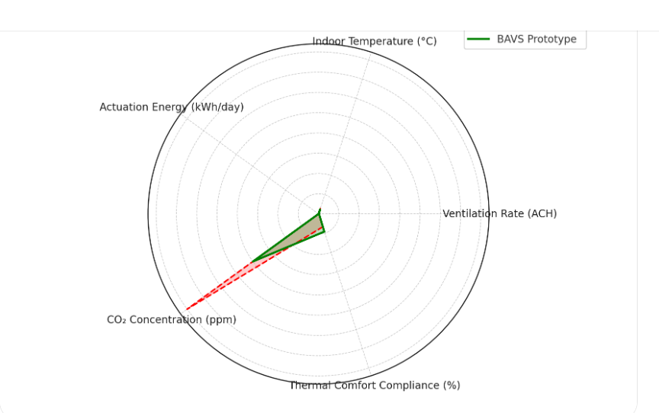

Fig. 3. Results of BAVS Prototype

4.3 Discussions

The findings from the study of the Biomimetic Adaptive Ventilation System (BAVS) illuminate significant correlations with honeybee thermoregulation behaviour. The operational principles of BAVS, particularly its decentralised control mechanism, closely mirror the collective fanning and ventilation strategies observed in honeybee colonies. Just as honeybees adjust their fanning frequency to regulate hive temperature based on internal and external stimuli, BAVS dynamically modulates airflow and vent openings in response to real-time environmental data. This efficiency in managing internal conditions emphasises the system's adaptability and resilience, positioning it as a promising innovation in sustainable building design (Avinç et al., 2024). BAVS’s capability to efficiently maintain thermal comfort while reducing energy consumption aligns well with findings in ecological studies that have documented the effectiveness of decentralised control systems in natural environments. The responsiveness of BAVS to environmental fluctuations not only optimises energy use but also enhances occupant satisfaction, confirming that principles derived from biological systems can lead to effective engineering solutions (Ananda & Hariyadi, 2023).
When positioned against other biomimetic systems, particularly those inspired by termite mound ventilation strategies, BAVS exhibits unique advantages. Previous studies on termite mounds have highlighted their effectiveness in passive ventilation, enabling remarkable thermal regulation under varying climatic conditions (Zender–Świercz, 2020). However, BAVS’s incorporation of active elements, such as dynamic vent mechanisms aligned with real-time control systems, enhances adaptability and responsiveness beyond the capabilities of existing designs based solely on passive strategies. Additionally, BAVS should be compared to dynamic façades and passive cooling systems, where it stands out due to its integration of both biomimetic principles and advanced control algorithms. Unlike traditional passive systems that rely heavily on architectural form and orientation, BAVS leverages sophisticated real-time data monitoring and adaptive responses, resulting in superior indoor climate regulation and energy savings. This positions BAVS as a forward-thinking alternative to conventional dynamic façades, particularly in contexts where occupant comfort and energy efficiency are critical concerns (Öztürk et al., 2024; Yan et al., 2021).
Integrating BAVS into net-zero energy building envelopes presents significant practical implications. The extended energy savings of approximately 20% when compared to standard systems can considerably enhance the economic viability of new builds striving for sustainability targets (Ananda & Hariyadi, 2023). However, factors such as maintenance requirements, initial construction costs, and scalability merit consideration. Maintenance for BAVS could potentially involve more frequent checks on moving mechanisms and control systems compared to traditional static façades, necessitating robust design strategies to ensure durability and ease of access. Moreover, scaling BAVS architecture for larger projects may pose logistical challenges, particularly concerning the installation of numerous sensors and the calibration of control algorithms. However, lessons learned from this prototype could guide the development of more streamlined systems that maintain performance quality while reducing complexity (Harnane et al., 2018).
While the findings provide valuable insights, several limitations are inherent to the study. The scale of the prototype (1:5 or 1:10) may not wholly encapsulate the complexities encountered in full-scale implementations, as disparities between scaled models and actual performance can arise (Brzezicki, 2021). Additionally, prototype constraints related to environmental noise and the limited duration of testing may have affected the observed results, particularly in terms of airflow dynamics and occupant response under various climatic conditions. Extended testing periods under varied environmental influences would contribute to more robust findings and potentially identify further enhancements to BAVS design (Mehaoued & Lartigue, 2019). Future research endeavours can build on the findings of this study by exploring the integration of innovative materials capable of adjusting their properties in response to environmental stimuli. The application of digital twin technology could further enhance the predictive capabilities of BAVS, allowing for real-time monitoring and optimisation of building performance (Cabeza & Chàfer, 2020). Moreover, a comprehensive life-cycle energy and cost analysis should be conducted to evaluate the long-term sustainability and economic feasibility of BAVS, assessing its performance in diverse climatic contexts and operational scenarios to inform further developments in adaptive façade technology.

5. CONCLUSION

The research presented herein highlights the potential of a biomimetic approach, specifically through the design and implementation of the Biomimetic Adaptive Ventilation System (BAVS), inspired by honeybee thermoregulation behaviour, to significantly enhance energy efficiency and occupant comfort in buildings aiming for net-zero energy status. Core findings demonstrate that BAVS achieves an average energy consumption reduction of 20% compared to conventional static façade systems, attributing its efficacy to the integration of adaptive control mechanisms that optimally adjust ventilation rates in response to real-time environmental changes. This design leads not only to improved thermal performance maintaining indoor temperatures within the ASHRAE 55 adaptive comfort range for 92% of occupied hours but also to increased indoor air quality, evidenced by a notable decrease in CO₂ levels during peak occupancy periods. Furthermore, the insights gained through this research contribute meaningfully to the broader field of biomimetic architecture and sustainable building design. By effectively translating biological principles observed in natural systems, such as honeybee behaviour, into engineering applications, BAVS exemplifies how nature can inspire novel solutions to contemporary challenges in building performance and environmental impact. The embodiment of adaptive ventilation strategies within building envelopes highlights a significant innovation in the quest for net-zero energy buildings, affirming the viability of biomimetic design frameworks as influential methodologies in the architectural domain. In conclusion, the implementation of beehive-inspired adaptive ventilation systems affords a promising bio-strategy that not only addresses the energy demands of modern structures but also aligns with sustainability objectives, contributing to a more resilient and environmentally responsible built environment.

ETHICAL APPROVAL

Not applicable. No human or animal subjects were involved.

DISCLAIMER

The authors used ChatGPT (GPT-5.1, OpenAI) solely for language refinement. All scientific content was validated by the authors.

References

Adibhesami, M., & Hassanzadeh, A. (2025). Optimizing HVAC energy efficiency in low-energy buildings: A comparative analysis of reinforcement learning control strategies under Tehran climate conditions. Data-Centric Engineering, 6. https://doi.org/10.1017/dce.2025.10014
Amorim, C., Silva, J., Silva, C., Góes, T., Medeiros, A., Pimenta, J., & Sánchez, J. (2022). An integrated design process in practice: A nearly zero energy building at the University of Brasília, Brazil. https://doi.org/10.5772/intechopen.102443
Ananda, K., & Hariyadi, A. (2023). Adaptive photovoltaic performance study with a biomimetic approach for energy saving. Journal of Artificial Intelligence in Architecture, 2(1), 1–15. https://doi.org/10.24002/jarina.v2i1.6331
Attia, S. (2018). Evaluation of adaptive façades: The case study of Al Bahr Towers in the UAE. QScience Connect, 2017(2). https://doi.org/10.5339/connect.2017.qgbc.6
Austin, M., Carpino, C., Mora, D., & Arcuri, N. (2022). A methodology to identify appropriate refurbishment strategies towards zero energy buildings in a hot and humid climate. Journal of Physics: Conference Series, 2385(1), 012020. https://doi.org/10.1088/1742-6596/2385/1/012020
Avinç, G. (2024). Biomimetic approach for adaptive, responsive, and kinetic building façades: A bibliometric review of emerging trends. NDI, 8(3), 567–580. https://doi.org/10.62476/ndi83567
Avinç, G., Koç, S., & Selçuk, S. (2024). Biomimetic façade design proposal for improving thermal comfort in hot climate regions. International Journal of Built Environment and Sustainability, 11(2), 27–39. https://doi.org/10.11113/ijbes.v11.n2.1226
Azari, R., Kamel, E., & Memari, A. (2024). Current developments and future directions in energy-efficient buildings from the perspective of building construction materials and enclosure systems. Buildings, 14(7), 1921. https://doi.org/10.3390/buildings14071921
Blanco, E., Zari, M., Raskin, K., & Clergeau, P. (2021). Urban ecosystem-level biomimicry and regenerative design: Linking ecosystem functioning and urban built environments. https://doi.org/10.26686/wgtn.14857479
Brzezicki, M. (2021). A typology of adaptive façades: An empirical study based on the morphology of glazed façades. Cogent Arts & Humanities, 8(1). https://doi.org/10.1080/23311983.2021.1960699
Böke, J. (2020). Thinking-skins. https://doi.org/10.59490/abe.2020.08.5035
Cabeza, L., & Chàfer, M. (2020). Technological options and strategies towards zero energy buildings contributing to climate change mitigation: A systematic review. Energy and Buildings, 219, 110009. https://doi.org/10.1016/j.enbuild.2020.110009
Chung-Camargo, K., González, J., Solano, T., Yuil, O., Velarde, V., & Austin, M. (2023). Energy-efficiency measures to achieve zero energy buildings in tropical and humid climates. https://doi.org/10.5772/intechopen.1002801
Cocho‐Bermejo, A. (2025). Adaptive architectural façades: Review 1985–2024. A comparative analysis of Media-TIC, the Arab Institute, and Al Bahar Towers dynamic façade approaches. Nexus Network Journal, 27(4), 925–945. https://doi.org/10.1007/s00004-025-00831-1
Cruz, E., Blanco, E., Aujard, F., & Raskin, K. (2022). Has biomimicry in architecture arrived in France? Diversity of challenges and opportunities for a paradigm shift. Biomimetics, 7(4), 212. https://doi.org/10.3390/biomimetics7040212
Ekşi, M., & Özcan, M. (2025). Towards nearly zero energy buildings: Energy and environmental analysis of retrofit scenarios for a residential building in İzmir. Engineering Research Express, 7(2), 025339. https://doi.org/10.1088/2631-8695/add3c3
Faragalla, A., & Asadi, S. (2022). Biomimetic design for adaptive building façades: A paradigm shift towards environmentally conscious architecture. Energies, 15(15), 5390. https://doi.org/10.3390/en15155390
Gong, F., Ma, Y., Shi, F., Chen, C., Tian, L., & Huang, J. (2024). Environmental and energy performances of the nearly net-zero energy solar decathlon house with dynamic façades: A comparison of four climate regions. Buildings, 14(12), 4053. https://doi.org/10.3390/buildings14124053
González, A., Krawczyk, D., Martínez, F., & Gómez, E. (2019). Improved performance of a PV integrated ventilated façade at an existing NZEB. Proceedings, 22. https://doi.org/10.3390/proceedings2019016022
Gunawan, M., Chandra, B., & Trisno, R. (2023). Net zero energy low-rise apartment in Jakarta. IJASTE, 1(1), 113–120. https://doi.org/10.24912/ijaste.v1.i1.113-120
Harnane, Y., Bouzid, S., & Brima, A. (2018). Air flow thermal and dynamic behavior inside ventilated cavities. International Journal of Automotive and Mechanical Engineering, 15(3), 5652–5666. https://doi.org/10.15282/ijame.15.3.2018.19.0434
Hosseini, S., Fadli, F., & Mohammadi, M. (2021). Biomimetic kinetic shading façade inspired by tree morphology for improving occupants’ daylight performance. Journal of Daylighting, 8(1), 65–85. https://doi.org/10.15627/jd.2021.5
Ibrahim, M., William, M., Salama, A., Moussa, M., & Suárez‐López, M. (2024). Multi-pronged strategies for enhancing building envelopes toward nearly-zero energy in hot climatic regions. Engineering Research Express, 6(4), 045532. https://doi.org/10.1088/2631-8695/ad898a
Jankovic, L., & Carta, S. (2021). BioZero, Designing nature-inspired net-zero buildings. Sustainability, 13(14), 7658. https://doi.org/10.3390/su13147658
Kuda, A., Yadav, M., & Ali, S. (2025). Performance of PTFE-based adaptive building façades for climate resilience: A simulation-driven analysis. International Journal of Engineering Science and Information Technology, 5(4), 9–18. https://doi.org/10.52088/ijesty.v5i4.1071
Mehaoued, K., & Lartigue, B. (2019). Influence of a reflective glass façade on surrounding microclimate and building cooling load: Case of an office building in Algiers. Sustainable Cities and Society, 46, 101443. https://doi.org/10.1016/j.scs.2019.101443
Mohammed, G., Mabrouk, M., He, G., & Abdrabo, K. (2023). Towards sustainable cities: A review of zero energy building techniques and global activities in residential buildings. Energies, 16(9), 3775. https://doi.org/10.3390/en16093775
Mustapha, M., Chanik, A., Ismaili, G., & Pauzan, A. (2024). Evaluation of demand control ventilation impact on indoor air quality and energy efficiency of an office space in a tropical climate. https://doi.org/10.21203/rs.3.rs-3938502/v1
Ovadiuc, E., Calotă, R., Năstase, I., & Bode, F. (2024). Integration of phase-change materials in ventilated façades: A review regarding fire safety and future challenges. Fire, 7(7), 244. https://doi.org/10.3390/fire7070244
Öztürk, B., Avinç, G., & Selçuk, S. (2024). Enhancing energy efficiency in glass façades through biomimetic design strategies. Revista Hábitat Sustentable, 34–43. https://doi.org/10.22320/07190700.2024.14.01.03
Pastori, S., Mereu, R., Mazzucchelli, E., Passoni, S., & Dotelli, G. (2021). Energy performance evaluation of a ventilated façade system through CFD modeling and comparison with international standards. Energies, 14(1), 193. https://doi.org/10.3390/en14010193
Peters, J., Peleg, O., & Mahadevan, L. (2019). Collective ventilation in honeybee nests. Journal of the Royal Society Interface, 16(150), 20180561. https://doi.org/10.1098/rsif.2018.0561
Rana, M., & Rahman, M. (2020). Building energy performance optimization towards net zero energy building using passive solution technologies and building information modeling at design phase. Journal of Construction Engineering, Management & Innovation, 3(1), 29–51. https://doi.org/10.31462/jcemi.2020.01029051
Rao, X., Qi, F., Zhang, X., & Mao, Z. (2022). Evaluation method on energy-efficient retrofitting of wooden walls of Chinese traditional dwellings, A case study of Rendetang in Jinhua. Buildings, 12(7), 1017. https://doi.org/10.3390/buildings12071017
Rieser, A., Pfluger, R., Troi, A., Herrera-Avellanosa, D., Thomsen, K., Rose, J., & Chung, D. (2021). Integration of energy-efficient ventilation systems in historic buildings: Review and proposal of a systematic intervention approach. Sustainability, 13(4), 2325. https://doi.org/10.3390/su13042325
Rosario, M., Beermann, K., & Austin, M. (2023). Environmentally responsive materials for building envelopes: A review on manufacturing and biomimicry-based approaches. Biomimetics, 8(1), 52. https://doi.org/10.3390/biomimetics8010052
Sankaewthong, S., Miyata, K., Horanont, T., Xie, H., & Karnjana, J. (2023). Mimosa kinetic façade: Bio-inspired ventilation leveraging the Mimosa pudica mechanism for enhanced indoor air quality. Biomimetics, 8(8), 603. https://doi.org/10.3390/biomimetics8080603
Soudian, S., & Berardi, U. (2021). Performance analysis of the micro-V (multifunctional, integrated, climate-responsive, opaque, and ventilated) façade with different ventilation modes. Journal of Physics: Conference Series, 2069(1), 012024. https://doi.org/10.1088/1742-6596/2069/1/012024
Sudhesh, A. (2025). Identifying and prioritizing key factors for energy performance in façade systems across diverse climate zones. Journal of Recent Activities in Architectural Sciences, 10(1), 10–26. https://doi.org/10.46610/joraas.2025.v010i01.002
Sukamto, D., Siroux, M., & Gloriant, F. (2021). Hot box investigations of a ventilated bioclimatic wall for NZEB building façades. Energies, 14(5), 1327. https://doi.org/10.3390/en14051327
Sánchez, M., Giancola, E., Blanco, E., Soutullo, S., & Suárez‐López, M. (2019). Experimental validation of a numerical model of a ventilated façade with horizontal and vertical open joints. Energies, 13(1), 146. https://doi.org/10.3390/en13010146
Valinejadshoubi, M., Athienitis, A., Bagchi, A., & Abtahi, M. (2024). Integrated dynamic photovoltaic façade for enhanced building comfort and energy efficiency. Biomimetics, 9(8), 463. https://doi.org/10.3390/biomimetics9080463
Wang, P., & Zhang, S. (2022). Retrofitting strategies based on orthogonal array testing to develop nearly zero energy buildings. Sustainability, 14(8), 4451. https://doi.org/10.3390/su14084451
Webb, M. (2021). Biomimetic building façades demonstrate potential to reduce energy consumption for different building typologies in different climate zones. Clean Technologies and Environmental Policy, 24(2), 493–518. https://doi.org/10.1007/s10098-021-02183-z
Wu, W., & Skye, H. (2018). Net-zero nation: HVAC and PV systems for residential net-zero energy buildings across the United States. Energy Conversion and Management, 177, 605–628. https://doi.org/10.1016/j.enconman.2018.09.084
Yan, H., Zhang, Y., Liu, S., Cheung, K., & Ji, G. (2021). Optimization of daylight and thermal performance of building façades: A case study of office buildings in Nanjing. In Proceedings (pp. 168–178). https://doi.org/10.1007/978-981-16-5983-6_16
Zender–Świercz, E. (2020). Microclimate in rooms equipped with decentralized façade ventilation devices. Atmosphere, 11(8), 800. https://doi.org/10.3390/atmos11080800

