Case report

DIAGNOSIS AND THERAPEUTIC MANAGEMENT OF HEPATOZOON CANIS INFECTION IN A GREAT DANE DOG

.
ABSTRACT
A three-year-old Great Dane was presented to the veterinary polyclinic in Thoothukudi with a history of intermittent fever, anorexia, weight loss, and hind limb lameness for the past two weeks. Clinical examination showed a pale conjunctival mucous membrane, cachexia, enlarged popliteal lymph nodes, and heavy tick infestation. Hematological parameters revealed normocytic, normochromic anemia, neutrophilia, and thrombocytopenia. Blood biochemistry showed mildly elevated liver enzymes, hyperproteinemia, and hypoalbuminemia. Peripheral blood smear examination with Giemsa stain under the microscope revealed multiple Hepatozoon canis gamonts in neutrophils. Furthermore, confirmation was obtained using PCR targeting the species-specific 18S rRNA gene of Hepatozoon spp. confirming this case as Canine Hepatozoonosis. The dog was successfully treated with imidocarb dipropionate, doxycycline, and supportive therapy, and the animal showed significant clinical improvement after one week of treatment.

Keywords: Hepatozoon canis, Haemoprotozoa, Neutrophils, Ticks, Canine, Great Dane

1. INTRODUCTION

Hepatozoon canis is an obligate intracellular apicomplexan protozoan parasite that causes a canine vector-borne hemoprotozoan disease through ingestion of infected ticks, most commonly the Rhipicephalus sanguineus (brown dog tick), which acts as the definitive host (Hasani et al., 2024). Canine hepatozoonosis is one of the clinically important diseases in veterinary practice that occurs worldwide, particularly in Africa, South America, Australia, Asia, including India (Vincent-Johnson et al., 2021). In India, hepatozoonosis has recently been reported from almost all states, mainly from Tamil Nadu, Maharashtra, Andhra Pradesh, Haryana, and Gujarat, among others (Panda et al., 2024; Bhagwan et al., 2025; Revathi et al., 2025). Globally, canine hepatozoonosis is caused by more than 340 species of Hepatozoan parasites, most commonly by H. canis, H. americanum, and H. felis in dogs and cats (Abdullah et al., 2024). The parasite undergoes a heterogeneous life cycle with vertebrates as intermediate hosts and invertebrate ticks as final hosts, where sporulation takes place (Gutiérrez-Liberato et al., 2021). Dogs primarily acquire the infection by ingesting ticks that contain mature sporulated oocysts (Jaiswala et al., 2023). R. sanguineus is the most common vector responsible for the spread of infection in dogs, found in temperate and tropical regions of countries, and plays a major role in the geographical spread and landscape epidemiology of canine hepatozoonosis (Chisu et al., 2023). Unlike other canine tick-borne protozoan parasites, H. canis infects both white blood cells and various tissues of the host body (Hasani et al., 2024). Hepatozoan sporozoites spread through the bloodstream and lymphatic system to various organs, including the lungs, liver, spleen, kidneys, and bone marrow, infecting WBCs and various tissue parenchyma (Vásquez-Aguilar et al., 2021). The disease is characterized by fever, anemia, emaciation, cachexia, lethargy, and muscular weakness, manifesting in various forms such as subclinical, acute, and chronic (Thao et al., 2025). However, the subclinical form is the most common in dogs and can be treated with proper therapy (Tołkacz et al., 2023). The severity of the disease and clinical manifestations depend on the immune status of the host and the level of parasitemia in the bloodstream (Matamoros-Suárez et al., 2025). Infection in dogs and cats can occur in many forms, with relapses often triggered by stress or concurrent parasitic infestations (Kolangath et al., 2024). This present paper reports the diagnosis and therapeutic management of H. canis infection in a Great Dane.

2. CASE HISTORY AND Diagnosis
A three-year-old male Great Dane was presented to the veterinary polyclinic, Thoothukudi, with a history of heavy tick infestation, intermittent fever, lethargy, anorexia, paraparesis, and cachexia persisting for the past two weeks. On physical examination, the rectal temperature was 103.5ºF (39.7ºC), indicating mild pyrexia, pulse rate 117/min, and respiratory rate 33/min. The mucous membranes appeared pale pink (Fig. 1), having a capillary refill time of approximately 2 seconds, suggesting anemia, and the popliteal lymph nodes were moderately enlarged. Ticks were observed attached to the ear margins and neck region. No other abnormalities were detected upon thoracic or abdominal auscultation.

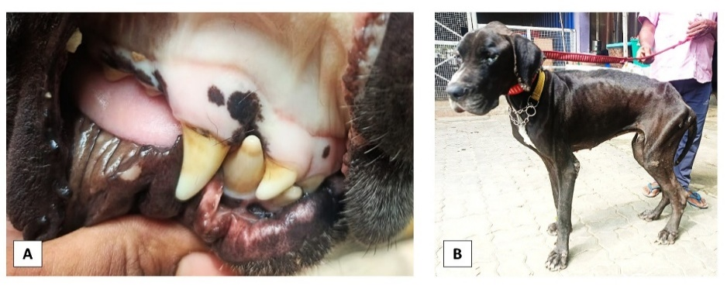

Fig. 1. Clinical presentation of the Dog
[A- Pale mucous membrane, B- Emaciated body condition]

Peripheral blood smear, when stained with Giemsa, revealed oval capsule shaped gamonts of Hepatozoon canis within neutrophils (Fig. 2). Hematological examination revealed marked regenerative normocytic, normochromic Anaemia with Hb (7.2 g/dL), PCV (24%), RBC (3.5×10⁶/µL), significant leukocytosis with WBC (23.2×10³/µL), neutrophilia (82%), and thrombocytopenia (85×10³/µL). Biochemical analysis indicated mildly elevated liver enzymes (ALT 190 U/L, ALP 310 U/L), and hyperproteinemia (8.1 g/dL) with hypoalbuminemia (2.1 g/dL). To confirm the infection, Polymerase Chain Reaction (PCR) was carried out on EDTA-anticoagulated whole blood as described earlier (Inokuma et al., 2002; Chisu et al., 2023) using species-specific primers (Hep-F (5′-ATACATGAGCAAAATCTCAAC-3′) and Hep-R (5′-CTTATTATTCCATGCTGCAG-3′) targeting the 18S rRNA gene of Hepatozoon spp. Amplification yielded a 625-bp band (Fig. 3), characteristic of Hepatozoon canis, thereby confirming the diagnosis.

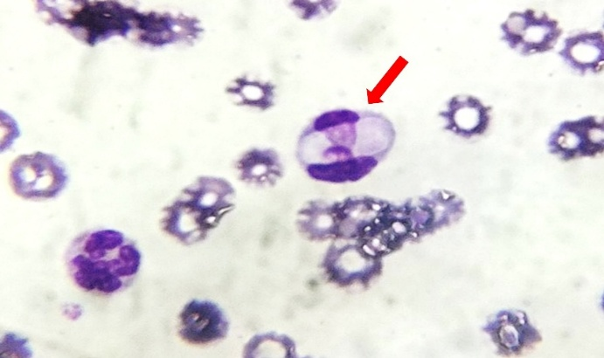

Fig. 2. H. canis gametocyte (Red arrowed) within a neutrophil [magnification ×1000]

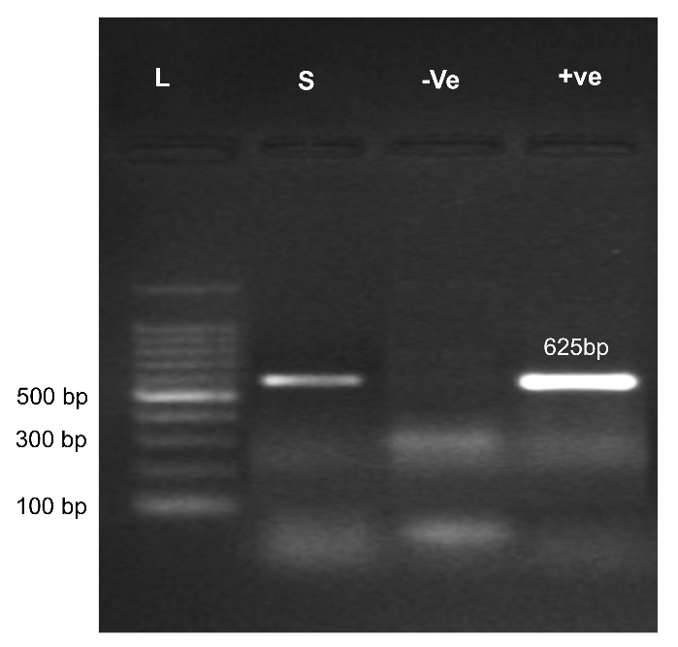

Fig. 3. H. canis genus-specific 18S rRNA PCR

[L- 100bp Ladder; S- Sample (625 bp); -Ve- Negative control; +Ve- Positive control]

3. TREATMENT AND CASE DISCUSSION
The dog was treated with antiprotozoal therapy comprising Imidocarb dipropionate, which is the primary drug of choice for Hepatozoon canis infection, at a dose rate of 6 mg/kg body weight through IM, with a repeated dose administered after 14 days. Nonsteroidal Anti-Inflammatory Drug, Meloxicam, was administered at a dose rate of 0.2 mg/kg SC to reduce the pyrexia. Intravenous crystalloid fluid, Normal Saline (0.9% NaCl) was administered IV at a dose rate of 70 ml/Kg/day to correct dehydration. B-complex vitamin injection (0.5 mL/10 kg IM), Iron dextran injection (15 mg/Kg IM) was also administered as supportive therapy. Doxycycline was prescribed at 10 mg/kg body weight orally (PO) twice daily (BID) for 21 days. Adjunctive management included hepatoprotective syrup (Silymarin and B-complex vitamins @ 5 mL twice daily PO) to enhance hepatic function, Hematinic syrup (Fe-folate @ 5 mL twice daily PO) for 1 month to correct anemia. The owner was advised to follow strict tick control measures using fluralaner chewable tablets and to prevent reinfestation, Fipronil 0.25 % spray was recommended to be applied once every 15 days. To enhance appetite and recovery, Threptin biscuits were given twice daily as a source of high-quality protein and essential amino acids. Marked clinical improvement was observed within one week of initiating therapy, with a gradual increase in appetite, reduction in body temperature, mucous membranes regaining normal pink colouration, and improvement in general activity. A follow-up hematological assessment was performed after 21 days, which revealed hemoglobin (12.9g/dL), Packed Cell Volume (38%), and RBC (5.8×10⁶/µL) levels returned towards the normal range. WBC (13.2×10³/µL) and neutrophil (69%) counts had normalized, platelet (265×10³/µL) numbers showed marked recovery, liver enzymes had decreased significantly; ALT (98 U/L), ALP (165 U/L) accompanied by decrease in total protein (6.8 g/dL) and improvement in serum albumin concentrations (3 g/dL) and blood smear negative for gamonts collectively indicating a favorable therapeutic response. The results of pre- and post-treatment hematological, biochemical parameters, and peripheral blood smear examination are depicted in Table 1.

Table 1. Pre- and post-treatment hematology and Biochemical profile

Parameter | Pre treatment | Post-Treatment after 21 Days
Hematological parameters
Hemoglobin (g/dL) | 7.2 g/dL | 12.9g/dL
Hematocrit / Packed Cell Volume (%) | 24% | 38%
Total Erythrocytes/RBC | 3.5×106/µL | 5.8×106/µL
Total Leucocyte/WBC | 23.2×103/µL (Leukocytosis) | 13.2×103/µL
Neutrophils (%) | 82% (Neutrophilia) | 69%
Platelets | 85×103/µL (Thrombocytopenia) | 265×103/µL
Biochemical parameters
ALT (Alanine Transaminase) | 190 U/L | 98 U/L
ALP (Alkaline Phosphatase) | 310 U/L | 165 U/L
Total Protein (g/dL) | 8.1 g/dL (hyperproteinemia) | 6.8 g/dL
Serum albumin (g/dL) | 2.1 g/dL (hypoalbuminemia) | 3 g/dL
Peripheral blood smear examination
Presence of Gamonts in Neutrophils | Present | Absent

The combination of imidocarb dipropionate and doxycycline has been reported to be highly effective in the treatment of canine hepatozoonosis (Jusu and Das, 2025; Tanwar et al., 2022). Imidocarb exerts its antiparasitic action by interfering with the parasite’s DNA and nucleic acid metabolism, leading to the death of protozoa, thereby improving hematological and biochemical parameters (Saleem et al., 2025; Riviere and Papich, 2018), whereas doxycycline aids in controlling potential secondary bacterial infections (Hasani et al., 2024). Supportive therapy with hepatoprotectants, hematinics, and vitamin supplements enhances recovery and improves hematological parameters (Aiello & Moses, 2016; Thakur et al., 2018). Similarly, earlier reports also suggested the combination therapy to alleviate the canine hepatozoonosis (Pizzaia Henrique et al., 2024). Reports by many clinicians suggest that at least eight weeks of treatment is required to eliminate H. canis gamonts from peripheral blood (Tanwar et al., 2022); however, in our case, no gamonts could be detected after 21 days of complete treatment. Dogs affected with Hepatozoon canis infection commonly exhibit non-specific clinical signs such as fever, anemia, weight loss, lethargy, and weakness, and can be treated with a combination of drugs with supportive therapy (Esteves, 2024). The disease pathogenesis involves parasitic invasion of neutrophils and monocytes, leading to inflammatory responses and muscle degeneration (Khalifa and Attia, 2024). However, Early diagnosis, antiprotozoal therapy, and regular follow-up with effective tick control measures, such as the use of acaricides monthly once, remain the fundamental components for successful treatment and management of Hepatozoon canis (Baneth and Allen, 2022).

4. Conclusion

Hepatozoon canis infection is an important tick-borne protozoan disease of dogs, characterized by fever, lethargy, anemia, and emaciation. The disease can be diagnosed through peripheral blood smear examination, PCR, and hematobiochemical analysis. Early detection and appropriate treatment using antiprotozoal drugs such as imidocarb dipropionate or doxycycline with other supportive care can improve recovery and reduce mortality. Regular tick control measures, maintenance of hygiene, and routine screening of dogs are essential to prevent infection and recurrence.

DISCLAIMER (ARTIFICIAL INTELLIGENCE)
Author(s) hereby declares that NO generative AI technologies such as Large Language Models (ChatGPT, COPILOT, etc) and text-to-image generators have been used during the writing or editing of this manuscript.

COMPETING INTERESTS
This work was carried out in collaboration between all the authors

References

Abdullah, M., Ali, R. J. S., & Nazeer, I. (2024). Canine and Feline Hepatozoonosis in Asia: Epidemiology and Clinical Insights. Trends in Animal and Poultry Sciences, 2(2), 14-20.

Aiello, S. E.,&amp; Moses, M. A. (2016). The Merck Veterinary Manual. 11th ed. Merck &amp; Co., Kenilworth, New Jersey.

Baneth, G., & Allen, K. (2022). Hepatozoonosis of dogs and cats. Veterinary Clinics: Small Animal Practice, 52(6), 1341-1358. https://doi.org/10.1016/j.cvsm.2022.06.011

Bhagwan, J., Singh, Y., Jhambh, R., Kumar, P., Sharma, M., Kumar, A., & Banger, Y. (2025). Molecular Characterization, Haemato-Biochemical Profile and Risk Factor of Hepatozoon Canis Infection in Dogs From, Haryana, India. Acta Parasitologica, 70(4), 169. https://doi.org/10.1007/s11686-025-01103-1

Chisu, V., Giua, L., Bianco, P., Masala, G., Sechi, S., Cocco, R., & Piredda, I. (2023). Molecular survey of Hepatozoon canis infection in domestic dogs from Sardinia, Italy. Veterinary Sciences, 10(11), 640. https://doi.org/10.3390/vetsci10110640

Esteves, M. F. D. S. F. (2024). Detection of Canine Vector-Borne Diseases Agents in Galgo Español Used as Hunting Dogs in Alentejo, Portugal (Master's thesis, Universidade de Lisboa (Portugal)). http://hdl.handle.net/10400.5/30765

Gutiérrez-Liberato, G. A., Lotta-Arévalo, I. A., Rodríguez-Almonacid, C. C., Vargas-Ramírez, M., & Matta, N. E. (2021). Molecular and morphological description of the first Hepatozoon (Apicomplexa: Hepatozoidae) species infecting a neotropical turtle, with an approach to its phylogenetic relationships. Parasitology, 148(6), 747-759. https://doi.org/10.1017/S0031182021000184

Hasani, S. J., Rakhshanpour, A., Enferadi, A., Sarani, S., Samiei, A., & Esmaeilnejad, B. (2024). A review of Hepatozoonosis caused by Hepatozoon canis in dogs. Journal of Parasitic Diseases, 48(3), 424-438. https://doi.org/10.1007/s12639-024-01682-2

Inokuma, H., Okuda, M., Ohno, K., Shimoda, K., & Onishi, T. (2002). Analysis of the 18S rRNA gene sequence of a Hepatozoon detected in two Japanese dogs. Veterinary Parasitology, 106(3), 265-271. https://doi.org/10.1016/s0304-4017(02)00065-1

Ivanov, A., & Tsachev, I. (2008). Mini-review Hepatozoon canis and Hepatozoonosis in the dog. Trakia Journal of Sciences, 6(2), 27. https://vertexaisearch.cloud.google.com/grounding-api-redirect/AUZIYQEd90lwWSKHA4rIl-lRXmOliavhPPJrF5r-ytNyD1wblgQiimxuSY69WTSiO0vE7c88X5yffLmgOmEDX6g4xStfsB4WC4eyIzqfP3d39b1K3n6dhbgsQcafJbKUPyFFlb9ilvvCGETrh9n3Qw8eyKjXzNU-0Y_O8T57ZjFy4LvFSEguADW6E0g3QO_w5NieEgZXDeO3qg04FqCqE=

Jaiswala, A. K., Kumara, P., Agrawalb, V., Singhc, A., & Singhd, S. K. (2023). Parasites of the musculoskeletal system. Organ-Specific Parasitic Diseases of Dogs and Cats, 265. https://doi.org/10.1016/B978-0-323-95352-8.00012-6

Jusu, G. Y., & Das, G. (2025). Therapeutic management of hepatozoonosis in a domestic dog in Nagaland, India-A case report. Indian J Anim Health, 64(1), 190-192. https://doi.org/10.36062/ijah.2024.09824

Khalifa, M. M., & Attia, M. M. (2024). Pathogenic effects of Hepatozoon canis (Apicomplexa: Hepatozoidae) on pet dogs (Canis familiaris) with amplification of immunogenetic biomarkers. Comparative Clinical Pathology, 33(2), 223-230. https://doi.org/10.1007/s00580-023-03542-6

Kolangath, S. M., Pawshe, M. D., Upadhye, S. V., Dhoot, V. M., Patil, M. S., & Kolangath, R. M. (2024). Molecular evidence of hepatozoonosis in tigers of Vidarbha region of Maharashtra State of India. BMC Veterinary Research, 20(1), 387. https://doi.org/10.1186/s12917-024-04224-3

Matamoros-Suárez, R., Montenegro, V. M., Villalobos-Brenes, F., Llaberia-Robledillo, M., Solano-Barquero, A., Baneth, G., ... & Rojas, A. (2025). Host switching is the main driver of coevolution between Hepatozoon parasites and their vertebrate hosts. Parasites & Vectors, 18(1), 293. https://doi.org/10.1186/s13071-025-06870-4

Panda, R., Nehra, A. K., Ram, H., Karikalan, M., Garg, R., Nala, R. R., & Pawde, A. M. (2024). Phylogenetic analysis and haplotype networking of Hepatozoon felis infecting wild animals in Gir National Park, Gujarat, India. Parasitology Research, 123(1), 92. https://doi.org/10.1007/s00436-023-08109-6

Pizzaia Henrique, A. L., Mendes Miranda, L., & Castilioni, L. (2024). Insights of hepatozoonosis transmitted by H. Canis. Revista de Ciencias Agroveterinarias, 23(2). https://doi.org/10.5965/223811712322024346

Revathi, P., Bharathi, M. V., Madhanmohan, M., Latha, B. R., & Rani, K. V. (2025). Molecular Epidemiology, Characterisation of Hepatozoon canis in Dogs as well as in Ticks and Haemato-biochemical Profile of the Infected Dogs in Chennai. Indian Journal of Animal Research, 59(5). https://doi.org/10.18805/IJAR.B-4801

Riviere, J.E., &amp; Papich, M. G. (2018). Veterinary Pharmacology and Therapeutics, 10th Edition. Wiley-Blackwell. https://www.wiley.com/en-us/Veterinary+Pharmacology+and+Therapeutics,+10th+Edition-p-9781118855829

Saleem, M. A. U., Wisal, M. A., Waqas, M., Mohsin, M., & Aleem, M. T. (2025). Anti-parasitic Drugs. In Organ-specific Parasites in Cattle (pp. 249-269). Bentham Science Publishers. https://doi.org/10.2174/97898153221011250101

Tanwar, J., Solanki, P., Marwaha, S., & Kachhawa, J. P. (2022). Combination therapy with imidocarb dipropionate and doxycycline to clear infection of Hepatozoon canis in dog.

Thakur, N., Chethan, G. E., Akhilesh, A. L., Kumari, P., Shehzad, M., Rajesh, J. B., ... & Banerjee, P. S. (2018). Therapeutic management of Hepatozoon canis induced acute hepatitis in a dog. Hemoglobin (g/dl), 8(12.1), 12-19. http://www.entomoljournal.com/archives/2018/vol6issue4/PartP/6-4-8-755.pdf

Thao, T. T., Thien, N. T., Gia, L. D., Thu, K. T., Tham, D. T., Chien, N. T. P., & Bich, T. N. (2025). Molecular characterization of Hepatozoon canis in dogs from Can Tho in Vietnam. Open Veterinary Journal, 15(10), 5273. https://doi.org/10.5455/OVJ.2025.v15.i10.44

Tołkacz, K., Kretschmer, M., Nowak, S., Mysłajek, R. W., Alsarraf, M., Wężyk, D., & Bajer, A. (2023). The first report on Hepatozoon canis in dogs and wolves in Poland: clinical and epidemiological features. Parasites & Vectors, 16(1), 313. https://doi.org/10.1186/s13071-023-05928-5

Vásquez-Aguilar, A. A., Barbachano-Guerrero, A., Angulo, D. F., & Jarquín-Díaz, V. H. (2021). Phylogeography and population differentiation in Hepatozoon canis (Apicomplexa: Hepatozoidae) reveal expansion and gene flow in world populations. Parasites & Vectors, 14(1), 467. https://doi.org/10.1186/s13071-021-04924-x

Vincent-Johnson, N., Baneth, G., & Allen, K. E. (2021). Hepatozoonosis. In Greene's Infectious Diseases of the Dog and Cat (pp. 1230-1247). WB Saunders. https://doi.org/10.1016/b978-0-323-50934-3.00099-9

