Review Article
Integrated Weed Management in Modern Agriculture: A Review of Innovative Approaches and Their Efficiency

Abstract:
One of the greatest biotic constraints to agricultural production systems across the world is weeds, which result in a loss of yield by up to 30-40 percent in the leading crops. Integrated Weed Management (IWM) has become a holistic approach that incorporates several control measures to control weed populations in the most effective way with the least environmental impacts and financial expenditure. The review looks at the new methods in the contemporary management of weeds, such as precision agriculture methods, biocontrols, cover cropping, allelopathic interactions, and new methods of herbicides application. The effectiveness of the different IWM strategies is considered in terms of economic feasibility, environmental sustainability and practical feasibility within the Indian agricultural settings. Recent reports have seen sensor-based detecting weed, robotic weeding systems and bio-herbicides promising outcomes in terms of lessening chemical dependency and keeping crop productivity. Combining the traditional knowledge and the modern technologies can provide sustainable solutions to the smallholder farmers in the developing countries. The paper highlights the necessity of region-specific IWM that takes into account the local cropping, the diversity of weed flora, the socio-economic status, and the climate parameters. IWM practices may help to cut down the development of herbicide resistance, improve soil health, boost biodiversity, and achieve long-term sustainability of agriculture to a large extent. The only way to do it successfully is to provide farmers with education, support the policy, and do further research of new technologies of the weed control adjusted to various agro-ecological regions.
Keywords: Integrated Weed Management, Precision Agriculture, Biological Control, Sustainable Farming, Herbicide Resistance, Crop Productivity

Introduction
Weeds were known as a major biological factor diminishing crop production since the beginning of crop domestication (Huang et al., 2022; Krug et al., 2023; Van Tassel et al., 2022). In India agriculture sustains an estimated 58% of population living in the rural area and significantly contributes to national economy and weed infestation imposes serious threats to the food security and livelihood of farmer (Yazdanpanah et al., 2021). "Weed," as applied to plants, includes anything that is growing where it's not wanted, competing with desired crops for such vital necessities as water, nutrients, light and space. The annual loss of yield from weeds to Indian agriculture is around ₹1,05,000 crores and the area under potential crop production affected by weeds has been estimated as 33%. Rice (Oryza sativa L.), wheat (Triticum aestivum L.), maize (Zea mays L.) and sugarcane (Saccharum officinarumL.) are some of the important crops in which heavy loss in yield occurs due to weeds from 15% to 60% depending upon composition, density and duration of weed competition.
In view of the traditional methods for weed control in India, which depend largely on manual weeding and chemical herbicides. Weeding by hands is widely manual work and it is labour intensive, time consuming, and cost escalating for the lack of work force (Gopal et al. Manual weeding costs ₹8,000-12 000/ha and 200-250 person-hours for two weedings in a single crop season. Herbicides Chemical Methods Of Weed Control The use of herbicides for weed control became very attractive to the farmers during the green revolution because it give rapid and cheap results. Nevertheless, overuse and abuse of herbicides has resulted in several negative downstream effects - herbicide- resistant weed biotypes, environmental pollution, reduction in soil resources such as soil microorganism populations that are beneficial to the fertility of the ground as well as potential harm due to exposure for humans and livestock.
Herbicide resistance is a major challenge in contemporary agriculture. Worldwide, more than 500 weed biotypes have evolved resistance to different herbicide mechanisms of action and some cases have also been observed in Indian agriculture. Weeds like Phalaris minor (little seed canary grass) in wheat and Echinochloa colona (jungle rice) in rice have emerged as resistant to widely-used herbicides even at higher doses, increasing the consumption of chemicals or use of newer, costlier versions. This has led agricultural scientists and policy makers to promote Integrated Weed Management (IWM) approaches, i.e., the combination of several control tactics aiming for efficient, economic, and environmentally sustainable weed control.
IWM is a transition from single-tactic weed control to an integrated system combining preventive, cultural, mechanical and biological as well as chemical control measures. The key tenant of IWM is that no one method of control will provide full and sustainable management of a weed, rather, the use of multiple tactics in concert creates synergies and efficiencies greater than summing individual components. Emerging IWM systems integrate state-of-the-art technologies like precision agriculture devices, sensor-based weed detection devices, robotic weeders and bio-herbicides in combination with conventional strategies. This review systematically appraises emerging IWM approaches, assesses their efficacy across a range of agricultural environments, and considers their applicability to Indian farming systems; with particular attention to the specific challenges confronting smallholder farmers working in resource-poor conditions.
Components of Integrated Weed Management
Preventive Weed Management
Prevention measures are the first barriers in IWM systems and involve preventing introduction and establishment of weed seeds in fields. They are also cheap and environmentally friendly practices that farmers frequently neglect. Planting materials used are certified weed-free crop seeds and the risk of introducing weed seeds is prevented. It is suggested that tainted crop seeds introduce 50-200 weed seeds per kg and support the development of continuous weed infestations. Equipment maintenance Proper farm equipment maintenance limits the spread of weed seed from field to field. There can be thousands of weed seeds are transported by tractors, combines and other machinery especially in case of plants such as Parthenium hysterophorus (congress grass) and Cyperus rotundus (purple nutsedge), helping its dispersion to larger areas.
Field sanitation, which involves destruction of weed patches in the field periphery (boundaries, irrigation channels and road sides) significantly lowers seed source. Parthenium hysterophorus a noxious invasive weed in India, is commonly sowing in disturbed sites and then develops into cultivated lands. Frequent checking and extermination of such groups avoid the major infestations. The screening of weed seeds in organic manures and composts is essential, since insufficiently decomposed farmyard manure contains viable weed seeds. Seed is devitalized by the solid composting at temperatures above 55-60°C for 15-20 days. Quarantine measures protect against introduction of exotic weed species through imported agricultural commodities, including feed and forage, grains and seeds. Recent incursions of invasive species such as Amaranthus palmeri (Palmer amaranth) in various states illustrate the necessity for strict biosecurity measures.
Cultural Weed Management
Cultural practices Cultural practices include modifications to crop management practices that make crops more competitive with weeds. The rotation of a crop with various species breaks the life cycle of weed and decreases the population weed by species. Rotation of rice with legumes like Vigna radiata ( mungbean ) or Cicer arietinum ( chickpea ) effectively manages grassy weeds and also develops soil nitrogen status. Competitive crop types that germinate quickly, exhibit early vigor and produce a thick canopy can inhibit weed populations. Weed-competitive rice genotypes being developed are reported to reduce the biomass of weeds by 20-30% compared with non-weed competitive cultivars.
The competitive ability of crop was enhanced by a proper value of planting density and spatial arrangement. Greater seeding rate within the range of recommended rates suppresses weed through faster canopy closure. Research in wheat cultivation indicates that only with a seed rate of 120-125 kg ha⁻¹, the weed granel density decreases by 35-40% without reducing grain quality. Early sowing results in crops establishing ahead of most early weed flushes and thus being more competitive. Late sowing also often leads to simultaneous germination of crops and weeds with increasingly more competitive implications. SSB is a method during which seedbeds are created 2-3 weeks in advance of sowing, irrigated and weeds are allowed to germinate with emerged weeds being eradicated before crop seeding. This also lowers the initial weed pressure by 60-70 %.
Weed Dynamics Are Greatly Affected By Methods Of Water Management. Accessgo To:998 Alternate Wetting And Drying In Rice Fields As A Method Of Lowland Weed Control Stephen Medd And Luis Lagoya* International Rice Research Institute, Los Baã±Os, Laguna, Philippines Use Of Rice-Fish Or Rice-Duck Systems (Jahn 1992; Heong Et Al. Weeds In Aerobic Rice Systems Differ From Flooded Weed Flora; Thus, New Management Strategies Are Needed. Management Can Be Achieved By Accurate Placement And Timing Of Fertilizer To Improve Crop Growth And Reduce Weed Access To Nutrients. The Deep Ss Application Of Urea In Rice Decreased The Availability Of N To Shallowly Rooted Weeds. Biologicalabstrac Mulching Using Organic Substances (Crop Residues) Inhibits The Germination Of Weeds By Laying A Physical Barrier And Modifying Soil Micro-Environment. Wheat Straw At 5 To 6 T Ha⁻¹ Reduced Weed Density By 50-60% In Subsequent Crops.
Mechanical Weed Management
Physical destruction or removal of weeds by means of implements and machinery is known as mechanical weed control. Hand weeding is labour-intensive, but still extensively practised in Indian agriculture especially on small holdings. If pulled by hand at 20-25 days after sowing, prior to weed flowering, no seed is produced and this reduces future infestations. Weeding in row crop can be carried out using conventional tools namely khurpi, kassi and wheel hoe. Newer mechanical weeders, such as the cono weeder, power weeder and rotary weeder have improved efficiency of operation and decreased labor requirements. 75-80% level of weed control has been achieved with cono weeders in rice with the use of 15-20 person-hours ha⁻¹ compared to 200-250 hrs for manual weeding.
Weed communities can be affected by tillage regimes thanks to soil disruption, seed means of deposit and soil seed bank dynamics changes. Traditional tillage with moldboard plowing buries weed seeds to inconvenient germination depths while reintroducing buried years old seedbank to surface. Conservation tillage with zero-tillage and minimum tillage minimizes soil disturbance but management practices may need to be integrated due to some weed species adapting better under reduced tillage. Ground beetles, crickets and ants increase weed seed predation in conservation tillage systems with contributions to natural control of weeds.
Weed control between crop rows is well managed by tractor-mounted cultivators for inter-row cultivation. It is especially applicable to wide-row plants such as cotton (Gossypium spp.), sugarcane, and maize. Cultivation timing is essential; when performed in the early stages of weed growth, operations reach their best efficiency. Both flaming and thermal weeding (with propane burners, hot water etc) kill emerged weeds by destroying the cellular structure. They are suitable for organic farming systems but must be applied cautiously to avoid lodging damage. Some emerging technology, such as robotic weeders with artificial intelligence and computer vision systems, can identify and take out individual weeds with minimal crop collateral.
Biological Weed Management
Biological control uses natural enemies such as insects, pathogens and herbivores to reduce the quantity of weeds. Classical biological control is the importation and release of host-specific natural enemies from the native range of the weed. Some successful cases are control of the lantana (Lantana camara) with Teleonemia scrupulosa (tingid bug) and the management of Eichhornia crassipes, such as weevils’ effect on this water weed (Neochetina spp.). Augmentative control enhances existing natural enemy populations by adding them to the cropping system at intervals. This method of application demands insectaries and knowledge of natural enemy ecology.
Bioherbicides, product preparations involving the use of phytotoxic microorganisms or their metabolites are environmentally safer substitutes for synthetic herbicides. Marchut, _Phytophthora palmivora‐ based bioherbicides effectively manage Mimosa pigra (giant sensitive plant). Fungal pathogens like Colletotrichum spp. have been formulated as mycoherbicides for the control of several broadleaved weeds. Difficulties to be overcome include obtaining equivalent field efficacy, preserving pathogen viability during storage and in dissemination formulations, and developing economically viable products. Weed inhibition by allelopathic cover crops and intercrops involve production of phytotoxic secondabry metabolites. And the allelopathy mechanisms of fine works such as Mucuna pruriens (L.) DC., Sesbania spp. and some species of Brassica are strong. Utilizing these crops in cropping systems also allows additionally natural weed control and an enhancement of soil fertility.
6 Grazing animals ( cattle, sheep and geese) can manage weeds under certain cropping systems. Controlled grazing in integrated systems allows livestock to manage cover crops and weeds. Geese are excellent for the control of grassy weeds in young tree plantings and some vegetable systems without harming crops. But animal arrests need to be carefully managed to avoid harm to crops and the captive animals.
Chemical Weed Management
Herbicides still play pivotal roles in IWM systems if used wisely. Selective herbicides kill certain weed species and do not damage crops; non-selective herbicides kill all plants. Time at which herbicides are applied determines the classification of herbicides as pre-plant, pre-emergence, and post-emergence. How herbicides cause function mode of action class provides a classification of herbicides according to their biochemical sites the target sites are indispensable in controlling resistance. The principal groups are the ACCase inhibitors, the ALS inhibitors, PS II inhibitors; synthetic auxins and glyphosate (EPSP synthase inhibitor).
A rotation of herbicides or their mixtures reduce the likelihood of resistance since weed populations are not experiencing multiple modes of action. Herbicides with different mechanisms would broaden the weed spectrum and avoid resistance for multiple selected species at the same time. Early application of pendimethalin as a pre-em option, followed by post-em use of 2,4-D can control mixed weed populations in wheat. Targeted herbicide application may save 30-50% of agrochemical inputs without compromising efficacy. Spot spraying attacks areas or patches of weeds rather than entire fields; most suitable for patchy weed patterns.
Timing of herbicide application is crucial in efficacy. Post-emergence applications of herbicides are most effective when weeds are small (2-4 leaf stage) and result in the greatest control at the lowest rates. Surfactants, crop oil concentrates and drift control adjuvants are known to improve herbicide efficacy. Knowing the persistence of a herbicide in soil prevents carry-over phytotoxicity to following crops. Those products with short persistence are suitable for highly cropping systems, while longer residual compounds may be more useful under conditions which require prolonged control.
Herbicide-resistant crop technology has transformed weed control in prominent crops worldwide; however, its adoption is restricted in India because of regulatory barriers. Crops that can be doused with herbicides from over the top, like glyphosate or glufosinate tolerance plants, simplify weed management. But overreliance on these technologies has pressured evolution of resistance, requiring a systems approach even from herbicide-resistant traits.
Innovative Technologies in Weed Management
Precision-Ag and Smart Weed Control
Real-time field variability analysis of weeds thanks for the technologies of precision agriculture, allows to control weed pression site specifically. The advent of both Global Positioning Systems (GPS) and Geographic Information Systems (GIS) have enabled the mapping of weeds to show where they occur spatially for inputting into weed models to provide site-specific control measures. Weed maps produced through successive surveys show areas that remain problematic and need to be target intensively. Proximal sensing technology from unmanned aerial vehicles (UAVs) equipped with multispectral or hyperspectral cameras can recognize weed infestations at early stages, distinguishing between weeds and crops according to the spectral signature. NDVI maps show differences in vegetation health, which can convey the presence of weeds.
The detection of weed species and densities are accurately extracted from sensor data using machine learning algorithms. CNNs trained on large image datasets provides 90-95% accuracy of weed identification. Variance rate application (VRA) technology which modifies amount of herbicide applied based on pattern of weed density, results in 30-60% less chemical usage. Applicators are directed by prescription maps to apply exact rates of herbicide to individual field zones. Real time application systems utilizing sensors sense weeds as they are being sprayed and only activate nozzles when weeds are detected. Such systems, which include cameras and imagery-analysis algorithms, can generate chemical savings of over 70% in regions with low weed numbers.
These gadgets feature AI, computer vision system and mechanism or lasers for removal of the weeds. Self-contained robots cruise farmlands, find individual weeds and destroy them with micro-precision hoes or jets of targeted laser light. Firms working on robotic weeders expect 90-95% control in their commercial products, with no need for herbicides at all. It can be coupled with Internet of Things (IoT) devices for field surveillance and automatic decision taking. Moisture sensors in the soil, weather stations and weed detection sensors all provide data to cloud platforms where analytics produce management recommendations that end up on farmers’ smartphones.
Biological Innovations and Bioherbicides
The development of microbial ecology and biotechnology has facilitated the exploration and production of bioherbicides. Analysis of soil microorganisms for phytotoxic activity has revealed many potential organisms. There are metabolites from Pseudomonas and Xanthomonas spp. which are toxic for certain weeds. Genetic manipulation increases pathogen virulence and broadens host ranges as safety requirements allow. With the encapsulation technologies, bioherbicide formulations stability and field efficacy can be improved. Microencapsulated fungal spores remain viable during storage and are effective in the delivery onto target weeds.
RNA interference (RNAi) is a powerful tool for the selective target-based weed control. Foliar applicated dsRNAs targeting important weed genes can cause gene silencing and killing of plant. While this has the potential for a higher specificity on target species compared with conventional herbicides, both regulatory and ecological aspects need to be fully considered. Herbicidal biopesticides of allelopathic plants consisting of metabolites form potential natural weed killer agents. Isolation and Application of Compounds from Sorghum spp. create products with herbicidal activity. To bring the item commercially, extraction processes, formulation chemistry, and production economics must be optimized.
(a) Consortia of biological control agents The combined use of several BCAs would improve efficacy and reliability. Mixed insects–pathogen formulations or mixed microbial species approach act at different weed growth stages. Synergistic effects of bio-agent and reduced dose herbicides is another encouraging strategy. Sublethal doses of herbicide stress the weeds, rendering them more susceptible to natural enemies; use of natural en- emies decreases reliance on chemicals.
Cover Cropping and Living Mulches
Multifunctional benefits cover crops offer include weed control, soil improvement, erosion protection and enhancement of biodiversity. Prudent choice of cover crop species with desired allelopathic qualities, growth patterns and establishment rates is essential in weed control tactics. Vicia villosa (hairy vetch), Secale cereale (rye) and Raphanus sativus (oilseed radish) are extremely effective at suppressing weeds. Cover crop biomass production is directly proportionate to weed suppression; thick stands of cover crops that produce 5 to 8 t ha⁻¹ will decrease the number of weeds in a field by 70-90%.
The point of termination and technique timing could affect the length of time weeds were suppressed. Rolling or mowing cover crops at flowering time results in a very dense layer of mulch and can be effective for 6-8 weeks after termination. Herbicidal termination through application of contact herbicides like chemical burndown maintains plant residues on the surface and kills cover crops. Living mulches of a cover crop in an intercropped cash crop reduce weeds by competition and occupy space. Clovers for intercropping with maize or vegetables also control weeds and is capable of atmospheric nitrogen fixation. To eliminate competition with cash crops, living mulches need to be pruned periodically after species selection is carefully made.
Relay cropping systems plant cover crops in standing cash crops preharvest to maintain uninterrupted soil coverage and weed suppression. Planting Trifolium spp. (clover) in wheat to create ground cover and reduce weed density after wheat harvest and through subsequent crop establishment_controls. Incorporation of cover crops in a diversified rotation provides ecological buffering and responds to multiple production challenges at once.
Efficiency Evaluation of IWM Strategies
Economic Efficiency
Input costs, labor requirements, effects on yield and market factors are all areas where economic evaluation of IWM systems is beneficial. Economic impacts of IWM programs relative to standard herbicide-only practices vary by regional labor costs, herbicide prices and crop values across studies. Where labor is expensive, mere mechanical edging and weeding become uneconomic, and the balance tips in favor of herbicide-based solutions. But IWM systems save money in the long run by staving off herbicide resistance and keeping soil healthy. The analyses of cost/benefit should consider externalities in the form of environmental clean-up costs and health problems arising from overuse of costly herbicides.
Remote sensing technologies in PA have the disadvantage of high start-up costs, but can generate savings due to reduced input costs. GPS-guided sprayers range from ₹8-12 lakhs, which is not affordable to single smallholder farmers but can be done for custom service suppliers or farmer coops. Precision agriculture providers (often with a subscription basis) that offer purchase of UAV monitoring and variable rate application in which equipment is not owned, reduce adoption barriers. If we start to look at BG as a step toward control, and consider good implementations of biological control allow it for be cost-effective over the longer term, well have a more reality-based system. When reduction in management costs were included, the benefit-cost ratio was >10:1 from the biological control of P. hysterophorus by Z. bicolorata (beetle).
Similarly, economic efficiency also relies on the experience and management skills of farmers. Judgements With propensity of Judgment IWM system, the judgment and decision-making level are higher than those of the calendar-scheduled herbicides strategy. The role of extension service and technical support ensures adoption success. Crop insurance and policy supports for IWM adoption can enhance economic viability, especially during periods of transition as farmers build required capacities.
Environmental Sustainability
Ecological advantages of IWM are the lessening of chemical residues, the preservation of biodiversity, and healthy soil conditions that can lead to lower carbon footprints. Such reduced herbicide use results in less groundwater contamination, surface water runoff pollution, and exposure to non-target organisms. Herbicides such as atrazine, commonly applied to maize, linger in soil and waterways, harming aquatic biota and potentially jeopardizing drinking water supplies. The risk associated with use of atrazine can be minimized by IWM systems that decrease dependence on atrazine. Enhancing habitat diversity through cover crops, no-till, and biological control provides homes for beneficial insects, birds, and soil organisms.
Enhancements of soil health indicators due to IWM management are linked to lesser tillage and organic matter addition by C-crops as well as decreased chemical input. Well-managed IWM systems exhibit increased soil microbial activity, earthworm numbers and improved soil structure. Sequestration potential is enhanced by cover cropping and less tillage. Soil cover with mulches (living, crop residues) prevents erosion, minimizes evaporation and tempers soil temperature fluctuations.
In terms of environmental performance, a number of life cycle assessments (LCA) comparing EC treated with IWM and that produced conventionally show that IWM is better than traditional systems. In LCA studies in rice, the IWM systems per unit output are responsible for 15-20% less emissions of greenhouse gases than herbicide-intensive systems. Savings are significantly affected by lower synthetic herbicide manufacturing, transportation and application energy needs. Water quality gains are realized in carryover effects at the watershed level for watersheds that adopt IWM practices.
Social and Practical Considerations
Access to the consumer with established acceptance and feasibility regarding IWM regimes. Farmers favour managerial systems that are adapted to already owned- equ ipp ed tractors, labour availability, and skill level. Complex IWM strategies using specialised machinery or advanced training risk being less adopted despite better agronomic and environmental performance. Farmers’ Participatory Research A technology development process that involves the farmer in its development ensures it is relevant and more likely to be adopted. Grower-managed, on-farm trials showcasing the efficacy of IWM promote confidence in and adoption of integrated programs.
Gender considerations are important as the share of women in agricultural labor force is high especially in weeding. Women and employment Women workers are beneficiaries of IWM technologies that decrease the drudgery associated with manual weeding, which may translate into implications for paid employment. Policy interventions, and alternative livelihood initiatives, are called for to balance the two positive aspects of mechanization with preservation of rural employment. Manual labour and technology have a significant impact on youth involvement in agriculture. The application of precision agriculture and robotic systems helps in attracting younger farmers to agriculture, which can ultimately reverse the trend of migration from rural areas to urban centres.
Cultural factors influence practice adoption. Indigenous knowledge systems have useful weed control strategies handed down through generations. Combining traditional wisdom with modern technology to provide culturally suitable, sustainable solutions. In some areas, certain cover crops or intercrops are traditionally used that supply weed suppression - documenting and development these practices will support IWM programs.
Regional Adaptations in Indian Agriculture
Rice-Based Systems
Rice is grown in a range of ecosystems in India like irrigated lowland, rainfed upland and deepwater and each environment has its own weed problems. Yield lose of rice with aquatic and semi-aquatic weeds such as barnyardgrass (Echinochloa crus-galli), smallflower umbrella sedge (Cyperus difformis), heartshape false pickerelweed (Monochoria vaginalis), Chinese sprangletop (Leptochloa chinensis) in transplanted lowland is so severe. IWM packages for IRR consisting of stale seedbed preparation, mechanical weeding (cono weeders) on 20 and 40 DAT, preemergence application of either pretilachlor or pyrazosulfuron-ethyl, or post-emergent herbicides such as bispyribac-sodium and fenoxaprop-p-ethyl against grassy weeds etc.
System of Rice Intensification (SRI), particularly focused on very young seedlings, wider plant spacing, and alternative wetting-drying, enables mechanical weeding and suppresses certain weed infestations. Nevertheless, dry periods with aerobic conditions favor some weed species which must be managed accordingly. Dry seeding rice (DSR), which is favored by water conservation and labor saving, encounters much more complicated weed control problems compared with transplanting rice. Early weed emerging with crops will compete more. DSR-IWM involves glyphosate application before sowing for killage (pre-planting of vegetation and pre-emergence of crops) followed by a pre-emergence herbicide (pendimethalin or pretilachlor), post-emergence herbicide(s) targeting specific weed type and at least one mechanical tillage.
upland rainfed rice systems are exposed to weed spectra dominated by terrestrial species, including Ageratum conyzoides (billy goat weed), Digitaria spp., and numerous broadleaf weeds. Scarcity of water limits flooding for control, which is overcome through crop competition by employing higher seeding rates with early maturing genotypes and mulching using available biomass. Incorporation of short-duration legume cover crops to rice fallows for weed management and enhanced soil nitrogen availability in consecutive rice cropping systems.
Wheat-Based Systems
Wheat is predominantly grown in the northwestern part of India, which can be considered as the breadbasket of India, but there it faces a very high level of weed pressure and Phalaris minor has become one of the most problematic weeds due to its wide herbicide resistance base. IWM approach consists on multiple crop rotations involving cotton, sugarcane and/or legumes to disrupt P. minor cycles. No-tillage wheat after rice decreases P. minor emeregance 40-50% by improving seedbed and maintaining residues. Nonetheless, some broadleaf weeds such as R. dentatus (toothed dock) and C. album (lambsquarters) develop under conservation agriculture,[ therefore, multimodal approaches are needed.
Herbicide rotation with multiple mechanisms of action results in retardation of evolution for resistance. Resistance was confirmed to ALS inhibitors, ACCase inhibitors and pinoxaden; application of the combination of these herbicides is a useful way for controllingP. minor when resistance is identified in the different individual herbicides. Brown manuring; growing Sesbania aculeata or Vigna radiata before wheat and conserving by herbicides operates by adding biomass which suppresses weeds and increases soil organic matter. Crop competition by using higher seed rates (125 kg ha⁻¹), competitive cultivars with early canopy closure, and appropriate fertilizer placement increases the capacity of weed suppression in wheat.
Weeding at 30-35days after planting of Wheat Manual weeding at 30-35 days is able to remove the weeds before seed setting but there is a scarcity of labor for carrying out the same. The implementation of precision herbicide application according to the density map of weeds has been applied and is efficient, this method allows for control while reducing cost. Targeted (Spot) spraying of P. minor patches found after field scouting or sensor-based detection can be applied to avoid population buildup and reduce herbicide use in clean areas.
Cotton and Sugarcane Systems
Cotton, as a spatio-temporal (wide spaced) kharif crop, experiences an extended period of weed interference during its growing season. Notable weeds in this are species Trianthema portulacastrum (horse purslane), Digera arvensis, Cyperus rotundus and various grasses. Barnstaple, P.O. Box 82The introduction negates the need to apply a pre-emergence herbicide or an early post-hath control herbicide on transgenic cotton.THE amount of fuel used in the application is reduced.Fields were put into vegetative checks by mowing at three-week intervals.Herbicides were applied with hand-held CO,-pressurized sprayers equipped The highest estimated ratio was listed first as applied pressure regulators. Conventional cotton production under IWM includes pendimethalin or fluchloralin applied pre-emergence, tractor-driven cultivators for inter-row cultivation, hand weeding for intra-row weeds and mulching (with cotton stalks or cover crops).
Intercropping of cotton with short-duration pulses such as Vigna unguiculata (cowpea) and Vigna mungo (blackgram) could supply ground covering for early crop growth accompanied by additional income. The use of polyethylene or organic mulches is efficient, for weed management not justifying themselves under any economic standpoint unless working on high value production systems. Cotton Drip irrigation in cotton enables farmers to accurately deliver water to the root-zone of the crop and restrict access to moisture by inter-row weeds.
Sugarcane: A long-sowing duration grown crop, which remains on soil for 10 – 12 months confronts enormous weed competition during establishment phases and harvesting (ratoon) following each harvest. The most common weeds are Bermuda grass (Cynodon dactylon), Cyperus rotundus, wild sugarcane (Saccharum spontaneum) and an array of broad leaved species. Postemergence treatments, atrazine applied preplant incorporated, and metribuzin or ametryn applied PRE can control early weed flushes. Weed growth is inhibited by decaying sugarcane tops and leaves used for trash mulch. Mechanical inter-row cultivation with tailor-made sugarcane cultivators during crop growth phases reduces weed pressure and incorporates organic manure.
The practice of intercropping sugarcane with legumes at an early stage or in the wide row interiors will reduce weeds and increase revenue. Combining burning of pre-harvest sugarcane and ratoons achieves destruction of weed seeds, reduction in weed pressure, but environmental issues such as nutrient loss should be more critically evaluated. Fertilizers containing herbicides that provide an integrated supply of nutrients and control the undesirable plants waterway facilitate management work in Brazil.
Vegetable and Horticultural Systems
Meticulous IWM management, such as plastic mulches, drip irrigation and precision technologies, is economically acceptable when high valuevegetable and fruit crops are produced. Black polyethylene (PE) mulch is a superior weed barrier, which can elevate the soil temperature and preserve moisture, and thus it has been commonly used in tomato (Solanum lycopersicum), capsicum (Capsicum annuum L.), strawberry production as well. These studies revealed that degradable mulch films being developed as alternatives have an equivalent weed control to the synthetic mulch, and may help alleviate these concerns of plastic pollution.
Organic production of vegetables consists entirely of nonchemical weed control. Incorporating cover crops, … Thermal weeding and intensive hand labor continues to keep weeds at bay. The Stale seedbed method is very effective, resulting in 60-70% reduction in initial weed emergence. Ground covers with dwarf legumes among vegetables act as a weed barrier and enhancing nitrogen availability. Dense planting of some vegetables such as onion (Allium cepa) and garlic (Allium sativum) increases the competitiveness of crops.
Orchards have an ongoing struggle with perennial weeds and long-term solutions are necessary. When kept free of weeds through herbicide treatments or mulching, tree basins offer a competitive-free zone for establishment of young trees. The inter-row space can be controlled with cover crops, mowing or selective herbicide application according to the age of the orchard and desired management intensity. In orc hards, cover crops offer several beneﬁts such as weed suppression, erosion contro l, beneficial insec t habitat and enhanced soil or ganic matter. Sowing of shade-tolerant cover crop species such as clovers will also enable success in the understorey.
Challenges and Opportunities in IWM Adoption
Knowledge and Extension Gaps
Succesful Imple-mentation of IWM is largely dependent on farmer knowledge and understanding about weed biology, ecology, management op-tions However most farmers have a poor understanding about these aspects. IWM education has to be the first priority in extension system by demonstrations, training program and farmers field schools. Relevance can be improved by developing region specific IWM modules reflecting local weed flora, cropping systems and resource constraints. Digital expansion platforms, including mobile apps and video, are better able to serve farmers than analog versions.
Farmer to farmer dissemination through PFS and peer learning helps in expediting adoption. The identification and support of lead farmers practicing IWM visibly demonstrates examples of success that can motivate change across the community. The interfaces between research, extension and farmers -permit fast feeding back and technology modification. Farmer participatory technology development in the research is done through incorporating farmers in the research chain as well ensuring that practical solutions based on actual constraint faced are derived.
Agricultural universities and research institutes should include priority areas of IWM covering emerging challenges such as herbicide resistance, climate change effects on weed ecology and technology modification for poor farmers. Innovations are inter-disciplinary and involve agronomy, ecology, engineering and IT solutions. Partnerships across the world enable people to learn from and adopt other global innovative solutions.
Economic and Policy Constraints
High initial capital investment on precision agriculture equipment, bio-agent and micro-implement for weeding constrain adoption among smallholder farmers. Subsidies, credit and equipment rental options are policy interventions that reduce financial barriers. Tailored contract dealers of precision agriculture equipment and services allow for access with no ownership. Farmer producer organizations (FPOs) and cooperatives are aggregating resources, helping members achieve economies of scale in the adoption of new technologies.
Price and availability of herbicides affect management choices. Subsidized or non-commercial generic cheap herbicides play a negative role in adoption of IWM at times by artificially making chemical control economical. Policy changes that achieve a balance between affordable herbicides and conservation not only enhance conservation but also sustain production practices. Certification schemes that acknowledge the adoption of IWM, along with price premiums for environmentally friendly commodities provide economic motivation. Organic and sustainable certified merchandise gets premium of 20-30% and increases profits even though there might be higher production expenses.
Insurance safety nets shield farmers from yield losses when shifting to IWM systems, and decrease the risks associated with an IWM adoption. Yields may come down initially when you go from conventional to integrated management, as soil health is being rebuilt and the beneficial organisms return. In such changes, safety net programs help farmers manage those transitions. Also, outpayment PES schemes are established from which farmers benefit for the environmental services provided by their adoption of IWM.
Climate Change Considerations
Weed distributions, phenology and competitiveness with crops are modified by climate change. Increasing temperatures are also lengthening growing seasons of some weeds, but also shifting ranges. Positive responses of atmospheric CO₂ concentration favor C3 weeds over C4 crops to various degrees in different systems. Changes in the rainfall distribution impact herbicide effectiveness and weed emergence period. IWM systems need to include climate adaptation scenarios such as choice of climate-resilient crops and weed management practices.
Invasive plants species extend their ranges in response to new climates. Surveillance systems for early invasions are essential in facilitating rapid response to prevent establishment. parthenium women who sleep with the devil parthenium weed The root of example. Establishing scenario-specific action plans and management strategies to anticipated invasions, enables stakeholders preparation for new challenges.
Conservation agricultural practices, such as reduced tillage and maintained soil cover can improve the systems' resilience to climate variability but also reduce weeds. Diversity stabilizes the response of biomass production in terms of crop functional groups, triggered by extreme climate more effectively than a single species. IWM approaches focusing on ecological resilience and diversity are also relevant in a climate adaptation context.
Technological Innovations and Future Directions
Ongoing developments in robotics, AI and sensors are set to enable a ‘quantum leap’ in the available weed control solutions. 24-7 fully autonomous weeding robots could completely replace human workers, and do so without herbicides. Cost-effectiveness and durability in the field remain development targets. Through a macro perspective, nano-herbicides based on nanoparticle formulations improve the herbicide efficiency, decrease its application dosage and finally cut back the environmental pollution by targeted release and reduced drift.
CRISPR-Cas9 and other gene editing tools offer the possibility for the creation of herbicide-tolerant crops without transgene insertion, which may help with regulatory approval and social acceptance. But fair access and biosafety dictate that governance must be vigilant. Digitization of use of agricultural inputs and practices using blockchain technology music check IWM adoption serving high value marketing/premium certification (Wijnand Zwinkels, Niek Koning). There is a growing demand among consumers for clear information on production methods, which in turn opens up the market for sustainability certified production.
Highly sophisticated artificial intelligence decision support systems, which accept weather data, soil details, weed dynamics and economic inputs to give help system take management decisions in field conditions. Smartphone-cloud-based platforms required to access sophisticated decision aids are offerings bringing democratized decision aid use. Weed distribution maps at the field scale can be established by crowdsourcing weed occurrence data from farmers in a region, which provide input for predictive modeling and proactive management planning.
Case Studies: Successful IWM Implementation
Case Study 1: Punjab Rice and Wheat System
Adoption of IWM in Rice-Wheat crop succession for herbicide resistance in Little seed canary grass (Phalaris minor L.) was assessed through a study carried out at Ludhiana district of Punjab. The farmers involved adopted: (1) zero-till wheat sowing with residue retention, (2) the preparation of a stale seedbed before rice planting, (3) herbicide rotation that included clodinafop-propargyl in year 1, sulfosulfuron in year 2 and pinoxaden in year 3, (4) per-rice cultivation mechanical weeding using cono weeder, and (5) monitoring and removal resistant P. minor biotypes before they produced seeds.
It was concluded that the weed control vs. farmers practice was 85-90%, compared with conventional approach of farmers which is 60-65%. Rice and wheat yields were improved from 12 to 15 per cent and 18-22 percent respectively over three years. Economic assessment averaged a net return 18% higher with 8% greater management expenses. Herbicide application was reduced by 35% during the study. Farmers reported to be highly satisfied with weeding, although occasionally labor availability for mechanical weeding was problematic. The decision rule informed from the study was that IWM technology could effectively manage herbicide resistance and enhance profitability in the wheat production system, but scaling should be achieved through government programs and extension services.
Case Study 2 : Cotton Farming in the State of Maharashtra
Experiments were conducted in Akola district of Maharashtra critically examining the IWM in rainfed cotton. Interventions consisted of: (1) application of pre-emergence pendimethalin, (2) interplanting of Vigna unguiculata (cowpea), one weeding event at 40 days after sowing APDS, mulching with cotton stalks after cowpea harvest and inter-row cultivation at 60APDS. Control plots were subjected to the farmers' practice, involving two hoe weedings.
Weed control was 80-85% in IWM treatments as against 70-72 % observed in farmer practice plots. 25% additional cotton seed was obtained and cowpea intercrop fetched extra income of ₹8,000-10,000 ha⁻¹. Total weed control costs were similar to conventional practices but net returns increased by 38%, which resulted from combined cotton yield increases and cowpea income. Soil organic carbon level raised by 8% after two seasons, indicating enhanced soil prosperity. Farmers valued the extra income from intercropping and expressed the willingness to carry on with system. The key constraints were the availability of cowpea at harvest times and access to market for cowpea produce.
Case study 3: Targeted Weed Management in Sugarcane
A technology demonstration in Coimbatore district of Tamil Nadu, India on precision weed management in sugarcane under UAV-based weed mapping and variable rate herbicide application was conducted. The system included: (1) drone surveys at 30 days after planting with UAV to map weed-infested areas in the field, (2) determination of weeds into bins such as low, medium and high density categories according to their threat on crop concerned, (3) creation of prescription maps for VRA; (4) GPS sprayer equipment taking decision based on identification information for application using atrazine at three application rates in high-density zones viz., low-medium density zone –0.5 kg ha⁻¹ ⁻¹, 1.0 kg ha⁻¹, and 1.5 kg ha⁻fweed Haera et al. -1 and persistent weed patch removal in particularly affected regions of fields by spot hand weeding.
The precision system had 88-92% weed control, which was not significantly different from uniform application of the herbicide at 1.5 kg ha⁻¹. Mean total herbicide volume in lbs ai/acre was reduced by 42%, and cost was saved by 38%. The yield of sugarcane was similar to the traditional method. Less herbicide runoff and lower residues in the soil were also environmentally favorable. Amortizing the drone and variable rate applicator cost of ₹3.2 lakhs on multiple cycles/farmers over equipment life. Technology was made available on custom hiring model at ` 1,500 ha⁻¹ to small holders. The development project proofed the viability of precision agriculture for sugarcane recommend of up scaling based on service provider models and cooperatives.
Table 1: Major Weed Species in Indian Agricultural Systems and Associated Crop Losses
Weed Species | Common Name | Life Cycle | Major Crops Affected | Yield Loss (%) | Distribution | Control Difficulty
Echinochloa crus-galli | Barnyardgrass | Annual | Rice, maize, vegetables | 25-40 | Widespread | Moderate to high
Phalaris minor | Little seed canary grass | Annual | Wheat, barley | 30-50 | Northwestern India | Very high (resistance)
Cyperus rotundus | Purple nutsedge | Perennial | Cotton, sugarcane, vegetables | 20-60 | Nationwide | Very high
Parthenium hysterophorus | Congress grass | Annual | All crops, wastelands | 10-30 | Semi-arid regions | High (invasive)
Cynodon dactylon | Bermuda grass | Perennial | Sugarcane, orchards | 15-45 | Nationwide | High
Trianthema portulacastrum | Horse purslane | Annual | Cotton, groundnut | 20-35 | Arid and semi-arid | Moderate
Ageratum conyzoides | Billy goat weed | Annual | Rice, vegetables | 15-30 | High rainfall areas | Moderate
Avena fatua | Wild oat | Annual | Wheat, oat | 25-45 | Northern plains | Moderate to high
Table 2: Comparison of Weed Management Methods Efficiency and Economic Parameters
Management Method | Weed Control Efficiency (%) | Cost (₹ ha⁻¹) | Labor Requirement (person-hours) | Environmental Impact | Sustainability Rating
Manual weeding (two times) | 75-85 | 10,000-14,000 | 200-250 | Very low | High
Herbicide only (conventional) | 70-80 | 2,500-4,000 | 5-10 | High | Low
Mechanical weeding | 65-75 | 4,000-6,000 | 15-25 | Low | Moderate-High
Integrated weed management | 85-95 | 6,000-9,000 | 30-50 | Low | Very high
Precision herbicide application | 85-90 | 3,500-5,500 | 8-12 | Very low | High
Biological control | 50-70 | 1,500-3,000 | 10-15 | Very low | Very high
Cover cropping systems | 60-80 | 3,000-5,000 | 20-30 | Very low | Very high
Table 3: Herbicide Resistance Status in Major Weed Species of India
Weed Species | Scientific Name | Herbicide Group | Mode of Action | Regions Affected | First Reported
Little seed canary grass | Phalaris minor | ALS inhibitors, ACCase inhibitors | ALS, ACCase | Punjab, Haryana, Rajasthan | 1990s
Jungle rice | Echinochloa colona | ALS inhibitors | ALS | Rice areas nationwide | 2005
Rigid ryegrass | Lolium rigidum | ACCase inhibitors | ACCase | Northwestern states | 2012
Goosegrass | Eleusine indica | Glyphosate, ACCase | EPSP, ACCase | Southern India | 2015
Lambsquarters | Chenopodium album | ALS inhibitors | ALS | Northern plains | 2008
Wild oat | Avena ludoviciana | ACCase inhibitors | ACCase | Punjab, Haryana | 2000s
Table 4: Cover Crop Species and Their Weed Suppression Characteristics
Cover Crop Species | Scientific Name | Biomass Production (t ha⁻¹) | Weed Suppression (%) | N₂ Fixation (kg ha⁻¹) | Termination Timing
Hairy vetch | Vicia villosa | 4-7 | 75-85 | 100-150 | Flowering
Cowpea | Vigna unguiculata | 3-5 | 65-75 | 80-120 | Pod formation
Sesbania | Sesbania aculeata | 5-8 | 80-90 | 120-180 | Pre-flowering
Rye | Secale cereale | 6-9 | 85-95 | 0 (non-legume) | Boot stage
Oilseed radish | Raphanus sativus | 4-6 | 70-80 | 0 (non-legume) | Pre-flowering
Velvet bean | Mucuna pruriens | 7-12 | 85-95 | 150-200 | Seed formation
Berseem clover | Trifolium alexandrinum | 3-5 | 60-70 | 80-120 | Pre-flowering
Table 5: Precision Agriculture Technologies for Weed Management Specifications
Technology | Principle | Accuracy | Cost (₹ lakhs) | Chemical Savings (%) | Application Scale | Technical Requirements
UAV multispectral imaging | Spectral signature detection | 85-92% | 2.5-4.0 | 30-40 (indirect) | 5-500 ha | Trained operator, software
Variable rate sprayer | GPS-guided application | 90-95% | 8-12 | 35-50 | 50-1000 ha | GPS, prescription maps
Sensor-based spot spraying | Real-time weed detection | 88-94% | 10-15 | 60-75 | 20-500 ha | Computer vision, sensors
Weed mapping software | Image analysis, mapping | 80-90% | 0.5-1.0 | 20-35 (indirect) | Any scale | Smartphone, internet
Robotic weeders | AI vision, mechanical removal | 90-96% | 25-35 | 90-100 | 1-100 ha | Autonomous navigation, AI
IoT sensor networks | Continuous monitoring | 75-85% | 3-6 | 25-40 (indirect) | Farm-level | Internet connectivity, cloud
Table 6: Economic Analysis of Integrated Weed Management System in Rice-Wheat Rotation
Parameter | Conventional System | IWM System | Change (%) | Notes
Weed control cost (₹ ha⁻¹) | 5,200 | 6,800 | +31 | Higher initial costs
Herbicide quantity (kg a.i. ha⁻¹ yr⁻¹) | 2.8 | 1.6 | -43 | Significant reduction
Labor requirement (person-hours yr⁻¹) | 35 | 55 | +57 | Mechanical weeding included
Rice yield (t ha⁻¹) | 5.2 | 5.8 | +12 | Improved control
Wheat yield (t ha⁻¹) | 4.5 | 5.3 | +18 | Reduced resistance issues
Gross returns (₹ ha⁻¹ yr⁻¹) | 1,85,000 | 2,15,000 | +16 | Combined crop value
Net returns (₹ ha⁻¹ yr⁻¹) | 95,000 | 1,12,000 | +18 | After all costs
Benefit-cost ratio | 2.05 | 2.21 | +8 | Improved profitability
Soil organic carbon (%) | 0.48 | 0.52 | +8 | Long-term benefit
Table 7: Biological Control Agents for Major Weed Species in India
Target Weed | Scientific Name | Biological Control Agent | Agent Type | Establishment Status | Efficacy Level
Water hyacinth | Eichhornia crassipes | Neochetina eichhorniae, N. bruchi | Weevils | Well established | High (70-80%)
Congress grass | Parthenium hysterophorus | Zygogramma bicolorata | Beetle | Established | Moderate (40-60%)
Lantana | Lantana camara | Teleonemia scrupulosa | Tingid bug | Partially established | Moderate (30-50%)
Crofton weed | Ageratina adenophora | Procecidochares utilis | Gall fly | Under evaluation | Low-Moderate (20-40%)
Chromolaena | Chromolaena odorata | Pareuchaetes pseudoinsulata | Moth | Established | Moderate-High (50-70%)
Water lettuce | Pistia stratiotes | Neohydronomus affinis | Weevil | Newly introduced | Under assessment

Figures
Figure 1: Components and Interactions in Integrated Weed Management Systems
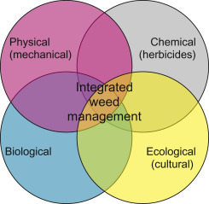
Figure 2: Decision-Making Framework for Selecting Weed Management Strategies
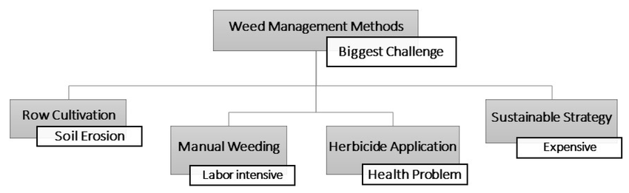

Figure 3: Herbicide Resistance Development Under Different Management Scenarios
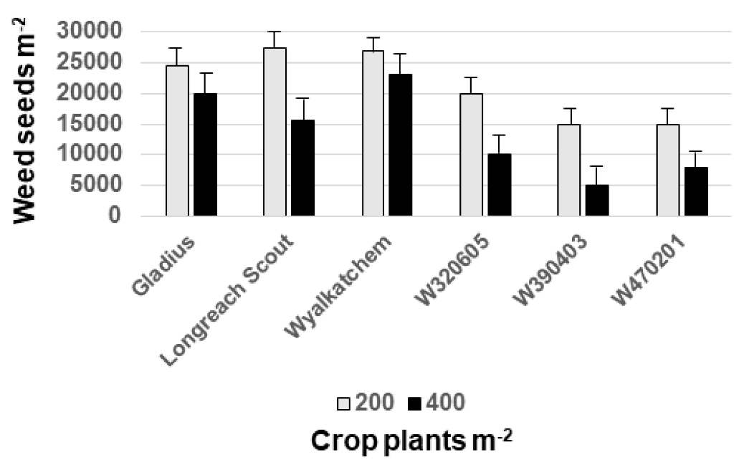
Figure 4: Precision Agriculture Workflow for Site-Specific Weed Management
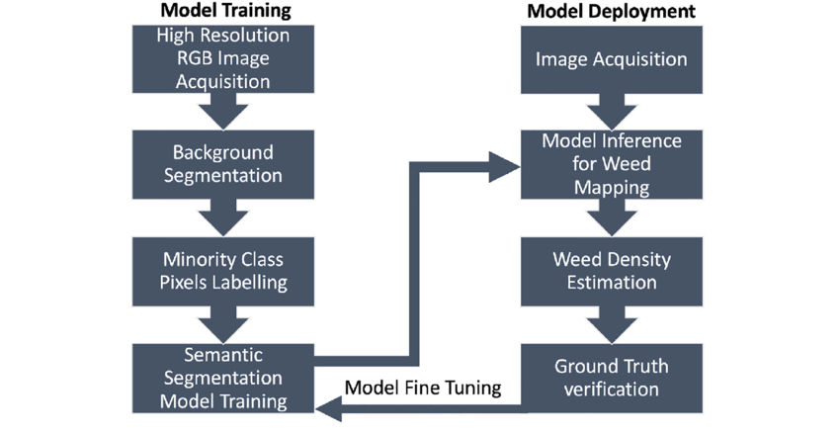
Figure 5: Weed Suppression Mechanisms in Cover Crop Systems
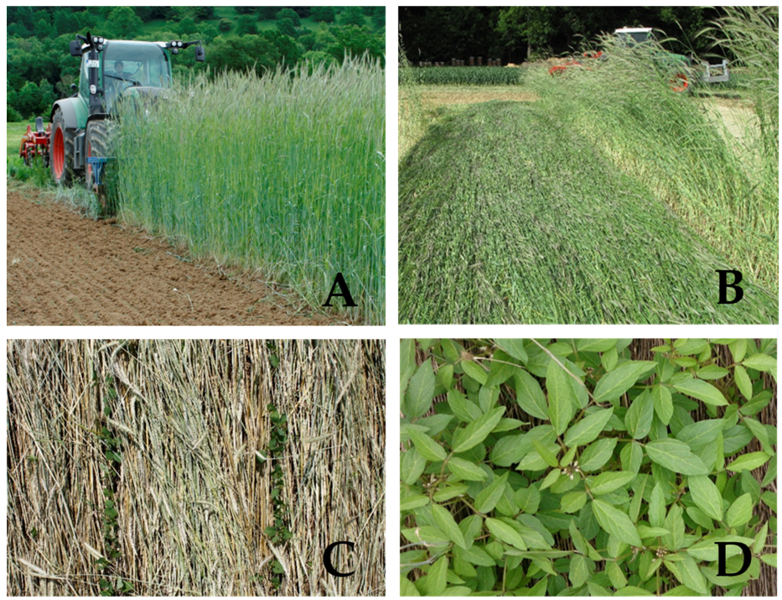
Figure 6: Temporal Dynamics of Weed Populations Under IWM
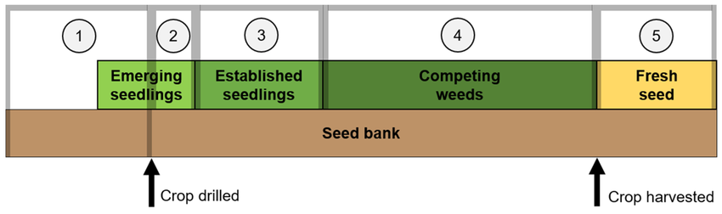
Figure 7: Economic Returns Across Different Weed Management Systems
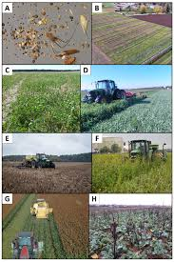
Figure 8: Regional Weed Management Challenges and Adapted IWM Strategies Across India
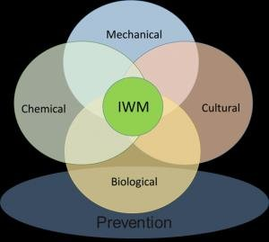
Figure 9: Robotic Weeder Technology Components and Operation
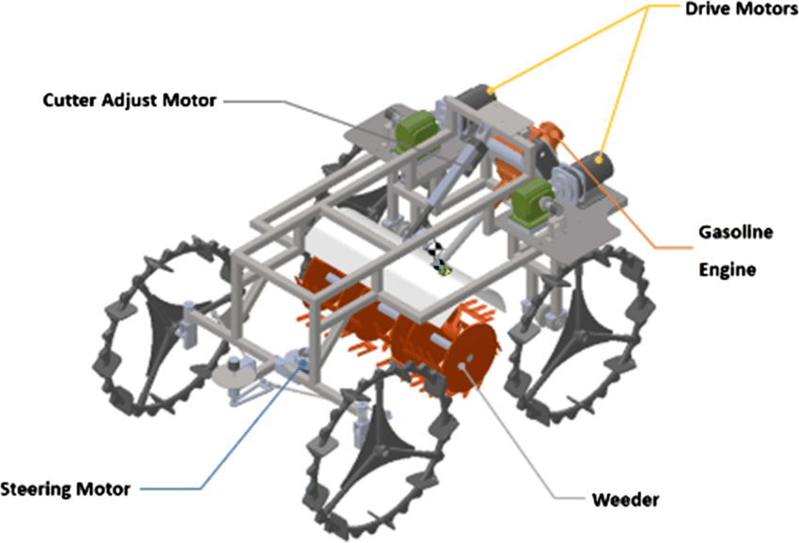

Figure 10: Environmental Benefits Comparison Between Conventional and IWM Systems
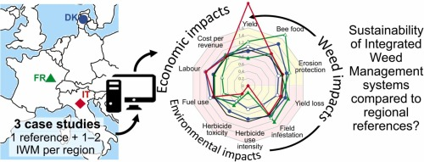
Conclusion
Integrated Weed Management represents the most comprehensive and sustainable approach to controlling weed populations in modern agricultural systems. The synergistic combination of preventive, cultural, mechanical, biological, and chemical methods addresses the multifaceted challenges posed by weeds while mitigating environmental degradation and economic losses. Evidence from numerous field studies demonstrates that IWM systems consistently achieve higher weed control efficiency, improved crop yields, and better economic returns compared to single-tactic approaches. The integration of precision agriculture technologies, biological innovations, and traditional knowledge creates robust management systems adaptable to diverse agro-ecological conditions. Successful implementation in Indian agriculture requires addressing critical challenges including knowledge dissemination, economic accessibility, and policy support. Regional adaptations considering local weed ecology, cropping systems, and farmer capacities ensure practical relevance and adoption success. As herbicide resistance continues spreading and environmental concerns intensify, transitioning toward IWM becomes imperative for sustainable agricultural intensification. Future developments in robotics, artificial intelligence, and biotechnology promise revolutionary advancements enhancing IWM effectiveness and efficiency, potentially transforming weed management from reactive problem-solving to proactive ecosystem stewardship ensuring food security for growing populations.
References
- Bhan, V. M., & Behera, U. K. (2014). Weed management in India—An overview. Indian Journal of Weed Science, 46(3), 228-246.
- Chauhan, B. S., & Abugho, S. B. (2012). Effect of crop establishment methods on weed management and rice yield. Weed Technology, 26(2), 361-366.
- Chhokar, R. S., & Sharma, R. K. (2008). Multiple herbicide resistance in Phalaris minor in wheat. Weed Biology and Management, 8(4), 280-286.
- Davis, A. S., Hill, J. D., Chase, C. A., Johanns, A. M., & Liebman, M. (2012). Increasing cropping system diversity balances productivity, profitability and environmental health. PLOS ONE, 7(10), e47149.
- Heap, I. (2024). The International Herbicide-Resistant Weed Database. www.weedscience.org
- Kumar, V., & Ladha, J. K. (2011). Direct seeding of rice: Recent developments and future research needs. Advances in Agronomy, 111, 297-413.
- Mahajan, G., & Chauhan, B. S. (2013). The role of cultivars in managing weeds in dry-seeded rice production systems. Crop Protection, 49, 52-57.
- Norsworthy, J. K., Ward, S. M., Shaw, D. R., Llewellyn, R. S., Nichols, R. L., Webster, T. M., Bradley, K. W., Frisvold, G., Powles, S. B., Burgos, N. R., Witt, W. W., & Barrett, M. (2012). Reducing the risks of herbicide resistance: Best management practices and recommendations. Weed Science, 60(SP1), 31-62.
- Pacanoski, Z., & Glatkova, G. (2014). The use of herbicides in sustainable weed management. Herbicides—Current Research and Case Studies in Use, InTech, 387-410.
- Rao, A. N., Johnson, D. E., Sivaprasad, B., Ladha, J. K., & Mortimer, A. M. (2007). Weed management in direct-seeded rice. Advances in Agronomy, 93, 153-255.
- Singh, S., Kirkwood, R. C., & Marshall, G. (1999). Biology and control of Phalaris minor Retz. (littleseed canarygrass) in cereals. Crop Protection, 18(1), 1-16.
- Slaughter, D. C., Giles, D. K., & Downey, D. (2008). Autonomous robotic weed control systems: A review. Computers and Electronics in Agriculture, 61(1), 63-78.
- Upadhyaya, M. K., & Blackshaw, R. E. (2007). Non-chemical weed management: Principles, concepts and technology. CAB International, Wallingford, UK.
- Walsh, M. J., Harrington, R. B., & Powles, S. B. (2012). Harrington seed destructor: A new nonchemical weed control tool for global grain crops. Crop Science, 52(3), 1343-1347.
- Yaduraju, N. T., & Mishra, J. S. (2002). Integrated weed management for rice and wheat cropping systems in India. Proceedings of the Brighton Crop Protection Conference—Weeds, 1, 197-202.
- Zhang, C., & Kovacs, J. M. (2012). The application of small unmanned aerial systems for precision agriculture: A review. Precision Agriculture, 13(6), 693-712.
- Huang, X., Huang, S., Han, B., & Li, J. (2022). The integrated genomics of crop domestication and breeding. Cell, 185(15), 2828-2839.
- Krug, A. S., BM Drummond, E., Van Tassel, D. L., & Warschefsky, E. J. (2023). The next era of crop domestication starts now. Proceedings of the National Academy of Sciences, 120(14), e2205769120.
- Van Tassel, D. L., DeHaan, L. R., Diaz-Garcia, L., Hershberger, J., Rubin, M. J., Schlautman, B., ... & Miller, A. J. (2022). Re-imagining crop domestication in the era of high throughput phenomics. Current Opinion in Plant Biology, 65, 102150.
- Yazdanpanah, M., Tajeri Moghadam, M., Savari, M., Zobeidi, T., Sieber, S., & Löhr, K. (2021). The impact of livelihood assets on the food security of farmers in Southern Iran during the COVID-19 pandemic. International journal of environmental research and public health, 18(10), 5310.

