Efficacy of Azithromycin and Atovaquone Combination Therapy in the Clinical Management of Babesia gibsoni Infection in Dogs

Abstract

Six dogs with clinical babesiosis were presented at the Veterinary Clinical Complex, Rajendranagar, Hyderabad. Breeds affected were Labrador Retriever (2), German Shepherd, Belgian Malinois, Golden Retriever, and one non-descript (n=6). Young dogs (<4 years) predominated (83.33%), and males were more affected (66.67%), possibly due to fight-related bite transmission of Babesia gibsoni in addition to ticks. Common clinical signs included fever (100%), anorexia and pale mucous membranes (83.3% each), lethargy and lymphadenopathy (66.7% each), splenomegaly and hemoglobinuria (50% each), and icterus (33.3%). Hematological findings revealed regenerative anemia, consistent thrombocytopenia (100%), and leukocytosis. Biochemical alterations included hyperbilirubinemia, elevated liver enzymes (ALT, AST, ALP), hypoalbuminemia, hyperglobulinemia, and mild azotemia in some cases. Giemsa-stained blood smears confirmed small intraerythrocytic B. gibsoni piroplasms in all dogs. Ultrasonography showed splenomegaly (50%), hepatomegaly, and increased renal echogenicity in affected cases. All dogs were treated with atovaquone (13.3 mg/kg TID) and azithromycin (10 mg/kg SID) for 10 days along with supportive therapy. Clinical recovery occurred within 7-10 days, with complete hematological improvement and negative blood smears by day 30.The study highlights the characteristic hemolytic anemia, thrombocytopenia, and multisystem involvement in canine B. gibsoni infection, along with excellent therapeutic response to the atovaquone–azithromycin protocol.

INTRODUCTION
Canine babesiosis is a haemoprotozoan disease caused by parasites of the genus Babesia. Several Babesia species occur worldwide, broadly classified into large forms (e.g., Babesia canis) and small forms (e.g., Babesia gibsoni). Babesia gibsoni is a small intraerythrocytic protozoan parasite that infects dogs, primarily invading red blood cells (erythrocytes), causing their rupture and resulting in hemolytic anemia.The parasite is commonly transmitted by ticks such as Haemaphysalis bispinosa and Haemaphysalis longicornis. Other routes of transmission include transplacental infection and direct blood contact during dog fights. Clinically, canine babesiosis presents with a wide range of severity—from hyperacute, shock-associated hemolytic crises to mild or subclinical infections. The clinical manifestations of B. gibsoni infection are similar to those caused by B. canis, including lymphadenopathy, splenomegaly, diarrhea, weight loss, proteinuria, hemoglobinuria, polyuria/polydipsia (PU/PD), and nephropathy. In most cases, the disease course is severe [Macintire et.al., 2002, Birkkenheuer et.al., 2004 and Lee et.al 2009). Un complicated babesiosis is typically characterized by anemia [Birkenheuer et.al., 1999), whereas complicated babesiosis involves dysfunction of one or more organs (Slade et.al.,2011)]. Blood smear examination remains the first-line diagnostic tool; however, in cases where blood smears are negative but infection is suspected, molecular techniques such as PCR or serological tests like the indirect fluorescent antibody test (IFAT) are recommended for confirmation (Kushwaha et.al 2017).
MATERIALS AND METHODS
A total of six animals of different ages, breeds, and sexes, presented to the Veterinary Clinical Complex (VCC), College of Veterinary Science, Rajendranagar, with clinical signs suggestive of babesiosis, were selected for the study. Detailed information regarding breed, age, and sex was systematically recorded. Each animal underwent a thorough physical and clinical examination, and all findings were carefully documented. History of tick infestation was recorded in alal the animals . Peripheral blood smears were prepared from the suspected animals from ear tips, stained with Giemsa stain, and examined microscopically for the presence of intraerythrocytic piroplasms. Blood samples were collected aseptically in sterile vials with and without EDTA for hematological and biochemical analysis. Blood samples from six apparently healthy animals served as control. Selected cases were further evaluated using diagnostic imaging techniques, such as ultrasonography, to support clinical assessment and confirm diagnosis. The final diagnosis was established based on clinical signs, serum biochemical findings, and blood smear examination. All affected animals were treated with a combination of Azithromycin @ 10 mg/kg body weight once daily (SID) and Atovaquone @ 13.3 mg/kg body weight thrice daily (TID) for 10 days, along with appropriate supportive therapy. The data obtained were subjected to the statistical analysis described by Snedecor and Cochran. The therapeutic response was evaluated based on the resolution of clinical signs and normalization of hematobiochemical parameters.

RESULTS AND DISCUSSION
Six dogs of different breeds, ages, and sexes presented to the Veterinary Clinical Complex, College of Veterinary Science, Rajendranagar, exhibiting clinical signs suggestive of babesiosis. The affected breeds included Labrador Retrievers (2/6; 33.33%), German Shepherd (1/6; 16.67%), Belgian Malinois (1/6; 16.67%), Golden Retriever (1/6; 16.67%), and non-descript breed (1/6; 16.67%). The highest occurrence of babesiosis was recorded in dogs aged below 4 years (83.33%), followed by those above 4 years (16.67%). Regarding sex distribution, males accounted for 66.67% (4/6) of the cases, while females comprised 33.33% (2/6). The higher occurrence of infection in male dogs may be attributed to their fighting behavior, which serves as a common mode of Babesia gibsoni transmission through bite wounds during dog fights, in addition to tick-borne transmission. The most common clinical manifestations observed were fever (100%), anorexia ( 5/6; 83.3%), pallor of mucous membranes ( 5/6; 83.3%), lethargy ( 4/6; 66.67%), and splenomegaly (3/6; 50%), lymphadenopathy( 4/6; 66.67%), hemoglobinuria (3/6; 50%) and icterus (2/6; 33.33%).These findings are in agreement with previous studies, which reported that B. gibsoni infection commonly manifests as fever, anemia, lethargy, and splenomegaly due to intravascular hemolysis and immune-mediated erythrocyte destruction (Singh et al., 2023; Tóthová et al., 2022).Other non specific sings included were vomiting, diarrhoea and weight loss ( 1/6;16.67% each).
Haematological analysis revealed a significant (p < 0.05) decrease in hemoglobin (Hb), packed cell volume (PCV), and total erythrocyte count (TEC) in infected dogs compared to healthy controls (Table 1). Similar findings were also reported by Bilwal et.al 2017. Thrombocytopenia was a consistent finding (100%), which is a hallmark of Babesia gibsoni infection, as reported by Birkenheuer et al. (2004). A significant (p < 0.05) elevation in leukocyte counts observed in Babesia-affected dogs may be attributed to the immune response mounted against the parasite and the severity of the infection. The hematological alterations observed are attributed to the destruction of parasitized erythrocytes, immune-mediated hemolysis, and splenic sequestration (Vial & Gorenflot, 2006). Compared to healthy controls, the mean PCV and Hb values were significantly reduced (p < 0.05), confirming the presence of regenerative anemia in affected dogs.
Biochemical analysis showed significantly (p < 0.05) elevated total bilirubin, ALT, ALP and AST levels, indicating hepatic involvement secondary to hemolysis. Total protein and globulin levels were significantly (p < 0.05) higher in infected dogs, whereas serum albumin wa significantly (p < 0.05) reduced (Table 2). Similar patterns were observed by Bilwal et.al (2017) and Tothova et al. (2020), who reported hypoalbuminemia and hyperglobulinemia in B. gibsoni-infected dogs due to chronic antigenic stimulation and immune activation. According to Tothova et. al (2020). Dogs infected with B. gibsoni exhibit significantly higher serum gamma-globulin concentrations and markedly lower albumin levels compared to those infected with B. canis. Blood urea nitrogen (BUN) and creatinine levels were mildly elevated in two animals, suggesting transient renal stress possibly due to hemoglobinuria or immune-mediated glomerular changes. These biochemical derangements align with reports by Solano-Gallego & Baneth (2011) and Lakshmi et.al (2024), indicating that Babesia infections can cause multisystem involvement, especially in severe or chronic cases.
Giemsa-stained peripheral blood smears revealed small, ring-shaped intraerythrocytic piroplasms characteristic of Babesia gibsoni in all six affected dogs (Figure 2). No hemoparasites were detected in healthy controls. The microscopic identification of B. gibsoni remains a cornerstone of diagnosis, although PCR is considered more sensitive, particularly in subclinical or carrier cases (Jefferies et al., 2003; CAPC Guidelines, 2024).
Ultrasonographic examination revealed splenomegaly in 50% (3/6) of the affected dogs, hepatomegaly with increased hepatic echogenicity in 33.3% (2/6), and hepatic congestion in 16.7% (1/6) of cases. Additionally, increased renal cortical echogenicity with loss of corticomedullary junction (CMJ) was observed in 33.3% (2/6) of the animals.
All infected dogs were treated with Atovaquone (13.3 mg/kg, TID) and Azithromycin (10 mg/kg, SID) for 10 days, along with supportive therapy. Clinical improvement, including normalization of body temperature, appetite, and activity, was observed within 7–10 days post-treatment. Haematological parameters showed gradual recovery, and follow-up blood smears at day 30 were negative for piroplasms in all the dogs. These findings corroborate the efficacy of the Atovaquone–Azithromycin combination, as reported by Birkenheuer et al. (2004), Kirk et.al (2017), Lakshmi et.al 2024 and Sakshi et al. (2025).
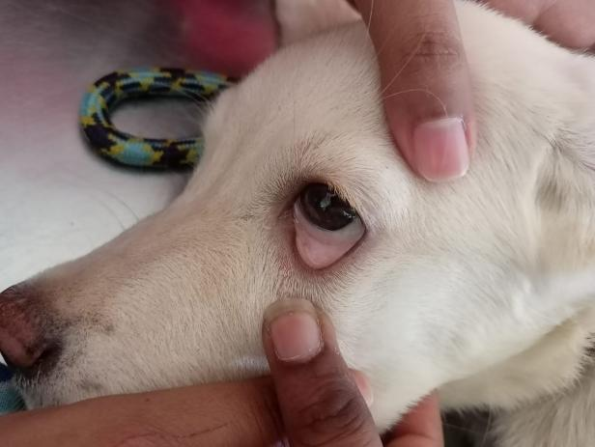 | 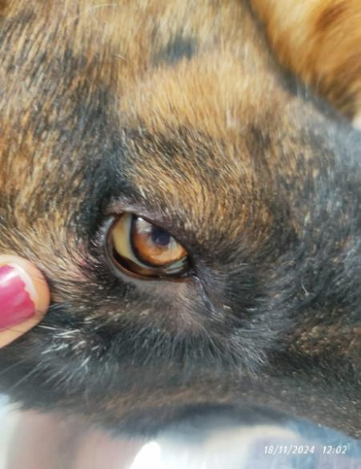
- Pale mucosa | - Icterus
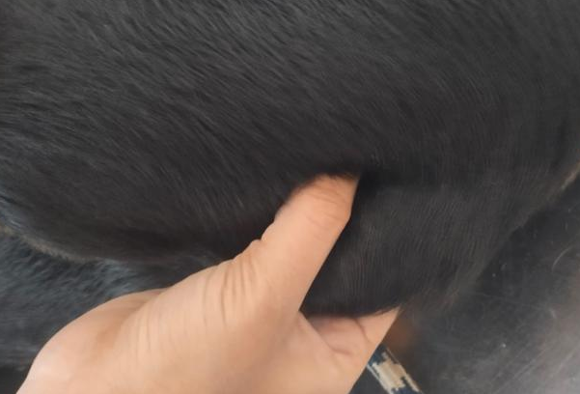 | 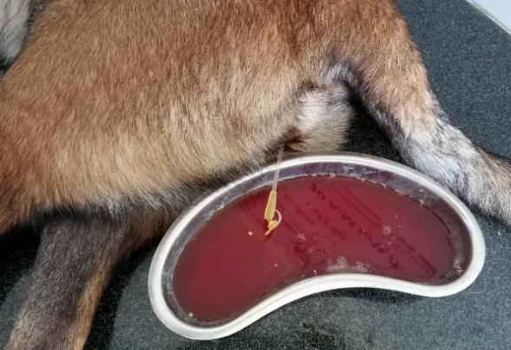
- Lypmhadenopathy | - Haemoglobinuria
Figure :1 Clinical signs exhibited by Babesia gibsoni affected dogs

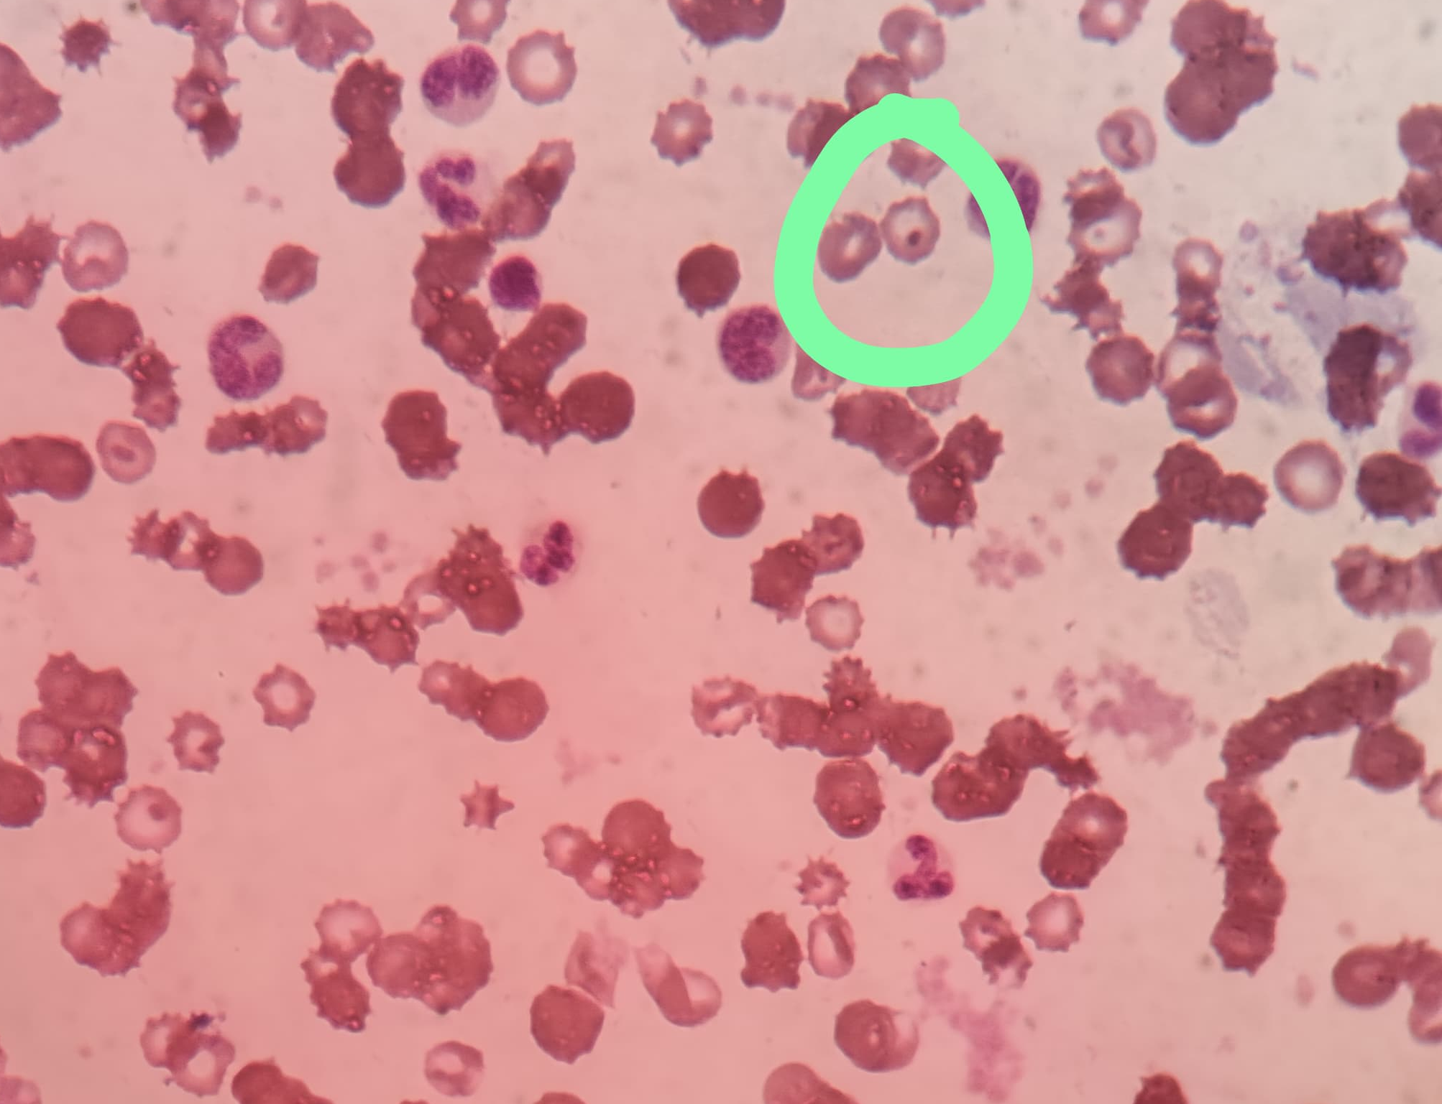
Figure 2: Giemsa-stained peripheral blood smear showing intraerythrocytic Babesia gibsoni organisms. Noticeable anisocytosis and poikilocytosis are also evident, which may reflect the hemolytic process associated with babesial infection.

Table: 1 Haematological findings in Babesia gibsoni affected dogs
Parameter | Healthy control (n=6) | Before therapy (n=6) | After Therapy (n=6)
Hb (g/dl) | 12.17±1.56^{ab} | 8.47±1.96^{b} | 13.56±1.78ª
TEC (10³/μL) | 5.22±0.27^{b} | 3.22±0.64^{c} | 6.67±0.29ª
TLC 10⁶/μL) | 15.21±0.14^{b} | 21.23±0.11ª | 14.11±0.76^{b}
PCV (%) | 51.14±1.14ª | 31.12±1.01^{b} | 52.24±1.09ª
PLT (10⁵/μL) | 2.13±0.28^{ab} | 0.83±0.22^{b} | 2.53±0.26ª
Neutrophils (%) | 77.18±0.14^{b} | 81.12±10.12ª | 75.18±0.14^{b}
Lymphocytes(%) | 13.18±0.21ª | 10.18± 0.11ª | 13.18±0.21ª
Monocytes (%) | 9.08±0.39ª | 8.01±0.43ª | 11.11±0.34ª
Eosinophils (%) | 1.08±0.45ª | 1.18±0.38ª | 1.08±0.45ª
Values bearing different superscripts in a row differ significantly (P< 0.05)
Values bearing similar superscripts in a row did not differ significantly (P >0.05)

Table: 2 Biochemical findings in Babesia gibsoni affected dogs
Parameter | Healthy control (n=6) | Before therapy (n=6) | After Therapy (n=6)
ALT(U/L) | 79.12±0.91^{b} | 112.12±1.19ª | 77.12±0.51^{b}
ALP(U/L) | 116.34±1.88^{b} | 156.34±1.98ª | 115.22±1.43^{b}
AST(U/L) | 70.78±1.72^{b} | 99.18±0.67ª | 70.18±0.12^{b}
Total protein  (mg/dL) | 6.90±0.98^{ab} | 8.18±0.18ª | 6.30±0.98^{b}
Albumin(mg/dL) | 3.11±0.89ª | 1.91±0.68^{b} | 3.09±0.32ª
Globulin(mg/dL) | 3.54±0.34^{ab} | 7.24±1.14ª | 3.14±0.04ª
Total bilirubin  (mg/dL) | 0.66±0.23^{b} | 1.96±0.73ª | 0.54±0.19^{b}
BUN (mg/dL) | 25.12±0.73ª | 31.09±0.43ª | 24.19±0.39ª
Creatinine (mg/dL) | 1.18±0.95ª | 1.68±0.45ª | 1.09±0.16ª
Values bearing different superscripts in a row differ significantly (P< 0.05)
Values bearing similar supesrscripts in a row did not differ significantly (P >0.05)

CONCLUSION
The present study highlights the diagnostic and clinicopathological features of Babesia gibsoni infection in dogs. The combination therapy of Atovaquone and Azithromycin proved effective in clinical recovery and normalization of hematobiochemical parameters. Although peripheral blood smears are useful for detecting piroplasms, the possibility of chronic carrier states necessitates long-term monitoring and molecular confirmation using PCR to ensure complete elimination of the parasite.

COMPETING INTERESTS DISCLAIMER:
Authors have declared that they have no known competing financial interests OR non-financial interests OR personal relationships that could have appeared to influence the work reported in this paper.

Reference
Bilwal, A. K., Mandali, G. C., & Tandel, F. B. (2017). Clinicopathological alterations in naturally occurring Babesia gibsoni infection in dogs of Middle-South Gujarat, India. VeterinaryWorld,10 (10),1227–1232.
Birkenheuer, A. J., Levy, M. G., Breitschwerdt, E. B. (2004). Efficacy of combined atovaquone and azithromycin for therapy of chronic Babesia gibsoni (Asian genotype) infections in dogs. Journal of Veterinary Internal Medicine, 18(4), 494–498.
Birkenheuer, A. J., Levy, M. G., Savary, K. C., Gager, R. B., & Breitschwerdt, E. B. (1999). Babesia gibsoni infections in dogs from North Carolina. Journal of the American Animal Hospital Association, 35(2), 125–128.
Companion Animal Parasite Council (CAPC). (2024). Babesia Guidelines. https://capcvet.org/guidelines/babesia
Jefferies, R., Ryan, U. M., Muhlnikel, C. J., & Irwin, P. J. (2003). Two species of canine Babesia in Australia: Detection and characterization by PCR. Journal of Parasitology, 89(2), 409–412.
Kirk, S. K., Levy, J. K., & Crawford, P. C. (2017). Efficacy of azithromycin and compounded atovaquone for treatment of Babesia gibsoni in dogs. Journal of Veterinary Internal Medicine, 31(4), 1108–1112.
Kushwaha, N., Mondal, D., Singh, K. P., & Mahapatra, R. R. (2017). Comparative evaluation of different diagnostic tests for Babesia gibsoni in dogs. Indian Journal of Animal Research, 52(12), 1642–1648.
Lee, M. J., Yu, D. H., Yoon, J. S., Li, Y. H., Lee, J. H., Chae, J. S., & Park, J. (2009). Epidemiologic and clinical surveys in dogs infected with Babesia gibsoni in South Korea. Vector-Borne and Zoonotic Diseases, 9(6), 681–686.
Macintire, D. K., Boudreaux, M. K., West, G. D., Bourne, C., Wright, J. C., & Conrad, P. A. (2002). Babesia gibsoni infection among dogs in the southeastern United States. Journal of the American Veterinary Medical Association, 220(3), 325–329.
Sakshi, Kumar, M., Sahu, U., Sharma, P., Rajput, P., De, U., Yadav, U., Yadav, S., Kumar, A., & Babu, S. (2025). A comparative clinical analysis of atovaquone-azithromycin and triple antimicrobial therapy in canine babesiosis. Uttar Pradesh Journal of Zoology, 46, 220–229.
Slade, D. J., Lees, G. E., Berridge, B. R., Clubb, F. J., Kuczynski, L. A., & Littman, M. P. (2011). Resolution of a proteinuric nephropathy associated with Babesia gibsoni infection in a dog. Journal of the American Animal Hospital Association, 47(2), 138–144.
Solano-Gallego, L., & Baneth, G. (2011). Babesiosis in dogs and cats—Expanding parasitological and clinical perspectives. Veterinary Parasitology, 295, 109456.
Tóthová, C., Karasová, M., Blaňarová, L., Fialkovičová, M., & Nagy, O. (2020). Differences in serum protein electrophoretic pattern in dogs naturally infected with Babesia gibsoni and Babesia canis. Scientific Reports, 10(1), 18904.
Vial, H. J., & Gorenflot, A. (2006). Chemotherapy against babesiosis. Veterinary Parasitology, 138(1–2), 147–160.

