Confirmation of the pathogenic potential (pathogenicity test) of Fusarium oxysporum f. sp. pisi causing wilt disease in pea crops

Abstract
This study aimed to verify the disease-causing ability of Fusarium oxysporum f. sp. pisi, responsible for pea wilt, under controlled conditions. Pea plants displaying typical wilt symptoms were collected, and the pathogen was isolated from the collar region using Potato Dextrose Agar (PDA). The fungus formed distinctive white to pinkish-white fluffy colonies with moderate aerial mycelium and was identified by its cultural and morphological characteristics. For pathogenicity tests, the pathogen was mass-produced on sorghum grains and incorporated into sterilized soil in earthen pots. Surface-sterilized seeds of the PSM-3 pea variety were planted, and the development of symptoms was observed.
Both naturally infected and artificially inoculated plants showed early and late signs of wilt. Early infections (30 days after sowing) caused the stem to shrink near the collar region and sometimes led to seedling collapse. Later infections (60 days after sowing) were characterized by drooping petioles and rachis, gradual yellowing and drying of leaves, and total plant wilting. Dissection of infected plants revealed internal browning of the vascular tissues and poorly developed root systems. All inoculated plants wilted within 45 days, and the pathogen were successfully re-isolated, thus satisfying Koch’s postulates. These results confirm that F. oxysporum f. sp. pisi is highly virulent and can produce typical wilt symptoms in pea, establishing its role as the causal agent of the disease.
Key words - Pea crop, Fusarium oxysporum f.sp. pisi, pathognecity test, Koch’s postulates
Introduction
Pea (Pisum sativum L.) is one of the major pulse crops grown in temperate regions of the world and was originally cultivated in the Mediterranean basin. It is cultivated globally and also serves as an important fodder crop for livestock (Rezene et al., 2015; Sardana et al., 2007). In India, pea is an important field and vegetable crop and ranks as the fourth most widely cultivated legume globally. With a production of 10.04 lakh tons, peas occupy 7.62 lakh hectares in the country (Anonymous, 2022). In Madhya Pradesh, peas are cultivated on approximately 132,009 hectares, producing about 139,204 metric tons, with an average productivity of 1,055.17 kg/ha. Jabalpur district alone contributes 18,609 hectares under pea cultivation with a production of around 23,969 metric tons and an average productivity of 1,288 kg/ha (Anonymous, 2022-23).
Pea crops are susceptible to several diseases, many of which cause substantial damage and yield loss. Annual disease incidence varies depending on local weather conditions. Common diseases include root rot, powdery mildew, and viral infections (Kharte et al., 2022). Other major diseases affecting pea cultivation include those caused by Fusarium spp., Rhizoctonia seedling blight, bacterial blight, Ascochyta foot rot, downy mildew, Pythium blight, Aphanomyces root rot, and wilt (Soylu and Dervis, 2011).
Fusarium wilt, caused by Fusarium oxysporum f. sp. pisi, is one of the most devastating diseases limiting pea production. It severely affects crop growth and significantly reduces yield. In northern Madhya Pradesh, pea wilt incidence ranged from 12.5% to 30.25% during 1981-82 and from 19.57% to 37.39% during 1982-83 (Sharma et al., 1989). Nationally, the disease causes yield losses ranging from 14% to 95% (Kumar et al., 1993) and may lead to up to 93% yield reduction when associated with root rot (Sharma et al., 2006).
Fusarium wilt is prevalent wherever peas are commercially cultivated (Merzoug et al., 2014). The pathogen survives in the soil as resting chlamydospores for more than ten years (Gupta & Gupta, 2019). It infects the roots and disrupts the vascular system at any crop growth stage (Bani et al., 2018). Typical symptoms include orange to dark red discoloration at the stem base and roots, followed by yellowing, wilting, and leaf curling from the flowering to pod-filling stages. Early infection may lead to seedling mortality, which is often overlooked due to the presence of nearby healthy plants (Sampaio et al., 2020).
The disease comprises two pathotypes and eight pathogenic races, and winter-grown pea crops are particularly vulnerable, with yield losses reaching up to 100% (Sharma et al., 2006; Zafar, 2020). The disease is especially severe under short crop rotation systems. Although fungicidal seed and soil treatments can manage the disease, they are often not cost-effective and pose environmental concerns. Botanical extracts and biocontrol agents provide safer and more eco-friendly alternatives, offering advantages such as ecological balance preservation, cost-effectiveness, minimal residue accumulation, health safety, and long-term efficacy.

In view of the high economic value of pea, the severe yield losses attributed to wilt disease, and the growing need for sustainable management approaches, this research was deemed necessary and was therefore undertaken.

Materials and methods
The present research, titled “Confirmation of Pathogenic Potential (Pathogenicity Test) of Fusarium oxysporum f. sp. pisi Causing Wilt Disease in Pea Crop,” was conducted in the Department of Plant Pathology, College of Agriculture, Jawaharlal Nehru Krishi Vishwavidyalaya, Jabalpur (M.P.).
Sterilization of pots
During the experiment, earthen pots measuring 10 cm in diameter with a capacity of 500 cm³ were used. The pots were sterilized by exposing them to fumes of a 4% formaldehyde solution inside a closed container and then stored in a clean, dry area covered with a sterilized polythene sheet. These sterilized pots were used throughout the study, and a continuous supply of sanitized pots was maintained during the experimentation.
Sterilization of soil composite

After sealing the soil heap with a polyethylene sheet for 15 days, the soil composite was sterilized using 4% commercial formaldehyde. To ensure complete evaporation of residual formaldehyde, the soil was subsequently spread in a thin layer and exposed to direct sunlight. Thereafter, the sterilized soil composite was stored in a sanitized metal tray covered with a polyethylene sheet and used as required during the experiment

Culture medium
Potato Dextrose Agar (PDA) was used for culture isolation, maintenance, and throughout the study. For medium preparation, 200 grams of peeled and sliced potatoes were boiled in 500 milliliters of distilled water for 30 minutes. The extract was filtered through a cheese cloth, and the volume was made up to 1000 milliliters by adding distilled water. The mixture was kept in a water bath to ensure complete dissolution of all components. Twenty grams of Agar-Agar strips were washed in distilled water, and twenty grams of dextrose were added to the extract. The prepared medium was dispensed into 250 ml conical flasks at 50 ml per flask. The flasks were plugged with cotton and sterilized in an autoclave at 121.6 °C and 1.05 kg/cm² pressure for 15 minutes before use.
Collection of sample
Diseased pea plants exhibiting typical wilt symptoms caused by Fusarium oxysporum f. sp. pisi were collected from the experimental field of the Department of Plant Pathology, Jabalpur. The plants were carefully uprooted to ensure that the entire root system remained intact. After collection, the roots were washed thoroughly with tap water and dried using blotting paper to remove excess moisture.
Isolation of the Pathogen
Roots of wilted pea plants exhibiting typical symptoms were used for pathogen isolation. Using a sterile knife, the infected tissue was cut into small pieces measuring 5-10 mm. These pieces were surface-sterilized with 1:1000 mercuric chloride (HgCl₂) for 30 seconds and then rinsed three times with sterile distilled water. The sterilized pieces were placed on Potato Dextrose Agar (PDA) plates and incubated at 24 ± 1°C for six days. Emerging fungal colonies were examined under a research binocular microscope, and colonies resembling Fusarium oxysporum f. sp. pisi were sub-cultured onto fresh PDA plates. The fungus was allowed to grow for seven days, and a pure culture was obtained using the hyphal-tip technique. The pure culture was maintained on PDA slants and identified based on cultural and morphological characteristics following Booth’s monograph.
Mass Multiplication of the Pathogenic Agent
The pathogenic isolate of Fusarium oxysporum f. sp. pisi grown on PDA was used for inoculum preparation. For bulk multiplication, crushed sorghum seeds were soaked in water and dispensed at 100 g per 250 ml flask. The flasks were autoclaved and, after cooling, inoculated with a 5 mm mycelial disc from a seven-day-old culture. The inoculated flasks were incubated at 24 ± 1°C to allow sufficient fungal growth (Tripathi, 1998).
Irrigation of Pots
The pots were irrigated by adding 50 ml of sterilized distilled water to maintain the desired moisture level. The water used was free from physical, chemical, and biological contaminants.
Pathogenicity Test
A pathogenicity test was conducted under glasshouse conditions to confirm the pathogenic potential of Fusarium oxysporum f. sp. pisi on pea plants. After sufficient fungal growth, the multiplied culture was mixed with 10 g of sterilized pot soil and thoroughly blended with 500 g of soil in each pot. The inoculated soil was allowed to incubate for 15 days to facilitate fungal establishment. Surface-sterilized seeds of pea variety PSM 3 were sown in the pots, five seeds per pot. A non-inoculated control was maintained for comparison. The pots were irrigated with 50 ml of sterilized tap water and monitored regularly for seed germination, seedling emergence, and mortality. Plants showing wilt symptoms were carefully uprooted, and the pathogen was re-isolated on PDA and identified, thus fulfilling Koch’s postulates.
Result & Discussion
Symptomatology
Symptoms were observed in both naturally infected and artificially inoculated plants. The disease manifests at two distinct stages: the seedling stage (around 30 DAS), referred to as “early wilt,” and the adult plant stage (around 60 DAS), known as “late wilt.”
In early wilt, shrinkage of the stem above and below the collar region is evident, which may eventually lead to the collapse of the entire seedling. Plants affected by late wilt show characteristic wilting symptoms, including drooping of the petioles and rachis, followed by yellowing and drying of the leaves that progress upward from the base. Pronounced drooping of the upper plant parts is a typical feature. As the disease progresses, leaves turn yellow to pale brown or straw-colored, and the dried leaflets remain attached to the plant even after its death. In severe cases, complete wilting and plant mortality occur.
The root system of infected plants is poorly developed, although no external rotting, drying, or discoloration is visible. When infected stems are split longitudinally, brown discoloration of the vascular bundles (xylem and pith) becomes evident. Root discoloration may range from partial to complete and may appear light to dark brown. In early wilt, the tip of the taproot is destroyed, resulting in an abnormally short and highly branched root system.

Isolation, purification, identification
Infected field pea plants exhibiting typical wilt symptoms were brought to the laboratory, where isolation was performed from the collar region of the infected plants on Potato Dextrose Agar (PDA) medium. Fusarium oxysporum f. sp. pisi was found to be associated with the roots of samples collected from farmers’ fields. The isolated fungus was characterized based on its cultural and morphological traits using a microscope at 10× and 40× magnification. On PDA, the fungus developed a white, fluffy colony with a distinct margin and moderate aerial mycelial growth. The pinkish-white mycelium was clearly visible with a well-defined colony margin when the Petri plate was inverted. After seven days of incubation at 26 ± 1 °C, the colony diameter ranged between 75 and 90 mm in a 90 mm Petri plate.
Pathogenicity
The pathogenicity of the test fungus (Fusarium oxysporum f. sp. pisi) was confirmed on the pea variety PSM 3, which was grown in earthen pots containing soil infested with the pathogen. Typical wilt symptoms were recorded, including yellowing of leaves, withering, drying of the stem, defoliation, marginal necrosis of the remaining leaves, and ultimately, death of the entire plant. Vertical splitting of infected stems revealed brown discoloration of the internal tissues (xylem). By 45 days after sowing, all plants in the infested pots were wilted, confirming that F. oxysporum f. sp. pisi isolated from naturally infected pea plants was capable of inducing typical wilt symptoms under controlled conditions. Wilting was also observed in pots containing sterilized soil inoculated with the test fungus.
The fungus was successfully re-isolated on PDA from the artificially inoculated wilted plants, showing abundant whitish mycelial growth characteristic of F. oxysporum f. sp. pisi.
In artificially inoculated plants, wilt symptoms appeared three weeks after sowing (during the seedling stage) in the variety PSM 3. Initially, seedlings exhibited drooping leaves while retaining a nearly normal green colour.
During the investigation, samples were brought to the laboratory, where isolation was carried out on Potato Dextrose Agar (PDA) medium. Fusarium oxysporum f. sp. pisi was successfully isolated, and pathogenicity tests were performed to assess the virulence of the fungus.
Pathogenicity of F. oxysporum f. sp. pisi on pea was confirmed following Koch’s postulates under pot conditions. The test fungus was first grown on crushed sorghum grains moistened with water and then thoroughly mixed with sterilized pot soil before sowing.
Symptoms developed within 17 days of inoculation, and plant mortality occurred by the 21st day. These observations are consistent with the findings of Sharma (2011) for pea wilt. The infected seedlings showed brown lesions on the roots and cotyledons, along with characteristic brown rot in the hypocotyl and epicotyl regions. The upper parts of the plants exhibited wilting and drying, while vascular tissues showed discoloration varying from pale yellow to deep orange-brown.
Pea (Pisum sativum L.) is an economically important cool-season, self-pollinated pulse crop (2n = 14) belonging to the family Leguminosae (McKay et al., 2003). Uttar Pradesh is the largest producer of field pea in India, contributing nearly 60% of national production, followed by Madhya Pradesh, Bihar, and Maharashtra.
Among the major constraints affecting pea cultivation, soil-borne pathogens are particularly destructive. Fusarium oxysporum is recognized as one of the most damaging soil-inhabiting fungi. Fusarium wilt of pea was first reported by Bisbay in Minnesota in 1918. The pathogen F. oxysporum f. sp. pisi is a major causal agent of pea wilt and belongs to a large species complex comprising over 150 host-specific formae speciales (Bertoldo et al., 2015). It has been associated with significant yield losses worldwide (Dubey et al., 2007).
Pea wilt manifests at both seedling and adult stages. Infection at the seedling stage is known as “early wilt,” whereas infections in mature plants are termed “late wilt.” Typical symptoms include drooping of leaflets, rachis, and petioles, with the upper portions of the plant showing the earliest signs. Lower leaves gradually become chlorotic, whereas the upper foliage initially remains dull green. As the disease progresses, all leaves turn yellow to pale brown or straw-coloured, similar to the symptoms described by Keniath et al. (2014).
Morphological characteristics of the isolated pathogen were also studied. On PDA, the fungus produced purplish-white, fluffy colonies with well-defined margins and moderate aerial mycelial growth. When the Petri plates were inverted, the purplish-white mycelium was clearly visible. Colony diameter ranged between 75 and 90 mm after seven days of incubation at 26 ± 1°C in 90 mm Petri dishes. The fungus produced micro-conidia, macro-conidia, and chlamydospores, with moderate sporulation, which aligns with the observations of R.K. Singh et al. (2010).
Infantino et al. (2006) earlier reported that F. oxysporum f. sp. pisi penetrates pea roots and infects the vascular system at any stage of plant growth. Infected plants often exhibit orange to dark red discoloration of the vascular tissues in the roots and lower stem. Above-ground symptoms include yellowing, wilting, and downward curling of leaves, especially during the flowering to pod-filling stages
Conclusion
The present study conclusively established the pathogenic potential of Fusarium oxysporum f. sp. pisi as the causal agent of wilt disease in pea. The pathogen was consistently isolated from naturally infected plants and accurately identified based on its cultural and morphological characteristics. Under controlled pot conditions, artificial inoculation of the pea variety PSM-3 resulted in the development of characteristic early and late wilt symptoms, including stem shrinkage, leaf drooping, chlorosis, vascular browning, and ultimately plant death. The successful re-isolation of the fungus from wilted; artificially inoculated plants fulfilled Koch’s postulates. These results clearly demonstrate that the isolated F. oxysporum f. sp. pisi is highly virulent and capable of inducing typical wilt symptoms in pea, thereby confirming its role as the principal causal agent of the disease.
Bibliography

Ministry of Agriculture & Farmers Welfare, Government of India. (2022). Horticultural Statistics at a Glance 2022. https://agriwelfare.gov.in/horticultural-statistics
Anonymous. 2023. District-wise area and production report: Jabalpur, Madhya Pradesh. Department of Agriculture, Government of Madhya Pradesh.
Bani, M., Cimmino, A., Evidente, A., Rubiales, D., & Rispail, N. (2018). Pisatin involvement in the variation of inhibition of Fusarium oxysporum f. sp. pisi spore germination by root exudates of Pisum spp. germplasm. Plant Pathology, 67(5), 1046–1054. https://doi.org/10.1111/ppa.12813
Bertoldo, C., Gilardi, G., Spadaro, D., Gullino, M. L., & Garibaldi, A. (2015). Genetic diversity and virulence of Italian strains of Fusarium oxysporum isolated from Eustoma grandiflorum. European Journal of Plant Pathology, 141(1), 83–97. https://doi.org/10.1007/s10658-014-0526-2
Dubey, S. C., Suresh, M., & Singh, B. (2007). Evaluation of Trichoderma species against Fusarium oxysporum f. sp. ciceris for integrated management of chickpea wilt. Biological Control. https://doi.org/10.1016/j.biocontrol.2006.06.006
Gupta R and Gupta S. 2019. Survival strategies of soil-borne fungal pathogens in agricultural ecosystems. Journal of Mycology and Plant Pathology. 49(2): 123–130.
Infantino, A., Kharrat, M., Riccioni, L., Coyne, C. J., McPhee, K. E., & Grunwald, N. J. (2006). Screening techniques and sources of resistance to root diseases in cool season food legumes. Euphytica, 147(1), 201–221. https://doi.org/10.1007/s10681-006-6963-z
Keniath, A. A., John, J., Jiji, T., & Thomas, T. 2014. Symptom expression of Fusarium oxysporum f. sp. pisi in field pea and its effect on plant physiology. Journal of Mycopathological Research, 52(2), 265–268.
Kharte, S., Gupta, P. K., Gharde, Y., & Pancholi, L. K. (2022). Distribution of pea diseases in major growing areas of Madhya Pradesh. Annals of Plant Protection Sciences, 30(1), 22–26. https://doi.org/10.5958/0974-0163.2022.00005.2
Kumar, A. 1993. Studies on resistance to Fusarium wilt in some cultivars of peas. M.Sc. Thesis, Dr. Y.S. Parmar University of Horticulture & Forestry, Solan, Himachal Pradesh. 71 pp.
McKay, K., Schatz, B., & Endres, G. (2003). Field pea production. North Dakota State University Extension Service. http://www.ext.nodak.edu/extpubs/plantsci/rowcrops/a1166.pdf
Merzoug, A., Belabid, L., Youcef-Benkada, M., Benfreha, F., & Bayaa, B. (2014). Pea Fusarium wilt races in western Algeria. Plant Protection Science, 50(2), 70-77. https://doi.org/10.17221/20/2013-PPS
Rezene, Y., Alemayehu, F., Gurmu, F., Negash, F., Banteyirgu, B., & Goa, Y. (2015). Registration of 'AMBERICHO' a newly released field pea (Pisum sativum L) variety for the Southern Highlands of Ethiopia. Journal of Plant Studies, 4(2), 42-43. https://doi.org/10.5539/jps.v4n2p42
Sampaio, A. M., Araújo, S. D. S., Rubiales, D., & Vaz Patto, M. C. (2020). Fusarium wilt management in legume crops. Agronomy, 10(8), 1073. https://doi.org/10.3390/agronomy10081073
Sardana S, Mahajan RK, Gautam NK and Ram B. 2007. Genetic variability in pea (Pisum sativum L.) germplasm for utilization. SABRAO Journal of Breeding and Genetics. 39(1): 31-41.
Sharma BL, Parasar RD and SudhBohre. 1989. Studies on survey of wilt of in Northern region of Madhya Pradesh. Legume Research. 12(3): 151- 152.
Sharma, P., Sharma, K. D., Sharma, R., & Plaha, P. (2006). Genetic variability in pea wilt pathogen Fusarium oxysporum f. sp. pisi in Northern-Western Himalayas. Indian Journal of Biotechnology, 5, 298-302. https://nopr.niscpr.res.in/handle/123456789/38/browse?rpp=20&sort_by=2&order=DESC&etal=-1&value=IJBT+Vol.05+%5B2006%5D&submit_browse=Go
Sharma, P. 2011. Biology and management of Fusarium oxysporum f. sp. pisi. Indian Phytopathology. 64(2): 117–123.
Singh, R.K., Sharma, A., and Verma, P. 2010. Morphological and cultural characteristics of Fusarium oxysporum f. sp. pisi. Journal of Plant Pathology, 22(3): 45–50.
Soylu, S. O. N. E. R., & Dervis, S. I. B. E. L. 2011. Determination of prevalence and incidence of fungal disease agents of pea (Pisum sativum L.) plants growing in Amik plain of Turkey. Research on Crops. 12(2): 588–592.
Tripathi SK. 1998. Studies on bio-efficacy of some plant extract / products on fungal wilt and root rots of linseed. M. Sc. (Ag.), Thesis, J. N. K. V. V., Jabalpur (M.P.).
Zafar, W. (2020). *Management of Fusarium wilt of pea through plant extracts and fungicides in relation to environmental factors* (Master's thesis, University of Agriculture, Faisalabad, Pakistan). https://www.researchgate.net/publication/344970000_MANAGEMENT_OF_FUSARIUM_WILT_OF_PEA_THROUGH_PLANT_EXTRACTS_AND_FUNGICIDES_IN_RELATION_TO_ENVIRONMENTAL_FACTORS

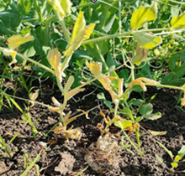 | 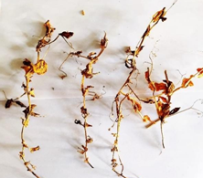
- Wilt affected plant | - Collected sample
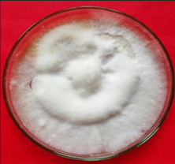 | 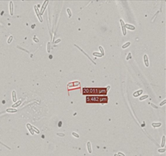
- Pathogen culture | - Microscopic view of conidia

Fig. 1 Isolation and purification of Fusarium oxysporum f. sp. pisi

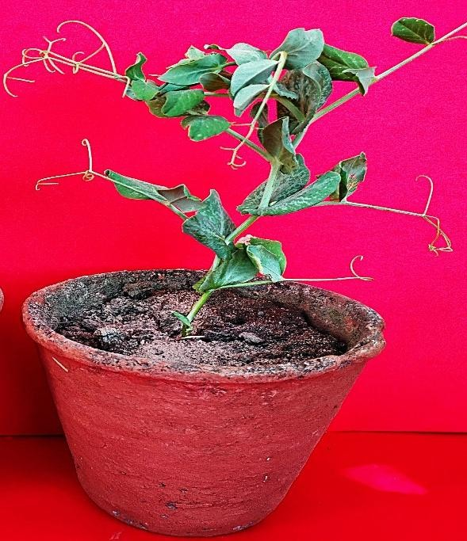
- Healthy plant
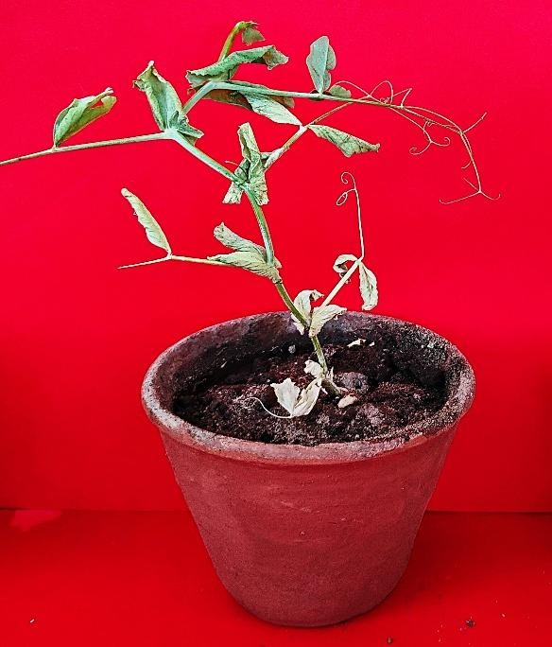
- Partially wilted plant
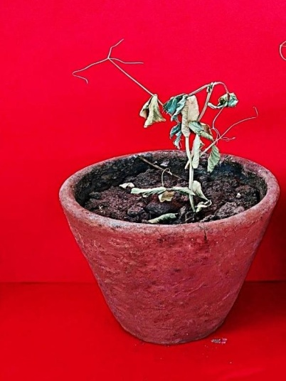
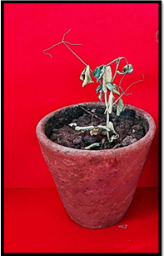
- Complete Wilted plant

Fig 2 Pathogenicity test confirming Koch’s postulates

