Review Article

Nutraceuticals: An insight into vegetables and their potential for nutrition-mediated health care

Abstract
"Neutraceuticals," an amalgamation of "calories" and "pharmaceuticals," have evolved into a standard means of boosting health and fewer one's likelihood of getting unwell.This study covers an in-depth investigation of nutraceuticals, which includes their sources, classification, relevance, accumulation in plants, and breeding-based improvements. We analyze the health benefits and modes of action associated with such bioactive ingredients, highlighting the way they could potentially be used for controlling and avoiding persistent illnesses. Furthermore, we explore the market's current trade and legislative framework to find aspects that could use enhancement. The investigation also looks at how lifestyle integration can be incorporated into real-life circumstances, highlighting the crucial importance of an extensive approach for nutraceutical-based wellness campaigns. Vegetables are a crucial component of the typical human diet and represent an important source of physiologically relevant nutraceuticals. A while ago, it was explored as an appropriate choice for avoiding and taking care of numerous diseases. Considering their reliability, utility, and feasible dietary and therapeutic effects, they deserve a lot of attention in the diet profession. Because their consumption is low in calories yet abundant in vitamins, minerals, antioxidants, and phytochemicals, vegetables are a natural dietary supplement that deserves to be analyzed as much as possible to preserve an environment that's healthy. The antioxidant qualities of numerous widespread phyto-nutraceuticals, such as carotenoids from vegetables and flavonoids from carrots and onions, serve as a crucial factor for combating ailments as well as diminishing their risk factors. Thenutraceutical sheds light on the vital role it plays in day-to-day life by enhancing the nutritional value of vegetables.When we define the nutraceutical value of the vegetable crops at that time, it explains the quality and quantity of the vegetables as well as their vitamins, minerals, phytochemicals, etc. Due to some factors like: quality of the soil, breeding techniques, climatic conditions, proper irrigation facilities, and the production techniques enhance the nutraceutical value or the nutritional value of the vegetables is enhanced.
Keywords:-Nutraceuticals, phytochemicals, plant Defence, gene expression, secondary metabolites, kinetics, biosynthesis, accumulation
Introduction
Nutraceuticals are derived from food substances or parts of the food from which we get more health benefits, such as prevention and treatment of diseases. The word “Nutraceutical” was created by combining two words, “Nutrition’’ and “Pharmaceutical” in 1989 byDr. Stephen De Felice, who is the chairman of the Foundation for Innovation in Medicine. Essentially, nutraceuticals help prevent chronic diseases. We obtain more nutraceuticals from vegetables, which provide more energy to promote our health and prevent diseases. Phytoneutraceuticals are yet another sort of chemical ingredient that living organisms undertake. These ingredients are extremely significant for human wellness,as they help prevent individuals from becoming fatigued and enhance the immune system within the body. The nutraceutical products are classified into three broad categories: such as (i) Nutrients, (ii) Herbals,and (iii) Dietary Supplements.
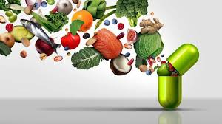

Image 1 : Nutraceuticals
(I). Nutrients:-It is the substance thatmeets the victuals requirements for the continuity of the entity and development.
(II). Herbals:-It is one type of medicine which we get from the plant parts such as seeds, Leaves, Roots, Flowers, Barks, and berries. The medicines are used for the prevention of all acute and chronic diseases. There are no more uses of chemicals.
(III). Dietary Supplements:-It is one type of compound that is derived from other sources such as steroid, hormone precursors, and pyruvate. It is a type of supplement that particularly assists with functions such as weight loss and food replacement.
Vegetables are defined as the herbaceous plants that area whole or partial edible part, which are used for cooking or raw consumption purposes, but not for dessert. By providing us with biomolecules that can maintain the benefits of a healthy condition, the vegetables are considered nutraceuticals. Phytochemicals and protective foods are more present in vegetables because of a large amount of saccharides, minerals, vitamins, and amino acids. Low consumption of fruits and vegetables can cause some diseases, like cardiovascular disease, as well as cancer.
Nutraceuticals:-
When calories and pharmaceuticals intersect, the pharmaceutical world is transformed. Basically, pharmaceutical, which plays a vital role in human beings daily life and prevent them from all kinds of diseases and boosttheir health, "Neutraceutical" is a generic abbreviation encompassing the concepts of "Nutrition" and "Pharmaceutical." In 1989, it was developed by Dr. Stephen De Felice. Scientist Dr.Stephen De Felice was the chairman of the Foundation for Innovation in Medicine. In another sense, nutraceuticals helped us prevent chronic diseases, such as cancer and other long-term illnesses. The vegetables are the storehouse of nutraceuticals. Phytochemicals are indeed present in nutraceuticals. Phytochemicals are a type of chemical compound extracted from plant parts. Herbals are among the most essential nutraceutical products that help prevent skin diseases, and we can utilize these herbals for cosmetic purposes, such as face packs, face washes, and face masks. Herbs are extracted from various plant parts, including berries, leaves, roots, and flowers. We can use the nutraceuticals as dietary supplements. It is one of the different metabolites that can be characterized through multiple pathways, notably pyruvate, steroid hormones, and estrogen precursors. It is one of the various kinds of supplements that have been extremely beneficial for purposes such as nutritional supplement replacement and weight loss. Nutraceuticals, encompassinga wide range of products, include foodstuffs with potential therapeutic or functional benefits that exceed fulfilling basic dietary needs. They have exceptionally low bioavailability, which reflects poor absorption, limited bioaccessibility, and/or chemical alteration in the digestive mechanism. Clients often find it extremely challenging to acknowledge the health benefits they derive from it. Along with their considerable dietary value, nutraceuticals are significant biomolecules that possess wellness benefits that may help prevent or alleviate various ailments. For the purpose of enhancing individual well-being, classical nutrients such as minerals, amino acids, vitamins, and polysaccharides have been widely utilized. The administration of the most recently manufactured nutritional supplements, which have proven exceptionally effective at providing wellness benefits, continues to rise in every aspect of our lives.Nutraceuticals are commonly known as food-based products thatconsistof a variety of compounds, including herbs, fats, prebiotics, probiotics, vitamins, and proteins.
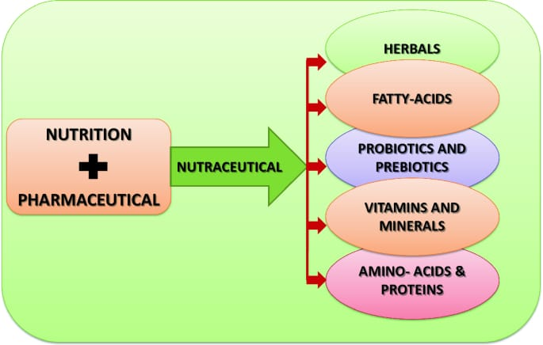
Image 2 The details of Nutraceuticals
Herbs: These are products derived from plant parts that possess medicinal and therapeutic values.
Fatty Acids:- In this type of neutral fatty acids, there are more types of properties present, such as immune modulatory, antioxidants, and anti-inflammatory. Omega-3 and Omega-6 represent instances of nutraceutical lipid types that support cognitive and cardiovascular wellness.
Probiotics, which are living microorganisms, are present in this type of nutraceutical (e.g., yeast and fungi). In this type of nutraceutical, we can utilize beneficial families of bacteria for dietary supplements, such as Lactobacillus and Bifidobacteria.
Prebiotic Nutraceuticals: The prebiotic nutraceuticals are also referred to as fibre nutraceuticals.
Vitamins and Minerals:-By consuming these, we can prevent all types of deficiencies.
Amino acids and proteins can help as the building blocks of the body, supporting muscle development, immune function, and tissue repair.
Properties of nutraceuticals:
Overthe past few years, a growing interest in nutraceuticals has been observed, which have both nutritional and therapeutic applications. They are mainly derived from fruits, vegetables, herbs, grains, and nuts. Nutraceuticals work feebly in our body by improving the immune system, reducing the risk of chronic diseases, and maintaining the overall well-being of human health. As it is mainly derived from natural resources, it has fewer side effects than conventional pharmaceuticals. All the properties are discussed below-
- Nutritional benefits:
Nutraceuticalsare rich in essential nutrients such as minerals (calcium, iron, magnesium, zinc, potassium, selenium), proteins, fibres, vitamins (A, C, D, E), and vitamin B complexes like B12, B6. It helps in providing balanced nutrition to our body and plays a great role for those people who don’t get enough nutrition from regular meals.
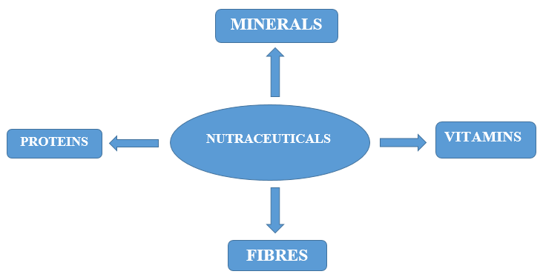

Image 3 Benefits of Nutraceuticals

- Antioxidant properties:
Most of the nutraceuticals are rich in antioxidants like carotenoids (Beta-carotene, Lycopene), flavonoids (EGCG, Quercetin), non-flavonoids (Curcumin, Resveratrol), polyphenols,thiols (Lipoic acid, Glutathione), and vitamins(C, E). These antioxidants help in improving gastrointestinal health, reproductive health, renal and excretory health, and also help in protecting the cells from free radicals, like oxidative stress due to oxygen free radicals.
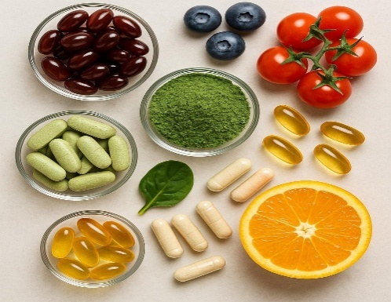

Image 4 Antioxidant properties of Nutraceuticals
- Disease prevention:
Many vegetables rich in nutraceuticals possess properties that can help prevent various diseases. They are suitable for curing the symptoms as well as preventing the disease from its roots, and help in improving immunity in the body. There are important key points discussed below-
- Immunity boosting-Nutraceuticalcontains probiotics, MUFAs, PUFAs, and vitamins, which help in strengthening the immune system. It builds several properties in our body, like anti-bacterial, anti-inflammatory, anti-cancer, anti-oxidant, and anti-viral properties. Regular use of this will provide a natural ability to fight against any disease.

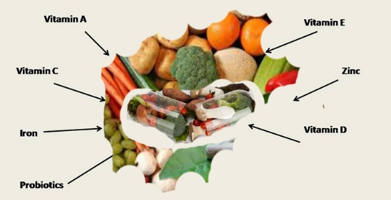

Image 5 Disease prevention of Nutraceuticals
- Cholesterol regulation- Naturally, the levels of cholesterol can be managed in our body with the help of nutraceuticals. Ingredients like plant sterols (campesterol, sitosterol, and stigmasterol), oats, flaxseed, and omega-3 fatty acids are the major ingredients for balancing cholesterol levels. These ingredients ensure proper cell membrane function, hormonal regulations, and other body processes. It reduces the bad cholesterol, i.e., Low-Density Lipoprotein, and improves the good cholesterol, i.e., High-Density Lipoprotein, which helps keep our heart and blood vessels healthy.
- Blood sugar control - It is essential to maintain a stable sugar level in our body, as lower or higher sugar levels can cause significant damage to our body. There are many plant-based nutraceuticals like cinnamon, fenugreek, berberine, bitter gourd, and aloe vera that help in improving insulin function and reducing sugar absorption.
- Bone HealthSupport - For improving bone health, minerals such as Ca, Mg, vitamin D, and K2 are important. These compounds strengthen the skeletal bodies, help in bone formation, and also prevent conditions like osteoporosis. Most important for women and older adults.
- Cancer risk reduction- Nutraceuticals like beta-carotene and sulfur compounds fight against free radicals, thereby reducing the growth of cancer cells. Apart from that, some of the natural compounds like curcumin from turmeric, resveratrol from grapes, help in slowing down the growth of other harmful cells in our body.
Importance:
Nutraceuticals play a vital role for four of the major groups of people, as mentioned below-
- Customer-Nowadays,people are more conscious about their health and they are more preferred to natural and self-medication. Nutraceuticals are beneficial for aged persons, i.e., those above 65 years those who spend more money on medicinal purposes.
- Shopkeeper-They are more likely to get more business opportunities by dealing with nutraceuticals.
- Government- For balancing the relationship between the pharmaceutical industry and human well-being. The government helps to reduce the cost of medicines so that everyone can easily afford them.
- Medical practitioners-They help to discover different technologies, so that consumers can get healthier nutrition and better health.
Phytonutrients and nutraceuticals from vegetables:
Vegetables are the main sources of essential nutrients like vitamins and minerals, and they also contain phytonutrients and other nutraceuticals. Phytonutrients are the elements that are derived from plants and have disease-preventing properties. Phytonutrients are divided into different classes based on their functions and other physical and chemical characteristics. The important classes of phytonutrients are discussed below-
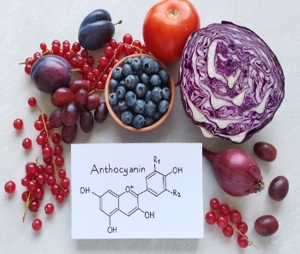

Image 6 Phytonutrients and nutraceuticals from vegetables

- Anthocyanins:These are one of the types of flavonoids, which are also known as flavanols and are soluble in water. It helps to providecolour to vegetables like red cabbage, red radish, purple cabbage, purple cauliflower, and broccoli. It has the potential to fight against the oxidative damage caused by free radicals and hence protects from diseases like cancer andcardiovascular diseases. Regular consumption of anthocyaninsaidsin diseases like diabetes and coronary artery disease.

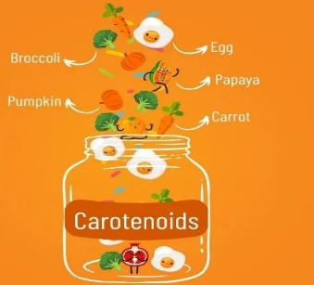

Image 7 Carotenoids
- Carotenoids:These are the fat-soluble pigments that provide orange-red colour to vegetables like tomato and carrot. A totalof 600 carotenoids are present, of which carotenes are 40-carbon tetraterpenes and do not have a hydroxyl or keto group. Carotenoids are divided into two groups, i.e., hydrocarbon carotenoids and oxycarotenoids. Hydrocarbon carotenoids are divided into β-carotene, α-carotene, and lycopene, respectively. Likewise,oxycarotenoids are divided into lutein and xanthophylls. β-carotene plays an important role intreating eye problems, as it is a precursor toVitamin A. These carotenoids have several properties for curing diseases like cardiovascular diseases, macular diseases, cancer, skin problems, etc.

- Flavonoids:Flavonoids are the primary polyphenolic compounds that are derived from plants. It helps to improve the function of Ascorbate- Vitamin C. It has several properties like anti-inflammatory, antioxidants, anti-allergic, anti-carcinogenic, and an immune booster. It reduces the production of ROS (Reactive Oxygen Species), which can cause oxidative stress, leading to cellular damage in the human body. It enhances the blood pressure by inhibiting the Angiotensin-Converting Enzyme (ACE). For example, onions and garlic contain bioflavonoids and quercetin, which protect from cancer and heart problems.

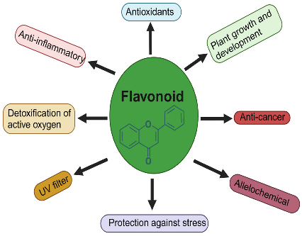

Image 8 Flavonoid

- Glucosinolates:These compounds are rich in sulfur and are mostly found in cruciferous vegetables like cabbage, broccoli, etc. It plays an important role in the detoxification of enzymes present in the liver, WBC (White Blood Cells), and cytokines, hence improving the immune system in the human body. The products of glucosinolates like isothiocyanates, dithiolthiones, and sulforaphaneactively participate in blocking the enzymes that are responsible for tumours in lungs, liver, breast, etc.

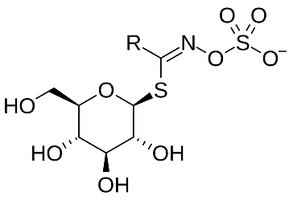

Image 9 Glucosinolates

- Indoles:Indoles are the bioactive compounds that mainly interact with vitamin C and bind chemical carcinogens in complexes. These compounds actively detoxify the enzymes. Indole-3-carbinol and DIM (Diindolylmethane) are some compounds of indolesthatsupportthe immune system, improve hormonal balance, and protect cells. The acid of the stomach produces products of indoles,such asascorbigen.

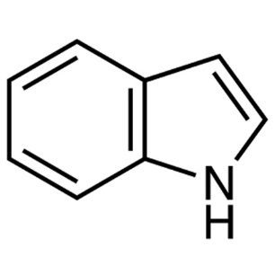

Image 10 Indoles
- Lipoic acid and ubiquinone: These are the antioxidants and mitochondrial cofactors that increase radical scavenging activity. It works in both the water and lipid phases, and can protect vitamins like E &C. It also aids in detoxification activities in the liver.

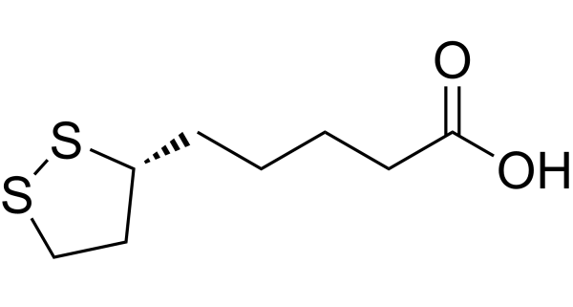
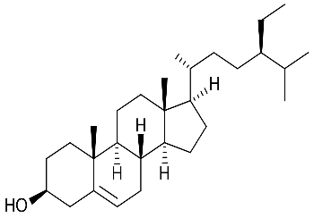

Image 11 Lipoic acid and ubiquinone

- Phytosterols:These are the plant-derived compounds that are mainly derived from green and yellow vegetables and their seeds. These facilitate the removal of cholesterol from the body by effectively competing with dietary cholesterol absorption in the intestines (Yadav et al., 2023). It also offers anti-cancer activities, especially in organs like the breast, colon, and prostate glands.
Table 1. Nutraceuticals derived from vegetables, their plant origin, and therapeutic roles (Arya et al., 2018).
Chemical compound | Plant source | Properties
Allicin | Garlic, onion, parsnip | Antifungal; antibacterial; antioxidant; used to treat arteriosclerosis
Beta carotene | Carrots, pumpkins, sweet potatoes, winter squash, Watermelon. | Anti-aging; anti-cancerous; improve lung function; reduce complications associated with diabetes
Tocopherol | Broccoli, carrot, celery, onion | It is a fat-soluble antioxidant that stops the production of reactive oxygen species formed when fat undergoes oxidation.
Betaine | Green leafy vegetables | Reduces toxic buildup of homocystine
Plant Glucosamine | Lettuce, peas, cabbage | Chondroitin and glucosamine are part of normal cartilage and act as a cushion between the joints.
Glutathione | Cruciferous vegetables | A tripeptide, which provides antioxidant properties, thereby protecting the cells against damage by free radicals
Hesperitin | Green vegetables | Anti-inflammtory
Saponin | beans, other legumes | Reduces blood cholesterol levels and the risk of cancer
Quercitin | Onion, broccoli, cabbage, lettuce, tomato | Useful in the treatment of progressive Alzheimer's disease; used in cancer and heart disease
Lignan | broccoli | Antioxidants mitigate the adverse effects in the body, including cellular damage and aging.
Luteoline | Cauliflower, celery, sweet pepper | A carotenoid that shows eye benefits
Ferulic acid | Turnip | Have anti-oxidizing properties that can moisturize skin, help with light and weather damage
Sulphoraphane | Broccoli | Used against breast cancer
Proanthocyanin | Red cabbage, eggplant | Help in urinary tract infections by inhibiting the adhesion of microorganisms like E. coli to the urinary tract wall.

Nutraceutical accumulation in plants:
Vegetables serve as vital sources of nutraceuticals, which are bioactive compounds like phenolics, flavonoids, anthocyanins, and glucosinolates. These substances are produced by plants in response to environmental stressors, thereby enhancing both their nutritional and therapeutic value and providing significant health benefits. The accumulation of these compounds involves intricate processes of sensing, signaling, and biosynthesis that occur during both the growth and post-harvest stages of development. As a result, vegetables can be seen as potential "bio-factories" for beneficial health compounds (Cisneros-Zevallos et al., 2021; Gupta et al., 2020).
Mechanisms of stress-induced Accumulation:
Plants detect stress factors, such as biotic (e.g., insect attacks, microbial infections) and abiotic (e.g., wounding, UV radiation, drought, heavy metals), through elicitors like ATP or jasmonates, which bind to receptors on cell membranes. This binding initiates signal transduction processes involving calcium ion fluxes, modulation of reactive oxygen species (ROS), and activation of transcription factors. These factors then bind to specific regions of DNA promoters, leading to the expression of genes responsible for converting primary metabolites (e.g., sugars, amino acids) into secondary metabolites (Cisneros-Zevallos et al., 2021; Kumar et al., 2022). The rate of accumulation depends on the biosynthesis rate (k5) outpacing the degradation/utilization rate (k6), which is influenced by the type, intensity, and duration of stress factors (Cisneros-Zevallos et al., 2020). For example, a combination of wounding and UV light can enhance phenolic production in carrots, while applying UV-C radiation post-harvest to dates can increase polyphenols and delay oxidative browning (Vignesh et al., 2024).
The accumulation process varies among plant species and tissues. Stress factors, such as drought or exposure to UV radiation, that occur before harvesting activate defense mechanisms in growing plants. In contrast, stress factors that occur after harvesting (e.g., chilling, exposure to ethylene) utilize the existing molecular machinery in detached plant parts to enhance the content of nutraceuticals (Behera et al., 2022). This adaptable response enables the development of tailored strategies to optimize nutraceutical accumulation for human consumption.
Instances of nutrient increase due to stress:
Stress factors notably elevate the levels of beneficial compounds in vegetables:
- Carrots: Enhanced phenolic antioxidants are observed through cutting and exposure to ultraviolet light, aiding in the fight against oxidative stress.
- Tea: Drought conditions promote the production of flavonoids (kaempferol, quercetin, myricetin) by fulvic acid, reinforcing antioxidant mechanisms.
- Grapes: Resveratrol levels are boosted through exposure to UV light and microbial infections, contributing to the maintenance of cardiovascular well-being.
- Bilberry: The presence of drought increases anthocyanins in leaves, providing support for chlorophyll protection against light.
- Sweetpotato: Attacks by insects trigger the production of jasmonic and chlorogenic acids as natural defenses against weevils.
- Dates (Deglet-Nour): Exposure to UV-C radiation enhances the presence of polyphenols after harvesting, which helps prolong shelf life.
- Broccoli: Damage to the plant and exposure to ethylene lead to higher levels of glucosinolates, which are associated with anti-cancer properties (Prabhakar, 2022).
Specific elicitors and their effects:
Elicitors enhance the production of beneficial compounds:
- Jasmonates (Methyl jasmonate, Jasmonic acid):Enhance tropane alkaloids in Solanaceae plants, such as Daturastramonium, which are known for their medicinal uses (Kumar et al., 2022).
- Salicylates (Salicylic acid): Increase phenolics and flavonoids in jalapeño peppers, enhancing their antioxidant properties (Behera et al., 2022).
- Chitosan: Derived from crustaceans, it enhances phenol production in Lilium regale, improving plant defense and nutrient content (Cisneros-Zevallos, 2021).
- Fungal elicitors: Enzymes from Rhizopusstolonifer trigger the production of anti-fungal casbene in castor beans (Vignesh et al., 2024).
- Heavy metals (Cadmium): Stimulate the production of phenolic antioxidants, aiding in detoxification processes (Solanki et al., 2022).
Challenges and research gaps:
Enhancing the accumulation of beneficial compounds faces obstacles, including a limited understanding of biosynthetic pathways, which hinders genetic modification (Solanki et al., 2022; Azeem et al., 2025). Variation in yields among species influenced by environmental factors (e.g., reduced phenolics in cultivated versus wild crops) and inconsistent post-harvest elicitation procedures impede scalability (Behera et al., 2022). Challenges also arise from extraction inefficiencies and the potential toxicity of new elicitors, such as nanoparticles, necessitating further investigation (Gupta et al., 2020). Research priorities include:
- Mapping pathways through proteomics and metabolomics (Kumar et al., 2022).
- Establishing standardized post-harvest stress protocols for consistent yields (Cisneros-Zevallos et al., 2020).
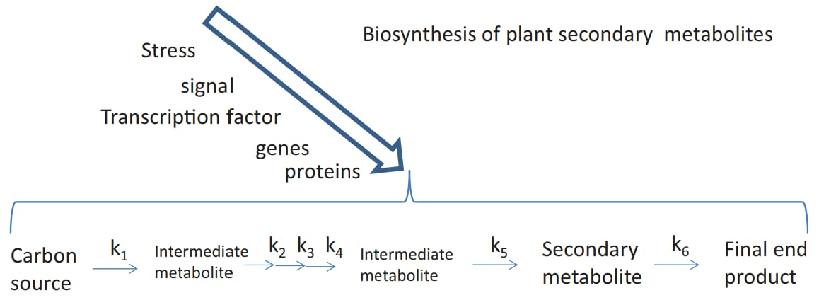
- Developing kinetic models to optimize biosynthesis (k5) over degradation (k6) (Azeem et al., 2025).

(Figure 1: Secondary metabolite accumulation kinetics, illustrating biosynthesis (k5) versus degradation (k6) rates (Cisneros-Zevallos et al., 2020)
Solutions:
CRISPR/Cas9 technology can be utilized to target biosynthetic pathways for enhanced production, while tissue culture can minimize environmental variability. Implementing sustainable extraction methods (e.g., enzyme-assisted, ultrasound-assisted) and conducting safety assessments for elicitors are crucial for scaling up nutraceutical production (Behera et al., 2022; Dhaliwal et al., 2025).
Progress achieved in breeding
Breeding methods have significantly enhanced the nutritional value of vegetables, contributing to the fight against global malnutrition through traditional, molecular, and transgenic techniques. These initiatives aim to enhance the presence of beneficial compounds, such as carotenoids, flavonoids, and glucosinolates, while also ensuring high crop yields and resilience (Parulekar et al., 2019; Solanki et al., 2022; Bhardwaj et al., 2022).
Traditional breeding accomplishments:
Classic breeding techniques such as selection, hybridization, and inducing mutations have led to the development of nutrient-dense varieties:
- Orange cauliflower: The Or gene enhances β-carotene levels, resulting in orange curds rich in vitamin A precursors.
- Purple cauliflower: The Pr gene stimulates anthocyanin accumulation, boosting antioxidant properties.
- High-glucosinolate broccoli: Crossbreeding with Brassica villosa increases sulforaphane, known for its anti-carcinogenic properties.
- Protein-rich potato: Introducing the AmA1 gene from Amaranthushypochondriacus elevates protein and amino acid content.
- Anthocyanin-rich tomato: The Aft gene enhances antioxidant levels under stressful conditions, improving nutritional value.
Indian breeding programs have introduced noteworthy varieties:
- Carrot:PusaAsita (rich in anthocyanin), PusaRudhira (high lycopene content), PusaNayanjyoti (abundant in β-carotene).
- Raddish:PusaJamuni, PusaGulabi (anthocyanin, lycopene).
- Sweet potato: BhuSona (14 mg/100g β-carotene), Sree Kanaka (high β-carotene content), Bhu Krishna (90 mg/100g anthocyanin).
- Tapioca:SreeVisakham (466 IU/100g carotene).
- Brinjal:PusaSafedBaigan 1 (rich in phenols).
- Tomato:PusaUphar, PusaRohini (vitamin C, lycopene).
- Red cabbage: Red Acre (abundant in anthocyanin).
These varieties retain significant nutraceutical content even after processing, supporting initiatives for biofortification to address micronutrient deficiencies (Solanki et al., 2022; Bouis et al., 2024).
CROP | VARIETIES | NUTRACEUTICALS
Carrot | PusaAsita, PusaRudhira, PusaNayanjyoti | Anthocyanin, Lycopene, β-Carotene
Raddish | PusaJamuni, PusaGulabi | Anthocyanin, Lycopene
Sweet potato | BhuSona, Sree Kanaka, Bhu Krishna | β-Carotene, Anthocyanin
Tomato | PusaUphar, PusaRohini | Vitamin C, Lycopene
Brinjal | PusaSafedBaigan 1 | Phenols, Antioxidants
Red cabbage | Red Acre | Anthocyanin

(Table 2: Varieties of vegetables rich in nutraceuticals)
(Parulekar et al., 2019; Solanki et al., 2022)
Molecular and transgenic breeding:
Advanced tools like marker-assisted selection (MAS) and CRISPR/Cas9 have enabled precise enhancements:
- Potato: AmA1 gene for increased protein; Or gene for boosted β-carotene levels.
- Sweet potato:The IbOr-Ins gene significantly enhances carotenoids.
- Tomato: chi-a, LC, C1 genes increase flavonoid levels; CrtZ/CrtW extend carotenoid pathways.
- Broccoli: QTL1 and QTL2 genes elevate sulforaphane content.
- Lettuce: GCH1 gene enhances folate levels (Bhardwaj et al., 2022).
CROP | GENE | NUTRACEUTICAL ENHANCEMENT
Potato | Or, AmA1 | β-Carotene, Protein
Cauliflower | Or, Pr | β-Carotene, Anthocyanin
Tomato | chi-a, LC, C1 | Flavonoids, Kaempferol
Sweet potato | IbMYB1 | Anthocyanin
Broccoli | QTL1, QTL2 | Sulforaphane
Lettuce | GCH1 | Folate

(Table 3: Genes for nutrient enrichment)
(Solanki et al., 2022; Dhaliwal et al., 2025)
Agronomic bio-fortification:
Agronomic practices complement breeding efforts:
- Tomato: Utilizing Tithonia compost enhances lycopene (0.71 mg/100g) and vitamin C levels (23-67%).
- Potato: Foliar application of zinc (3.6 g/plant) optimizes zinc content.
- Amaranthus: Incorporation of Spirulina increases iron content (43.99 mg/g).
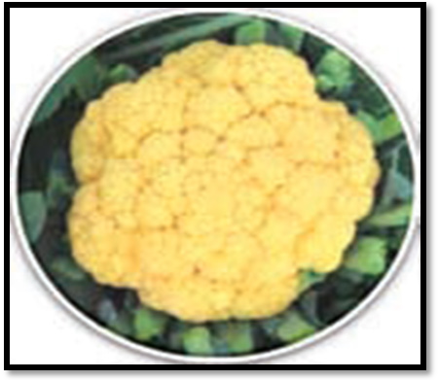
- Iodine enrichment in tomato: Addition of potassium iodide enhances iodine levels (Parulekar et al., 2019; Ahammed et al., 2025).

(Figure 2: Pusa Beta Kesari 1 first bio-fertified cauliflower (8-10 ppm β-carotene) (Solanki et al., 2022)
Research gaps:
Challenges such as limited genetic diversity, regulatory obstacles for transgenic crops, and insufficient sustainability assessments impede progress. Applications of CRISPR in vegetables lag behind those in cereals, and the scalability of bio-fortification programs requires significant investment (Behera et al., 2022; Bouis et al., 2024; Dhaliwal et al., 2025).

HEALTH BENEFITS AND ACTIONS OF NUTRACEUTICALS FROM VEGETABLES
Various nutraceuticals derived from vegetables, such as allicin, quercetin, β-carotene, sulforaphane, and lycopene, provide antioxidant, anti-inflammatory, and anticancer effects, helping to combat chronic diseases (Cisneros-Zevallos, 2021; Prabhakar, 2022; Vignesh et al., 2024).
Key nutraceuticals and their functions:
- Allicin (Garlic/Onion):
- Antioxidant: Eliminates ROS, activates Nrf2, and reduces LDL oxidation for heart health.
- Anti-cancer: Blocks HDAC and VEGF, suppressing stomach/colon cancers.
- Anti-inflammatory: Reduces NLRP3 and COX-2, easing arthritis symptoms (Sánchez-Sánchez et al., 2020).
- Quercetin (Onion/Broccoli/Cabbage):
- Antioxidant: Binds metals, inhibits xanthine oxidase, lowering Alzheimer’s risk by reducing amyloid plaques.
- Anti-cancer: Inhibits NF-κB and targets the G2/M phase, specifically breast/prostate cancers.
- Anti-inflammatory: Inhibits MAPK, 5-LOX, managing asthma (Vignesh et al., 2024).

- β-Carotene (Carrot/Sweet potato/Cauliflower):
- Antioxidant: Neutralizes singlet oxygen, enhances superoxide dismutase, supporting eye/lung health.
- Anti-cancer: Improves cell signaling, lowering lung/skin cancer risks.
- Anti-inflammatory: Regulates NF-κB, boosts IL-10, aiding diabetes (Prabhakar, 2022).
- Sulforaphane (Broccoli):Removes carcinogens through phase II enzymes, guarding against breast/colon cancers.
- Lycopene (Tomato): Reduces oxidative stress, decreasing prostate/lung cancer risks.
- Glucosinolates (Brassica): Generate isothiocyanates, hindering carcinogen activation (Parveen et al., 2025).
COMPOUND | SOURCE | PROPERTIES
Allicin | Garlic, Onion | Antibacterial, Antioxidant, Anti-cancer
Quercetin | Onion, Broccoli, Cabbage | Anti-alzheimer’s, Anti-cancer, Anti-inflammatory
β-Carotene | Carrot, Sweet potato, Cauliflower | Antioxidant, Anti-cancer, Eye health
Sulforaphane | Broccoli | Anti-breast/Colon cancer
Lycopene | Tomato | Anti-prostate/Lung cancer
Glucosinolates | Cabbage, Cauliflower | Anti-cancer, Detoxification
(Table 4: Key nutraceuticals in vegetables)
(Vignesh et al., 2024; Prabhakar, 2022)
Prevention of diseases and health benefits:
- Cardiovascular: Flavonoids block ACE, strengthen small blood vessels, and lower high blood pressure (Parveen et al., 2025).
- Diabetes: Omega-3s/catechins enhance insulin sensitivity (Delgadillo-Puga et al., 2020).
- Cancer: Carotenoids/sulfur compounds counteract tumor growth (Vignesh et al., 2024).
- Neurological: Lutein/folic acid decreaseshomocysteine levels, guarding against Alzheimer's disease (Gupta et al., 2020).
- Eye disorders: Lutein/zeaxanthinprevents cataracts (Prabhakar, 2022).
- Gastrointestinal:Fibers/prebiotics improve gut bacteria, boosting immunity (Behera et al., 2024).
Benefits of specific vegetables:
- Solanaceous (Tomato, Eggplant): Lycopene/phenolics reduce cancer/diabetes risks.
- Brassica (Broccoli, Cabbage):Glucosinolates prevent oxidative stress/cancer.
- Root crops (Carrot, Raddish): Carotenoids/isothiocyanates provide antimicrobial benefits.
- Bulb/Salad crops (Garlic, Lettuce): Organosulfurs/phenols assist in cancer prevention (Prabhakar, 2022; Vignesh et al., 2024).
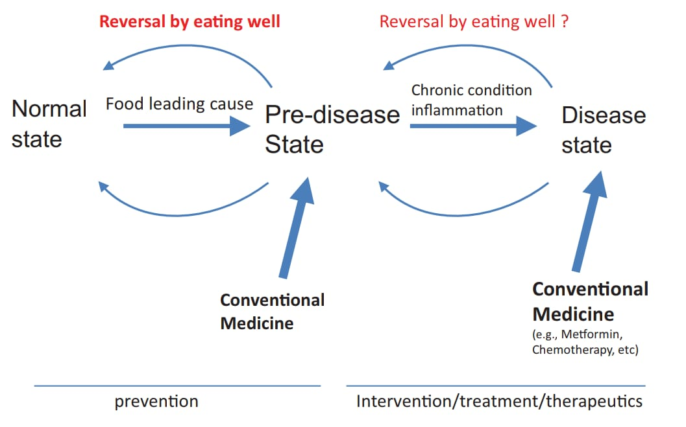

(Figure 3: Integrated approach connecting chronic diseases, food, and nutraceuticals)
(Cisneros-Zevallos et al., 2020)
Areas for further research:
While preclinical trials show promise (e.g., alliin reducing metaflammation), human studies lack consistency and long-term data. Understanding bioavailability and dosage responses is crucial for verifying health benefits (Gupta et al., 2020; Patel & Patel, 2021; Vignesh et al., 2024).
NUTRACUTICAL MARKETING TRADE AND REGULATORY LANDSCAPE
To attract consumers who are health-conscious in a highly regulated and competitive sector, nutraceutical content marketing needs a systematic strategy. Effective tactics include using data-driven, tailored content on digital platforms to target certain demographics, such as athletes or young people, who make up a major portion of the industry. Online nutraceutical markets are expected to increase at a 11.7% CAGR between 2025 and 2033, and Ayurvedic foundations are also becoming more popular, making up around 30% of the market. From a commercial standpoint, India exported nutraceuticals valued at USD 80 million in 2018. Influencer collaborations, social media, and instructional materials like blogs and videos foster trust, while gripping narratives and case studies bolster brand loyalty. Clear labeling and sustainable packaging appeal to environmentally friendly, approachable customer who follows Ayurvedic principles, while utilizing popular products like immune boosters or handy forms like gummies,meet rising demand. By 2030, the worldwide nutraceutical industry is predicted to grow to USD 919.1 billion. To

Table 5 SOME NUTRACUTICAL PRODUCTS ARE AVAILABLE WORLDWIDE
SL .NO | PRODUCT NAME | DOSAGE FORM | INGREDIENTS | CATEGORY | COMPANY NAME
1 | Chyawanprash | Semi-solid | Amla, Ashwagandha, Pippali | Immune booster | Dabur India Ltd.
2 | Calcirol D-3 | Tablet | Calcium and vitamins | Calcium supplement | Cadila Healthcare Ltd., Ahmedabad, India
3 | GRD Powder | Powder | Proteins, vitamins, minerals, carbohydrates | Nutritional supplement | ZydusCadila Ltd., Ahmedabad, India
4 | Protinex | Powder | Predigested proteins, vitamins, minerals, and carbohydrates | Protein supplement | Pfizer Ltd., Mumbai, India
5 | Coral Calcium | Powder | Calcium and trace elements | Calcium supplement | Nature’s Answer, Hauppauge, NY, USA
6 | Amiriprash (Gold) | Semi-solid | ChyawanprashAvaleha, Swarnabhasma, Rassindur | Immunomodulator | UapPharmaPvt Ltd.
7 | Omega Woman | Liquid/Capsules | Lycopene, Resveratrol, antioxidants, vitamins | Immune supplement | Wassen, Surrey, U.K.
8 | Celestial Healthtone | Syrup | Dry fruit extract | Immune booster | Celestial Biolabs Ltd.
9 | Follihair | Tablet | Biotin, amino acids, vitamins, minerals, and natural extract | Hair care supplement | Abbott
10 | Shallaki | Tablet | Shallaki pure herb | Pain & inflammation | Himalaya
11 | Black Cohosh | Capsule | Black cohosh root | Dietary supplement | BiotrexNutraceuticals

REGULATORY LANDSCAPE OF NUTRACUTICALS
The Food Safety and Standards Authority of India (FSSAI) is mostly responsible for overseeing the nutraceutical industry in India in accordance with the Food Safety and Standards Act of 2006.
Crucial elements consist of:
Product Classification: Nutraceuticals are food-based products that provide health advantages over and beyond basic nourishment. Functional foods, dietary supplements, and foods for certain medical or nutritional needs are some examples of these categories.
Registration and Licensing: Manufacturers are required to get licenses based on turnover.
- Basic Enrollment (≤ 12 lakh)
- License from the State (₹12 lakh to ₹20 crore)
- Central License (more than ₹20 cr)
Ingredient Approval - New ingredients need to undergo safety evaluations and expert review. The FSSAI keeps a list of authorized vitamins, minerals, botanicals, probiotics, and amino acids.
Labeling & Claims - Labels need to contain the FSSAI license number, cautions, suggested usage, and nutritional information. Health claims must be non-disease-related, accurate, and supported by science.
Manufacturing Standards - Good Manufacturing Practice (GMP) adherence is required and covers quality control procedures, equipment validation, and facility cleanliness.
Post-market surveillance - Keeping an eye on items for negative impacts and compliance, and quickly recalling unsafe products.
Table 6 DIFFERENT COUNTRIES REGULATE NUTRACEUTICALS UNDER VARYING FRAMEWORKS:
REGION | REGULATORY BODY | KEY NOTES
USA | FDA (under DSHEA) | Regulates as dietary supplements; labeling and safety are key
EU | EFSA | Evaluates health claims; harmonized standards across member states
Australia | TGA | Regulates complementary medicines; strict on efficacy and safety
China | SAMR | Oversees health food registration; traditional medicine integration
India | FSSAI, AYUSH, MoHFW | Multi-agency oversight; evolving standards and innovation incentives

PRACTICAL APPLICATION FOR LIFESTYLE INTIGRATION:
The plants have Secondary metabolites like phytonutrients, supplements, and nutraceuticals. The saying "Let food be the medicine and medicine be the food," which was first used by Hippocrates more than 2,500 years ago, is gaining a lot of attention these days as consumers and food scientists become more aware of the numerous health advantages of particular foods. The science and policy make their production, processing, and use; however, they only marginally include many of these important entities.Nutraceutical words such as functional foods, dietary supplements, designer foods, medical foods, pharma foods, phytochemicals, and so on have been compiled here. In one way or another, functional meals can help regulate a variety of conditions, including cancer, obesity, diabetes, cardiovascular disease, immune system-based diseases, chronic inflammatory disorders, degenerative diseases, various forms of depression, hypertension, and memory difficulties. There are numerous functional foods, such as fruits and vegetables, seafood and their byproducts, spices, etc., that show positive health effects. Vitamins and other bioactive substances are crucial to human health.
Colours of fruit and vegetables:
Generally speaking, foods with similar colors have comparable protective substances. A rainbow of vibrant fruits and vegetables should be consumed daily to get the full spectrum of health benefits. For example-
- Watermelon and tomatoes are examples of red foods. These include lycopene, which is believed to be good for heart disease and to protect against cancer.
- Kale and spinach are examples of green veggies. In these,Zeaxanthin and lutein may help to prevent age-related eye damage, etc.
- Blue and purple food, such as eggplant and blueberries. These have anthocyanins, which could help to prevent cancer.
- Cauliflower and other white foods have sulforaphane, which helps to prevent some types of cancer.
A list of fruits and vegetables high in nutrients and their advantages for a child's diet may be found here.

Table 7 NUTRACEUTICAL-RICH VEGETABLES AND FRUITS FOR CHILDREN'S DIET-
SLNO. | CATEGORY | ITEM | KEY NUTRACEUTICALS | HEALTH BENEFITS
1 | fruit | Blueberries | Anthocyanins, Vitamin C, Fiber | Brain development, antioxidant support
2 | fruit | Apples | Quercetin, Fiber, Vitamin C | Gut health, immunity, and anti-inflammatory support
3 | fruit | Bananas | Potassium, Vitamin B6, Fiber | Energy boost, digestion, heart health
4 | fruit | Oranges | Vitamin C, Flavonoids, Fiber | Immunity, skin health, antioxidant protection
5 | fruit | Pineapple | Bromelain, Vitamin C | Anti-inflammatory, digestion, immunity
Table 8 NUTRACEUTICAL-RICH VEGETABLES AND FRUITS FOR YOUNG ADULTS DIET-
SLNO. | CATEGORY | ITEM | KEY NUTRACEUTICALS | HEALTH BENEFITS
1 | Fruits | Grapes | Resveratrol, Quercetin, Vitamin C | Heart health, anti-aging, antioxidant protection
2 | Fruits | Mango | Beta-carotene, Vitamin A, Vitamin E | Skin glow, immune strength, eye health
3 | Fruits | Watermelon | Lycopene, Citrulline, Vitamin C | Hydration, skin health, and muscle recovery
4 | Fruits | Avocado | Oleic acid, Vitamin E, Potassium | Hormonal balance, heart health, and skin nourishment
5 | Fruits | Banana | Potassium, Vitamin B6, Magnesium | Energy boost, muscle support, stress relief

Table 9 NUTRACEUTICAL-RICH VEGETABLES AND FRUITS FOR PREGNANT WOMEN'S DIET-
SL NO. | CATEGORY | ITEM | KEY NUTRACEUTICALS | HEALTH BENEFITS FOR PREGNANCY
1 | Fruit | Banana | Vitamin B6, potassium | Reduces morning sickness, regulates blood pressure, aids brain development
2 | Fruit | Berries | Antioxidants (vitamin C, polyphenols), fiber | Fights inflammation, boosts skin health, regulates blood sugar
3 | Fruit | Oranges | Vitamin C, folate, flavonoids | Aids iron absorption, hydrates, and supports nervous system development
4 | Fruit | Pomegranate | Iron, antioxidants | Enhances blood circulation, reduces fatigue, and improves heart health
5 | Fruit | Apple | Vitamin C, fiber, and flavonoids | Lowers risk of childhood asthma, improves digestion, and strengthens immunity
Table 10 NUTRACEUTICAL-RICH VEGETABLES AND FRUITS FOR OLD PEOPLE'S DIET-
SL NO. | CATEGORY | ITEM | KEY NUTRACEUTICALS | HEALTH BENEFITS FOR OLDER ADULTS
1 | Fruit | Papaya | Vitamin C, lycopene | Boosts immunity, reduces oxidative stress, supports skin and heart health
2 | Fruit | Apple | Quercetin, fiber, vitamin C | Lowers cholesterol, supports digestion, and reduces diabetes risk
3 | Fruit | Blueberries | Flavonoids, vitamin C, anthocyanins | Enhances memory, slows cognitive aging, supports immune function
4 | Fruit | Grapefruit | Vitamin C, beta-carotene, flavanones | Strengthens immunity, supports heart health, and reduces inflammation
5 | Fruit | Kiwi | Vitamin C, fiber, potassium | Aids digestion, supports heart health, boosts immunity

Challenges for nutraceuticals:
Numerous obstacles impede the nutraceutical industry's expansion and recognition. Regulatory uncertainty is one of the main problems since nutraceuticals sometimes fall between food and medicine, which results in inconsistent regulations for marketing, labeling, and approval between nations. Quality control and standardization present additional challenges because it might be challenging to guarantee the precise dosage, purity, and consistency of bioactive chemicals in natural goods. Furthermore, there is a dearth of solid scientific validation because many nutraceuticals are not subjected to thorough clinical trials to demonstrate their efficacy and safety. Additional safety issues include the potential for infection, adulteration, or negative interactions with prescription medications. Additionally, consumers are not well-informed, and the widespread notion that "natural means safe" frequently results in abuse or overconsumption. The potency of bioactive compounds is also impacted by storage and stability problems, as many of them deteriorate with time, decreasing the efficacy of products.
Future prospects of neutracuticals-
The nutraceutical market is expected to increase significantly due to rising consumer consciousness of wellness and health. Nutraceuticals, or foodstuffs with additional health advantages, are becoming a staple of everyday life as people move from reactive to preventive healthcare. This covers nutritional supplements, functional meals, and drinks that promote mental clarity, digestion, immunity, and the treatment of chronic illnesses. Due to increased demand and innovation, the worldwide industry is growing quickly; estimates indicate it may reach $850 billion by 2030.
Additionally, technological advancement is changing the terrain. Utilizing nanotechnology, nutrients can be made more bioavailable so that the body can absorb them more effectively. Biotechnology and fermentation methods are improving components' sustainability and potency. Along with increasing the effectiveness of products, these developments are making it possible to create previously unattainable innovative formulations. A growing number of businesses are investing in clean-label products, regenerative agriculture, and eco-friendly packaging as concerns about ingredient transparency and environmental effects increase. As a result of this tendency, the sector is being pushed into more ethical procedures, which increases customer loyalty and trust.

- Advances in nanofabrication technology for nutraceuticals-
Some of the deadliest diseases have been known to be prevented by bioactive substances such as polyphenolics, flavonoids, bioactive peptides, pigments, and essential fatty acids. Nutraceuticals are those healthy substances that can be found in food or food ingredients and have been shown to have positive effects on health or medicine. In the field of food sciences, nanoencapsulation and nanofabricated delivery methods are emerging trends. The production of biocompatible active ingredients and nutraceuticals in a sustainable manner unquestionably improves food quality and fosters health. Delivery systems based on proteins, lipids (liquid and solid), and carbohydrates are instances of nanofabricated delivery systems.
- Progress in Functional Foods and Beverages-
These are common foods supplemented with bioactive substances that provide specific health advantages over and above basic sustenance. Vitamin-and mineral-enriched cereals for energy and immunity, omega-3 fortified eggs for cardiovascular support, and probiotic-rich yogurt for gut health are all becoming mainstays in contemporary diets. In addition to sating hunger, consumers are increasingly looking for foods that promote long-term wellness, disease prevention, and mental clarity.

- Future Prospects for Development in Herbal Nutraceuticals -
In the nutraceutical business, where demand for nutraceutical goods is rising faster than ever before, herbal nutraceuticals are playing a significant role. In addition to basic nutrition, herbal products that contain phytochemicals like lutein, carotenoids, phenolic compounds, plant-based sterols, etc., provide many other health benefits. Our forefathers employed herbs like garlic, ginger, ginkgo biloba, ginseng, turmeric, onion, ashwagandha, brahmi, and more to treat a variety of illnesses. The regulatory framework for the trading and marketing of innovative nutraceutical goods within their borders has been built in many nations in the present worldwide market and potential future.

CASE STUDIES-
Case study-1:
Research Article:Medicinal uses of selected wild edible vegetables consumed by the Hyderabad-Karnataka region of Karnataka State in India.
HanumantappaBherigiNayaka, Department of Life Sciences, Faculty of Sciences, KristuJayanti College Autonomous, Bengaluru, Karnataka, India.
Received: 29 October 2019
Revised: 27 December 2019
Accepted: 7 January 2020
Objective: The purpose of this study was to assess the medicinal value of wild vegetables consumed by local people of the Hyderabad-Karnataka region of Karnataka State in India.
28-Jul-20, Dept. of VSC,Nayaka (2019)
Material and method:
Study area: The current study focused on selected deep rural villages situated in each of the six local municipalities of the Hyderabad Karnataka region (Bidar, Gulbarga, Yadgir, Raichur, Koppal, and Ballary)


Map 1 - Study duration: 10 months

Table 11 : Ethno medicinal properties of documented wild edible vegetables

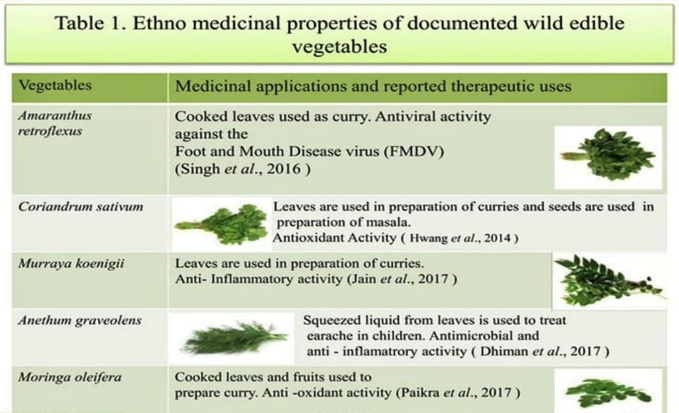

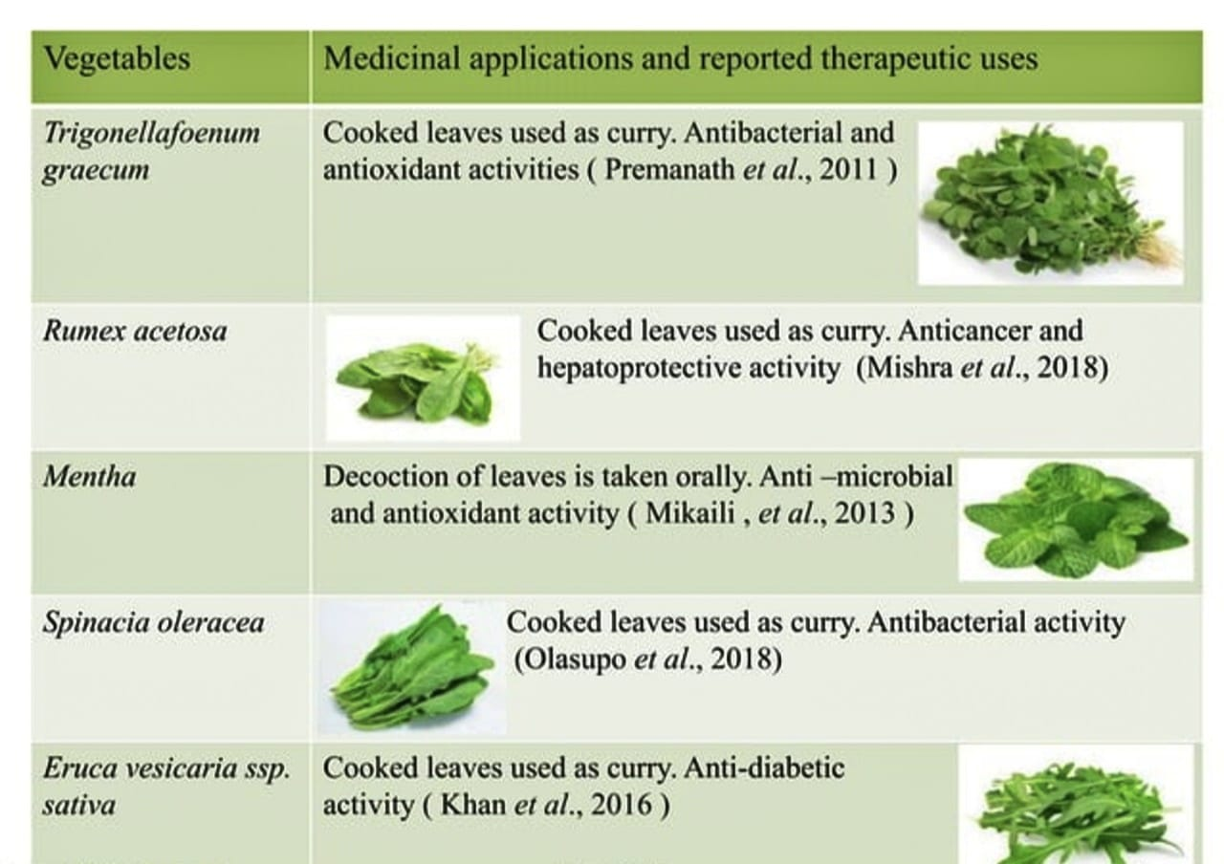

Number of respondents: 160, 28-Jul-20, Dept. of VS
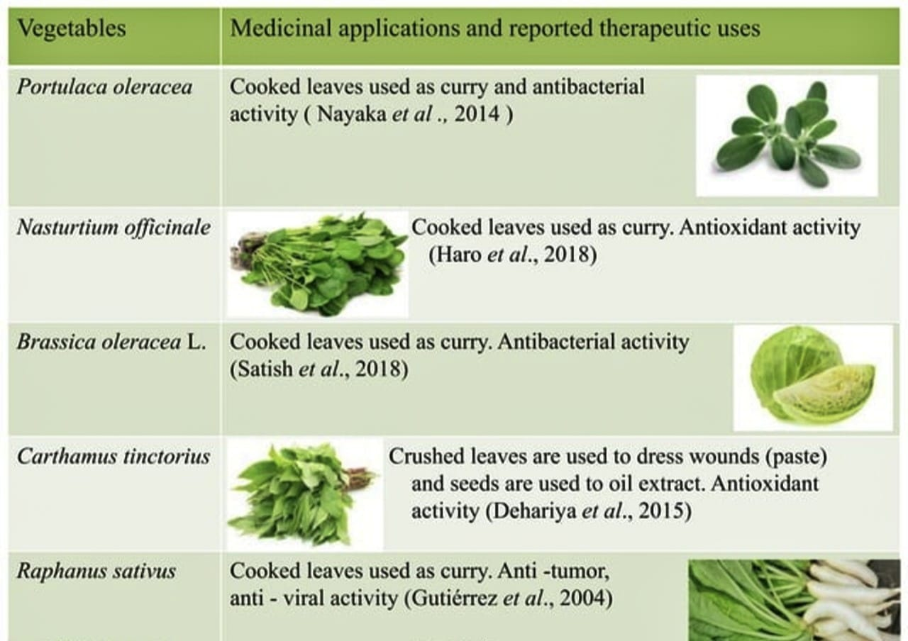
Source: Nayaka(2019), 28-july-20, Dept. Of VSC

Role of vegetables in the prevention of diabetes:
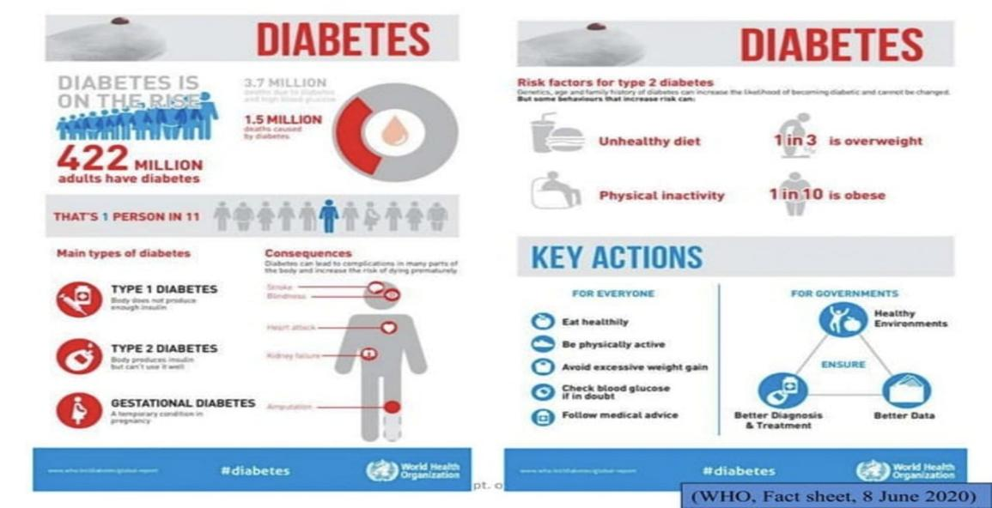
Image 12 Diabetes: Facts, Risks, Consequences, and Key Actions

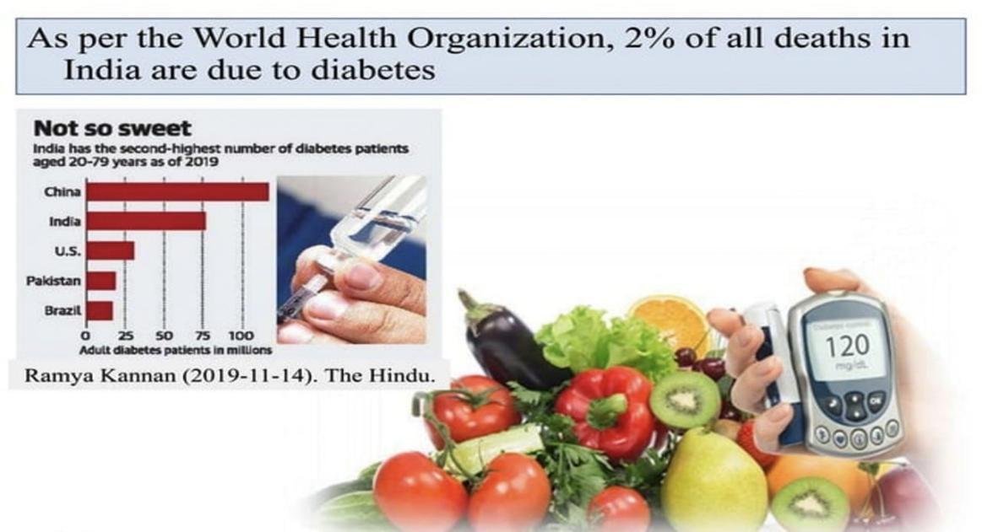

Image 13 : Diabetes in India: A Growing Health Challenge
Case study-2:
Improvement of Protein Energy Malnutrition by Nutritional Intervention with MoringaOleifera among Anganwadi Children in Rural Area in Bangalore, India
Sources:
- V S Srikanth', S Mangala², G Subrahmanyam³
- M.B.B.S. Final Year Student, Vydehi Institute of Medical Sciences and Research Centre, Bangalore, Karnataka, India, Professor of Community Medicine, Vydehi Institute of Medical Sciences and Research Centre, Bangalore, Karnataka, India, Professor and HOD of Community Medicine, Vydehi Institute of Medical Sciences and Research Centre, Bangalore, Karnataka, India
- Corresponding Author: Dr.Mangala Subramanian, 53, 3 Main Road, S.B.M. Colony, Anand Nagar, Bangalore 560024, Karnataka, India. E-mail: xxx@gmail.com
Objective:
a) Identifying children with protein-energy malnutrition
b) To give nutritional intervention in the form of Moringaoleifera powder to the children for 2 months
c) To reassess the nutritional status after the nutritional intervention at the end of 2 months.
( Srikanthet al., 2014)
Material and method:
- A before-and-after study was conducted in the rural field practice area of Vydehi Institute of Medical Sciences and Research Centre, Bangalore, India
Group | Number of children's
Intervention group | 30
Control group | 30

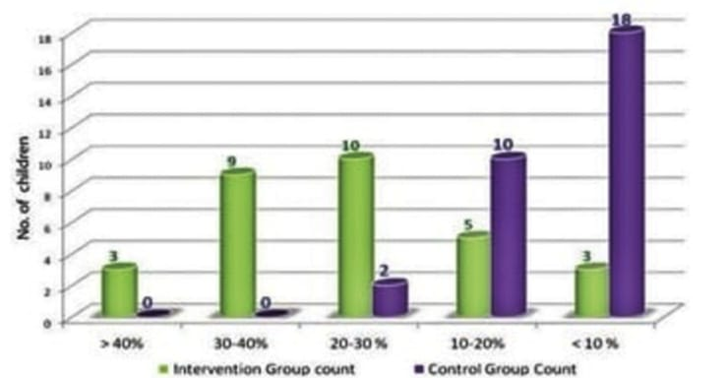
- Nutritional Intervention was given in the form of Moringaoleifera leaf powder 15 g twice daily for two months. Reassessment of the nutritional status was done after 2 months.
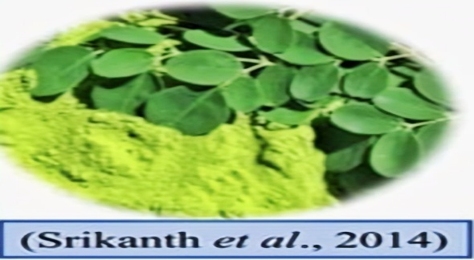


Source: (Srikanth et al., 2014)
(Fig:4 Percentage improvement of weight among intervention and control groups)

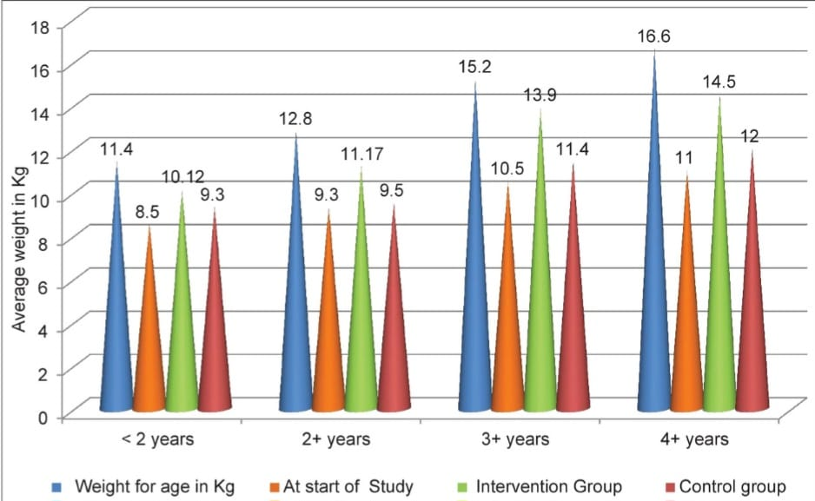

Source: (Srikanth et al., 2014)
(Fig:5 Age-wise weight improvement among intervention and control groups)
Case study-3:
Nutraceutical value of salad vegetables to combat COVID-19
Dr. AD Ashok, J Ravivarman, and Dr. K Kayalvizhi, Institute of Agriculture, Tamil Nadu Agricultural University, Kumulur, Trichy, Tamil Nadu, India
Journal of Pharmacognosy and Phytochemistry 2020; 9(3): 2144-2148
Table 12 – Role of salads in human health
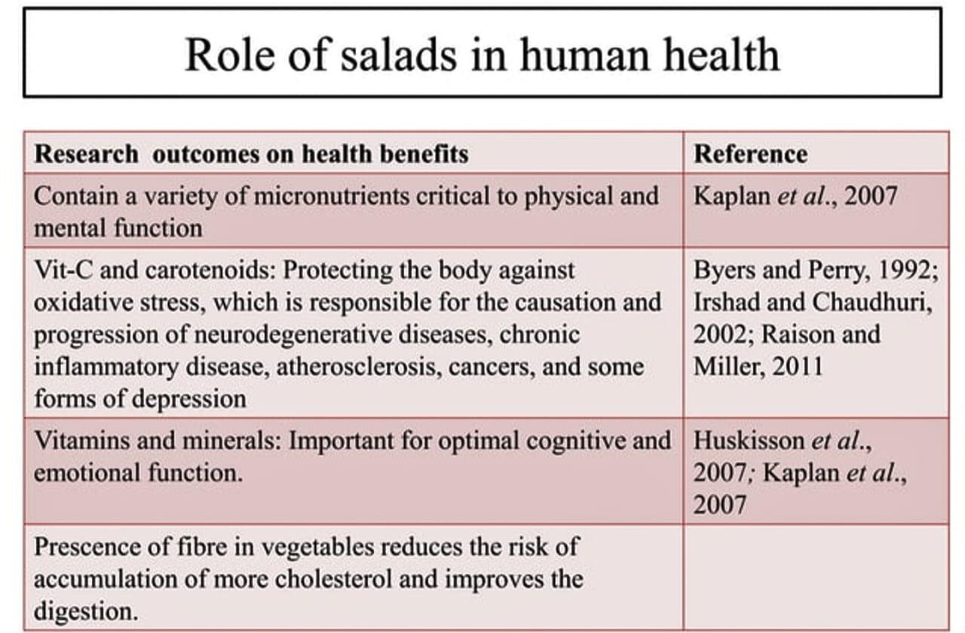

Objective: To study the importance of salad vegetables in our diet to overcome viral infections.

Source: (Ashok et al., 2020)

CONCLUSION-
A practical and efficient strategy to improve health, especially for all kinds of people, is to incorporate fruits and vegetables into daily meals. Addition of high-nutrient-content foods like broccoli, spinach, avocados, sweet potatoes, and berries can help people maintain their health while addressing common pregnancy-associated or other health diseases, including anemia, abnormalities, constipation, and diabetes. Adding fruits to breakfast smoothies, including veggies in main meals, adding some raw fruit in snacks, and arranging colorful fruits in diversified plates to provide a wide range of nutrients and a long-term healthy life.
REFERENCES-
- Ahammed, S., Rahim, M., & Hossain, M. (2025). Biofortification of potato tubers with zinc through foliar application of Zn fertilizer. Asian Plant Research Journal, 13(2), 72-82.
- Arya, M. S., Reshma, U. R., Thampi, S. S., Anaswara, S. J., & Sebastian, K. (2019). Nutraceuticals in vegetables: New breeding approaches for nutrition, food, and health: A review. Journal of Pharmacognosy and Phytochemistry, 8(1), 677–682.
- Azeem, A., Khan, S., Zia UlHaq, M., Shafiq, S., Aslam, M. T., Munir, S., &SikandarZaman, M. (2025). Biofortification strategies for enhancing crop nutritional value: A review of methods, challenges, and future directions. Discover Plants, 2(1), 185.
- Behera, S., Panda, M. K., Kohlmeier, M., &Behera, R. (2022). Improving nutrition through biofortification – A systematic review. Frontiers in Nutrition, 9, 1043655.
- Behera, S. R., Pandey, R., Dhathri, M., Negi, P., Jakhwal, R., Sahoo, S., ...&Mohapatra, A. (2024). Agronomic biofortification of vegetable crops – A systematic review. Journal of Advances in Biology & Biotechnology, 27(9), 942-956.
- Bhardwaj, A. K., Chejara, S., Malik, K., Kumar, R., Kumar, A., &Yadav, R. K. (2022). Agronomic biofortification of food crops: An emerging opportunity for global food and nutritional security. Frontiers in Plant Science, 13, 1055278.
- Bouis, H., Foley, J., Lividini, K., Jumrani, J., Reinke, R., Van Der Straeten, D., ...& Pfeiffer, W. H. (2024). Biofortification: Future challenges for a newly emerging technology to improve nutrition security sustainably. Current Developments in Nutrition, 8(12), 104478.
- Cisneros-Zevallos, L. (2021). The power of plants: How fruit and vegetables work as source of nutraceuticals and supplements. International Journal of Food Sciences and Nutrition, 72(5), 660-664.
- Cisneros-Zevallos, L., Jacobo-Velázquez, D. A., & Osorio, M. (2020). Urolithins: A review of their metabolism, bioactivity, and potential health benefits. Journal of Agricultural and Food Chemistry, 68(12), 3456–3467.
- Delgadillo-Puga, C., Cuchillo-Hilario, M., & Navarro-Ocaña, A. (2020). Goat milk enriched with plant polyphenols prevents obesity and insulin resistance. Food & Function, 11(6), 5263–5274.
- Faruque, F., et al. (2022). Improving nutrition through biofortification: A systematic review. Frontiers in Nutrition, 9, Article 1043655. https://doi.org/10.3389/fnut.2022.1043655
- Gupta, S., & Prakash, J. (2020). Nutraceuticals: Exploring the gap between promise and proof. Food Research International, 137, 109543.
- Kumar, R., Sharma, A., & Gupta, M. (2022). Elicitation approaches for enhancing bioactive compounds in plants: A critical review. Plant Physiology and Biochemistry, 189, 36-47.
- Parulekar, Y. R., Haldankar, P. M., Dalvi, N. V., Salvi, B. R., & Bhattacharyya, T. (2019). Nutraceuticals and their biofortification in vegetable crops: A review. Advanced Agricultural Research & Technology Journal, 3(2), 219–229.
- Parveen, A., Gupta, S., & Sharma, R. (2025). Nutraceuticals in chronic disease management: Bridging nutrition and health. Journal of Functional Foods, 112, 106012.
- Prabhakar, B. N. (2022). Vegetables as nutraceuticals and future plant drugs. Annals of Phytomedicine, 11(1), 1-6.
- Solanki, V. G., Solanki, S. R., & Solanki, R. S. (2022). Biofortification of vegetable crops – A review. The Pharma Innovation Journal, 11(10), 1060-1066.
- Vandana et al. (2022). Biofortification of vegetable crops to boost nutraceuticals in human diet: A review. The Pharma Innovation Journal, 11(10), 59–86.
- Vasanthkumar, S. S., Gowshika, R., Pooja, U. K., Manjusha, M. R., Sreekumar, G., Bharathi, S., &Rubika, R. (2024). Exploring nutraceuticals in underutilized vegetables and their pharmacological activities. Medicinal Plants, 16(2), 246–254. https://doi.org/10.5958/0975-6892.2024.00026.3
- Vignesh, A., Amal, T. C., Sarvalingam, A., &Vasanth, K. (2024). A review on the influence of nutraceuticals and functional foods on health. Food Chemistry Advances, 5, 100749.

