Assessment of Seasonal Variations in Cool and Warm Temperature Extremes in Chhattisgarh: A Pre- and Post-1986 Analysis

Abstract
The seasonal changes in temperature extremes—cool and warm days (TX10P and TX90P) and nights (TN10P and TN90P)—across Chhattisgarh's agro-climatic zones are evaluated in this research before and after 1986, a worldwide standard for rapid climate change. The study, which makes use of long-term climate data and standardized indices suggested by the Expert Team on Climate Change Detection and Indices (ETCCDI), shows that, especially in the Bastar Plateau and Chhattisgarh Plain Zones, the frequency of warm days and nights has significantly increased while the frequency of cool night events has decreased. The research also examines variations in the frequency of moderate and severe droughts, revealing that although severe droughts were more localized, moderate droughts increased generally after 1986. These changes in climatic patterns are strongly linked to threats to agriculture, particularly the productivity of rice, which emphasizes the urgent need for climate adaptation plans tailored to individual regions. The results provide a thorough, seasonal, and district-level investigation of climatic extremes and their possible effects on the state's food security, therefore addressing a significant gap in prior studies.
Keywords: Chhattisgarh, Temperature Extremes, Seasonal Variation, Pre- and Post-1986, Agro-Climatic Zones, Climate Change

Introduction
Chhattisgarh, which is located in central India, has a subtropical climate with hot summers, a humid monsoon, and cold winters (Thakur, 2017). In the past few decades, the state has seen extensive climatic changes, specifically in the way of extremes in temperature. Both cool and warm variations of temperature have become more dominant and are symptomatic of more general climatic changes happening at regional and global levels. Evaluating seasonal fluctuations in temperature extremes is essential to the comprehension of the local expression of global climate change and their cascading impacts on agriculture, water resources, ecosystems, and public health. The increase in warm days and nights and decrease in cold nights in Chhattisgarh are the most obvious signs of the state's deteriorating climatic variability (Mulla et al., 2023). Trends at the season show persistent increase in maximum temperatures in summer and post-monsoon seasons while minimum temperatures in winter have shown variability—oscillating between phases of stability and warming. These trends directly impact crop yield, irrigation requirements, and susceptibility to heat illness. 1986 is also identified as a worldwide turning point in climate research since the onset of increasingly rapid warming trends. For Chhattisgarh, this research investigates the manner in which patterns of temperature extremes, i.e., cool and warm temperature events, have changed prior to and subsequent to 1986. Through long-term climatic data over seasons and regions, this analysis attempts to find key insights into temporal variations of temperature behavior. Detection of these trends is critical for climate-resilient policy development and adjustment strategies in agriculture, health, and environmental management.
This study analyses the seasonal variability in severe temperatures in Chhattisgarh spanning two notable climatic epochs—pre-1986 and post-1986—to inform regional planning in an ever- changing climate. This study needs a literature evaluation to understand past climate patterns, warming trends, and regional temperature extremes. Previous Chhattisgarh district research on long-term climatic variability and its effects constitutes the empirical basis for this study.
(Thakur, 2017) analyzed long-term climatic information for the period from 1901 to 2002 for 16 Chhattisgarh districts. The observations indicated an overall increase in both minimum and maximum temperatures, particularly in Dantewada, Bastar, and Kanker districts. The rise in nocturnal temperatures (minimum temperature) is alarming, as it alters the conventional diurnal temperature range, which is essential for crop physiology and human comfort (Thakur, 2017).
In addition, a spatiotemporal temperature study by (Maniar & Pattnaik, 2019) of the eastern regions of Chhattisgarh noted an upward trend in warm nights throughout the summer season (March to May) from 1988–2017. This suggests an erosion of nocturnal cooling, especially in Raigarh district, whose warm night frequencies have been on an upward trend. Conversely, the number of cold nights has decreased, indicating decreasing instances of extreme cool weather events within the region (Maniar & Pattnaik, 2019).
At Raipur district, (Khavse et al., 2015) indicated seasonality in temperature patterns. Their trend analysis of data between 1971 and 2013 showed rising trends in monthly maximum temperatures, notably in December, indicating warmer winters. On the other hand, there was a declining trend in August rainfall, indicating a twin challenge of warming and precipitation uncertainty (Khavse et al., 2015).
(Mishra et al., n.d.), in a basin-level study of the Kharun basin in Chhattisgarh, observed appreciable seasonal variation in minimum and maximum temperatures. Their Mann-Kendall and Sen's slope trend analysis supported the increase in maximum temperature in monsoon and summer season months, while at some stations, there was a sharp decrease in winter minimum temperatures, which influence rabi crops (Mishra et al., n.d.).
The effects of these seasonal variations are already being experienced in the agricultural industry. Temperature fluctuations, particularly during the onset stages of important crop development, such as the pulse crop, influence the yield of pulses in a number of districts in Chhattisgarh (Rajput & VISHWAVIDYALAYA, 2021). Increased winter temperatures have especially affected crops that depend on cooler temperatures for flowering and grain filling.
While Chhattisgarh's growing trend of temperature extremes and their effects on agriculture are well-documented in the literature, much of the research that has been done so far has either focused on a small number of districts, short time periods, or certain temperature indices without a season-by-season breakdown. Furthermore, even though rice is a crucial crop for the area, previous research has seldom shown a clear correlation between these temperature changes and agricultural results like rice output. This disparity emphasises the need of a thorough, zone-by-zone, and seasonally-segmented examination of warm and cool temperature extremes over an extended period of time.
In order to overcome this drawback, our research compares trends before and after 1986 in order to assess seasonal changes in cold and warm temperature extremes (TX10P, TX90P, TN10P, and TN90P) throughout all agro-climatic zones of Chhattisgarh. The study offers important insights for region-specific agricultural planning and climate adaptation strategies by incorporating these results with their possible consequences for rice yield.

Material and methods
With a quantitative and observational method, this study compares Chhattisgarh's seasonal variation in warm and cold temperature extremes prior to and post-1986, a year famous globally for sudden climatic changes. Temperature indices related to severe events and their implications for local rice yields are the prime points of concern.

Study Area
This study's geographic scope encompasses all of Chhattisgarh's agroclimatic zones, including the Northern Hill Zone, the Bastar Plateau Zone, and the Chhattisgarh Plain Zone. These zones together reflect different topographical and climatic variables that affect rice yield.

Time Period
Data was segmented into two distinct temporal windows:

    - Pre-1986 period
    - Post-1986 period

This classification helps in separating long-term climatic indicators and analyzing the historical development of temperature extremes.

Data Sources
Historical daily temperature record (min and max) was obtained from India Meteorological Department (IMD) and respective secondary databases for over 70 years. Drought occurrence records were cross-checked from peer-reviewed publications like Sinha et al. (2017) and regional weather bulletins.

Temperature Indices Used
The research uses globally recognised percentile-based indices that are suggested by the Expert Team on Climate Change Detection and metrics (ETCCDI) to analyse temperature extremes:
    - TX10P (Cool Days): Days when daily maximum temperature is below the 10th percentile.
    - TX90P (Warm Days): Days when daily maximum temperature is above the 90th percentile.
    - TN10P (Cool Nights): Days when daily minimum temperature is below the 10th percentile.
    - TN90P (Warm Nights): Days when daily minimum temperature is above the 90th percentile.

Seasonal Classification

Temperature extremes were evaluated seasonally across:

    - Winter (December to February)

    - Summer (March to May)

Results
  - The difference in Winter Cool and Warm Days (TX10P and TX90P)
Winter cool days rose by 2–6% in Bastar Plateau Zone, which is highest in the state. The Chhattisgarh Plain Zone experienced largely no change, though districts such as Raigarh, Gariyaband, Dhamtari, Balod, Southern Durg, and Rajnandgaon experienced a 1–2% fall. Bilaspur block alone experienced a 1% rise. Koriya, Surajpur, and Balrampur experienced a 1% rise in the Northern Hill Zone, while Northern Jashpur and Southern Surguja experienced no change. Southern Jashpur experienced a 1% fall.
Winter warm days went up in all zones. Bastar's Bijapur, Dantewada, and Sukma went up by 6–7%, and Narayanpur and Kondagaon by 9%. Rajnandgaon increased by 6% in the Plains, while Gariyaband, south Raigarh, and Dhamtari had the highest increase of 9–10%. The rest increased 5–8%. In the Northern Hills, warm days went up by 4–5%, with Balrampur registering the lowest at 4% (Maniar & Pattnaik, 2019).

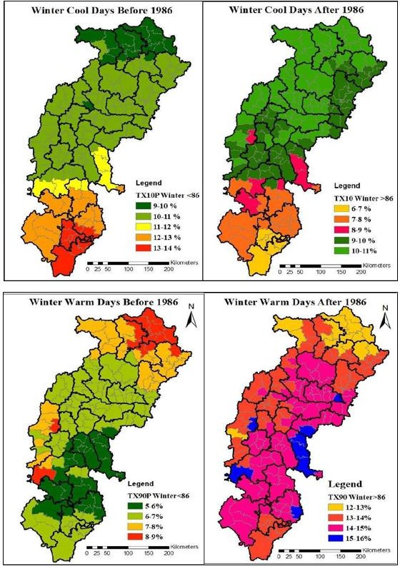

Figure 1 Winter Cool and Warm Days Before and After 1986

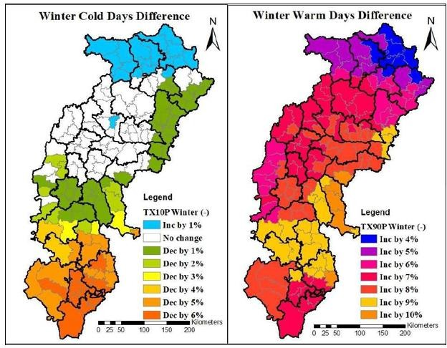

Figure 2 Change in winter cool and warm days

The difference in Summer Cool and Warm Days (TX10P and TX90P)
Cool summer days reduced by 1–3% in the Bastar Plateau Zone. In the Chhattisgarh Plain Zone, an increase of 1–3% was observed in most places, but Bilaspur block and Northern Raigarh registered no change. In the Northern Hill Zone, Bharatpur (Koriya), Premnagar (Surajpur), and Bhanupratapur (Surguja) registered a 1% decline, while Ramanujganj (Balrampur), Duldula, Jashpur, and Manora blocks registered a 1% increase.
Warm days rose throughout the state. Bastar recorded 1–4% increase, while the Chhattisgarh Plains reported mixed trends: a 2–6% decline in some pockets but a 5–6% rise in Kabeerdham, Northern Mungeli, Bilaspur, Korba, Bemetara, Durg, Balod, and Dhamtari. Warm days increased in the Northern Hills by 1–3%, with Balrampur recording the minimum rise (1%) and Bharatpur (Koriya) the maximum (4%).

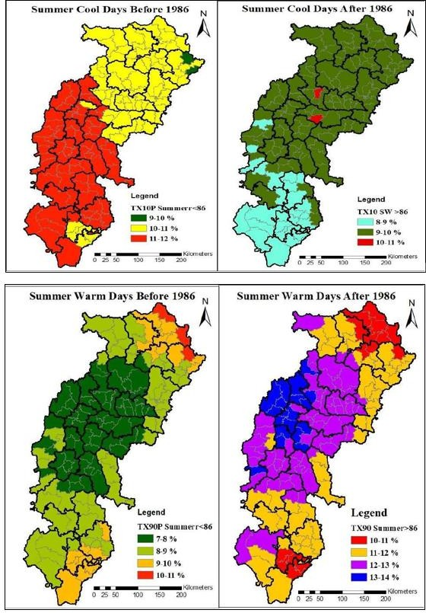

Figure 3 Summer Cool and Warm Days Before and After 1986

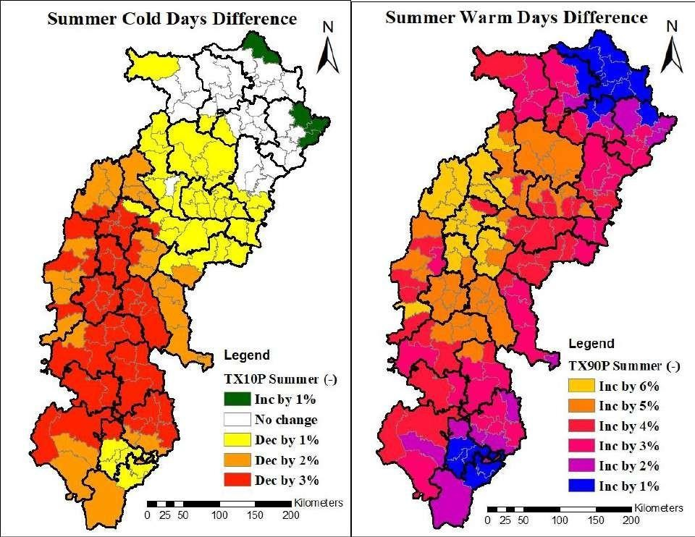
Figure 4 Change in Summer Cool and Warm Days

The difference in Winter Cool and Warm Nights (TN10P and TN90P)
In winter, cool nights in the Bastar Plateau Zone decreased predominantly by 1–4%, with an exception of a 1% rise in Bastar and Kondagaon and zero change in Orchha, Bhairamgarh, Gidam, and Jagdalpur. In the Chhattisgarh Plain Zone, the majority of districts registered a 1– 4% rise, with Southern Rajnandgaon, Sahaspur Lohara, Northern Mungeli, and Pendra Road (Bilaspur) registering no change. In the Northern Hill Zone, Surguja went down by 1%, the majority of regions went up by 1–2%, and Bharatpur, Lakhanpur, and Batouli didn't change.
For winter warm nights, Bastar Plateau recorded an increase of 1–4% in Southern Bijapur, Dantewada, Sukma, and Bastar, and there was no change in Bhopalpattnam and Bastanar. Other regions decreased by 1–4%. In the Plains, the majority of regions such as Kabeerdham, Northern Mungeli, and Bilaspur rose by 1–4%, whereas Mohla, Sahaspur Lohara, and large parts of Korba remained unchanged. Gariyaband and Raigarh registered the maximum fall (5– 6%), whereas the rest dropped by 2–4%. In the Northern Hills, Koriya and Surajpur recorded

1–4% rises, whereas the rest of the regions fell by 1–3%, barring Balrampur and Ramanujganj, which remained unchanged.
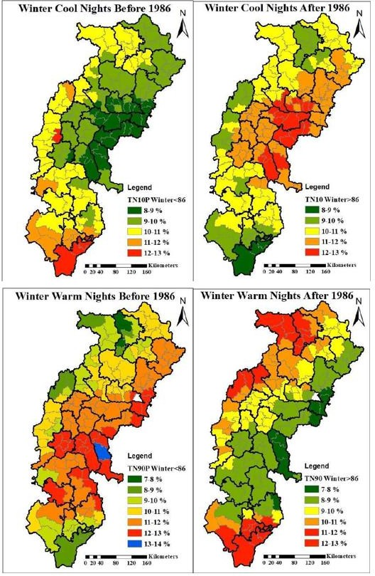

Figure 5 Winter Cool and Warm Nights Before and After 1986

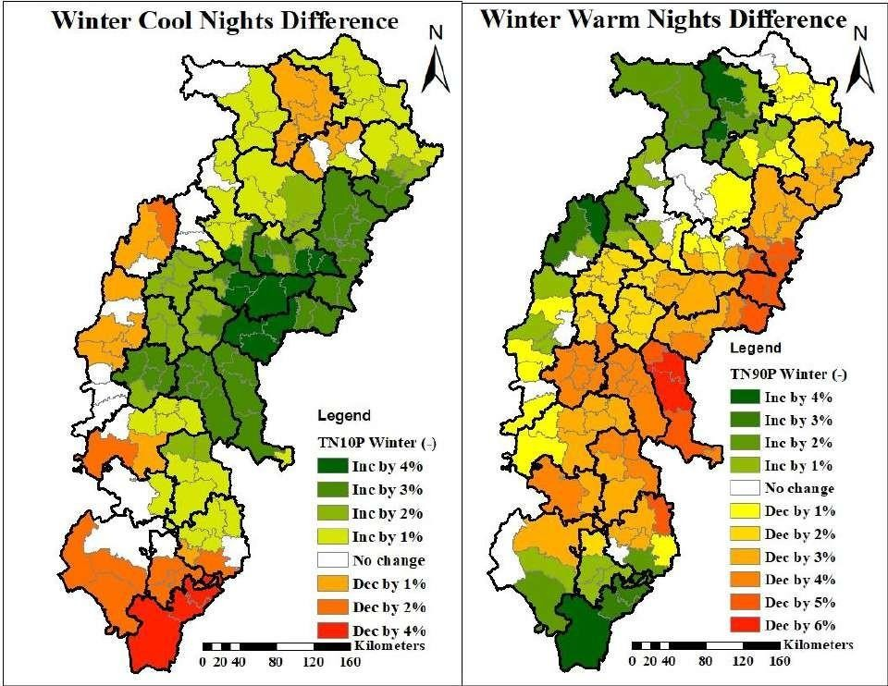
Figure 6 Changes in winter cool and warm nights

The difference between Summer Cool and Warm Nights (TN10P and TN90P)
Cool nights in summer in the Bastar Plateau Zone predominantly reflected no change in regions such as Orchha, Northern Bijapur, Bastar, and Dantewada. Kondagaon and Northern Bastar indicated a 1% rise, and other regions indicated a fall of 1–3%. In the Chhattisgarh Plain Zone, the western part (Mungeli to Kabeerdham) indicated a decline of 1–4%, with Kabeerdham recording the maximum decline. The east zone (Raigarh to Gariyaband) experienced a 2–4% increase, and the remaining areas experienced a 1–2% increase. In the Northern Hill Zone, Batouli and Bharatpur remained unchanged, Surajpur experienced a 1–2% decrease, and other areas experienced a 1–4% increase in summer cool nights.
For warm nights, the Sukma region experienced a 1% increase, while the rest of the Bastar Zone experienced 1–6% increases, the maximum being in the regions of Kondagaon and Bastar. In the Plains, blocks such as Chhuriya, Mohla, and Sahaspur Lohara remained unchanged, while other blocks experienced 1–2% increments. Raigarh, Balod, Gariyaband, and Dhamtari were the maximum declining at 5–6%, while the rest experienced 1–4% declines. In

the Northern Hills, Surajpur grew 1–2%, Koriya fell 1–2%, and eastern districts experienced a 3–6% decline in summer warm nights.
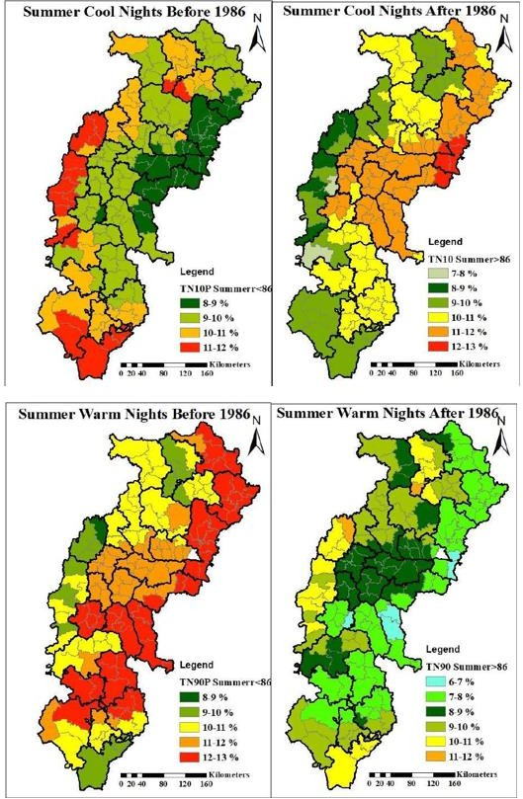

Figure 7 Summer Cool and Warm Nights Before and After 1986

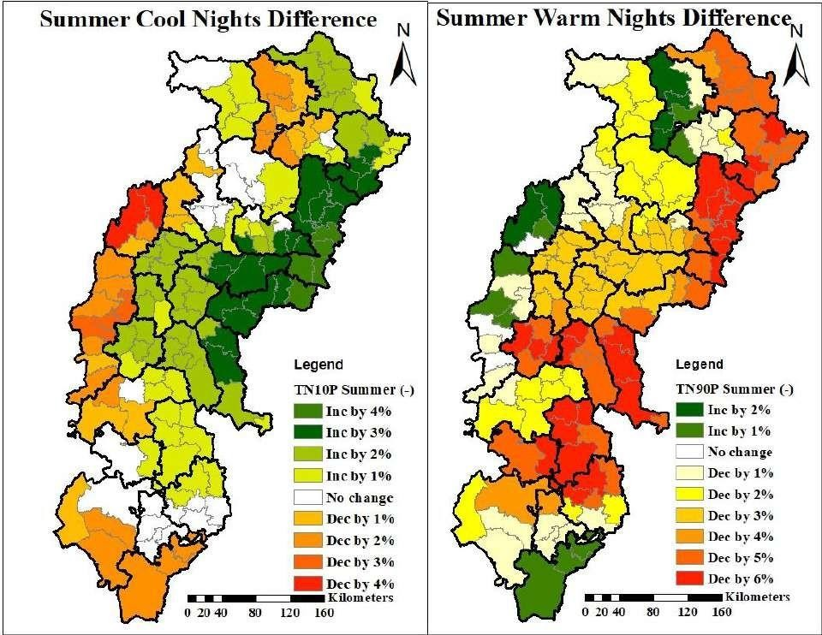
Figure 8 Summer Cool and Warm Nights Difference

Change in Moderate and Severe Drought
All districts of Chhattisgarh have faced at least two moderate droughts in the last 70 years. Kabeerdham was the lone district that did not have any moderate drought prior to 1986. After 1986, moderate drought frequency overall increased in the state (Sinha et al., 2017), although it reduced in some areas of the Bastar Plateau Zone—particularly Bijapur, Bhopalpattanam, Konta, Sukma, and Kuakonda, whereas Eastern Bastar and Kondagaon remained unchanged. But Narayanpur, Northern Bijapur, and Dantewada experienced two additional drought instances compared to the previous years.
In the Chhattisgarh Plain Zone, districts such as Southern Rajnandgaon, Northern Mungeli, Bilaspur, Balod, Gariyaband, Mahasamund, Raigarh, and Korba remained static. Some districts—Bemetara, Central Rajnandgaon, Western Korba, Janjgir-Champa, Baloda Bazar (Kesdol), Dhamtari, and Balod block—experienced a decrease in droughts, perhaps because of the rise in rainfall. Others documented a rise of 2 to 6 droughts over 35 years (Sanjay Bhelawe et al., 2015). In the Northern Hill Zone, Western Surajpur and Wadrafnagar did not change, but majority zones, such as southern Surguja, recorded a rise in frequency of droughts.

Severe droughts were less common. In 70 years, Balod, Bastar, Dantewada, Durg, Kabeerdham, Kondagaon, Korba, Narayanpur, Sukma, and Surguja never had any severe droughts. Among 27 districts, 20 experienced at least one severe drought prior to or following 1986. Raigarh and Surajpur experienced two incidents prior to 1986, whereas others, such as Bijapur, Raipur, Baloda Bazar, Bilaspur, Janjgir-Champa, Mahasamund, Surajpur, and Balrampur, experienced severe droughts for the first time following 1986. Overall, the number of severe droughts decreased post-1986.

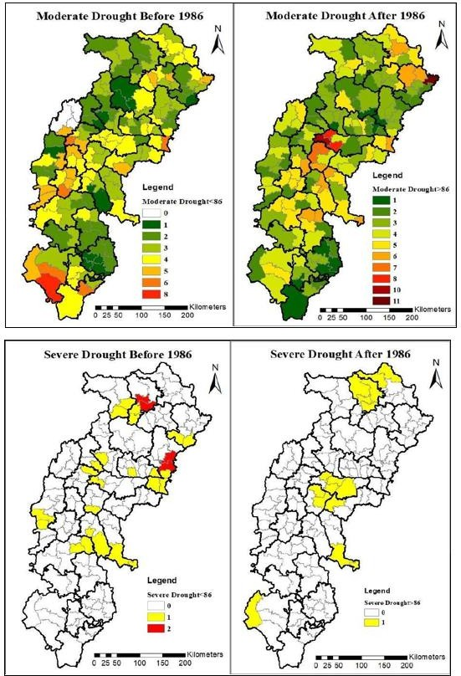

Figure 9 Occurrence of Moderate and Severe Droughts

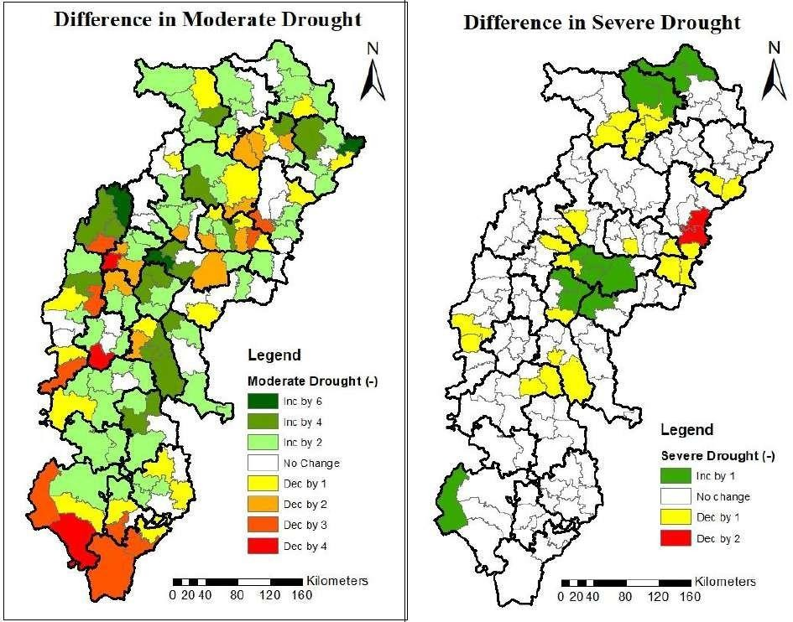
Figure 10 Change in Moderate and Severe Drought

Discussion
The observations reveal steady rise in warm days and nights across seasons and agro-climatic regions, particularly over the Bastar Plateau and Chhattisgarh Plain Zones, reflecting an absolute change in temperature extremes over Chhattisgarh since 1986. Although some northern and southern parts experienced a small increase in winter cold days, most districts experienced no change or decline, which reinforced the trend towards warming. Regional differences were observed in the cold summer nights and days, with small rises in the east and falls in the western regions. Winter and summer warm nights rose sharply, especially in Bastar and Kondagaon, showing a reduction in cooling at nights, which is important for crop recuperation. Additional support for these findings can be gleaned from the drought study, which indicates that mild droughts were more frequent in most regions subsequent to 1986, with severe droughts becoming less frequent but more diffuse and affecting some districts for the first time. The significance of climate-resilient agricultural practices in Chhattisgarh is underscored by the fact that these climatic changes are likely to have a substantial effect on crop phenology, rice yields, and water resource management.

Conclusion
The seasonal temperature extremes in Chhattisgarh have changed significantly since 1986, according to this research. Warm days and nights have clearly increased, while cool days and nights have shown a mixed tendency across the state's agro-climatic zones. Changes in agricultural circumstances, namely rice output, are strongly associated with these climatic fluctuations, notably the rise in warm nights and the fall in cold occurrences. The temporal and geographical study also shows that, whereas severe droughts have decreased in frequency, moderate droughts are becoming more common in several regions. By filling in gaps in the literature by conducting a thorough, zone-by-zone, and season-by-season assessment of temperature extremes over an extended period of time, this study offers vital information for drought mitigation and climate-resilient agricultural planning in the area.

References
Khavse, R., Deshmukh, R., Manikandan, N., Chaudhary, J. L., & Kaushik, D. (2015). Statistical analysis of temperature and rainfall trend in Raipur district of Chhattisgarh. Current World Environment, 10(1), 305–312.
Maniar, K., & Pattnaik, S. (2019). Spatiotemporal patterns of surface temperature over western Odisha and eastern Chhattisgarh. SN Applied Sciences, 1, 1–11.
Mishra, V. K., Khalkho, D., Pandey, V. K., & Banwasi, R. (n.d.). Trend Analysis of Rainfall and Temperature in the Kharun Watershed: Implications for Climate and Water Management. International Journal of Environment and Climate Change, 14(11).
Mulla, S., Ahmed, R., Singh, K. K., Singh, S. K., Deshmukh, N., & Inamdar, F. K. (2023). Climate change effect on-climate parameters like temperature, rainfall and water resources sectors in India. In Climate change impacts in India (pp. 9–59). Springer.
Rajput, B. L., & VISHWAVIDYALAYA, I. G. K. (2021). STUDIES ON WEATHER CHARACTERIZATION AND THEIR IMPACT ON MAIN PULSES IN DIFFERENT DISTRICTS OF CHHATTISGARH. INDIRA GANDHI KRISHI VISHWAVIDYALAYA
RAIPUR (Chhattisgarh).

Sanjay Bhelawe, S. B., Chaudhary, J. L., Manikandan, N., & Rupesh Deshmukh, R. D. (2015).
Meteorological drought assessment in Raipur district of Chhattisgarh state, India.

Sinha, H. K., Chaudhary, J. L., Manikandan, N., & Bhuarya, S. K. (2017). Spatial analysis of

meteorological drought in Chhattisgarh State. Indian Journal of Dryland Agricultural Research and Development, 32(2), 94–97.
Thakur, H. S. (2017). LONG-TERM RAINFALL AND TEMPERATURE TREND IN CHHATTISGARH AND THEIR RELATIONSHIP WITH MAJOR CLIMATE MODES.
Indira Gandhi Krishi Vishwavidhyalaya, Raipur.

