Phyto-therapeutic Targeting of NF-κB Pathway in Inflammation-Linked Disorders

ABSTRACT
Inflammation is a vital biological response to injury and infection, but its persistence beyond resolution stages contributes to a range of chronic diseases, including arthritis, asthma and autoimmune disorders. The nuclear factor kappa-light-chain-enhancer of activated B cells (NF-κΒ) pathway has emerged as a central mediator in sustaining inflammatory cascades through Pro-inflammatory cytokines, chemokines, and adhesion molecules undergo transcriptional regulation. Although conventional anti-inflammatory drugs may offer short-term relief, their long-term use is frequently limited by serious side effects and inadequate targeting of the root causes. In recent years, medicinal plants have gained attention for their potential to manage inflammation in a safer and more holistic way. This review focuses on five such plants- Eclipta alba, Zingiber officinale, Asparagus racemosus, Phyllanthus emblica and Justica adhatoda- all of which have shown notable analgesic and anti-inflammatory properties. These herbs act through various mechanisms, including suppression of pro-inflammatory cytokines, inhibition of oxidative stress and modulation of NF-κΒ pathway. Beyond these, the review also highlights other herbal agents known for influencing inflammatory responses through NF-κΒ inhibition. The article further discusses the pathogenesis of chronic inflammatory diseases, the biological role of NF-κB, and the limitations of existing treatment options. Together, this review emphasizes the growing relevance of plant-based therapies as effective and safer alternatives for inflammation-related disorders, especially those involving NF-κΒ dysregulation.
Keywords: Inflammation, NF-κB pathway, Oxidative stress, Herbal medicine, Chronic inflammatory diseases

INTRODUCTION
Pathogens, damaged cells, or toxic compounds trigger a complex biological response called inflammation. It is essential for initiating the healing process, preventing the spread of infection and resorting tissue homeostasis. Despite being protective and usually resolving on its own, chronic inflammation can become harmful and contribute to the progression of multiple non-communicable diseases, such as rheumatoid arthritis, asthma, neurodegenerative disorders, cardiovascular diseases, and even certain cancers ^{[1]}. This dual nature of inflammation makes it a subject of critical interest in both conventional and alternative medical systems.
At the molecular level, inflammation is driven by a cascade of signaling events involving the activation of immune cells, release of pro-inflammatory cytokines, production of reactive oxygen species and expression of inflammation-associated genes. Among the central regulators of this cascade is the nuclear-factor kappa-light-chain-enhancer of activated B cells (NF-κΒ) pathway. NF-κΒ is a transcription factor that is essential for orchestrating the inflammatory response. Multiple genes involved in immune response, apoptosis, cell proliferation, and cytokine production are regulated by it ^{[2]}. When activated in excess or for prolonged periods, NF-κΒ contributes significantly to chronic inflammatory diseases.NF-κΒis now-a-days more targeted as it has been considered a prototypical proinflammatory signaling pathway. It activates the most essential mediators of inflammation in our body like interleukin 1 (IL-1) and tumor necrosis factorα (TNF α). The main pathway by which NF-κΒ induce inflammation is called canonical pathway. The constituents of NF-κΒfamily are I-kappaB kinase (IKK) which consists components like IKKα, ΙΚΚβ, and NEMO (ΙΚΚγ) ^{[3]}.

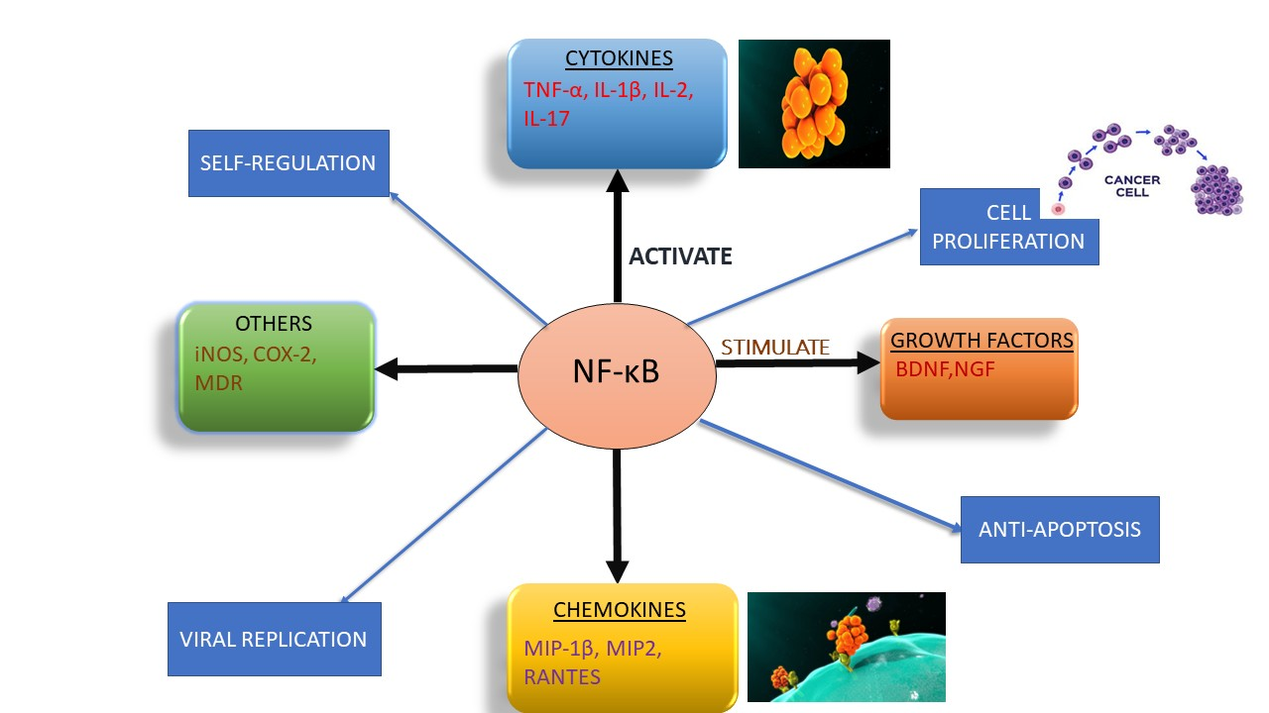
Figure 1: Schematic representation of inflammatory triggers (pathogens, toxins, injury) and the role of NF-κB in mediating cytokine release and chronic inflammation
Modern medicines have made significant progress in managing inflammation through pharmacological interventions such as NSAIDs, corticosteroids, and disease-modifying anti-rheumatic drugs (DMARDs) are types of non-steroidal anti-inflammatory drugs. These drugs are effective in reducing pain and inflammation; however, they come with several drawbacks. Long-term use of NSAIDs is associated with gastrointestinal irritation, cardiovascular risks, renal impairment and hepatotoxicity. Corticosteroids, while potent, can lead to immunosuppression, bone loss and endocrine disturbances. Moreover, many of these drug’s act on downstream pathways of inflammation and may not address its root molecular mechanisms ^{[4]}. These limitations highlight the need for alternative approaches that are not only effective but also safe and capable of targeting the underlying causes of chronic inflammation.
Phytotherapy, which involves the use of plant-based compounds in medicine, has gained significant attention as a promising alternative to synthetic anti-inflammatory agents in recent decades. Bioactive compounds found in medicinal plants found in traditional systems such as Ayurveda, traditional Chinese medicine, and Unani have diverse pharmacological effects, including anti-inflammatory, analgesic, antioxidant, and immunomodulatory actions^{[5]}. One of the most compelling aspects of herbal medicine is its multi-targeted mode of action.
The focus of this review is on five traditional medicinal plants that have shown promising anti-inflammatory and analgesic effects in preclinical and clinical studies. Traditional medicine has used these plants for centuries to treat pain, swelling, respiratory problems, and digestive disorders. Modern pharmacological research has begun to validate many of these traditional claims, revealing that these plants contain active constituents such as flavonoids, terpenoids, alkaloids and polyphenols that interact with inflammatory pathways, particularly NF-kB.
The five traditional medicinal plants are as follows ^{[6]}:
- Eclipta alba- This plant commonly known as false daisy belong to family Arteraceae. The main phytoconstituent of this plant, which prevents the proliferation of human renal cells through the NF-κB pathway, is Wedelolactone.
- Zingiber officinalis- This plant mainly used in kitchen to enhance aroma and taste in food called as ginger belong to family Zingiberaceae. Ginger mainly affects NF-κΒ pathway in arthritis. It also inhibits cyclooxygenase pathway.
- Asparagus racemosus- The common name of this plant belonging to family Liliaceaeis satavari and the therapeutic part of the plant is its root.
- Phyllanthus emblica-This plant is called as Indian gooseberry or amla belong to family Phyllanthaceae. It mainly contains amino acids, vitamin C and minerals, so it is evident that it has some antioxidant property.
- Justica adhatoda-This plant belonging to family Acanthaceaeis known as Bhaiker. It lowers the mediators like IL-1β, ΤΝF-α.
While these five plants are the focus of this article, they represent a broader class of botanicals with similar properties. Numerous other herbs-such as Curcuma longa (turmeric), Withania somnifera (ashwagandha), Boswellia serrata (Indian frankincense), Tinospora cordifolia (heartleaf moonseed), By acting on the body, they have shown comparable anti-inflammatory effects on the NF-κB pathway and other inflammatory pathways.
Furthermore, understanding the common pathogenesis of inflammatory diseases- which often converge on NF-κB as a central node- reinforces the value of targeting this pathway. Whether the inflammation arises in joints, lungs, skin or internal organs, the molecular events leading to tissue damage frequently involve overactivation of NF-κB. This makes NF-κB not only a shared therapeutic effect but also a biomarker for disease severity and progression. By intervening at this critical control point, phytochemicals may offer upstream, preventive and curative benefits that surpass symptom-focused treatments ^{[7]}.
INFLAMMATION AND NF-κB CONNECTION
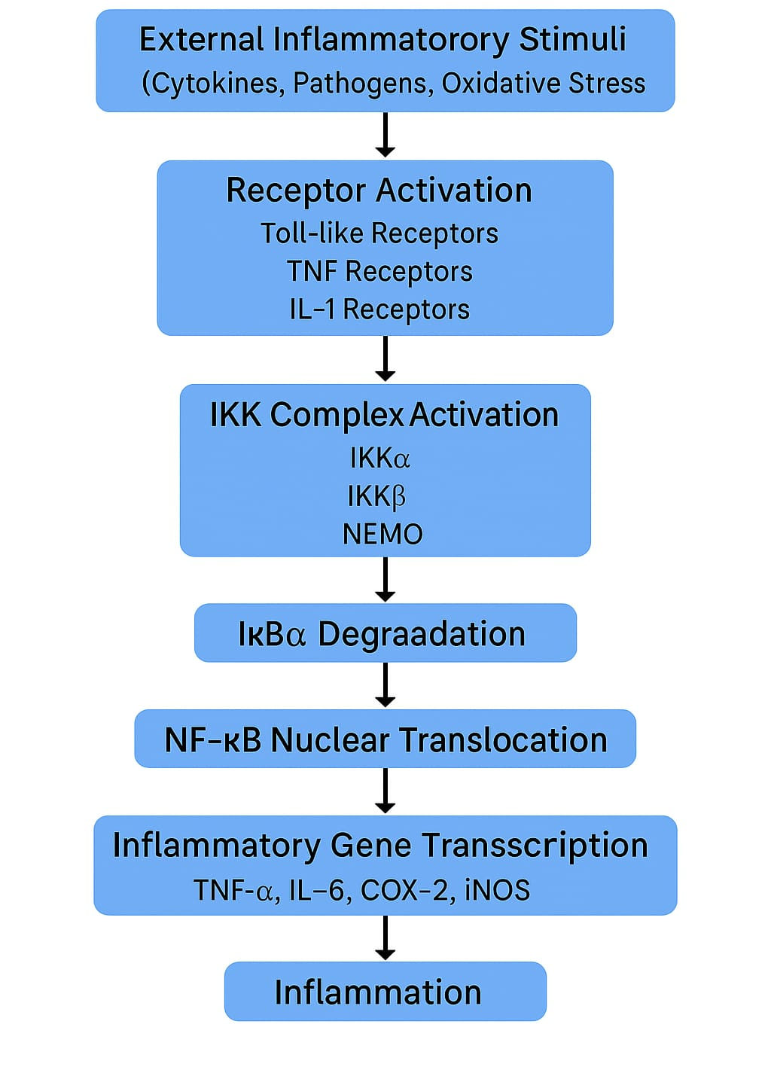
At the heart of the inflammatory process lies a pivotal transcription factor known as Nuclear Factor-Kappa B (NF-κB).
Figure 2: Discovery of NF-κB transcription factor and its role in immune regulation
The NF-κB signaling pathway has been discovered before four decades. When this pathway was discovered, it only focused on inflammatory pathway, but with years of investigation and research the new insights of NF-κB was established. Ranjan Sen and David Baltimore were the first to identify this factor in their laboratory. They identified the nuclear factor in B lymphocytes which was end-labelled DNA fragments were used for electrophoretic migration assays to evaluate binding to the kappa enhancer of the gene encoding the k light chain of immunoglobulin.and named it as NF-κB ^{[8]}. When further investigation was completed the use of NF-κB in treating major diseases was established. Hence in this article we are going to target NF-κB with traditional plants so we can overcome the drawbacks of conventional medicines.
NF-κB Transcription Factor Family: The family of NF-κB consists of five proteins such as p65 (RelA), RelB, c-Rel, p105/p50(NF-κB1) and p100/52(NF-κB2) these proteins form homodimer and heterodimer complexes which are transcriptionally active when any stimuli of inflammation approaches and produce proteins. The stimuli can be many inflammatory mediators like TNFα, IL-1, LPS, CD40, BAFF, and lymphotoxin-β ^{[9]}. The two pathways responsible for inflammation is Canonical/Classical pathway and Non-Canonical/Alternate pathway.
Structure and mechanism of NF-κB:
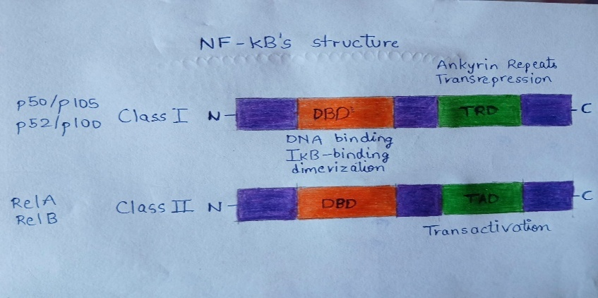
Figure 3: Structure of NF-κB family proteins showing RelA, RelB, c-Rel, p50/p105, and p52/p100 subunits with their transactivation domains
The structure of NF-κB consists of two classes- Class 1: p50/p105 and p52/p100 and Class 2: Rel A and Rel B. There is N-terminal domain and C-terminal domain in structure as shown in figure. Class 1 p50 and p52 domains can repress transcription because they don't have C-terminal transactivation domains. The Class 2 Rel A and Rel B contain C-terminal transcription activation domains (TADs) which enable them to activate target gene expression.
- Canonical/Classical pathway:
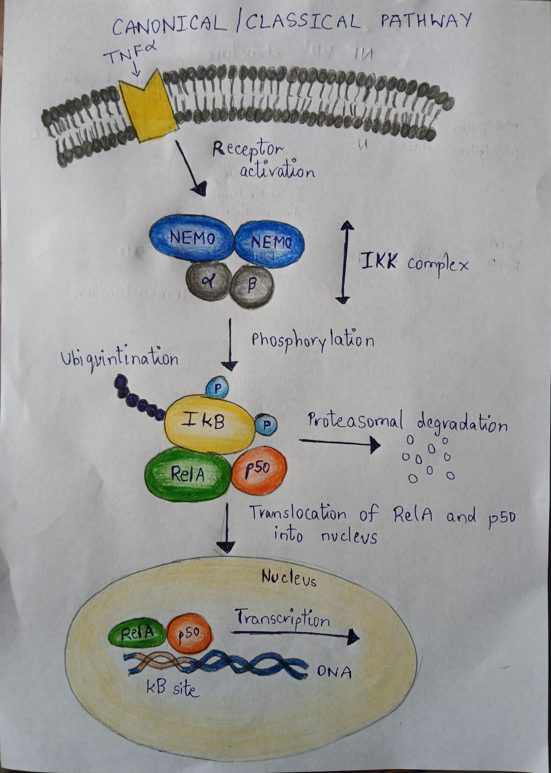
Figure 4: Canonical NF-κΒ signaling pathway depicting IκB phosphorylation, degradation, and NF-κB nuclear translocation
The heterodimers p50 and Rel A when the canonical pathway is activated, they are responsible for transcription of genes. In steady state the p50 and Rel A are sequestered in the cytoplasm by the IκΒ proteins which is inhibitor of NF-κB. This protein consists of three groups: the typical IκΒproteins (IκΒα, ΙκΒβ, and ΙκΒε), the precursor proteins (p100 and p105), and the atypical IκΒ proteins ^{[10]}. Now, the pathway starts with the attachment of TNFαlike inflammatory mediators to the receptor result in activation of receptor, which cause phosphorylation of IκB molecules by IKKs. IKK consists of two subunits IKKα andΙΚΚβ which are homologous and one regulatory subunit IKKγ (also called as NEMO). IKKαmainly regulates non-canonical pathway, IKKβ is essential for activation of canonical pathway in response to proinflammatory cytokines and chemokines. NEMO has N-terminal which binds to IKKs and C-terminal which mediates its interaction with the upstream signaling adapters. The activated IKKβ induces phosphorylation of IκΒprotein which leads to its ubiquitination and its subsequent proteasomal degradation. This results in release of NF-κB dimers that translocate to the nucleus of cell and induce transcription of target gene.
- Non-Canonical/Alternate Pathway
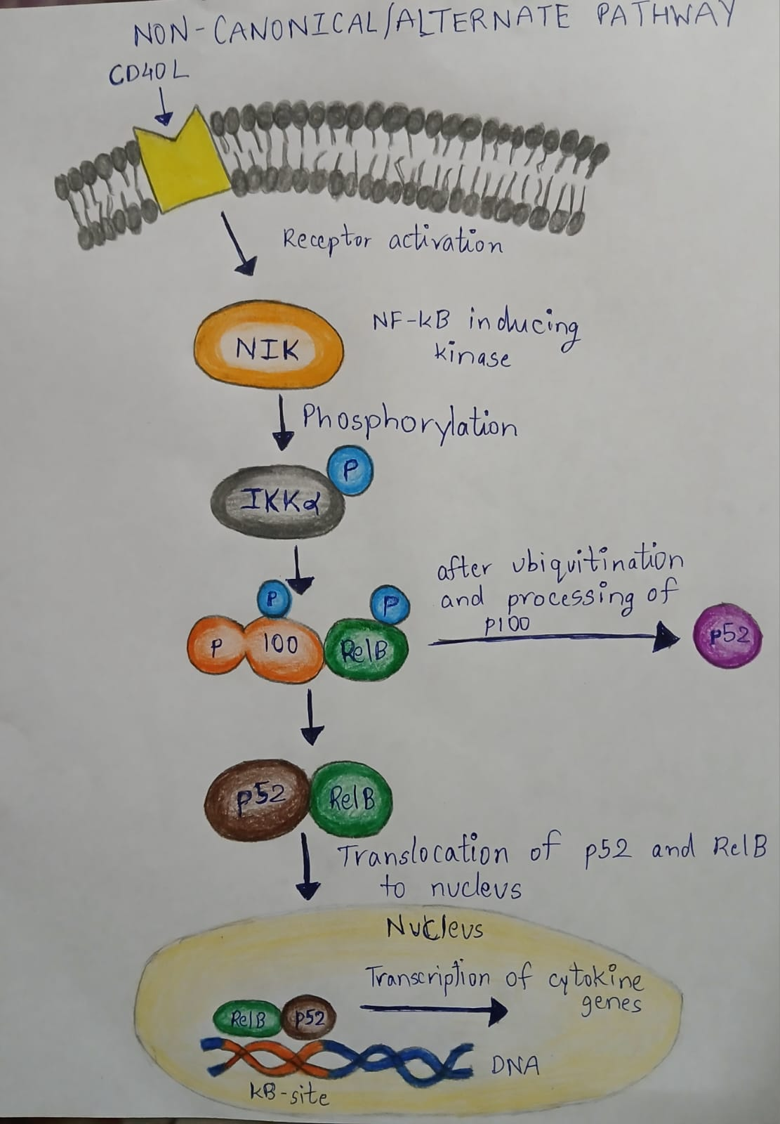
Figure 5: Non-canonical NF-κB signaling pathway involving p100 processing into p52, RelB dimerization, and nuclear activity
Non-canonical pathways use the heterodimers Rel B and p52 as transcription factors. p100 is precursor for p52 formation which combine with the Rel B and translocate to nucleus. When the cytokines or microbial agents like CD40L attaches to the receptor the activation of receptor results in phosphorylation of IKKα. The production of p52 is dependent on ubiquitination and phosphorylation of p100. A sequence that responds to NIK can be found in the C-terminal of p100. Two serine residues are identified to be phosphorylated by NIK-IKKα. This two serine are needed for p100 processing ^{[11]}. After the processing of p100, p52 produced and with RELB it translocate in the nucleus and bind to κΒ site of DNA which further transcribes the target gene.
Limitations of Current Anti-Inflammatory Therapies:
Introduction to anti-inflammatory therapies: Anti-inflammatory therapies aim to alleviate the discomfort and tissue damage caused by inflammatory conditions, which are common in a wide range of disorders, including autoimmune diseases, arthritis, cardiovascular diseases and chronic obstructive pulmonary disease (COPD) ^{[12]}. There are primarily two types of anti-inflammatory medications: non-steroidal anti-inflammatory drugs (NSAIDs) and corticosteroids, in addition to biologics and disease-modifying anti-rheumatic drugs (DMARDs) which are utilized for specific conditions such as rheumatoid arthritis (RA) and inflammatory bowel disease (IBD).
- Non-steroidal anti-inflammatory drugs (NSAIDs): NSAIDs, including ibuprofen, aspirin and naproxen, are among the most commonly used anti-inflammatory medications. They work by inhibiting cyclooxygenase (COX), the enzyme responsible for converting arachidonic acid into pro-inflammatory prostaglandins, which are critical mediators of inflammation. They generally cause gastrointestinal toxicity when taken in high dose which leads to ulcer ^{[13]}. Furthermore, some NSAIDS which inhibits the COX-2 cause cardiovascular disease ^{[14]}. Renal impairment is also a major side-effect which enable us to think before using them ^{[15,16]}.
- Corticosteroids: Corticosteroids, such as prednisone and dexamethasone, are potent anti-inflammatory drugs that work by suppressing the immune system and inhibiting the production of inflammatory cytokines. Short-term side effects of these drugs are weight gain, fluid retention and mood swings ^{[17]}. But their long-term use cause osteoporosis (bone thinning), adrenal suppression (cortisol production supress), hyperglycaemia, cataracts, glaucoma and psychiatric effects ^{[18]}.
- Disease-modifying anti-rheumatic drugs (DMARDs): DMARDs are a class of medications used to treat autoimmune diseases like rheumatoid arthritis and lupus. They work by modifying the underlying disease process rather than simply alleviating symptoms. But they slow onset action cause delay in therapeutic benefit. Due to suppression of immune system, several infections like tuberculosis, pneumonia and fungal infections increases ^{[19]}.
- Biologic response modifiers and monoclonal antibodies: Biologic response modifiers (BRMs) and monoclonal antibodies have revolutionized the treatment of certain inflammatory diseases, particularly autoimmune disorders like rheumatoid arthritis and inflammatory bowel disease. These biologics work by targeting specific proteins involved in inflammation, such as tumour necrosis factor (TNF-α), interleukins, or cell surface receptors.
- High risk of adverse effects: high risk of developing certain types of cancer, such as lymphomas.
- High cost and accessibility: As with DMARDs, biologic treatments are very expensive. The high cost, coupled with the need for frequent infusions or injections, makes these therapies less accessible to a large portion of the population ^{[20]}.
Overview of the Medicinal Plants and Their Phyto-Constituents: In the context of inflammation, five medicinal plants-Eclipta alba, Zingiber officinale, Asparagus racemosus, Phyllanthus emblica, and Justica adhatoda-stand out due to their potent analgesic, anti-inflammatory and NF-κB modulating properties. Each of these plants is endowed with a unique spectrum of phytoconstituents that contribute to their therapeutic potential. This section provides an in-depth overview of these botanicals, focusing on their phytochemical profile and mechanisms relevant to inflammation and immune modulation.
- Eclipta alba (False daisy)
Phyto-constituents: Eclipta alba, commonly known as Bhringraj. One of the most important compounds found in Eclipta alba is Wedelolactone. This is a coumestan-type compound that plays a key role in reducing inflammation by blocking harmful proteins in the body, especially those involved in the NF-κB pathway, which causes swelling and pain ^{[21]}.
Anti-inflammatory activity: Another major compound is Luteolin, a flavonoid known for its strong antioxidant and anti-inflammatory actions. Luteolin helps neutralize free radicals (harmful oxygen-containing molecules) in the body and also reduces the production of inflammatory chemicals like TNF-α and IL-6. Eclipta alba also contains β-amyrin, triterpenoids that contributes to its pain-relieving and anti-inflammatory effects ^{[22]}. Moreover, Ursolic acid, another triterpenoid present in Eclipta alba, has been shown to have anticancer, anti-inflammatory and antioxidant activities through interference with key inflammatory signalling pathways like NF-κB.
Analgesic properties: Eclipta alba, is known for its natural pain-relieving (analgesic) properties. The analgesic action of Eclipta alba comes from its rich mix of active compounds, especially Wedelolactone, Luteolin and β-amyrin. These compounds work in the body by interacting with key biological systems that control pain and inflammation. One of the main causes of pain in the body is inflammation-a process where tissues swell due to injury or infection. In many cases, this involves the activation of a protein called NF-κB, which triggers the production of pain-causing chemicals like prostaglandins and cytokines (e.g., IL-1β, TNF-α). Eclipta alba helps by blocking the activation of NF-κB, which means fewer pain signals are produced.
Additionally, Wedelolactone and Luteolin reduces oxidative stress and protect nerves from damage, which can also contribute to chronic pain ^{[23]}.
- Zingiber officinale (Ginger):
Phyto-constituents: zingiber officinale, commonly known as ginger, is a commonly utilized herbal remedy recognized for its abundant phytochemical composition and therapeutic effects. It is composed of numerous bioactive substances that enhance its health advantages, especially its anti-inflammatory, antioxidant, and pain-relieving effects. The major phytoconstituents of ginger are Gingerols, Shogaols, Paradols, and Zingerone. Among them, [6]-gingerol is the most abundant and biologically active component in fresh ginger. It gives ginger its pungent flavour and exhibits potent anti-inflammatory and antioxidant properties. [6]-gingerol undergoes dehydration to form [6]-shogaol has stronger bioactivity, particularly in reducing inflammation and pain ^{[24]}.
Anti-inflammatory activity: It exhibits significant antioxidant and anti-inflammatory effect by inhibiting phosphorylation and degradation of IκB which results in inhibition of p100, RelB, RelA and p50 which are subunits of NF-κB. In addition to these compounds, ginger contains volatile oils such as Zingiberene, β-bisabolene, Camphene and cineole, which contribute to its anti-inflammatory action. Ginger is also rich in Phenolic acids, Flavonoids and diarylheptanoids, which provide further antioxidant and immunomodulatory effects ^{[25]}.
Analgesic properties:
The primary mechanism behind ginger’s pain-relieving effect involves its anti-inflammatory action. Pain is often the result of inflammation, where chemical signals like prostaglandins and cytokines stimulate nerve endings. Gingerols and shogaols help inhibit cyclooxygenase (COX) and lipoxygenase (LOX) enzymes, which are involved in the production of prostaglandins and leukotrienes-key mediators of pain and inflammation ^{[26]}.

- Asparagus racemosus (Shatavari):
Phyto-constituents: Asparagus racemosus, commonly known as Shatavari. The major class of compounds found in Asparagus racemosus is Steroidal Saponins, known as Shatavarins. Among them, Shatavarins IV is the most studied and is considered the principal active compound ^{[27]}.
The plant contains a variety of flavonoids like Kaempferol, Quercetin and Rutin, which are powerful antioxidants. These flavonoids assist in counteracting detrimental free radicals, lower oxidative stress, and safeguard tissues from harm ^{[28]}.
Analgesic properties: One of the primary ways Asparagus racemosus provides pain relief is through its anti-inflammatory effect. Inflammation is often a key cause of pain, especially in conditions like arthritis, muscle strain or injury.
Anti-inflammatory activity: The plant suppresses the release of pro-inflammatory chemicals, such as prostaglandins, cytokines (like IL-6 and TNF-α), and COX enzymes, all of which are involved in triggering NF-κB pathway ^{[29]}.

- Phyllanthus emblica (Amla):
Phyto-constituents: Phyllanthus emblica, commonly known as Amla or Indian gooseberry, is a powerful medicinal plant known for its wide range of health-promoting properties. One of the most notable compounds in amla is Ascorbic acid (Vitamin C). This antioxidant Vitamin plays a crucial role in neutralizing free radicals, boosting the immune system, and reducing inflammation ^{[30]}. Amla also contains Hydrolysable tannins such as Emblicanin A and B, Punigluconin and Pedunculagin, which have potent antioxidant and anti-inflammatory effects ^{[31]}.
Immunomodulatory activity: In addition, amla is as source of Flavonoids such as Quercetin and Kaempferol, which have demonstrated activity in modulating key signalling pathway like NF-κB. These flavonoids help suppress pro-inflammatory cytokines and support overall immune balance.
Analgesic properties: Analgesic activity is attributed to its ability to moderate sensory neuron sensitivity. Excessive reactive oxygen species (ROS) in inflamed tissues amplify pain signals. The antioxidant profile of Phyllanthus emblica mitigates this effect, creating a more stable intracellular environment and reducing pain amplification. Interestingly, amla’s analgesic benefits may also involve modulation of the hypothalamic-pituitary-adrenal (HPA) axis, which influences both inflammation and pain perception ^{[32]}.

- Justica adhatoda (Vasaka):
Phyto-constituents: Justica adhatoda, commonly known as Vasaka or Malabar nut, is a medicinal plant revered in traditional medicine system for its potent therapeutic properties. Its wide-ranging pharmacological actions can be traced to a rich assortment of Alkaloids, Tannins, Saponins and essential oils, each contributing uniquely to its bioactivity.
Anti-inflammatory activity: The hallmark compounds of Justica adhatoda are its Quinazoline alkaloids, primarily Vasicine and Vasicinone. Vasicine is well-known for its Broncho-dilatory, anti-inflammatory and mucolytic actions, while Vasicinone-its oxidized derivative-offers supportive synergistic effects, including anti-allergic potential ^{[33]}. Beyond alkaloids, the plant contains a variety of Flavonoids, including Luteolin and Apigenin, which play essential roles in scavenging free radicals and modulating immune responses. These compounds not only strengthen the antioxidant defence system but also influence key enzymes and signalling pathways like NF-κB involved in inflammation and pain perception ^{[34]}.
Analgesic properties: Unlike conventional analgesics that primarily inhibit pain through direct neural suppression, Vasaka employs a multi-targeted approach, subtly influencing inflammatory mediators like IL-6 and TNF-α, neuronal excitability and vascular responses associated with pain. One of the distinctive features of Vasaka’s analgesic activity is its modulatory effect on prostaglandin synthesis. Through the action of alkaloids like Vasicine and Vasicinone, the plant helps reduce the production of pro-inflammatory prostaglandins by downregulating cyclooxygenase (COX) enzyme activity ^{[35]}.
Mechanism of Medicinal Plants: All five plants exert their anti-inflammatory and analgesic activity by interfering at key steps of NF-κB pathway through their specific phytoconstituents.
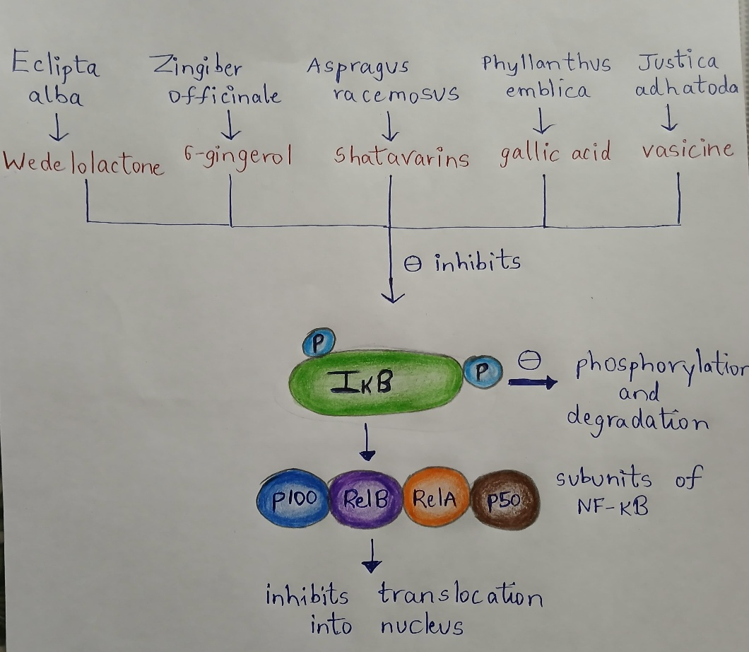
Figure 6: Herbal compounds from five medicinal plants (Eclipta, Ginger, Shatavari, Amla, Vasaka) act at different checkpoints of NF-κB signaling to suppress inflammation
- Eclipta alba- It contains Wedelolactone, which mainly inhibits the IKK complex, thus preventing the phosphorylation and degradation of IκΒ, keeping NF-κB sequestered in the cytoplasm.
- Zingiber officinale- This plant is rich in 6-gingerol and shogaol, which reduce oxidative stress and block the activation of upstream signaling molecules like TNF-αand IKK which are required for activation of NF-κB pathway. This results in halting the cascade at an early stage.
- Asparagus racemosus- It contains saponins and Shatavarins, which suppress IKK-NF-κb axis, thereby downregulating pro-inflammatory gene expression.
- Phyllanthus emblica- It contains gallic acid and ellagic acid, which acts as anti-oxidant and also interfere with IκΒ phosphorylation, so Rel A and p50 subunit of NF-κB cannot translocate to nucleus and pathway is inhibited.
- Justica adhatoda- It contains vasicine which interfere in the translocation of subunits of NF-κB into the nucleus results in inhibition of the transcription of genes. So, all these phytoconstituents interfere with NF-κB pathway at different sites and prevent transcription of genes.
Under normal conditions, NF-κB protein family is present in the cytoplasm in an inactive state, when cells are exposed to any stress such as inflammatory mediators like cytokines (TNFαand IL-β), oxidative stress or pathogens the IKK complex in NF-κB pathway gets activated which results in phosphorylation of IκB. After phosphorylation its degradation is marked by proteasomal enzyme. The degradation results in translocation of subunits of NF-κB into the nucleus where transcription of genes is done. All the phytoconstituents of plants inhibits this process.
Additional Medicinal Plants Which Show Analgesic and Anti-Inflammatory Properties: The inflammatory diseases like Rheumatoid arthritis and IBD are treated by the medicinal plants before invention of synthetic medicines. In 19th century the aspirin was invented. With the invention of aspirin new era started in medicine of analgesic and anti-inflammatory. The first one to observe anti-inflammatory and analgesic property in leaves and bark of plants was Hippocrates ^{[36]}. The medicinal plants which are anti-inflammatory and analgesic is Curcuma Longa, Withania Somnifera, Boswellia Serrata, Tinospora Cordifolia. These entire medicinal plants inhibit various inflammatory pathway, most of them interfere with NF-κB pathway.
Curcuma longa- Curcuma longa often known as turmeric belonging to family Zingiberaceae is herbaceous perennial plant. The essential oil extracted from turmeric’s rhizome contains sesquiterpenoids. Cucurma longa contains over 300 physiologically active substances, including sterols, alkaloids, polyphenols, diterpenes, and triterpenoids ^{[37]}. The main phytoconstituent present in it is Curcuminoid. The different concentration of curcumin (bisα, β-unsaturatedβ-diketone), diacetylcurcumin, and curcumin manganese complex (CpCpx) complexes shows higher level of scavenging activity resulting in its anti-oxidant effect ^{[38].}
Anti-inflammatory property- curcumin reduce produced Nitrous Oxide and Oxygenfree radical. Additionally, it inhibits NF-κB activation and suppresses TNFα, IL-1β, TGF-β1, ICAM Further, and curcumin also possess wound healing property. Curcumin has been used in many inflammatory diseases like arthritis, hepatic disorders, and neurogenerative disorders.
Mechanism of curcumin- it exhibits anti-inflammatory effect by inhibiting the IKKα complex of NF-κB pathway so the phosphorylation and degradation of IκΒisinhibited and transcription of genes cannot take place. So, whole pathway of NF-κB is disturbed.

Withania Somnifera- often known as ashwagandha belongs to the family Solanaceae. The roots and leaves of ashwagandha was used for its phytoconstituents. There were many trials conducted to found which disease is cured by ashwagandha, resulted in curing hepatotoxicity, Parkinson’s disease and hyperlipidemia. The phytochemicals present in this plant is steroidal lactones called withanolides. Other substances like withaniol, somnirol, somnitol, withanic acid, phytosterol, and ipuranol are also present.
Anti-inflammatory activity- Withaferin A was found to suppress the arthritic syndrome and also does not show any side-effects. It was found that Withaferin A is more potent than Hydrocortisone sodium succinate. Some extracts from the plant showed suppression of neuroinflammation and neurogenerative disorders. The potent nature of these plants is there due to presence of steroids.
Mechanism of action- The Withaferin A of plants inhibited the tumor necrosis factor which activates the canonical pathway of NF-κB so the activation IKK is inhibited and further progression of pathway is not there. Some studies reveal that the anti-inflammatory activity of plant can also be due to lymphocyte proliferation and delayed hypersensitivity ^{[40]}.

Analgesic property- The methanolic extract of plant was found to exhibit the property of analgesic against morphine-induced tolerance in the rats by activation of peroxisome proliferator-activated receptorγ. Τhe neurotransmitter serotonin level is responsible for pain in body, so the extract of plant showed the property of reducing the serotonin. Additionally, the inhibition of NF-κB activation resulted in elevation of apoptosis ^{[39]}.

Boswellia Serrata-often known as Indian Frankincense, Indian olibanum or Salai guggul contains dry exudate of oleo-gum-resin. In traditional Ayurvedic medicine this oleo-gum-resin is used to treat many inflammatory diseases related to various parts of human body such as eye, skin, gums, gastrointestinal tract and also inflammatory diseases of respiratory tract like asthma, bronchitis, etc. All three parts that is oil, gum and resin have its own importance in therapeutic activity. The essential oil contains sesquiterpenes; the gum portion consists of pentose and hexose sugar. The main phytoconstituent of plant is boswellic acid which is found in resin part. Together all the species of Boswellia has 200 or more phytoconstituents.
Anti-inflammatory activity- among the phytoconstituents like α andβ-Boswellic acid (BA), Acetylatedα and β-Boswellic acid (ABA), 3-O-acetyl-11-keto-β-Boswellic acid (ABKA), 11-keto-β-Boswellic acid (KBA) the most potent constituents which show anti-inflammatory activity are KBA and ABKA. The other phytoconstituents present are Lupeolic acid, Acetyl-Lupeolic acid, Incensole acetate, and Incensole oxide ^{[40]}.
Mechanism of action- the inhibition of prostaglandins has shown some extent of anti-inflammatory activity. Moreover, inhibition of 5-LO that is inhibition leukotrienes has significantly shown attention in the inflammatory disease as many chronic inflammatory diseases are concerned with leukotrienes production. Additionally, Boswellia Serrata extract inhibit tumor necrosis factor alpha (ΤΝFα), Interleukin-1beta (IL-β), NO and mitogen activated protein (MAP) kinases. The inhibition of prostaglandins has also shown significantly less inflammation in periodontium associated with plaque induced gingivitis. So, this plant mostly prevent inflammation in many parts of the body.
Analgesic property- Frankincense which is known commonly, treat muscular and arthritic pain. The phytoconstituent previously mentioned AKBA showed the analgesic activity.
Tinospora Cordifolia- commonly known as Guduchi contains secondary compounds like alkaloids, steroids, diterpenoids, lactones, aliphatic acid and glycosides. All these compounds have been extracted from roots, stem or whole plant. Many studies suggest to have property like anti-inflammatory, anti-spasmodic, anti-arthritic, anti-diabetic and anti-allergic. The main alkaloids present in the plants are Berberine, Choline, Palmatine, Tembetarine, Tetrahydropalmatine. Also, the glycosides present are18- norclerodane, Furanoid diterpene, Tinocordiside, Tinocordifolioside, Cordioside. Moreover, the main compound of the plant steroids contains β-sitosterol, hydroxy ecdysone, Ecdysterone, Giloinsterol tends to exhibits the anti-osteoporotic effects in mammals.
Anti-inflammatory property-the phytoconstituent responsible for anti-inflammatory effect is Nonacosan-15-one dichloromethane. Another constituent octacosanol also exhibit anti-inflammatory activity ^{[42]}.
Mechanism of action- many evidences suggest, this plant exerts property of inhibiting the cyclooxygenase which came out beneficial in management of various inflammatory diseases. Also, the phases of cytokinesIL-4 and TNF-α was reduced with increase in inhibitorκB which inhibits the NF-κB in the cytoplasm.
Different diseases that can be cured by targeting NF-κB pathway
The NF-κB transcription factor governs a variety of cellular processes like survival, proliferation, angiogenesis and differentiation. As a result, dysregulation of this pathway plays role to the development and progression of numerous disease unrelated to classical inflammation, including cancer, neurodegenerative disorders, metabolic syndromes, cardiovascular complications and aging-related dysfunctions. Understanding how NF-κB is implicated in these non-inflammatory diseases open avenues for more comprehensive therapeutic strategies.
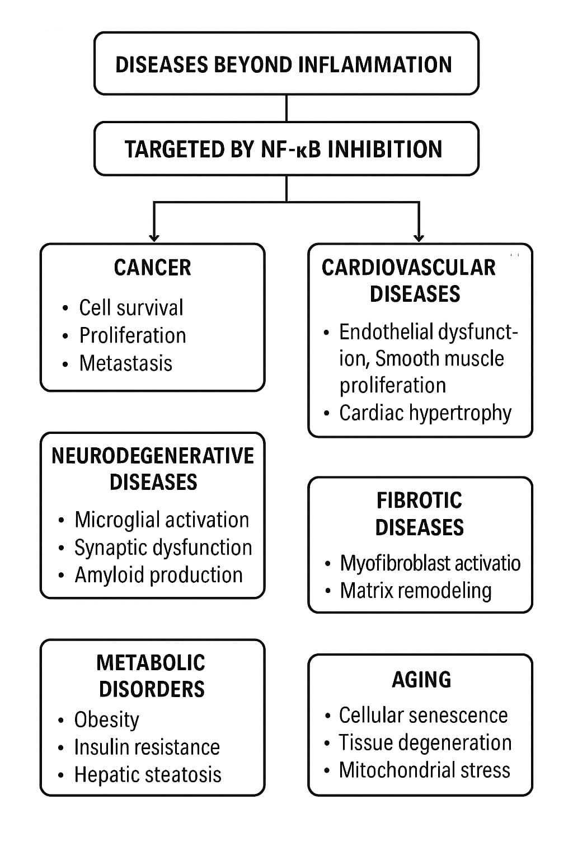
Figure 7: NF-κB dysregulation across cancer, neurodegeneration, metabolic and cardiovascular diseases.

Cancer: Among the most researched areas outside of inflammation where NF-κB plays a pivotal role is oncogenesis. In many types of cancer, NF-κB becomes constitutively active, meaning it is persistently turned on even without stimuli. This abnormal activity promotes tumor growth by stimulating genes that control:
Cell growth (e.g. Bcl-2, Bcl-xL): NF-κB helps cancer cells evade apoptosis (programmed cell death), allowing them to survive under stress or chemotherapy.
Cell proliferation (e.g. cyclin D1): It accelerates cell cycle progression, leading to uncontrolled division.
Angiogenesis (e.g. VEGF): It supports the generation of new blood vessels, providing nutrients and oxygen to growing tumors.
Metastasis (e.g. MMPs): NF-κB induces enzymes that degrade extracellular matrix, helping cancer cells invade other tissues. Notably, cancers like breast cancer, multiple myeloma, colorectal cancer and pancreatic cancer have shown NF-κB activation as a central driver of progression ^{[43]}.
Neurodegenerative diseases: NF-κB also has a significant role in the nervous system, particularly in the development and progression of neurodegenerative disease such as Alzheimer’s disease (AD), Parkinson’s disease (PD), Huntington’s disease (HD), and Amyotrophic lateral sclerosis (ALS). While some level of NF-κB activity is required for normal neuronal function, chronic activation leads to:
Microglial activation: Glial cells release pro- inflammatory cytokines and reactive oxygen species (ROS), damaging neurons.
Synaptic dysfunction: Persistent NF-κB signaling alters neurotransmitter balance and impairs synaptic plasticity.
Amyloid production: In Alzheimer’s disease, NF-κB promotes the transcription of enzymes like BACE1, increasing β-amyloid plaque formation.
Mitochondrial stress: Excess NF-κB activation exacerbates oxidative stress, contributing to neuronal apoptosis. Modulating this pathway using natural compounds (like curcumin, resveratrol) and experimental drugs helps reduce neuroinflammation and slow neurodegeneration, making NF-κB an attractive target for neuroprotective therapies ^{[44]}.
Metabolic disorders: In the context of obesity and metabolic syndrome, the NF-kb pathway plays a role that is distinct from classical inflammation. Here, it contributes to metabolic dysregulation, insulin resistance and lipo-toxicity.
Adipose tissue dysfunction: In obesity, expanded adipose tissue shows increased NF-κB signaling, which disrupts adipokine balance (e.g. leptin, adiponectin).
Insulin resistance: NF-κB interferes with insulinreceptor signaling in muscle and in muscle and liver cells, reducing glucose uptake and contributing to type 2 diabetes mellitus.
Hepatic steatosis: NF-κB activation in liver cells promotes fat accumulation and impairs lipid metabolism, leading to fatty liver disease (NAFLD and NASH). Inhibition of NF-κB has shown improvement in insulin sensitivity and lipid metabolism in both preclinical and early human studies, suggesting a strong therapeutic potential in managing metabolic dysfunction ^{[45]}
Cardiovascular diseases: NF-κB contributes significantly to the pathology of atherosclerosis, hypertension and heart failure through mechanisms independent of classic inflammation.
Endothelial dysfunction: NF-κB induces expression of adhesion molecules (e.g. ICAM-1, VCAM-1), making blood vessels more susceptible to plaque formation.
Smooth muscle proliferation: In arterial walls, NF-κB encourages the growth of extracellular matrix and smooth cells deposition, contributing to arterial stiffening.
Ischemia-reperfusion injury: In myocardial infraction, NF-κB activation post-reperfusion exacerbates cell death and impairs cardiac function.
Cardiac hypertrophy: Chronic stress or high blood pressure leads to NF-κB mediated gene expression that thickens heart muscles, eventually impairing contractility. Drugs that modulate this pathway (like statins, ACE inhibitors and omega-3 fatty acids) indirectly reduces NF-κB activation and show improved cardiovascular outcomes ^{[46]}. Research is ongoing to develop direct NF-κB targeted therapeutics for cardiac care.
Aging and cellular senescence: NF-κB is one of the most important transcription factors in the process of cellular aging and senescence. Its activity increases with age, particularly in post-mitotic tissues like the brain, liver and kidney. It drives the senescence-associated secretory phenotype (SASP), a pro-inflammatory state seen in aged cells.
Cell cycle arrest: NF-κB modulates p53 and p21 pathways that maintain cells in a non-dividing state.
Mitochondrial dysfunction: Enhanced NF-κB signaling increases ROS production, leading to DNA damage and energy imbalance.
Tissue degeneration: Chronic NF-κB activity contributes to sarcopenia (muscle loss), skin aging and age-related immune dysfunction. Caloric restriction, known to prolong life-span, reduces NF-κB activity, and agents like metformin and rapamycin also suppress this pathway, indicating its strong connection to longevity regulation.
Fibrotic diseases:
In diseases like pulmonary fibrosis, renal fibrosis and liver cirrhosis, NF-κB regulates the fibrotic cascade by:
- Promoting Myofibroblast activation.
- Enhancing secretion of pro-fibrotic cytokines like TGF-β1.
- Supporting collagen deposition and matrix remodeling.
Persistent NF-κB signaling in fibrotic tissues accelerates scarring and loss of organ function. Inhibition of this pathway has demonstrated anti-fibrotic effects in both animal models and in-vitro studies.
Reproductive and hormonal disorders: Emerging evidence points to NF-κB involvement in reproductive diseases such as endometriosis and polycystic ovarian syndrome (PCOS). In these cases:
Endometrial lesions: NF-κB is overexpressed, promoting survival of ectopic endometrial cells.
Hormonal imbalance: NF-κB influences the hypothalamic-pituitary-gonadal axis, altering hormone release and ovulation.
Ovulation dysfunction: In PCOS, it interferes with follicular maturation and induces ovarian fibrosis. Modulating NF-κB can improve hormonal balance and fertility outcomes in these conditions.
Conclusion
Persistent activation of the NF-κB pathway plays a central role in the onset and progression of chronic inflammatory and degenerative diseases. While existing anti-inflammatory drugs alleviate symptoms, they fail to correct upstream molecular dysregulation and are often limited by adverse effects. Medicinal plants provide a promising complementary approach by offering multi-target actions, including antioxidant, immunomodulatory, and NF-κB–inhibitory effects. Phytochemicals from Eclipta alba, Zingiber officinale, Asparagus racemosus, Phyllanthus emblica, and Justicia adhatoda demonstrate significant potential to suppress inflammatory mediators and restore immune balance. Their mechanisms of action—ranging from inhibition of IKK activation to prevention of NF-κB nuclear translocation—highlight their ability to intervene at critical checkpoints of the inflammatory cascade. Integrating these traditional remedies with modern molecular insights may pave the way for the development of safer, affordable, and disease-modifying therapeutics. However, further preclinical validation, standardized phytochemical characterization, and well-designed clinical studies are essential to establish their long-term efficacy and safety. Ultimately, plant-based NF-κB modulators represent a valuable frontier in the search for next-generation therapies for chronic inflammation and its associated disorders.

REFERENCES
- Liu T, Zhang L, Joo D, Sun SC. NF-kB signaling in inflammation. Signal Trans duct Targeted Therapy. 2017;2:17023. https://doi.org/10.1038/sigtrans.2017.23
- Lawrence T. The nuclear factor NF-kB pathway in inflammation. Cold spring Harb Perspect Biol. 2009;1(6):a001651. https://doi.org/10.1101/cshperspect.a001651
- Abdulkhaleq LA, Assi MA, Abdullah R, Zamri-SaadM,Taufiq-Yap YH, Hezmee MNM. The crucial roles of inflammatory mediators in inflammation: A review. Vet World. 2018;11(5):627-635 https://doi.org/10.14202/vetworld.2018.627-635
- Thornton SJ, et al. A comprehensive review of non-steroidal anti-inflammatory drug use in the elderly. Aging Dis. 2018;9(1):27-45. https://doi.org/10.14336/AD.2017.0306
- Naithani R, Vashisht V, Rawat AKS. Herbal bioactives in treatment of inflammation: An overview. S Afr J Bot. 2021;143:205-25. https://doi.org/10.1016/j.sajb.2021.07.027
- Shen P, Yang X, Jiang J, Wang X, Liang T, He L. Wedelolactone from Eclipta alba inhibits lipopolysaccharide-enhaced cell proliferation of human renal mesangial cells via NF-κB signaling pathway. Am J Transl Res. 2017;9(5):2132-2142. https://www.ncbi.nlm.nih.gov/pmc/articles/PMC5446498/
- Zhao Y, Chen X, Liu X, Wu J, Wang J. Decoding nature: multi-target anti-inflammatory mechanisms of natural products in the TLR4/NF-kB pathway. Front Pharmacol. 2025;15:1467193. https://doi.org/10.3389/fphar.2024.1467193
- Guo, Q., Jin, Y., Chn, X. et al.NF-κB in biology and targeted therapy: new insights and translation implications.Signal Transduction and Targeted Therapy.2024;6:53 https://doi.org/10.1038/s41392-024-01757-9
- Zheng, C., Yin, Q. & Wu, H. Structural studies of NF-κB signaling. Cell Research 21. 2011;183-195 https://doi.org/10.1038/cr.2010.171
- Oeckinghaus A, Ghosh S. The NF-kappaB family of transcription factors and its regulation. Cold Spring Harb Perspect Biol. 2009;1(4):a000034. https://doi.org/10.1101/cshperspect.a000034
- Yu, H., Lin, L.,Zhang, Z.et al. Targeting NF-κB pathway for the therapy of diseases: mechanism and clinical study. Signal transduction Target Therapy. 2020; 209. https://doi.org/10.1038/s41392-020-00312-6
- Kragstrup TW, Nygaard U, Schou JS, et al. Current and emerging strategies for anti-inflammatory treatment: focus on molecular and biological targets. Front Pharmacol. 2022;13:1063246. https://doi.org/10.3389/fphar.2022.1063246
- Lanas A, et al. Gastrointestinal damage associated with NSAIDs use: a review. Arthritis Res Ther. 2015;17:72.
- Bindu S, Mazumder S, Bandyopadhyay U. NSAIDs and organ damage: current perspective. Biochem Pharmacol. 2020;180:114147. https://doi.org/10.1016/j.bcp.2020.114147
- Gershfield-wilkins A, Dupont M, Sharp C, O’Hara R. Non-steroidal anti-inflammatory drug effects on renal and cardiovascular function: from physiology to clinical practice. Eur J Prev cardiol. 2020;27(8):850-66. https://doi.org/10.1177/2047487319848105
- Crofford LJ. Use of NSAIDs in treating patients with arthritis. Arthritis Res Ther. 2013;15(suppl 3):S2. https://doi.org/10.1186/ar4174
- De Vries TW, StaekEurwatnya P, Roorda RJ, Terwee CB, Raat H. Systemic review of the toxicity of short-course oral corticosteroids in children. Arch Dis Child. 2012;97(11):1024-31. https://doi.org/10.1136/archdischild-2015-309522
- Curtis JR, Westfall AO, Allison J, Bijlsma JWJ, Freeman A, George M, et al. Population-based assessment od adverse events associated with long-term glucocorticoids use. Arthritis Rheum. 2006;55(3):420-6. https://doi.org/10.1002/art.21984
- Gul A, et al. Risk of serious infection with biological and conventional synthetic disease-modifying antirheumatic drugs in rheumatoid arthritis: results from a large US cohort. Arthritis Rheumatol. 2019;71(1):142-52. https://doi.org/10.1002/acr2.11064
- Putrik P, Ramiro S, Keszei AP, Kvien TK, Van der Heijde D, Boonen A, et al. Inequities in access to biologic and synthetic DMARDs across 46 European countries. Arthritis Res Ther. 2013;15(6):R171. https://doi.org/10.1136/annrheumdis-2012-202603
- Rattanasinganchan P, Pakapongpan S, Srikummool M, et al. Comprehensive profiling of bioactive compounds from Eclipta alba (L.) Hassk. Reveals potent anti-inflammatory and antioxidant agents. Plants (Basel). 2024;13(1):33. https://doi.org/10.3390/plants13010033
- Roy RK, Thakur M, Dixit VK. A review on the ethnopharmacological significance of Eclipta alba L. (Asteraceae). J Ethnopharmacol. 2016;38:102-12.
- Pandey PS, Upadhyay KK, Pandey DN. Experimental evaluation of the analgesic property of Eclipta alba (L.) Hassk. Anc Sci Life. 1997;17(1):36-40. https://www.ncbi.nlm.nih.gov/pmc/articles/PMC3331089/
- Wang W, Li P, Blanchard C, et al. Bioactive compounds and bioactivities of ginger (Zingiber officinale Roscoe). Foods (Basel). 2019;8(6):185. https://doi.org/10.3390/foods8060185
- Kim JW, Cho JY. A review on pharmacological properties of Zingerone. Food Chem Toxicol. 2015;75:209-24. https://doi.org/10.1155/2015/816364
- Wojdacz R, Chen J, Stachlewicz G, et al. A comprehensive review of pain-lowering mechanisms of Zingiber officinale (Ginger). Phytother Res. 2021;35(7):3501-17. https://doi.org/10.1002/ptr.6730
- Singh AK, Srivastava A, Kumar V, Singh K. Phytochemicals, medicinal and food applications of Shatavari (Asparagus racemosus): An updated review. Nat Prod J. 2018;8(1):1-18. https://doi.org/10.2174/2210315507666170922145258
- Srivastava PL, Shukla A, Kalunke RM, et al. Comprehensive metabolic and transcriptomic profiling of various tissues provide insights for saponin biosynthesis in the medicinally important Asparagus racemosus. Sci Rep. 2018;8:9098. https://doi.org/10.1038/s41598-018-27440-y
- Ahsan H, Haider I, Mushtaq MN, Anjum I. Evaluation of anti-inflammatory and analgesic activity of the aqueous methanolic extract of Asparagus racemosus in experimental models. Farmacia. 201967(2):299-306. https://doi.org/10.31925/farmacia.2019.2.22
- Haq N, Wasiuddin, Zubair M. Phytochemistry and pharmacology of Phyllanthus emblica (Indian gooseberry)- A concise review. Front Pharmacol. 2023;14:1288618. https://doi.org/10.3389/fphar.2023.1288618
- Sharma R, Sharma DK. Assessment of total phenolic content and antioxidant potential of Phyllanthus emblica fruit extract. Biomed Res Int. 2021;2021:6623791.
- Tiwari P, Rana SV, Arya B, Kumar U. Analgesic and anti-inflammatory activities of Phyllanthus emblica fruit extract in experimental models. BMC Complement Altern Med. 2014;14:321. https://doi.org/10.1186/1472-6882-14-321
- Khandelwal P, Wadhwani BD, Rao RS, et al. Exploring the pharmacological and chemical aspects of pyrrolo-quinazoline deriatives in Adhatoda Vasica. Heliyon. 2024;10(4):e25727. https://doi.org/10.1016/j.heliyon.2024.e25727
- Nasir F, et al. Phytochemical characterization of Justica adhatoda leaf extracts. Scientifica (Cairo). 2024;2024:1374346. https://doi.org/10.1155/2024/1374346
- Mulla WA, More SD, Jamge SB, Pawar AM, Khadabadi SS. Evaluation of anti-inflammatory and analgesic activities of ethanolic extract of roots of Adhatoda Vasica Linn. Int J PharmTech Res. 2010;2(2):1364-8. http://www.sphinxsai.com/2010/PT~Vol2~No.2/PT(2)1364-1368.pdf
- Singh A. Anti-inflammatory and Analgesic Agents from Indian Medicinal Plants.2000
- Liju, Vijayastelter B.;Jeena, Kottarapat; Kyttan, Ramadasan. An evaluation of antioxidant, anti-inflammatory, and antinociceptive activities of essential oil from Curcuma longa. L. Indian Journal of Pharmacology. 2011; 43(5):p 526-531. https://doi.org/10.4103/0253-7613.84961
- Emeka J, Iweala, ,Miracle E, Uche, Emmanuel Dike Dike, Lotanna Richard Etumnu, Titilope M. Dokunmu,Adurosakin E. Oluwapelumi, Benedict Chukwuebuka Okoro, Omoremime E. Dania, Abiodun H. Adebayo, EziucheAmadikeUgbogu. Curcuma longa: Ethnochemistry, pharmacological activities and toxicity profiles-A review, Pharmacological Research –Modern Chinese Medicine.2023(6); 100222. https://doi.org/10.4103/0253-7613.84961
- Saleem S, Muhammad G, Hussain MA, Altaf M, Bukhari SNA. Withania somnifera L.: Insights into the phytochemical profile, therapeutic potential, clinical trials, and future prospective. Iran J Basic Medicinal Science.2020; 23(12) :1501-1526. https://doi.org/10.22038/IJBMS.2020.47050.10852
- Farah Iram, Shah Alam Khan, Asif Husain, Phytochemistry and potential therapeutic actions of Boswellic acids: A mini-review, Asian Pacific Journal of Tropical Biomedicine.2017; 513-523. https://doi.org/10.1016/j.apjtb.2017.05.001
- Abdel-Reheim MA, Ali ME, Gaafar AGA, Ashour AA. Quillaja saponin mitigatesmethotrexate-provoked renal injury; insight into Nrf-2/Keap-1 pathway modulation with suppressionof oxidative stress and inflammation. J Pharmacy Health Care Science.2024; 10(1):17.
- M. Tiwari, U.N. Dwivedi, P. Kakkar. Tinospora cordifolia extract modulates COX-2, Inos, ICAM-1, pro-inflammatory cytokines and redox status in murine model of asthma. Journal of Ethnopharmacology. 2014; 0378-8741. https://doi.org/10.1016/j.jep.2014.01.031
- Karin M. Nf-kB as a critical link between inflammation and cancer. Mol Cancer. 2013;12:86. https://doi.org/10.1186/1476-4598-12-86
- Kaltschmidt B, Kaltschmidt C. Significance of NF-kB in neurodegenerative pathologies: Alzheimer’s disease and multiple sclerosis. Front Mol Neurosci. 2015;8:69. https://doi.org/10.3389/fnmol.2015.00069
- Arkan MC, et al. IKK-β links inflammation to obesity-induced insulin resistance. Nat Med. 2015;11(2):191-8. https://doi.org/10.1038/nm1185
- Gareus R, et al. Endothelial NF-kB inhibition reduces atherosclerosis and vascular inflammation. EMBO Mol Med. 2008;7(3):241-6. https://doi.org/10.1016/j.cmet.2008.08.016

