The cold chain of biotherapies within a hospital pharmacy : Evaluation of the process and dispensing practices.

Abstract :
So-called ‘cold’ medicines are drugs that must be stored at a temperature between 2°C and 8°C. In the pharmaceutical market, the proportion of thermolabile medicines is steadily increasing with the development of recombinant DNA technology.
Throughout its lifecycle, a thermolabile drug undergoes multiple stages of storage and transport between various stakeholders, and the cold chain must be maintained to ensure the quality and safety of the product.
A break in the cold chain may result from a lack of resources, training, or information. Indeed, healthcare professionals are not always aware of the impact or risk associated with a cold chain failure. Such a breach can pose a triple risk for the healthcare institution : a health risk due to the alteration of the drug’s quality, which may affect its efficacy and patient safety, a financial risk, and a regulatory risk.
This study was conducted within the Special Status Products Management Unit (UGPSP) of the Mohammed V Military Teaching Hospital in Rabat, with the following objectives :
- To evaluate the cold chain process from the reception to the dispensing of thermolabile products to patients, in order to identify weaknesses in the system.
- To ensure the continuity of this chain with patients and their administration methods, in order to guarantee the drug’s efficacy during its use.
This study highlighted good control of the cold chain within the pharmacy department, particularly during the reception and storage of thermolabile drugs by a qualified team. However, the dispensing stage remains the weak point of the chain and still requires improvements.
Keywords : Cold chain, monoclonal antibodies, temperature, thermolabile products.

Introduction :
The use of biotherapies has grown significantly since the 1980s with the development of recombinant DNA technology. Monoclonal antibodies constitute a major class of biopharmaceutical products, with indications now covering a wide range of diseases (Le Basle et al., 2020) (Burgevin et al., 2024). The protein nature of these drugs makes them sensitive to any temperature changes.
The cold chain refers to all the processes during which maintaining one or more products at a specific temperature is essential to preserve the product’s quality. The stages range from manufacturing to the administration of the medicines to the patient (“Recommandations de gestion des produits de santé soumis à la chaîne du froid entre +2°C et +8°C à l’officine,” n.d.).
The pharmacist, as a specialist in medicines, is constantly concerned with their quality and is deeply involved in the measures that ensure the cold chain of thermolabile medicines throughout the entire process. They make sure that the medicines are kept under optimal storage conditions and during all transfers, so as not to break the cold chain.
Storage must therefore be carried out according to the manufacturer’s recommendations: in a freezer at a temperature below -15 °C, in a refrigerator or cold room between +2 °C and +8 °C, or at room temperature below 25 °C or 30 °C (Saint-Lorant et al., 2014).
A break in the cold chain can result from a lack of resources, training, or information. Indeed, healthcare professionals are not always aware of the impact or risk associated with a break in the cold chain (Castel and Saint-Lorant, 2015). Such a break can pose a triple risk for the healthcare institution: a health risk due to the alteration of the medicine’s quality—affecting its efficacy and patient safety—a financial risk, and a regulatory risk (Saint-Lorant et al., 2014).
This study was conducted within the Unit for the Management of Special-Status Products (UMSSP) at the Mohammed V Military Teaching Hospital (HMIMV) in Rabat, with the following objectives :
- Evaluate the cold chain pathway from receipt through to the dispensing of thermolabile products to patients in order to detect failures and critical points.
- Ensure the continuity of this chain for patients and monitor their methods of use in order to guarantee the medicine’s effectiveness during administration.
Materials and Methods :
The study was conducted at the Mohammed V Military Teaching Hospital (HMIMV) in Rabat, a 1,200-bed facility that plays an important role in the Health Logistics component of the Royal Armed Forces Health Service. It contributes to the medical support of the forces even in peacetime and is organized into four sectors: a management sector, a technical activity sector, and an administration and management sector.
The technical activity sector includes :
- A medical division
- A surgical division
- An anesthesia and intensive care division
- A pharmacy division, which is subdivided into three services (medicines, medical devices, and reagents) and includes units such as the Unit for the Management of Special-Status Products (UMSSP).
Beyond its specific military missions, the HMIMV collaborates with public healthcare institutions and receives a significant number of civilian patients.
This is a prospective study conducted by a resident pharmacist in the department, with the objective of evaluating the management pathway of the cold chain for thermolabile medicines from delivery to the pharmacy service to dispensing to patients in order to identify the main failures in the process.
An audit of compliance with the cold chain after dispensing was carried out by a pharmacist from the department using a questionnaire and was conducted over a two-month period, from January 1 to March 1, 2025.
The questionnaire was completed by the pharmacist, who interviewed the patient or, if applicable, their representative. The questions focused on compliance with the cold chain during transport, the storage conditions of thermolabile medicines at home (Trastuzumab, Pertuzumab, Rituximab, Adalimumab, Golimumab, Infliximab, Tocilizumab, Cetuximab, Etanercept, etc.), and their handling when administered within the clinical service.
These are biotherapies that require storage at a temperature between 2 and 8 °C, commonly referred to as “cold” medicines.
Results :
- The cold chain pathway at the UGPSP :
The cold chain pathway begins with the ordering of thermolabile medicines. Indeed, when placing an order, we specify the days and hours during which our service is open. This first step is important to avoid deliveries outside of working hours, which could cause a break in the cold chain due to delayed delivery.
- Receipt and temporary storage of medicines
The reception of thermolabile medicines in the pharmacy is carried out by a qualified team composed of a supervising pharmacist and a technician specialized in the handling of temperature-sensitive products. This team ensures compliance with the cold chain throughout transport by verifying the presence and adequacy of cold packs and by systematically checking temperature records upon arrival.
Once received, the thermolabile products are placed in intermediate storage in dedicated refrigerators located in the warehouse area, pending their release and validation by a technical committee.
Each delivery of thermolabile medicines is processed as a priority in order to prevent any break in the cold chain. In the event of non-compliance, the pharmaceutical laboratory is contacted to arrange the return of the product.
- The storage of thermolabile products in the cold room
After validation by the technical committee, the products are stored in the cold room under controlled temperature conditions. A monthly inventory is carried out by the pharmacist responsible for the unit’s storage area in order to remove any expired products.
- Dispensing of medicines
The pharmacist, for his part, stores the products in the cold room until the medication is dispensed. It is his responsibility to provide the patient with all necessary elements to ensure that the cold chain is not broken. This may range from simple counselling to providing insulated pouches for transport to the patient’s refrigerator. This step is crucial to maintaining the integrity of the product and ensuring full treatment adherence.
- Identification of Critical Points in the Circuit :
The cold chain of thermolabile drugs is a critical issue and involves a multitude of interconnected stakeholders. Maintaining a stable temperature throughout the entire circuit is essential to ensure that patients receive effective treatment. At each stage, there are critical points that can be managed through tools, training, or regular monitoring. Accordingly, we were able to identify the critical points associated with each step of our cold chain management that require the implementation of measures to control and minimize this risk (Table 1).
Table 1 : Critical points corresponding to each stage of the circuit.
Stages of the circuit | Critical points
Reception and temporary storage | - Lack of temperature indicators to verify transport conditions  - Absence of thermometers for real-time temperature monitoring
Product storage | - Compliance of refrigerators and cold rooms  - Alarms signaling any power outage incidents affecting only the pharmacy department  - Technical maintenance of the cold room to ensure appropriate temperature
Medication dispensing | - Lack of insulated pouches  - Poorly managed refrigerator storage

- Post-dispensing audit :
This audit, conducted over a two-month period, allowed us to analyze post-dispensing practices according to two axes :
- The transport conditions of thermolabile medicines :
This step is essential to ensure the stability of the medicine and, consequently, its therapeutic efficacy. However, it is often poorly managed by patients. Those who live near the hospital can easily comply with the optimal conditions for transporting it to their refrigerator. In contrast, for patients coming from distant cities, the issue arises despite the use of insulated pouches, which do not always suffice to maintain the recommended temperature required to ensure the stability of the medicine.
The issue also concerns new patients starting biotherapies, who are not informed about the specific features of these treatments or the need to bring an insulated pouch when they come to the pharmacy.
- Storage in the refrigerator :
Medicines that require compliance with the cold chain (storage in a refrigerator between +2°C and +8°C) must be stored carefully in specific locations inside the refrigerator. During the audit, we found that some patients wonder whether they can place these products in the freezer. However, excessively low temperatures can alter the medicine, as indicated in the recommendations.

Discussion :
The European Pharmacopoeia defines the stability of a medicine as follows: “A medicine is considered stable when, within a specified period of time, its essential properties do not change or change only within acceptable limits.” This definition also implies that medicines must be stored under appropriate conditions (“Article L5121-1 - Code de la santé publique - Légifrance,” n.d.).
So-called “cold” medicines are drugs that must be stored at a temperature between 2°C and 8°C. On the pharmaceutical market, the proportion of thermolabile medicines that need to be stored between 2°C and 8°C has been steadily increasing with the development of recombinant DNA technology (Fekete et al., 2012) (Collet, n.d.).
The drug supply chain, before administration, includes a series of steps that must be followed to ensure its quality (Drouard, 2023). The first stage in a medicine’s lifecycle begins in a pharmaceutical laboratory. From the moment of its production, a drug can be considered thermolabile, with raw materials sensitive to temperature. Once produced, the medicine is packaged and then stored within the pharmaceutical laboratory.
The medicine can then be delivered directly to the hospital pharmacy; this step requires that the products be transported under controlled temperature conditions throughout the journey. Once it reaches its destination, the medicine is stored again. Following a medical prescription, the medicine is dispensed to the patient and undergoes another transport stage to the patient’s home, where it can be stored once more.
Throughout its lifecycle, a thermolabile medicine undergoes multiple stages of storage and transport between different stakeholders, and the cold chain must be maintained to ensure the quality and safety of the product.
The use of biotherapies has expanded significantly since the 1980s with the development of recombinant DNA technology. Monoclonal antibodies constitute a major class of biopharmaceutical products, with indications now covering a wide range of diseases, from cancer to asthma, as well as central nervous system disorders, infectious diseases, and moderate to severe flares of chronic inflammatory bowel diseases (IBD) (Burgevin et al., 2024).
Monoclonal antibodies, like other therapeutic proteins, can be exposed to temperature variations during handling, storage, and transport (Hawe et al., 2009). Elevated temperatures can disrupt the native conformation of the protein to a degree sufficient to promote aggregation, although this begins at temperatures well below the protein’s equilibrium melting temperature (Tm). The rate of aggregation increases at high temperatures, as with other protein reactions (“Physical Stability of Proteins in Aqueous Solution,” 2024). Heat-induced unfolding generally leads to irreversible conformational changes. High temperatures also accelerate chemical reactions such as hydrolysis and oxidation (Wang, 2005) (Hawe et al., 2009).
Low temperatures can also induce protein denaturation, particularly during freeze–thaw cycles, due to the combination of multiple stress factors (such as a drop in buffer pH caused by crystallization, cryoconcentration of solute molecules, and the formation of water–ice interfaces). These phenomena affect both the colloidal and conformational stability of proteins (Horn et al., 2018).
The assessment of compliance with the cold chain in the hospital showed effective control of this chain within the pharmacy department during the receipt and storage of medicines. This performance is linked to the continuous training of the team responsible for receiving deliveries and the regular monitoring of temperature fluctuations in the cold room by the hospital’s technical department. A study conducted in Tunisia showed that the lack of information among personnel responsible for transporting and/or storing medicines led to an average cold chain break of 20 minutes, with a potential risk of the medication being stored at room temperature (Zribi et al., 2019). However, it appeared that dispensing, transport, and storage of medicines by patients still require further awareness-raising efforts. It is essential to emphasize the importance of maintaining the cold chain throughout the entire circuit, up to administration, in order to preserve the drug’s effectiveness.
Our analysis of the critical points in the circuit enabled us to implement corrective actions to ensure optimal risk control :
- Continuous staff training :
Training for the staff responsible for receiving thermolabile health products is necessary and mandatory. During this training, it would be useful to highlight :
- The need to give priority to handling thermolabile health products
- Regularly checking refrigerator temperatures
- Properly closing the refrigerators
- Store thermolabile medicines in dedicated refrigerators (no food allowed)
- Report any unexplained events.
- At the time of dispensing :
It is important to explain to the patient that the cold chain must be maintained without interruption until the administration of the medication. Any break in this chain can compromise the treatment's efficacy. To ensure safe transport to the patient's refrigerator, insulated bags and cold packs are provided to those who do not have them, thus ensuring the required temperature is maintained.
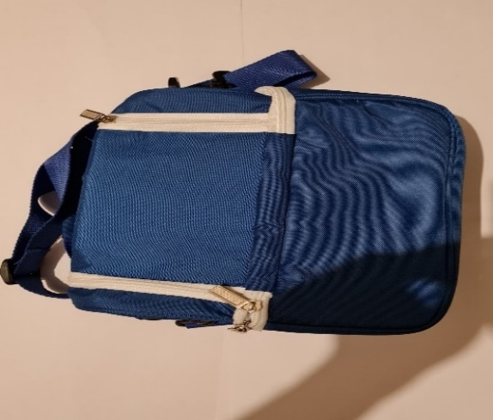
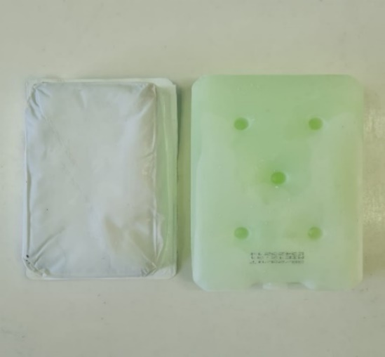
Figure 1.a : Refrigerant packs
Figure 1.b : insulated bag

Additional guidance provided to patients :
- Transport without an insulated container should be strictly prohibited
- Strictly adhere to the indicated temperatures
- Do not freeze medications stored at 2–8°C
- Do not refreeze a healthcare product
- Regularly monitor refrigerator temperatures.
To this end, a summary sheet outlining the essential rules for managing medications requiring refrigeration was prepared by the responsible pharmacist (Figure 2). A copy of this sheet is provided to each relevant patient to ensure adherence to proper storage practices.
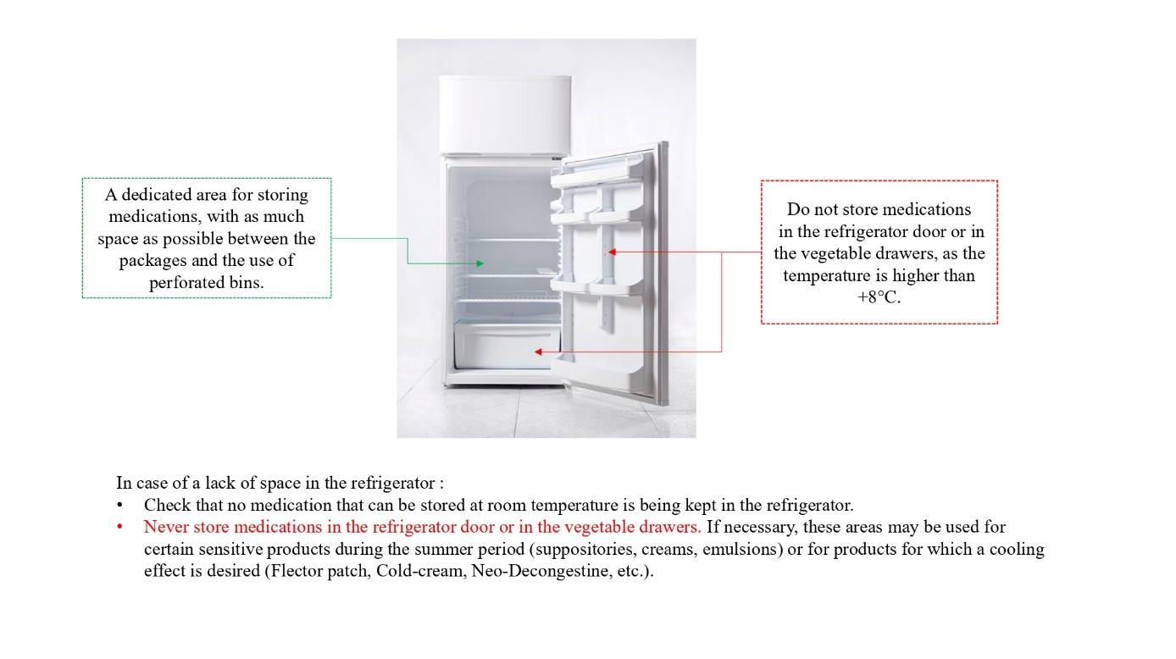
Figure 2 : the explanatory document outlining the guidelines for the management of cold-chain medications

Conclusion
Monoclonal antibodies are, without a doubt, the most specific medications currently available on the market. They now play a key role in the modern therapeutic management of serious conditions. These biotechnology-derived and highly costly medicines fall under pharmaceutical responsibility, and the hospital pharmacist is the guarantor of their proper use—from procurement to storage, and ultimately to administration to the patient. They consist of particularly sensitive active substances that require strict compliance with the cold chain (i.e., storage in a refrigerator between +2°C and +8°C), and their number continues to increase.
The continuous improvement of the cold chain remains a major current issue for healthcare institutions, given the range of risks associated with the quality of these medications and, consequently, with the patient’s pharmacological management. This chain begins with ordering and extends through delivery, storage, and dispensing—the latter constituting the weakest link in the process and still requiring considerable efforts in terms of patient education.

References
- Article L5121-1 - Code de la santé publique - Légifrance [WWW Document], n.d. URL https://www.legifrance.gouv.fr/codes/article_lc/LEGIARTI000048701765
- Burgevin, A., Duclaux-Loras, R., Charlois, A.-L., Barrau, M., Faure, M., Nancey, S., 2024. Biotherapy treatments for Inflammatory Bowel Disease. Hépato-Gastro & Oncologie Digestive 31, 1133–1148. https://doi.org/10.1684/hpg.2024.2865
- Castel, C., Saint-Lorant, G., 2015. [Securing the use of thermosensitive drugs]. Rev Infirm 39–41. https://doi.org/10.1016/j.revinf.2015.07.012
- Collet, C.-É., n.d. Le circuit de la chaîne du froid des médicaments: un enjeu majeur pour un nouveau centre hospitalier universitaire. https://dumas.ccsd.cnrs.fr/dumas-03615264v1
- Drouard, M., 2023. La chaîne du froid et ses médicaments. Actualités Pharmaceutiques 62, 15–18. https://doi.org/10.1016/j.actpha.2023.09.021
- Fekete, S., Veuthey, J.-L., Guillarme, D., 2012. New trends in reversed-phase liquid chromatographic separations of therapeutic peptides and proteins: Theory and applications. Journal of Pharmaceutical and Biomedical Analysis, Review Papers on Pharmaceutical and Biomedical Analysis 2012 69, 9–27. https://doi.org/10.1016/j.jpba.2012.03.024
- Hawe, A., Kasper, J.C., Friess, W., Jiskoot, W., 2009. Structural properties of monoclonal antibody aggregates induced by freeze–thawing and thermal stress. European Journal of Pharmaceutical Sciences 38, 79–87. https://doi.org/10.1016/j.ejps.2009.06.001
- Horn, J., Schanda, J., Friess, W., 2018. Impact of fast and conservative freeze-drying on product quality of protein-mannitol-sucrose-glycerol lyophilizates. European Journal of Pharmaceutics and Biopharmaceutics 127, 342–354. https://doi.org/10.1016/j.ejpb.2018.03.003
- Le Basle, Y., Chennell, P., Tokhadze, N., Astier, A., Sautou, V., 2020. Physicochemical Stability of Monoclonal Antibodies: A Review. Journal of Pharmaceutical Sciences 109, 169–190. https://doi.org/10.1016/j.xphs.2019.08.009
- Physical Stability of Proteins in Aqueous Solution: Mechanism and Driving Forces in Nonnative Protein Aggregation | Request PDF, 2024. . ResearchGate. https://doi.org/10.1023/a:1025771421906
- Recommandations de gestion des produits de santé soumis à la chaîne du froid entre +2°C et +8°C à l’officine [WWW Document], n.d. . CNOP. URL https://www.ordre.pharmacien.fr/les-communications/focus-sur/les-actualites/recommandations-de-gestion-des-produits-de-sante-soumis-a-la-cha%C3%AEne-du-froid-entre-2-c-et-8-c-a-l-officine
- Saint-Lorant, G., Souchon, J., Guillard, P., Barbier-Courteille, F., Hecquard, C., 2014. Amélioration continue de la chaîne du froid des médicaments dans un établissement de santé. Le Pharmacien Hospitalier et Clinicien 49, 162–175. https://doi.org/10.1016/j.phclin.2013.06.003
- Wang, W., 2005. Protein aggregation and its inhibition in biopharmaceutics. International Journal of Pharmaceutics 289, 1–30. https://doi.org/10.1016/j.ijpharm.2004.11.014
- Zribi, K., Zribi, E., Sakly, N., 2019. Maîtrise de la chaîne du froid des médicaments au CHU Habib Bourguiba : analyse des risques a posteriori d’un incident de rupture de la chaîne du froid et évaluation des pratiques. Le Pharmacien Hospitalier et Clinicien 54, 177–183. https://doi.org/10.1016/j.phclin.2019.02.002

