Original Research Article
Formulation and Evaluation of α-Arbutin Based Periorbital depigmentation hydrogel patches for Cosmetic Application

ABSTRACT
Aim: The present study aims to formulate and evaluate α-arbutin–based hydrogel patches for periorbital depigmentation and management of under-eye dark circles.
Place and Duration of Study: HSK college of pharmacy, Bagalkote
Methodology: Hydrogel patches were prepared using Agar/PVA (F1), Gelatine/PVA (F2), and Pectin (F3) by solvent-casting method. Formulations were evaluated for organoleptic properties, pH, weight, thickness, swelling index, folding endurance, tensile strength, drug content, FTIR compatibility, antioxidant activity, and in-vitro drug release using Franz diffusion cell.
Results: FTIR confirmed absence of drug–polymer interaction. F1 showed optimal mechanical properties (tensile strength 2.97 kg; folding endurance 321) and swelling (72.97%). Drug content ranged from 85.10 – 89.12%. F2 exhibited highest drug release (95.72% at 90 min), while F1 showed release (75.49%). Antioxidant activity (DPPH) demonstrated strong scavenging potential.
Conclusion: α-Arbutin hydrogel patches were successfully developed with safe pH, good flexibility, enhanced antioxidant activity, and controlled depigmenting agent release. F1 was identified as the most suitable formulation for cosmetic under-eye application.

Keywords: α-Arbutin, Hydrogel patches, Periorbital hyperpigmentation, Dark circles, Ascorbic acid.

INTRODUCTION

Dark circles are known as bilateral, homogeneous hyper chromic macules and patches primarily involving the lower eyelids but also sometimes extending towards the upper eyelids, eyebrows, malar regions, temporal regions and the lateral nasal root. It is also termed as ‘periorbital melanosis’. Periorbital hyperpigmentation (POH), commonly referred to as under-eye dark circles, characterized by increased pigmentation or shadowing beneath the eyes and is a frequent cosmetic concern.¹ Its etiology includes melanin overproduction, vascular congestion, structural shadow formation, aging, stress, sun exposure, dehydration, vitamin deficiency, lifestyle and genetic factors.²
Hydrogel patches are advanced topical carriers composed of hydrophilic polymer networks capable of holding significant water content. They provide hydration, cooling, improved penetration, and release of active agents making them ideal for delicate periorbital skin. These are mini sheet masks that are made of hydrogel material and curve to fit the contours of the face. The hydrogel material helps maximize nutrient absorption and provide fast acting results.³
α-Arbutin is a potent and safe tyrosinase inhibitor widely used for cosmetic depigmentation. Combined with ascorbic acid, its antioxidant and brightening effects are amplified. It is a naturally derived hydroquinone glycoside widely used as a safe and effective skin-lightening and depigmenting agent. It acts primarily by inhibiting tyrosinase, the key enzyme involved in melanin biosynthesis, thereby reducing excess pigmentation and improving overall skin tone. Compared to conventional depigmenting agents such as hydroquinone, α-arbutin exhibits superior stability, reduced cytotoxicity, and a lower risk of irritation, making it suitable for long-term cosmetic use.⁴
The present research focuses on developing α-arbutin loaded periorbital depigmenting hydrogel patches and evaluating their suitability for periorbital depigmentation.
2 MATERIALS AND METHODS
2.1 Materials
α-Arbutin was purchased from BRM Chemicals (Delhi), L-ascorbic acid from Molychem (Mumbai), agar and polyvinyl alcohol (PVA) from Thermo Fisher Scientific India Pvt. Ltd. (Mumbai), gelatine and pectin from Loba Chemical Pvt. Ltd. (Mumbai), and vitamin E from Procter & Gamble Health Ltd. (Goa). Glycerol, propylene glycol, butylated hydroxyanisole (BHA), benzalkonium chloride, sodium hydroxide pellets, and potassium dihydrogen orthophosphate were obtained from standard commercial suppliers. All chemicals used were of analytical grade.
2.2 Instruments
A UV–Visible spectrophotometer (Shimadzu, Japan), hot air oven (Oswald, Mumbai), sonicator (Equitron), electronic balance (Essae-Teraoka FB-600), magnetic stirrer (REMI 1MLH) and heating mantle (Sunrise Scientific Inc.) were utilized in the study.
2.3 FTIR Compatibility Studies
FTIR spectra of α-arbutin, PVA, agar, ascorbic acid, and the formulated patches were recorded using an ATR-FTIR spectrophotometer. Approximately 10 mg of each sample was scanned over a wavelength range of 4000 to 800 cm⁻¹ at a resolution of 10 cm⁻¹ to assess drug excipient interactions.⁵
2.4 Preparation of Standard Calibration Curve of α-Arbutin
A stock solution of α-arbutin (1000 μg/ml) was prepared by dissolving 10 mg in 10 ml of pH 7.2 phosphate buffer. A secondary stock (100 μg/ml) was obtained by diluting 1 ml of the primary stock to 10 ml with the same buffer. Working standards (10–50 μg/ml) were prepared by further dilution. A UV scan of a 30 μg/ml solution (200–400 nm) was performed to determine λ_{max} using pH 7.2 buffer as blank. Absorbances of all working standards were measured at λ_{max}, and a calibration curve (absorbance vs concentration) was plotted. Linearity was assessed using regression analysis.⁶

2.5 Formulation of Periorbital Depigmenting Hydrogel Patches
Three formulations (F1–F3) were prepared using different polymer combinations: agar/PVA (F1), gelatine/PVA (F2), and pectin (F3). The compositions are presented in Table 1.
2.5.1 Preparation Procedure
Weigh required amount of polymers like agar & polyvinyl alcohol (PVA), add agar slowly to hot distilled water heated to ~85-90°C with continuous stirring until fully dissolved and clear. Now slowly add PVA to the solution until homogenous, stir continuously for 20-30 minutes maintaining temperature to prevent formation of lumps and accelerate the dissolution and then slowly add all other excipients (F1).⁷
Weigh required amount of polymers Gelatine and PVA, add gelatine slowly to hot distilled water with continuous stirring until completely dissolved, now slowly add PVA to the solution until homogeneous, stir continuously for few minutes and then add all other excipients (F2).⁸
Weigh required amount of Polymer pectin and slowly dissolve it in the preheated distilled water by slow and continuous stirring until the liquid is clear than add all other recipients (F3).⁹
Vitamin E and BHA were pre-dissolved in propylene glycol, followed by the addition of glycerin. α-Arbutin and ascorbic acid were dissolved separately in small volumes of distilled water. Due to thermal sensitivity, α-arbutin was incorporated only after cooling the polymer solutions below 40°C. Benzalkonium chloride was added as a preservative. All formulations were sonicated to remove entrapped air.
The mixtures were poured into Petri dishes and dried in a hot air oven at 40°C for 4–5 hours. Dried patches were carefully removed and cut into standard periorbital shapes using mould.¹⁰
INGREDIENTS (100gm) | F1(gm) | F2(gm) | F3(gm)
α-arbutin | 2 | 2 | 2
L-Ascorbic Acid | 0.5 | 0.5 | 0.5
Agar | 1.5 | ----- | -----
Poly Vinyl Alcohol | 10 | 10 | -----
Gelatine | ----- | 3 | -----
pectin | ----- | ------ | 6
Vitamin E | 0.5 | 0.5 | 0.5
Glycerin | 7 | 7 | 7
Propylene Glycol | 5 | 5 | 5
Butylated Hydroxy Anisole (BHA) | 0.1 | 0.1 | 0.1
Benzalkonium Chloride | 0.1 | 0.1 | 0.1
Distilled Water | qs | qs | qs
Table No 1: Composition of hydrogel patch

2.5.2 Preparation of Storage Serum
A serum was prepared by dissolving α-arbutin in a small amount of water and subsequently mixing with glycerin. The patches were stored in this serum in airtight containers to maintain hydration and prevent drug loss.
2.6 Evaluation of Formulated Patches
2.6.1 Organoleptic Properties
Formulations were examined visually for colour, odour, and texture.
2.6.2 pH Measurement
The surface of each patch was moistened with distilled water and pH was determined by contacting pH indicator paper with the patch surface.¹¹
2.6.3 Patch Weight and Thickness
Three patches from each formulation were weighed using an analytical balance. Thickness was measured at three different positions on each patch using Vernier callipers, and mean values were calculated.¹²
2.6.4 Swelling Index
Dried patches were weighed (W_{d}), immersed in storage serum for 2 h, blotted, and reweighed (W_{s}). Swelling index was calculated using:¹³
$$\text{Swelling Index (\%)}=\frac{W_{s}-W_{d}}{W_{d}}×100$$
2.6.5 Shrinkage Study
Patches were weighed initially and dried in a hot air oven at 40°C for 24 h. The percentage shrinkage was calculated from the weight loss.¹⁴
2.6.6 Folding Endurance
Patches were repeatedly folded at the same point until breakage occurred. The number of folds sustained before breaking represented folding endurance.¹⁵
2.6.7 Tensile Strength
Tensile strength was measured using a tensiometer with fixed and movable grips. The force required to break the patch was recorded and expressed in kg.¹⁶
2.6.8 Drug Content
Patch samples (2 × 2 cm²) were triturated with pH 7.2 buffer, transferred to volumetric flasks, diluted stepwise (Stock 1 → Stock 2 → Stock 3), and analysed spectrophotometrically at λ_{max} (282.5 nm). Drug content was determined from the calibration curve.¹⁷
2.6.9 In Vitro Drug Release
A modified diffusion cell setup was used. Patches were placed on pre-soaked diffusion membranes and mounted in diffusion tubes. The receptor compartment contained 100 ml pH 7.2 buffer, stirred at 120 rpm. Samples (1 ml) were withdrawn at 15-minute intervals up to 90 minutes and replaced with fresh buffer. Absorbance was measured at 282.5 nm, and cumulative drug release was calculated. Experiments were conducted in triplicate.¹⁸⁻¹⁹
2.6.10 Antioxidant Activity (DPPH Assay)
Each patch was cut into small pieces, dissolved in 10 ml water, filtered, and mixed with 1 ml DPPH ethanol solution to obtain final concentrations of 10–100 μg/ml. After 30 minutes of incubation at room temperature, absorbance was measured at 517 nm. Ascorbic acid served as the standard. Radical scavenging activity was calculated using:
$$\text{Scavenging Activity (\%)}=\frac{A_{c}-A_{s}}{A_{c}}×100$$
where A_{c} is control absorbance and A_{s} is sample absorbance.²⁰⁻²¹
3. RESULTS AND DISCUSSION
3.1 Calibration Curve of α-Arbutin
The standard calibration curve of α-arbutin (1–5 µg/mL) showed a linear increase in absorbance with concentration (Table 2; Fig. 1), confirming adherence to Beer–Lambert’s law and suitability of the method for quantitative analysis. This linearity ensured accurate determination of drug content and release from the hydrogel formulations.
Table No 2: Absorbance data of Standard calibration of α-arbutin
Concentration | Absorbance
0 | 0
1 | 0.125
2 | 0.210
3 | 0.275
4 | 0.380
5 | 0.471

Fig 1: Standard Calibration Curve of α-arbutin

3.2 FTIR Interaction Studies
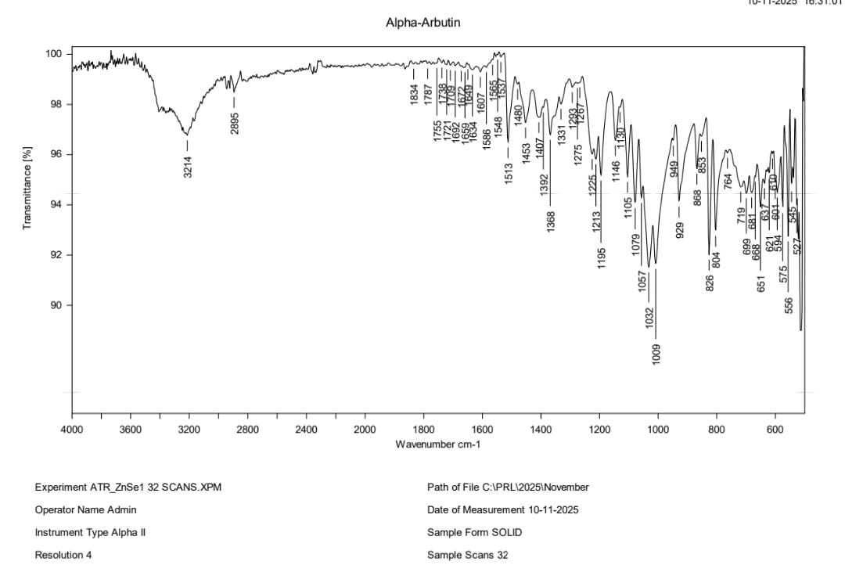
FTIR spectra of α-arbutin, ascorbic acid, PVA, agar, and the final hydrogel patch were compared to assess possible interactions (Figs. 2–6). Individual components exhibited characteristic
O–H, C–O, C=O and C–H stretching vibrations. In the hydrogel patch, the O–H band appeared broader and shifted to lower wavenumbers, indicating hydrogen bonding between the drug and polymers. Minor shifts in C–O–C and C=O peaks also suggested physical interactions. No new peaks were observed, confirming the absence of chemical incompatibility and retention of drug functionality within the patch matrix. This confirms a stable hydrogel network formed by intermolecular hydrogen bonding among PVA, agar, α-arbutin, and ascorbic acid.
Fig 2: FTIR Spectroscopy of α-arbutin
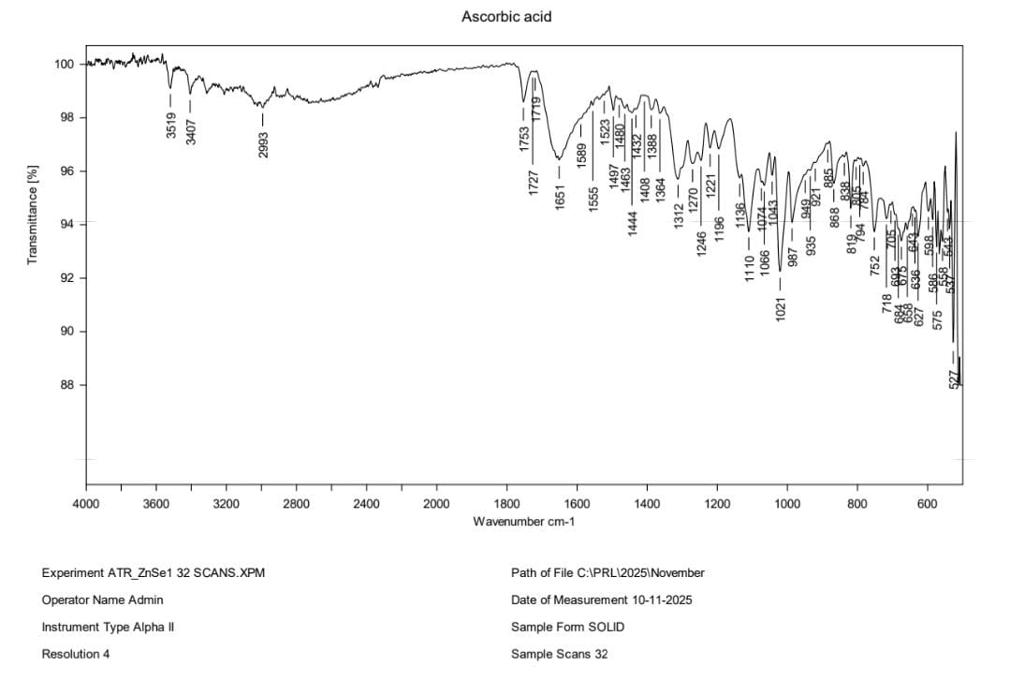
Fig 3: FTIR Spectroscopy of Ascorbic acid

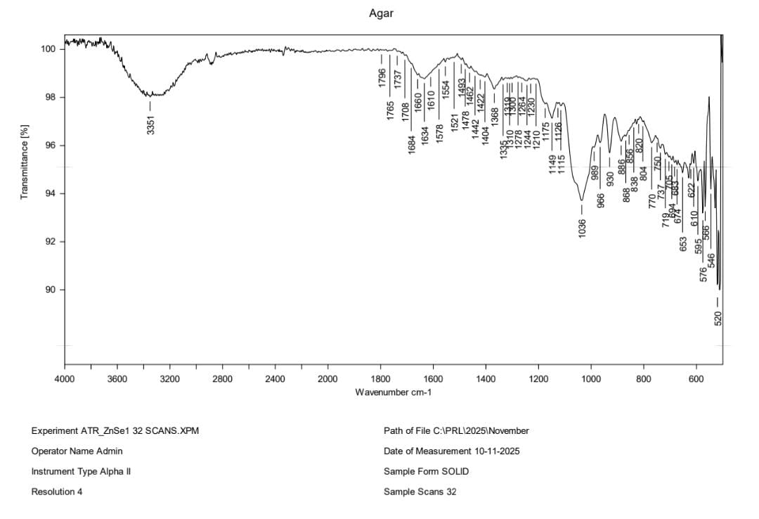
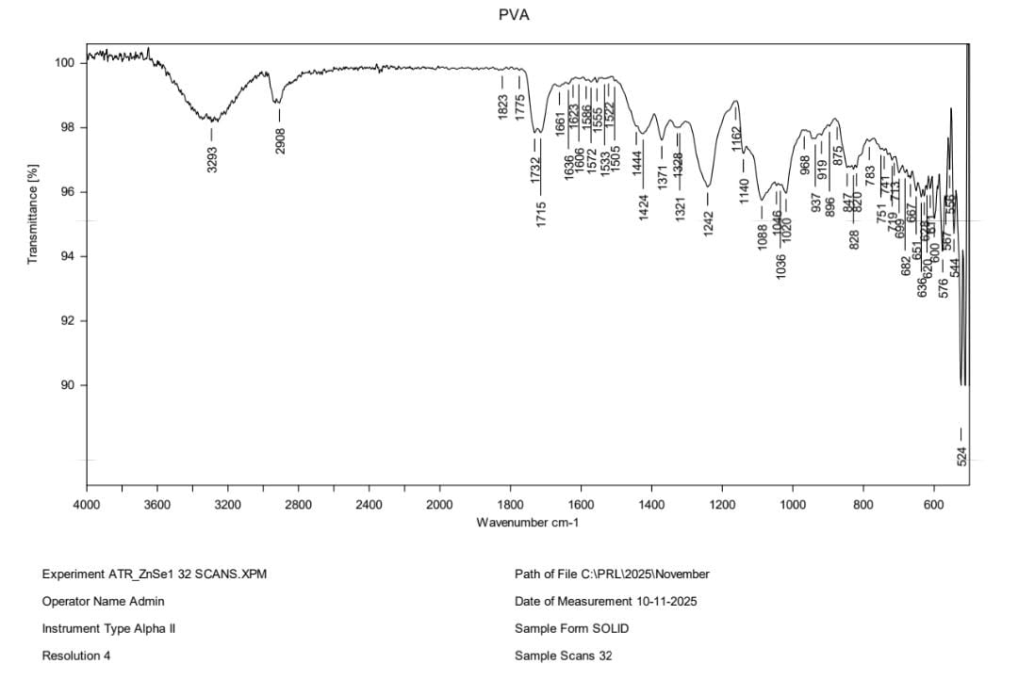
Fig 4: FTIR Spectroscopy of Poly vinyl alcohol
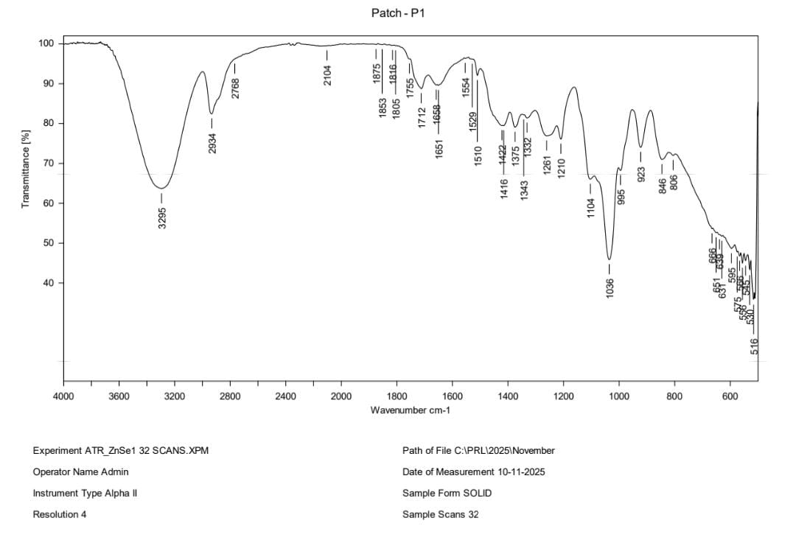
Fig 5: FTIR Spectroscopy of Agar
Fig 6: FTIR Spectroscopy of hydrogel patch
3.3 Organoleptic Evaluation
All formulations (F1–F3) appeared smooth, flexible, and free from cracks. F1 and F2 were white, while F3 exhibited a pale-yellow color. All patches were odorless, which is desirable for cosmetic and dermatological applications.
3.4 pH Evaluation
The pH of patches ranged from 5 to 8. F1 exhibited a pH of 6, close to skin’s natural pH (5.5–7), indicating minimal risk of irritation and suitability for periorbital application. F2 was slightly alkaline (pH 8), potentially less suitable for sensitive under-eye skin.
3.5 Patch Weight and thickness
Patch weight varied between 0.58 and 0.63 g across formulations. The low variability in F1 indicated uniform casting and consistent polymer distribution. F3 showed comparatively higher deviation, suggesting uneven polymer dispersion. Thickness ranged from 0.55 to 1.12 mm. F1 and F3 were uniformly thin (≈0.55 mm), whereas F2 had a greater thickness (1.12 mm), likely due to higher viscosity of the gel mixture. Uniform thickness in F1 enhances both comfort and drug release consistency.
3.6 Swelling Index
Swelling behaviour is crucial for hydrogel hydration and drug diffusion. F1 exhibited the highest swelling index (72.97%), followed by F2 (70.34%), F3 showed significantly lower swelling (29.28%), which indicates a denser polymer network. The optimal swelling index of F1 supports improved hydration of the under-eye region and enhances drug release.
3.7 Shrinkage Study
Shrinkage occurred due to water loss during drying. F1 demonstrated the lowest shrinkage thus maintaining flexibility and shape better than F2 and F3. The stable polymeric network in F1 contributes to improved structural integrity during storage.
3.8 Folding Endurance
Folding endurance ranged from 96 to 321. F1 showed the highest value (321 folds), indicative of superior flexibility and mechanical stability. F2 also showed good endurance (260), whereas F3 had poor folding capacity (96), making it unsuitable for repetitive handling.
3.9 Tensile Strength
Tensile strength values ranged from 2.00–2.97 kg. F1 showed the highest tensile strength (2.97 kg), attributed to PVA's elasticity and agar's rigidity. Strong tensile properties also ensure ease of handling and application without tearing.
3.10 Drug Content
Drug content uniformity ranged between 85.10% and 89.12%. All formulations remained within acceptable pharmaceutical limits, indicating homogeneous dispersion of α-arbutin in the hydrogels. F3 showed the highest drug content but weaker mechanical properties.
  - In Vitro Drug Release
In vitro release studies for 90 minutes (Fig. 7) revealed that F1 exhibited the highest cumulative drug release 95.72%, F2 released about 70.61% of the drug, F3 released about 69.89% of the drug. The faster release from F1 is attributed to its optimal swelling capacity, uniform thickness, and efficient polymer-drug compatibility. The network formed by PVA and agar allowed controlled hydration and enhanced diffusion of α-arbutin.

Fig 7: Evaluation of In vitro drug release of Hydrogel patches
3.12 Antioxidant Activity
Antioxidant studies comparing α-arbutin, the hydrogel patch, and ascorbic acid (standard) demonstrated that the hydrogel patch retained significant antioxidant activity (Fig. 8). This may be due to the stabilizing effect of the polymer matrix on α-arbutin and the synergistic presence of ascorbic acid. Such activity supports the patch’s potential for reducing oxidative stress and pigmentation around the eyes.

Fig 8: Anti-oxidant activity of Ascorbic acid, α-arbutin and Hydrogel patch
4. CONCLUSION
In the present study, periorbital depigmenting hydrogel patches containing α-arbutin, ascorbic acid and vitamin E were successfully formulated using different polymeric combinations of PVA, agar, gelatin and pectin. FTIR analysis confirmed the absence of chemical interactions between the drug and excipients, indicating good compatibility and stability of the formulations. All prepared patches were evaluated for their physicochemical, mechanical, and performance characteristics.
Among the developed formulations, F1 (PVA–agar-based patch) exhibited the most desirable properties, including acceptable pH (6–7), uniform thickness, superior tensile strength, high folding endurance, optimum swelling behaviour, and enhanced drug release. The patch also demonstrated good aesthetic appeal and flexibility, making it suitable for application on the delicate under-eye region. Storage of the patches in a glycerin-based serum ensured adequate hydration and maintained their integrity throughout handling.
Overall, the findings indicate that the formulated hydrogel patches are stable, non-irritant, and efficient carriers for the topical delivery of α-arbutin. The study supports the potential use of such hydrogel-based systems as an effective, convenient, and cosmetically acceptable alternative to conventional topical depigmenting formulations for periorbital hyperpigmentation.

COMPETING INTERESTS DISCLAIMER:
Authors have declared that they have no known competing financial interests OR non-financial interests OR personal relationships that could have appeared to influence the work reported in this paper.

5. REFERENCE
- Bhat S, Amirthalingam M, Ballambat SP, Bhupasandra Vasudev M, Gupta PK, Padya BS, Mutalik S, Seetharam RN. (2022). Novel bioactive formulation derived from the conditioned medium of mesenchymal stromal cells reduces under‐eye dark circles in human volunteers. Journal of Cosmetic Dermatology. 21(2):814-26.
- https://share.google/KtV9PRecYv60AbIX3
- https://share.google/4utMERLuMk12pP1UP
- Boo YC. (2021). Arbutin as a skin depigmenting agent with antimelanogenic and antioxidant properties. Antioxidants.10(7):1129
- https://share.google/q2uoerU9yD3RFlfmz
- Repert S, Matthes S, Rozhon W. (2022). Quantification of arbutin in cosmetics, drugs and food supplements by hydrophilic-interaction chromatography. Molecules. 2;27(17):5673.
- Behera L, Mohapatra S. (2025). A stretchable PVA–agar hydrogel patch embedded with metal-doped carbon dots (MCD) for monitoring the Ca⁺² biomarker. Materials Advances. 6(4):1392-402.
- Jain D, Carvalho E, Banthia AK, Banerjee R. (2011). Development of polyvinyl alcohol–gelatin membranes for antibiotic delivery in the eye. Drug development and industrial pharmacy. 37(2):167-77.
- Musabayane CT, Munjeri O, Matavire TP. (2003). Transdermal delivery of chloroquine by amidated pectin hydrogel matrix patch in the rat. Renal failure. 25(4):525-34.

- Bernauer U, Bodin L, Chaudhry Q, Coenraads PJ, Dusinska M, Ezendam J, Gaffet E, Galli CL, Panteri E, Rogiers V, Rousselle C. SCCSOPINION on the safety of alpha-arbutin and beta-arbutin in cosmetic products-SCCS/1642/22–Final Opinion (Doctoral dissertation, European commission).
- RiyaZS, Nair D, Abhirami JR, Abhirami JP, Ramesh NK. (2025). Formulation and evaluation of herbal hydrogel under eye patch. 14(5):779-798.
- El-Gendy N, Abdelbary G, El-Komy M, Saafan A. (2009). Design and evaluation of a bio adhesive patch for topical delivery of gentamicin sulphate. Curr Drug Delivery. 6(1):50–7.
- Karadaǧ E, Saraydin D, Çetinkaya S, Güven O. (1996). In vitro swelling studies and preliminary biocompatibility evaluation of acrylamide based hydrogels. Biomaterials. 17(1):67–70.
- Mawalia, Mawalia, et al. (2022). “Utilization of water extract of yellow potato (solanum tuberosum L.) in Hydrogel Eye Mask as anti-aging formulation.” ScienceRise: Pharmaceutical Science, 4(38): 80–88. https://doi.org/10.15587/2519 4852.2022.261641.
- Khan N, Pawar AP, Patil S, Patil PR, Patil PV, Patil PN, Dalvi SR, Kshirsagar SV, Kale M. (2024). Formulation and evaluation of polyherbal anti-acne patch. MGM Journal of Medical Sciences. 11(2):234-41.
- Keleb E, Sharma RK, Mosa EB, Aljahwi AA. (2010). Transdermal drug delivery system-design and evaluation. International journal of advances in pharmaceutical sciences 1:1(3).
- Pardhi S, Bisen MP, Bawankar MS, Vishwakarma MA, Upadhyay MT, Marwade MS. (2024). Fabrication of Transdermal Patches. 6(6):1-8.
- Van der Harst M, Bull S, Laffont C, Klein W. (2005). Gentamicin nephro toxicity–a comparison of in vitro findings with in vivo experiments in equines. Vet Res Commun. 29:247–61
- El-Gendy N, Abdelbary G, El-Komy M, Saafan A. (2009). Design and evaluation of a bioadhesive patch for topical delivery of gentamicin sulphate. Curr Drug Delivery. 6(1):50–7.
- Siddiqui N, Rauf A, Latif A, Mahmood Z. (2017). Spectrophotometric determination of the total phenolic content, spectral and fluorescence study of the herbal Unani drug Gul-e-Zoofa (Nepeta bracteata Benth). Journal of Taibah university medical sciences. 1;12(4):360-3.
- Roy A, Khan A, Ahmad I, Alghamdi S, Rajab BS, Babalghith AO, Alshahrani MY, Islam S, Islam MR. (2022). Flavonoids a bioactive compound from medicinal plants and its therapeutic applications. BioMed research international. (1):5445291.

