Original Research Article

Assessment of Ethylene Glycol Toxicity on Liver, Spleen and Reproductive Organs

.
ABSTRACT

Ethylene glycol (EG) is a widely used organic compound found in various consumer products. Due to its accessibility, EG ingestion has led to numerous cases of poisoning. While its effects on the central nervous, cardiopulmonary, and renal systems are well-documented, limited research has explored its impact on other organs. This study investigates the effects of EG exposure on the liver, spleen, and male reproductive organs (testis, epididymis, seminal vesicle, and prostate) in Wistar rats. Rats were administered 0.75% EG orally for 12 hours daily over a 28-day period and compared to untreated controls. Histopathological analysis revealed that prolonged low-dose EG exposure induced notable changes in several organs. Liver tissues showed dilated sinusoids, hepatocyte necrosis, and vacuolization. Testicular tissue exhibited vacuolization, sloughing of germ cells, germ cell death, and disruption of the germinal epithelium. In the prostate, blood congestion was observed. In contrast, no significant histological changes were noted in the spleen, epididymis, or seminal vesicles. These findings demonstrate that even at low concentrations, repeated EG exposure can adversely affect the liver and components of the male reproductive system. The results underscore the need for increased monitoring and regulation of EG, particularly in occupational and environmental settings where long-term, low-level exposure may occur.

Keywords: Ethylene glycol; Histopathology; Liver; Spleen; Reproductive organ

1. INTRODUCTION

Ethylene glycol (EG) is a widely utilised substance most commonly found in antifreeze solutions. Other uses of EG include hydraulic fluids, de-icing formulas, surface coatings and more. In addition to being used as a primary component of various products, it is also a chemical intermediate in manufacturing polyester fibres, films, and polyethylene terephthalate (Upadhyay et al., 2008). EG is easily accessible as it is an organic compound found in various household products. In addition, it has a sweet taste, leading to many accidental ingestions, commonly by children, as well as intentional cases of suicide attempts. Individuals have also been found to ingest EG in an effort to become intoxicated (Davis et al., 1997). There have been cases where individuals have been exposed to EG through water supply contamination, leading to epidemic toxicity (Factor & Lava, 1987; Friedman et al., 1962; Goldsher & Better, 1979).
Historically, most knowledge on ethylene glycol toxicity and poisonings has been limited to understanding of similar compounds such as methanol due to the lack of studies and interest in ethylene glycol (Davis et al., 1997). Now, knowledge of EG poisonings in humans is majorly based on poisoning case studies, most of which are caused by ingesting antifreeze solutions or brake fluids. These cases tend to present the worst-case scenarios, with large intake quantities and severe symptoms leading to hospitalisation or death. Instances of such poisoning help determine the approximate value threshold for lethality, so at what volumes and concentrations is EG intake fatal. This information is useful when studying specifically severe cases most often caused by accidental or intentional ingestion of readily available products at home, work or in shops. These case studies are less relevant regarding the understanding of exposure to small amounts of ethylene glycol daily, either through products used at home, such as cleaning supplies or at work in the case of mechanics or aeroplane maintenance staff (Fowles et al., 2017).
Most research into EG and findings published are predominantly targeted at its effects on the kidneys. Considering the use of EG is still a common practice, and people may be exposed to its toxic effect without being aware, one of the aims of this study is to raise awareness of the issue. The focus is on the liver, spleen and reproductive organs, as these are organs with vital functions, and any damage EG may cause should be noted. A subchronic toxicity study was carried out to identify any changes to the liver and spleen tissue, analysed using histopathology.
2. methodology

2.1 Animals
Male Wistar albino rats weighing between 120 and 150 g were used for sub-chronic toxicity test. The rats were acclimatized to standard laboratory conditions for 7 days prior to treatment. The animals had access to tap water and regular feed while being kept at a constant temperature of 25 ± 1 °C with a 12-hour dark/light cycle. The rats were purchased from Nomura Siam International Co., Ltd., Bangkok, Thailand. All animal procedures were carried out strictly in accordance with the protocols and guidelines approved by the Institutional Animal Care and Use Committee of the Biology Department, Faculty of Science, Chiang Mai University (Re. 002/18).
2.2 Experimental groups
Male Wistar rats were split into two groups of five for treatment and control. The control group received dechlorinated tap water, and the treatment group received 0.75% ethylene glycol as drinking water. Alongside this, they were fed rat pellet food ad libitum. The drinking water was changed every day for 28 days of treatment (Karadi et al., 2006). Following the OECD Guideline for Testing of Chemicals Test No. 408, this protocol was carried out to study sub-chronic toxicity. After 28 days, the rats were sacrificed, and the liver, spleen and reproductive organs (testis, epididymis, seminal vesicle, and prostate gland) of each animal were collected.

2.3 Histological processing and staining
The collected organs were fixed in Bouin’s solution until histological processing. The tissue samples were then dehydrated in gradually increasing concentrations of ethanol (70%, 85%, 95% and absolute). After dehydrating, the samples were cleared using increasing xylene to absolute ethanol ratios, and then infiltrated with paraffin. Paraffin-embedded tissues were sectioned into 6 µm-thick sections for histopathological study. The sample slides were stained with haematoxylin & eosin (H&E) for each organ to observe the histopathological features (Harris, 1900). Moreover, Masson’s trichrome (MT) staining technique was performed to observe collagen fiber accumulation (Sheehan & Hrapchak, 1980) in the liver and spleen.
2.4 Analysis
All stained slides were evaluated using a light microscope at various magnifications to study different structures. Once lesions were identified, a light microscope equipped with an Olympus DP12 camera was used to take photographs.

3. results and discussion

3.1 Liver tissue
Microscope observations of the treated liver tissue found a number of lesions. Starting with the tissue stained using H&E and focusing on the structure of the central vein and tissue surrounding it. The normal structure surrounding the central vein appears to be disrupted by the consumption of ethylene glycol. In ethylene glycol-affected liver samples, the sinusoids are dilated, and the way in which they surround the central vein is random and disordered (Fig. 1A-1B).
Another vital component of the liver is the hepatocytes. Healthy hepatocytes have a long, slightly rectangular shape with a clearly distinguishable nucleus coloured purple when stained with H&E (Fig. 1A). In the liver of EG-treated rats, the hepatocytes appear a darker shade of pink with no distinguishable nucleus, the cells have gone through necrosis (Fig. 1B).
Moving onto liver samples stained with Masson’s Trichrome. The major difference between the control and treatment groups found with this stain is the presence of blue staining in the sinusoidal areas of the liver tissue of treated rats. Blue staining indicates connective tissue by specifically staining collagen fibres with Aniline blue (Fig. 1C-1D). No additional effects of EG had been found using this staining method.
3.2 Splenic tissue
Microscopic examination of the spleens from the treated group of rats revealed no histological alterations in either stain (Fig. 2). The structure of the white pulp and red pulp in the treated spleens was not different from that in the control spleens. Additionally, the Masson's trichrome-stained sections showed no increase in connective tissue, indicating no lesions in this tissue.
3.3 Reproductive organs
Histological investigation showed that ethylene glycol induced pathological changes in testicular and prostatic tissues of rats (Fig. 3). Vacuolization, sloughing of germ cell, germ cell death and disarrangement of germinal epithelium were found in testicular tissues of EG-treated groups (Fig. 3B). Furthermore, we observed blood congestion in the prostatic tissue of rats treated with ethylene glycol (Fig. 3H). The occurrence of prostatic congestion in medical terms refers to the swelling of the prostate gland due to an excessive accumulation of fluid. This condition may occur as a result of an enlarged prostate gland. Whereas the seminal vesicle and epididymis showed no signs of histological alteration (Fig. 3D, 3F).
Hepatic metabolism converts drugs and other compounds into more easily excreted products and sometimes have less impact on the organism (Atici et al., 2005). Despite this, some of the breakdown products still have toxic effects. Since the liver is responsible for the detoxification of the metabolism, it is likely to be affected by these toxic compounds. EG metabolites are an example of these toxic compounds. Previous study on the effect of triclosan on the liver had similar findings to our research. The liver presented damaged hepatocytes, cell necrosis, and collagen deposition after 8 weeks of exposure, exhibiting time-dependent hepatic fibrosis (Liu et al., 2024). Therefore, we can conclude EG has similar effects, and prolonged exposure to EG can induce cell apoptosis and fibrosis in the liver. This would also explain small amounts of collagen deposition in our findings, as they show early stages of fibrosis development.
Lesions in the spleen may occur for a range of reasons, such as age-related changes. However, many of the lesions occur as direct or indirect effects of treatment, in our case, EG treatment (Suttie, 2006). The spleen is the body's second largest lymphoid organ and has a range of roles to carry out. Its main functions are the immunological response, monitored by the white pulp, and hematopoiesis and red blood cell clearance, carried out by the red pulp. Damage to the spleen will decrease the body's ability to carry out these tasks, and in the case of irreversible damage and a splenectomy, other organs have to take over (Lewis et al., 2019). The red pulp is composed of a meshwork of splenic cords, which are made up of reticular fibres and cells (Cesta, 2006). Reticular fibres are composed of type III collagen. This describes the blue staining highlighting collagen in the control group spleen when stained with masons trichrome. The lack of this staining in the treatment group suggests EG may have something to do with destroying these fibres and disrupting the organisation of the spleen. However, there are still no reports on the effects of EG on splenic tissue.
For reproductive organs, cells at various stages of proliferation appeared disorganized, with each stage exhibiting irregularities and some undergoing lysis, resulting in the detachment of progenitor cells into the lumen of the seminiferous tubule. Additionally, vacuoles were observed adjacent to the germinal epithelium, attached to the wall of the seminiferous tubule. The formation of vacuoles eventually led to the disruption of Sertoli cell function, impacting the microenvironment and integrity of germ cells (Creasy, 2001). The observed irregularities in cellular arrangement and the extrusion of germ cells signify a compromised microenvironment, potentially induced by toxic or chemical stimuli (Chapin et al., 1983).
The aim of this experiment was to find histopathological changes in rat liver and spleen and reproductive organs after EG exposure for 28 days. Although there was a fair number of results, there are ways to improve follow-up studies to increase our understanding and applications of the results. In the previous study EG was administered to Sprague Dawley rats via drinking water. The results indicated a significant decrease in both body weight and the weights of various organs, including the spleen and liver (Fowels et al., 2017). These alterations in organ sizes and weights may hold substantial significance when considered in conjunction with other findings, such as histopathological changes (Sellers et al., 2007).
An enhancement to the experimental protocol could involve administering different concentrations of EG to the rats. For example, administering EG in concentrations ranging from 0.32% to 5% has enabled the observation of differential effects across various levels (Melnick, 1984). Such an approach could provide insights into a safe threshold for EG exposure in occupational settings, where individuals may encounter daily exposure.
The 16-week sub-chronic toxicity study confirms that Wistar rats are more sensitive to EG-induced renal toxicity than F-344 rats under equal dietary exposure conditions (Cruzan et al., 2004) This suggests that other toxicological effects of EG may also manifest more severely in Wistar rats compared to other strains and species. Sensitivity to toxicants often varies not only across species and strains but also between sexes—for instance, rats tend to be more sensitive than mice, and males more than females. While rats are widely used as models for human toxicity due to certain physiological similarities, they are not perfect analogs; interspecies differences can lead to variations in symptom presentation and toxicity thresholds.
It is also important to consider the duration of exposure. In the referenced study, rats were exposed to EG for 16 weeks, whereas our study employed a shorter, 28-day exposure period. This difference in exposure time could significantly influence the observed outcomes. To gain a more comprehensive understanding of EG’s toxicity profile, a follow-up study could be designed in which rats are exposed to EG over varying durations—such as 4 weeks, 8 weeks, and 16 weeks. Such a study would more accurately simulate occupational exposure scenarios, particularly for workers who handle EG over extended periods, and help establish more precise safety guidelines.
In addition to experimental refinements, preventative strategies should be explored to reduce accidental EG ingestion. One commonly implemented approach has been the incorporation of aversive agents such as denatonium benzoate, an extremely bitter compound, into EG-containing products. This method has been adopted in the United States, the United Kingdom, and several other countries to counteract EG’s naturally sweet taste, which can be appealing, particularly to children and animals. However, studies have shown that the addition of denatonium benzoate did not lead to a measurable decrease in ingestion-related poisonings in the United States, particularly in the context of antifreeze products (Jobson et al., 2015). This indicates that while flavour deterrents may contribute to prevention strategies, they are not sufficient on their own, and more comprehensive safety measures—such as secure packaging, clearer labelling, and public education—should also be considered.

4. Conclusion

This sub-chronic toxicity study has shed light on the histopathological effects of EG exposure on the liver, spleen and reproductive organs. The findings suggest that EG can have significant impacts on liver, testis and prostate gland after 28 days of exposure. Overall, this research contributes to our knowledge of EG toxicity and its potential effects on vital organs, encouraging further exploration into the mechanisms underlying these histopathological changes and their implications for human health. Increased awareness and safety measures can play a critical role in minimizing EG-related poisonings and their consequences.

References

Atici, S., Cinel, I., Cinel, L., Doruk, N., Eskandari, G., & Oral, U. (2005). Liver and kidney toxicity in chronic use of opioids: An experimental long term treatment model. Journal of Biosciences, 30, 245–252. https://doi.org/10.1007/BF02703705
Cesta, M. F., (2006). Normal structure, function, and histology of the spleen. Toxicologic Pathology, 34(5), 455–465. https://doi.org/10.1080/01926230600867743
Chapin, R.E., Morgan, K. T., & Bus, J. S. (1983). The morphogenesis of testicular degeneration induced in rats by orally administered 2,5-hexanedione. Experimental and Molecular Pathology, 38(2), 149–169. https://doi.org/10.1016/0014-4800(83)90082-5
Creasy, D. M. (2001). Pathogenesis of male reproductive toxicity. Toxicologic Pathology, 29(1), 64–76. https://doi.org/10.1080/019262301301418865
Cruzan, G., Corley, R. A., Hard, G. C., Mertens, J. J. W. M., McMartin, K. E., Snellings, W. M., Gingell, R., & Deyo, J. A. (2004). Subchronic toxicity of ethylene glycol in Wistar and F-344 rats related to metabolism and clearance of metabolites. Toxicological Sciences, 81(2), 502–511. https://doi.org/10.1093/toxsci/kfh206
Davis, D. P., Bramwell, K. J., Hamilton, R. S., & Williams, S. R. (1997) Ethylene glycol poisoning: case report of a record-high level and a review. Journal of Emergency Medicine, 15(5), 653 –667. https://doi.org/10.1016/s0736-4679(97)00145-5
Factor, S. A., & Lava, N. S. (1987). Ethylene glycol intoxication: a new stage in the clinical syndrome. New York State Journal of Medicine, 87, 179–180.
Fowles, J., Banton, M., Klapacz, J., & Shen, H. (2017). A toxicological review of the ethylene glycol series: Commonalities and differences in toxicity and modes of action. Toxicology Letters, 278, 66–83. https://doi.org/10.1016/j.toxlet.2017.06.009
Friedman, E. A., Greenberg, J. B., Merrill, J. P., & Dammin, G. J. (1962). Consequences of ethylene glycol poisoning: report of four cases and review of the literature. American Journal of Medicine, 32, 891–902.
Goldsher, M., & Better, O. S. (1979). Antifreeze poisoning during the October 1973 war in the Middle East: case reports. Military Medicine, 144, 314–315.
Harris, H. F. (1900). On the rapid conversion of haematoxylin into haematin staining reactions. Journal of Applied Microscopy and Laboratory Methods, 3, 777–780.
Jobson, M. A., Hogan, S. L., Maxwell, C. S., Hu, Y., Hladik, G. A., Falk, R. J., Beuhler, M. C., & Pendergraft, W. F. (2015). Clinical features of reported ethylene glycol exposures in the United States. PLoS ONE, 10(11), e0143044. https://doi.org/10.1371/journal.pone.0143044
Karadi, R. V., Gadge, N. B., Alagawadi, K. R., & Savadi, R. V. (2006). Effect of Moringa oleifera Lam. root-wood on ethylene glycol induced urolithiasis in rats. Journal of Ethnopharmacology, 105(1-2), 306–311. https://doi.org/10.1016/j.jep.2005.11.004
Lewis, S. M., Williams, A., & Eisenbarth, S. C. (2019). Structure and function of the immune system in the spleen. Science Immunology, 4(33), eaau6085. https://doi.org/10.1126/sciimmunol.aau6085
Liu, J., Zhang, L., Xu, F., Zhang, P., & Song, Y. (2024). Chronic administration of triclosan leads to liver fibrosis through hepcidin-ferroportin axis-mediated iron overload. Journal of Environmental Sciences, 137, 144–154. https://doi.org/10.1016/j.jes.2023.02.004
Melnick, R. L. (1984). Toxicities of ethylene glycol and ethylene glycol monoethyl ether in Fischer 344/N rats and B6C3F1 mice. Environmental Health Perspectives, 57, 147–155. https://doi.org/10.1289/ehp.8457147
Sellers, R. S., Morton, D., Michael, B., Roome, N., Johnson, J. K., Yano, B. L., Perry, R., & Schafer, K. (2007). Society of toxicologic pathology position paper: organ weight recommendations for toxicology studies. Toxicologic Pathology, 35(5), 751–755. https://doi.org/10.1080/01926230701595300
Sheehen, D. C., & Hrapchak, B. B. (1980). Theory and practice of histotechnology, 2nd edn. The CV Mosby Company, St Louis.
Suttie, A. W. (2006). Histopathology of the spleen. Toxicologic Pathology, 34(5), 466–503. https://doi.org /10.1080/01926230600867750
Upadhyay, S., Carstens, J., Klein, D., Faller, T. H., Halbach, S., Kirchinger, W., Kessler, W., Csanády, G. A., & Filser, J. G. (2008). Inhalation and epidermal exposure of volunteers to ethylene glycol: kinetics of absorption, urinary excretion, and metabolism to glycolate and oxalate. Toxicology Letters, 178(2), 131 –41. https://doi.org/10.1016/j.toxlet.2008.02.010

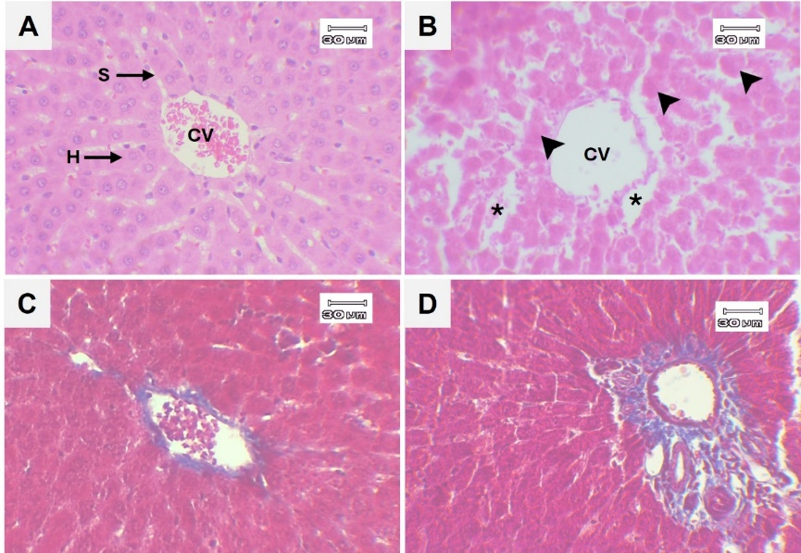
Fig. 1. Light microscope images comparing structure of the liver in control (A, C) and treatment (B, D) rats. (A, C) Control section illustrating central vein (CV), hepatic sinusoid (S) and hepatocyte (H). (B, D) Liver of EG treatment showing cell necrosis (head arrows) and dilated sinusoid (asterisk). H&E stain (A-B) and MT stain (C-D) at 200x magnification.

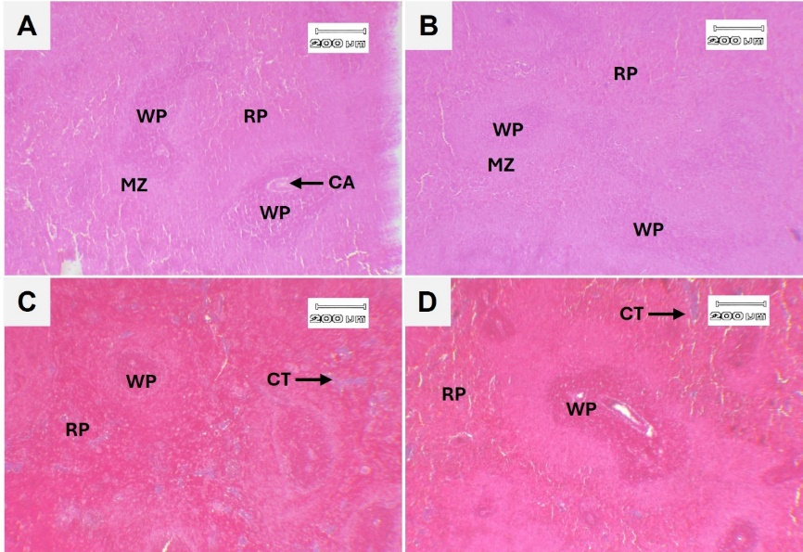
Fig. 2. Light microscope images showing the spleen of control (A, C) and treatment (B, D) rats. white pulp (WP), red pulp (RP), central arteriole (CA) and marginal zone (MZ). H&E (A-B) and MT stain (C-D) at 40x magnification.
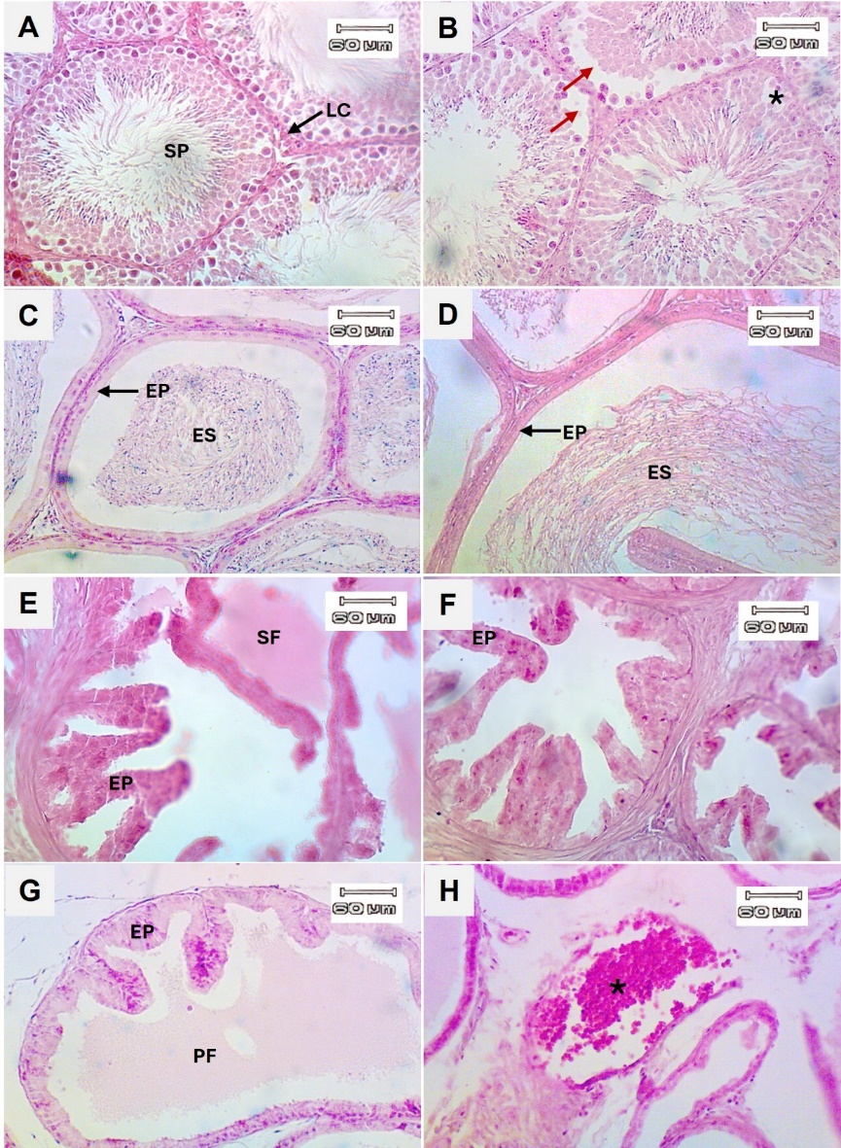
Fig. 3. Light microscope images showing the reproductive organs. (A) Control testis section, (B) EG-treated testis illustrating germ cell sloughing (red arrows) and vacuolization (asterisk). (C-D) Control and treated epididymis sections showing epididymal spermatozoa (ES) and epithelium (EP). (E-F) Control and treated seminal vesicle sections showing seminal fluid (SF). (G) Control prostatic tissue illustrating prostatic fluid (PF). (H) Prostate gland of EG treatment illustrating blood congestion (asterisk). H&E stain at 100x magnification.

