Phytochemical screening and in vitro antibacterial activity of 96% ethanolic extract of Khaya grandifoliola (Meliaceae) against hospital-acquired methicillin-resistant Staphylococcus aureus (MRSA) strains

ABSTRACT
Objective: As part of efforts to promote medicinal plants found in the flora of Ivory Coast, this study focused on Khaya grandifoliola (Meliaceae). The aim is to conduct a phytochemical study and evaluate the antibacterial activity of the bark of the Khaya grandifoliola trunk. Methicillin-resistant Staphylococcus aureus (MRSA) is a major nosocomial pathogen that causes serious morbidity and mortality worldwide.
Methodology: The extract from the bark of the Khaya grandifoliola trunk was obtained by maceration for 24 hours in 96% absolute ethanol and subjected to phytochemical tests to detect the presence of polyphenols, flavonoids, coumarins, tannins, sterols, polyterpenes and saponins as secondary metabolites. Its antibacterial activity was evaluated on methicillin-resistant Staphylococcus aureus strains of hospital origin and a reference strain ATCC 29213. Results: The ethanolic extract of Khaya grandifoliola exhibited antibacterial activity against all Staphylococcus strains, with bacterial growth inhibition diameters ranging from 15.7±0.6 to 22.3±0.6 mm at 200mg/mL; from 15.7±0.6 to 20.3±0.6 mm at 100mg/mL and from 13.7±0.6 to 18.7±0.6 mm at 50mg/mL. The ethanolic extract of Khaya grandifoliola was active on the strains tested with minimum inhibitory concentrations (MIC) ranging from 12.5 to 3.12 mg/mL. It was bactericidal on all strains of Staphylococcus aureus. Conclusion: The results of the study revealed that the ethanolic extract of Khaya grandifoliola was active at different concentrations on all strains tested, which justifies its traditional use in the treatment of certain bacterial diseases.
Keywords: Khaya grandifoliola, phytochemical test, antibacterial activity, methicillin-resistant Staphylococcus aureus, Ivory Coast

1. INTRODUCTION
Methicillin-resistant Staphylococcus aureus (MRSA) strains pose a global threat due to their virulence and widespread distribution in hospitals and communities. In addition, methicillin-resistant staphylococci (MRSA) now have extensive resistance profiles that go well beyond beta-lactams. They are frequently resistant to fluoroquinolones, aminoglycosides, macrolides, tetracyclines and clindamycin, reflecting the global spread of multiple and complex resistance mechanisms (1). Antibiotic resistance is a biological phenomenon that medicine will struggle to eliminate. A few decades ago, several diseases appeared to have been brought under control through the use of antibiotics. Scientific and technological advances even led to the belief that many diseases could be eradicated. However, the increasing resistance developed by microorganisms and the regular emergence of new infectious agents have disproved this optimistic prognosis. For more than twenty years, numerous determinants of resistance have been described with the emergence of increasingly resistant bacteria (2). No known bacterial species or antibiotic is currently immune to the phenomenon of resistance, hence the importance of directing research towards new avenues and, above all, towards plants, which have always been a source of inspiration for new medicines. The use of plants as remedies for numerous illnesses dates back to the beginning of the century (3). In Africa, particularly in West Africa, new medicines are often beyond the reach of the poorest people. As a result, up to 80% of the population uses medicinal plants as a remedy for infections and diseases (4). Medicinal plants have become potential sources of essential raw materials for the discovery of new molecules needed for the development of future medicines. In addition, several researchers are focusing on these natural biomolecules that act as antimicrobials. Medicinal plants are of great importance to the health of individuals and society. Their medicinal value lies in certain chemical substances that produce a specific physiological action on the human body (5). Khaya grandifoliola is a medicinal plant found in Ivory Coast. It is a large woody tree belonging to the Meliaceae family, commonly known as African mahogany (6). It is widespread in West Africa, from the Guinean coast to Cameroon, and extends eastwards across the Congo Basin to Uganda and parts of Sudan. It can grow up to 40 m tall. Its bark is grey and produces a bitter gum when injured. The anti-malarial, anti-ulcer, anti-anaemic and hypoglycaemic properties of the stem bark have also been reported (7–9). As a result, the exploitation of new bioactive molecules with limited or no side effects from natural sources and their adoption as a therapeutic alternative to synthetic molecules have become priority objectives for scientific research and the food and pharmaceutical industries. This study was undertaken to evaluate the phytochemical composition and antibacterial activities against methicillin-resistant Staphylococcus aureus strains of the 96% ethanolic extract of the bark of Khaya grandifoliola (Meliaceae) harvested in Tiébissou, Ivory Coast.

2. MATERIALS AND METHODS
2.1. Materials
2.1.1. Study setting
This experimental study was conducted at the Unit for Antibiotics, Natural Substances and Surveillance of Microorganism Resistance to Anti-infectives (ASSURMI) in the Bacteriology-Virology Department of the Pasteur Institute of Ivory Coast (IPCI).

2.1.2. Plant material
It consists of bark from the trunk of Khaya grandifoliola (Meliaceae) harvested specifically in Ahougnassou-Allahou in the department of Tiébissou (Bélier Region, Ivory Coast) in April 2025.

2.1.3. Bacterial strains tested
The methicillin-resistant Staphylococcus aureus (MRSA) strains of hospital origin used in the study are listed in Table I. They come from the collection of the Unit for Antibiotics, Natural Substances and Surveillance of Microorganisms with Anti-Infective Properties (ASSURMI) of the Department of Bacteriology and Virology at the Pasteur Institute of Ivory Coast. These strains are known to cause several infections (urinary, intestinal, respiratory, etc.).

Table I: Resistance phenotypes of the bacterial strains tested
Bacterial strain | Code | Type of sample | Resistance phenotype
Staphylococcus aureus | 1227C/25 | Suppuration | AMST02, BLST04
Staphylococcus aureus | 1239A/25 | Urine | AMST02, MLST01
Staphylococcus aureus | 1242C/25 | Suppuration | AMST02, BLST04
Staphylococcus aureus | 1273C/25 | Blood | AMST02, MLST01, BLST04
Staphylococcus aureus | 1274C/25 | Blood | AMST02, BLST04
Staphylococcus aureus | 1275C/25 | Blood | AMST02, MLST01, BLST04
Staphylococcus aureus | 1277C/25 | Blood | AMST02, MLST01, BLST04
Staphylococcus aureus | ATCC 29213 | - | Sauvage
AMST02 : Phenotype KTG, MLST01 : Constitutive MLSb phenotype, BLST04 : Meti-R Phenotype, ATCC : American Type Culture Collection

2. METHODS
2.1. Harvesting and obtaining plant powder
The freshly harvested plant bark was dried in the shade and protected from moisture. Once dried, the bark of the K. grandifoliola (Meliaceae) trunk was ground into fine powder for extraction.

2.2. Preparation of the ethanolic extract
An ethanolic maceration was carried out. 20 g of K. grandifoliola (Meliaceae) bark powder and 200 mL of 96% ethanol were stirred for 24 hours at laboratory temperature. After filtration, the extracts were dried in an oven at 50°C.

2.3. Extract yield
After extraction, the yield of the prepared extract is expressed as a percentage (%) and calculated using the following formula :
Yield (%) = m / M * 100
- R (%): yield expressed as a percentage.
- m: mass of the recovered extract.
- M: mass of the initial dry plant material.

2.4. Phytochemical screening
The major families of secondary metabolites were sought in the plant using standard characterisation methods. Polyphenols and tannins were identified using the FeCl3 test and Stiasny's reagent; flavonoids using the cyanidin reaction; saponins by the foam test; triterpenes and steroids by the Liebermann Burchard test; alkaloids by the Mayer and Dragendorf tests; and coumarins by the lactone ring test (10).

2.5. Sterility test of Khaya grandifoliola (Meliaceae) extracts
The purpose of this test was to verify that the extracts did not contain any germs. To do this, 0.1 g of the extract was enriched by adding it to 10 mL of thioglycolate broth and incubated at 37°C for 24 hours. After this period, the broth was seeded onto a Petri dish containing nutrient agar and another containing Sabouraud agar, then incubated under the same conditions. The substance is declared sterile if no colonies are visible on the agar plate after 24, 48 and 72 hours of incubation at 37°C.

2.6. Preparation of the concentration range
A solution with a concentration of 200 mg/mL was prepared in sterile distilled water using the dry extract of the plant. This solution underwent a series of twofold dilutions, resulting in concentrations ranging from 100 to 3.12 mg/mL.

2.7. Antibacterial activity
2.7.1. Well diffusion technique
25 mL of Mueller-Hinton Agar was poured into sterile 90 mm diameter Petri dishes and left to cool. From 24-hour bacterial cultures, dilutions in 0.85% NaCl Medium (0.85% sodium chloride) were made. Using a sterile swab, the entire surface of the Mueller-Hinton agar was seeded. After seeding, 6 mm diameter wells were made using the large end of the Pasteur pipette. The wells were then filled with 50 μL of the extract (200, 100 and 50 mg/mL) to be tested. The plates were then incubated in an oven at 37°C for 24 hours. The antibacterial activity of the extracts was revealed by the appearance of inhibition zones around the wells. The diameters of the inhibition zones formed around the wells were measured in millimetres using a calliper.

2.7.2. Determination of antibacterial parameters
2.7.2.1. Counting the bacterial inoculum
To perform the count, the bacterial inoculum was diluted in steps of 10 until a dilution of 10-4 was reached. Four successive dilutions were obtained at 10-1, 10-2, 10-3 and 10-4. The initial bacterial inoculum and the four successive dilutions were seeded using a 2 µL calibrated loop on Mueller-Hinton agar plates, in 5 cm long streaks. This is box A.

2.7.2.2. Antibacterial tests
The antibacterial tests were performed according to the modified method of Konan et al. from 2014 (11). The liquid dilution method was performed on a 96-well plate. A volume of 100 µL of extract, of known concentration within the concentration range, was added to the experimental wells. The growth control well received 100 µL of sterile distilled water. All wells (experimental and growth control) received 100 µL of bacterial inoculum. Final concentrations ranging from 100 to 3.12 mg/mL were achieved.
The sterility control well received 200 µL of Mueller-Hinton broth. The 96-well plate was incubated for 24 hours at 37°C.
The MBC is the lowest concentration of extract for which no bacterial growth was observed. The contents of the wells in which there was no visible growth were used to inoculate Mueller-Hinton agar in 5 cm streaks using a 2 µL calibrated loop. This Petri dish is designated B. Analysis of the results after 24 hours of incubation determined the MBC (Minimum Bactericidal Concentration), which is the lowest concentration that kills 99.9% of bacteria in culture. Each test was repeated three times.

2.8. Determination of sensitivity (12)
Sensitivity to different essential oils is organised according to the diameter of the inhibition zones as follows:
− Resistant: for a diameter of 6 mm;
− Sensitive: for a diameter between 9-14 mm;
− Very sensitive: for a diameter between 15-19 mm;
− Extremely sensitive: for a diameter greater than 20 mm.
According to Beddou (2015) (13), the CMB/CMI ratio must be less than 4 to confirm that the antibacterial power of an extract is bactericidal.

2.9. Statistical analysis
All results obtained were recorded in Excel software and expressed as mean ± standard deviation.

3. RESULTS
3.1. Yield of the extraction method for Khaya grandifoliola (Meliaceae)
Maceration with ethanol yielded a brown powder with a yield of 7.04%.
3.2. Phytochemical composition
Phytochemical screening of the 96% ethanol extract using colour reactions revealed the presence of several groups of secondary metabolites known to have interesting biological activities (antibacterial activity, antifungal activity, antioxidant activity, etc.) (Table II). The presence of the compound is indicated by the symbol (+).

Table II: Phytochemicals detected in the 90% ethanol extract of Khaya grandifoliola (Meliaceae)
Phytochemical family | Tests | 96% ethanol extract
Polyphenols | FeCl₃ | +
Flavonoids | Shinoda, Basic lead acetate | +
Flavonoids | Ammonia | +
Coumarins | NaOH, Lactonic cycle | +
Tannins | Stiasny | +
Sterols, Polyterpenes | CH₃CO₃CH₃ / H₂SO₄ | +
Saponins | Foam index | 333,3
+ : presence of the compound

3.2. Sterility test
Sterility tests carried out showed that the ethanolic extract of Khaya grandifoliola (Meliaceae) bark shows no signs of contamination.

3.3. Antibacterial activity of the ethanolic extract of Khaya grandifoliola (Meliaceae) bark
The agar diffusion method (Mueller-Hinton) was used to demonstrate the antibacterial activity of the 96% ethanol extract of Khaya grandifoliola (Meliaceae) bark against methicillin-resistant strains of Staphylococcus aureus. The concentrations of the extract used were: 200, 100 and 50 mg/mL. The negative control used was sterile distilled water. Table III shows the inhibition diameters of the extract and the reference antibiotic used. The inhibitory effects of the ethanolic extract of Khaya grandifoliola (Meliaceae) bark are illustrated in Figure 1.

Table III: Diameters of inhibition zones (mm) illustrating the antibacterial activity of the ethanolic extract of the bark of Khaya grandifoliola (Meliaceae)
Bacterial strain | Code | Concentration of 96% ethanol extract of Khaya grandifoliola (mg/mL) |  |  | Cefoxitin (FOX, 30µg)
Bacterial strain | Code | C1 (200mg/mL; Ø : mm) | C2 (100mg/mL; Ø : mm) | C3 (50mg/mL; Ø : mm) | Cefoxitin (FOX, 30µg)
Staphylococcus aureus | 1227C/25 | 18,7±0,6 | 16,7±0,6 | 14,3±0,6 | 15 (R)
Staphylococcus aureus | 1239A/25 | 20,3±0,6 | 18,3±0,6 | 15,7±0,6 | 33 (S)
Staphylococcus aureus | 1242C/25 | 18,3±0,6 | 17,7±1,2 | 15±1 | 17 (R)
Staphylococcus aureus | 1273C/25 | 15,7±0,6 | 15,7±1,2 | 14,7±0,6 | 12 (R)
Staphylococcus aureus | 1274C/25 | 19,7±0,6 | 18,7±0,6 | 16,7±1,2 | 8 (R)
Staphylococcus aureus | 1275C/25 | 17,7±0,6 | 15,7±0,6 | 13,7±0,6 | 20 (R)
Staphylococcus aureus | 1277C/25 | 17,7±0,6 | 16,7±0,6 | 15,3±0,6 | 9 (R)
Staphylococcus aureus | ATCC 29213 | 22,3±0,6 | 20,3±0,6 | 18,7±0,6 | 30 (S)
Ø : Diameter, C : Concentration, ATCC : American Type Culture Collection, R : Resistant, S : Sensitive

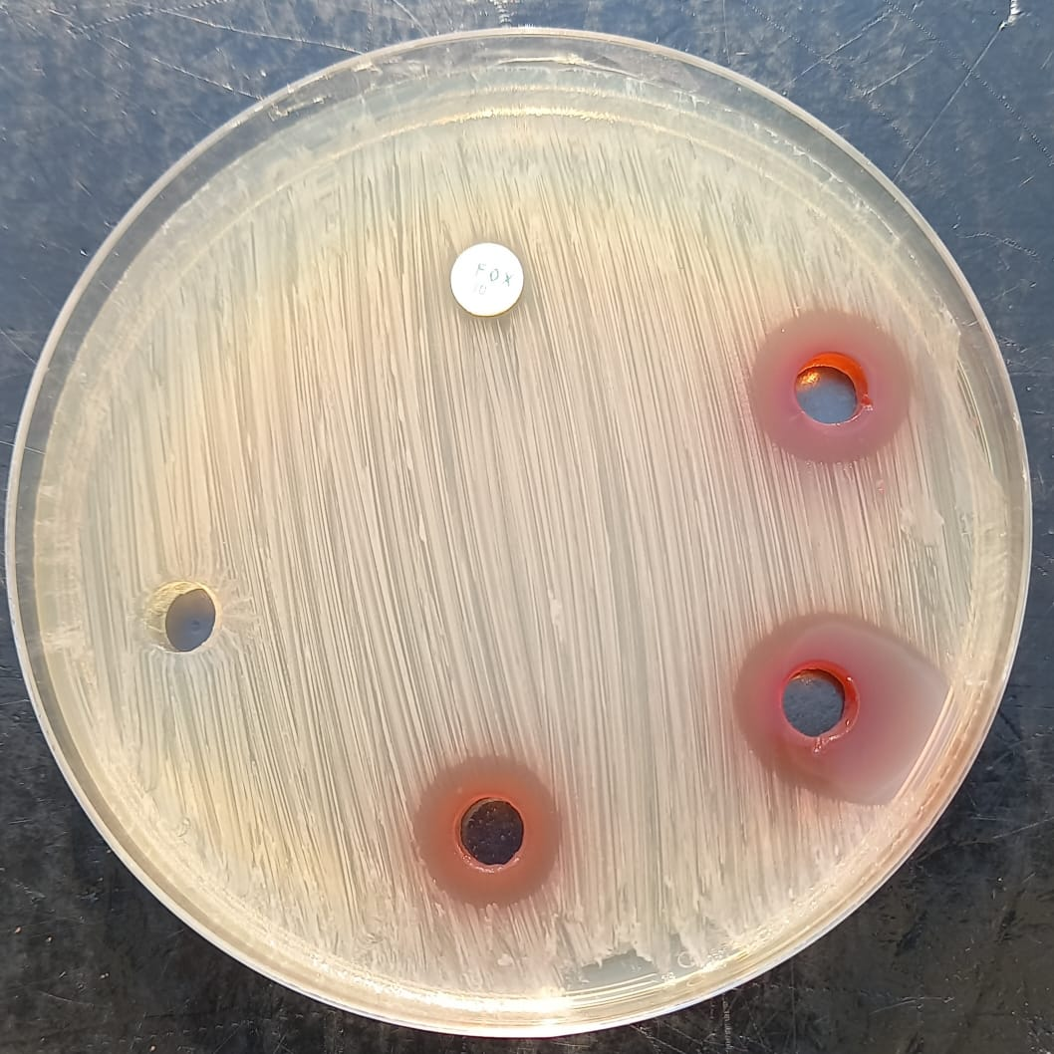
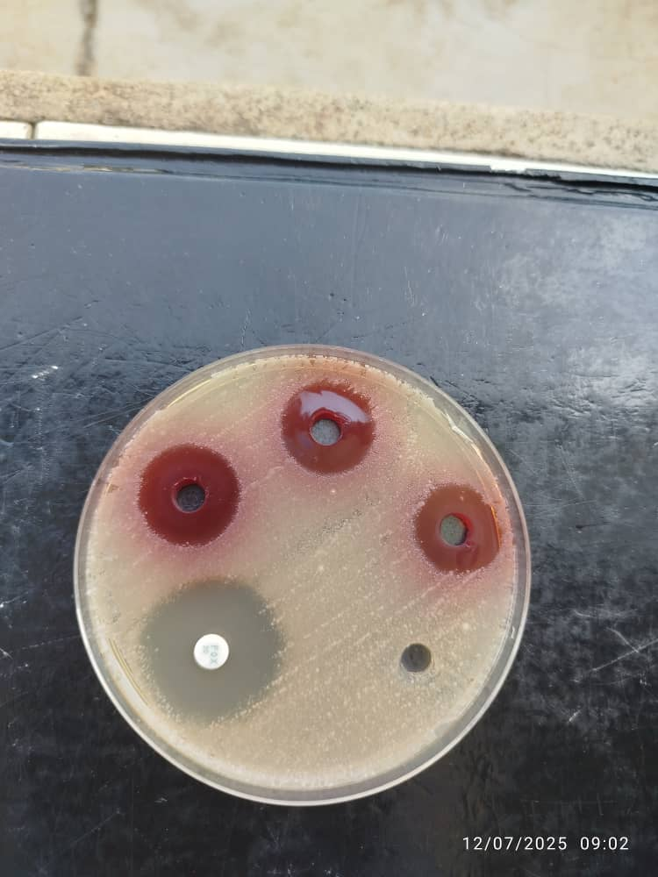
C1
C2
C3
EDS
FOX
C1
C2
C3
EDS
FOX
A
B

Figure 1: Inhibitory effect of 96% ethanol extract from the bark of Khaya grandifoliola (Meliaceae) on sensitive Staphylococcus aureus strain 1239A/25 (A) and methicillin-resistant Staphylococcus aureus strain 1274C/25 (B)
FOX : Cefoxitin (30µg), EDS : Sterile distilled water, C1 : Concentration of 200mg/mL, C2 : Concentration of 100 mg/mL, C3 : Concentration of 50 mg/mL, : Resistant, : Sensitive

3.4. Determination of MIC and MBC
The MIC and MBC values and the antibacterial activity of the 96% ethanol extract of the bark of Khaya grandifoliola (Meliaceae) studied are presented in Table IV. We can conclude that the 96% ethanol extract of Khaya grandifoliola (Meliaceae) bark has bactericidal activity against the strains used.

Table IV: Minimum inhibitory concentrations (MIC) and bactericidal concentrations (MBC) of the 96% ethanolic extract of the bark of the trunk of Khaya grandifoliola (Meliaceae) and their antibacterial activity
Bacterial species | Code | Settings |  |  | Antibacterial power
Bacterial species | Code | MIC (mg/mL) | MBC (mg/mL) | Rapport MBC/MIC | Antibacterial power
Staphylococcus aureus | 1227C/25 | 6,25 | 6,25 | 1 | Bactericide
Staphylococcus aureus | 1239A/25 | 3,12 | 6,25 | 2 | Bactericide
Staphylococcus aureus | 1242C/25 | 12,5 | 12,5 | 1 | Bactericide
Staphylococcus aureus | 1273C/25 | 12,5 | 12,5 | 1 | Bactericide
Staphylococcus aureus | 1274C/25 | 6,25 | 12,5 | 1 | Bactericide
Staphylococcus aureus | 1275C/25 | 6,25 | 12,5 | 2 | Bactericide
Staphylococcus aureus | 1277C/25 | 12,5 | 12,5 | 2 | Bactericide
Staphylococcus aureus | ATCC 29213 | 3,12 | 6,25 | 2 | Bactericide
MIC : Minimum inhibitory concentration, MBC : Minimum Bactericidal Concentration, ATCC : American Type Culture Collection

DISCUSSION
Medicinal plants are used in traditional Ivorian medicine, as well as in many other countries, and are known for their numerous pharmacological activities. In this study, resistant MRSA strains and an ATCC reference strain were used to determine the antibacterial activity of the 96% ethanolic extract of Khaya grandifoliola (Meliaceae) bark. Analysis of this work shows that six families of chemical compounds are characterised. These are polyphenols, flavonoids, coumarins, tannins, sterols, polyterpenes and saponins. These are bioactive compounds with known antibacterial properties. (14,15). According to Hirata et al. (2009) (16), Polyphenols have various biological properties, including antibacterial activity. Flavonoids, on the other hand, have antifungal and antibacterial properties (17). Tannins are known for their ability to inhibit the growth of many microorganisms, including bacteria (18).
These results are confirmed by other studies, namely the presence of certain chemical families in medicinal plants (19,20).
The 96% ethanol extract of the bark of Khaya grandifoliola (Meliaceae) inhibited bacterial growth at all three concentrations (200, 100 and 50 mg/mL). The inhibition diameters ranged from 13.7±0.6 to 22.3±0.6 mm. As reported in the literature, an extract is considered active when it induces an inhibition zone greater than or equal to 10 mm (13). This extract shows good activity against methicillin-resistant Staphylococcus aureus compared to the reference molecule, cefoxitin. This could be explained by the fact that reference antibiotics are isolated, pure molecules with known concentrations, according to Sourabie et al. (2010) (21), whereas the 96% ethanol extract is an unpurified mixture (22). There could also be synergy in the extract studied, between highly active compounds and others with limited antimicrobial effects (23).
Determining minimum inhibitory and bactericidal concentrations not only allows activities to be confirmed, quantified and compared, but also characterises the nature of the effect revealed by an extract on a given microorganism. A substance is said to be bactericidal when the MBC/MIC ratio is equal to 2 and bacteriostatic when this ratio is greater than 2 (13). Therefore, an overall interpretation of the results obtained shows that the MBC/MIC ratios are all less than or equal to 2. This extract was therefore bactericidal on all methicillin-resistant Staphylococcus aureus strains studied. Considering the minimum inhibitory concentrations, the lowest value was observed in a hospital-acquired strain of methicillin-sensitive Staphylococcus aureus 1239A/25 and the reference strain ATCC 29213 at 3.12 mg/mL. Finally, the results obtained in vitro are only a first step in the search for biologically active natural substances. Further testing will be necessary and should further enhance the value of the species Khaya grandifoliola (Meliaceae).

CONCLUSION
The action of the 96% ethanol extract of Khaya grandifoliola (Meliaceae) clearly demonstrates and confirms its use in traditional medicine. The antibacterial activity of the 96% ethanol extract of the bark of the trunk of Khaya grandifoliola (Meliaceae) was studied on six strains of methicillin-resistant Staphylococcus aureus, one strain of non-methicillin-resistant Staphylococcus aureus and one reference strain (Staphylococcus aureus ATCC 29213). The results of this study suggest that the secondary metabolites present in this extract, namely polyphenols, flavonoids, coumarins, tannins, sterols, polyterpenes and saponins, are responsible for the antibacterial activity observed in all the methicillin-resistant strains of Staphylococcus aureus used. In addition, the 96% ethanol extract showed bactericidal activity against all Staphylococcus strains tested. This result could justify the traditional use of this medicinal plant for Staphylococcus aureus infections, although further studies are needed.

COMPETING INTERESTS DISCLAIMER:
Authors have declared that they have no known competing financial interests OR non-financial interests OR personal relationships that could have appeared to influence the work reported in this paper.

REFERENCES

1. Rello J, van Engelen TSR, Alp E, Calandra T, Cattoir V, Kern WV, et al. Towards precision medicine in sepsis: a position paper from the European Society of Clinical Microbiology and Infectious Diseases. Clin Microbiol Infect Off Publ Eur Soc Clin Microbiol Infect Dis. Dec 2018;24(12):1264‑72.
2. Alekshun MN, Levy SB. Molecular mechanisms of antibacterial multidrug resistance. Cell. March 23, 2007;128(6):1037‑50.
3. Karou D, Dicko MH, Simpore J, Traore AS. Antioxidant and antibacterial activities of polyphenols from ethnomedicinal plants of Burkina Faso. Afr J Biotechnol. 1 Sep 2005;4(8):823‑8.
4. Marston A, Hostettmann K. Natural product analysis over the last decades. Planta Med. June 2009;75(7):672-82.
5. Department of 1Biological and 2Chemical Sciences Michael Okpara University of Agriculture, Umudike P.M.B 7267,Umuahia, Abia State, Nigeria., Edeoga HO, Okwu DE, Mbaebie BO. Phytochemical constituents of some Nigerian medicinal plants. Afr J Biotechnol. May 2005;4(7):685‑8.
6. Hutchinson J, Dalziel JM, Keay RWJ, Hepper FN. Flora of West Tropical Africa: All Territories in West Africa South of Latitude 18° N. and to the West of Lake Chad, and Fernando Po. London, UK: Royal Botanic Gardens Kew; 2014.
7. Bumah VV, Essien EU, Agbedahunsi JM, Ekah OU. Effects of Khaya grandifoliola (Meliaceae) on certain biochemical parameters in rats. J Ethnopharmacol. 1 Dec 2005;102(3):446‑9.
8. Makinde JM, Awe SO, Agbedahunsi JM. Effect of Khaya grandifoliola extract on Plasmodium berghei berghei in mice. Phytother Res. 1988;2(1):30‑2.
9. Njikam RN, Njikam N. Curative Dose of Khaya grandifoliola. Stem Bark for the Treatment of Gastric Ulcers Using Wistar Rats. Pharm Biol. 1 Jan 2006;44(2):152‑5.
10. Bekro YA, Mamyrbekova JA, Boua BB, Bi FT, Ehile EE. Ethnobotanical study and phytochemical screening of Caesalpinia benthamiana (Baill.) Herend. and Zarucchi (Caesalpiniaceae). Sci Nat. 2007;4(2):217‑25.
11. Konan F, Guessennd N, Oussou K, Bahi C, Coulibaly A, Djaman A, et al. Antibacterial effect of the aqueous extract of the bark of Terminalia glaucescens Planch ex Benth (Combretaceae) on the in vitro growth of extended-spectrum beta-lactamase-producing enterobacteria (EBLSE). Int J Biol Chem Sci. Oct 21, 2014;8(3):1192
12. Ponce AG, Fritz R, Del Valle C, Roura SI. Antimicrobial activity of essential oils on the native microflora of organic Swiss chard. LWT - Food Sci Technol. Nov 2003;36(7):679-84.

13. Doctoral Thesis. BEDDOU F., 2015 [Internet]. [cited 5 Nov 2025]. Available from: https://dspace.univ-tlemcen.dz/server/api/core/bitstreams/002b56bf-eb1d-4f7b-9305-49a27e9f1943/content
14. These Sylvie MOREL.pdf [Internet]. [cited 10 Nov 2025]. Available from: https://theses.hal.science/file/index/docid/671071/filename/These_Sylvie_MOREL.pdf
15. Daglia M. Polyphenols as antimicrobial agents. Curr Opin Biotechnol. Apr 2012;23(2):174‑81.
16. Hirata T, Fujii M, Akita K, Yanaka N, Ogawa K, Kuroyanagi M, et al. Identification and physiological evaluation of the components from citrus fruits as potential drugs for anti-corpulence and anticancer. Bioorg Med Chem. 1 Jan 2009;17(1):25‑8.
17. Gülçin İ, Huyut Z, Elmastaş M, Aboul-Enein HY. Radical scavenging and antioxidant activity of tannic acid. Arab J Chem. Jan 2010;3(1):43‑53.
18. Sepúlveda L, Ascacio-Valdés J, Rodriguez R, Aguilera-Carbo A, Aguilar C. Ellagic Acid: Biological Properties and Biotechnological Development for Production Processes. Afr J Biotechnol. 11 Dec 2012;10:4518‑23.
19. Malik F, Hussain S, Sadiq A, Parveen G, Wajid A, Shafat S, et al. Phyto-chemical analysis, anti-allergic and anti-inflammatory activity of Mentha arvensis in animals. Afr J Pharm Pharmacol. Feb 1, 2003;ISSN 1996-0816 © 2012 Academic Journals.
20. Sujana P. Antibacterial Activity and Phytochemical Analysis of Mentha piperita L. (Peppermint)—An Important Multipurpose Medicinal Plant. Am J Plant Sci. 1 Jan 2013;04:77‑83.
21. Sourabie TS, Nikiema JB, Lega I, Nacoulma OG, Guissou IP. In vitro study of the antibacterial activity of extracts from a plant in the Burkinabé pharmacopoeia: the case of Argemone mexicana L. (Papaveraceae). Int J Biol Chem Sci [Internet]. 2010 [cited 10 Nov 2025];4(6). Available from: https://www.ajol.info/index.php/ijbcs/article/view/64954
22. Ganfon H, Houvohessou JP, Assanhou AG, Bankole HS, Gbenou J. Antibacterial activity of the ethanolic extract and fractions of Anogeissus leiocarpa (DC) Guill. Et Perr. (Combretaceae). Int J Biol Chem Sci. 27 Aug 2019;13(2):643-51.

23. Rokia S, Drissa D, Seydou D, Colette E, Flabou B. Antibacterial and analgesic activity of two traditional remedies used in the treatment of urinary tract infections and cystitis in Mali. 2006 [cited 10 Nov 2025]; Available from: https://library.adhl.africa/handle/123456789/11115

