Original Research Article

Correlation Between Flow Properties and Structural Crack Repair Applicability in Mortars Based on Calcite and Polyester Resin

.
ABSTRACT

The primary goal of this study was to evaluate the rheological performance and fresh-state workability of a repair mortar formulated using polyester resin and calcite filler, and to establish a precise correlation between the filler-to-binder ratio and the mortar’s suitability for various structural crack applications. An experimental design focusing on systematic variations in filler dosage (Resin/Calcite ratios ranging from 50/50 to 30/70) was utilized to characterize the material’s flowability limits and workability thresholds. The mixtures were prepared using a precision balance (± 0.01 g) with Polyester Resin (PP 70*60) and calcite, activated by the Methyl Ethyl Ketone Peroxide (MEKP) catalyst. Flowability was quantitatively assessed using a scaled cone method adapted from ASTM C1437/C1437M. Fluidity exhibited a clear inverse correlation with the calcite content. The 50R-50C mix established a 100% flow benchmark, completely overflowing the test apparatus, while mixes approaching 70% calcite resulted in a non-workable solid. Specifically, the 40R-60C mix achieved a quantifiable flow of 41.73%, demonstrating controlled sag resistance. This rheological characterization defines a crucial workability window for the composite, indicating that the 30% resin 70% calcite proportion is the limit for effective homogenization. In conclusion, the established correlation provides a direct framework for the structural engineer to formulate application-specific mortar dosages, optimizing workability to match crack geometry and orientation, thereby minimizing the use of external formwork and ensuring the complete, durable sealing of structural defects in both horizontal and overhead placements.

Keywords: Crack repair; mortar; calcite; polyester resin; fluidity.

1. INTRODUCTION

Structural cracking represents an inherent and persistent challenge in civil engineering. As the occurrence of fissures and cracks is often multifactorial and may lie outside the control of builders and property users, the focus shifts from total prevention to effective repair and the mitigation of subsequent structural and durability issues. Injection with repair mortars is a proven method for the rehabilitation of these fissures. However, material selection must not only prioritize mechanical properties but also its rheological behavior (fluidity). Adequate fluidity is essential to ensure the mortar can successfully penetrate and fully seal the crack's micro-structure, thereby guaranteeing a durable and reliable repair.

The objective of this research is to determine the applicability of a polyester resin and calcite-based repair mortar by correlating its flow properties with specific mix proportions. This comprehensive analysis will allow us to propose an optimal dosage for its use in structural crack injection depending on the type of crack.

Given that many structures are constructed with inherently crack-prone systems, a continuous and systematic structural management framework is necessitated. This robust framework encompasses several critical phases: status inspection, identification of damage causes and deterioration mechanisms, selection of appropriate corrective procedures and actions, monitoring the effectiveness of interventions, and prospective evaluation of crack propagation to ensure the long-term structural integrity of the buildings (Verstrynge et al. 2021).

The necessity for structural crack repair is entirely dependent on the nature and magnitude of the defects. In specific contexts, such as confined masonry shear walls, the issue moves beyond mere aesthetics. As demonstrated by researchers like Riahi, the initiation and propagation of cracks, particularly those extending into the vertical confinement elements (castles/tie-columns), can drastically reduce the stiffness of the walls, leading to a loss of structural rigidity of up to 40% (Riahi et al., 2009). This substantial reduction in stiffness directly impacts the building's capacity to withstand lateral loads (e.g., seismic forces). Therefore, effective repair is not simply about damage mitigation; it is a mandatory measure to restore the wall's pre-damage stiffness and ensure the adequate seismic and structural performance of the building.

Workability, specifically defined by the material's fluidity, is the critical design parameter when adapting a repair mortar for various structural applications. The geometry and width of structural cracks are highly variable, ranging from hairline micro-fissures to wider defects requiring bulkier material. Therefore, a successful repair protocol necessitates that the mortar's flow properties be tailored to the specific defect. A high-fluidity state (low viscosity) guarantees maximum penetrability for injection into fine, narrow cracks, ensuring the adhesive reaches the deepest points of the void. Conversely, a lower-fluidity state (higher viscosity) allows the mortar to be used in vertical or overhead applications without sagging, providing better control and containment when repairing wider joints or spalls. This variability in flow performance is not a limitation, but an essential tool for engineers to select the appropriate mix design that matches the specific application requirement and achieves complete, effective sealing. Flowability is a crucial property that reflects the diffusion characteristics of grouting materials and serves as a critical parameter to evaluate slurry workability (Choi et al., 2015).

Structural cracks are broadly classified by their geometry, a critical factor that directly influences the required mortar fluidity. Cracks typically range from micro-fissures (≤0.1 mm in width), which often arise from plastic shrinkage or thermal stress, to larger, structural cracks (≥0.5 mm) indicative of movement, excessive loading, or foundational issues. The challenge lies in sealing the narrowest defects, where the repair material must possess an extremely low viscosity to achieve capillary penetration, ensuring complete bonding and load transfer across the fracture surface. Conversely, wider cracks and joints can accommodate materials with higher viscosity, simplifying containment and minimizing material loss during the injection process.

Beyond geometry, the structural location dictates the workability demands of the repair mortar. Vertical cracks in columns or shear walls, and particularly overhead cracks in slabs or beams, present significant challenges as gravity tends to pull the fluid material downward. For these applications, the mortar's fluidity must be carefully balanced to provide sufficient thixotropy (the ability to flow when pumped but retain shape when stationary), preventing premature dripping while maintaining penetrability. In contrast, horizontal cracks in slabs or foundation elements allow for the use of self-leveling, lower-viscosity mortars, where the primary concern is the depth of penetration rather than sag control. This contextual requirement underlines the necessity of tailoring the mix design to match both the crack size and the gravitational orientation of the repair site.

Traditional repair mortars are commonly based on Portland cement and fine aggregate. The widespread adoption of these materials is largely due to the ease of access and cost-effectiveness of their base components. However, conventional cementitious systems often present limitations regarding ductility, bond strength, and crack resistance, highlighting a substantial need for improvement in their structural objectives. Consequently, the research community continually seeks alternative binder and aggregate materials. For instance, Ojha et al. (2021) sought to enhance the properties of a traditional mortar by incorporating Styrene-Butadiene Rubber (SBR) latex as an additive. Among the properties successfully improved, the authors found that a dosage containing 15% SBR latex resulted in an average flow of 80%, a rheological state considered optimal for fully covering the surface area of a crack during application. This finding underscores the necessity of chemical modification to achieve the required flow characteristics that exceed the limitations of simple cement-sand mixes (Ojha et al., 2021).

Polymer-based repair mortars are widely favored in structural rehabilitation due to their superior bond strength, low shrinkage, and enhanced durability when compared to conventional cementitious alternatives. These high-performance materials typically combine an organic binder (like polyester, epoxy, or acrylic) with mineral fillers (such as calcite or silica) to form a composite matrix. D. M. Costa (2017), in a key investigation into polymer cement mortars (PCM), established that workability is a subjective property directly dependent on fluidity and cohesion, validating the flow table test as an effective tool for rheological characterization, as the spreading obtained is related to the material's yield stress (Costa, 2017). This underscores the necessity of quantifying flow in the fresh state, as the polymer phase significantly alters the viscosity and internal friction of the mix, which, in turn, dictates its ability to be applied via low-pressure injection or placement into structural defects. Numerous studies have demonstrated that polymers can effectively enhance the fluidity of cement and moderate its hydration (Pavlitschek et al., 2013).

The precise formulation of these mortars dictates their suitability for specific applications. Recent literature highlights that the inclusion of fillers like calcite is essential for balancing costs and mechanical properties, while the type and amount of the polymer define the overall performance. Building upon this, W. A. Warid et al. (2016) demonstrated the potential of alkali-activated materials (geopolymers), noting their excellent repair characteristics and bond strength to concrete substrates. Their work affirms that optimizing the binder composition is paramount for materials used in concrete rehabilitation, as slight modifications in the mix design can significantly impact the final microstructure and mechanical stability of the repair (Warid et al., 2016). Therefore, the goal is not merely to measure flow, but to understand how the filler-to-binder ratio affects the rheological profile to achieve a customized mortar capable of maximizing the sealing efficiency for various crack types.

Polyester resin serves as an excellent binder for high-performance repair mortars due to its cost-effectiveness, rapid setting time, and superior mechanical properties compared to conventional cement-based materials. As a thermosetting polymer, it forms a rigid, cross-linked matrix upon curing, offering high compressive and tensile strength crucial for structural applications. When paired with the calcite filler, the resin effectively encapsulates the mineral particles, creating a composite with minimal porosity and enhanced resistance to chemical attack and moisture ingress. This combination is particularly beneficial for crack repair, as the low viscosity of the liquid resin allows for easy incorporation of the filler and catalyst to achieve the required flow characteristics; once injected, the polymer hardens quickly to restore the structural integrity of the concrete substrate, providing a fast and durable rehabilitation solution.

Calcite is the chosen mineral filler for the repair mortar, primarily serving as a cost-effective substitute for a fraction of the more expensive polymer resin, ensuring the economic viability of the structural repair system. Functionally, it acts as a rigid aggregate within the polyester matrix, which is instrumental in increasing the composite's compressive strength and overall rigidity. Furthermore, the characteristics of the calcite particles are essential for the finished material's performance. For instance, Galván-Ruiz et al. (2009) highlight the importance of particle size distribution, noting that it directly influences key properties of mortars such as adhesion, capillarity, and porosity (Galván et al., 2009). Thus, controlling the particle loading and size is paramount, as it directly governs the rheological profile of the mix, allowing the mix designer to precisely tune the mortar's fluidity to match the necessary penetration depth for various crack geometries.

Despite the established use of polymer-based mortars for structural rehabilitation, a definitive and systematic methodology for mix design optimization remains a critical challenge in civil engineering. As demonstrated, the selection of the correct fluidity is paramount, given that successful crack repair hinges on maximum penetrability for various crack geometries and orientations (e.g., vertical vs. overhead placement). While polyester resin offers superior mechanical strength and calcite provides necessary cost control and reinforcement, the precise filler-to-binder ratio required to balance these structural benefits with the essential rheological properties (flow) has not been rigorously defined across diverse application scenarios.

This research addresses this gap by focusing on the flow performance of the Calcite/Polyester system as the primary design criterion. By systematically correlating changes in mix proportions with the resulting fluidity, this study will provide the practical engineering data necessary to define application-specific dosages, thereby ensuring reliable sealing, minimizing material waste, and translating laboratory characterization into dependable, cost-effective field performance for structural crack injection.

2. material and methods

The present investigation evaluated the flow performance of a high-performance repair mortar formulated using polyester resin and calcite. The primary objective was to observe and rigorously characterize its rheological behavior in the fresh state to establish reliable criteria for its application in structural cracks. To achieve this, a set of controlled experimental trials were designed and conducted, focusing on two distinct mix designs with varying component dosages. These proportions were specifically selected to systematically evaluate the effect of the resin-to-calcite ratio on the overall workability of the material, a crucial factor that determines the mortar's penetrability and subsequent success in structural rehabilitation.

2.1 Materials

The repair mortar evaluated in this investigation was formulated from three principal components: polyester resin, catalyst, and calcite filler. Specifically, the polyester resin utilized was the "PP 70*60" grade, chosen for its high chemical resistance, superior adhesion to cementitious substrates, and desirable rapid curing rate. This curing process was chemically activated by the "K-200" catalyst, which is composed of Methyl Ethyl Ketone Peroxide (MEKP). The precise dosage of this catalyst allowed for the direct control of the polymerization speed and the corresponding working time (pot life) of the mortar. As the primary mineral filler, calcite (${CaCO}_{3}$) was incorporated as an inert material to serve a dual purpose: optimizing the volumetric stability of the mix and significantly enhancing both the workability and adhesion of the final composite. The materials utilized are shown in Figures 1 through 3.

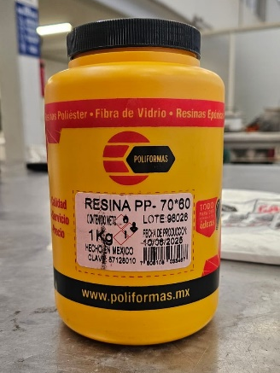
Fig. 1. Polyester Resine PP 70*60
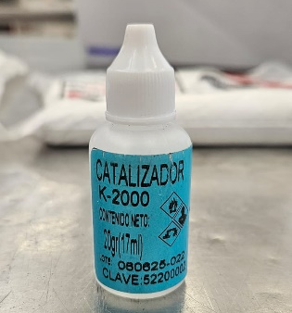
Fig. 2. Methyl Ethyl Ketone Peroxide Catalyst
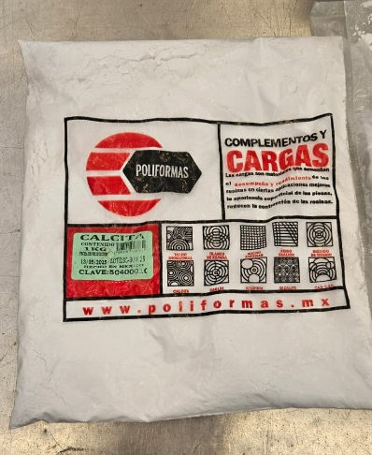
Fig. 3. Calcite

2.2 Mixing Process

Four distinct repair mortar mixtures were prepared using only polyester resin and calcite as the primary components, with no other additives employed. This approach was selected to isolate and characterize the effect of the binder-to-filler ratio on the fresh state properties.
As shown on Table 1 The dosages used for the investigation were as follows:
- Mix A (50R-50C): Consisted of a 50% polyester resin (250 g) and 50% calcite (250 g) proportion. The working time was controlled using 10 drops of the K-200 (MEKP) catalyst. (
- Mix B (40R-60C): Consisted of a 40% polyester resin (200 g) and 60% calcite (300 g) proportion. The working time was controlled using 8 drops of the K-200 (MEKP) catalyst.
- Mix C (35R-65C): Consisted of a 35% polyester resin (175 g) and 65% calcite (325 g) proportion. The working time was controlled using 7 drops of the K-200 (MEKP) catalyst.
- Mix D (30R-70C): Consisted of a 30% polyester resin (150 g) and 70% calcite (300 g) proportion. The working time was controlled using 6 drops of the K-200 (MEKP) catalyst.

Table 1. Composition of Repair Mortar Mixtures

Mixture | Calcite | Polyester Resin
Mix A  Mix B | 50%  60% | 50%  40%
Mix D | 65%  70% | 35%  30%

Each mixture was meticulously homogenized using a combination of mechanical and manual stirring to ensure the proper dispersion of the calcite filler within the resin matrix, thereby preventing the formation of lumps or segregation. The total mass of each batch was carefully controlled and adjusted to guarantee the repeatability of the tests and the feasibility of performing multiple subsequent assays with the exact same dosage. The catalyst utilized was dosed according to the manufacturer’s specifications for the polyester resin, which suggested using 40 drops of the K-200 (MEKP) catalyst per kilogram of resin. Consequently, the catalyst amount for each sample was precisely adjusted based on the total grammage of the respective mixtures. On Figure 4 it is observed the result of mixing polyester resin and calcite.

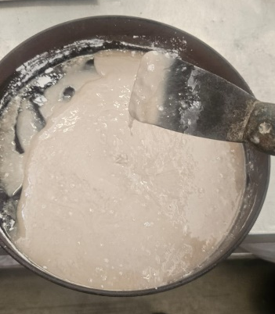
Fig. 4. Polyester Resin and Calcite Mixture

2.3 Methodology

The mortar's flowability was evaluated using the flow table test, based on the ASTM Standard Test Method for Flow of Hydraulic Cement Mortar (ASTM C1437/C1437M) (ASTM, 2020). For the four principal mix designs, the mixture was placed on the flow table, and the specified methodology of controlled dropping was used to simulate the material's expansion across the surface. According to the standard, the initial diameter and the final spread diameter achieved after the controlled drops were measured, allowing for the quantification of the spreading capacity.

However, upon observation that Mix A (50R-50C) exceeded the limits established by the standard, completely overflowing the flow table, a modification to the testing procedure was necessary. To accurately quantify this high fluidity without material loss, a scaled-down cone simulating the functionality of the standard flow cone was fabricated, possessing 1/4 of the volume of the original ASTM cone. This adaptation allowed for controlled testing while accommodating the extremely high flowability of the mix.

Material dosing was performed using a precision balance ( ± 0.01 g), ensuring the accuracy required for the established proportions in each mixture. The components were mixed in metallic trays using a metallic spatula. This rigorous mixing procedure—combining both manual effort and the use of inert equipment—was essential to promote adequate homogenization between the resin, calcite, and catalyst, actively preventing the formation of lumps or segregation within the matrix. The selection of these specific equipment and procedures was aimed at guaranteeing experimental repeatability, validating the reliability of the results, and ensuring comparability with other related studies found in the specialized literature. The primary equipment used for the standard flow test, alongside the cone and the methodology as per ASTM C1437/C1437M, is presented in Figures 5 and 6. However, due to the extremely high fluidity of the polyester-calcite mixes, the scaled-down mold (fabricated to accommodate the flow and prevent overflow) was utilized for Mixes B, C, and D, and this modified apparatus is specifically illustrated in Figure 7.
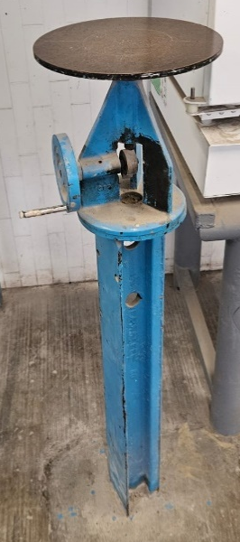
Fig. 5. Flow Table

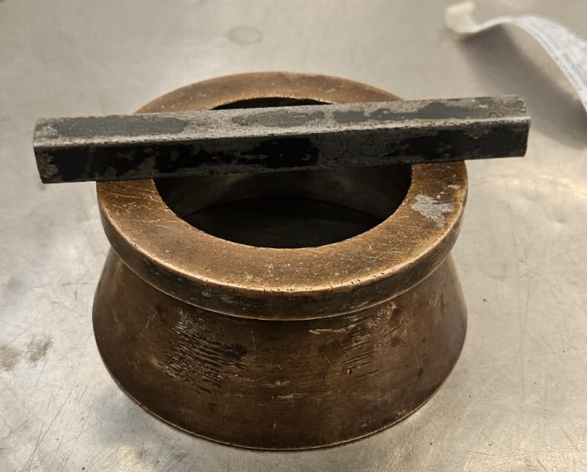
Fig. 6. Flow Cone and Tamping Rod
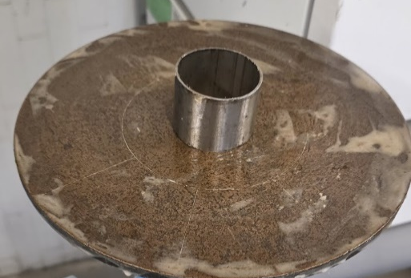
Fig. 7. 1/4 Scaled Flow Mold

3. results and discussion

3.1 Results

The experimental phase of this investigation comprised flow testing across four distinct mixtures, which allowed for the comprehensive characterization of the material's fresh state behavior. Upon initial mixing, the constituent materials immediately yielded a highly fluid consistency, demonstrating an extremely low yield stress. This highly plastic behavior, easily deforming under minimal shear stress, was observed in the 50% resin–50% calcite (Mix A) dosage. Homogenization of the mixtures presented no difficulty in the initial stages of formulation.

Specifically, Mix A (50R-50C) exhibited flowability far exceeding the scope of the ASTM C1437/C1437M standard, resulting in the mixture completely overflowing the flow table. This result is designated as a 100% spread value, serving as a critical reference point for establishing the maximum rheological capacity of the mortar, even though subsequent samples were analyzed using a scaled apparatus to prevent material loss. It is observed in Figure 8, how the Mix A aims to overflow the table due to its fluidity.

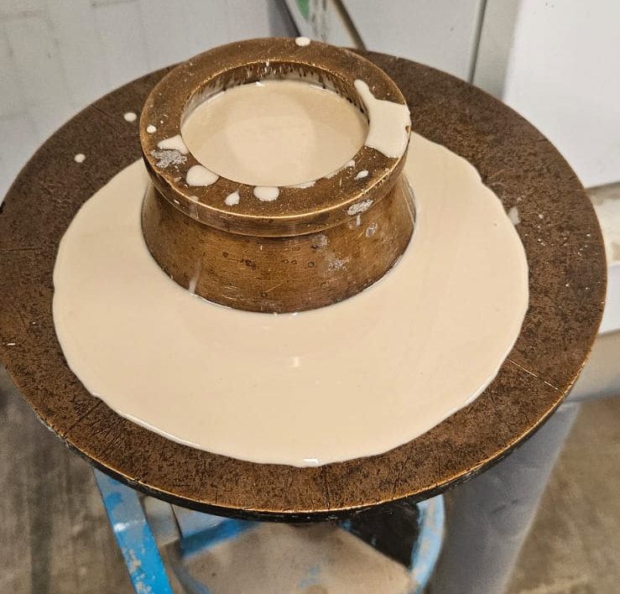
Fig. 8. Mix A Fluidity Result
It was consistently observed that as the amount of calcite filler increased in the dosage, the mortar's fluidity decreased, and the required effort for proper homogenization intensified. This inverse relationship between calcite content and flow is quantitatively demonstrated in Table 2. The maximum usable filler loading was reached at Mix D (30% resin - 70% calcite), beyond which the mixture was practically a solid. Furthermore, attempts to formulate a higher filler ratio (e.g., 80% calcite 20% resin) were unsuccessful due to immediate segregation and the inability to achieve a homogeneous, workable composite. The quantified flow percentages obtained remained outside the conventional range established by the ASTM C1437, thus the results presented are non-normalized for the standard.

The standard method for quantifying flowability is the Flow Percentage (%Flow), calculated as the increase in the final spread diameter (D Final) relative to the initial diameter (D Initial) of the cone base.
$$Flow (\%)=(\frac{D_{Final}-D_{Initial}}{D_{Initial}})X100$$
Since the standard flow test (ASTM C1437/C1437M) was exceeded, the following technical assumptions are made to normalize the results:
- Flow Table Diameter (D Table): It is the standard 254 mm.
- Initial Diameter (D Initial): Based on the observation that Mix A (50R-50C) achieved a 100% flow (overflowing the 254 mm table), the diameter of the scaled cone used was 127 mm.
Table 2. Calculated Flow of the Various Mixtures

Mix Designation | Measured Gap (dGap) | Calculated Flow (%)
A  C  D | 0 cm  3.7 cm  4.6 cm  8.4 cm | 100%  41.73  27.56  0

The calculated flow value of 0 for the 70C-30R mix indicates that this mixture is almost a solid and demonstrates a complete loss of workability as more calcite is used on the mixture. This mix falls below the minimum rheological threshold and should be classified as a non-workable, non-injectable material. As observed in Figure 9, the mixtures visually demonstrate a progressive loss of fluidity as the filler (calcite) content is increased from left to right. Figure 10 is a visual representation of the inverse relation of fluidity and calcite content on the repair mortar.

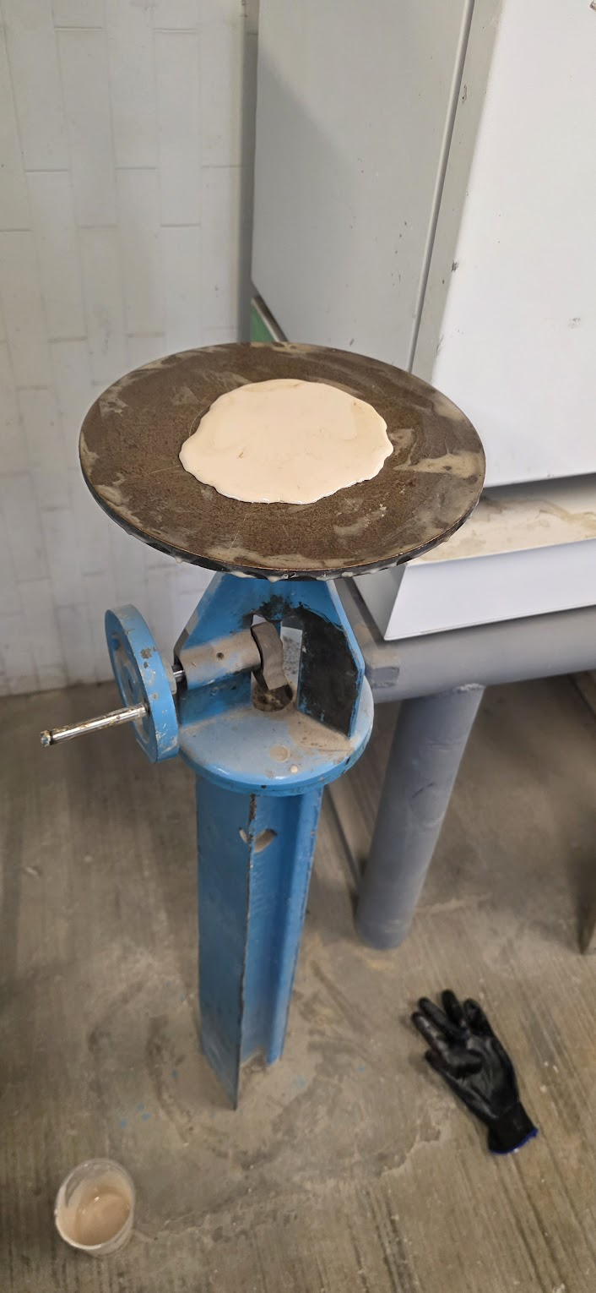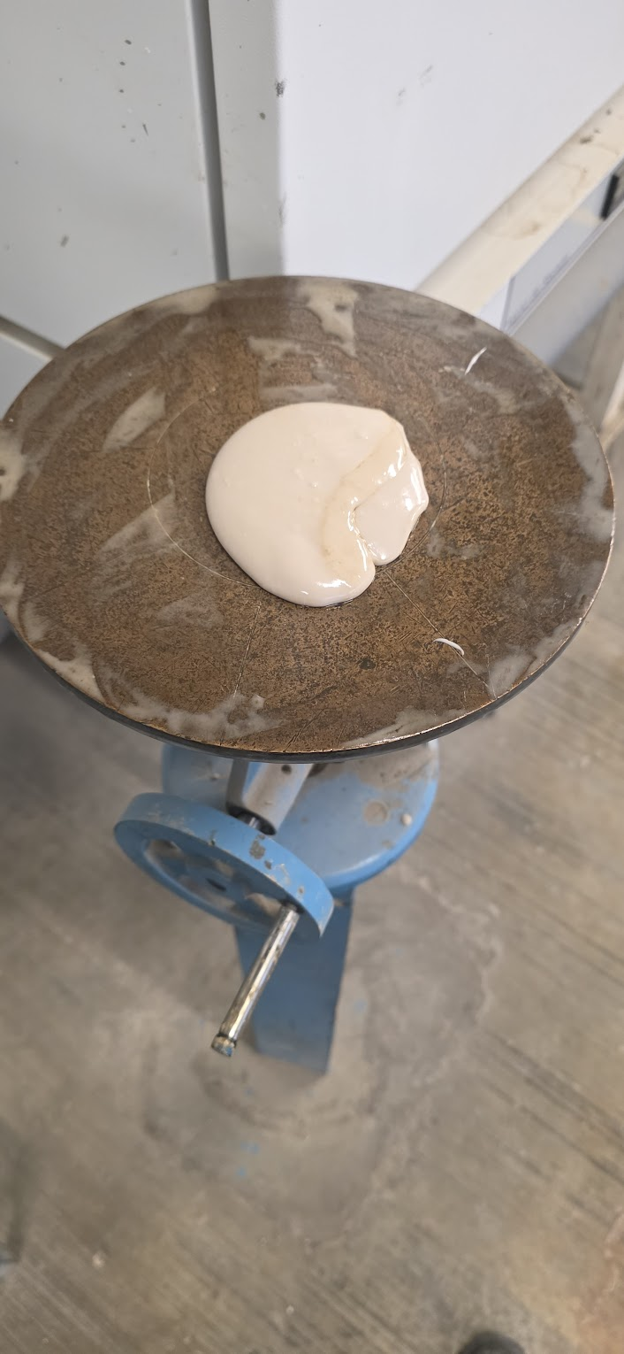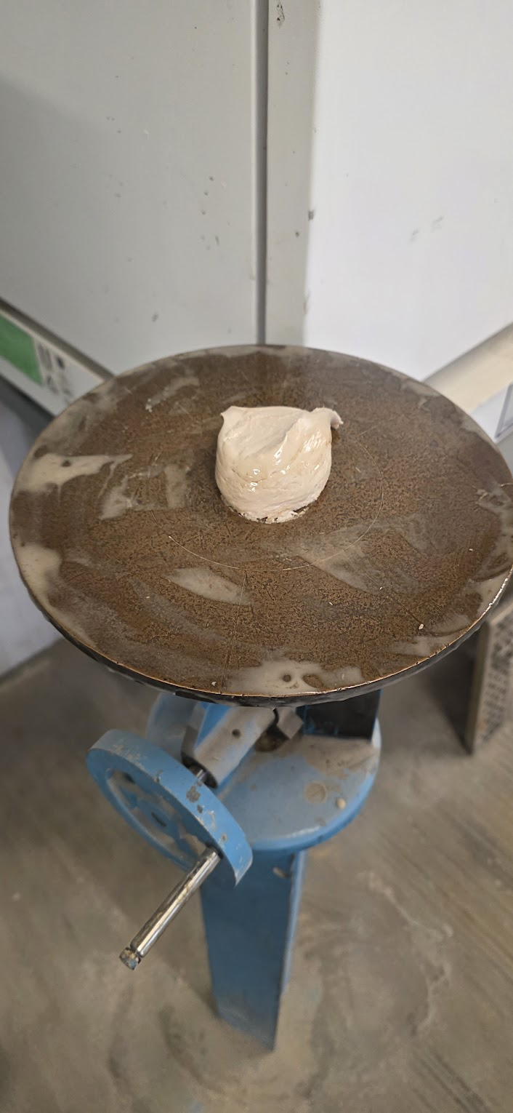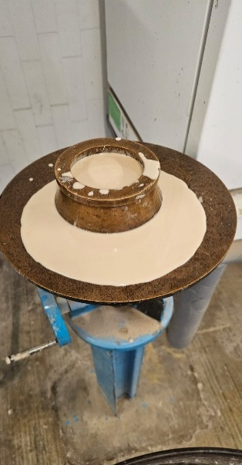
Fig. 9. From Left To Right Mix A, B, C and D
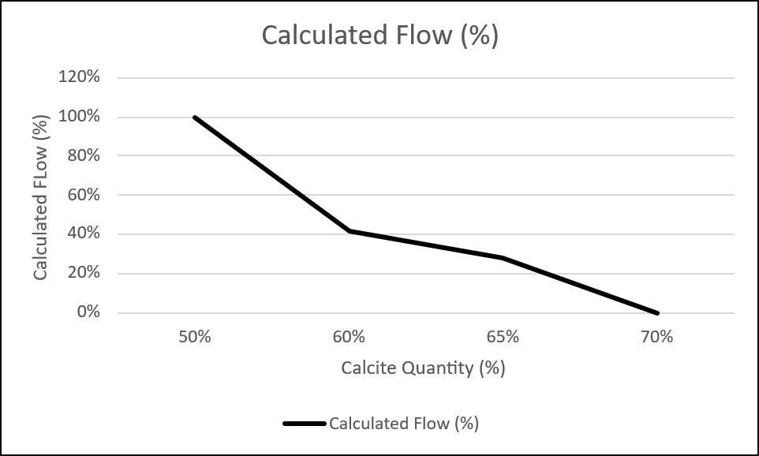
Fig. 10. Calculated Flow According to its Calcite content
Based on the flow results observed during the tests, a direct correlation can be established between the mortar’s fluidity and its potential application in structural crack repair. Crucially, this fluidity control allows for application-specific recommendations that could eliminate the need for costly external formwork (shuttering) in certain applications
3.2 Discusion

The experimental results highlight that the workability, defined by the material's fluidity and rheological behavior, is the paramount design parameter when developing a polymer-based repair mortar. The mixtures formulated with a high resin content, such as Mix A (50R-50C), immediately exhibited an extremely low yield stress and plastic viscosity, as evidenced by the mixture completely overflowing the standard flow table. While Mix A provided an empirical benchmark for 100% fluidity, this maximum spread capacity simultaneously demonstrates the difficulty in utilizing such a highly fluid material for most practical repair scenarios, especially those involving cracks in non-horizontal surfaces.

Table 3 outlines the type of crack that can be repaired based on the specific mix proportion utilized. It is essential to note that these recommendations are based solely on the rheological behavior (workability) of the mortar and must be validated by verifying the material’s mechanical strength properties before undertaking any significant structural repair.

Table 3. Recommended Use of Repair Mortar Based on Fluidity

Mix Designation | Fluidity Level | Crack Repair Recommendation
A  C  D | Very High  High  Low  None | Floor Cracks  Sloped Slab Cracks  Wall Cracks  Overhead Cracks (Ceilings)
The investigation clearly established that the concentration of the calcite filler acts as the direct and primary control mechanism for the mortar's rheology. An inverse relationship was quantitatively confirmed (as detailed in Table 2): increasing the calcite loading systematically decreases the mortar’s fluidity. This finding is crucial for practical application. The shift from an easy-to-homogenize, highly fluid state (Mix A and B) to a material with significant internal friction that requires increased mixing effort (approaching Mix D) allows the engineer to precisely tune the mix design. The formulation limits were clearly demonstrated by the failure to achieve a workable paste at a $20\%$ resin ratio, resulting in immediate segregation and poor matrix cohesion, reinforcing the necessity of maintaining the binder-to-filler ratio within the 30%–70% range for field use.

The ability of the repair mortar to fully penetrate the defect is the critical factor for successful rehabilitation, particularly in micro-fissures. Technical literature underscores that for an injection material to restore structural integrity, it must possess a rheology specifically designed for the narrowest crack widths. For instance, Xue and Geng (2020) found that the optimal injection material for micro-crack repair requires a viscosity below 500 mPa and a yield stress close to zero (Xue et al., 2020). This condition of high fluidity is essential to ensure capillarity and deep penetration of the binder into the smallest structural cracks. Without achieving this minimum fluidity threshold, the mortar fails to achieve a complete monolithic seal, leaving voids that compromise both durability and load transfer capacity.

For the repair of cracks in overhead (ceiling) structures, the primary rheological requirement shifts from high penetrability to superior sag resistance and thixotropy (shear-thinning behavior). The mortar must maintain dimensional stability immediately after placement to counteract gravitational forces, minimizing the need for complex formwork. Researchers continually focus on achieving this non-sag behavior by tuning filler composition. For instance, Hu and Jin (2024) successfully improved the sag resistance of coatings by incorporating diatomite filler, demonstrating that controlling the filler concentration directly augments the yield stress of the fresh material. This strategy is essential for ensuring the repair material remains affixed to the substrate in vertical and inverted orientations, facilitating successful, high-build application (Hu et al., 2024).

The ability to control workability is directly linked to the success of structural repair interventions. The need for a material to remain in place without sagging is a critical factor distinguishing applications. High Fluidity for Penetration:

- The highly fluid mixes (e.g., Mix A or B with minimal filler) are ideal for pressure injection or grouting of fine micro-fissures and hairline cracks (≤0.5 ). In these cases, the low viscosity is mandatory to guarantee maximum penetrability and effective adhesion deep within the void.

- Low Fluidity for Shape Retention: Conversely, the repair of larger defects in vertical (wall) and overhead (ceiling) structures necessitate a material with significantly higher yield stress (low fluidity) to prevent run-off and ensure proper shape retention. Even with the aid of formwork (shuttering), using a low-viscosity material for wide, deep cracks in these orientations presents significant challenges: the material is prone to leaking through formwork gaps, exhibits segregation, and is extremely difficult to confine and manipulate. Mixes with a higher calcite content (closer to Mix D) provide the necessary thixotropy and pseudo-solid behavior to be applied without relying heavily on secondary containment measures, thereby simplifying the repair protocol and increasing application control.

This study demonstrates that polyester-calcite mortars are rheological adaptable to meet the diverse demands of structural crack repair. The established correlation between mix proportion and resulting fluidity (Table 2) provides a rational framework for selecting the appropriate dosage to match the specific geometry and orientation of the structural defect, optimizing repair efficiency and reducing reliance on external support systems. The next critical step is to validate the mechanical properties of these rheological optimized mixes to ensure their structural capacity.

4. Conclusion

Based on the characterization of the fresh-state properties of the polyester resin and calcite-based repair mortar, the following conclusions are established:

- Workability is Systematically Controllable: The investigation successfully established a strong, inverse correlation between the calcite filler concentration and the resulting fluidity of the repair mortar. This demonstrates that the polymer-calcite system is rheological tunable and highly suitable for controlled applications.

- High Fluidity Benchmark: The base mixture (Mix A, 50R-50C) exhibited exceptionally low yield stress, achieving 100% flow and overflowing the standard test apparatus. This confirms the material's potential for maximum penetrability when injecting hairline micro-fissures (≥.1 mm ).
- Role of Calcite as a Rheological Modifier: Increasing the calcite content systematically reduced the fluidity and increased the required mixing effort. This effect is crucial for achieving the necessary control, as mixtures exceeding 70% filler were deemed unusable due to a total loss of cohesion and difficulty in homogenization.

- Application-Specific Dosing Framework: The flow characterization provides a direct, practical framework for matching the mix design to the structural application. Specifically Low-calcite, high-fluidity mixes are necessary for pressure injection into narrow cracks.

- High-calcite, low-fluidity mixes are necessary for vertical and overhead applications, as they provide the required sag resistance and containment, significantly reducing the reliance on external formwork (shuttering) in these complex repair sites.

While this study successfully optimized the mortar based on workability criteria, the successful implementation of the mix proportions and recommendations outlined in Table 3 requires subsequent validation of their long-term mechanical properties (e.g., compressive and tensile bond strength) to fully confirm the material’s structural performance capacity.

COMPETING INTERESTS DISCLAIMER:
Authors have declared that they have no known competing financial interests OR non-financial interests OR personal relationships that could have appeared to influence the work reported in this paper.

References

- Van Steen, C., & Verstrynge, E. (2021). Degradation monitoring in reinforced concrete with 3D localization of rebar corrosion and related concrete cracking. Applied Sciences, 11(15), 6772. https://doi.org/10.3390/app11156772
- Riahi, Z., Elwood, K. J., & Alcocer, S. M. (2009). Backbone model for confined masonry walls for performance-based seismic design. Journal of Structural Engineering, 135(6), 644–654. https://doi.org/10.1061/(ASCE)ST.1943-541X.0000012
- Choi, Y. W., Park, M. S., Choi, B. K., & Oh, S. R. (2015). A study on the evaluation of field application of high‐fluidity concrete containing high volume fly ash. Advances in Materials Science and Engineering, 2015, Article ID 507018. https://doi.org/10.1155/2015/507018
- Choi, Y. W., Park, M. S., Choi, B. K., & Oh, S. R. (2015). A study on the evaluation of field application of high‐fluidity concrete containing high volume fly ash. Advances in Materials Science and Engineering, 2015, Article ID 507018. https://doi.org/10.1155/2015/507018
- Costa, D. M. (2017). Rheology of polymer cement mortars for concrete repair. Materiales de Ingeniería y Ciencia (Material Science, Engineering). https://fenix.tecnico.ulisboa.pt/downloadFile/563345090415290/resumo%20alargado%20-%20en.pdf
- Pavlitschek, T., Jin, Y., & Plank, J. (2013). Film formation of a non-ionic ethylene-vinyl acetate latex dispersion in cement pore solution. Advanced Materials Research, 687, 316-321. https://doi.org/10.4028/www.scientific.net/AMR.687.316
- Warid Wazien, A. Z., Abdullah, M. M. A. B., Razak, R. A., Rozainy, M. M. A. Z. R., Tahir, M. F. M., Faris, M. A., & Hamzah, H. N. (2016). Review on potential of geopolymer for concrete repair and rehabilitation. MATEC Web of Conferences. https://doi.org/10.1051/matecconf/20164101065
- Galván-Ruiz, M., Hernández, J., Baños, L., Noriega-Montes, J., & Rodríguez-García, M. E. (2009). Characterization of calcium carbonate, calcium oxide, and calcium hydroxide as starting point to the improvement of lime for their use in construction. Journal of Materials in Civil Engineering, 21(11), 694-698. https://doi.org/10.1061/(ASCE)0899-1561(2009)21:11(694)
- ASTM International. (2020). ASTM C1437-20: Standard test method for flow of hydraulic cement mortar. https://www.astm.org/c1437-20.html
- Xue, S., & Geng, P. (2020). Optimization of flowability and mechanical properties of cementitious grout for micro-crack repair. Construction and Building Materials, 240, 117865. https://doi.org/10.1016/j.conbuildmat.2020.117865
- Hu, X., & Jin, M. (2024). Improving sag resistance in geopolymer coatings using diatomite filler: effects on rheological properties and early hydration. Materials (Basel) https://doi.org/10.3390/ma17112516

