Integrating GeoAI and Deep Learning for Sustainable Agriculture: Sentinel-2 Based Crop Mapping and Yield Prediction for Selected Crops in Sokoto, Nigeria

Abstract
To improve agricultural surveillance in Sokoto State, Nigeria, this study combines GeoAI and Deep Learning, specifically utilising Sentinel-2 imagery and a Random Forest (RF) classifier and regressor. By precisely mapping crops and forecasting yield, the research seeks to enhance sustainable agriculture. For the 2023 growing season, multiple sources of data were used, such as Sentinel-2 Surface Reflectance, CHIRPS rainfall, and TerraClimate temperature. With a Kappa Coefficient of 0.82 and an Overall Accuracy of 99.70%, the crop classification model demonstrated a remarkable ability to recognise the three main crop kinds (onion, rice, and pepper). On the other hand, despite demonstrating an excellent statistical fit (R² = 0.84; r = 0.92), the RF regression model created for onion yield prediction showed a large systematic over-prediction bias of +9,244 kg/ha. Due to the short sample size of ground-based yields (n=14), this bias led to large relative errors (Relative RMSE: 51.80%) and hampered the model's practical reliability. The results support the use of GeoAI for precise resource mapping and spatial classification in semi-arid regions, but they also highlight the urgent need for more extensive, representative ground-truthing projects to reduce bias and realise the full potential of remote sensing-based yield forecasting for precision agriculture.
Keywords: GeoAI, Sentinel-2 Imagery, Random Forest Classifier, Crop Mapping, Yield Prediction, Remote Sensing, Precision Agriculture

Introduction
Crop production prediction and agricultural monitoring have been transformed by the combination of artificial intelligence and remote sensing technologies. With its high-resolution multispectral capabilities, Sentinel-2 satellite imagery offers vital information on soil moisture, plant health, and growth patterns that facilitates precise crop monitoring (Aslan et al., 2024). By capturing nonlinear relationships between variables, deep learning techniques such as Convolutional Neural Networks (CNNs) and ensemble methods have shown impressive success in processing complex agricultural datasets for crop mapping and yield prediction (Joshi et al., 2023). Despite obstacles from cloud cover, small farm sizes, and varied cropping systems, Sentinel-2 data has been successful in mapping smallholder farming systems in African environments, especially in Nigeria (Ibrahim et al., 2021). However, the absence of standardised procedures, the scarcity of training data, and the requirement for more generalisable models across various locales and crops are some of the issues facing current research (Aslan et al., 2024; Joshi et al., 2023).
The substantial potential of integrating satellite imagery with machine learning techniques for precision agriculture applications is demonstrated by recent research. In order to estimate crop yield in coastal regions using Sentinel-2 data and NDVI analysis, Mahalakshmi et al., (2025) devised a deep learning strategy that improved food productivity by 20% while attaining 98.7% accuracy compared to standard methods' 85–90%. For crop mapping in Senegal's groundnut basin, Panwar & Singh, (2024) used Random Forest models using Sentinel-2 multispectral data. They achieved 93.57% accuracy after resolving class imbalance through SMOTE, compared to 57.43% before to augmentation. Baidar (2020) demonstrated recommendable performance with excellent accuracy using 2D and 3D Convolutional Neural Networks with multi-temporal Sentinel-2 data for rice crop categorisation and yield estimation in Nepal's Terai districts. Together, these studies demonstrate how satellite remote sensing combined with cutting-edge machine learning algorithms can offer precise, affordable solutions for crop monitoring, yield prediction, and precision agriculture deployment in underdeveloped nations.
Methodology
Study Area and Data Sources
The FAO GAUL (2015) administrative level-1 dataset's boundaries were used to conduct the study in Sokoto State, Nigeria (Figure 1). Two distinct study area polygons, totalling 3,167.57 hectares of agricultural training area, were included in the analysis. The main sources of data were CHIRPS and TerraClimate data, as well as 690 scenes of Sentinel-2 Surface Reflectance (SR) Harmonised imagery from January to December 2023(Table 1). The QA60 band was used to eliminate cloud and cirrus pixels from Sentinel-2 data that had less than 40% cloud cover. After creating a median composite, it was trimmed to the study's boundaries. The Sentinel-2 bands were used to calculate important spectral and vegetation indices, such as NDVI, EVI, NDWI, GNDVI, NDRE, and SAVI. Because of their sensitivity to vegetation health, these indices were essential predictors for classification and yield modelling. To improve model accuracy, two climate variables were resampled and added as extra predictor bands: mean annual maximum temperature (from TerraClimate averaging) and total annual rainfall (from CHIRPS summing).

Table 1: Study Area Characteristics
Parameter | Value | Source
Location | Sokoto State, Nigeria | GAUL Admin Level 1
Study area polygons | 2 | FAO GAUL 2015
Agricultural area (training) | 3,167.57 ha | Training polygons
Imagery source | Sentinel-2 SR Harmonized | ESA Copernicus
Temporal coverage | January-December 2023 | 690 images
Cloud cover threshold | <40% | Pre-processing filter
Imagery after cloud mask | 690 scenes | QA60 band filtering

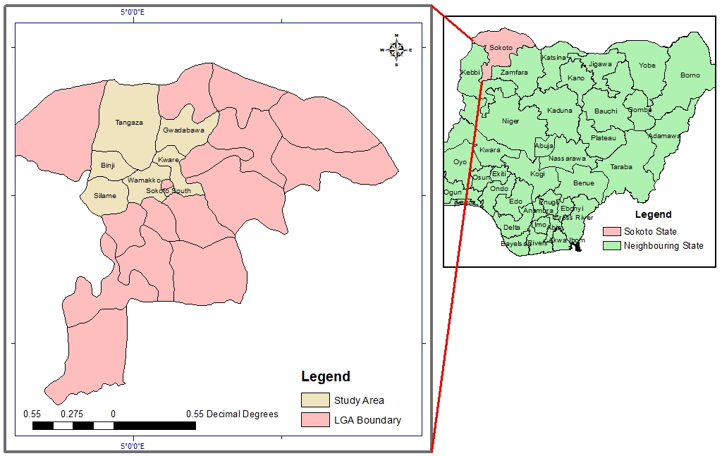
Figure 1Study Area

Crop Classification and Area Estimation
Ground truth polygons for rice, pepper, and onions were used in the classification. To reduce class bias, the dataset, which was initially largely composed of onion samples, was divided into around 4,040 samples for training and 1,009 for validation. Using both spectral indices and meteorological variables as input features, a Random Forest (RF) classifier was trained on 80% of the data. Overall accuracy, the Kappa coefficient, and a confusion matrix were used to evaluate classification accuracy. By masking the categorised map by each crop class and using pixel-based area computation, the crop area was approximated.

Table 2: Classification Accuracy Assessment (Overall Metrics)
Metric | Value
Overall Accuracy | 99.70%
Kappa Coefficient | 0.82
Training samples (balanced) | 4,040
Validation samples | 1,009

Table 3: Classification Accuracy Assessment (Confusion Matrix)
 | Predicted Onion | Predicted Pepper | Predicted Rice | Row Total | User's Accuracy
Actual Onion | 999 | 0 | 0 | 999 | 99.90%
Actual Pepper | 2 | 3 | 0 | 5 | 60.00%
Actual Rice | 1 | 0 | 4 | 5 | 80.00%
Column Total | 1,002 | 3 | 4 | 1,009 | -
Producer's Accuracy | 99.70% | 100% | 100% | - | -

Table 4: Classification Accuracy Assessment (Class-wise Performance)
Crop Class | Producer's Accuracy (Precision) | User's Accuracy (Recall) | F1-Score
Onion (Class 0) | 100% | 99.70% | 99.85%
Pepper (Class 1) | 60% | 100% | 75.00%
Rice (Class 2) | 80% | 100% | 88.89%

Yield Modelling and Productivity Zonation
Using yield data from the ground, onions were chosen for yield modelling. The Interquartile Range (IQR) approach was used to clean the data, standardise it to kg/ha, and eliminate outliers. Temperature, rainfall, reflectance bands, and spectral indices were used as explanatory variables in a Random Forest regression model. Of the small total dataset of 14 samples, the model was trained on 70% (11 samples) and validated on 30% (3 samples). Pearson, RMSE, MAE, and bias were used to assess performance. Lastly, using the 33rd and 67th percentiles as thresholds, the estimated yield map was divided into zones of low, medium, and high productivity. Tables 4, 5, and 6 show the yield model performance.

Table 5: Yield Model Performance (Model Specifications)
Parameter | Value
Algorithm | Random Forest Regression
Number of trees | 500
Input features | 15 variables
Total samples | 14
Training samples (80%) | 11
Validation samples (20%) | 3

Table 6: Yield Model Performance (Performance Metrix)
Metric | Value | Interpretation
R² | 0.84 | 84% of variance explained
Pearson Correlation (r) | 0.92 | Very strong positive relationship
RMSE | 10,870 kg/ha | Root mean squared error
MAE | 9,244 kg/ha | Mean absolute error
Bias | +9,244 kg/ha | Systematic over-prediction
Relative RMSE | 51.80% | RMSE / mean yield
Relative MAE | 44.10% | MAE / mean yield

Table 7: Yield Model Performance (Yield Statistics)
Statistic | Value (kg/ha)
Mean yield | 20,971
Minimum yield | 7,000
Maximum yield | 40,000
Q1 (25th percentile) | 18,000
Q3 (75th percentile) | 30,000
IQR (Interquartile Range) | 12,000
Range | 33,000

RESULT & DISCUSSION
Crop Classification Accuracy
With a strong Kappa Coefficient of 0.82 and an Overall Accuracy of 99.70%, the crop categorisation model performed quite well. Rice fared well (F1-score: 88.89%), and onion categorisation was almost flawless (F1-score: 99.85%). The most difficult class was pepper, which had a lower F1-score of 75.00% and some misclassification, indicating strong recall but low precision. This was probably because there were only five real validation samples or spectral overlap. With a kappa coefficient of 0.82, your model matches the performance reported by Park, Jin-Ki & Park, Jong-Hwa, (2015), and your overall accuracy of 99.70% even surpasses most previous results, approaching the high accuracies of 97–98% achieved by Zhang et al., (2016). These results align with trends in recent UAV-based crop classification studies. Class-wise performance also aligns with literature, as onion and rice showed strong F1-scores similar to the high accuracies reported by Zheng et al., (2024), whereas the lower pepper F1-score of 75% reflects challenges noted by Nansen et al., (2013), who emphasized issues of over-fitting and reduced reliability when classes have very small sample sizes or spectral overlap.
Table 8: Validation Results (Actual vs Predicted)
Sample # | Actual Yield (kg/ha) | Predicted Yield (kg/ha) | Error (kg/ha) | Relative Error (%)
1 | 7,000 | 16,244 | +9,244 | +132.1%
2 | 18,000 | 27,244 | +9,244 | +51.4%
3 | 23,000 | 32,244 | +9,244 | +40.2%
Mean | 16,000 | 25,244 | +9,244 | +57.8%
Note: All three validation samples show identical absolute error (+9,244 kg/ha), indicating systematic bias.

Onion Yield Model Performance
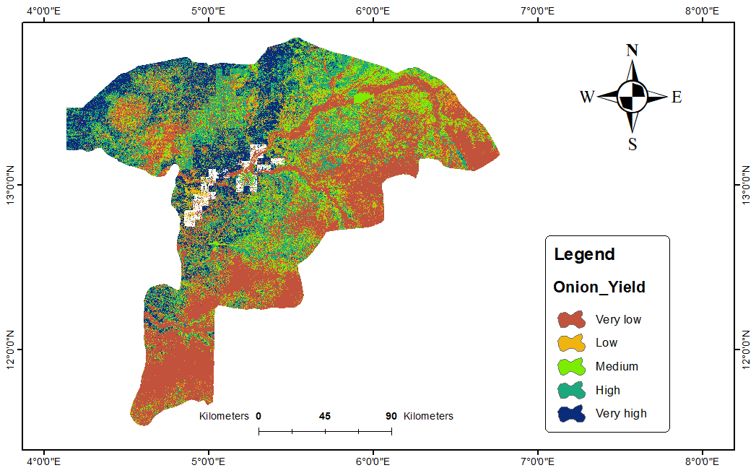
Figure 2 Onion Yield Distribution.
The result illustrated by Figure 1 shows that the Random Forest regression model demonstrated a strong statistical fit, despite the small sample size (n=14), accounting for 84% of the variation and producing a very high Pearson correlation (r=0.92) between the predicted and observed yields.
Nevertheless, the model showed consistent bias and substantial prediction error:
High Error: The Root Mean Square Error (RMSE) was 10,870 kg/ha, and the Mean Absolute Error (MAE) was 9,244 kg/ha.
Systematic Over-prediction: The model continuously overestimated yield projections, as seen by the positive bias of precisely +9,244 kg/ha. Rather than random fluctuation, this consistent inaccuracy across all three validation samples is a clear indication of systematic bias.
Relative Error: The high absolute error translated to a significant Relative RMSE of 51.80% and Relative MAE of 44.10%.
Yield Distribution
With yields ranging from a low of 7,000 kg/ha to a high of 40,000 kg/ha (average: 20,971 kg/ha), the data show considerable variation in crop performance (Figure2). About one-third of the land falls into the low (<18,000 kg/ha), medium (18,000–24,000 kg/ha), and high (>24,000 kg/ha) productivity zones, according to the productivity zonation, which indicates a balanced distribution across the region. The study's results align with earlier agricultural research findings. Grain yields in northeastern Colorado ranged from 6.9 to 15.5 Mg/ha, according to Hornung et al., (2006), showing significant geographic differences in crop performance across management zones. In Ethiopia’s central Rift Valley, Getnet et al., (2016) identified notable yield gaps of 4.2-9.2 t/ha for maize and 2.5-4.7 t/ha for wheat across agricultural zones. The smallest gaps appeared in the central lowlands, where water-limited potential yields also decreased. Sopheap et al., (2012) observed even greater variation in cassava yields, ranging from 12.7 to 37.2 t/ha in Cambodia, with yield gaps of 8.9-24.4 t/ha attributed to soil nutrient shortages, crop duration, and weed competition. Collectively, these studies support the idea that significant yield differences across productivity zones are common across various crops and regions worldwide. Kovvuri & Khushalani, (2025) highlight that such variations reflect crops' sensitivity to climate, environment, and management factors.
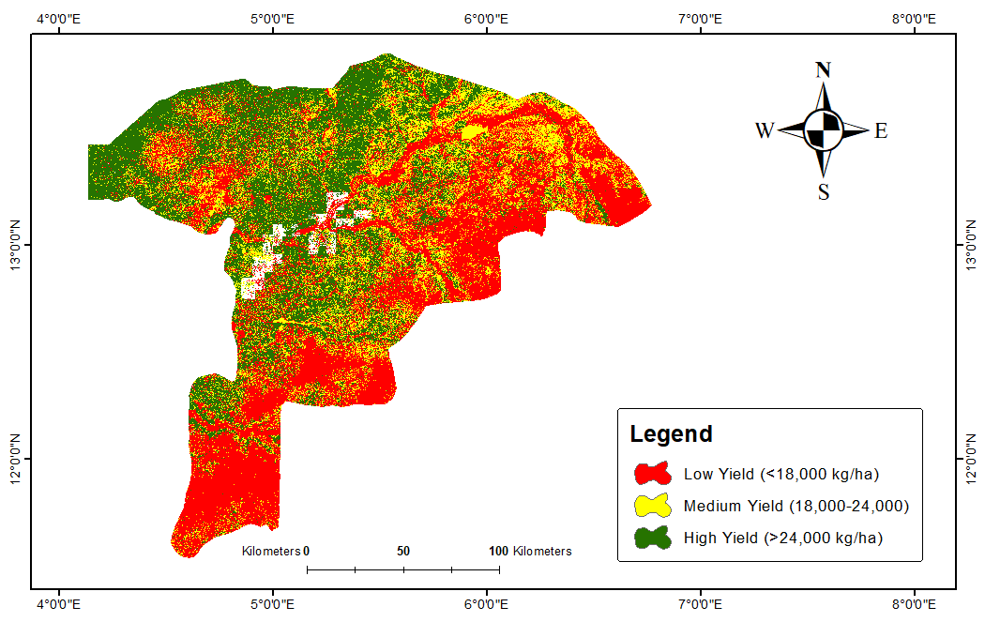
Figure 3 Production Zones

Table 9: Productivity Zone Distribution
Zone | Threshold (kg/ha) | Description | Est. Area (%)
Low | <18,000 | Below average yield | ∼33%
Medium | 18,000−24,000 | Typical yield | ∼33%
 | >24,000 | Above-average yield | ∼33%
Note: Thresholds determined by: 33rd and 67th percentiles of filtered yield data (n=14)

Conclusion
Crop classification in Sokoto State was significantly enhanced by the integration of Sentinel-2 indices and climate variables using a Random Forest model, which yielded nearly flawless accuracy for key crops such as rice and onions. The approach effectively differentiated between crop varieties, providing a solid basis for agricultural monitoring based on remote sensing. In terms of capturing the underlying relationship between biophysical and climatic parameters and onion yield, the yield modelling component showed high statistical potential (R 2=0.84, r=0.92). However, because of the high and persistent systematic over-prediction bias (Bias = +9,244 kg/ha), the model is currently unreliable for precise field-level prediction. The model's practical usefulness for making real-world predictions is severely limited by this high error magnitude, which translates to a 51.80% relative RMSE. The study emphasises that while there are high-performing fields, targeted interventions in low-productivity zones and actions like dataset expansion, model recalibration, improved feature selection, and guided agricultural practices are crucial for enhancing GeoAI-driven yield predictions and sustainable agriculture. A small, heterogeneous yield dataset limits model reliability.

References
- Aslan, M. F., Sabanci, K., & Aslan, B. (2024). Artificial Intelligence Techniques in Crop Yield Estimation Based on Sentinel-2 Data: A Comprehensive Survey. Sustainability, 16(18), 8277. https://doi.org/10.3390/su16188277
- Getnet, M., Van Ittersum, M., Hengsdijk, H., & Descheemaeker, K. (2016). YIELD GAPS AND RESOURCE USE ACROSS FARMING ZONES IN THE CENTRAL RIFT VALLEY OF ETHIOPIA. Experimental Agriculture, 52(4), 493–517. https://doi.org/10.1017/S0014479715000216
- Hornung, A., Khosla, R., Reich, R., Inman, D., & Westfall, D. G. (2006). Comparison of Site‐Specific Management Zones: Soil‐Color‐Based and Yield‐Based. Agronomy Journal, 98(2), 407–415. https://doi.org/10.2134/agronj2005.0240
- Ibrahim, E. S., Rufin, P., Nill, L., Kamali, B., Nendel, C., & Hostert, P. (2021). Mapping Crop Types and Cropping Systems in Nigeria with Sentinel-2 Imagery. Remote Sensing, 13(17), 3523. https://doi.org/10.3390/rs13173523
- Joshi, A., Pradhan, B., Gite, S., & Chakraborty, S. (2023). Remote-Sensing Data and Deep-Learning Techniques in Crop Mapping and Yield Prediction: A Systematic Review. Remote Sensing, 15(8), 2014. https://doi.org/10.3390/rs15082014
- Kovvuri, M., & Khushalani, B. (2025). Comprehensive analytical report on crop performance using ratio-based metrics. Agriculture and Food Sciences Research, 12(2), 84–92. https://doi.org/10.20448/aesr.v12i2.6960
- Mahalakshmi, S., Jose Anand, A., & Partheeban, P. (2025). Soil and crop interaction analysis for yield prediction with satellite imagery and deep learning techniques for the coastal regions. Journal of Environmental Management, 380, 125095. https://doi.org/10.1016/j.jenvman.2025.125095
- Nansen, C., Geremias, L. D., Xue, Y., Huang, F., & Parra, J. R. (2013). Agricultural case studies of classification accuracy, spectral resolution, and model over-fitting. Applied Spectroscopy, 67(11), 1332–1338. https://doi.org/10.1366/12-06933
- Panwar, S. V., & Singh, S. (2024). A Review on Crop Yield Prediction using Deep Learning. 2024 8th International Conference on Inventive Systems and Control (ICISC), 106–111. https://doi.org/10.1109/ICISC62624.2024.00025
- Park, J.-K., & Park, J.-H. (2015). Crops Classification Using Imagery of Unmanned Aerial Vehicle (UAV). Journal of The Korean Society of Agricultural Engineers. https://doi.org/10.5389/KSAE.2015.57.6.091
- Park, J.-K., & Park, J.-H. (2015). Crops Classification Using Imagery of Unmanned Aerial Vehicle (UAV). Journal of The Korean Society of Agricultural Engineers, 57(6), 91–97. https://doi.org/10.5389/KSAE.2015.57.6.091
- Sopheap, U., Patanothai, A., & Aye, T. M. (2012). Unveiling constraints to cassava production in Cambodia: An analysis from farmers’ yield variations. International Journal of Plant Production. https://doi.org/10.22069/ijpp.2012.757
- Zhang, X., Sun, Y., Shang, K., Zhang, L., & Wang, S. (2016). Crop Classification Based on Feature Band Set Construction and Object-Oriented Approach Using Hyperspectral Images. IEEE Journal of Selected Topics in Applied Earth Observations and Remote Sensing, 9(9), 4117–4128. https://doi.org/10.1109/JSTARS.2016.2577339
- Zheng, Z., Yuan, J., Yao, W., Kwan, P., Yao, H., Liu, Q., & Guo, L. (2024). Fusion of UAV-Acquired Visible Images and Multispectral Data by Applying Machine-Learning Methods in Crop Classification. Agronomy, 14(11), 2670. https://doi.org/10.3390/agronomy14112670

