Terrestrial Water Storage and Ground Water Variability Across the River Basins in Nigeria using GRACE and GRACE-FO

Abstract
Water resource management in Nigeria faces increasing challenges due to climate variability, population growth, and land use changes. This study presents a satellite-based, remote sensing approach in the estimation of Terrestrial Water Storage (TWS) dynamics across Nigeria’s twelve River Basin Development Authorities (RBDAs), utilizing data from the GRACE and GRACE-FO satellite missions. The research aims to quantify monthly TWS anomalies, and additionally, it estimates groundwater storage anomalies (GWSA) by integrating GRACE-derived TWS with soil moisture and surface water datasets. Results reveal pronounced seasonal fluctuations in TWS, with wet seasons (April – October) showing positive anomalies and dry seasons (November – March) marked by deficits. Southern basins like Lower Benue and Cross River exhibited higher water retention, while northern basins such as Sokoto faced persistent water stress. Long-term trends indicate a decline in TWS recovery during recent wet seasons, particularly in 2024, suggesting the impact of climate change and increased evapotranspiration. Groundwater remained relatively stable, acting as a buffer during dry spells, whereas surface water and soil moisture showed more dynamic responses to rainfall and evaporation. The study concludes that satellite-based monitoring offers a robust framework for understanding Nigeria’s hydrological dynamics. It recommends basin-specific interventions, including improved dam infrastructure, climate-resilient land use practices, and groundwater recharge strategies. These insights are vital for informing national water policies and enhancing resilience against future hydrological uncertainties.

Keywords: GRACE and GRACE-FO, Groundwater Storage Anomalies, River Basins, Terrestrial Water Storage, Water Resource Management

- Introduction
Water storage plays a crucial role in the hydrological cycle, influencing both natural ecosystems and human activities. In Nigeria, understanding terrestrial water storage (TWS) dynamics is vital for sustainable water resource management, particularly in light of climate change and increasing demands from agriculture and urbanisation processes.
Nigeria is characterized with diverse climatic and hydrological conditions, ranging from humid coastal regions to arid zones in the North. This variability underscores the need for regional assessments of water storage patterns to inform policies on water security and disaster mitigation which support SDG 6 such as improved water quality, integrated water resource management, and ecosystem protection.
Nigeria faces significant water challenges, including scarcity, floods, and droughts, which are exacerbated by climate change, population growth, and inadequate infrastructure. Water scarcity is particularly severe in the northern regions, where low rainfall and high evaporation rates contribute to dwindling water resources according to Ahile, Mailumo, and Ikape, (2024). Rapid urbanization has increased demand for potable water, yet poor distribution networks and contamination limit access for millions of Nigerians as stated by Baba-Ahmed, (2024). The shrinking of Lake Chad, which has lost 90% of its water over the past 40 years, highlights the severity of the crisis as identified by Baba-Ahmed, (2024). The global water cycle is the continuous movement of water within the Earth's hydrosphere, encompassing key processes such as precipitation, evaporation, infiltration, runoff, and storage. Water exists in various reservoirs, including the atmosphere, oceans, ice caps, rivers, lakes, and groundwater. Among these, TWS represents all forms of water stored on land, including soil moisture, surface water, groundwater, snow, and glaciers as opined by Rodell et al. (2018). As a critical component of the hydrological cycle, TWS influences climate regulation, agricultural productivity, and water resource availability.
According to Syed et al. (2008) changes in TWS impact atmospheric moisture levels, which in turn affect precipitation and climate variability. Famiglietti, (2004) study identified that groundwater recharge occurs as surface water infiltrates underground aquifers, maintaining long-term sustainability, especially in regions with high water demand.
According to Zehe, Becker, Bárdossy, & Plate, (2005), the integration of satellite-derived data with hydrological models further improves predictions related to droughts, floods, and groundwater depletion, ensuring that water resources are managed effectively for future generations.
Traditional water assessments primarily rely on ground-based methods such as gauge stations, well measurements, and hydrological modeling. Traditional hydrological monitoring in Nigeria faces several limitations, primarily due to outdated methods, inadequate infrastructure, and environmental challenges. One major issue is the lack of extensive gauge networks, particularly in remote areas, which makes it difficult to obtain accurate and continuous hydrological data as observed by Baballe, Sani, Ibrahim, Musa, and Dahiru, (2023). Many monitoring stations suffer from poor maintenance, leading to data gaps and inconsistencies that hinder effective water resource management.
The Gravity Recovery and Climate Experiment (GRACE) mission, launched in 2002, introduced satellite gravimetry as a groundbreaking tool for measuring changes in Earth's gravity field, directly linked to variations in mass, including terrestrial water storage as observed by Tapley et al. (2004). The mission provided monthly global TWS data, which significantly improved hydrological modeling and water resource management strategies as stated by Wahr, Molenaar, and Bryan, (2004) and Rodell et al. (2018) estimates of water storage changes, offering valuable insights into groundwater depletion, drought patterns, and flood dynamics.
Building on GRACE’s success, the GRACE Follow-On (GRACE-FO) mission, launched in 2018, enhances monitoring capabilities with improved instrumentation and extended operational lifespan according to Landerer, Flechtner, Save, Webb, and Watkins, (2020). Tapley et al. (2004) also observed that the utilized twin satellites to measure variations in Earth's gravity field allows researchers to estimate mass redistribution due to water movement. These missions have been extensively used to assess global and regional water storage trends, demonstrating their reliability for hydrological studies, particularly in data-scarce regions like Nigeria. Advancements in satellite monitoring, particularly through missions like GRACE and GRACE-FO, have enhanced global water tracking, allowing for better resource management and disaster preparedness according to Getirana, Kumar, Girotto, & Rodell, (2017). These observations contribute to policy-making efforts, helping societies adapt to changing water conditions and environmental challenges as stated by Rodell, Chen, Kato, Famiglietti, & Nigro, (2005).
The Gravity Recovery and Climate Experiment (GRACE) and its successor, GRACE Follow-On (GRACE-FO), have revolutionized large-scale Terrestrial Water Storage (TWS) monitoring by providing precise satellite-based measurements of Earth's gravitational anomalies. These missions enable scientists to track seasonal and long-term changes in water distribution across global basins, offering valuable insights into hydrological cycles, groundwater depletion, and climate variability according to Ahi and Cekim, (2021).
The integration of GRACE and GRACE-FO data has transformed global hydrological studies, enabling policymakers to develop sustainable water management strategies and mitigate climate-related water challenges. These missions continue to provide critical insights into Earth's changing water dynamics, supporting efforts to address water scarcity, flooding, and groundwater depletion worldwide.
In this study, GRACE and GRACE-FO data was utilised to quantify regional variations in Nigeria’s terrestrial water storage, assessing both seasonal fluctuations and long-term trends. This approach will provide insights into water availability dynamics, aiding policymakers and resource managers in developing sustainable water governance strategies.
Despite the crucial role of TWS in water resource management, long-term monitoring remains inadequate due to sparse ground-based observation networks and data accessibility issues. These limitations pose serious obstacles to achieving Sustainable Development Goal (SDG) 6, which advocates for ensuring availability and sustainable management of water and sanitation for all. Traditional ground-based monitoring struggles with accessibility and high operational costs, preventing the collection of comprehensive hydrological insights needed to support SDG 6 targets such as improved water quality, integrated water resource management, and ecosystem protection. For example, the Chad Basin suffers from extreme water scarcity due to the shrinking of Lake Chad, while the Niger Delta faces pollution from oil activities. Other basins experience flooding, erosion, and declining groundwater levels, all of which hinder their ability to support agriculture, water supply, and regional development. Strengthening community involvement and governance will also be key to ensuring sustainable water use across Nigeria’s river basins.

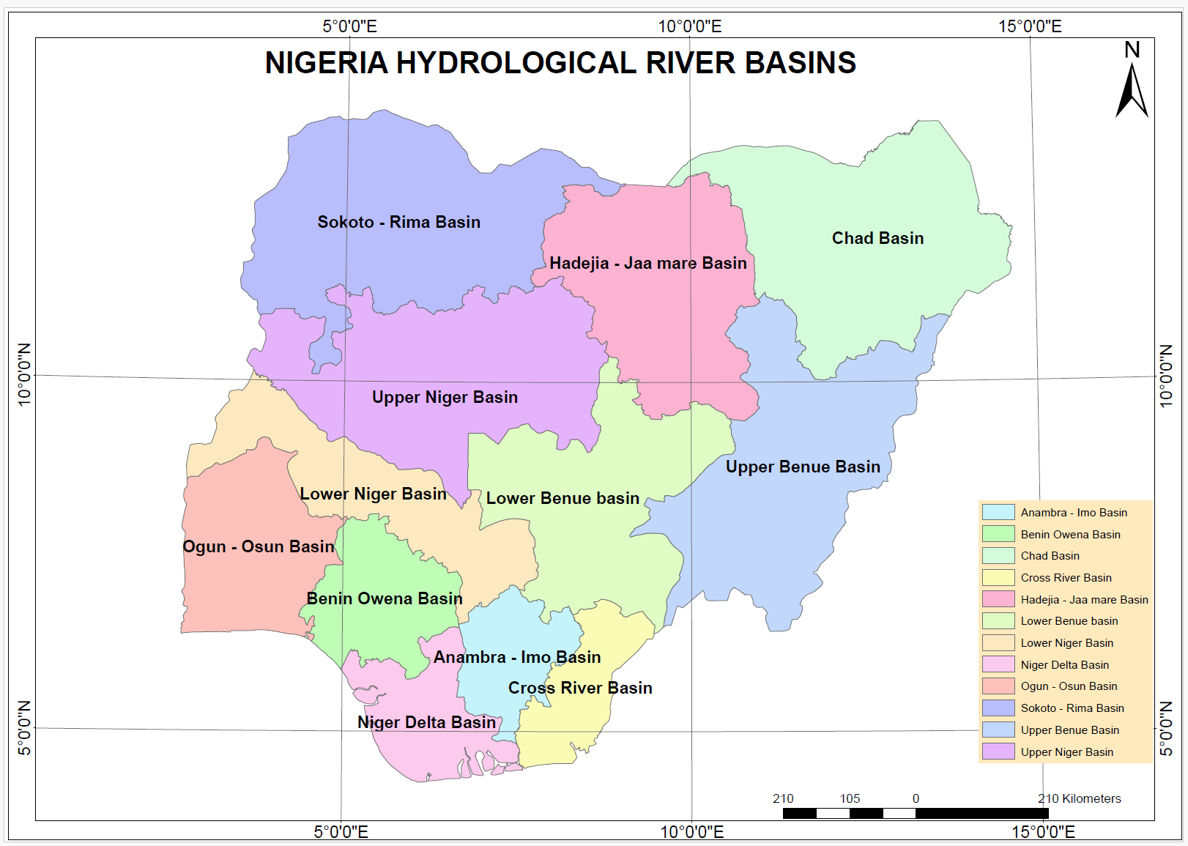
Figure 1.0: Nigerian Hydrological River Basins
Source: (Victor Elijah Akpan, 2021)

The twelve River Basin Development Authorities (RBDAs) across Nigeria are directly impacted by these challenges, figure 1 is the study area map.

1.1 Aim of the Study
The aim of the study is to estimate Terrestrial Water Storage and Ground Water anomalies across the hydrological River Basins in Nigeria. The two specific objectives are:
- Evaluate TWS changes within the hydrological river basins/regions of Nigeria,
- Evaluate monthly average TWS changes within the hydrological river basins/regions of Nigeria,
- Estimation of Groundwater storage anomalies within the hydrological river basins/regions of Nigeria.
- Materials and Methods
2.1 Data (GRACE/GRACE-FO) Acquisition and Processing
To access GRACE/GRACE-FO satellite data online, we explored some of these resources like GRACE Tellus Data Portal and EARTHDATA SEARCH as shown in Figure 2 and Table 1 below which provided access to GRACE/GRACE-FO monthly mass grids, including global surface mass changes (land and ocean), land water storage, and ocean-bottom pressure. NASA Earthdata offers comprehensive information and data from the GRACE and GRACE-FO missions like some details on the instruments, data specifications, and access to the data catalog. The GRACE-FO Data Portal was also accessed, and it provided a global surface mass anomalies observed by the GRACE-FO satellites, including changes in ice sheets, glaciers, near-surface and underground water storage, and ocean bottom pressure.
The data acquisition process is a crucial aspect of this study, as it involves sourcing and organizing all datasets required for the analysis of Terrestrial Water Storage (TWS) anomalies and Groundwater variability in Nigeria. The primary dataset used in this research is derived from the GRACE (Gravity Recovery and Climate Experiment) and GRACE-FO (Follow-On) satellite missions, which measure changes in the Earth's gravity field to detect variations in terrestrial water storage. These datasets, provided by NASA and the German Research Centre for Geosciences (GFZ), offer monthly TWS anomalies in NetCDF (.nc) format, spanning the temporal range from January 2004 to December 2004, January 2014 to December 2014, and January 2024 to December 2024. In addition to the primary TWS data, Groundwater variability data were all acquired from the Earthdata search database for these years interval with data release version RL06 for the dataset, an administrative boundary dataset of Nigeria was acquired to delineate the study area according to the river basin authorities, which will help in facilitating spatial analysis.
Table 1: Different Data Sources Used for the Study
S/N | Dataset | Source | Temporal Resolution | Spatial Resolution | Format
1. | GRACE/GRAC-FO  TWS Anomalies | NASA JPL (EarthData Portal) | Monthly | 0.5° x 0.5° (~55km) | NetCDF
2. | Precipitation (e.g. CHIRPS, ERA5) | NASAEarthData /ClimateSERV | Daily/Monthly | 0.05° (~5km)/ 0.25° (~25km) | NetCDF/  GeoTIFF
3. | Evapotranspiration (e.g. MODIS/GLEAM | NASA EarthData/ /GLEAM | 8-day/ Monthly | 0.25° (~25km) | NetCDF
4. | Soil Moisture (GLDAS/ERA5-Land) | NASA GLDAS (EarthData Portal) | 3-hourly/ Monthly | 0.25° (~25km) | NetCDF
5. | Surface Water Storage (GLDAS) | NASA GLDAS | Monthly | 0.25° (~25km) | NetCDF
6. | Ground Water | NASA GLDAS | Monthly | 0.5° x 0.5° (~55km) | NetCDF
7. | Administrative Boundary (Nigeria) | GADM (https://gadm.org) | N/A | Vector | Shapefile/kml
8. | Basin Boundaries | FAO Hydrosheds/HydroBASINS | N/A | Vector | Shapefile/kml

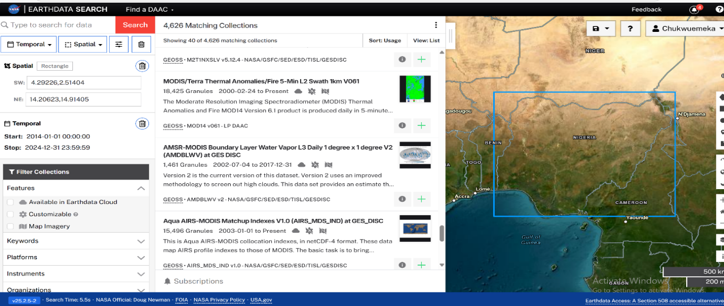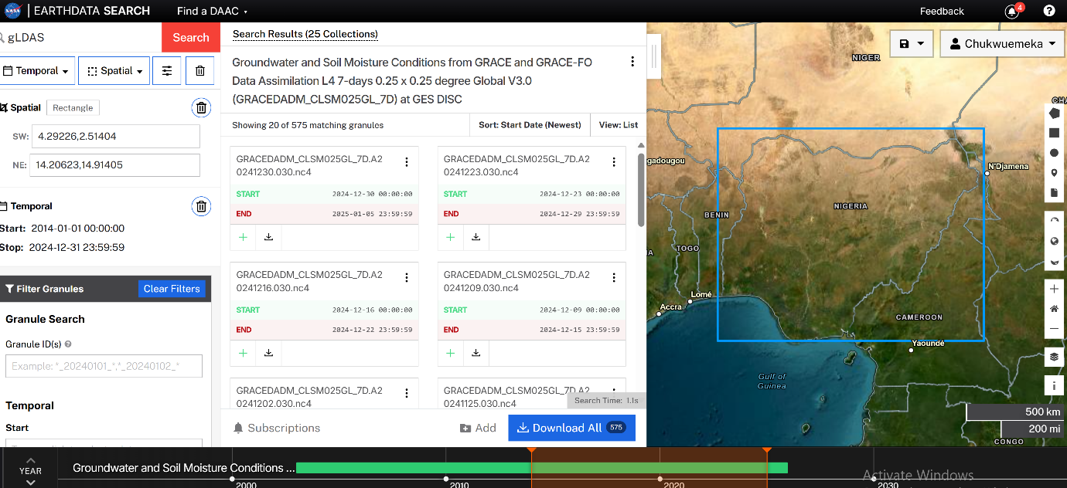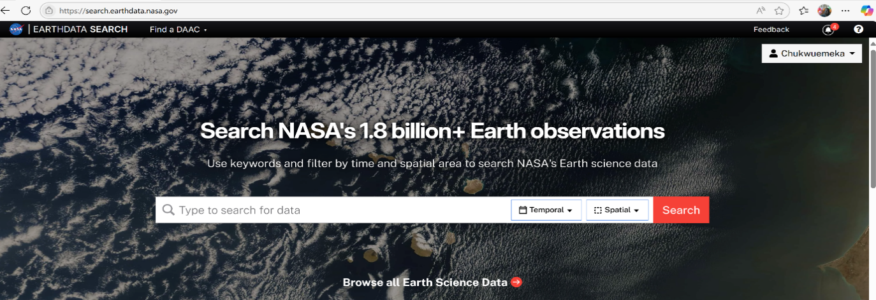
Figure 2: EarthData Search Interface for download of GRACE and GRACE – FO data

2.3 Methods
The remote sensing approach was employed in this research for the extraction of Terrestrial Water Storage anomalies and Ground water storage anomalies. The mathematical model (underlying physical model) underlying the GRACE and GRACE-FO satellite missions is designed to measure variations in Earth’s gravity field, which reflect changes in mass distribution - such as shifts in terrestrial water storage, ice sheets, and ocean currents. These twin satellites orbit Earth in tandem and use a highly precise K-band ranging system to detect minute changes in the distance between them, caused by gravitational anomalies. The core of the model is based on Newton’s law of gravitation and orbital mechanics, which are used to derive mass change estimates from observed gravitational signals. At the heart of the GRACE/GRACE-FO data processing is the spherical harmonic representation of Earth’s gravity field. The gravitational potential $V(r, θ, λ)$ at a point on or above Earth’s surface is expressed as:
$∆g(θ,∅,t)≈\sum_{l=0}^{L}{\sum_{m=0}^{l}{∆C_{lm}\left(t\right)Y_{lm}\left(θ,∅\right)+∆S_{lm}\left(t\right)Y_{lm}\left(θ,∅\right)}}$ …1

Where:

$GM$ is the gravitational constant times Earth’s mass, $r$is the radial distance from Earth’s center, $R$is Earth’s mean radius, $θ$ is colatitude, $λ$ is longitude, $C_{nm} and S_{nm}$ are spherical harmonic coefficients,

$P_{nm}$ are associated Legendre polynomials. These coefficients $C_{nm} and S_{nm}$are derived from satellite observations and represent the spatial and temporal variations in Earth’s gravity field. Changes in these coefficients over time are used to infer mass redistribution, such as groundwater depletion or glacial melting.
The conversion of GRACE and GRACE-FO satellite data into Equivalent Water Thickness (EWT) enables scientists to quantify changes in terrestrial water storage (TWS) in terms of millimeters of water height. This process begins by interpreting variations in Earth’s gravity field captured as spherical harmonic coefficients into surface mass anomalies. The gravitational potential $V(r, θ, λ)$ is modeled using:
$V\left(r, θ, λ\right)=\frac{GM}{r}\left[1+\sum_{n=2}^{∞}{\sum_{m=0}^{n}{{\left(\frac{R}{r}\right)}^{n}(C_{nm}}\cos\left(mλ\right)P_{nm}(COSθ)}\right]$ … 2

These coefficients $(C_{nm},S_{nm})$ reflect mass redistribution across the globe. To convert this into EWT, the surface mass change $∆σ$ is divided by the density of water $ρ_{w},$ yielding:

$EWT=\frac{∆σ }{∆σ }$ … 3

This final value represents the thickness of water that would produce the same gravitational signal, allowing researchers to monitor groundwater depletion, flooding, or drought conditions over time. The EWT metric is especially valuable in regions like Nigeria, where ground-based hydrological data is limited, offering a reliable and scalable method for tracking water resource changes and supporting sustainable development goals.
The hydrological separation and water balance model applied to Terrestrial Water Storage (TWS) is a powerful framework for understanding how water is distributed and changes over time across landscapes. TWS represents the total amount of water stored above and below the land surface, including surface water, soil moisture, groundwater, snow, and vegetation. To analyze TWS effectively, scientists use a water balance model that separates these components and quantifies their individual contributions to the overall water budget. The foundational equation for the water balance model is:
$P=ET+Q+∆S$ …4

Where:

$P$ is precipitation (input), $ET$ is evapotranspiration (loss to atmosphere), $Q$ is runoff (surface and subsurface flow), $∆S$ is the change in terrestrial water storage.

In the context of GRACE/GRACE-FO satellite data, TWS anomalies are derived from changes in Earth’s gravity field and then separated into individual hydrological components using auxiliary datasets and models. The separation is typically expressed as:

$TWSA=SMA+SWA+GWSA$ …5

Where:

$TWSA$ is the Terrestrial Water Storage Anomaly, $SMA$ is Soil Moisture Anomaly, $SWA$ is Surface Water Anomaly, $GWSA$ is Groundwater Storage Anomaly. By rearranging this equation, researchers can isolate groundwater changes:

$GWSA=TWSA-(SMA+SWA)$ … 6

This hydrological separation is essential for identifying which component is driving water scarcity or surplus in a region. For example, in Nigeria’s Chad Basin, declining TWSA values combined with stable SMA and SWA suggest that groundwater is being depleted. This insight supports targeted interventions such as groundwater recharge projects, improved irrigation practices, and climate-adaptive water management.

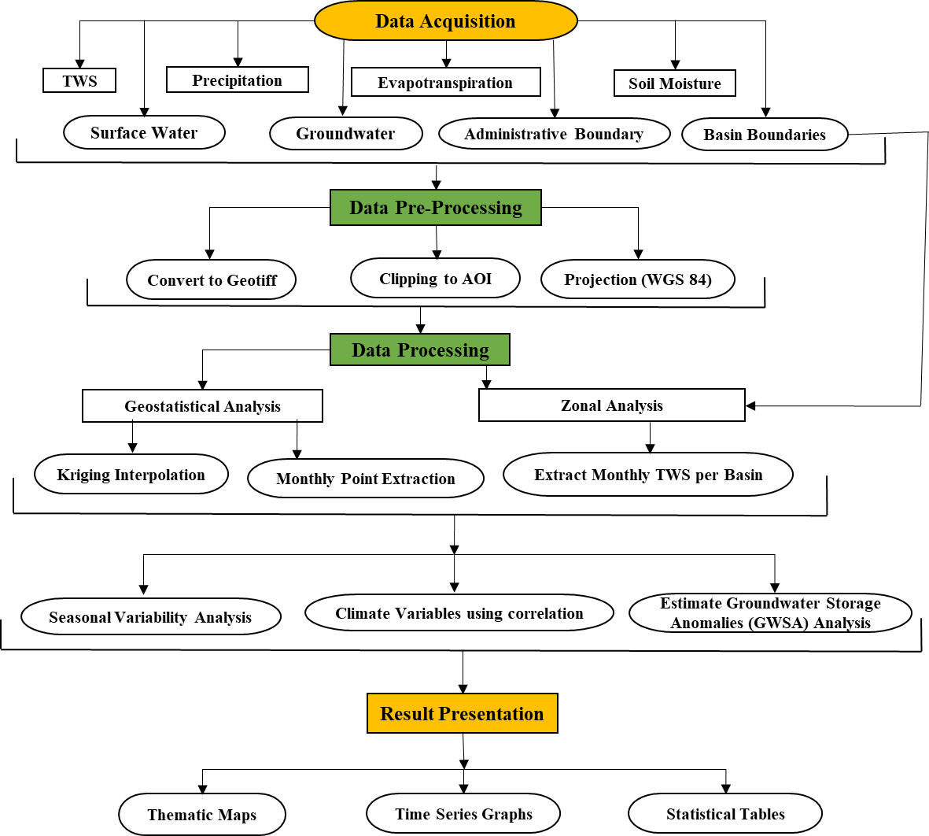
Figure 3: Flowchart showing the Procedure used in this Research.

3.0 Results and Discussion

The results of objectives 1 and 2 were satisfied with the results shown on tables 2a, 2b, 3a, 3b, 4a, 4b and Figure 4 and 5.

Table 2a: Results of monthly TWS Anomalies of the Hydrological Basin in 2004
S/N | RBDA | Jan. | Feb. | Mar. | Apr. | May | June
1. | Lower Benue basin | -76.213 | -93.57 | -101.11 | -82.06 | -10.73 | 47.33
2. | Cross River Basin | -91.24 | -145.35 | -167.47 | -96.84 | 24.42 | 78.04
3. | Anambra - Imo Basin | -80.50 | -115.37 | -125.29 | -50.20 | 40.85 | 74.06
4. | Niger Delta Basin | -68.38 | -102.77 | -115.11 | -4.75 | 48.95 | 62.86
5. | Benin Owena Basin | -73.44 | -91.61 | -107.56 | -63.04 | 9.60 | 70.82
6. | Ogun - Osun Basin | -54.67 | -60.61 | -81.23 | -66.98 | -21.37 | 47.95
7. | Lower Niger Basin | -61.86 | -72.06 | -84.27 | -69.52 | -13.36 | 46.89
8. | Upper Niger Basin | -69.06 | -80.78 | -91.04 | -91.87 | -22.60 | 29.98
9. | Sokoto - Rima Basin | -38.52 | -55.45 | -65.47 | -69.78 | -35.15 | -11.31
10. | Hadejia - Jaa mare Basin | -46.03 | -64.84 | -75.24 | -80.13 | -48.12 | -13.27
11. | Chad Basin | -32.16 | -48.89 | -58.22 | -63.65 | -52.15 | -44.16
12. | Upper Benue Basin | -70.63 | -89.23 | -97.36 | -90.26 | -30.01 | 16.72
Source: (Researcher, 2025)

Table 2b: Results of monthly TWS Anomalies of the Hydrological Basin in 2004
S/N | RBDA | July | August | Sept. | Oct. | Nov. | Dec.
1. | Lower Benue basin | 58.24 | 91.46 | 106.80 | 73.24 | 12.41 | -83.94
2. | Cross River Basin | 69.85 | 68.46 | 99.69 | 92.06 | 58.15 | -94.38
3. | Anambra - Imo Basin | 67.09 | 54.27 | 92.39 | 77.13 | 40.48 | -100.71
4. | Niger Delta Basin | 64.35 | 40.50 | 69.49 | 59.35 | 32.82 | -115.37
5. | Benin Owena Basin | 86.41 | 74.08 | 107.03 | 85.73 | 47.54 | -98.69
6. | Ogun - Osun Basin | 87.77 | 69.13 | 113.21 | 102.47 | 44.84 | -62.13
7. | Lower Niger Basin | 78.55 | 89.21 | 104.69 | 72.58 | 15.17 | -64.08
8. | Upper Niger Basin | 83.55 | 135.45 | 125.29 | 76.70 | -5.56 | -60.62
9. | Sokoto - Rima Basin | 50.04 | 132.83 | 122.73 | 47.56 | -16.84 | -44.35
10. | Hadejia - Jaa mare Basin | 33.82 | 135.41 | 123.93 | 46.20 | -16.00 | -56.00
11. | Chad Basin | 2.58 | 83.77 | 101.60 | 43.57 | -4.11 | -29.50
12. | Upper Benue Basin | 63.26 | 116.23 | 126.75 | 79.03 | 9.30 | -67.17
Source: (Researcher, 2025)

Table 3a: Results of monthly TWS Anomalies of the Hydrological Basin in 2014
S/N | RBDA | Jan | Feb. | March | Apr | May | June
1. | Lower Benue basin | -80.37 | NaN | -84.51 | -57.25 | 13.65 | -5.13
2. | Cross River Basin | -58.43 | NaN | -70.99 | 12.89 | 66.47 | 75.77
3. | Anambra - Imo Basin | -60.66 | NaN | -47.32 | 9.09 | 57.82 | 73.75
4. | Niger Delta Basin | -67.62 | NaN | -37.02 | 15.08 | 34.85 | 42.11
5. | Benin Owena Basin | -41.11 | NaN | -59.90 | -2.94 | 40.06 | 48.43
6. | Ogun - Osun Basin | -61.79 | NaN | -83.36 | -56.99 | 15.92 | -0.97
7. | Lower Niger Basin | -79.16 | NaN | -87.13 | -47.92 | 20.77 | 13.62
8. | Upper Niger Basin | -90.23 | NaN | -105.87 | -87.33 | -1.47 | -32.64
9. | Sokoto - Rima Basin | -78.61 | NaN | -99.62 | -98.81 | -52.31 | -73.35
10. | Hadejia - Jaa mare Basin | -71.32 | NaN | -95.87 | -92.37 | -47.95 | -74.69
11. | Chad Basin | -54.69 | NaN | -76.81 | -79.23 | -62.81 | -72.77
12. | Upper Benue Basin | -76.14 | NaN | -96.87 | -72.51 | 1.38 | -16.87
Source: (Researcher, 2025)
Table 3b: Results of monthly TWS Anomalies of the Hydrological Basin in 2014
S/N | RBDA | July | August | Sept. | Oct. | Nov. | Dec.
1. | Lower Benue basin | NaN | 23.03 | 79.34 | 71.44 | 17.48 | -51.05
2. | Cross River Basin | NaN | 6.81 | 90.34 | 79.56 | 67.84 | 24.14
3. | Anambra - Imo Basin | NaN | 1.53 | 80.29 | 61.30 | 47.43 | 1.77
4. | Niger Delta Basin | NaN | -20.64 | 52.98 | 52.80 | 44.80 | 8.78
5. | Benin Owena Basin | NaN | 34.33 | 99.19 | 84.61 | 66.19 | 17.19
6. | Ogun - Osun Basin | NaN | 39.50 | 85.49 | 97.08 | 60.47 | -17.50
7. | Lower Niger Basin | NaN | 37.79 | 99.54 | 80.61 | 19.80 | -56.41
8. | Upper Niger Basin | NaN | 33.92 | 122.83 | 78.95 | -10.50 | -72.78
9. | Sokoto - Rima Basin | NaN | 27.43 | 103.51 | 56.48 | -17.59 | -63.36
10. | Hadejia - Jaa mare Basin | NaN | 24.64 | 91.44 | 57.64 | -14.89 | -53.80
11. | Chad Basin | NaN | -17.66 | 5.83 | 0.49 | -44.80 | -41.53
12. | Upper Benue Basin | NaN | 39.09 | 91.42 | 74.11 | 4.74 | -54.78
Source: (Researcher, 2025)

Table 4a: Results of monthly TWS Anomalies of the Hydrological Basin in 2024
S/N | RBDA | Jan. | Feb. | Mar. | Apr. | May | June
1. | Lower Benue basin | -82.19 | -95.01 | -84.12 | -73.32 | -46.50 | -19.79
2. | Cross River Basin | -107.45 | -152.47 | -106.86 | -69.92 | 7.02 | 32.90
3. | Anambra - Imo Basin | -100.44 | -126.30 | -88.22 | -55.64 | 6.02 | 23.86
4. | Niger Delta Basin | -127.29 | -163.33 | -112.22 | -46.19 | 12.81 | 18.06
5. | Benin Owena Basin | -92.79 | -124.17 | -104.03 | -80.78 | -15.97 | -0.66
6. | Ogun - Osun Basin | -76.81 | -107.32 | -116.08 | -106.64 | -50.65 | -7.36
7. | Lower Niger Basin | -67.11 | -78.84 | -74.46 | -71.31 | -30.01 | -20.31
8. | Upper Niger Basin | -81.26 | -91.95 | -94.05 | -96.46 | -60.51 | -37.65
9. | Sokoto - Rima Basin | -89.70 | -101.91 | -109.58 | -112.18 | -97.09 | -73.94
10. | Hadejia - Jaa mare Basin | -87.73 | -102.01 | -110.64 | -115.55 | -102.21 | -73.24
11. | Chad Basin | -82.62 | -93.84 | -100.38 | -105.91 | -106.07 | -75.30
12. | Upper Benue Basin | -85.14 | -99.43 | -101.02 | -94.70 | -67.33 | -42.08
Source: (Researcher, 2025)

Table 4b: Results of monthly TWS Anomalies of the Hydrological Basin in 2024
S/N | RBDA | July | August | Sept. | Oct. | Nov. | Dec.
1. | Lower Benue basin | 15.48 | 10.70 | 45.36 | 55.58 | -26.63 | -83.94
2. | Cross River Basin | 55.49 | 8.94 | 41.87 | 70.83 | 1.06 | -94.38
3. | Anambra - Imo Basin | 46.35 | -7.64 | 18.36 | 44.22 | -21.76 | -100.73
4. | Niger Delta Basin | 25.80 | -48.96 | -26.65 | 14.54 | -27.89 | -115.37
5. | Benin Owena Basin | 54.52 | -11.82 | 5.16 | 57.10 | -17.29 | -98.69
6. | Ogun - Osun Basin | 43.12 | -28.03 | -22.62 | 61.97 | 20.35 | -62.13
7. | Lower Niger Basin | 38.49 | -2.87 | 40.75 | 75.40 | -7.78 | -64.08
8. | Upper Niger Basin | 32.32 | 42.39 | 93.05 | 93.78 | -5.96 | -60.62
9. | Sokoto - Rima Basin | -12.13 | 59.87 | 127.62 | 87.21 | -1.30 | -44.35
10. | Hadejia - Jaa mare Basin | -8.19 | 88.74 | 125.40 | 55.24 | -18.31 | -56.00
11. | Chad Basin | 18.87 | 93.84 | 114.25 | 59.62 | -0.35 | -29.48
12. | Upper Benue Basin | 20.43 | 34.29 | 67.42 | 71.07 | -15.66 | -67.17
Source: (Researcher, 2025)
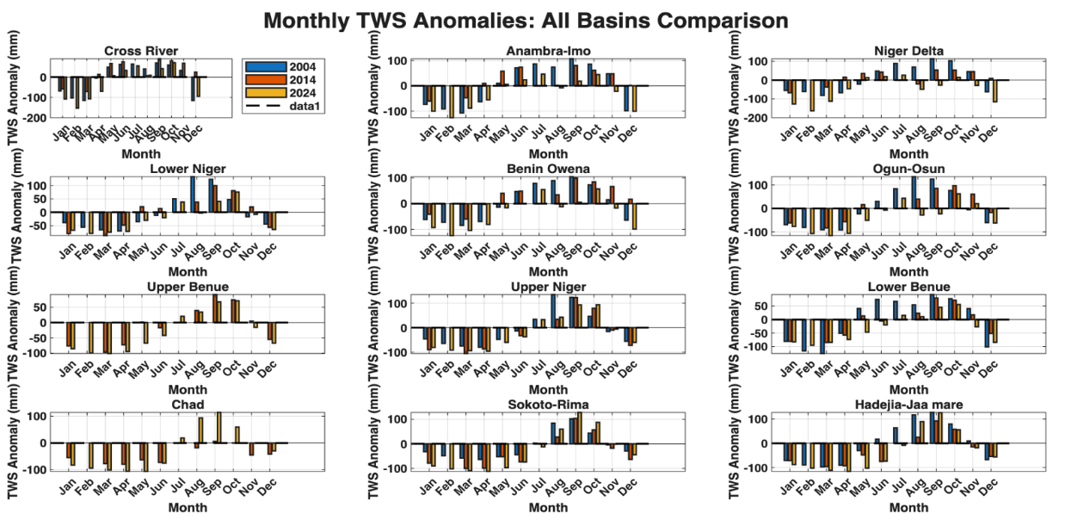
Figure 4: Plot showing Monthly TWS Anomalies in the Hydrological Basins

Table 5a: Results of Monthly Average TWS anomalies in the Hydrological Basin 2004 to 2024
SN | Average TWS | Jan. | Feb. | Mar. | Apr. | May | June
1. | Average_TWS 2004 | -63.56 | -85.04 | -97.45 | -69.09 | -9.14 | 33.83
2. | Average_TWS 2014 | -68.35 | 0.00 | -78.77 | -46.52 | -1.89 | 7.20
3. | Average_TWS 2024 | -90.04 | -111.38 | -100.14 | -85.72 | -45.87 | -22.96
Source: (Researcher, 2025)

Table 5b: Results of Monthly Average TWS anomalies in the Hydrological Basin 2004 to 2024
SN | Average TWS | July | Aug. | Sept. | Oct. | Nov. | Dec.
1. | Average_TWS 2004 | 62.15 | 90.90 | 107.80 | 71.30 | 18.18 | -73.08
2. | Average_TWS 2014 | 0.00 | 19.15 | 83.52 | 66.25 | 20.08 | -29.94
3. | Average_TWS 2024 | 27.55 | 19.96 | 52.50 | 62.21 | -10.13 | -73.08
Source: (Researcher, 2025)

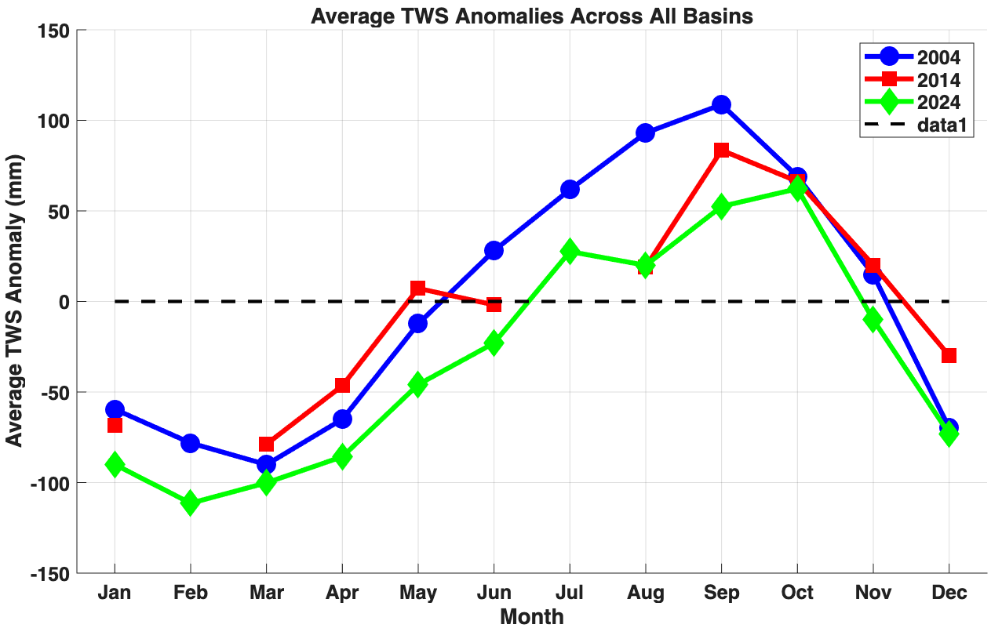
Figure 5: Plot showing the Average Monthly TWS Anomalies in the Hydrological Basins

Table 6: Seasonal variability and long-term trends of TWS
Season | Year | 2004 |  | 2014 | 2024
Dry | Jan | -63.56 |  | -68.35 | -90.04
Dry | Feb | -85.04 |  | 0.00 | -111.38
Dry | Mar | -97.45 |  | -78.77 | -100.14
Rainy | Apr | -69.09 |  | -46.52 | -85.72
Rainy | May | -9.14 |  | -1.89 | -45.87
Rainy | June | 33.83 |  | 7.20 | -22.96
Rainy | July | 62.15 |  | 0.00 | 27.55
Rainy | August | 90.90 |  | 19.15 | 19.96
Rainy | Sept | 107.80 |  | 83.52 | 52.50
Rainy | Oct | 71.30 |  | 66.25 | 62.21
Dry | Nov | 18.18 |  | 20.08 | -10.13
Dry | Dec | -73.08 |  | -29.94 | -73.08

The results of objective 3 were satisfied with the results shown on tables 7a, 7b, 8a, 8b, 9a, 9b and Figures 6 and 7.

Table 7a: Results of the Monthly Groundwater variability in the Hydrological Basin in 2004
S/N | RBDA | Jan. | Feb. | Mar. | Apr. | May | June
1. | Lower Benue basin | 0.016533 | 0.014252 | 0.013568 | 0.014423 | 0.013804 | 0.013930
2. | Cross River Basin | 0.016498 | 0.014222 | 0.013539 | 0.014393 | 0.013776 | 0.013901
3. | Anambra - Imo Basin | 0.016448 | 0.014179 | 0.013498 | 0.014349 | 0.013733 | 0.013858
4. | Niger Delta Basin | 0.016639 | 0.014344 | 0.013655 | 0.014516 | 0.013893 | 0.014020
5. | Benin Owena Basin | 0.016400 | 0.014138 | 0.013459 | 0.014307 | 0.013694 | 0.013818
6. | Ogun - Osun Basin | 0.016437 | 0.014169 | 0.013489 | 0.014339 | 0.013724 | 0.013849
7. | Lower Niger Basin | 0.016504 | 0.014227 | 0.013544 | 0.014398 | 0.013780 | 0.013906
8. | Upper Niger Basin | 0.016817 | 0.014498 | 0.013801 | 0.014672 | 0.014042 | 0.014170
9. | Sokoto - Rima Basin | 0.017418 | 0.015015 | 0.014294 | 0.015196 | 0.014544 | 0.014676
10. | Hadejia - Jaa mare Basin | 0.017301 | 0.014914 | 0.014198 | 0.015093 | 0.014446 | 0.014577
11. | Chad Basin | 0.017501 | 0.015087 | 0.014362 | 0.015268 | 0.014613 | 0.014746
12. | Upper Benue Basin | 0.016736 | 0.014427 | 0.013734 | 0.0146 | 0.013974 | 0.014101
Source: (Researcher, 2025)

Table 7b: Results of the Monthly Groundwater variability in the Hydrological Basin in 2004
S/N | RBDA | July | August | Sept. | Oct. | Nov. | Dec.
1. | Lower Benue basin | 0.013694 | 0.015694 | 0.015133 | 0.013711 | 0.012636 | 0.013048
2. | Cross River Basin | 0.013666 | 0.015661 | 0.015101 | 0.013683 | 0.012610 | 0.013021
3. | Anambra - Imo Basin | 0.013624 | 0.015613 | 0.015055 | 0.013641 | 0.012571 | 0.012981
4. | Niger Delta Basin | 0.013782 | 0.015795 | 0.015230 | 0.013800 | 0.012718 | 0.013132
5. | Benin Owena Basin | 0.013584 | 0.015568 | 0.015011 | 0.013601 | 0.012535 | 0.012943
6. | Ogun - Osun Basin | 0.013615 | 0.015602 | 0.015045 | 0.013632 | 0.012563 | 0.012972
7. | Lower Niger Basin | 0.013670 | 0.015666 | 0.015106 | 0.013687 | 0.012614 | 0.013025
8. | Upper Niger Basin | 0.013930 | 0.015964 | 0.015393 | 0.013947 | 0.012854 | 0.013273
9. | Sokoto - Rima Basin | 0.014428 | 0.016534 | 0.015943 | 0.014446 | 0.013313 | 0.013747
10. | Hadejia - Jaa mare Basin | 0.014330 | 0.016423 | 0.015836 | 0.014348 | 0.013223 | 0.013654
11. | Chad Basin | 0.014496 | 0.016613 | 0.016019 | 0.014514 | 0.013376 | 0.013812
12. | Upper Benue Basin | 0.013862 | 0.015886 | 0.015319 | 0.013880 | 0.012791 | 0.013208
Source: (Researcher, 2025)

Table 8a: Results of the Monthly Groundwater variability in the Hydrological Basin in 2014
S/N | RBDA | Jan | Feb | Mar | Apr | May | June
1. | Lower Benue basin | 0.005323 | 0.029202 | -0.01567 | -0.01288 | -0.00605 | 0.008373
2. | Cross River Basin | -0.00342 | 0.029141 | -0.01220 | -0.00808 | -0.00438 | 0.011152
3. | Anambra - Imo Basin | -0.00365 | 0.029051 | -0.01226 | -0.00824 | -0.00459 | 0.011330
4. | Niger Delta Basin | -0.00451 | 0.029390 | -0.00999 | -0.00643 | -0.00380 | 0.010309
5. | Benin Owena Basin | -0.00420 | 0.028967 | -0.00858 | -0.00558 | -0.00323 | 0.009109
6. | Ogun - Osun Basin | -0.00063 | 0.029032 | -0.01237 | -0.00925 | -0.00429 | 0.009068
7. | Lower Niger Basin | 0.002303 | 0.029151 | -0.01568 | -0.01228 | -0.00541 | 0.009799
8. | Upper Niger Basin | 0.010442 | 0.029704 | -0.01549 | -0.01574 | -0.00794 | 0.005911
9. | Sokoto - Rima Basin | 0.022854 | 0.030766 | -0.01421 | -0.02152 | -0.01228 | -0.00092
10. | Hadejia - Jaa mare Basin | 0.026566 | 0.030558 | -0.01411 | -0.02166 | -0.01467 | -0.00430
11. | Chad Basin | 0.033987 | 0.030912 | -0.01392 | -0.02457 | -0.01827 | -0.01051
12. | Upper Benue Basin | 0.013097 | 0.029560 | -0.01663 | -0.01613 | -0.00839 | 0.004094
Source: (Researcher, 2025)

Table 8b: Results of the Monthly Groundwater variability in the Hydrological Basin in 2014
S/N | RBDA | July | August | Sept | Oct | Nov | Dec
1. | Lower Benue basin | 0.016219 | 0.020458 | 0.015975 | 0.007587 | -0.00036 | 0.014070
2. | Cross River Basin | 0.016185 | 0.022672 | 0.016686 | 0.007782 | -0.00197 | 0.014041
3. | Anambra - Imo Basin | 0.016135 | 0.023118 | 0.017025 | 0.007915 | -0.00206 | 0.013998
4. | Niger Delta Basin | 0.016323 | 0.020066 | 0.014241 | 0.006491 | -0.00234 | 0.014161
5. | Benin Owena Basin | 0.016089 | 0.017004 | 0.011728 | 0.005284 | -0.00233 | 0.013957
6. | Ogun - Osun Basin | 0.016125 | 0.018358 | 0.013831 | 0.006584 | -0.00134 | 0.013988
7. | Lower Niger Basin | 0.016191 | 0.021392 | 0.016867 | 0.008259 | -0.00064 | 0.014045
8. | Upper Niger Basin | 0.016498 | 0.018923 | 0.015271 | 0.007681 | 0.001989 | 0.014312
9. | Sokoto - Rima Basin | 0.017087 | 0.015293 | 0.013162 | 0.006925 | 0.006254 | 0.014823
10. | Hadejia - Jaa mare Basin | 0.016972 | 0.013504 | 0.010467 | 0.005044 | 0.006898 | 0.014724
11. | Chad Basin | 0.017169 | 0.010976 | 0.008189 | 0.003129 | 0.008416 | 0.014894
12. | Upper Benue Basin | 0.016418 | 0.018386 | 0.014645 | 0.006336 | 0.000548 | 0.014243
Source: (Researcher, 2025)

Table 9a: Results of the Monthly Groundwater variability in the Hydrological Basin in 2024
S/N | RBDA | Jan | Feb | Mar | Apr | May | June
1. | Lower Benue basin | 0.014210 | 0.013617 | 0.015051 | 0.013076 | 0.015308 | 0.014657
2. | Cross River Basin | 0.014180 | 0.013589 | 0.015019 | 0.013048 | 0.015276 | 0.014626
3. | Anambra - Imo Basin | 0.014136 | 0.013547 | 0.014973 | 0.013008 | 0.015229 | 0.014582
4. | Niger Delta Basin | 0.014301 | 0.013705 | 0.015148 | 0.013160 | 0.015406 | 0.014751
5. | Benin Owena Basin | 0.014095 | 0.013508 | 0.01493 | 0.012971 | 0.015185 | 0.014539
6. | Ogun - Osun Basin | 0.014127 | 0.013538 | 0.014963 | 0.013000 | 0.015219 | 0.014572
7. | Lower Niger Basin | 0.014185 | 0.013593 | 0.015025 | 0.013053 | 0.015281 | 0.014631
8. | Upper Niger Basin | 0.014454 | 0.013852 | 0.01531 | 0.013301 | 0.015571 | 0.014909
9. | Sokoto - Rima Basin | 0.014970 | 0.014346 | 0.015857 | 0.013776 | 0.016127 | 0.015442
10. | Hadejia - Jaa mare Basin | 0.014870 | 0.014250 | 0.01575 | 0.013683 | 0.016019 | 0.015338
11. | Chad Basin | 0.015042 | 0.014415 | 0.015932 | 0.013841 | 0.016204 | 0.015515
12. | Upper Benue Basin | 0.014384 | 0.013784 | 0.015236 | 0.013236 | 0.015495 | 0.014837
Source: (Researcher, 2025)

Table 9b: Results of the Monthly Groundwater variability in the Hydrological Basin in 2024
S/N | RBDA | July | August | Sept | Oct | Nov | Dec
1. | Lower Benue basin | 0.01412 | 0.015844 | 0.014691 | 0.017089 | 0.015112 | 0.014532
2. | Cross River Basin | 0.01409 | 0.015811 | 0.01466 | 0.017053 | 0.01508 | 0.014501
3. | Anambra - Imo Basin | 0.014047 | 0.015762 | 0.014615 | 0.017001 | 0.015034 | 0.014457
4. | Niger Delta Basin | 0.01421 | 0.015946 | 0.014785 | 0.017199 | 0.015209 | 0.014625
5. | Benin Owena Basin | 0.014006 | 0.015717 | 0.014573 | 0.016952 | 0.014991 | 0.014415
6. | Ogun - Osun Basin | 0.014037 | 0.015752 | 0.014605 | 0.016989 | 0.015024 | 0.014447
7. | Lower Niger Basin | 0.014095 | 0.015816 | 0.014665 | 0.017059 | 0.015085 | 0.014506
8. | Upper Niger Basin | 0.014363 | 0.016117 | 0.014944 | 0.017383 | 0.015372 | 0.014782
9. | Sokoto - Rima Basin | 0.014876 | 0.016693 | 0.015478 | 0.018004 | 0.015921 | 0.01531
10. | Hadejia - Jaa mare Basin | 0.014775 | 0.01658 | 0.015373 | 0.017883 | 0.015814 | 0.015207
11. | Chad Basin | 0.014946 | 0.016772 | 0.015551 | 0.018089 | 0.015997 | 0.015383
12. | Upper Benue Basin | 0.014293 | 0.016038 | 0.014871 | 0.017298 | 0.015297 | 0.01471
Source: (Researcher, 2025)

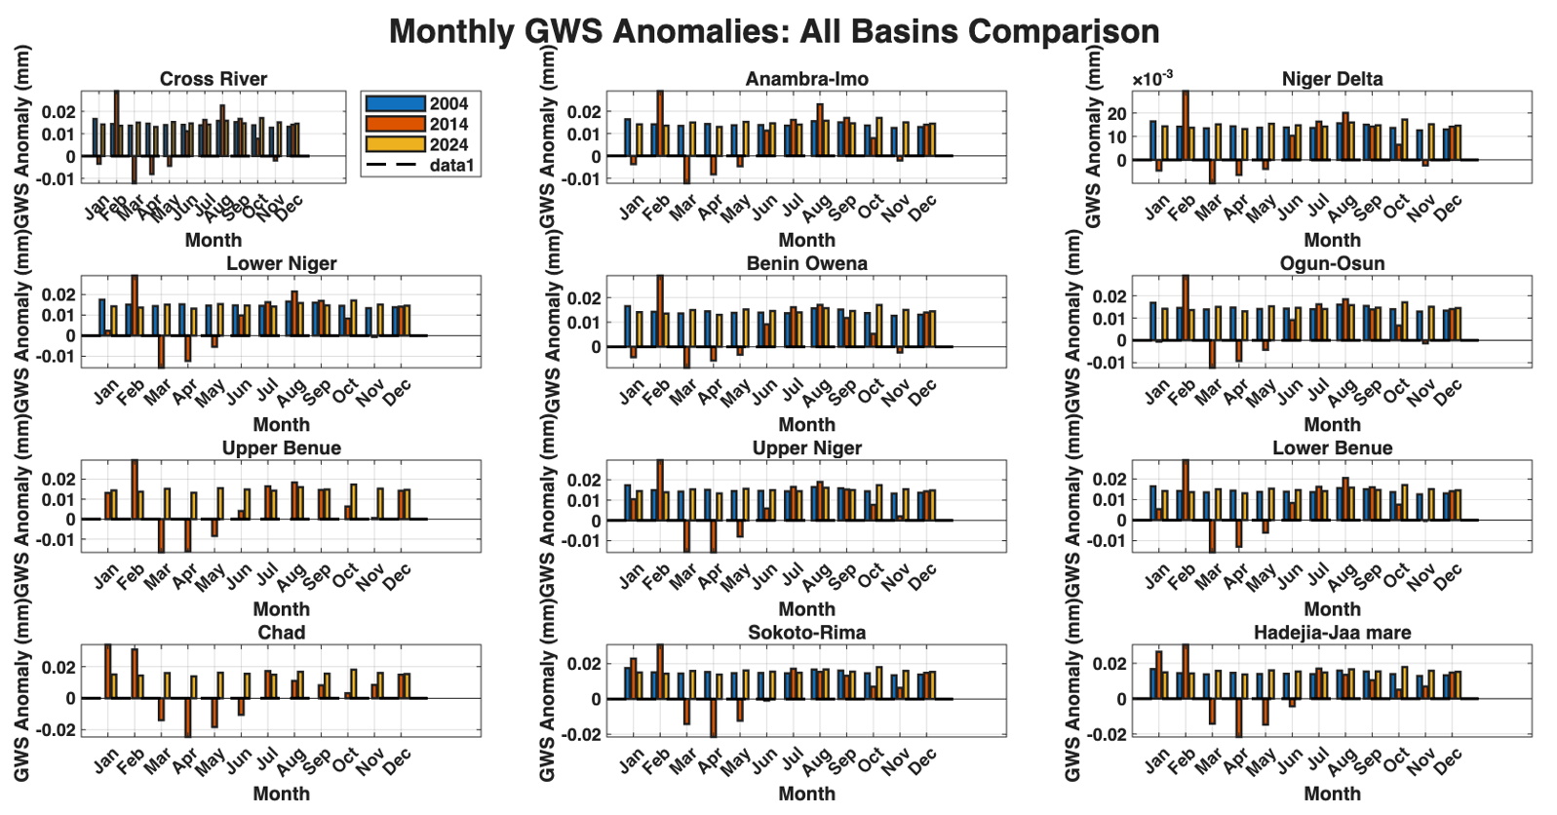
Figure 6: Plot showing Monthly GWS Anomalies in the Hydrological Basins

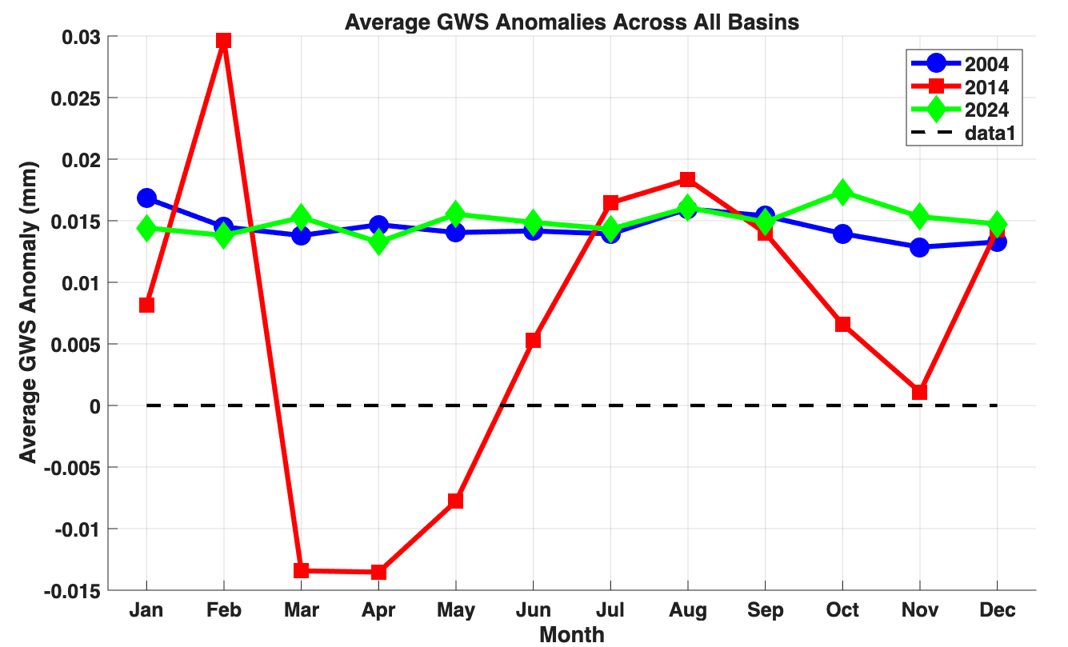
Figure 7: Plot showing the Average Monthly GWS Anomalies in the Hydrological Basins

3.1 Discussion of Results
The analysis of TWS anomalies for 2004, 2014, and 2024 (Tables 2a, 2b, 3a, 3b and 4a & 4b) reveals significant seasonal fluctuations across the river basins, with negative anomalies observed during the dry season and positive anomalies during the wet season. In 2004, the Lower Benue Basin exhibited a pronounced decrease in TWS during the dry season, January to March, (table 2a) followed by a

strong recovery during the rainy season, April to September, peaking at 106.80 in August (table 2b). This pattern is consistent with Hughes et al. (2005), who noted that water storage in tropical basins is highly responsive to seasonal rainfall. The observed positive anomalies during the wet season reflect the replenishment of water resources from precipitation and runoff, which is a well-established feature in the literature (Schwartz et al., 2010). Similarly, the Cross River Basin and Anambra-Imo Basin also showed negative anomalies in the dry season, with recovery observed from May through September. In 2014, the recovery of TWS in the rainy season was slightly less pronounced compared to 2004, which may indicate a reduction in the intensity of rainfall or an increase in evapotranspiration. This aligns with Rasmussen et al. (2018), who observed that longer dry spells and higher temperatures could diminish water retention in basins over time. By 2024, the peak TWS anomalies were significantly lower (52.50 in September), reflecting reduced water storage during the rainy season. This decline in peak TWS values could be linked to changing climatic conditions, such as decreased rainfall or increased evapotranspiration, supporting findings from Kunkel et al. (2017), who suggested that global climate change is influencing seasonal water storage patterns in sub-Saharan Africa. Figure 5 clearly shows the spatial variation of TWS anomalies, with higher values in the Southern basins (e.g., Lower Benue, Cross River) and lower values in the Northern, arid regions, which is consistent with the geographical distribution of rainfall in the region.
The analysis of seasonal variability and long-term trends in TWS further supports the findings of Objective 2 Figure 5 and tables 5a, 5b & 6. In 2004, the wet season (April to September) showed significant positive anomalies in TWS, with a peak in September (107.80), reflecting the typical seasonal replenishment of water resources. This is in line with the observations of Liu et al. (2012), who found that tropical river basins experience strong seasonal water storage dynamics. The dry season months showed negative anomalies, with January to March showing substantial deficits, which aligns with Chikwana et al. (2016), who highlighted that dry season deficits are a common feature in African hydrological cycles due to low precipitation and high evaporation. By 2014, while the seasonal pattern remained similar, the TWS anomalies were slightly lower, with a peak of 83.52 in September, which could reflect changes in rainfall intensity or increased evapotranspiration during the wet season. According to Foley et al. (2013), evapotranspiration can significantly impact the availability of surface and groundwater in tropical basins, and this could explain the reduced TWS in the southern basins during the wet season. In 2024, the long-term trend shows a decline in TWS anomalies, particularly in the rainy season. The peak TWS in September was much lower (52.50), suggesting that water storage has been increasingly affected by climate variability, potentially driven by changes in precipitation patterns or land use, as suggested by Bates et al. (2008), who argued that both climate change and land use changes are altering water storage dynamics in regions like Nigeria. Tables 6 provides a clear numerical representation of this shift, showing that over the years, the recovery of TWS during the wet season has become less pronounced.

In 2004, the groundwater variability table 7a & 7b and figure 6 shows a relatively stable trend throughout the year for most river basins. For instance, the Lower Benue Basin shows small fluctuations, starting at 0.016533 in January and remaining within a narrow range until December (0.013048). This suggests a steady groundwater level with minimal seasonal variation. Similar patterns are observed in the Cross River Basin, Anambra-Imo Basin, and other basins, where groundwater levels remain relatively constant, with slight fluctuations corresponding to the seasonal changes. Figure 7 provides a spatial variability map showing that groundwater in 2004 remained largely stable across the basins, with no significant seasonal rise or drop. This suggests that groundwater in these basins was not heavily impacted by rainfall or evapotranspiration during the year.
In 2014, the groundwater variability (Tables 8a & 8b) displays more pronounced fluctuations compared to 2004. For instance, the Lower Benue Basin begins with a low value of 0.005323 in January and shows more variation, with a dip to -0.01567 in March, followed by a recovery to 0.01407 in December. This could indicate periods of groundwater depletion in early months, possibly due to lower rainfall or increased evapotranspiration. Similar trends are seen in other basins like the Cross River and Anambra-Imo basins, where groundwater levels fluctuate, particularly in the middle of the year. Figure 6 & 7 shows that in 2014, the spatial distribution of groundwater variability is more dynamic, with certain basins, particularly in the south, experiencing more noticeable fluctuations in water storage compared to the year 2004.
In 2024, groundwater variability (Table 9a & 9b) follows a more stable trend, similar to 2004, with small fluctuations. For example, the Lower Benue Basin starts at 0.01421 in January and maintains a relatively constant range throughout the year, with the anomaly fluctuating between 0.013076 and 0.017089. This stability is also observed in other basins like the Cross River Basin, where the groundwater levels remain consistent throughout the months. Figure 6 &7 illustrates that in 2024, groundwater storage is still relatively stable across the regions, with some basins like Chad and Sokoto-Rima showing slightly higher fluctuations, which may indicate less stable groundwater conditions in arid or semi-arid areas. This trend was consistent across the Cross River, Anambra-Imo, and Lower Benue Basins.
4.0 Conclusion
The study has provided a comprehensive evaluation of Nigeria’s TWS and GWS across the hydrological river basins Nigeria. Seasonal fluctuations were evident, with wet seasons contributing to significant water accumulation and dry seasons marked by pronounced deficits. These patterns underscore the importance of understanding basin-specific responses to climatic inputs and the need for tailored water management strategies across diverse ecological zones. Seasonal analysis revealed a weakening in TWS recovery during recent wet seasons, particularly in 2024, suggesting a shift in hydrological balance likely driven by climate change and land use alterations. This trend poses risks to agricultural productivity, ecosystem stability, and water availability, especially in regions already vulnerable to drought. The study emphasizes the urgency of integrating seasonal forecasting and hydrological modeling into national water policies.
Groundwater levels remained relatively stable, acting as a buffer during dry spells, while surface water and soil moisture showed more immediate responses to rainfall and evaporation. The southern basins, such as Cross River and Lower Niger, consistently exhibited higher water retention due to favorable climatic conditions, whereas northern basins like Sokoto faced persistent water stress. In conclusion, the research contributes valuable insights into Nigeria’s hydrological dynamics and offers a foundation for sustainable water resource management. It advocates for basin-specific interventions such as groundwater recharge enhancement, climate-resilient land use practices, and improved monitoring systems. By aligning water governance with seasonal and spatial realities, Nigeria can better safeguard its water future in the face of evolving environmental challenges.

References
Ahi, G. O., and Cekim, H. O. (2021). Long-term temporal prediction of terrestrial water storage changes over global basins using GRACE and limited GRACE-FO data. Acta Geodaetica et Geophysica, 56(3), 321–344. https://doi.org/10.1007/s40328-021-00338-4
Ahile, S. I., Mailumo, D. A., and Ikape, M. O. (2024). Nigeria’s water crisis and the challenge of meeting the sustainable development goals. International Journal of Innovative Environmental Studies Research, 12(3), 156–164. https://www.seahipublications.org/wp- content/uploads/2024/07/IJIESR-S-15-2024.pdf
Baba-Ahmed, A. (2024). Water scarcity in Nigeria: Challenges, causes, and solutions. Applied Worldwide. https://nigeria.appliedworldwide.com/water-scarcity-in-nigeria-challenges- causes-and-solutions/
Baballe, M. A., Sani, S. A., Ibrahim, A., Musa, A. A., and Dahiru, M. (2023). Drawbacks of traditional environmental monitoring systems. Global Journal of Research in Engineering and Computer Sciences, 3(4), 1–12.
Bates, B.C., Kundzewicz, Z. W., Wu, S. & Palutikof, J. P. (Eds.). 2008. Climate Change and Water. Technical Paper of the Intergovernmental Panel on Climate Change (IPCC). Geneva: IPCC Secretariat.
Chikwana, R., Mzezewa, J. & van Rensburg, L.D. (2016). Rainfall variability, dry spells and their impact on maize yield in the Limpopo Province of South Africa. South African Journal of Plant and Soil, 33(3), 189-198. https://doi.org/10.1080/02571862.2015.1079934.
Famiglietti, J. S. (2004). Remote sensing of terrestrial water storage, soil moisture and groundwater. Hydrological Processes, 18(11), 2189–2196. https://doi.org/10.1002/hyp.5525
Foley, J. A., Ramankutty, N., & Brauman, K. A. (2013). Global consequences of land use. Science, 309(5734), 570-574. https://doi.org/10.1126/science.1111772
Getirana, A., Kumar, S., Girotto, M., and Rodell, M. (2017). Rivers and floodplains as key components of global terrestrial water storage variability. Geophysical Research Letters, 44(10), 10359–10368. https://doi.org/10.1002/2017GL074684
Hughes, D. A., & Smakhtin, V. U. (2005). Variability of water availability in river basins in the world’s arid and semi-arid regions. Hydrology and Earth System Sciences, 9(5), 209-222. https://doi.org/10.5194/hess-9-209-2005
Lui, J., Tian, H., Wood, E. F. & Vorosmarty, C. J. (2012). Water availability and variability in the tropics under climate change, 2(6), 404-409. https://doi.org/10.1038/nclimate1497
Kunkel, K. E., et al. (2017). Temperature and precipitation trends in the twentieth century. Geophysical Research Letters, 44(16), 8719-8728. https://doi.org/10.1002/2017GL073767
Landerer, F. W., Flechtner, F. M., Save, H., Webb, F. H., and Watkins, M. M. (2020). Extending the global mass change data record: GRACE Follow-On instrument and science data performance. Geophysical Research Letters, 47(12), e2020GL088306. https://doi.org/10.1029/2020GL088306
Landerer, F. W., Flechtner, F. M., Save, H., Webb, F. H., and Watkins, M. M. (2020). Extending the global mass change data record: GRACE Follow-On instrument and science data performance. Geophysical Research Letters, 47(12), e2020GL088306. https://doi.org/10.1029/2020GL088306
Rasmussen, P., et al. (2018). Impacts of climate change on water storage in regions with seasonal precipitation. Nature Climate Change, 8(5), 467-474. https://doi.org/10.1038/s41558-018-0167-6
Rodell, M., Chen, J., Kato, H., Famiglietti, J. S., and Nigro, J. (2005). Estimating groundwater storage changes in the Mississippi River Basin (USA) using GRACE. Hydrogeology Journal, 13(4), 639–653. https://doi.org/10.1007/s10040-004-0374-7
Rodell, M., Famiglietti, J. S., Wiese, D. N., Reager, J. T., Beaudoing, H. K., Landerer, F. W., and Lo, M. H. (2018). Emerging trends in global freshwater availability. Nature, 557(7707), 651–659. https://doi.org/10.1038/s41586-018-0123-1
Schwartz, R. J., et al. (2010). Hydrological trends in the changing climate of the global tropics. Journal of Climate, 23(11), 3125-3136. https://doi.org/10.1175/2010JCLI3580.1
Syed, T. H., Famiglietti, J. S., Rodell, M., Chen, J., and Wilson, C. R. (2008). Analysis of terrestrial water storage changes from GRACE and GLDAS. Water Resources Research, 44(2), W02433. https://doi.org/10.1029/2006WR005779
Tapley, B. D., Bettadpur, S., Ries, J. C., Thompson, P. F., and Watkins, M. M. (2004). GRACE measurements of mass variability in the Earth system. Science, 305(5683), 503–505. https://doi.org/10.1126/science.1099192
Wahr, J., Molenaar, M., and Bryan, F. (2004). Time variability of the Earth's gravity field: Hydrological and oceanic effects and their implications. Journal of Geophysical Research: Solid Earth, 109(B2), B02403. https://doi.org/10.1029/2003JB002897
Zehe, E., Becker, R., Bárdossy, A., and Plate, E. (2005). Uncertainty in hydrologic modeling and its implications for predicting the hydrologic response of small catchments. Advances in Water Resources, 28(8), 1013–1029. https://doi.org/10.1016/j.advwatres.2004.10.003

