Original Research Article

Seasonal Variability and Risk Assessment of Heavy Metals in Shallow Groundwater of Selected Areas in Oyo Town, Southwestern Nigeria

ABSTRACT
Groundwater remains the main source of potable water in many urban and peri-urban communities in Nigeria, particularly where municipal supply is inadequate. This study investigates the seasonal variability and potential health risks of heavy metals in shallow groundwater from selected areas of Oyo Town, Southwestern Nigeria. Forty groundwater samples (20 per season) were collected from hand-dug wells in both wet and dry seasons and analyzed for twelve heavy metals (Al, Cd, Fe, B, Ba, Co, Pb, Mn, Cr, Zn, Cu, Ni) using Inductively Coupled Plasma Mass Spectrometry (ICP-MS). Data were assessed using descriptive statistics, ANOVA, Pearson correlation, and U.S. EPA health risk assessment models. Results revealed that aluminum (Al), lead (Pb), iron (Fe), manganese (Mn), and cadmium (Cd) exceeded WHO guideline values in multiple locations. Seven metals (Al, Cd, B, Ba, Mn, Cr, and Cu) showed statistically significant seasonal variations (p < 0.05): cadmium (Cd) and chromium (Cr) were elevated in the wet season, while aluminum (Al) and manganese (Mn) were higher in the dry season. Hazard Index (HI) values indicated greater non-carcinogenic risk in the wet season, with all locations exceeding the safety threshold (HI > 1) for both adults and children; children consistently demonstrated greater vulnerability. These findings underscore the urgent need for systematic groundwater monitoring, stricter regulation of waste disposal and agricultural practices, and the provision of alternative safe water sources, in order to safeguard public health and promote sustainable groundwater use in Oyo Town.
Keywords: Groundwater quality, Heavy metals, Seasonal variation, Oyo Town, Water contamination, Nigeria.
1.0 INTRODUCTION
Groundwater is a vital freshwater resource for billions of people globally, particularly in countries where surface water is scarce or unreliable. In Nigeria, shallow hand-dug wells serve as a primary source of drinking water for urban and peri-urban populations. In Oyo Town, rapid urbanization and inadequate municipal water infrastructure have intensified dependence on groundwater (Adejumo and Adelowokan 2020; David 2013).
However, groundwater quality is increasingly threatened by contamination from both natural and anthropogenic sources. Natural contamination may arise from water–rock interactions, infiltration of poor-quality surface water (streams, rivers, lakes), seawater intrusion, or geothermal influences (Jolaosho et al., 2024). Heavy metals are of particular concern because of their toxicity, environmental persistence, and tendency to bioaccumulate (WHO, 2022; Hameed et al., 2020). Their sources include weathering of mineralized bedrock, leachates from domestic waste, agricultural runoff, industrial effluents, and vehicular emissions. In urban centers such as Oyo Town, risks are heightened during the rainy season due to increased infiltration and leaching of contaminants from waste dumpsites, markets, automobile repair workshops, and agricultural fields (Jolaosho et al., 2024; Ojekunle et al., 2022).
Previous studies in southwestern Nigeria have reported elevated concentrations of heavy metals such as cadmium (Cd), lead (Pb), manganese (Mn), and iron (Fe) in groundwater, often linked to the geochemistry of Basement Complex rocks and poor waste management practices (Agaku et al., 2025; Ojekunle et al., 2022). However, little attention has been given to the seasonal dynamics of heavy metal contamination in shallow aquifers, which are particularly vulnerable to surface pollution and direct recharge. Understanding these seasonal variations is crucial for identifying contamination pathways, assessing potential health risks, and guiding groundwater protection strategies.
Therefore, this study investigates the seasonal variability of heavy metal concentrations in shallow groundwater of Oyo Town and evaluates the associated non-carcinogenic health risks for adults and children. The findings are intended to provide scientific evidence for groundwater quality management, public health protection, and sustainable water use in rapidly urbanizing environments.
1.1 Study Area
Oyo Town lies within the tropical savannah climatic zone of southwestern Nigeria, with distinct wet (April–October) and dry (November–March) seasons. It is located between latitudes 7°47'N and 7°62'N, and longitudes 3°52'E and 4°00'E. The geology comprises Precambrian Basement Complex rocks, predominantly granites, gneisses, and migmatites, which influence groundwater chemistry through weathering and mineral dissolution. Recharge is mainly from direct rainfall infiltration and subsurface flow. Shallow wells are the main water sources due to limited municipal supply. Table 1 provides their corresponding geographic coordinates while Figure 1 shows the geological map of the sampling locations.
Table 1: Sample location coordinates
Sample Location | Latitude (°N) | Longitude (°E)
Cele | N7° 50' 35.024 | E3° 54' 31.576''
Isokun road | N7° 52' 49.12'' | E3° 55' 46.124''
Alayande | N7° 52' 24.924'' | E3° 54' 41.76''
Araromi 1 | N7° 49' 37.228'' | E3° 55' 48.452'
Araromi 2 | N7° 49' 45.264'' | E3° 55' 31.476''
Dacamca | N7° 48' 38" | E3 55' 60''
Mobolaje 1 | N7° 50' 26.076'' | E3° 56' 27.924''
Mobolaje 2 | N7° 50' 31.404'' | E3° 56' 14.46''
Bola | N7° 50' 50.256'' | E3° 55' 28.396''
Adesina | N7° 53' 30" | E3° 55' 42.5
Oke -Afin | N7° 51' 12" | E3° 55' 59"
Sakutu | N7° 51' 26" | E3° 56' 20"
Oke Alapo | N7° 51' 40" | E3° 50' 56"
Lagbodoko | N 7° 51' 17.7 | E03° 56 05.4
Iyalamu | N7° 51' 27" | E3° 56' 14"
Oke ebo 1 | N7° 50' 53" | E3° 56' 40"
Oke ebo 2 | N7° 51' 50" | E3° 56' 53"
Baago | N7° 50' 39" | E3°56' 33"
Oluajo | N7° 51' 8" | E3° 55' 57"
BodeThomas | N7° 51' 21" | E3° 58' 28"

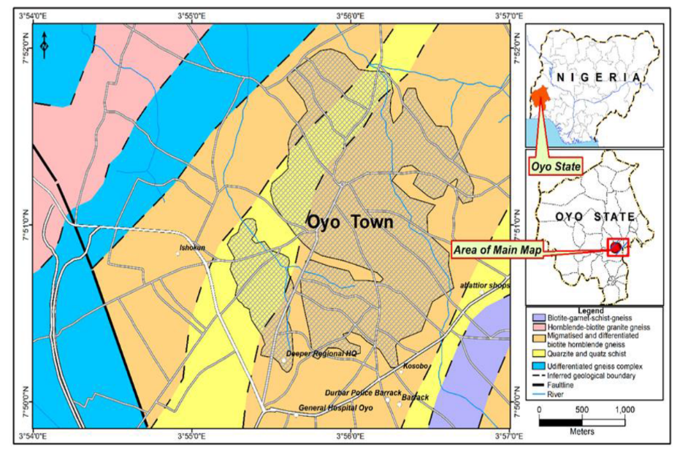
Figure 1: Geological map of the study area (modified after NGSA)
2.0 MATERIAL AND METHODS
2.1 Groundwater Sampling and Analysis
Groundwater samples were collected from 20 hand-dug wells during both the wet (April–October) and dry (November–March) seasons, giving a total of 40 samples. The wells, commonly used for domestic water supply, ranged between 3–12 m in depth (typical of shallow aquifers in the area). (Figure 1). Samples were collected in acid-washed, pre-cleaned 1 L polyethylene bottles, immediately acidified to pH < 2 using ultrapure nitric acid, stored in ice chests, and transported to the laboratory to minimize changes in chemical composition.

2.2 Laboratory Analysis
Twelve heavy metals (Al, Cd, Fe, B, Ba, Co, Pb, Mn, Cr, Zn, Cu, and Ni) were analyzed using Inductively Coupled Plasma Mass Spectrometry (ICP-MS) following standard APHA (2017) procedures. Instrumental detection limits ranged from 0.0001–0.005 mg/L, depending on the element.
Quality Assurance/Quality Control (QA/QC) measures involved the use of method blanks, duplicate samples, and certified reference materials (CRM) to verify accuracy and precision. Recovery rates for CRMs were within 90–110%.2.3 Data Analysis
2.3 Data Analysis
Descriptive statistics and one-way Analysis of Variance (ANOVA) were conducted using SPSS v26, with a 95% confidence level (p < 0.05) set for statistical significance. Post-hoc comparisons were applied to identify specific seasonal differences where applicable. Pearson correlation analysis was also performed to assess potential relationships and sources of heavy metals.

2.4 Health Risk Assessment
Non-carcinogenic health risks were assessed using the U.S. EPA (2011) model for oral ingestion. The chronic daily intake (CDI) of each metal was calculated using the formula:
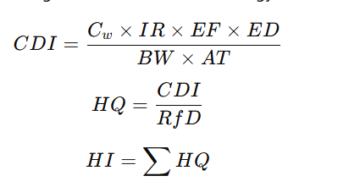
Where:
- Cw​ = metal concentration (mg/L)
- IR = ingestion rate (2 L/day for adults; 1 L/day for children)
- EF = exposure frequency (365 days/year)
- ED = exposure duration (30 years for adults; 6 years for children)
- BW = body weight (70 kg adults; 15 kg children)
- AT = averaging time (ED × 365 days)
- Rf= reference dose for each metal
The Hazard Quotient (HQ) was calculated as CDI/RfD, while the Hazard Index (HI) was obtained as the sum of HQs across metals. An HQ or HI value > 1 indicates potential health risk. Only the ingestion pathway was considered in this study.
3.0 RESULTS AND DISCUSSION
3.1 Heavy Metal Concentrations
Table 2 presents the seasonal concentrations of heavy metals in groundwater. The results reveal two dominant patterns. Aluminum (Al) concentrations were notably higher during the dry season, with a mean value of 3.92 mg/L and a maximum concentration of 42.652 mg/L. These values far exceed the WHO aesthetic guideline of 0.2 mg/L (WHO, 2022), suggesting intense mineral weathering but may also reflect anthropogenic inputs from refuse dumpsites and effluents from small-scale aluminum and metal workshops common in Oyo Town. The wet season showed a lower mean of 0.478 mg/L, though still above the recommended limit.
Cadmium (Cd) during the dry season had a mean of 0.00071 mg/L—within the WHO limit of 0.003 mg/L. However, the wet season value rose to 0.0237 mg/L, clearly surpassing the guideline. This elevation may be attributed to agricultural runoff, use of phosphate fertilizers, and leaching from industrial waste (Jolaosho, et al., 2024; Adimalla and Qian, 2021). In Oyo Town, intensive vegetable farming around peri-urban wells likely contributes to cadmium enrichment during the rainy season through fertilizer application and soil leaching.
Iron (Fe) was also present in elevated concentrations across both seasons. The dry season recorded a mean of 2.15 mg/L, while the wet season had 0.510 mg/L—both exceeding the WHO aesthetic limit of 0.3 mg/L (WHO, 2022). The higher levels in the dry season are likely due to oxidation and accumulation under low recharge conditions, as groundwater tends to concentrate solutes under limited recharge and enhanced evaporative effects (Aladejana et al., 2020). However, localized waste dumpsites and corroded roofing sheets discarded in residential areas may further contribute to iron enrichment in shallow wells.
Table 2: Seasonal concentrations of heavy metals in groundwater
Parameter (mg/L) | Season | Min | Max | Mean | Median | Std. Dev | WHO (mg/L)
Aluminum (Al) | Dry | 0.491 | 42.652 | 3.92 | 1.018 | 9.50 | 0.2
 | Wet | 0.066 | 1.952 | 0.478 | 0.134 | 0.604 | 0.2
Cadmium (Cd) | Dry | 0.0001 | 0.00025 | 0.00071 | 0.00025 | 0.00088 | 0.003
 | Wet | 0.0228 | 0.0240 | 0.0237 | 0.0239 | 0.00036 | 0.003
Iron (Fe) | Dry | 0.075 | 22.770 | 2.15 | 0.387 | 5.19 | 0.3
 | Wet | 0.020 | 4.524 | 0.510 | 0.031 | 1.129 | 0.3
Boron (B) | Dry | 0.006 | 0.101 | 0.025 | 0.012 | 0.027 | 2.4
 | Wet | 0.036 | 0.439 | 0.123 | 0.119 | 0.082 | 2.4
Barium (Ba) | Dry | 0.111 | 1.600 | 0.438 | 0.279 | 0.447 | 0.7
 | Wet | 0.031 | 0.261 | 0.156 | 0.156 | 0.055 | 0.7
Cobalt (Co) | Dry | 0.0001 | 0.125 | 0.014 | 0.0030 | 0.031
 | Wet | 0.0208 | 0.0271 | 0.0216 | 0.0210 | 0.0016
Lead (Pb) | Dry | 0.001 | 0.225 | 0.0189 | 0.003 | 0.0517 | 0.01
 | Wet | 0.029 | 0.053 | 0.038 | 0.036 | 0.006 | 0.01
Manganese (Mn) | Dry | 0.009 | 7.123 | 1.28 | 0.283 | 2.11 | 0.4
 | Wet | 0.049 | 0.639 | 0.146 | 0.069 | 0.179 | 0.4
Chromium (Cr) | Dry | 0.001 | 0.027 | 0.0043 | 0.001 | 0.0074 | 0.05
 | Wet | 0.028 | 0.033 | 0.030 | 0.0288 | 0.0017 | 0.05
Zinc (Zn) | Dry | 0.014 | 2.415 | 0.290 | 0.097 | 0.541 | 3.0
 | Wet | 0.009 | 0.809 | 0.156 | 0.105 | 0.182 | 3.0
Copper (Cu) | Dry | 0.001 | 0.123 | 0.0129 | 0.0035 | 0.0275 | 2.0
 | Wet | 0.011 | 0.072 | 0.050 | 0.054 | 0.015 | 2.0
Nickel (Ni) | Dry | 0.002 | 0.061 | 0.0105 | 0.006 | 0.0145 | 0.07
 | Wet | 0.0032 | 0.0062 | 0.0050 | 0.0052 | 0.00089 | 0.07
Boron (B) remained well within the WHO maximum permissible limit of 2.4 mg/L in both seasons, with mean concentrations of 0.025 mg/L (dry) and 0.123 mg/L (wet), indicating minimal health risk.
Barium (Ba) concentrations averaged 0.438 mg/L (dry) and 0.156 mg/L (wet), both below the WHO health-based guideline of 0.7 mg/L. This suggests that the groundwater is generally safe regarding barium toxicity (WHO, 2022).
Cobalt (Co) showed a seasonal increase from 0.014 mg/L in the dry season to 0.0216 mg/L in the wet. Although WHO has not set a guideline for cobalt, elevated levels may point to anthropogenic influences such as battery and metal waste (ATSDR, 2020).
Lead (Pb) exceeded the WHO limit of 0.01 mg/L in both seasons. The dry season mean was 0.0189 mg/L, and the wet season was even higher at 0.038 mg/L. This is a significant concern, as lead is highly toxic and can cause neurological and developmental damage, especially in children (WHO, 2022). The high lead levels can be linked to anthropogenic activities such as emissions from high traffic density, improper disposal of batteries, and waste burning in Oyo Town. Such sources intensify during the wet season when leaching and infiltration mobilize lead into groundwater.
Manganese (Mn) averaged 1.28 mg/L in the dry season—well above the WHO limit of 0.4 mg/L. However, wet season levels (0.146 mg/L) remained within acceptable range. Elevated manganese can cause staining, taste issues, and potential neurological effects at higher exposures (WHO, 2022). Given the geology of the Basement Complex terrain, natural geogenic weathering is expected; however, improper waste management and runoff from open markets may also enhance Mn loading in some locations.
Chromium (Cr) levels in both seasons were within the WHO limit of 0.05 mg/L. The wet season had a higher mean (0.030 mg/L) compared to the dry (0.0043 mg/L), possibly due to leaching from surface sources during rainfall. Given the geology of the Basement Complex terrain, natural geogenic weathering is expected; however, improper waste management and runoff from open markets may also enhance Mn loading in some locations.
Zinc (Zn) concentrations were safely within the WHO guideline of 3.0 mg/L, with 0.290 mg/L (dry) and 0.156 mg/L (wet). No health risk is expected from zinc at these levels.
Copper (Cu) values were far below the WHO limit of 2.0 mg/L in both seasons, with means of 0.0129 mg/L (dry) and 0.050 mg/L (wet), indicating safe levels.
Nickel (Ni) concentrations also remained within WHO limits (0.07 mg/L), with 0.0105 mg/L in the dry season and 0.0050 mg/L in the wet season.
3.2 Seasonal Variability (ANOVA)
Statistically evaluate the seasonal differences in heavy metal concentrations within groundwater from the study area, a one-way Analysis of Variance (ANOVA) was conducted for each parameter. Table 3 show comparison of the average concentration of the different heavy metals for both season of the year.
The results show that seven (7) of the twelve (12) analyzed heavy metals exhibit statistically significant seasonal variation (p < 0.05), indicating that their concentrations differ meaningfully between wet and dry periods.
Specifically, aluminum (Al) showed a highly significant difference (p = 0.0003), with concentrations markedly higher in the dry season. This pattern suggests reduced dilution during the dry period and possible geogenic contributions from weathered alumino-silicate minerals. Similarly, cadmium (Cd) presented a significant seasonal variation (p < 0.0001), with elevated wet season levels possibly linked to leaching from agricultural inputs and surface contamination.
Other metals that showed significant seasonal effects include boron (B), barium (Ba), manganese (Mn), chromium (Cr), and copper (Cu). These variations may result from differences in groundwater recharge, oxidation conditions, and land use dynamics between seasons.
Table 3: Comparison of average concentration of heavy metals in both season
Parameter | Dry Mean (mg/L) | Wet Mean (mg/L) | P-Value
Al | 3.9200 | 0.4780 | 0.0003
Cd | 0.0007 | 0.0237 | <0.0001
Fe | 2.1500 | 0.5100 | 0.3854
B | 0.0250 | 0.1230 | <0.0001
Ba | 0.4380 | 0.1560 | 0.0015
Co | 0.0140 | 0.0216 | 0.4295
Pb | 0.0189 | 0.0380 | 0.2573
Mn | 1.2800 | 0.1460 | 0.0391
Cr | 0.0043 | 0.0300 | <0.0001
Zn | 0.2900 | 0.1560 | 0.2395
Cu | 0.0129 | 0.0500 | 0.0059
Ni | 0.0105 | 0.0050 | 0.1783
In contrast, iron (Fe), lead (Pb), cobalt (Co), zinc (Zn), and nickel (Ni) did not exhibit statistically significant differences across seasons (p > 0.05). This may indicate that their sources are more stable and less influenced by seasonal hydrological processes or that background levels persist irrespective of seasonal change.
3.3 Correlation Analysis
The correlation analysis suggests common geochemical origins for some metals but also indicates anthropogenic influences. Table 4 shows the Pearson correlation matrix for the dry season; it revealed several strong positive associations among the heavy metals. Aluminum (Al) exhibited very strong positive correlations with iron (Fe, r = 0.93), zinc (Zn, r = 0.91), copper (Cu, r = 0.93), nickel (Ni, r = 0.90), and lead (Pb, r = 0.94), indicating common geochemical sources or similar geochemical behavior in groundwater. Such patterns often reflect lithogenic origins from weathering of aluminosilicate and sulfide minerals, as well as possible anthropogenic contributions (Jolaosho, et al., 2024; Aladejana et al., 2020)).
Iron (Fe) also demonstrated high correlations with zinc (r = 0.98) and copper (r = 0.95), suggesting mobilization through related hydrogeochemical processes such as mineral dissolution or contamination from agricultural inputs.
Cobalt (Co) correlated strongly with barium (Ba, r = 0.87), while manganese (Mn) showed moderate to strong associations with aluminum (r = 0.59), barium (r = 0.64), and cobalt (r = 0.76), which may indicate co-occurrence from ferromanganese oxides and hydroxides.
In contrast, boron (B) displayed generally weak and negative correlations with most metals, implying a different source or geochemical pathway, possibly linked to geogenic background rather than anthropogenic influx.
 | Al  mg/L | Cd  mg/L | Fe  mg/L | B  mg/L | Ba  mg/L | Co  mg/L | Pb  mg/L | Mn  mg/L | Cr  mg/L | Zn  mg/L | Cu  mg/L | Ni  mg/L
Al mg/L | 1
Cd mg/L | 0.52 | 1
Fe mg/L | 0.93 | 0.57 | 1
B mg/L | -0.07 | -0.07 | 0.15 | 1
Ba mg/L | 0.52 | 0.61 | 0.50 | -0.17 | 1
Co mg/L | 0.80 | 0.51 | 0.79 | -0.11 | 0.87 | 1
Pb mg/L | 0.94 | 0.60 | 0.98 | 0.02 | 0.51 | 0.79 | 1
Mn mg/L | 0.59 | 0.42 | 0.64 | 0.12 | 0.64 | 0.76 | 0.62 | 1
Cr mg/L | 0.69 | 0.37 | 0.71 | -0.02 | 0.29 | 0.56 | 0.74 | 0.38 | 1
Zn mg/L | 0.91 | 0.57 | 0.98 | 0.09 | 0.49 | 0.78 | 0.98 | 0.64 | 0.69 | 1
Cu mg/L | 0.93 | 0.56 | 0.95 | -0.02 | 0.49 | 0.79 | 0.96 | 0.59 | 0.74 | 0.98 | 1
Ni mg/L | 0.89 | 0.74 | 0.92 | -0.11 | 0.66 | 0.82 | 0.94 | 0.58 | 0.63 | 0.93 | 0.92 | 1
Table 4: Correlation Analysis for Dry season

Cadmium (Cd) showed a high correlation with barium (Ba, r = 0.78), implying shared origins, possibly from phosphate fertilizer residues or mineral dissolution. Aluminum (Al) maintained strong correlations with chromium (r = 0.79) and moderate correlations with lead (r = 0.56) and zinc (r = 0.59), pointing towards aluminosilicate weathering and associated trace metal release. Conversely, copper (Cu) displayed negative correlations with most metals, especially cadmium (r = –0.49) and nickel (r = –0.48), indicating it may be influenced by localized contamination sources such as plumbing corrosion or specific industrial discharges (Ojekunle et al., 2022).

For instance, strong associations of Pb with Cr and Zn in the wet season (Table 4) imply shared contamination pathways from vehicular emissions, roadside workshops, and waste burning, all of which are prevalent land-use activities in Oyo Town. Similarly, Cd’s strong correlation with Ba points toward fertilizer residues in agricultural zones.

The wet season correlation matrix Table 5 showed a different interaction pattern. Cobalt (Co) exhibited a very strong correlation with iron (Fe, r = 0.99) and manganese (Mn, r = 0.91), highlighting their possible joint mobilization during wetter periods, likely due to redox changes or enhanced leaching from soils. Lead (Pb) correlated strongly with chromium (Cr, r = 0.84) and zinc (Zn, r = 0.74), suggesting a mixture of lithogenic sources and similar anthropogenic influences such as industrial effluents and vehicular emissions (Krishna and Mohan 2014)

Table 5: Correlation Analysis for wet season
 | Al  mg/L | Cd  mg/L | Fe  mg/L | B  mg/L | Ba  mg/L | Co  mg/L | Pb  mg/L | Mn  mg/L | Cr  mg/L | Zn  mg/L | Cu mg/L | Ni  mg/L
Al mg/L | 1
Cdmg/L | 0.19 | 1
Femg/L | 0.35 | -0.15 | 1
B mg/L | -0.11 | 0.39 | -0.13 | 1
Bamg/L | 0.49 | 0.78 | 0.09 | 0.23 | 1
Comg/L | 0.28 | -0.21 | 0.99 | -0.13 | 0.04 | 1
Pbmg/L | 0.56 | 0.33 | 0.67 | -0.06 | 0.52 | 0.65 | 1
Mnmg/L | 0.28 | -0.09 | 0.88 | -0.08 | 0.19 | 0.91 | 0.77 | 1
Crmg/L | 0.79 | 0.18 | 0.70 | -0.10 | 0.46 | 0.65 | 0.84 | 0.69 | 1
Znmg/L | 0.59 | 0.23 | 0.49 | -0.14 | 0.31 | 0.47 | 0.74 | 0.48 | 0.62 | 1
Cumg/L | -0.06 | -0.49 | -0.13 | -0.02 | -0.36 | -0.08 | -0.34 | -0.12 | -0.17 | -0.36 | 1
Nimg/L | 0.49 | 0.51 | 0.43 | -0.09 | 0.54 | 0.36 | 0.56 | 0.36 | 0.67 | 0.47 | -0.48 | 1
3.4. Health Risk Assessment
The Hazard Index (HI) values for the twenty groundwater sampling locations indicates notable seasonal and demographic variations in potential non-carcinogenic health risks. Table 6 presents the Hazard Index values for adults and children during the dry season, while Figure 2 illustrates the same data in bar chart format. The results show that HI values for adults exceeded the safety threshold of unity (HI > 1) in only three locations (15%), with a maximum HI of 3.16, primarily attributable to manganese (Mn) and chromium (Cr) exposure. In contrast, children exhibited higher susceptibility, with HI exceedances in eight locations (40%) and a maximum HI reaching 7.37. Manganese remained the dominant risk driver for children in this period, consistent with its neurotoxic potential at elevated exposure levels (ATSDR, 2022).
Table 7 presents the Hazard Index values for adults and children during the wet season, while Figure 3 provides a bar chart visualization of the same data. The results reveal a more critical scenario compared to the dry season, as HI values exceeded unity (HI > 1) in all sampling locations (100%) for both adults and children. For adults, HI values reached up to 4.85, with cadmium (Cd) and chromium (Cr) identified as the major contributors. Children were significantly more vulnerable, with HI values ranging as high as 11.42, predominantly driven by Cd and Cr exposure. The widespread exceedances during the wet season underscore the influence of land-use activities such as agricultural runoff, leaching from waste disposal sites, and infiltration of contaminated surface water, which intensify during periods of high rainfall (Wali et al., 2025; Iqbal et al., 2023).

Table 6: Hazard Index for Dry season Adult and Children
Location | Hazard Index for Adult | Hazard Index for Children
Cele | 0.254392 | 0.593582
Isokun road | 0.097637 | 0.22782
Alayande road | 0.056297 | 0.13136
Araromi 1 | 0.063916 | 0.149138
Araromi 2 | 0.076719 | 0.179011
Dankanka | 1.16429 | 2.716677
Mobolaje 1 | 0.559705 | 1.305979
Mobolaje 2 | 0.186841 | 0.435963
Bola | 0.295249 | 0.688915
Adesina | 0.500138 | 1.166989
Oke -Afin | 0.146968 | 0.342926
Sakutu | 0.489127 | 1.141296
Oke Alapo | 0.809177 | 1.888079
Lagbodoko | 0.077467 | 0.180757
Iyalamu | 0.323859 | 0.755672
Oke ebo 1 | 0.193247 | 0.45091
Oke ebo 2 | 1.472726 | 3.43636
Baago | 3.15915 | 7.371349
Oluajo | 0.775934 | 1.810513
Bode Thomas | 0.241957 | 0.564566

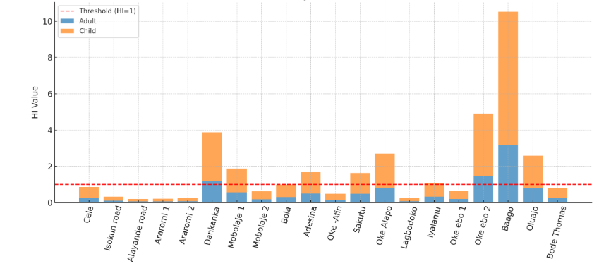
Figure 2: Hazard Index (HI) values for adults and children during the dry season across groundwater sampling locations in Oyo Town. The red dashed line represents the safety threshold (HI = 1). Children consistently show higher HI values than adults, with exceedances observed in 40% of locations.

Table 7: Hazard Index for Wet Adult and Child
Location | Hazard for Adults | Hazard for Children
Cele | 2.409653 | 5.622523
Isokun road | 2.500779 | 5.835151
Alayande road | 2.513313 | 5.864398
Araromi 1 | 2.449875 | 5.716375
Araromi 2 | 2.640124 | 6.16029
Dankanka | 2.406545 | 5.615271
Mobolaje 1 | 2.518302 | 5.876038
Mobolaje 2 | 2.393023 | 5.58372
Bola | 2.426247 | 5.661243
Adesina | 2.288819 | 5.340577
Oke -Afin | 2.408878 | 5.620715
Sakutu | 2.3798 | 5.552866
Oke Alapo | 2.624184 | 6.123097
Lagbodoko | 2.390945 | 5.578873
Iyalamu | 2.562134 | 5.978314
Oke ebo 1 | 2.291726 | 5.347361
Oke ebo 2 | 2.410479 | 5.624451
Baago | 2.417179 | 5.640084
Oluajo | 2.403118 | 5.607276
Bode Thomas | 2.641133 | 6.162643

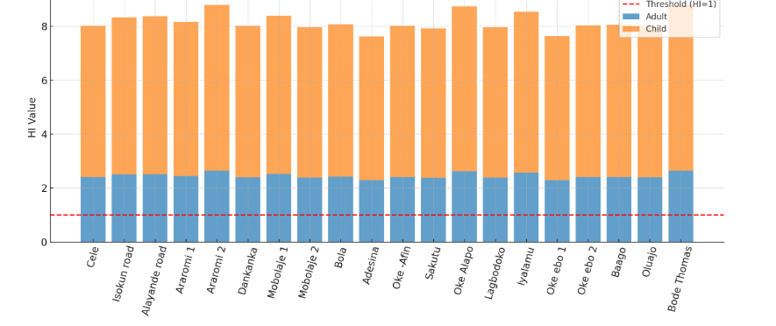
Figure 3: Hazard Index (HI) values for adults and children during the wet season across groundwater sampling locations in Oyo Town. All locations recorded HI values greater than unity, with significantly higher risks for children compared to adults.
A seasonal comparison is shown in Figure 4, where the contrast between wet and dry seasons highlights the pronounced vulnerability of children and the widespread exceedance of HI in the wet season, this is likely due to enhanced mobilization of metals into groundwater through surface runoff, leaching of contaminated soils, and intensive land-use activities in Oyo Town, particularly poorly managed waste dumpsites, roadside mechanic workshops, open markets, and agricultural fields. (Agaku et al., 2025; Iqbal et al., 2023). The higher vulnerability of children compared to adults can be attributed to their lower body weight, higher water intake per body mass unit, and greater physiological sensitivity to toxicants (USEPA, 2011).
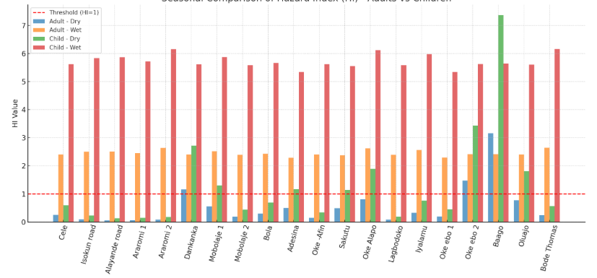
Figure 4: Seasonal comparison of Hazard Index (HI) values for adults and children in Oyo Town. The plot highlights the marked increase in HI values during the wet season, with children showing consistently greater vulnerability across all locations.
4.0 CONCLUSION
This study assessed the seasonal variability of heavy metals in shallow groundwater from selected areas of Oyo Town, Southwestern Nigeria, and their associated non-carcinogenic health risks. The findings revealed that aluminum (Al), cadmium (Cd), lead (Pb), iron (Fe), and manganese (Mn) frequently exceeded WHO guideline values across both wet and dry seasons. Seasonal variations were evident: geogenic-driven metals such as Al, Fe, and Mn were elevated during the dry season due to reduced dilution, mineral weathering, and redox conditions, while anthropogenic-driven metals including Cd, Cr, Pb, B, and Cu were more pronounced in the wet season, influenced by fertilizer application, leaching from dumpsites, and surface runoff. Health risk assessment indicated that children were more vulnerable than adults, with Hazard Index (HI) values exceeding the safe threshold in 40% of locations during the dry season and in all locations during the wet season, where Cd and Cr were the dominant risk drivers.
These results highlight serious health implications. Elevated levels of Pb, Cd, and Mn pose risks of neurological, renal, and developmental disorders, particularly in children, while the widespread exceedance of HI during the wet season underscores the vulnerability of shallow aquifers to both natural and anthropogenic contamination. The findings demonstrate that Oyo Town, like many rapidly urbanizing Nigerian communities, faces significant water quality challenges that threaten the sustainability of groundwater as a safe drinking water source.
To mitigate these risks, urgent interventions are required. Regular groundwater quality monitoring should be institutionalized to detect contamination trends early. Strict regulation of waste management and agricultural practices is needed to minimize leaching of toxic metals. Communities should be sensitized to the health risks associated with contaminated groundwater and encouraged to adopt household-level treatment methods such as filtration or boiling where feasible. In the long term, provision of alternative safe water sources, improved sanitation, and enforcement of environmental protection laws are essential to safeguard public health and ensure sustainable groundwater use in Oyo Town.

REFERENCES
Adejumo, B. A., and Adelowokan, T. A. (2020). Characteristics of hand-dug wells in urban centres: A case study of Ibadan, Southwestern Nigeria. The International Journal of Humanities & Social Studies, 8(3), 130–136. https://www.internationaljournalcorner.com/index.php/theijhss/article/view/151668
Adimalla, N., and Qian, H. (2021). Groundwater quality evaluation using water quality index (WQI) for drinking purposes and human health risk (HHR) assessment in an agricultural region of Nanganur, South India. Ecotoxicology and Environmental Safety, 207, 111277. https://doi.org/10.1016/j.ecoenv.2020.111277
Agaku, R. M., Ikyumbur, J. T., Amanyi M. I., and Onwoke, E. E. (2025). Assessment of Heavy Metals Concentration in Ground Water in Gboko, Nigeria. Nigerian Journal of Physics, 34(1), 122-133. https://doi.org/10.62292/njp.v34i1.2025.390.
Agency for Toxic Substances and Disease Registry (ATSDR). (2020). Toxicological profile for lead. U.S. Department of Health and Human Services, Public Health Service. https://www.atsdr.cdc.gov/toxprofiles/tp13.pdf
Aladejana, J. A., Kalin, R. M., Sentenac, P., & Hassan, I. (2020). Assessing the impact of climate change on groundwater quality of the shallow coastal aquifer of Eastern Dahomey Basin, Southwestern Nigeria. Water, 12(1), 224. https://doi.org/10.3390/w12010224
David, O. O. (2013). Sustainable Groundwater Exploitation in Nigeria. Journal of Water Resources and Ocean Science, 2(2), 9-14. https://doi.org/10.11648/j.wros.20130202.11
Hameed, M., Khurshid, Z., Bhat, R. A., and Qayoom, I. (2020). Concerns and threats of heavy metals' contamination on aquatic ecosystem. In V. S. Sharma & A. K. Varma (Eds.), Bioremediation and biotechnology (Vol. 4): Techniques for noxious substances remediation (pp. 1–21). Springer. https://doi.org/10.1007/978-3-030-48690-7_1
Iqbal, M. (2023). Hydrogeochemical characteristics and quality assessment of groundwater in agricultural regions. Groundwater for Sustainable Development, 20, 100857.
Jolaosho, T. L., Mustapha, A. A., and Hundeyin, S. T. (2024). Hydrogeochemical evolution and heavy metal characterization of groundwater from southwestern Nigeria: An integrated assessment using spatial, indexical, irrigation, chemometric, and health risk models. Heliyon, 10(19), e38364. https://doi.org/10.1016/j.heliyon.2024.e38364
Jolaosho, T. L., Mustapha, A. A., and Hundeyin, S. T. (2024). Hydrogeochemical evolution and heavy metal characterization of groundwater from southwestern Nigeria: An integrated assessment using spatial, indexical, irrigation, chemometric, and health risk models. Heliyon, 10(19), e38364. https://doi.org/10.1016/j.heliyon.2024.e38364
Krishna, A.K., and Mohan, K.R. (2014) Risk assessment of heavy metals and their source distribution in waters of a contaminated industrial site. Environ Sci Pollut Res 21, 3653–3669. https://doi.org/10.1007/s11356-013-2359-5
Ojekunle, O. Z., Rasaki, A., Taiwo, A. M., Adegoke, K. A., Balogun, M. A., Ojekunle, O. O., Anumah, A. O., Ibrahim, A. O., and Adeyemi, A. (2022). Health risk assessment of heavy metals in drinking water leaching through improperly managed dumpsite waste in Kurata, Ijoko, Sango area of Ogun State, Nigeria. Groundwater for Sustainable Development, 18, 100792. https://doi.org/10.1016/j.gsd.2022.100792
United States Environmental Protection Agency (USEPA). (2023). Integrated Risk Information System (IRIS). https://www.epa.gov/iris
Wali S.U., Usman A.A., Danladi P., Usman H.M., and Aliyu S.(2025) Assessment of heavy metals (As, Ba, Co and Ni), pollution in rural drinking water sources, using correlation and principal component analysis in Western Sokoto Basin, Nigeria. Int J Hydro. 2025;9(2):60‒72.DOI: 10.15406/ijh.2025.09.00404

