Original Research Article

DESIGN, SIMULATION, AND FABICATION OF A COCONUT DEHUSKING MACHINE

Abstract- Coconut dehusking is a critical post-harvest operation in coconut processing, particularly in developing countries where the process is still largely carried out manually using machetes or spike-based tools. These traditional methods are labour-intensive, unsafe, time-consuming, and often result in damage to the coconut shell and meat. This study presents the design, simulation, and fabrication of an electrically powered coconut dehusking machine aimed at improving efficiency, safety, and product quality. The machine utilises a pair of counter-rotating roller blades that bite and tear the husk from the coconut without penetrating the shell, thereby minimising the breakage associated with conventional spike mechanisms. The design methodology involved conceptual development, component selection, and analytical calculations to determine key parameters such as coconut geometry, torque, power requirement, and gear transmission. A three-dimensional computer-aided design (CAD) model of the machine was developed and subjected to kinematic and finite element simulations to assess its operational behaviour and structural integrity before fabrication. The machine was subsequently fabricated using locally available materials and assembled into a functional prototype. Performance evaluation of the fabricated machine shows that it can dehusk approximately 200–250 coconuts per hour, with reduced labour input and improved operational safety. The results demonstrate that the developed machine is efficient, economical, and suitable for small- to medium-scale coconut processing enterprises. This work provides a practical approach to integrating design analysis, simulation, and fabrication in the development of indigenous agricultural processing equipment.
Keywords: Coconut, Dehusking machine, Mechanical design, Roller blade mechanism, CAD simulation, Fabrication, Agricultural mechanisation.

INTRODUCTION
Coconut palm (Cocos nucifera L.) is a member of the family Arecaceae (palm family) and the only species of the genus Cocos (Nampoothiri et al., 2018) that is widely cultivated and consumed globally. The coconut fruit is a drupe, not a true nut. A coconut has three layers: exocarp, mesocarp, and endocarp (Library of Congress, 2019). The exocarp and mesocarp make up the husk of the coconut. The mesocarp or “shell” thus exposed is the hardest part of the coconut and is composed of fibres called coir (Oladele et al., 2022). However, the outer shell of the coconut is smooth and greenish or yellowish or brownish, while the inner shell that surrounds the seed, which is the white coconut meat, is brown and hard. The size of a coconut with husk varies from 145 to 200 mm in diameter, and it can be 200 to 300 mm long (Piyathissa and Kahandage, 2016). The thickness of the outer shell, which is also called the husk, is about 25 – 50 mm thick (Friday Aje Ovat et al., 2019). Moreover, the different parts of a coconut can be used for domestic, commercial, and industrial purposes. They are part of the daily diet of people. In some villages in Nigeria, the coconut husk is used for cooking, the coir or the fibre is used for making mats, carpets, ropes, and nets, while the liquid (Coconut water) stored in the nut is used for drinking, cooking, and also for making coconut oil. Coconut is known for greater versatility than other fruits (Balaji and Abinaya, 2024; Olorunfemi et al., 2022).
In Nigeria, coconut contributes significantly to household nutrition and small-scale agro-based enterprises, with its husk, shell, water, and meat finding diverse uses in local and commercial settings. Despite its economic importance, one of the major challenges in coconut processing remains the removal of the tough outer husk, a post-harvest operation that is essential before further utilisation of the nut. There is a need to improve the method of dehusking coconuts in Nigeria, as the manual method mostly used is somewhat unsafe, uncomfortable, and uneconomical. It exposes the workers to injury from sharp objects and heavy lifting. With the development and advancement in technology, machines and some special means have been developed to carry out the removal of the husk, depending on the particular kind of nuts in question, to appropriately separate and/or treat the nut to recover either the husk/or the meat area.
A critical review of existing mechanised coconut dehusking machines reveals that many designs rely on penetrating spikes or sharp projections to pierce and tear the husk. While effective to some extent, such mechanisms often lead to cracking of the shell, damage to the endosperm, and inconsistent dehusking performance. Furthermore, spike-based systems may pose additional safety risks to operators. These limitations highlight the need for improved machine concepts that can achieve efficient husk removal while preserving coconut quality and ensuring safer operation. Consequently, alternative mechanisms that rely on controlled biting and tearing actions rather than penetration are desirable for enhanced performance.
In response to these challenges, this study proposes the development of an electrically powered coconut dehusking machine that employs a pair of counter-rotating roller blades to remove the husk through a controlled peeling and tearing action. Unlike conventional spike mechanisms, the roller blade system is intended to minimise shell breakage and product loss while maintaining high dehusking efficiency. The machine is designed using locally available materials and simple power transmission elements such as gears, chains, and sprockets, which makes it suitable for small- and medium-scale agro-processing enterprises in developing economies.
Therefore, this research aims to design, simulate, and fabricate a coconut dehusking machine that is efficient, safe, and cost-effective. The specific objectives are to:
- Develop a conceptual and analytical design of the machine based on coconut geometric and mechanical requirements;
- Create a CAD model and perform kinematic and finite element simulations to assess operational feasibility and structural integrity; and
- Fabricate a functional prototype and evaluate its dehusking capacity and practical performance.

LITERATURE REVIEW
The coconut palm (Cocos nucifera) probably originates from the tropical regions of Southeast Asia and Melanesia. For thousands of years, it has been an important part of the region's economy and culture. Coconuts are often referred to as the "tree of life" because they provide food, shelter, clothing, and even medicine (Foale, 2019). Coconut is a common ingredient in most Nigerian households. It is commonly used in cuisine, such as coconut rice, and in the production of coconut oil (Parmar et al., 2020). In the country of Nigeria. Coconut is sometimes eaten raw because of its great nutritional value, benefits to heart health, contributions to blood sugar regulation, potent antioxidants, and fibre content. Water for rehydration, milk for dairy alternatives, coconut cream for cooking, and dessicated coconut for baking are all available in coconut. In botany, husk is the outer shell of a seed. It may also refer to the leafy outer covering of a coconut. A husk is the protective outer layer of a seed, fruit, or vegetable. The husk of nuts is not always edible and should be removed before consuming the nut meat inside. The diameter and length of a coconut husk can range from 145 to 200 mm. Though coconut is widely used throughout Nigeria, dehusking is a difficult task (Friday Aje Ovat et al., 2019).
Coconut dehusking is the process of removing the husk from a coconut. Coconut dehusking is one of the most demanding post-harvest processes (VARGHESER & JACOB, 2014). Coconut farmers in Nigeria and around the world have traditionally utilised a crowbar-shaped instrument of iron or wood mounted vertically with the tip of the above or a machete to de-husk a coconut (Rahul Sabale, 2016). Conventional technology has limitations, such as the need for great strength and specialised skills, the risk of the blade crushed coconut injuring a hand or foot, and the time-consuming and uncomfortable de-husking position (Candra B Satriardi et al., 2016). Traditional dehusking is done manually with a machete or a crowbar, which requires a lot of human effort, expertise, and training. After considering the extra work and energy required to dehusk coconut, as well as the very limited results obtained, it became clear that a mechanised and more efficient method of dehusking was required. Jippu Jacob, then an Associate Professor at the Kelappaji College of Agricultural Engineering and Technology (KCAET) of the Kerala Agricultural University (KAU), invented the first coconut dehusking machine. This machine removes the coconut husk froms the coconut to produce dehusked coconut using two rotating rollers with spikes at the tips. Coconut husk can also be used in downstream industries. Coconut husk can be used as a raw material in numerous industries, including spring beds, mattresses, car seats, vehicle seats, pillows, rugs, rope, net, doormats, carpets, and vehicle dashboards.
In the mid-20th century, electric and gasoline-powered machines were developed to replace old manual models. These machines use rotating blades or rollers to cut and strip coconut shells. They are much faster and more efficient than their predecessors, but they still have their drawbacks. For example, they are often noisy, heavy, and require considerable maintenance. In recent years, advances in technology have led to the development of more complex coconut peeling machines. These machines use a variety of techniques to remove coconut shells, including abrasive sandblasting, water jet, and mechanical rollers. They are usually computer-controlled and can be programmed to handle different sizes and shapes of coconuts. However, one of the main advantages of modern coconut peeling machines is that they are much more efficient and precise than previous models. They can process large quantities of coconuts in a relatively short time and with little waste. This is especially important where coconut production is a major industry, as it can help reduce labour costs and increase productivity (I.U. Onyenanu & U.O. Uwadibe, 2024).
Chandra Dinath explained the machine's obvious way to remove the husk from the coconut using the majority of rollers that rotate in opposite directions appropriately. Thus, each roller incorporates the majority of the infiltrating spikes placed to effectively enter and connect to the shell segment. Coconut. The connection of the rollers is mixed with the holding action of the head, which has the effect of tearing the coconut shell, leaving the bare coconut without the shell. Rahul Sabale says that “many agricultural equipment items are developed for post-harvest operations as all post-harvest operations are tedious tasks to perform”. The coconut peeling stage is considered the longest, most stressful, most tiring, and most difficult to perform. Many attempts have been made to carry out this shelling mission manually as well as by mechanised methods. This shelling mission was traditionally performed with different hand tools such as crowbars and machetes, depending on the skill of the worker and sometimes involving training. Machines or mechanisation were also developed to eliminate the low output caused by hand tools. Such machines were developed all over the world, and very few became popular. "The basic purpose of this machine is to suck out the coconut shell and get rid of the traditional method of peeling," says Vijay Kumar G Tile. The outer shell of a coconut is hard, about 1 to 2 inches thick. This article deals with the improvement and structure of the pneumatic coconut shelling machine. This company plans to provide a machine with high performance and an affordable price to coconut growers and the coconut industry.
MATERIALS AND METHODS
This study adopted a design-based engineering approach that integrates conceptual development, analytical design, computer-aided modelling and simulation, and physical fabrication of a coconut dehusking machine. The methodology was structured to progress from problem definition and concept generation to prototype development and performance assessment.
Conceptual Design and Working Principle
The conceptual design of the coconut dehusking machine was developed after a critical review of existing manual and mechanised dehusking methods. The design emphasises overcoming the limitations of spike-based mechanisms, which often damage the coconut shell and kernel. The proposed machine uses a pair of counter-rotating rollers fitted with blades that bite and tear the husk from the coconut through a controlled peeling action rather than penetration. The machine is electrically powered and consists of two main dehusking rollers, a roller flap for holding and guiding the coconut, and a power transmission system, which comprises a geared reduction motor, a chain and sprocket arrangement, and spur gears. Also, torque is transmitted from the electric motor to one roller via a chain and sprocket, while the second roller is driven through a gear pair, ensuring synchronised counter-rotation.
Machine Components and Materials
These components and their uses are shown in Table 1, while Table 2 shows the material selection, which was guided by mechanical strength requirements, resistance to weather, ease of fabrication, and suitability of local sourcing.
Table 1: Components of the Coconut Dehusking Machine and Their Uses
S/N | Element | Diagram | Proposed Usage
1 | Machine Frame | Figure 1: Frame of a dehusking machine  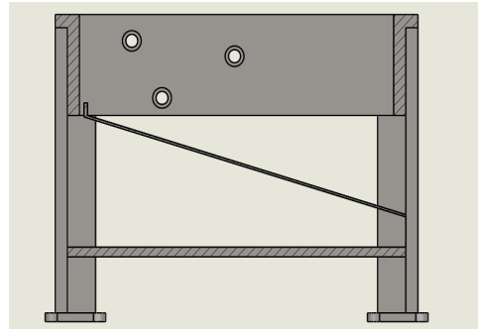 | The machine frame is a metallic structure welded together to serve as the support, base, and body of the machine. It is formed by welding angle iron and metal sheets together.
2 | Shaft | 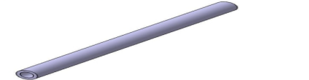  Figure 2: Shaft | A long piece of circular metal used for transmitting rotary motion and torque from one point to the other in a machine. Shafts are machined on and are considered based on length and diameter.
3 | Roller with Blade | 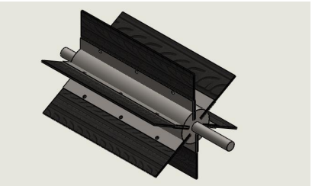  Figure 3: Roller with Blade | A roller having blades attached to it through the allen nuts to make it replaceable for ease of maintenance or replacement, welding or machining process and the blade rotates on the same axis as the roller. The blade attached to the roller has a sharp edge to serve the purpose of peeling circular objects in any direction.
4. | Roller with Flap | 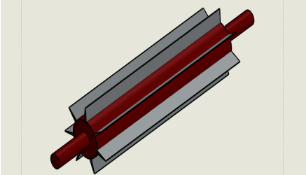  Figure 4: Roller with Flap | A flap is attached to the roller through the machining process, and the flap rotates on the same axis as the roller. The flap is a rubber-like material with a different kind of thickness, and it is mostly used for in-feed or mounting pressure in an operation. The kind of thickness needed to be attached to the roller is dependent on the kind of pressure needed to be mounted.
5 | Bearing (Pillow) | 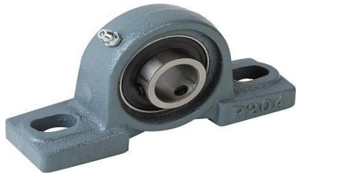  Figure 5: Bearing (Pillow) | This is assemblies consist of rolling elements and usually inner and outer races, which are used for rotating or linear shaft applications. This project is used to provide support for a rotating shaft with the help of compatible bearings and various accessories. The assembly consists of a mounting block that houses a bearing.
6 | Spur Gears Gear system | 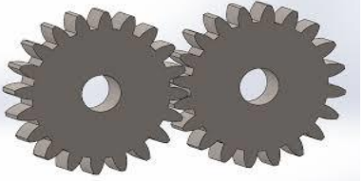  Figure 6: Spur Gears Arrangement | Used for transmitting torque from one shaft to the other at very short or closed distances
7 | Chain and Sprocket System | 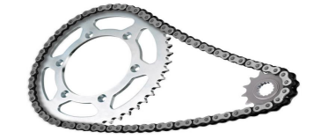  Figure 7: Chain and Sprocket System | Chains and sprockets are power transmission components used to transfer power from the electric motor to other parts of the machine that need to be driven. It is used to transmit a large force and avoid slippage.
8 | Electric Geared Reduction Motor | 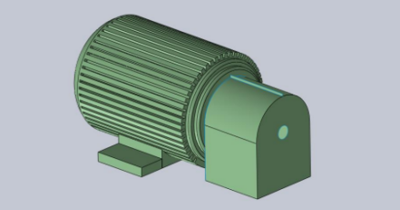  Figure 8: Electric Geared Reduction Motor | An electric geared reduction motor is to be used because the dehusking process doesn’t need high speed. It is an all-in-one combination of an electric motor and gearbox to reduce the actual speed of the motor to the desired speed. This makes the reduction of speed possible, with high torque required for sharing the coil off the nut.
9 | Coupling | 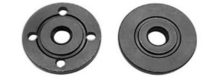  Figure 9: Coupling | Usually used between the output and input shafts for continuous rotation in the same direction.
10 | Bolts and Nuts | 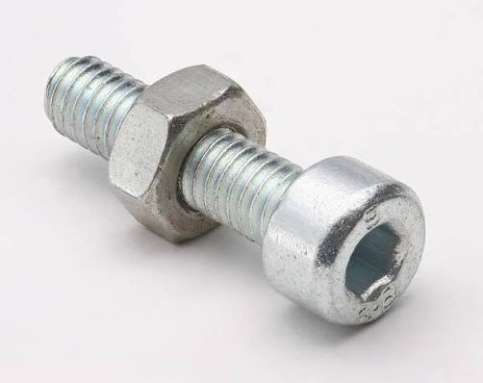  Figure 10: Bolt and nut | For the component’s assembly at the temporal joints, for ease of disassembly during repair and maintenance. These also give grip and firmness to jointed parts.
11 | Discharge Part (orifice) |  | The discharge part is responsible for displacing the deshusked coconut and the husk removed from the machine.

Table 2: Material Selection for Fabrication
S/N | Component | Usable Materials | Selected | Reason for selection
1 | Gear | - Copper alloys  - Iron alloys  - Aluminium alloys  - Thermoplastics  - High carbon steel | High carbon steel | A high level of ductility in the brass alloy
2 | Sprocket | - Cast iron  - Plastic  - Steel  - Stainless steel  - High carbon steel | High carbon steel | It is the most common and economical material.
3 | Shaft | - Mild steel  - Stainless steel  - Chrome-plated carbon steel  - Carbon fibre | Mild steel | It has a good level of machinability and weldability.
4 | Frame | - Mild steel  - Aluminium  - Angle iron | Mild steel  Angle iron | - High impact strength  - Good ductility and weldability
5 | Rollers | - Mild steel  - Stainless steel  - Chrome-plated carbon steel  - Carbon fibre  - Wood | Mild steel | It has a good level of machinability and weldability.
6 | Cover and blades | - Mild steel  - Sheet metal | Sheet metal | - High impact strength  - Good ductility and weldability
7 | Flaps | - Rubber  - Fiber | Fiber | - Fibre strength and flexibility  - Fibre extensibility and elasticity
8 | Machine guides | - Metal Sheet  - Aluminium sheet  - Copper | Metal sheet | It has more strength, corrosion resistance, and formability.

RESULTS AND DISCUSSION
Design Analysis and Calculations
Data Mining for the Coconut Fruit
Geometric parameters of the coconut fruit were collected from the literature to ease the design process of the dehusker. Geometric mean diameter (Dg), Sphericity (Φ), and surface area (S) were calculated by using the following equations (Jahromi et al., 2008)
D_{g} = (LWT)⁻³ (1)
Φ = D_{g} /L (2)
S = πD_{g}² (3)
Where: L is the Length of the de-husked coconut, mm; W is the Width of the de-husked coconut, mm; T is the Thickness of the de-husked coconut, mm, and π is 3.142
Using equations 1 to 3, after data collection, D_{g,} Φ, and S were found to be 131.04 mm, 0.436 mm and 53,952.8 mm, respectively.
Table 3: Design Analysis Results of Each Component of the Coconut Dehusking Machine
S/N | Components | Equations | Result
1 | Reduction motor | - Torque = force x perpendicular distance  - Power = Torque x Angular velocity  - Torque of motor = $\frac{power supplied by motor}{angular velocity}$  - Velocity Ratio of reduction gear =$\frac{speed of gear}{speed of electric motor}$ | 450N  339.3Nm/s  10.2kNm/s  1:19
2 | Spur Gear | - Number of teeth = $\frac{ pitch circle diameter}{Module}$  - Addendum = 1.00 x m  - Dedendum = 1.25 x m  - Tooth Depth = 2.25 x m  - Tip Diameter = D + 2m  - Root diameter = d – 2.5m  - Gear Power Ratio = Na Ta | 37 teeth  4mm  5mm  9mm  156mm  138mm  1:1
3 | Discharge Tray | Angle of repose = mgsinΦ (solid work derived) | 15.97º
4 | Bearing | Standard table | P208
5 | Frame | Dimension | L= 900mm  B= 500mm  H= 650mm
6 | Shaft | Dimension | D= 40mm  L= 600mm
7 | Blade | Dimension | L= 40mm  B= 450mm  T= 3mm
8 | Flap | Dimension | L= 200mm  B= 450mm  T= 10mm

CAD Modelling and Simulation
A kinetic simulation of the coconut dehusking machine as performed using computer-aided design (CAD) software to analyse its dehusking efficiency. The simulation involved modelling the machine’s dehusking mechanism, including the movement of the dehusking drum and the coconut’s interaction with the machine, as shown in the images below. The following are the key simulation parameters:
- Coconut size and shape
- Dehusking drum speed and rotation
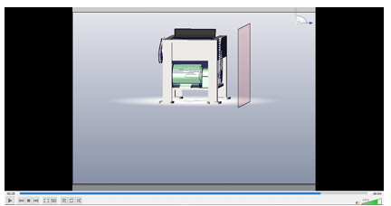
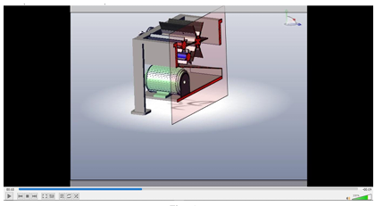
- Dehusking drum design and geometry.

Figure 11: Simulation process from start to finish
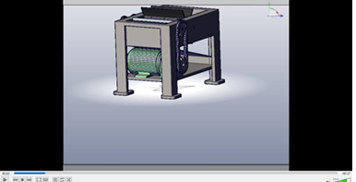
Figure 12: Simulation Finish

Fabrication Procedure
The fabrication of the coconut de-husking consists of the components listed above, starting from the frame, which is the main supporting structure upon which other components of the machine are mounted. It is a welded structure constructed with a mild steel angle iron bar. The de-husking unit consists of three rollers, with two rollers having fixed blades and the last roller having flaps attached to it. Those rollers are galvanised steel pipes of known diameters. Two of the blades were formed with welded metal sheets as blades on the rollers, while the last roller has a thick rubber fixed on it as a flap. The driving and driven roller shafts are mild steel rods supported at both ends by ball bearings. 2 spur gears are being used with the pitch circle diameters in consideration and number of teeth respectively to transmit power, and this was done by attaching the driving and driven roller shafts to a motor. The machine was driven by an electric motor in order to release the needed torque and power to de-husk.
Bill of Engineering Material and Evaluation (BEME)

A bill of engineering material and evaluation (BEME) was prepared to estimate the cost of fabricating the machine. The major cost items are seen in Table 4 below, and the total fabrication cost of the machine was estimated at approximately N390,000. This indicates that the machine can be produced at a relatively affordable cost using local resources.

Table 4: Bill of Engineering Material and Evaluation (BEME)
S/N | Machine component | Material | Description | Quantity | Cost per quantity | Total Cost
1 | Frame | 2II x 2II Angle iron | 50 x 50 x 4mm | 1 length | 13,000 | N13,000
2 | Shaft | Mild steel | 40 dia x 600mm | 3 | 5,000 | N15,000
3 | Rollers | Mild steel | 80 dia x 450mm | 3 | 8,000 | N24,000
4 | Roller blade | Mild steel | 450 x 40 x 10mm thick | 1 full length | 12,000 | N12,000
5 | Flaps | Rubber (Fibre) | 450 x 200 x 15/20mm thick | 1 full length | 20,000 | N20,000
6 | Bearing (Pillow) | Bought out | Bore 40 dia P208 | 6 | 2,500 | N15,000
7 | Cover | Sheet metal | 1 mm | Full plate | 14,000 | N14,000
8 | Bolt, nut and washer | Bought out | M6 and M12 | M6-24  M12 |  | N4,000
9 | Electric gear reduction motor |  | 2hp, 100rpm, 1:12 | 1 pc | 90,000 | N90,000
10 | Chain and sprocket | High Carbon steel | Same number of teeth | 4 sprockets and 2 chains | 5,000 | N20,000
11 | Spur gear | High Carbon steel | M2 40T | 2 pcs | 5,000 | N10,000
12 | Electrode |  | Guage 12 | 1 pack | 4,000 | N4,000
13 | Cutting disc |  |  | 2 | 1,000 | N2,000
14 | Grinding disc |  |  | 1 | 1,500 | N1,500
15 | Hacksaw blade |  |  | 5 pcs | 300 | N1,500
16 | Paints |  |  |  |  | N8,500
17 | Transport |  |  |  |  | N5,000
18 | Miscellaneous |  |  |  |  | N15,000
19 | Workmanship |  |  |  |  | N100,000
20 | Bushing |  |  |  |  | N5,000
21 | Flanges |  |  |  |  | N5,000
22 | Wires and a socket |  | 2.5mm and 1.5mm | 2.5mm-8 yards  1.5mm-4 yards |  | N5,600
 |  |  |  | Total |  | 390,000

The results of the design, simulation, and fabrication show that the coconut dehusking machine developed in this study works well and is more effective than many existing machines. During the design stage, the main mechanical values were calculated, and a 2 hp geared electric motor was chosen to give about 45 Nm of torque to drive the two rollers. This amount of torque is enough to remove the tough coconut husk. The frame and shafts were also sized based on the loads expected during operation, so the machine would be strong and stable when in use. This gave a good base for building the machine.
The simulation results supported the design. The motion simulation showed that the rollers can rotate freely without blocking, and that the blades can grip the husk properly without causing problems. The structural simulation also showed that important parts like the frame and shafts can carry the working loads without damage. This means the machine is strong enough before even building it. Using simulation in this way helps to improve performance and reduce the risk of failure before making the real machine. After fabrication and testing, the machine was able to dehusk about 200 to 250 coconuts per hour. The husk was removed well, and there was very little damage to the coconut shell and meat. This result is better than many recent studies. For example, Adedipe (2024) reported a cost-effective machine that took about 96 seconds per coconut, which is about 37 coconuts per hour, although this was still better than manual dehusking, which takes about 165 seconds per nut. Another study in Nigeria reported a mechanised machine that could dehusk about 120 coconuts per hour with 90% efficiency using spiked rollers and a 1.5 hp motor. Compared to these, the present machine shows a much higher output.
Recent reviews also show that most mechanised coconut dehusking machines can handle between 80 and 200 coconuts per hour, depending on their design and power. Owuama et al. (2025) reported that semi-automatic spiked roller machines usually fall within this range, while more advanced automatic machines can reach up to about 271 coconuts per hour in ideal conditions. This means that the performance of the present machine is within the upper range of modern designs, even though it uses a simple mechanism and materials that can be maintained locally. When compared with other designs, both strengths and weaknesses can be seen. Machines that use spiked rollers are good at removing husk, but they often crack the coconut shell, especially when the coconuts are not the same size. Olorunfemi et al. (2022) reported that although spiked machines can give good efficiency, controlling the force between the husk and shell is still a challenge. In contrast, the roller-blade system used in this study removes the husk in a more controlled way, and during testing, less shell breakage was observed. Also, when compared with dual-blade machines studied by Santos et al. (2025), which focused on usability and comfort for users, the present machine shows similar working ability but places more focus on mechanical efficiency and higher output. Santos and co-workers showed that user comfort and ease of use are important, and this suggests that adding more ergonomic features in future designs could further improve this machine.
Overall, the performance of the developed coconut dehusking machine shows that combining design, simulation, and fabrication is an effective way to produce a simple and useful machine for local use. The machine works faster than many existing designs, reduces human effort, and is safer than manual dehusking. However, there is still room for improvement, such as better blade shapes, adjustable feeding for different coconut sizes, and improved comfort for the operator. Future work could also look at using renewable energy, like solar power, so the machine can be used in areas without reliable electricity.
CONCLUSION
This study successfully designed, simulated, and fabricated a coconut dehusking machine that can remove coconut husks faster, safer, and with less effort than manual methods. The design calculations helped in selecting suitable machine parts, especially the 2 hp geared motor, which provided enough torque to drive the rollers for effective dehusking. The CAD modelling and simulations confirmed that the machine parts could move smoothly and withstand the expected working loads without failure. The fabricated prototype performed well during testing and achieved a dehusking capacity of about 200 to 250 coconuts per hour. The roller-blade mechanism was able to remove the husk effectively while causing little damage to the coconut shell and kernel. This shows that the machine can improve productivity and reduce operator fatigue compared to traditional hand methods and many existing mechanised designs. Overall, the results prove that integrating analytical design, computer simulation, and practical fabrication is an effective approach for developing simple and affordable agricultural processing machines. The developed coconut dehusking machine is therefore suitable for small- and medium-scale coconut processors, especially in developing regions where low-cost and locally maintainable equipment is needed.
RECOMMENDATION
Based on the results of this study, several improvements and future directions are suggested to further enhance the performance and usefulness of the developed coconut dehusking machine. The shape and material of the blades can be improved to make husk removal more efficient and to reduce wear during long-term use. Adding an adjustable feeding system or roller gap will help the machine handle coconuts of different sizes more easily and safely. The overall layout of the machine, including its height and operating position, can also be refined to improve user comfort and reduce strain during operation. Further testing of the machine over longer periods is recommended to better understand its durability, maintenance needs, and performance under real working conditions. Safety can be improved by adding protective covers around moving parts and including simple emergency stop features to protect the operator. It is also suggested that future versions of the machine explore the use of alternative power sources, such as solar or hybrid systems, so that the machine can be used in areas with limited access to electricity. With these improvements, the machine can be developed further for large-scale production and wider use by farmers and small coconut processors as an affordable and locally maintainable solution.

COMPETING INTERESTS DISCLAIMER:
Authors have declared that they have no known competing financial interests OR non-financial interests OR personal relationships that could have appeared to influence the work reported in this paper.

REFERENCES
Balaji, D. G., & Abinaya, C. (2024). COCONUT: A VERSATILE AND MULTIPURPOSE CROP. KRISHI SCIENCE – eMagazine for Agricultural Sciences, 5(6). https://www.researchgate.net/publication/381550813_COCONUT_A_VERSATILE_AND_MULTIPURPOSE_CROP
Satriardi, H. C. B., Susilawati, A., & Arief, D. (2016). Design of Coconut De-husking Machine Using Quality Function Deployment Method. Proceeding of Ocean, Mechanical and Aerospace -Science and Engineering-. https://isomase.org/OMAse/Vol.3-2016/Section-5/3-9.pdf
Foale, M. (2003). The coconut odyssey: The bounteous possibilities of the tree of life. ACIAR Monograph No. 101. https://www.aciar.gov.au/sites/default/files/legacy/node/453/mono101.pdf
Friday Aje Ovat, Aje, & Simon Ogbeche Odey. (2019, November 8). Development and Performance Evaluation of Coconut Dehusking Machine. ResearchGate; Elsevier. https://www.researchgate.net/publication/337104188_Development_and_Performance_Evaluation_of_Coconut_Dehusking_Machine
Onyenanu, I. U., & Uwadibe, U. O. (2024). Development of a Cost-Effective Coconut Dehusking Machine. International Journal of Innovative Science and Research Technology. https://doi.org/10.38124/ijisrt/ijisrt24apr2283
Kumar, S., & Moses, S. C. (2023). Ergonomical Evaluation and Dynamic Performance of Pedal Operated Coconut Dehusker. International Journal of Current Microbiology and Applied Sciences. https://doi.org/10.20546/ijcmas.2023.1205.027
Library of Congress. (2019). Is a coconut a fruit, nut, or seed? https://www.loc.gov/everyday-mysteries/item/is-a-coconut-a-fruit-nut-or-seed//
Naik, L. (2020, April 13). Manually Operated Coconut Dehusking Machine for Rural Agriculturist. Academia.edu; Zenodo. https://www.academia.edu/79492673/Manually_Operated_Coconut_Dehusking_Machine_for_Rural_Agriculturist
Naliapara, V. A., Gojiya, D. K., Dobariya, U. D., & Vyas, D. M. (2022). The Technological Developments in Power Operated Coconut (Cocos nucifera L.) Dehusking and Deshelling Machines: A Review. Current Journal of Applied Science and Technology, 46–62. https://doi.org/10.9734/cjast/2022/v41i2431770
Krishnakumar, V., Thampan, P. K., & Nair, M. A. (Eds.). (2018). The Coconut Palm (Cocos nucifera L.) - Research and Development Perspectives. Springer Singapore. https://doi.org/10.1007/978-981-13-2754-4
Oladele, I. O., Adelani, S. O., Makinde-Isola, B. A., & Omotosho, T. F. (2022). Coconut/coir fibres, their composites and applications. In Plant Fibres, Their Composites, and Applications (pp. 181–208) https://doi.org/10.1016/b978-0-12-824528-6.00004-7
Olorunfemi, B. J., Olumilua, A. E., Kayode, S. E., & Arounsoro, A. A. (2022). Development of a Modified Dehusking Machine for Local Varieties of Coconut. COVENANT JOURNAL of ENGINEERING TECHNOLOGY, 6(1). https://journals.covenantuniversity.edu.ng/index.php/cjet/article/view/3040
Owoyemi, J. M., Akinwamide, T. O., & Ibidokun, A. O. (2022). Development of coconut plantation in Nigeria; Problems and prospects. International Journal of Agriculture and Plant Science, 4(1), 58-66.
Parmar, P. T., Singh, A. K., & Borad, S. G. (2020). Coconut (Cocos nucifera). In B. Tanwar & A. Goyal (Eds.), Oilseeds: Health Attributes and Food Applications (pp. 163–189). Springer Singapore. https://doi.org/10.1007/978-981-15-4194-0_7
Piyathissa, S. D. S., & Kahandage, P. D. (2016). Introducing an appropriate mechanical way for Coconut dehusking. Procedia Food Science, 6, 225–229. https://doi.org/10.1016/j.profoo.2016.02.020
Sabale, R. M., & Kolhe, K. P. (2016). Design and development of a coconut dehusker for small scale coir industry and marginal farmers. *International Journal of Engineering Research and Technology*, *5*(2).
Science, 1(2), 42–47. https://doi.org/10.29210/81063900
Adzimah, S. K., & Turkson, S. O. (2015). Conceptual Design of Coconut Dehusking Machine. Innovative Systems Design and Engineering, 6(5).
Varghese, A., & Jacob, J. (2014). A Review of Coconut Husking Machines. International Journal of Design And Manufacturing Technology, 5(3). https://doi.org/10.34218/IJDMT.5.3.2014.30320140503009
Yunus, M. F. M., Yasin, S. N. T. M., Fadzli, N. K. S. M., Suhaimi, S. N. B., & Zainuddin, N. H. (2020). Conceptual design of dual purpose coconut dehusking machine. Southeast Asian Journal of Technology and Science, 1(2), 42-47. https://doi.org/10.29210/81063900

