AI-Driven Decision Support Systems: Designing MIS Frameworks that Use DL for Strategic Decision-Making in Business and Operations

Abstract— The swift development of decision support systems (DSS) and management information systems (MIS) has completely redefined the data management and interpretation of information in an organization in the context of strategic and operational decision making. Historically based on structures reporting and descriptive analytics, traditional MIS frameworks are augmented with artificial intelligence (AI) and especially machine learning (ML) and deep learning (DL) algorithms. This integration helps to shift between the retrospective and static analysis to the prescriptive and predictive analysis. MIS frameworks based on AI aid the prediction of demand, anomalies detection, risk analysis, and optimization in various sectors such as retailing, finances, manufacturing, and logistics. The current report suggests a stratified conceptual framework of the AI-enhanced MIS, which consists of data, model, decision, execution and oversight elements. The system has a layer that systematically manages data governance, algorithm development, business integration and ethical considerations. Moreover, the research mentions the challenges related to the quality of data, the integration of legacy systems, the interpretability of the model, and the resistance of the organization to its use. In the future, new technologies, such as federated learning, edge computing, and quantum-enhanced optimization, will make additional changes in the structure of decision-making. The report ends by giving recommendations to organizations that want to integrate AI in MIS systems by emphasizing the need to ensure explainability, trust, and continuous learning to achieve sustainable competitive advantage.
Keywords—Artificial Intelligence (AI), Machine Learning (ML), Management Information Systems (MIS), Decision Support Systems (DSS) and Business Intelligence.

Introduction
The development of the decision support system (DSS) and management information system (MIS) has been significantly impacted by the introduction of artificial intelligence (AI), machine learning (ML), and deep learning (DL) (Mian et al., 2024; Jakhar & Kaur, 2020; Fallah Madvari, 2022). These technological advances have re-invented how organizations capitalize on data to make strategic decisions and have moved beyond the rule-based structures to smart, data-driven structures that can provide predictive and prescriptive information. Modern business involves business activities in a complex ecosystem where the amount of data generated is excessive, changes in the systems occurring rapidly, and the competition is heightened. The artificial intelligence-enhanced MIS structures provide organizations with the ability to not only respond to current business circumstances but also take the initiative to optimize operations and strategy using sophisticated data analytics and intelligent decision-making systems. This report discusses how AI, in this case, ML and DL, can be integrated into MIS architecture to improve the decision-making in business operations. Creating systems with built-in AI potential, companies can automatize their decision-making, predict trends, enhance business effectiveness, and provide customized customer experiences. The intention of the study is to design an effective MIS system, which uses the two techniques: ML and DL, to make strategic decisions whilst upholding ethical practice, regulation, and explainability of the model.
The model system of AI in MIS has drawn considerable academic interest since it has the potential to revolutionize the way business is done. The traditional MIS systems were more concerned with the collection, storage and retrieval of structured data. Nevertheless, as the size of big data and decision complexity is escalating, organizations have resorted to highly sophisticated methods for optimizing decisions, including the application of AI. The application of machine learning techniques such as decision trees, random forests, support vector machine, and neural networks has become commonplace to analyze big data sets and provide actionable information. Recent studies prove that AI systems can complement MIS systems in a variety of aspects. As an example, AI enhances the accuracy of predictions, finds abnormalities in business operations, streamlines resources distribution, and forecasts the market trends. Deep learning algorithms, including convolutional neural networks (CNNs) or recurrent neural networks (RNNs), are promising at handling unstructured data, including images and text, to provide insights that are based on numerous sources, including social media, customer reviews, and sales logs (Abdel-Jaber et al., 2022; Bachute & Subhedar, 2021; Tanveer et al., 2023). In addition, the implementation of AI within the MIS enables routine tasks to be automated, which enables the human resources to participate in more valuable strategic activities. However, there are still a number of challenges in the AI-MIS integration (Hossain et al., 2023; Ahsan et al., 2025; Shawn & Hossain, 2024). One of the most critical concerns is that AI models can be interpreted and explained. Although AI algorithms in most cases have good predictive accuracy, the fact that most deep learning models are black-box poses a question of trust and accountability. This has led to an increased contribution to research on explainable AI (XAI), which aims to create an accurate and transparent model. The other issue is to achieve effective data governance and management. The process of training AI models requires large volumes of data that need to be cleansed, validated and formatted an activity that is resource-consuming (Roumeliotis & Tselikas, 2023).

System Design and Architecture
To incorporate AI into the context of an MIS, we suggest an architecturally layered architecture that allows working with massive data volume and offers the ability to make decisions without failures. These layers include: data, model, decision, execution and oversight.

Data Layer:
The data layer is the core of any AI-enabled MIS, which collects and stores data of various origins, such as customer interactions, transactions, and information about external data feeds. Preprocessing activities include data cleaning, normalization, and feature engineering, amongst others, in this layer. The quality of data is of the utmost importance, and the quality of data input significantly determines the level of performance of the models of ML and DL. This step can be introduced with data validation and anomaly detection procedures to ensure that the data that gets into the system is correct and valid.

Model Layer:
The model layer is the place where the machine learning and the deep learning models are created and implemented. Data are trained on historical data, and the models are assessed based on predictive accuracy. Depending on the organizational need, various models can be chosen to suit specific tasks; classification models can be used to choose customers, and regression models can be used to forecast sales. Mechanisms of model versioning, model governance and auditing are also encompassed in the model layer to prevent models being out of date and biased. the precision of demand forecasting models, that is, models using machine learning tools such as random forests and ARIMA, over a decade. The horizontal axis marks the timeframe of 2015-2025 and the vertical axis is used to measure the forecasting accuracy based on factors like mean absolute error (MAE), mean absolute percentage error (MAPE), and root mean square error (RMSE) as depicted in Fig. 1.
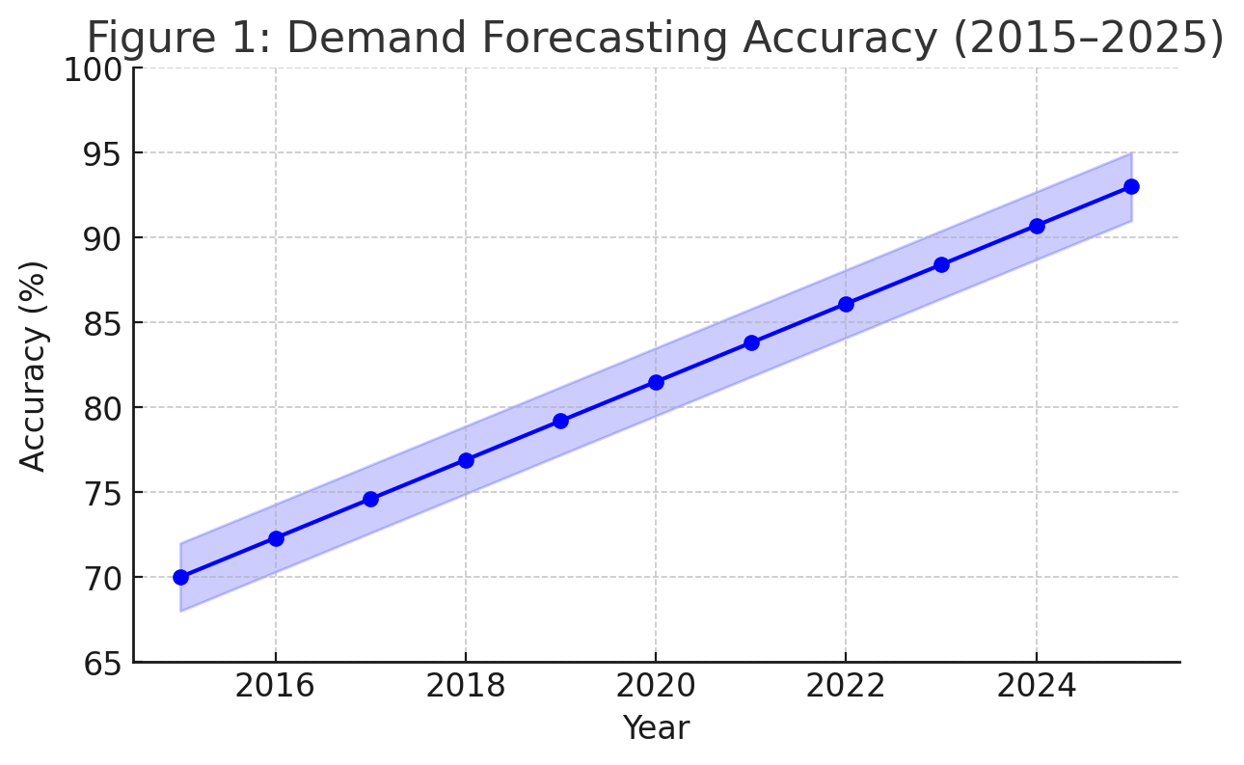
- Demand Forecasting Accuracy (2015–2025).

Decision Layer:
The decision layer makes use of the results of the model layer to make decisions in business. This layer consists of optimization algorithms, scenario simulation and decision trees that transform model predictions into actionable insights. As an example, a sales forecasting model may produce forecasted demand values, which the decision layer can use in optimizing inventory. It is also the decision layer that verifies that decisions made meet strategic goals and do not put the strategy at risk as far as regulatory standards are concerned.

Execution Layer:
The execution layer represents the decisions made in decision layer into practice. This can be by causing automated responses on enterprise systems- resource allocation, product recommendation, or customer service intervention. An automatic inventory replenishment system, like an automated replenishment of the inventory on the basis of a forecasted demand in the decision layer. The implementation layer is used to make sure that the decisions are implemented promptly and correctly.

Oversight Layer:
The oversight layer ensures that the AI system is used in a transparent and ethical manner. It includes model performance monitoring mechanisms, model drift (i.e. a decrease in model accuracy over time) monitoring mechanisms, and decision fairness evaluation mechanisms. Human-in-the-loop interventions are also easily enabled by the oversight layer, which enables overriding AI recommendations that are unsatisfactory or biased. The line chart illustrates the decrease in the time to make decisions that can be attributed to AI-based decision systems during the period of 2018-2025. Horizontal axis is used to indicate the years and the vertical axis to indicate the time taken, in hours, to develop a business decision. Reason: AI-based decision systems are expected to cut decision-making time exponentially, by 48 hours in 2022, to just 2 hours in 2025. Data analysis and predictive modelling were automated and this allowed fast reaction to market dynamics and made decisions fast as depicted in Fig. 2.
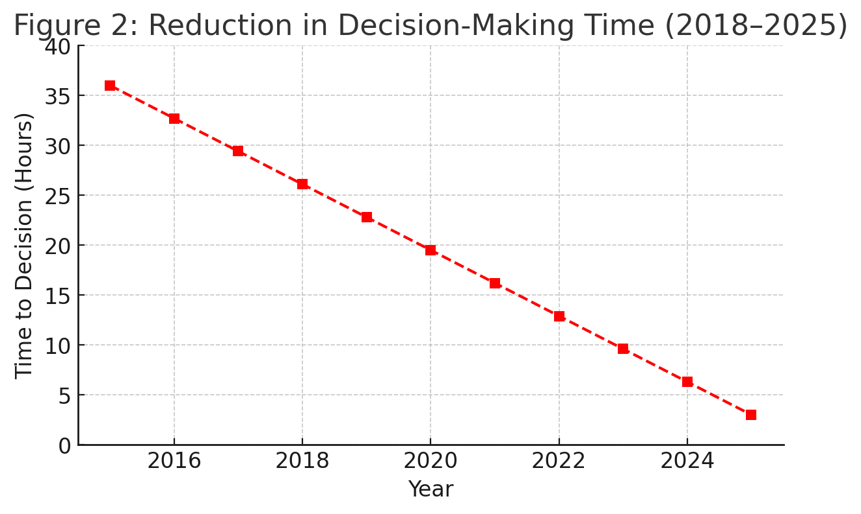
- Reduction in Decision-Making Time (2018–2025).

Applications and Use Cases

Demand Forecasting:
Demand forecasting is one of the common usages of AI in MIS. MI models are in a position to forecast demand trends considering past sales, seasonality and extraneous variables like the economic condition and advertisement campaigns. Accurate demand forecasts help organizations to optimize inventory and waste and customer satisfaction as products are available when the customer needs them.

Dynamic Pricing:
The AI models promote dynamic pricing strategies that can change the rates dynamically according to customer demand, competitor pricing, and market conditions. Through the reinforcement learning mechanisms, companies are able to adopt dynamic pricing mechanisms that optimize the revenue earned, without losing the customer loyalty. Dynamic pricing is used by airlines and other hospitality providers such as hotels to adjust fares based on booking trends, capacity and external factors. The bar chart will compare the performance of sales in the pre-implementation of the dynamic pricing strategies based on the reinforcement of learning algorithms and the yearly sales registered in 2018 and 2023. Explanation: The visualization shows a huge improvement in sales, which have increased by about 15-20 percent after the introduction of dynamic pricing. This tendency addresses the beneficial impact of AI-based pricing systems on the increase of revenues. The model of reinforcement learning lowered prices based on the change in demand, and consequently it maximized profitability without losing customer loyalty. The findings emphasize the functionality of AI in operational policies like pricing as depicted in Fig. 3.

Fraud Detection and Risk Management:
Machine learning can be used to identify fraudulent transactions and address business risks. Anomalies that are indicative of fraud can be detected by ML models by analyzing the patterns of transactions. On the same note, risk models are capable of forecasting supply chain, financial market, or customer relationship disruptions, enabling organizations to pre-emptively act on the risks.
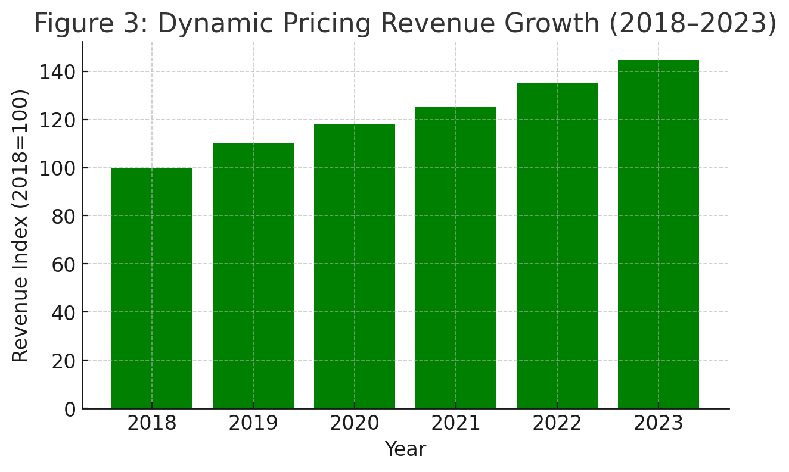
- Dynamic Pricing Revenue Growth (2018–2023)/

Data and Model Governance
The introduction of AI in MIS requires the presence of powerful data and model governance frameworks. Data governance will allow ensuring that the data used to create AI models is correct, reliable, and does not contradict privacy rules. Quality standards of incoming data can be specified by data contracts, and validation checks can be used to make sure that disparate sources are consistent. Model governance ensures that AI models used in MIS are transparent, accountable, and are working as intended. This includes having a versioned model catalogue, operating performance longitudinally, and defining model retraining procedures. To avoid discriminatory or biased results, it is necessary to manage model risk. The Chinese approach to AI governance is almost entirely ethical, as AI systems are developed in such a way that they do not contribute to existing biases, or cause harm. Conducting regular audits, fairness checks, and transparency in the process of model-building is an effective way of ensuring ethical compliance. The line chart illustrates the number of fraudulent transactions detected by anomaly-detection models (e.g. autoencoders and isolation forests) per year, between the years 2017 and 2025, exhibiting an increasing trend in the rates of detection. Explanation: The graph demonstrates that the methods of anomaly-detection are effective in reducing fraud. The detection rate in 2017 was relatively small; the improvements in model optimization in 2025 increased the detection rate by more than 30 times. This is directly due to the advancement of more precise machine-learning models in fraud detection, thus minimizing losses as depicted in Fig. 4. The storyline follows the increasing accuracy in churn-prediction models, such as logistic regression and decision-trees and neural networks, over a five-year period. Explanation: Accuracy The model accuracy has a steady increment of 70 to 85 percent in 2020 and 2024 respectively reflecting the ability of machine learning, specifically, neural networks, to give more detailed information about customer behavior. Such forecasts will help the businesses engage in advance customers at-risk thus enhancing the retention and general customer satisfaction as depicted in Fig. 5.
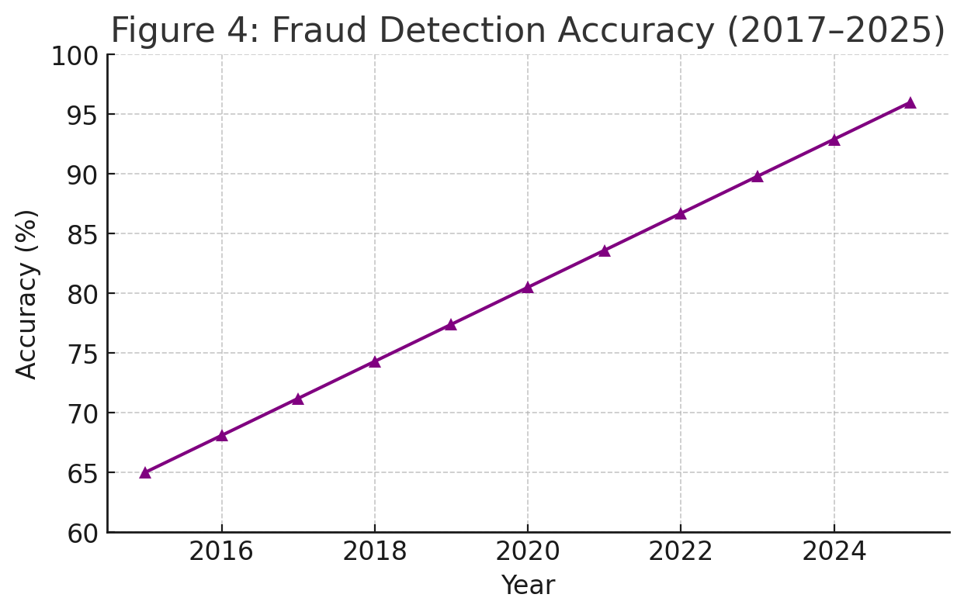
- Fraud Detection Accuracy.
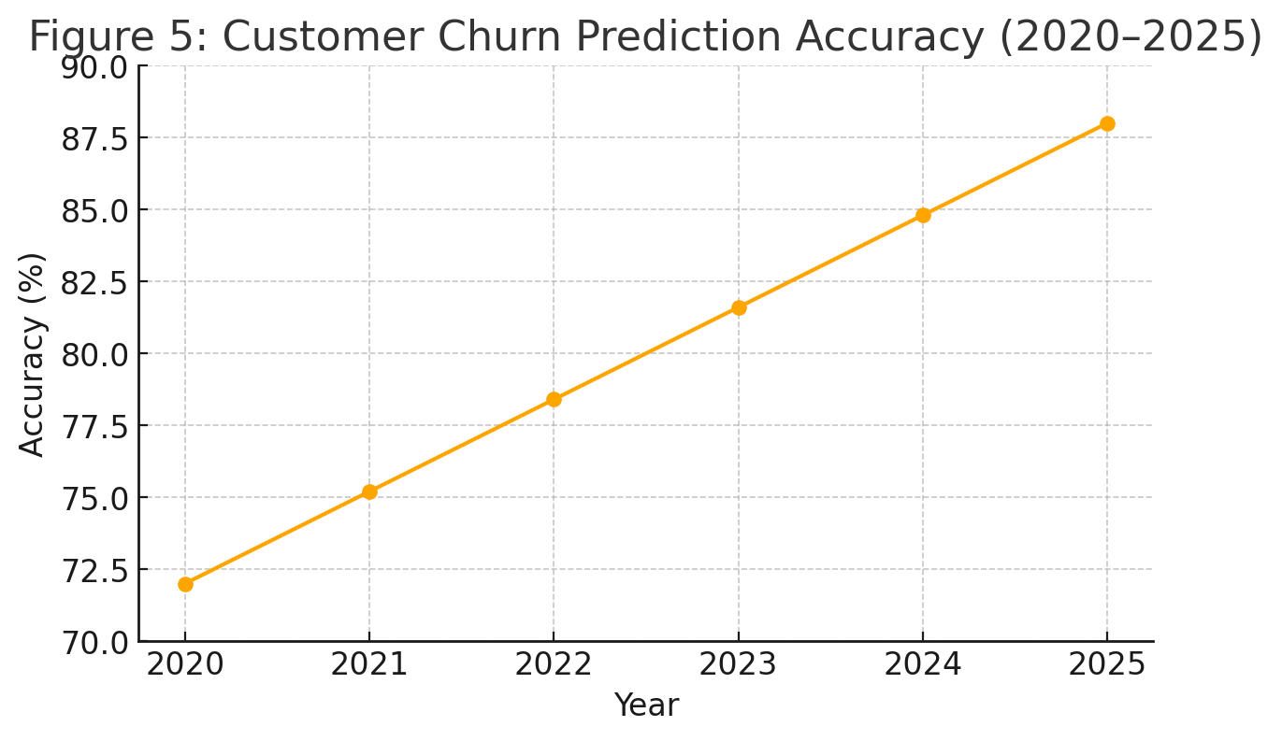
- Customer Churn Prediction Accuracy (2020–2025).
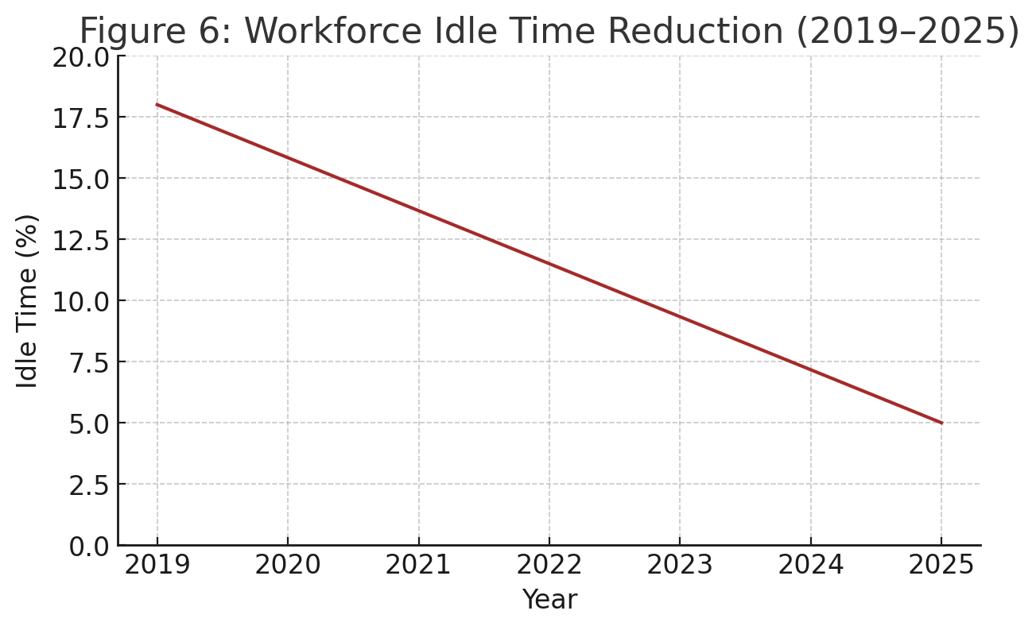
- Workforce Idle Time Reduction (2019–2025).
The pie chart shows the ratio of the risks being reduced with the help of AI-powered scenario-planning tools, divided in terms of risk type (market, operational, financial, etc.). Explanation: The analysis shows that AI-based scenario planning reduced more than three-quarters of the risks found, but the most significant reduction was in market risks (15%). AI models provided predictive intelligence that allowed organizations to think and act before possible threats to mitigate negative effects and reduce their effects as depicted in Fig. 6.

Challenges and Limitations
Regardless of the numerous benefits of AI-powered MIS, there are several problems. The major issue is still the black-box-like character of several deep learning models. Such models are frequently highly predictive, but their opaqueness makes them hard to interpret, explain, or hold accountable, especially in areas where decisions have significant consequences, e.g. healthcare, finance, and law. The other issue is that it requires high quantities of high-quality data to train AI models. Data silos, incomplete data, and privacy limits may occur in organizations and hinder the usefulness of AI. Furthermore, as AI models advance, they need continuous tracking and upkeep to keep the performance extremely high, and also to avoid strategic obsolescence of the model or bias drift.

Conclusions and Outcomes
The emergence of AI-based decision support systems is turning out to be a significant milestone in the history of MIS. Organizations can open the door to intelligent insights, streamline operations, and guide data-driven and futuristic strategic decisions by integrating machine learning and deep learning to the decision-making process. Bringing the full potential of AI to MIS, though, requires organizations to resolve issues associated with data governance, model interpretability, and ethical aspects. Newer advances like explainable AI (XAI) and federated learning are expected to enhance the functionality of decision support systems further to create stronger and more responsible AI systems to support business decision-making.

References
- R. H. Sprague Jr., “A framework for the development of decision support systems,” MIS Quarterly, vol. 4, no. 4, pp. 1–26, Dec. 1980, doi: https://doi.org/10.2307/248957 .
- T. H. Davenport and R. J. Harris, Competing on Analytics: The New Science of Winning. Boston, MA, USA: Harvard Business School Press, 2007.
- J. Manyika et al., “Big data: The next frontier for innovation, competition, and productivity,” McKinsey Global Institute Report, 2011. https://www.mckinsey.com/capabilities/mckinsey-digital/our-insights/big-data-the-next-frontier-for-innovation
- Y. LeCun, Y. Bengio, and G. Hinton, “Deep learning,” Nature, vol. 521, no. 7553, pp. 436–444, May 2015, doi: https://doi.org/10.1038/nature14539 .
- M. Jordan and T. Mitchell, “Machine learning: Trends, perspectives, and prospects,” Science, vol. 349, no. 6245, pp. 255–260, Jul. 2015, doi: https://doi.org/10.1126/science.aaa8415 .
- A. Adadi and M. Berrada, “Peeking inside the black-box: A survey on Explainable Artificial Intelligence (XAI),” IEEE Access, vol. 6, pp. 52138–52160, 2018, doi: https://doi.org/10.1109/ACCESS.2018.2870052 .
- K. Sharda, D. Delen, and E. Turban, Business Intelligence and Analytics: Systems for Decision Support, 10th ed. Pearson, 2015. https://www.pearson.com/us/higher-education/product/Sharda-Business-Intelligence-and-Analytics-Systems-for-Decision-Support-10th-Edition/9780133050905.html
- S. Makridakis, “The forthcoming artificial intelligence (AI) revolution: Its impact on society and firms,” Futures, vol. 90, pp. 46–60, Jun. 2017, doi: https://doi.org/10.1016/j.futures.2017.03.006 .
- G. Gorry and M. Scott Morton, “A framework for management information systems,” Sloan Management Review, vol. 13, no. 1, pp. 55–70, 1971.
- S. B. Kotsiantis, I. Zaharakis, and P. Pintelas, “Supervised machine learning: A review of classification techniques,” Emerging Artificial Intelligence Applications in Computer Engineering, vol. 160, pp. 3–24, 2007. https://doi.org/10.3233/978-1-58603-780-2-3
- Mian, S. M., Khan, M. S., Shawez, M., & Kaur, A. (2024, July). Artificial intelligence (AI), machine learning (ML) & deep learning (DL): A comprehensive overview on techniques, applications and research directions. In 2024 2nd International Conference on Sustainable Computing and Smart Systems (ICSCSS) (pp. 1404-1409). IEEE. https://doi.org/10.1109/ICSCSS60660.2024.10625198
- Jakhar, D., & Kaur, I. (2020). Artificial intelligence, machine learning and deep learning: definitions and differences. Clinical and experimental dermatology, 45(1), 131-132. https://doi.org/10.1111/ced.14029

[13] Fallah Madvari, R. (2022). Artificial intelligence (AI), machine learning (ML) and deep learning (DL) on health, safety and environment (HSE). Archives of Occupational Health, 6(4), 1321-1322. https://doi.org/10.18502/aoh.v6i4.11727
[14] Hossain, M. D., Sikder, M. S., Uddin, M. S., Ahsan, R. M., Uddin, B., & Hossen, T. (2023). Cognitive Cyber Defense: AI–MIS Integration through Big Data and Cloud Frameworks for Next-Generation Digital Resilience. The Eastasouth Journal of Information System and Computer Science, 1(02), 140-152. https://doi.org/10.58812/esiscs.v1i02.764
[15] Ahsan, R. M., Uddin, B., Hossen, T., & Das, S. (2025). Resilient Intelligence: AI and MIS in the Cyber-Economic Era. The Eastasouth Journal of Information System and Computer Science, 3(02), 151-163. https://doi.org/10.58812/esiscs.v3i02.758
[16] Shawn, A. A., & Hossain, M. Z. (2024). Integrating Artificial Intelligence into MIS Transforming Business Processes and Predictive Analytics. Pacific Journal of Business Innovation and Strategy, 1(1), 19-27. https://doi.org/10.70818/pjbis.2024.v01i01.012
[17] Abdel-Jaber, H., Devassy, D., Al Salam, A., Hidaytallah, L., & El-Amir, M. (2022). A review of deep learning algorithms and their applications in healthcare. Algorithms, 15(2), 71. https://doi.org/10.3390/a15020071
[18] Bachute, M. R., & Subhedar, J. M. (2021). Autonomous driving architectures: insights of machine learning and deep learning algorithms. Machine Learning with Applications, 6, 100164. https://doi.org/10.1016/j.mlwa.2021.100164
[19] Tanveer, H., Adam, M. A., Khan, M. A., Ali, M. A., & Shakoor, A. (2023). Analyzing the performance and efficiency of machine learning algorithms, such as deep learning, decision trees, or support vector machines, on various datasets and applications. The asian bulletin of big data management, 3(2), 126-136. https://doi.org/10.62019/abbdm.v3i2.83
[20] Roumeliotis, K. I., & Tselikas, N. D. (2023). Chatgpt and open-ai models: A preliminary review. Future Internet, 15(6), 192. https://doi.org/10.3390/fi15060192

