Original Research Article

Research on Thermal Environment Optimization in Livestock Transport Vehicles Using CFD

.
ABSTRACT

With the advent of African Swine Fever, biosecurity requirements during transportation have become increasingly stringent. Vehicles transporting pigs between large-scale farms are increasingly adopting fully enclosed air-filtered trailers, significantly reducing the risk of viral infection during transit. However, due to the complete sealing of the cargo compartment, insufficient ventilation or excessive internal temperatures can easily lead to pigs suffocating. This study focuses on air-filtered pig transport vehicles, simulating and experimentally analyzing the internal airflow and temperature distribution. Results indicate relatively high temperatures and slow airflow at the rear of the compartment. Corresponding optimization designs for the vehicle interior are proposed to address this phenomenon.

Keywords: Transportation compartment; Structural Optimization; Finite element.

1. INTRODUCTION

Currently, an increasing number of pig transport vehicles are adopting fully enclosed air-filtered designs. These vehicles feature filter cotton installed at the front of the cargo compartment, effectively blocking most pathogenic viruses from contaminating the pigs inside ^{[1]}. However, due to their fully enclosed nature, these vehicles rely solely on intake vents for ventilation. This design creates a critical risk: improper internal airflow field design can easily lead to suffocation of the pigs. Consequently, analyzing the internal airflow field during the design process of such vehicles has become increasingly vital.
Fluent stands as the world's leading fluid analysis software. Developed by ANSYS, this internationally dominant commercial computational fluid dynamics (CFD) package commands a 60% market share in the United States ^{[2]}. It employs a finite volume method based on unstructured grids, integrating advanced technologies such as dynamic mesh re-meshing and separated vortex simulation. Fluent supports complex flow field simulations spanning the range from incompressible to hypersonic conditions. The software includes pressure-based decoupled/coupled solvers, density-based implicit/explicit solvers, and turbulence simulation tools such as the Spalart-Allmaras model and k-ε model. It accurately simulates physical phenomena including laminar flow, turbulent flow, heat transfer, chemical reactions, multiphase flow, and rotating machinery. Its modular architecture encompasses preprocessors (ICEM CFD), specialized solvers (POLYFLOW, FIDAP), and industry-specific modules (e.g., G/Turbo for rotating machinery, AIRPAK for HVAC), supporting multiphysics coupling simulations. Leveraging high-accuracy solvers, user-defined functions (UDFs), and robust post-processing capabilities, Fluent is widely adopted across aerospace, automotive engineering, energy, and environmental sectors. It stands as the preferred tool for solving complex fluid dynamics challenges in both industrial and academic settings ^{[3]}.
This paper employs Fluent software to analyze temperature and velocity fields within vehicle interiors. It identifies locations with elevated temperatures and reduced airflow velocity, enabling targeted optimization designs.

2. Introduction to Research Subject and Experimental Data Measurement

  - Introduction to the Air-Filtered Livestock Transport Vehicle
This study examines a 9.6-meter livestock transport vehicle manufactured by a specialized vehicle producer in Henan Province as the research subject. The overall dimensions of the vehicle body are 8692 × 2500 × 2600 mm. The complete vehicle configuration is illustrated in Figure 1.

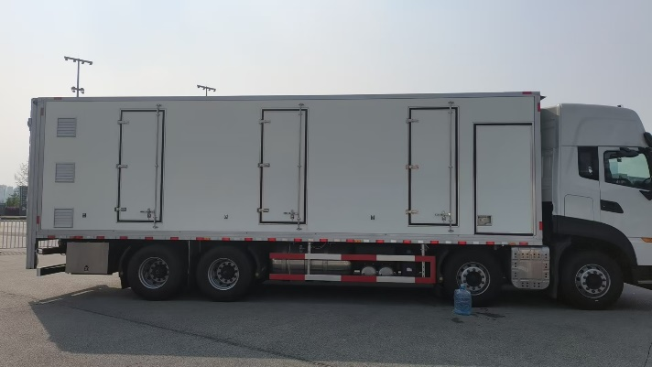
Fig.1 Overall Vehicle Diagram

The vehicle consists of two main sections: the air filtration chamber and the passenger compartment. Fresh air first enters the air filtration chamber through louvers at the front of the passenger compartment. Within the filtration chamber, an air conditioning unit cools the incoming fresh air to approximately 24°C (75°F). The air then passes through filter cotton to remove viruses and impurities before being blown into the passenger compartment via intake fans through the fan wall. The intake vents are located at the front of the vehicle, with three per level. The exhaust vents are situated at the rear of the vehicle, with two per level. Details are shown in Figure 2.

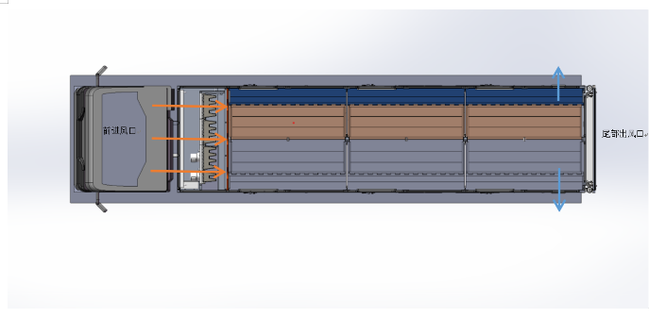
Fig.2 Vehicle Ventilation Structure Diagram

The interior of the cargo compartment is primarily divided into a three-tier structure by two layers of flooring panels. Each tier is subdivided into three pens, resulting in a total of nine pen compartments within the compartment. The total pig capacity ranges from 90 to 120 head, with variations depending on the size of the pigs.
  - In-Compartment Experimental Data Measurement

Vehicle experimental data testing was conducted on August 22, 2025, under clear weather conditions with an ambient temperature of 39°C and an outdoor wind speed of 1 m/s. The purpose of this measurement was to provide validation data for the subsequent simulation analysis of the vehicle's internal flow field and temperature field, while also establishing boundary conditions for the corresponding simulation analysis. The specific measurement conditions are illustrated in Figure 3 below.
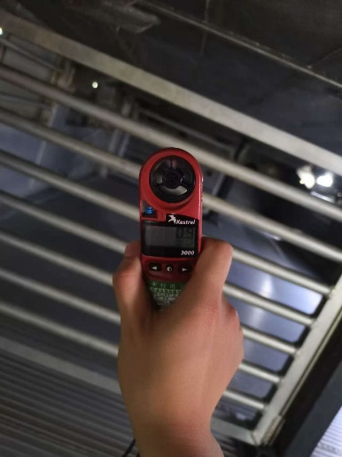
Fig.3: Actual Data Measurements Inside the Carriage
For wind speed and temperature testing inside the carriage, measurement points were established at three locations per compartment. These points were positioned along the longitudinal axis at 430mm intervals from the floor panel, with equal lateral spacing between points. Each measurement was taken three times. Each deck contains three compartments across three levels, requiring measurements at 27 points throughout the car interior. Specific measurement locations are shown in Figure 4, with results presented in Table 1.
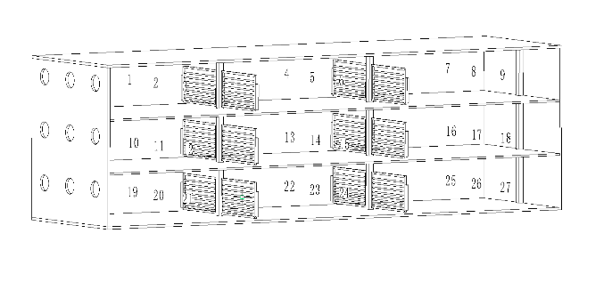
Fig.4: Car Measurement Point Locations
Table.1: Actual measurement point data
Location | Wind Speed | Temperature
1 | 4.1 | 25.2
2 | 4 | 25.2
3 | 3.8 | 24.8
4 | 3.9 | 27.3
5 | 4.2 | 26.3
6 | 3.8 | 26.5
7 | 3.7 | 28.5
8 | 3.5 | 28.2
9 | 4.2 | 27.6
10 | 1.1 | 25.2
11 | 1.2 | 24
12 | 1 | 24.5
13 | 1.3 | 26
14 | 0.6 | 25.2
15 | 1.1 | 26.3
16 | 0.8 | 27.2
17 | 1.2 | 26.1
18 | 0.9 | 24.3
19 | 0.2 | 25.2
20 | 0.3 | 25.3
21 | 0.5 | 26.1
22 | 0 | 25.2
23 | 0.2 | 26.1
24 | 0.1 | 27.1
25 | 0 | 27.6
26 | 0.5 | 26.5
27 | 0.1 | 28

In the actual measurement of air intake conditions within the passenger compartment, wind speed at the intake end was measured by drawing circles with diameters of 100 mm and 280 mm centered on the outlet opening. Eight points were uniformly selected on each circle, totaling 16 measurement points. The average wind speed was then calculated. The specific locations the measured values are listed in Table 2.

Table.2: Fan Measurement Point Locations
Point | Wind Speed | Point | Wind Speed
1 | 14.3 | 9 | 2.8
2 | 13.1 | 10 | 1.5
3 | 12.4 | 11 | 2.6
4 | 10.6 | 12 | 1.4
5 | 10.1 | 13 | 4.4
6 | 10.8 | 14 | 2.1
7 | 11.4 | 15 | 2.2
8 | 11.3 | 16 | 1
Average wind speed |  | 7

- Thermal Environment Numerical Simulation in the Passenger Compartment
  - Simplified CFD Model Development for Passenger Carriage

When establishing the CFD model for the passenger carriage, structural simplifications are necessary to further reduce analysis computation time while maintaining computational accuracy. Theoretically, the closer the simplified model aligns with the actual interior structure, the more accurate the computational results will be relative to real-world outcomes. Therefore, during this model simplification process, components with minimal impact on fluid dynamics results were omitted. Specific simplifications are outlined below:
(1) Omit panel gaps
(2) All surfaces assumed fully sealed
(3) Removal of the car's filter compartment. The measured ventilation rate of 7 m/s was obtained with the filter compartment and filter cotton present; thus, the filter compartment is excluded from the analysis.
The simplified model for this analysis was constructed using SolidWorks. The resulting simplified model is shown in Figure 5:
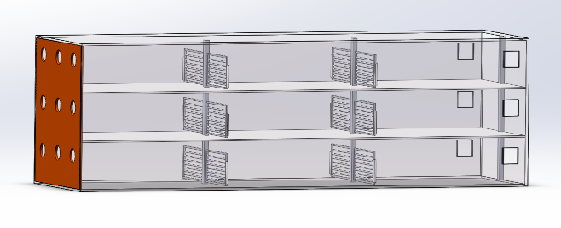
Fig.5 Simplified Model
  - Mesh Generation
After 3D modeling in SolidWorks, the model was imported into the ANSYS Workbench platform for mesh generation using the Meshing software. During meshing, the following elements were defined: inlet (nine air inlets), outlet (six air outlets at the rear), board (floor panel), left-wall (left side of the compartment), right-wall (right side of the compartment), and roof (ceiling panel).
Subsequently, the vehicle body undergoes mesh generation. Unstructured meshes are employed to balance computational efficiency. Mesh refinement is applied in regions with complex fluid flow, while simplification occurs in areas with simpler flow patterns, ensuring accuracy where necessary ^{[4]}. The maximum mesh size was set to 80 mm. At the inlet (nine air inlets) and outlet (six rear air outlets), the mesh size was set to 20 mm. At the gate, where fluid flows through gaps, the mesh size was also set to 20 mm with a mesh growth factor of 1.2. Three expansion layers were implemented, resulting in a total of 24,382,164 mesh cells. The post-meshing model is illustrated in Figure 6.
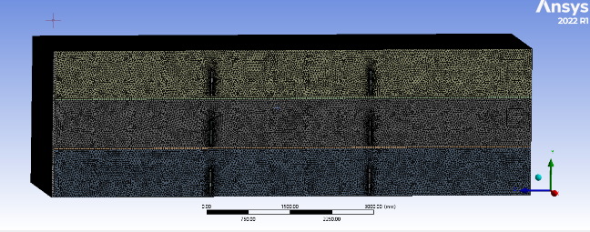
Fig.6: Post-meshing model diagram
  - Fundamentals of Computational Fluid Dynamics

Computational fluid dynamics must satisfy three fundamental governing equations: the continuity equation, momentum equation, and energy equation. CFD simulations are based on numerical solutions to these equations ^{[5]}. In this simulation, air is modeled as incompressible, and the airflow within the compartment is assumed steady-state ^{[6]}. Gaps between compartments are neglected, treating the compartments as fully sealed. To determine the airflow state within the car, the Reynolds number is calculated using the formula:
where: ρ is the fluid density; μ is the fluid viscosity coefficient; v is the average fluid velocity; D is the characteristic constant, taken as the diameter of the flow channel. Calculations yield a Reynolds number Re > 4,000 ^{[7]}. Therefore, a turbulent flow model is selected for the internal fluid flow within the car ^{[8]}. For the turbulent model selection, the k-ε model was chosen as the standard for simulating the interior airflow ^{[9]}. Computations were performed using the SIMPLE algorithm ^{[10]}.
  - Boundary Condition Setup

This simulation targeted summer operating conditions. The ambient temperature was set to 39°C, matching the measured environmental temperature during testing. The measured wall temperatures of the passenger compartment are shown in Table 3.
Table.3: Measured Boundary Conditions
Location | Temperature/°C
Front Air Inlet | 24
Top Panel | 41.5
Left Side Panel | 39.2
Right Side Panel | 37.3
Front End Cap | 25
Rear End Cap | 38.9
Bottom Panel | 36.5

The outer body material of the vehicle is polyurethane, with a density of 45 kg/m³, specific heat capacity of 1260 J/(kg·K), and thermal conductivity of 0.0216 W/(m·K). The interior partition doors and shelves are made of aluminum alloy with a density of 2719 kg/m³, specific heat capacity of 871 J/(kg·K), and thermal conductivity of 202.4 W/(m·K).
Air inlet/outlet conditions: Based on actual measurements, the inlet air temperature is 24°C with a velocity of 7 m/s. The outlet is a static pressure outlet with an outlet pressure of standard atmospheric pressure.

- Results Analysis and Optimization Design
  - Simulation Results Analysis

FLUENT software within ANSYS was employed to analyze the velocity and temperature fields within the vehicle cargo compartment. Given the large-scale three-dimensional airflow within the compartment, analysis focused solely on velocity and temperature fields at selected representative cross-sections.
Analysis of Results on the YZ Plane
(1) Velocity Field Analysis
The velocity field contour plot on the XY plane, 800 mm from the side panel, is shown in Figure7 Analysis reveals that wind speeds are highest at the vehicle's front end, reaching up to 8 m/s. Velocities decrease in the middle and rear sections, with the lowest value of only 0.2 m/s observed near the rear grille door. Wind speeds increase near the rear end, primarily due to the influence of the rear exhaust vents. Overall, the vehicle exhibits a wind speed field characterized by higher speeds at the front and lower speeds in the middle and rear sections.
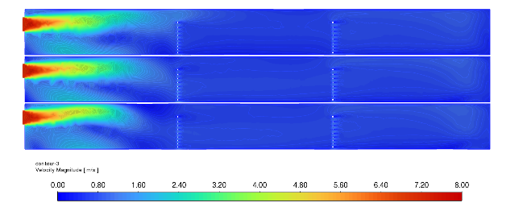
Fig.7 YZ-Plane Wind Speed Contour Map
(2) Temperature Field Analysis
The temperature field contour map of the XY plane 800 mm from the side panel is shown in Figure 8. Analysis reveals that the overall trend shows lower temperatures near the front end close to the outlet and higher temperatures at the rear end. This is primarily due to higher wind speeds at the front end and lower wind speeds at the rear end. Regarding height distribution, the first and third layers exhibit higher temperatures while the intermediate layer is cooler. This occurs because the bottom plate heats the lower portion of the first layer and the top plate heats the upper portion of the third layer under the influence of external high temperatures.
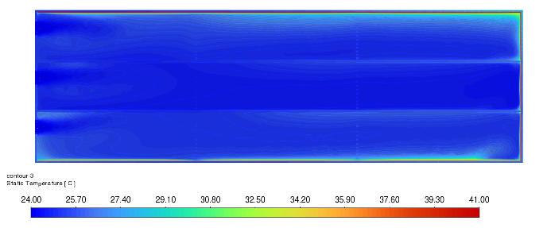
Fig. 8 Temperature Field on XY Plane
Analysis of XZ Plane Results
(1) Velocity Field Analysis
The velocity field contour plot at the XZ plane 4000 mm from the front panel is shown in Figure 9. Analysis reveals higher wind speeds on both sides of the body, with lower speeds in the central region, particularly the lower-middle section. This is primarily because the longitudinal pillars at the front obstruct the airflow, causing it to split toward the left and right sides. The higher airflow velocity at the top of each layer compared to the bottom is mainly due to the upward positioning of the air vents.
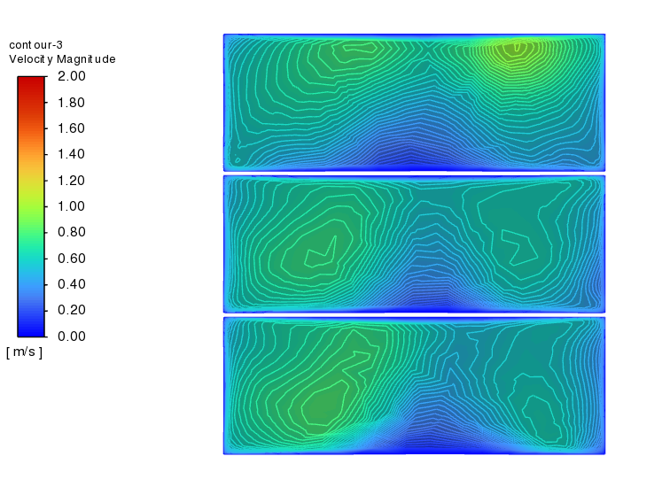
Fig.9 XZ Plane Velocity Field
(2) Temperature Field Analysis
Analysis of the temperature field contour map at the XZ plane 4000mm from the front panel reveals an overall trend of higher temperatures near the outer body and lower temperatures farther from it. Vertically, the first and third layers exhibit higher temperatures, while the second layer is cooler. This is primarily influenced by wall heat transfer. The first and third layers have larger wall-adjacent areas, resulting in higher temperatures, while the second layer has a smaller wall-adjacent area and thus lower temperatures.
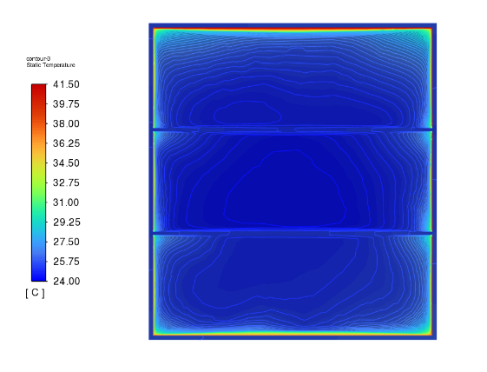
Fig.10: Temperature Field on XZ Plane

4.1.3 Analysis of XY Plane Results
(1) Velocity Field Analysis
The velocity field contour map at the XY plane 1500 mm above the base plate is shown in Figure 11. Analysis reveals higher wind speeds at the front end of the enclosure and lower speeds at the rear end. This is primarily influenced by the gate and central pillars in the middle pen section, where wind speeds are lower in the center and higher on both sides. In the rear pen section, wind speeds are higher near the outlet due to its influence.
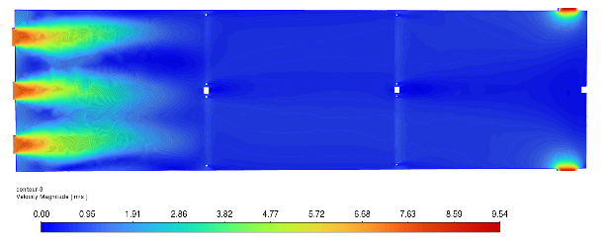
Fig.11 XY-Plane Velocity Field
(2) Temperature Field Analysis
The temperature field contour plot at the XY plane 1500mm above the base plate is shown in Figure 12. Analysis reveals that the overall trend shows higher temperatures near the outer enclosure and lower temperatures farther from it. The front corner near the inlet exhibits lower wind speeds and higher temperatures due to the influence of the hot enclosure panel. At the side panels, the barrier door creates a blocking effect, resulting in higher temperatures in the rear section behind the door.
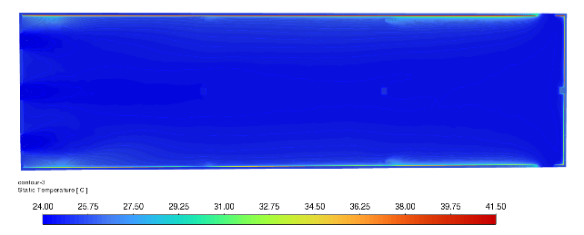
Fig.12 Temperature Field on XY Plane
  - Simulation Results Verification

The temperature and wind speed data from FLUENT analysis under identical environmental conditions were compared with measured values at corresponding points. The comparison results are presented as variation line charts in Figures 13 and 14.
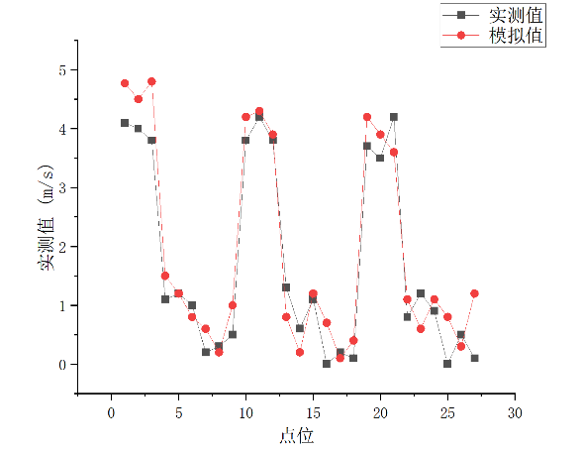
Fig.13 Speed Comparison Line Chart
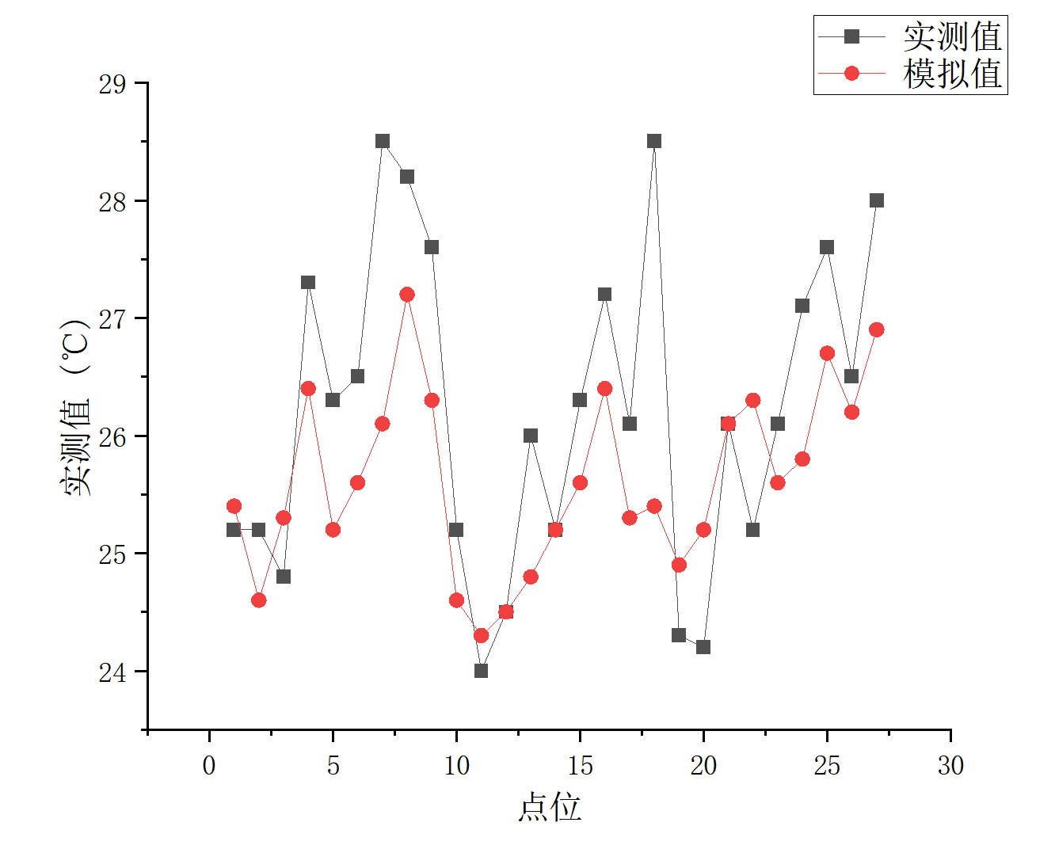
Fig.14 Temperature Comparison Line Chart
The figures show that the simulated air velocity values inside the passenger compartment generally exceed the measured values. This discrepancy primarily stems from the simulation neglecting gaps in the side panels and omitting certain components that have minimal impact on the internal convection field during model simplification. However, the overall trend aligns closely between measured and simulated values. The temperature line chart indicates that overall measured temperatures exceed simulated values. This discrepancy primarily stems from the simulation treating the car body panels as a sealed enclosure and disregarding the embedded steel framework within the panels. Nevertheless, the overall trend aligns closely between numerical simulation and measured values.
  - Ventilation Optimization Design

Overview of Optimized Structure.
Analysis of measured and simulated data reveals significant disparities in wind speed and temperature between the front and rear sections of the original ventilation structure. This imbalance risks causing cold stress to pigs in the front section and heat stress to those in the rear. Therefore, optimizing the ventilation structure to address these temperature and wind speed inefficiencies is imperative.
The primary cause of high wind speeds and low temperatures at the front, coupled with low wind speeds and high temperatures at the rear, is the forward airflow. This optimization modifies the nine forward air inlets to side-mounted circular inlets. Air enters through these inlets, flows through the interior of the compartment, and exits via square outlets. The side airflow effectively minimizes the obstruction caused by the partition doors. The specific airflow configuration is illustrated in Figure 15.
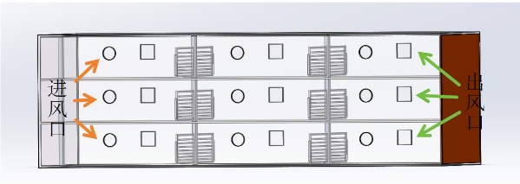
Fig.15 Schematic of the Improved Design
Analysis of Optimization Results.
(1) Velocity Field Analysis
As shown in Figures 16 and 17, the velocity field analysis reveals that switching from front to side air intake results in nearly uniform wind speeds across the entire vehicle length. Ventilation uniformity is significantly enhanced, with rear wind speeds increasing from 0.5 m/s to 6 m/s—meeting the ventilation requirements for pig transport.
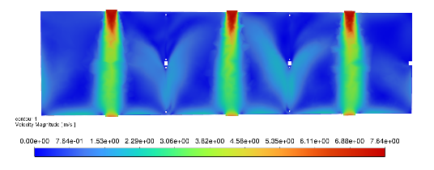
Fig.16 XY cross-section at 400 mm above the floor
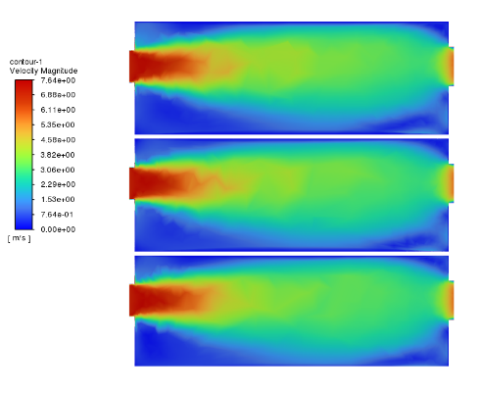
Fig.17 ZX cross-section at 2400 mm from the front panel
(2) Temperature Field Analysis
As shown in Figures 18 and 19, the temperature field analysis reveals that after switching from front-to-rear to side-to-rear airflow, temperatures at the front and rear ends of the compartment became largely consistent. However, temperatures in the corners of the compartment remained relatively higher. Compared to the front-to-rear airflow configuration, the temperature uniformity within the compartment improved significantly. The overall average temperature of the compartment remained around 25°C, meeting the temperature requirements for pig transportation.
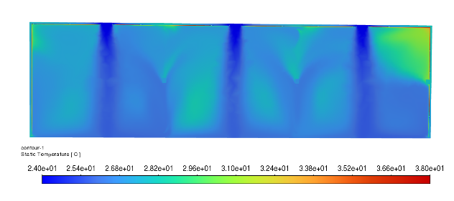
Fig.18 XY cross-section at 400 mm from the floor
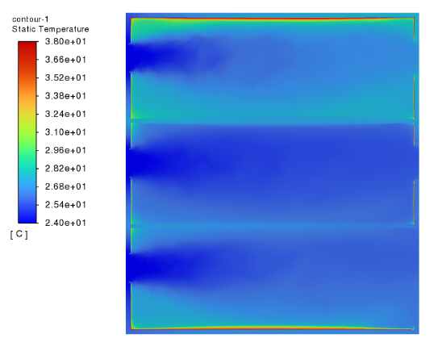
Fig.19 ZX cross-section at 2400 mm from the front panel

5. CONCLUSION

This paper established a CFD model of the passenger compartment interior and conducted experimental measurements and simulation studies of the temperature and velocity fields within the vehicle body. The primary conclusions are as follows:
(1) The CFD model accurately simulates relevant parameters of the temperature and velocity fields within existing passenger compartments. Subsequent measurements of temperature and velocity fields in actual vehicles were conducted, and a comparative analysis between measured and simulated values validated the accuracy of the simulations. Analysis of the simulation results revealed issues with uneven ventilation distribution within the vehicle.
(2) To address the uneven ventilation issue, a side-intake ventilation scheme was implemented. This increased the average wind speed at the rear of the vehicle from 0.2 m/s to 4 m/s, significantly improving ventilation uniformity. This approach provides new insights and methods for enhancing ventilation uniformity in similar structures..
Competing interests

Authors have declared that no competing interests exist.

DISCLAIMER (ARTIFICIAL INTELLIGENCE)
Author(s) hereby declare that NO generative AI technologies such as Large Language Models (ChatGPT, COPILOT, etc.) and text-to-image generators have been used during the writing or editing of this manuscript.

References

[1] Griffin,O.M.Vortex-Excited Cross-Flow Vibrations of a Single Cylindrical Tube[J]. Journal of Pressure Vessel Technology, 1980, 102(2):158-166 https://doi.org/10.1115/1.3263315
[2] Wang Q Y ,Chen X ,Wang B , et al.Multi-Objective Optimization for the Section Structure of Sandwich Plate Applied in the High-Speed Train Compartments[J].Applied Mechanics and Materials,2014,3337(597-597):535-539.DOI:10.4028/www.scientific.net/AMM.597.535.. https://doi.org/10.4028/www.scientific.net/AMM.597.535
[3] Nan X W ,Xiu L D ,Shuang H D .Finite Element Analysis and Structural Optimization of Heavy-Duty Truck's Carriage[J].Advanced Materials Research,2010,148-149(148-149):601-605. https://doi.org/10.4028/www.scientific.net/AMR.148-149.601
[4] Dudka P A .The Design of the Crystals Structure Study: I. Optimization of Data Collection on Modern Diffractometers[J].Crystallography Reports,2025,70(5):845-852. https://doi.org/10.1134/S1063774525600425
[5] Chen B ,Liu P ,Jiang L , et al.Improving the beneficiation performance of the water-only cyclone by optimizing the cone structure[J].Powder Technology,2026,469(P1):121760-121760. https://doi.org/10.1016/J.POWTEC.2025.121760
[6] Ishii N, Imaichi K, Hirose A. Dynamic instability of Tainter-gates[J]. Practical experiences with flow-induced vibrations, 1980: 452-460. https://doi.org/10.1007/978-3-642-81528-7_49
[7] Ishii N. Folsom Dam gate failure evaluation based on modal analysis and suggestion[J]. USBR, 1995.
Thang N D,Naudascher E.Vortex-excited vibrations of underflow gates[J].Journal of Hydraulic Research, 1986, 24(2): 133-151. https://doi.org/10.1080/00221688609499327
[8] Kolkman P A. A simple scheme for calculating the added mass of hydraulic gates[J]. Journal of fluids and structures, 1988, 2(4): 339-353. https://doi.org/10.1016/S0889-9746(88)90051-5
[9] Erdbrink C D, Krzhizhanovskaya V V, Sloot P M A. Reducing cross-flow vibrations of underflow gates: Experiments and numerical studies[J]. Journal of Fluids and Structures, 2014, 50: 25-48 https://doi.org/10.1016/j.jfluidstructs.2014.06.010
[10]Zhuang Z ,Xu T ,Xiong Y , et al.An integrated framework for body-fitted topology optimization considering buckling load factor, stiffness, and von mises stress[J].Computer Methods in Applied Mechanics and Engineering,2026,448(PB):118520-118520. https://doi.org/10.1016/J.CMA.2025.118520

