Original Research Article
Performance and Economic Feasibility Assessment of a Small-Scale Updraft Gasifier for Domestic Applications in South-West Nigeria

Abstract
Nigeria needs alternatives to liquefied petroleum gas (LPG), whose growing price and scarcity have led to a greater reliance on firewood and charcoal, increasing pollution and carbon footprint. To provide sustainable and affordable cooking energy, this study examines the performance and economic viability of a small-scale updraft gasifier designed for home use in South-Western Nigeria. Investigation of the effects of temperature and feedstock size on gasifier performance revealed that higher operating temperatures improved the gas's higher heating value (HHV) and overall system efficiency. With a power output of 7.60 kW, thermal efficiency of 81.6%, and a char yield of 10%, the gasifier demonstrated efficient operation and acceptable gas quality. Economically, the system provided about 20,000 MJ of cooking energy annually at a Levelized Cost of Cooking (LCOC) of ₦0.82/MJ, which is substantially less than the ₦31.95/MJ for LPG. Its high viability was confirmed by the payback period of 0.37 years and the net present value (NPV) of ₦976,447, respectively. These results suggest that domestically produced biomass gasifiers can provide a low-cost, clean, and energy-efficient domestic cooking option, particularly in areas with an abundance of agricultural waste, thereby supporting Nigeria's clean energy transition and sustainability goals.

Keywords: biomass; gasifier; Nigeria; techno-economic analysis; agricultural waste; efficiency

1. Introduction
In every developing or developed country, a steady energy supply supports basic amenities, such as cooking, lighting, transportation, and healthcare. [1]. On a larger scale, it promotes major economic sectors, including manufacturing, agriculture, and commerce [2], [3]. When the energy sector works efficiently, the economy grows, the poverty rate declines, and the living standards of the people improve [4].
Nigeria is the most populous country in Africa, with an estimated 237 million people [5]. However, about 40% of the population does not have access to electricity [4], and even those connected to the grid cannot boast of a steady power supply in their homes or workplaces. Hence, liquefied petroleum gas (LPG) is the more reliable option for cooking. According to the World Bank, 30.9% of Nigerians live below the global extreme poverty line [6]. To put this into perspective, approximately 73 million Nigerians live on less than $2.15 per person per day. This means many Nigerians cannot afford to purchase LPG due to its high cost. Therefore, they resort to alternatives, such as kerosene, firewood, or charcoal. There are two major implications to this. First, the heavy reliance on fossil fuels poses health and environmental risks through the release of toxic fumes into the atmosphere [7], [8]. Second, the use of firewood and charcoal has increased deforestation rates, contributing to climate change [9], [10].
Renewable energy and effective waste management offer a possible solution to Nigeria’s energy crisis. Renewable energy sources, including solar, wind, and biomass, are posited to potentially replace fossil fuels (coal, oil, and natural gas) as the primary sources of energy [1]. Presently, the exploration of biomass as a renewable energy source has continued to gain momentum, contributing to 50% of renewable energy sources globally [1]. This is no surprise, as biomass is naturally abundant compared to other renewable energy sources. They can be grouped into forestry (woody biomass) and agricultural crops or wastes from agriculture, industries, animals, and sewage (non-woody biomass) [1], [11], [12]. Due to the high heating value of woody biomass, it is the most attractive resource, with an estimated worldwide energy supply of 56 EJ [11]. Gliricidia Sepium wood is chosen for this study due to its high gross calorific value (GCV) [13] and abundance in South-West Nigeria. Despite its potential as a renewable energy source, its conversion to useful energy is not widely reported.
The performance of a biomass material for energy generation doesn’t rely solely on its inherent properties; the selected conversion route also plays a crucial role [14]. Biomass is typically converted into energy via thermochemical (e.g., pyrolysis, torrefaction, and gasification) or biochemical processes (e.g., enzymatic hydrolysis, fermentation, and aerobic/anaerobic digestion) [1], [15]. Owing to their rapid reaction times and excellent conversion efficiency, thermochemical methods are typically more effective than biochemical methods [1]. Among all types of thermochemical methods, gasification offers the highest efficiency, produces lower NOx and SOx emissions, requires a smaller amount of oxygen, and operates at lower temperatures [16]. Reports show that it is capable of producing 5 kW of power for small to medium-sized gasifiers [17]. Three types of gasifiers are entrained flow, fluidized bed, and fixed bed gasifiers [1]. Fixed-bed gasifiers are preferable for small-scale gasification and are further divided into updraft and downdraft gasifiers. In an updraft gasifier, also known as a counter-current gasifier, the gasifying agent is introduced at the bottom of the vertical reactor vessel, while the biomass feedstock is introduced from the top [1]. It offers lower operational temperatures (200 to 400 °C), high thermal efficiency (40 to 70%), compatibility with various particle sizes (5 to 100 mm), and tolerance to moisture content (up to 60%) [1], [18].
Owing to the aforementioned merits, this study involved the design and construction of a small-scale updraft gasifier to convert Gliricidia Sepium wood into a combustible gas, also known as syngas. The syngas generated from this study can be used for cooking, transportation, power generation, or the production of biochemicals, such as lubricants or solvents [1], [18]. In developed countries, biomass conversion technologies are already established at industrial scales. However, in developing countries like Nigeria, there is a need for small and affordable biomass conversion systems that can be deployed at the domestic level. An updraft gasifier is a great choice due to its low construction cost, ease of use, and compatibility with various locally available biomass feedstocks. This study is relevant in Nigeria, where the high cost of cooking gas continues to burden households. Moreover, it provides new insights into the feasibility of Gliricidia Sepium wood, an abundant but underreported woody biomass. In addition to providing clean energy for cooking, this study presents a techno-economic analysis that provides insights into the viability of updraft gasifiers for domestic use in South-Western Nigeria.
2. Methodology
2.1 Materials and equipment
The primary materials used in this study were the biomass feedstock and the materials used for constructing the updraft gasifier. 5 kg of dry Gliricidia Sepium wood was obtained from Ile-Ife, South-Western Nigeria. The woods were further dried in an oven for 2 hours at 60 ℃ to remove the remaining moisture content. They were then cut into sizes ranging from 6 to 20 mm and weighed into five batches of 1 kg. Gliricidia Sepium was selected for its high volatile matter content, as shown in Table 1. Table 2 outlines the materials used in constructing the updraft gasifier, while Table 3 details the equipment used during the gasification process.
Table 1. Ultimate analysis of Gliricidia Sepium [19].
Properties | Average composition
Volatile matter | 73.14%
Nitrogen | 0.48%
Hydrogen | 2.85%
Sulphur | 0.03%
Ash content | 1.28%
Gross calorific value | 19.55 MJ kg⁻¹
Density | 992.95 kg m⁻³

Table 2. Updraft gasifier construction materials.
Material | Gasifier component | Rationale
Mild steel | Inner and outer fuel hoppers with an ash container | Affordable, high tensile strength, and easy to fabricate [20].
Galvanized iron | Gas outlet pipe, air inlet pipe, grate, torus, and feeding/ignition ports. | Affordable, durable, and anti-corrosive [20].
Fiberglass | Insulator | Poor thermal conductivity and non-flammable [21].

Table 3. Equipment employed for the gasification process.
Equipment | Function
Air blower | Supplied airflow into the gasifier to support gasification and maintain the air-fuel ratio.
Digital thermometer with thermocouples | Measured the temperature at various gasifier zones.
LCD digital anemometer | Determined the flow rate of the air supplied by the blower into the gasifier.
Kane 425 flue gas analyzer | Provided the concentration of the syngas composition (CO and CO₂ only)
Weighing scale | Measured the mass of the biomass feedstock and produced ash.
Smart timer | Recorded the duration of the gasification process.

2.2.1 Design calculations
Some assumptions were made in designing the updraft gasifier: the gasifier efficiency and rated power were taken to be 70% and 10 kW, respectively. Furthermore, the specific gasification rate (SGR) was chosen to be 84 ${{kg m}^{-2} h}^{-1}$. The fuel consumption rate (FCR) and reactor diameter were calculated using Equation (1) and (2) [22], [23]. The reactor height and gasifier operating time were computed via Equation (3) and (4) [22], [23].
$FCR= \frac{P}{GCV x η_{g} }$ (1)
$D_{r}=({\frac{4 x FCR}{SGR x π })}^{\frac{1}{2}}$ (2)
$H_{r}= \frac{SGR x T}{ρ_{f}}$ (3)
$T= \frac{ ρ_{f} x V_{r}}{FCR}$ (4)
Where FCR is fuel consumption rate (${kg h}^{-1}$), P is the rated power or thermal energy of the gasifier ($kW$), GCV represents the gross calorific value of Gliricidia Sepium (${MJ kg}^{-1}$), and $η_{g}$ stands for gasifier efficiency (%). $D_{r}$ is the reactor diameter ($m$), SGR equals specific gasification rate ${{(kg m}^{-2} h}^{-1}$), T is the gasifier operating time ($h$), while $ρ_{f}$ and $V_{r}$ are the density of the fuel (${kg m}^{3}$) and reactor volume ($m^{3}$), respectively.
The calculated value of the FCR was 2.63 ${kg h}^{-1}$, while it was 0.2 $m$ for the reactor diameter. The reactor height and gasifier operating time (from ignition to complete gasification of fuel in the reactor) were calculated to be 0.5 $m$ and 1.85 $h$.
2.2.2 CAD Design
The design calculations obtained in the previous section were utilized to develop the CAD model of the updraft gasifier. This visual model aided the construction of the gasifier by ensuring the dimensional accuracy of the gasifier components and seamless assembly. Fig. 1 portrays the CAD models of the updraft gasifier.
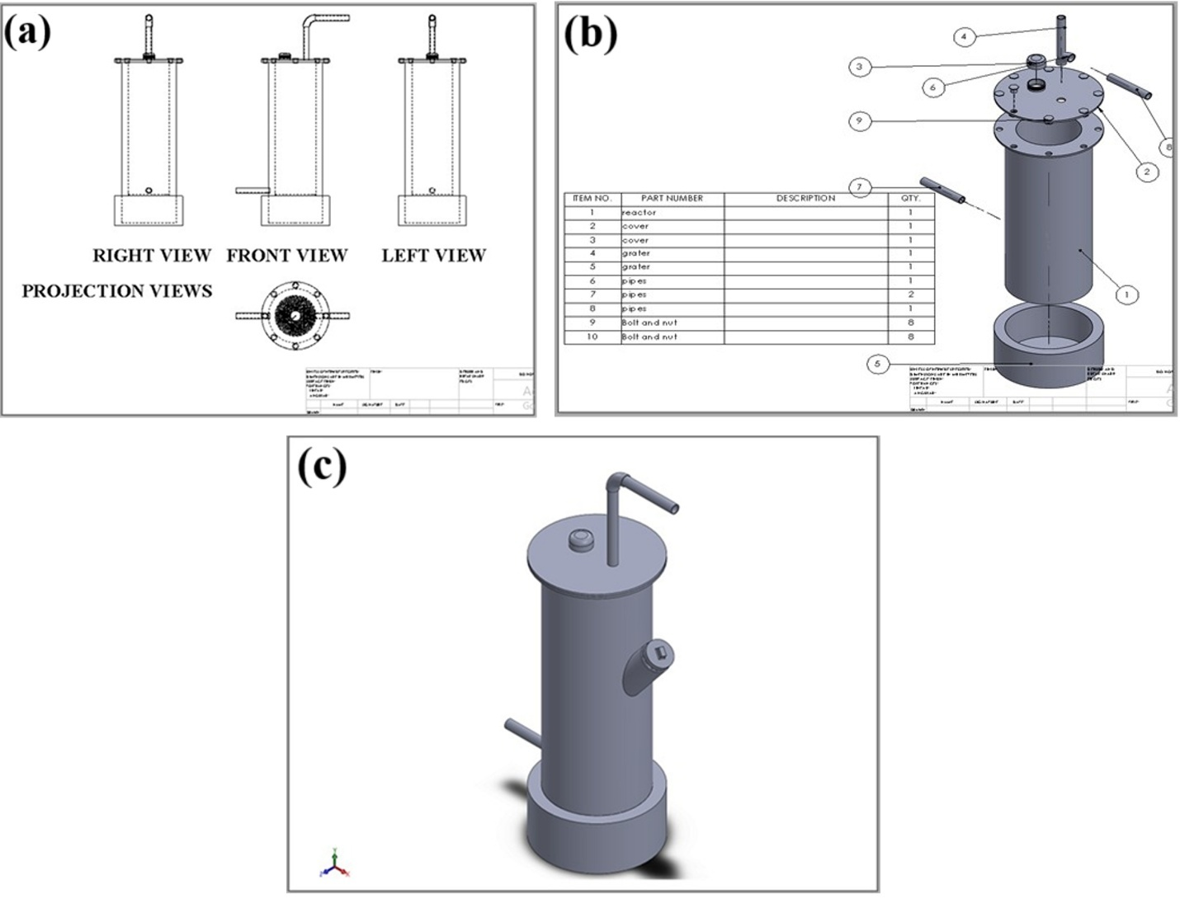
Figure 1. The updraft gasifier’s (a) Projection views, (b) Exploded view with part list, and (c) Isometric view.
2.2.3 Construction of the updraft gasifier
This process began with the cutting of two 2 mm-thick mild steel plates and folding them into the inner and outer fuel hoppers, which have diameters of 0.14 m and 0.2 m, respectively. To minimize energy loss during gasification, a 0.6 m-thick fiberglass layer was inserted between the inner and outer fuel hoppers. The height of the reactor is 0.5 m. The ash container was made from mild steel and had the same diameter as the reactor, with a height of 0.1 m, resulting in a total height of 0.6 m for the updraft gasifier. The grate was fabricated from 2 mm-thick galvanized iron with over twenty 11 mm holes for easy ash removal. It has the same diameter as the reactor, and one end is fixed to the bottom of the reactor with a hasp on the other end connecting to the side of the reactor. This helps facilitate the quick discharge of heavy ash into the removable ash container located below it. Similarly, the torus was fabricated from galvanized iron and welded to the inner fuel hopper around the grate. Twelve 2mm holes were drilled into it to enable the updraft of the compressed air into the inner fuel hopper. The feeding port at the top of the gasifier and the ignition port on the center side were both made from galvanized iron and have a diameter of 64 mm. The gas outlet and air inlet pipes were fabricated from galvanized iron. One end of the gas outlet pipe is welded to the lid of the fuel hopper. It is from this pipe that the syngas is obtained for further processing and application. The gas outlet pipe is shaped like a “7” with a height of 0.19 m and a width of 0.24 m. The gas flows through a diameter of 17 mm. The air inlet pipe is used to pass the compressed atmospheric air from the portable air blower to the torus. The diameter of the air inlet is 17 mm with a length of 0.137 m. The various stages of the updraft gasifier construction are depicted in Fig. 2.
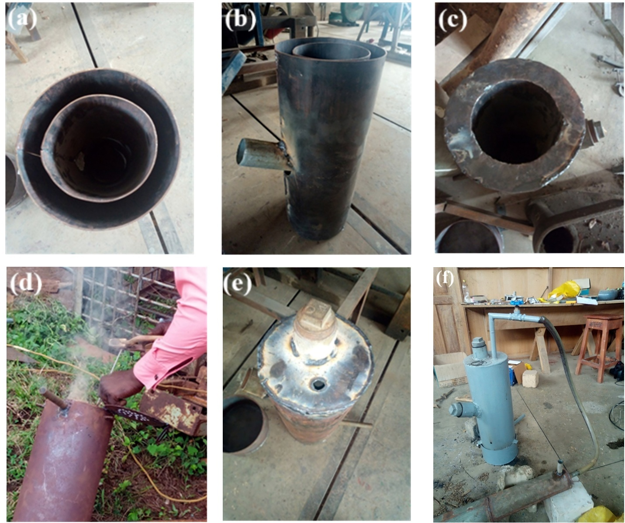
Figure 2. Stages of updraft gasifier construction showing (a) Reactor, (b) ignition port and vertical view of the reactor, (c) Reactor post insulation, (d) Welding of grate to reactor bottom, (e) Sealed reactor top with feedstock feeding port, drilled hole for gas outlet pipe, and ash container, and (f) completed updraft gasifier.
2.3 Experimental procedure
The testing of the updraft gasifier was performed in a well-ventilated laboratory to ensure proper release of gases during operation and overall safety. Several test runs were conducted prior to the main test to evaluate the gasifier’s performance and identify areas requiring design modifications. Minor adjustments were then made to improve air distribution into the inner fuel hopper and minimize energy loss to the surroundings.
The main tests were performed using 1 kg of Gliricidia Sepium wood split into two equal batches. The threaded feeding port was opened by turning anticlockwise, and 0.5 kg of feedstock was fed into the reactor. The port was then closed tightly. The thermocouples were then gently inserted into the gasifier zones, and the initial temperature was measured to ensure they were working correctly. Next, the air blower was connected to the gasifier air inlet via a nozzle. The reactor was lit via the ignition port, and the air blower was switched on after the feedstock in the reactor had been sufficiently ignited. The air velocities at the blower outlet and gasifier air inlet were measured using a digital anemometer and adjusted to the desired velocities. After approximately 10 minutes, the combustion zone temperature increased, indicating that the feedstock had fully ignited. The reactor was then opened, and the remaining 0.5 kg was introduced into the reactor and sealed air-tight using a wrench.
Thick white smoke was observed emanating from the gas outlet pipe, and approximately 20 minutes later, combustible gases were released. A flexible hose was used to connect the gas outlet pipe to a cooling tank, lowering the temperature of the syngas. The syngas continued to burn with a steady blue flame for a long time, until no more combustible gases were emitted. Performance parameters, including operating time and temperature readings from the gasifier zones, were recorded throughout the process. After complete gasification, the char residue was released through the grate, left to cool, and then weighed to calculate the char yield and assess the efficiency of the fuel conversion. The gasifier was cleaned and allowed to cool completely before repeating the procedure for different feedstock sizes. Table 4 shows the operating parameters of the gasification process.
Table 4. Gasifier operating parameters.
Parameters | Values
Start-up time ($t_{s}$) | 1h 21mins
Operating time ($t_{o}$) | 0.5h
Total operating time ($t_{t}$) | 1hr 51mins
Weight of wood | 1 kg
Weight of char produced | 0.1 kg
Air velocity at the gasifier air inlet | 1 ${ms}^{-1}$
Air velocity at blower outlet | 4.6 ${ms}^{-1}$

3. Results and discussion
3.1. Updraft gasifier performance evaluation
The results obtained were used to evaluate the performance of the gasifier, including gasifier efficiency, energy input, and power output. The performance results of the updraft gasifier are presented in Table 5. It is observed that the FCR is
$2 {kg h}^{-1}$. Akhator et al. achieved an FCR of 1.25 ${kg h}^{-1}$ when a downdraft gasifier was run on wood chips [24]. The FCR influences the power input/output of a gasifier. If it increases, the power input/output will increase and vice versa. The calculated power input and output were
$10.86 and 7.60 kW$, respectively. Typically, the power output is less than the power input due to energy losses as the temperature increases; however, these losses were minimized by proper insulation of the reactor. In this study, the SGR was found to be 63.69 ${{kg m}^{-2} h}^{-1}$. Kumararaja et al. achieved an SGR of 75 ${{kg m}^{-2} h}^{-1}$ using a downdraft gasifier and wood as feedstock [25]. Generally, wood has a lower SGR compared with other biomass [26]. For instance, in the study by Yin et al., rice husk gasification yielded an SGR of 960 ${{kg m}^{-2} h}^{-1}$ in a circulating fluidized bed gasifier and 127 ${{kg m}^{-2} h}^{-1}$ in a downdraft fixed bed gasifier [27]. The combustion zone rate is the ratio of the reactor length to operation time and was calculated to be $1 {m h}^{-1}$. Heat energy input was determined to be 19.55 $MJ.$The thermal efficiency was assumed to be 70% based on design calculations and subsequently confirmed by the ratio of power input to power output. Gasifier efficiency was 81.6% as confirmed by previous studies, which reported gasifier efficiencies ranging between 70 to 90% [28], [29], [30]. The percentage char produced was 10%, suggesting the biomass feedstock was efficiently converted into gaseous products. Typically, a lower char yield indicates a higher degree of gasification and a more complete thermal breakdown of the fuel [31], [32].
Table 5. Performance summary of the constructed updraft gasifier.
Parameters | Values
FCR | $$2 {kg h}^{-1}$$
SGR | $$63.69 {{kg m}^{-2} h}^{-1}$$
Combustion Zone Rate (CZR) | $1 {m h}^{-1}$
Heat Energy Input ($H_{i}$) | 19.55 $MJ$
Power Input ($P_{i}$) | $$10.86 kW$$
Power Output ($P_{o}$) | $$7.60 kW$$
Thermal Efficiency ($η_{t}$) | 70%
Gasifier Efficiency ($η_{g})$ | $$81.6\%$$
Percentage Char Produced | 10%

3.2 Updraft gasifier temperature profile
The temperature of the four reactor zones was measured using thermocouples for four different time frames: before and after ignition, when combustible gas was produced, and when it was depleted. The temperatures at the different zones (combustion, reduction, pyrolysis, and drying) of the gasifier were recorded and presented in Table 6. Fig. 3 shows the relationship between the temperatures of the four reactor zones with time. From the graph, it can be observed that the temperature of each reactor zone increased with time. In the drying zone, the moisture content of the wood samples dropped significantly due to the large amount of heat generated from the combustion zone. The temperature of the drying zone is typically about 100 to 200 °C [33], [34], but the drying zone temperature was as high as 256 °C because it took a longer time to remove the remaining moisture content of the dry wood.
From when combustible gases were produced, the temperature of the pyrolysis zone increased from 227 °C in the drying zone to 278 °C (and later 256 to 371 °C). This increase in temperature led to the breakdown of wood particles into volatile gases, char, and tar. The highest temperature recorded in the pyrolysis zone was 371 °C, aligning with the 200-500 °C range reported in literature [35], [36]. The reduction zone is located just above the combustion zone, with a temperature range of 26 to 436 °C. The char produced in the pyrolysis zone moved down to the reduction zone, where the unconverted carbon in the char reacted with carbon dioxide (${CO}_{2}$) produced by the combustion zone to give off combustible gas, carbon monoxide (CO). Tar cracking occurs in the reduction zone to reduce the tar content of the syngas. Hence, the reduction zone is important in producing combustible gases and improving the quality of syngas.
The combustion zone is where oxidation of the wood fuel occurs, and it has a temperature range of between 26 and 539 °C. In the combustion zone, the remaining char burnt fiercely under uniform air distribution, which led to the release of ${CO}_{2}$ and a large amount of heat. Hence, the temperature increased rapidly to 539 °C. The combustion zone plays a vital role in the gasification process as the heat released aids the reduction, pyrolysis, and drying processes.

Table 6. Gasifier temperature profile
Temperature ($℃ )$
Time Combustion zone Reduction zone Pyrolysis zone Drying zone
Start 26 26 26 26
Ignition 29 55 109 121
Combustible gas 353 320 278 227
Stop 539 436 371 256

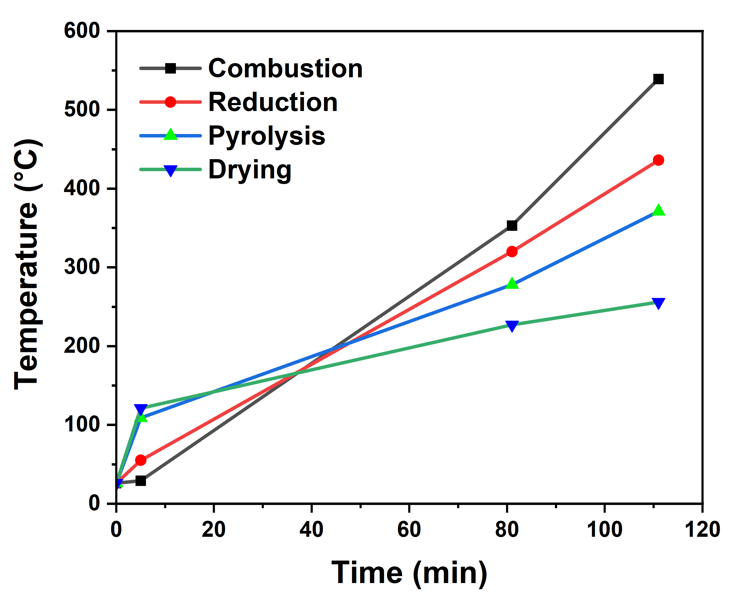
Fig. 3. Temperature variations of reactor zones with gasification time.

3.2.1 Effect of temperature on syngas concentration
In this study, only the CO and ${CO}_{2}$ concentration of the syngas were measured. Fig. 4 shows the variation of CO and ${CO}_{2}$ concentration with temperature. The ${CO}_{2}$ concentration of the syngas remained at 3.7% throughout the gasification process, while the CO concentration increased with temperature. At 306 °C, the CO concentration increased to 12.32% but dropped to 9.08% at 320 °C. The additional air required to raise the gasification temperature after the pyrolysis reaction is essentially finished consumes the syngas’ combustible components and lowers their concentration [37]. This explains the decrease in CO concentration at 320 °C. However, as the temperature increased further, the concentration increased, reaching a peak value of 20.2% at 453 °C, which agrees well with the study by Amin et al. [38]. Large amounts of hydrogen, carbon monoxide, and small molecular hydrocarbons are produced during the secondary cracking of tar, increasing the concentration of combustible components in the syngas [39].
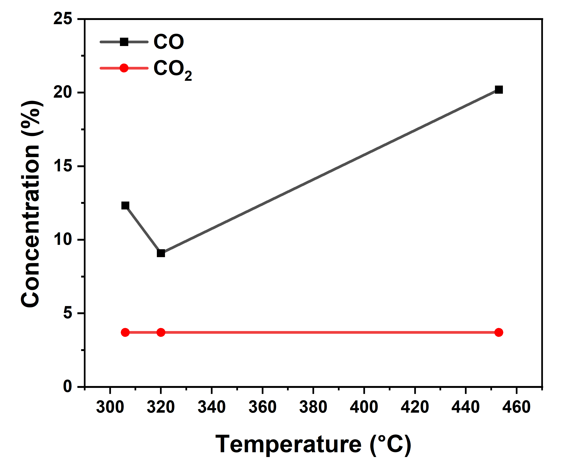
Fig. 4. Chart of CO and CO₂ concentration at increasing temperature.
3.2.2 Effect of temperature on gasifier efficiency
Temperature plays a vital role in biomass gasification. The effect of temperature is evident on the system's efficiency. As the temperature increases, the higher heating value of the gas and subsequently the system efficiency increase. Besides, the temperature increase in the reactor increases the endothermic reaction of the gasification process. The total energy of the syngas then increases, resulting in an improvement in efficiency. Fig. 5 shows the relationship between gasifier efficiency and temperature.
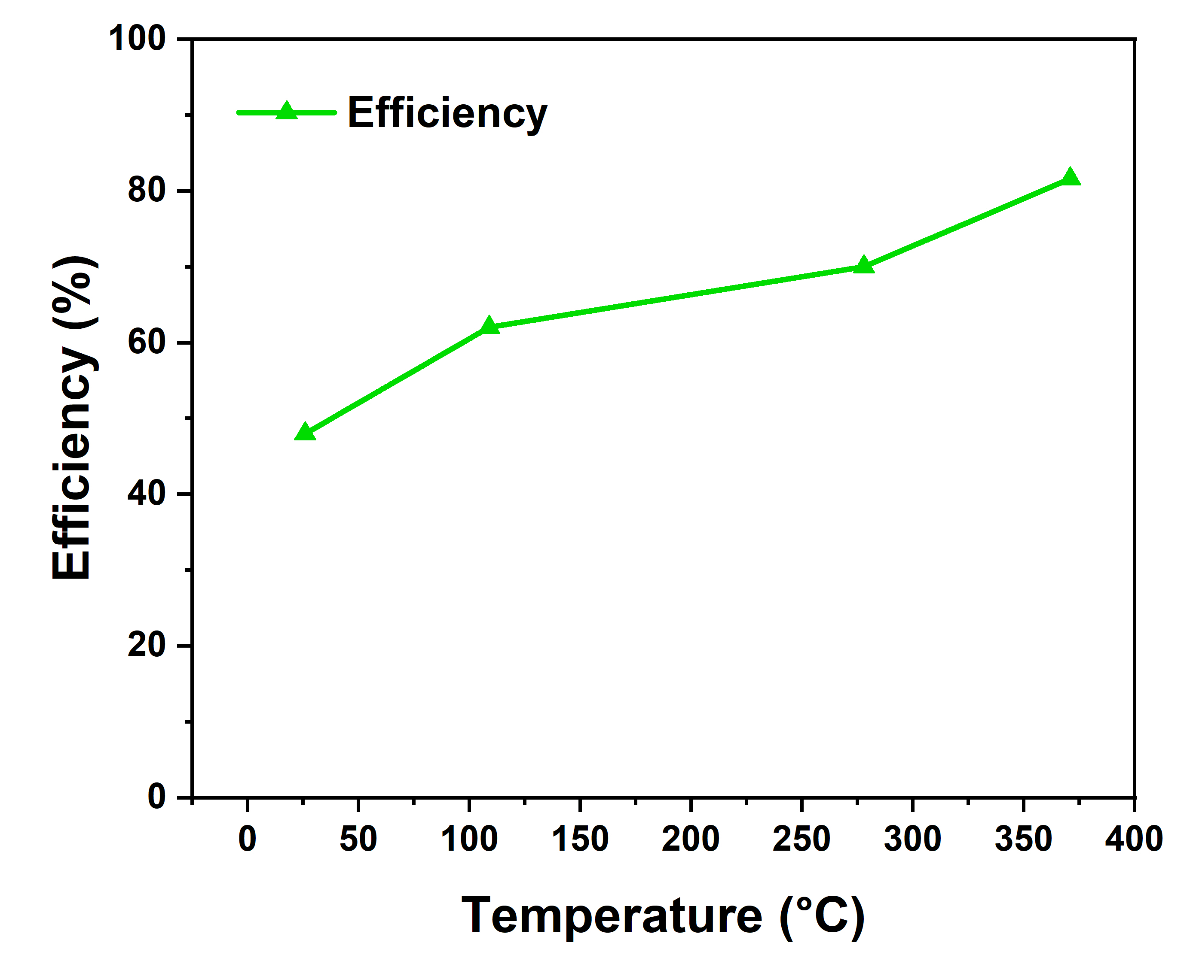
Fig. 5. A graph of gasifier efficiency at rising temperatures.
3.3 Effect of feedstock size
The first obvious effect of feedstock size on the gasification process is the start-up time. Gliricidia sepium wood samples with small sizes ranging from 6-8 mm gasified faster and produced combustible gas at about 19 minutes from ignition time. This test, however, used larger samples with sizes ranging from 16 to 20 mm. These samples took a longer time to gasify, with a start-up time of 81 minutes. The immediate effect of this on the gasification process is that, as the start-up time increases, the total operating time increases. Additionally, as the particle size increases, the temperature increases as the larger wood sizes release more heat. Fig. 6 shows the temperature profile of the varied wood sizes. It can be observed that the larger particle size had higher temperatures in all four zones. Fig. 7 shows the relationship between efficiency and particle sizes. The feedstock size did not appear to have any effect on the syngas composition.
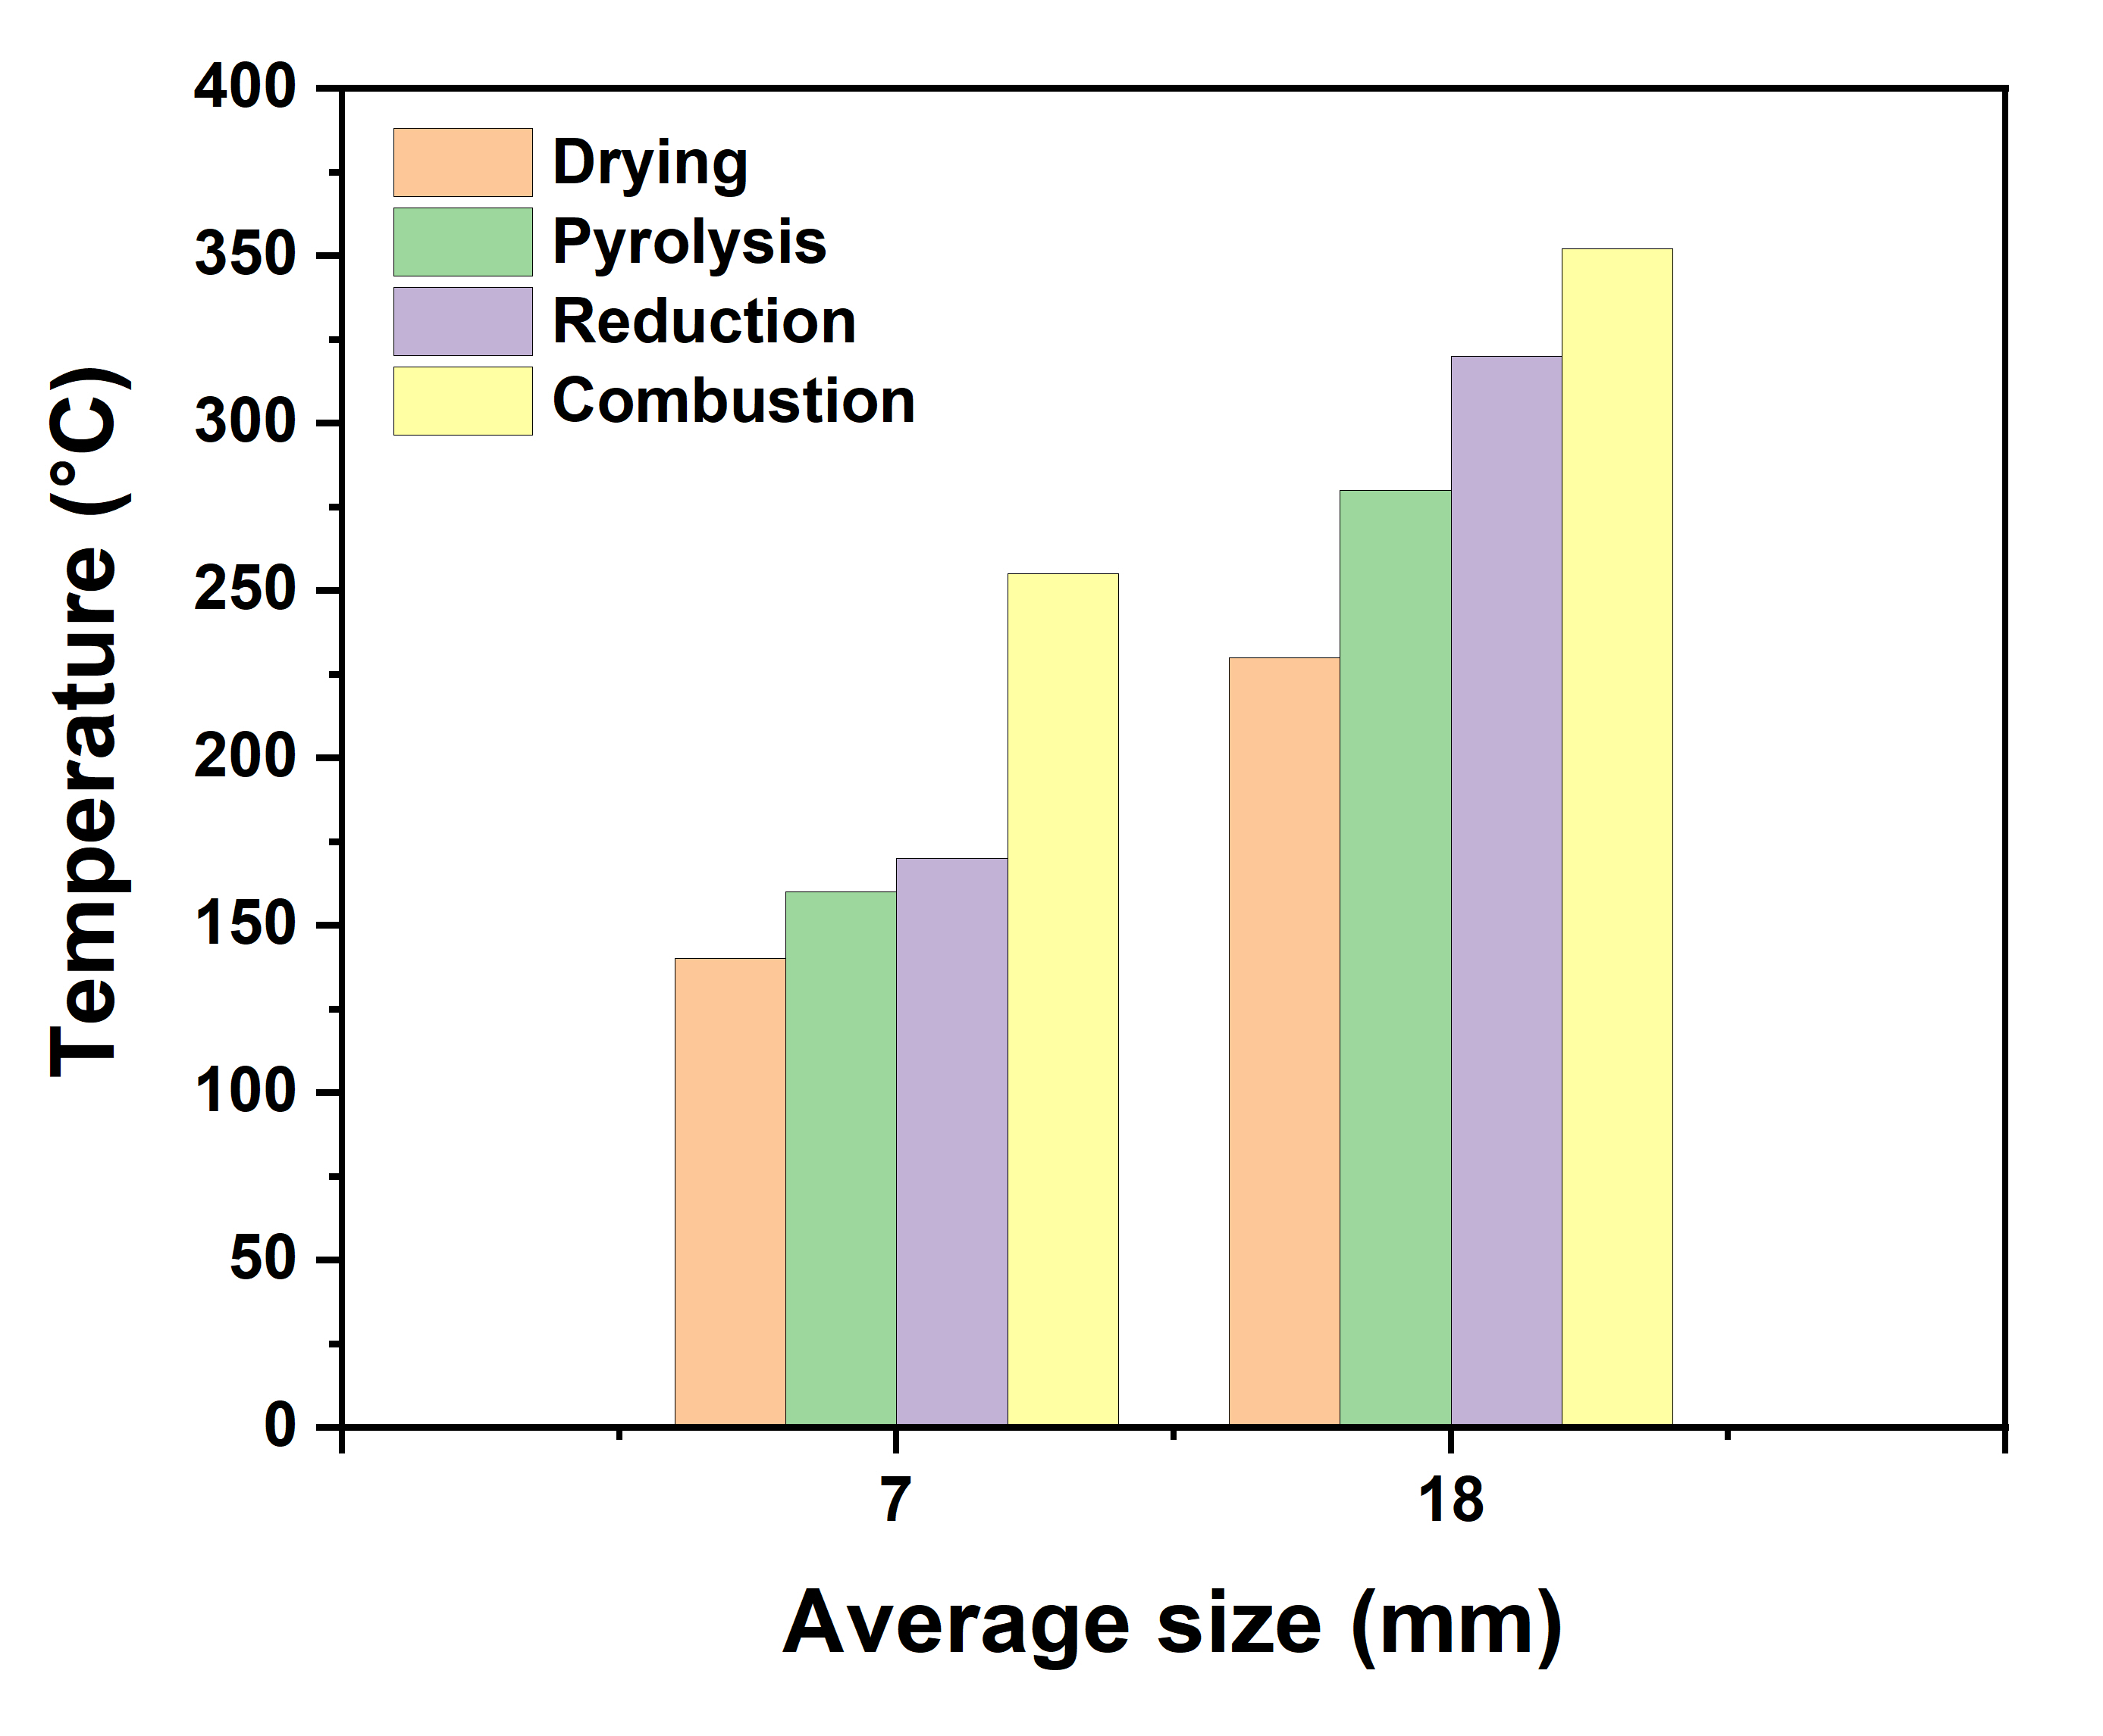
Fig. 6. A plot of average feedstock size vs. temperature.
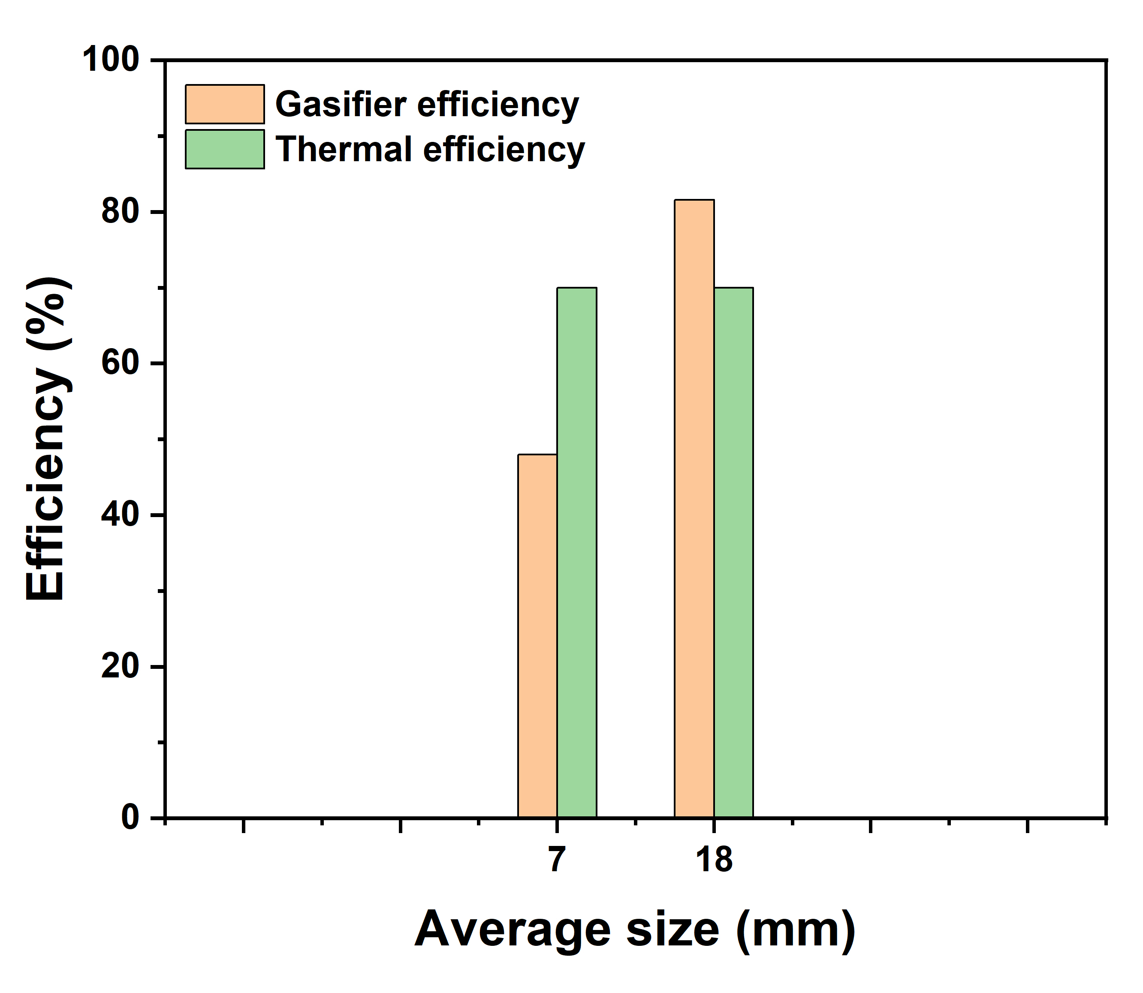
Fig. 7. A plot of average feedstock size vs. thermal and gasifier efficiencies.
3.4 Char and tar composition
The char produced was measured, and the percentage char was calculated mathematically. The results of the experiment showed that the percentage char produced from gasification was 10% as confirmed by Qian et al. [40]. The tar content of syngas had high concentrations at lower temperatures, approximately 200 °C. As the temperature increased to above 350 °C, the concentration of tar decreased. The tertiary formation reactions are probably the main cause of the drop in tar concentration. Between 300 and 500 °C, the primary and secondary tars both break down, but the tertiary tar formation rises, leading to a slight overall drop in the concentration of total tar [40].
3.5 Techno-economic analysis of the updraft gasifier
Due to the high cost of cooking gas in Nigeria, many homes are unable to afford electric cookers or hotplates because of the unstable electricity supply, resulting in an increased reliance on alternatives, such as firewood and charcoal. In 2018, these solid fuels accounted for 67.8% of primary energy consumption in Nigeria's cities and rural areas [41], [42], [43]. A rise in deforestation, greenhouse gas emissions, and indoor air pollution has all been caused by this circumstance. More than 83% of Nigerians did not have access to clean cooking fuels and technologies in 2021 [44], [45]. This rate is marginally higher than the 81.5% regional average for Sub-Saharan Africa [46]. Biomass gasifiers offer a viable alternative, converting abundant agricultural waste into a clean gas suitable for domestic use. However, obtaining both technical feasibility and economic viability is necessary for their broad adoption. Hence, the techno-economic prospects of small-scale gasifiers for Nigerian households, especially in the South-West, are assessed in this subsection. Table 7 and Table 8 provide the technical and economic viability of biomass gasifiers compared to liquified petroleum gas (LPG) cookers, respectively. The updraft gasifier uses agricultural residues to eliminate recurring fuel expenses, whereas the LPG cooker has high annual fuel and maintenance costs (₦210,000 and ₦7,000, respectively). As a result, the gasifier generates huge yearly savings of ₦210,000 and a quick payback period of roughly 0.37 years. Compared to LPG's ₦31.95/MJ, its significantly lower levelized cost of cooking (LCOC) of ₦0.82/MJ and net present value (NPV) of ₦976,447 over a seven-year period demonstrate strong economic viability. Furthermore, the gasifier offers more cooking energy (~20,000 MJ) per year, which makes it a more economical and environmentally friendly choice for urban and rural households with high LPG prices.

Table 7. Technical Assessment of LPG Cooker vs. Updraft Gasifier
Parameter | LPG | Updraft gasifier | Ref.
Cost | High | Low | [47]
Energy efficiency | 70-90% | 60-80% | [48][49]
Emissions | Low | Low to moderate (depends on char/tar handling) | [50]
Maintenance | Low | Moderate | -

Table 8. Economic Feasibility of LPG Cooker vs. Updraft Gasifier
Fuel source | Capital  (₦) | Annual maintenance (₦) | Annual fuel cost (₦) | Annual savings (₦) | Payback (years) | NPV  (₦) | LCOC (₦/MJ) | Annual cooking energy (MJ)
LPG cooker | 86,000 | 7,000 | 210,000 | 0 | 0 | 0 | 31.95 | 7,344
Updraft gasifier | 80,000 | 0 | 0 | 210,000 | 0.37 | 976,447 | 0.82 | ~20,000

The following estimations/assumptions were made:
- Average LPG refill price for a 12.5 kg cylinder - ₦14,000/kg (October 2025) [51]
- Average household LPG refills yearly – 12
- Average cooking energy per kg for LPG – 13.6 kWh [52]
- Average cooking energy per kg for Gliricidia Sepium – 19.8 MJ/kg [53]
- Average household wood gasified yearly – 1,000 kg
- Discount rate, r – 10%
- Economic lifetime, n – 7 years
Equations 5-8 [54] were used in calculating the following:
Annual saving = (LPG Fuel + maintenance costs) – (Gasifier Fuel + maintenance costs) (5)
$Payback=\frac{Capital}{Annual savings}$ (6)
$NPV=\sum_{t=1}^{n}{\frac{Annual savings}{{(1+r)}^{t}}}-capital$ (7)
$LCOC= \frac{Capital annuity + annual maintenance cost + annual fuel cost}{annual cooking energy}$ (8)
Where $Capital annuity=Capital x \frac{r}{1-{\left(1+r\right)}^{-n}}$

4. Conclusion
This study assessed the performance and economic feasibility of a small-scale updraft biomass gasifier for domestic use in South-West Nigeria. The gasifier achieved an impressive efficiency of 81.6% and a power output of 7.60 kW, sufficient for household cooking needs. The effect of temperature and feedstock size on the gasifier efficiency was investigated. It was observed that increasing the temperature increased the higher heating value of the gas and consequently its efficiency. Furthermore, the larger feedstock sizes (16-20 mm) took longer times to gasify and released more heat, resulting in higher temperature profiles across the four reactor zones and increased gasifier efficiency. The percentage char produced was 10%, indicating acceptable gas quality for domestic use.
Economically, the updraft gasifier demonstrated strong viability with a deliverable cooking energy of ~20,000 MJ/year compared to 7,344 MJ/year for LPG cookers. Besides, its extremely low LCOC of ₦0.82/MJ, compared to ₦31.95/MJ for LPG cookers, showcases its cost efficiency. Based on these findings, locally made updraft gasifiers can offer Nigerians an affordable, eco-friendly, and energy-efficient alternative for cooking at home, particularly in the southwestern region, where there is an abundance of agricultural waste.
Nevertheless, before this technology can be adopted on a large scale, tar mitigation, standardized fabrication, and user training should be prioritized to guarantee reliable operation and safety. Its adoption would be further improved by government clean energy policies, subsidies on gasifier prices, and awareness campaigns on clean and affordable energy. All things considered, the results of this study suggest that small-scale biomass gasifiers are a viable technology for achieving Nigeria's objectives in the clean energy transition.

COMPETING INTERESTS DISCLAIMER:
Authors have declared that they have no known competing financial interests OR non-financial interests OR personal relationships that could have appeared to influence the work reported in this paper.

References
Situmorang, Y. A., Zhao, Z., Yoshida, A., Abudula, A., & Guan, G. (2020). Small-scale biomass gasification systems for power generation (<200 kW class): A review. Renewable and Sustainable Energy Reviews, 117, 109486. https://doi.org/10.1016/J.RSER.2019.109486
Moosavi-Nezhad, M., Salehi, R., Aliniaeifard, S., Winans, K. S., & Nabavi-Pelesaraei, A. (2022). An analysis of energy use and economic and environmental impacts in conventional tunnel and LED-equipped vertical systems in healing and acclimatization of grafted watermelon seedlings. Journal of Cleaner Production, 361, 132069. https://doi.org/10.1016/j.jclepro.2022.132069
Ghasemi-Mobtaker, H., Kaab, A., Rafiee, S., & Nabavi-Pelesaraei, A. (2022). A comparative of modeling techniques and life cycle assessment for prediction of output energy, economic profit, and global warming potential for wheat farms. Energy Reports, 8, 4922–4934. https://doi.org/10.1016/j.egyr.2022.03.184
Somoye, O. A. (2023). Energy crisis and renewable energy potentials in Nigeria: A review. Renewable and Sustainable Energy Reviews, 188, 113794. https://doi.org/10.1016/j.rser.2023.113794
Statista. (2025). African countries with the largest population as of 2025. https://www.statista.com/statistics/1121246/population-in-africa-by-country/
World Bank. (2025). Nigeria Poverty and Equity Brief : October 2025. Poverty and Equity Brief. https://documents.worldbank.org/en/publication/documents-reports/documentdetail/099253204222517873
Amzat, A. (2021). Amid health and environmental hazards, Nigeria spends $2.4bn on generators in 2 decades. The ICIR. https://www.icirnigeria.org/amid-health-and-environmental-hazards-nigeria-spends-2-4bn-on-generators-in-2-decades/
Maren, I. B., Agandu, J., & Morgan, M. M. (2013). Energy security in Nigeria: Challenges and way forward. International Journal of Engineering Science Invention, 2(11), 1–6. https://www.ijesi.org/studys/Vol%202(11)/Version-1/A0211010106.pdf
Rose, J., Bensch, G., Munyehirwe, A., & Peters, J. (2022). The forgotten coal: Charcoal demand in sub-Saharan Africa. World Development Perspectives, 25, 100401. https://doi.org/10.1016/j.wdp.2022.100401
Chidumayo, E. N., & Gumbo, D. J. (2013). The environmental impacts of charcoal production in tropical ecosystems of the world: A synthesis. Energy for Sustainable Development, 17(2), 86–94. https://doi.org/10.1016/j.esd.2012.07.004
Balat, M., & Ayar, G. (2005). Biomass energy in the world, use of biomass and potential trends. Energy Sources, 27(10), 931–940. https://doi.org/10.1080/00908310490449045
Johansson, T. B., McCormick, K., Neij, L., & Turkenburg, W. (2006). The potentials of renewable energy. In D. Aßmann, U. Laumanns, & D. Uh (Eds.), *Renewable energy: A global review of technologies, policies, and markets* (1st ed., pp. 15-47). Routledge. https://doi.org/10.4324/9781849772341
Putra, H. P., Kuswa, F. M., Prayoga, M. Z. E., Samudra, H. E., Prabowo, & Hariana, H. (2024). Investigation on combustion characteristics and ash-related issues of Calliandra calothyrsus and Gliricidia sepium using thermogravimetric analysis and drop tube furnace. Bioresource Technology, 394, 130212. https://doi.org/10.1016/j.biortech.2023.130212
Ojodun, O. E., Imoisili, P. E., & Jen, T. C. (2025). Thermal annealing-induced structural modifications and electrochemical enhancement of NiO/CNT electrodes synthesized by spray pyrolysis for high-performance supercapacitors. Electrochemistry Communications, 178, 108010. https://doi.org/10.1016/j.elecom.2025.108010
Chowdhury, N.-R. (2014). Advances and Trends in Woody Biomass Gasification (Master's thesis, Instituto Superior Técnico, Lisbon, Portugal). https://fenix.tecnico.ulisboa.pt/homepage/aluno/nahid-ur-rahman-chowdhury
Kumar, A., Jones, D. D., & Hanna, M. A. (2009). Thermochemical Biomass Gasification: A Review of the Current Status of the Technology. Energies (Basel), 2(3), 556–581. https://doi.org/10.3390/en20300556
Kirubakaran, V., Sivaramakrishnan, V., Nalini, R., Sekar, T., Premalatha, M., & Subramanian, P. (2009). A review on gasification of biomass. Renewable and Sustainable Energy Reviews, 13(1), 179–186. https://doi.org/10.1016/j.rser.2007.07.001
Sansaniwal, S. K., Pal, K., Rosen, M. A., & Tyagi, S. K. (2017). Recent advances in the development of biomass gasification technology: A comprehensive review. Renewable and Sustainable Energy Reviews. https://doi.org/10.1016/j.rser.2017.01.038
Oyelere, A. T., & Oluwadare, A. O. (2019). Studies on Physical, Thermal and Chemical Properties of Wood Gliricidia sepium for Potential Bioenergy Production. International Journal of Biomass and Renewables, 8(2), 28–38. https://myjms.mohe.gov.my/index.php/ijbr/article/view/6202
Ibrahim, M. B. T. (2019). DESIGN AND PERFORMANCE EVALUATION OF AN UPDRAFT GASIFIER. International Journal of Engineering Research & Technology (IJERT). https://doi.org/10.17577/IJERTV8IS090001
Cao, X., Liu, J., Cao, X., Li, Q., Hu, E., & Fan, F. (2015). Study of the thermal insulation properties of the glass fiber board used for interior building envelope. Energy and Buildings, 107, 49–58. https://doi.org/10.1016/j.enbuild.2015.08.007
Amin, M., Wickramaarachchi, W. A. M. K. P., & Narayana, M. (2016). Performance analysis of updraft gasifier. In *2016 International Conference on Sustainable Energy Engineering and Application (ICSEEA)*. https://doi.org/10.1109/ICSEEA.2016.7873568
Ojolo, S. J., Abolarin, S. M., & Adegbenro, O. (2012). Development of a Laboratory Scale Updraft Gasifier. International Journal of Manufacturing Systems, 2(2), 21–42. https://doi.org/10.3923/ijmsaj.2012.21.42
Akhator, P. E., Obanor, A. I., & Sadjere, E. G. (2019). Design and development of a small-scale biomass downdraft gasifier. Nigerian Journal of Technology, 38(4), 922. https://doi.org/10.4314/njt.v38i4.15
Kumararaja, L., Reddy, P. G., Ramanan, M. V., & Sethumadhavan, R. (2010). Experimental investigation on the changes in bed properties of a downdraft biomass gasifier. International Journal of Engineering, Science and Technology, 2(6), 98-106. https://doi.org/10.4314/ijest.v2i6.63701
Kukharets, S., Golub, G., Horetska, I., & Wróbel, M. (2022). A Theoretical Model of the Gasification Rate of Biomass and Its Experimental Confirmation. Energies, 15(20), 7721. https://doi.org/10.3390/en15207721
Yin, X. L., Wu, C. Z., Zheng, S. P., & Chen, Y. (2002). Design and operation of a CFB gasification and power generation system for rice husk. Biomass and Bioenergy, 23(3), 181–187. https://doi.org/10.1016/S0961-9534(02)00042-9
Unsomsri, N., Kaewkungam, P., Sriromreun, P., Wiriyasart, S., & Kaewluan, S. (2025). Performance and characteristics of updraft gasifier integrated with cyclonic syngas burner for clean hot gas production from biomass pellets. Energy Sources, Part A: Recovery, Utilization, and Environmental Effects, 47(1), 5755–5770. https://doi.org/10.1080/15567036.2025.2471436
Mai, T. D., Koós, T., Sebe, E., Siménfalvi, Z., & Kállay, A. A. (2023). Efficiency Enhancement of the Single Line Multi-Stage Gasification of Hungarian Low-Rank Coal: Effects of Gasification Temperature and Steam/Carbon (S/C) Ratio. Energies (Basel), 16(11), 4427. https://doi.org/10.3390/en16114427
Shahbaz, M., Al-Ansari, T., Inayat, M., Sulaiman, S. A., Parthasarathy, P., & McKay, G. (2020). A critical review on the influence of process parameters in catalytic co-gasification: Current performance and challenges for a future prospectus. Renewable and Sustainable Energy Reviews, 134, 110382. https://doi.org/10.1016/J.RSER.2020.110382
Ismail, T. M., & El-Salam, M. A. (2017). Parametric studies on biomass gasification process on updraft gasifier high temperature air gasification. Applied Thermal Engineering, 112, 1460–1473. https://doi.org/10.1016/j.applthermaleng.2016.10.026
Adeniyi, A. G., Iwuozor, K. O., Muritala, K. B., Emenike, E. C., & Adeleke, J. A. (2023). Conversion of biomass to biochar using top‐lit updraft technology: a review. Biofuels, Bioproducts and Biorefining, 17(5), 1411–1424. https://doi.org/10.1002/bbb.2497
Espina, R. U., Barroca, R. B., Simpao, F. T., & Zamora, R. M. (2024). Temperature Profile of a Biomass Gasification Power System. *IOP Conference Series: Earth and Environmental Science*, *1354*(1), 012002. https://doi.org/10.1088/1755-1315/1354/1/012002
Sulaiman, F., Suhendi, E., Prastuti, N., & Choir, O. A. (2019). The Effect of Temperature and Time of Gasification Process and The Addition of Catalyst to The Composition of The Combustible Gas from The Wastes of Tobacco Leaves With Gasifier Updraft. FLYWHEEL : Jurnal Teknik Mesin Untirta, 5(1), 1-8. https://doi.org/10.36055/fwl.v0i0.4821
Rahman, M. M., Henriksen, U. B., & Ciolkosz, D. (2023). Startup process, safety and risk assessment of biomass gasification for off-grid rural electrification. Scientific Reports, 13(1), 21395. https://doi.org/10.1038/s41598-023-46801-w .
[36] I. G. Harouna et al., “Experimental study of the co‐gasification of wood and polyethylene in a two‐stage gasifier,” Energy Sci Eng, vol. 8, no. 7, pp. 2322–2334, Jul. 2020, doi: 10.1002/ese3.667.
Zhang, X., Li, K., Zhang, C., & Wang, A. (2020). Performance analysis of biomass gasification coupled with a coal-fired boiler system at various loads. Waste Management. https://doi.org/10.1016/j.wasman.2020.01.039
Amin, M., Wickramaarachchi, W. A. M. K. P., & Narayana, M. (2016). Performance analysis of updraft gasifier. In 2016 International Conference on Sustainable Energy Engineering and Application (ICSEEA). https://doi.org/10.1109/ICSEEA.2016.7873568
Guan, G., Kaewpanha, M., Hao, X., & Abudula, A. (2016). Catalytic steam reforming of biomass tar: Prospects and challenges. Renewable and Sustainable Energy Reviews. https://doi.org/10.1016/j.rser.2015.12.316
Qian, K., Kumar, A., Patil, K., Bellmer, D., Wang, D., Yuan, W., & Huhnke, R. L. (2013). Effects of biomass feedstocks and gasification conditions on the physiochemical properties of char. Energies, 6(8), 3972–3986. https://doi.org/10.3390/en6083972
Łaska, G., & Ige, A. R. (2023). A Review: Assessment of Domestic Solid Fuel Sources in Nigeria. Energies, 16(12), 4722. https://doi.org/10.3390/en16124722
Nnaji, M., Eze, A. A., Uzoma, C. C., & Nnaji, C. E. (2021). Addressing Household Cooking Fuel Options in Nigeria. IOP Conference Series: Earth and Environmental Science, 730(1), 012038. https://doi.org/10.1088/1755-1315/730/1/012038
Tunde, A. M., Adeleke, E. A., & Adeniyi, E. E. (2013). Impact of charcoal production on the sustainable development of Asa Local Government Area, Kwara State, Nigeria. African Research Review, 7(2), 1-15. https://doi.org/10.4314/afrrev.v7i2.1
Yetano Roche, M., Slater, J., Malley, C., Sesan, T., & Eleri, E. O. (2024). Towards clean cooking energy for all in Nigeria: Pathways and impacts. Energy Strategy Reviews, 53, 101366. https://doi.org/10.1016/j.esr.2024.101366
WHO. (2023). Goal 7 | Indicator 7.1.2 Proportion of population with primary reliance on clean fuels and technologies. https://www.who.int/data/gho/data/themes/air-pollution/household-air-pollution
International Energy Agency. (2023). A Vision for Clean Cooking Access for All. https://www.iea.org/reports/a-vision-for-clean-cooking-access-for-all
LPG in Nigeria. (2025). LPG market charts. https://lpginnigeria.com/chart
Lasisi, S. O. (2021). An analysis of liquefied petroleum gas adoption for household cooking in Nigeria. (Publication No. 10245) [Doctoral dissertation, Walden University]. https://scholarworks.waldenu.edu/dissertations/10245
Mehta, Y., & Richards, C. (2017). Gasification Performance of a Top-Lit Updraft Cook Stove. Energies, 10(10), 1529. https://doi.org/10.3390/en10101529
Oke, D. O., Fakinle, B. S., Sonibare, J. A., & Akeredolu, F. A. (2020). Evaluation of emission indices and air quality implications of liquefied petroleum gas burners. Heliyon. https://doi.org/10.1016/j.heliyon.2020.e04755
Business Day. (2025). Cooking gas price drops to ₦1,400/kg, say retailers. BusinessDay NG. https://businessday.ng/energy/article/cooking-gas-price-drops-to-%E2%82%A61400-kg-say-retailers/
ELGAS. (2023). Liter to kg, MJ, kWh & l to m³: LPG Measurement Unit Conversions. https://www.elgas.com.au/elgas-knowledge-hub/residential-lpg/lpg-gas-unit-conversions/
Atapattu, A. J., Raveendra, T., Pushpakumara, D. K. N. G., & Rupasinghe, M. (2017). Regeneration potential of Gliricidia sepium (Jacq.) Kunth ex Walp. as a fuelwood species. Indian Journal of Plant Sciences.
Sobamowo, G. M., & Ojolo, S. J. (2018). Techno-Economic Analysis of Biomass Energy Utilization through Gasification Technology for Sustainable Energy Production and Economic Development in Nigeria. Journal of Energy, 2018, 1–16. https://doi.org/10.1155/2018/4860252

