Original Research Article
Reactivity of Rice Husk on The Strength Properties of Concrete

.
ABSTRACT

Aims: This study investigated the effect of rice husk ash (RHA) as a partial replacement for cement on the fresh and hardened properties of concrete.
Methodology: Rice husk was sourced, cleaned, and combusted under controlled conditions, with the resultant ash ground to pass a 75 µm sieve. Characterization of fine and coarse aggregates revealed relatively narrow particle gradations, suggesting potential implications for packing density and paste demand.
Results: Workability, assessed via slump tests, increased from 4.5 cm in the control mix to a peak of 7.0 cm at 10% replacement, then slightly decreased at 15%, indicating optimal workability around 10% RHA. Compressive strength results revealed that the control concrete exhibited consistent strength gain from 13.7 MPa at 7 days to 20.65 MPa at 28 days. At 5% replacement, early strength was lower than the control but surpassed it by 14 days (17.81 MPa) due to continued pozzolanic reaction, though final 28-day strength (18.53 MPa) remained slightly lower than the control. Strength decreased at 10% and 15% replacement levels across all curing ages, achieving 13.50 MPa and 8.20 MPa respectively at 28 days, indicating that excessive ash reduced available cementitious compounds and led to increased porosity.
Conclusion: The study concludes that RHA exhibits moderate pozzolanic reactivity and can be effectively used as a supplementary cementitious material at low dosages, with 5% identified as the optimum replacement level for structural concrete in this experimental condition.

Keywords: Reactivity, Rice husk ash, Concrete, Compressive strength

1. INTRODUCTION

It is a popularly known fact that Ordinary Portland Cement (OPC), the primary binder of concrete, the world’s most widely used construction material, significantly contributes to global CO₂ emissions due to the high energy requirements of clinker production. In response to environmental and sustainability concerns, researchers have increasingly turned to supplementary cementitious materials (SCMs) to reduce cement usage and enhance performance.
Rice Husk Ash (RHA) is one such SCM, produced from the controlled combustion of rice husks, an abundant agricultural by-product. Rich in amorphous silica, RHA exhibits strong pozzolanic activity, wherein silica reacts with calcium hydroxide (Ca(OH)₂), generated during cement hydration, to form additional calcium silicate hydrate (C–S–H) gel. This secondary hydration leads to pore refinement, improved microstructure, increased long-term strength, and enhanced durability of concrete (Sadiqul et al., 2022).
The degree of RHA’s effectiveness hinges on several parameters: the amount and purity of amorphous silica, particle fineness, processing conditions (such as combustion temperature and grinding), and mix design factors like replacement ratio and curing environment (Siddika et al., 2021; Endale et al., 2022). Controlled combustion (below 700°C) helps preserve the silica in its amorphous, highly reactive state, while excessive heat promotes crystallization, which diminishes pozzolanic reactivity (Sadiqul et al., 2022).
Numerous studies have demonstrated that replacing cement with RHA, typically within the range of 5% to 20%, can maintain or even enhance compressive strength, especially at later curing ages. For instance, RHA concrete matched or outperformed OPC concrete after extended curing periods (30+ days) due to the gradual buildup of additional C–S–H gel (Umasabor and Okovido, 2018; Rao et al., 2023). In Umasabor and Okovido (2018), 5% RHA replacement achieved up to 81.8% higher 200-day compressive strength than OPC control mixes, attributed to prolonged pozzolanic reactions.
Against this knowledge, this study investigates how rice husk ash, carefully processed and characterized, affects the mechanical strength of concrete, with a focus on its pozzolanic reactivity and implications for sustainable material use. By evaluating variables such as RHA dosage, and curing age of concrete, this research aims to identify optimal replacement levels that balance performance and sustainability

2. methodology
2.1 Materials Collection and Preparation
The materials used in this study on the Reactivity of Rice Husks on the Strength Properties of concrete are as follows
Cement: Limestone Portland cement of grade 42.5, gotten from our local supply store, is used for this study. It is made sure that there are no lumps in the cement bag and that the cement is free of moisture before adding it to the concrete mix.
Rice Husk Ash (RHA): Rice husk ash is the result of burning of rice husk. A large portion of the evaporable parts of rice husk are gradually lost during consuming and the essential deposits are the silicates. The attributes of the debris are subject to (1) arrangement of the rice husks, (2) consuming temperature, and (3) consuming time.
Fine Aggregates: Fine aggregates are the material going through an IS sieve 4.75 mm (Figure 1) and hold on to 150m gauge. Locally accessible sand is utilized as fine aggregates in this experimental investigation.
Coarse aggregate: Coarse aggregates which may passing 75mm sieve and retained on 4.75mm IS sieve (Figure 1) is obtained. Locally accessible coarse aggregate is utilized for test, that accessible on closer construction material shop.
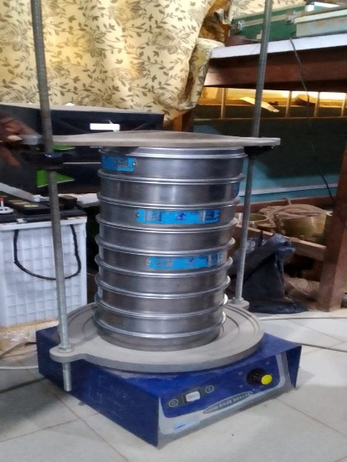
Fig. 1. Stack of sieves for the sieve analysis of fine and coarse aggregates

2.1.1 Preparation of Rice Husk Ash
The rice husk ask used in this study was prepared by calcinating the rice husk. Rice husk (Figure 2) was procured from local rice mills, ensuring the material was free from contaminants such as stones, dust, and other foreign particles. The collected rice husk was stored in a dry, covered area to prevent moisture absorption and microbial activity. The rice husk was sieved to remove any remaining impurities. The cleaned husk was air-dried under ambient conditions to reduce its moisture content, facilitating efficient combustion. The rice husk was open burned to obtain rice husk carbon (Figure 3), which was then calcinated at a temperature of 700oC to obtain rice husk ash (Figure 4). A muffle furnace was utilized to burn the rice husk under controlled conditions. The combustion process was carried out at temperatures ranging between 500°C and 700°C for a duration of 6 to 8 hours. This temperature range was maintained to ensure the production of amorphous silica, which is highly pozzolanic. Post-combustion, the furnace was allowed to cool naturally to room temperature to prevent rapid cooling, which could lead to the formation of crystalline silica. The cooled ash was ground using a ball mill to achieve a fine powder. The ground ash was sieved through a 75 μm mesh to ensure uniform particle size, enhancing its reactivity when used in concrete.
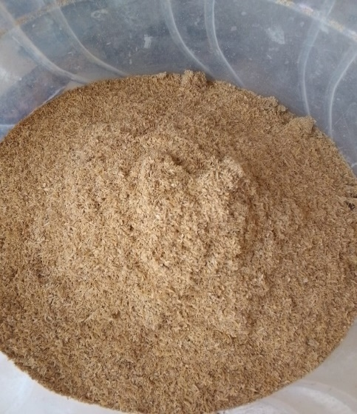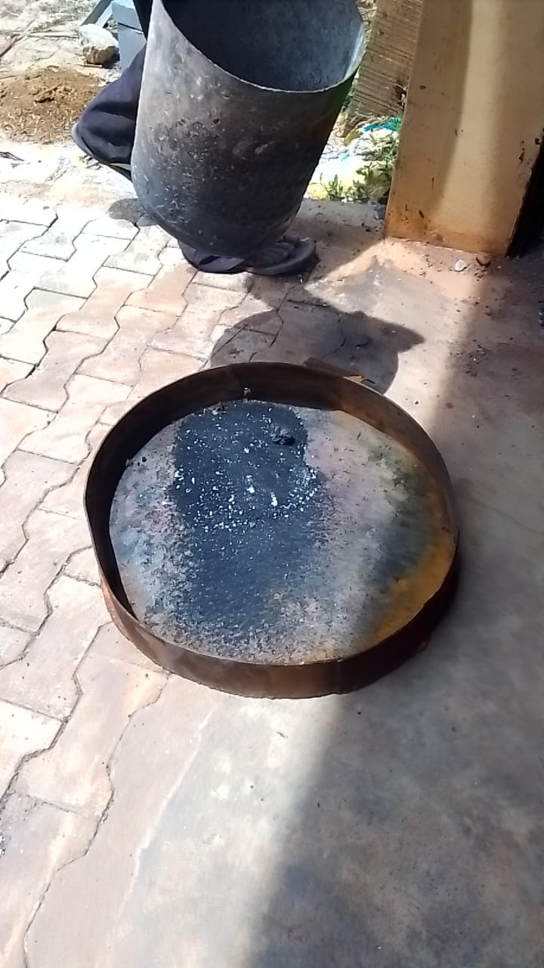
Fig. 2. Rice Husk Fig. 3. Rice Husk Carbon after Open Burning
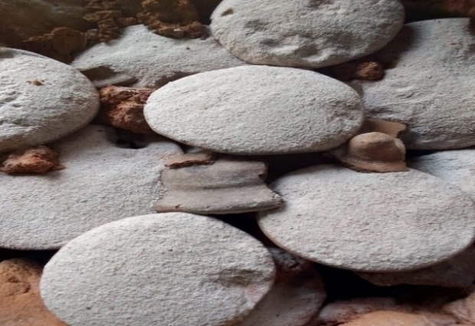
Fig. 4. Rice Husk Ash after Calcination at 800oC in the muffle furnace
The chemical composition of the RHA was determined using X-ray fluorescence (XRF) analysis, focusing on the silica content to assess its pozzolanic activity. The specific surface area and particle size distribution were measured to evaluate the physical characteristics influencing the reactivity of the RHA. The prepared RHA was stored in airtight containers to prevent moisture ingress and contamination.

2.2 Proportioning of Concrete Grade
The standard proportion according to IS:456-2000, for M15 grade concrete is 1:2:4. Based on empirical studies, the optimal dosage of Rice Husk Ash (RHA) as a partial replacement for cement in concrete varies, but several studies suggest that a replacement level between 0% and 15% by weight of cement (Figure 5) can enhance the strength properties of concrete. In this study, concrete is supplanted with rice husk ash at different rates (0%, 5%, 10% and 15%) as shown on Table 1.
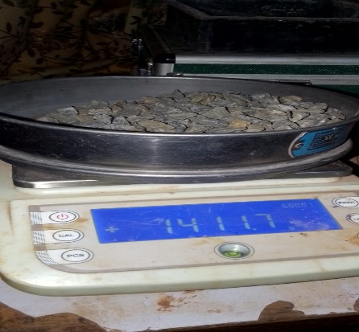
Fig. 5. Weighing of Aggregates

Table 1. Proportioning of Concrete Materials
Percentage replacement | RHA (kg) | Cement (kg) | Sand (kg) | Gravel (kg) | Water (kg)
0 % | 0 | 4.12 | 6.19 | 12.37 | 2.26
5 % | 0.206 | 3.914 | 6.19 | 12.37 | 2.26
10 % | 0.412 | 3.708 | 6.19 | 12.37 | 2.26
15 % | 0.618 | 3.502 | 6.19 | 12.37 | 2.26

2.2.1 Curing of Cubes
The sample specimens are set apart for 24 hours and are kept in vibration free place. After this period, the specimens are put in submerged condition in fresh water in a tank and are cured for 7, 14, 21 and 28 days before testing. The duration of curing of sample is according to their schedule of testing.
2.3 Laboratory Tests
2.3.1 Slump Test
To ensure that the concrete used for the casting of the cubes is good workability, slump tests (Figure 7) was carried out for every batching.
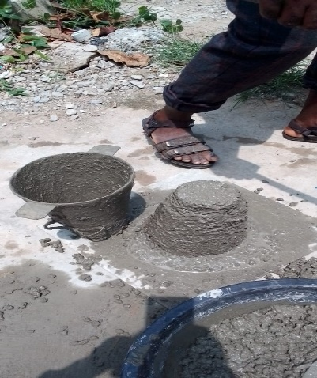
Fig. 7. Slump Test
Apparatus; Slump Test Cone
The slump cone was placed on a smooth, horizontal, waterproof base plate. The slump cone was then filled with freshly mixed concrete in three or four equal layers, tamping each layer 25 times with a bullet-nosed metal rod. After the top layer has been tamped, The excess concrete and level the surface with a trowel. Finally, the slump cone was carefully lifted vertically and observe the change in height of the concrete. This is the slump value

2.3.2 Compressive Strength Test
The IS: 516 1959 code was followed for testing the compressive strength of the concrete cubes. The concrete cubes were casted in sizes of 100mm x 100mm x 100mm. These samples were tested using the UTM (Universal Testing Machine) of capacity 2000KN. at pace of 140 kg/cm2/min. The universal testing machine was used to measure the specimens' compressive strength at 7, 14, 21, and 28 days of cure.
Apparatus includes; Universal Testing Machine (UTM) with a capacity of up to 2000 kN; Standard concrete cube molds (100 mm × 100 mm × 100 mm); Weighing scale (accurate to 0.01 g); Tamping rod; Water bath or curing tanks for specimen curing; and Vernier caliper (for measuring dimensions of specimens).
The concrete specimens were prepared by mixing and pouring the different concrete mixes into the cube molds. The prepared concrete specimen was then compacted using a tamping rod to remove any air bubbles and ensure uniform distribution. The specimens were cured in a curing tank 7, 14, and 28 days. After curing, the specimens were removed from the curing tank, and the dimensions of each cube (length, width, and height) was measured. The specimens were placed in the compressive strength machine and a gradual load at a constant rate of 0.25 MPa per second will be applied until the specimen fails. The maximum load sustained by the specimen before failure was recorded. And the compressive strength was calculated using the formula in Eqn. 1
Compressive Strength = F / A Eqn. 1
Where, F = Maximum load at which the cube crushed

3. results and discussion
3.1 Characterization of Materials
The measured bulk density (Table 2) of the sand was 1.21848 g/cm³ (≈1,218 kg/m³), while for the granite (coarse aggregate), it was 1.4968 g/cm³ (≈1,497 kg/m³). These values fall within the typical ranges reported in literature (Mohanta and Murmu, 2022). Fine aggregates such as river sands generally demonstrate bulk densities in the range of 1,600–1,800 kg/m³, depending on grain size, sorting, and compaction conditions (Abdias et al., 2023). Similarly, bulk densities for aggregates used in normal-weight concrete commonly lie between 1,200–1,750 kg/m³ (Xing et al., 2022). The bult density of the sand suggest it may be loosely packed, lightly compacted, or possess lower-density mineral content, while the granite aligns well toward the higher end for aggregates. The specific gravity of the granite is reported as 2.648, which is consistent with commonly observed values for granite, typically between 2.6 and 2.7. This indicates dense rock material, suitable for coarse aggregate in concrete mixes.

Table 2. Characterization of Materials
 | Bulk Density | Specific Gravity
Sand | 1.21848 g/cm³ | -
Granite | 1.4968 g/cm³ | 2.648

3.2 Particle Size Distribution of Aggregates
Table 3 to Table 6 and Figure 8 and Figure 9 gives the particle size parameters for the fine and coarse aggregates. From Table 4.3, the coefficient of conformity Cu and coefficient of curvature Cc was 2.29 and 1.08 respectively for fine aggregates and 1.24 and 1.15 respectively for coarse aggregates. A Cu value below 4 suggests a narrow size distribution, typical of uniformly graded materials, while a Cc value between 1 and 3 is required for a well-graded aggregate. With Cu = 2.29 (well under 4), the sand lacks a wide range of particle sizes, which may lead to lower packing density and higher void content, potentially affecting workability and strength development. Similar to the fine aggregate, this coarse aggregate is poorly graded, as Cu = 1.24 is significantly less than the threshold of 4 for gravel; a Cc within 1–3 alone does not make it well-graded. Such a narrow gradation suggests particles are of very similar size, resulting in limited interlocking and potential inefficiencies in packing.

Table 3. Particle Size Distribution of Fine Aggregate
Sieve Opening (mm) | Weight of Sieve | Weight of Sieve + Material | Weight Retained | Percentage Retained | Percentage Passing (%)
4.75 | 526.6 | 539.6 | 13.0 | 1.92 | 98.1
2.75 | 528.6 | 448.4 | 29.8 | 4.4 | 93.7
1.18 | 508.7 | 619.0 | 110.3 | 16.29 | 77.41
0.85 | 488.6 | 603.6 | 115.0 | 16.98 | 60.43
0.425 | 450.9 | 751.3 | 300.4 | 44.35 | 16.08
0.200 | 415.9 | 507.2 | 93.3 | 13.78 | 2.3
0.150 | 407.2 | 417.7 | 10.5 | 1.55 | 0.75
0.075 | 408.9 | 413.2 | 4.4 | 0.65 | 0.1
Pan | 373.6 | 374.2 | 0.6 | 0.09 | 0.01
 |  |  | 677.3 | 100

Table 4. Particle Size Parameter for Fine Aggregate
Particle Size Parameter | Value
D₁₀ (10% Passing) | 0.35
D₃₀ (30% Passing) | 0.55
D₆₀ (60% Passing) | 0.8
Coefficient of Uniformity (Cu) | 2.29
Coefficient of Curvature (Cc) | 1.08

Fig. 8. Particle Size Distribution of Fine Aggregate

Table 5. Particle Size Distribution of Coarse Aggregate
Sieve Opening (mm) | Weight of Sieve | Weight of Sieve + Material | Weight Retained | Percentage Retained | Percentage Passing (%)
19 | 680.4 | 680.4 | 0 | 0 | 100
9.5 | 573.8 | 1411.7 | 837.9 | 83.7 | 16.3
4.75 | 526.5 | 679.5 | 153.0 | 15.3 | 1.0
Pan | 373.5 | 383.7 | 10.2 | 1.0 | 0
 |  |  | 1001.1 | 100

Table 6. Particle Size Parameter for Coarse Aggregate
Particle Size Parameter | Value
D₁₀ (10% Passing) | 8.5
D₃₀ (30% Passing) | 10.15
D₆₀ (60% Passing) | 10.5
Coefficient of Uniformity (Cu) | 1.24
Coefficient of Curvature (Cc) | 1.15

Fig. 9. Particle Size Distribution of Coarse Aggregate

3.3 Microstructural Analysis: EDS and XRD Results
The EDS and XRD results of the RHA sample together confirmed that the RHA is rich in silica, which is essential for pozzolanic reactions. The dominantly amorphous nature (based on expected XRD results) suggests high pozzolanic reactivity.

3.3.1 Energy Dispersive Spectroscopy (EDS)
The EDS analysis performed on the rice husk ash (Figure 10) revealed a dominant presence of silicon (Si) and oxygen (O), confirming that the material is silica-rich. A material being silica rich is a defining trait of a reactive pozzolanic material. The high concentration of SiO₂ corresponds with reported values in scientific literature, where amorphous silica content in RHA often exceeds 90% when produced under controlled conditions (Nduka et al., 2022). This chemistry is critical, as amorphous silica is highly reactive in alkaline environments, undergoing pozzolanic reactions with calcium hydroxide (Ca(OH)₂) to form additional calcium silicate hydrate (C–S–H) gel. This contributes significantly to the long-term mechanical strength and durability of cementitious systems.
Trace levels of elements such as carbon (C), calcium (Ca), sodium (Na), iron (Fe), magnesium (Mg), aluminum (Al), and titanium (Ti) were also detected. Among these, calcium may contribute slightly to early cementitious bonding, while aluminum and iron oxides can partake in forming secondary hydrates like calcium aluminate hydrate (C–A–H) and calcium aluminosilicate hydrate (C–A–S–H), adding minor benefits to matrix density and microstructural refinement. However, the low concentration of these trace elements suggests their influence is supplementary relative to the dominating silica content.

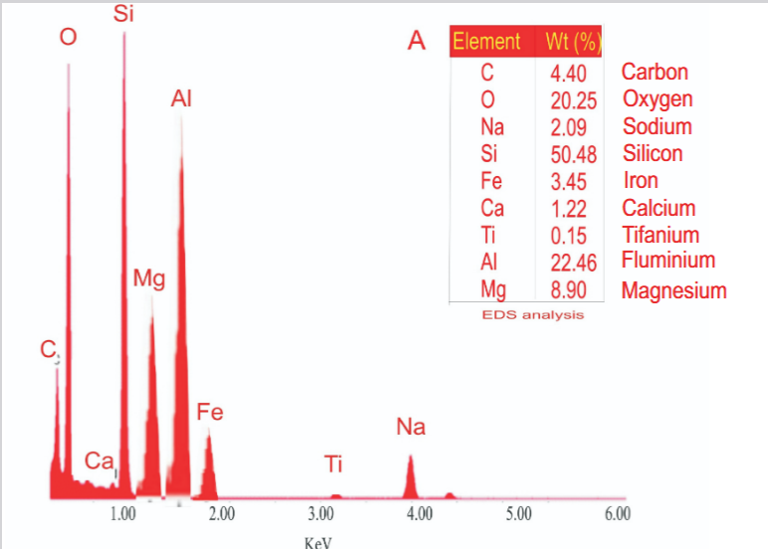
Fig. 10. Energy Dispersive Spectroscopy (EDS) of Rice Husk

The absence of potentially harmful heavy metals or kiln-origin contaminants affirms that the ash is clean and suitable for applications in construction. This aligns with findings by from studies that reported that both muffle furnace and open-air RHA contained no significant toxic elements and were suitable for use in concrete (Kamweru et al., 2020). This reinforces the practicality of the RHA as a safe and sustainable supplementary cementitious material.
The high levels of SiO₂ and O reinforce the pozzolanic potential of the rice husk ash. The pozzolanic reaction mechanism involves amorphous silica reacting with calcium hydroxide, produced during cement hydration, to form C-S-H, thereby densifying the microstructure and enhancing mechanical and durability properties (Das et al., 2020). This system behavior underpins many improvements observed in concrete incorporating properly processed RHA. Although minor elements like Mg, Fe, and Al are present, their levels are insufficient to replace cementitious material but may provide micro-filler effects or participate in hydration reactions to produce C–A–H gels that fortify the cement matrix. Nonetheless, the dominance of silica and oxygen in the composition confirms that silicate-based reactions will primarily define the ash’s contribution to concrete performance. The confirmation of elemental purity and absence of deleterious compounds indicates that the ash was effectively produced under controlled combustion conditions (e.g., 500–700 °C), which is essential for preserving amorphous silica and pozzolanic quality (Thiedeitz et al., 2020).

3.3.2 X-ray Diffraction (XRD)
XRD test (Figure 11) was conducted to assess crystallinity vs. amorphous content in the RHA sample. In pozzolanic materials like RHA, amorphous silica is highly desirable due to its high reactivity with Ca(OH)₂. The XRD pattern for the RHA exhibited a broad hump between 2θ = 20°–30°, indicating the presence of non-crystalline (amorphous) silica. The sample showed a dominant amorphous phase with minor crystalline peaks, confirming that the RHA was properly combusted, thus, retaining silica in a reactive amorphous state.
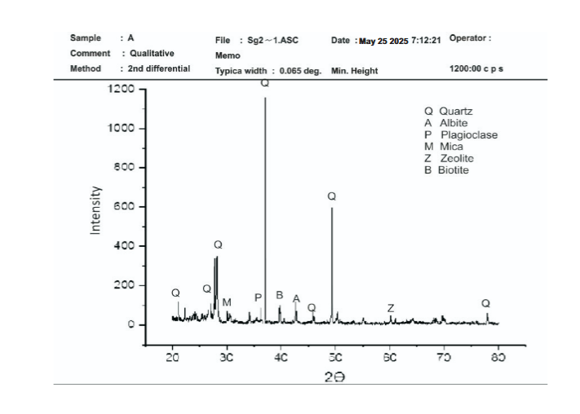
Fig. 11. X-ray Diffraction of Rice Husk

3.4 Slump Test on Concrete
The slump test measures the workability of concrete, indicating how easily it can be mixed, placed, and finished. Table 7 shows the slump measurement of the concrete at various percentages. The concrete had slumps of 45mm, 55mm, 70mm and 60mm at 0% RHA, 5 % RHA 10 % RHA and 15 % RHA. These reflect a general increase in slump, and thus improved workability, as RHA replacement increases up to 10%, after which slump decreases slightly at 15% suggesting an initial plasticizing effect from RHA addition that peaks before workability begins to decline.

In conventional concrete, medium slump values, typically 50–120 mm, are considered ideal for most structural applications, offering a good balance between ease of placement and stability (Sadiqul et al., 2022; Ajwad, et al., 2022; Ubayi et al., 2024). The control slump (45 mm) lies at the low end of that range, indicating relatively stiff consistency, while the 10% RHA mix (70 mm) falls well within the preferred range, suggesting notably better workability. Several studies have observed similar trends with RHA inclusion. Often, low to moderate RHA replacement improves workability, possibly due to the fine ash particles acting as micro-fillers that aid in lubrication and particle movement (Ubayi et al., 2024). Ubayi et al., (2024) reported plasticizing effects with RHA up to around 24% replacement, enhancing workability compared to the control mix. However, as RHA content increases beyond an optimal level, slump tends to decrease, because the highly porous, fine RHA increases the overall surface area of the binder, demands more water, and increases mix friction (Sadiqul et al., 2022). This is evident in in Figure 12, where slump declines from 70 mm at 10% replacement to 60 mm at 15%.

Table 7. Slump Test
Percentage of Replacement | Slump Values
0 % | 4.5 cm
5 % | 5.5 cm
10 % | 7.0 cm
15 % | 6.0 cm

Fig. 12. Slump Test

3.5 Water Absorption of Concrete Cubes
The water absorption test was conducted to evaluate the influence of rice husk ash (RHA) on the durability potential of concrete. The results on Table 8 and Figure 13 showed that the control mix (0% RHA) recorded a water absorption of approximately 1.38%, while the 5% and 10% RHA mixes recorded lower values of 1.12% and 1.09%, respectively. This indicates that partial replacement of cement with RHA up to 10% improved the resistance of concrete to water uptake. However, at 15% RHA replacement, water absorption increased to about 1.58%, which was even higher than that of the control mix. This suggests that higher proportions of RHA may have compromised the compactness of the matrix, creating pathways for water ingress.

The reduced water absorption at 5% and 10% RHA can be attributed to the dual effect of micro-filling and pozzolanic activity (Paris et al., 2016; Odero et al., 2022; Hasan et al., 2022). Finely ground RHA particles act as fillers that block voids in the cement paste, thereby refining the pore structure (Barbhuiya et al., 2025). Additionally, the amorphous silica in RHA reacts with calcium hydroxide released during cement hydration to produce extra calcium silicate hydrate (C–S–H) gel. This gel densifies the microstructure and reduces the connectivity of pores, resulting in lower permeability and absorption (Barbhuiya et al., 2025). Conversely, at 15% replacement, the dilution of cementitious material likely limited the amount of calcium hydroxide available for reaction, while the higher ash content may have led to poor compaction and unreacted particles, ultimately increasing porosity and water uptake.

These findings are in line with earlier research. Studies have reported that optimum RHA replacements of 5–15% generally reduce water absorption compared to control concrete. For instance, a study found that mixes with up to 15% RHA exhibited lower water absorption values than the control, while higher dosages led to increased absorption due to reduced cementitious content (Godwin et al., 2022). Similarly, Endale et al., (2022) reported a 14% reduction in water absorption at 20% RHA replacement, attributing this to improved packing density and pore refinement. On the other hand, Balraj et al., (2021) indicated that at 20 wt% RHA, water absorption decreased nearly threefold compared to the control, but only when finely ground RHA was used. These variations emphasize that processing conditions, fineness, and dosage are critical determinants of RHA’s effectiveness. This results of this study confirm that incorporating RHA at 5–10% replacement reduces water absorption and enhances the impermeability of concrete, thereby improving durability. However, replacement beyond this threshold, as seen in the 15% mix, may have adverse effects unless adjustments in mix design or the use of admixtures are adopted. This highlights the importance of identifying an optimal dosage range for RHA in concrete to balance strength and durability.

Table 8. Water Absorption Concrete Cubes
WATER ABSORPTION
Dosages | 0% | 5 % | 10 % | 15 %
Dry weight | 2.89 | 2.68 | 2.76 | 2.53
Weight after Curing | 2.93 | 2.71 | 2.79 | 2.57
Water Absorption (%) | 1.38 | 1.12 | 1.09 | 1.58

Fig.13. Water Absorption of Concrete Cubes

3.6 Compressive Strength Test on Concrete Cubes
Table 9 and Figure 14 presents the compressive strength results of concrete cubes incorporating different proportions of rice husk ash (RHA) as a partial replacement for cement. The compressive strength of the control sample (0% RHA) increased progressively from 13.7 MPa at 7 days to 20.65 MPa at 28 days, showing the normal hydration process of cement. However, with the inclusion of RHA, a noticeable variation in strength development was observed, which reflects the influence of RHA’s pozzolanic reactivity and its interaction with the hydration products of cement.
At 5% RHA replacement, the early strength (10.84 MPa at 7 days) was slightly lower than that of the control, but by 14 days, the compressive strength increased to 17.81 MPa, surpassing the control specimen at the same age. This improvement indicates that at lower replacement levels, the rice husk ash contributed to strength development through secondary pozzolanic reactions. The amorphous silica in the RHA reacts gradually with calcium hydroxide [Ca (OH)₂] released during cement hydration to form additional calcium silicate hydrate (C–S–H) gel, which densifies the microstructure and improves the overall strength. The delayed strength gain at 5% replacement aligns with the typical behaviour of pozzolanic materials, where strength development continues over an extended curing period as the pozzolanic reaction progresses (Amin et al., 2019).
For the 10% RHA mix, the compressive strength remained relatively low across all curing ages (10.06 MPa at 7 days, 10.11 MPa at 14 days, and 13.50 MPa at 28 days). This suggests that while some pozzolanic activity occurred, it was insufficient to offset the reduction in cement content. The diminished strength at this level implies that either the RHA reactivity was limited, possibly due to incomplete combustion or inadequate fineness, or that excessive replacement reduced the amount of calcium hydroxide available for reaction. This implies that at this higher replacement level the pozzolanic reaction / contribution of RHA hasn’t fully compensated for the reduced cement content, or that the RHA is less reactive (possibly due to insufficient fineness or higher residual carbon). Many studies show an optimum at ~5 – 10% RHA; beyond that the dilution of cement dominates and strength drops (Zaid et al., 2021; Huang et al., 2023). Zaid et al., (2021) and Huang et al., (2023) reported that at a 10% RHA replacement, compressive strength decreased by approximately 9–13% compared to the control mix over respective ages, and higher replacements (15–20%) resulted in even more pronounced reductions (~20–28%). Furthermore, Kotwal et al., (2022) found that while concrete with 10–20% RHA maintains acceptable performance, the compressive strength generally diminishes as RHA content increases.

At 15% RHA replacement, the compressive strength dropped significantly, reaching only 8.20 MPa after 28 days of curing. This reduction indicates that beyond a certain limit, the dilution effect of replacing cement with RHA outweighs the benefits of pozzolanic activity. The reduced calcium hydroxide content and increased unreacted ash particles at higher replacement levels likely contributed to a more porous and weaker matrix (Amin et al., 2019).

Table 9. Compressive Strength on Concrete Cubes
COMPRESSIVE STRENGTH TEST
CURUNG DAY | 0% | 5 % | 10 % | 15 %
7 | 13.7 | 10.84 | 10.06 | 5.69
14 | 14.62 | 17.81 | 10.11 | 6.22
28 | 20.65 | 18.53 | 13.5 | 8.2

Fig. 14. Compressive strength of concrete

The strength trend demonstrates that the rice husk ash used in this study exhibits moderate pozzolanic reactivity. The results indicate that 5% replacement provides an optimum balance between strength development and cement substitution, while higher replacement levels (10–15%) lead to a loss in mechanical performance. The observed behaviour suggests that with proper burning and grinding to enhance reactivity, rice husk ash can serve as an effective supplementary cementitious material. Furthermore, extended curing periods may yield improved results due to the slow but continuous nature of the pozzolanic reaction. The observed strength trend indicates that the rice husk ash used has some pozzolanic reactivity (since 5% replacement improved the 14-day strength). However, it also suggests that above ~10% replacement the matrix becomes weaker, thus for your concrete mix the optimum RHA content lies around 5%, and further increases reduce effectiveness. It implies that the RHA must be properly processed (burning conditions, fineness) to ensure high reactivity. Finally, it shows that curing time is essential, since the pozzolanic reaction is slower than primary cement hydration, longer-term performance (beyond 28 days) might show further gains for the lower RHA replacement levels

4. Conclusion
Based on the experimental investigation, the following conclusions are drawn:
i. The slump of concrete increased with RHA content up to 10%, peaking at 7.0 cm, then decreased at 15%. This suggests improved flowability at moderate RHA levels, with diminishing returns at higher replacements due to increased surface area and water demand.
ii. Compressive strength increased with curing age for all mixes, with the control concrete achieving the highest 28-day strength of 20.65 MPa, representing normal hydration behavior of OPC.
iii. Concrete with 5% RHA replacement showed improved strength development at later ages, surpassing the control at 14 days and achieving comparable strength at 28 days, indicating effective pozzolanic contribution at low dosage.
iv. Strength declined at 10% and 15% RHA replacements across all curing ages, suggesting that higher replacement levels reduced available cementitious compounds and increased matrix porosity.
v. The reactivity of rice husk ash is evident and beneficial when incorporated into concrete at optimal replacement levels. While the strength development at lower RHA percentages (5–10%) aligns with pozzolanic expectations, higher replacements may require careful mix design and quality control to avoid adverse effects. The study demonstrates that properly processed RHA has the potential to partially replace cement in concrete, thereby reducing environmental impact, lowering cost, and promoting sustainable construction practices.

5. RECOMMENDATIONS
Based on these conclusions the following recommendations are made
i. Consider focusing further testing around 5–15% RHA replacement, as this range is widely reported to balance pozzolanic gains with preservation of cementitious binder content.
ii. Explore 10–15% replacement in particular, since many studies, especially on M20-grade concrete, found this to be optimal for both strength and durability.
iii. Conduct durability tests such as water absorption, chloride penetration, sulfate resistance, and microstructural analysis to assess the long-term benefits of RHA on concrete performance, as pozzolanic action improves pore refinement.

References
Abdias, M., Blanche, M., Nana, U., Abanda, H., François, N. and Chrispin, P. (2023) River Sand Characterization for Its Use in Concrete: A Revue. Open Journal of Civil Engineering, 13, 353-366. doi: 10.4236/ojce.2023.132027.
Ajwad, A., Ahmad, S., Abdullah., Jaffar, S. T. A., Ilyas, U., Adnan, M. A., (2022). Effect of Using Rice Husk Ash as Partial Replacement of Cement on Properties of Fresh and Hardened Concrete || Architecture Civil Engineering Environment - The Silesian University of Technology doi: 10.2478/ACEE-2022-0017
Amin, M. N., Hissan, S., Shahzada, K., Khan, K., & Bibi, T. (2019). Pozzolanic Reactivity and the Influence of Rice Husk Ash on Early-Age Autogenous Shrinkage of Concrete. Frontiers in Materials, 6, 465448. https://doi.org/10.3389/fmats.2019.00150
Balraj A, Jayaraman D, Krishnan J, Alex J. (2021) Experimental investigation on water absorption capacity of RHA-added cement concrete. Environ Sci Pollut Res Int. 2021 Dec;28(45):63623-63628. doi: 10.1007/s11356-020-11339-1. Epub 2020 Oct 23. PMID: 33097994.
Barbhuiya, S., Das, B.B., Adak, D. et al. (2025) Rice husk ash in structural concrete: influence on strength, durability and sustainability. Discov. Concr. Cem. 1, 14 (2025). https://doi.org/10.1007/s44416-025-00013-9
Das, S. K., Mishra, J., Singh, S. K., Mustakim, S. M., Patel, A., Das, S. K., & Behera, U. (2020). Characterization and utilization of rice husk ash (RHA) in fly ash–Blast furnace slag based geopolymer concrete for sustainable future. Materials Today: Proceedings, 33, 5162-5167.
Dhoble, Y., & Ahmed, S. (2018). Study on cementitious properties of steel slag by partial replacement of cement. Global Journal of Engineering Science and Researches, 5(7), 213-220.
Endale, S. A., Taffese, W. Z., Vo, D., & Yehualaw, M. D. (2022). Rice Husk Ash in Concrete. Sustainability, 15(1), 137. https://doi.org/10.3390/su15010137
Godwin A. Akeke , Udeme U. Udokpoh, 2022, Improvement in the Properties of Concrete Containing Rice Husk Ash as A Partial Replacement for Portland Limestone Cement, INTERNATIONAL JOURNAL OF ENGINEERING RESEARCH & TECHNOLOGY (IJERT) Volume 11, Issue 02 (February 2022),
Hasan, N. M. S., Rahman Sobuz, M. H., Hayet Khan, M. M., Mim, N. J., Meraz, M. M., Datta, S. D., Rana, M. J., Saha, A., Mohammad Akid, A. S., Mehedi, M. T., Houda, M., & Sutan, N. M. (2022). Integration of Rice Husk Ash as Supplementary Cementitious Material in the Production of Sustainable High-Strength Concrete. Materials, 15(22), 8171. https://doi.org/10.3390/ma15228171
Huang, Y., Lei, Y., Luo, X., & Fu, C. (2023). Prediction of compressive strength of rice husk ash concrete: A comparison of different metaheuristic algorithms for optimizing support vector regression. Case Studies in Construction Materials, 18, e02201. https://doi.org/10.1016/j.cscm.2023.e02201
Kamweru, Paul & Gichumbi, Joel & Ndiritu, Francis & Jonathan, Kaleli. (2020). Characterization of rice husk ash prepared by open air burning and furnace calcination. Journal of Chemical Engineering and Materials Science. 11. 24-30. 10.5897/JCEMS2020.0348.
Kotwal, S, S., Kadam , V. S., More, M. M., Patil, A. S., Mohite, N. A., Mane V. V. (2022). A Literature Review on Use of Rice Husk Ash as Cementation Material || Ijraset Journal For Research in Applied Science and Engineering Technology https://doi.org/10.22214/ijraset.2022.46170
Mohanta, N. R., & Murmu, M. (2022). Alternative coarse aggregate for sustainable and eco-friendly concrete - A review. Journal of Building Engineering, 59, 105079. https://doi.org/10.1016/j.jobe.2022.105079
Nduka, D. O., Olawuyi, B. J., Fagbenle, E. O., & Fonteboa, B. G. (2022). Mechanical and microstructural properties of high-performance concrete made with rice husk ash internally cured with superabsorbent polymers. Heliyon, 8(9), e10502. https://doi.org/10.1016/j.heliyon.2022.e10502
Odero, B. J., Mutuku, R. N., Nyomboi, T., & Gariy, Z. A. (2022). Mechanical Strength and Water Transport Properties of Concrete Containing Treated Recycled Aggregates. The Open Civil Engineering Journal, 16.
Paris, J. M., Roessler, J. G., Ferraro, C. C., DeFord, H. D., & Townsend, T. G. (2016). A review of waste products utilized as supplements to Portland cement in concrete. Journal of Cleaner Production, 121, 1-18. https://doi.org/10.1016/j.jclepro.2016.02.013
Rao, M. S. C., Packialakshmi, S., Rath, B., Alharbi, S. A., Alfarraj, S., Praveenkumar, T. R., & Gavurová, B. (2023). Utilization of agricultural, industrial waste and nanosilica as replacement for cementitious material and natural aggregates–Mechanical, microstructural and durability characteristics assessment. Environmental Research, 231, 116010.
Sadiqul Hasan, N. M., Rahman Sobuz, M. H., Hayet Khan, M. M., Mim, N. J., Meraz, M. M., Datta, S. D., Rana, M. J., Saha, A., Mohammad Akid, A. S., Mehedi, M. T., Houda, M., & Sutan, N. M. (2022). Integration of Rice Husk Ash as Supplementary Cementitious Material in the Production of Sustainable High-Strength Concrete. Materials, 15(22), 8171. https://doi.org/10.3390/ma15228171
Siddika, A., Mamun, M. A. A., Alyousef, R., & Mohammadhosseini, H. (2021). State-of-the-art-review on rice husk ash: A supplementary cementitious material in concrete. Journal of King Saud University - Engineering Sciences, 33(5), 294-307. https://doi.org/10.1016/j.jksues.2020.10.006
Thiedeitz M, Schmidt W, Härder M, Kränkel T. Performance of Rice Husk Ash as Supplementary Cementitious Material after Production in the Field and in the Lab. Materials (Basel). 2020 Sep 28;13(19):4319. doi: 10.3390/ma13194319. PMID: 32998325; PMCID: PMC7579036.
Ubayi, S. M., Mathur, C. V., Abubakar, B. S., & Idris, H. (2024). Rice Husk Ash in Concrete: A Review of Cement Replacement Proportions and Mechanical Properties. International Journal in Engineering Sciences.
Umasabor, R., & Okovido, J. (2018). Fire resistance evaluation of rice husk ash concrete. Heliyon, 4(12), e01035. https://doi.org/10.1016/j.heliyon.2018.e01035
Xing, W., Tam, V. W., Le, K. N., Hao, J. L., & Wang, J. (2022). Life cycle assessment of recycled aggregate concrete on its environmental impacts: A critical review. Construction and Building Materials, 317, 125950. https://doi.org/10.1016/j.conbuildmat.2021.125950
Zaid, O., Ahmad, J., Siddique, M. S., & Aslam, F. (2021). Effect of Incorporation of Rice Husk Ash Instead of Cement on the Performance of Steel Fibers Reinforced Concrete. Frontiers in Materials, 8, 665625. https://doi.org/10.3389/fmats.2021.665625

