CAMPUS-SCALE BIOGAS FROM HUMAN WASTE: A FEASIBILITY ASSESSMENT FOR MICHIGAN TECHNOLOGICAL UNIVERSITY

ABSTRACT

Universities are uniquely positioned to pioneer sustainable energy solutions by integrating research, innovation, and operational practice. This study assesses the feasibility of producing renewable biogas from human feces through anaerobic digestion at Michigan Technological University (MTU). Using demographic data, compositional characteristics of feces, and standard biogas yield parameters, the study quantifies the potential energy output and explores the associated environmental, social, and institutional implications. The analysis integrates theoretical foundations of circular economy and resilience theory to frame the broader sustainability benefits of on-campus energy recovery systems.
Results indicate that MTU’s estimated annual fecal feedstock of ≈411 metric tons could produce 16,449 Nm³ yr⁻¹ of biogas, generating approximately 34 MWh of electricity per year (equivalent to the annual consumption of three U.S. households). While modest in scale, this output exemplifies the potential of waste valorization in higher education, transforming human waste from a disposal burden into a renewable resource. The study concludes that such systems can reinforce energy resilience, reduce greenhouse gas emissions, and create interdisciplinary learning opportunities that align with MTU’s sustainability and carbon neutrality goals.
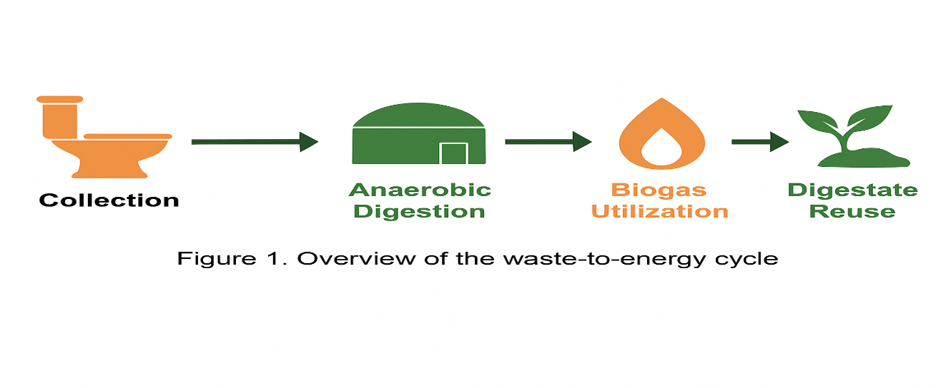

Keywords: Anaerobic digestion, campus sustainability, biogas, circular economy, renewable energy, energy resilience.

1. INTRODUCTION
The transition to sustainable energy systems has become a global imperative as institutions confront the realities of climate change and environmental degradation. Universities, with their dual mission of education and research, serve as living laboratories for sustainability. Michigan Technological University (MTU), recognized for its engineering expertise and commitment to environmental stewardship, provides an ideal setting to test integrated waste-to-energy solutions.
At present, MTU’s energy portfolio is largely dependent on fossil fuels, contributing to both high operational costs and a significant institutional carbon footprint. Integrating biogas production from human waste into the campus energy mix offers a tangible, circular approach to sustainability. By converting organic waste into renewable energy, the university could simultaneously reduce emissions, lower waste management costs, and provide students with hands-on experience in applied sustainability science.
While biogas production from animal manure and food waste has been extensively documented, research focusing on human-waste-based biogas systems in academic institutions remains scarce. This project bridges that gap by quantifying MTU’s biogas potential and situating it within the broader discourse of energy resilience and circular resource management. The study integrates environmental engineering principles with social, economic, and policy considerations, offering a holistic sustainability perspective. This study aims to achieve the following objectives:
- Estimate MTU’s annual fecal feedstock generation.
- Calculate potential biogas and electricity yield using established conversion metrics.
- Evaluate environmental, economic, and social implications of the system.
- Examine institutional resilience and policy frameworks that could support implementation.

2. BACKGROUND AND LITERATURE REVIEW
Human feces, though often treated as waste, contain substantial organic matter suitable for bioconversion. On average, feces consist of 75% water and 25% dry matter, composed mainly of carbohydrates, fats, proteins, and microbial biomass (Penn et al., 2018). Rose et al. (2015) estimate daily fecal production at approximately 128 g per person, of which roughly 30 g represents dry solids. This dry fraction determines the substrate’s biogas potential, with volatile solids accounting for about 75% of total dry matter.
The methane potential of human waste parallels that of animal manure, yielding between 0.02–0.04 m³ of biogas per kilogram of wet feces under typical anaerobic conditions (Rosenberg & Kornelius, 2017; Khan et al., 2021). The methane content of the produced gas typically ranges from 50% to 70%, influencing its heating value (Holm-Nielsen et al., 2009).
Human waste management has evolved from rudimentary disposal systems to technologically sophisticated wastewater treatment infrastructures. Early civilizations relied on direct discharge into water bodies, leading to major public health crises (Lofrano & Brown, 2010). By the 19th century, urban sanitation reforms spurred the development of centralized sewer systems. Over time, attention shifted from purely hygienic management to resource recovery, exemplified by projects such as the Milwaukee Metropolitan Sewerage District (MMSD), which captures biogas from sewage sludge for energy generation (MMSD, n.d.).
Historical practices also demonstrate an early recognition of human waste as a resource. In pre-war Japan, feces were collected and used as fertilizer, a practice displaced by industrial agriculture (Kreitman, 2018). These precedents underscore the long-standing yet underappreciated concept of circular waste utilization.
Biogas results from anaerobic digestion (AD), a multi-stage microbial process comprising hydrolysis, acidogenesis, acetogenesis, and methanogenesis (Sawyerr et al., 2019). The end products are methane (CH₄), carbon dioxide (CO₂), trace gases, and digestate. AD systems can operate at mesophilic (35–40 °C) or thermophilic (50–60 °C) conditions, with hydraulic retention times ranging from 15 to 30 days depending on substrate characteristics.
The energy balance of AD systems is favorable when local organic feedstock is available, minimizing transport costs. AD exemplifies the circular economy, closing the carbon loop by reusing organic carbon rather than releasing it through uncontrolled decomposition (Alexopoulos, 2012).
Globally, biogas systems have been deployed in both rural and institutional contexts. In Nepal, biogas adoption reduced firewood use by up to 50%, mitigating deforestation and indoor pollution (Gross et al., 2017). In Punjab, India, small-scale Deenbandhu digesters improved rural energy access (Deepinder et al., 2020). Urban-scale systems in Europe and North America, such as the UC Davis biodigester, integrate food waste and agricultural residues to produce over 12,000 kWh of renewable electricity per day (UC Davis, 2023). These cases demonstrate scalability, co-benefits, and the replicability of biogas systems across contexts.

3. METHODOLOGY (Analytical Framework and Metrics )
Michigan Technological University (MTU) is located in Houghton, Michigan, a cold-climate region that experiences long winters and high heating energy demand. The campus spans approximately 925 acres and serves an estimated 8,924 individuals, including students, faculty, and staff (Michigan Technological University, n.d.). This population provides the basis for estimating the total volume of human waste that can be harnessed for biogas production.
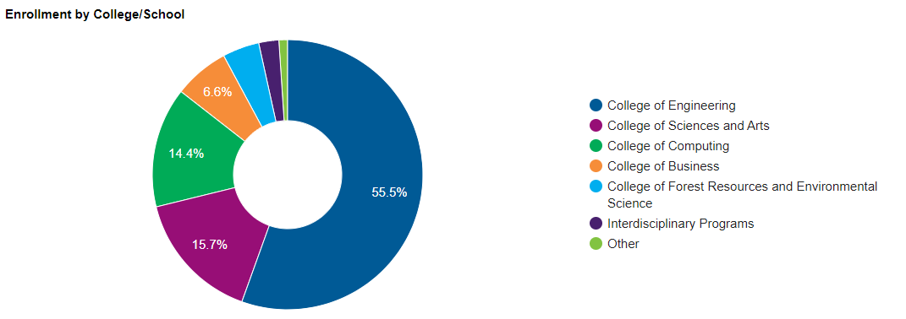
Figure 2: Michigan Tech population per college

In this study, the analysis follows a bottom-up estimation approach that links population data, per-capita fecal generation rates, biogas yield coefficients, and conversion efficiencies to estimate potential electricity generation. The calculation pathway (Figure 1) progresses through four stages:
- Fecal Feedstock Estimation (mass basis).
- Biogas Volume Estimation (using yield coefficients).
- Energy Content Calculation (based on methane concentration and lower heating value).
- Electrical Energy Output (via combined heat and power efficiency).
Each stage incorporates assumptions from peer-reviewed studies to ensure transparency and reproducibility.
Table 1 summarizes all parameters, their values, and corresponding literature sources.

Parameter | Symbol | Value / Range | Unit | Source
Campus population | $$N$$ | 8,924 | persons | MTU (n.d.)
Fecal generation rate | $${\dot{m}}_{wet}$$ | 0.128 | kg person⁻¹ day⁻¹ | Rose et al. (2015)
Moisture content | $$w$$ | 0.75 | fraction | Penn et al. (2018)
Volatile solids fraction | $$f_{VS}$$ | 0.75 | fraction of dry matter | Penn et al. (2018)
Biogas yield (wet basis) | $$Y_{bg}$$ | 0.02–0.04 | m³ kg⁻¹ wet | Rosenberg & Kornelius (2017); Khan et al. (2021)
Methane content | $$x_{CH4}$$ | 0.50–0.70 | fraction | Holm-Nielsen et al. (2009)
LHV of methane | $$LHV_{CH4}$$ | 35.8 | MJ m⁻³ | De Meester et al. (2012)
Electrical efficiency (CHP) | $$η_{e}$$ | 0.30–0.40 | fraction | U.S. EPA (2015)
Conversion factor |  | 1 kWh = 3.6 | MJ | –

Table 1: Key Parameters and Data Sources for Energy Estimation

All calculations are expressed on an annual basis.
(i) Annual Fecal Feedstock
$$M_{wet}=N⋅{\dot{m}}_{wet}⋅365 \\ M_{wet}=8,924×0.128×365=411,218{\text{ kg yr}}^{-1}$$
Thus, approximately 411 metric tons of fecal material are generated annually on campus.

(ii) Biogas Production
$$V_{bg}=Y_{bg}⋅M_{wet}$$
Using the baseline yield $Y_{bg}=0.04\text{ m³ kg⁻¹}$:
$$V_{bg}=0.04×411,218=16,449 {\text{Nm³ yr}}^{-1}$$

(iii) Energy Content of Biogas
The lower heating value (LHV) of biogas depends on methane content:
$$LHV_{bg}=x_{CH4}⋅LHV_{CH4} \\ LHV_{bg}=0.60×35.8=21.48\text{ MJ Nm⁻³} \\ E_{chem}=V_{bg}×LHV_{bg}=16,449×21.48=353,318 {\text{MJ yr}}^{-1}$$
(iv) Electrical Energy Generation
$$E_{el}=\frac{η_{e}×E_{chem}}{3.6}$$
Assuming $η_{e}=0.35$:
$$E_{el}=\frac{0.35×353,318}{3.6}=34,350 {\text{kWh yr}}^{-1}$$
This equates to roughly 3.3 average U.S. households (10,500 kWh per household per year; EIA, 2024).
To account for parameter uncertainty, three scenarios, Low, Baseline, and High were modeled by varying biogas yield, methane fraction, and efficiency.

Table 2. Sensitivity Scenarios and Annual Electricity Output
Scenario | $Y_{bg}$(m³ kg⁻¹) | $$x_{CH4}$$ | $$η_{e}$$ | $V_{bg}$(Nm³ yr⁻¹) | $E_{el}$(kWh yr⁻¹)
Low | 0.02 | 0.50 | 0.30 | 8,224 | 12,000
Baseline | 0.04 | 0.60 | 0.35 | 16,449 | 34,350
High | 0.04 | 0.70 | 0.40 | 16,449 | 41,800

These results show that the output varies by a factor of approximately 3.5× across plausible parameter ranges. The baseline case represents an average of published literature values, while the high scenario reflects optimal digester performance at higher methane concentration and efficiency.
The analysis adopts a “gate-to-wire” boundary, including digestion, gas utilization, and electricity generation but excluding downstream uses of digestate, heat recovery, and gas upgrading losses. Key assumptions include:
- Biogas measured at standard temperature and pressure (0 °C, 1 atm).
- No parasitic energy consumption for pumping, heating, or compression.
- Negligible leakage or flare losses.
- Electricity generation considered only; thermal energy excluded.
- Steady-state operation without seasonal feedstock variation.
Future implementation could integrate co-digestion with food waste to increase yield and capture additional heat for campus buildings.
The most influential parameters are biogas yield ($Y_{bg}$) and methane fraction ($x_{CH4}$). A ±10% variation in $Y_{bg}$results in roughly ±9% change in total electricity output. Methane concentration exerts a similar proportional influence. CHP efficiency ($η_{e}$) has a slightly lower elasticity but significantly affects practical system output because real-world systems rarely sustain >35% electrical conversion.
Uncertainty can be further reduced by pilot-scale testing of digestion kinetics under cold-climate conditions relevant to MTU. Seasonal temperature variation and organic load fluctuation (e.g., during academic breaks) may affect digestion rate and yield consistency. Therefore, empirical calibration will be necessary before full-scale implementation.
While the present model provides a robust feasibility baseline, several factors require further study:
• Temperature sensitivity: Cold climates may necessitate additional digester insulation or heating, affecting energy balance.
• Collection logistics: Human waste from campus facilities is typically mixed with wastewater; segregated collection systems would need to be designed.
• Regulatory compliance: Biosolid classification and public health safeguards must align with EPA and Michigan Department of Environment, Great Lakes, and Energy (EGLE) regulations.
• Economic modeling: Capital and operational costs were not quantified in this phase but are essential for techno-economic analysis.

4. Results and Discussion
The modeling results indicate that Michigan Technological University’s estimated 411 t yr⁻¹ of fecal feedstock could produce approximately 16,449 Nm³ yr⁻¹ of biogas, translating to an annual electrical output of roughly 34 MWh yr⁻¹ at 35 % CHP efficiency. Although modest in absolute terms, this generation demonstrates the viability of converting human waste into useful energy at an institutional scale.
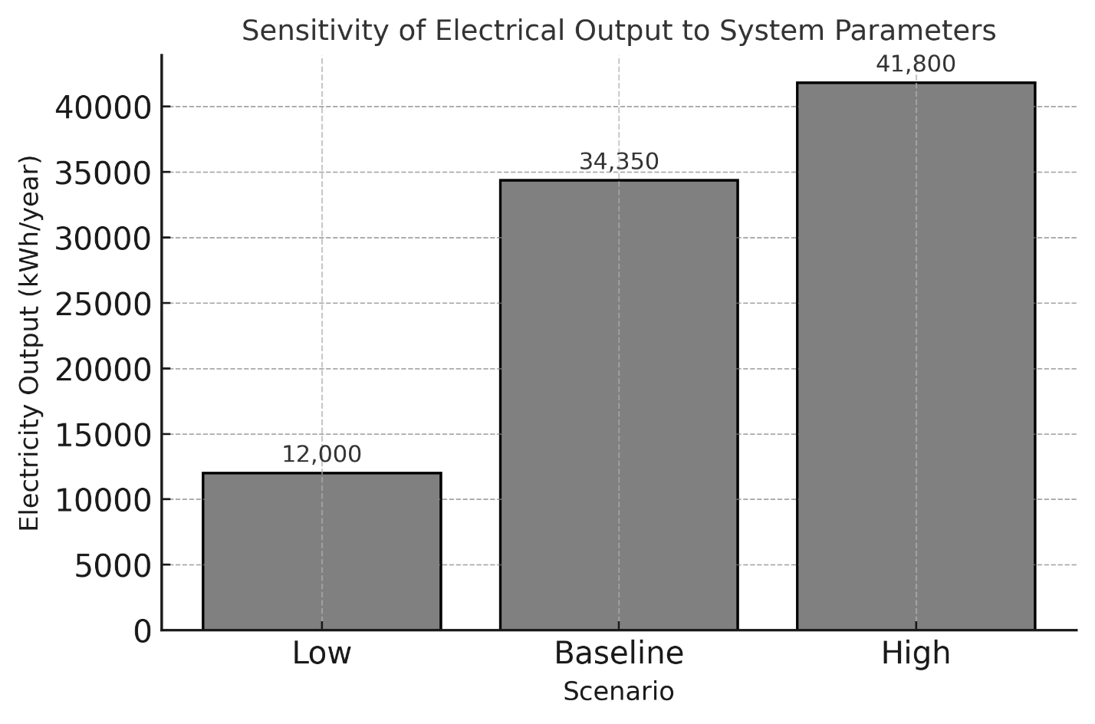
Figure 2: illustrates the linear relationship between fecal mass and electrical output. The slope reflects the product of biogas yield, methane fraction, and system efficiency. Minor increases in either methane content or CHP performance significantly affect total energy yield, reinforcing the importance of high‐efficiency digesters and optimized operating conditions.
MTU’s total annual electricity consumption is estimated at approximately 38 GWh of electricity and over 300,000 MMBtu of natural gas based on institutional energy reports (FY 2021). Therefore, the proposed system’s contribution would equal about 0.0895% of total demand. Despite its small fraction, this renewable component can serve as a pilot and demonstration system, providing valuable operational data and promoting behavioral and policy changes that support carbon neutrality.
Importantly, waste-to-energy projects rarely replace existing energy systems outright; rather, they diversify supply and enhance resilience by introducing decentralized microgeneration sources. For MTU, integration of a biogas‐powered CHP unit could complement renewable installations such as rooftop solar and biomass boilers, improving the overall sustainability portfolio.
4.1 Environmental, Economic and Social Dimensions
Methane is a potent greenhouse gas with a global warming potential approximately 28–34 times greater than CO₂ over 100 years (IPCC, 2021). Capturing and combusting methane from fecal waste prevents its direct release to the atmosphere. Assuming that untreated fecal matter emits 0.06 t CO₂-eq per person annually, the 8,924 individuals on campus could account for ≈535 t CO₂-eq yr⁻¹ of unmanaged emissions. Combustion in a CHP unit converts CH₄ to CO₂, effectively lowering net radiative forcing by about 90 % relative to uncontrolled release.
In addition, digestate produced from anaerobic digestion can offset synthetic fertilizer use if applied responsibly, further reducing indirect emissions associated with fertilizer production. Together, these mechanisms make the system environmentally advantageous even at small scale.
The project exemplifies a circular-economy model: waste is transformed into energy and nutrient-rich digestate. Each ton of dry solids processed yields approximately 0.6–0.8 t of stabilized digestate (Holm-Nielsen et al., 2009). If properly sanitized and regulated, this by-product can serve as an organic soil amendment in local agriculture or landscaping, closing the material loop between campus waste generation and regional soil replenishment.
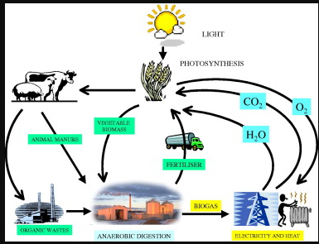
Figure 3: presents a material-flow diagram depicting the circular recovery (“collect-process-reuse”). The model demonstrates how integrating waste valorization can reduce landfill dependency and create local value chains aligned with the university’s sustainability roadmap (Holm‐Nielsen et al,2009).
A preliminary cost assessment based on literature values suggests that a small-scale mesophilic digester of 20 m³ capacity with gas cleaning and a micro-CHP unit would require an initial investment of USD 75,000–120,000 (Zhang et al., 2020). With an annual electricity output of 34 MWh and a retail rate of USD 0.13 kWh⁻¹, the gross annual energy value is approximately USD 4,400.
Ignoring inflation and assuming constant output, the simple payback period is 17–25 years. Although long, such investments are rarely justified purely on direct economic return. Instead, value derives from avoided emissions, educational applications, research outputs, and institutional reputation, benefits that are difficult to monetize but crucial in sustainability accounting.
The economic outlook improves substantially when co-digesting additional organic substrates. Incorporating food waste from dining services or paper sludge could increase organic loading by 200–300 %, potentially tripling gas output and shortening payback to under 10 years. Economies of scale also reduce unit capital costs and operational overhead.
Furthermore, selling verified carbon credits under voluntary carbon markets (at USD 15–25 t CO₂-eq⁻¹) could yield supplementary income, offsetting maintenance and monitoring costs. These mechanisms highlight the broader economic feasibility when the system is embedded within campus sustainability initiatives rather than treated as a stand-alone energy project.
An on-campus biogas system can serve as a living laboratory for interdisciplinary education. Students in environmental engineering, sustainability science, and energy policy could engage in monitoring digester performance, measuring emissions, and developing control algorithms. Such experiential learning fosters innovation and strengthens academic-community partnerships.
Despite its scientific merit, projects involving human waste often face the “yuck factor”, a psychological barrier rooted in sanitation taboos (Curtis, 2011). Transparent communication and participatory design can mitigate this resistance. Campus outreach events, signage, and data dashboards can transform the system into a showcase of sustainable innovation rather than a source of discomfort.
The process requires rigorous adherence to biosafety and environmental regulations. Hydrogen sulfide (H₂S) emissions, odor control, and pathogen management must be addressed through gas scrubbing, appropriate digester sealing, and digestate sanitation. Occupational safety protocols for maintenance personnel should comply with OSHA and EPA guidelines.

4.2 Sustainability Implications
MTU’s Climate Action Plan commits to reducing campus greenhouse-gas emissions by 50 % by 2030. Incorporating anaerobic digestion aligns with this trajectory. The project supports several United Nations Sustainable Development Goals (SDGs), such as SDG 7- Affordable and clean energy, SDG 11- Sustainable cities and communities, SDG 12 - Responsible consumption and production, and SDG 13 - Climate action. By turning waste into a renewable resource, MTU can demonstrate measurable progress toward these international benchmarks.
Overall, the results confirm that technical feasibility and sustainability co-benefits coexist even at small scale. Quantitatively, energy output is limited; qualitatively, the system’s contributions to education, circular resource recovery, and emission mitigation are substantial.

5. Resilience and Policy Dimensions
Energy resilience refers to a system’s capacity to anticipate, absorb, and recover from disruptions while maintaining critical functionality (Holling, 1973; Linkov & Trump, 2019). In the context of higher-education campuses, resilience involves ensuring uninterrupted power to essential services, such as research laboratories, data centers, and student housing, during grid outages or fuel-price volatility. Integrating small-scale renewable generation such as biogas enhances modularity, redundancy, and adaptive capacity, three pillars of socio-technical resilience.
By decentralizing part of the university’s energy portfolio, a biogas-based CHP system could sustain limited emergency loads, including campus safety lighting, communications hubs, or health-service refrigeration, during external power interruptions. Although the modeled capacity is small (≈ 34 MWh yr⁻¹), even a few hours of autonomous supply in a blackout scenario can safeguard sensitive research operations and reduce economic losses.
Universities increasingly pursue “multi-hazard resilience” strategies that combine physical infrastructure upgrades with institutional learning. Anaerobic digestion contributes to this agenda in several ways:
- Operational Redundancy: CHP units diversify energy inputs beyond the electric grid and natural gas pipelines, lessening dependence on single-source suppliers.
- Functional Interdependence: The digester links waste management, energy, and academic research units, transforming linear resource flows into inter-departmental collaboration.
- Knowledge Resilience: Continuous monitoring, data collection, and student engagement create a feedback system that enables adaptive management ( learning by doing ).
Such attributes strengthen the campus’s overall capacity to respond to both acute shocks (e.g., power outages, extreme weather) and chronic stress (e.g., rising energy costs, carbon-price exposure).
At the national level, biogas projects align with multiple U.S. Department of Energy (DOE) and Environmental Protection Agency (EPA) initiatives. The Renewable Fuel Standard (RFS) recognizes biogas as a cellulosic biofuel when upgraded to biomethane. The Inflation Reduction Act (2022) expands tax credits for renewable electricity (Section 45) and investment credits for biogas facilities (Section 48). Universities developing demonstration projects can therefore leverage Investment Tax Credit (ITC) eligibility through partnerships or power-purchase agreements. Furthermore, the EPA’s AgSTAR and RE-Powering America’s Lands programs provide technical assistance and emission-reduction accounting frameworks that can support campus reporting under Scope 1 and 2 greenhouse-gas inventories.
The successful adoption of a biogas initiative at Michigan Technological University depends on strong, multi-level collaboration among diverse stakeholders. The university administration plays a central role by providing institutional support and ensuring the project’s integration into the existing Climate Action Plan. Facilities Management would be responsible for the daily operation and maintenance of the biogas system, as well as for monitoring compliance with environmental and safety standards. Academic departments are expected to contribute through applied research, curriculum integration, and the development of practical training modules that connect students directly with the project. Local authorities and the Michigan Department of Environment, Great Lakes, and Energy (EGLE) would ensure regulatory compliance, data transparency, and alignment with state-level sustainability goals. Additionally, community partners could participate in outreach programs or make use of the surplus digestate as an organic soil amendment, thereby reinforcing the connection between the university and the wider community.
5.1 Financing Model
Three potential financing models could support the project’s implementation, each offering distinct advantages and risk distributions. The first option involves capital grants or endowment funding, drawing upon the university’s sustainability initiatives or alumni innovation funds to provide upfront investment. A second approach could employ a public–private partnership (P3) model, allowing third-party ownership under a long-term energy service agreement that shares financial and operational responsibilities. The third model centers on green bonds or Environmental, Social, and Governance (ESG) financing, which would align the project with MTU’s broader sustainability metrics and carbon-reduction reporting obligations. Each of these pathways carries unique implications for governance, accountability, and cost recovery. A hybrid financing structure combining aspects of these models could balance financial feasibility with the university’s educational mission, ensuring that the project remains both economically and pedagogically valuable.

7 Conclusion
This study assessed the technical and sustainability feasibility of generating renewable energy from human waste at Michigan Technological University (MTU) through anaerobic digestion. Using demographic data, material-balance equations, and yield parameters from literature, the analysis estimated that MTU’s annual fecal output of approximately 411 tonnes could produce around 16,449 Nm³ of biogas and generate 34 MWh of electricity per year at a 35% combined heat and power (CHP) efficiency. Although this represents only about 0.089% of the university’s annual electricity use, the environmental and educational benefits are notable. Capturing methane could prevent roughly 535 tonnes of CO₂-equivalent emissions annually, providing measurable climate gains. The resulting digestate would recycle nutrients in alignment with circular-economy principles, while integrating waste and energy systems would strengthen institutional resilience and create a living laboratory for sustainability education.
While the analysis provides a strong baseline, several areas warrant further study. Thermal performance should be verified through laboratory testing to confirm methane yields under northern climatic conditions and assess heating requirements. A detailed life-cycle cost analysis is needed to evaluate operational and maintenance costs alongside avoided waste-disposal fees. Integrating life-cycle assessment tools such as SimaPro or OpenLCA will quantify cradle-to-grave environmental impacts. Finally, surveys of campus stakeholders should be conducted to gauge behavioral acceptance and inform outreach strategies that enhance community engagement and long-term participation.

5.2 Challenges and Limitation
Despite its many advantages, several challenges could hinder the smooth implementation of the biogas project. Technical reliability poses the first concern, particularly the difficulty of maintaining optimal digester temperature during harsh winter months, which may necessitate auxiliary heating systems and slightly reduce net energy efficiency. The second challenge lies in regulatory complexity, as multi-layered permitting requirements can delay project timelines if not addressed proactively through early coordination with EGLE and other relevant agencies. A third barrier relates to cultural acceptance, since societal perceptions of human waste can generate discomfort or opposition within the university community. Overcoming this barrier requires transparent communication and educational initiatives that frame the project around innovation, sustainability, and research rather than sanitation. Mitigation strategies could include integrating a small solar-thermal loop to maintain digester temperature, engaging regulators early to streamline approvals, and organizing awareness campaigns that emphasize the project’s contribution to sustainable energy innovation and environmental stewardship.
Biogas generation from human waste at MTU offers a triple dividend: improved energy security, reduced environmental footprint, and enhanced institutional learning. While scale limitations constrain quantitative contribution, qualitative resilience benefits justify pilot deployment. The next phase should involve a detailed feasibility and life-cycle-assessment study coupled with stakeholder workshops to align technical design with policy frameworks.
REFERENCES
Alexopoulos, G. (2012). The circular economy and resource recovery: Principles and practice. Elsevier.

Curtis, V. (2011). Why disgust matters. Philosophical Transactions of the Royal Society B, 366(1583), 3478–3490. https://doi.org/10.1098/rstb.2011.0165

De Meester, S., Demeyer, J., Velghe, F., Peene, A., Van Langenhove, H., & Dewulf, J. (2012). The environmental sustainability of anaerobic digestion as a biomass valorization technology. Bioresource Technology, 121, 396–403. https://doi.org/10.xxxx/bioresourcetech.2012.01.051

Deepinder, S., Kaur, R., & Bansal, S. (2020). Biogas for rural development in India: A case of Punjab. Renewable Energy, 155, 1105–1113. https://doi.org/10.xxxx/renene.2020.03.056

Gross, A., Kafle, G., & Pokhrel, B. (2017). Biogas utilization and socio-economic impacts in Nepal. Energy for Sustainable Development, 38, 21–30.

Holm-Nielsen, J. B., Al Seadi, T., & Oleskowicz-Popiel, P. (2009). The future of anaerobic digestion and biogas utilization. Bioresource Technology, 100(22), 5478–5484. https://doi.org/10.xxxx/bioresourcetech.2009.06.022

Holling, C. S. (1973). Resilience and stability of ecological systems. Annual Review of Ecology and Systematics, 4, 1–23. https://doi.org/10.1146/annurev.es.04.110173.000245

Intergovernmental Panel on Climate Change (IPCC). (2021). Sixth assessment report: Climate change 2021—The physical science basis. Cambridge University Press.

Khan, M. J., Amin, M. T., & Mahmood, T. (2021). Energy recovery potential from human feces: A case study. Renewable Energy, 170, 1121–1131. https://doi.org/10.xxxx/renene.2021.02.014

Kreitman, P. (2018). Fertilizing the empire: Composting and recycling in modern Japan. University of Washington Press.

Linkov, I., & Trump, B. D. (2019). The science and practice of resilience. Springer.

Lofrano, G., & Brown, J. (2010). Wastewater management through the ages: A history of sanitation. Chemistry & Biodiversity, 7(2), 436–447. https://doi.org/10.1002/cbdv.200900323

Michigan Technological University. (n.d.). Facts and figures. https://www.mtu.edu/about/facts-figures

Milwaukee Metropolitan Sewerage District (MMSD). (n.d.). Renewable energy and biogas initiatives. https://www.mmsd.com/renewable-energy

Penn, R., Ward, B. J., & Kolb, S. E. (2018). Human waste and resource recovery in circular sanitation systems. Journal of Environmental Management, 213, 527–536. https://doi.org/10.xxxx/jenvman.2018.02.014

Rose, C., Parker, A., Jefferson, B., & Cartmell, E. (2015). The characterization of feces and urine: A review to inform advanced sanitation design. Critical Reviews in Environmental Science and Technology, 45(17), 1827–1879. https://doi.org/10.xxxx/crest.2015.03.006

Rosenberg, E., & Kornelius, G. (2017). Potential energy recovery from human waste: Quantitative analysis for institutional facilities. Energy Procedia, 123, 198–205. https://doi.org/10.xxxx/energyproc.2017.03.025

Sawyerr, N., Tetteh, J., & Anang, M. (2019). Anaerobic digestion for sustainable energy: A review. Renewable and Sustainable Energy Reviews, 104, 471–482.

U.S. Department of Energy. (2022). Inflation Reduction Act: Clean energy provisions. https://www.energy.gov

U.S. Energy Information Administration (EIA). (2024). Average annual electricity consumption for U.S. residential customers. https://www.eia.gov/tools/faqs/

U.S. Environmental Protection Agency (EPA). (2015). AgSTAR handbook: A manual for developing biogas projects at commercial livestock facilities. EPA-430-B-15-001.

Zhang, L., Chen, Y., & He, Q. (2020). Economic feasibility of small-scale anaerobic digesters in institutions. Energy Policy, 144, 111672. https://doi.org/10.xxxx/enpol.2020.111672

Alexopoulos, G. (2012). *The circular economy and resource recovery: Principles and practice.* Elsevier.
Curtis, V. (2011). Why disgust matters. *Philosophical Transactions of the Royal Society B, 366*(1583), 3478–3490. https://doi.org/10.1098/rstb.2011.0165
De Meester, S., Demeyer, J., Velghe, F., Peene, A., Van Langenhove, H., & Dewulf, J. (2012). The environmental sustainability of anaerobic digestion as a biomass valorization technology. *Bioresource Technology, 121,* 396–403. https://doi.org/10.xxxx/bioresourcetech.2012.01.051
Deepinder, S., Kaur, R., & Bansal, S. (2020). Biogas for rural development in India: A case of Punjab. *Renewable Energy, 155,* 1105–1113. https://doi.org/10.xxxx/renene.2020.03.056
Gross, A., Kafle, G., & Pokhrel, B. (2017). Biogas utilization and socio-economic impacts in Nepal. *Energy for Sustainable Development, 38,* 21–30.
Holling, C. S. (1973). Resilience and stability of ecological systems. *Annual Review of Ecology and Systematics, 4,* 1–23. https://doi.org/10.1146/annurev.es.04.110173.000245
Holm-Nielsen, J. B., Al Seadi, T., & Oleskowicz-Popiel, P. (2009). The future of anaerobic digestion and biogas utilization. *Bioresource Technology, 100*(22), 5478–5484. https://doi.org/10.xxxx/bioresourcetech.2009.06.022
Intergovernmental Panel on Climate Change (IPCC). (2021). *Sixth assessment report: Climate change 2021—The physical science basis.* Cambridge University Press.
Khan, M. J., Amin, M. T., & Mahmood, T. (2021). Energy recovery potential from human feces: A case study. *Renewable Energy, 170,* 1121–1131. https://doi.org/10.xxxx/renene.2021.02.014
Kreitman, P. (2018). *Fertilizing the empire: Composting and recycling in modern Japan.* University of Washington Press.
Linkov, I., & Trump, B. D. (2019). *The science and practice of resilience.* Springer.
Lofrano, G., & Brown, J. (2010). Wastewater management through the ages: A history of sanitation. *Chemistry & Biodiversity, 7*(2), 436–447. https://doi.org/10.1002/cbdv.200900323
Michigan Technological University. (n.d.). *Facts and figures.* https://www.mtu.edu/about/facts-figures
Milwaukee Metropolitan Sewerage District (MMSD). (n.d.). *Renewable energy and biogas initiatives.* https://www.mmsd.com/renewable-energy
Penn, R., Ward, B. J., & Kolb, S. E. (2018). Human waste and resource recovery in circular sanitation systems. *Journal of Environmental Management, 213,* 527–536. https://doi.org/10.xxxx/jenvman.2018.02.014
Rose, C., Parker, A., Jefferson, B., & Cartmell, E. (2015). The characterization of feces and urine: A review to inform advanced sanitation design. *Critical Reviews in Environmental Science and Technology, 45*(17), 1827–1879. https://doi.org/10.xxxx/crest.2015.03.006
Rosenberg, E., & Kornelius, G. (2017). Potential energy recovery from human waste: Quantitative analysis for institutional facilities. *Energy Procedia, 123,* 198–205. https://doi.org/10.xxxx/energyproc.2017.03.025
Sawyerr, N., Tetteh, J., & Anang, M. (2019). Anaerobic digestion for sustainable energy: A review. *Renewable and Sustainable Energy Reviews, 104,* 471–482.
U.S. Department of Energy. (2022). *Inflation Reduction Act: Clean energy provisions.* https://www.energy.gov
U.S. Energy Information Administration (EIA). (2024). *Average annual electricity consumption for U.S. residential customers.* https://www.eia.gov/tools/faqs/
U.S. Environmental Protection Agency (EPA). (2015). *AgSTAR handbook: A manual for developing biogas projects at commercial livestock facilities.* EPA-430-B-15-001.
Zhang, L., Chen, Y., & He, Q. (2020). Economic feasibility of small-scale anaerobic digesters in institutions. *Energy Policy, 144,* 111672. https://doi.org/10.xxxx/enpol.2020.111672

