Review Article

A bibliometric analysis of sustainable procurement in tourism accommodations: Local embeddedness in hotels and Airbnb apartments

Abstract. This paper addresses an important research gap in the accommodation sector by comparatively analysing hotels and Airbnb apartments through the perspective of economic leakage and local embeddedness. Thus, particularly in the case of Airbnb apartments, studies that take the non-homogeneity of accommodations into account are rare, making this an underexplored area in sustainable tourism research. Therefore, the aim of this study was to examine how local procurement influence sustainability outcomes in the accommodation sector. The research question of the study was: How do procurement practices and regulatory frameworks shape local embeddedness and economic leakage in hotels and Airbnb accommodations? To address this, a systematic-narrative literature review (2000-2025) as well as a co-occurrence analysis using VOSviewer was employed. Several existing studies suggest that rapid growth of Airbnb presents both opportunities and challenges for destinations by affecting housing markets and local life dynamics while potentially offering benefits to local communities depending on ownership type. Although there are diverse regulatory approaches globally, ranging from liberal self-regulation to strict controls, results indicate context-specific policies that differentiate accommodation ownership types can potentially increase tourism's positive contributions. Based on the reviewed literature and current trends, it was concluded that: (1) smaller accommodations (independent hotels/local Airbnb hosts) exhibit higher local embeddedness and cause less economic leakage; (2) differentiated regulatory frameworks (tax incentives for hotels, simplified licensing for local Airbnb hosts) can optimise sustainability outcomes. Finally, a conceptual model for procurement-driven sustainability is proposed and empirical validation in Hungarian contexts for future research is recommended.
Keywords: Hotel, Airbnb apartments, local embeddedness, economic leakage, tourism policy

Introduction
The phenomenon of sustainable development, particularly through UN Sustainable Development Goals (SDGs) 8 (decent work), 11 (sustainable cities), and 12 (responsible consumption), frames global tourism’s dual role as both economic catalyst and source of socio-environmental pressures (United Nations, 2023). Within this context, sustainability has become an increasingly important issue for destinations that face environmental, economic, and social challenges (Mowforth & Munt, 2015). Hence, while tourism can significantly benefit local economies (Incera & Fernández, 2015), it also generates challenges such as economic leakages (Vogt, 2008), over-tourism, as well as with the rise of short-term rentals, housing shortages (Duso et al., 2024). Sustainable tourism therefore must increase positive impacts while minimizing negative consequences (United Nations World Tourism Organization, 2004).
As a core component of tourism systems (Chandra & Ranjan, 2022), accommodations have a considerable impact on tourism's economic footprint (Ioannides & Gyimóthy, 2020), hence, local sustainability outcomes. Understanding the economic footprint of accommodations is therefore essential, as their procurement and operational models directly determine the degree of value retained within local economies.
At the centre of mitigating above mentioned trade-offs is local embeddedness which is seen as the basis of economic behaviour as well as the following consequences (Hess, 2009). In case of accommodations, this can be characterised as the extent businesses interact with local economies (Czernek-Marszałek, 2020; Wen et al., 2020) which manifests primarily through procurement practices (Andriotis, 2002). Hence, heavy reliance on external suppliers intensifies economic leakages (Mitchell & Ashley, 2010; Mayer & Vogt, 2016), which is measured as the outflow of money from local economy when businesses purchase supplies from external sources (Vogt, 2008; Mitchell & Ashley, 2010; Lehmeier, 2015; Mayer & Vogt, 2016). Such practices that undermine local production networks (Torres, 2003; Rhiney, 2009) also increase carbon emissions because of extended supply chains (Hu et al., 2015).
Notably, hotels and short-term rental apartments like Airbnb apartments operate under different models (Zervas et al., 2017) that may result distinct sustainability impacts. Thus, Airbnb accommodations include a broader range of lodging options, ranging from private rooms to entire apartments and houses, whereas hotels typically only provide traditional hotel rooms (Forgacs & Dimanche, 2016). Nonetheless, most Airbnb accommodations are apartments, to illustrate, in 2024 short-term rental market of Budapest, entire-apartment listings dominated, comprising 91% of offerings, while private rooms (8%) and shared rooms (<1%) represent a minority share (Airdna, 2025). In this regard, rapid expansion of Airbnbs also intensified concerns about housing access and neighbourhood disruption (Nieuwland & van Melik, 2018). Additionally, hotels offer extra services like room service, housekeeping, and concierge services (Yeon, et al., 2020). Recognising these differences is important, as they potentially determine the extent to which each accommodation type contributes to or leaks from local economy.
Furthermore, both Airbnb apartments and hotels have different ownership types which makes the nature of their respective effects even more complex.
In case of hotels, majority of research studies use a “binary” classification, differentiating between independent hotels and hotel chains (Marco-Lajara, et al., 2014; 2019; Úbeda-García, et al., 2018). Therefore, it can be assumed that there are two main types of hotel businesses: independent, which do not belong to any larger parent company or brand (Pirnar, 2016) and chain hotels, which are owned and operated by a parent company that manages multiple properties, also known as branded hotels (O’Neill & Carlbäck, 2011). While this may be considered an oversimplification of the hotel industry, the main factor behind this distinction lies in the contrasting supply chain structures of chain and independent hotels, especially in their geographical footprint as well as level of community integration.
Moreover, chain hotels typically employ standardised procurement strategies that often prioritise global supply chains, whereas independent hotels possess more flexibility to source locally (Kamann & Gyurácz-Németh, 2023). Such differences in procurement are an important factor directly influencing their economic leakage levels.
On the other hand, Airbnb properties, although mostly treated as homogenous category in tourism literature (Guttentag, et al., 2025) also have distinctive differences based on ownership types. Thus, the host of a space may either be present at the time of the rental or be absent, possibly on vacation or even managing the space as a permanent rental (Guttentag, 2015). Hence, those apartments that are managed by local hosts are claimed to be more deeply integrated into residential areas which potentially increase community participation (Levendis & Dicle, 2016). These distinctions imply that local economic and social impacts of Airbnb apartments cannot be fully understood and regulated without considering host ownership models.
All in all, despite extensive research on Airbnb apartments’ effects on hotel performance metrics (e.g., Aznar, et al., 2016; Blal, et al., 2018), the literature lacks two significant aspects when evaluating economic impact and sustainability of accommodations. First, methodological gaps exist as most hotel-Airbnb comparison studies rely on tourist expenditure data without procurement insights (e.g., Guttentag & Smith, 2017; Mody et al., 2017). Second, empirical research homogenises Airbnb hosts despite evidence that ownership type can fundamentally affect economic and community outcomes (Lee & Kim, 2023).
This paper addresses these gaps by asking:
How can procurement-driven policies optimise sustainability outcomes across accommodation types? This is also contextualised through Hungary’s 2025 Budapest rental restrictions as a strategic response to housing crises.

Literature review: Economic sustainability and local embeddedness of accommodations
Sustainable tourism involves maintaining cultural integrity, essential ecological processes, as well as guaranteeing fair economic distribution (Liu, 2003; Hashemkhani Zolfani et al., 2015). In this regard, the accommodation sector plays an important role in sustainability transitions due to its environmental footprint and economic linkages within destinations (Bohdanowicz & Martinac, 2007).
Economic leakage is a term to illustrate the portion of tourism revenue that leaves the host economy through purchases made from external suppliers (Vogt, 2008; Mitchell & Ashley, 2010; Lehmeier, 2015). By increasing dependency on imports, this reduces the positive local impact of tourism and weakens local business development (Mayer & Vogt, 2016). Considering such effects, it becomes clear that economic leakages are significant threat to sustainable tourism development in destinations.
Conversely, the theory of embeddedness refers to businesses' structural integration into local socio-economic networks (Hess, 2009). In this regard, economic embeddedness is achieved through making local investments, hence, establishing sustained local linkages (Liang & Plakias, 2022). In tourism, this can be determined as the degree to which businesses integrate with the local community through procurement and employment (Andriotis, 2002; Czernek-Marszałek, 2020; Wen et al., 2020). Thus, when accommodations source goods and services locally, they support small businesses and suppliers (United Nations, 1999). Such practices are potentially strengthening the local tourism filière (Capone & Boix, 2008) and reducing economic leakages (Mitchell, et al., 2014; Thomas-Francois, et al., 2017).
Moreover, using local products not only benefits the local community in economic ways but also has the potential to decrease CO₂ emissions. This happens as a result of the reduced transportation when procured from local suppliers, as opposed to importing goods from distant locations (Stein & Santini, 2021). Thus, local sourcing can shorten supply chains and minimise the carbon footprint generated by transportation (Hu et al, 2015) which contribute to environmental sustainability subsequently. Therefore, local embeddedness simultaneously mitigates economic leakage and environmental harm, aligning with SDGs 8, 12, and 13.
Having established above, accommodation providers, specifically hotels and Airbnb apartments differ in their business models (Yeon et al., 2020; Zervas et al., 2017). Since hotels require more versatile and higher-volume procurement, they conduct more business operations than “Air bed and breakfasts”, which naturally affects how both engage with local economies based on their respective operational size. This is also in line with the notion that smaller accommodation establishments are more prone to procure locally as indicated by Andriotis (2002). In addition, one of the main reasons for the success of Airbnb might be its unique value proposition: "Live like a local" (Oskam & Boswijk, 2016, p. 26). Hence, it can be stated that Airbnb apartments increase the usage and purchase of local products as both hosts and their customers can be more likely to interact with the local communities (Yannopoulou, et al., 2013) due to the community-based nature of many Airbnb listings and their closer proximity to local businesses.
There have been a number of studies that examined local supply chains of accommodations and their economic impact. To illustrate, Andriotis (2002) found that there is a negative relationship between the room capacity of the accommodation services and their local supply rates in the island of Crete. This indicates the SMEs tend to engage more closely with local suppliers, hence, scale plays a significant role in determining local economic integration.
Another example would be the research by Mitchell et al. (2014) regarding the economic effect of hotels in the town of Sarigerme, Turkey by applying value chain analysis. Although the findings confirmed substantial national-level benefits, local communities did not enjoy the same positive outcomes. Therefore, economic leakages can exist even within national borders. Telfer and Wall (2010) have also conducted a study regarding the local food purchases of three Indonesian hotels and according to the results, the bigger star hotels were discovered possessing substantial connections with their respective local supply networks while the smaller non-star hotel was almost entirely reliant on the products of local suppliers.
Abovementioned studies collectively support the view that procurement behaviour is shaped by ownership type and scale which may have implications for local embeddedness and sustainable development. However, they also reveal gaps in the current literature as they focused mostly on food procurement and neglected other important procurement categories such as furnishings and services which can be a limiting factor for the scope of economic analysis.
Moreover, most studies in measuring economic linkages of accommodations do not compare across different models, including the Airbnb apartments. This is a particularly important issue considering the rise of short-term rental platforms like Airbnb has brought additional complexity to the accommodation sector (Guttentag, 2019), making them one of the most debated topics in today’s tourism research (Smith et al., 2023). Guttentag, (2019) and Oskam and Boswijk (2016) also confirm noticeably few studies have examined Airbnb-specific linkage impacts on localities and argue that the main reason behind this is the sharp and considerable growth of Airbnb and other similar initiatives is still too recent, thus, such businesses have not yet been fully reflected in academic literature.
Having stated that, there are several valuable contributions about the Airbnb apartments’ economic contributions. One prime example can be the one by Lee and Kim (2023) who emphasised the heterogeneity of Airbnb listings and their dissimilar impacts on housing market, taking sustainability as the focus point. The authors indicated that increased Airbnb listings resulted higher rent prices and housing prices in New-York city, which agrees with the results of previous studies, such as the ones by Horn and Merante (2017) and Ram and Tchetchik (2022) although it was later denied by Airbnb (2024) that the negative effects were not mitigated after the introduction of stricter rules for short-term rentals.
Furthermore, Cheng et al. (2020) attempted to measure direct, indirect and induced carbon footprints of Airbnb apartments in the city of Sydney, Australia by taking account the host’s income, household expenditure data as well as their estimated re-spending patterns. While the study considered the carbon footprint of web servers as well, which is noteworthy, the key lacking aspect of this study might be the fact that it focuses only on the hosts and disregard the guests’ carbon footprint which definitely deserves attention.
Research conducted by Levendis and Dicle (2016) also measured the economic effect of Airbnb apartments and provided important multipliers of the industry on the economy of New Orleans, though disregarding the heterogeneity of such accommodations. Finally, Smith et al. (2023) have investigated diverse effects of Airbnb apartments on localities within the city of Budapest, also discussing the opinion of various stakeholders in the areas on effects of Airbnb apartments as such parties one of the core elements of transforming the city’s inner districts into “party districts” which is also referred as gentrification in the literature.
To recapitulate, the reviewed literature shows that accommodation models, particularly hotels and Airbnb apartments, have distinct operational and procurement behaviours that form their sustainability performance. However, existing research lacks a unified framework that connects procurement practices, economic leakage, local embeddedness, and environmental impacts. Moreover, although there are numerous studies on Airbnb, most do not examine economic linkages in detail, such as local sourcing. In addition, the majority of these studies treat Airbnb listings as a homogeneous category, without considering the differences between locally owned properties and those managed by absentee hosts which can affect local embeddedness. Addressing these gaps is important for designing proper tourism policies that promote sustainable development. Therefore, this paper aims to contribute by connecting these dimensions and investigating how procurement decisions across accommodation types, especially between heterogeneous Airbnb ownership models affect sustainability outcomes in tourism destinations.

Methodology
In this paper, a hybrid literature review by integrating a systematic PRISMA protocol (BMJ, 2020) with a narrative synthesis of conceptual and policy documents was adopted. This two‑stage approach enabled to identify and screen peer‑reviewed studies published between 2000 and 2025, using key terms such as “accommodation sustainability”, “economic leakage in accommodations”, “Airbnb regulation”, and “hotel local embeddedness.” The resulting records were retrieved via the Google Scholar plugin in Publish or Perish software to generate an analysable dataset for further bibliometric work.
Based on this dataset, a VOSviewer bibliometric co‑occurrence analysis (van Eck & Waltman, 2010) was performed to visualise how key concepts cluster and interrelate across the literature, thereby uncovering the conceptual structure of embeddedness in the accommodation sector.
Co-occurrence analysis belongs in the semantic network theory and also utilised in tourism studies (e.g., Zuo, et al., 2023). In this analysis, weighted networks are characterised by adjacency matrix to measure present connections between nodes (Radhakrishnan, et al., 2017). Hence, it is based on the calculation of how often pairs of keywords appear together in titles and abstracts to reveal clusters of related concepts. The resulting keyword maps (Figures 1 and 2) depict nodes (keywords) sized by frequency and linked by lines whose thickness reflects co-occurrence strength which allows readers to visualise major themes and their interrelationships. VOSviewer was selected for its user-friendly interface, robust clustering algorithms, and ability to handle large bibliographic datasets. Alternatives might include Bibliometrix package in RStudio (CRAN Team, 2025) or network analysis in Gephi, but these may either require more advanced coding or not be able to provide easily readable graphs.
Finally, to contextualise findings, a case study of Hungary’s 2025 Budapest short-term rental restrictions was applied to illustrate how procurement patterns and regulatory responses intersect in a real-world setting.
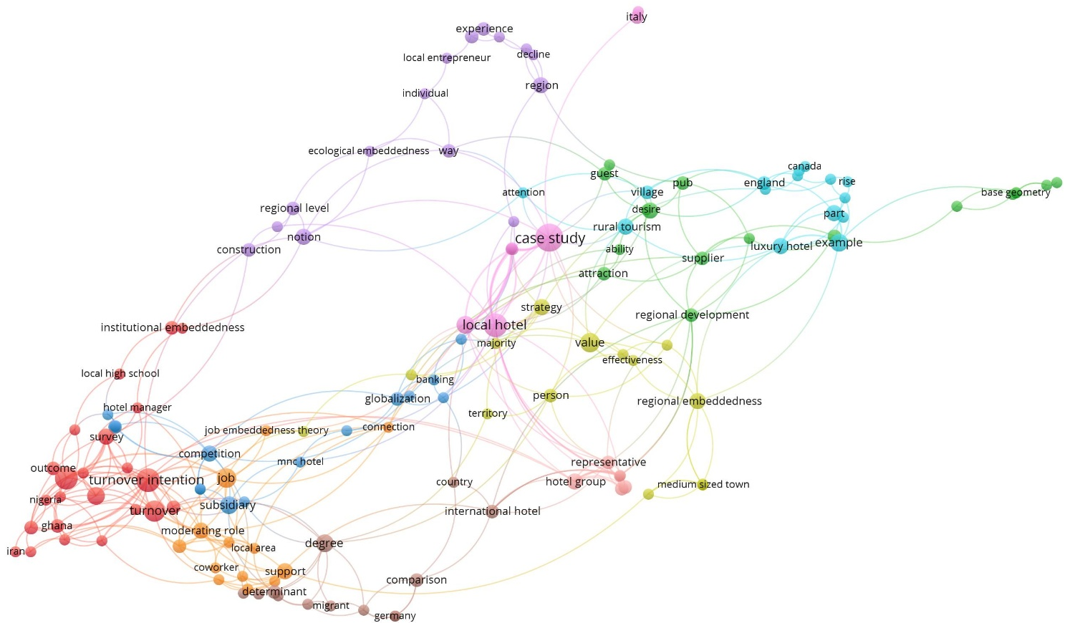
Figure 1 – Keyword co-occurrence map of search term “hotel local embeddedness” in Google Scholar
Source: Own edition (Generated via VOSviewer)

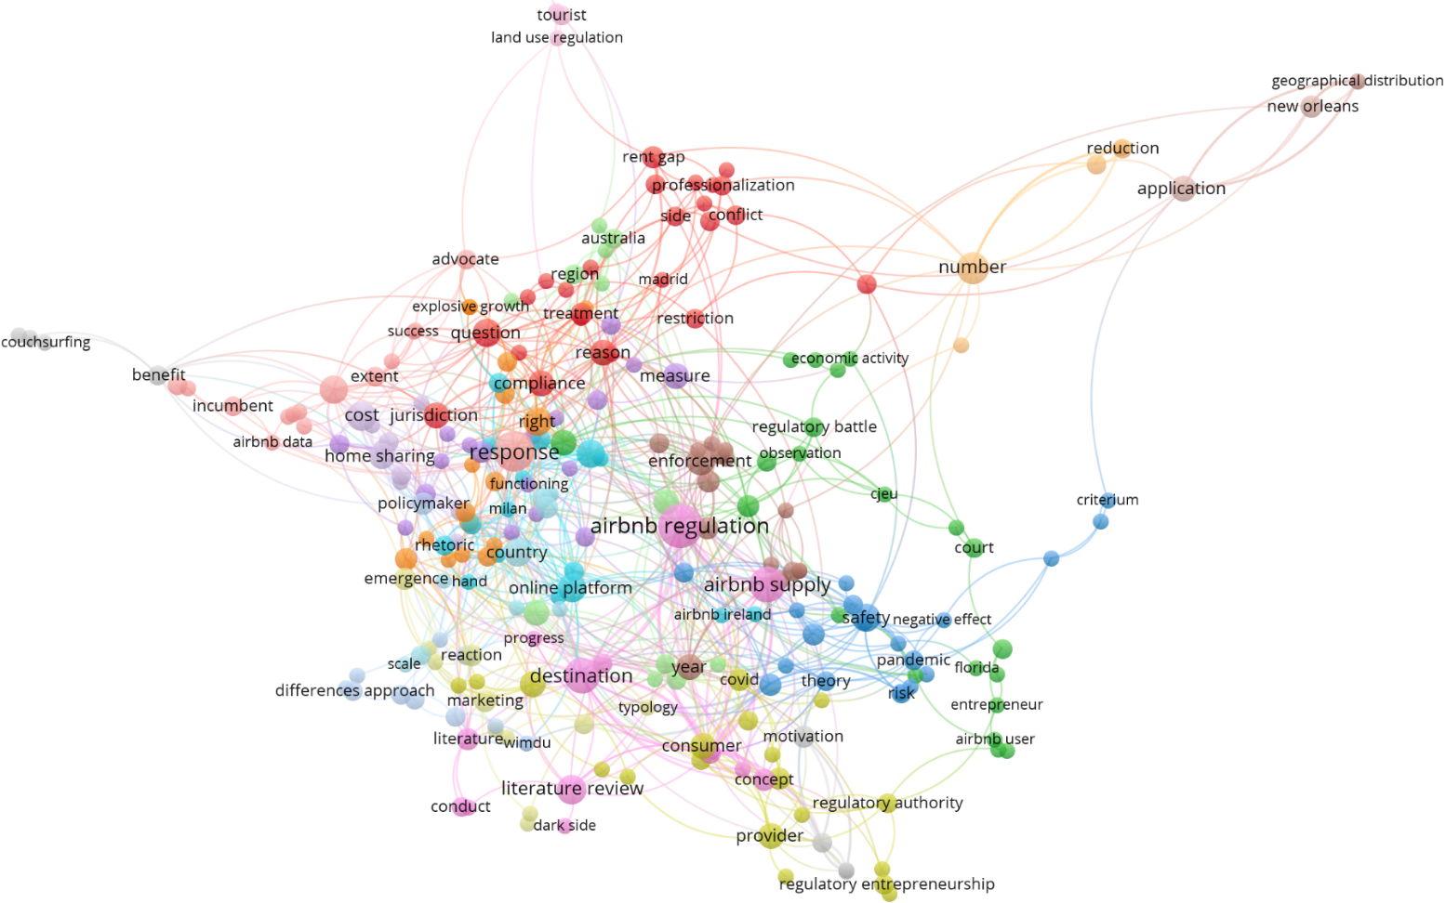Figure 2 – Keyword co-occurrence map of search term “Airbnb regulation” in Google Scholar
Source: Own edition (Generated via VOSviewer)

Discussion: Sustainable procurement framework for accommodation embeddedness
It is evident that many cities have introduced regulations on short-term rentals (Nieuwland & van Melik, 2018), ranging from liberal self-regulation to strict controls (von Briel & Dolnicar, 2021). Thus, the taxonomy by von Briel and Dolnicar (2021) illustrated in Figure 3 categorises these interventions into four distinct types based on the level of government intervention.
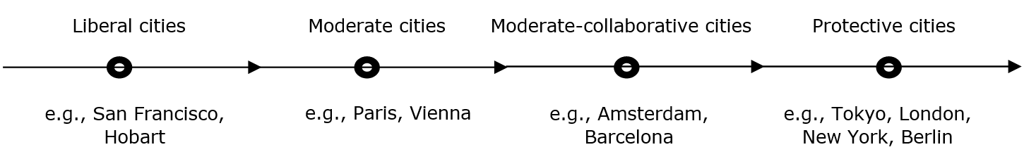
Figure 3 – Categorization of cities based on Airbnb regulations
Source: Own edition based on von Briel and Dolnicar (2021)
In this regard, this study extends the framework by integrating procurement-focused differentiation, arguing that effective sustainability policies must distinguish not only regulatory intensity but also accommodation ownership types and procurement behaviours.
Accordingly, Figure 4 presents the proposed conceptual framework for aligning procurement with sustainability in accommodation. For hotels, tax incentives for local sourcing, green-certification schemes and mandatory data transparency can encourage sourcing from local vendors and solidify supply-chain ties. On the other hand, for Airbnb apartments, better-rationalised host licensing and limits on multi-listing can guide peer-to-peer rentals toward community support instead of purely profit-driven growth which result in the over-exploitation of the urban areas. Such differentiated policy measures demonstrate how targeted instruments can improve economic embeddedness while reducing leakages.
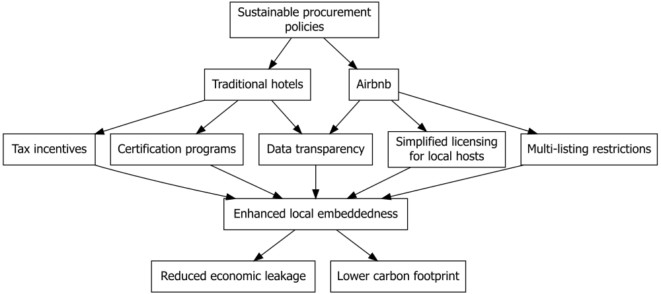
Figure 4 – Conceptual framework of sustainable procurement and embeddedness
Source: Own edition

The framework’s policy mechanisms are grounded in the theory of embeddedness, which emphasises that economic exchanges are embedded within social and institutional networks (Hess, 2009; Liang & Plakias, 2022). In tourism, embeddedness is actualised via procurement, local hiring and community engagement (Andriotis, 2002; Czernek-Marszałek, 2020). Local sourcing thus retains tourist revenue within the destinations and improves supplier relationships. Ecologically, shorter supply chains reduce carbon emissions, which further connects procurement practices to environmental goals (Hu et al., 2015; Stein & Santini, 2021). Embedding economic activities in local contexts therefore addresses both leakage and sustainability imperatives.
The VOSviewer co-occurrence map in Figure 1 depicts several interesting points in procurement’s role in regional development. Hence, the prominent “local hotel” cluster which is linked to terms of “supplier”, and “regional embeddedness” indicates strong focus on community-based sourcing. By contrast, the “mnc hotel” (multinational company) cluster ties to “globalization” and “competition”, which points to internationally driven supply chains that bypass local economies. Additional clusters labelled “institutional embeddedness”, and “ecological embeddedness” show that scholars increasingly frame procurement as a matter of governance and environmental responsibility. These distinctions confirm that hotel ownership and scale matter for embedding economic benefits locally in case of accommodations.
In this regard, the co-occurrence map on Airbnb regulation (Figure 2) emphasises governance challenges at the intersection of housing market and tourism industry. Clusters around “rent gap” and “conflict” depict scholarly concern with affordability pressures and local opposition, while links to “economic activity” and “CJEU” reflect legal negotiations over platform accountability (Guttentag, 2017; von Briel & Dolnicar, 2021). Hajibaba and Dolnicar (2017) further document that cities worldwide, from New York and Barcelona to Tokyo and Tasmania have experimented with diverse regulatory approaches (restrictions, licensing, platform partnerships), yet many measures required iterative refinement and enforcement to be effective. Moreover, von Briel and Dolnicar (2021) observe that listing declines are often temporary as hosts adapt by time, and Hübscher and Kallert (2023) show that geographic restrictions may merely displace listings to adjacent districts. Meanwhile, theme of “regulatory entrepreneurship” indicate that policymakers are piloting sandbox frameworks to balance innovation with community protections. Above scholarly divergence perpetuates policy blind spots: regulating Airbnb as purely a housing issue ignores its potential for leakage reduction through procurement reforms. These dynamics show that effective Airbnb regulation must combine housing controls with procurement and data-sharing obligations to increase local embeddedness.
All in all, Figures 1 and 2 reveal a clear gap: hotel procurement literature is rich in analyses of local economic linkages, whereas Airbnb research concentrates on housing-market impacts and regulatory conflicts but largely overlooks supply-side behaviours and host procurement strategies. Commission-based leakage, which is the portion of tourist spending captured by platform fees has also drawn scholarly attention, thus, Gössling et al. (2025) estimate that Airbnb commissions alone diverted over €39.5 million from Norway’s 2023 visitor revenue and the authors also call for research into how leakage, tourism growth, and platform dynamics interact. As platform fees represent a distinct form of economic outflow, host procurement practices remain under-examined, showing the necessity for future studies to examine procurement-level leakages as well. This gap is significant given Lee and Kim’s (2023) finding that Airbnb’s impact on localities can vary dramatically by ownership, also previously theoretically discussed by Guttentag (2015, p. 1193).
The policy case of Budapest’s 2025 short-term rental restrictions also confirms above-discussed tensions. Although short-term rentals became a prominent feature of Hungarian tourism only in recent decades, their use in Budapest dates back to the 1960s (Michalkó, 2001, in Smith et al., 2023). Notwithstanding, the Hungarian government now treats them as a housing issue rather than a tourism matter, imposing a two-year suspension on new permits in Budapest from January 2025, while existing registered accommodations remain unaffected (Ministry of National Economy, 2024; Office of National Assembly, 2024). National authorities justify this by noting that over 40% of official guest nights in Budapest occur in short-term rental apartments, compared to a 28% average in other regional capitals. Therefore, this regulation aims to protect local residents’ housing options but risks penalising embedded hosts who contribute economically through local procurement and community linkages. In this regard, the framework (Figure 4) suggests that combining licensing requirements with data-sharing obligations and better-targeted incentives could increase procurement-based embeddedness among peer-to-peer providers without unjustifiably limiting tourism supply.
Above discussion emphasised the need for differentiated, evidence-based procurement policies across accommodation models. Effective strategies must mitigate economic leakage and support local suppliers, while recognising the distinct operational and ownership structures of hotels and Airbnb apartments as well as their subcategories.

Conclusion
This paper examined how procurement-driven policies can enhance sustainability outcomes in the accommodation sector by focusing on local embeddedness and economic leakage. The central research question “How can procurement-driven policies optimise sustainability outcomes across accommodation types?” was addressed through a combination of literature synthesis, co-occurrence mapping, and a case study of Hungary’s 2025 short-term rental policy reform.
The analysis demonstrated differences in how traditional hotels and Airbnb accommodations interact with local economies. Hotels, particularly independent ones, are more likely to engage in local sourcing practices, while multinational chain hotels often depend on global supply chains. In case of Airbnb apartments, its community-based model introduces further regulatory complexities, and its economic impact depends on host type. Listings managed by absentee owners risk leaking tourism revenue from the localities, while locally operated listings possess a higher potential for local embeddedness. However, most existing Airbnb literature narrowly focuses on housing-market pressures or platform competition, neglecting procurement’s role in leakage mitigation.
To address these gaps, this study proposed a conceptual framework rooted in embeddedness theory and offer differentiated policy pathways. For hotels, tax-based incentives and certification schemes can promote sustainable procurement. For Airbnb accommodations, simplified licensing for local hosts and multi-listing limits grounded in regulatory typology of von Briel and Dolnicar (2021) can support embeddedness while reducing leakage.
The Budapest case further illustrated the challenge of balancing housing regulation with local economic development. While the short-term rental permit restrictions aim to ease housing, it may mistakeably penalise locally embedded hosts who contribute to local economies through procurement and employment. Hence, a more nuanced approach, one that distinguishes between absentee multi-listers, and locally hosted units could optimise both housing access and sustainability outcomes.
Finally, future research should empirically analyse procurement practices across accommodation subtypes as also suggested by Gössling et al. (2025), while Hungary’s regulatory transition offers a valuable testing ground for such research.

COMPETING INTERESTS DISCLAIMER:
Authors have declared that they have no known competing financial interests OR non-financial interests OR personal relationships that could have appeared to influence the work reported in this paper.

References
Andriotis, K. (2002). Scale of hospitality firms and local economic development. The case of Crete. Tourism Management, 23(4), 333-341. https://doi.org/10.1016/S0261-5177(01)00094-2.
Aznar, J. P., Sayeras, J. M., Galiana, J., & Rocafort, A. (2016). Sustainability commitment, new competitors’ presence, and hotel performance: the hotel industry in Barcelona. Sustainability , 755; https://doi.org/10.3390/su8080755.
Blal, I., Singal, M., & Templin, J. (2018). Airbnb’s effect on hotel sales growth. International Journal of Hospitality Management, 85-92. https://doi.org/10.1016/j.ijhm.2018.02.006.
BMJ. (2020, 01 04). The PRISMA 2020 statement: an updated guideline for reporting systematic reviews. Retrieved from thebmj: https://www.bmj.com/content/372/bmj.n71.short
Bohdanowicz, P., & Martinac, I. (2007). Determinants and benchmarking of resource consumption in hotels—Case study of Hilton International and Scandic in Europe. Energy and Buildings, 39(1), 82-95. https://doi.org/10.1016/j.enbuild.2006.05.005.
Capone, F., & Boix, R. (2008). Sources of growth and competitiveness of local tourist production systems: an application to Italy (1991–2001). The Annals of Regional Science, 42(2008), 209-224. https://doi.org/10.1007/s00168-007-0133-7.
Chandra, S., & Ranjan, A. (2022). Sustainability and Competitiveness of Transforming Tourist Accommodation. In V. Costa, & C. Costa (Eds.), Sustainability and Competitiveness in the Hospitality Industry (pp. 141-165). Hershey, Pennsylvania: IGI Global. https://doi.org/10.4018/978-1-7998-9285-4.
Cheng, M., Chen, G., Wiedmann, T., Hadjikakou, M., Xu, L., & Wang, Y. (2020). The sharing economy and sustainability – assessing Airbnb’s direct, indirect and induced carbon footprint in Sydney. Journal of Sustainable Tourism, 28(8), 1083-1099. https://doi.org/10.1080/09669582.2020.1720698.
CRAN Team. (2025, 06 09). bibliometrix: Comprehensive Science Mapping Analysis. Retrieved from The Comprehensive R Archive Network: https://cran.r-project.org/web/packages/bibliometrix/index.html
Czernek-Marszałek, K. (2020). Social embeddedness and its benefits for cooperation in a tourism destination. Journal of Destination Marketing & Management, 15(2020), 100401. https://doi.org/10.1016/j.jdmm.2019.100401.
Duso, T., Michelsen, C., Schaefer, M., & Tran, K. D. (2024). Airbnb and rental markets: Evidence from Berlin. Regional Science and Urban Economics, 106(2024), 104007. https://doi.org/10.1016/j.regsciurbeco.2024.104007.
Gössling, S., Humpe, A., Løseth, K., Walnum, H. J., Sun, Y., Dolnicar, S., . . . Iversen, N. M. (2025). Economic leakage to reservation platforms: Norway. Annals of Tourism Research, 103957. https://doi.org/10.1016/j.annals.2025.103957.
Guttentag, D. (2015). Airbnb: disruptive innovation and the rise of an informal tourism accommodation sector. Current Issues in Tourism, 18(12), 1192– 1217. https://doi.org/10.1080/13683500.2013.827159.
Guttentag, D. (2017). Regulating Innovation in the Collaborative Economy: An Examination of Airbnb’s Early Legal Issues. In D. Dredge, & S. Gyimóthy (Eds.), Collaborative Economy and Tourism (pp. 97-128). Cham: Springer. https://doi.org/10.1007/978-3-319-51799-5_7.
Guttentag, D. (2019). Progress on Airbnb: A literature review. Journal of Hospitality and Tourism Technology, 10(4), 814-844. https://doi.org/10.1108/JHTT-08-2018-0075.
Guttentag, D. A., & Smith, S. (2017). Assessing Airbnb as a disruptive innovation relative to hotels: Substitution and comparative performance expectations. International Journal of Hospitality Management, 1-10. https://doi.org/10.1016/j.ijhm.2017.02.003.
Hajibaba, H., & Dolnicar, S. (2017). Regulatory reactions around the world. In S. Dolnicar, Peer-to-Peer Accommodation Networks (pp. 120-136. http://dx.doi.org/10.23912/9781911396512-3609). Oxford, UK: Goodfellow Publishers.
Hashemkhani Zolfani, S., Sedaghat, M., Maknoon, R., & Zavadskas, E. K. (2015). Sustainable tourism: a comprehensive literature review on frameworks and applications. Economic Research-Ekonomska Istraživanja, 28(1), 1–30. https://doi.org/10.1080/1331677X.2014.995895.
Hess, M. (2009). Embeddedness. In N. Thrift, & R. Kitchin, International Encyclopedia of Human Geography (pp. 423–428). Amsterdam: Elsevier Science. https://doi.org/10.1016/b978-008044910-4.00151-6
Horn, K., & Merante, M. (2017). Is home sharing driving up rents? Evidence from Airbnb in Boston. Journal of Housing Economics, 38(2017), 14-24. https://doi.org/10.1016/j.jhe.2017.08.002.
Hu, A. H., Huang, C.-Y., Chen, C.-F., Kuo, C.-H., & Hsu, C.-W. (2015). Assessing carbon footprint in the life cycle of accommodation services: the case of an international tourist hotel. International Journal of Sustainable Development & World Ecology, 22(4), 313-323. https://doi.org/10.1080/13504509.2015.1049674.
Hübscher, M., & Kallert, T. (2023). Taming Airbnb locally: Analysing regulations in Amsterdam, Berlin and London. Journal of Economic and Social Geography, 114(1), 6-27. https://doi.org/10.1111/tesg.12537.
Incera, A. C., & Fernández, M. F. (2015). Tourism and income distribution: Evidence from a developed regional economy. Tourism Management, 48(1), 11-20. https://doi.org/10.1016/j.tourman.2014.10.016.
Ioannides, D., & Gyimóthy, S. (2020). The COVID-19 crisis as an opportunity for escaping the unsustainable global tourism path. Tourism Geographies, 22(3), 624–632. https://doi.org/10.1080/14616688.2020.1763445.
Kamann, D., & Gyurácz-Németh, P. (2023). Network embeddedness and leadership style: Determinants of crisis response behaviour. Journal of Economics, Management and Trade, 29(4), 13-27. https://doi.org/10.9734/jemt/2023/v29i41086.
Lee, S., & Kim, H. (2023). Four shades of Airbnb and its impact on locals: A spatiotemporal analysis of Airbnb, rent, housing prices, and gentrification. Tourism Management Perspectives, 49(2023), 101192. https://doi.org/10.1016/j.tmp.2023.101192.
Lehmeier, H. (2015). Warum immer Tourismus? (1st ed., Vol. 26). Bamberg: University of Bamberg Press. https://doi.org/10.20378/irb-2973.
Levendis, J., & Dicle, M. F. (2016). The economic impact of Airbnb on New Orleans. Journal of Marketing Research, 54(5), 687-705. https://dx.doi.org/10.2139/ssrn.2856770.
Liang, C.-L., & Plakias, Z. T. (2022). Chapter 86 - Interdisciplinary system and network perspectives in food and agricultural economics. In C. B. Barrett, & D. R. Just, Handbook of Agricultural Economics (pp. 4705-4779. https://doi.org/10.1016/bs.hesagr.2022.03.002). Amsterdam: Elsevier.
Liu, Z. (2003). Sustainable tourism development: A critique. Journal of Sustainable Tourism, 11(6), 459–475. https://doi.org/10.1080/09669580308667216.
Mayer, M., & Vogt, L. (2016). Economic effects of tourism and its influencing factors. Zeitschrift für Tourismuswissenschaft, 8(2), 169-198. https://doi.org/10.1515/tw-2016-0017.
Michalkó, G. (2001). Social and geographical aspects of tourism in Budapest. European Spatial Research and Policy, 8(1), 105-118. https://m2.mtmt.hu/gui2/?mode=browse&params=publication;1124546.
Ministry of National Economy. (2024). Az Airbnb szabályozás szigorítása a Budapesti lakhatási probléma megoldását szolgálja. Letöltés dátuma: 2025. 02 18, forrás: https://kormany.hu/hirek/az-airbnb-szabalyozas-szigoritasa-a-budapesti-lakhatasi-problema-megoldasat-szolgalja
Mitchell, J., & Ashley, C. (2010). Tourism and Poverty Reduction (1st ed.). London: Earthscan. https://search.worldcat.org/title/1120276098.
Mitchell, J., Font, X., & Li, S. (2014). What is the impact of hotels on local economic development? Applying value chain analysis to individual businesses. Anatolia, 26(3), 347-358. https://doi.org/10.1080/13032917.2014.947299.
Mody, M. A., Suess, C., & Lehto, X. (2017). The accommodation experiencescape: a comparative assessment of hotels and Airbnb. International Journal of Contemporary Hospitality Management, 29(9), 2377-2404. https://doi.org/10.1108/IJCHM-09-2016-0501.
Mowforth, M., & Munt, I. (2015). Tourism and Sustainability (4th ed.). London: Routledge. https://doi.org/10.4324/9781315795348.
Nieuwland, S., & van Melik, R. (2018). Regulating Airbnb: How cities deal with perceived negative externalities of short-term rentals. Current Issues in Tourism, 23(7), 811–825. https://doi.org/10.1080/13683500.2018.1504899.
Office of National Assembly. (2024, 10 31). Rövid távú szálláskiadás. Retrieved 02 28, 2025, from https://www.parlament.hu/documents/d/guest/infojegyzet_2024_31_rovid_tavu_szallaskiadas
Oskam, J., & Boswijk, A. (2016). Airbnb: The future of networked hospitality businesses. Journal of tourism futures, 2(1), 22-42. https://doi.org/10.1108/JTF-11-2015-0048.
Radhakrishnan, S., Erbis, S., Isaacs, J. A., & Kamarthi, S. (2017). Novel keyword co-occurrence network-based methods to foster systematic reviews of scientific literature. PLOS ONE, e0185771. https://doi.org/10.1371/journal.pone.0185771.
Ram, Y., & Tchetchik, A. (2022). Complementary or competitive? Interrelationships between hotels, Airbnb and housing in Tel Aviv, Israel. Current Issues in Tourism , 25(22), 3579-3590. https://doi.org/10.1080/13683500.2021.1978954.
Rhiney, K. (2009). Towards a new model for improved tourism-agriculture linkages? The case of two farmers' co-operatives in Jamaica. Caribbean Geography, 15(2), 142-159.
Smith, M. K., Egedy, T., Csizmady, A., Jancsik, A., Olt, G., & Michalkó, G. (2023). Non-planning and tourism consumption in Budapest's inner city. In P. Niewiadomski (Ed.), Tourism in Post-Communist States (1st ed., pp. 246–270). London: Routledge. https://doi.org/10.4324/9781003362418.
Stein, A., & Santini, F. (2021). The sustainability of “local” food: A review for policy-makers. Review of Agricultural, Food and Environmental Studies, 103(2022), 77–89. https://doi.org/10.1007/s41130-021-00148-w.
Telfer, D. J., & Wall, G. (2010). Strengthening backward economic linkages: Local food purchasing by three Indonesian hotels. Tourism Geographies, 2(4), 421-447. https://doi.org/10.1080/146166800750035521.
Thomas-Francois, K., von Massow, M., & Joppe, M. (2017). Service-oriented, sustainable, local food value chain – A case study. Annals of Tourism Research, 65(1), 83-96. https://doi.org/10.1016/j.annals.2017.05.008.
Torres, R. (2003). Linkages between tourism and agriculture in Mexico. Annals of Tourism Research, 30(3), 546-566. https://doi.org/10.1016/S0160-7383(02)00103-2.
United Nations. (1999). Sustainable tourism: A non-governmental organization perspective. New York: United Nations. https://sdgs.un.org/documents/csd-7-background-paper-4-sustainable-tourism-18404.
United Nations. (2023). Achieving the sustainable development goals through tourism – toolkit of indicators for projects (TIPs). Madrid, Spain: World Tourism Organization.
United Nations World Tourism Organization. (2004). Indicators of Sustainable Development for Tourism Destinations: A Guidebook (1 ed.). Madrid: World Tourism Organization. https://www.e-unwto.org/doi/book/10.18111/9789284407262.
van Eck, N. J., & Waltman, L. (2010). Software survey: VOSviewer, a computer program for bibliometric mapping. Scientometrics, 523-538. https://doi.org/10.1007/s11192-009-0146-3.
Vogt, L. (2008). Regional Development of Peripheral Areas with Tourism (in German:Regionalentwicklung peripherer Räume mit Tourismus) (1st ed.). Nuremberg: Frankische Geographischer Arbeiten: Sonderband 38.
von Briel, D., & Dolnicar, S. (2021). The evolution of Airbnb regulation - An international longitudinal investigation 2008–2020. Annals of Tourism Research, 87(2021), 102983. https://doi.org/10.1016/j.annals.2020.102983.
Wen, T., Zhang, Q., & Li, Y. (2020). Why small tourism enterprises behave responsibly: using job embeddedness and place attachment to predict corporate social responsibility activities. Current Issues in Tourism, 24(10), 1435–1450. https://doi.org/10.1080/13683500.2020.1797648.
Yannopoulou, N., Moufahim, M., & Bian, X. (2013). User-generated brands and social media: Couchsurfing and AirBnb. Contemporary Management Research, 9(1), 85–90. https://doi.org/10.7903/cmr.11116.
Yeon, J., Song, H. J., & Lee, S. (2020). Impact of short-term rental regulation on hotel industry: a difference-in-differences approach. Annals of Tourism Research, 83(2020), 102939. https://doi.org/10.1016/j.annals.2020.102939.
Zervas, G., Proserpio, D., & Byers, J. W. (2017). The rise of the sharing economy: Estimating the impact of Airbnb on the hotel industry. Journal of Marketing Research, 54(5), 687-705. https://doi.org/10.1509/jmr.15.0204.
Zuo, B., Tsai, C.-H., Su, C.-H., Jantes, N., Chen, M.-H., & Liu, J. (2023). Formation of a tourist destination image: Co-occurrence analysis of destination promotion videos. Journal of Destination Marketing & Management, 100763. https://doi.org/10.1016/j.jdmm.2023.100763.

