Evaluation of Granule Size Indices in Commercially Available Urea Fertilizers in India

.
ABSTRACT

Urea is the most widely used nitrogen fertilizer in India, yet limited information is available on the granule size characteristics of commercially available products from different manufacturers. Granule size plays an important role in fertilizer handling, metering behavior, and field application uniformity. In the present study, urea samples were collected from ten major Indian manufacturers, and their particle size characteristics were evaluated using percentile-based granule size indices, including d₅, d₁₆, d₈₄, and d₉₀. The d₅ values ranged from 0.394 to 0.861 mm, d₁₆ ranged from 0.650 to 0.943 mm, d₈₄ ranged from 1.311 to 1.484 mm, and d₉₀ ranged from 1.359 to 1.565 mm. One-way ANOVA showed statistically significant differences (p < 0.05) for all granule size indices among the ten manufacturers, and Tukey post-hoc analysis indicated a high number of significantly different pairwise comparisons for each index. These findings highlight differences in size variability among Indian urea brands.

Keywords: Urea fertilizer, Granule size indices, Particle size distribution, Percentile diameters

1. INTRODUCTION

Nitrogen (N) is one of the most essential macronutrients required for plant growth and crop yield. Urea has emerged as the most widely used nitrogen fertilizer and serves as the primary nitrogen source in agricultural production systems (Bhatti, 1992; Glibert et al., 2006). In India, the demand for urea has remained consistently high due to the country’s large agricultural sector and the extensive area under nitrogen-intensive crops such as rice and wheat. According to the recent governmental data, urea production in India increased from about 244.58 lakh metric tonnes per annum in 2019-20 to 314.09 lakh metric tonnes per annum in 2023-24 (Anonymous, 2024). Domestic production meets a large portion of the urea demand, with reports indicating that around 87.78% of urea consumption is currently met by indigenous manufacturing (Anonymous, 2024).
Despite this high production and use, there exist marked differences among commercially available urea fertilizers in terms of their physical properties. Particle size distribution is a key physical characteristic of granular fertilizers that affects their bulk behavior, including packing and segregation (Perfect et al., 1998). Among the factors affecting the deposition of granular fertilizers, particle size is the most significant, followed by particle density (Fulton & Port, 2016). The larger differences in particle size within a fertilizer increase the likelihood of uneven distribution or segregation (Gavrilović et al., 2018). Granule size influences various aspects of fertilizer performance, including flowability, bulk density, storage behaviour, spreading uniformity (for broadcast application), and discharge rate in mechanical or automated fertilizer applicators. One critical property is granule size distribution, often expressed through metrics such as d₅, d₁₆, d₈₄, and d₉₀ - indicating the diameters at which 5%, 16%, 84% and 90% of the sample’s mass falls below, respectively. Uniformity and consistency in granule size distribution are particularly important when fertilizers are applied using precision or variable-rate application equipment, as uneven granule size may result in non-uniform discharge, misapplication, or blockages.
Internationally, several researchers have evaluated the particle size distribution and physical characteristics of granular fertilizers such as by Bhatti (1992), Miserque & Pirard, (2004), and Simsek & Guliyev (2021). Other work, such as that by Virk et al. (2013), obtained particle sizes (d₁₆, d₅₀, and d₈₄) from the camsizer data. Although such research provides valuable insights into fertilizer performance at a global scale, studies focusing on the particle size characteristics of Indian urea fertilizers remain limited, despite India being one of the largest producers and consumers of urea globally. Variations in manufacturing technology, prilling versus granulation processes, and quality control practices among Indian manufacturers can lead to significant differences in granule size distribution, which in turn may influence fertilizer application uniformity. Although certain physical properties of fertilizers are commonly assessed during manufacturing, individual factories often use their own procedures to evaluate these characteristics (Allaire & Parent, 2004). However, actual particle sizes may differ from their intended specifications, as granules are susceptible to breakage and abrasion during transportation and handling. Therefore, the present study was undertaken to evaluate the particle size characteristics of ten commercially available urea fertilizer brands in India. Sieve analysis was conducted to determine the d₅, d₁₆, d₈₄, and d₉₀ indices, which serve as key descriptors of granule size distribution. The findings aim to provide insights into the physical quality of urea available in Indian markets and to support the design and calibration of fertilizer application systems.

2. material and methods
2.1 Sample Collection
Urea fertilizer samples were collected from ten different commercial brands commonly available in the Indian market. The manufacturers were selected based on their status as major urea producers in the country, considering factors such as production capacity, market presence, and distribution coverage. Together, these manufacturers represent a substantial portion of the commercial urea supply available to Indian farmers. A standard 45 kg bag of urea was procured from each manufacturer through authorized agricultural input suppliers and local fertilizer distribution outlets to ensure that the samples reflected the typical products available to end users. To maintain confidentiality, all collected samples were anonymized and labeled as Sample I, II, III, IV, V, VI, VII, VIII, IX, and X, with each designation corresponding to a distinct manufacturer widely represented in the Indian fertilizer market.
2.2 Sieve Analysis
In our previous work (Kumar et al., 2025), the sieve analysis procedure and the corresponding mass fraction retained on each sieve were described in detail to characterize the particle size distribution of commercial urea fertilizers. A schematic representation of the sieve stack arrangement is shown in Fig. 1. From each ten samples, approximately 500 g of urea was placed on the top sieve, and the entire assembly was mounted on a mechanical sieve shaker for a fixed duration to ensure consistent vibration and complete separation of granules according to size. After sieving, the mass of material retained on each sieve was recorded, and the corresponding mass fraction was calculated. The present study employs these mass fraction data to compute percentile-based granule size indices, including d₅, d₁₆, d₈₄, and _{d90}. These indices enable a more detailed assessment of granule size variability by capturing both the finer and coarser fractions of the distribution, thereby providing deeper insights into the physical characteristics of urea fertilizers.
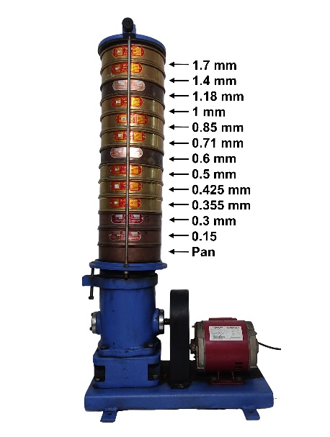
Fig. 1 Sieve Stack Arrangement
2.3 Determination of Granule Size Indices (Percentile Diameters d₅, d₁₆, d₈₄, and d₉₀)
The granule size indices of the urea samples were determined using percentile-based particle size parameters calculated from the cumulative mass distribution obtained through sieve analysis. For each sample, the cumulative percentage of material passing through successive sieves was plotted against the corresponding sieve aperture size to generate the particle size distribution curve. As described by Miserque & Pirard (2004), such curves are characterized by percentile diameters denoted as d_{x}, where x represents the weight fraction (in percent) of particles passing a sieve of mesh size d.
Based on this principle, the percentile diameters d₅, d₁₆, d₈₄, and d₉₀ were determined by interpolation. The lower percentile diameters- d₅ and d₁₆-correspond to the particle sizes at which 5% and 16% of the sample mass passed through the sieve, indicating that the remaining 95% and 84% of the material, respectively, consisted of larger particles retained above that size. Conversely, the upper percentile diameters d₈₄, and d₉₀ represent the particle sizes below which 84% and 90% of the total sample mass passed, leaving 16% and 10% as the coarser fraction.
Together, these percentile-based parameters provide a detailed representation of the granule size distribution, capturing both fine and coarse components of the fertilizer samples. Their inclusion allows for a more comprehensive assessment of granule size variability than traditional single-point descriptors and offers deeper insight into the physical characteristics and handling behavior of commercially available urea fertilizers.
2.4 Statistical Analysis
The statistical analysis was conducted to evaluate the variability in the granule size indices of urea samples obtained from ten different manufacturers. Each sample was analyzed with four replications. A one-way analysis of variance (ANOVA) with Tukey’s post hoc test was performed to determine whether significant differences existed among the manufacturers for each of the granule size indices (d₅, d₁₆, d₈₄, and d₉₀). All statistical analyses were carried out using OriginPro 2025 (OriginLab Corporation, USA).
3. results and discussion
3.1 d₅ Granule Size Index
The d₅ values of the ten urea samples ranged from 0.394 mm to 0.861 mm, indicating notable variation in the smallest percentile diameter among the manufacturers. The coefficient of variation (CV) for d₅ ranged from 0.12% to 4.95%, indicating differences in consistency within the individual samples. As illustrated in Fig. 2, the minimum d₅ value was observed for Sample III, whereas the maximum d₅ value was recorded for Sample IX.
The results of the one-way ANOVA, summarized in Table 1, demonstrated that the differences in the mean d₅ values among the ten manufacturers were statistically significant at the 0.05 level. The Tukey post-hoc comparison further confirmed that 35 out of the 45 possible manufacturer pairings exhibited significant differences in d₅ at the 0.05 significance level. These findings highlight the considerable variability in d₅ among commercially available urea fertilizers, suggesting that manufacturers differ substantially in terms of granule size characteristics represented by this percentile diameter.
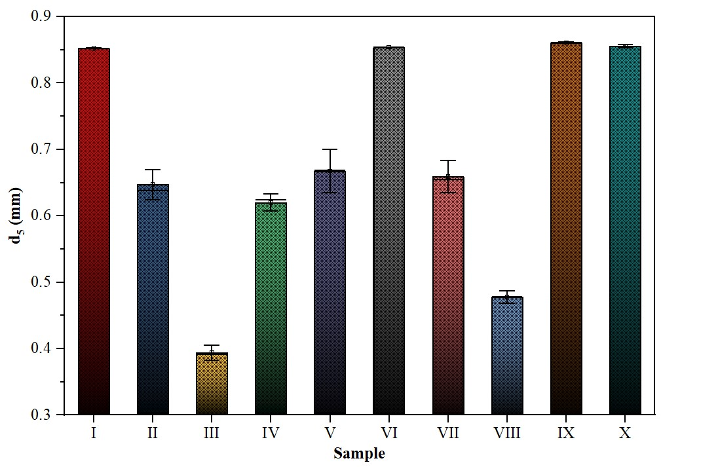
Fig. 2 d₅ Granule Size Index for Urea Samples
Table 1: One-Way ANOVA for d₅ Granule Size Index
Source of Variation | DF | Sum of Squares | Mean Square | F Value | Tabular F (5%)
Model | 9 | 1.00215 | 0.11135 | 431.8819* | 2.21
Error | 30 | 0.00773 | 2.57825E-4
Total | 39 | 1.00988

3.2 d₁₆ Granule Size Index
As shown in Fig. 3, the d₁₆ values of the ten urea samples ranged from 0.650 mm (Sample III) to 0.943 mm (Sample IV), indicating variability in the lower percentile granule size among manufacturers. The CV for d₁₆ varied from 0.00 to 1.06%. The results of the one-way ANOVA for d₁₆ are presented in Table 2. The analysis showed that, at the 0.05 significance level, the differences in mean d₁₆ values across the ten manufacturers were statistically significant. A subsequent Tukey post-hoc test further identified that 40 out of the 45 possible manufacturer pairwise comparisons exhibited significant differences at the 0.05 level, confirming substantial variability in d₁₆ among the commercial urea brands.
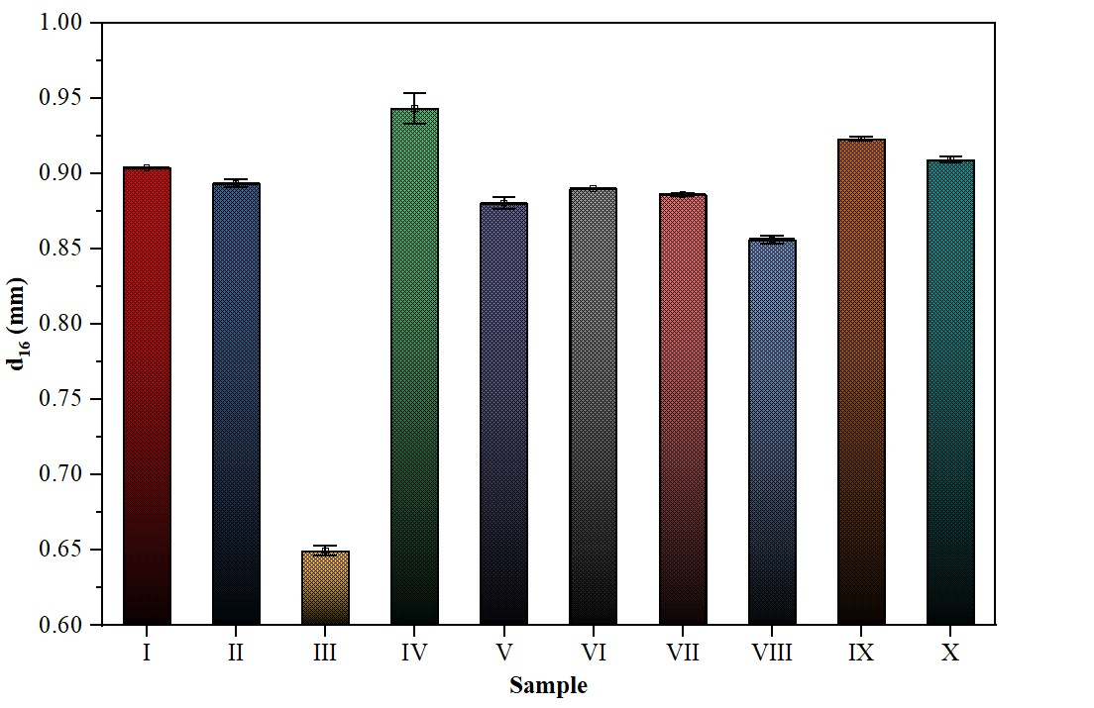
Fig. 3 d₁₆ Granule Size Index for Urea Samples
Table 2: One-Way ANOVA for d₁₆ Granule Size Index
Source of Variation | DF | Sum of Squares | Mean Square | F Value | Tabular F (5%)
Model | 9 | 0.24332 | 0.02704 | 1809.403* | 2.21
Error | 30 | 4.4825E-4 | 1.49417E-5
Total | 39 | 0.24377

3.3 d₈₄ Granule Size Index
The d₈₄ values of the ten urea samples ranged from 1.311 mm to 1.484 mm, indicating moderate variability among the manufacturers in the upper portion of the granule size distribution. The CV values for d₈₄ were relatively low, ranging from 0.07% to 0.76%, suggesting that the larger granule fractions were generally consistent within each manufacturer's product. As illustrated in Fig. 4, the minimum d₈₄ value was recorded for Sample III, whereas the maximum d₈₄ value was observed for Sample IX.
The results of the one-way ANOVA for d₈₄ presented in Table 3 showed that, at the 0.05 significance level, the differences in mean d₈₄ values across the ten manufacturers were statistically significant, indicating non-uniformity in the coarser granule size characteristics among the brands. A subsequent Tukey post-hoc test revealed that 39 out of the 45 possible manufacturer pair comparisons exhibited significant differences at the 0.05 level. The high number of significant pairwise differences confirm substantial variability in the d₈₄ granule size index among commercially available urea fertilizers in India.
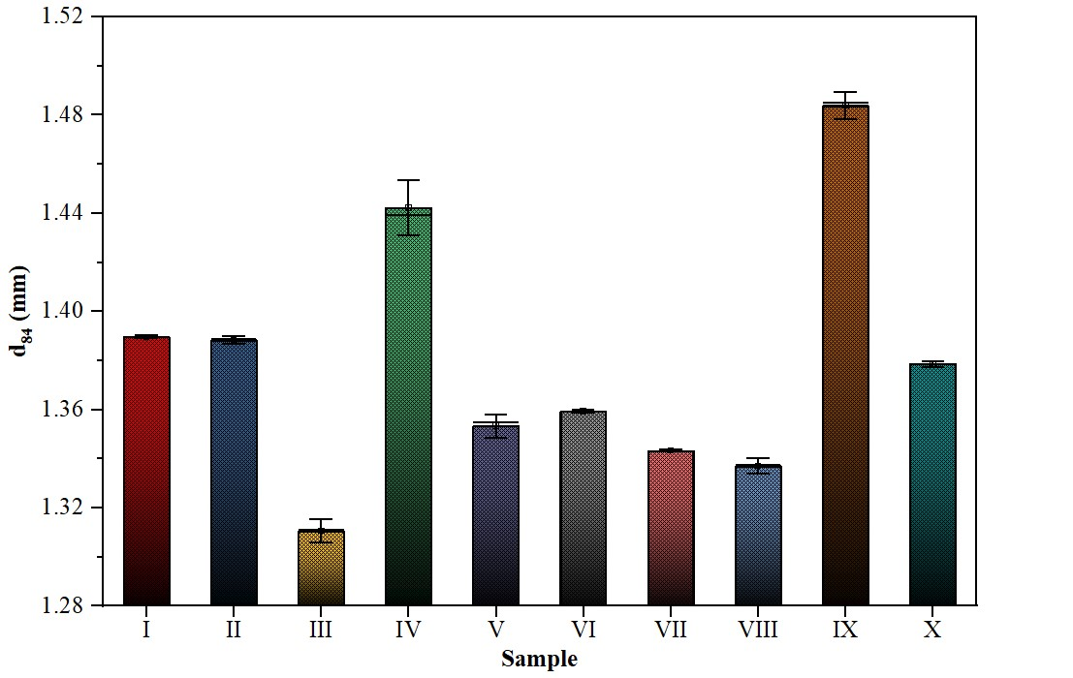
Fig. 4 d₈₄ Granule Size Index for Urea Samples
Table 3: One-Way ANOVA for d₈₄ Granule Size Index
Source of Variation | DF | Sum of Squares | Mean Square | F Value | Tabular F (5%)
Model | 9 | 0.09569 | 0.01063 | 484.206* | 2.21
Error | 30 | 6.5875E-4 | 2.19583E-5
Total | 39 | 0.09635

3.4 d₉₀ Granule Size Index
As shown in Fig. 5, the d₉₀ values of the ten urea samples ranged from 1.359 mm (Sample III) to 1.565 mm (Sample IX). The CV for d₉₀ ranged from 0.00 to 0.63%, indicating relatively low within-manufacturer variability. The results of the one-way ANOVA for d₉₀ are presented in Table 4. The analysis showed that, at the 0.05 significance level, the differences in mean d₉₀ values across the ten manufacturers were statistically significant. A subsequent Tukey post-hoc test revealed that 40 out of the 45 possible manufacturer pairwise comparisons exhibited significant differences at the 0.05 level, indicating substantial variation in d₉₀ among the commercially available urea brands.
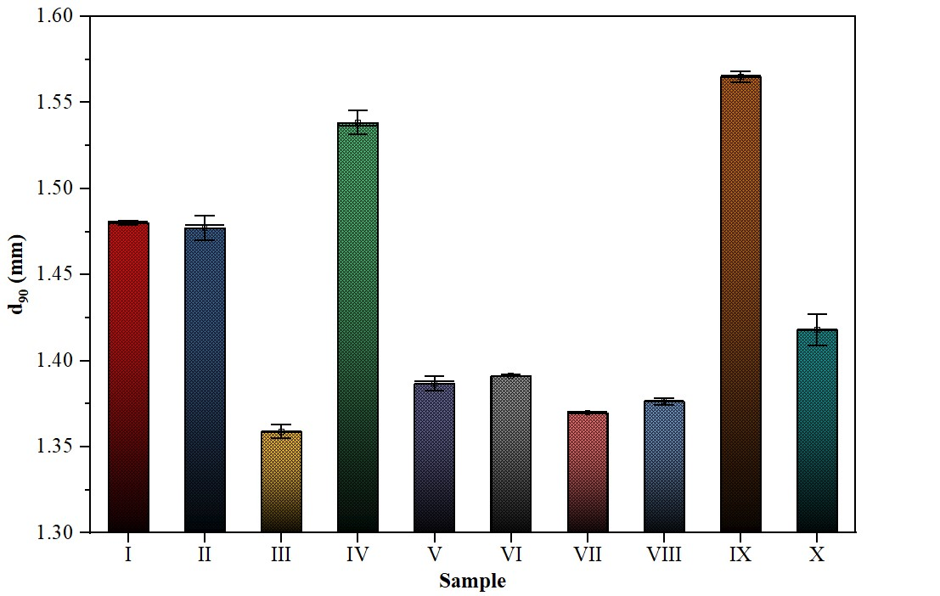
Fig. 5 d₉₀ Granule Size Index for Urea Samples
Table 4: One-Way ANOVA for d₉₀ Granule Size Index
Source of Variation | DF | Sum of Squares | Mean Square | F Value | Tabular F (5%)
Model | 9 | 0.19731 | 0.02192 | 924.708* | 2.21
Error | 30 | 7.1125E-4 | 2.37083E-5
Total | 39 | 0.19802

4. Summary and Conclusion

The present study evaluated the granule size characteristics of ten commercially available urea fertilizers in India using percentile-based indices (d₅, d₁₆, d₈₄, and d₉₀). The results highlighted substantial variability in particle size distribution among manufacturers, as revealed through one-way ANOVA and Tukey’s post hoc analysis. Such differences in granule size indices have important implications for fertilizer handling, flow behavior, segregation potential, and mechanical application efficiency. The key findings of the study are summarized below:
- The percentile-based granule size indices (d₅, d₁₆, d₈₄, and d₉₀) varied considerably among the ten urea manufacturers, indicating significant differences in granule size across commercial brands.
- d₅ values ranged from 0.394 to 0.861 mm, with the lowest value for Sample III and the highest for Sample IX. Similarly, d₁₆ values ranged from 0.650 to 0.943 mm, with Samples III and IV showing the minimum and maximum values, respectively.
- d₈₄ values ranged from 1.311 to 1.484 mm, indicating variability in the coarser granule fraction. Sample III exhibited the lowest d₈₄ and Sample IX the highest. d₉₀ values ranged from 1.359 to 1.565 mm, with clear variation across samples.
- The coefficients of variation for all percentile diameters were generally below 5%.
- One-way ANOVA revealed statistically significant differences across all percentile diameters studied, and Tukey’s post-hoc comparisons confirmed that the majority of manufacturer pairs differed significantly for each d-value.
- The granule size indices presented provide foundational data useful for calculating uniformity indices, enabling quantitative assessment of fertilizer distribution quality in field application.
- The results can also be utilized in particle simulation models of urea fertilizer, supporting virtual testing of flow behavior, metering accuracy, and machine design optimization.
Competing interests

Authors have declared that no competing interests exist.

References

Allaire, S. E., & Parent, L. E. (2004). Physical Properties of Granular Organic-based Fertilisers, Part 2: Dynamic Properties Related to Water. Biosystems Engineering, 87(2), 225–236. https://doi.org/10.1016/j.biosystemseng.2003.09.007

Anonymous. (2024). Annual Report 2023-2024. Department of Fertilizers, Ministry of Chemicals & Fertilizers, Government of India. https://fert.nic.in/documents/annual-report-2023-2024

Bhatti, M. E. (1992). Physical properties comparative study of urea of different companies in Pakistan. Fertilizer Research, 32, 13–17. https://doi.org/10.1007/BF01054389

Fulton, J., & Port, K. (2016). Physical Properties of Granular Fertilizers and Impact on Spreading. The Ohio State University. https://ohioline.osu.edu/factsheet/fabe-5501

Gavrilović, M., Dimitrijević, A., Radojičin, M., Mileusnić, Z., & Miodragović, R. (2018). Effects of the application system on the physical and mechanical properties of mineral fertilizers. Journal on Processing and Energy in Agriculture, 22(4), 180–183. https://doi.org/10.5937/jpea1804180G

Glibert, P. M., Harrison, J., Heil, C., & Seitzinger, S. (2006). Escalating worldwide use of urea: A global change contributing to coastal eutrophication. Biogeochemistry, 77, 441–463. https://doi.org/10.1007/s10533-005-3070-5

Kumar, V., Rajan, P., Deshmukh, M. M., Gupta, C., Thakare, S. K., Thakare, S. H., Gajakos, A. V., & Kanade, S. A. (2025). Comparative study of particle size distribution in Commercial urea fertilizers from India. International Journal of Research in Agronomy, 8(7), 10–13. https://doi.org/10.33545/2618060X.2025.v8.i7Sa.3189

Miserque, O., & Pirard, E. (2004). Segregation of the bulk blend fertilizers. Chemometrics and Intelligent Laboratory Systems, 74(1), 215–224. https://doi.org/10.1016/j.chemolab.2004.03.017

Perfect, E., Xu, Q., & Terry, D. L. (1998). Improved parameterization of fertilizer particle size distribution. Journal of AOAC International. https://doi.org/10.1093/jaoac/81.5.935

Şimşek, H. M., & Guliyev, R. (2021). The investigation of physical properties of composite fertilizer including boron micro element. Sakarya University Journal of Science, 25(5), 1245–1252. https://doi.org/10.16984/saufenbilder.853343

Virk, S. S., Mullenix, D. K., Sharda, A., Hall, J. B., Wood, C. W., Fasina, O. O., McDonald, T. P., Pate, G. L., & Fulton, J. P. (2013). Case study: Distribution uniformity of a blended fertilizer applied using a variable-rate spinner-disc spreader. Applied Engineering in Agriculture, 29(5), 627–636. https://doi.org/10.13031/aea.29.9774

