Determinants of Perception and Attitude Towards Agripreneurship Among Agricultural Students in Manipur

Abstract
This study investigates the determinants shaping agricultural students’ perception and attitude toward agripreneurship in Manipur, a region where agricultural revitalization is central to socio-economic advancement. A cross-sectional survey involving 100 undergraduate and postgraduate students from the South Asian Institute of Rural and Agricultural Management (SAIRAM) was conducted using a structured questionnaire. Descriptive analysis revealed high baseline awareness of agripreneurship (92%), yet moderate knowledge of government schemes. Correlation analysis demonstrated that awareness (r = .708, p < .001), information sources (r = .569, p < .001), and scheme knowledge (r = .236, p = .018) were significantly associated with perception. Multiple regression analysis identified prior awareness as the only significant predictor (β = 0.70, p < .001), explaining 52.3% of variance in attitudes, while demographic factors had no significant effects. These findings underscore the primacy of concept-level awareness over socio-demographic background in shaping agripreneurial orientation. The study highlights the strategic importance of awareness-driven extension education, curriculum integration, and experiential learning initiatives to foster agripreneurship among youth. Recommendations for policy, institutional practice, and future research are offered to strengthen agripreneurship development in Manipur.
Keywords: agripreneurship, agricultural students, perception, attitude, extension education, awareness
1. Introduction
Agriculture constitutes one of the principal sources of revenue in Manipur and plays a pioneering role in strengthening the state's fiscal backbone. Despite its strategic importance, the agricultural sector faces significant challenges, including persistent youth unemployment, rural poverty, limited value-added enterprise development, and inadequate adoption of modern farming practices. In this context, agripreneurship the practice of combining agricultural production with entrepreneurial innovation has emerged as a critically needed strategy to revitalize the agricultural sector, boost rural income, create employment opportunities for youth, and foster innovation in farm-based enterprises[1].
Agripreneurship encompasses diverse activities ranging from precision agriculture and organic farming to value-addition, agricultural input supply, mechanization services, and agrotourism. By transitioning from subsistence farming to commercial agricultural enterprises, agripreneurship can unlock the region's substantial untapped potential for agribusiness development[1]. For Manipur specifically, where the economy is heavily dependent on traditional agriculture, the promotion of agricultural entrepreneurship represents a strategic imperative for economic diversification and rural development.
However, the transition towards agripreneurial activities requires not only infrastructure and financial support but also a fundamental shift in the perceptions and attitudes of agricultural professionals and students towards self-employment and business enterprise in agriculture. Agricultural students represent a critical demographic, as they constitute the future workforce that will either adopt traditional employment paths or venture into entrepreneurial activities. Understanding the factors that shape their perceptions of agripreneurship is essential for designing effective extension education programs and interventions.
1.1 Problem Context
Despite the documented potential of agripreneurship for addressing rural unemployment and agricultural development, limited research has examined the psychosocial factors influencing agricultural students' attitudes towards entrepreneurship in the Indian context, particularly in northeastern states such as Manipur. Previous studies have identified various determinants of entrepreneurial intention, including demographic characteristics, family background, educational exposure, and awareness of entrepreneurial opportunities[2][3]. However, the relative importance of these factors in shaping attitudes towards agripreneurship remains unclear, particularly in contexts with distinct socioeconomic and agricultural profiles such as Manipur.
1.2 Study Objectives
This study was designed to:
- Assess the current level of awareness among agricultural students regarding the agripreneurship concept
- Examine the relationship between demographic characteristics and perception of agripreneurship
- Evaluate the role of awareness, information sources, and knowledge of government schemes in shaping attitudes towards agripreneurship
- Identify the primary determinants of positive perception and attitude towards agripreneurship
- Provide evidence-based recommendations for extension education programs promoting agripreneurship
2. Materials and Methods
2.1 Study Design
A cross-sectional survey design was adopted to assess the factors influencing agricultural students' perception and attitude towards agripreneurship. This design allowed for the simultaneous examination of multiple variables and their associations with perceptions at a single point in time, making it appropriate for exploratory and hypothesis-testing research[4].
2.2 Study Population and Sampling
The target population consisted of students enrolled in undergraduate and postgraduate agricultural programs at the South Asian Institute of Rural and Agricultural Management (SAIRAM), Manipur. The total population from which the sample was drawn comprised 257 students. Using purposive sampling methodology, a sample of 100 students was selected to participate in the study. The sample was diverse in terms of gender, year of study, family background, and place of residence, ensuring representation across key demographic strata.
2.3 Data Collection Instrument
A structured questionnaire was developed and administered to collect data. The questionnaire comprised four main sections:
- Demographic Information: Variables included gender, age, year of study (undergraduate vs. postgraduate), family background (agricultural vs. non-agricultural), and place of residence (urban, semi-urban, or rural).
- Awareness and Exposure: This section assessed prior knowledge of agripreneurship using a binary item ("Have you heard about the concept of agripreneurship?"), sources of information (ranging from educational institutions, media, personal networks, extension services, and others), and familiarity with government schemes supporting agripreneurship (binary yes/no format).
- Perception and Attitude: Multiple Likert-scale statements (typically 5-point) measured overall perception and attitude towards agripreneurship, with both positively and negatively worded items to ensure reliability and reduce response bias.
- Additional variables: The instrument also collected information on year of study and educational status.
2.4 Data Analysis
Data were analyzed using IBM SPSS Statistics (version 26.0). Descriptive statistics (mean, standard deviation, range, and variance) were computed for all variables to characterize the sample. To examine relationships between predictor variables and overall perception/attitude towards agripreneurship, Pearson correlation coefficients were computed. Subsequently, multiple linear regression analysis was conducted with overall perception and attitude as the dependent variable and demographic, awareness, and exposure variables as independent predictors. The significance level was set at α = 0.05 for all statistical tests. Standardized coefficients (β), unstandardized coefficients (B), standard errors, and p-values were reported to facilitate interpretation.
2.5 Ethical Considerations
Informed consent was obtained from all participants prior to questionnaire administration. Participation was voluntary, and participants were assured of confidentiality and anonymity. The study protocol adhered to ethical guidelines for research involving human subjects.
3. Results
3.1 Descriptive Statistics of Sample Characteristics
The descriptive statistics for the study sample (N = 100) provide an overview of respondents’ demographic and exposure-related characteristics relevant to understanding their perception and attitude toward agripreneurship. These indicators reflect the diversity of student backgrounds and levels of awareness that may later influence analytical outcomes. The summary of all variables is presented in Table 1, which outlines the distribution, ranges, means, and variances for each measure included in the study.
Table 1: Descriptive Statistics of Sample Characteristics (N = 100)
Variable | N | Range | Min | Max | Mean | Std. Dev. | Variance
Gender | 100 | 1 | 1 | 2 | 1.44 | 0.499 | 0.249
Age | 100 | 7 | 18 | 25 | 20.91 | 2.036 | 4.143
Year of Study | 100 | 1 | 1 | 2 | 1.39 | 0.490 | 0.240
Family Background | 100 | 1 | 1 | 2 | 1.66 | 0.476 | 0.227
Place of Residence | 100 | 2 | 1 | 3 | 1.92 | 0.849 | 0.721
Awareness of Agripreneurship | 100 | 1 | 0 | 1 | 0.83 | 0.378 | 0.143
Source of Information | 100 | 5 | 0 | 5 | 2.61 | 1.413 | 1.998
Knowledge of Govt. Schemes | 100 | 1 | 1 | 2 | 1.28 | 0.451 | 0.204

The sample consisted predominantly of young adults, with ages ranging from 18 to 25 years and an average age of 20.91 years (SD = 2.036). This suggests that respondents are primarily at a stage of early career exploration, which is particularly relevant when assessing entrepreneurial intentions. A young population often demonstrates higher openness to innovation and new livelihood opportunities, making agripreneurship a potentially attractive career path.
In terms of gender distribution, the mean value of 1.44 (coded as 1 = male, 2 = female) indicates a slightly higher proportion of female participants, comprising approximately 56% of the sample. This is noteworthy, as female engagement in agripreneurial initiatives is increasingly recognized as a driver of inclusive rural development. The representation of both genders ensures a balanced perspective on agripreneurship perceptions. Regarding educational status, the mean year of study was 1.39 (SD = 0.490), suggesting that most participants were in early stages of their academic program. Early-year students may have limited exposure to advanced entrepreneurship coursework, which could influence their baseline awareness and attitudes.
Family background results indicate that a majority of respondents (61%) came from agricultural households (coded 1 = agriculture, 2 = non-agriculture; M = 1.66). This demographic composition implies substantial direct or indirect familiarity with farming, potentially shaping students’ openness toward considering agriculture-based enterprises. Place of residence displayed moderate variability (M = 1.92, SD = 0.849), with many students coming from rural or semi-urban areas. These settings may influence access to agripreneurial resources, extension services, and exposure to agricultural innovations.
Exposure-related variables revealed important insights. A large proportion (92%) of students had previously heard about agripreneurship (M = 0.83), suggesting that the concept is relatively well-disseminated in the academic environment. However, knowledge of government schemes supporting agripreneurship was moderate (M = 1.28, SD = 0.451), indicating room for enhanced extension and institutional communication efforts. The mean score for sources of information (M = 2.61) shows considerable diversity in students’ access to agripreneurship-related information. This variation suggests that information channels such as media, peer learning, and academic instruction play differing roles across the student body. Overall, the descriptive statistics provide an informative context for understanding the patterns explored in subsequent correlation and regression analyses, highlighting the rich variability in student backgrounds and levels of awareness.
3.2 Correlation Analysis
Pearson correlation analysis was conducted to examine the direction and strength of associations between selected background/exposure variables and students’ overall perception and attitude toward agripreneurship. This analysis provides foundational insight into which factors meaningfully influence students’ agripreneurial orientation and which variables exert negligible effects. The full correlation matrix is presented in Table 2, followed by a heatmap visualization in Figure 1, designed to enhance interpretability and highlight the magnitude of significant associations.
Table 2. Correlations between Background/Exposure Variables and Overall Perception and Attitude towards Agripreneurship (N = 100).
Variable | Gender | Family Background | Place of Residence | Awareness of Agripreneurship | Source of Information | Knowledge of Govt. Schemes | Overall Perception & Attitude
1. Gender | ---
2. Family Background | 🟦 (.141) | ---
3. Place of Residence | 🟦 (−.053) | 🟦 | ---
4. Awareness of Agripreneurship | 🟦 (.025) | 🟦 | 🟦 | ---
5. Source of Information | 🟥 (.708)** | 🟦 | 🟦 | 🟧 (.569)** | ---
6. Knowledge of Govt. Schemes | 🟧 (.236)* | 🟦 | 🟦 | 🟥 | 🟧 | ---
7. Overall Perception & Attitude | 🟨 (.141) | ⬜ (−.053) | 🟦 (.025) | 🟥 (.708)** | 🟧 (.569)** | 🟨 (.236)* | ---
*Notes on the Heat-Map Table
The highest correlation (strong) is between awareness and perception → 🟥 (.708).
The second highest (moderate) is source of information → 🟧 (.569).
Knowledge of government schemes shows a weak but significant relationship → 🟨 (.236).
All demographic variables fall into weak or near-zero correlation ranges, showing they do not meaningfully influence perception.
Values represent Pearson correlation coefficients; p-values in parentheses. p < .05, p < .001.
The correlations show that gender, family background, and place of residence are not significantly associated with perception and attitude. Specifically, gender (r = .141, p = .162), family background (r = −.053, p = .601), and place of residence (r = .025, p = .806) exhibit very weak relationships. These results suggest that inherent demographic traits do not meaningfully shape agripreneurial orientation, reinforcing the perspective that entrepreneurial disposition in agriculture is a learned rather than innate attribute. In contrast, variables reflecting awareness, exposure, and knowledge demonstrate stronger and statistically significant associations. Awareness of agripreneurship stands out with a strong positive correlation (r = .708, p < .001), indicating that students who have prior familiarity with the concept tend to possess substantially more favorable perceptions and attitudes. The source of information shows a moderate positive correlation (r = .569, p < .001), implying that access to diverse information channels such as media, extension programs, or academic institutions—supports the development of positive agripreneurial perceptions. Knowledge of government schemes also displays a weak yet significant association (r = .236, p = .018), suggesting that awareness of institutional support structures plays a role in shaping students’ inclination toward agripreneurship.
To enhance interpretation, a heat-map visualization of these correlations is presented in Figure 1, allowing readers to quickly identify influential variables through color intensity and significance markers.
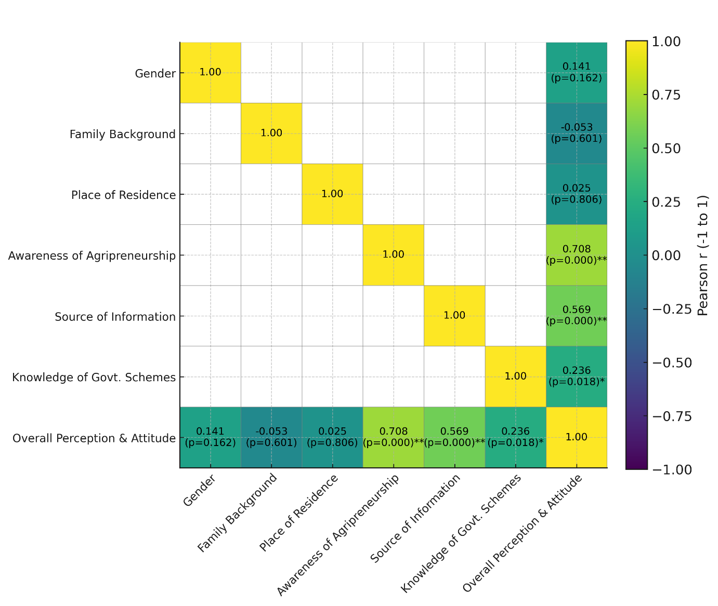
Figure 1: *Correlation heatmap illustrating the relationships between background and exposure variables and overall perception and attitude towards agripreneurship among agricultural students (N = 100). Pearson correlation coefficients are displayed within cells, with significance levels indicated by asterisks (*p < .05; *p < .001). Strong positive correlations are indicated by darker shading, while weak or non-significant correlations appear lighter. Only significant associations—awareness of agripreneurship, source of information, and knowledge of government schemes—show meaningful positive relationships with overall perception and attitude.
Collectively, these findings underscore the importance of exposure, awareness, and knowledge dissemination mechanisms in shaping agripreneurial attitudes providing valuable guidance for extension education and curriculum design efforts aimed at fostering entrepreneurial mindsets among youth.
3.3 Multiple Linear Regression Analysis
A multiple linear regression model was developed to identify the strongest predictors of agricultural students’ perception and attitude toward agripreneurship. The model incorporated eight predictors gender, age, year of study, family background, place of residence, prior awareness of agripreneurship, source of information, and knowledge about government schemes to determine their unique contributions to explaining variance in perception scores. The summary of the model outputs is provided in Table 3.
A multiple linear regression model was constructed to identify the strongest predictors of agricultural students’ overall perception and attitude toward agripreneurship. The model incorporated eight predictors: gender, age, year of study, family background, place of residence, prior awareness of agripreneurship, source of information, and knowledge of government schemes. This analytical approach allows for the simultaneous assessment of each variable’s unique contribution while controlling for other factors. The complete regression output is presented in Table 3, with graphical representations shown in Figures 2.
Table 3. Multiple Linear Regression Predicting Overall Perception and Attitude Towards Agripreneurship (N = 100).
Predictor | B | SE B | β | t | p
Constant | 22.63 | 2.70 | – | 8.38 | <.001
Gender | 0.48 | 0.49 | 0.07 | 0.97 | .336
Age | -0.01 | 0.15 | -0.01 | -0.09 | .925
Year of study | -0.53 | 0.59 | -0.08 | -0.89 | .376
Family background | -0.29 | 0.59 | -0.04 | -0.49 | .622
Place of residence | 0.59 | 0.34 | 0.16 | 1.72 | .088
Heard about agripreneurship | 6.04 | 1.14 | 0.70 | 5.31 | <.001
Source of information | 0.09 | 0.31 | 0.04 | 0.29 | .770
Knowledge about govt schemes | 0.13 | 0.59 | 0.02 | 0.22 | .830
Note. B = unstandardized coefficient; SE B = standard error; β = standardized coefficient; p = significance level.
The overall regression model was statistically significant, F(8, 91) = 12.43, p < .001, and explained a substantial proportion of variance with R² = 0.523 and Adjusted R² = 0.481. This indicates that the included predictors collectively account for 52.3% of the variability in perception and attitude. Among all predictors, prior awareness of agripreneurship emerged as the only statistically significant variable (B = 6.04, β = 0.70, p < .001). This exceptionally strong standardized coefficient indicates that awareness is the dominant predictor, far outweighing demographic or informational variables. A one-unit increase in awareness results in an estimated 6.04-point rise in perception scores, emphasizing awareness as the most influential determinant.
Place of residence demonstrated a marginal effect (B = 0.59, p = .088), suggesting that students from urban or semi-urban areas may exhibit slightly more favorable views, likely due to greater exposure to entrepreneurial activity or better access to support infrastructure. Although this effect does not reach statistical significance, it may signal an emerging pattern worthy of further investigation. All other predictors gender, age, year of study, family background, source of information, and knowledge of schemes showed non-significant effects (p > .05), indicating that neither demographic characteristics nor general informational exposure independently influence perceptions unless paired with deeper conceptual awareness.
Graphical interpretations are provided through Figure 2, which displays regression coefficients with standard errors, and Figure 3, which presents a forest plot with 95% confidence intervals. Both figures visually reinforce that only agripreneurship awareness has a meaningful predictive effect.
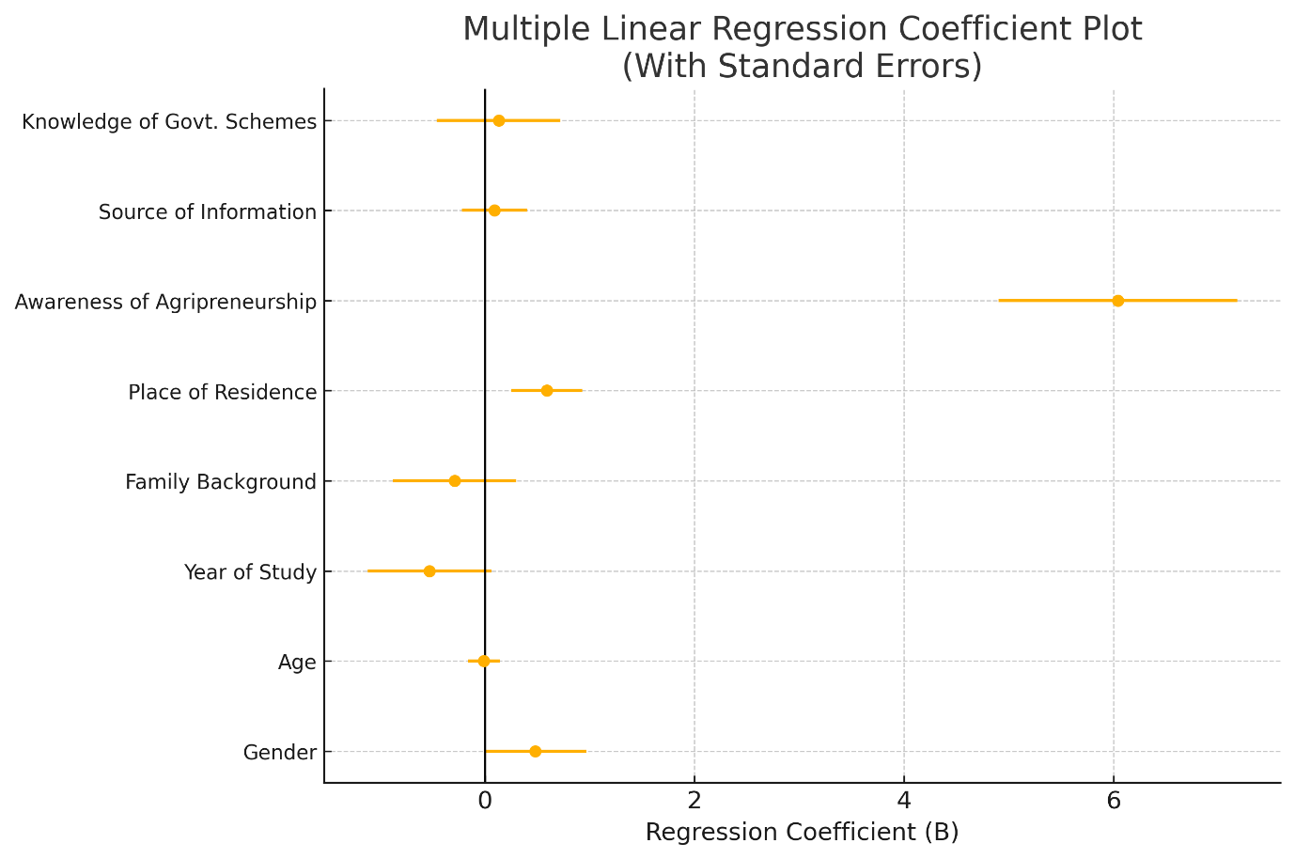
Figure 3. Forest plot showing the unstandardized regression coefficients and 95% confidence intervals for the eight predictors included in the multiple linear regression analysis. The visualization emphasizes that awareness of agripreneurship is the sole significant determinant of perception and attitude, as its confidence interval lies entirely above zero, whereas the intervals for all other predictors cross the zero line, indicating non-significance.
4. Discussion
4.1 Interpretation of Descriptive Statistics of Sample Characteristics
The sample (N = 100) is composed of young agricultural students (mean age = 20.91, SD = 2.04, range 18–25) who are largely at an early stage of professional formation. Most respondents were in early years of study (mean year = 1.39, SD = 0.49), and a majority came from agricultural households (61%; M = 1.66, SD = 0.476). Gender was slightly female-skewed (M = 1.44), and general awareness of agripreneurship was very high (92%; M = 0.83, SD = 0.378). Knowledge of government schemes was moderate (M = 1.28, SD = 0.451), while sources of information about agripreneurship varied (M = 2.61, SD = 1.41). This finding aligns with established entrepreneurship literature, which emphasizes that awareness and knowledge serve as foundational cognitive constructs for entrepreneurial intention and behavior [2][3].
For SAIRAM, these descriptors indicate a timely intervention opportunity: students are young, receptive, and frequently have some agricultural exposure but show only moderate procedural knowledge about support mechanisms. In Manipur’s wider context a state with a predominantly rural economy and limited agribusiness infrastructure the mix of agricultural family background and high concept-awareness suggests readiness for targeted capacity-building. However, moderate scheme knowledge indicates a communication gap: while students know agripreneurship exists, they may not understand how to operationalize government programs (e.g., incubation, credit linkage). Practically, SAIRAM can leverage its curricular and extension linkages to convert baseline awareness into actionable know-how by integrating practical modules, scheme walkthroughs, and local internship placements that reflect Manipur’s agro-ecological opportunities (horticulture, small-scale processing, floriculture, aquaculture).
4.2 Interpretation of Correlation Findings
The correlation analysis shows a clear pattern: demographic variables (gender r = .141, p = .162; family background r = −.053, p = .601; place of residence r = .025, p = .806) are not significantly associated with perception and attitude, whereas exposure-related variables are. Awareness of agripreneurship has a strong positive correlation with perception (r = .708, p < .001); source of information shows a moderate correlation (r = .569, p < .001); knowledge of government schemes is weak but significant (r = .236, p = .018). This contrasts with some earlier studies that emphasized demographic determinism in entrepreneurial aspirations [5].
Interpretively, these coefficients indicate that students’ cognitive exposure—knowing what agripreneurship is and where to learn about it matters far more than demographic background. For SAIRAM, this means outreach and pedagogy that improve conceptual clarity (case studies, labs, entrepreneur talks) will likely raise attitude scores more effectively than demographic-targeted measures. In Manipur, the strong r = .708 suggests state-level awareness campaigns (KVKs, college-extension partnerships, targeted social media) could shift perceptions at scale; however, the weaker r = .236 for scheme knowledge implies that simply naming schemes is insufficient communications must illustrate concrete, local examples of scheme use (e.g., small processing units in Imphal Valley) to increase perceived utility and uptake.
4.3 Interpretation of Multiple Regression Findings
The multivariate model explained substantial variance (R² = 0.523; Adjusted R² = 0.481; F(8,91)=12.43, p < .001). Critically, prior awareness was the only statistically significant predictor in the full model (B = 6.04, SE = 1.14, β = 0.70, t = 5.31, p < .001). Place of residence showed a marginal effect (B = 0.59, SE = 0.34, β = 0.16, p = .088). All other predictors gender, age, year of study, family background, source of information, and scheme knowledge were non-significant when controlling for others (p > .05).
These results imply that while multiple factors correlate with perception at the bivariate level, awareness is the proximal causal lever when other variables are controlled. For SAIRAM, this points to prioritizing structured awareness-to-skill pathways: embed agripreneurship modules early, run applied workshops that convert conceptual awareness into business planning skills, and provide mentorship to translate awareness into intention. In Manipur, given the state's small- and niche-market opportunities, policy and extension bodies should couple awareness campaigns with place-based supports (market linkages, micro-credit windows, demonstration enterprises) so that the strong effect of awareness (β = 0.70) is realized as tangible entrepreneurial activity, especially in semi-urban hubs where the marginal residence effect suggests slightly greater readiness.
5. Implications for Extension Education
These findings carry substantial implications for extension education and policy:
a) Awareness Campaigns: The dominance of awareness as a predictor suggests that large-scale awareness campaigns, whether delivered through digital media, educational institutions, extension services, or community platforms, could be transformative[6]. Extension services should consider multimedia campaigns highlighting success stories of agripreneurs, entrepreneurial pathways in agriculture, and the range of possible ventures beyond traditional farming.
b) Curriculum Integration: Agricultural educational institutions should integrate agripreneurship modules into formal curricula, moving beyond passive exposure to active engagement with entrepreneurial concepts, case studies, and practical skill-building. This institutional integration could ensure that all agricultural students gain awareness and understanding of agripreneurship.
c) Experiential Learning: Beyond classroom instruction, experiential learning opportunities—such as field visits to successful agribusinesses, entrepreneur mentorship programs, and business plan development exercises can deepen awareness and enhance its translation into entrepreneurial intention[7].
d) Targeted Interventions: Although demographic factors were non-significant, targeted programs addressing the specific informational and support needs of distinct student subgroups (e.g., first-generation agricultural learners, students from non-agricultural backgrounds transitioning to agriculture) may still be warranted to ensure inclusive reach.
e) Government Scheme Communication: The non-significance of government scheme knowledge suggests the need for more effective communication and demonstration of how these schemes translate into tangible support. Extension agents should be equipped to facilitate access to and understanding of these schemes, moving beyond pamphlet-based dissemination to personalized, problem-focused consultation.
6. Context-Specific Relevance for Manipur
Manipur’s agrarian economy, characterized by fragmented markets, limited value addition, and youth unemployment, presents both an urgent need and a fertile landscape for agripreneurship development [1]. The results highlight that while students possess high conceptual awareness, this awareness must be deepened into practical understanding to stimulate entrepreneurial action. Awareness-driven interventions are particularly critical given the state’s infrastructural constraints and emerging agribusiness niches—such as organic farming, floriculture, medicinal plants, and small-scale processing. Strengthening agripreneurship aligns directly with state development priorities, including livelihood diversification, rural enterprise promotion, and sustainable agricultural modernization [8]. SAIRAM, as a key academic institution, is positioned to serve as an agripreneurship incubation node, partnering with extension agencies, government departments, and private sector actors to deliver opportunity-driven programming. Scaling awareness through targeted communication, entrepreneurship clubs, and regional demonstration models can accelerate youth participation in agribusiness. Thus, agripreneurship promotion is not merely an educational priority but a strategic development pathway for Manipur’s rural transformation.
7. Conclusions
This study demonstrates that agripreneurship awareness is the dominant determinant of agricultural students’ perception and attitude toward agripreneurship in Manipur, far outweighing the influence of demographic or background characteristics. Although 92% of students had heard of agripreneurship, regression findings show that the quality of this awareness not simply its presence drives positive attitudes (β = 0.70, p < .001). By contrast, gender, age, year of study, family background, information sources, and knowledge of government schemes showed no significant predictive power when examined simultaneously. These results indicate that students’ entrepreneurial orientation is cognitively and informationally driven rather than demographically structured. For SAIRAM and similar institutions, this underscores an urgent need to strengthen agripreneurship-focused curricula, enhance hands-on learning opportunities, and create structured pathways for translating awareness into entrepreneurial capability. In Manipur’s broader context marked by rural unemployment and limited agribusiness diversification building strong awareness ecosystems can serve as a catalytic strategy for youth-led agricultural transformation. Overall, the findings highlight awareness-building as the most effective and scalable intervention point for agripreneurship development.
8. Key Recommendations
8.1. For Extension Education Programs:
- Develop Comprehensive Awareness Campaigns: Design and implement targeted awareness campaigns highlighting the diversity of agripreneurial opportunities, including value-added agriculture, precision farming, agricultural technology services, and agrotourism.
- Establish Agripreneurship Hubs: Create campus-based or community-based agripreneurship hubs providing mentorship, business planning support, market linkages, and access to financial resources.
- Integrate Entrepreneurship into Agricultural Curricula: Mandate inclusion of agripreneurship modules in undergraduate and postgraduate agricultural programs, with emphasis on practical skill-building and experiential learning.
- Facilitate Entrepreneur Mentorship: Connect agricultural students with successful agripreneurs for mentoring, knowledge transfer, and motivation.
- Strengthen Communication of Government Support Schemes: Conduct targeted workshops and webinars to educate students about relevant government schemes, eligibility criteria, application processes, and success stories of beneficiaries.
8.2. For Policy and Agricultural Development:
- Fund Extension Education Initiatives: Allocate dedicated funding to extension services for agripreneurship awareness campaigns and capacity-building programs.
- Create Student Entrepreneur Incentives: Develop specific incentive programs (grants, concessional credit, tax benefits) for agricultural students and recent graduates entering agripreneurship.
- Establish Market Linkages: Facilitate connections between agripreneur initiatives and markets, supply chains, and distribution networks to enhance viability and sustainability.
8.3. For Future Research:
- Longitudinal Studies: Conduct follow-up studies tracking changes in attitudes and actual entrepreneurial behavior over time.
- Qualitative Investigations: Employ qualitative methods to gain deeper understanding of how awareness translates into behavioral intention and actual entrepreneurial action.
- Intervention Evaluations: Evaluate the effectiveness of specific awareness-building interventions in changing attitudes and fostering entrepreneurial behavior.
Authors’ contributions
This work was carried out in collaboration among all authors. All authors read and approved the final manuscript.
DISCLAIMER (ARTIFICIAL INTELLIGENCE)
Author(s) hereby declare that NO generative AI technologies such as Large Language Models (ChatGPT, COPILOT, etc) and text-to-image generators have been used during writing or editing of this manuscript.
COMPETING INTERESTS
Authors have declared that no competing interests exist.

References
[1] Chungkham, D., Singh, S. R., Ram, D., & Leishangthem, B. S. (2025). Prospects of agripreneurship in Manipur, India. Journal of Scientific Research and Reports, 31(6), 1015–1032. https://doi.org/10.9734/jsrr/2025/v31i63194 .
[2] Megaladevi, P., Malini, D. H., Nagi, M. S., Kumar, S. A. S., & Muthukrishnan, B. (2024). Entrepreneurial Intentions among the Agricultural Graduates in Rural Location. In ORGANIZATION, PURPOSE, AND VALUES (1st ed., Vol. 1, pp. 456–468). Taylor & Francis. https://doi.org/10.4324/9781003501374-34 .
[3] Condor, R. (2020). Entrepreneurship in agriculture: a literature review. International Journal of Entrepreneurship and Small Business, 40(4), 516-562. https://doi.org/10.1504/ijesb.2020.10031117 .
[4] Laerkner, E., Egerod, I., & Hansen, H. P. (2015). Nurses’ experiences of caring for critically ill, non-sedated, mechanically ventilated patients in the Intensive Care Unit: A qualitative study. Intensive and Critical Care Nursing. https://doi.org/10.1016/j.iccn.2015.01.005
[5] Verheul, I., Thurik, R., Grilo, I., & Van Der Zwan, P. (2011). Explaining preferences and actual involvement in self-employment: Gender and the entrepreneurial personality. Journal of Economic Psychology, 33(2), 325–341. https://doi.org/10.1016/j.joep.2011.02.009
[6] Pan, Y., Zhang, S., & Zhang, M. (2024). The impact of entrepreneurship of farmers on agriculture and rural economic growth: Innovation-driven perspective. Innovation and Green Development, 3(1), 100093. https://doi.org/10.1016/j.igd.2023.100093
[7] Neck, H. M., & Greene, P. G. (2010). Entrepreneurship Education: Known Worlds and New Frontiers. Journal of Small Business Management, 49(1), 55–70. https://doi.org/10.1111/j.1540-627X.2010.00314.x
[8] United Nations. (2015). Transforming our world: The 2030 agenda for sustainable development. https://sdgs.un.org/publications/transforming-our-world-2030-agenda-sustainable-development-17981

