Assessing the Entrepreneurial Behaviour of Tribal Women involved in Sericulture: A Study from Dhemaji District, Assam

ABSTRACT
The study entitled “Assessing the Entrepreneurial Behaviour of Tribal Women Involved in Sericulture: A Study from Dhemaji District, Assam” was undertaken to evaluate the entrepreneurial orientation of tribal farm women engaged in sericulture activities. Sericulture, being one of the most promising agro-based enterprises in Assam, provides substantial livelihood opportunities and contributes to women’s socio-economic empowerment. The research was carried out in Dhemaji district of Assam, purposively selected for its prominence in sericulture production. A total of 120 respondents were selected through multistage random sampling across ten villages. Primary data were collected using a pre-tested structured interview schedule, and entrepreneurial behaviour was measured using a standardized scale. Analytical tools such as frequency, percentage, mean, standard deviation, Entrepreneurial Behaviour Index (EBI), and Weighted Mean Score (WMS) were employed for interpretation.The results revealed that a majority (69.17%) of the respondents exhibited a medium level of entrepreneurial behaviour, followed by 17.50 percent with low and 13.33 percent with high levels. Among the behavioural components, self-effectiveness ranked first, followed by social involvement and opportunity detection, indicating strong self-confidence and social participation among the respondents. Conversely, leadership ability and creativity ranked lowest, suggesting a need for strengthening leadership and innovative capacities through targeted interventions.The study concludes that tribal women engaged in sericulture possess considerable entrepreneurial potential, which can be harnessed through systematic training, capacity-building programmes, and institutional support. Enhancing their access to resources, credit, and market linkages would further promote sericulture as a sustainable avenue for women-led entrepreneurship and rural development in Assam.
Keywords: Sericulture, Entrepreneurial behaviour, Tribal women, Self-effectiveness, Leadership, Assam

1. INTRODUCTION
Entrepreneurship has been increasingly recognized as a vital instrument for accelerating rural development and ensuring economic self-reliance, particularly among tribal and marginalized communities. In India, where agriculture and allied activities form the backbone of the rural economy, sericulture stands out as one of the most promising agro-based industries. It not only generates substantial employment opportunities but also preserves indigenous traditions and craftsmanship (Lakhsmanan, 2012) ^{[5]}. India occupies the second position globally in raw silk production, contributing nearly 18 percent of the world’s total silk output, with four major varieties—mulberry, tasar, eri, and muga—cultivated in diverse agro-climatic regions (Bordoloi et al., 2020) ^{[1]}. Among these, Assam holds a distinctive place as the only state producing all four commercial varieties of silk, with muga and eri enjoying special cultural and economic significance.
In the tribal-dominated regions of Assam and other parts of Northeast India, sericulture serves as both a source of livelihood and a traditional heritage activity, practiced primarily by women. Tribal women actively participate in almost every stage of sericulture—ranging from mulberry cultivation and silkworm rearing to cocoon harvesting, spinning, and weaving. Their role is not limited to labour contribution; rather, they exhibit managerial and entrepreneurial traits that ensure the smooth functioning and sustainability of their enterprises (Kankanawadi et al., 2025) ^{[4]}. Through their involvement, women contribute substantially to household income, employment generation, and rural sustainability (Jyotsna et al., 2019) ^{[3]}. Entrepreneurial behaviour refers to the composite of personal, social, and economic characteristics that enable individuals to identify opportunities, take risks, innovate, and manage enterprises effectively (Chandra & Sharma, 2018) ^{[2]}. Among tribal farm women engaged in sericulture, such behaviour manifests through their decision-making abilities, leadership qualities, achievement motivation, and capacity to adapt to changing market demands. The development of entrepreneurial behaviour is, therefore, crucial for improving production efficiency, enhancing value addition, and expanding the commercial viability of sericulture enterprises (Swami et al., 2019) ^{[10]}.
Despite its potential, sericulture in tribal areas has long been viewed as a subsistence activity rather than a commercially driven enterprise. However, with the growing recognition of women’s contribution and the introduction of entrepreneurship development programmes, a gradual shift is being observed. Various government and non-government organisations have initiated interventions to strengthen women’s entrepreneurial capacity through training, skill enhancement, and access to institutional support (Reddy et al., 2020) ^{[8]}. These initiatives aim to transform tribal farm women from traditional producers into self-reliant entrepreneurs capable of managing and expanding sericulture ventures (Neehkar, 1996) ^{[7]}. In the context of Assam, where sericulture is deeply intertwined with the socio-cultural fabric of tribal life, studying the entrepreneurial behaviour of farm women becomes particularly relevant. It provides an understanding of how traditional skills and indigenous knowledge systems are being integrated with entrepreneurial initiatives to promote inclusive growth, empowerment, and sustainable rural development. Recognizing this importance, the present study has been undertaken to assess the entrepreneurial behaviour of tribal farm women engaged in sericulture, with a focus on understanding their role in strengthening rural livelihoods and contributing to the overall development of the sericulture sector.
2. METHODOLOGY
The study was conducted in Dhemaji district of Assam, which was selected purposively for the research as it is one of the major sericulture-producing districts of the state. A total of ten villages were chosen through random sampling, and from each village, twelve respondents were randomly selected, constituting a total sample size of 120 tribal farm women engaged in sericulture. The respondents were identified following a multistage sampling procedure. Data were collected through personal interviews using a pre-tested structured schedule. To measure the entrepreneurial behaviour of the respondents, the scale developed by (Schmidt et al.,2018)^{[9]}; modified by (Nandini et al.,2020)^{[6]}; and retested by the researcher was employed. For the analysis of data, statistical tools such as frequency, percentage, mean, standard deviation, Entrepreneurial Behaviour Index (EBI), and Weighted Mean Score (WMS) were used to interpret and draw meaningful conclusions.
EBI (Entrepreneurial Behaviour Index)
$EBI=\frac{Entrepreneurial behaviour score obtained}{Max obtainable entrepreneurial behaviour score }$x 100

WMS (Weighted Mean Score)
WMS$=\frac{Sum of product of frequency and score assigned}{Total no. of respondents}$
3. RESULTS AND DISCUSSION
From Table 1, it is evident that most respondents (69.17%) exhibited a medium level of entrepreneurial behaviour, followed by 17.50% with a low level and only 13.33% with a high level of entrepreneurial behaviour. These results suggest a favourable potential for entrepreneurial growth among tribal women engaged in sericulture. Although the majority demonstrate a moderate level of entrepreneurship, there remains room to uplift those with lower levels and to further strengthen the capabilities of the high achievers. Implementing structured training programmes, capacity-building initiatives, and institutional support can greatly contribute to enhancing the entrepreneurial environment in the area.
Table 1 - Distribution of respondents according to their entrepreneurial behaviour
Sl No | Category | Range | Frequency | Percentage | Mean | SD
1 | Low | Below 75.1 | 21 | 17.50
2 | Medium | 75.1-91.9 | 83 | 69.17 | 83.5 | 8.4
3 | High | Above 91.9 | 16 | 13.33
 | Total |  | 120 | 100

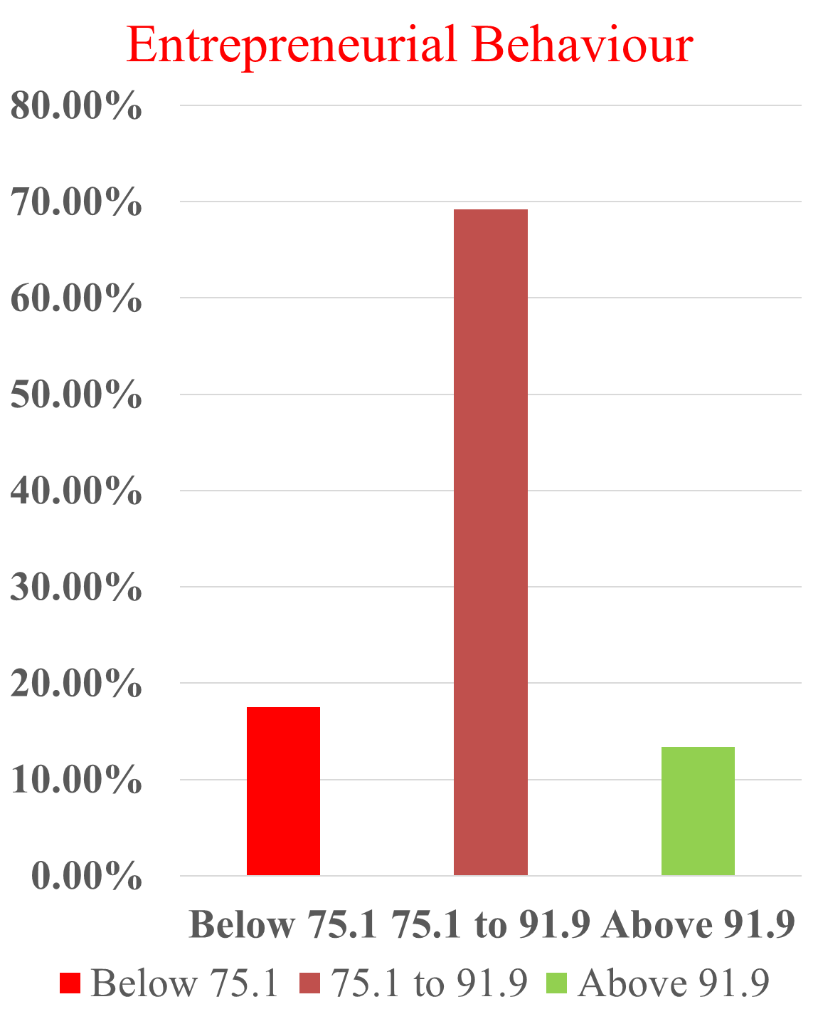

Fig 1 - Distribution of respondents according to their entrepreneurial behaviour

Table 2 - Distribution of respondents according to their total entrepreneurial behaviour score (EBS), entrepreneurial behaviour index (EBI), Weightage mean score (WMS) and rank.
Sl no | Items | EBS | EBI | WMS | Rank
A | SELF-EFFECTIVENESS
1 | I believe that I have the capacity to make sericulture entrepreneurship profitable | 688 | 81.90 | 5.7 | I
2 | I am sure that I am competent enough to be a successful entrepreneur | 629 | 74.88 | 5.2 | II
3 | I am capable of trying different practices in sericulture farming | 562 | 66.90 | 4.68 | III
B | OPPORTUNITIES DETECTOR
1 | I always observe other sericulture farmers search for opportunity to  learn things | 556 | 66.19 | 4.63 | I
2 | I frequently look for improved  varieties & technologies to increase the business profit | 536 | 63.80 | 4.46 | II
3 | I frequently seek for different rearing practices that brings higher profit in  short period | 486 | 57.85 | 4.05 | III
C | SOCIAL INVOLVEMENT
1 | I have frequent contact with other sericulture farmers | 720 | 85.71 | 6.00 | I
2 | I have involved in sericulture self-help group activity. | 532 | 63.33 | 4.43 | II
3 | I often attend training program & field tour | 428 | 50.95 | 3.56 | III
D | PLANING ABILITY
1 | I plan in advance about the period of chemical disinfection to rearing sheds | 624 | 74.28 | 5.2 | I
2 | I always plan in advance about the time period to procure worms suiting to the mulberry growth | 482 | 57.38 | 4.01 | II
3 | I frequently faced issues regarding  cultivation and rearing practices that had planned earlier | 475 | 56.54 | 3.91 | III
E | RISK BEARING ABILITY
1 | I have experienced economic loss due to pest & disease attack | 490 | 58.33 | 4.08 | I
2 | I would like to adopt completely new method for silkworm rearing that  involves certain kind of risk | 480 | 57.14 | 4.00 | II
3 | I frequently faced with profit loss due to price decline / price fluctuation | 478 | 56.90 | 3.98 | III
F | LEADERSHIP ABILITY
1 | Other sericulture farmers approach  me for my guidance on sericulture rearing | 416 | 49.52 | 3.46 | I
2 | I often assign sericulture activities to family members and labors only | 396 | 47.14 | 3.3 | II
3 | I have been chosen as leader for sericulture Self-help group | 255 | 30.35 | 2.12 | III
G | CREATIVITY
1 | I always practice different rearing  method than other sericulture farmers | 422 | 50.23 | 3.51 | I
2 | I frequently do experiments with new ideas in sericulture enterprise | 420 | 50 | 3.50 | II
3 | I repeatedly change the way of sericulture cultivation to obtain more yield. | 380 | 45.23 | 3.16 | III

Self-effectiveness
The highest-ranked in this component, with a WMS of 5.7, was "I believe that I have the capacity to make sericulture entrepreneurship profitable." This strong score reflected a high level of confidence among the respondents in their ability to generate income from sericulture. It suggested that they viewed profitability as a core strength and key motivator in pursuing sericulture-based entrepreneurship. This positive outlook likely played a significant role in strengthening their commitment to entrepreneurial activities in the sector.
In contrast, the lowest-ranked achieved, with a WMS of 4.68 and ranked third, was the statement "I am capable of trying different practices in sericulture farming." This score indicated that while respondents generally held a positive perception of their ability to experiment with various sericulture practices, there remained a degree of caution or uncertainty in adopting new or innovative techniques. This hesitation may have been influenced by limited access to technical knowledge, fear of failure, or insufficient institutional support.
Opportunities detector
In the opportunities detector, the highest-ranked, with a WMS of 4.63, was "I always observe other sericulture farmers and search for opportunities to learn things." This reflected a strong inclination among respondents to learn from peer experiences and remain observant of successful practices within their community. Such behavior demonstrated a growth-oriented mindset and a readiness to adapt, which are crucial traits for entrepreneurial success. It also suggested that experiential learning and peer observation were important channels for knowledge acquisition in sericulture entrepreneurship.
In this aspect, the lowest-ranked, with a WMS of 4.05 and ranked third, was the statement "I frequently seek for different rearing practices that bring higher profit in a short period." This score indicated that although respondents showed some interest in profit-maximizing techniques, they were relatively less proactive in experimenting with short-term high-gain methods. This may have been due to a preference for stability over risk, or a lack of access to information and training about alternative rearing practices.
Social involvement
The most positively perceived statement, ranked first with a Weighted Mean Score (WMS) of 6.00, was "I have frequent contact with other sericulture farmers." This indicated that strong peer-to-peer interaction played a key role in their entrepreneurial journey. Regular communication with fellow farmers likely helped in knowledge exchange, problem-solving, and motivation, reinforcing their sense of community and shared purpose in sericulture. On the other hand, the lowest score within this aspect, with a WMS of 3.56 and ranked third, was for the statement "I often attend training programs and field tours." This pointed to relatively limited participation in formal learning or exposure visits. Such low involvement may have resulted from barriers such as time constraints, lack of awareness, logistical challenges, or insufficient institutional support. Despite the value of such activities in enhancing skills and knowledge, they appeared underutilized by the respondents.
Planning ability
In planning ability, the highest-ranked statement, with a WMS of 5.20, was "I plan in advance about the period of chemical disinfection to rearing sheds." This highlighted the respondents' strong awareness of the importance of timely disinfection-a crucial practice in sericulture that directly impacts larval health and cocoon yield. Planning ahead for shed sanitation likely helped prevent disease outbreaks and contributed to maintaining a hygienic rearing environment.
At the other end, the lowest-ranked statement, with a WMS of 3.91 and ranked third, was "I frequently faced issues regarding cultivation and rearing practices that had been planned earlier." This suggested that despite efforts to plan, respondents often encountered unforeseen challenges in both host plant cultivation and silkworm rearing. These difficulties could have stemmed from climatic unpredictability, pest infestations, or input availability mismatches. Such issues reflect the dynamic and risk-prone nature of sericulture, where even well-intentioned plans can be disrupted without adequate support systems and contingency measures.
Risk bearing ability
The top-ranked statement, with a WMS of 4.08, was "I have experienced economic loss due to pest and disease attack." This score indicated that economic setbacks from biotic stress were a common reality for many sericulture rearers. In sericulture, where silkworms are highly sensitive to environmental changes and hygiene lapses, pest and disease outbreaks could severely impact cocoon yield, underscoring the high-risk nature of the activity.
On the other hand, the lowest-ranked statement, with a WMS of 3.98 and ranked third, was "I frequently faced profit loss due to price decline/price fluctuation." Although price instability affected earnings, it appeared to be slightly less pressing than biological threats. This may suggest that respondents had either adapted to market fluctuations or had fewer expectations of price consistency. Nevertheless, it reflected the vulnerability of sericulture farmers to external economic forces, where unstable market conditions could erode income despite consistent production efforts.

Leadership ability
The highest-ranked statement in this aspect, with a WMS of 3.46, was "Other sericulture farmers approached me for my guidance on sericulture rearing." This suggested that some respondents were recognized as informal leaders or experienced practitioners within their communities. Their knowledge and practical insights likely made them valuable sources of guidance, contributing to the collective learning within the sericulture ecosystem.
In contrast, the lowest-ranked statement, "I have been chosen as leader for sericulture Self-help group," received a WMS of 2.12 and was ranked third. This indicated limited formal leadership roles among the respondents. Despite possessing practical experience, many were not in officially recognized positions of authority. This gap may have stemmed from social norms, lack of confidence, or structural barriers that restricted women’s active leadership in organized sericulture groups.
Creativity
Creativity in sericulture was reflected through experimentation, innovation, and the willingness to deviate from conventional practices in pursuit of better results. The highest-rank perceived in this category, with a WMS of 3.51, was "I always practiced different rearing methods than other sericulture farmers." This indicated that some respondents displayed a strong sense of originality and independence in their approach. By exploring alternative rearing methods, they likely aimed to improve efficiency or adapt to specific environmental or resource constraints.
In contrast, the lowest-ranked belief, "I repeatedly changed the way of sericulture cultivation to obtain more yield," received a WMS of 3.16. This relatively lower score pointed to some hesitation or inconsistency in adopting new cultivation strategies. It may have stemmed from a lack of resources, fear of failure, or limited technical support. While the intention to improve yield was evident, continuous change in practices may have been seen as risky or impractical without proven results.

Table 3 - Distribution of components according to their overall ranking of entrepreneurial behaviour of tribal farm women engaged in sericulture
Sl No | Category | Mean score | Rank
A | Self-effectiveness | 5.01 | I
B | Opportunities detector | 4.2 | III
C | Social involvement | 4.52 | II
D | Planning ability | 4.18 | IV
E | Risk bearing ability | 3.83 | V
F | Leadership ability | 2.8 | VII
G | Creativity | 3.2 | VI

- Self-effectiveness (Mean: 5.01, Rank I): This was the most dominant trait, indicating that the respondents believe strongly in their own abilities, decision-making power, and capacity to complete tasks effectively. It suggests high confidence and self-reliance among the women, which forms the foundation of entrepreneurial success.
- Social involvement (Mean: 4.52, Rank II): The women demonstrate active participation in social and community networks, which can be vital for accessing resources, support, and collaborative opportunities. It reflects a socially aware and community-oriented mindset.
- Opportunities detector (Mean: 4.2, Rank III): The ability to identify and seize new opportunities is moderately high. This shows that women are open to exploring new ventures or markets but may require more exposure and encouragement to take initiative consistently.
- Planning ability (Mean: 4.18, Rank IV): Respondents show moderate planning skills, which is essential for setting goals, organizing resources, and managing time. The close score with opportunity detection indicates room for improvement in forward-thinking strategies.
- Risk bearing ability (Mean: 3.83, Rank V): The score suggests a cautious approach to risk. While they are willing to take some calculated risks, fear of failure or financial insecurity might limit more adventurous steps.
- Creativity (Mean: 3.2, Rank VI): Creativity scores are relatively low, indicating that innovation in practices or products is not yet a strong area. This could be due to limited training, exposure, or confidence in deviating from traditional methods.
- Leadership ability (Mean: 2.8, Rank VII): This is the least exhibited trait, implying that fewer women are taking on leadership roles or initiating change within their communities or enterprises. This might reflect cultural norms, lack of empowerment, or limited experience in decision-making roles.

4. CONCLUSION
The study revealed that a majority of the tribal farm women engaged in sericulture in Dhemaji district exhibited a medium level of entrepreneurial behaviour, indicating considerable potential for further development. Among the various components assessed, self-effectiveness emerged as the most dominant trait, reflecting the women’s strong confidence and determination to make sericulture a profitable enterprise. This was followed by social involvement and opportunity detection, which demonstrate their willingness to engage with peers and explore new ideas. However, relatively lower scores in leadership ability and creativity highlight areas that require focused attention and institutional support.
The findings suggest that while the respondents possess basic entrepreneurial traits, they need enhanced exposure, technical training, and access to credit and market linkages to translate their potential into sustained entrepreneurial success. Encouraging participation in self-help groups, leadership training, and innovative practices could empower these women to take more active roles in enterprise management and community decision-making.
Overall, the study underscores that sericulture has immense potential as a tool for economic empowerment and sustainable rural development among tribal women. With targeted interventions—such as capacity-building programs, technology dissemination, and supportive policies—these women can transform from traditional practitioners into dynamic entrepreneurs, contributing significantly to both household income and the regional silk economy of Assam.

REFERENCES
Bordoloi, R., Dutta, P., & Das, P. (2020). Role of women in sustainable sericulture development in Assam. Indian Journal of Extension Education, 56(4), 95–99.
Chandra, S., & Sharma, N. (2018). Entrepreneurial behaviour of rural women in agriculture and allied sectors. Journal of Entrepreneurship and Innovation Management, 4(1), 33–41.
Jyotsna, M., Patil, S. S., & Devi, L. (2019). Health and occupational hazards among women sericulture workers. Journal of Rural Development, 38(3), 412–419.
Kankanawadi, D. B., Kulkarni, R. R., & Pawar, R. S. (2025). Socio-economic impact of women’s participation in sericulture: A case study from Karnataka. International Journal of Agricultural Sciences, 15(2), 221–229.
Lakhsmanan, S. (2012). Sericulture in India: A review of progress and prospects. Indian Silk, 51(9), 5–10.
Nandhini, S., Rohini, A., Murugananthi, D., & Anandhi, V. (2020). Entrepreneurial behavior of sericulture farmers in Tamil Nadu. Current Journal of Applied Science and Technology, 39(28), 12-20. https://doi.org/10.9734/cjast/2020/v39i2830934
Neehkar, N. (1996). Women in sericulture: Issues and opportunities. Indian Journal of Social Work, 57(3), 351–359.
Reddy, G. S., Kumar, P. R., & Rao, M. (2020). Entrepreneurship development among women through sericulture enterprises. Journal of Rural Entrepreneurship, 6(2), 72–80.
Schmidt, S., Bohnenberger, M. C., Panizzon, M., Marcon, S. R. A., Toivonen, E., & Lampinen, M. (2018). Students entrepreneurial behaviour: An eight-construct scale validation. International Journal of Entrepreneurship, 22(2), 1-20. https://www.abacademies.org/articles/students-entrepreneurial-behaviour-an-eightconstruct-scale-validation-7254.html
Swami, H. M., Mehta, P., & Singh, S. (2019). Socio-cultural barriers to women entrepreneurship in rural India. Journal of Extension and Rural Studies, 45(2), 167–174.

