Original Research Article

Morphological Diversity and Multivariate Classification of Chile de Árbol Collections from Northern Mexico

ABSTRACT

The objective of this study was to characterize the morphological variability of chile de árbol collections from the regions of Chihuahua and Sinaloa and to evaluate their potential for use in breeding programs. Fourteen quantitative morphological traits were analyzed, including plant height (AP), plant width (ANP), first bifurcation height (APB), stem diameter (DT), mature leaf width and length (AHM and LHM), corolla length (LC), fruit length and width (LF and AF), fruit pedicel length (LP), fruit wall thickness (EPF), number of fruits per plant (NF), total fresh weight (PF), and average fruit weight (PPF), following IPGRI descriptors. Morphological data were examined through ANOVA, principal component analysis, and hierarchical clustering using R software. The ANOVA results revealed highly significant differences for most variables, evidencing substantial phenotypic variation among the collections. The principal component analysis explained 64.7% of the total variation through three components associated with plant growth and reproductive structure (PC1), fruit characteristics (PC2), and leaf traits (PC3). The biplot further distinguished three functional groups of collections aligned with fruit number, vegetative vigor, and fruit size attributes. Consistently, the clustering method separated the 20 collections into four morphologically distinct groups. Overall, these findings demonstrate considerable variability within the germplasm and underscore the value of local materials as strategic resources for chile de árbol breeding.

Keywords: Morphological characters, principal component analysis, cluster analysis, descriptors, diversity

1. INTRODUCTION
The origin of Capsicum annuum L. peppers is in the tropical and subtropical regions of the Americas, particularly in Mesoamerica (Luna-Ruiz et al., 2018). Their domestication occurred in pre-Columbian times, with archaeological evidence indicating selection processes in Mexico and parts of Central America more than 6,000 years ago (Perry et al., 2007; Chiou et al., 2024). Within the genus Capsicum, five domesticated species are recognized: C. annuum, C. baccatum, C. chinense, C. frutescens, and C. pubescens (Walsh & Hoot, 2001; McCoy et al., 2023), with C. annuum being the most widely cultivated worldwide (Bobadilla-Larios et al., 2017).

In Mexico, chile peppers are an emblematic agricultural product of great cultural and economic importance (Aguilar-Meléndez et al., 2021). Their consumption is diverse; they can be eaten fresh, cooked, or used as a condiment, and their agro-industrial value lies in the production of a wide range of products such as frozen, dehydrated, pickled, and canned chiles (Colque et al., 2021). In the specific case of chile de árbol, the main producing states are Jalisco, San Luis Potosí, Hidalgo, Zacatecas, and Chihuahua (SIAP, 2024).

In these regions, wide morphological variations in the fruit have been documented, expressed as differences in shape, color, size, texture, aroma, and pungency. Such variations reflect the different natural and artificial selection pressures to which local populations have been exposed (Walsh & Hoot, 2001; Rêgo et al., 2011). Morphological characterization is a fundamental tool in breeding programs, as it allows the selection and grouping of outstanding genotypes in terms of quality, disease resistance, and yield (Quevedo & Laurentin, 2020).

The improvement of chile de árbol has been driven largely by empirical selection carried out by farmers themselves, generating materials with high genetic variability. However, this variability has not been fully characterized, which represents an important opportunity to establish formal breeding strategies in the medium and long term. Therefore, the objective of this study was to characterize the morphological variability of chile de árbol collections from the regions of Chihuahua and Sinaloa and to evaluate their potential for use in breeding programs.

2. materialS and methods

Plant material

The chile de árbol seeds were obtained from a selection derived from a collection made in the regions of Villa López and Valle de Allende in Chihuahua and Escuinapa in Sinaloa (Table 1). Fruits were selected from vigorous plants with uniform, fully ripe fruits. Sowing was carried out on February 15, 2023, in 200-cell trays using a peat moss and vermiculite substrate. Transplanting was performed under greenhouse conditions on April 20, 2023, following a randomized complete block design with four replications.

Table 1. Chile de árbol collections from different regions of Chihuahua and Sinaloa.
Collection ID | Collection site | Municipality/Locality
UA1 | Rancho Blanco | Valle de Allende, Chihuahua
UA2 | Rancho Blanco | Valle de Allende, Chihuahua
UA4 | Rancho Blanco | Valle de Allende, Chihuahua
UA5 | Campana | Villa López, Chihuahua
UA6 | Campana | Villa López, Chihuahua
UA7 | Campana | Villa López, Chihuahua
UA8 | Cairo | Villa López, Chihuahua
UA9 | Cairo | Villa López, Chihuahua
UA10 | Moro | Villa López, Chihuahua
UA11 | Moro | Villa López, Chihuahua
UA12 | Moro | Villa López, Chihuahua
UA13 | Moro | Villa López, Chihuahua
UA14 | Moro | Villa López, Chihuahua
UA15 | Moro | Villa López, Chihuahua
UA16 | Moro | Villa López, Chihuahua
UA17 | Moro | Villa López, Chihuahua
UA18 | Moro | Villa López, Chihuahua
UA19 | Moro | Villa López, Chihuahua
UA20 | Isla del Bosque | Escuinapa, Sinaloa
UA21 | Isla del Bosque | Escuinapa, Sinaloa

Descriptors evaluated

Twenty genotypes derived from a selection were used. Five plants and ten fruits were evaluated according to the Capsicum descriptors of IPGRI (1995). The descriptors evaluated under greenhouse conditions were plant height (AP, m); plant width (ANP, cm); first bifurcation height (APB, cm); stem diameter (DT, cm); mature leaf width (AHM, cm); mature leaf length (LHM, cm); corolla length (LC, mm); fruit length (LF, cm); fruit width (AF, cm); fruit pedicel length (LP, mm); fruit wall thickness (EPF, cm); number of fruits per plant (NF); total fresh weight (PF, g); and average fruit weight (PPF, g).

Statistical analysis

The quantitative data on morpho-agronomic characteristics were analyzed using analysis of variance (ANOVA), and the means were calculated along with their standard errors and coefficient of variation (CV).

Principal component analysis (PCA) was performed to determine the variables that most influenced group formation, and a hierarchical cluster analysis was conducted to group the collections based on Euclidean distances using Ward’s minimum variance method (Ward, 1963).

Statistical analyses were performed using R software, employing the “Agricolae” and “Factoextra” packages for the analysis of variance and multivariate analyses (R Core Team, 2024).

3. results and discussion

The 14 morpho-agronomic traits evaluated in the 20 chile de árbol collections showed broad phenotypic variation, encompassing plant, leaf, fruit, and yield characteristics, with the corresponding values presented in Table 2. This variation has been previously reported in populations of Capsicum annuum L. and is attributed to both genetic differences and processes of domestication and local adaptation (Rodríguez-Campos, 2019).

Plant height (AP) showed average values ranging from 1.46 to 1.83 m. Collection UA11 (1.83 m) was the tallest, followed by UA13 (1.78 m), while UA20 and UA21 (1.46 and 1.47 m, respectively) had the shortest plants. This type of variation is similar to what has been observed in wild and landrace chili pepper materials, where plant vigor and height depend on the level of domestication and selection (Hernández-Verdugo et al., 1999). Plant width (ANP) ranged from 74.33 to 95.33 cm, with UA9 (95.33 cm) being the widest collection, in contrast to UA14 (74.33 cm), which had the smallest width.

The height of the first bifurcation (APB) ranged from 15.33 to 28.33 cm, with UA19 (28.33 cm) having the highest bifurcation and UA1 (15.33 cm) the lowest. Stem diameter (DT) ranged from 0.76 to 1.18 cm, with UA11 showing the thickest stem (1.18 cm), while UA14 and UA15 had the smallest values (0.76 cm). These differences reflect variation in the strength of the plant’s main stem, a trait related to mechanical support and stress tolerance (Taiz & Zeiger, 2006).

For leaf characteristics, mature leaf width (AHM) ranged from 3.52 to 4.61 cm, with UA19 (4.61 cm) having the widest leaves and UA15 (3.52 cm) the narrowest. Mature leaf length (LHM) ranged from 8.87 to 11.38 cm, with UA12 (11.38 cm) showing the longest leaves, while UA16 (8.87 cm) had the smallest value. Variation in leaf size can affect the plant’s exchange of carbon, water, and energy with its environment, influencing plant photosynthetic rates (Li et al., 2020). Corolla length (LC) ranged from 2.05 to 2.85 mm, with UA7 (2.85 mm) having the longest flowers and UA14 (2.05 mm) the smallest.

For fruit characteristics, fruit length (LF) ranged from 8.45 to 11.71 cm, with UA10 (11.71 cm) having the longest fruits and UA20 (8.45 cm) the shortest. Fruit width (AF) varied from 0.87 to 1.24 cm, with UA2 (1.24 cm) having the widest fruits and UA21 (0.87 cm) the narrowest. Fruit pedicel length (LP) ranged from 37.48 to 53.99 mm, with UA7 (53.99 mm) showing the longest pedicels and UA20 (37.48 mm) the shortest. Fruit wall thickness (EPF) ranged from 0.29 to 1.14 cm, with UA4 (1.14 cm) having the thickest fruit walls and UA15 (0.29 cm) the thinnest.

The yield characteristics showed the greatest differences among collections. The number of fruits per plant (NF) ranged from 18.00 (UA4) to 63.25 (UA15), indicating that UA15 had the highest fruit load. Total fresh weight (PF) ranged from 50.75 to 152.25 g, with UA6 (152.25 g) showing the highest yield, while UA19 presented the lowest value (50.75 g). Average fruit weight (PPF) ranged from 1.47 to 3.96 g, with UA4 and UA10 (3.96 and 3.51 g, respectively) having the heaviest individual fruits, whereas UA15 (1.47 g) had the lowest average fruit weight. The combination of NF, PF, and PPF has been widely used to select outstanding chile materials, especially in landrace and native populations (Chakrabarty & Islam, 2017).

Table 2. Morpho-agronomic characteristics of 20 chile de árbol collections from the regions of Chihuahua and Sinaloa.
 | AP | ANP | APB | DT | AHM | LHM | LC | LF | AF | LP | EPF | NF | PF | PPF
UA1 | 1.61±0.07 | 75.33±5.79 | 15.33±1.23 | 0.92±0.03 | 3.68±0.12 | 9.35±0.32 | 2.20±0.05 | 9.04±0.49 | 1.01±0.02 | 41.61±2.28 | 0.58±0.06 | 31.25±2.87 | 75.50±10.88 | 2.43±0.25
UA2 | 1.63±0.04 | 76.67±3.32 | 23.67±2.97 | 0.84±0.04 | 4.43±0.28 | 10.50±0.08 | 2.46±0.08 | 9.62±0.96 | 1.24±0.19 | 46.75±3.63 | 0.48±0.14 | 22.00±6.58 | 55.50±20.75 | 2.36±0.22
UA3 | 1.65±0.02 | 91.33±0.94 | 16.50±0.54 | 0.96±0.11 | 4.29±0.14 | 10.79±0.40 | 2.25±0.05 | 11.41±0.41 | 1.17±0.11 | 49.20±2.05 | 1.14±0.06 | 18.00±4.38 | 61.50±2.40 | 3.96±0.77
UA5 | 1.64±0.02 | 87.33±1.93 | 20.67±1.53 | 0.89±0.06 | 4.09±0.06 | 10.46±0.52 | 2.58±0.10 | 10.49±0.10 | 1.20±0.12 | 45.38±1.67 | 0.51±0.14 | 55.25±9.55 | 135.25±20.99 | 2.51±0.35
UA6 | 1.68±0.01 | 79.00±3.89 | 17.17±0.51 | 0.82±0.04 | 3.89±0.23 | 9.07±0.53 | 2.49±0.11 | 11.14±0.41 | 0.93±0.04 | 47.99±6.55 | 0.65±0.15 | 55.25±14.96 | 152.25±38.72 | 2.95±0.31
UA7 | 1.74±0.02 | 85.67±2.01 | 25.33±1.12 | 1.06±0.07 | 4.59±0.08 | 10.74±0.20 | 2.85±0.15 | 10.94±0.27 | 0.99±0.06 | 53.99±2.31 | 0.46±0.05 | 42.50±10.36 | 112.00±47.02 | 2.42±0.51
UA8 | 1.64±0.01 | 86.67±1.18 | 22.50±1.27 | 0.96±0.05 | 4.33±0.03 | 10.37±0.14 | 2.40±0.12 | 10.28±0.42 | 1.19±0.17 | 46.81±3.09 | 0.55±0.05 | 51.25±10.71 | 136.50±29.70 | 2.70±0.17
UA9 | 1.70±0.01 | 95.33±1.84 | 16.67±0.85 | 0.85±0.06 | 3.60±0.09 | 9.82±0.25 | 2.18±0.09 | 10.87±0.66 | 1.02±0.05 | 47.63±3.47 | 0.50±0.09 | 46.75±13.11 | 82.25±36.87 | 1.82±0.47
UA10 | 1.72±0.01 | 91.67±2.95 | 18.27±2.35 | 0.96±0.06 | 4.39±0.06 | 10.16±0.22 | 2.67±0.07 | 11.71±0.73 | 1.13±0.13 | 51.00±3.31 | 0.64±0.12 | 35.75±7.11 | 109.75±16.68 | 3.51±0.81
UA11 | 1.83±0.02 | 91.17±2.66 | 24.17±1.01 | 1.18±0.07 | 4.16±0.11 | 10.67±0.33 | 2.55±0.10 | 9.10±0.40 | 0.94±0.02 | 49.16±4.70 | 0.39±0.09 | 43.00±11.85 | 65.75±16.94 | 1.53±0.27
UA12 | 1.72±0.02 | 88.67±1.93 | 19.70±1.78 | 0.90±0.05 | 4.28±0.17 | 11.38±0.10 | 2.34±0.03 | 9.25±0.32 | 1.03±0.05 | 41.83±3.85 | 0.38±0.08 | 35.75±9.08 | 62.75±14.86 | 1.93±0.35
UA13 | 1.78±0.02 | 89.33±1.7 | 21.33±2.44 | 0.96±0.03 | 4.08±0.18 | 11.14±0.08 | 2.67±0.07 | 9.51±0.12 | 0.94±0.06 | 43.92±3.00 | 0.33±0.05 | 37.00±12.38 | 52.00±20.94 | 1.61±0.33
UA14 | 1.75±0.05 | 74.33±2.78 | 23.17±0.92 | 0.76±0.02 | 4.28±0.23 | 10.16±0.45 | 2.05±0.01 | 11.10±0.54 | 1.13±0.07 | 44.22±1.69 | 0.49±0.07 | 32.50±6.85 | 86.53±20.53 | 2.66±0.28
UA15 | 1.63±0.03 | 79.5±3.37 | 20.67±0.42 | 0.76±0.05 | 3.52±0.19 | 9.37±0.40 | 2.26±0.10 | 10.50±0.19 | 0.99±0.04 | 43.88±2.04 | 0.29±0.05 | 63.25±22.57 | 72.25±19.56 | 1.47±0.45
UA16 | 1.70±0.06 | 81.5±0.74 | 21.67±1.53 | 0.82±0.03 | 3.69±0.36 | 8.87±1.03 | 2.52±0.15 | 10.34±0.67 | 1.01±0.12 | 47.56±4.49 | 0.57±0.08 | 47.25±15.91 | 108.00±44.84 | 2.36±0.41
UA17 | 1.65±0.05 | 86.67±1.31 | 22.50±1.06 | 0.77±0.02 | 3.98±0.21 | 9.91±0.33 | 2.28±0.17 | 10.70±0.22 | 0.96±0.04 | 47.36±0.34 | 0.46±0.09 | 55.00±8.38 | 83.00±3.34 | 1.62±0.26
UA18 | 1.60±0.07 | 79.5±2.67 | 18.83±2.37 | 0.94±0.04 | 3.95±0.06 | 9.86±0.32 | 2.17±0.05 | 8.95±0.43 | 0.93±0.04 | 40.74±1.67 | 0.51±0.05 | 52.25±15.10 | 133.75±62.53 | 2.24±0.43
UA19 | 1.70±0.02 | 90.33±5.48 | 28.33±0.51 | 1.06±0.15 | 4.61±0.11 | 10.43±0.37 | 2.43±0.10 | 9.67±0.23 | 0.93±0.02 | 51.43±2.07 | 0.61±0.07 | 25.50±5.32 | 50.75±9.78 | 2.01±0.05
UA20 | 1.46±0.02 | 78.67±3.92 | 21.50±0.74 | 0.92±0.05 | 4.18±0.08 | 9.36±0.14 | 2.11±0.07 | 8.45±0.68 | 1.13±0.06 | 37.48±0.63 | 0.47±0.08 | 47.00±12.18 | 100.25±33.03 | 2.22±0.38
UA21 | 1.47±0.03 | 76.00±2.94 | 21.50±0.20 | 0.85±0.06 | 4.48±0.09 | 10.37±0.38 | 2.19±0.20 | 10.14±0.35 | 0.87±0.03 | 47.72±1.56 | 0.52±0.09 | 30.75±4.37 | 53.00±14.04 | 1.76±0.37
Mean | 1.66 | 84.23 | 20.97 | 0.91 | 4.12 | 10.14 | 2.38 | 10.16 | 1.04 | 46.28 | 0.53 | 41.36 | 89.43 | 2.30
CV % | 4.38 | 7.09 | 14.05 | 13.48 | 8.07 | 7.71 | 8.71 | 9.50 | 2.70 | 13.30 | 33.45 | 54.17 | 63.83 | 35.66
df | 19 | 19 | 19 | 19 | 19 | 19 | 19 | 19 | 19 | 19 | 19 | 19 | 19 | 19
P value | < 0.001 | < 0.001 | < 0.001 | < 0.001 | < 0.001 | < 0.001 | < 0.001 | < 0.001 | 0.092 | 0.067 | < 0.001 | 0.271 | 0.239 | < 0.001
Means (± standard error); coefficient of variation (CV, %); degrees of freedom (df); plant height (AP, m); plant width (ANP, cm); first bifurcation height (APB, cm); stem diameter (DT, cm); mature leaf width (AHM, cm); mature leaf length (LHM, cm); corolla length (LC, mm); fruit length (LF, cm); fruit width (AF, cm); fruit pedicel length (LP, mm); fruit wall thickness (EPF, cm); number of fruits per plant (NF); total fresh weight (PF, g); average fruit weight (PPF, g).

Principal component analysis

In the principal component analysis (PCA), the variation of 14 morphological characteristics of chile de árbol was evaluated, resulting in three principal components that explained 64.7% of the total variance (Table 3). Previous studies have shown that principal components can explain a significant portion of total morphological variation, ranging from 42.55% to 79.3% (Gutiérrez-Burón et al., 2020; García, 2021; Bran et al., 2023).
The first three principal components accounted for most of the total variation. Principal Component 1 (PC1) explained 28.2% of the variance and was associated with plant height, plant width, corolla length, and fruit pedicel length, which are characteristics related to plant growth and reproductive structure. PC2 explained 20.9% of the variance and was associated with average fruit weight, fruit wall thickness, and fruit length, which are fruit-related characteristics. PC3 accounted for 15.6% of the total variance and was associated with mature leaf width and mature leaf length, which are characteristics related to plant foliage.

Table 3. Eigenvectors and eigenvalues of the principal components for 20 chile de árbol collections from Chihuahua and Sinaloa.
Variables | PC1 | PC2 | PC3
AP | 0.8 | -0.1 | 0.0
ANP | 0.7 | 0.1 | 0.1
APB | 0.3 | -0.4 | 0.4
DT | 0.5 | -0.1 | 0.5
AHM | 0.3 | 0.2 | 0.8
LHM | 0.4 | -0.1 | 0.7
LC | 0.8 | 0.0 | 0.0
LF | 0.4 | 0.7 | -0.3
AF | -0.1 | 0.6 | 0.2
LP | 0.8 | 0.3 | 0.2
EPF | 0.0 | 0.9 | 0.2
NF | 0.1 | -0.3 | -0.9
PF | 0.1 | 0.3 | -0.7
PPF | 0.1 | 1.0 | 0.1
Eigenvalue | 3.9 | 2.9 | 2.2
Explained variance (%) | 28.2 | 20.9 | 15.6
Cumulative variance (%) | 28.2 | 49.0 | 64.7
PC = Principal Component 1, 2, and 3. Plant height (AP, m); plant width (ANP, cm); first bifurcation height (APB, cm); stem diameter (DT, cm); mature leaf width (AHM, cm); mature leaf length (LHM, cm); corolla length (LC, mm); fruit length (LF, cm); fruit width (AF, cm); fruit pedicel length (LP, mm); fruit wall thickness (EPF, cm); number of fruits per plant (NF); total fresh weight (PF, g); average fruit weight (PPF, g).

The biplot (Figure 1) of the first two principal components (PC1 and PC2), which together explain 49.1% of the total variation, allowed visualization of the distribution of the 20 chile de árbol collections and their association with the morphological characteristics evaluated.

In the upper left quadrant, the variable number of fruits per plant (NF) was prominent, being associated with collections UA15, UA17 and UA18. These materials showed a higher productive capacity in terms of fruit load.

In contrast, the upper right quadrant was defined by variables associated with plant vigor, including first bifurcation height and stem diameter (APB, DT), plant height and plant width (AP, ANP), corolla length (LC), and mature leaf length and width (LHM, AHM). In this region, collections UA7, UA19, UA11, UA12 and UA13 were grouped, characterized by vegetative development.

On the other hand, the lower right quadrant grouped variables related to fruit size and physical characteristics, such as fruit length (LF), fruit wall thickness (EPF), fruit width (AF), and average fruit weight (PPF). These variables were mainly associated with collections UA10 and UA4, which had longer, thicker, and heavier fruits. Finally, the lower left quadrant grouped collections UA6, UA14, UA5, and UA8, which were positioned opposite to the components associated with fruit size and weight, suggesting materials with smaller fruits or lower structural development.

Overall, the biplot allowed the identification of three functional groups of collections: (i) materials associated with fruit number (NF), (ii) materials associated with vegetative vigor (APB, DT, AP, ANP), and (iii) materials associated with fruit size (LF, EPF, PPF). This multivariate differentiation provides a solid basis for selecting outstanding materials in chile de árbol breeding programs.

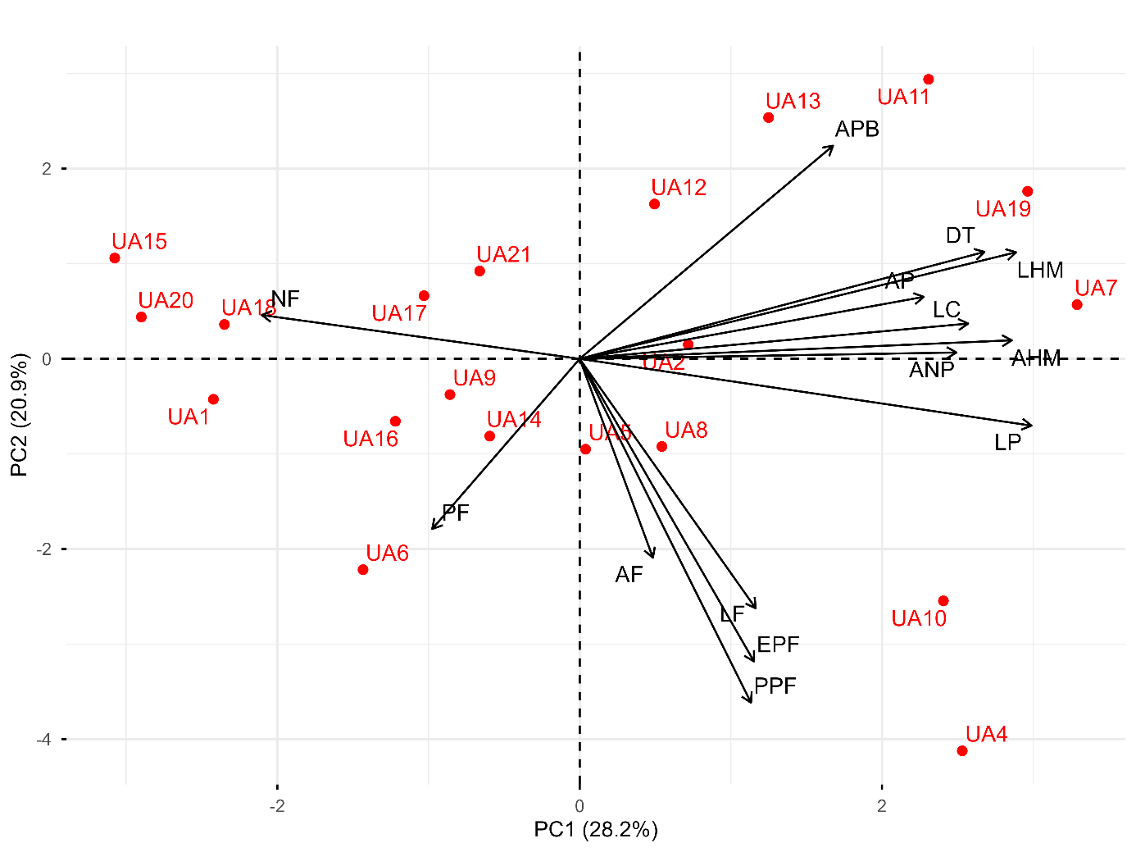
Figure 1. Multivariate distribution of 20 chile de árbol collections based on 14 morpho-agronomic characteristics, using the first two principal components in Chihuahua and Sinaloa.

Cluster analysis

The cluster analysis grouped the 20 chile de árbol collections into four morphologically distinct groups (Figure 2). Similarly, Toledo-Aguilar et al. (2016) identified four different morphological groups in their studies on poblano peppers. Group I included collections UA6, UA16, UA9, UA15, and UA17, characterized by a total fresh weight of 99.6 g. Group II consisted of collections UA1, UA18, UA20, UA21, UA2, and UA14, which were associated with the number of fruits per plant, with an average of 36.0. Group III was composed of collections UA12, UA13, UA11, and UA19, characterized by a first bifurcation height of 23.4 cm. Group IV included collections UA4, UA5, UA8, UA7, and UA10, which were characterized by an average fruit weight of 3.0 g and a fruit wall thickness of 0.66 mm. These analyses provide a detailed understanding of the broad morphological and genetic variability present in chile populations, highlighting the importance of native germplasm in breeding and conservation programs (Leyva et al., 2018).
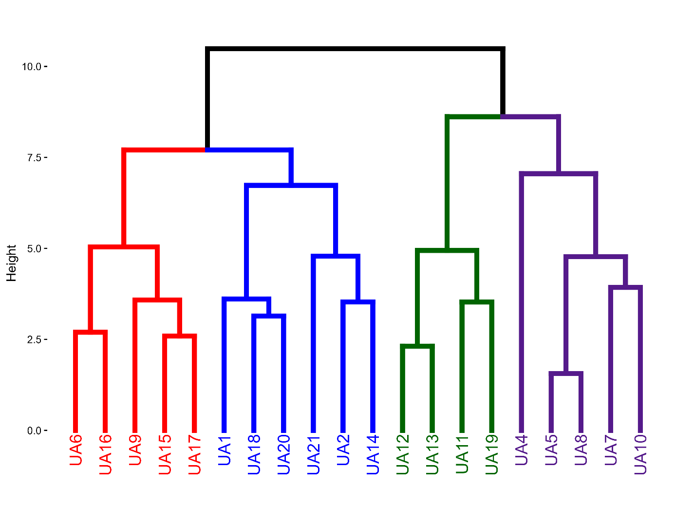
Figure 2. Dendrogram of 20 chile de árbol collections from Chihuahua and Sinaloa based on morpho-agronomic characteristics.

4. Conclusion
The analysis of the morpho-agronomic variability of chile de árbol from the regions of Chihuahua and Sinaloa reveals broad diversity in the characteristics evaluated. The results of the principal component analysis and cluster analysis show that it is possible to identify and group genotypes with distinct characteristics that could be used in breeding programs.

DISCLAIMER (ARTIFICIAL INTELLIGENCE)
Generative AI tools were used only to assist with language editing and formatting. All study design, data analysis, interpretation, and scientific content are the sole responsibility of the authors.

References
Aguilar-Meléndez, A., Vásquez-Dávila, M. A., Manzanero-Medina, G. I., & Katz, E. (2021). Chile (Capsicum spp.) as Food-Medicine Continuum in Multiethnic Mexico. Foods. https://doi.org/10.3390/foods10102502
Bobadilla-Larios, V., Esparza-Ibarra, E., Delgadillo-Ruiz, L., Gallegos-Flores, P., & Ayala-Lujan, J. L. (2017). Variedades de chile (Capsicum annuum L.) identificadas mediante marcadores RAPD. Tropical and Subtropical Agroecosystems, 20(3), 465-473. https://doi.org/10.56369/tsaes.2419
Bran, R. A. A., Castillo, B. Z., Astudillo, E. A., & Morales, C. J. M. (2023). Análisis de la variabilidad morfológica ex situ del chile miraparriba (Capsicum spp.). South Florida Journal of Development, 4(2), 761-772. https://doi.org/10.46932/sfjdv4n2-011
Chakrabarty, S., & Islam, A. A. (2017). Selection criteria for improving yield in chili (Capsicum annuum). Advances in Agriculture, 2017(1), 5437870. https://doi.org/10.1155/2017/5437870
Chiou, K. L., Lira-Noriega, A., Gallaga, E., Hastorf, C. A., & Aguilar-Meléndez, A. (2024). Interdisciplinary insights into the cultural and chronological context of chili pepper (Capsicum annuum var. annuum L.) domestication in Mexico. Proceedings of the National Academy of Sciences of the United States of America, 121(47), e2413764121. https://doi.org/10.1073/pnas.2413764121
Colque, X. R., Alba, T. A., & Siles, A. C. (2021). Los ajíes nativos y su potencial agroindustrial. Journal Boliviano de Ciencias, 17(Especial), 53-62. https://doi.org/10.52428/20758944.v17iEspecial.6
Garcia, A. R. (2021). Caracterización morfológica in situ de chiles (Capsicum spp.) silvestres y cultivados en la región Usumacinta, Tabasco. Kuxulkab', 27(58), 49-57. https://doi.org/10.19136/kuxulkab.a27n58.3959
Gutiérrez-Burón, R., Latournerie-Moreno, L., Garruña-Hernández, R., Ruiz-Sánchez, E., Lara-Martín, A. R., & Castañón-Nájera, G. (2020). Diversidad fenotípica de chile Amashito de Tabasco y Chiapas, México. Revista mexicana de ciencias agrícolas, 11(3), 649-662. https://doi.org/10.29312/remexca.v11i3.2087
Hernández-Verdugo, S., Dávila, P., & Oyama, K. (1999). Síntesis del conocimiento taxonómico, origen y domesticación del género Capsicum. Botanical Sciences. https://doi.org/10.17129/botsci.1583
International Plant Genetic Resources Institute, Asian Vegetable Research and Development Center, & Centro Agronómico Tropical de Investigación y Enseñanza. (1995). Descriptors for Capsicum (Capsicum spp.). International Plant Genetic Resources Institute. http://hdl.handle.net/10568/72851
McCoy, J., Martínez-Ainsworth, N., Bernau, V., Scheppler, H., Hedblom, G., Adhikari, A., McCormick, A., Kantar, M., McHale, L., Jardón-Barbolla, L., Mercer, K. L., & Baumler, D. (2023). Population structure in diverse pepper (Capsicum spp.) accessions. BMC Research Notes, 16(1), 20. https://doi.org/10.1186/s13104-023-06293-3
Leyva, O. R., Andrés, M. P., Del Valle, H. D., Meneses, M. I., Murguía, G. J., Galindo, M. E., López, S. H., Serna, L. R., Del Rosario, A. L., Lee, E. H., Sierra, M., & Espinosa, C. A. (2018). Caracterización morfológica de poblaciones de chile manzano (Capsicum pubescens Ruiz y Pav.) en la región centro del estado de Veracruz, México. Revista Bio Ciencias, 5, e388. https://doi.org/10.15741/revbio.05.e388
Li, Y., Zou, D., Shrestha, N., Xu, X., Wang, Q., Jia, W., & Wang, Z. (2020). Spatiotemporal variation in leaf size and shape in response to climate. Journal of Plant Ecology, 13(1), 87-96. https://doi.org/10.1093/jpe/rtz053
Luna-Ruiz, J. de J., Nabhan, G. P., & Aguilar-Meléndez, A. (2018). Shifts in plant chemical defenses of Chile Pepper (Capsicum annuum L.) Due to Domestication in Mesoamerica. Frontiers in Ecology and Evolution. https://doi.org/10.3389/fevo.2018.00048
Perry, L., Dickau, R., Zarrillo, S., Holst, I., Pearsall, D. M., Piperno, D. R., Berman, M. J., Cooke, R. G., Rademaker, K., Ranere, A. J., Raymond, J. S., Sandweiss, D. H., Scaramelli, F., Tarble, K., & Zeidler, J. A. (2007). Starch fossils and the domestication and dispersal of chili peppers (Capsicum spp. L.) in the Americas. Science, 315(5814), 986–988. https://doi.org/10.1126/science.1136914
Quevedo, M., & Laurentin, H. (2020). Caracterización fenotípica de tres cultivares de ají dulce (Capsicum chinense Jacq.) venezolano. Agronomía Mesoamericana, 31(3), 729-741. https://doi.org/10.15517/am.v31i3.40302
R Core Team. (2024). R: A language and environment for statistical computing. R Foundation for Statistical Computing. https://www.R-project.org/
Rêgo, E. R., Rêgo, M. M., Matos, I. W. F., & Barbosa, L. A. (2011). Morphological and chemical characterization of fruits of Capsicum spp. accessions. Horticultura Brasileira, 29(3), 364-371. https://doi.org/10.1590/S0102-05362011000300018
Rodríguez-Campos, E. (2018). La diversidad genética de Capsicum annuum en México. In A. Aguilar-Meléndez, M. A. Vázquez-Dávila, E. Katz, & M. R. Hernández Colorado (Eds.), Los chiles que le dan sabor al mundo: contribuciones multidisciplinarias (Primera ed., pp. 52–67). Xalapa, Veracruz, México: Universidad Veracruzana. https://doi.org/10.25009/uv.2185.1087
SIAP (Servicio de Información Agroalimentaria y Pesquera). (2024). Cierre de la producción agrícola 2024. Secretaría de Agricultura y Desarrollo Rural. https://nube.siap.gob.mx/cierreagricola/
Taiz, L., & Zeiger, E. (2006). Plant physiology. 4th Edition, Sinauer Associates, Inc., Sunderland.
Toledo-Aguilar, R., López-Sánchez, H., López, P. A., Guerrero-Rodríguez, J. D. D., Santacruz-Varela, A., & Huerta-de la Peña, A. (2016). Diversidad morfológica de poblaciones nativas de chile poblano. Revista mexicana de ciencias agrícolas, 7(5), 1005-1015. https://doi.org/10.29312/remexca.v7i5.227
Walsh, B. M., & Hoot, S. B. (2001). Phylogenetic relationships of Capsicum (Solanaceae) using DNA sequences from two noncoding regions: The chloroplast atpB-rbcL spacer region and nuclear waxy introns. International Journal of Plant Sciences. https://doi.org/10.1086/323273
Ward, J. H. (1963). Hierarchical grouping to optimize an objective function. Journal of the American Statistical Association, 58(301), 236-244. https://doi.org/10.1080/01621459.1963.10500845

