Original Research Article

Identification and morphological characterisation of candidate morphotypes for reforestation with Pterocarpus erinaceus in two classified forests in northern Côte d'Ivoire

Abstract

Pterocarpus erinaceus is a species native to Africa, recognised for its high socio-economic potential. However, overexploitation has led to a reduction in its populations and the disappearance of high-performance morphotypes. The high-performance morphotypes that still exist are poorly documented, hence the interest of this study, which aims to identify and characterise them in order to provide plant material suitable for reforestation programmes. The study was conducted in the classified forests of Boundiali and La Palée. Following three (3) prospecting areas, a system of quadrats associated with transects made it possible to identify 123 morphotypes of interest out of the 865 trees listed, or 14.22%, a relatively low rate. Zone 3 has a higher density of trees of interest than zones 1 and 2, estimated at 6.43 trees of interest/ha. The trees of interest were grouped into three morphotypes. The first morphotype, composed of young trees, constitutes a genetic reservoir for future reforestation programmes. The second morphotype consists of slender individuals that may possess rare alleles inherited from large trees that have disappeared as a result of illegal logging. The third morphotype, consisting of dominant and mature trees, constitutes a seed pool and contributes to maintaining gene flow between generations.

Keywords: Pterocarpus erinaceus; Identification; Morphological characterisation; Classified forest; Côte d'Ivoire

- Introduction
According to the Forest Code in Côte d'Ivoire, Law No. 2019-675 of 23 July 2019 (Article 1) defines a forest as any area of at least 0.1 hectares in a single block, containing forest trees whose crowns cover at least 30% of the surface area and which can reach a height of at least 5 metres when mature. This vegetation formation represents a dynamic and heterogeneous environment, exerting a direct or indirect effect on the soil, climate and water regime. The natural resource potential it contains is an important source of income for local populations.
Among these resources is Pterocarpus erinaceus, a deciduous tree that can reach a height of 15 to 25 metres (Duvall, 2008). This tree is of considerable social and economic importance. Its parts have many therapeutic properties and are used in the treatment of more than sixty ailments (Ouinsavi et al., 2021). Its wood is also highly prized, particularly for the manufacture of musical instruments such as the balafon, but also as timber for making furniture (beds, tables and parquet flooring) and decorative objects (Traoré and Martinez-Cortizas, 2023; Gérard et al., 2016). In addition, its leaves are used as fodder for livestock, particularly goats and sheep (Silué et al., 2014).
P. erinaceus is found in Africa in the Guineo-Sudanese and Sudano-Sahelian zones (Arbonnier, 2004; Ouédraogo et al., 2006). In Côte d'Ivoire, according to the national forest and wildlife inventory (IFFN) carried out from 2019 to 2020, the species is widely distributed in the northern half of the country, with a high concentration from V Baoulé (from Kpouebo to Bouaké), the contact zone between the forest domain in the south and the savannah in the north (Zon et al., 2022). It is reported in several classified forests. A classified forest is known to be an area whose boundaries and use are defined by regulations.
However, the events of the Ivorian crisis from 2002 to 2010 led to a significant deterioration of these areas, marked by the violation of forest boundaries and increased illegal exploitation of resources. Between 2010 and 2016, P. erinaceus was subject to intensive exploitation, with exports to China estimated at over US$400 million in 2014 (UN, 2014; Interpol, 2016; EIA, 2022). This sustained anthropogenic pressure has caused a significant decline in the various P. erinaceus populations, characterised by a decrease in mature individuals, a reduction in natural regeneration potential and worrying genetic erosion.
In this context, it appears essential to identify morphotypes with interesting morphological traits in order to develop plant material suitable for reforestation and restoration programmes in classified forests. However, the lack of data on the morphological variability of P. erinaceus in northern Côte d'Ivoire limits the selection of high-performance reproductive material for reforestation. Hence the interest of this work, which aims to identify and characterise the morphotypes of P. erinaceus that are likely to constitute high-performance plant material for reforestation programmes. More specifically, the aim is to: (i) identify the trees with the best morphological conformations in each surveyed area with; and (ii) characterise the intra- and inter-population morphological variability that exists within this population of trees of interest.

- Materials and methods
  - Study site
The study was conducted in two classified forests located in northern Côte d'Ivoire, the Palée and Boundiali classified forests. In the Boundiali classified forest, covering an area of 78,000 hectares, two prospecting areas were inventoried (Area 1 and Area 2). In the Palée classified forest, covering an area of 45,000 hectares, one area was surveyed (Zone 3) (Figure 1). These two classified forests are located in the Bagoué region, whose capital is the town of Boundiali, located 800 kilometres from Abidjan, the economic capital of Côte d'Ivoire. The climate of the Bagoué region is Sudanese, characterised by a long dry period from October to May and a rainy season with two peak rainfall periods, in June and September (Table 1). Temperatures range from 21 to 35 °C. The landscape is dotted with inselbergs reaching heights of 421 metres, as well as plateau areas. The vegetation of Bagoué is characteristic of Sudanese zones. Tree species such as iroko (Milicia excelsa), teak (Tectona grandis) and Vène wood (Pterocarpus erinaceus) are found there (Ministry of Agriculture and Rural Development, 2021).

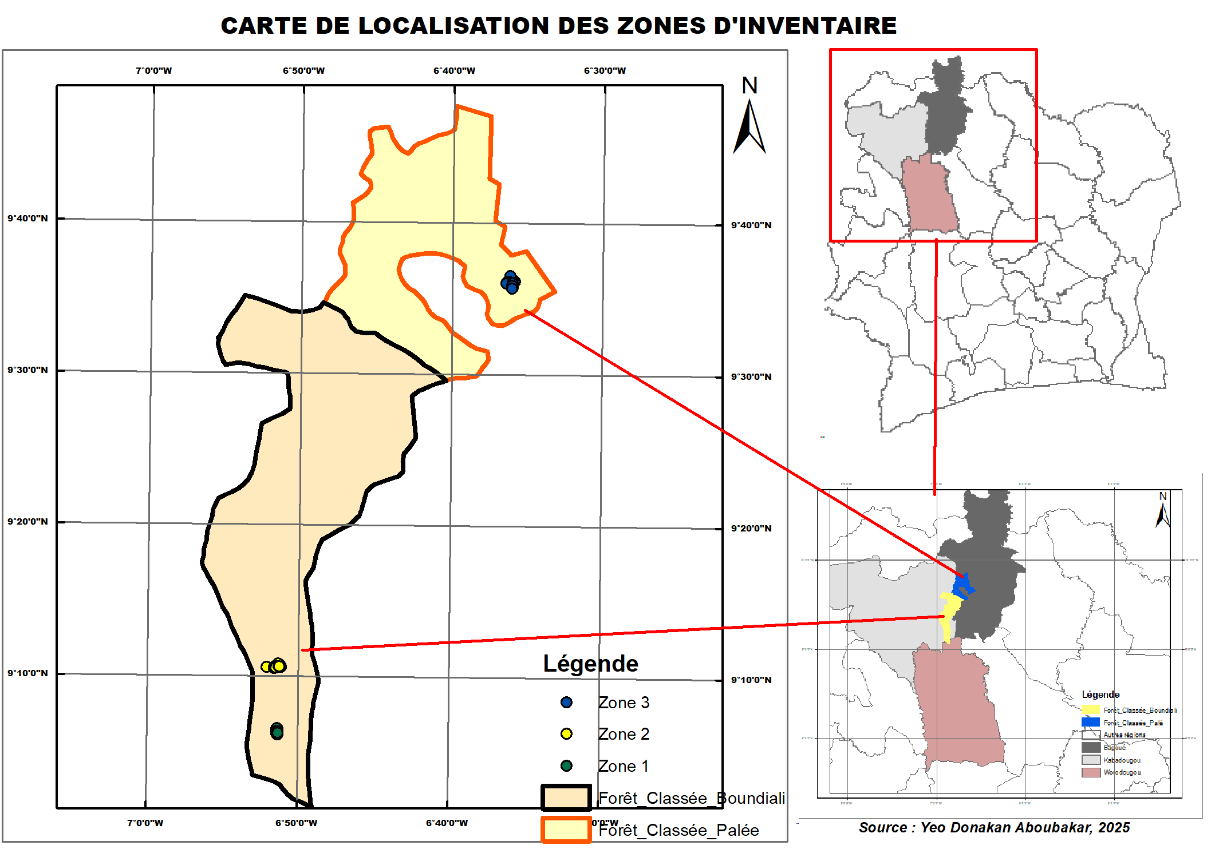
Fig.1 . Map of inventory areas

Table 1. Monthly rainfall in Boundiali from 2011 to 2020 (Source: Ministry of Agriculture and Rural Development, 2021)
Year | January | February | March | April | May | June | July | August | September | October | November | December | Total
2011 | 0 | 19.5 | 75.0 | 53.0 | 131.0 | 142.0 | 252.5 | 198.0 | 184.0 | 174.0 | 0.0 | 0 | 1,229.0
2012 | 0.0 | 8.6 | 42.8 | 140.1 | 165.8 | 136.7 | 180.1 | 319.0 | 211.6 | 108.4 | 46.7 | 41.1 | 1,400.9
2013 | 0.0 | 37.2 | 91.7 | 97.9 | 210.0 | 161.7 | 109.2 | 199.2 | 240.3 | 127.0 | 21.4 | 14.6 | 1,310.2
2014 | 0.0 | 30.8 | 66.0 | 257.1 | 168.4 | 227.9 | 87.9 | 358.9 | 255.0 | 123.1 | 134.4 | 0 | 1,709.5
2015 | 0.0 | 0.0 | 13.3 | 11.0 | 154.4 | 132.5 | 127.4 | 404.8 | 269.2 | 239.4 | 45.7 | 0.0 | 1,397.7
2016 | 31.6 | 10.2 | 18.4 | 142.9 | 126.0 | 99.6 | 290.5 | 277.3 | 186.4 | 21.9 | 27.1 | 0 | 1,231.9
2017 | 0.0 | 0.0 | 21.2 | 112.7 | 87.6 | 153.8 | 396.8 | 176.7 | 126.7 | 34.8 | 4.8 | 0 | 1,115.1
2018 | 0.8 | 30.2 | 52.6 | 85.3 | 145.5 | 265.9 | 474.5 | 236.5 | 425.4 | 180.3 | 45.7 | 0 | 1,942.8
2019 | 0.0 | 0.1 | 49.2 | 95.5 | 95.1 | 137.0 | 108.5 | 623.7 | 333.0 | 167.9 | 69.1 | 0 | 1,679.1
2020 | 0.0 | 0.5 | 95.8 | 70.9 | 121.9 | 180.6 | 300.7 | 261.3 | 133.6 | 1.3 | 0.0 | 0.0 | 1,166.6

  - Plant material
The plant material used in this study initially consisted of all mature P. erinaceus trees found in each of the areas surveyed. Subsequently, only trees with a good morphological conformation that could be of interest for exploitation were preselected.
  - Study method
    - Method for identifying and selecting morphotypes
Adult P. erinaceus trees were identified using a quadrat system combined with transects. This involved identifying wooded and accessible hilltops, from which a 100 x 200 metre mother plot was established, constituting the zero quadrat of the inventory. From this point, transects were opened in the cardinal directions (north, south, west and east), descending from the summit until a natural obstacle such as a watercourse or the flank of a new summit was encountered. Along each trail, 100 x 200 metre quadrats were laid out at regular intervals of 100 metres. In each quadrat, P. erinaceus trees were listed and then coded. Trees selected through mass selection were given the symbol "+" added to their code. This selection consisted of retaining individuals with good morphological and health characteristics. Each tree was given a score based on its straightness, which had to be as straight as possible, the appearance of its trunk and crown, and finally the absence of defects such as grooves, bumps, etc. The selected trees were subjected to morphometric measurements to characterise their morphotypes.
    - Data collection
Data collection was carried out on all the selected trees. It consisted of taking several quantitative measurements. Seven (7) main variables were measured. The total height of the tree (Hato), measured from the base of the tree to the highest point of the living crown. The height of the trunk (HTrc) and the height of the first branch of the tree (HPBrch). The diameter of the tree at 1.3 m above the ground (DTrc); determined from the circumference using the formula:
$DHoup=\frac{C}{π}$ ; where D is the diameter and C is the circumference.
The north-south (EnNS) and east-west (EnOE) spans were measured using a tape measure, which made it possible to calculate the average crown diameter (DHoup) using the formula:
$DHoup=\frac{EnNS+EnOE}{2}$
    - Data analysis
The data collected was processed using R software version 4.4.3.
First, a Chi-square test was used to compare the proportions of trees selected between the different areas. This test was followed by an analysis of variance (ANOVA) to compare the averages of the densities of trees identified and selected per area. Interpopulation diversity was assessed using the Kruskal-Wallis test at a 5% threshold. When this proved significant for each quantitative parameter, a post-hoc test was applied. These analyses were preceded by descriptive statistics on quantitative parameters such as the mean, minimum, maximum, standard deviation and coefficient of variation. The selected trees were structured using principal component analysis (PCA) to determine the variables that contribute most to morphological variability. This step was followed by ascending hierarchical classification (AHC), which allowed the trees to be grouped according to their similarity.
- Results
  - Identification and distribution of individuals of interest of Pterocarpus erinaceus
The floristic inventory carried out in the three study areas identified 865 mature P. erinaceus trees. Of these, 123 trees, or 14.22%, were identified as being of interest for reforestation programmes (Table 2). The χ² test revealed a significant difference in the proportions of trees of interest and 'simple' trees in the three areas (p<0.001). In zone 1 of the Boundiali classified forest, the proportion of trees of interest is 9.68% (CI = [0.05; 0.18]), while in zone 2 it is 6.54% (CI = [0.04; 0.10]). The confidence intervals (CI) for zones 1 and 2 overlap, indicating that there are no statistically significant differences between their proportions of trees of interest. In contrast, zone 3 of the Palée classified forest has the highest proportion of trees of interest, at 22.22% (CI = [0.18; 0.27]). As the lower limit of the CI for zone 3 is higher than the upper limit for zones 1 and 2, this reveals a significant difference between zone 3 of La Palée and zones 1 and 2 of Boundiali.
Table 3 shows that the total density of trees inventoried in each zone is statistically different (F = 5.61; p = 0.008). Zone 2 of the Boundiali classified forest has a density of 20.4 trees/ha, which is the highest. Zone 3 of the La Palée classified forest has a total tree density estimated at 11.2 trees/ha, and zone 1 has a tree density per hectare estimated at 7.75 trees/ha. The average density of trees of interest in the different zones is almost identical (F = 1.583; p = 0.225). However, zone 3 appears to have the highest density of trees per hectare, with an average of 1.50 trees of interest/ha. Zones 1 and 2 have densities of 1.25 trees of interest/ha and 1.30 trees of interest/ha, respectively.

Table 2. Proportion of Pterocarpus erinaceus trees identified in the different zones
Methods | Total | Zone 1 | Zone 2 | Zone 3 | P
Total tree | 865 | 93 | 367 | 405
Interest income trees (%) | 123 (14.22) | 9 (9.68) | 24 (6.54) | 90 (22.22) | <0.001
CI (95%) Interest trees | [0.12; 0.17] | [0.03; 0.16] | [0.04; 0.09] | [0.18; 0.26] | <0.001
Single trees (%) | 742 (85.78) | 84 (90.32) | 343 (93.46) | 315 (77.78) | <0.001
CI (95%) Single trees | [0.83; 0.88] | [0.84; 0.97] | [0.91; 0.96] | [0.74; 0.82] | <0.001
P: P-value of the chi-square test; CI: Confidence interval

Table 3. Density of Pterocarpus erinaceus trees identified in each zone
Zone | Zone 1 | Zone 2 | Zone 3 | F | P
Number of plots | 6 | 9 | 18
Number of trees | 93 | 367 | 405
Total tree density (ha) | 7.75^{b} | 20.4ª | 11.2^{b} | 5.61 | 0.008
Interest rate density | 1.12 ± 1.25 | 2 ± 1.30 | 2.5 ± 1.50 | 1.523 | 0.225
P: P. Value of ANOVA test; *numbers with different letters are statistically different
  - Structure and selection of tree diversity of interest in Pterocarpus erinaceus
    - Evaluation of intra- and inter-population diversity of trees of interest
Descriptive analysis of the various parameters (Table 4) evaluated shows that, for most of the parameters studied, no significant difference is observed between the three zones at the 5% threshold. Only trunk diameter (DTrc) shows a significant difference between the three zones (P = 0.043). Zone 3 includes trees with a larger average trunk diameter of 36.01 cm. The average trunk diameter in zones 1 and 2 is 31.86 cm and 29.84 cm, respectively. The coefficient of variation (CV) shows marked variability only for trunk diameter in zone 3 (CV = 31.88%), unlike zones 1 (CV = 19.09) and 2 (CV = 21.39%), where variability remains moderate (CV < 30%).
In zone 1, the trees have an average exploitable stem height (Hfut) of 5.90 m with a high variability estimated at 40.88%. As for the height of the first branch (HPBranch) and the total height (Hato), they are 5.07 m and 16.29 m respectively, with variability between trees. For crown dimensions, there is variability between trees with coefficients of variation greater than 30% for the parameters north-south span (CV = 36.96%), west-east span (CV = 30.97%) and crown diameter (CV = 33.02%).
In zone 2, the trees have a total height (Hato) of 11.40 m, a stem height (Hfut) of 5.61 m and a first branch height (HPBranch) of 4.65 m. For these parameters, there is significant variability between trees. In fact, the coefficients of variation for each of the parameters are greater than 30% and are 34.78% for total height, 36.94% for usable stem height and 46.72% for first branch height, respectively. As for the crown, the trees vary relatively little in size. The west-east span and crown diameter have coefficients of variation that do not vary (CV < 30%). However, there is variation in the north-south span (CV = 34.36%).
The trees in zone 3 have a total height, trunk height and height of the first branch estimated for each parameter at 13.23 m, 5.67 m and 4.46 m respectively. The trees in this zone differ from each other in terms of these parameters, particularly with regard to the total height of the first branch, which has a high coefficient of variation (CV = 51.40%). As for the crown, the trees have the most developed crowns of the three zones surveyed. The average crown height is 8.38 m, while the north-south and west-east spans are 8.51 m and 8.24 cm, respectively. However, there is variability in these parameters between trees in this zone (CV < 30%).

Table 4 . Descriptive statistics for the parameters evaluated
Variables | Modalities | Zone 1 | Area 2 | Zone 3 | F | p
DTrc (cm) | Average | 31.87^{ab} | 29.84^{b} | 36.01ª | 6.29 | 0.043
DTrc (cm) | Min | 21.33 | 20.69 | 14.64 | 6.29 | 0.043
DTrc (cm) | Max | 42.02 | 44.25 | 58.57 | 6.29 | 0.043
DTrc (cm) | Standard deviation | 6.08 | 6.38 | 11.48 | 6.29 | 0.043
DTrc (cm) | CV (%) | 19.09 | 21.39 | 31.88 | 6.29 | 0.043
Hfut (m) | Average | 5.90ª | 5.61ª | 5.67ª | 0.169 | 0.919
Hfut (m) | Min | 4.10 | 3.00 | 2.50 | 0.169 | 0.919
Hfut (m) | Max | 12.00 | 11:00 | 12.00 | 0.169 | 0.919
Hfut (m) | Standard deviation | 2.41 | 2.07 | 1.74 | 0.169 | 0.919
Hfut (m) | CV (%) | 40.88 | 36.94 | 30.75 | 0.169 | 0.919
HPBranch (m) | Average | 5.07ª | 4.65ª | 4.46ª | 0.215 | 0.898
HPBranch (m) | Min | 2.10 | 1.60 | 1.90 | 0.215 | 0.898
HPBranch (m) | Max | 12.00 | 11.00 | 9.00 | 0.215 | 0.898
HPBranch (m) | Standard deviation | 2.81 | 2.17 | 1.52 | 0.215 | 0.898
HPBranch (m) | CV (%) | 55.39 | 46.72 | 34.01 | 0.215 | 0.898
Hato (m) | Average | 16.29ª | 11.40ª | 13.23ª | 4.094 | 0.129
Hato (m) | Min | 5.64 | 4.63 | 5.00 | 4.094 | 0.129
Hato (m) | Max | 31.64 | 18.60 | 57.73 | 4.094 | 0.129
Hato (m) | Standard deviation | 7.97 | 3.97 | 6.80 | 4.094 | 0.129
Hato (m) | CV (%) | 48.95 | 34.78 | 51.40 | 4.094 | 0.129
EnNS (m) | Average | 8.16ª | 7.71ª | 8.51ª | 0.801 | 0.67
EnNS (m) | Min | 1.60 | 4.30 | 1.80 | 0.801 | 0.67
EnNS (m) | Max | 11.40 | 14.10 | 16.90 | 0.801 | 0.67
EnNS (m) | Standard deviation | 3.01 | 2.65 | 3.49 | 0.801 | 0.67
EnNS (m) | CV (%) | 36.96 | 34.36 | 41.04 | 0.801 | 0.67
EnOE (m) | Average | 7.72ª | 8.08ª | 8.24ª | 0.001 | 0.9992
EnOE (m) | Min | 1.70 | 4.10 | 1.80 | 0.001 | 0.9992
EnOE (m) | Max | 10.06 | 12.50 | 15.50 | 0.001 | 0.9992
EnOE (m) | Standard deviation | 2.39 | 2.33 | 3.18 | 0.001 | 0.9992
EnOE (m) | CV (%) | 30.97 | 28.83 | 38.55 | 0.001 | 0.9992
Dhoupie (m) | Average | 7.94ª | 7.90ª | 8.38ª | 0.382 | 0.825
Dhoupie (m) | Min | 1.65 | 4.20 | 2.35 | 0.382 | 0.825
Dhoupie (m) | Max | 10.73 | 12.95 | 15.80 | 0.382 | 0.825
Dhoupie (m) | Standard deviation | 2.62 | 2.33 | 3.14 | 0.382 | 0.825
Dhoupie (m) | CV (%) | 33.02 | 29.51 | 37.52 | 0.382 | 0.825
Dtrc: Trunk diameter; Hfut: Stem height; HPBranch: Height of first branch; Hato: Total height; EnNS: North-South span; EnOE: West-East span; Dhoupie: Crown diameter; min: minimum; max: maximum; CV: Coefficient of Variation; p: p-value of the Kruskal-Wallis test; *means with different letters are statistically different

    - Evaluation of diversity factors
Principal component analysis (PCA) was performed on all trees of interest identified. It was based on seven (7) variables measured on each tree of interest in each population (Table 5). In this population, the first two axes explain 76.65% of the variability. Axis 1 alone explains 50.19% of this variability. The variables trunk diameter (DTrc), north-south span (EnNS), west-east span (EnOE) and crown diameter (Dhoupie) are linked to axis 1 with respective correlations of 0.82; 0.91, 0.91 and 0.96, respectively. Axis 2 explains 26.46% of the variability and is linked to stem height (SH) and first branch height (FBH) with respective correlations of 0.8895 and 0.89.
    - Classification of individuals of trees of interest of Pterocarpus erinaceus
The ascending hierarchical classification (AHC) based on the Euclidean distance method structures the trees of interest of Pterocarpus erinaceus into three distinct morphological groups (Figure 2). Group I consist of trees with the lowest averages for all parameters studied compared to the average for the total population. The total height (Hto) is 10.40 m, while the population average is 13.10 m. The stem height (Hfut) has an average of 5.00 m, while that of the overall population is 5.67 m. The trunk diameter (DTrc) is 28.43 cm, while that of the total population is 34.50 m. Group II is composed of individuals with an average stem height (Hfut) of 9.09 m, which is higher than the value for the total population studied, which is 5.67 m. In addition, the individuals in this group have a greater height of the first branch (HPBranch = 8.5 m). However, these individuals have statistically different North-South spans (EnNS = 6.35 m), West-East spans (EnOE = 5.94 m) and crown diameters (Dhoupie = 6.14 m) that are smaller than those of the total population. As for group III, the individuals are mature and dominant. They are characterised by a north-south span (EnNS = 11.62 m), a west-east span (EnOE = 10.98 m), a trunk diameter (Dtrc = 44.04 cm), and a total height (Hato = 16.13 m) that are greater than those of the overall population.

Table 5. Correlation between variables and the two main axes
 | Axis 1 | Axis 2
Variance | 3.51 | 1.85
% Variance | 50.19 | 26.46
Cumulative variance | 50.19 | 76.65
Variables
Dtrc | 0.82 | -0.0168
Hfut | 0.21 | 0.8895
HPBranch | 0.13 | 0.8916
Hato | 0.43 | 0.4222
EnNS | 0.91 | -0.1549
EnOE | 0.91 | -0.1794
Dhoupie | 0.96 | -0.1767
Dtrc: Trunk diameter; Hfut: Trunk height; HPBranch: Height of the first branch; Hato: Total height; EnNS: North-South span; EnOE: West-East span; Dhoupie: Crown diameter

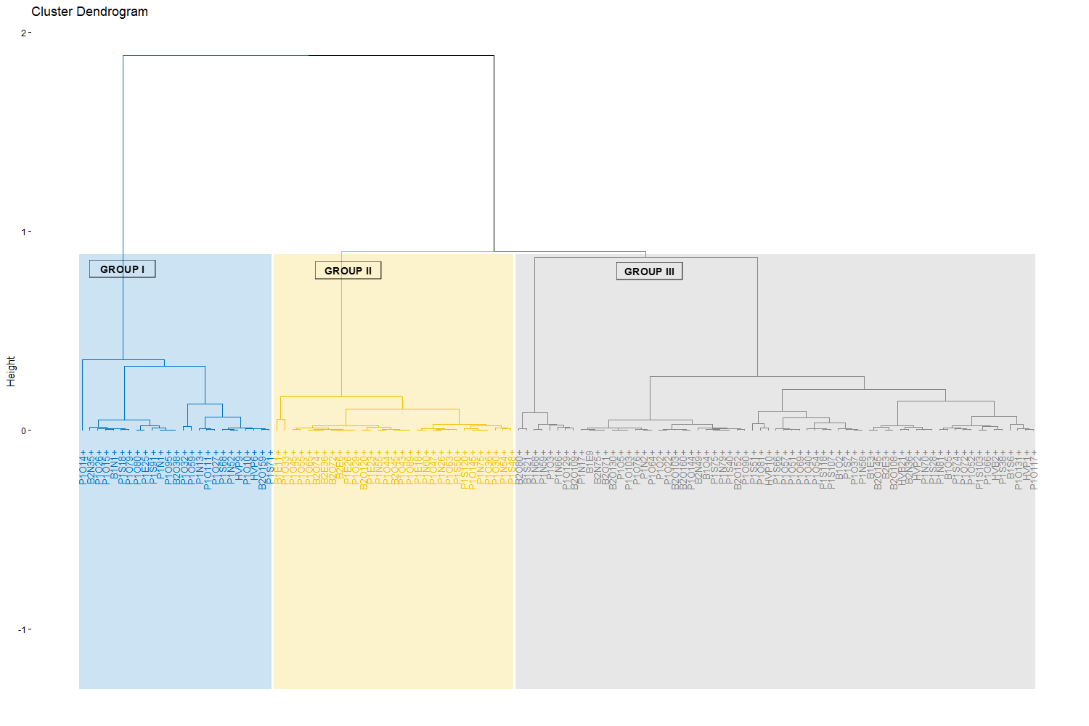
Fig 2 . Dendrogram of morphotypes of interest in P. erinaceus

Table 6. Characteristics of the groups formed by ascending hierarchical classification
 | v.test | Group average | Population mean | Group standard deviation | Population standard deviation | p-value
Group I
Hfut | -4.33 | 5.00 | 5.67 | 1.19 | 1.84 | <0.001
HPBranch | -4.58 | 3.87 | 4.55 | 1.12 | 1.76 | <0.001
Hato | -4.95 | 10.40 | 13.10 | 3.25 | 6.47 | <0.001
EnOE | -6.37 | 6.59 | 8.17 | 2.04 | 2.95 | <0.001
DCtrc | -6.83 | 28.43 | 34.50 | 7.92 | 10.57 | <0.001
EnNS | -7.08 | 6.37 | 8.33 | 1.89 | 3.29 | <0.001
Dhoupie | -7.16 | 6.48 | 8.25 | 1.77 | 2.94 | <0.001
Group II
HPBranch | 7.78 | 8.50 | 4.55 | 1.62 | 1.76 | <0.001
Hfut | 6.44 | 9.09 | 5.67 | 1.75 | 1.84 | <0.001
EnNS | -2.09 | 6.35 | 8.33 | 1.89 | 3.29 | 0.04
Dhoupie | -2.48 | 6.14 | 8.25 | 1.29 | 2.94 | 0.01
EnOE | -2.62 | 5.94 | 8.17 | 1.92 | 2.95 | 0.01
Group III
Dhoupie | 8.84 | 11.30 | 8.25 | 1.85 | 2.94 | <0.001
EnNS | 8.53 | 11.62 | 8.33 | 2.39 | 3.29 | <0.001
EnOE | 8.11 | 10.98 | 8.17 | 1.94 | 2.95 | <0.001
DCtrc | 7.71 | 44.04 | 34.50 | 7.25 | 10.57 | <0.001
Hato | 4.00 | 16.13 | 13.10 | 8.06 | 6.47 | <0.001
Dtrc: Trunk diameter; Hfut: Trunk height; HPBranch: Height of the first branch; Hato: Total height; EnNS: North-South span; EnOE: West-East span; Dhoupie: Crown diameter
- Discussion
Restoring vegetation cover is crucial in combating climate change and the disappearance of certain species. This activity depends on many factors. It is essential to have high-quality plant material in sufficient quantities that is suited to the environment in question. In the case of P. erinaceus, which is classified as an endangered species by the International Union for Conservation of Nature (Barstow, 2018), the study reveals that the proportion of adult P. erinaceus trees that are well suited for reforestation programmes varies from one area to another and is relatively low, at 14.22%. This low rate could be explained by selective logging in recent decades, which has favoured the elimination of the best morphotypes and led to an erosion of genetic diversity. Indeed, from 2010 to 2016, Côte d'Ivoire was one of the main suppliers of P. erinaceus wood to Asian countries, including China (AEI, 2022). This trade was essentially unregulated and clandestine. The best-conformed morphotypes were the most sought after. However, according to Degen et al. (2006) and Roque et al. (2023), selective cutting is responsible for the loss and reduction of rare alleles responsible for characteristics desired for reforestation programmes. Previous studies conducted by Goba et al. (2019) revealed that the overexploitation of P. erinaceus in Côte d'Ivoire has led to a regeneration deficit and an imbalance in the age classes of the different stands. This has resulted in a decrease in adult reproductive morphotypes and difficulty in producing reforestation material adapted to the needs of different reforestation programmes.
Despite the loss of many morphotypes, there are still a few that have interesting characteristics in different areas, particularly in zone 3, which has the highest density of trees of interest, at 6.43 trees/ha. These trees of interest show diversity within each zone, as evidenced by coefficients of variation greater than 30% for most of the variables measured. This diversity allows the trees of interest to be structured into three morphotypes. Although Group I has lower parameters than the populations of trees of interest, it is very important. These trees include young individuals that represent an ideotype that could prove interesting for reforestation programmes. They constitute a genetic reservoir for maintaining diversity and genetic adaptability in an environment that has been subject to intensive exploitation, which has led to the disappearance of large trees (Ouedraogo et al., 2014; Goua et al., 2017). According to Adji et al. (2022), young P. erinaceus trees have structural characteristics that can be identified and selected, thus constituting a strategic core of genetic resources to stabilise natural populations and support restoration efforts. Group II is characterised by slender morphotypes with a trunk and a significant first branching height. This characteristic could be attributed to an environment where competition for light was intense. Individuals in this group may have originated from the cohort that was forming before the overexploitation of P. erinaceus. The presence of large trees created competition for resources, including light, which promotes the vertical growth of young plants (Sanneh, 2023). Studies show that P. erinaceus has a distribution dominated by young to medium-sized individuals in exploited areas in Togo, suggesting that part of this cohort comes from the generation prior to massive overexploitation and that regeneration occurs in a more or less open environment (Adjonou et al., 2010; CITES, 2022). This group is of interest for reforestation, as the individuals are the direct descendants of certain large trees that have disappeared and may possess genes of interest that have been lost due to the disappearance of large P. erinaceus trees. Group III is composed of mature and dominant individuals. These individuals are the last large trees that escaped the overexploitation of P. erinaceus. It is characterised by individuals with significant crown development, a characteristic of adult morphotypes described in several studies (Goba et al., 2019). This crown development makes individuals in this group the preferred producers and disseminators of seeds, ensuring the sexual reproduction of P. erinaceus and the flow of genes between generations. Studies of genetic diversity using microsatellites show that large trees constitute a reservoir of alleles that are crucial for the resilience of the species (Johnson et al., 2020). In addition, they have a morphology that is sought after by reforestation programmes and are a breeding ground for current seed, which could support reforestation programmes for the restoration of this species' ecosystem.
- Conclusion
This study, which aimed to identify and characterise morphotypes that could potentially be used in reforestation programmes, highlighted the low proportion of high-performance P. erinaceus plant material available for reforestation programmes. Zone 3 of the Palée classified forest has a higher density of P. erinaceus trees of interest. These trees of interest must be monitored and protected. The trees of interest are structured into three morphological groups. The first group represents future potential for reforestation programmes. The second group consists of individuals that are the descendants of large trees that were victims of overexploitation and may contain certain lost alleles. The third group consists of dominant trees that have survived illegal exploitation and are the main providers of seeds, ensuring genetic flow from generation to generation. These morphotypes therefore constitute a basis for obtaining quality plant material for reforestation programmes. However, it is essential to assess the genetic diversity of these morphotypes and to establish a reliable technique for producing seedlings to ensure their reproduction and support reforestation programmes.

REFERENCES
Adji, B. I., Akaffou, D. S., & Sabatier, S. (2022). Variation in growth unit morphology in Khaya senegalensis (Desr.) A. Juss. (Meliaceae) and Pterocarpus erinaceus Poir. (Fabaceae) according to habitat and climate. Bois & Forêts des Tropiques, 354, 41–54. https://doi.org/10.19182/bft2022.354.a36768
Adjonou, K., Ali, N., Kokutse, A. D., & Kokou, K. (2010). Study of the dynamics of overexploited natural stands of Pterocarpus erinaceus Poir. (Fabaceae) in Togo. Bois et Forêts des Tropiques, 306(1), 33–43. https://doi.org/10.19182/BFT2010.306.A20431

Arbonnier, M. (2002). Trees, shrubs and lianas of the dry zones of West Africa (573 p.). Paris: Quae / CIRAD / MNHN. https://science.mnhn.fr/ref/isbn/2-85653-546-1

Barstow, M. (2018). Pterocarpus erinaceus. The IUCN Red List of Threatened Species 2018: e.T62027797A62027800. https://doi.org/10.2305/IUCN.UK.2018-2.RLTS.T62027797A62027800.en
CITES – Côte d’Ivoire. (2022). National Management Plan for Pterocarpus erinaceus (African rosewood) in Côte d’Ivoire. Ministry of Water and Forests, CITES Management Authority.

Degen, B., Blanc, L., Caron, H., Maggia, L., Kremer, A., & Gourlet-Fleury, S. (2006). Impact of selective logging on genetic composition and demographic structure of four tropical tree species. Biological Conservation, 131, 386–401. https://doi.org/10.1016/j.biocon.2006.02.004
Duvall, S.C. (2008). Pterocarpus erinaceus Pear. In D. Louppe, A. A. Oteng-Amoako, & M. Brink (Eds.), PROTA 7(1): Timbers / Lumber. Wageningen: PROTA. https://www.prota4u.org/database/protav8.asp?g=pe&p=Pterocarpus+erinaceus+Poir.
Environmental Investigation Agency (EIA). (2022). Poached Timber — Forest crimes, corruption and ivory trafficking in the Malian rosewood trade. https://us.eia.org/wp-content/uploads/2022/05/EIA_US_Mali_Timber_report_0422_FINAL.pdf
Gérard, J., Leban, J.-M., & Kames, J. (2016). Tropical Timber Atlas: Technological characteristics and uses of 283 tropical woods. International Tropical Timber Organization (ITTO). https://www.itto.int/files/itto_project_db_input_file/Project/ITTO_PD_533_09_Rev.2_(I)_ATLAS_2016_FR_EN_ES_web.pdf

Goba, A. E., Koffi, K. G., Sié, R. S., Kouonon, L. C., & Koffi, Y. A. (2019). Demographic structure and natural regeneration of natural stands of Pterocarpus erinaceus Poir. (Fabaceae) in the savannas of Côte d’Ivoire. Bois & Forêts des Tropiques, 341, 5–14. https://doi.org/10.19182/bft2019.341.a31750
Goua, M., Tiébré, M. S., N’Da, K., & Traoré, D. (2017). Structure, dynamics and regeneration of Pterocarpus erinaceus Poir. in the Ivorian savannas: Implications for sustainable management. Journal of Applied Biosciences, 109, 10645–10657.

Interpol. (2016). Law enforcement and the West African Rosewood trade: Understanding and changing international trade—the case of Pterocarpus erinaceus. Bissau Workshop, March 29–31, 2016.
Johnson, B. N., Quashie, M. L. A., Chaix, G., Camus-Kulandaivelu, L., Adjonou, K., Segla, K. N., Kokutse, A. D., Ouinsavi, C., Bationo, B. A., Rabiou, H., Kokou, K., & Vignes, H. (2020). Isolation and characterization of microsatellite markers for the threatened African endemic tree species *Pterocarpus erinaceus* Poir. *Ecology and Evolution*, 10(23), 13403–13411. https://doi.org/10.1002/ece3.6944
Ministry of Agriculture and Rural Development (MADER). (2021). Feasibility study for the establishment of agro-industrial parks and aggregation and service centers for the agro-industrial hub development project in northern Côte d'Ivoire (2PAI-NORD CI). CEFCOG / CAFEXI Consulting. https://www.afdb.org/sites/default/files/rapport-definitif-eies_boundiali_08102021_0.pdf
Nacoulma, B. M. I., Traoré, S. V., Ouédraogo, M., Traoré, S., Boussim, J. I., & Thiombiano, A. (2020). Isolation and characterization of microsatellite markers for Pterocarpus erinaceus using next-generation sequencing. Molecular Biology Reports, 47(12), 9539–9547.
United Nations (UN). (2014). Final report of the Panel of Experts on Côte d'Ivoire (S/2014/266).https://www.un.org/ga/search/view_doc.asp?symbol=S/2014/266&Lang=F
Ouédraogo, A., Thiombiano, A., Hahn-Hadjali, K., & Guinko, S. (2006). Assessment of the degradation status of stands of four woody species in the Sudanian zone of Burkina Faso. Sécheresse, 17(4), 485–491. https://doi.org/10.1684/SEC.2006.0058

Ouédraogo, A., Thiombiano, A., Hahn, K., & Guinko, S. (2014). Regeneration of five threatened tree species in Burkina Faso: Implications for conservation. International Journal of Biodiversity and Conservation, 6(2), 103–114.
Ouinsavi, C., Adigla, A. W., Houetchegnon, T., Akin, Y., & Dossou, J. (2021). Traditional uses of African rosewood (Pterocarpus erinaceus Poir.) through sociolinguistic groups and pathways of conservation in Benin. International Journal of Biodiversity and Conservation, 13(4), 200–213. https://doi.org/10.5897/IJBC2021.1509
Roque, R. H., Sebbenn, A. M., Boshier, D. H., Filho, A. F., & Tambarussi, E. V. (2023). Logging affects genetic diversity parameters in an Araucaria angustifolia population: An endangered species in southern Brazil. Forests, 14(5), 1046. https://doi.org/10.3390/f14051046
Segla, K. N., Kokutse, A. D., Adjonou, K., & Kokou, K. (2015). Variability of mechanical properties of Pterocarpus erinaceus wood as a function of cambial age. Journal of Tropical Forest Science, 27(3), 394–403. https://doi.org/10.19182/bft2015.324.a31266
Silué, N., Fofana, J. I., Silué, S., Diarrassouba, N., Kouass i, A. F., & Kouakou, K. (2014). Identification of woody species used in cattle feed in the Poro region (northern Côte d’Ivoire). Agronomie Africaine, 26(3), 217–229. https://www.ajol.info/index.php/aga/article/view/110900
Traoré, M., & Martínez-Cortizas, A. (2023). Color and chemical composition of timber woods (Daniellia oliveri, Isoberlinia doka, Khaya senegalensis, and Pterocarpus erinaceus) from southern Mali. Forests, 14(4), 767. https://doi.org/10.3390/f14040767
Zon, D. S., Soro, B., Missa, K., Kakou, Y. S. C., Zouh, B. Z. F., Koné, Y. C., Lébri, M., Dié, A., & Dien, K. O. (2022). Notice of Non-Detrimental Trade (NDTT) on Pterocarpus erinaceus Poir. in Côte d’Ivoire. CITES Scientific Authority, Côte d’Ivoire. https://cites.org/sites/default/files/documents/ACNP_Pterocarpus_erinaceus_Cote_dIvoire_2022.pdf

