Original Research Article

Distribution of root biomass in the parklands of Vitellaria paradoxa C. F. Gaertn (SHEA) of the southern Sudanese zone in Burkina Faso

.
ABSTRACT

Background and aims: Agroforestry is identified as a system that could contribute to mitigating climate change in sub-Saharan countries. Vitellaria paradoxa parks are widespread in Burkina Faso and are recognized for their significant socio-economic and environmental value. The aim of this study was to assess the distribution of root biomass in Vitellaria paradoxa parks.
Methods: The research was conducted in four locations in the southern Sudanese zone, where three trees per site were selected. For each tree, pits were dug in two separate areas: under the canopy and outside the canopy (halfway between the tree and its nearest neighbour), totalling 24 pits. Root sampling was carried out at five depths (0-100 cm) with manual separation of roots by species and category (fine and coarse).
Results: The results reveal a significantly higher biomass of coarse roots under the canopy (5.21 ± 0.32 tDM ha-1) than outside (2.18 ± 0.32 tDM ha-1). The biomass of fine roots was highest in the topsoil layer (0–20 cm) (2.06 ± 0.12 tDM ha-1), with higher values under the canopy (1.27 ± 0.08 tDM ha-1). The highest density of fine roots belonged to herbaceous plants (sorghum and weeds, 0.79 ± 0.09 tDM ha-1), while those of V. paradoxa were found in deeper layers.
Conclusions: This differential root distribution confirms the low underground competition between shea trees and crops, validating the sustainable potential of these agroforestry parks. Furthermore, the significant root biomass highlights their role as a significant carbon sink. Appropriate management of these systems therefore represents a promising solution for national climate change mitigation strategies.

Keywords: Roots carbon pool, Vitellaria paradoxa, Agroforestry systems, Roots biomass, Burkina Faso

1. INTRODUCTION

Agroforestry, defined as a land use system that deliberately combines perennial woody plants with crops and/or livestock, is based on ecological and economic interactions between its various components (Boffa, 2000). Recognised for its many advantages, this practice is a promising lever for designing sustainable agricultural systems that are resilient to climate change. Trees improve soil fertility by increasing organic matter and biological activity (Price and Gordon, 1998), combat erosion (Lee and Jose, 2003), and recycle nutrients deep into the soil for crops (JOSE, 2009). They also constitute a significant carbon sink, thereby mitigating the effects of climate change (Jackson et al, 1996; Nair, 2012). However, while the aerial benefits of agroforestry are increasingly well documented, the root component, often referred to as the ‘hidden half’ of the plant (Waisel et al., 1992), remains poorly understood. Yet roots, which act as interfaces between the plant and the soil, play a fundamental role. Their biomass is a major source of soil organic carbon (Eswaran et al., 1993), and understanding its distribution is essential for optimising the productivity and sustainability of agroforestry systems (Bayala et al., 2004). Previous studies on the root systems of woody species in semi-arid areas have highlighted their ability to develop deep growth and accumulate significant root biomass (Gning et al., 2025; Massaoudou et al., 2025). However, few studies have specifically focused on the roots of agroforestry tree species, with most concentrating mainly on root biomass and distribution (Koala et al., 2021; Gning et al.,2025).
In Burkina Faso, in agroforestry parks dominated by Vitellaria paradoxa C.F.Gaerthn (shea tree) – an emblematic species of the Sudanian zone (Boffa, 2000) – research has mainly focused on the aerial impact of trees. Studies have examined shading, yields of underlying crops (Kessler, 1992), and carbon sequestration in above-ground biomass (Sanou et al, 2025). However, the distribution of root biomass and its role in underground interactions between trees and crops have been little investigated (Bayala et al., 2004), despite their crucial importance.
Consequently, this work aims to fill this gap by studying the root distribution of shea trees and their interactions with a cereal crop, sorghum. The objective is to make a key scientific contribution to the informed and sustainable management of agroforestry parks in West Africa

2. Methodology

2.1. Site

The study was conducted in four (04) villages located in two (02) different provinces (Tuy and Ioba). These are the villages of Djuie (11.198418°, -3.781958°) and Gombélédougou (11.185946°, -3.555146°) in the municipality of Koumbia and in the province of Tuy, and the villages of Lofing (11.1915998459°, -3.0529999733) and Guéguéré (11.125016°, -3.178171°) in the municipalities of Dano and Guéguéré in the province of Ioba.
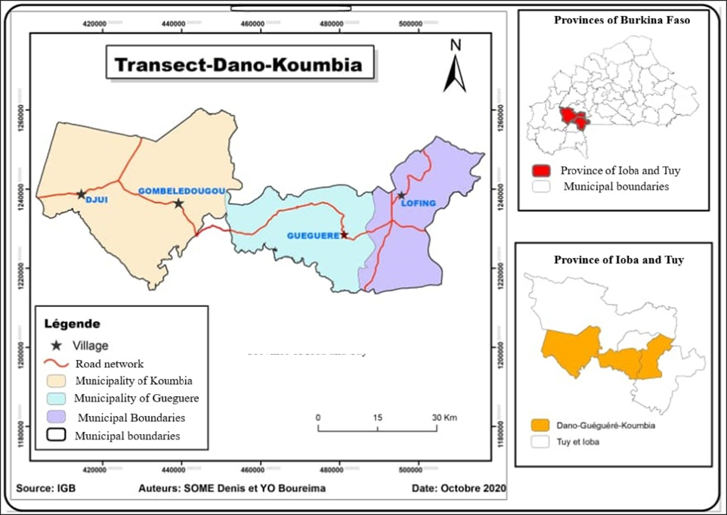
Figure 1 : Location of study sites

2.2. Sampling design
The data was collected in shea parks after the associated cereal crop (sorghum) had been harvested. The study was conducted in four localities in southern Sudan along a Dano-Koumbia transect, which is the programme's area of intervention. The criteria in the choice of sites were the presence and abundance of populations of the species Vitellaria paradoxa. In each locality, three plots were selected for the study and in each plot, one tree was selected for root measurement. For each of the selected trees, two (2) areas were taken into account: an area under the canopy (Z1) located 1 m from the tree trunk; an area outside the canopy (Z3), located 3 m beyond the edge of the canopy (Marone, 2015; Yameogo, 2004). Each of these two zones constituted a sampling point. At each sampling point, two pits were carefully dug (Figure 2). A total of 24 pits were dug in the four locations, i.e. 12 pits under the canopy (Z1) and 12 others outside the canopy (Z3).
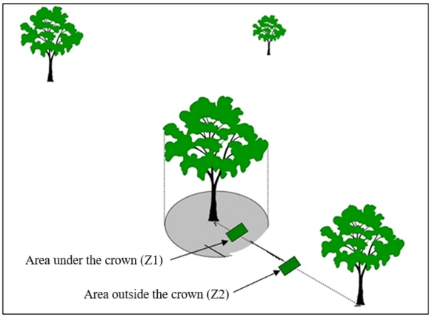
Figure 2: Arrangement of measurement points for tree root biomass at depth
.
2.3. Data collection.
Several methods are used to estimate root biomass. In this study, the direct method of monolith extraction was used at the sampling point. This method is widely described in the literature (Ping et al., 2010; Taylor et al., 2013 and Koala et al., 2015). This method requires the extraction of soil monoliths followed by the separation of roots from soil particles by washing. Thus, a pit measuring 0.49 m³ (0.7 m x 0.7 m x 1 m) was carefully dug at each sampling point (photo 2). The pit was 100 cm deep and the root assessment took into account five horizons: 0-20; 20-30; 30-50; 50-80; 80-100 cm (Figure 3). The decision to limit the depth to 100 cm was based on data from the literature (Cornelissen et al., 2003; Bouttier, 2013). A total of 120 soil samples (5 depths/pit x 24 pits) were collected in the field.

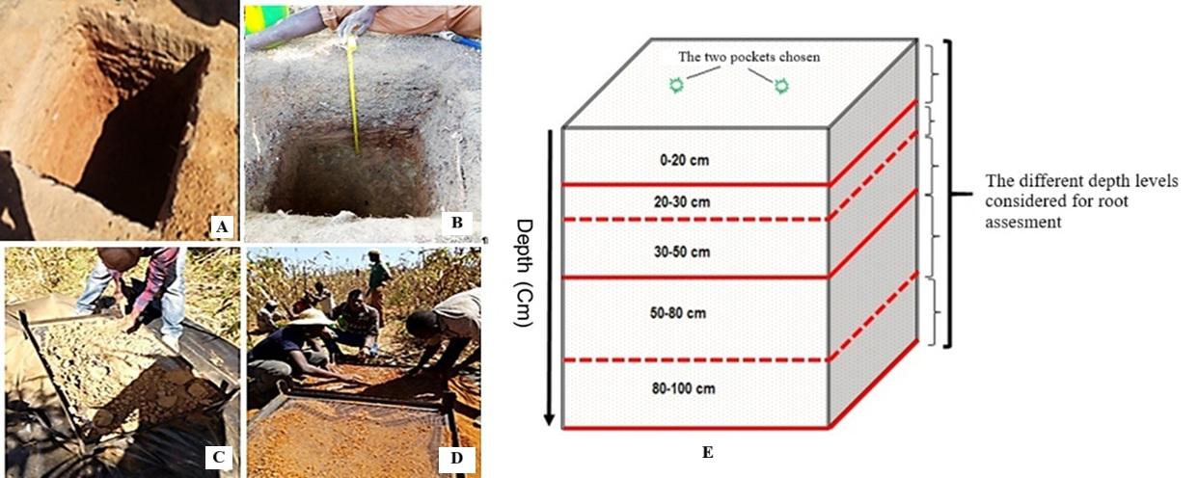
Figure 3: Overview of sampling pits (A ; B), root sorting (C ; D) and the Diagram showing the location of the pit and depth levels considered for soil collection and root assessment (E).
The soil was removed by depth level (layer) (Figure 3 E). All of this soil was placed on a 5 mm mesh sieve laid on a tarpaulin (Figure 3C&D). The roots were sorted manually and packed in plastic bags, labelled, and the fresh weight (FW) in g was measured using a precision electronic balance accurate to 0.1 g. The labels indicated the date the roots were harvested, the name of the village, the plot number, the area where the pit was located, and the depth. The roots of the different species were identified (based on their colour and morphology). Due to ambiguous definitions of roots (Ping et al., 2010; Norby and Jackson, 2000), root diameter was used in this study as the criterion for defining the different root classes. Thus, all roots with a diameter of less than 2 mm (d ≤ 2 mm) are considered fine roots, and all those with a diameter greater than 2 mm (d > 2 mm) are considered coarse roots (Defrenet, 2012). We considered the total biomass of coarse roots and fine roots in each layer. Very fine roots that escaped sorting were captured as follows: At each depth level considered, before disturbing the soil, a sub-sample was taken using cylindrical steel tubes with an internal diameter of 4 cm and a height of 10 cm. This sample was transported to the laboratory for washing in order to sort out the very fine roots that would not have been sorted in the field.
The most commonly used washing procedure is washing with water. For this purpose, we have developed equipment that is also used by Pucheta et al. (2004) and Klumpp et al. (2007) to wash and separate the roots efficiently. The equipment consists of two containers (50 cm in diameter) covered respectively by 5 mm and 2 mm mesh sieves and connected vertically.
The fine roots extracted after washing were weighed and the weight extrapolated for the volume of soil blocks taken at each depth. The weight found was added to that of the fine roots sorted in the field. The dry mass (DM) of the fine and coarse roots was measured separately after drying the roots collected by layer in an oven at 80°C until a constant weight was reached.
In order to compare our results with those of previous studies, the mass of coarse and fine roots per layer estimated in grams over an area of 0.49 m² was converted to tonnes per hectare (t ha⁻¹) using the following formula:.

$${Bm}_{C}i \left(t {ha}^{-1}\right)=\frac{\frac{DMi(en g)}{1 000 000}x10 000}{0,49 m^{2}} (1)$$
Where Bmci = biomass of fine roots or coarse roots per layer and 0.49 m² = pit area.
The biomass per layer of fine roots (BmCF) and coarse roots (BmCG) obtained in this way was combined to determine the total root biomass per layer (BmCT)

$${Bm}_{C}T \left(t {ha}^{-1}\right)= {Bm}_{C}F+ {Bm}_{C}G (2)$$

2.4. Data analysis
All data obtained on root biomass were organised and compiled using EXCEL 2013 spreadsheets, then statistically processed using XLSTAT software version 2014.2.07. Analysis of variance (ANOVA) and Tukey's multiple comparison test were used to compare the effects of factors (site, depth, canopy and species) on root dry biomass. For all factors, a P-value of less than 0.05 was accepted as statistically significant.

3. RESULTS AND DISCUSSION

3.1. Caractéristiques des arbres étudiés

There were no significant differences between the trees selected for the study (table 1). They had an average diameter of 36.5 ± 7.7 cm, a height of 11.2 ± 1.5 m and a crown area of 76.4 ± 20.5 m².
Table 1: Characteristics of the trees covered by the study
Sites |  | Diameter at 1,30m (cm) |  |  | Height (m) |  |  | Crown area (m²)
Sites |  | Mean | IC à 95 % |  | Mean | IC à 95 % |  | Mean | IC à 95 %
Sites |  | Mean | LL | UL | Mean | LL | UL | Mean | LL | UL
Djuié |  | 30.6 | 20 | 41.2 | 11.4 | 8.7 | 14.1 | 74.9 | 37.9 | 112
Gombélédougou |  | 30.2 | 19.6 | 40.8 | 10.3 | 7.6 | 13.1 | 76.7 | 39.7 | 113.8
Guéguéré |  | 49.7 | 39.1 | 60.3 | 10.7 | 7.9 | 13.4 | 94.6 | 57.6 | 131.7
Lofing |  | 35.8 | 25.2 | 46.4 | 12.3 | 9.6 | 15 | 59.5 | 22.5 | 96.6
F |  | 3.918 |  |  | 0.537 |  |  | 0.801
P |  | 0.054 |  |  | 0.67 |  |  | 0.528
IC à 95%= Confidence Interval at 95% ; LL = Lower Limit ; UL = Upper Limit

3.2. Densities of fine and coarse roots at study sites

In relation to the site, fine roots andcoarse roots had contrasting distributions. Fine roots were distributed evenly across all sites. Theydid not differ significantly between sites (P = 0.363) (Figure4). However, the density of thick roots was significantlydifferent between sites (P = 0.018) (Figure 4). The density of large roots (5.25± 0.56 tDM ha-1) at the Djuie site was higher than at all other sites, which were virtually similar. They were 2.92 ± 0.56 tDM ha-1; 3.48 ± 0.56 tDM ha-1; and 3.13 ± 0.56 tDM ha-1 at Gombledougou, Guéguéré, and Lofing, respectively. The absence of significant differences between fine root densities could be explained by the homogeneity of the trees between sites (Table 1). These observations may also be linked to the fact that all sites belong to the same climate zone. Similar results were reported by Ouedraogo et al., (2019). However, this root density result is lower than those obtained by Fortier et al., 2011, who obtained root biomass ranging from 1.86 to 2.62 tDM ha-1 in hybrid poplar strips in southern Quebec. This difference in root density could be explained by the fact that these authors worked on agrosystems that were different from those in this study
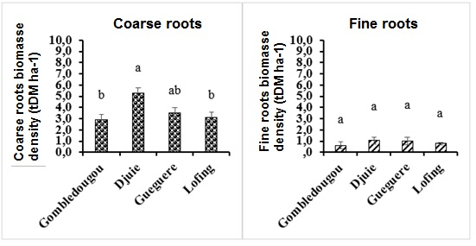
Figure 4: Density of fine roots and coarse roots at study sites
3.3. Distribution of fine root biomass according to soil depth and crown area at each study site
Figure 5 shows the distribution of fine roots according to depth and crown area. Analysis of this figure shows that depth (P < 0.0001) and crown area (P < 0.0001) had a significant effect on fine roots. The interaction between these two factors was also statistically significant. For the soil layer ranging from 0 to 1 m, the highest density of fine root biomass was located at a depth of 0-20 cm (2.06 ± 0.12 tDM ha-1), followed by the 20-30 cm layer (1.31 ± 0.12 tDM ha-1). However, the lowest value was recorded in the 80-100 cm layer (0.03 ± 0.12 tDM ha-1). In general, the area under the canopy showed the highest fine biomass (1.27 ± 0.08 tDM ha-1) compared to 0.43 ± 0.08 tDM ha-1 outside the canopy. The 0-50 cm layer contains 92% of fine biomass. Our results are similar to those of Koala et al, (2021), who found a proportion of 91% at a depth of 0–50 cm in Prosopis africana (Guill. et Rich.) Taub parks in the northern Sudanese zone of Burkina Faso. Diatta (2015) found the same result in the semi-arid Niayes zone in Senegal, with proportions ranging from 71% to 100% in the first 60 cm of depth for species such as Acacia raddiana (73%), Euphorbia balsamifera (100%), Balanites aegyptiaca (71%) and Nauclea macrophylla (74%). These results confirm that root biomass density is high in the top few centimetres of soil in tropical ecosystems (Jackson et al., 1996). Research conducted by Monti and Zatta (2009) on species such as Sorghum bicolor yielded similar results. Root biomass is more concentrated in horizons that are chemically richer and moister (Gning et al, 2025). Therefore, the accumulation of root biomass in the 0-50 cm layer could mean that this is the most humid and fertile layer (Mou et al., 1995; Vogt et al., (1993); Lambers and Posthumus, (1980).
The estimated root biomass density in the 0–20 cm layer is 2.06 ± 0.12 tDM ha⁻¹ (48%). This root density result is lower than those reported by Koala et al., 2015, in the classified forests of Tiogo and Laba in the Sudanian zone, which obtained 55.70% biomass in this layer. This relatively low root density in shea parks could be explained by soil disturbance and low tree density (Dodd et al., 2011). Indeed, we obtained an average tree density ranging from 16 to 21 trees per hectare, whereas in Tiogo and Laba, it was over 25 trees per hectare.
The ANOVA results indicate that the density of fine roots in herbaceous plants is greater in the 0-20 cm layer. This result corroborates those of Wu and Deng., 2011. They report that the root biomass of herbaceous plants is greater in the top few centimetres of soil. In contrast, the fine roots of shea trees are less abundant in the anchorage zone of herbaceous plants. Similar results were revealed by Bayala et al., 2004 in shea and néré parks in the Sudano-Sahelian zone in Saponé and by Soumare et al., (1994) in Acacia seyal and Sclerocarya birrea parks in Mali. Numerous authors have shown that competition for soil resources is lower in shea parks (Massaoudou et al, 2025, Clermont-Dauhin et al. 2019).
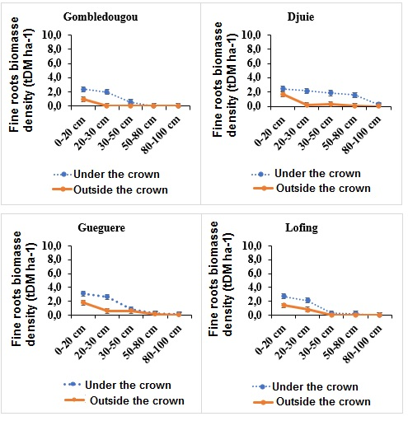
Figure 5: Density of fine roots according to crown and depth at study sites
3.4. Distribution of coarse roots biomass according to soil depth by crown area
Coarse roots vary significantly depending on depth (P < 0.0001) and crown (P < 0.0001). However, the interaction between depth and crown (P = 0.226) has no significant effect on large root biomass. It varies between 5.06 ± 0.5 tDM ha-1 and 1.23 ± 0.5 tDM ha-1 for depth and 5.21 ± 0.32 tDM ha-1 to 2.18 ± 0.32 tDM ha-1 for crown. Analysis of the results shows a high proportion of roots under the canopy and in the 0-20, 20-30 and 30-50 cm layers. The low root biomass is located at a depth of 80-100 cm and outside the canopy (Figure 6). This is consistent with the results of work carried out by Soumare et al. (1994), who found that the area under the canopy has the highest root biomass in Acacia seyal parks in Mali. This could be explained firstly by the greater availability of water and essential mineral salts under the canopy, thus promoting root development. Indeed, the efficient decomposition of fine roots and the fall of litter contribute to improving the organic carbon content of the soil, and therefore the fertility under the canopy (Kaur et al., 2000). In addition, soil permeability also plays a role in root distribution. Water infiltration under tree canopies in shea parks is higher than outside the canopy (Bayala et al., 2006). Indeed, under the canopy, improved soil structure would lead to a higher density of large roots under the canopy.
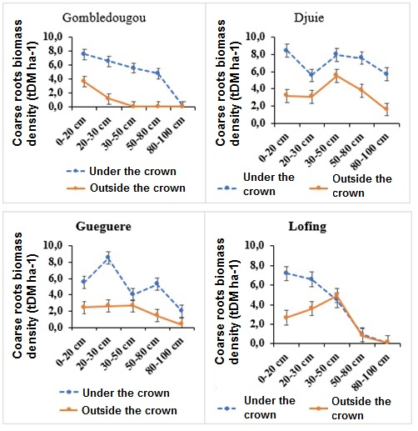
Figure 6: Density of coarse roots according to crown and depth at study sites
3.5. Distribution of fine roots of Vitellaria paradoxa versus those of sorghum and adventitious according to depth

3.5.1. Outside of the crown of V. paradoxa

The general trend for the fine roots of V. paradoxa and those of sorghum and weeds is a drastic decrease in fine root biomass with increasing depth. The surface layer (0–20 cm) contains the highest biomass for both groups (Fitter, 1987). V. paradoxa has a biomass of approximately 0.8 tDM ha-1. Sorghum & Weeds has the highest biomass (figure...), reaching approximately 1.15 tDM ha-1. This high surface concentration is typical of fine roots, which are responsible for absorbing water and nutrients, and is exacerbated by the presence of cultivated plants (sorghum), which often have a shallow root system (Bayala et al., 2008). This suggests intense competition for water and nutrients in the surface layer outside the canopy, where the fine roots of V. paradoxa are outcompeted by the root systems of cultivated plants and weeds (Bayala et al., 2008; Fitter, 1987). Biomass in the middle layer (20–30 cm) falls significantly for both categories, but this decrease is more pronounced for sorghum and weeds. However, the biomass of sorghum and weeds remains about four times higher than that of V. paradoxa (approximately 0.4 tDM ha-1 versus 0.1 tDM ha-1). In the 30-50 cm layer, the values are similar, with almost equal biomass (around 0.15 tDM ha-1), indicating that the impact of annual plants (sorghum and weeds) decreases more rapidly than that of trees (Bayala et al., 2008). In the deep layer (50-100 cm), fine root biomass becomes very low (less than 0.2 tDM ha-1 and tends towards zero at a depth of 80-100 cm for both groups, indicating very limited root activity in these layers. The results show that most of the fine root activity in the agroforestry system takes place in the top 20 centimeters of soil (Bayala et al., 2008; Clermont-Dauphin et al., 2019). Outside the canopy, V. paradoxa trees face intense root competition from cultivated plants and weeds, particularly in the surface layer (0-20 cm), which could potentially affect their access to nutrients and water in this area.

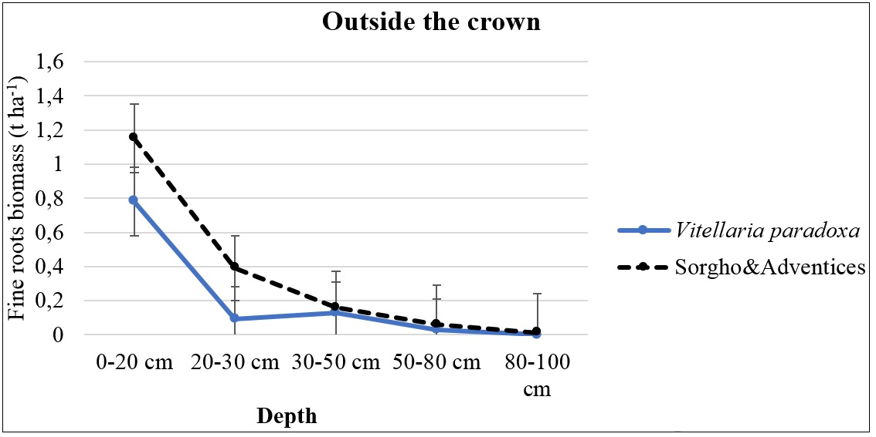
Figure 7: Distribution of fine root density according to depth Outside the crown of v. paradoxa

3.5.2. Under the crown of V. paradoxa

Unlike the ‘Outside the Crown’ zone (previous figure), the biomass of fine shea tree roots is extremely low in the 0-20 cm layer (less than 0.1 tDM ha-1), indicating a virtual absence of fine root activity at the surface directly beneath the tree. Shea biomass reaches its maximum, approximately 1.2 tDM ha-1 in the 20-30 cm layer. Beyond 30 cm, biomass decreases steadily but remains significantly higher than that of sorghum and weeds. For example, at 50–80 cm, shea still has a fine biomass of around 0.4 tDM ha-1, while sorghum and weeds have fallen to 0.05 tDM ha-1. Comparison of the two curves reveals a strategy of avoidance or spatial segregation on the part of shea trees to minimise competition with crops and weeds under their own canopy (Bayala et al., 2004). Shea trees appear to intentionally reduce the density of their fine roots in the 0-20 cm layer, where the root activity of sorghum and weeds is overwhelming (more than 25 times greater than that of shea trees in this layer). This absence of fine roots on the surface beneath the crown may be a response to root competition or toxicity/allelopathy linked to shea litter, or even to the shade itself, which alters root phenology (Dossa et al., 2008; Bayala et al., 2006). The peak biomass of shea trees in the 20-30 cm layer suggests that they shift their main absorption to a slightly deeper level, allowing them to access resources below the area of maximum activity of annual crops (Bayala et al., 2008). The continued presence of fine roots in deeper layers (50-80 cm) confirms its role as a deep-rooted crop, ensuring its survival during periods of water stress, unlike annual crops. Despite spatial segregation, there is strong competition in the 20-30 cm zone, where sorghum and weeds maintain very high biomass (around 2.2 tDM ha-1) compared to the peak activity of shea trees (1.2 tDM ha-1). This is the main point of competition for the tree under its canopy. The root distribution under the canopy highlights a clear vertical segregation. Sorghum and weeds dominate the surface layer (0-20 cm), while shea trees shift their main fine root activity (their peak) to the sub-layer (20-30 cm) and maintain a more pronounced presence at greater depths (Bayala et al., 2008). This is an adaptation that allows shea trees to coexist with crops by reducing direct competition for resources, although there is still significant overlap (and therefore competition) in the middle layer (20–30 cm).
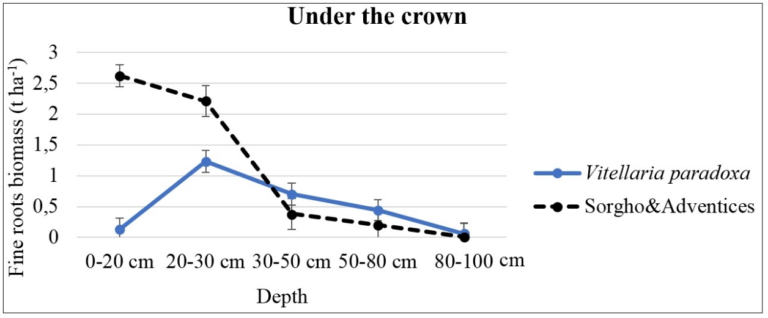
Figure 8: Distribution of fine root density according to depth under the crown of v. paradoxa
4. Conclusion

The study successfully characterized the architecture and spatial distribution of Vitellaria paradoxa root system in the agroforestry parklands and quantified the below-ground competition with associated annual crops (sorghum) and weeds. Fine root biomass is highly concentrated in the superficial layers, with approximately 92% found in the 0-50 cm depth, confirming the general pattern of high root activity in the most fertile and humid topsoil of tropical ecosystems. Outside the canopy, shea trees face intense competition, particularly in the 0-20 cm layer, where the fine roots of annuals (sorghum/weeds) are overwhelmingly dominant. Under the canopy, V. paradoxa exhibits a clear spatial segregation strategy (avoidance) by drastically reducing its fine root density in the highly competitive 0-20 cm surface layer. The trees shift their main absorptive activity, demonstrated by the peak fine root biomass (1.2 tDM ha-1), to the deeper 20-30 cm layer, allowing them to access resources below the area of maximum annual crop activity. The continued presence of shea fine roots in the deep layers (50-80 cm) confirms its role as a deep-rooted species, securing access to resources, especially water, during dry periods and conferring a distinct survival advantage over shallow-rooted annual crops. Despite this effective vertical segregation, significant competition persists in the 20-30 cm layer, which represents the main interaction zone where the peak activity of the shea tree overlaps with substantial root biomass from sorghum and weeds which should be the focus of future research and management interventions aimed at optimizing resource use efficiency and maximizing the productivity of both the shea tree and the associated crops

8. References

1-Boffa, J.-M. (1999). Agroforestry parklands in Sub-Saharan Africa. FAO Conservation Guide 34. https://www.fao.org/4/x3940e/x3940e00.htm
2- Price, G. W., & Gordon, A. M. (1998). Spatial and temporal distribution of earthworms in a temperate intercropping system in southern Ontario, Canada. Agroforestry Systems, 44, 141–149. https://doi.org/10.1023/A:1006213603150
3- Lee, K. H., & Jose, S. (2003). Soil respiration and microbial biomass in a pecan–cotton alley cropping system in Southern USA. Agroforestry Systems. https://doi.org/10.1023/A:1025404019211
4- Jose, S. (2009). Agroforestry for ecosystem services and environmental benefits: An overview. Agroforestry Systems, 76, 1-10. https://doi.org/10.1007/s10457-009-9229-7
5-Nair, P. K. R. (2012). Climate Change Mitigation: A Low-Hanging Fruit of Agroforestry. In P. Nair & D. Garrity (Eds.), Agroforestry - The Future of Global Land Use (Vol. 9, pp. 31-67). Springer. https://doi.org/10.1007/978-94-007-4676-3_7
6- Waisel, Y., Eshel, A., & Kafkafi, U. (Eds.). (2002). Plant Roots: The Hidden Half, Third Edition. Marcel Dekker Inc. https://doi.org/10.1201/9780203909423
7- Eswaran, H., Van Den Berg, E., & Reich, P. (1993). Organic Carbon in Soils of the World. Soil Science Society of America Journal. https://doi.org/10.2136/sssaj1993.03615995005700010034x
8- Bayala, J., Teklehaimanot, Z., & Ouedraogo, S. (2004). Fine root distribution of pruned trees and associated crops in a parkland system in Burkina Faso. Agroforestry Systems, 60, 13–26. https://doi.org/10.1023/B:AGFO.0000009401.96309.12
9-Gning, M., Bassene, C., Diatta, A. A., Senghor, Y., Ba, H. R., & Manga, A. G. B. (2025). Approches agroécologiques de gestion des adventices : rôle de Macroptilium lathyroides en association, paillage et enfouissement dans la culture du maïs. Journal of Applied Biosciences, 211, 22374–22387. https://doi.org/10.35759/JABs.211.6
10-Massaoudou, M., & Mahamane, L. (2025). A review of the direct and indirect effects of African agroforestry trees. Discover Forests, 1(1), 37. https://doi.org/10.1007/s44415-025-00028-x
11-Koala, J., Kagambega, O. R., & Sanou, L. (2021). Distribution des stocks de carbone du sol et de la biomasse racinaire dans un parc agroforestier à Prosopis africana (Guill., et Rich.) Taub au Burkina Faso, Afrique de l’Ouest. Journal of Applied Biosciences, 160, 16482–16494. https://doi.org/10.35759/JABs.160.5
12-Gning, F., Jourdan, C., Diatta, M., Ngom, D., & Ræbild, A. (2025). Root growth and biomass partitioning of nine juvenile Sahelian agroforestry tree species under drought and irrigation treatments. Plant and Soil, 512, 1509–1527. https://doi.org/10.1007/s11104-024-07155-y
13- Kessler, J. J. (1992). The influence of karité (Vitellaria paradoxa) and néré (Parkia biglobosa) trees on sorghum production in Burkina Faso. Agroforestry Systems, 17, 97–118. https://doi.org/10.1007/BF00053116
14- Sanou, C. L., Neya, O., Agodzo, S. K., Bessah, E., Antwi-Agyei, P., Zougmoré, R., Sawadogo, L. Z. N. B., & Thiombiano, A. (2025). Woody species diversity and aboveground carbon stocks in agroforestry systems in Burkina Faso. *Discover Sustainability*, *6*, 234. https://doi.org/10.1007/s43621-025-00868-9
15-Marone, Diatta. (2015). Étude du potentiel de stock de carbone d’espèces agroforestières et de leurs traits fonctionnels en lien avec les systèmes d’utilisation des terres au Sénégal. Université Laval., Québec, Canada.
16-Yameogo, K. M. (2004). Effet du karité et du néré sur la dynamique de l’eau du sol et sa relation avec la performance des cultures associées dans un parc agroforestier à Saponé (province du Bazèga, Burkina Faso). Université de Bobo-Dioulasso. https://www.beep.ird.fr/greenstone/collect/upb/index/assoc/IDR-2004-YAM-EFF/IDR-2004-YAM-EFF.pdf
17-Ping, X., Zhou, G., Zhuang, Q., Wang, Y., Zuo, W., Shi, G., Lin, X., & Wang, Y. (2010). Effects of sample size and position from monolith and core methods on the estimation of total root biomass in a temperate grassland ecosystem in Inner Mongolia. *Geoderma*, *155*(3-4), 262–268. https://doi.org/10.1016/j.geoderma.2009.12.009
18-Dipesh, K. C., & Schuler, J. L. (2013). Estimating Fine-Root Production and Mortality in the Biomass Plantations. Communications in Soil Science and Plant Analysis, 44(17), 2514–2523. https://doi.org/10.1080/00103624.2013.811516
19-Koala J., Sawadogo L., Sawadogo P., Zida D., Aynekulu E., Said M., et Nacro H B., (2015). Cumulative effects of 20-yearsof livestock grazing, prescribed early fire and selective tree cuting on below ground biomass in sudanian savanna woodland west africa, International Journal of Current Research 7(03), pp.13603-13613
20- Cornelissen, J. H. C., Lavorel, S., Garnier, E., Díaz, S., Buchmann, N., Gurvich, D. E., Reich, P. B., Ter Steege, H., Morgan, H. D., Van Der Heijden, M. G. A., Pausas, J. G., & Poorter, H. (2003). A handbook of protocols for standardised and easy measurement of plant functional traits worldwide. Australian Journal of Botany, 51(4), 335-380. https://doi.org/10.1071/BT02124 .
21-Bouttier, L. (2013). Distribution spatiale des racines fines, disponibilité de la lumière et rendement dans un système de culture intercalaire avec arbres feuillus en zone tempérée. Université de Montréal. https://papyrus.bib.umontreal.ca/xmlui/handle/1866/25267
22-Norby, R. J., & Jackson, R. B. (2000). Root dynamics and global change: seeking an ecosystem perspective. New Phytologist, 147(1), 3–12. https://doi.org/10.1046/j.1469-8137.2000.00676.x
23-Defrenet, E. (2012). Évaluation de la biomasse et de la productivité souterraines du caféier dans un système agroforestier au Costa Rica. Sciences agricoles. https://dumas.ccsd.cnrs.fr/dumas-00782273
24-Pucheta, E., Bonamici, I., Cabido, M., & Díaz, S. (2004). Below-ground biomass and productivity of a grazed site and a neighbouring ungrazed exclosure in a grassland in central Argentina. Austral Ecology, 29(2), 201–208. https://doi.org/10.1111/j.1442-9993.2004.01337.x
25-Klumpp, K., Soussana, J. F., & Falcimagne, R. (2007). Effects of past and current disturbance on carbon cycling in grassland mesocosms. *Agriculture, Ecosystems & Environment*, *121*, 59–73. https://doi.org/10.1016/j.agee.2006.12.005
26-Ouédraogo, W. O., Gomgnimbou, A. P. K., Santi, S., Ilboudo, D., & Toguyeni, A. (2019). Quantification de la Biomasse et stockage du carbone du massif forestier de l'Ecole Nationale des Eaux et Forêts de Dindéresso province du Houet au Burkina Faso. International Journal of Biological and Chemical Sciences, 13(7), 3276-3288. https://doi.org/10.4314/ijbcs.v13i7.24 .
27-- Fortier, J., Truax, B., Gagnon, D., & Lambert, F. (2013). Root biomass and soil carbon distribution in hybrid poplar riparian buffers, herbaceous riparian buffers and natural riparian woodlots on farmland. SpringerPlus, 2(1), 539. https://doi.org/10.1186/2193-1801-2-539
28-Diatta M., (2015). Etude du potentiel de séquestration du carbone d’espèces agroforestières et de leurs traits fonctionnels en lien avec les systèmes d’utilisation des terres au Sénégal. Thèse de Doctorat, Université Laval, Québec, Canada.
29-Jackson, R. B., Canadell, J., Ehleringer, J. R., Mooney, H. A., Sala, O. E., & Schulze, E. D. (1996). A global analysis of root distributions for terrestrial biomes. Oecologia, 108(3), 389–411. https://doi.org/10.1007/BF00333714
30-Monti, A., & Zatta, A. (2009). Root distribution and soil moisture retrieval in perennial and annual energy crops in Northern Italy. Agriculture, Ecosystems and Environment, 132(3-4), 252-259. https://doi.org/10.1016/j.agee.2009.04.007
31-Mou, P., Jones, R. H., Mitchell, R. J., & Zutter, B. (1995). Spatial distribution of roots in sweetgum and loblolly pine monocultures and relations with above-ground biomass and soil nutrients. Functional Ecology, 9(4), 689–699. https://doi.org/10.2307/2390162
32-Vogt, K. A., Publicover, D. A., Bloomfield, J., Perez, J. M., Vogt, D. J., & Silver, W. L. (1993). Belowground responses as indicators of environmental change. Environmental and Experimental Botany, 33(1), 189–205. https://doi.org/10.1016/0098-8472(93)90065-N
33-Lambers, H., & Posthumus, F. (1980). The effect of light intensity and relative humidity on growth rate and root respiration of Plantago lanceolata and Zea mays. Journal of Experimental Botany, 31(6), 1621–1630. https://doi.org/10.1093/jxb/31.6.1621 .
34-Dodd, M. B., Crush, J. R., Mackay, A. D., & Barker, D. J. (2011). The “root” to more soil carbon under pasture. Proceedings of the New Zealand Grassland Association, 73, 43-50. https://www.grassland.org.nz/publications/nzgrassland_publication_201.pdf
45-Wu, Y., Wu, J., Deng, Y., Tan, H., Du, Y., Gu, S., & Cui, X. (2011). Comprehensive assessments of root biomass and production in a Kobresia humilis meadow on the Qinghai-Tibetan Plateau. Plant and Soil, 338(1-2), 497–510. https://doi.org/10.1007/s11104-010-0562-4
36-Soumare A., Groot J.J.R., Kone D. et Radersma S., (1994). Structure spatiale du système racinaire de deux arbres du Sahel: Acacia seyal et Sclerocarya birrea. Rapport PSS N° 5, Wageningen, 38p.
37-Kaur, B., Gupta, S. R., & Singh, G. (2000). Soil carbon, microbial activity and nitrogen availability in agroforestry systems on moderately alkaline soils in northern India. Applied Soil Ecology, 15, 283-294. https://doi.org/10.1016/S0929-1393(00)00079-2
38-Fitter, A. H. (1987). An architectural approach to the comparative ecology of plant root systems. New Phytologist, 106, 61-77. https://doi.org/10.1111/j.1469-8137.1987.tb04683.x
39-Bayala, J., Dossa, G. L. Y., Sanou, J., Teklehaimanot, Z., & Kalinganire, A. (2004). Fine root distribution of pruned trees and associated crops in a parkland in Burkina Faso. Agroforestry Systems https://doi.org/10.1023/B:AGFO.0000009401.96309.12
40-Clermont-Dauphin, C., Séguis, L., Velluet, C., Degbé, M., Cournac, L., & Seghieri, J. (2019). Impacts du karité sur les ressources du sol et la production d'une culture de maïs associée dans un parc agroforestier soudanien du Nord-Est du Bénin. In J. Seghieri & J.-M. Harmand (Eds.), Agroforesterie et services écosystémiques en zone tropicale (pp. 159-172). Éditions Quae. https://doi.org/10.35690/978-2-7592-3059-4
41-Dossa, G. L. Y., Sinsin, B., & Teklehaimanot, Z. (2008). Productivity of cotton and sorghum in an agroforestry system of shea trees Vitellaria paradoxa Gaertn) in northern Benin. Journal of Agriculture and Biological Sciences, 4(4), 169-178.
42-Bayala, J., Mohn, H. C., Ouédraogo, S. J., & Zombré, N. P. (2006). Above- and below-ground impacts of Vitellaria paradoxa (Gaertn.) on soil properties and Sorghum bicolor (L.) Moench in Burkina Faso. Nutrient Cycling in Agroecosystems, 74(3), 223-231.

