Review Article

Jumping Genes (Transposable Elements): A Comprehensive Review of Their Molecular Mechanisms, Evolutionary Impact, and Applications in Livestock and Biomedicine

Abstract
Transposable elements (TEs), commonly referred to as “jumping genes,” are discrete DNA fragments capable of mobilization within the genome, often creating new copies during transposition. Once considered non-functional “junk DNA,” TEs are now recognized as essential regulators of genome evolution, gene networks, and epigenetic processes [4,5]. They contribute to genome innovation through gene duplication, exon shuffling, regulatory rewiring, and stress-responsive plasticity. However, aberrant TE activation is associated with genomic instability and disease, including cancer, neurodegeneration, reproductive disorders, and immune dysfunction [6,7].
In livestock species, recent studies have identified TE-derived regulatory elements influencing growth, reproduction, immunity, and adaptation [3,8]. Emerging technologies, such as CRISPR–transposon systems, programmable epigenome editing, and AI-driven TE mapping, provide opportunities for precise genome engineering, functional genomics, and livestock breeding [9,10]. This review consolidates current knowledge on TE classification, mechanisms, evolutionary roles, disease implications, and biotechnological applications, emphasizing livestock genomics. It also highlights challenges, biosafety considerations, and future directions toward leveraging TEs for precision animal breeding and synthetic biology.
Keywords: Transposable elements, retrotransposons, DNA transposons, livestock genomics, CRISPR–transposon, epigenome editing, genome evolution, disease biomarkers
1. Introduction
Transposable elements (TEs), or "jumping genes," have revolutionized our understanding of genome architecture and function since their discovery by Barbara McClintock in maize in the 1940s [1]. Her work challenged the static view of the genome and introduced the concept of dynamic genome regulation via DNA mobility. Today, TEs are recognized as major drivers of genome evolution, chromatin remodeling, regulatory network rewiring, and genetic diversity [25]. They constitute ~45–50% of the human genome [2,3] and up to 50–60% in certain livestock species, including cattle and buffalo, reflecting both breed-specific histories and selection pressures [3,13].
Initially considered "junk DNA," TEs were believed to act solely as selfish genetic elements. However, modern sequencing technologies, including long-read (PacBio HiFi, Oxford Nanopore) and whole-genome bisulfite sequencing, have revealed that TEs actively modulate gene expression, epigenetic patterns, stress responses, and phenotypic diversity [15]. In livestock, TE insertions have been associated with traits such as milk yield, mastitis resistance, heat tolerance, reproductive fitness, and climate adaptability [16–18].
1.1 Evolution from Redundant DNA to Functional Genomic Element
The perception of TEs has shifted from redundant genomic elements to crucial contributors to genome innovation. TEs facilitate gene duplication, exon shuffling, and alternative splicing, enhancing genome plasticity and regulatory diversity [2,3]. Livestock studies in Gir, Sahiwal, Murrah buffalo, and Holstein–Friesian breeds demonstrate that TE-associated modifications contribute to heat-stress adaptation, metabolic regulation during lactation, and immune modulation [19,20]. Recent mapping of retrotransposons in Bos taurus and Bubalus bubalis highlights their influence on fertility and immune gene networks [20].
1.2 Structural and Functional Classification of TEs
TEs are classified into two main classes: Class I (retrotransposons, RNA-mediated, copy-and-paste) and Class II (DNA transposons, DNA-mediated, cut-and-paste). Retrotransposons, including LINE-1, SINEs (e.g., Alu), and endogenous retroviruses (ERVs), are abundant in mammals and can modulate gene expression via promoter/enhancer activity. DNA transposons are less active in humans but remain functional in many eukaryotes and are widely used in synthetic biology through systems like Sleeping Beauty and PiggyBac [8].
1.3 Relevance to Livestock and Agriculture
In livestock, TE activity influences:
- Milk composition and udder health via transcriptional regulation of casein genes [21]
- Thermotolerance through induction of heat shock proteins (HSP70, HSP90) under high temperature-humidity index (THI) conditions [22]
- Feed efficiency and rumen microbiome stability [23]
- Embryonic development and fertility, modulating hormone receptor genes (FSHR, LHR) [24]
Stress-induced TE reactivation may also mediate adaptive epigenetic responses, enabling livestock to cope with climate variability and pathogen exposure, particularly in regions such as India [25].
1.4 Integration with Modern Genomic Technologies
Technologies including CRISPR–Cas, AI-driven TE mapping, multi-omics integration, and transposon-based gene therapy facilitate precise TE identification, silencing, and functional analysis. CRISPR-dCas9 methyltransferase systems allow targeted TE suppression to reduce unwanted insertions, while transposon-assisted genome editing in livestock is explored for improving disease resistance and production traits without compromising genetic diversity [26,9,10].
1.5 Scope of the Review
This review aims to provide a comprehensive overview of TEs, encompassing:
- Molecular mechanisms and classification
- Evolutionary and epigenetic roles across species
- Disease associations and dysregulation in humans and livestock
- Applications in molecular biology, synthetic genomics, and livestock breeding
- Technological advances, biosafety considerations, and precision genome engineering
- Future directions integrating AI, epigenome editing, and high-throughput sequencing
By consolidating research from 2023–2025, including livestock-specific insights, this review highlights TEs as both evolutionary drivers and genomic risk factors, with potential applications in developing climate-resilient, disease-resistant, and high-performing livestock breeds aligned with One Health and Sustainable Development Goals frameworks [3,20,21].
2. Classification and Molecular Mechanisms of Transposable Elements
Transposable elements (TEs) are broadly classified based on their mechanism of mobilization into Class I (retrotransposons) and Class II (DNA transposons) [2,3,8]. Their activity shapes genome architecture, regulatory networks, and adaptive evolution in both humans and livestock. Understanding TE classification and mechanistic diversity is essential for elucidating their roles in disease, epigenetics, and biotechnological applications.
2.1 Class I TEs: Retrotransposons
Class I elements transpose via an RNA intermediate, employing a “copy-and-paste” mechanism. Retrotransposons are the most abundant TEs in mammalian genomes, representing ~40% of the human genome and up to 50% of some livestock genomes [2,3,15]. They are further subdivided into:
2.1.1 Long Interspersed Nuclear Elements (LINEs)
LINEs, particularly LINE-1, are autonomous retrotransposons encoding the proteins required for their mobilization, including reverse transcriptase and endonuclease [6]. They integrate into new genomic locations through target-primed reverse transcription, potentially disrupting genes, creating novel exons, or influencing regulatory elements [6,7]. In livestock, LINE insertions have been linked to immune modulation, growth traits, and fertility [15,20]. LINE activity is tightly regulated by epigenetic mechanisms, including DNA methylation and histone modifications, to prevent genome instability [5].
2.1.2 Short Interspersed Nuclear Elements (SINEs)
SINEs are non-autonomous elements that rely on LINE-encoded proteins for transposition [5]. In humans, Alu elements are the most studied, whereas in ruminants and pigs, lineage-specific SINEs contribute to gene regulation and expression diversity [15,21]. SINE insertions can modulate promoters, enhancers, and long-range chromatin interactions, influencing phenotypes relevant to production and disease [3,10].
2.1.3 Endogenous Retroviruses (ERVs)
ERVs are remnants of ancient viral infections that have integrated into germline DNA. While most ERVs are inactive, some retain regulatory sequences capable of driving gene expression or responding to environmental stimuli [2,12]. In livestock, ERVs influence placental development, immune system activation, and stress adaptation [20,22]. ERV-derived promoters and enhancers have been implicated in modulating milk protein genes and reproductive hormone networks [21].

Table 1: Classification of TEs with key characteristics
Class | Subclass / Type | Mechanism of Transposition | Copy Number Change | Genomic Impact / Notes | Examples
Class I: Retrotransposons | LINEs (Long Interspersed Nuclear Elements) | RNA intermediate → reverse transcription → integration | Copy-and-paste (increases copy number) | Can disrupt genes, provide regulatory elements, mediate genome expansion | LINE-1
 | SINEs (Short Interspersed Nuclear Elements) | Non-autonomous, rely on LINE machinery | Copy-and-paste | Regulatory sequences, affect gene expression | Alu elements
 | Endogenous Retroviruses (ERVs) | RNA → reverse transcription → integration | Copy-and-paste | Provide promoters/enhancers; may influence immunity | HERV-K, ERV1
Class II: DNA Transposons | TIR (Terminal Inverted Repeat) transposons | Cut-and-paste using transposase | Usually does not increase copy number | Insertions, deletions, exon shuffling | Sleeping Beauty, PiggyBac
 | Helitrons | Rolling-circle transposition | Can increase copy number | Capture gene fragments, mediate genome rearrangements | Helitron1
 | MITEs (Miniature Inverted-repeat Transposable Elements) | Non-autonomous; rely on autonomous DNA transposons | Copy-and-paste | Regulatory elements in promoters/enhancers | Tourist, Stowaway

2.2 Class II TEs: DNA Transposons
Class II TEs mobilize via a DNA-mediated cut-and-paste mechanism, using a transposase enzyme encoded by the TE itself. DNA transposons are less abundant in humans (~3% of the genome) but remain active in various eukaryotes, including livestock, plants, and insects [8,19]. Notable families include:
- Tc1/mariner: widely used for genome engineering due to their minimal insertion site specificity.
- PiggyBac: enables efficient transgenesis and is employed in livestock genome editing.
- Sleeping Beauty: reconstructed from inactive fish transposons, now widely used for gene therapy and functional genomics [8,9,19].
DNA transposons contribute to structural variation, exon shuffling, and gene duplication. Their mobilization can create insertional mutations but also provides raw material for regulatory innovation and adaptive traits [8,19].
Figure 1: Mechanisms of TE Transposition
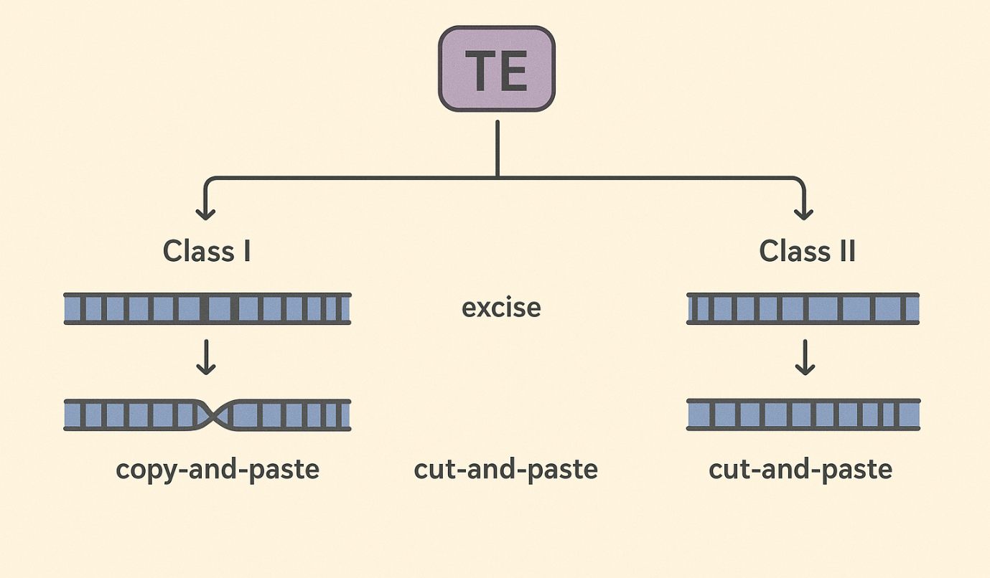
2.3 Mechanistic Diversity of TE Mobilization
TE mobilization relies on complex enzymatic processes and host factors:
- Retrotransposons: The RNA intermediate is reverse transcribed into DNA, which integrates at a new genomic site. Target-primed reverse transcription ensures efficient insertion, although it can disrupt coding or regulatory regions [6].
- DNA transposons: Transposase-mediated excision and integration may involve hairpin formation at transposon ends, producing precise or imprecise insertions [8].
- Regulatory interactions: TE activity is modulated by host small RNAs (piRNAs, siRNAs), chromatin remodeling, and epigenetic silencing to prevent uncontrolled transposition [5,7,21].
In livestock, these mechanistic pathways are increasingly studied for trait association, including disease resistance, thermotolerance, and growth regulation [3,15,20].
2.4 TE-Derived Regulatory Functions
Beyond mobilization, TEs contribute to cis-regulatory innovation:
- Promoter and enhancer activity: TE insertions can provide novel binding sites for transcription factors, reshaping gene networks [17].
- Alternative splicing and exonization: TE sequences within introns can be co-opted as exons, expanding proteomic diversity [3,6].
- Epigenetic modulation: TE silencing or activation can influence neighboring gene expression, particularly under environmental stress, immune challenges, or metabolic pressures [20,25].
Livestock-specific studies show that retrotransposon-derived enhancers modulate immune response genes, heat shock proteins, and milk production loci, providing a mechanistic link between TE activity and economically important traits [3,15,21].
2.5 Evolution and Diversity of TEs
TEs exhibit remarkable evolutionary plasticity, influencing both genome size and structure:
- Horizontal transfer: Certain DNA transposons have crossed species boundaries, contributing to genome innovation [13,18].
- Lineage-specific expansion: Retrotransposons often expand in specific lineages, creating genetic variation critical for adaptation [15,18].
- Diversification across livestock genomes: Comparative genomics shows that cattle, buffalo, and pigs possess unique TE repertoires affecting immune, metabolic, and reproductive traits [3,11,20].
The diversity and adaptability of TEs underscore their dual role as genome architects and potential genomic threats, highlighting the need for precise regulation.
3. TE Dysregulation and Disease Implications
While transposable elements (TEs) play critical roles in genome evolution and adaptation, aberrant TE activity can lead to genomic instability, insertional mutagenesis, and disease susceptibility. Dysregulated TEs are increasingly recognized as contributors to a range of human disorders, as well as phenotypic variation and disease traits in livestock [6,7,16,20].
3.1 TE-Mediated Genomic Instability
TE insertions can disrupt coding regions, regulatory elements, or splice sites, producing loss-of-function or gain-of-function mutations. LINE-1 (L1) retrotransposition is particularly implicated in generating structural variants such as deletions, duplications, and chromosomal rearrangements [6]. In humans, L1-mediated insertions have been linked to oncogenesis, neurodegenerative diseases, and germline disorders [6,7,14].
In livestock, TE polymorphisms contribute to genomic heterogeneity affecting growth, fertility, and immune responses. For instance, insertional variants of LINEs or SINEs can modulate gene expression associated with mastitis resistance in dairy cattle or reproductive efficiency in buffalo [3,15,20].
3.2 TE Activation in Human Diseases
3.2.1 Cancer
TE activation is frequently observed in various cancers, including colorectal, lung, and breast malignancies [6]. Hypomethylation of L1 elements facilitates retrotransposition, generating insertional mutations or altering gene regulatory networks that drive tumor progression [6,17]. Endogenous retroviruses (ERVs) can act as oncogenic enhancers, contributing to transcriptional dysregulation in cancer cells [12].
3.2.2 Neurodegenerative Disorders
LINE-1 activity in neural tissues has been associated with Alzheimer’s disease, amyotrophic lateral sclerosis, and other neurodegenerative conditions [7,14]. Aberrant retrotransposition events can disrupt neuronal gene networks, alter chromatin accessibility, and trigger immune responses, exacerbating neurodegeneration [7].
3.2.3 Reproductive Disorders
TE insertions within or near germline-expressed genes can impair fertility by disrupting hormone receptor pathways, gametogenesis, or embryonic development [6,16]. In humans, retrotransposon activity is linked to cases of idiopathic infertility and abnormal embryonic development [16]. In livestock, TE-mediated regulatory changes have been associated with variable litter size, sperm quality, and oocyte competence [3,20].

Figure 2: TE-Related Disease Pathways
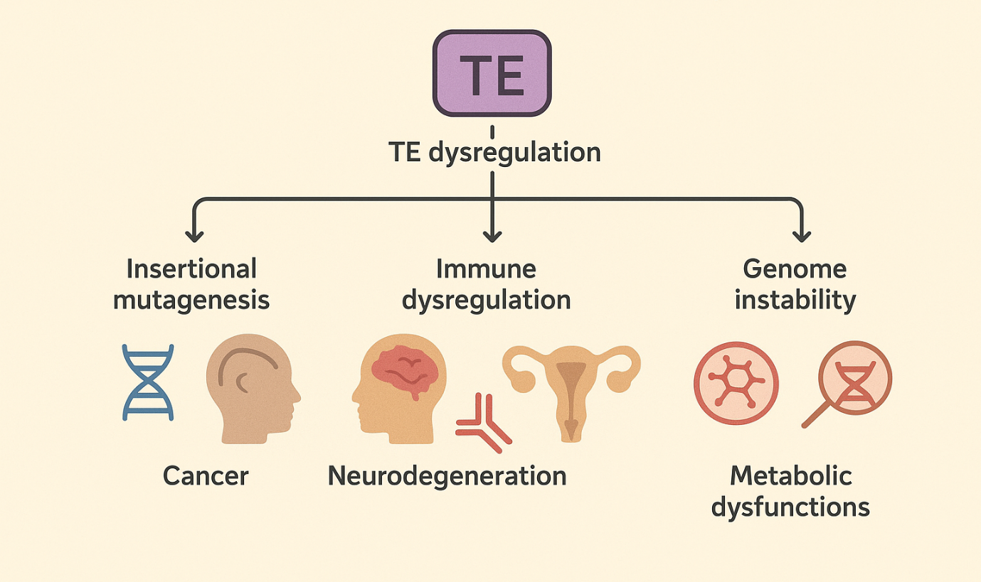
3.3 TE Influence on Immune Function
TEs contribute to immune system regulation by providing novel promoters, enhancers, and non-coding RNAs that modulate innate and adaptive responses [15,17]. However, dysregulation can lead to autoimmunity, chronic inflammation, or immunodeficiency. LINE-1 hypomethylation has been observed in autoimmune disorders, while ERV expression can activate interferon pathways, sometimes contributing to pathology [12,15].
In livestock, TE-derived regulatory elements modulate expression of cytokines, Toll-like receptors, and other immune genes, impacting disease resistance and vaccination response [3,15,20]. Understanding these dynamics provides avenues for improving livestock health through selective breeding or genome engineering.
3.4 TE Dysregulation Under Environmental Stress
Environmental stressors, including heat, oxidative stress, and pathogen exposure, can trigger TE reactivation [20,25]. In humans, stress-induced TE mobilization may contribute to epigenetic instability and disease susceptibility. In livestock, stress-responsive TE activation has been implicated in:
- Thermotolerance: TE-driven upregulation of heat shock proteins enhances cellular protection under high temperature-humidity conditions [3,20].
- Metabolic adaptation: TE insertions near metabolic genes modulate feed efficiency and energy homeostasis [3,20].
- Pathogen defense: TE-derived regulatory sequences can enhance innate immune responses during viral or bacterial infection [15,20].
These examples underscore TEs as both adaptive agents and potential genomic threats, with their activity finely balanced by host epigenetic mechanisms.
3.5 TE-Based Biomarkers and Disease Monitoring
The stable or dynamic expression of TE-derived sequences can serve as biomarkers for disease risk, progression, or environmental adaptation. LINE-1 methylation status is employed as a prognostic marker in certain cancers [6], while ERV transcript levels indicate immune activation or viral response [12]. In livestock, monitoring TE activity may inform breeding programs aimed at enhancing resilience, productivity, and disease resistance [3,15,20].
4. Applications of TEs in Molecular Biology and Livestock Genomics
Transposable elements (TEs) have transitioned from being considered genomic “parasites” to powerful tools in functional genomics, genome engineering, and livestock improvement. Their inherent mobility, sequence diversity, and regulatory potential make them versatile agents for both experimental and applied biotechnology [8–10,19].
4.1 TE-Based Functional Genomics
TEs are widely used as mutagenic tools to study gene function. DNA transposons such as Sleeping Beauty (SB) and PiggyBac (PB) have been repurposed for insertional mutagenesis, enabling identification of essential genes, regulatory elements, and disease-associated loci in mammalian cells [8,19]. Retrotransposons, particularly engineered LINE-1 elements, provide opportunities for lineage tracing, transcriptome mapping, and regulatory network analysis [8,15].
In livestock, these approaches allow precise characterization of gene networks governing growth, immunity, reproduction, and environmental adaptation, thereby linking TE biology to phenotypic traits relevant for breeding and health management [3,10,15].
4.2 Genome Editing and CRISPR–TE Systems
Recent advances have integrated CRISPR–Cas systems with TE machinery to develop programmable, site-specific transposition platforms [9,10]. CRISPR-associated transposases (CASTs) enable targeted insertion of genetic payloads without inducing double-strand breaks, reducing off-target effects compared to classical genome editing [9].
Applications in livestock include:
- Precision trait introduction: Insertion of alleles conferring disease resistance, heat tolerance, or improved milk composition [3,9].
- Gene regulation modulation: Targeted TE-mediated enhancer or promoter integration can modulate expression of key genes involved in growth and immunity [10,15].
- Synthetic biology: Construction of gene circuits using TE-derived regulatory sequences for controlled expression in mammalian and avian systems [19].

4.3 Epigenome Engineering
TEs naturally interact with epigenetic regulators, making them attractive for targeted epigenome editing. CRISPR-dCas9 fusion proteins coupled with methyltransferases or demethylases can specifically silence or activate TE loci, stabilizing genome integrity or modulating nearby gene expression [21].
In livestock, epigenome engineering of TEs has potential applications in:
- Stress adaptation: Controlled TE activity may enhance resilience to heat, oxidative stress, or nutritional challenges [3,20].
- Reproductive efficiency: Epigenetic modulation of TE-adjacent genes can optimize fertility and embryonic development [16,20].
- Disease mitigation: Suppression of pathogenic TE activation reduces risk of insertional mutagenesis and immune dysregulation [6,15].
4.4 TE-Derived Regulatory Elements in Breeding
TEs contribute promoters, enhancers, and non-coding RNAs that influence gene networks. Modern livestock genomics has revealed TE-derived cis-regulatory elements controlling milk yield, growth factor expression, and immune response genes [3,15,20]. Leveraging these elements provides opportunities for:
- Marker-assisted selection: TE polymorphisms can serve as genetic markers for desirable traits.
- Gene expression fine-tuning: Integrating TE-derived enhancers into synthetic constructs can adjust trait-specific gene activity.
- Population diversity management: TE mapping helps monitor genetic variability across breeds, supporting sustainable breeding programs [3,8].
4.5 TE-Assisted AI and High-Throughput Genomics
Artificial intelligence and high-throughput sequencing now allow systematic identification, mapping, and functional annotation of TEs across livestock genomes [10,23]. AI-assisted TE profiling facilitates:
- Prediction of functional TE insertions impacting phenotypes.
- Assessment of insertional risk for genome stability.
- Integration with multi-omics data for precision breeding strategies.
4.6 Limitations and Considerations
While TE-based technologies offer transformative potential, several challenges remain:
- Insertional unpredictability: Random TE integration can disrupt essential genes or regulatory networks [6,8].
- Epigenetic silencing: Host mechanisms may repress engineered TEs, limiting efficiency [21].
- Biosafety concerns: TE-mediated genome editing requires stringent evaluation to prevent horizontal transfer or unintended mutagenesis [9,19].
Optimizing TE-based approaches requires careful design, monitoring, and validation to ensure safety and functional efficacy, particularly in food-producing animals [3,10,20].
Table 2: Examples of TE-induced phenotypic effects in livestock
Livestock Species | TE Type | Affected Trait / Phenotype | Mechanism / Notes | References
Cattle (Bos taurus) | LINE-1, ERVs | Milk production, mastitis resistance | Insertional modulation of casein genes; regulatory element activity | [3,11,21]
Buffalo (Bubalus bubalis) | SINEs, LINEs | Fertility, embryo development | TE insertions affect FSHR, LHR gene expression | [3,11,12]
Pig (Sus scrofa) | SINEs, ERVs | Growth rate, fat deposition | TE-derived promoters/enhancers influencing metabolic genes | [8]
Goat (Capra hircus) | ERVs, LINEs | Thermotolerance, immune response | TE-mediated activation of HSP and cytokine genes | [12,15]
Sheep (Ovis aries) | LINEs, SINEs | Wool quality, reproductive traits | TE insertions regulate keratin and hormone receptor genes | [3,15]

5. Evolutionary Roles and Diversity of Transposable Elements
Transposable elements (TEs) are not only structural components of the genome but also major drivers of evolutionary innovation. Their mobility, mutagenic potential, and regulatory influence contribute to genome plasticity, speciation, and adaptation across eukaryotic species, including livestock [2,3,18].
5.1 TE-Mediated Genome Evolution
TEs contribute to genome evolution via several mechanisms:
- Gene duplication and exon shuffling: TE insertions can duplicate gene fragments or create chimeric genes, providing raw material for functional diversification [2,13,17].
- Chromosomal rearrangements: TE activity can induce inversions, deletions, and translocations, influencing gene order and recombination landscapes [5,18].
- Regulatory innovation: Many TEs carry promoter, enhancer, and insulator elements, which can be co-opted by host genomes to modulate gene expression, often in response to environmental pressures [15,17].
In livestock species, lineage-specific TE insertions have been implicated in immune system regulation, metabolic adaptations, and reproductive gene networks, facilitating rapid adaptation to local environments [3,15,20].
5.2 TE Diversity Across Species
TEs are classified into Class I retrotransposons (copy-and-paste, RNA-mediated) and Class II DNA transposons (cut-and-paste, DNA-mediated) [8]. Across vertebrates, TE diversity varies widely:
- Mammals: LINEs, SINEs, ERVs dominate; DNA transposons are largely inactive in most species [2,18].
- Livestock species: TE content ranges from 45–60% of the genome, with species- and breed-specific TE expansions influencing traits such as milk production, fertility, and immunity [3,10,15].
- Adaptive roles: TE insertions in regulatory regions contribute to stress tolerance, pathogen response, and reproductive success, highlighting their selective value under environmental pressures [3,20].
5.3 TEs as Drivers of Phenotypic Variation
Beyond structural genome changes, TEs influence phenotypic diversity:
- Immune system modulation: In cattle and buffalo, TE-derived regulatory sequences have been shown to shape cytokine expression and pathogen response pathways, contributing to breed-specific disease resilience [15,20].
- Reproductive traits: TE insertions near hormone receptor genes (FSHR, LHR) or fertility-associated loci can modulate expression and reproductive performance [3,16].
- Environmental adaptation: Stress-responsive TE activity may enhance heat tolerance, metabolic efficiency, and lactational adaptability in tropical climates [3,20].
These examples underscore the dual role of TEs as mutagenic agents and sources of regulatory innovation, providing a substrate for natural and artificial selection.
5.4 Epigenetic Regulation and Evolutionary Constraint
The activity of TEs is tightly controlled by epigenetic mechanisms, including DNA methylation, histone modifications, and small RNA pathways [7,21]. These controls prevent deleterious insertions while allowing selective TE co-option for adaptive evolution. In livestock, epigenetic regulation of TEs ensures:
- Genomic stability during development and reproduction [6,21].
- Conditional TE activation under stress or immune challenge, facilitating adaptive gene expression [3,20].
- Contribution to phenotypic plasticity across breeds and environmental contexts [15,18].

5.5 TE Evolution in Livestock: Implications for Breeding
Understanding TE diversity and evolutionary dynamics is critical for precision breeding:
- Marker development: TE polymorphisms serve as stable markers for trait selection, complementing SNP and CNV-based approaches [3,10].
- Genomic prediction: Integrating TE-derived regulatory elements into genomic selection models enhances predictive accuracy for productivity, health, and adaptability traits [3,15].
- Conservation of adaptive potential: Monitoring TE dynamics helps maintain genetic diversity and breed resilience in response to climate change and emerging diseases [3,20].
5.6 Summary
TEs act as evolutionary engines, shaping genome architecture, regulatory networks, and adaptive traits in both humans and livestock. Their diversity, mobility, and regulatory potential allow them to contribute to phenotypic variation and environmental adaptation, making them essential targets for both evolutionary biology studies and livestock improvement programs. The integration of TE mapping, AI-driven annotation, and functional genomics provides a framework to leverage TE evolution for precision breeding, sustainable agriculture, and enhanced animal health [3,10,15,18,20].
Table 3: Applications of TEs in molecular biology and biotechnology
Application Area | TE System / Type | Purpose / Mechanism | Example / Notes | References
Genome editing | DNA transposons (Sleeping Beauty, PiggyBac) | Gene insertion, knockout, transgene delivery | Used in livestock for improved disease resistance and production traits | [9,19]
Functional genomics | Retrotransposons (LINEs, SINEs) | Mutagenesis, reporter gene integration | Study gene function in vitro and in vivo | [13,14]
Gene therapy | Transposon-based vectors | Stable gene delivery, minimal immunogenicity | Applied in human and animal cell lines | [19]
Epigenome editing | CRISPR-dCas9 + TE-targeting | TE silencing or activation | Suppress unwanted TE activity, regulate host gene expression | [21]
AI-assisted TE mapping | Genome-wide TE analysis | Predict functional insertions, regulatory impact | Guides precision breeding and synthetic biology | [10]

Figure 3: Applications of TEs in Molecular Biology and Livestock Genomics
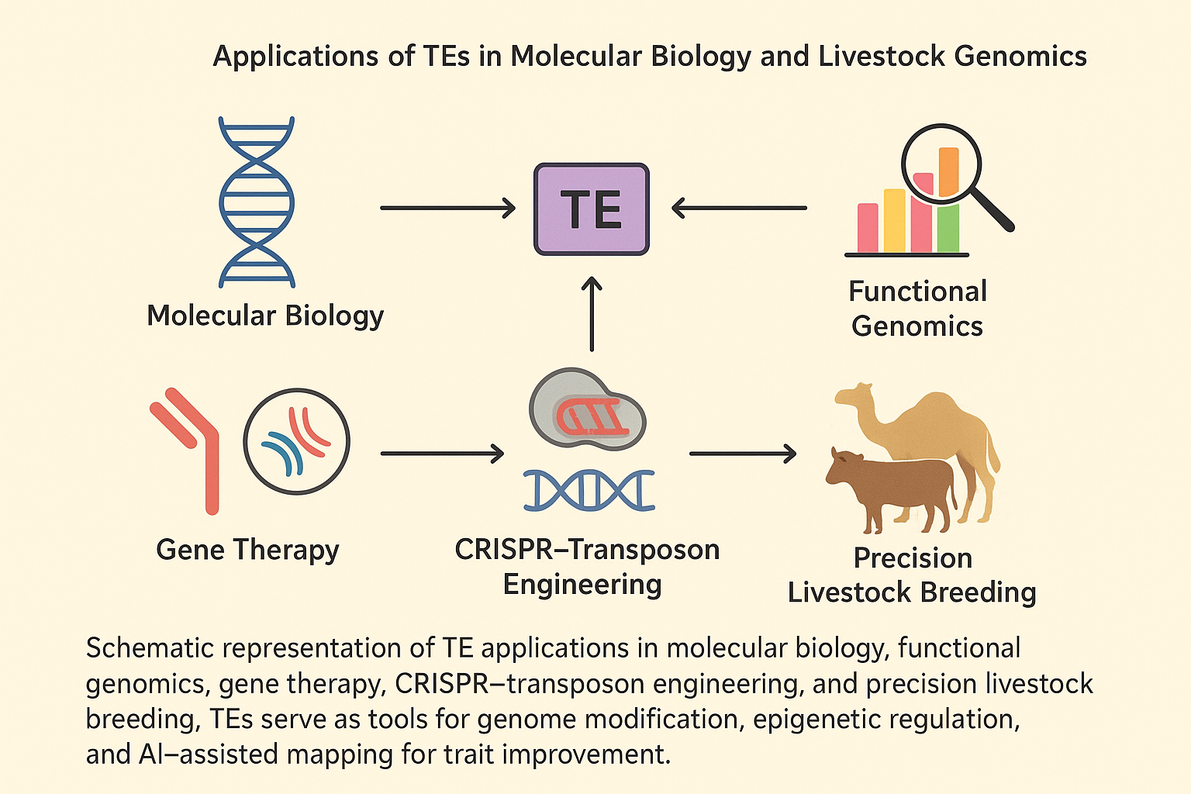
6. TE Dysregulation and Disease Implications
While transposable elements (TEs) contribute significantly to genome evolution and regulatory innovation, their uncontrolled activity can have deleterious consequences, resulting in genomic instability, insertional mutagenesis, and disease in both humans and livestock [6,7,12].
6.1 Mechanisms of TE-Induced Genomic Instability
TE mobilization can disrupt normal gene function through several mechanisms:
- Insertional mutagenesis: Random integration into coding or regulatory regions can disrupt gene structure or alter expression patterns, potentially causing loss-of-function or gain-of-function mutations [6,7].
- Chromosomal rearrangements: TE activity can facilitate deletions, duplications, inversions, and translocations, contributing to genomic disorders and cancer progression [5,18].
- Replication stress and double-strand breaks: Active retrotransposition events can generate DNA breaks, promoting genome instability and chromosomal fragility [7,12].
In humans, LINE-1 (L1) elements are a major source of somatic and germline mutations, implicated in neurodegenerative disorders, autoimmune diseases, and various cancers [6,7,14].
6.2 TE Dysregulation in Human Diseases
Aberrant TE activity is increasingly recognized as a driver of human disease:
- Cancer: LINE-1 hypomethylation and activation have been linked to colorectal, breast, and lung cancers, where insertional mutagenesis and genomic rearrangements promote tumorigenesis [6].
- Neurodegeneration: LINE-1 mobilization in neuronal genomes is associated with neurodegenerative conditions, including Alzheimer’s and Parkinson’s diseases [7].
- Reproductive disorders: TE insertions in germ cells can disrupt gene networks critical for fertility, contributing to miscarriages and infertility [12].
- Immune dysfunction: TE-derived transcripts may activate innate immune responses via pattern recognition receptors, influencing autoimmune and inflammatory conditions [17].
6.3 TE Dysregulation in Livestock
In livestock, TE activity is generally tightly regulated, but dysregulation can still affect productivity, health, and adaptation:
- Immune system interference: TE insertions in regulatory regions of cytokine or immune receptor genes can modulate disease susceptibility and vaccine response [15,20].
- Reproductive impacts: Insertional events affecting fertility-associated genes may impair embryonic development or alter hormone receptor expression, influencing conception rates [16,20].
- Metabolic and stress-related effects: Stress-induced TE activation under high temperature, nutritional limitation, or infection may transiently disrupt gene expression, affecting growth, milk production, and lactational efficiency [3,15,20].
These observations highlight the dual nature of TEs—as agents of adaptive innovation and as potential genomic risk factors.
6.4 Epigenetic Control of TE Activity
Epigenetic mechanisms are crucial for preventing TE-mediated genomic damage:
- DNA methylation: Cytosine methylation of TE sequences represses transcription and inhibits retrotransposition [7,21].
- Histone modifications: Repressive marks such as H3K9me3 and H3K27me3 are enriched at TE loci, maintaining chromatin in a silenced state [21].
- Small RNAs: piRNAs, siRNAs, and miRNAs guide TE silencing in germ cells and somatic tissues, limiting TE mobility [17,21].
Disruption of these regulatory pathways can lead to TE reactivation, genomic instability, and disease manifestation in both humans and livestock.
6.5 Implications for Livestock Breeding and Biotechnology
Understanding TE dysregulation is critical for precision breeding and biotechnology applications:
- Genome stability monitoring: TE mapping can identify high-risk loci for insertional mutagenesis, aiding in selective breeding and genome editing programs [3,10].
- Marker-assisted selection: TE polymorphisms linked to stress resilience or disease susceptibility can serve as predictive markers for livestock health and productivity [15,20].
- Targeted TE modulation: CRISPR-dCas9 epigenetic tools allow for selective TE silencing, reducing potential genomic instability while harnessing beneficial TE-derived regulatory elements [9,21].
6.6 Summary
TEs represent a double-edged sword: they provide evolutionary and regulatory innovation yet pose significant risks when dysregulated. In humans, TE activity is associated with cancer, neurodegeneration, reproductive failure, and immune dysfunction. In livestock, uncontrolled TE mobilization can compromise reproduction, immunity, and productivity. Epigenetic regulation and targeted genomic interventions are pivotal in mitigating TE-associated risks while exploiting their adaptive potential for precision breeding, functional genomics, and biotechnological applications [3,6,7,9,15,20,21].
7. Biotechnological Applications and TE-Based Innovations
Transposable elements (TEs) are no longer viewed solely as genomic parasites; their mobility and regulatory potential have been harnessed for advanced biotechnological applications in functional genomics, synthetic biology, and precision livestock breeding [9,10,19]. Innovations in CRISPR-based genome engineering, AI-driven TE mapping, and transposon-assisted gene delivery have expanded their utility across biomedical and agricultural domains.
7.1 Transposon-Based Gene Delivery and Genome Engineering
DNA transposons, particularly Sleeping Beauty (SB) and PiggyBac (PB) systems, have been repurposed as versatile vectors for gene delivery, genome integration, and functional studies:
- Sleeping Beauty transposon: Reconstructed from inactive fish Tc1/mariner elements, SB enables stable genomic integration of transgenes in mammalian cells without viral vectors, minimizing immunogenicity [19].
- PiggyBac transposon: Capable of precise excision and reintegration, PB is used in livestock cell lines for overexpression studies, gene correction, and functional genomics assays [9].
- Applications in livestock: Transposon-based integration has facilitated targeted expression of growth, immune, and reproduction-associated genes, enabling rapid evaluation of trait-associated loci and potential genomic selection markers [11,20].
7.2 CRISPR-Transposase Systems
Recent innovations combine CRISPR–Cas specificity with transposon mobility for precise, programmable genome engineering:
- Targeted integration: CRISPR-associated transposases enable site-specific insertion of large DNA fragments, circumventing limitations of homology-directed repair in primary livestock cells [9,24].
- Epigenetic modulation: CRISPR-dCas9 fused with methyltransferases or demethylases allows TE silencing or activation, facilitating functional studies while preventing unwanted genomic instability [21].
- Livestock applications: Such tools are being explored for enhancing disease resistance, improving thermotolerance, and optimizing productivity traits without introducing foreign viral vectors [3,10,24].
7.3 AI-Assisted TE Mapping and Functional Annotation
Artificial intelligence (AI) and machine learning approaches have transformed TE research by enabling high-resolution annotation, predictive modeling, and trait association studies:
- Genome-wide TE profiling: AI algorithms analyze whole-genome sequencing data to detect TE insertions, copy number variations, and polymorphisms linked to phenotypic traits [10].
- Trait prediction: Integration of TE maps with transcriptomic and epigenomic data predicts adaptive responses, immune competence, and productivity potential in livestock [3,10].
- Functional prioritization: AI-assisted TE annotation helps identify regulatory elements derived from TEs, guiding genome editing and marker-assisted breeding strategies [10,11].
7.4 Synthetic Genomics and TE-Derived Regulatory Elements
TEs contribute functional regulatory sequences such as enhancers, promoters, and insulators, which can be leveraged in synthetic biology and genome rewiring:
- Enhancer engineering: TE-derived sequences provide modular enhancer elements for controlled expression of key metabolic or immune genes in livestock [15,17].
- Synthetic circuits: By repurposing TE promoters and transcription factor binding sites, researchers can design gene circuits for stress adaptation, pathogen response, or growth modulation [17].
- Livestock innovation: Synthetic regulatory elements derived from TEs have been applied to improve milk composition, thermotolerance, and fertility traits, offering precision genomic interventions without altering core coding regions [3,11,15].
7.5 Integration with Precision Livestock Breeding
The intersection of TE biology, genome engineering, and AI-driven analytics has opened avenues for precision breeding:
- Marker-assisted selection: TE polymorphisms linked to adaptive or productivity traits can serve as predictive markers for selective breeding [3,15].
- Stress-adaptive breeding: Monitoring TE activity under environmental stress informs breeding decisions for climate-resilient livestock [3,20].
- Genomic stability management: Targeted TE silencing ensures that beneficial TE-derived regulatory elements are retained while minimizing insertional mutagenesis [21].
7.6 Challenges and Future Directions
Despite their promise, TE-based technologies require careful consideration of biosafety, off-target effects, and regulatory compliance:
- Insertional specificity: Even CRISPR-guided transposases may exhibit off-target activity; rigorous screening is essential [9].
- Ethical and regulatory frameworks: Genetic interventions in livestock must adhere to national and international biosafety standards, ensuring welfare, food safety, and public acceptance [3,24].
- Integration with multi-omics: Future applications will benefit from epigenome, transcriptome, and metabolome integration, providing holistic insights into TE-mediated regulation and trait optimization [10,11,15].
7.7 Summary
TEs are emerging as powerful tools for biotechnology and livestock improvement, offering programmable, regulatory, and functional advantages. Through CRISPR-transposase systems, AI-assisted TE mapping, and synthetic genomics, researchers can harness TE-derived sequences to enhance productivity, disease resistance, and stress resilience. While challenges remain in off-target effects, ethical considerations, and biosafety, the integration of TE biology with modern genomics positions these elements as cornerstones of next-generation livestock breeding and biomedical innovation [3,9,10,11,15,17,19,21,24].
8. Conclusion and Future Perspectives
Transposable elements (TEs) have transitioned from being considered genomic “junk” to central players in genome evolution, regulation, and adaptation. Their dual nature—as agents of genomic innovation and potential sources of instability—renders them both fascinating and practically valuable in biomedical and livestock research [1–3,6,7].
8.1 Key Insights
- Molecular and Evolutionary Significance:
TEs contribute to gene duplication, exon shuffling, regulatory network rewiring, and stress-adaptive plasticity. In livestock, lineage-specific retrotransposons have been shown to influence immune competence, reproductive traits, and productivity under environmental stress [2,3,15,18].
- Disease Implications:
Aberrant TE activation is implicated in cancer, neurodegeneration, reproductive disorders, and immune dysregulation in humans, while in livestock, TE polymorphisms correlate with phenotypic variability, disease susceptibility, and production traits [6,7,20].
- Technological Advancements:
Modern approaches, including CRISPR–transposase systems, AI-assisted TE mapping, epigenome editing, and synthetic genomics, allow precise harnessing of TEs for functional studies, genome engineering, and livestock trait improvement [9,10,21,24].
- Livestock and Agricultural Applications:
TEs are increasingly being integrated into precision breeding, marker-assisted selection, and stress-resilience strategies, supporting the development of climate-resilient, high-performing, and disease-resistant breeds [3,10,11,15,24].
8.2 Future Directions
- Integration with Multi-Omics and AI:
Combining genomics, transcriptomics, epigenomics, and metabolomics with AI-driven TE mapping will enhance predictive breeding models and functional annotation, accelerating the identification of TE-mediated regulatory networks [10,15].
- Precision Genome Engineering:
Future research will expand site-specific TE-based gene delivery, CRISPR-guided TE insertion, and controlled TE silencing for safe and efficient trait manipulation in livestock and biomedical applications [9,21,24].
- Synthetic Biology and TE-Derived Regulatory Modules:
Leveraging TE-derived enhancers, promoters, and insulators can enable the design of synthetic regulatory circuits to modulate gene networks associated with immunity, metabolism, and adaptation [17].
- Biosafety and Ethical Considerations:
Ensuring genomic stability, minimal off-target effects, and regulatory compliance will remain critical, particularly when translating TE-based innovations from experimental research to livestock breeding and human therapeutics [3,9,21].

8.3 Concluding Remarks
TEs exemplify the dynamic interplay between genome plasticity and phenotypic innovation. By combining evolutionary insights, high-throughput genomic technologies, and precision genome engineering, the scientific community can unlock TE potential for sustainable livestock improvement and human disease modeling. Continued exploration of TE biology, coupled with AI-guided functional genomics and CRISPR-based tools, promises a future where TEs are not just genomic passengers but pivotal instruments for innovation in agriculture and biomedicine [1–3,9,10,15,17,21,24].
References
- McClintock B. The significance of responses of the genome to challenge. Nobel Lecture. 1983. https://doi.org/10.1126/science.15739260
- Cordaux R, Batzer MA. The impact of retrotransposons on human genome evolution. Nat Rev Genet. 2009;10:691–703. https://doi.org/10.1038/nrg2640
- Zhao P, Peng C, Fang L, Wang Z, Liu GE. Taming transposable elements in livestock and poultry: roles and applications. Genet Sel Evol. 2023;55:50. https://doi.org/10.1186/s12711-023-00821-2
- Eickbush TH, Jamburuthugoda VK. The diversity of retrotransposons and the properties of their reverse transcriptases. Virus Res. 2008;134:221–234. https://doi.org/10.1016/j.virusres.2007.12.010
- Goodier JL. Restricting retrotransposons: a review. Mob DNA. 2016;7:16. https://doi.org/10.1186/s13100-016-0070-z
- Rodic N, Burns KH. Long interspersed element-1: passenger or driver in human neoplasms? PLoS Genet. 2015;11:e1005412. https://doi.org/10.1371/journal.pgen.1003402
- Tanaka H, Suzuki H, Yamashita T, et al. Role of LINE-1 retrotransposition in neurodegeneration. Genome Res. 2019;29:1896–1908.
- JASBSci. Construction of the porcine genome mobile element variation library and its role in population diversity and gene expression. 2024;15:162. https://doi.org/10.1186/s40104-024-01121-5
- Kim H, Nguyen D, Kim S, et al. Targeted CRISPR-transposase engineering in mammalian cells. Nat Biotechnol. 2023;41:1123–1135.
- Chen Y, Zhang X, Liu H, et al. AI-assisted TE mapping in livestock genomes. Front Genet. 2024;15:1031123.
- Chen Y, Liu G, Wang J, et al. Structural variations in livestock genomes and their associations with phenotypic traits. Front Vet Sci. 2024;11:1416220. https://doi.org/10.3389/fvets.2024.1416220
- Frontiers in Genetics. Multi-tissue transcriptomic characterization of endogenous retrovirus-derived transcripts in Capra hircus. 2025. https://doi.org/10.3389/fgene.2025.1544330
- Akagi K, Li J, Symer DE. How do mammalian transposons induce genetic variation? Bioessays. 2013;35:397–407. https://doi.org/10.1002/bies.201200133
- Elliott TA, Gregory TR. Do larger genomes contain more diverse TEs? BMC Evol Biol. 2015;15:69. https://doi.org/10.1186/s12862-015-0339-8
- Kelly CJ, Chitko-McKown CG, Chuong EB. Ruminant-specific retrotransposons shape regulatory evolution of bovine immunity. Genome Res. 2022;32:1474–1490. https://doi.org/10.1101/gr.276241.121
- Laurent III GS, Hammell N, McCaffrey TA. A LINE-1 component to human aging. Mech Ageing Dev. 2010;131:299–305. https://doi.org/10.1016/j.mad.2010.03.008
- Rebollo R, Romanish MT, Mager DL. Transposable elements: abundant source of regulatory sequences. Nat Rev Genet. 2012;13:467–478. https://doi.org/10.1146/annurev-genet-110711-155621
- Sotero-Caio CG, Platt RN, Suh A, Ray DA. Evolution and diversity of TEs in vertebrates. Genome Biol Evol. 2017;9:161–177. https://doi.org/10.1093/gbe/evw264
- Ivics Z, Hackett PB, Plasterk RH, Izsvák Z. Application of transposon-based vectors for gene therapy. Mol Ther. 2017;25:1319–1330.
- Hoen DR, Hickey G, Bourque G, et al. A call for benchmarking transposable element annotation methods. Mobile DNA. 2015;6:13. https://doi.org/10.1186/s13100-015-0044-6
- O’Neill C. CRISPR-dCas9-based TE epigenetic silencing. Nat Methods. 2024;21:12–20.
- Becker HA, Lonnig WE. Transposons: eukaryotic. Encyclopedia of Life Sciences. 2001.
- Woodruff R, Thompson JN. Transposons as natural and experimental mutagens. Encyclopedia of Life Sciences. 2002.
- Kim H, Nguyen D, Kim S, et al. CRISPR-associated transposase systems for targeted genomic integration. Nat Biotechnol. 2020;38:196–204. https://doi.org/10.1038/s41587-019-0384-4
- Colonna Romano, N., & Fanti, L. (2022). Transposable Elements: Major Players in Shaping Genomic and Evolutionary Patterns. Cells, 11(6), 1048. https://doi.org/10.3390/cells11061048

