Impact of Frontline Demonstrations on Organic Paddy Cultivation in ASR District, Andhra Pradesh

ABSTRACT
Krishi Vigyan Kendra, Kondempudi conducted Front Line Demonstrations (FLDs) on organic paddy cultivation in different villages of ASR district to compare the yield and economic returns of recommended organic practices with traditional farmer methods, where only farmyard manure (FYM) was applied. In the demonstration fields, farmers followed the organic Package of Practices developed by Acharya N.G. Ranga Agricultural University. In contrast, traditional fields received a single application of FYM at 6.25 t/ha, without any other organic inputs. The results, based on three years of pooled data, showed that the demonstration fields achieved a higher yield of 34.2 q/ha, net income of ₹40,790/ha, and a benefit-cost ratio of 2.12, compared to traditional practices. The lower yield and income in traditional methods were mainly due to the insufficient nutrient supply from FYM alone, which could not meet the crop’s full nutrient requirements.
Keywords: Paddy, Front Line Demonstration, Organic and Traditional Farmer Practices, Yield and Economics

Introduction

Rice (Oryza sativa L.) is a staple food for over half the global population, with the highest consumption in Asia. As population growth and changing dietary patterns increase rice demand, sustainable production practices become critical. In India, states like West Bengal, Uttar Pradesh, Punjab, Andhra Pradesh, Tamil Nadu, Bihar, Odisha, and Chhattisgarh contribute over 70% of national paddy production (Singh et al., 2021). However, intensive rice farming reliant on synthetic fertilizers and pesticides has raised concerns over soil degradation, food safety, environmental harm, and public health. In response, organic and natural farming systems are gaining attention. These practices emphasize ecological balance, soil health, and nutritional quality while minimizing chemical use. Organic inputs such as compost, farmyard manure (FYM), green manure, and vermicompost enrich soil biodiversity, support beneficial microorganisms, and improve nutrient cycling and crop resilience (Sharma A.K., 2006). Compared to conventional methods, organic systems offer safer food, better soil structure, and enhanced resistance to pests and climate extremes.
The Alluri Sitarama Raju (ASR) district, located in the hilly tribal belt of Andhra Pradesh, offers a unique opportunity for organic agriculture. Farming here is largely organic by default due to minimal use of agrochemicals and strong traditional knowledge systems. In mandals like Hukkumpeta, Araku, Dumrriguda, Pedabayalu, Anantagiri, and Munchingput, tribal farmers practice mixed cropping, rainfed cultivation, and use locally available inputs such as FYM and forest litter though often without structured agronomic guidance. This region presents a strong foundation for the formal adoption of organic farming through certification, training, and market linkage. Evidence suggests that optimizing organic inputs can sustain or even improve yields while preserving soil fertility (Stockdale et al., 2001). With targeted interventions, ASR district can emerge as a model for sustainable tribal agriculture.
In light of these multifaceted benefits and contextual factors, the present study is undertaken to promote organic farming in tribal areas through appropriate, evidence-based recommendations. The goal is to enhance agricultural productivity particularly in paddy cultivation by introducing integrated organic practices that go beyond the sole application of Farm Yard Manure (FYM), which is currently the primary input used by tribal farmers. By optimizing organic inputs and improving soil health, the proposed interventions are expected not only to improve crop yields but also to contribute positively to the environment, human health, cultural preservation, and the local economy.
Materials and Methods: Krishi Vigyan Kendra, Kondempudi has conducted 30 front line demonstrations in 12 ha area on farmer’s field in different villages of ASR district from 2022 to 2024. In front line demonstrated field, the paddy crop was sown with a variety of RGL-2537 and treatments of T1: Organic farming package of ANGRAU (T₁ : Organic farming (Seed treatment with Pseudomonas fluorescence @ 10 g/ kg of seed first and shade dry for few hours. Basal application: Raising green manure crop with a seed rate of 15 kg per acre and in situ incorporation at 50% flowering stage before transplanting. Application of farm yard manure (FYM) @ 10.0 t per hactare at the time of planting. Application of Azospirillum, PSB and KRB @ 1250 ml per ha each, along with 100 kg FYM at the time of planting. Top dressing: Neemcake @ 500 kg per hectare at tillering and Pl stage. Soil application of Drava Jeevamrutham (500 L per hactare) three times from 15 DAT at 20 days interval and T2: farmers practice (FYM @ 6.25 t/ha). Soils condition of ASR district was red loamy in texture with low to medium in organic carbon content and other nutrients like Nitrogen, Phosphorous, and High in Potassium. In front line demonstrated fields; Seeds were sown as nursery after seed treatment and transplant only healthy seedlings in the field at 30 days old. All the organic package was imposed as per information mentioned in Package of Practices in paddy field as per. The output data like growth attributes, yield attributes , expenditure, profit, yield etc were collected from farmers grow paddy under demonstrated field as well as farmer grown paddy under traditional farming practices to compare the gap between the technologies. Finally, the Technology gap, Extension gap, Technology index along with B:C ratio were analysed by the formulas as given by (Katare et al. 2011) and (Samui et al. 2000).
Results and Discussion:
Effect of Organic Package of ANGRAU on Growth, Yield Components, and Yield
30 Front line demonstration on organic farming paddy were shown on farmers field in 12ha areas during three consecutive years i.e., 2022-23, 2023-24 and 2024-25. In demonstration field, farmers follows all the cultural and management practices from nursery sowing of paddy crop to final harvest in their field as mentioned in organic Package of Practices like Pseudomonas fluorescence @ 10 g/ kg of seed first and shade dry for few hours. Basal application: Raising green manure crop with a seed rate of 15 kg per acre and in situ incorporation at 50% flowering stage before transplanting. Application of farm yard manure (FYM) @ 10.0 t per hectare at the time of planting. Application of Azospirillum, PSB and KRB @ 1250 ml per ha each, along with 100 kg FYM at the time of planting. Top dressing: Neemcake @ 500 kg per hectare at tillering and Pl stage. Soil application of Drava Jeevamrutham (500 L per hectare) three times from 15 DAT at 20 days interval. The application of the organic package developed by ANGRAU had a significant influence on growth parameters, yield components, and overall yield when compared to the sole application of farmyard manure (FYM), as shown in Table 1. Growth parameters such as plant height and number of tillers per hill were recorded at 30-day intervals. In the frontline demonstration plots, the average plant height was 50.7 cm at 30 days after transplanting (DAT), 90.8 cm at 60 DAT, 114.4 cm at 90 DAT, and 113.6 cm at harvest. In contrast, under farmers' practice, the corresponding values were lower, recorded at 42.6 cm, 82.5 cm, 101.3 cm, and 100.3 cm, respectively. With record to Yield components were measured at harvest and included the number of productive tillers per hill, number of grains per panicle, and panicle length. In the demonstration plots, the average number of productive tillers per hill was 12.5, with 252 grains per panicle and a panicle length of 24.5 cm. Under farmers' practice, the averages were 7.9 productive tillers per hill, 218 grains per panicle, and a panicle length of 24.4 cm. The organic input package demonstrated a positive impact on both growth and yield attributes compared to the application of FYM alone. This improvement could be attributed to the higher concentration of macro- and micronutrients, as well as the steady and continuous release of nutrients provided by the organic package. The consistent nutrient supply likely enhanced tillering ability and improved the conversion rate of total tillers into productive tillers, ultimately leading to a greater number of panicles per square meter. These findings are in line with the results reported by Sangeetha et al. (2010) and Ananda et al. (2006).
Table:1 Growth parameters and yield attributing parameters in between Front Line Demonstration and Farmer’s Practices.
Treatments | At 30 DAT |  | At 60 DAT |  | At 90 DAT
Treatments | Plant height (cm) | No.of Tillers/hill (No.) | Plant height (cm) | No.of Tillers/hill (No.) | Plant height (cm) | No.of Tillers/hill (No.)
T₁:Organic farming method (ANGRAU) | 50.7 | 9.1 | 90.8 | 14.7 | 114.4 | 14.0
T₂: Farmers’ practice (use of FYM 6.25 t/ha) | 42.6 | 6.4 | 82.5 | 8.6 | 101.3 | 8.1
Treatments | At harvest
Treatments | Plant height (cm) | No.of Tillers/hill (No.) | No.of productive tillers/ hill (No.) |  | No. of grains/ panicle (No.) | Panicle Length (cm)
T₁:Organic farming method (ANGRAU) | 113.6 | 13.0 | 12.5 |  | 252 | 24.5
T₂ : Farmers’ practice (use of FYM 6.25 t/ha) | 100.3 | 8.0 | 7.9 |  | 218 | 24.4
Yield Performance and Impact of the Organic Package of ANGRAU
The three-year study results, presented in Table 2, demonstrate the positive impact of the organic package developed by ANGRAU on paddy yield when compared to traditional farmers' practice (sole application of FYM). In the frontline demonstration plots, the paddy yield recorded was 28.5 q/ha, 33.6 q/ha, and 40.4 q/ha during the agricultural years 2022–23, 2023–24, and 2024–25, respectively. In contrast, under the farmers’ practice, yields were consistently lower at 22.5 q/ha, 25.3 q/ha, and 31.6 q/ha across the corresponding years. An analysis of the data revealed that the application of ANGRAU’s organic package led to per cent yield improvements of 26.3%, 33.0%, and 27.7% over farmers' practice during 2022–23, 2023–24, and 2024–25, respectively. These results clearly highlight the effectiveness of the integrated organic nutrient management approach advocated in the ANGRAU package.
The consistent yield advantage observed in the demonstration fields can be attributed to several key factors. Firstly, the organic package ensured a balanced and continuous supply of both macro- and micronutrients throughout the crop growth cycle. Unlike the sole application of FYM, which may release nutrients slowly and in lower quantities, the comprehensive organic package included a combination of nutrient sources that provided both immediate and sustained nutrient availability. This steady nutrient supply supported critical physiological processes such as tillering, panicle initiation, flowering, and grain filling, leading to overall better crop performance. Secondly, the improvement in soil physical properties, such as increased water-holding capacity, better aeration, and enhanced microbial activity due to the application of organic inputs, may have played a crucial role. Healthier soil conditions promote stronger root development, which improves nutrient and water uptake efficiency, directly influencing plant vigor and productivity. Furthermore, the adoption of good cultural management practices, such as timely sowing, proper plant spacing, regular weeding, pest and disease management, and efficient irrigation scheduling, as part of the demonstration package, contributed significantly to the yield enhancement.
The findings of the study are in agreement with earlier research by Sangeetha et al. (2010), Ananda et al. (2006), and more recently S.K. Dutta et al. (2024), who also reported that the application of multiple organic nutrient sources, combined with best agronomic practices, leads to significant improvements in crop growth, yield components, and final yield. Their studies similarly emphasized that organic farming systems, when managed effectively, can achieve yields comparable to or even surpassing those of conventional systems, especially over the long term due to improvements in soil health.
Technology Gap, Extension Gap, and Technology Index:
The technology gap during the three-year study period varied from 4.6 to 16.5, with specific values of 16.5 in 2022–23, 11.4 in 2023–24, and 4.6 in 2024–25 and presented in table.2 . Similarly, the extension gap ranged from 5.9 to 8.8 q/ha, recorded as 5.9 in 2022–23, 8.4 in 2023–24 and 8.8 in 2024–25. The observed technology and extension gaps among farmers were primarily attributed to a lack of awareness and knowledge regarding improved organic production practices for paddy cultivation. These gaps can be effectively minimized by organizing frontline demonstration programs on farmers' fields, which significantly enhance farmers' technical knowledge and adoption levels, as reported by Beigh et al. (2015). The average technology index across the three years was 24.0%, with yearly variations of 36.6% in 2022–23, 25.2% in 2023–24 and 10.2% in 2024–25. A lower technology index indicates higher feasibility and better adaptability of the demonstrated technology under field conditions.
The persistent gaps were mainly due to the traditional farming practices prevalent among tribal farmers, who typically cultivated paddy without the application of sufficient nutrient sources and proper agronomic practices. The exclusive reliance on FYM, without supplementation by other organic inputs, resulted in inadequate nutrient availability during critical crop growth stages, leading to reduced yields. The yield gap between potential and demonstration plots is thus largely explained by the combined impact of extension and technology gaps. To bridge these gaps, farmers must be educated on improved technologies through strengthened technology transfer mechanisms and the establishment of farmer education centres, as emphasized by Mandavkar et al. (2012)

Table: 2. Comparison of Yield, % increase over farmers practices, technology gap, extension gap and technology index in between Front Line Demonstration and Farmer’s Practices.
Year | No .of farmers | Area | Yield (q/ha) |  |  | % increase Yield Over farmers Practice | Technology gap | Extension Gap | Technology Index
Year | No .of farmers | Area | PY | DY | FP
2022-2023 | 10 | 4 | 45 | 28.5 | 22.5 | 26.3 | 16.5 | 5.9 | 36.6
2023-2024 | 10 | 4 | 45 | 33.6 | 25.3 | 33.0 | 11.4 | 8.4 | 25.2
2024-2025 | 10 | 4 | 45 | 40.4 | 31.6 | 27.7 | 4.6 | 8.8 | 10.2
Total/Mean | 30 | 12 | 45 | 34.2 | 26.5 | 29.0 | 10.8 | 7.7 | 24.0
PY: Potential Yield, DY: Demonstration Yield and FP: Farmers Practice
Economics of Frontline Demonstrations versus Traditional Farmers’ Practices
The comparative economic analysis between frontline demonstrations and traditional farmers’ practices, as presented in Table 3, revealed a distinct economic advantage in favor of the demonstration plots. On average, the gross cost, gross return, and net return under the frontline demonstration fields were recorded as Rs. 37,486, Rs. 78,275, and Rs. 40,790 per hectare, respectively. In contrast, under traditional farmers' practices, the gross cost, gross return, and net return were comparatively lower, amounting to Rs. 32,552, Rs. 60,731, and Rs. 28,179 per hectare, respectively. Analyzing the results year-wise, in the frontline demonstration plots, the gross cost incurred was Rs. 28,675 during 2022–23, Rs. 38,640 during 2023–24, and Rs. 45,143 during 2024–25. On the other hand, in the farmers' practice fields, the gross cost was recorded at Rs. 23,567, Rs. 34,200, and Rs. 39,890 during the corresponding years. Although the input costs were marginally higher under demonstration fields, this was justified by the substantially greater gross and net returns observed. In terms of returns, the gross and net returns achieved in the demonstration fields were Rs. 68,448 and Rs. 39,773 during 2022–23, Rs. 73,458 and Rs. 34,818 during 2023–24, and Rs. 92,920 and Rs. 47,778 during 2024–25, respectively. Meanwhile, under traditional farmers’ practices, the gross and net returns were significantly lower, recorded at Rs. 54,192 and Rs. 30,625 during 2022–23, Rs. 55,230 and Rs. 21,030 during 2023–24, and Rs. 72,772 and Rs. 32,882 during 2024–25.
Table: 3 Gross cost, Gross return, Net return and B:C ratio in between Front Line Demonstration and Farmer’s Practices.
Year | Economics of Demonstration |  |  |  | Economics of Demonstration
Year | Gross Cost (Rs/ha) | Gross Returns (Rs/ha) | Net Returns (Rs/ha) | B:C Ratio (Rs/ha) | Gross Cost (Rs/ha) | Gross Returns (Rs/ha) | Net Returns (Rs/ha) | B:C Ratio (Rs/ha)
2022-2023 | 28675 | 68448 | 39773 | 2.4 | 23567 | 54192 | 30625 | 2.3
2023-2024 | 38640 | 73458 | 34818 | 1.9 | 34200 | 55230 | 21030 | 1.6
2024-2025 | 45143 | 92920 | 47778 | 2.1 | 39890 | 72772 | 32882 | 1.8
Mean | 37486 | 78275 | 40790 | 2.12 | 32552 | 60731 | 28179 | 1.91
Further, the Benefit-Cost (B:C) ratio, which is a vital indicator of the profitability of an agricultural intervention, was consistently higher in the frontline demonstration plots compared to the farmers' practice plots. In the demonstration plots, the B:C ratio was recorded as 2.4 during 2022–23, 1.9 during 2023–24, and 2.1 during 2024–25. In contrast, under farmers' practices, the B:C ratio was slightly lower, recorded at 2.3, 1.6, and 1.8 for the corresponding years. This clearly indicated that even though the gross cost of cultivation was slightly higher under demonstrations due to the adoption of improved organic technologies, the returns realized were much higher, making the demonstration plots economically more viable and attractive. Additionally, S.K. Dutta et al. (2024) observed that the use of integrated organic nutrient management practices not only improved soil health but also resulted in higher crop yields and better economic returns, thereby advocating for the widespread dissemination of such technologies among farming communities.
Conclusion :
The present study clearly demonstrates that the adoption of the ANGRAU organic package significantly outperformed the traditional farmers’ practice of using only farmyard manure (FYM) in terms of growth, yield attributes, productivity, and economic returns in paddy cultivation. The frontline demonstration plots consistently recorded higher plant height, more productive tillers per hill, greater panicle length, and a higher number of grains per panicle compared to the farmers’ practice, reflecting the beneficial effects of a balanced and steady supply of macro and micro nutrients provided by the organic package. Overall, the results underline the importance of adopting a holistic organic package rather than relying on a single input like FYM. The ANGRAU organic technology demonstrated not only the potential for higher yields but also offers a sustainable pathway for improving soil fertility and productivity over time, which is crucial for long-term agricultural sustainability.

References:
Ananda, M.G., Ananda, M.R., Reddy, V.C and Ajayakumar, M.Y. 2006. Influence of different organic sources on yield and its components and benefit cost ratio of paddy (Oryza sativa L.) and groundnut (Arachis hypogaea L.) in paddy – groundnut cropping system. Crop Research. 31 (3): 329-333. https://www.cabidigitallibrary.org/doi/full/10.5555/20063144372
Beigh, M.A., Rufaida Mi,r S Z A., Matoo, J.M. and Sibat, F.K. 2015. Impact analysis of front line demonstration of rice (Oryza sativa) on the yield, economics and farmer’s knowledge in temperate region of India. Scientific Research and Essays. 10(4): 449-455. https://doi.org/10.5897/SRE2015.6284
Katare, S., Pandey, S.K. and Mustafa, M. 2011. Yield gap analysis of Rapeseed-mustard through front line demonstrations. Agriculture Update. 6: 5-7. https://www.cabidigitallibrary.org/doi/full/10.5555/20133292720
Keelery S. Production volume of rice India FY 2010-2023; 2024. www.statistica. com Available:https://www.statista.com/statistic s/1140236/india-production-volume-of-rice.
Mandavkar, P.M., Sawant, P.A. and Mahadik. 2012. Evaluation of Front Line Demonstration traials on rice in raigad district of Maharashtra. Raj J Extn Edu 20: 4-6. http://www.rseeudaipur.org/wp-content/uploads/2013/02/023.pdf
M.K. Singh, Fateh Singh and Praduman Bhatnagar. (2021). Impact of front line demonstration over traditional farmers practice on short duration paddy. Int. J. Adv. Res. Biol. Sci. 8(5): 143-146.
Peng S B, Yang J C. 2003. Current status of the research on high yielding and high efficiency in resource use and improving grain quality in rice. Chin J Rice Sci, 17: 275–280. https://www.cabidigitallibrary.org/doi/full/10.5555/20033132361
Sangeetha, S.P., Balakrishna and Bhuvaneshswari, J. 2010. Organic nutrient sources on growth and yield of rice. Madras Agricultural Journal. 97 (7 9): 251-253. https://www.cabidigitallibrary.org/doi/full/10.5555/20113290006
Samui, S.K., Maitra, S., Roy, D.K., Mondal, A.K. and Saha, D. 2000. Evaluation on front line demonstration on groundnut (Arachis hypogea L.). J of Indian Soc of Coastal Agriculture Research. 18: 180-183.
Sharma AK. The potential of organic farming in drylands of India; 2006. https://orgprints.org/9844/
S.K. Dutta, Sarma, H. H., Saud, R. K., Konwar, M. J., Gogoi , B., Mahanta. S. and Pathak. K. 2024. Impact of Organic and Natural Farming Practices on Growth, Yield Attributes and Yield of Joha Rice. Journal of Scientific Research and Reports. 30, (6):302-309. 10.9734/JSRR/2024/v30i62045
Stockdale EA, Lampkin NH, Hovi M, Keatings R, Lennartsson EM, Macdonold DW, Padel S, Tattersall FH, Wolfe MS, Watson CA. Agronomic and environmental implications of organic farming systems. Advan. Agron. 2001;70:261-327.(8). https://doi.org/10.1016/S0065-2113(01)70007-7
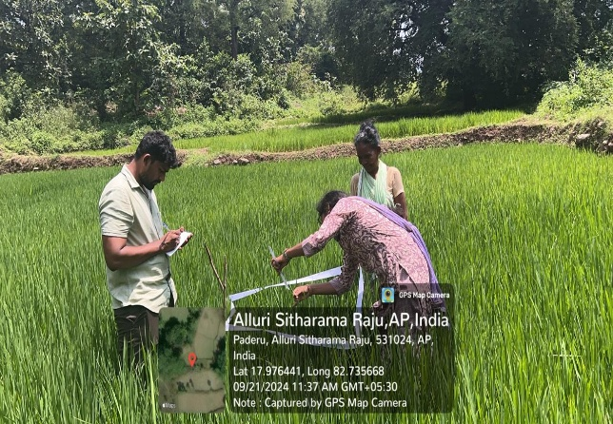 | 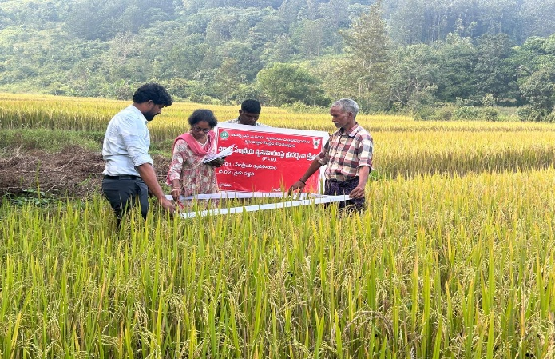
Plate:1 & 2 Recording of Bio-Metric Observations
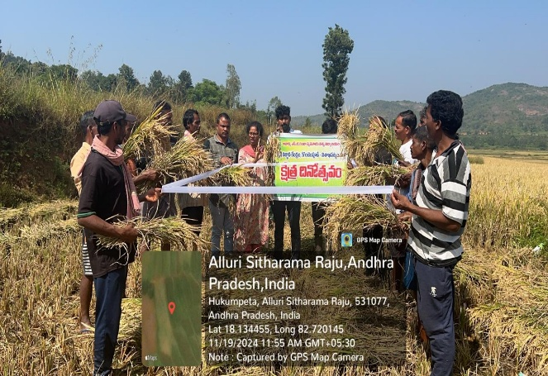 | 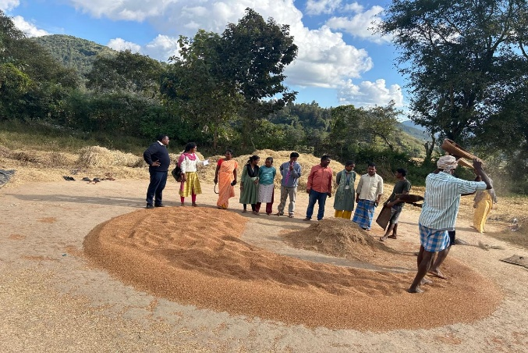
Plate : 3 Conducting field Day | Plate: 4 Involved in threshing operations

