Original Research Article

Physical bases of the distribution of Naja melanoleuca for sustainable aquaculture production in the Republic of Bénin

.
ABSTRACT

Aims: This study aimed to identify the physical and environmental determinants of the spatial distribution of Naja melanoleuca in southern Bénin and to evaluate how this spatial structure can inform sustainable aquaculture development. Specifically, the study examined whether cobra distribution patterns and hotspot clusters correlate with climatic variables and whether predictive mapping can support risk-based aquaculture planning.
Study Design: A cross-sectional ecological study integrating spatial statistics, environmental modeling, and geospatial prediction.
Place and Duration of Study: The research was conducted across 39 communes of southern Bénin between January and December 2024. Spatial analyses and modeling were performed at the Laboratory of Animals and Fisheries Sciences (LaSAH), National University of Agriculture, Bénin.
Methodology: Field records of N. melanoleuca encounters were compiled and georeferenced. Spatial structure was assessed using Global Moran’s I and the Getis-Ord Gi* statistic. Climatic variables (rainfall, vapour pressure, visibility, wind speed) were extracted from national datasets and integrated into a multiple regression model. Residual diagnostics (Shapiro–Wilk W = .98, p = .73) validated model assumptions. The final regression equation was projected in a GIS to generate a predictive abundance map. Model accuracy was evaluated by correlating predictions with independent field observations.
Results: Global Moran’s I showed spatial independence (I = .01, p > .05), but local Gi* analysis revealed significant clusters ranging from −2 to 1.95, with higher Z-scores concentrated in the southeast. A directional gradient was observed from northwest to southeast, matching climatic gradients. The predictive model explained a significant portion of spatial variability and correlated strongly with independent observations (r = .77). Predicted abundance declined from the southeast toward the northwest, identifying high-risk zones for aquaculture in the southeast.
Conclusion: Cobra distribution in southern Bénin is not random but environmentally structured. Predictive mapping offers a practical tool for minimizing predation risks, guiding site selection, and strengthening sustainable aquaculture development.

Keywords: Snake, fish production, spatial distribution, modeling, environmental factors, West Africa

1. INTRODUCTION
Aquaculture is an increasingly important contributor to food security, nutrition and rural livelihoods in West Africa, and national strategies have emphasized its expansion to offset stagnating capture fisheries and meet domestic protein demand (FAO, 2020). In Bénin, a diversity of smallholder and traditional systems (including floodplain “whédos” and earthen-pond production) constitute an important part of inland production, but these systems remain vulnerable to environmental change, disease and biological losses that reduce profitability (Dagoudo et al., 2024). Best-practice guidance for small-scale cage and pond farming highlights biosecurity, site selection and predator management as core measures to protect production and returns (Kassah, 2023).
A major, under-addressed constraint to profitable, sustainable aquaculture in West Africa is predation by wildlife (birds, mammals, reptiles) which can cause recurrent stock losses, increase labour and protection costs, and endanger workers (Otieno, 2019; Adelakun et al., 2015). In many small-scale systems, predator control remains ad hoc and reactive, producing only partial mitigation (Otieno, 2019). Among vertebrate predators recorded at aquaculture sites in southern Bénin, large elapid snakes commonly referred to as forest cobras (genus Naja) are frequently encountered and represent both economic and occupational-health concerns. Note that the Naja melanoleuca complex has recently been taxonomically revised, revealing cryptic diversity in West/Central Africa that can complicate distributional inference and management recommendations (Wüster et al., 2018).
Because predator impacts are spatially heterogeneous, reactive, farm-by-farm control is inefficient. Spatially explicit risk assessment (mapping hotspots of predator abundance or encounter probability) offers a practical route to targeted prevention: species-distribution and spatial-statistics methods (e.g., regression-based habitat models, hotspot/Getis-Ord Gi* mapping, and ensemble SDMs) have been successfully applied to medically important snakes and to wildlife-conflict problems elsewhere to prioritise monitoring and mitigation resources (Yousefi et al., 2020; Pintor et al., 2021; Martínez et al., 2024). Geospatial products that combine validated statistical models with field data are widely recommended for operational planning because they translate ecological relationships into management-ready maps (Pintor et al., 2021; Esri, 2024).
This study responds to a clear operational need in Bénin: to move predator management from reactive local fixes to spatially planned prevention. We therefore assessed the physical (climatic and landscape) correlates of Naja encounters at 748 aquaculture sites across southern Bénin (April 2022–April 2024), characterized the species’ spatial structure using centroid, standard deviational ellipse and local hotspot metrics, and built a predictive, GIS-mapped regression model linking abundance to environmental drivers. By combining field observations with spatial modelling and hotspot analysis, our objective was to produce a validated, user-oriented decision-support map that identifies high-risk zones for targeted mitigation enabling farmers, extension services and planners to prioritise protection measures and site selection to reduce losses and improve safety (Nyhus, 2016; FAO, 2020).

2. material and methods

2.1. Study Area
The study area is located in southern Bénin, between 1°35’ and 2°50’ east longitude and between 6°10’ and 7°42’’ north latitude. It is bordered to the north by the Collines Department, to the east by Nigeria, to the south by the Atlantic Ocean, and to the west by Togo. Covering an area of 17,440.26 km², it includes seven (7) departments: Atlantique, Littoral, Ouémé, Plateau, Mono, Couffo, and Zou (Fig. 1).
The entire hydrographic network of the study area is characterized by a web of temporary and permanent watercourses, as well as lakes and lagoons (Fig. 2). Temporary rivers are mainly located in the northern part of the study area, where surface runoff is strongly influenced by the Sudanian–Guinean rainfall regime. This means that many of these streams dry up or experience a significant reduction in flow during the dry season.
Permanent rivers, lakes, and lagoons, on the other hand, form the backbone of the hydrological system of the study area, providing a constant and vital water resource. Three major rivers define the area’s physiography: the Ouémé River (to the west), and the Mono and Couffo Rivers (to the east). Several lakes also dot the landscape, the most prominent being Lake Nokoué (which forms a hydrographic complex with the Cotonou and Porto-Novo lagoons to the southeast) and Lake Ahémé to the east. In addition, the presence of marshy zones is notable, especially in the southern part, indicating low-lying or confluence areas where water stagnates, essential for the local ecosystem and for certain agricultural practices (Figure 2).
In southern Bénin, temperature distribution (Fig. 3) is uneven, forming a south–north vertical gradient. The northern part represents the warmest zone, showing the highest mean temperatures (ranging from 27.47 °C to 27.6 °C). This region corresponds to inland areas where the moderating effect of the ocean is less perceptible, resulting in a more continental climate.
Around this central hot core, temperatures gradually decrease. A transition zone presents still relatively high values (from 27.24 °C to 27.46 °C), while more moderate temperatures (from 26.93 °C to 27.23 °C) occur on the peripheral margins. This relative moderation is particularly noticeable along the western border with Togo and in the extreme south, where the indirect influence of the Atlantic Ocean and the local topography (hills and plateaus) helps temper the climate (Fig. 3).
Relative humidity (Fig. 4) shows a spatial distribution pattern strongly influenced by proximity to the sea. The observed values indicate that the highest relative humidity (ranging from 80.57% to 83.18%) is concentrated exclusively in the extreme southern part of the study area. This zone directly benefits from humid air masses coming from the ocean, maintaining high humidity levels throughout the year. Moving northward, humidity gradually decreases. The central and northern parts of the study area thus display the lowest values (from 72.38% to 76.87%). This decrease is typical of continental effects: the farther one moves from the coast, the weaker the maritime influence becomes, resulting in lower relative humidity and a drier climate, especially during the dry season (Fig. 4).

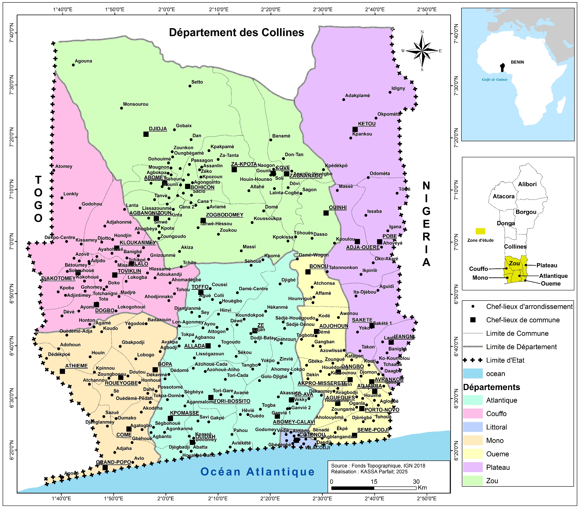
Fig. 1: Map of the study area

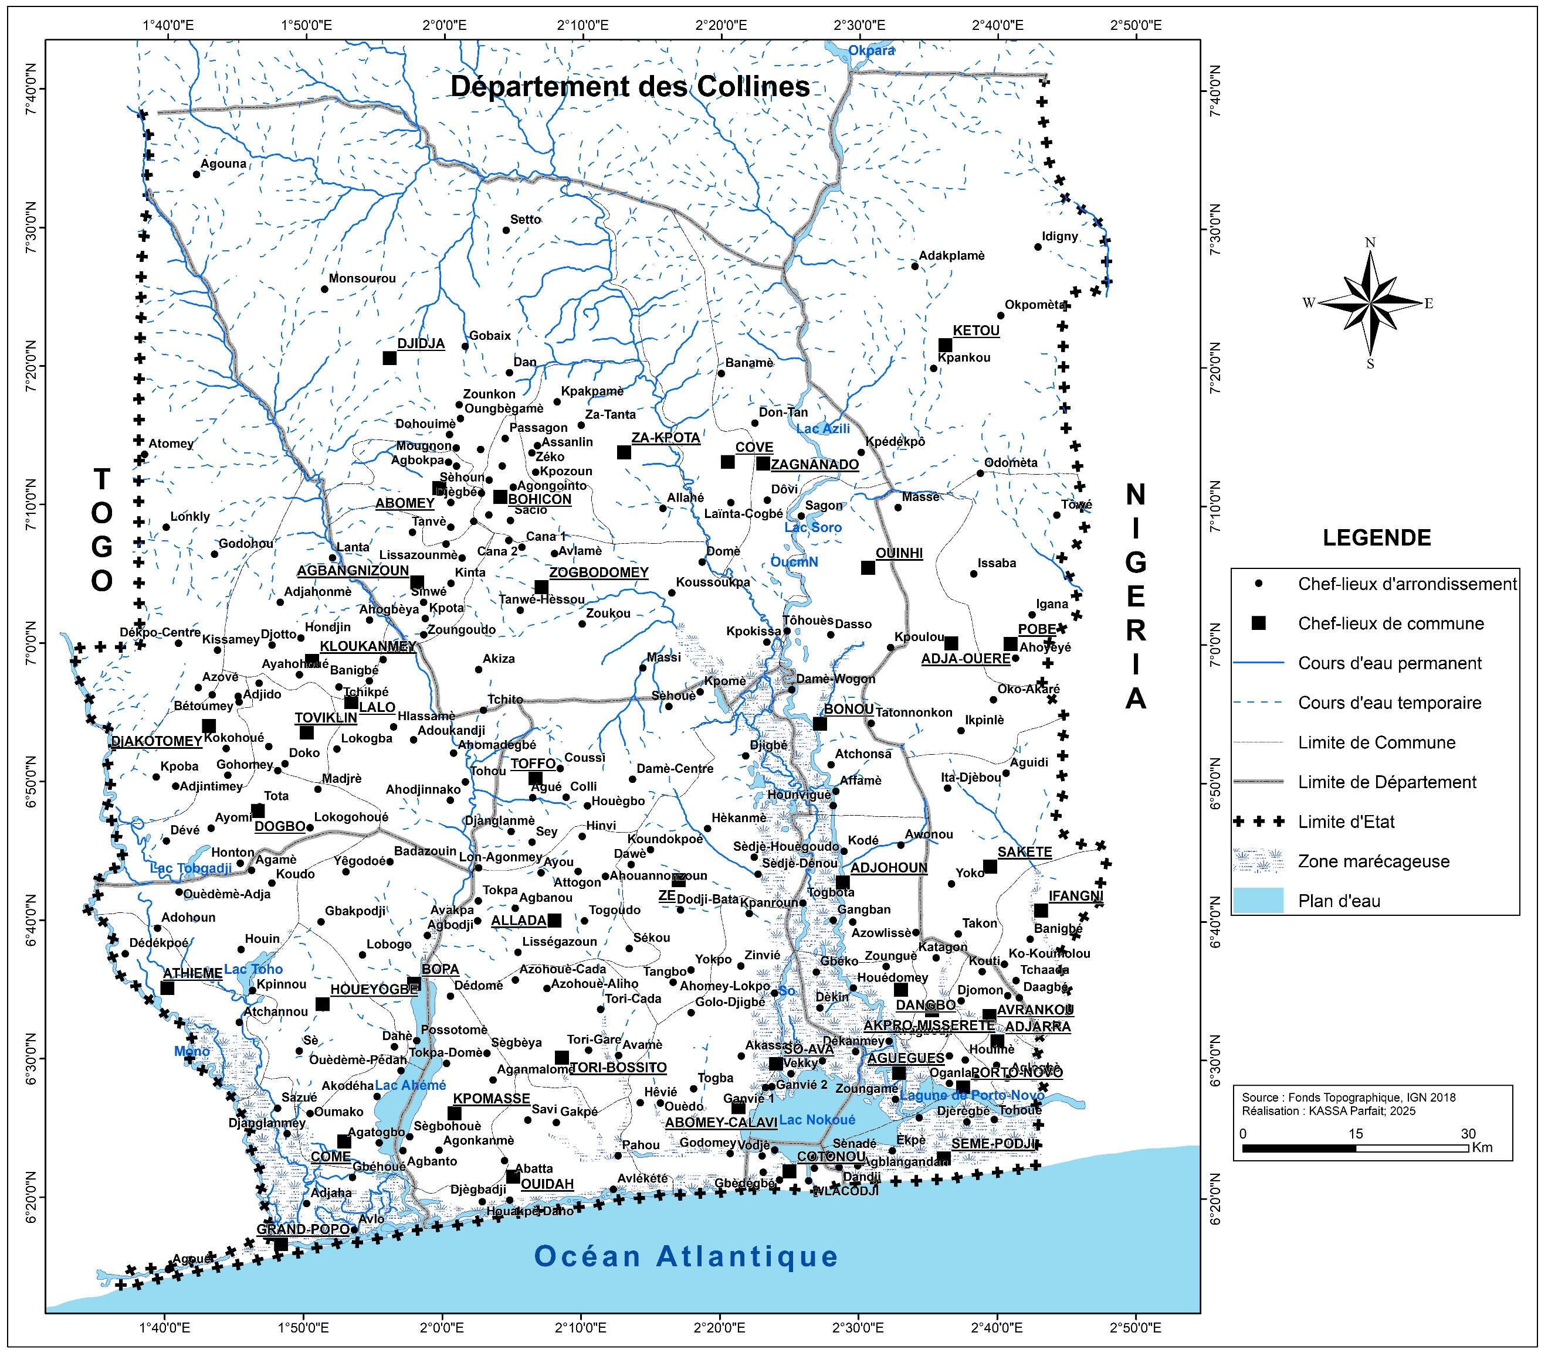
Fig. 2: Hydrographic network of the study area
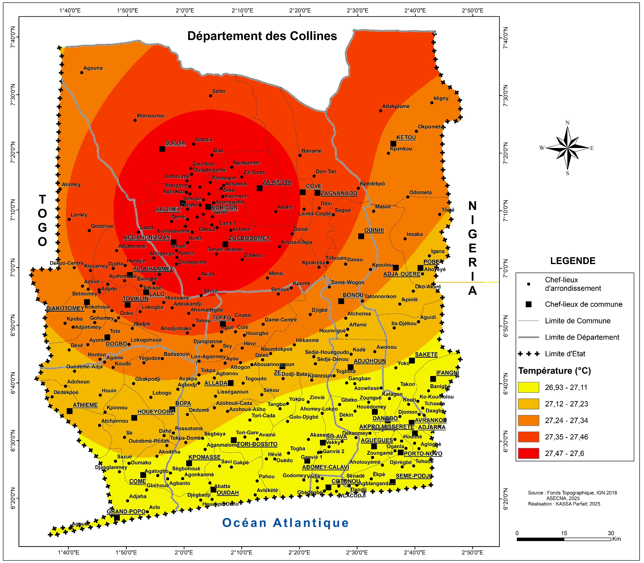

Fig. 3: Spatial distribution of ambient temperature in southern Bénin

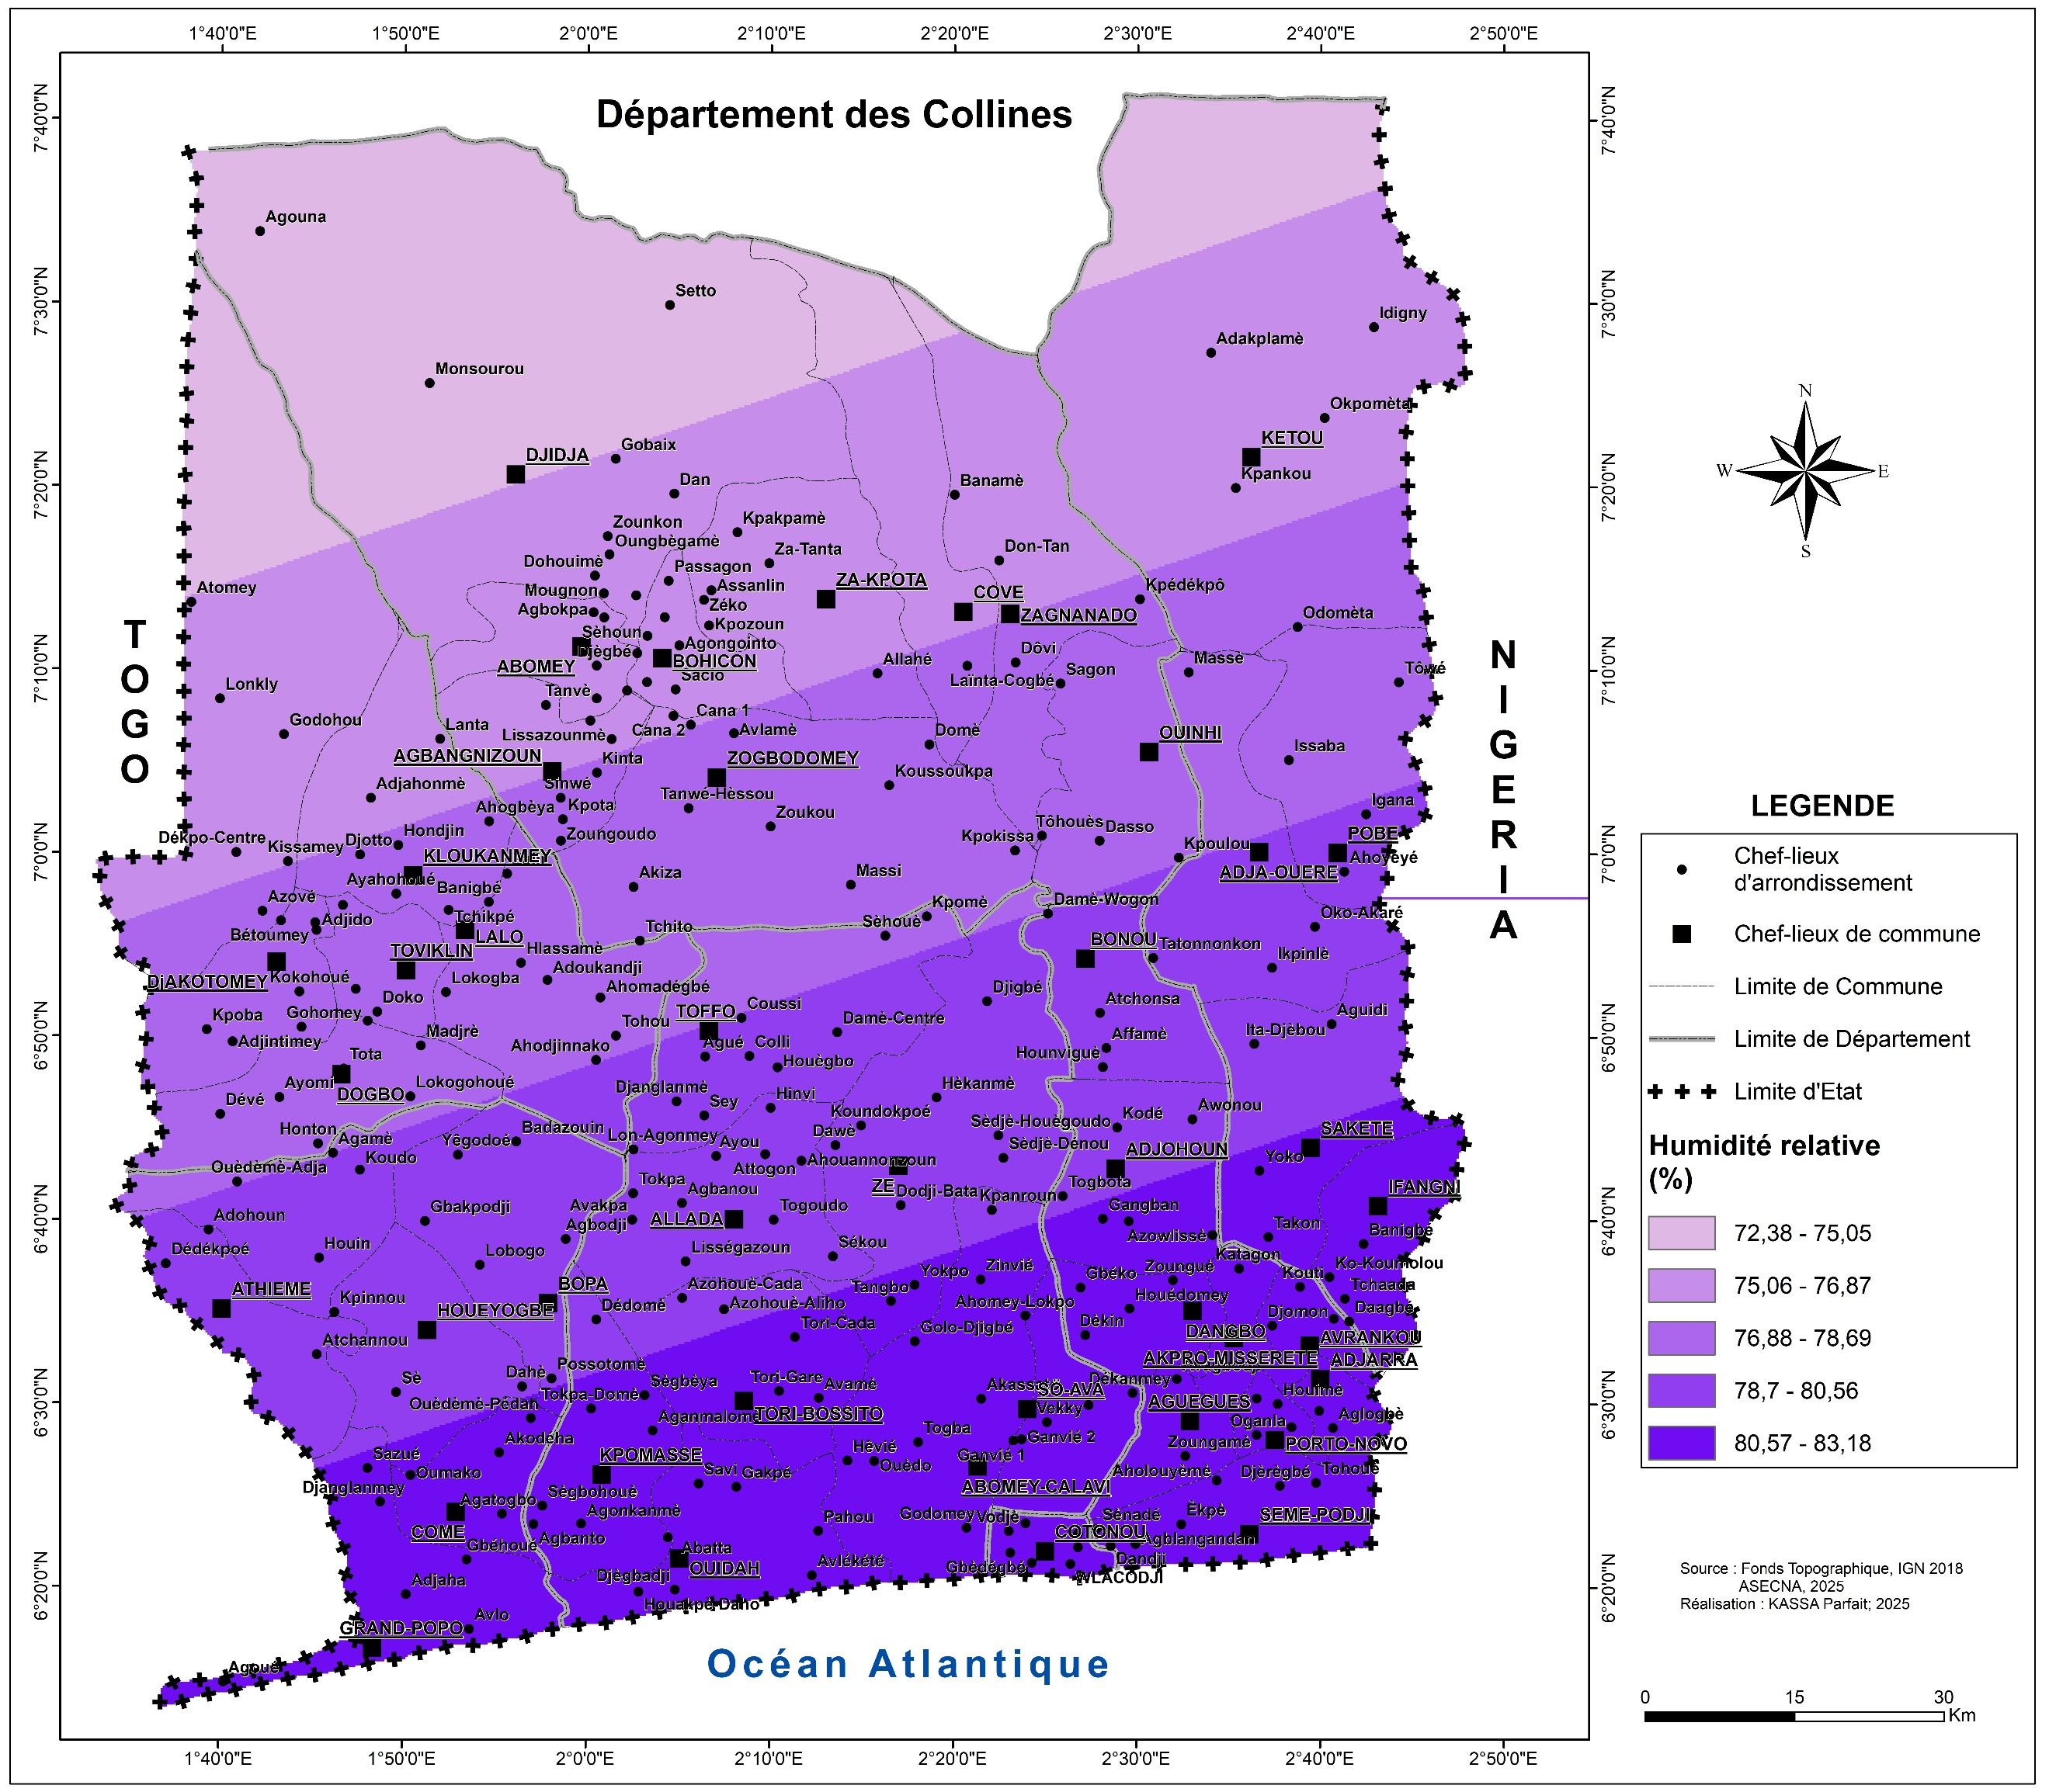
Fig. 4: Spatial distribution of relative humidity in southern Bénin

2.2. Data Collection and Spatial Analysis
Field data were gathered over a two-year period from April 2022 to April 2024. Surveys were conducted seasonally during both diurnal and nocturnal hours across a range of aquaculture facilities to monitor predator presence. To ensure a practical yet representative sample from the total of 749 sites, a targeted selection strategy was implemented. The selection criteria prioritized sites that were geographically accessible for the transport of personnel and gear, featured diverse types of aquaculture infrastructure, and were spaced at least 2 km apart to minimize the chance of repeatedly counting the same individual predators. Furthermore, authorization was obtained from all site proprietors prior to data collection. This process led to the inclusion of 748 sites in the final dataset. The research design incorporated descriptive, longitudinal, and prospective cross-sectional surveys. Records on the occurrence and population density of Naja melanoleuca were compiled from 39 different communes.
For the spatial examination, ArcGIS 10.3 software was utilized to decipher the distribution patterns of the species. Key metrics such as the centroid, mean center, and standard deviational ellipse were computed to quantify the central tendency and directional bias of the distribution. To evaluate spatial dependence, global autocorrelation was measured using Moran's I index. Additionally, the Getis-Ord Gi* statistic was applied to detect localized clusters, identifying specific areas with statistically significant concentrations of high or low abundance.
2.3. Environmental Variables and Modeling
The analysis incorporated a suite of environmental parameters suspected to influence cobra distribution. These variables consisted of temperature, precipitation, relative humidity, visibility, atmospheric pressure, wind speed, and the Normalized Difference Vegetation Index (NDVI). Data sourced from meteorological stations were spatially interpolated across the study region using geostatistical techniques, including Kriging and Inverse Distance Weighting (IDW). For each variable, the interpolation method that produced the smallest prediction error was selected for the final analysis.
To quantify the relationship between Naja melanoleuca abundance and the environmental factors, a linear regression framework was employed. An initial Principal Component Analysis (PCA) was conducted to explore the underlying structure of the environmental dataset. The most robust regression model was chosen based on the highest adjusted R-squared value, optimizing the balance between explanatory power and model complexity. The selected model underwent rigorous validation, including checks for normality of the residuals and homogeneity of variances using statistical tests like the Breusch-Pagan test. Once validated, the model was applied geographically within the GIS to generate a predictive distribution map for N. melanoleuca. The map's accuracy was subsequently evaluated by comparing its predictions against 15 randomly chosen field observation points that had been reserved for this purpose.

3. results and discussion

3.1. Spatial Structure and Clustering of Naja melanoleuca
The spatial distribution of Naja melanoleuca in southern Bénin was non-random and markedly aggregated. The computed mean center and centroid were both positioned in the south-eastern portion of the study area, suggesting the presence of a core distribution zone for the species, an outcome consistent with the principle that non-random occurrence patterns often emerge from ecological or anthropogenic gradients (Moore & McGuire, 2019). This pattern was further clarified through the standard deviational ellipse, whose dimensions (x-axis: 37.76 km; y-axis: 45.57 km) encompassed 24 of the 39 communes and captured 77% of all recorded cobra occurrences. Such directional clustering, oriented from the northwest toward the southeast, aligns with established spatial-analysis approaches used to detect anisotropy and directional trends in wildlife distribution (Wang et al., 2015; Esri, 2024a) (Fig. 5)
The initial Global Moran’s I index suggested spatial independence (I = 0.018, p = 0.05). However, global indicators such as Moran’s I provide a single summary statistic across the entire study area and may therefore mask meaningful local clustering patterns, especially in ecologically heterogeneous landscapes (Anselin, 2019; Abdulhafedh, 2017). To reveal localized structure, we applied the Getis–Ord Gi* statistic, which is specifically designed to detect significant hotspots and coldspots by evaluating each feature in relation to its neighbors (Ord & Getis, 1995). The Gi* analysis refined the Moran’s I interpretation by identifying significant clusters of high and low values (General G Observed = 0.000013, Z-score = 2.31), confirming the presence of local spatial dependence even when global autocorrelation was weak.
The spatial arrangement of these Gi* clusters (Figure 6) shows a progressive increase in Gi* Z-scores from the northwest toward the southeast, indicating a clear hotspot of Naja melanoleuca encounters in the south-eastern portion of the country. Such patterns, weak global structure combined with strong local hotspots arranged along environmental or anthropogenic gradients are well documented in wildlife spatial ecology (Sussman et al., 2019).
This clustering pattern is especially important for aquaculture planning, as hotspot analysis is widely recognized as an effective tool to pinpoint geographic zones where human–wildlife conflict is most intense and where targeted mitigation strategies will have the highest impact (Nyhus, 2016). The identified hotspot zone therefore highlights the areas where conflict between aquaculture facilities and this predator is likely to be most concentrated.

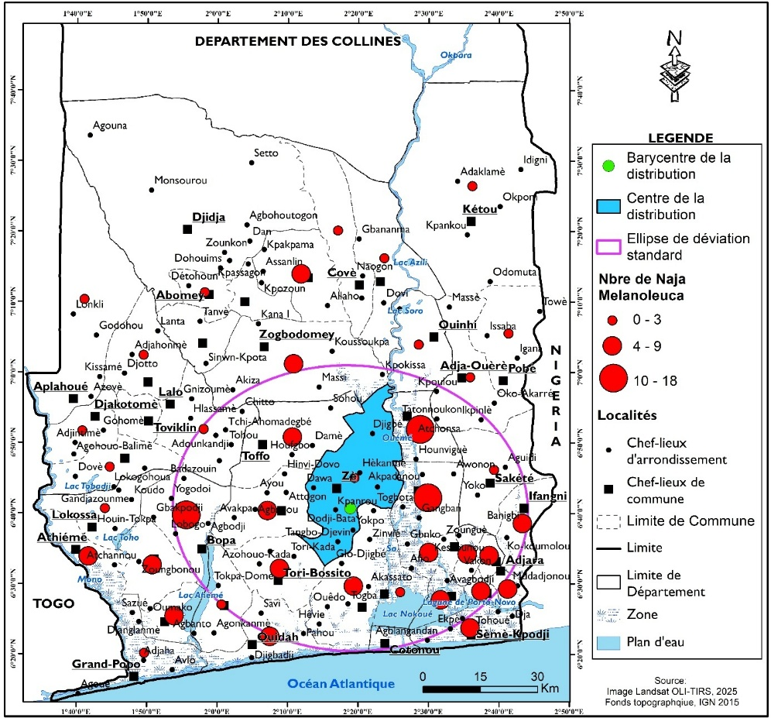
Fig. 5: Local Spatial Configurations of Naja melanoleuca

The results from evaluating the Getis–Ord Gi* index produced the following summary statistics for the 39 communes: minimum = −2; maximum = 1.95; mean = 0.34; standard deviation = 1.08; cumulative total = 13.26. These descriptive outputs are consistent with standard reporting of Gi* z-scores (which quantify local spatial association for each feature relative to its neighbors) and can be directly interpreted using ArcGIS Pro’s Hot Spot Analysis procedures (Esri, 2024a). The classification of Gi* Z-scores into three map classes using the Jenks (natural breaks) method is an accepted cartographic approach for grouping continuous spatial statistics into visually and statistically interpretable categories while minimizing within-class variance (Esri, 2024b; Sussman et al., 2019).
Visual inspection and spatial analysis of Fig. 6 reveal a clear gradient of increasing Gi* Z-scores from the northwest toward the southeast, with the southeastern area concentrating the highest Gi* values. Directional clustering of this kind commonly occurs when species occurrences respond to environmental gradients or landscape drivers; similar spatial gradient/hotspot patterns have been documented in ecological studies that link local clusters of encounters to climatic and habitat variables (Hu et al., 2021; Martínez et al., 2024). In this study, the spatial arrangement of high and low Gi* values aligns spatially with gradients in rainfall, visibility, vapour pressure and wind speed, which is consistent with the expectation that abiotic climatic factors can structure local aggregation of ectothermic predators (Ratnarathorn et al., 2024; Martínez et al., 2024).
Because Global Moran’s I is a single global summary, a near-zero or non-significant Moran’s I does not rule out meaningful local structure; the presence of statistically significant Gi* hotspots therefore confirms a structured, non-random distribution of Naja melanoleuca at the local scale (Anselin, 2019; Sussman et al., 2019). From a management perspective, identification of these localized clusters is critical: hotspot maps provide spatially explicit targets where mitigation, monitoring and resource allocation for aquaculture protection will be most effective (Nyhus, 2016; Sharma, 2020).
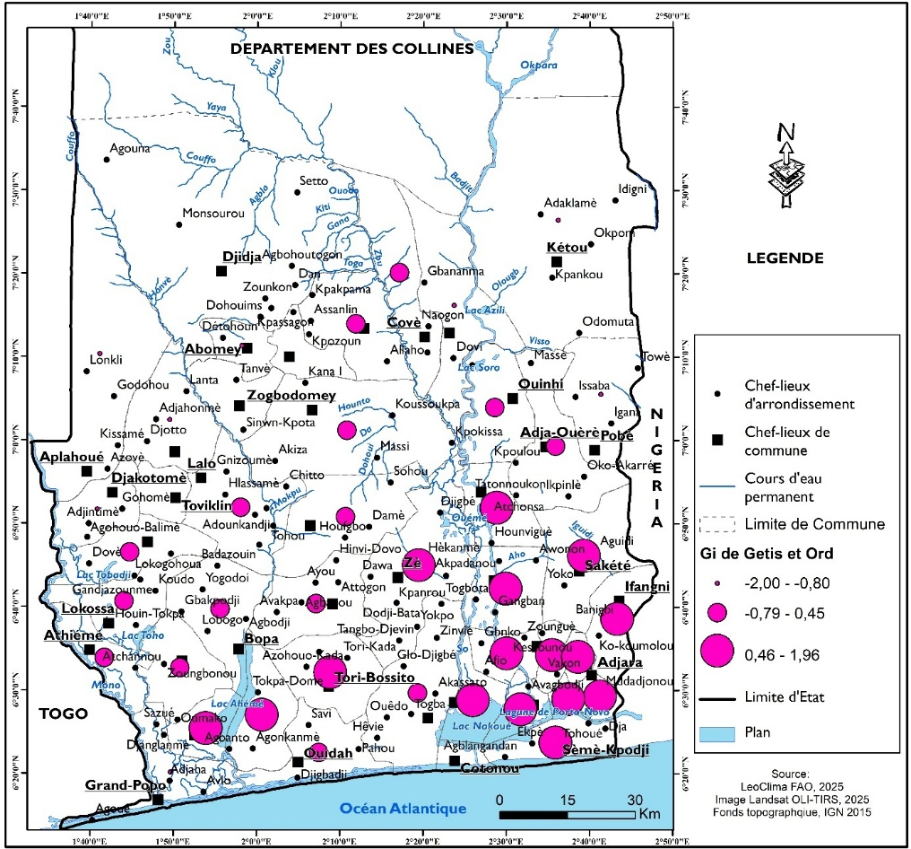
Fig. 6: Spatial configuration of Naja melanoleuca according to the Getis-Ord index Spatial distribution model of Naja melanoleuca

3.2. Key Environmental Drivers and Predictive Modeling
The relationship between cobra abundance and environmental parameters was robustly modeled using multiple linear regression. The most parsimonious and powerful model included four variables: visibility, relative humidity, rainfall, and vapour pressure. This model explained 78.4% of the observed variance (Adjusted R² = .78), demonstrating a strong link between the species' distribution and these physical factors (Table 1).
Table 1: Coefficient of determination values for the best model of Naja melanoleuca
Model | Number of variables in the model | Variables included | R² | Adjusted R²
1 | 6 | Visibility; Humidity; Temperature; Number of rainy days; Rainfall; Vapor pressure | .81 | .78
1 | 4 | Visibility; Humidity; Rainfall; Vapor pressure | .82 | .78

Table 2 presents the results of the Fisher test for the best model of Naja melanoleuca. The Fisher test (F = 21.81; p < .0001) reveals that the model is highly significant overall, with less than a .1% probability of error in asserting that the variables included are relevant for explaining the variance of Naja melanoleuca.
However, the examination of Type III Sum of Squares indicates that only rainfall contributes significantly to the species’ variability. This suggests that although several factors influence its distribution, rainfall constitutes the main environmental determinant in this model.

Table 2: Results of the Fisher test for the best model of Naja melanoleuca
Source | D | Sum of squares | Mean of squares | F | Pr > F
Model | 4.00 | 284.14 | 71.03 | 21.81 | <.0001
Error | 19.00 | 61.85 | 3.25
Corrected total | 23.00 | 346.00

Table 3 presents the parameters of the regression equation describing the distribution of Naja melanoleuca as a function of environmental variables. The regression equation obtained:
Naja melanoleuca = 3795.24 + 5.27 × Visibility – 0.85 × Humidity – .21 × Rainfall – 3.47 × Vapor Pressure,
shows that the presence of Naja melanoleuca is positively associated with visibility, but negatively correlated with relative humidity, rainfall, and vapor pressure. Among these variables, rainfall exhibits a significant effect (t = –2.85; p = .01), confirming that increasing precipitation tends to reduce the likelihood of the species’ presence. This suggests that N. melanoleuca in southern Bénin is more abundant in areas with lower precipitation. Ecologically, this could be because regions of high rainfall are associated with habitats that are less favorable, such as permanently waterlogged soils or denser, less navigable vegetation, potentially affecting thermoregulation, prey availability, or nesting sites. The negative relationships with humidity and vapour pressure further support the interpretation that this cobra species may prefer slightly drier microclimates within the study area. The positive association with visibility likely reflects a preference for more open landscapes, which could facilitate movement and basking, and is a common feature around aquaculture facilities where vegetation is cleared.

Table 3: Parameters of the regression equation for the distribution of Naja melanoleuca based on environmental variables
Source | Value | Standard Error | t | Pr > |t|
Constant | 3795.24 | 3191.77 | 1.18 | .24
Visibility | 5.26 | 5.00 | 1.05 | .30
Humidity | -.85 | .47 | -1.78 | .09
Rainfall | -.21 | .07 | -2.85 | .01
Vapor pressure | -3.47 | 3.10 | -1.12 | .27

3.3. Model Validation and Predictive Map for Aquaculture Planning
Fig. 7 shows the residual normality test. The Shapiro–Wilk normality test for Naja melanoleuca yielded a statistic of W = .98, which is close to 1, indicating a good fit to normality. The associated p-value (p = .73) is much higher than the significance threshold (α = .05), suggesting that the residuals are normally distributed. Consequently, the model is considered valid.

Fig. 7: Q–Q plot of residual fit for Naja melanoleuca
This first level of model validation allows for the production of a theoretical map representing the predicted distribution of Naja melanoleuca.
Analysis of the prediction map for Naja melanoleuca (Fig. 8) reveals a gradual decline in the species’ presence from the southeast toward the northwest. This spatial pattern closely mirrors that of certain ecological variables such as rainfall, visibility, humidity, vapor pressure, and temperature. It thus appears that the northwestern region is unfavorable for the proliferation of Naja melanoleuca, as the model predicts relatively low abundance there. Conversely, the southern and eastern parts of Bénin provide the most suitable ecological conditions for the species’ proliferation.
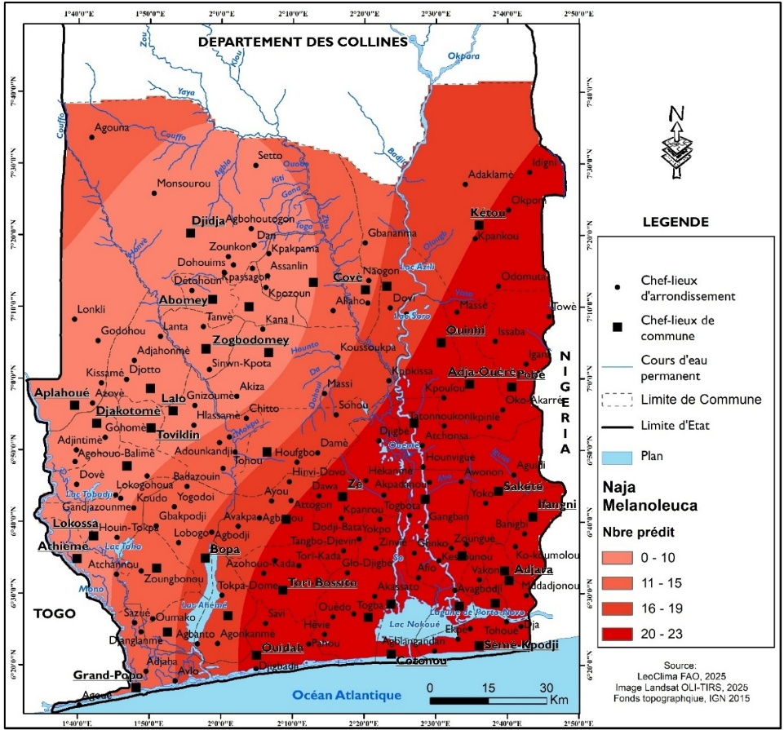
Fig. 8: Predicted spatial distribution of Naja melanoleuca

3.4. Comparison of the Naja melanoleuca Model with Field Observations
For Naja melanoleuca (Fig. 9), the correlation coefficient between the observed and predicted distributions is R = .77, indicating a strong positive correlation between these two variables. Therefore, the predicted data are consistent with the field observations.

Fig. 9: Correlation between predicted and observed field values for Naja melanoleuca

Overall, the model was validated through residual analysis and independent field comparison. Normality of the regression residuals was supported by a Shapiro–Wilk statistic close to 1 (W = 0.98, p = .73), which—together with Q–Q diagnostics indicates that the standard linear regression assumptions were met and that parametric inference from the fitted model is defensible (Shatz, 2024). Contemporary discussions of diagnostic practice emphasise combining numerical normality tests with graphical inspections (Q–Q plots, histograms, residual vs fitted) and visual-inference protocols (lineup plots) because formal tests alone can be misleading when sample size is small or large; using both approaches therefore strengthens confidence in residual normality for ecological regression models (Li, Cook, Tanaka, & VanderPlas, 2023; Arnastauskaitė, Ruzgas, & Bražėnas, 2021).
After checking residuals and other standard assumptions (homoscedasticity, independence), the fitted regression equation was projected spatially within a GIS environment to produce a continuous predictive surface of Naja melanoleuca potential abundance (i.e., the regression’s linear predictor evaluated at rasterized environmental layers), a standard and well-established workflow for translating statistical models into management-ready hazard/suitability maps (Ruda et al., 2018; FAO, 2018). The resulting prediction map shows a clear southeast - northwest gradient (higher predicted abundance in the south-east declining toward the north-west), a pattern that closely follows the spatial gradient of key climatic predictors in the model (notably rainfall). Such congruence between mapped predictions and the underlying environmental drivers is an expected outcome when those drivers are both statistically important in the model and spatially structured (Martínez et al., 2024; Ratnarathorn et al., 2024).
Model accuracy was assessed against independent field observations reserved for validation: the predicted pixel values extracted at those validation points correlated strongly with observed abundance (r = .77), demonstrating good predictive performance and practical utility (examples of similar field-validation approaches and strong observed–predicted associations are reported in Nolan et al., 2022 and Zimmer et al., 2023). Because the predictive map both reproduces the modelled climate/visibility gradients and matches withheld field data, it constitutes a robust decision-support product for aquaculture planners. In practical terms, the map identifies south-eastern zones as “high-risk” for cobra predation, areas where pre-emptive mitigation (e.g., reinforced pond fencing, exclusion structures, perimeter clearing, intensified monitoring and farmer training) should be prioritised while north-western zones emerge as comparatively lower-risk, and therefore relatively preferable for siting new farms (Nyhus, 2016; FAO, 2018). Applied spatial predictions of this kind have proven effective in targeting limited mitigation resources to local hotspots of human–wildlife conflict in other systems (Zimmer et al., 2023; Ruda et al., 2018).

4. Conclusion
This study successfully determined the physical determinants of the distribution of Naja melanoleuca in southern Bénin. The results demonstrate a non-random spatial distribution, characterized by a significant concentration in the south-eastern part of the country, structured into local clusters. Modeling the relationship with environmental factors identified rainfall as the primary determinant of this distribution, with the species showing a preference for less humid conditions. Other significant variables included visibility, relative humidity, and vapour pressure. The final predictive model, validated by a strong correlation with field observations, explains 78.4% of the variance in the species' abundance. The resulting potential distribution map represents a valuable decision-support tool for developing sustainable aquaculture. It allows for the identification of high-risk predation zones where enhanced mitigation measures should be considered, and more favourable areas for establishing new sites. Thus, these results provide a scientific foundation for the rational spatial planning of aquaculture activities, aiming to minimize conflicts with this predator and secure production.

References

Abdulhafedh, A. (2017). A novel hybrid method for measuring the spatial autocorrelation of vehicular crashes: Combining Moran’s index and Getis-Ord Gi* statistic. Open Journal of Civil Engineering, 7(2), 208–221. https://doi.org/10.4236/ojce.2017.72013
Adelakun, K. M., Adeola, A. J., Ayeni, S. M., & Bakare, K. (2015). Perception of fish farmers to wildlife predator attacks of fish ponds in Borgu Local Government Area of Niger State, Nigeria. BIBECHANA, 13, 29–37.
Anselin, L. (2019). A local indicator of multivariate spatial association: Extending the LISA concept. Geographical Analysis, 51(2), 133–150. https://doi.org/10.1111/gean.12189
Arnastauskaitė, J., Ruzgas, T., & Bražėnas, M. (2021). An exhaustive power comparison of normality tests. Mathematics, 9(7), Article 788. https://doi.org/10.3390/math9070788
Dagoudo, M., Adjahouinou, D. C., Tossavi, N. D., Amegnaglo, C. J., Nzau Matondo, B., Ovidio, M., & Montchowui, E. (2024). Traditional fish hole aquaculture system in Bénin: Status, challenges and research prospects for sustainable development in climate change mitigation. Sustainability, 16(23), 10499. https://doi.org/10.3390/su162310499
Esri. (2024a). Hot Spot Analysis (Getis-Ord Gi) — ArcGIS Pro Spatial Statistics* (documentation). Retrieved from https://pro.arcgis.com/en/pro-app/latest/tool-reference/spatial-statistics/hot-spot-analysis.htm
Esri. (2024b). Data classification methods—Natural Breaks (Jenks) (ArcGIS Pro documentation). Retrieved from https://pro.arcgis.com/en/pro-app/latest/help/mapping/layer-properties/data-classification-methods.htm
FAO. (2018). Guidance on spatial technologies for disaster risk management in aquaculture (Guidance document). Food and Agriculture Organization of the United Nations. https://www.fao.org/fishery/zh/publications/3679
FAO. (2020). The State of World Fisheries and Aquaculture 2020: Sustainability in action. Rome: Food and Agriculture Organization of the United Nations. https://doi.org/10.4060/ca9229en
Hu, Y., Fan, H., Chen, Y., Chang, J., Zhan, X., Wu, H., Zhang, B., Wang, M., Zhang, W., Yang, L., Hou, X., Shen, X., Pan, T., Wu, W., Li, J., & Wei, F. (2021). Spatial patterns and conservation of genetic and phylogenetic diversity of wildlife in China. Science Advances, 7(4), eabd5725. https://doi.org/10.1126/sciadv.abd5725
Kassah, J. E. (WorldFish). (2023). Best management practices guidelines for small-scale tilapia cage aquaculture in Ghana and Nigeria. WorldFish / IFAD-ProSCAWA. https://hdl.handle.net/20.500.12348/5491
Li, W., Cook, D., Tanaka, E., & VanderPlas, S. (2023). A plot is worth a thousand tests: Assessing residual diagnostics with the lineup protocol (preprint). arXiv. https://arxiv.org/abs/2308.05964
Martínez, P. A., Teixeira, I. B. F., Siqueira-Silva, T., da Silva, F. F. B., Lima, L. A. G., Chaves-Silveira, J., Olalla-Tárraga, M. Á., Gutiérrez, J. M., & Amado, T. F. (2024). Climate change-related distributional range shifts of venomous snakes: A predictive modelling study of effects on public health and biodiversity. The Lancet Planetary Health, 8, e163–e171. https://doi.org/10.1016/S2542-5196(24)00005-6
Martínez, P. A., Teixeira, I. B. F., Siqueira-Silva, T., da Silva, F. F. B., Lima, L. A. G., Chaves-Silveira, J., Olalla-Tárraga, M. Á., Gutiérrez, J. M., & Amado, T. F. (2024). Climate change-related distributional range shifts of venomous snakes: A predictive modelling study of effects on public health and biodiversity. The Lancet Planetary Health, 8, e163–e171. https://doi.org/10.1016/S2542-5196(24)00005-6
Moore, T. W., & McGuire, M. P. (2019). Using the standard deviational ellipse to document changes to the spatial dispersion of seasonal tornado activity in the United States. npj Climate and Atmospheric Science, 2, 21. https://doi.org/10.1038/s41612-019-0078-4
Nolan, V., Gilbert, F., Reed, T., & Reader, T. (2022). Distribution models calibrated with independent field data predict two million ancient and veteran trees in England. Ecological Applications. https://doi.org/10.1002/eap.2695
Nyhus, P. J. (2016). Human–wildlife conflict and coexistence. Annual Review of Environment and Resources, 41, 143–171. https://doi.org/10.1146/annurev-environ-110615-085634
Ord, J. K., Getis, A. (1995) Local spatial autocorrelation statistics: distributional issues and an 497 application. Geographical Analysis 27(4), 286-306
Otieno, N. E. (2019). Economic impact of predatory piscivorous birds on small-scale aquaculture farms in Kenya. Aquaculture Reports, 15, 100220. https://doi.org/10.1016/j.aqrep.2019.100220
Pintor, A. F., Vallejos, E., & co-authors. (2021). Addressing the global snakebite crisis with geo-spatial analyses—Recent advances and future direction. Toxicon: X, 11, 100076. https://doi.org/10.1016/j.toxcx.2021.100076
Ratnarathorn, N., Sanunsilp, N., Laoungbua, P., Tawan, T., Sumontha, M., Kongrit, C., & Thaweepworadej, P. (2024). Species richness, seasonality, and mortality of snakes in human–snake conflicts in Thailand: Insights from citizen science data. Biological Conservation, 294, 110603. https://doi.org/10.1016/j.biocon.2024.110603
Ruda, A., Kolejka, J., & Silwal, T. (2018). GIS-Assisted Prediction and Risk Zonation of Wildlife Attacks in the Chitwan National Park in Nepal. ISPRS International Journal of Geo-Information, 7(9), 369. https://doi.org/10.3390/ijgi7090369
Sharma, P., Pandey, P., Mishra, S., & Gokhale, C. (2020). Mapping human–wildlife conflict hotspots in a transboundary landscape: Implications for conflict mitigation and conservation. Global Ecology and Conservation, 23, e01157. https://doi.org/10.1016/j.gecco.2020.e01157
Shatz, I. (2024). Assumption-checking rather than (just) testing: The importance of visualization and effect size in statistical diagnostics. Behavior Research Methods, 56(2), 826–845. https://doi.org/10.3758/s13428-023-02072-x
Sussman, A. L., Gardner, B., Adams, E. M., Salas, L., Kenow, K. P., Luukkonen, D. R., Monfils, M. J., Mueller, W. P., Williams, K. A., Leduc-Lapierre, M., & Zipkin, E. F. (2019). A comparative analysis of common methods to identify waterbird hotspots. Methods in Ecology and Evolution, 10(11), 1972–1984. https://doi.org/10.1111/2041-210X.13209
Wang, B., Shi, W., & Miao, Z. (2015). Confidence analysis of standard deviational ellipse and its extension into higher dimensional Euclidean space. PLoS ONE, 10(3), e0118537. https://doi.org/10.1371/journal.pone.0118537
Wüster, W., Chirio, L., Trape, J.-F., Ineich, I., Jackson, K., Greenbaum, E., … Broadley, D. G. (2018). Integration of nuclear and mitochondrial gene sequences and morphology reveals unexpected diversity in the forest cobra (Naja melanoleuca) species complex in Central and West Africa (Serpentes: Elapidae). Zootaxa, 4455(1), 68–98. https://doi.org/10.11646/zootaxa.4455.1.3
Yousefi, M., Kafash, A., Khani, A., & Nabati, N. (2020). Applying species distribution models in public health research by predicting snakebite risk using venomous snakes’ habitat suitability as an indicating factor. Scientific Reports, 10, Article 12345. https://doi.org/10.1038/s41598-020-74682-w
Zimmer, S. N., Holsinger, K. W., & Dawson, C. A. (2023). A field-validated ensemble species distribution model of Eriogonum pelinophilum, an endangered subshrub in Colorado, USA. Ecology and Evolution, 13, e10816. https://doi.org/10.1002/ece3.10816

